Name of journal: World Journal of Radiology
ESPS Manuscript NO: 11376
Columns: Topic Highlight

WJR 6th Anniversary Special Issues (2): Gastrointestinal imaging

Conventional radiological strategy of common gastrointestinal neoplasms

Li YZ et al. Radiological features of GI neoplasms

Yi-Zhuo Li, Pei-Hong Wu

Yi-Zhuo Li, Pei-Hong Wu, Imaging Diagnosis and Interventional Center, State Key Laboratory of Oncology in Southern China, Cancer Center, Sun Yat-sen University, Collaborative Innovation Center for Cancer Medicine, Guangzhou 510060, Guangdong Province, China

Author contributions: Li YZ and Wu PH solely contributed to this paper.

Conflict-of-interest: The authors declare that they have no conflicting interests to commercial, personal, political, intellectual, or religious.

Open-Access: This article is an open-access article which selected by an in-house editor and fully peer-reviewed by external reviewers. It distributed in accordance with the Creative Commons Attribution Non Commercial (CC BY-NC 4.0) license, which permits others to distribute, remix, adapt, build upon this work non-commercially, and license their derivative works on different terms, provided the original work is properly cited and the use is non-commercial. See: http://creativecommons.org/licenses/by-nc/4.0/
Correspondence to: Pei-Hong Wu, MD, Imaging Diagnosis and Interventional Center, State Key Laboratory of Oncology in Southern China, Cancer Center, Sun Yat-Sen University, Collaborative Innovation Center for Cancer Medicine, 651 Dongfeng Road East, Guangzhou 510060, Guangdong Province, China. wupeihong56@126.com

Telephone: +86-20-87343272 Fax: +86-20-87343272

Received: May 18, 2014
Peer-review started: May 19, 2014
First decision: June 27, 2014
Revised: November 21, 2014
Accepted: December 3, 2014
Article in press:
Published online:

Abstract
This article summarized the clinical characteristics, imaging features of common gastrointestinal (GI) neoplasms in terms of conventional radiologic imaging methods. Barium studies are very available for displaying primary malignancies. They are minimally or not at all invasive. A neoplasm may be manifested as various imaging findings, including mucosal disruption, soft mass, ulcer, submucosal invasion, and lumen stenosis on barium studies. Benign tumors are typically appearing as smoothly marginated intramural masses. Malignant neoplasms are most often appearing as irregular infiltrative lesions at barium examination. Tumor extension to adjacent GI segments may be indistinct on barium images. Cross-sectional images such as computed tomography and magnetic resonance imaging may provide more accurate details of the adjacent organ invasion, omental or peritoneal spread.

© 2014 Baishideng Publishing Group Inc. All rights reserved.

Key words: Gastrointestinal; Barium enema; Computed tomography; Magnetic resonance imaging; Neoplasm

Core tip: Gastrointestinal neoplasms are very common diseases. A neoplasm may be manifested as a wide spectrum of imaging findings. Barium studies are very available for displaying primary malignancies in a short time and at low cost. Malignant neoplasms are most often appearing as irregular infiltrative lesions at barium examination. Cross-sectional imaging such as computed tomography or magnetic resonance imaging may provide more accurate details of the adjacent organ invasion, omental or peritoneal spread.

Li YZ, Wu PH. Conventional radiological strategy of common gastrointestinal neoplasms. World J Radiol 2014; In press

INTRODUCTION
The techniques of gastrointestinal (GI) radiology have changed dramatically in the recent three decades. The basic mission of modern GI radiology are earlier diagnosis, better anvenue to evidence-based treatment options, predict tumor response to treatment and non-invasive follow-up^{[1]}.
Barium enema can provide valuable information. Multi-slices computed tomography (MSCT) has proven to have more valuable information for abdominal imaging. High-resolution magnetic resonance imaging (MRI) with its high soft tissue contrast has documented its clinical application in abdominal imaging. Positron emission tomography (PET) has excellent tissue penetration. However, apart from the conventional imaging such as barium enema and multi-slice computed tomography (CT), the other options should increase its specificity and sensitivity using exogenous tracers or contrast agents.
The objective of this paper is to review the conventional radiological imaging of common gastrointestinal neoplasm.

ESOPHAGEAL DISEASE
Esophageal carcinoma
About 80% of esophageal neoplasms are malignant, and more than 90% of these are squamous cell carcinomas (SCCs) or adnocarcinomas^{[2]}.
SCC is the most common malignant esophageal neoplasm worldwide. It arises from epithelial cells with stratified squamous differentiation, which develops from precursor lesions of intraepithelial neoplasia^{[3]}. Alcohol and tobacco use are the most important risk factors for SCC of the esophagus. Most of the SCCs occur in the middle third of the esophagus, then the upper and lower third of the esophagus^{[4,5]}. Pathologically, SCCs appear a variety of gross morphologic types, polypoid mass, flat, or ulcerated lesions. About 65% of the SCCs patients are men, and the peak ages range is from 60 to 74 years^{[6]}. Adenocarcinomas are the second common malignant tumor of the esophagus. The majority of the esophageal adenocarcinomas develop from malignant degeneration of underlying Barrett epithelium, which are located in the distal esophagus, and the gastroesophageal junction, and these tumors have tendence to invade the stomach^{[7]}. About 85% of the esophageal adenocarcinoma patients are men^{[2]}.
At barium esophagography, most SCCs show an infiltrative irregular luminal stricture, filling defect, with or without areas of ulceration (Figures 1-3).
At CT, esophageal cancer shows a soft tissue mass, or localized irregular esophageal wall thickening, with irregular luminal narrowing. The located wall thickening may be asymmetric in the early stage and concentric thickening (advanced stage). The lesions usually show moderate enhancement (Figure 4). CT plays very important roles in evaluating the primary tumor, mediastinal invasion, lymph node involvement, distant metastases such as liver, lungs, and bones, and the complications of esophageal obstruction.
At MR imaging, esophageal carcinoma reveals irregular soft tissue mass with low T1 weighted signal intensity, and intermediate T2 weighted signal intensity. MR imaging was reported to be comparable to CT in evaluating tumor’s features, including local spread, distant metastases, and lymph node involvement^{[8,9]}.
At FDG-PET, esophageal carcinoma and its metastases show avid uptake value. However, the regional lymph nodes may be obscured by the high uptake tissue of primary tumor^{[10]}.

Other malignant esophageal neoplasms
Leiomyosarcoma is a relatively common malignant tumor of esophagus than the others apart from esophageal carcinoma. At esophagography, this tumor shows intramural mass with large exophytic parts, with or without calcification and tracking areas. At CT images, they reveal heterogeneous mass with exophytic edge^{[11]}. At MR imaging, they appear as intermediate signal intensity heterogeneous mass with exophytic edge on T1W images, and slight high signal intensity on T2W images.
The lesions usually show moderate arterial phase enhancement both at CT and MR images.

Benign esophageal neoplasms
Benign tumors are usually small and without ulceration, or peritumoral invasion, or distant metastases, and do not cause symptoms, so, less than 1% of esophageal tumors come to clinical attention^{[12]}. General imaging features of these tumors show a smooth intramural or intraluminal homogeneous mass, without necrosis, or peritumoral spread.
Leiomyoma is the commonest benign esophageal neoplasms. They arise in the mature smooth muscle cells of the esophagus. Most patients of esophageal leiomyoma asymptomatic, the remaining usually may develop dysphagia, or pain, depending on the lesion’s size and the amount of encroachment on the esophageal lumen. At barium examination, an intramural mass with a sharply defined, smooth or lobulated filling defects form the typical findings^{[13]} (Figure 5). At CT, esophageal leiomyomas show sharply marginated homogeneous mass in the mid to lower third esophagus. These tumors show isoattenuating of slight hypoattenuating to muscle at nonenhanced CT, and moderate enhancement, occasionally with coarse calcification (Figure 6). At MRI, slightly hyperintense at T2 weighted, slightly hypointense at T1 weighted images, and with moderate homogeneous enhancement without necrosis^{[14]}.

GASTRIC DISEASE
Gastric cancer
Most of the primary gastric cancers are adenocarcinoma. Adenocarcinoma represents over 95% malignant tumors of the stomach^{[15]}. Common risk factors relating to the development of gastric adenocarcinoma include Helicobacter pylori infection^{[16]}, chronic gastritis, pernicious anemia, adenomatous polyps^{[17]}. Gastric primary adenocarcinoma most often occurs in the gastric antrum, followed by lesser curvature and cardia of the stomach.

Early gastric cancer: Radiologically, early gastric cancer is identified as a superficial lesion that is confined to the gastric mucosa and has not spreaded to the muscularis propria. It may featured as polypoids, superficial, or depressed lesions^{[18]}. The folds entering the central of the lesion are often irregular, nodular, or club-shaped, or it may be manifested by plaque-like elevation^{[19]}. On CT scans, Gastric cancer is shown as thickening of the gastric wall (Figure 7). The major benefits of CT scanning in patient with gastric cancer are preoperative staging, treatment planning, prognosis evaluation, and recurrences detection.
Advanced carcinoma: Advanced gastric carcinomas may be classified as polypoid, ulcerative, or infiltrative lesions according to their gross morphologic appearance. Imaging feature overlapping may occur in this classification^{[17]}. Polypoid-type tumors usually appear as a large mass lesion. The surface of the lesion may be highly irregular. Large lesions may protrude into the lumen^{[20]}. There may be a distinct angular demarcation or “shelf” at the tumor margins. When the lesion located in the antrum, the tumor may obstruct the outlet of the stomach. Ulcerated-type carcinoma reveals an irregular, ulcer crater. Radiating folds are irregular converging to the edge of the ulcer crater^{[20]} (Figure 8) Infiltrative lesions display diffuse, predominantly submucosal infiltrative tumor, with irregular narrowing of the lumen and rigidity of the most part or the whole gastric wall due to the desmoplastic reaction-the so-called linitis plastic^{[21]} (Figure 9).

Gastric lymphoma
In adults, the stomach is the most frequent organ of GI tract lymphomas. Non-Hodgkin’s lymphoma is more common than Hodgkin’s disease^{[22]}. Much of this tumor spread is submucosal. The invasion gastric wall by the lymphoma is relative flexibility. Findings of enlargement of the spleen, involvement of retrogastric and other regional lymph nodes are the suggestive of lymphoma. On barium studies, gastric lymphoma reveals nodular, polypoid mass. The marked sign is thickened gastric folds^{[23,24]}. Its findings may mimic other tuomrs, such as adenocarcinoma, leiomyosarcoma.
At CT, gastric lymphoma reveals as segmental or diffuse, smooth homogeneous, iso-attenuated (minimal enhancement), wall thickening or mass (FigURE 10). Lymphoma usually involves more than one site of the stomach. It is seldom lead to gastric outlet obstruction than is gastric adenocarcinoma because lymphoma is a “soft” tumor^{[25]}. In contrast, the gastric adenocarcinoma, usually appears as more focal wall thickening, more enhancement, direct infiltration beyond the gastric wall; mural rigidity; and luminal narrowing (linitis plastica), which may result in the gastric outlet obstruction^{[26]}.

Gastrointestinal stromal tumors
Gastrointestinal stromal tumors (GISTs) are the most frequent mesenchymal tumors of the GI tract, which arise from the interstitial cells of Cajal. previously, mesenchymal tumors of the gastrointestinal tract were classified as leiomyosarcomas or leiomyomas^{[27,28]}, However, more and more evidences suggested that GISTs are a unique entity. So GISTs were separate from leiomyomas and leiomyosarcomas. GISTs are now defined as spindle cell, epithelioid, and a pleomorphic mesenchymal tumors of the gastrointestinal tract. GISTs express the KIT protein (CD117, stem cell factor receptor) detected at immunohistochemistry^{[29-31]}. This finding differentiates GISTs from leiomyomas, leiomyosarcomas, schwannomas, and neurofibromas, which do not express the KIT protein^{[32]}. As the survival prolonged of GISTs patients, and the recognition progress of GISTs have made imaging more and more important for diagnosis and monitoring the treatment outcome. CT is the option of imaging modality for these purposes^{[33]}. There are three important factors in determining malignancy GISTs: mitoticrate, tumor size, and site^{[34]}.
At CT, the frequent imaging findings of GISTs are of a round, exophytic, well-circumscribed heterogeneously enhancingtumour, appearing as a mass extrinsic to the wall of the stomach (Figure 11). Central fluid attenuation, indicative of necrosis is common in larger lesions. Smaller lesions may reveal homogeneous in density. The liver is the most common site for metastasis^{[35]}. CT may display the adjacent organ spreading, ascites and omental or peritoneal infiltrate. Associated lymphadenopathy is unfrequent than gastric adenocarcinoma or lymphoma^{[28]}.

SMALL INTESTINAL NEOPLASMS
Primary neoplasms of the small intestine are rare. Primary tumors of small intestine are less than 2% of primary gastrointestinal tumors^{[36,37]}. They may occur in association with genetic diseases,chronic intestinal inflammatory disorders. The frequent benign tumors of small intestine are leiomyoma, lipoma, hamartoma, desmoid tumor. These tumors are usually asymptomatic. The requent small intestinal primary malignancies are adenocarcinoma, leiomyosarcoma, lymphoma. These tumors may lead to intestinal obstruction, jaundice, bleeding. Extraintestinal tumors may peritoneal metastasis^{[38]}.

Malignant neoplasms
Adenocarcinoma of the small intestine is frequent. It is approximately 30% to 50% of all malignant tumors in small intestine^{[39,40]}. Proximal duodenum and jejunum is the usual site of the primary small intestinal adenocarcinoma, except in the setting of Crohn’s disease^{[38,41]}. Predisposing risk factors include: villous adenomas, adenomatous polyps, celiac disease, long-standing Crohn’s disease^{[42,43]}. The most frequent clinical features of the small intestinal adenocarcinomas are obstruction, overt or occult GI bleeding, weight loss, and jaundice. Enteroclysis is a reliable sensitive diagnostic means for depicting intra-cavity small intestinal disease^{[44,45]}. The presence of extra-cavity spread or metastases can be evaluated with CT scan; in some instances, magnetic resonance imaging, EUS, or angiography may also be useful^{[38]}.
On barium examination, the general radiologic appearances are filling defects, annular narrowing, polypoid and/or ulcerated masses, or a combination of these. Infiltrating adenocarcinomas are the most frequent type^{[46,47]}. These are almost revealed as short, sharply demarcated, annular constricting lesions, mucosal disruption. Polypoid-type adenocarcinomas may displayed as large, irregular, polypoid-filling defects. Ulceration is common in adenocarcinomas. Mixed radiologic features such as infiltrating, polypoid, and ulcerating lesions indicate advanced lesion. CT is used for demonstrating the intestine, mesentery, lymph nodes and liver metastases in single examination, and for staging the tumor, as well as follow-up after the treatment.

Lymphoma
Lymphoma is one of the most frequent tumors of the small intestine. Intestinal Lymphomas are considered to be primary when the lesion is found in the small intestine, the clinical symptoms are related to intestinal invasion^{[48]}. The majority of small intestine lymphomas are non-Hodgkin’s lymphomas (NHL)^{[49]}, coming from mucosa-associated lymphoid tissue (MALT). This tuomrs are mostly located in the ileum. The lymphoid follicles of the submucosa are the site of origin of lymphoma, as these are more numerous in the ileum than in the jejunum^{[50]}.
On barium examination, the general radiologic signs include luminal narrowing, cavitation, ulceration, valvulae conniventes thickening, discrete intraluminal filling defects and intramural masses^{[48]}. The frequent finding of NHL is the lumen narrowing without intestinal obstruction. A discrete, broad-based mass are characteristic radiologic features of lymphomas^{[48,51]}. The valvulae conniventes thicking is a relative less frequent finding of lymphoma^{[20]}. Focal aneurysmal dilatation is highly suggestive of lymphoma^{[48]}.
CT and MRI can reveal the sites and extent of the tumor involvement, such as abdominal lymph nodes and solid viscera, and staging at a single examination. The lymphoma may be displayed as a homogeneous soft tissue mass with only a small intraluminal component. The tumors are only slight or moderate enhancement after the intravenous injection of contrast medium^{[50]}.

Leiomyosarcoma
Leiomyosarcoma is the fourth most frequently primary small-intestine tumor. It is equally distributed in the jejunum and ileum. Leiomyosarcomas are predominantly extraluminal and eccentric. Acute bleeding is the most common presenting symptom. And the necrosis, haemorrhage is also frequent. In occasional, the less frequent signs may be seen: the calcification, fistula formations, and secondary infection^{[46,47]}.
The most common radiologic feature is a large irregular exophytic mass with or without ulceration, cavitation, or fistula formation^{[17]}. There is marked enhancement of the solid component of the tumor following intravenous contrast medium^{[52]}. The less frequent finding, leiomyosarcoma may display as a large irregular cavity filled with barium^{[17]}.

Benign neoplasms
Leiomyomas are the most common primary benign tumors in the small bowel. The jejunum, the ileum and the duodenum are the most frequent location^{[53]}. Leiomyomas are usually single, firm soft tissue masses with well-defined margin. It is reprted that there are four different types: intraluminal, intramural, extraluminal, and dumbbell shaped^{[54]}. Microscopically, leiomyomas consist of bundles of well-differentiated smooth muscle with no evidence of mitosis. The absence of mitosis is a critical parameter in differentiating it from leiomyosarcoma)^{[38]}. The most often radiologic features, Leiomyomas are shown as regular smooth intramural filling defects on barium studies or regular homogenous soft-tissue mass on CT scans. There is moderate enhancement of the tumor following intravenous contrast medium.
Adenomas are the most frequent asymptomatic small intestinal benign tumors. Histologically, there are three types: villous, tubular, and tubulovillous. Villous with atypia, and/or large size increase the risk for malignancy^{[55]}. Because of their potential of malignant transformation, these tumors should be resected or ablated endoscopically^{[38]}. The general radiologic findings, adenomas are shown as round smooth intraluminal filling defects on barium examination or smooth well-defined regular soft-tissue mass on CT scans and with moderate enhancement after intravenous contrast medium.

COLORECTAL NEOPLASMS
Colorectal carcinoma
Colorectal carcinoma is an extremely common malignancy of the large bowel and in developed countries, it is one of the most frequent causes of death from cancer^{[56]}. Other types of malignant tumors, such as primary lymphoma, leiomyosarcoma are relatively rare^{[17]}. About 69% of carcinomas occur in the colon, and only 31% of them are in the rectum and rectosigmoid junction^{[57,58]}. Usually colorectal carcinomas are not diagnosed till it is relatively advanced.
The barium enema examination were proven safe and accurate for detecting colorectal tumors. Early carcinoma usually presents as a polypoid lesion. Polyps show as filling defects in the barium column, or as soft-tissue densities coated with barium within the air-filled lumen. Larger polypoid lesions generally reveal an irregular and/or ulcerated mucosal surface^{[17,59]} (Figure 12). A flat ulcerating type of carcinoma is more frequent in the transverse and descending colon^{[60]}. Infiltrating type of carcinoma is featured by thickened bowel wall due to infiltrated submucosal and muscular layers^{[61]}.
CT can be used for assessing the extension areas of the tumor, such as locoregional spreading, distant metastases^{[62]}. On CT scanning, the polypoid type reveals a bulky mass with lobulated margins. In infiltrating type appears eccentric or concentric thickening wall. The density of the lesion increases markedly after injection of contrast medium^{[62]}(Figure 13). CT may be used in assessing the extramural spread of tumor. When extra-intestinal infiltration is diagnosed in the presence of irregularity and dense stripes in the peri-intestinal adipose tissue. CT may also be used in assessment of the extension of any locoregional spread and distant metastases, such as spreading to the adjacent or distant organs (bladder, vagina, and abdominal and pelvic muscles). The liver is the most commonly infiltrated organ by metastases from colorectal cancer, and CT has more than 90% sensitivity in diagnosing lesions larger than 1 cm^{[63,64]}. Complications of colorectal carcinoma include obstruction, perforation, pericolic abscess, ischemic colitis, intussusception.

Lymphoma
Other malignances invade the colon are rare. Primary lymphomas of the colon often involve the cecum and rectum and non-Hodgkin’s in type. The tumors may appear as localized, large, extra-luminal masses or constricting. Diffuse infiltration is the most frequent form of colonic lymphoma, and is featured by nodules with intact mucosal surface and diffuse or segmental distribution^{[17,23,24]}. The local complications of lymphoma include perforation, pneumatosis coli and intussusception.

Polyps
A “polyp” is a raised mucosal lesion. This term does not imply any histological features. Metaplastic polyps are relatively more common in the rectum, and less common in the colon. These are no malignant potential. Most adenomas are polyps. Adenomas are well-defined circumscribed areas of dysplastic epithelium. The overall pattern of the epithelium and stroma may be classified as tubular, villous or mixed. The significance of the adenoma is its malignant potential. The imaging features create by a polyp depends on the angle at which it is viewed, and its relationship to the barium pool. Several signs are described on the radiologic features: (1) Meniscus sign: En face view showing a clearly defined inner and outer margin of the meniscus; (2) Increased density sign: On barium enema, polyps are intraluminal lesion coated with barium. The incident X-ray beam may pass through four layers of barium. These factors may increase the density. A localized area of “increased density” may also be drawn; and (3) Filling defect: A polyp on the dependent wall creates a “shadow” (Low density area) in the barium pool. This feature is helpful in differentiating that the lesion is intraluminal. If the polyp is on the non-dependent wall, it may be hidden by the dense barium pool. To confirm the relationship between the lesions and the intestinal wall, it is helpful turning the patients from side to side with the table flat and viewing the lesions at different angles.
In general, the radiologic features of a polyp may be noted as six “S’s”-its site, size, shape (regular/irregular), surface texture (smooth, lobulated, very nodular), symmetry of the base (smooth/irregular, indrawn), and singulary or otherwise^{[65]}. Although polyposis syndrome are general rare, they play important roles in relation to cancer prevention, screening and genetic counseling.

CONCLUSION
Conventional radiographs can provide valuable information on Detection, characterization, staging and prediction of treatment response of GI malignancies. However, Barium imaging have some limited role in staging GI tract tumors. Tumor spreading to adjacent GI segments, and accompanying complications may not be disclosed by barium imaging. Crosssectional imaging may provide more accurate details of the adjacent organ invasion, omental or peritoneal spread.

REFERENCES
1 Hoeffel C, Mulé S, Romaniuk B, Ladam-Marcus V, Bouché O, Marcus C. Advances in radiological imaging of gastrointestinal tumors. Crit Rev Oncol Hematol 2009; 69: 153-167 [PMID: 18674926 DOI: 10.1016/j.critrevonc]
2 Lewis RB, Mehrotra AK, Rodriguez P, Levine MS. From the radiologic pathology archives: esophageal neoplasms: radiologic-pathologic correlation. Radiographics 2013; 33: 1083-1108 [PMID: 23842973 DOI: 10.1148/rg.334135027]
3 Glickman JN. Section II: pathology and pathologic staging of esophageal cancer. Semin Thorac Cardiovasc Surg 2003; 15: 167-179 [PMID: 12838487]
4 Levine MS, Laufer I, Yamada A. Tumors of the esophagus. In Laufer I, Levine MS (eds): “Double contrast radiology of the gastrointestinal tract.” Philadelphia: WB Saunders; 199: 157–190
5 Meyers MA. Carcinoma of the esophagus: Imaging, staging and management. In Meyers MA (ed): “Neoplasms of the digestive tract: imaging, staging and management.” Philadelphia: Lippincott-Raven; 1998: 9-19
6 Trivers KF, Sabatino SA, Stewart SL. Trends in esophageal cancer incidence by histology, United States, 1998-2003. Int J Cancer 2008; 123: 1422-1428 [PMID: 18546259 DOI: 10.1002/ijc.23691]
7 Bosch A, Frias Z, Caldwell WL. Adenocarcinoma of the esophagus. Cancer 1979; 43: 1557-1561 [PMID: 445351]
8 Riddell AM, Hillier J, Brown G, King DM, Wotherspoon AC, Thompson JN, Cunningham D, Allum WH. Potential of surface-coil MRI for staging of esophageal cancer. AJR Am J Roentgenol 2006; 187: 1280-1287 [PMID: 17056917]
9 Takashima S, Takeuchi N, Shiozaki H, Kobayashi K, Morimoto S, Ikezoe J, Tomiyama N, Harada K, Shogen K, Kozuka T. Carcinoma of the esophagus: CT vs MR imaging in determining resectability. AJR Am J Roentgenol 1991; 156: 297-302 [PMID: 1898802]
10 Bruzzi JF, Munden RF, Truong MT, Marom EM, Sabloff BS, Gladish GW, Iyer RB, Pan TS, Macapinlac HA, Erasmus JJ. PET/CT of esophageal cancer: its role in clinical management. Radiographics 2007; 27: 1635-1652 [PMID: 18025508]
11 Levine MS, Buck JL, Pantongrag-Brown L, Buetow PC, Hallman JR, Sobin LH. Leiomyosarcoma of the esophagus: radiographic findings in 10 patients. AJR Am J Roentgenol 1996; 167: 27-32 [PMID: 8659399]
12 Rice TW. Benign esophageal tumors: esophagoscopy and endoscopic esophageal ultrasound. Semin Thorac Cardiovasc Surg 2003; 15: 20-26 [PMID: 12813685]
13 Levine MS. Benign tumors of the esophagus: radiologic evaluation. Semin Thorac Cardiovasc Surg 2003; 15: 9-19 [PMID: 12813684]
14 Yang PS, Lee KS, Lee SJ, Kim TS, Choo IW, Shim YM, Kim K, Kim Y. Esophageal leiomyoma: radiologic findings in 12 patients. Korean J Radiol 2001; 2: 132-137 [PMID: 11752983]
15 Fishman EK, Urban BA, Hruban RH. CT of the stomach: spectrum of disease. Radiographics 1996; 16: 1035-1054 [PMID: 8888389]
16 Parsonnet J, Friedman GD, Vandersteen DP, Chang Y, Vogelman JH, Orentreich N, Sibley RK. Helicobacter pylori infection and the risk of gastric carcinoma. N Engl J Med 1991; 325: 1127-1131 [PMID: 1891020]
17 Gourtsoyiannis N, Grammatikakis J, Prassopoulos P. Role of conventional radiology in the diagnosis and staging of gastrointestinal tract neoplasms. Semin Surg Oncol 2001; 20: 91-108 [PMID: 11398203]
18 Farley DR, Donohue JH. Early gastric cancer. Surg Clin North Am 1992; 72: 401-421 [PMID: 1549800]
19 White RM, Levine MS, Enterline HT, Laufer I. Early gastric cancer. Recent experience. Radiology 1985; 155: 25-27 [PMID: 3975406]
20 Levine MS, Megibow AJ: Carcinoma. In Gore RM, Levine MS, Laufer I (eds): “Textbook of gastrointestinal radiology.” Philadelphia: WB Saunders; 1994: 660–683
21 Levine MS, Kong V, Rubesin SE, Laufer I, Herlinger H. Scirrhous carcinoma of the stomach: radiologic and endoscopic diagnosis. Radiology 1990; 175: 151-154 [PMID: 2156284]
22 Papadimitriou CS, Papacharalampous NX, Kittas C. Primary gastrointestinal malignant lymphomas. A morphologic and immunohistochemical study. Cancer 1985; 55: 870-879 [PMID: 3917844]
23 Dodd GD. Lymphoma of the hollow abdominal viscera. Radiol Clin North Am 1990; 28: 771-783 [PMID: 2190270]
24 Zornoza J, Dodd GD. Lymphoma of the gastrointestinal tract. Semin Roentgenol 1980; 15: 272-287 [PMID: 7001640]
25 Horton KM, Fishman EK. Current role of CT in imaging of the stomach. Radiographics 2003; 23: 75-87 [PMID: 12533643]
26 Gollub MJ. Imaging of gastrointestinal lymphoma. Radiol Clin North Am 2008; 46: 287-312, ix [PMID: 18619382 DOI: 10.1016/j.rcl.2008.03.002]
27 Clark RA, Alexander ES. Computed tomography of gastrointestinal leiomyosarcoma. Gastrointest Radiol 1982; 7: 127-129 [PMID: 7084594]
28 Pannu HK, Hruban RH, Fishman EK. CT of gastric leiomyosarcoma: patterns of involvement. AJR Am J Roentgenol 1999; 173: 369-373 [PMID: 10430139]
29 Miettinen M, Lasota J. Gastrointestinal stromal tumors--definition, clinical, histological, immunohistochemical, and molecular genetic features and differential diagnosis. Virchows Arch 2001; 438: 1-12 [PMID: 11213830]
30 Kindblom LG, Remotti HE, Aldenborg F, Meis-Kindblom JM. Gastrointestinal pacemaker cell tumor (GIPACT): gastrointestinal stromal tumors show phenotypic characteristics of the interstitial cells of Cajal. Am J Pathol 1998; 152: 1259-1269 [PMID: 9588894]
31 Fletcher CD, Berman JJ, Corless C, Gorstein F, Lasota J, Longley BJ, Miettinen M, O'Leary TJ, Remotti H, Rubin BP, Shmookler B, Sobin LH, Weiss SW. Diagnosis of gastrointestinal stromal tumors: A consensus approach. Hum Pathol 2002; 33: 459-465 [PMID: 12094370]
32 Hersh MR, Choi J, Garrett C, Clark R. Imaging gastrointestinal stromal tumors. Cancer Control 2005; 12: 111-115 [PMID: 15855894]
33 Bano S, Puri SK, Upreti L, Chaudhary V, Sant HK, Gondal R. Gastrointestinal stromal tumors (GISTs): an imaging perspective. Jpn J Radiol 2012; 30: 105-115 [PMID: 22190071 DOI: 10.1007/s11604-011-0020-0]
34 Miettinen M, El-Rifai W, H L Sobin L, Lasota J. Evaluation of malignancy and prognosis of gastrointestinal stromal tumors: a review. Hum Pathol 2002; 33: 478-483 [PMID: 12094372]
35 Burkill GJ, Badran M, Al-Muderis O, Meirion Thomas J, Judson IR, Fisher C, Moskovic EC. Malignant gastrointestinal stromal tumor: distribution, imaging features, and pattern of metastatic spread. Radiology 2003; 226: 527-532 [PMID: 12563150]
36 Landis SH, Murray T, Bolden S, Wingo PA. Cancer statistics, 1998. CA Cancer J Clin 1998; 48: 6-29 [PMID: 9449931]
37 Barclay TH, Schapira DV. Malignant tumors of the small intestine. Cancer 1983; 51: 878-881 [PMID: 6821853]
38 Gill SS, Heuman DM, Mihas AA. Small intestinal neoplasms. J Clin Gastroenterol 2001; 33: 267-282 [PMID: 11588539]
39 Brücher BL, Roder JD, Fink U, Stein HJ, Busch R, Siewert JR. Prognostic factors in resected primary small bowel tumors. Dig Surg 1998; 15: 42-51 [PMID: 9845562]
41 Miller TL, Skucas J, Gudex D, Listinsky C. Bowel cancer characteristics in patients with regional enteritis. Gastrointest Radiol 1987; 12: 45-52 [PMID: 3792758]
42 Swinson CM, Slavin G, Coles EC, Booth CC. Coeliac disease and malignancy. Lancet 1983; 1: 111-115 [PMID: 6129425]
43 Collier PE, Turowski P, Diamond DL. Small intestinal adenocarcinoma complicating regional enteritis. Cancer 1985; 55: 516-521 [PMID: 3965106]
44 Maglinte DD, Kelvin FM, O'Connor K, Lappas JC, Chernish SM. Current status of small bowel radiography. Abdom Imaging 1996; 21: 247-257 [PMID: 8661560]
45 Bessette JR, Maglinte DD, Kelvin FM, Chernish SM. Primary malignant tumors in the small bowel: a comparison of the small-bowel enema and conventional follow-through examination. AJR Am J Roentgenol 1989; 153: 741-744 [PMID: 2672733]
46 Gourtsoyiannis NC, Nolan DJ: Primary malignant neoplasms: “Imaging of small intestinal tumours.” Amsterdam: Elsevier; 1997: 105–189
47 Gourtsoyiannis N, Makó E. Imaging of primary small intestinal tumours by enteroclysis and CT with pathological correlation. Eur Radiol 1997; 7: 625-642 [PMID: 9166558]
48 Gourtsoyiannis NC, Nolan DJ. Lymphoma of the small intestine: radiological appearances. Clin Radiol 1988; 39: 639-645 [PMID: 3243056]
49 Lewin KJ, Ranchod M, Dorfman RF. Lymphomas of the gastrointestinal tract: a study of 117 cases presenting with gastrointestinal disease. Cancer 1978; 42: 693-707 [PMID: 354774]
50 Grainger RG, Allison DJ, Baert A. Diagnostic radiology: A text book of medical imaging. Third edition, Volume two: 995-996
51 Sartoris DJ, Harell GS, Anderson MF, Zboralske FF. Small-bowel lymphoma and regional enteritis: radiographic similarities. Radiology 1984; 152: 291-296 [PMID: 6739786]
52 Grainger RG, Allison DJ, Baert A. Diagnostic radiology: A text book of medical imaging. 3rd ed. Volume two: 996
53 Blanchard DK, Budde JM, Hatch GF, Wertheimer-Hatch L, Hatch KF, Davis GB, Foster RS, Skandalakis JE. Tumors of the small intestine. World J Surg 2000; 24: 421-429 [PMID: 10706914]
54 STARR GF, DOCKERTY MB. Leiomyomas and leiomyosarcomas of the small intestine. Cancer 1955; 8: 101-111 [PMID: 13231039]
55 Bjork KJ, Davis CJ, Nagorney DM, Mucha P. Duodenal villous tumors. Arch Surg 1990; 125: 961-965 [PMID: 2378560]
56 Padhani AR. Advances in imaging of colorectal cancer. Crit Rev Oncol Hematol 1999; 30: 189-199 [PMID: 10439064]
57 Coates RJ, Greenberg RS, Liu MT, Correa P, Harlan LC, Reynolds P, Fenoglio-Preiser CM, Haynes MA, Hankey BF, Hunter CP. Anatomic site distribution of colon cancer by race and other colon cancer risk factors. Dis Colon Rectum 1995; 38: 42-50 [PMID: 7813344]
58 Devesa SS, Chow WH. Variation in colorectal cancer incidence in the United States by subsite of origin. Cancer 1993; 71: 3819-3826 [PMID: 8508350]
59 Laufer I. Double contrast enema: technical aspects. In Laufer I, Levine MS (eds): “Double contrast gastrointestinal radiology.” Philadelphia: WB Saunders; 1992: 423–445
60 Boland CR. Malignant tumors of the colon. In Yamada T (ed): “Textbook of gastroenterology.” Philadelphia: Lippincott-Raven; 1995: 1967–2026
61 Kelvin FM. Diagnosis of colorectal cancer by conventional radiology. In Meyers MA (ed): “Neoplasms of the digestive tract: imaging, staging and management.” Philadelphia: Lippincott-Raven; 1998: 219–235
62 Angelelli G, Ianora AA, Scardapane A, Pedote P, Memeo M, Rotondo A. Role of computerized tomography in the staging of gastrointestinal neoplasms. Semin Surg Oncol 2001; 20: 109-121 [PMID: 11398204]
63 Leen E, Angerson WJ, Wotherspoon H, Moule B, Cook TG, McArdle CS. Detection of colorectal liver metastases: comparison of laparotomy, CT, US, and Doppler perfusion index and evaluation of postoperative follow-up results. Radiology 1995; 195: 113-116 [PMID: 7892449]
64 Horton KM, Abrams RA, Fishman EK. Spiral CT of colon cancer: imaging features and role in management. Radiographics 2000; 20: 419-430 [PMID: 10715340]
65 Grainger RG, Allison DJ, Baert A. Diagnostic radiology: A text book of medical imaging. 3rd ed. Volume two: 1016-1021

P-Reviewer: Chiu KW, Tsushima Y, Verma S
S-Editor: Song XX L-Editor: E-Editor:
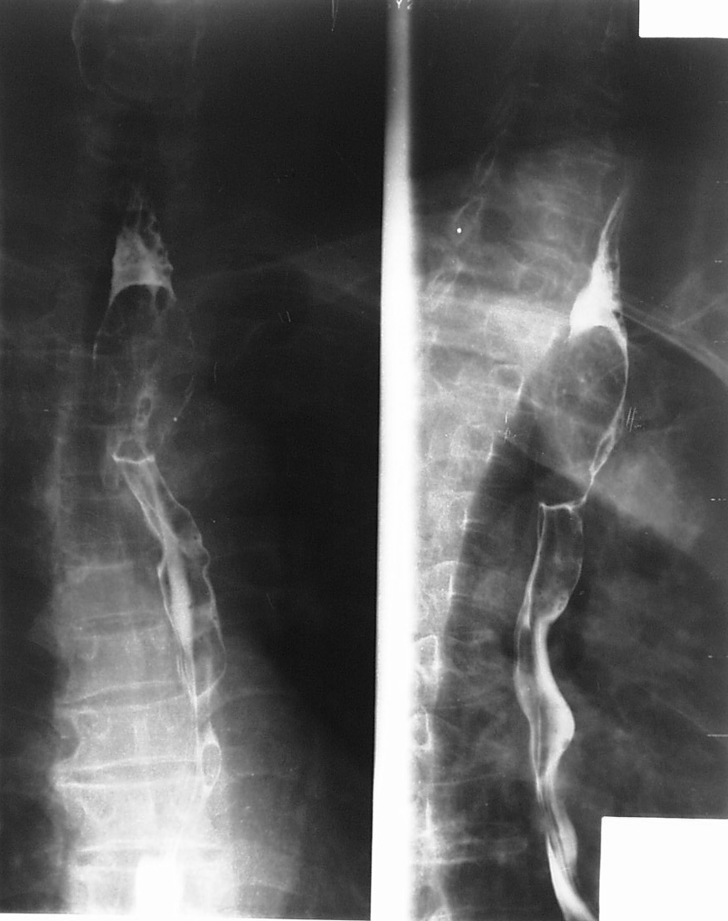
Figure 1 A 60-year-old male patient with squamous-cell carcinoma in the first third section of esophagus. Polypoid-type lesions, presented as filling defect, with luminal narrowing, without ulceration.

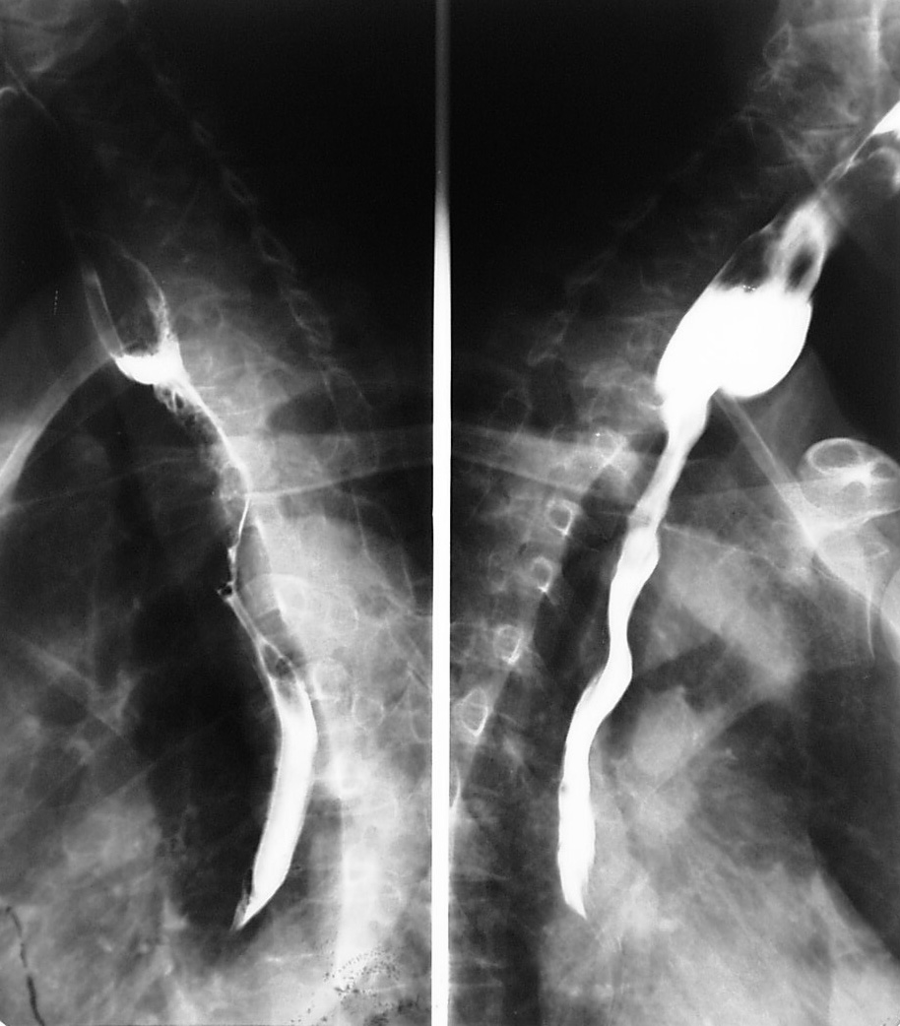
Figure 2 A 60-year-old male with squamous-cell carcinoma. At barium esophagography, Infiltration in the upper third of esophageal carcinoma, with irregular luminal narrowing, mucosal destruction, dilatation, and abrupt proximal borders. Pre-stenotic dilatation is also present.

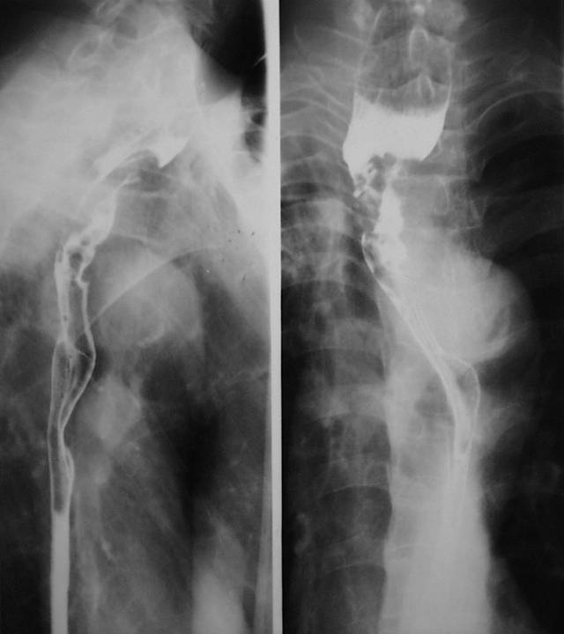
Figure 3 A 59-year-old male with advanced esophageal carcinoma. Asymmetric stenosis of the first third esophagus, with central, large irregular ulceration, surrounded by a radiolucent rim of neoplasmatic infiltration.

A B
C
Figure 4 A 61-year-old male with squamous-cell carcinoma in the first third section of esophagus. At computed tomography, esophageal cancer shows a soft tissue mass, with irregular luminal narrowing. The located wall thickening was asymmetric. The lesion shows moderate arterial phase enhancement (A) and slight venous phase enhancement (B). The enlarged lymph node metastasis is shown in the upper right paratracheal (C).

Figure 5 A 29-year-old female with leiomyoma. A large exophytic submucosal mass with a sharply defined, smooth filling defect is shown in the distal esophagus.

A B
C
Figure 6 A 29-year-old female with leiomyoma. Esophageal leiomyoma shows sharply marginated homogeneous mass in the lower third esophagus. These tumors show isoattenuating of slight hypoattenuating to muscle at non-enhanced computed tomography (A), and moderate arterial (B) and venous (C) phase enhancement.

A B
C
Figure 7 A 56-year-old femal patient with early gastric carcinoma. Computed tomography scans showing thickening wall and narrowing antrum of stomach (A), moderate arterial (B) and venous (C) phase enhancement.

Figure 8 A 62-year-old male with ulcerated gastric carcinoma: a huge ulcerated mass is seen in the gastric antrum. The margins of the neoplasm’s tissue surrounding the irregular ulcer are also seen.

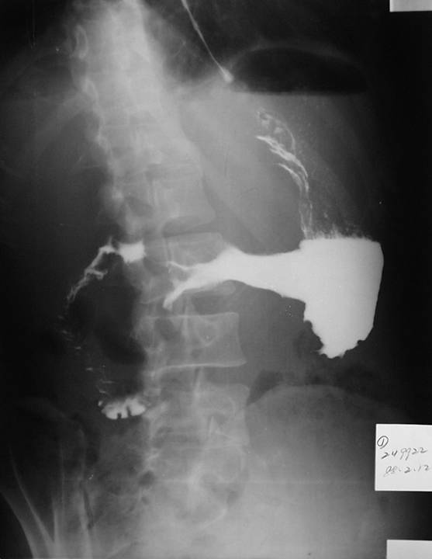
Figure 9 A 56-year-old male. Diffuse, marked gastric narrowing, with irregular contour and thickened spiculated folds due to primary scirrhous carcinoma.

A B
C
Figure 10 A 60-year-old female patient with mucosa-associated lymphoid tissue in gastric antrum. The tumor reveals as segmental, smooth homogeneous wall thickening on non-contrast computed tomography (A), and minimal enhancement on arterial (B) and venous (C) phase enhancement.

A B
C D
Figure 11 A 76-year-old female with gastrointestinal stromal tumors. Axial plain (A) shows an round, exophytic soft tissue mass, appearing as a dominant mass extrinsic to the wall of the stomach, contrast-enhanced computed tomography arterial (B) and venous phase (C) scan shows slightly enhancing, occasionally with coarse calcification. Liver metastases were shown (D).

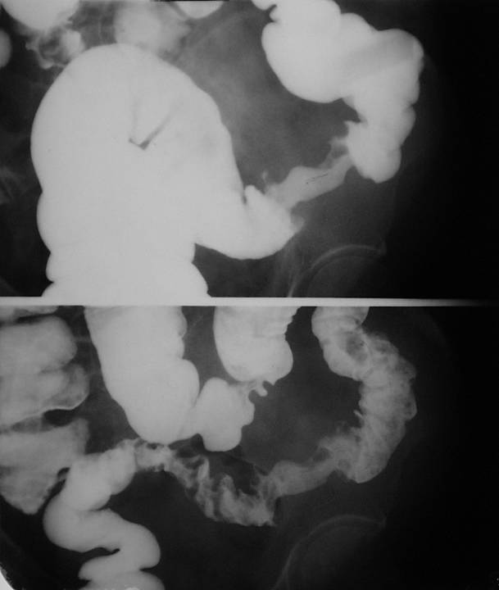
Figure 12 A 59-year-old female patient with sigmoid carcinoma. An annular stenosis of the sigmoid colon, having an irregular mucosal surface, with contour deformity.

Figure 13 Sigmoid colon cancer in a 59-year-old female. Contrast-enhanced spiral computed tomography scan shows luminal narrowing and marked wall thickening. There is adjacent stranding of the serosa and mesenteric fat, a small lymph node anterior to the irregular thickening wall.

