Name of Journal: World Journal of Gastrointestinal Oncology
Manuscript NO: 69281
Manuscript Type: LETTER TO THE EDITOR

Prevention of late complications of endoscopic resection of colorectal lesions with a coverage agent: Current status of gastrointestinal endoscopy

Miao YD et al. Late complications colorectal lesions resection prevention

Yan-Dong Miao, Xiao-Long Tang, Jiang-Tao Wang, Deng-Hai Mi

Yan-Dong Miao, Xiao-Long Tang, Jiang-Tao Wang, Deng-Hai Mi, The First Clinical Medical College, Lanzhou University, Lanzhou 730000, Gansu Province, China

Deng-Hai Mi, Dean's office, Gansu Academy of Traditional Chinese Medicine, Lanzhou 730000, Gansu Province, China

Author contributions: Mi DH and Miao YD designed the research; Miao YD wrote this comment; Tang XL and Wang JT made academic advice; Mi DH reviewed this manuscript; and all authors approved the final manuscript.

Corresponding author: Deng-Hai Mi, MD, Chief Doctor, Dean, The First Clinical Medical College, Lanzhou University, No. 1 Donggang West Road, Chengguan District, Lanzhou 730000, Gansu Province, China. mi.dh@outlook.com

Received: June 23, 2021
Revised: July 31, 2021
Accepted: January 25, 2022
Published online:
Abstract
Endoscopic ectomy of large nonpedunculated colorectal lesions (≥ 20 mm) might cause significant adverse incidents, such as delayed perforation and delayed bleeding, despite the closure of mucosal lesions with clips. The conventional utilization of prophylactic clipping has not decreased the risk of postprocedural delayed adverse events, and additional outcomes and cost-effectiveness research is needed for patients with proximal lesions ≥ 20 mm, in whom prophylactic clipping might be useful. Coverage of the wound after endoscopic excision offers shield protection against delayed concomitant diseases.

Key Words: Endoscopic resection; Non-pedunculated colorectal lesions; Complication; Delayed bleeding; Delayed perforation; Coverage agents

Miao YD, Tang XL, Wang JT, Mi DH. Prevention of late complications of endoscopic resection of colorectal lesions with a coverage agent: Current status of gastrointestinal endoscopy. World J Gastrointest Oncol 2022; In press

Core Tip: The conventional application of prophylactic clipping has not diminished overall risk of postprocedural delayed adverse events, and additional efficacy and cost-effectiveness studies are needed in patients with large (20 mm) non-pedunculated colorectal lesions, in whom prophylactic clipping may be useful. The preventive process significantly decreases the risk of delayed adverse events (delayed bleeding and delayed perforation) by more than 80%.
TO THE EDITOR
We read the paper by Lorenzo-Zúñiga et al^{[1]} with great interest. The authors reviewed the currently available literature on preventing delayed perforation (DP) and delayed bleeding (DB) with overlays after endoscopic mucosal excision or endoscopic submucosal resection.
This systematic collection and review of the present literature on prevention of DP and DB with coverage bandages after endoscopic submucosal dissection or endoscopic mucosal resection (EMR) of large nonpedunculated colorectal lesions (LNPCLs) indicated several interesting outcomes; however, there are some deficiencies. First, the database for literature selection should not be limited to PubMed. Other common medical databases should also be selected, such as Medline, Ovid, Embase, and Web of Science. The data obtained in this way will be more comprehensive, and the results will be more meaningful.
The European Society of Gastrointestinal Endoscopy (ESGE) recommends hot snare polypectomy for pedunculated polyps. To stem bleeding from pedunculated colorectal polyps with stalk diameters ≥ 10 mm or heads ≥ 20 mm, the ESGE recommends pretreatment of the stalk with injectable diluted epinephrine and/or mechanical hemostasis (moderate quality evidence, highly recommended)^{[2]}.
We agree with Lorenzo-Zúñiga et al^{[1]}, who reported that the conventional utilization of prophylactic clipping has not diminished the overall risk of postprocedural bleeding, and focus on the economic efficiency ratio is needed. A cohort study of 8366 colonoscopies involving polypectomy conducted by Forbes et al^{[3]} yielded 95 delayed postpolypectomy bleeding (DPPB) incidents. Preventive clipping was not related to reduced DPPB (adjusted odds ratio 1.27; 0.83-1.96). Other efficacy and cost-effectiveness studies are needed for patients with proximal lesions ≥ 20 mm, in whom prophylactic clipping might be useful. Another multicenter cohort study was conducted on patients with nontruncated lesions ≥ 20 mm resected by EMR and found that DB occurred in 45 of 1034 EMRs (4.5%)^{[4]}. Tsutsumi et al^{[5]} performed a systematic review and meta-analysis to identify whether endoscopic prophylaxis procedures reduced delayed adverse events. They found that the preventive process significantly decreased the risk of delayed adverse events (DB and DP) by more than 80%. We drew a schematic diagram to give an overview of this paper. Endoscopic removal of LNPCLs might lead to significant adverse events, such as DP and DB, despite the closure of mucosal lesions with clips (Figure 1A). Coverage of the defects after endoscopic excision supplies shielding protection to prevent delayed complications (Figure 1B). The above results confirm that the work done by Lorenzo-Zúñiga et al^{[1]} is worthy of recognition and that our findings can serve as a complement to their research. In the future, we should re-evaluate the efficacy of prophylactic clipping of LNPCLs and further explore the role of coverage agents in preventing delayed adverse events.

ACKNOWLEDGEMENTS
Yan-Dong Miao especially thanked Wu-Xia Quan for her care, patience, and support over the years.

REFERENCES
1 Lorenzo-Zúñiga V, Bustamante-Balén M, Pons-Beltrán V. Prevention of late complications with coverage agents in endoscopic resection of colorectal lesions: Current landscape in gastrointestinal endoscopy. World J Gastroenterol 2021; 27: 1563-1568 [PMID: 33958843 DOI: 10.3748/wjg.v27.i15.1563]
2 Ferlitsch M, Moss A, Hassan C, Bhandari P, Dumonceau JM, Paspatis G, Jover R, Langner C, Bronzwaer M, Nalankilli K, Fockens P, Hazzan R, Gralnek IM, Gschwantler M, Waldmann E, Jeschek P, Penz D, Heresbach D, Moons L, Lemmers A, Paraskeva K, Pohl J, Ponchon T, Regula J, Repici A, Rutter MD, Burgess NG, Bourke MJ. Colorectal polypectomy and endoscopic mucosal resection (EMR): European Society of Gastrointestinal Endoscopy (ESGE) Clinical Guideline. Endoscopy 2017; 49: 270-297 [PMID: 28212588 DOI: 10.1055/s-0043-102569]
3 Forbes N, Hilsden RJ, Lethebe BC, Maxwell CM, Lamidi M, Kaplan GG, James MT, Razik R, Hookey LC, Ghali WA, Bourke MJ, Heitman SJ. Prophylactic Endoscopic Clipping Does Not Prevent Delayed Postpolypectomy Bleeding in Routine Clinical Practice: A Propensity Score-Matched Cohort Study. Am J Gastroenterol 2020; 115: 774-782 [PMID: 32167938 DOI: 10.14309/ajg.0000000000000585]
4 Albéniz E, Gimeno-García AZ, Fraile M, Ibáñez B, Guarner-Argente C, Alonso-Aguirre P, Álvarez MA, Gargallo CJ, Pellisé M, Ramos Zabala F, Herreros de Tejada A, Nogales Ó, Martínez-Ares D, Múgica F, de la Peña J, Espinós J, Huerta A, Álvarez A, Gonzalez-Santiago JM, Navajas F, Martínez-Cara JG, Redondo-Cerezo E, Merlo Mas J, Sábado F, Rivero L, Saperas E, Soto S, Rodríguez-Sánchez J, López-Roses L, Rodríguez-Téllez M, Rullán Iriarte M, Elosua González A, Pardeiro R, Valdivielso Cortázar E, Concepción-Martín M, Huelin Álvarez P, Colán Hernández J, Cobian J, Santiago J, Jiménez A, Remedios D, López-Viedma B, García O, Martínez-Alcalá F, Pérez-Roldán F, Carbó J, Enguita M. Clinical validation of risk scoring systems to predict risk of delayed bleeding after EMR of large colorectal lesions. Gastrointest Endosc 2020; 91: 868-878.e3 [PMID: 31655045 DOI: 10.1016/j.gie.2019.10.013]
5 Tsutsumi K, Kato M, Kakushima N, Iguchi M, Yamamoto Y, Kanetaka K, Uraoka T, Fujishiro M, Sho M; Japan Duodenal Cancer Guideline Committee. Efficacy of endoscopic preventive procedures to reduce delayed adverse events after endoscopic resection of superficial nonampullary duodenal epithelial tumors: a meta-analysis of observational comparative trials. Gastrointest Endosc 2021; 93: 367-374.e3 [PMID: 32835670 DOI: 10.1016/j.gie.2020.08.017]

Footnotes
Conflict-of-interest statement: No conflict of interest associated with any of the senior authors or other coauthors contributed their efforts in this manuscript.

Open-Access: This article is an open-access article that was selected by an in-house editor and fully peer-reviewed by external reviewers. It is distributed in accordance with the Creative Commons Attribution NonCommercial (CC BY-NC 4.0) license, which permits others to distribute, remix, adapt, build upon this work non-commercially, and license their derivative works on different terms, provided the original work is properly cited and the use is non-commercial. See: https://creativecommons.org/Licenses/by-nc/4.0/

Provenance and peer review: Invited article; Externally peer reviewed.
Peer-review model: Single blind

Peer-review started: June 23, 2021
First decision: July 29, 2021
Article in press:

Specialty type: Oncology
Country/Territory of origin: China
Peer-review report’s scientific quality classification
Grade A (Excellent): 0
Grade B (Very good): 0
Grade C (Good): C, C
Grade D (Fair): D
Grade E (Poor): 0

P-Reviewer: Jung K, Komeda Y S-Editor: Wang JJ L-Editor: A P-Editor:
Figure Legends
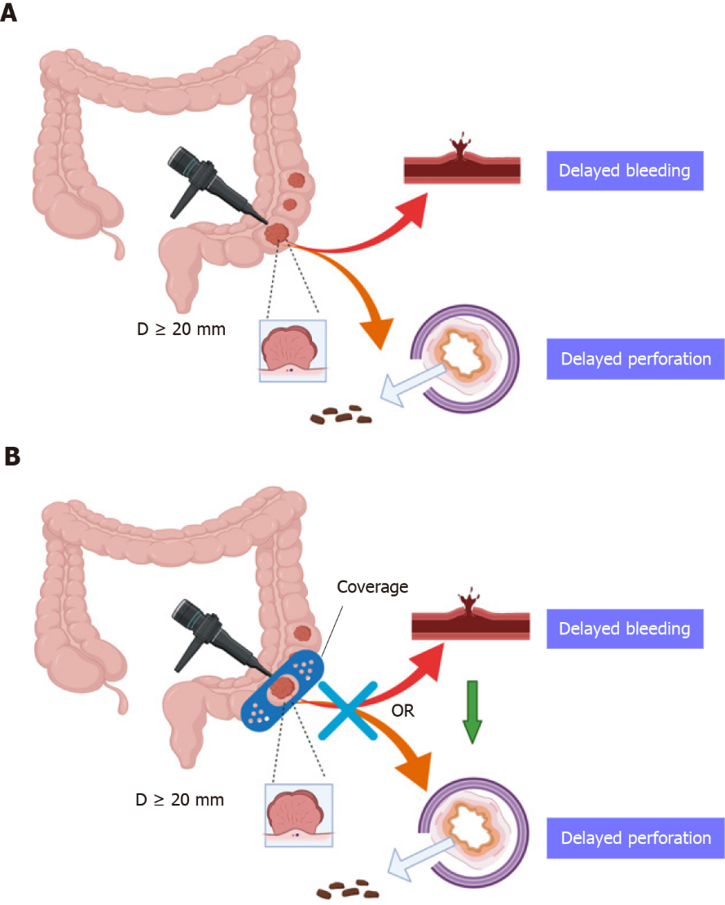
Figure 1 Flow chart of the research design and analysis. This figure was created with BioRender.com. A: Endoscopic excision of large nonpedunculated colorectal lesions might lead to significant adverse complications, such as delayed bleeding (DB) and delayed perforation (DP); B: Coverage of the wound after endoscopic excision supplies shield protection to reduce or prevent delayed complications, such as DB and DP. Large nonpedunculated colorectal lesions (≥ 20 mm).

