Name of Journal: World Journal of Clinical Cases
Manuscript NO: 67203
Manuscript Type: CASE REPORT

Intravascular papillary endothelial hyperplasia as a rare cause of cervicothoracic spinal cord compression: a case report

Gu HL et al. Cervicothoracic spinal IPEH

Hong-lin Gu, Xiao-qing Zheng, Shi-qiang Zhan, Yun-bing Chang

Hong-lin Gu, Xiao-qing Zheng, Shi-qiang Zhan, Yun-bing Chang, Department of Spine Surgery, Guangdong Provincial People’s Hospital, Guangdong Academy of Medical Sciences, Guangzhou 510080, Guangdong Province, China

Author contributions: All authors of this manuscript have actively participated in the data acquisition, and they all have read and approved the final version of the manuscript; Gu Hl and Zheng Xq collected the clinical data and drafted the main manuscript text; Zhan Sq and Chang Yb performed the surgery and revised the paper.

Supported by Guangdong Medical Science and Technology Research Fund Project, No. A2021454.

Corresponding author: Yunbing Chang, MD, Chief Doctor, Department of Spine Surgery, Guangdong Provincial People’s Hospital, Guangdong Academy of Medical Sciences, No. 106 Zhongshan Road II, Guangzhou 510080, Guangdong Province, China. sygkspine@163.com

Received: April 20, 2021
Revised: June 28, 2021
Accepted: September 14, 2021
Published online: December 6, 2021

Abstract
BACKGROUND
Intravascular papillary endothelial hyperplasia (IPEH) is a rare benign reactive vascular lesion that grows into an expansile compressing mass. It most commonly involves the skin and subcutaneous tissue. Spinal involvement is rare, with only 11 reported cases in the literature. We report, to our knowledge, the first case of IPEH in the cervicothoracic spinal canal and present a literature review.

CASE SUMMARY
A 27-year-old man presented with acute-onset neck pain, numbness, and weakness in his extremities. Magnetic resonance imaging showed an epidural mass in the cervicothoracic (C6-T1) spinal canal and vertebral hemangioma (VH) involving the C7 vertebral body. C6-T1 Laminectomy and radical excision of the mass were performed. Histopathological examinations revealed papillary proliferation of vascular endothelial cells with thrombus formation, and an IPEH diagnosis was made. By his 6-mo follow-up appointment, his symptoms were relieved without recurrence. The possible pathogenesis, clinical and imaging features, differential diagnosis, and management of IPEH were reviewed.

CONCLUSION
We report, to our knowledge, the first case of IPEH in the cervicothoracic spinal canal, treated via complete resection, and showing a favorable outcome. We found a causal relationship between spinal IPEH and VH; this partly explains the mechanism of IPEH.

Key Words: Intravascular papillary endothelial hyperplasia; Cervicothoracic; Spinal cord compression; Thrombosis; Hemangioma; Case report

©The Author(s) 2021. Published by Baishideng Publishing Group Inc. All rights reserved.

Citation: Gu HL, Zheng XQ, Zhan SQ, Chang YB. Intravascular papillary endothelial hyperplasia as a rare cause of cervicothoracic spinal cord compression: a case report. World J Clin Cases 2021; 9(34): 10681-10688
URL: https://www.wjgnet.com/2307-8960/full/v9/i34/10681.htm
DOI: https://dx.doi.org/10.12998/wjcc.v9.i34.10681

Core Tip: Intravascular papillary endothelial hyperplasia (IPEH) is a rare benign reactive vascular lesion that grows into an expansile compressing mass. Spine involvement is rare, with only 11 case reports on its occurrence. We reported the first case of IPEH in the cervicothoracic spinal canal, which was treated via complete resection and had a good prognosis. We also found a causal relationship between spinal IPEH and vertebral hemangioma, and this partly explained the mechanism of IPEH.

INTRODUCTION
Intravascular papillary endothelial hyperplasia (IPEH) was first reported in 1923 by Pierre Masson in a case of an infected hemorrhoidal vein. Initial reports referred to the lesion as a “Masson tumor” or hemangioendotheliome vegetant intravasculaire^{[1]}. In 1975, Clearkin and Enzinger described the lesion as an unusual and exaggerated thrombus reorganization, rather than a true tumor, and the condition was renamed IPEH^{[2]}. IPEHs typically occur in the skin and subcutaneous tissues of the head and neck or limbs^{[3]}; it rarely occurs in the spine. To our knowledge, only 11 cases of IPEH of the spine have been reported. We report the first case of IPEH of the cervicothoracic spinal canal and present a literature review.

CASE PRESENTATION
Chief complaints
A 27-year-old man presented to the Department of Spine Surgery of our hospital with complaints of neck pain, limb numbness, and weakness.

History of present illness
His symptoms started suddenly, 4 d prior to hospital presentation.

History of past illness
The patient had no trauma history. A similar episode of transient limb numbness and weakness occurred 6 years earlier.

Personal and family history
He denied any personal or family history of other diseases.

Physical examination
Physical examination revealed tenderness of the paraspinal muscle of the C6-T1 spinous process, muted sensory responsiveness to touch along the T1 dermatome, and grade IV muscle strength in the four limbs.

Laboratory examinations
The results of all blood analyses — including coagulation markers, inflammatory indicators, and tumor markers — were within normal limits.

Imaging examinations
Spinal radiography and computed tomography demonstrated no obvious bone destruction. Enhanced cervical magnetic resonance imaging (MRI) showed a homogenously enhanced epidural mass in the C6-T1 spinal canal. The mass compressed the spinal cord and extended into the left C7-T1 foramen. It appeared hypointense on T1-weighted images (T1WIs) and hyperintense on T2WI. Moreover, a 0.5 cm × 0.5 cm × 0.6 cm-sized heterogeneously enhanced hyperintense mass was found in the C7 vertebral body on T2WI, which was suggestive of a benign vertebral hemangioma (VH) (Figure 1).

DIFFERENTIAL DIAGNOSIS
The mass was possibly an epidural schwannoma; however, we needed to exclude a nonneurogenic tumor diagnosis. The patient required surgical spinal cord decompression for symptom relief. The final diagnosis was confirmed histopathologically.

FINAL DIAGNOSIS
The final diagnosis was cervicothoracic spinal IPEH.

TREATMENT
The patient underwent C6-T1 Laminectomy, left C7-T1 foramen decompression, and radical excision of the epidural mass. A C6-T1 posterior instrumented fusion was performed to stabilize the facetectomy at the spinal level, proximal to the cervicothoracic junction. We observed a dark red, nodular, highly vascularized 3 cm × 1.5 cm × 1 cm mass compressing the spinal cord and left C7 nerve root dorsally. The mass was subsequently excised (Figure 2), and an intraoperative frozen section revealed a diagnosis of benign neoplasm originating from blood vessels. Histopathological examination revealed papillary proliferation of vascular endothelial cells with thrombus formation, consistent with IPEH (Figure 3).

OUTCOME AND FOLLOW-UP
After the surgery, the patient showed gradual neurologic improvement. At his 6-mo follow-up, he was symptom-free, with no spinal cord compression or recurrence on MRI (Figure 4). The clinical timeline of the patient is depicted in Figure 5.

DISCUSSION
IPEH is a rare benign reactive vascular lesion that expands to form a compressing mass. There is no age predilection for IPEH, and its incidence is higher in women than in men^{[4]}, with a female-to-male ratio of 4:1 for intracranial lesions^{[5]}. Although spinal presentations are rare, they occur more commonly in men^{[6]}. IPEHs are commonly located in the skin and subcutaneous tissues of the head and neck or limbs^{[3]} but have also been reported in the oral mucosa, lip, thyroid, maxillary sinus, parotid, lung, superior vena cava, adrenal gland, renal vein, forearm, foot, and intracranially^{[7–11]}. There are 11 reported cases of spinal IPEH, including ten cases involving men and one case involving a woman, with patient age ranging from 16 years to 58 years (see Table 1 for details)^{[6,12-21]}. Among these cases, in one case, the mass was located in the vertebral body and in the remaining ten cases, the mass was located in the spinal canal. Only one case of an intradural mass and nine cases of an epidural mass have been reported. The most common site of involvement was the thoracic spinal canal (n = 7). Of the three remaining cases, two cases involved the lumbar spine and one case involved the thoracolumbar junction. The mass in one case was multifocal, involving the cervical, thoracic, and lumbar vertebral bodies. The present report is the first report of cervicothoracic spinal IPEH.
The pathogenesis of IPEH remains controversial. Some authors believe that IPEH is an excessive reaction to a normal thrombus reorganization process^{[2,22–24]}. Others proposed that IPEH is a benign proliferation of endothelial cells with secondary thrombosis and fibrin deposition^{[25]}. Few authors believe that there is a causal relationship between VH and spinal IPEH. Mozhdehipanah et al^{[17]} reported a case of IPEH in the T4-T6 spinal canal. Two adjacent vertebral bodies (T4 and T5) demonstrated VH. The author speculated that bleeding within the spinal canal subsequently formed an organized thrombus, transformed into Masson's hemangioma and manifested symptoms^{[17]}. According to Petry et al^{[12]}, IPEH of the vertebral body develops from underlying thrombosis of the basivertebral venous plexus or a preexisting VH. In the present case, spinal cord compression was most severe at the C7 Level. Additionally, a hemangioma was found in the C7 vertebral body, suggesting a possible relationship between spinal IPEH and VH. Therefore, the mechanism behind IPEH could be an excessive reaction to the normal thrombus reorganization process. However, it is difficult to make conclusions based on the few cases. Future, well-powered studies on the relationship between VH and IPEH in the spinal canal are needed.
Preoperative diagnosis of spinal IPEH is challenging because of its non-specific MRI features and the need to differentiate IPEH from arteriovenous malformations, schwannomas, or neurofibromas via imaging technology. Reported cases of spinal IPEH mostly exhibited isointensity or low signal intensity on T1WI and high or variable signal intensity on T2WI with contrast enhancement. Three cases presented as dumbbell-shaped masses, mimicking schwannoma^{[6]}. The present patient was preoperatively diagnosed with epidural schwannoma, which typically features papillary proliferation of vascular endothelial cells, localized intravascularly, with normal thrombus formation in the entire papillary tissue^{[4,23,26]}. The pathological findings in our case are consistent with a diagnosis of IPEH. However, IPEH must be distinguished from other benign and malignant lesions, including cavernous/capillary hemangioma, Kaposi sarcoma, endovascular papillary, and angioendothelioma. Importantly, IPEH should be differentiated from angiosarcoma to avoid unnecessary radiation and surgery^{[11]}.
Spinal manifestations of IPEH may be associated with chest or back pain, lower limb numbness, paralysis, and bladder dysfunction caused by spinal cord or cauda equina compression^{[6]}. Treatment is only considered when pain or compression-related symptoms occur, and complete surgical resection is the preferred treatment. Prognosis after complete resection is good, with minimal recurrence. Nine of the 11 patients in the reported cases underwent radical resection, and no recurrence was noted during follow-up. Further, the patient in the present case — who presented with acute-onset numbness and weakness of the limbs owing to spinal cord compression — underwent complete surgical resection. His symptoms were relieved and had not recurred by the 6-mo follow-up visit. Adjuvant radiotherapy can be considered for lesions that cannot be completely removed or that are recurrent. To our knowledge, there is only one reported case of radiotherapy for incompletely resected spinal IPEH. This case showed the potential benefit of radiation following the recurrence of benign IPEH in a patient with epidural disease^{[21]}.

CONCLUSION
The main pathological change attributable to IPEH is benign vascular endothelial papillary hyperplasia with thrombosis; however, the mechanism of this relationship remains controversial. Spinal IPEH is rare, occurring more frequently in men, and is localized to the thoracic spine. Importantly, our findings suggest that spinal IPEH is related to VH. There are no prior reports of IPEH in the cervical spinal canal. To our knowledge, this is the first case of IPEH in the cervicothoracic spinal canal which was associated with a favorable outcome after complete resection.

ACKNOWLEDGEMENTS
The authors wish to thank the patient for his contributions to this report.

REFERENCES
1 Masson P. Hemangioendotheliome vegetant intravasculaire. Bull Soc Anat (Paris) 1923; 93: 517-532
2 Clearkin KP, Enzinger FM. Intravascular papillary endothelial hyperplasia. Arch Pathol Lab Med 1976; 100: 441-444 [PMID: 947306]
3 Espinosa A, González J, García-Navas F. Intravascular Papillary Endothelial Hyperplasia at Foot Level: A Case Report and Literature Review. J Foot Ankle Surg 2017; 56: 72-74 [PMID: 27989349 DOI: 10.1053/j.jfas.2016.09.016]
4 Hashimoto H, Daimaru Y, Enjoji M. Intravascular papillary endothelial hyperplasia. A clinicopathologic study of 91 cases. Am J Dermatopathol 1983; 5: 539-546 [PMID: 6666836 DOI: 10.1097/00000372-198312000-00004]
5 Perez Prat G, Serrano Jimenez M, Cancela Caro P, Cardenas Ruiz-Valdepeñas E, Rivero Garvia M, Marquez Rivas FJ. Staged Management of Intracranial Masson Tumor: An Unexpected Gauntlet: Case Report and Review of the Literature. World Neurosurg 2018; 114: 194-203 [PMID: 29550594 DOI: 10.1016/j.wneu.2018.03.054]
6 Oktar N, M Ozer H, Demirtas E. Spinal intravascular papillary endothelial hyperplasia. Case report and review of the literature. Br J Neurosurg 2019: 1-3 [PMID: 30964346 DOI: 10.1080/02688697.2019.1597832]
7 Mahapatra QS, Sahai K, Malik A, Mani NS. Intravascular papillary endothelial hyperplasia: An unusual histopathological entity. Indian Dermatol Online J 2015; 6: 277-279 [PMID: 26225335 DOI: 10.4103/2229-5178.160269]
8 Barritt AW, Merve A, Epaliyanage P, Aram J. Intracranial papillary endothelial hyperplasia (Masson's tumour) following gamma knife radiosurgery for temporal lobe epilepsy. Pract Neurol 2017; 17: 214-217 [PMID: 28232387 DOI: 10.1136/practneurol-2016-001573]
9 Narwal A, Sen R, Singh V, Gupta A. Masson's hemangioma: A rare intraoral presentation. Contemp Clin Dent 2013; 4: 397-401 [PMID: 24124316 DOI: 10.4103/0976-237X.118363]
10 Clifford PD, Temple HT, Jorda M, Marecos E. Intravascular papillary endothelial hyperplasia (Masson's tumor) presenting as a triceps mass. Skeletal Radiol 2004; 33: 421-425 [PMID: 15205930 DOI: 10.1007/s00256-004-0772-z]
11 Mardani P, Askari A, Shahriarirad R, Ranjbar K, Erfani A, Anbardar MH, Moradmand S. Masson's Tumor of the Hand: An Uncommon Histopathological Entity. Case Rep Pathol 2020; 2020: 4348629 [PMID: 32274236 DOI: 10.1155/2020/4348629]
12 Petry M, Brown MA, Hesselink JR, Imbesi SG. Multifocal intravascular papillary endothelial hyperplasia in the retroperitoneum and spine: a case report and review of the literature. J Magn Reson Imaging 2009; 29: 957-961 [PMID: 19306442 DOI: 10.1002/jmri.21724]
13 Ali SZ, Farmer PM, Black K, Rosenthal A. Masson's hemangioma of spinal meninges causing cord compression with paraplegia. Ann Clin Lab Sci 1994; 24: 371-375 [PMID: 7944274]
14 Porter DG, Martin AJ, Mallucci CL, Makunura CN, Sabin HI. Spinal cord compression due to Masson's vegetant intravascular hemangioendothelioma. Case report. J Neurosurg 1995; 82: 125-127 [PMID: 7815116 DOI: 10.3171/jns.1995.82.1.0125]
15 Taricco MA, Vieira JO Jr, Machado AG, Ito FY. Intravascular papillary endothelial hyperplasia causing cauda equina compression: case report. Neurosurgery 1999; 45: 1478-1480 [PMID: 10598718 DOI: 10.1097/00006123-199912000-00044]
16 Lanotte M, Molinaro L, Crudo V, Filosso PL, Crasto SG, Roncaroli F, Cassoni P. Spinal cord compression due to an extra-dural intra-vascular papillary endothelial hyperplasia of the thoracic spine. Acta Neurochir (Wien) 2010; 152: 877-880 [PMID: 19763392 DOI: 10.1007/s00701-009-0502-3]
17 Mozhdehipanah H, Samiei F, Sayadnasiri M. Masson's hemangioma: A very rare cause of spinal cord compression. Neurol India 2013; 61: 89-90 [PMID: 23466857 DOI: 10.4103/0028-3886.108032]
18 Singla N, Kapoor A, Sodhi HB, Bal A, Chatterjee D. Straddling across the neural foramina with a leash of blood vessels: Mason's vegetant intravascular hemangioendothelioma mimicking a schwannoma. Neurol India 2016; 64: 348-349 [PMID: 26954824 DOI: 10.4103/0028-3886.177619]
19 Behera BR, Panda RN, Mishra S, Dhir MK. Masson Hemangioma-An Unusual Cause of Thoracic Compressive Myelopathy. World Neurosurg 2017; 98: 876.e9-876.e13 [PMID: 27894942 DOI: 10.1016/j.wneu.2016.11.099]
20 Tanaka M, Hiyama A, Sakai D, Katoh H, Sato M, Watanabe M. Intravascular Papillary Endothelial Hyperplasia (Masson's Tumor) Within Cauda Equina. J Am Acad Orthop Surg Glob Res Rev 2018; 2: e087 [PMID: 30656267 DOI: 10.5435/JAAOSGlobal-D-17-00087]
21 Bhalla N, Husband DJ, Pillay R, Thorp N. Radiotherapy for a benign cause of cauda equina compression in a known case of breast carcinoma. BMJ Case Rep 2013; 2013 [PMID: 23784763 DOI: 10.1136/bcr-2013-009549]
22 Salyer WR, Salyer DC. Intravascular angiomatosis: development and distinction from angiosarcoma. Cancer 1975; 36: 995-1001 [PMID: 1237350 DOI: 10.1002/1097-0142(197509)36:3<995::aid-cncr2820360323>3.0.co;2-b]
23 Akdur NC, Donmez M, Gozel S, Ustun H, Hucumenoglu S. Intravascular papillary endothelial hyperplasia: histomorphological and immunohistochemical features. Diagn Pathol 2013; 8: 167 [PMID: 24125024 DOI: 10.1186/1746-1596-8-167]
24 Guledgud MV, Patil K, Saikrishna D, Madhavan A, Yelamali T. Intravascular papillary endothelial hyperplasia: diagnostic sequence and literature review of an orofacial lesion. Case Rep Dent 2014; 2014: 934593 [PMID: 24891960 DOI: 10.1155/2014/934593]
25 Kuo T, Gomez LG. Papillary endothelial proliferation in cystic lymphangiomas. A lymphatic vessel counterpart of Masson's vegetant intravascular hemangioendothelioma. Arch Pathol Lab Med 1979; 103: 306-308 [PMID: 582267]
26 Díaz-Flores L, Gutiérrez R, Madrid JF, García-Suárez MP, González-Álvarez MP, Díaz-Flores L Jr, Sáez FJ. Intravascular papillary endothelial hyperplasia (IPEH). Evidence supporting a piecemeal mode of angiogenesis from vein endothelium, with vein wall neovascularization and papillary formation. Histol Histopathol 2016; 31: 1271-1279 [PMID: 27323848 DOI: 10.14670/HH-11-795]

Footnotes
Informed consent statement: Informed written consent was obtained from the patient for publication of this report and any accompanying images.

Conflict-of-interest statement: The authors declare that they have no conflict of interest.

CARE Checklist (2016) statement: The authors have read the CARE Checklist (2016), and the manuscript was prepared and revised according to the CARE Checklist (2016).

Open-Access: This article is an open-access article that was selected by an in-house editor and fully peer-reviewed by external reviewers. It is distributed in accordance with the Creative Commons Attribution NonCommercial (CC BY-NC 4.0) license, which permits others to distribute, remix, adapt, build upon this work non-commercially, and license their derivative works on different terms, provided the original work is properly cited and the use is non-commercial. See: http://creativecommons.org/Licenses/by-nc/4.0/

Provenance and peer review: Unsolicited article; Externally peer reviewed

Peer-review started: April 20, 2021
First decision: June 23, 2021
Article in press: September 14, 2021

Specialty type: Neurosciences
Country/Territory of origin: China
Peer-review report’s scientific quality classification
Grade A (Excellent): 0
Grade B (Very good): B
Grade C (Good): C, C
Grade D (Fair): D
Grade E (Poor): 0

P-Reviewer: Cucuzza ME, Khanna V, Kung WM S-Editor: Gong ZM L-Editor: Filipodia P-Editor: Wang LYT

Figure Legends
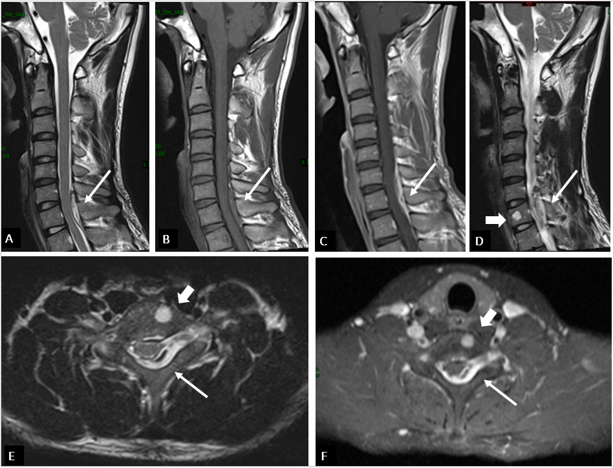
Figure 1 Preoperative magnetic resonance imaging. A and D: Sagittal T2-weighted imaging (T2WI); B: Sagittal T1-weighted imaging (T1WI); C: Sagittal T1WI of the spine with contrast; E: Axial T2WI; F: Axial T1WI with contrast. A posterior spinal epidural mass located from C6 to T1 (thin arrow) appeared high signal intensity on T2WI sagittal and axial images, and low signal intensity on T1WI images. A gadolinium-enhanced scan reveals inhomogeneous enhancement. And a 0.5 cm × 0.5 cm × 0.6 cm-sized round tumor (thick arrow) can be seen on the left side of the C7 vertebral body; high signal intensity is observed on T2WI and homogeneous enhancement is detected on T1WI after contrast agent administration.

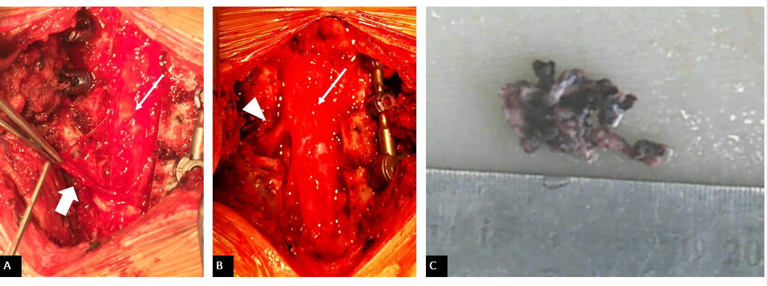
Figure 2 Intraoperative images. A: Operative view of a dark red, nodular, highly vascularized epidural mass (thick arrow) measuring 3 cm × 1.5 cm × 1 cm compressing the left side of the spinal cord (thin arrow) after C6-T1 Laminectomy. B: View of the surgeon after complete resection of the mass and decompression of dura (thin arrow) and left C7 nerve root (triangle). C: Nodular fragment of the lesion.

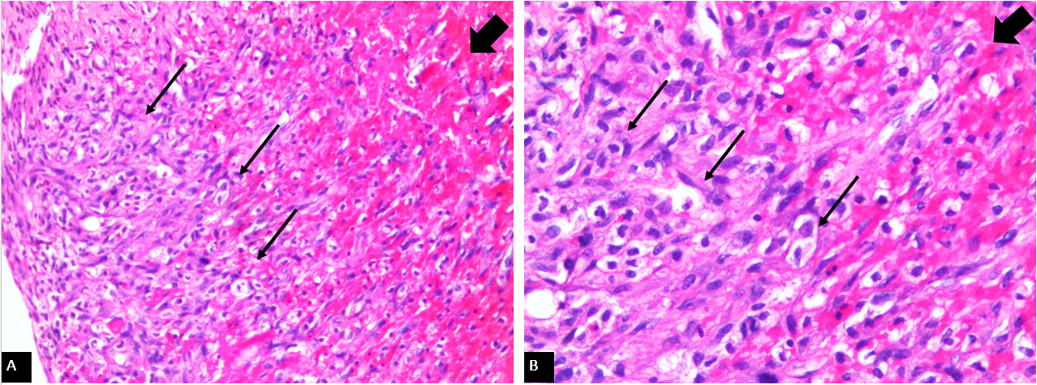
Figure 3 Histological features of the epidural mass. A: Hematoxylin-eosin (HE); × 100; B: HE × 200. Histopathological pictomicrograph shows dilated thin-walled vessels lined by a monolayer of obese endothelial cells (thin arrows). The lumen appears to be filled with organizing thrombi (thick arrow).

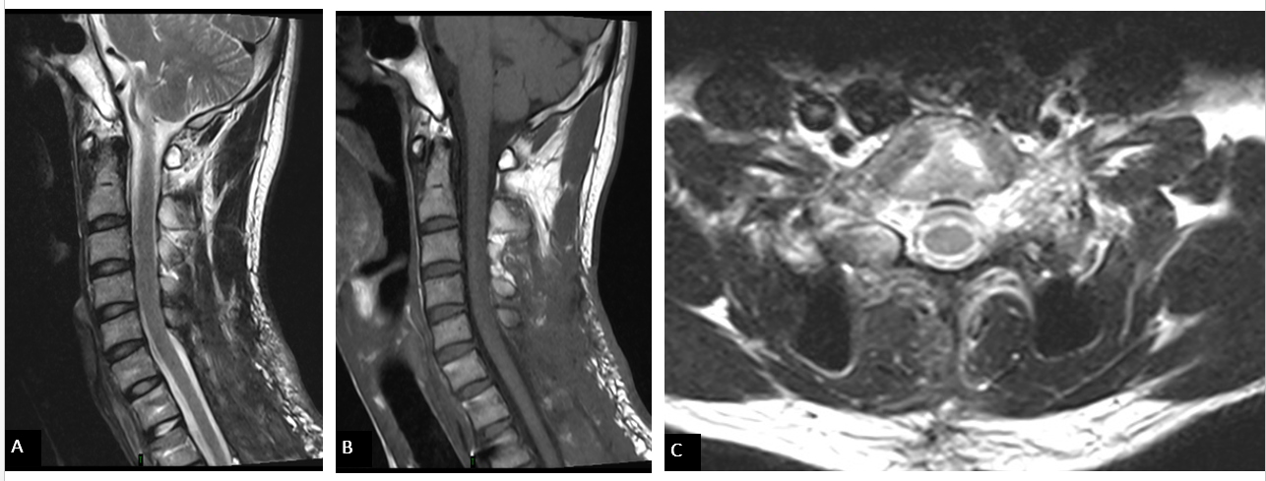
Figure 4 Postoperative magnetic resonance imaging at 6-mo follow-up. A-C: magnetic resonance imaging showing total relief of the previously noted spinal cord compression and no signs of recurrence.

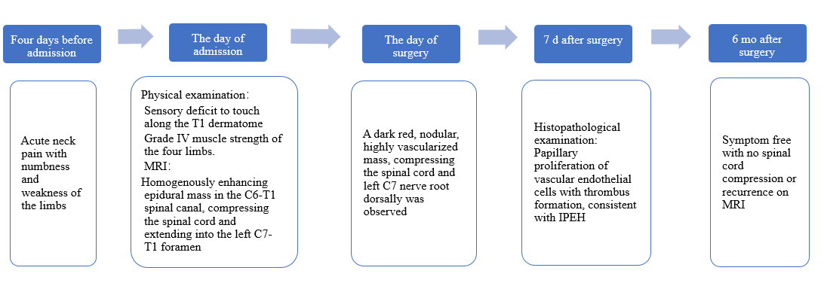
Figure 5 Patient timeline. MRI: magnetic resonance imaging; IPEH: Intravascular papillary endothelial hyperplasia.
Table 1 Summary of reported cases of spinal intravascular papillary endothelial hyperplasia
No. | Ref. | Year | Age (yr) | Sex | Primary location | Clinical features | Radiological  Features | Treatment | Size (cm)
1 | Ali et al^{[13]} | 1994 | 42 | M | T8 posterior epidural mass | Paraplegia for 2 wk duration | MRI non-specific T1/T2 signal changes | Radical excision | 1.5
2 | Porter et al^{[14]} | 1995 | 16 | M | T6 posterior epidural mass | Midthoracic radicular back pain with hesitancy for 1-wk duration | CT myelography: extradural thecal compression posteriorly with abnormal lamina | T6 laminectomy with T5-T6 right partial facetectomy | 4 × 2 × 1
3 | Taricco et al^{[15]} | 1999 | 17 | M | T12-L1 posterior epidural mass | Pain, numbness, paresis of left lower limb with bladder dysfunction for 1 mo | Contrast-enhanced CT of spine: hyperdense lesion; MRI: T1-iso, T2-hyperintense with homogeneous contrast enhancement | T12-L1 laminectomy with radical excision of mass | Not mentioned
4 | Petry et al^{[12]} | 2009 | 47 | M | Multifocal lesions of the spine | Diffuse low back pain | MRI T1-iso, T2-hyperintense with homogeneous contrast enhancement | No surgery | not mentioned
5 | Lanotte et al^{[16]} | 2010 | 33 | M | T6-T7 paraverte-bral mass extending epidural space | Back pain, hesitancy with paraparesis for 2 wk | MRI T1 hypo- T2 hyperintense mass | T6 laminectomy and excision of intracanal mass | 4.5 × 2.5 × 2.5
6 | Mozhdehi-panah et al^{[17]} | 2013 | 58 | M | T4-6 posterior epidural mass | Spastic paraparesis and sensory deficit for 1 mo | MRI T2 hyperintense mass | Laminectomy and radical excision of mass | 3×1
7 | Bhalla et al^{[21]} | 2013 | 51 | F | L1 centered on spinous process and involving pedicles | Back pain with paraparesis | MRI L1 centered on spinous process and involving pedicles causing cauda equina compression | Preoperative embolization, incomplete excision and Radiotherapy | 4.6×4.3×5.5
8 | Singla et al^{[18]} | 2016 | 40 | M | T12-L1 dumbbell-shaped mass | Back pain and numbness of the right lower trunk for 2 yr | MRI dumbbell-shaped mass mimicking schwannoma | Radical excision | Not mentioned
9 | Behera et al^{[19]} | 2017 | 32 | M | T4-5 posterior epidural mass | Paraplegia for 4 mo | MRI T1 hypo- T2 hyperintense mass | Radical excision | 5 × 3 × 2
10 | Tanaka et al^{[20]} | 2018 | 40 | M | L2-3 intradural mass | Low back pain and leg pain beginning approximately 5 yr ago and 1 mo ago | Isointense on T1 and hypointense with partial areas of high signal intensity on T2 without contrast enhancement | L2-3 laminectomy and durotomy with radical excision of mass | 2.5 × 1.5 × 1
11 | Oktar et al^{[6]} | 2019 | 37 | M | T4-5 dumbbell-shaped mass | Dermatomal tingling burning pain with paresis of right lower limb for 1 mo | MRI dumbbell-shaped mass mimicking schwannoma | Radical excision | 5 × 2 × 3
12 | Present case | 2020 | 27 | M | C6-T1 posterior epidural mass | Neck pain and numbness and weakness of the extremities | MRI: T1-hypo-, T2-hyperintense with homogeneous contrast enhancement | C6-T1 laminectomy with C7-T1 left partial facetectomy and radical excision of the mass | 3 × 1.5 × 1
MRI: magnetic resonance imaging; CT: Computed tomography.

Published by Baishideng Publishing Group Inc
7041 Koll Center Parkway, Suite 160, Pleasanton, CA 94566, USA
Telephone: +1-925-3991568
E-mail: bpgoffice@wjgnet.com
Help Desk: https://www.f6publishing.com/helpdesk
https://www.wjgnet.com

© 2021 Baishideng Publishing Group Inc. All rights reserved.

