Name of Journal: World Journal of Hepatology
Manuscript NO: 87924
Manuscript Type: MINIREVIEWS

Function of macrophage-derived exosomes in chronic liver disease: From pathogenesis to treatment

Xiang SY et al. Macrophage-derived exosomes in CLD

Shi-Yi Xiang, Kai-Li Deng, Dong-Xue Yang, Ping Yang, Yu-Ping Zhou

Shi-Yi Xiang, Kai-Li Deng, Health Science Center, Ningbo University, Ningbo 315211, Zhejiang Province, China

Shi-Yi Xiang, Dong-Xue Yang, Ping Yang, Yu-Ping Zhou, Department of Gastroenterology, The First Affiliated Hospital of Ningbo University, Ningbo 315020, Zhejiang Province, China

Kai-Li Deng, School of Traditional Chinese Medicine, Southern Medical University, Guangzhou 510515, Guangdong Province, China

Dong-Xue Yang, Yu-Ping Zhou, Institute of Digestive Disease of Ningbo University, Ningbo University, Ningbo 315020, Zhejiang Province, China

Yu-Ping Zhou, Ningbo Key Laboratory of Translational Medicine Research on Gastroenterology and Hepatology, Ningbo Key Laboratory, Ningbo 315020, Zhejiang Province, China

Author contributions: Xiang SY performed the writing, prepared the figures and tables; Xiang SY and Deng KL designed the outline and coordinated the writing of the paper; Yang DX, Yang P, and Zhou YP provided review of the draft versions of the paper prior to submission of the final version; and all authors have read and approved the final manuscript.

Supported by Ningbo Natural Science Foundation, No. 2022J229; and the Project of Ningbo Leading Medical & Health Discipline, No. 2022-S04.

Corresponding author: Yu-Ping Zhou, PhD, Doctor, Department of Gastroenterology, The First Affiliated Hospital of Ningbo University, No. 247 Renmin Road, Jiangbei District, Ningbo 315020, Zhejiang Province, China. fyzhouyuping@nbu.eu.cn

Received: September 2, 2023
Revised: October 9, 2023
Accepted: October 23, 2023
Published online: November 27, 2023

Abstract
Chronic liver disease (CLD) imposes a heavy burden on millions of people worldwide. Despite substantial research on the pathogenesis of CLD disorders, no optimal treatment is currently available for some diseases, such as liver cancer. Exosomes, which are extracellular vesicles, are composed of various cellular components. Exosomes have unique functions in maintaining cellular homeostasis and regulating cell communication, which are associated with the occurrence of disease. Furthermore, they have application potential in diagnosis and treatment by carrying diverse curative payloads. Hepatic macrophages, which are key innate immune cells, show extraordinary heterogeneity and polarization. Hence, macrophage-derived exosomes may play a pivotal role in the initiation and progression of various liver diseases. This review focuses on the effects of macrophage-derived exosomes on liver disease etiology and their therapeutic potential, which will provide new insights into alleviating the global pressure of CLD.

Key Words: Chronic liver disease; Macrophage; Exosomes; Function; Etiology; Treatment

©The Author(s) 2023. Published by Baishideng Publishing Group Inc. All rights reserved.

Citation: Xiang SY, Deng KL, Yang DX, Yang P, Zhou YP. Function of macrophage-derived exosomes in chronic liver disease: From pathogenesis to treatment. World J Hepatol 2023; 15(11): 1196-1209
URL: https://www.wjgnet.com/1948-5182/full/v15/i11/1196.htm
DOI: https://dx.doi.org/10.4254/wjh.v15.i11.1196

Core Tip: Chronic liver disease (CLD) affects hundreds of millions of individuals worldwide, and identifying the causes and researching viable therapies could lessen the global burden. As nanovesicles produced by cells, exosomes are able to facilitate intercellular communication and play a crucial role in a variety of systemic disorders. Immune cells such as macrophages are intimately associated with liver diseases. In this review, the importance of macrophage-derived exosomes in CLD, from pathophysiology to therapeutic potential, is highlighted.

INTRODUCTION
Chronic liver disease (CLD) imposes a heavy burden on millions of people worldwide. A total of 1.5 billion people worldwide had suffered from CLD by 2017^{[1]}. Approximately 2 million individuals worldwide die each year from liver disease^{[2]}. Chronic hepatitis, cirrhosis and liver cancer are the three main CLDs. Among the ranked global causes of death, cirrhosis is 11th, while hepatocellular carcinoma (HCC) is 16^{th[3]}. We reviewed numerous studies and found that the pathogenesis of CLD is multifactorial. Most liver diseases are associated with steatosis, oxidative stress, alcoholism, inflammation^{[4]}, the environment, the microbiome, metabolism, and genetic factors^{[5]}. However, in addition to liver transplantation, current therapy consists only of eliminating the etiology and treating the complications of cirrhosis^{[6]}. Therefore, the exploration of the pathogenic mechanism and identification of optimal treatment strategies are urgently needed.
Exosomes can be released into biological fluids by all cells under physiological or pathological conditions. Exosomes are produced by budding and have apparent molecular heterogeneity because of various membrane-related protein complexes. Exosomes contain components including RNAs, DNAs, lipids, proteins, amino acids, and metabolites^{[7]}. These soluble and extracellular components can enter cells through endocytosis and plasma membrane invagination, which involve the surface proteins on exosomes^{[8]}. Substances within exosomes stimulate recipient cells, thereby altering signal transduction pathways^{[9]}. Therefore, by carrying these payloads, exosomes can mediate intercellular communication^{[10]}. When exosomes are taken up by other cells, the components alter the phenotype of recipient cells and disrupt the dynamic equilibrium of cellular transformation, demonstrating their unique functions in maintaining cellular homeostasis^{[11,12]}. Furthermore, exosomes may serve as biomarkers or therapeutic targets in the diagnosis and treatment of various diseases^{[9,11,13]}. At present, exosomes have been widely studied in liver diseases. In alcoholic liver disease (ALD)^{[14]}, alcohol increases the generation of exosomes, which is due to autophagic damage and the destruction of autophagosomes or lysosomes. During the progression of nonalcoholic fatty liver disease (NAFLD)^{[15]}, hepatocyte-derived exosomal microRNA (miR)-192-5p can activate proinflammatory macrophages. In liver fibrosis^{[16]}, activated hepatic stellate cells (HSCs) release fibrogenic vesicles. Furthermore, engineered exosomes can be used for drug delivery. For instance, Tang et al^{[17]} showed that exosomes from mesenchymal stem cells (MSCs) modified to carry small interfering RNA or an antisense oligonucleotide targeting signal transducer and activator of transcription 3 (STAT3) could directly inhibit STAT3 to treat fibrosis. Lou et al^{[18]} also modified exosomes from MSCs to carry miR-199a-3p, which improved the chemotherapy sensitivity of liver cancer, proving that exosomes can be used as novel therapeutic agents by acting as nanocarriers to deliver drugs or molecules. In conclusion, exosomes can drive or inhibit disease progression and have potential utility in liver disease therapy.
Macrophages are the core cellular component of the liver and are crucial in maintaining organ homeostasis and coping with liver injury^{[19]}. As key immune cells, they contribute to the development of hepatic disease by polarizing into diverse phenotypes in response to microenvironmental stimulation^{[20]} or expressing their heterogeneity through the production of cytokines, cell surface markers, and transcriptomes^{[21]}. Due to the specific physiological roles of macrophages, the involvement of macrophage-derived exosomes in the development and progression of liver disease has been extensively studied. For instance, relaxin is an antifibrotic peptide hormone that affects vasodilation, thereby alleviating fibrosis and protecting organs through its cognate G protein-coupled receptor relaxin family peptide receptor 1. A study showed that after binding to receptors expressed by hepatic macrophages, relaxin can change the phenotype of macrophages, and macrophages can release exosomes to promote relaxin-mediated HSC dormancy and alleviate hepatic fibrosis (HF)^{[22]}. In vitro, interleukin-6 (IL-6) treatment upregulated exosome generation-related genes, stimulating the release of miR-223-rich exosomes from macrophages, which can transfer and reduce the expression of fibrogenic TAZ in liver cells to alleviate liver fibrosis^{[23]}. However, macrophage-derived exosomes can also accelerate disease progression; for example, exosomes derived from macrophages treated with lipopolysaccharide (LPS) promote liver fibrosis^{[24]}, and exosomes derived from M2 macrophages can mediate HCC metastasis^{[25]}. At present, determining how to use macrophage-derived exosomes to treat disease has become a research hotspot. Studies have shown that macrophage-derived exosomes can be used as natural nanocarriers to deliver proteins^{[26]} or drugs^{[27]}, induce immune activation and participate in immunotherapy^{[28]}. Overall, investigating the various physiological functions of macrophage-derived exosomes can lead to a better understanding of the pathogenesis and treatment of CLD.
This review discusses the biology and physiological functions of exosomes, focusing on exosomes derived from macrophages in the etiology of liver disease, as well as the possible use of exosomes in diagnosis, prognosis, and treatment, which will help in the search for the best therapeutic strategies for liver disease and contribute to reducing the global burden of liver disease (Figure 1).

OVERVIEW OF MACROPHAGE-DERIVED EXOSOMES
Exosomes are a subtype of extracellular vesicles secreted by all cells and are widely distributed in various body fluids. These factors mediate cell-to-cell communication and play specific roles in normal physiological functions and the occurrence of diseases. Macrophages are important immune cells in the human body, and their unique heterogeneity and phenotype result in different physiological effects. In addition, macrophage-derived exosomes participate in the occurrence of diseases in various systems.

Biology of exosomes
Exosomes are small nanoscale vesicles with diameters of 30-150 nm^{[29]}. They originate in endosomes and form mature exosomes during interactions with other vesicles or organelles^{[8]}. First, the cell invaginates the cell membrane through budding to generate clathrin bodies, which enter the cytoplasm and form early endosomes^{[30,31]}. Late endosomes mature from early endosomes by interacting with the Golgi complex, which can form intraluminal vesicles (ILVs) by invagination of the restrictive membrane^{[10]}. ILVs are then further endocytosed to generate multivesicular bodies (MVBs), which are known as multivesicular endosomes^{[8]}. Ultimately, MVBs have two outcomes: Some MVBs enter the lysosomal pathway and are degraded by the lysosome, while others fuse with the cell membrane and release multiple vesicular structures into the extracellular matrix as exosomes^{[31]}. Therefore, the biogenesis of exosomes can be divided into the following processes: Budding, envelope invagination, MVB production, and MVB release. All cells, whether normal or abnormal, can release exosomes, and cancer cells release more exosomes than other cells^{[9]}. Exosomes can exhibit unique characteristics based on their cell origin and material composition. As a double lipid-encapsulated vesicle, exosomes contain a variety of substances, such as DNAs, RNAs, lipids, and proteins, and the composition or contents of these vesicles vary depending on the cell source^{[32]}. Moreover, exosomes can be isolated from various types of body fluids, such as plasma^{[33]}, serum^{[34]}, and urine^{[35]}. In summary, exosomes are tiny vesicles secreted by various cells, and their secretion mechanism is related to membrane fusion. In addition, secreted exosomes can be widely distributed throughout the body, enabling them to play a role in a variety of systems.

Function of exosomes
Because structure determines function, the function of exosomes is dependent on their complex and specific characteristics, which are determined by the cell type from which they are derived. Exosomes can be involved in the immune response, antigen presentation, cell migration, cell differentiation, tumor invasion, and other processes. The most important function of exosomes is to mediate intercellular communication^{[9]}. Exosomes transfer cargo to recipient cells by binding to cell surface receptors, undergoing plasma membrane fusion, or through the endocytic system^{[36]}, which can activate signaling pathways, alter gene expression, or regulate the overall function of the recipient cell. For example, the decrease in hsa_circ_0074854 carried by exosomes secreted by HCC cells can inhibit M2 macrophage polarization, thus delaying the migration and invasion of HCC cells^{[37]}. Cancer-associated fibroblasts can transfer exosomal miRNAs directly to tumor cells and enhance their cell-related functions, such as epithelial-mesenchymal transition and chemoresistance^{[38]}. Therefore, exosomes can mediate material exchange between cells, are involved in cellular communication, and reflect the different physiological functions of cells; thus, they are often used as biomarkers of diseases or targeted delivery vectors of substances. The expression levels of some miRNAs in serum exosomes are significantly upregulated in patients with pancreatic cancer; thus, some miRNAs are considered useful markers for the early diagnosis and progression of pancreatic cancer^{[39]}. The delivery of engineered exosomes loaded with an iron shedding inducer [erastin (ER)] and photosensitizer (rose bengal) into tumor tissue can specifically induce ferroptosis in HCC cells, which can be used as a new treatment strategy for malignant tumors^{[40]}. In conclusion, exosomes have wide-ranging functions. Whether as carriers of substances or as signaling factors, exosomes have powerful cellular communication functions, which is an area for future basic research to determine clinical applications.

Exosomes derived from macrophages
Macrophages are immune cells that can be found in most tissues and serve numerous roles^{[41]}. For instance, macrophages are derived from monocytes and have phagocytic functions; these cells can engulf and kill intracellular parasites, bacteria, and tumor cells, as well as aging and abnormal cells, which is critical for immune defense, immune stability, and immune surveillance. In addition, macrophages are uniquely heterogeneous. In a dynamically changing microenvironment, macrophages can exhibit two phenotypes that perform different functions: Classically activated macrophages (M1) and alternatively activated macrophages (M2)^{[42]}. M1 macrophages can be activated by LPS alone or in combination with T-helper 1 (Th1) cytokines [such as interferon (IFN)-γ and granulocyte-macrophage colony-stimulating factor] and can produce proinflammatory cytokines, such as IL-1β, IL-6, IL-12, IL-23, tumor necrosis factor (TNF)-α, chemokine (C-X-C motif) ligand (CXCL) 1-3, CXCL8-10, chemokine (C-C motif) ligand (CCL)2-5, and CCL11. Therefore, M1 macrophages are able to mediate functions such as antigen presentation, Th1 immune reactions, proinflammatory effects, pathogen elimination, and antitumor activity^{[43-46]}. However, M2 macrophages can be further divided into M2a, M2b, M2c, and M2d subtypes and can release complex cytokines. Specifically, when injury causes an acute inflammatory response or organ fibrosis, inflammatory factors such as IL-4 and IL-13 activate M2 macrophages to transform into M2a macrophages to inhibit inflammation, mediate damage repair and promote fibrosis. In response to LPS and immune complexes, M2 macrophages can be transformed into M2b macrophages, which can regulate immunity and induce the occurrence of infection and cancer. Glucocorticoids, IL-10, and transforming growth factor-beta (TGF-β) can induce the polarization of M2 macrophages to M2c macrophages, which perform functions such as phagocytosis, immunosuppression, and tissue remodeling. Moreover, M2d macrophages are induced by toll-like receptor (TLR) agonists and adenosine A2A receptor ligands to cause angiogenesis and promote cancer. M2 macrophages can produce various cytokines, including Arg1, CCL17, CCL22, IL-10, IL-1β, IL-6, TNF-α, IL-12, IL-10, TGF-β, CXCL13, and IL-10, which can mediate numerous functions, including inhibiting inflammation, wound healing, the Th2 immune response, anaphylaxis, fibrosis, immune regulation, supporting tumors, promoting infection, and angiogenesis^{[47-51]}. Therefore, when homeostasis is disrupted, the polarization of different macrophage phenotypes occurs, which means that macrophages are remarkably plastic cells (Figure 2).
Macrophages are capable of secreting exosomes, and macrophage-derived exosomes are present in multiple systems. In addition, macrophage-derived exosomes are involved in various diseases and act as therapeutic targets and drug carriers. In recent years, research has mainly focused on the involvement of macrophage-derived exosomes in systemic diseases. For instance, in multimicrobial sepsis, lactate promotes macrophages to release exosomes containing lactated/acetylated high mobility box-1 (HMGB1), which increases endothelial cell permeability and accelerates sepsis. Therefore, reducing circulating levels of exosomal HMGB1 be a therapeutic strategy for the treatment of sepsis^{[52]}. In head and neck squamous cell carcinoma (HNSCC), the long non-coding RNA (lncRNA) HOTTIP in exosomes secreted by M1 macrophages upregulates the TLR5/NF-κB signaling pathway via the competing sponges miR-19a-3p and miR-19b-3p to inhibit the progression of HNSCC^{[53]}. In the respiratory system, Wei et al^{[54]} found that the exosomes derived from M2 macrophages in patients with lung adenocarcinoma could encapsulate miR-942, and these exosomes enhanced the invasion and migration of lung adenocarcinoma cells and promoted angiogenesis by regulating FOXO1 protein to alleviate β-catenin inhibition. In addition, macrophage-derived exosomes are also valuable in the treatment of chronic pulmonary fibrosis^{[55]} and asthma^{[56]}. In the circulatory system, macrophage-derived exosomes accelerate atherosclerosis in patients with diabetes^{[57]}, but they can also be used for myocardial tissue repair in acute myocardial infarction^{[58]}. Moreover, macrophage-derived exosomes can serve as carriers for drug delivery. In a mouse model of Alzheimer’s disease (AD), macrophage-derived exosomes could carry silybin, allowing it to cross the blood-brain barrier and reduce astrocyte-mediated neuroinflammation and improve cognitive deficits in AD mice^{[59]}. In conclusion, macrophage-derived exosomes are widely distributed in the body and are associated with a variety of systemic diseases, and exosomes can play an important role in the treatment of diseases by acting as therapeutic targets or drug carriers. Given the importance of macrophages in the physiology of the liver, much research has been devoted to the link between macrophage-derived exosomes and the onset of CLD. Therefore, this review focuses on the impact of macrophage-derived exosomes on the etiology and treatment of CLD.

MACROPHAGE-DERIVED EXOSOMES IN CLD
CLD has impacted tens of thousands of patients worldwide, its pathogenesis has been explored, and its therapeutic regimen has been optimized. In recent years, there has been intensive study of the function of macrophage-derived exosomes in some diseases. In this review, the use of macrophage-derived exosomes to treat NAFLD, HF, HCC, and other liver diseases is discussed in the context of pathogenesis and therapeutic potential.

NAFLD
NAFLD is the most common CLD and is recognized as a global public health problem. The pathogenesis of NAFLD is complex^{[5,60]}. During the pathogenesis of NAFLD, hepatic damage caused by inflammation, oxidative stress, and lipotoxicity eventually cause collagen deposition and fiber regeneration, which lead to liver fibrosis^{[61]}. During this process, obesity, type 2 diabetes, resistance to insulin, HSC activation, the environment, genetics, and other factors accelerate the progression of liver injury. However, due to the complexity of the pathophysiology and the heterogeneity of disease phenotypes, there is currently no specific drug to treat NAFLD. Healthy lifestyle interventions and weight loss are mostly used to prevent this disease in high-risk groups, and individualized combination therapy is often used to treat patients^{[62]}. Only a better understanding of the pathogenesis and progression of this disease can provide a more accurate treatment plan. Therefore, we focused on the role of exosomes in NAFLD and their potential use in treatments.
The study of macrophage-derived exosomes in the pathogenesis and treatment of NAFLD has made considerable and remarkable progress and has potential applications in NAFLD therapy. For example, in sepsis associated with NAFLD, exosomes released by Trem2-deficient macrophages carry a large amount of miR-106b-5p and cause abnormal mitochondrial structure and energy metabolism in hepatocytes by blocking mitofusin 2 (Mfn2), which accelerates the progression of NAFLD and increases the susceptibility of NAFLD patients to sepsis^{[63]}. In addition, miR-155-rich exosomes secreted by adipose tissue macrophages improved insulin sensitivity and maintained glucose homeostasis in obese mice^{[64]}. Similarly, miR-69 released from M2 macrophages had the same effect^{[65]}. In obese individuals, macrophage-derived exosomes are increased and delivered to hepatocytes, thereby regulating obesity-related insulin resistance^{[66]} (Figure 3). In conclusion, exosomes derived from macrophages typically carry different cargos and transfer them between liver cells, and these exosomes can not only initiate but also delay the progression of NAFLD.

HF
HF is a dynamic and highly integrated molecular, cellular, and tissue process involving most types of CLD that undergo repeated substantial liver damage and continuous activation of inflammatory responses^{[67]}. During these processes, the activation of hepatic myofibroblasts results in the secretion of extracellular matrix proteins, including collagen, which can lead to fibrous scars and, eventually, the development of HF^{[68]}. If not treated in time, HF will progress to cirrhosis, HCC, and eventually liver failure, but unfortunately, the only treatment that can achieve a complete cure is liver transplantation^{[69]}. Previously, hepatic macrophages, which are specific immune cells, were shown to be important in the progression of HF. Macrophages mediate various functions in fibrotic liver homeostasis, disease progression, and injury recovery and are considered potential targets to protect against fibrosis^{[21]}. Notably, intercellular crosstalk between hepatic macrophages and HSCs is vital for stimulating HSC activation^{[24]}. Therefore, exosomes derived from macrophages are important for intercellular crosstalk during the pathogenesis of HF.
Recent studies have shown that exosomes derived from different sources are involved in the pathogenesis, diagnosis, and potential treatment of HF. This review will focus on research on macrophage-derived exosomes in HF. On the one hand, exosomes derived from macrophages accelerate HF. For instance, when THP-1 macrophages were treated with LPS, the exosomes secreted by these cells were changed, and the alteration in miRNA correlated with HF progression, increasing fibrotic gene expression and promoting HSC replication and activation^{[24]}. Similarly, another study showed that exosomes secreted by LPS-treated macrophages could overexpress miR-500, which promoted the proliferation and activation of HSCs to accelerate the progression of fibrosis by inhibiting MFN2^{[70]}. Deng et al^{[71]} found that exosomes derived from LPS-treated macrophages could increase the expression levels of collagen-1 and alpha-smooth muscle actin in JS1 cells. According to recent research, LPS stimulation enhances the expression of miR-155-5p in macrophage-derived exosomes, which facilitates the activation of HSCs, resulting in oxidative stress and collagen production^{[72]}. Autophagy contributes to the progression of liver damage in the early stages of liver fibrosis, and CCL4 can exacerbate autophagy, which causes M1 macrophages to polarize and secrete exosomes rich in miR-423a-5p to encourage HSC activation and control HF^{[73]}. The miRNAs carried by macrophage-derived exosomes in these examples could accelerate HF, but they were also shown to be expressed at high levels in serum, which suggested that these miRNAs can be used as biomarkers for the diagnosis of fibrosis. On the other hand, exosomes derived from macrophages can be used to delay HF. Hepatic macrophages are important mediators of relaxin-mediated amelioration of HF. When the relaxin receptor on macrophages binds to relaxin, their phenotype can be changed from the profibrogenic phenotype to the pro-resolution phenotype, and the pro-resolution phenotype can secrete exosomal miR-30a-5p to inhibit the growth of HSCs. Therefore, nanoparticle-mediated delivery of miR-30a-5p can alleviate liver fibrosis^{[22]}. In another recent study, phillygenin, an active ingredient in the Chinese medicine Forsythiae Fructus, was shown to inhibit StarD13-targeted M1 macrophage exosomal miR-125b-5p to reduce HSC activation, thereby alleviating the progression of liver fibrosis^{[74]}. Macrophage-derived exosomes can also delay or treat the occurrence of NAFLD-HF. For instance, miR-411-5p is present in exosomes secreted by M2 macrophages and can suppress HSC activation in NAFLD^{[75]}. In contrast, miR-223-enriched exosomes suppressed the expression of profibrotic TAZ to inhibit the development of NAFLD^{[23]}. Kupffer cells (KCs) are a special type of macrophage in the liver that can also produce exosomes. In nonalcoholic steatohepatitis (NASH), KCs deliver endogenous miR-690 to HSCs via exosomes, which can help treat HF in NASH by suppressing the expression of profibrotic genes^{[65]}. These results demonstrate that macrophage-derived exosomes can alleviate the progression of HF and interact with HSCs (Figure 4). Therefore, research on macrophage-derived exosomes in HF mainly focuses on the crosstalk between macrophages and HSCs, and the mechanisms are diverse and should be analyzed from multiple perspectives. Since the search for a better treatment strategy for HF is ongoing, future studies should focus on how to use macrophage-derived exosomes to diagnose or treat HF.

HCC
Worldwide, HCC is one of the most common causes of cancer death, and HCC is a major type of liver cancer, accounting for more than 90% of cases^{[76]}. HCC is caused by many pathogenic factors, and its prognosis is poor. Most patients are diagnosed with advanced HC, for which chemotherapy and immunotherapy are by far the best treatment options^{[77]}. Therefore, the burden of HCC in the world is still severe, and it is important to continue to find new methods for early diagnosis and treatment to improve HCC prognosis. Because exosomes mediate cell communication and carry substances that can be exchanged between cells, macrophages can take up exosomes released by tumor cells in the tumor microenvironment, which affects tumor growth or metastasis by altering macrophage phenotypes. For example, Li et al^{[78]} found that exosomes produced by HCC contain abundant levels of lncRNA TUC339, which alters macrophage phenotype, ultimately accelerating the rapid growth of tumors by promoting tumor immune evasion. In addition, another study showed that ER-stressed HCC cells released exosomal miR-23a-3p, which upregulated programmed cell death ligand 1 expression in macrophages and inhibited T-cell functions, thereby ameliorating tumor progression^{[79]}. Similarly, ER-stressed HepG2 cell-derived exosomes promoted the expression of cytokines through the activation of the JAK2/STAT3 pathway, and these exosomes ultimately led to the immunosuppression of macrophages and promoted tumor growth^{[80]}. These results indicate the close connection between exosomes secreted by hepatic carcinoma cells and macrophages, and the impact on macrophages has a robust effect on the growth of HCC. Therefore, we discuss the role of macrophage-derived exosomes in HCC, including the mechanism and application value in diagnosing or treating HCC (Figure 5 and Table 1).
Studies have shown that exosomes derived from macrophages mainly promote the growth and invasiveness of HCC. According to recent research, tumor-associated macrophage (TAM)-derived exosomal lncRNAs increase aerobic glycolysis and cell growth in HCC by controlling the miR-548s/ALDH1A3 pathway, thereby contributing to disease malignancy^{[81]}. Liu et al^{[82]} discovered that the miRNAs in exosomes secreted by macrophages were altered, and these miRNAs could reduce androgen receptor (AR) expression and translation to enhance the invasion of HCC. In addition, miR-15b was increased in the exosomes of arsenite-treated macrophages, and this factor could be delivered to HCC cells to promote HCC^{[83]}. Exosomes produced by M2-polarized macrophages could induce TGF-β1/bone morphogenetic protein 7 pathway imbalances and promote the invasiveness of liver cancer^{[84]}. Similarly, Li et al^{[85]} reported that M2 macrophage-derived exosomes were rich in miR-27a-3p, and these exosomes could promote cancer cell stemness via the miR-27a-3p/thioredoxin-interacting protein pathway. Moreover, miR-660-5p-rich M2 macrophage-derived exosomes could promote liver cancer development by downregulating KLF3^{[86]}. These results indicate that some substances loaded in exosomes can promote tumor growth, invasion, and metastasis, which can provide new insights into the pathogenesis of HCC.
In addition, these results increase enthusiasm for using exosomes in cancer treatment. For example, exosomal miR-628-5p generated by M1 macrophages prevented the m6A alteration of circFUT8, which prevented the proliferation of HCC^{[87]}. Additionally, M1 macrophage-derived exosomal miR-326 inhibited HCC cells from proliferating, forming colonies, migrating, invading, and promoting apoptosis by decreasing the expression of NF-κB^{[88]}. Exosomes released by M2 macrophages could also prevent HCC. M2 macrophage-derived exosomal miR-92a-2-5p enhanced liver cancer invasion, and preclinical research showed that inhibiting miR-92a-2-5p in macrophages could reverse the effect of coculture on AR and weaken the invasion of HCC^{[82]}. MiR-21-5p in exosomes derived from M2 macrophages could enter HCC tissue and deplete CD8+ T cells, providing new insights into tumor immunotherapy^{[89]}. Another team showed that the levels of miR-125a and miR-125b in exosomes secreted by TAMs could inhibit HCC stem cells^{[90]}. Chen et al^{[91]} recently showed that IL-2 was an important factor that further regulated TAM-derived exosomal miRNAs to enhance the inhibition of cancer progression. Likewise, RBPJ+/+ macrophage-derived exosomes could also suppress neoplasms^{[92]}. Further study of the effects of these exosomes in the treatment of liver cancer would provide important value in the search for early diagnostic screening markers for patients, which will help in the development of novel schemes for clinical treatment and is critical for reducing the burden of HCC patients worldwide.

Other CLD
The range of CLDs is varied; in addition to NAFLD, HF, and HCC, CLDs also include alcoholic fatty liver disease, viral liver disease, and immune liver disease. Current research into the role of macrophage-derived exosomes in other liver diseases also deserves attention.
Viral hepatitis is a liver disease caused by infection by various hepatitis viruses. The prognosis is generally good, but due to inappropriate lifestyles and untimely treatment, some cases progress to more serious liver diseases, such as liver failure. Therefore, some studies have explored the relationship between exosomes and viral hepatitis. A study showed that macrophage-derived exosomes could spread to hepatocytes and promote IFN-α-induced hepatitis B virus (HBV) resistance, and these factors relied on the main pathways of viral invasion^{[93]}. Antiviral molecules can also enter hepatocytes through internalized INF-α-treated macrophage-derived exosomes, thereby reducing the replication of HBV^{[94]}. Similarly, exosomes released from Tlr3-activated macrophages are enriched in many hepatitis C virus (HCV)-resistant miRNAs, and when these exosomes are taken up by HCV hepatocytes, they can mediate anti-HCV activity by inhibiting HCV replication in cells, which suggests a potential treatment for HCV^{[95]}. These studies show that in viral liver diseases, exosomes carrying antiviral substances are transmitted from macrophages and absorbed by diseased liver cells; thus, these exosomes are therapeutic carriers, indicating a potential novel treatment method for viral hepatitis. In ALD, the main causative factor is alcohol intake. Alcohol stimulation increases the expression of miR-155 and increases the release of macrophage-derived exosomes by reducing lysosome-associated proteins in the liver, leading to the dysregulation of lysosomal autophagy^{[14]}. Alcohol exposure can increase the number of miR-27a-rich exosomes produced by monocytes, which can polarize primitive monocytes into M2 macrophages^{[96]}. In another study, macrophage-derived exosomes were shown to participate in immune regulation in concanavalin A-induced hepatitis^{[97]}. A recent study showed that Concanavalin A could promote the release of exosomes from type I macrophages and that these exosomes contained the lncRNA H19, which induced apoptosis in autoimmune liver disease cells, suggesting a new avenue for developing treatments for autoimmune liver diseases^{[98]}. In summary, research on exosomes in liver diseases has increased, which is conducive to exploring new treatments for CLD in the future.

CONCLUSION
The role and potential therapeutic value of exosomes in CLD have been the focus of research in recent years. Understanding the mechanism by which macrophage-derived exosomes affect liver diseases is critical for identifying their roles in liver disease pathogenesis and improving their therapeutic effects. In liver disease, macrophages can be activated and polarized. These activated macrophages secrete exosomes that carry various miRNAs and proteins, and these substances are encapsulated in exosomes and transferred from cell to cell. Macrophage-derived exosomes disrupt normal signaling between parenchymal and nonparenchymal cells in the liver, ultimately leading to liver damage and can act on specific targets to activate or inhibit signaling pathways and mediate related pathological processes. Thus, macrophage-derived exosomes are involved in the diagnosis of liver disease as biomarkers, and the signaling targets of these exosomes can also be used as potential therapeutic targets, providing more novel strategies for the diagnosis and treatment of liver disease. This article reviewed the mechanism and functions of macrophage-derived exosomes in liver diseases.
Currently, the link between macrophage-derived exosomes and liver diseases has mostly focused on a subset of liver diseases, such as NAFLD, HF, and HCC. However, the occurrence and development of CLDs are complicated processes involving multiple causes, stages, and links. In response to viral infection, alcohol intake, a high-fat diet, and drugs, liver inflammation and cellular degeneration first occur, which are accompanied by a series of adaptive events in the liver, including autophagy, aging, and the innate immune response, but these events can further aggravate liver damage, such as the activation of HSCs, leading to the accumulation of extracellular matrix and HF. Without early treatment, HF can further develop into cirrhosis, HCC, and even liver failure. Thus, some of the pathological stages of CLD overlap and further evolve. However, most current studies have only been conducted in vivo and in vitro, which limits the research object to a single liver disease while ignoring the role of macrophage-derived exosomes in the complex pathogenesis of CLD. Therefore, it is important to provide new ideas for subsequent studies so that researchers can focus on the role of macrophage-derived exosomes in different stages of CLD, which will be valuable to understanding the pathogenesis and treatment of many complex liver diseases.
Additionally, it has been found that different stimuli can cause macrophages to polarize into M1 and M2 cells and that M2 cells can then further differentiate into many subtypes. However, at present, there is still a lack of research on the mechanism by which these different isoforms release exosomes and the released exosome contents, which can be the focus of future research. In terms of clinical applications, techniques for extracting and purifying exosomes are improving, but determining how to amplify and change these extracted exosomes into a form that can be used in clinical settings requires cooperation and communication between different fields to develop a better treatment plan to reduce the global burden of CLD.
In the future, the development of exosomes is expected to shift from basic research to clinical applications. In recent years, exosomes have been recognized as potential biological treatments and drug delivery vehicles for the treatment of a variety of diseases. Compared with commonly used nanoparticles, macrophage-derived exosomes have the advantages of low immunogenicity and escape from macrophage phagocytosis. However, there are still gaps in clinical trials of macrophage-derived exosomes for the treatment of CLD. Before clinical translation, we urgently need to confirm which exosome components have profound diagnostic and therapeutic value, especially as accurate biomarkers that reflect disease status, target membrane segments, and critical cargo involved in the disease process. In addition, these systemically delivered exosomes tend to become trapped in nonspecific organs, particularly the liver, lungs, and spleen, resulting in inadequate target doses. Surface modifications for targeted delivery may provide an opportunity to enhance or expand the innate therapeutic value of exosomes. To improve the stability and delivery efficiency of natural exosomes, emerging biological nanotechnology provides a new option for precise material delivery. By designing exosome-like nanovesicles and membrane-camouflaging nanoparticles, the loading and delivery efficiency of effective substances of natural exosomes can be improved. In future clinical treatment of CLD, exosomes from macrophages can carry key effective substances and act as drug carriers after targeted modification or nanotechnology engineering and finally realize individualized targeted therapy, making great contributions to relieving the pressure of global liver diseases.

REFERENCES
1 Moon AM, Singal AG, Tapper EB. Contemporary Epidemiology of Chronic Liver Disease and Cirrhosis. Clin Gastroenterol Hepatol 2020; 18: 2650-2666 [PMID: 31401364 DOI: 10.1016/j.cgh.2019.07.060]
2 Zhou L, Shen M, Fan X, Liu Y, Yang L. Pathogenic and Potential Therapeutic Roles of Exosomes Derived From Immune Cells in Liver Diseases. Front Immunol 2022; 13: 810300 [PMID: 35185900 DOI: 10.3389/fimmu.2022.810300]
3 Asrani SK, Devarbhavi H, Eaton J, Kamath PS. Burden of liver diseases in the world. J Hepatol 2019; 70: 151-171 [PMID: 30266282 DOI: 10.1016/j.jhep.2018.09.014]
4 Seitz HK, Bataller R, Cortez-Pinto H, Gao B, Gual A, Lackner C, Mathurin P, Mueller S, Szabo G, Tsukamoto H. Alcoholic liver disease. Nat Rev Dis Primers 2018; 4: 16 [PMID: 30115921 DOI: 10.1038/s41572-018-0014-7]
5 Friedman SL, Neuschwander-Tetri BA, Rinella M, Sanyal AJ. Mechanisms of NAFLD development and therapeutic strategies. Nat Med 2018; 24: 908-922 [PMID: 29967350 DOI: 10.1038/s41591-018-0104-9]
6 Ramachandran P, Henderson NC. Antifibrotics in chronic liver disease: tractable targets and translational challenges. Lancet Gastroenterol Hepatol 2016; 1: 328-340 [PMID: 28404203 DOI: 10.1016/S2468-1253(16)30110-8]
7 Pegtel DM, Gould SJ. Exosomes. Annu Rev Biochem 2019; 88: 487-514 [PMID: 31220978 DOI: 10.1146/annurev-biochem-013118-111902]
8 Kalluri R, LeBleu VS. The biology, function, and biomedical applications of exosomes. Science 2020; 367 [PMID: 32029601 DOI: 10.1126/science.aau6977]
9 Zhang L, Yu D. Exosomes in cancer development, metastasis, and immunity. Biochim Biophys Acta Rev Cancer 2019; 1871: 455-468 [PMID: 31047959 DOI: 10.1016/j.bbcan.2019.04.004]
10 Barile L, Vassalli G. Exosomes: Therapy delivery tools and biomarkers of diseases. Pharmacol Ther 2017; 174: 63-78 [PMID: 28202367 DOI: 10.1016/j.pharmthera.2017.02.020]
11 Wortzel I, Dror S, Kenific CM, Lyden D. Exosome-Mediated Metastasis: Communication from a Distance. Dev Cell 2019; 49: 347-360 [PMID: 31063754 DOI: 10.1016/j.devcel.2019.04.011]
12 Sun Z, Wang L, Dong L, Wang X. Emerging role of exosome signalling in maintaining cancer stem cell dynamic equilibrium. J Cell Mol Med 2018; 22: 3719-3728 [PMID: 29799161 DOI: 10.1111/jcmm.13676]
13 Kalluri R. The biology and function of exosomes in cancer. J Clin Invest 2016; 126: 1208-1215 [PMID: 27035812 DOI: 10.1172/JCI81135]
14 Babuta M, Furi I, Bala S, Bukong TN, Lowe P, Catalano D, Calenda C, Kodys K, Szabo G. Dysregulated Autophagy and Lysosome Function Are Linked to Exosome Production by Micro-RNA 155 in Alcoholic Liver Disease. Hepatology 2019; 70: 2123-2141 [PMID: 31090940 DOI: 10.1002/hep.30766]
15 Liu XL, Pan Q, Cao HX, Xin FZ, Zhao ZH, Yang RX, Zeng J, Zhou H, Fan JG. Lipotoxic Hepatocyte-Derived Exosomal MicroRNA 192-5p Activates Macrophages Through Rictor/Akt/Forkhead Box Transcription Factor O1 Signaling in Nonalcoholic Fatty Liver Disease. Hepatology 2020; 72: 454-469 [PMID: 31782176 DOI: 10.1002/hep.31050]
16 Gao J, Wei B, de Assuncao TM, Liu Z, Hu X, Ibrahim S, Cooper SA, Cao S, Shah VH, Kostallari E. Hepatic stellate cell autophagy inhibits extracellular vesicle release to attenuate liver fibrosis. J Hepatol 2020; 73: 1144-1154 [PMID: 32389810 DOI: 10.1016/j.jhep.2020.04.044]
17 Tang M, Chen Y, Li B, Sugimoto H, Yang S, Yang C, LeBleu VS, McAndrews KM, Kalluri R. Therapeutic targeting of STAT3 with small interference RNAs and antisense oligonucleotides embedded exosomes in liver fibrosis. FASEB J 2021; 35: e21557 [PMID: 33855751 DOI: 10.1096/fj.202002777RR]
18 Lou G, Chen L, Xia C, Wang W, Qi J, Li A, Zhao L, Chen Z, Zheng M, Liu Y. MiR-199a-modified exosomes from adipose tissue-derived mesenchymal stem cells improve hepatocellular carcinoma chemosensitivity through mTOR pathway. J Exp Clin Cancer Res 2020; 39: 4 [PMID: 31898515 DOI: 10.1186/s13046-019-1512-5]
19 Krenkel O, Tacke F. Liver macrophages in tissue homeostasis and disease. Nat Rev Immunol 2017; 17: 306-321 [PMID: 28317925 DOI: 10.1038/nri.2017.11]
20 Wang C, Ma C, Gong L, Guo Y, Fu K, Zhang Y, Zhou H, Li Y. Macrophage Polarization and Its Role in Liver Disease. Front Immunol 2021; 12: 803037 [PMID: 34970275 DOI: 10.3389/fimmu.2021.803037]
21 Tacke F, Zimmermann HW. Macrophage heterogeneity in liver injury and fibrosis. J Hepatol 2014; 60: 1090-1096 [PMID: 24412603 DOI: 10.1016/j.jhep.2013.12.025]
22 Hu M, Wang Y, Liu Z, Yu Z, Guan K, Liu M, Wang M, Tan J, Huang L. Hepatic macrophages act as a central hub for relaxin-mediated alleviation of liver fibrosis. Nat Nanotechnol 2021; 16: 466-477 [PMID: 33495618 DOI: 10.1038/s41565-020-00836-6]
23 Hou X, Yin S, Ren R, Liu S, Yong L, Liu Y, Li Y, Zheng MH, Kunos G, Gao B, Wang H. Myeloid-Cell-Specific IL-6 Signaling Promotes MicroRNA-223-Enriched Exosome Production to Attenuate NAFLD-Associated Fibrosis. Hepatology 2021; 74: 116-132 [PMID: 33236445 DOI: 10.1002/hep.31658]
24 Chen L, Yao X, Yao H, Ji Q, Ding G, Liu X. Exosomal miR-103-3p from LPS-activated THP-1 macrophage contributes to the activation of hepatic stellate cells. FASEB J 2020; 34: 5178-5192 [PMID: 32061112 DOI: 10.1096/fj.201902307RRR]
25 Wu J, Gao W, Tang Q, Yu Y, You W, Wu Z, Fan Y, Zhang L, Wu C, Han G, Zuo X, Zhang Y, Chen Z, Ding W, Li X, Lin F, Shen H, Tang J, Zhang Y, Wang X. M2 Macrophage-Derived Exosomes Facilitate HCC Metastasis by Transferring α(M) β(2) Integrin to Tumor Cells. Hepatology 2021; 73: 1365-1380 [PMID: 32594528 DOI: 10.1002/hep.31432]
26 Yuan D, Zhao Y, Banks WA, Bullock KM, Haney M, Batrakova E, Kabanov AV. Macrophage exosomes as natural nanocarriers for protein delivery to inflamed brain. Biomaterials 2017; 142: 1-12 [PMID: 28715655 DOI: 10.1016/j.biomaterials.2017.07.011]
27 Xia Y, Rao L, Yao H, Wang Z, Ning P, Chen X. Engineering Macrophages for Cancer Immunotherapy and Drug Delivery. Adv Mater 2020; 32: e2002054 [PMID: 32856350 DOI: 10.1002/adma.202002054]
28 Wang S, Li F, Ye T, Wang J, Lyu C, Qing S, Ding Z, Gao X, Jia R, Yu D, Ren J, Wei W, Ma G. Macrophage-tumor chimeric exosomes accumulate in lymph node and tumor to activate the immune response and the tumor microenvironment. Sci Transl Med 2021; 13: eabb6981 [PMID: 34644149 DOI: 10.1126/scitranslmed.abb6981]
29 Alzhrani GN, Alanazi ST, Alsharif SY, Albalawi AM, Alsharif AA, Abdel-Maksoud MS, Elsherbiny N. Exosomes: Isolation, characterization, and biomedical applications. Cell Biol Int 2021; 45: 1807-1831 [PMID: 33913604 DOI: 10.1002/cbin.11620]
30 Jella KK, Nasti TH, Li Z, Malla SR, Buchwald ZS, Khan MK. Exosomes, Their Biogenesis and Role in Inter-Cellular Communication, Tumor Microenvironment and Cancer Immunotherapy. Vaccines (Basel) 2018; 6 [PMID: 30261592 DOI: 10.3390/vaccines6040069]
31 Liang Y, Duan L, Lu J, Xia J. Engineering exosomes for targeted drug delivery. Theranostics 2021; 11: 3183-3195 [PMID: 33537081 DOI: 10.7150/thno.52570]
32 Jeppesen DK, Fenix AM, Franklin JL, Higginbotham JN, Zhang Q, Zimmerman LJ, Liebler DC, Ping J, Liu Q, Evans R, Fissell WH, Patton JG, Rome LH, Burnette DT, Coffey RJ. Reassessment of Exosome Composition. Cell 2019; 177: 428-445.e18 [PMID: 30951670 DOI: 10.1016/j.cell.2019.02.029]
33 Lobb RJ, Becker M, Wen SW, Wong CS, Wiegmans AP, Leimgruber A, Möller A. Optimized exosome isolation protocol for cell culture supernatant and human plasma. J Extracell Vesicles 2015; 4: 27031 [PMID: 26194179 DOI: 10.3402/jev.v4.27031]
34 Tang YT, Huang YY, Zheng L, Qin SH, Xu XP, An TX, Xu Y, Wu YS, Hu XM, Ping BH, Wang Q. Comparison of isolation methods of exosomes and exosomal RNA from cell culture medium and serum. Int J Mol Med 2017; 40: 834-844 [PMID: 28737826 DOI: 10.3892/ijmm.2017.3080]
35 Pisitkun T, Shen RF, Knepper MA. Identification and proteomic profiling of exosomes in human urine. Proc Natl Acad Sci U S A 2004; 101: 13368-13373 [PMID: 15326289 DOI: 10.1073/pnas.0403453101]
36 Dilsiz N. Role of exosomes and exosomal microRNAs in cancer. Future Sci OA 2020; 6: FSO465 [PMID: 32257377 DOI: 10.2144/fsoa-2019-0116]
37 Zhao S, Mi Y, Guan B, Zheng B, Wei P, Gu Y, Zhang Z, Cai S, Xu Y, Li X, He X, Zhong X, Li G, Chen Z, Li D. Tumor-derived exosomal miR-934 induces macrophage M2 polarization to promote liver metastasis of colorectal cancer. J Hematol Oncol 2020; 13: 156 [PMID: 33213490 DOI: 10.1186/s13045-020-00991-2]
38 Hu JL, Wang W, Lan XL, Zeng ZC, Liang YS, Yan YR, Song FY, Wang FF, Zhu XH, Liao WJ, Liao WT, Ding YQ, Liang L. CAFs secreted exosomes promote metastasis and chemotherapy resistance by enhancing cell stemness and epithelial-mesenchymal transition in colorectal cancer. Mol Cancer 2019; 18: 91 [PMID: 31064356 DOI: 10.1186/s12943-019-1019-x]
39 Goto T, Fujiya M, Konishi H, Sasajima J, Fujibayashi S, Hayashi A, Utsumi T, Sato H, Iwama T, Ijiri M, Sakatani A, Tanaka K, Nomura Y, Ueno N, Kashima S, Moriichi K, Mizukami Y, Kohgo Y, Okumura T. An elevated expression of serum exosomal microRNA-191, - 21, -451a of pancreatic neoplasm is considered to be efficient diagnostic marker. BMC Cancer 2018; 18: 116 [PMID: 29385987 DOI: 10.1186/s12885-018-4006-5]
40 Liang G, Zhu Y, Ali DJ, Tian T, Xu H, Si K, Sun B, Chen B, Xiao Z. Engineered exosomes for targeted co-delivery of miR-21 inhibitor and chemotherapeutics to reverse drug resistance in colon cancer. J Nanobiotechnology 2020; 18: 10 [PMID: 31918721 DOI: 10.1186/s12951-019-0563-2]
41 Epelman S, Lavine KJ, Randolph GJ. Origin and functions of tissue macrophages. Immunity 2014; 41: 21-35 [PMID: 25035951 DOI: 10.1016/j.immuni.2014.06.013]
42 Shen M, Shen Y, Fan X, Men R, Ye T, Yang L. Roles of Macrophages and Exosomes in Liver Diseases. Front Med (Lausanne) 2020; 7: 583691 [PMID: 33072790 DOI: 10.3389/fmed.2020.583691]
43 Shapouri-Moghaddam A, Mohammadian S, Vazini H, Taghadosi M, Esmaeili SA, Mardani F, Seifi B, Mohammadi A, Afshari JT, Sahebkar A. Macrophage plasticity, polarization, and function in health and disease. J Cell Physiol 2018; 233: 6425-6440 [PMID: 29319160 DOI: 10.1002/jcp.26429]
44 Mantovani A, Biswas SK, Galdiero MR, Sica A, Locati M. Macrophage plasticity and polarization in tissue repair and remodelling. J Pathol 2013; 229: 176-185 [PMID: 23096265 DOI: 10.1002/path.4133]
45 Wang N, Liang H, Zen K. Molecular mechanisms that influence the macrophage m1-m2 polarization balance. Front Immunol 2014; 5: 614 [PMID: 25506346 DOI: 10.3389/fimmu.2014.00614]
46 Yunna C, Mengru H, Lei W, Weidong C. Macrophage M1/M2 polarization. Eur J Pharmacol 2020; 877: 173090 [PMID: 32234529 DOI: 10.1016/j.ejphar.2020.173090]
47 Colin S, Chinetti-Gbaguidi G, Staels B. Macrophage phenotypes in atherosclerosis. Immunol Rev 2014; 262: 153-166 [PMID: 25319333 DOI: 10.1111/imr.12218]
48 Funes SC, Rios M, Escobar-Vera J, Kalergis AM. Implications of macrophage polarization in autoimmunity. Immunology 2018; 154: 186-195 [PMID: 29455468 DOI: 10.1111/imm.12910]
49 Wang LX, Zhang SX, Wu HJ, Rong XL, Guo J. M2b macrophage polarization and its roles in diseases. J Leukoc Biol 2019; 106: 345-358 [PMID: 30576000 DOI: 10.1002/JLB.3RU1018-378RR]
50 Grinberg S, Hasko G, Wu D, Leibovich SJ. Suppression of PLCbeta2 by endotoxin plays a role in the adenosine A(2A) receptor-mediated switch of macrophages from an inflammatory to an angiogenic phenotype. Am J Pathol 2009; 175: 2439-2453 [PMID: 19850892 DOI: 10.2353/ajpath.2009.090290]
51 Ferrante CJ, Leibovich SJ. Regulation of Macrophage Polarization and Wound Healing. Adv Wound Care (New Rochelle) 2012; 1: 10-16 [PMID: 24527272 DOI: 10.1089/wound.2011.0307]
52 Yang K, Fan M, Wang X, Xu J, Wang Y, Tu F, Gill PS, Ha T, Liu L, Williams DL, Li C. Lactate promotes macrophage HMGB1 lactylation, acetylation, and exosomal release in polymicrobial sepsis. Cell Death Differ 2022; 29: 133-146 [PMID: 34363018 DOI: 10.1038/s41418-021-00841-9]
53 Jiang H, Zhou L, Shen N, Ning X, Wu D, Jiang K, Huang X. M1 macrophage-derived exosomes and their key molecule lncRNA HOTTIP suppress head and neck squamous cell carcinoma progression by upregulating the TLR5/NF-κB pathway. Cell Death Dis 2022; 13: 183 [PMID: 35210436 DOI: 10.1038/s41419-022-04640-z]
54 Wei K, Ma Z, Yang F, Zhao X, Jiang W, Pan C, Li Z, Pan X, He Z, Xu J, Wu W, Xia Y, Chen L. M2 macrophage-derived exosomes promote lung adenocarcinoma progression by delivering miR-942. Cancer Lett 2022; 526: 205-216 [PMID: 34838826 DOI: 10.1016/j.canlet.2021.10.045]
55 Rasaei R, Tyagi A, Rasaei S, Lee SJ, Yang SR, Kim KS, Ramakrishna S, Hong SH. Human pluripotent stem cell-derived macrophages and macrophage-derived exosomes: therapeutic potential in pulmonary fibrosis. Stem Cell Res Ther 2022; 13: 433 [PMID: 36056418 DOI: 10.1186/s13287-022-03136-z]
56 Li C, Deng C, Zhou T, Hu J, Dai B, Yi F, Tian N, Jiang L, Dong X, Zhu Q, Zhang S, Cui H, Cao L, Shang Y. MicroRNA-370 carried by M2 macrophage-derived exosomes alleviates asthma progression through inhibiting the FGF1/MAPK/STAT1 axis. Int J Biol Sci 2021; 17: 1795-1807 [PMID: 33994863 DOI: 10.7150/ijbs.59715]
57 Bouchareychas L, Duong P, Phu TA, Alsop E, Meechoovet B, Reiman R, Ng M, Yamamoto R, Nakauchi H, Gasper WJ, Van Keuren-Jensen K, Raffai RL. High glucose macrophage exosomes enhance atherosclerosis by driving cellular proliferation & hematopoiesis. iScience 2021; 24: 102847 [PMID: 34381972 DOI: 10.1016/j.isci.2021.102847]
58 Long R, Gao L, Li Y, Li G, Qin P, Wei Z, Li D, Qian C, Li J, Yang G. M2 macrophage-derived exosomes carry miR-1271-5p to alleviate cardiac injury in acute myocardial infarction through down-regulating SOX6. Mol Immunol 2021; 136: 26-35 [PMID: 34058620 DOI: 10.1016/j.molimm.2021.05.006]
59 Huo Q, Shi Y, Qi Y, Huang L, Sui H, Zhao L. Biomimetic silibinin-loaded macrophage-derived exosomes induce dual inhibition of Aβ aggregation and astrocyte activation to alleviate cognitive impairment in a model of Alzheimer's disease. Mater Sci Eng C Mater Biol Appl 2021; 129: 112365 [PMID: 34579884 DOI: 10.1016/j.msec.2021.112365]
60 Eslam M, Valenti L, Romeo S. Genetics and epigenetics of NAFLD and NASH: Clinical impact. J Hepatol 2018; 68: 268-279 [PMID: 29122391 DOI: 10.1016/j.jhep.2017.09.003]
61 Kumar S, Duan Q, Wu R, Harris EN, Su Q. Pathophysiological communication between hepatocytes and non-parenchymal cells in liver injury from NAFLD to liver fibrosis. Adv Drug Deliv Rev 2021; 176: 113869 [PMID: 34280515 DOI: 10.1016/j.addr.2021.113869]
62 Powell EE, Wong VW, Rinella M. Non-alcoholic fatty liver disease. Lancet 2021; 397: 2212-2224 [PMID: 33894145 DOI: 10.1016/S0140-6736(20)32511-3]
63 Hou J, Zhang J, Cui P, Zhou Y, Liu C, Wu X, Ji Y, Wang S, Cheng B, Ye H, Shu L, Zhang K, Wang D, Xu J, Shu Q, Colonna M, Fang X. TREM2 sustains macrophage-hepatocyte metabolic coordination in nonalcoholic fatty liver disease and sepsis. J Clin Invest 2021; 131 [PMID: 33586673 DOI: 10.1172/JCI135197]
64 Ying W, Riopel M, Bandyopadhyay G, Dong Y, Birmingham A, Seo JB, Ofrecio JM, Wollam J, Hernandez-Carretero A, Fu W, Li P, Olefsky JM. Adipose Tissue Macrophage-Derived Exosomal miRNAs Can Modulate In Vivo and In Vitro Insulin Sensitivity. Cell 2017; 171: 372-384.e12 [PMID: 28942920 DOI: 10.1016/j.cell.2017.08.035]
65 Ying W, Gao H, Dos Reis FCG, Bandyopadhyay G, Ofrecio JM, Luo Z, Ji Y, Jin Z, Ly C, Olefsky JM. MiR-690, an exosomal-derived miRNA from M2-polarized macrophages, improves insulin sensitivity in obese mice. Cell Metab 2021; 33: 781-790.e5 [PMID: 33450179 DOI: 10.1016/j.cmet.2020.12.019]
66 Liu T, Sun YC, Cheng P, Shao HG. Adipose tissue macrophage-derived exosomal miR-29a regulates obesity-associated insulin resistance. Biochem Biophys Res Commun 2019; 515: 352-358 [PMID: 31153636 DOI: 10.1016/j.bbrc.2019.05.113]
67 Parola M, Pinzani M. Liver fibrosis: Pathophysiology, pathogenetic targets and clinical issues. Mol Aspects Med 2019; 65: 37-55 [PMID: 30213667 DOI: 10.1016/j.mam.2018.09.002]
68 Kisseleva T, Brenner D. Molecular and cellular mechanisms of liver fibrosis and its regression. Nat Rev Gastroenterol Hepatol 2021; 18: 151-166 [PMID: 33128017 DOI: 10.1038/s41575-020-00372-7]
69 Cheng D, Chai J, Wang H, Fu L, Peng S, Ni X. Hepatic macrophages: Key players in the development and progression of liver fibrosis. Liver Int 2021; 41: 2279-2294 [PMID: 33966318 DOI: 10.1111/liv.14940]
70 Chen L, Huang Y, Duan Z, Huang P, Yao H, Zhou Y, Ji Q, Liu X. Exosomal miR-500 Derived From Lipopolysaccharide-Treated Macrophage Accelerates Liver Fibrosis by Suppressing MFN2. Front Cell Dev Biol 2021; 9: 716209 [PMID: 34676206 DOI: 10.3389/fcell.2021.716209]
71 Deng K, Dai Z, Yang P, Yang D, Zhou Y. LPS-induced macrophage exosomes promote the activation of hepatic stellate cells and the intervention study of total astragalus saponins combined with glycyrrhizic acid. Anat Rec (Hoboken) 2022 [PMID: 35730909 DOI: 10.1002/ar.25009]
72 Lin J, Lou A, Li X. [Lipopolysaccharide stimulates macrophages to secrete exosomes containing miR-155-5p to promote activation and migration of hepatic stellate cells]. Nan Fang Yi Ke Da Xue Xue Bao 2023; 43: 994-1001 [PMID: 37439172 DOI: 10.12122/j.issn.1673-4254.2023.06.15]
73 Hu Z, Chen G, Yan C, Li Z, Wu T, Li L, Zhang S. Autophagy affects hepatic fibrosis progression by regulating macrophage polarization and exosome secretion. Environ Toxicol 2023; 38: 1665-1677 [PMID: 37186334 DOI: 10.1002/tox.23795]
74 Ma C, Wang C, Zhang Y, Li Y, Fu K, Gong L, Zhou H, Li Y. Phillygenin inhibited M1 macrophage polarization and reduced hepatic stellate cell activation by inhibiting macrophage exosomal miR-125b-5p. Biomed Pharmacother 2023; 159: 114264 [PMID: 36652738 DOI: 10.1016/j.biopha.2023.114264]
75 Wan Z, Yang X, Liu X, Sun Y, Yu P, Xu F, Deng H. M2 macrophage-derived exosomal microRNA-411-5p impedes the activation of hepatic stellate cells by targeting CAMSAP1 in NASH model. iScience 2022; 25: 104597 [PMID: 35789846 DOI: 10.1016/j.isci.2022.104597]
76 Llovet JM, Kelley RK, Villanueva A, Singal AG, Pikarsky E, Roayaie S, Lencioni R, Koike K, Zucman-Rossi J, Finn RS. Hepatocellular carcinoma. Nat Rev Dis Primers 2021; 7: 6 [PMID: 33479224 DOI: 10.1038/s41572-020-00240-3]
77 Anwanwan D, Singh SK, Singh S, Saikam V, Singh R. Challenges in liver cancer and possible treatment approaches. Biochim Biophys Acta Rev Cancer 2020; 1873: 188314 [PMID: 31682895 DOI: 10.1016/j.bbcan.2019.188314]
78 Li X, Lei Y, Wu M, Li N. Regulation of Macrophage Activation and Polarization by HCC-Derived Exosomal lncRNA TUC339. Int J Mol Sci 2018; 19 [PMID: 30274167 DOI: 10.3390/ijms19102958]
79 Liu J, Fan L, Yu H, Zhang J, He Y, Feng D, Wang F, Li X, Liu Q, Li Y, Guo Z, Gao B, Wei W, Wang H, Sun G. Endoplasmic Reticulum Stress Causes Liver Cancer Cells to Release Exosomal miR-23a-3p and Up-regulate Programmed Death Ligand 1 Expression in Macrophages. Hepatology 2019; 70: 241-258 [PMID: 30854665 DOI: 10.1002/hep.30607]
80 He C, Hua W, Liu J, Fan L, Wang H, Sun G. Exosomes derived from endoplasmic reticulum-stressed liver cancer cells enhance the expression of cytokines in macrophages via the STAT3 signaling pathway. Oncol Lett 2020; 20: 589-600 [PMID: 32565984 DOI: 10.3892/ol.2020.11609]
81 Xu M, Zhou C, Weng J, Chen Z, Zhou Q, Gao J, Shi G, Ke A, Ren N, Sun H, Shen Y. Tumor associated macrophages-derived exosomes facilitate hepatocellular carcinoma malignance by transferring lncMMPA to tumor cells and activating glycolysis pathway. J Exp Clin Cancer Res 2022; 41: 253 [PMID: 35986343 DOI: 10.1186/s13046-022-02458-3]
82 Liu G, Ouyang X, Sun Y, Xiao Y, You B, Gao Y, Yeh S, Li Y, Chang C. The miR-92a-2-5p in exosomes from macrophages increases liver cancer cells invasion via altering the AR/PHLPP/p-AKT/β-catenin signaling. Cell Death Differ 2020; 27: 3258-3272 [PMID: 32587378 DOI: 10.1038/s41418-020-0575-3]
83 Li J, Xue J, Ling M, Sun J, Xiao T, Dai X, Sun Q, Cheng C, Xia H, Wei Y, Chen F, Liu Q. MicroRNA-15b in extracellular vesicles from arsenite-treated macrophages promotes the progression of hepatocellular carcinomas by blocking the LATS1-mediated Hippo pathway. Cancer Lett 2021; 497: 137-153 [PMID: 33080309 DOI: 10.1016/j.canlet.2020.10.023]
84 Ning J, Ye Y, Bu D, Zhao G, Song T, Liu P, Yu W, Wang H, Li H, Ren X, Ying G, Zhao Y, Yu J. Imbalance of TGF-β1/BMP-7 pathways induced by M2-polarized macrophages promotes hepatocellular carcinoma aggressiveness. Mol Ther 2021; 29: 2067-2087 [PMID: 33601054 DOI: 10.1016/j.ymthe.2021.02.016]
85 Li W, Xin X, Li X, Geng J, Sun Y. Exosomes secreted by M2 macrophages promote cancer stemness of hepatocellular carcinoma via the miR-27a-3p/TXNIP pathways. Int Immunopharmacol 2021; 101: 107585 [PMID: 34601333 DOI: 10.1016/j.intimp.2021.107585]
86 Tian B, Zhou L, Wang J, Yang P. miR-660-5p-loaded M2 macrophages-derived exosomes augment hepatocellular carcinoma development through regulating KLF3. Int Immunopharmacol 2021; 101: 108157 [PMID: 34673296 DOI: 10.1016/j.intimp.2021.108157]
87 Wang L, Yi X, Xiao X, Zheng Q, Ma L, Li B. Exosomal miR-628-5p from M1 polarized macrophages hinders m6A modification of circFUT8 to suppress hepatocellular carcinoma progression. Cell Mol Biol Lett 2022; 27: 106 [PMID: 36474147 DOI: 10.1186/s11658-022-00406-9]
88 Bai ZZ, Li HY, Li CH, Sheng CL, Zhao XN. M1 Macrophage-Derived Exosomal MicroRNA-326 Suppresses Hepatocellular Carcinoma Cell Progression Via Mediating NF-κB Signaling Pathway. Nanoscale Res Lett 2020; 15: 221 [PMID: 33263825 DOI: 10.1186/s11671-020-03432-8]
89 Pu J, Xu Z, Nian J, Fang Q, Yang M, Huang Y, Li W, Ge B, Wang J, Wei H. M2 macrophage-derived extracellular vesicles facilitate CD8+T cell exhaustion in hepatocellular carcinoma via the miR-21-5p/YOD1/YAP/β-catenin pathway. Cell Death Discov 2021; 7: 182 [PMID: 34282135 DOI: 10.1038/s41420-021-00556-3]
90 Wang Y, Wang B, Xiao S, Li Y, Chen Q. miR-125a/b inhibits tumor-associated macrophages mediated in cancer stem cells of hepatocellular carcinoma by targeting CD90. J Cell Biochem 2019; 120: 3046-3055 [PMID: 30536969 DOI: 10.1002/jcb.27436]
91 Chen H, Tang C, Tan C, Wu F, Li Z, Ji W, Lu L, Xu C, Shen Z, Huang Y. IL-2 Modulates TAMs Derived Exosomal MiRNAs to Ameliorate Hepatocellular Carcinoma Development and Progression. J Oncol 2022; 2022: 3445350 [PMID: 36284632 DOI: 10.1155/2022/3445350]
92 Zhang L, Zhang J, Li P, Li T, Zhou Z, Wu H. Exosomal hsa_circ_0004658 derived from RBPJ overexpressed-macrophages inhibits hepatocellular carcinoma progression via miR-499b-5p/JAM3. Cell Death Dis 2022; 13: 32 [PMID: 35013102 DOI: 10.1038/s41419-021-04345-9]
93 Yao Z, Qiao Y, Li X, Chen J, Ding J, Bai L, Shen F, Shi B, Liu J, Peng L, Li J, Yuan Z. Exosomes Exploit the Virus Entry Machinery and Pathway To Transmit Alpha Interferon-Induced Antiviral Activity. J Virol 2018; 92 [PMID: 30282711 DOI: 10.1128/JVI.01578-18]
94 Li J, Liu K, Liu Y, Xu Y, Zhang F, Yang H, Liu J, Pan T, Chen J, Wu M, Zhou X, Yuan Z. Exosomes mediate the cell-to-cell transmission of IFN-α-induced antiviral activity. Nat Immunol 2013; 14: 793-803 [PMID: 23832071 DOI: 10.1038/ni.2647]
95 Zhou Y, Wang X, Sun L, Zhou L, Ma TC, Song L, Wu JG, Li JL, Ho WZ. Toll-like receptor 3-activated macrophages confer anti-HCV activity to hepatocytes through exosomes. FASEB J 2016; 30: 4132-4140 [PMID: 27605546 DOI: 10.1096/fj.201600696R]
96 Saha B, Momen-Heravi F, Kodys K, Szabo G. MicroRNA Cargo of Extracellular Vesicles from Alcohol-exposed Monocytes Signals Naive Monocytes to Differentiate into M2 Macrophages. J Biol Chem 2016; 291: 149-159 [PMID: 26527689 DOI: 10.1074/jbc.M115.694133]
97 Kawata R, Oda S, Koya Y, Kajiyama H, Yokoi T. Macrophage-derived extracellular vesicles regulate concanavalin A-induced hepatitis by suppressing macrophage cytokine production. Toxicology 2020; 443: 152544 [PMID: 32739513 DOI: 10.1016/j.tox.2020.152544]
98 Zhang Y, Hong L, Li X, Li Y, Zhang X, Jiang J, Shi F, Diao H. M1 macrophage-derived exosomes promote autoimmune liver injury by transferring long noncoding RNA H19 to hepatocytes. MedComm (2020) 2023; 4: e303 [PMID: 37398637 DOI: 10.1002/mco2.303]

Footnotes
Conflict-of-interest statement: All the authors report no relevant conflicts of interest for this article.

Open-Access: This article is an open-access article that was selected by an in-house editor and fully peer-reviewed by external reviewers. It is distributed in accordance with the Creative Commons Attribution NonCommercial (CC BY-NC 4.0) license, which permits others to distribute, remix, adapt, build upon this work non-commercially, and license their derivative works on different terms, provided the original work is properly cited and the use is non-commercial. See: https://creativecommons.org/Licenses/by-nc/4.0/

Provenance and peer review: Unsolicited article; Externally peer reviewed.
Peer-review model: Single blind

Peer-review started: September 2, 2023
First decision: September 27, 2023
Article in press: October 23, 2023

Specialty type: Gastroenterology and hepatology
Country/Territory of origin: China
Peer-review report’s scientific quality classification
Grade A (Excellent): 0
Grade B (Very good): B
Grade C (Good): C
Grade D (Fair): 0
Grade E (Poor): 0

P-Reviewer: Dauyey K, Kazakhstan; Sholkamy A, Egypt S-Editor: Wang JJ L-Editor: A P-Editor: Cai YX

Figure Legends
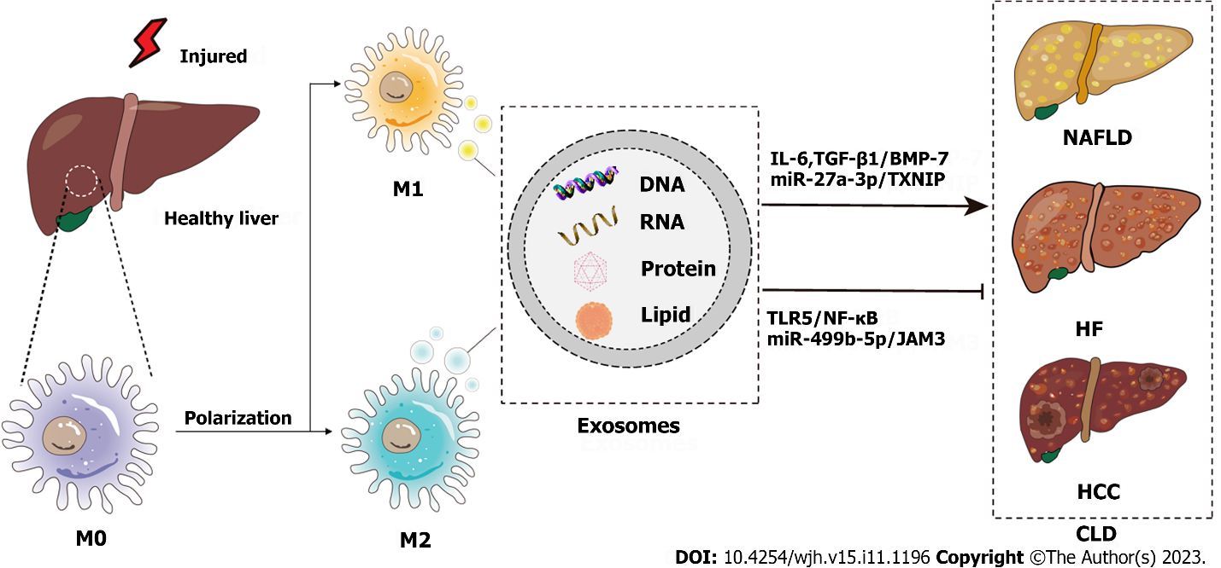
Figure 1 Schematic diagram of the pathogenesis of chronic liver disease from the perspective of macrophage-derived exosomes. Injured livers activate macrophages to secrete exosomes that encapsulate RNAs, DNAs, lipids, proteins, etc., which influence the development of chronic liver disease through various signaling pathways. CLD: Chronic liver disease; NAFLD: Nonalcoholic fatty liver disease; HF: Hepatic fibrosis; HCC: Hepatocellular carcinoma; IL-6: Interleukin-6; TGF: Transforming growth factor; BMP: Bone morphogenetic protein; TXNIP: Thioredoxin-interacting protein; TLR: Toll-like receptor.

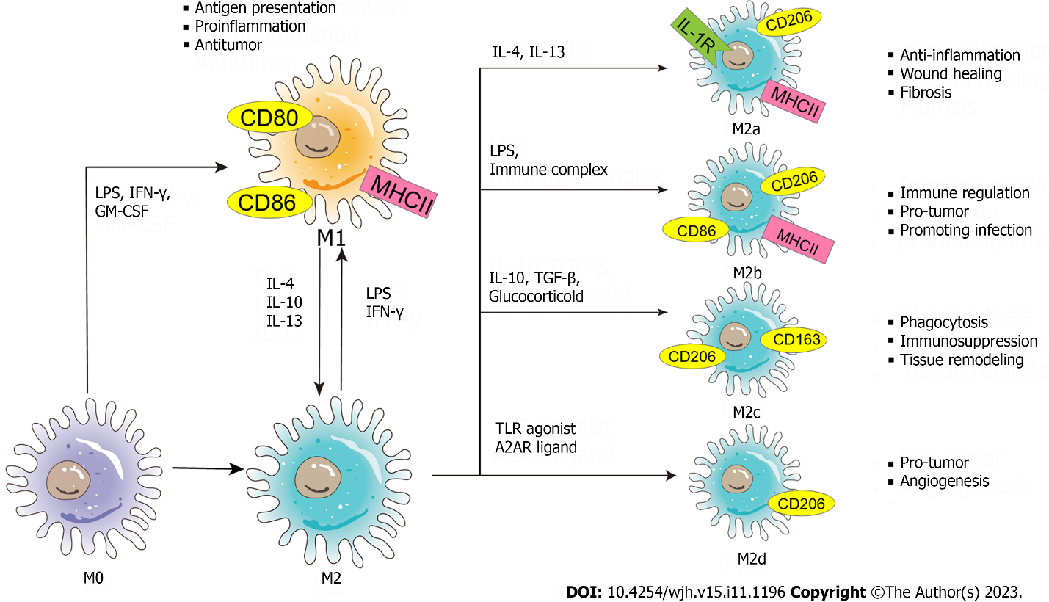
Figure 2 Schematic diagram of the phenotypes and functions of macrophage polarization. The nature macrophage can be activated by a variety of influencing factors (such as lipopolysaccharide, interferon-γ, granulocyte-macrophage colony-stimulating factor, etc.) and polarized into two phenotypes - classically activated macrophages and alternatively activated macrophages. Exosomes carry stimulatory factors to activate macrophages. Macrophages themselves secrete exosomes to form a signal transmission network between macrophages and other cells. (M0: M0 macrophage; M1: M1 macrophage; M2: M2 macrophage; M2a: M2a macrophage; M2b: M2b macrophage; M2c: M2c macrophage; M2d: M2d macrophage; LPS: Lipopolysaccharide; IFN-γ: Interferon-γ; GM-CSF: Granulocyte-macrophage colony-stimulating factor; IL: Interleukin; TLR: Toll-like receptor; A2AR: A2A receptor; MHC: Major histocompatibility complex; TGF: Transforming growth factor.

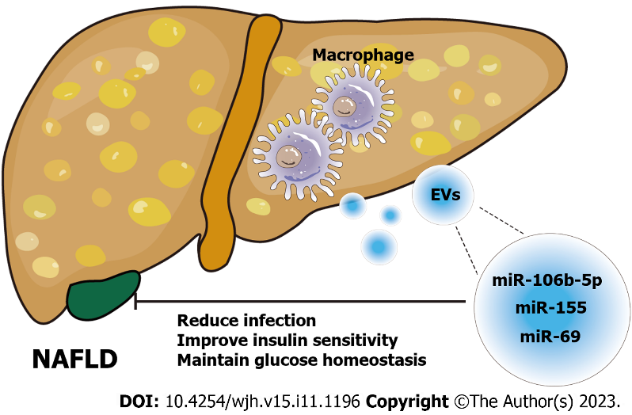
Figure 3 Schematic diagram of the role of macrophage-derived exosomes in nonalcoholic fatty liver disease. Exosomes derived from macrophages carry different microRNAs (miR-106b-5p^{[63]}, miR-155^{[64]}, miR-69^{[65]}) to act on nonalcoholic fatty liver disease cells and alleviate the disease progression by regulating liver homeostasis. NAFLD: Nonalcoholic fatty liver disease; EVs: Extracellular vesicles; miRNA: MicroRNA.

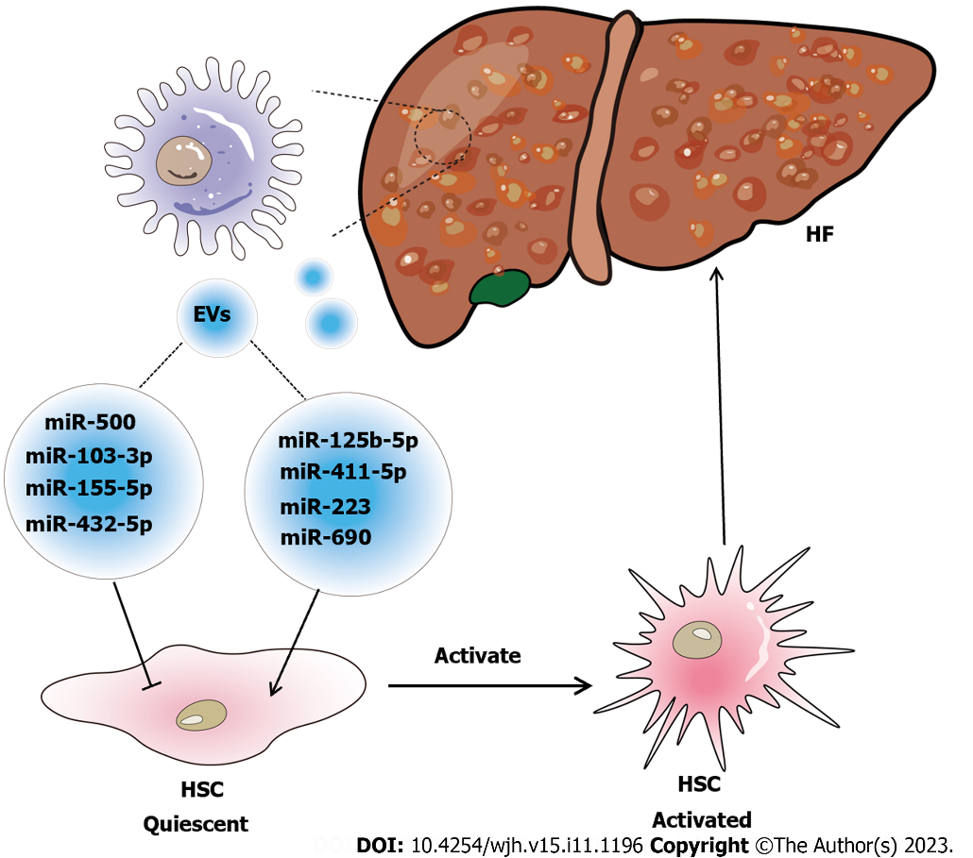
Figure 4 Schematic diagram of the relationship between macrophage-derived exosomes and hepatic fibrosis. Exosome-mediated communication between macrophages and hepatic stellate cell (HSC) influences the disease progression of hepatic fibrosis (HF). Special substances carried in exosomes, such as microRNAs (miR-103-3p^{[24]}; miR-500^{[70]}; miR-155-5p^{[72]}; miR-432-5p^{[73]}; miR-125b-5p^{[74]}; miR-411-5p^{[75]}; miR-690^{[65]}; miR-223^{[23]}, are signaling factors that induce the activation of HSC to form cirrhosis or inhibit the activation of HSC to alleviate HF. EVs: Extracellular vesicles; HSC: Hepatic stellate cell; HF: Hepatic fibrosis.

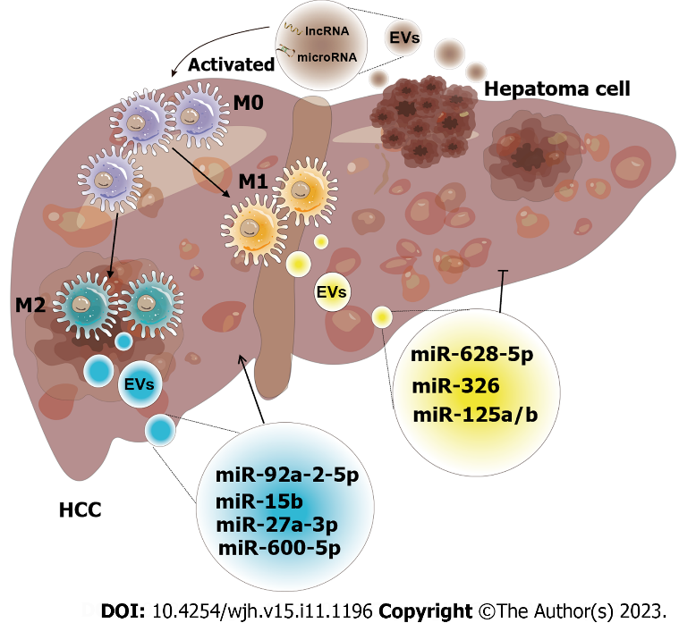
Figure 5 Schematic diagram of the effect of exosomes derived from macrophages on hepatocellular carcinoma. The crosstalk of exosomes between macrophages and hepatocellular carcinoma (HCC) affects tumor progression. Both exosomes released by macrophages and HCC have unique intracellular components, including a variety of mRNAs, microRNAs, long non-coding RNAs, lipids, etc. These intracellular components are utilized as communicators to induce pathways that result in increased or inhibited cell proliferation, invasion, and other hallmarks of malignancy (M0: M0 macrophage; M1: M1 macrophage; M2: M2 macrophage; miR-92a-2-5p^{[82]}; miR-15b^{[83]}; miR-27a-3p^{[85]}; miR-660-5p^{[86]}; miR-628-5p^{[87]}; miR-326^{[88]}; miR-125a/b^{[90]}). EVs: Extracellular vesicles; HCC: Hepatocellular carcinoma; miRNA: MicroRNA; lncRNA: Long non-coding RNA.

Table 1 Association of the macrophage-derived exosomes with hepatocellular carcinoma
Ref. | Macrophage cell type/phenotype | HCC cell lines/model/tissue | Exosome contents | Findings
Liu et al^{[82]}, 2020 | THP-1/M2 | Human HCC cell lines: SK-HEP-1 and HepG2 cell; mouse HCC cell lines: Hepa 1-6 | MiR-92a-2-5p | Promote HCC invasion via altering the AR/PHLPP/p-AKT/β-catenin signaling
Li et al^{[83]}, 2021 | THP-1/M2 | Human HCC cell lines: SMMC-7721 | MiR-15b | Promotes the progression of HCC by blocking the LATS1-mediated Hippo pathway
Li et al^{[85]}, 2021 | THP-1/M2 | Human HCC cell lines: Huh7, 97H, HepG2, LM3 and SMMC-7721 | MiR-27a-3p | Promote cancer stemness of HCC via the miR-27a-3p/TXNIP pathways
Tian et al^{[86]}, 2021 | THP-1/M2 | Human HCC cell lines: HepG2 and Bel-7402; human HCC tumor tissues | MiR-660-5p | Promote the development of HCC by regulating KLF3
Bai et al^{[88]}, 2020 | THP-1/M1 | Human HCC cell line BEL-7404, HepG2, SMMC-7721 and QGY-7703; Xenograft nude mouse model | MiR-326 | Suppresses HCC progression via NF-κB signaling pathway
Pu J et al^{[89]}, 2021 | C57BL/6 mouse bone marrow-derived macrophages/M2 | Murine model of primary HCC (C57BL/6) | MiR-21-5p | Facilitate CD8+T cell exhaustion in HCC via the miR-21-5p/YOD1/YAP/β-catenin pathway
Wang et al^{[90]}, 2019 | TAMs/M1 | Human HCC cell lines: Huh7, HepG2 and BEL-7404; human HCC tumor tissues | MiR-125a/b | Suppressed HCC cell proliferation and stem cell properties by targeting CD90
Zhang et al^{[92]}, 2022 | THP-1/M2 | Human HCC cell lines: SMMC-7721and HepG2; Xenograft nude mouse model (BALB/C) | hsa_circ_0004658 | Inhibits HCC progression via miR-499b-5p/JAM3
HCC: Hepatocellular carcinoma; M1: M1 macrophage; M2: M2 macrophage; TAMs: Tumour-associated macrophages; miRNA: MicroRNA; AR: Androgen receptor; LATS1: Suppressor kinase 1; TXNIP: Thioredoxin-interacting protein.

Published by Baishideng Publishing Group Inc
7041 Koll Center Parkway, Suite 160, Pleasanton, CA 94566, USA
Telephone: +1-925-3991568
E-mail: bpgoffice@wjgnet.com
Help Desk: https://www.f6publishing.com/helpdesk
https://www.wjgnet.com

© 2023 Baishideng Publishing Group Inc. All rights reserved.

