Name of Journal: World Journal of Stem Cells
Manuscript NO: 65148
Manuscript Type: REVIEW

Effects of immune cells on mesenchymal stem cells during fracture healing

Ehnert S et al. Immune cells and MSC during fracture healing

Sabrina Ehnert, Borna Relja, Katharina Schmidt-Bleek, Verena Fischer, Anita Ignatius, Caren Linnemann, Helen Rinderknecht, Markus Huber-Lang, Miriam Kalbitz, Tina Histing, Andreas K Nussler

Sabrina Ehnert, Caren Linnemann, Helen Rinderknecht, Tina Histing, Andreas K Nussler, Siegfried Weller Research Institute at the BG Trauma Center Tübingen, Department of Trauma and Reconstructive Surgery, University of Tübingen, Tübingen 72076, Germany

Borna Relja, Experimental Radiology, Department of Radiology and Nuclear Medicine, Otto-von-Guericke University, Magdeburg 39120, Germany

Katharina Schmidt-Bleek, Julius Wolff Institute and Berlin Institute of Health Center of Regenerative Therapies, Charité - University Medicine Berlin, Berlin 13353, Germany

Verena Fischer, Anita Ignatius, Institute of Orthopedic Research and Biomechanics, Ulm University Medical Center, Ulm 89091, Germany

Markus Huber-Lang, Institute for Clinical and Experimental Trauma-Immunology (ITI), University Hospital Ulm, Ulm 89091, Germany

Miriam Kalbitz, Department of Trauma and Orthopedic Surgery, University Hospital Erlangen Friedrich-Alexander University Erlangen-Nürnberg (FAU), Erlangen 91054, Germany

Author contributions: Each author performed a literature research for a specific section of the review article; Each author wrote a section of the review article; Ehnert S and Nussler AK compiled the individual sections; Ehnert S produced the graphics; all authors reviewed and edited the compiled manuscript.

Supported by German Research Foundation (DFG) focusing on “Interplay between mononuclear and osteogenic cells during fracture healing in type 2 diabetics“, No. EH 471/2 (to Ehnert S); German Research Foundation within the context of the Collaborative Research Center (CRC) 1149 “Danger Response, Disturbance Factors and Regenerative Potential after Acute Trauma”, No. 251293561, C01 (to Ignatius A and Fischer V); DFG in context of the CRC 1149, No. 251293561, A01 and No. 251293561 Z02 (to Huber-Lang M); and DFG in the context of the CRC 1149, No. 251293561, C07 (to Kalbitz M).

Corresponding author: Andreas K Nussler, PhD, Academic Research, Director, Pharmacist, Professor, Senior Scientist, Siegfried Weller Research Institute at the BG Trauma Center Tübingen, Department of Trauma and Reconstructive Surgery, University of Tübingen, Schnarrenbergstr. 95, Tübingen 72076, Germany. andreas.nuessler@med.uni-tuebingen.de

Received: February 28, 2021
Revised: March 31, 2021
Accepted: September 3, 2021
Published online:

Abstract
In vertebrates, bone is considered an osteoimmune system which encompasses functions of a locomotive organ, a mineral reservoir, a hormonal organ, a stem cell pool and a cradle for immune cells. This osteoimmune system is based on cooperatively acting bone and immune cells, cohabitating within the bone marrow. They are highly interdependent, a fact that is confounded by shared progenitors, mediators, and signaling pathways. Successful fracture healing requires the participation of all the precursors, immune and bone cells found in the osteoimmune system. Recent evidence demonstrated that changes of the immune cell composition and function may negatively influence bone healing. In this review, first the interplay between different immune cell types and osteoprogenitor cells will be elaborated more closely. The separate paragraphs focus on the specific cell types, starting with the cells of the innate immune response followed by cells of the adaptive immune response, and the complement system as mediator between them. Finally, a brief overview on the challenges of preclinical testing of immune-based therapeutic strategies to support fracture healing will be given.

Key Words: Trauma; Bones; Immune response; Mesenchymal stem cells; Fracture healing

Ehnert S, Relja B, Schmidt-Bleek K, Fischer V, Ignatius A, Linnemann C, Rinderknecht H, Huber-Lang M, Kalbitz M, Histing T, Nussler AK. Effects of immune cells on mesenchymal stem cells during fracture healing. World J Stem Cells 2021; In press

Core Tip: There is substantial evidence that immune cells influence mesenchymal stem cells (MSCs) after trauma. Bone is considered as an osteoimmune system based on cooperatively acting bone and immune cells, cohabitating within the bone marrow. The subdivisions are highly interdependent, sharing progenitors, mediators, and signaling pathways. During fracture healing many different cell types categorized to the innate and adaptive immune system interact. MSCs with their manifold immunomodulatory and regenerative properties serve as progenitors for fibroblasts, chondrocytes and osteoblasts. The alterations in the immune response usually become apparent early in the healing process of a fracture. This opens new avenues for early interventions.

INTRODUCTION
In vertebrates, bone can be considered as an osteoimmune system encompassing functions of a locomotive organ, a mineral reservoir, a hormonal organ, a stem cell reservoir and a cradle for immune cells. This osteoimmune system is based on cooperatively acting bone and immune cells, cohabitating within the bone marrow. They are highly interdependent, a fact that is confounded by shared progenitors and signaling pathways. Receptor activator of nuclear factor kappa B ligand (RANKL) is a well described example of this interdependency. Well known as a key factor for osteoclast differentiation, RANKL also regulates T-cell differentiation and proliferation^{[1]}. Mesenchymal stem cells (MSC) are adult stem cells. In bone, MSCs are traditionally found in the bone marrow. They act as precursor cells for chondrogenic, adipogenic and osteogenic cells during bone homeostasis and fracture healing^{[2]}. However, MSCs also play crucial roles in hematopoiesis and maintenance of immune cell progenitors^{[3]}. Recently, different MSC subsets with distinct roles on different immune cell progenitors have been described^{[4,5]}. In MSCs, this process seems to be strongly dependent on the expression of stem cell growth factor, also known as C-type lectin domain family 11 member A or osteolectin. MSCs lacking this factor seem to regulate hematopoiesis, while MSCs expressing osteolectin strongly influence maintenance and function of common lymphoid progenitor cells and their progenies^{[4]}. Furthermore, these osteolectin positive MSCs, prone to undergoing osteogenesis^{[5]}, increase in number following a bone fracture and thus, represent the main source of osteoprogenitor cells during fracture healing^{[4]}.
The bone-immune cell interplay at first considered the role of the innate immune system but more and more the role of the adaptive immune system was investigated. With respect to the adaptive immune system, the question arises whether it has beneficial or detrimental effects on regeneration. Considering evolution, the development of the immune system coincides with a decline in the regenerative capacity — i.e. the more elaborate the immune response the less capable of regeneration an organism is^{[6]}. A hallmark of adaptive immunity is its capacity to “remember” pathogens. This immune memory is only present in vertebrates, which constitute 1%-2% of the living species^{[7]}. Indeed, while their immune system is very elaborate, vertebrates only have a very limited regenerative capacity. An exception are mammalian embryos, which, still lacking adaptive immune responses, are capable of scar-free regeneration, a capacity that diminishes after birth and with aging^{[8]}. This indicates that adaptive immunity is rather unfavorable for regeneration.
In human adults, most tissues heal with scar tissue formation. Bone, however, is capable of healing without scar tissue formation. Bone healing is a highly complex process consisting of numerous well-orchestrated interdepending and overlapping steps, which, if undisturbed, result in tissue fully restored in form and function^{[9]}. Using endochondral bone regeneration as a model, effects of the innate and adaptive immune system have been investigated to understand their role in regenerative processes and to explore the possibility of using immune-modulatory strategies for the development of new therapeutic approaches. Upon bone injury and inadvertent vessel rupture, the initial step in healing consists of coagulation and the coupled release of platelet-derived pro-inflammatory cytokines, e.g., interleukin (IL)-6, or tumor necrosis factor (TNF)-α^{[10]}. The main functions of the clotting reaction are the closure of a possible breach of the outer hull of an individual and a strong defense against possible invading pathogens. The released cytokines stimulate homing of leukocytes into the fracture site (Figure 1). With vessel rupture, the supply of oxygen and nutrients is diminished at the injury site. Thus, cells active in this initial phase of bone healing need to be capable of functioning in this detrimental environment (low pH, low oxygen, disturbed sodium and potassium balance^{[11,12]}).
Neutrophils, the most abundant immune cells, are the first cells to arrive at inflammatory sites. The fracture hematoma was shown to be a strong inducer of neutrophil homing^{[13,14]}. Within less than an hour, they are recruited to the site of fracture^{[15]}, triggered by damage associated molecular patterns (DAMPs), including mitochondrial DNA (deoxyribonucleic acid) fragments^{[16]}. Equipped with highly potent activities such as phagocytosis, respiratory burst, or neutrophil extracellular trap (NET) formation, neutrophils strongly contribute to the first inflammatory reaction and formation of granulation tissue. Additional recruitment of fresh neutrophils from bone marrow by the C-X-C chemokine receptor (CXCR) type 4 (CXCR4)-C-X-C motif chemokine ligand (CXCL) 12 (CXCL12) axis, further supports the inflammatory reaction^{[17]}. This inflammatory reaction at the beginning of the healing process has a substantial influence on the whole process^{[18]}. As a consequence of the systemic inflammatory reaction, neutrophils invade not only the site of injury but also lung and liver tissue rapidly after a fracture^{[19]}. Almost simultaneous to neutrophils, mast cells (MCs) and dendritic cells (DCs) appear in the fracture hematoma. As tissue-resident hematopoietic cells, MCs modulate innate and adaptive immune responses, not only in the early inflammatory phase of fracture healing, but also later during bone remodeling, where MCs exert several functions in the regulation of angiogenesis, osteogenesis, and osteoclastogenesis^{[20]}. Shortly after, natural killer (NK) cells arrive at the site of injury, attracted by pro-inflammatory cytokines TNF-α and IL-6^{[21]}. The role of NK cells in fracture healing is not fully understood and seems strongly dependent on the current inflammatory status. Within one day, monocytes are recruited to the fracture hematoma. They first differentiate into pro-inflammatory M1 macrophages, contributing to the clearance of the granulation tissue by phagocytosis. During callus formation, anti-inflammatory M2 macrophages are present, supporting migration of osteoprogenitor cells, matrix formation, and angiogenesis^{[22]}. As precursors for osteoclasts, monocytes/macrophages also contribute to the final remodeling phase of fracture healing. Osteoclast differentiation is strongly dependent on factors secreted by B- and T-lymphocytes, which invade the fracture site, when granulation tissue is fully accomplished. In their pro-inflammatory state, T cells may act in the fracture environment^{[23,24]}.
This initial pro-inflammatory reaction is required to initiate fracture healing, not only for defense purposes but also to attract cells needed in the downstream healing process. However, this process needs to be tightly monitored, because the pro-inflammatory reaction becomes detrimental if it is too strong or lasts too long^{[25]}. Under anaerobic conditions the transcription factor, hypoxia inducible factor 1α, is stabilized and induces the expression of angiogenic factors by cells in the fracture site. This initiates the essential revascularization step by homing of endothelial progenitor cells (EPCs). Expression analysis revealed that upregulation of angiogenic factors is paralleled by enhanced anti-inflammatory signaling, to terminate the initial pro-inflammatory reaction in order to proceed towards the next healing phase^{[9]}. A switch from pro- to anti-inflammatory signaling is achieved, i.e., by an upregulation of IL-4 and IL-13, which support the Th2 (T helper cells type 2) and M2 phenotype in T cells and macrophages^{[26]}. Influencing the initial immune reaction by local application of these cytokines in a mouse osteotomy model significantly improved healing^{[22]}, emphasizing the importance of a tightly regulated initial inflammatory reaction and of swift downregulation of the initial pro-inflammatory reaction for a successful healing outcome. Thus, repeated irritation of the fracture hematoma can favor non-union^{[27]}. Furthermore, movement of the early fracture hematoma into muscle tissue can induce ectopic bone formation^{[28]}, underlining the importance of the hematoma in the bone forming process.
The initial pro-inflammatory phase is required to attract progenitor cells, e.g., EPCs or MSCs, to the site of fracture. MSCs with their manifold immunomodulatory and regenerative properties serve as progenitors for fibroblasts, chondrocytes and osteoblasts involved in the following callus formation. NK-, B-, and T-cells contribute to the effect of MSCs during this phase of fracture healing. Osteoblasts are the bone forming cells, producing collagen I that serves as the matrix for mineralization. In a mouse osteotomy model lacking mature T- and B-cells the mineralization process was accelerated^{[29]}. However, in these animals an imbalance between collagen subunits I A1 and I A2 was observed. Histologically, the resulting arrangement of collagen I fibers appeared porous and osteoblasts showed an altered distribution within the fracture callus. These changes within the mineralization process were attributed to the lack of T-cells, using mouse models with either B- or T-cell deficiency^{[29]}. Thus, T cells guide osteoblast distribution and the deposition of collagen I during callus formation. Later, homeostasis of bone is mediated mainly by the interaction between osteoblasts and osteoclasts, which derive from monocytes. The balance between these cell types is tightly regulated by the response of the respective progenitors, as well as T-cells acting during the remodeling phase of fracture healing^{[29]}.
The participation of each of the described cell types is required for successful fracture healing. In the following sections, the interplay between different immune cell types and osteoprogenitor cells will be more closely elaborated, starting with the cells of the innate immune response followed by the cells of the adaptive immune response, and the complement system as a mediator between them. Finally, a brief overview on the challenges of preclinical testing of immune-based therapeutic strategies to support fracture healing will be provided.

ROLE OF THE INNATE IMMUNE RESPONSE IN FRACTURE HEALING
Neutrophils
Neutrophils represent an essential part of the innate immune system. Neutrophils derive from common myeloid progenitor cells, which in turn originate from pluripotent hematopoietic stem cells (HSCs) in the bone marrow. The recruitment of neutrophils to the fracture hematoma may be mediated by released DAMPs originating from injured cells at fracture sites^{[16]}. Mitochondrial particles can act as DAMPs^{[30]}, and cytokines such as IL-1α or IL-8 (also known as CXCL8) are known to recruit neutrophils to injury sites^{[31,32]}. With regard to the fracture healing process, neutrophils have been described to strongly induce the initial inflammatory reaction (Figure 2), but their role in the actual healing process is rather underrated.
In vivo, depletion of neutrophils is a common method of investigating their effect on healing processes. In small rodents like mice and rats, neutrophil depletion was shown to delay fracture healing^{[15]}, with increased stiffness of the newly formed bone^{[33]}, possibly due to reduced MSC infiltration and favored chondrogenic differentiation^{[34]}. This is supported by in vitro studies, showing that neutrophils form a kind of extracellular matrix that supports MSC influx into the fracture hematoma^{[35]}, but also inhibit matrix formation by MSCs^{[36]}. Furthermore, a negative effect of freshly recruited neutrophils was observed, which induced apoptosis of undifferentiated and differentiated osteogenic cells^{[37]}. Here, a reactive oxygen species (ROS)-dependent mechanism was proposed. This is in contrast to a recent study, showing that neutrophils alter cytokine release by MSCs but not their osteogenic differentiation^{[38]}, suggesting that the activation status of the neutrophils is critical in this process.
The observed delay in fracture healing in neutrophil depleted mice was no longer observed when an additional thorax trauma was present, emphasizing the role of neutrophils in systemic inflammatory responses following trauma^{[15]}. Also, the application of neutrophils directly after fracture was reported to improve bone healing in these neutrophil depleted mice. As a possible regulatory mechanism, CCL (C-C-motif chemokine ligand) 2 induced recruitment of monocytes was discussed^{[39]}. CCL2, LL-37 (cathelicidin), AZU1 (azurocidin, also known as cationic antimicrobial protein CAP37 or heparin-binding protein), and other neutrophil secreted factors may pave the way for inflammatory monocytes^{[40]}. Therefore, an indirect role of neutrophils in the healing process is possible, as monocytes are known to support healing by a CCL2-dependent mechanism, which gives a differentiation signal to MSCs^{[41]}.
Further investigations suggest that neutrophils may support angiogenesis and revascularization during the healing process, by releasing factors e.g., VEGF (vascular endothelial growth factor) and Ang1 (Angiopoietin 1), inducing inflammatory angiogenesis^{[42,43]}. In addition, neutrophils were shown to release MMP9 (matrix metalloproteinase 9) in response to VEGF, inducing angiogenesis in hypoxic tissue^{[44]}.
TNF-α release from neutrophils was also suggested to be a possible mechanism by which neutrophils accelerate wound healing^{[45,46]} and lead to early strength of surgical incisions^{[47]}. However, the role of MSCs was not investigated in these studies. In MSCs, TNF-α was reported to enhance migration^{[48]} but also to inhibit osteogenesis^{[49,50]}. Thus, the direct effect of neutrophils on MSC development remains controversial.
The neutrophil to lymphocyte ratio and neutrophil counts were established as tools to predict trauma outcome and as markers for complication development. In most studies, high circulating neutrophil counts were associated with a higher risk of complications or postoperative mortality^{[51-55]}. Furthermore, a higher neutrophil count in the blood of trauma patients was identified as a predictor for the development of delayed bone healing^{[56]}. In addition, it was shown that neutrophil depletion reduced sepsis development after chest trauma in mice^{[57]}. A variety of studies suggest that neutrophils play a major role in severe complications after trauma such as acute respiratory distress syndrome (ARDS), systemic inflammatory response syndrome (SIRS), MODS (multi-organ dysfunction syndrome), or ischemia-reperfusion damage^{[57,58]}. MSCs were suggested as a possible tool to reduce/ prevent tissue damage in these situations. MSCs reduce apoptosis of neutrophils in vitro^{[59]} and cause reduced attachment of neutrophils to endothelial cells^{[60]}. The application of MSCs improved phagocytosis in a bacterial sepsis model in mice^{[61]}, reduced infiltration of neutrophils into the liver^{[62]}, and consequently improved survival in both studies. Furthermore, MSCs reduced inflammation, neutrophil infiltration, and the release of tissue-harming factors by these cells in an injured gut model or a vasculitis model^{[63,64]}. ROS release was either increased^{[65,66]} or reduced^{[67]} depending on the study, but in general, there is consensus that MSCs seem to balance the neutrophil response.
Apart from strong induction of overall inflammation, neutrophils have another defense mechanism, called NETs^{[68,69]}. Consisting of released chromatin covered with antimicrobial peptides and proteases, NETs are strongly bactericidal^{[68]}. There is evidence that NETs are formed in response to trauma^{[70,71]}. However, a general pathologic role of NET formation in healing processes has not yet proven. Nevertheless, overshooting NET formation can lead to pathological^{[72]} or delayed healing^{[73]}. Furthermore, NETs are known to be toxic to epithelial and endothelial cells^{[74,75]}; thus, a toxic effect on MSCs is feasible. However, one study showed reduced NET formation and increased survival in a mouse model of lipopolysaccharide (LPS)-induced acute lung injury due to MSC application^{[76]}. In vitro stimulation of neutrophils with MSC-conditioned medium increased NET formation, although the overall response was delayed^{[77]}.
Another aspect that needs to be considered when discussing neutrophils and trauma is neutrophil phenotypes. Neutrophils are directly affected by trauma. They exert reduced reactivity to stimuli after trauma like bacterial infections^{[78]} or fMLP (N-formylmethionyl-leucyl-phenylalanine)^{[79-81]}. Reduced chemotaxis can be observed to different cytokines after lung trauma^{[70]}. Surface markers [e.g., cluster of differentiation (CD) 62 and 11b, or L-Selectin] and receptors (e.g., CXCR1, CXCR2, or FcγRII, also known as CD32) are altered after trauma and thus also influence neutrophils reaction to other stimuli (reviewed in ^{[78]}). Recently, the categorization of neutrophils into “N1” and “N2” phenotypes, similar to monocyte/macrophage and T-cell types, was proposed. Neutrophils were divided into inflammatory (N1) and anti-inflammatory (N2)^{[82]}. Two recent reviews reported the role of neutrophil phenotypes in septic complications after trauma^{[83,84]}. However, their distinct role in tissue repair and their effect on MSCs remain to be elucidated.
In summary, a clear role of neutrophils in the induction of inflammation and possible complications such as SIRS and ARDS has been identified. Their role in the actual healing process and their effect on MSCs remain largely unclear and different results from studies indicate both positive and negative effects on fracture healing. The analysis of neutrophil phenotypes within these results could help to clarify the role of neutrophils in fracture healing. An overshooting inflammatory response and NET formation by neutrophils are, however, consistently related to tissue damage and prolonged healing.

Monocytes and macrophages
Monocytes and macrophages also belong to the innate immune system. Like neutrophils, systemic or circulating monocytes and macrophages derive from the common myeloid progenitor cells in the bone marrow. In many organs, including bone, tissue-resident macrophages also exist, which predominantly derive from embryonic macrophages. In bone, these tissue-resident macrophages are named osteomacs. Osteomacs are closely associated with areas of bone formation, forming a canopy-like structure on top of the active osteoblasts^{[85]}. Upon depletion of macrophages in a macrophage-fas-induced apoptosis (MAFIA) mouse model, not only the osteomacs but also the layer of active osteoblasts were lost^{[86]}, suggesting that macrophages play an active role in osteoblast mediated bone formation and hence fracture healing^{[87]}. Monocytes infiltrate the injury site, usually within one day following fracture. Depending on the milieu they differentiate into immunogenic M1 macrophages or immunosuppressive M2 macrophages, DCs or later even into bone resorbing osteoclasts (Figure 3). In the early inflammatory phase of fracture healing monocytes are stimulated towards the pro-inflammatory M1 phenotype by inflammatory cytokines and to a lesser extent by bacterial products, such as LPS. These M1 macrophages phagocytose cellular debris and pathogens, produce large amounts of nitric oxide and ROS, and secrete cytokines, e.g., interferon (IFN)-γ, TNF-α, and IL-6. Thus, M1 macrophages contribute to the pro-inflammatory response following fracture. The cytokines secreted by M1 macrophages support homing of MSCs to the site of fracture^{[85,88]}. Transforming growth factor beta (TGF-β) and associated activation of NADPH (nicotinamide adenine dinucleotide phosphate) oxidase 4 (NOX4) and focal adhesion kinase seem to play a crucial role in this process^{[89]}. Later, during the granulation phase, the phenotype switches towards anti-inflammatory M2 upon stimulation with IL-4 and IL-13. M2 macrophages, which primarily secrete IL-10, actively support tissue repair during soft and hard callus formation by suppressing inflammation^{[22,90]}. IL-10 production, also associated with tolerogenic DCs and regulatory B-cell function, is critically required for fracture healing and bone health. IL-10^{-/-} mice were reported to develop osteopenia in both cancellous and cortical bone by suppressing new bone formation^{[91]}.
In a mouse model of intramembranous bone formation, macrophages were closely associated with woven bone deposition by osteoblasts during all the phases of the healing process^{[92]}. Depletion of macrophages affected deposition of woven bone and impaired healing of the defect in this model. Interestingly, macrophage depletion at the time of injury was more detrimental compared to depletion of macrophages at later stages of fracture healing^{[92]}. This observation was confirmed in a mouse model investigating cancellous bone healing of drill holes^{[93]}. In mouse models of endochondral fracture healing, depletion of macrophages in the early inflammatory phase of healing, resulted in reduced callus size, delayed hard callus formation, and delayed fracture union^{[22,94]}.
Some in vitro studies have closely investigated the effect of the different macrophage phenotypes on bone formation. Conditioned medium from non-activated J774A.1 murine macrophages increases alkaline phosphatase (ALP) activity in MSCs, an effect mediated by secreted bone morphogenetic protein 2 (BMP2)^{[41]}. This result was confirmed by another study showing that non-activated human monocytes enhance proliferation, ALP activity, and expression of osteocalcin and osteopontin, in human bone marrow derived MSCs (BMMSCs). It was found that these effects were not dependent on cell-cell-contacts but partially dependent on BMP2^{[95]}. When cell-cell-contact is provided, non-activated human monocytes stimulate bone formation by BMMSCs via the cytokine oncostatin M (OSM), which is secreted by monocytes directly upon cell-cell-contact with MSCs^{[96]}. There are few studies that suggest that the observed effect is enhanced in M1 macrophages^{[97-99]}, and that this effect depends on OSM secreted by LPS challenged macrophages following activation of prostaglandin E2 (PGE2) and cyclooxygenase-2 (COX-2)^{[99,100]}.
When investigating the roles of monocytes and macrophages in fracture healing, the individual age has to be considered. Comparing fracture healing in young (3 mo) and old (24 mo) mice, no difference in the amount of macrophages in the fracture callus was observed. However, a constant up-regulation of M1/pro-inflammatory gene expression was observed in the macrophages of old mice. Therefore, preventing the infiltration of macrophages into the fracture site improved healing outcomes in old mice^{[101,102]}. Similarly, when surgical reposition of the fracture is required, anesthetics may affect MSC-macrophage interaction. For example, local anesthetics, e.g., lidocaine and bupivacaine, have been reported to directly inhibit secretion of pro-inflammatory cytokines by macrophages, without affecting their viability^{[103]}. Furthermore, these drugs may alter MSC effects in macrophage polarization by attenuating TNF-α and PGE2 secretion^{[103]}.
MSCs have been shown to suppress the M1 phenotype in macrophages, including the associated secretion of pro-inflammatory cytokines, in favor of the M2 phenotype with increased production of anti-inflammatory cytokines. This phenotypic switch from M1 to M2 macrophages is possibly mediated by PGE2^{[104-106]}, via IL1RA (IL-1 receptor alpha), and IL-6^{[107]}, and/or by activation of NF-kB (nuclear factor-kappa B) and STAT-3 (signal transducer and activator of transcription 3), which is thought to require IFN-γ mediated indoleamine 2,3-dioxygenase activation^{[108,109]}. Additionally, MSCs seemed to reduce CD86 and major histocompatibility complex (MHC) class II expression in LPS-stimulated macrophages, impairing their immunogenic effects on CD4⁺ T-cell^{[104]}.

MCs
Although, best known for promoting allergic reactions^{[110]}, MCs also actively participate in fracture healing^{[20]}. MCs derive from hematopoietic progenitors in the bone marrow and characteristically express CD34 and the surface marker c-Kit (proto-oncogene c-KIT, also known as CD117) that is important for MC growth, differentiation and survival^{[111]}. MC progenitors are released from the bone marrow into the blood stream and finally mature in the mucosal or connective target tissues dependent on the local environment and growth factor availability^{[112]}. In their large number of secretory granules, MCs store numerous preformed mediators, including cytokines and chemokines (e.g., IL-1β, IL-6, IL-8, TNF-a), histamine, heparin, enzymes (e.g., tryptases, chymases), and growth factors [e.g., VEGF, fibroblast growth factor (FGF), TGF-β]. These mediators can be rapidly released upon activation by cytokines, complement factors, or immunoglobulins (Ig), i.e., through crosslinking of the FceRI (Fc epsilon RI) receptor via IgE^{[113]}. MCs interact with many other immune cells via these mediators, thus, contributing to both the innate and adaptive immune responses^{[114]}. Furthermore, MCs are capable of de novo synthesis of several mediators (e.g., IL-1, IFN-g, RANKL). Many of these MC mediators are known to exert osteo-catabolic (RANKL, TNF-a, histamines) or osteo-anabolic effects [TGF-β, FGF, GM-CSF (granulocyte-macrophage colony-stimulating factor)]^{[115]}, which is why MCs are supposed to regulate bone metabolism (Figure 4). Confirming this, patients with postmenopausal osteoporosis, rheumatoid arthritis, osteoarthritis, or other inflammatory diseases affecting bone, display increased numbers of MCs in the bone marrow^{[116-119]}.
Experimental phenomenological studies showed that MCs may also play a role in bone fracture healing. They are present in the fracture callus, especially in the early soft callus near blood vessels and in the later bony callus in proximity to osteoclasts^{[120,121]}. Recent more mechanistic studies in various MC-deficient mouse models revealed the roles of MCs in fracture-induced inflammation, angiogenesis, as well as in anabolic and catabolic activities during the healing and remodeling process. In more detail, bone healing was delayed in MC-deficient Kit^{W-sh/W-sh} mice indicated by an impaired transformation of woven bone into lamellar bone, reduced revascularization and increased osteoclast parameters^{[122]}. In MC-deficient Cpa3^{Cre/+} mice, bone repair was also impaired shown by reduced vascularization, bone mineralization and cortical bridging of the fracture callus^{[123]}. However, these mouse models have the drawback that c-Kit is also expressed in osteoclasts and some immune cells, and Cpa3 (carboxypeptidase A3) in basophils and T-cells. Overcoming these limitations, fracture healing was investigated in MC-deficient Mcpt5 Cre R-DTA mice that lack connective tissue MCs without affecting other cell populations^{[124]}. Interestingly, the levels of pro-inflammatory cytokines including IL-6 or CXCL1 were significantly reduced after fracture both systemically and locally in these mice. In addition, chemokine concentrations of KC (keratinocytes-derived chemokine, also known as CXCL1), MIP-2 (macrophage inflammatory protein 2, also known as CXCL2) and granulocyte colony-stimulating factor (G-CSF), known to attract neutrophils, were significantly reduced in MC-deficient mice. This confirmed that fewer neutrophils and macrophages were recruited to the fracture hematoma. These results indicate an important role for MCs in fracture-induced local and systemic inflammation by the release of inflammatory mediators inducing the recruitment and activation of immune cells. Later in healing, callus bone content was increased in MC-deficient Mcpt5 Cre R-DTA mice associated with reduced osteoclast numbers, indicating that MCs may enhance osteoclast activity during callus remodeling. Supporting these findings, in vitro analysis further showed that MCs promote osteoclastogenesis via granular mediators, especially via histamine^{[124]}.
In conclusion, MCs are present during the whole fracture healing process and mainly modulate the inflammatory response, vascularization and osteoclastic bone remodeling by using their broad spectrum of mediators. Hence, MCs can also influence MSCs present during the healing process as MSCs are responsive for MC mediators through various receptors, e.g., IL-1 receptor (IL-1R), IL-6R, TNFR (TNF receptor), CXCR1, TGFβRI (TGF-β receptor 1), or bFGFR (basic FGF receptor)^{[125]}. On the other hand, MSCs also secrete factors including TGF-β, VEGF, or IL-6^{[126]}, that could modulate the function of MCs, as they express the appropriate receptors (TGFβR1/2, VEGF receptor, IL-6R)^{[127]}. MSCs are recruited to the injured region following fracture and initiate the repair phase by differentiation into chondrocytes and osteoblasts^{[128]}. A direct interaction of MCs and MSCs during fracture healing has not been identified so far. In physiological bone turnover of MC-deficient Kit^{W/W-v} and Kit^{W-sh/W-sh} mice, osteoblast parameters were changed probably due to an altered MSC differentiation capacity^{[129,130]}; however, the underlying mechanisms need to be further investigated. In vitro, several studies observed effects of MCs on MSCs or vice versa. Co-culture experiments revealed that MCs can promote the proliferation of MSCs, but inhibit their differentiation via the PDGF (platelet-derived growth factor) pathway^{[131]}. Furthermore, pre-incubation of MSCs with exosomes isolated from MCs induced the migration of MCSs via exosomal TGF-β^{[132]}. Pre-treatment of MSCs with MC conditioned medium improved the therapeutic effect of MSCs in atopic dermatitis in mice^{[133]}. Vice versa, MSCs can also influence MCs in a co-culture system, by reducing their degranulation and cytokine production^{[134]}. Moreover, the culture medium of MSCs pre-treated with TNF-a inhibited MC activation and histamine release in a model of allergic conjunctivitis^{[135]}. MSC administration in various inflammatory settings including interstitial cystitis^{[136]}, atopic dermatitis^{[137]}, intracranial aneurysm^{[138]}, osteoarthritis^{[139]}, or allergic rhinitis^{[140]}, improved disease outcome, i.e., by reducing the number of MCs or their degranulation.
Hence, the effects of MCs on MSCs during bone healing are likely due to influencing migration, proliferation, and differentiation of MSCs. This might be of special interest in conditions of MC accumulation as observed in osteoporosis and probably also during fracture healing in osteoporotic bone or other inflammatory conditions in bone. Moreover, MSCs might also directly influence MC behavior during fracture healing by modulating MC numbers, degranulation, cytokine production and mediator release. In conclusion, more and more specific roles of MCs in fracture healing have been identified in recent years; however, the crosstalk of MCs and MSCs in this context requires further elucidation.

DCs
DCs derive from common myeloid progenitor cells in the bone marrow. DCs are specialized antigen presenting cells (APCs) that can also take up and process antigens, and have the capacity to stimulate resting T-cells in the primary immune response^{[141]}. DCs process phagocytosed antigens into peptides in order to present them to T-cells via MHC molecules on their cell surface, which primes T-cells as part of the adaptive immune response^{[142]}. DCs differentiate from monocytes and secrete IL-12, favoring the differentiation of naïve CD4⁺ T-cells toward T helper type 1 (Th1) cells, thus, contributing to the pro-inflammatory response required for homing of MSCs. Therefore, DCs are assumed to be active mainly in the early phases of fracture healing (Figure 5). However, the specific roles of DCs in fracture healing are yet to be elucidated. MSCs in turn have been shown to impair the maturation of DCs from monocytes or CD34⁺ hematopoietic precursors^{[143]}. As a result, fewer pro-inflammatory cytokines were secreted. This MSC mediated inhibition of DC function seems to be dependent on cell-to-cell contacts^{[144]}. Another study suggested that MSCs inhibitory effects on DCs are related to the production of TGF-β and downregulation of DC costimulatory molecules (e.g., CD40, CD80, CD86), thus contributing to the activation of regulatory T-cells (Tregs)^{[145,146]}. Yet another study suggested that MSCs secrete growth-regulated oncogenic chemokines when co-cultured with monocyte-derived DCs, which acquire a myeloid-derived suppressor cell-like phenotype under this condition^{[147]}. Furthermore, MSCs were reported to induce expression of SOCS1 (suppressor of cytokine signaling 1) in DCs in an IL-6-dependent manner. This way, DCs acquire a tolerogenic phenotype with increased production of IL-10^{[148]}.

NK cells
NK cells, as part of the innate immune system, make up approximately 5% to 10% of all lymphocytes within peripheral blood. They derive from common lymphoid progenitor cells, which originate from HSCs in the bone marrow. Upon their primary mode of action, conventional NK cell subsets can be characterized by the expression of surface marker CD56. CD56^{dim} NK cells mainly exert cytotoxic activities against tumor or infected cells via a MHC class I dependent recognition mechanism. CD56^{bright} NK cells show an increased cytokine production capacity mainly secreting IFN-γ and TNF-α, thereby, amplifying immune responses^{[149,150]}. NK cells require priming by IL-12, IL-15, IL-18, IL-21, and IFN-α/β prior to activation which underlines that their range of action is widely believed to be within infectious environments, where classically activated NK cells contribute to the Th1 response^{[151-153]}.
The role of NK cells during trauma and their interaction with MSCs is not fully understood and seems strongly dependent on the current inflammatory status. After trauma, NK cells are among the first cells to arrive at the site of injury attracted by TNF-α and IL-6^{[21]} (Figure 5). General immune suppression as a response to major trauma also affects NK cells. For example IFN-γ secretion was suppressed, following major trauma, when facing infectious challenges mimicked by Staphylococcus aureus^{[154]}. In vitro, NK cell activity was shown to be suppressed when incubated with fluids from early fractures or soft tissue injuries^{[155]}. Decreased phosphorylation of mTOR (mechanistic target of rapamycin) and increased CD117 expression were identified as regulators of trauma-induced NK cell dysregulation^{[156]}. To escape NK cell-driven lysis due to generally low MHC class I expression or NK cell mediated harm through massive IFN-γ production, MSCs were shown to be able to adapt within inflammatory environments. For example, MSCs were reported to increase MHC class I expression in response to high IFN-γ levels or increased resistance against cytotoxic NK cells upon Toll-like receptor 3 stimulation^{[157-159]}. MSCs were found to be recruited to non-infectious environments, by CXCL7 secreted by primary unstimulated NK cells^{[160]}. Classically, MSCs are reported to exhibit immune-suppressive properties towards NK cells — they secrete IL-10, TGF-β, and PGE-2, thereby limiting NK cell function and proliferation^{[161-163]}. However, the immune-stimulatory effects of MSCs have also been reported. CD56^{bright} NK cells, primed with IL-12 and IL-18, showed increased secretion of IFN-γ when co-cultured with MSCs without direct cell-cell contact^{[164]}. CCL2 was identified as the main immunomodulatory cytokine in this process. MSCs secreted CCL2 in response to IFN-γ, which primed NK cells for additional IFN-γ release in a positive feedback loop^{[165]}. A recent study showed a time-dependent effect of MSCs on NK cells in the context of infected tissue injury. Shortly after injury (4 h) MSCs induced a pro-inflammatory response in NK cells by stimulating IFN-γ release. However, 24 h post-infection, MSCs induced a senescence-associated NK cell phenotype (SASP) by TGF-β and IL-6 secretion, which was accompanied by a change in the population from CD56^{bright} CD16⁺ to CD56^{bright} CD16⁻. SASP NK cells then triggered further IL-6 release, angiogenesis, and MSC proliferation, overall favoring tissue regeneration^{[166]}.
In summary, these studies suggest, that there is a tight interplay between NK cells and MSCs during fracture healing. However, the effects strongly depend on the inflammatory status.

ROLE OF THE ADAPTIVE IMMUNE RESPONSE IN FRACTURE HEALING
T-cells
T-cells play crucial roles in the adaptive immune response. They are of hematopoietic origin, as they derive from common lymphoid progenitor cells in the bone marrow. Maintenance of these common lymphoid progenitor cells is strongly dependent on the recently described subset of osteolectin positive MSCs, which can be found in close proximity to the arterioles in the central bone marrow and the endosteum^{[4]}. It has been shown, that these osteolectin positive MSCs are required for T-cell as well as B-cell mediated bacterial clearance following an infection^{[4]}. Using bone regeneration as a model, the effect of the adaptive immune system and more specifically the impact of T-cells has been investigated in order to first understand their role in regenerative processes and to secondly explore the possibility to use immune modulatory strategies to develop new therapeutic approaches. Similar to the cells of the innate immune response, T cells are also involved in many steps of fracture healing^{[167]} (Figure 6). However, their activation status seems to be crucial. As discussed in the introduction, there is a loss of regenerative capacity in mammals starting after birth and upon aging. At birth, the adaptive immune system is still naïve. The number of naïve T-cells decreases with age, changing into effector, effector/central memory and terminally differentiated T-cells in a rate that is dependent on the antigens the individual encounters over time^{[168]}. This highly individual immune aging process is therefore somewhat separated from chronological aging. In order to determine whether immune age influences bone properties, an approach was chosen where one group of mice was aged under sterile (specific pathogen free) conditions while a complementary group was housed under conditions where they encountered environmental pathogens. While the first group remained more or less immunologically naïve over the period of two years, the second group gained immune experience, developing central and effector memory cells^{[169]}. Comparing bone parameters from these two groups of mice showed a stiffer and more brittle bone in animals with an experienced/aged immune system^{[169]}. This is an indicator of the negative effect the change from the naïve immune status towards an experienced immune status, with central and effector memory T-cells and terminally differentiated T-cells, has on bone. Also the lack of T-cells, especially naïve T-cells, results in lower bone quality and delayed bone healing^{[169,170]}. The above mentioned osteolectin positive MSCs, required for maintenance of the common lymphoid progenitor cells and adequate T-cell response, have been reported to decrease in number with age^{[4,5]}. As the number of naïve T-cells also decreases with age, a direct correlation between these two cell types may be feasible. However, the effects of the MSCs on the T-cells seem to be strongly dependent on the cells activation status. It has been proposed that MSCs cause a downregulation of Fas receptor and Fas ligand on T-cell surface and thus, may rescue T-cells from activation-induced cell death^{[171]}. TGF-β and hepatocyte growth factor, secreted by MSCs, have been identified to be soluble mediators suppressing T-cell proliferation, a process that can be augmented by cell-cell-contacts between the two cell types^{[172]}. An immune composition with high levels of effector memory and terminally differentiated T-cells could thus be an indicator of delayed or disturbed bone healing. Indeed, a clinical study showed that delayed bone healing occurred in patients with high levels of terminally differentiated CD8⁺ T-cells^{[170]}. Thus, high percentages of terminally differentiated CD8⁺ T-cells in peripheral blood could represent a biomarker for delayed healing that could easily be identified within one hour after a patient is hospitalized with a bone injury, opening possibilities for early intervention^{[170]}. Amazingly, high percentages of these effector T-cells in peripheral blood or within the fracture hematoma, were not a result of the injury, but a result of antigen exposure over time.
Better characterization of the different T-cell subsets during bone healing, may shed light on their role in the healing process. Recently, IL-17 producing γδ T-cells, which are present in the fracture during callus formation, have been identified to promote bone healing^{[173]}. However, T-cell differentiation is also critically dependent on osteoblasts, which produce notch ligand DLL4 (delta like ligand 4), the key regulator for this process^{[174]}. Thus, sepsis-induced ablation of osteoblasts contributes to an immune deficiency^{[175]}.
Tregs, described to play a pivotal role in peripheral immune tolerance, are able to modulate both the innate and adaptive immune responses. Heme oxygenase-1 (HO-1) is a key contributor to MSC-mediated suppression of allo-activated T-cells, and induction of Tregs. For example, MSCs induce, in a HO-1-dependent fashion, IL-10⁺ Tr1 (T regulatory type 1) and TGF-β⁺ Th3 Treg-subsets in allo- and T-cell receptor-activated lymphocytes^{[176]}. Furthermore, HO-1 facilitates MSCs to induce Tregs from naïve T-cells and promote their proliferation^{[176]}. Tregs have the ability to alter and kill target cells such as APCs and effector T-cells. Furthermore, they may influence inflammatory cytokine environments and metabolic pathways^{[177]}. Thus, these cells are required for maintenance of self-tolerance, or preventing excessive inflammation and autoimmune diseases. In the setting of trauma, Tregs become prominent when the granulation tissue is formed and remain at the fracture site until remodeling starts. They contribute to the specific release of anti-inflammatory cytokines such as IL-10, inducing a shift towards a Th2 lymphocyte-mediated response and/or lymphocyte anergy, and thus, to profound (post-traumatic) immunosuppression^{[178,179]}. Later during fracture healing, Tregs are thought to control osteoblast and osteoclast function.
In vivo, the number of Tregs in peripheral blood is inversely correlated to serum markers of bone resorption, not only in rheumatoid arthritis patients but also in healthy controls, suggesting that Tregs control bone destruction^{[180]}. Increasing numbers of Tregs improved clinical signs of rheumatoid arthritis and suppressed local and systemic bone destruction^{[180]}. Furthermore, the suppressive effects of Tregs on osteoclast differentiation were confirmed in vitro^{[180]}. It was suggested that enhancing the activity of Tregs may beneficially influence the treatment of inflammation-induced bone loss observed in rheumatoid arthritis. Yet, the effects and regulatory mechanisms of Tregs on osteoclastogenesis were investigated only in a limited number of studies. In a monocyte and Tregs co-culture system, Tregs inhibited osteoclast differentiation and reduced the resorbed areas^{[181]}. The authors have shown that this suppression of osteoclast differentiation was cytokine-dependent, as osteoclast differentiation was blocked by anti-TGF-β or anti-IL-4 antibody treatment. As no direct cell-to-cell contacts were required to inhibit osteoclast function by Tregs, TGF-β and IL-4 may represent the key cytokines for this suppressive function of Tregs^{[181]}.
RANKL promoting the differentiation of bone-resorbing osteoclasts is thought to negatively impact bone healing, but is also active in T-cell differentiation and proliferation^{[1]}. In a study, patients with isolated closed tibial fracture were subdivided into normal healing and delayed healing groups, based on their healing progression. In these patients, CD45RA-CD62L-effector memory cells most effectively suppressed RANKL. These cells were present at lower frequencies and with functional impairment in patients with delayed healing^{[182]}. Hence, bone-resorbing osteoclast formation may be favored in these patients, suggesting a possible mechanism for delayed bone healing^{[182]}. Another study supported the findings that multiple reductions in Tregs function in delayed healing patients could produce long-lasting consequences in the bone fracture healing process^{[183]}.
It has become evident that tissue destruction is associated with a decrease in local regulatory processes, including a decrease in forkhead box P3 (Foxp3)-expressing Tregs. CCL22 is a known chemoattractant for Tregs. With the help of a controlled release system, composed of a degradable polymer with a proven track record of clinical translation, poly(lactic-co-glycolic) acid, capable of generating a steady release of CCL22 from a point source effectively recruited Tregs to the site of injection^{[184]}. Upon administration of CCL22 in murine experimental periodontitis, increases in Treg-associated anti-inflammatory molecules, a decrease in pro-inflammatory cytokines, and a marked reduction in alveolar bone resorption were observed^{[184]}. In addition, the application of CCL22 reduced clinical measures of inflammation and improved alveolar bone loss in a ligature-induced periodontitis in beagle dogs^{[184]}. Thus, Tregs recruited to the site of injury by CCL22 are associated with a decrease in bone resorption by reducing inflammation. STAT-3 as a key signaling protein in the skeletal and immune system, and may be a key regulator in this process^{[185]}. The study provides evidence that STAT-3 enhances Tregs-mediated suppression of counteracting inflammation, suggesting that STAT-3 could be used as a prognostic marker to identify patients at risk of developing delayed union or nonunion^{[185]}.
In another study, systemic infusion of MSCs improved cell-based bone regeneration via upregulation of Tregs^{[186]}. In this study, the immunomodulatory function of BMMSCs was proven in vitro. Systemic infusion of these BMMSCs significantly improved cell-based repair of critical-sized calvarial defects in a murine model^{[186]}. In the implantation sites, IFN-γ and TNF-α levels were reduced via upregulation of Tregs, resulting in marked enhancement of cell-based bone regeneration, but with only limited contribution of BMMSC homing^{[186]}.
Apparently, Tregs also contribute to impaired bone healing induced by local accumulation of CD8⁺ effector T-cells (T_{EFF}). The endogenous regeneration is impaired by increasing the primary "useful" inflammation toward a damaging level with Tregs regulating the pro-inflammatory reaction to enhance healing^{[187]}. The study provided evidence that CD4⁺ Tregs might counteract undesired effects of CD8⁺ T_{EFF}, as the healing outcome was improved by an adoptive Tregs therapy^{[187]}. The data from the mouse osteotomy model were supported by clinical data showing that patients with impaired fracture healing have demonstrated higher T_{EFF}/Tregs ratios compared to uneventful healers^{[187]}. These findings demonstrated the key-role of a balanced T_{EFF}/Tregs response following injury required for successful bone regeneration^{[187]}.
Although more and more studies show possible roles of the adaptive immune system in bone healing, the underlying mechanisms and involved cell types are still unclear and remain to be elucidated in further studies.

B-cells
Like T-cells, antibody producing B-cells belong to the adaptive immune response. They also differentiate from common lymphoid progenitor cells, which are derived from HSCs in the bone marrow. MSCs support the development of T- and B-cells from HSCs by soluble factors and cell-cell-contacts^{[188]}. Both cell types infiltrate the fracture callus in a two-waved fashion (Figure 7). Interestingly, the number of B-cells seemed to exceed the T-cells during the fracture healing process, where B-cells progressively underwent effector maturation^{[189]}. Early during callus formation B-cells have been described to undergo direct cell-cell-contact with osteoprogenitor cells, presumably regulating their differentiation. However, as described above, the lack of mature T- and B-cells accelerated the formation of the mineralized matrix in a mouse osteotomy model^{[29]}. However, the observed changes within the mineralized matrix where attributed to the lack of T-cells, using mouse models with either B- or T-cell deficiency^{[29]}. Another study suggested, that B-cells regulatory function is required for successful bone healing, as in patients with delayed healing of tibia fractures B-cells seemed to lose their capability to produce IL-10 with time^{[190]}. Another study even suggested, that the initial expression of IL-10 by B-cells is diminished in patients developing a non-union^{[191]}. During the healing process, these antibody and IL-10 producing CD27⁺ B-cells effectively suppressed IFN-γ, TNF-α, and IL-2 expression in CD4⁺ T-cells, as well as IFN-γ and TNF-α expression in CD8⁺ T-cells in a Foxp3 dependent manner^{[191]}. Likewise, in vitro CD19⁺CD27^{bright} B-cells suppressed proliferation of CD4⁺ T-cells and enhanced Foxp3 expression in Tregs. However, the mechanism was not dependent on IL-10 but TGF-β and direct cell-cell-contact^{[192]}. Furthermore, CD19⁺CD27^{bright} B-cells were reported to reduce the numbers of pro-inflammatory Th17 cells, independently of cell-cell-contacts^{[193]}. This indicates that B-cells have crucial immunomodulatory roles during fracture healing.
However, B-cells may also affect bone cells and vice versa. For example, in rheumatoid arthritis patients, B-cells have been reported to suppress osteogenesis via TNF-α and CCL3^{[194]}. Similarly, B-cells inhibited osteoblast maturation when challenged with G-CSF during homing of hematopoietic stem and progenitor cells. Simultaneous activation of osteoclasts, however, was attributed to T-cells^{[195]}. Interestingly, Rag1^{-/-} mice displayed higher than normal levels of osteoclasts, although lacking T- and B-cells^{[196]}. As a possible explanation for this, a response to the elevated osteoblast function was suggested. In turn, MSCs may inhibit proliferation, activation, and antibody secretion of B-cells, possibly by altering MAPK (mitogen-activated protein kinase) activity^{[197]}. It is assumed that MSCs inhibit B-cell proliferation by secreted factors inducing cell cycle arrest in the G0/G1 phase^{[198]}, and preventing B-cells maturation by inducing expression of maturation protein-1^{[199]}. Furthermore, MSCs may suppress both B- and T-cell activation by secreted IFN-γ and cell-to-cell contact via programmed cell death 1 receptor (PD-1) and its ligand (PD-L1)^{[200]}. In vitro, however, contradictory data exist, showing that MSCs may promote the proliferation and differentiation of B-cells^{[201]}.

COMPLEMENT SYSTEM
The complement system represents the major fluid phase innate immune surveillance system^{[202]}. As a protein cascade, the complement system contains multiple serine proteases, which can be activated by different pathways early after trauma and during systemic inflammation^{[202,203]}. The generated complement activation products can function as anaphylatoxins (C3a, C5a), opsonins (C3b), or membrane attack complexes (MAC formed by C5b-9) all of which help sensing and clearing of tissue debris, damaged cells, and pathogens after trauma^{[204]}. However, if excessively produced or out of control by suppressed complement regulatory proteins (CRegs), activated complement may also reveal harmful features for the host^{[203]}.
On a cellular level, multipotent MSCs are critically involved in healing processes after tissue damage and bone fracture. A hypothesis-free global transcriptional analysis of the bone fracture region post trauma suggested, that several complement and coagulation factors are significantly upregulated at the fracture site^{[205]}. Focusing on MSCs, it is well established that these cells express several key complement receptors (e.g., C3aR or C5a receptors) and membrane-bound CRegs (e.g., CD35, 46, 55, and 59) all of which play an important role in the concerted recruitment of leukocytes and subsequent induction of repair processes^{[206]}. Trauma can also result in systemic complement activation with generation of the central anaphylatoxins C3a and C5a, which can induce all classical signs of inflammation. C3a represents a potent chemoattractant for MSCs^{[207]} and C5a strongly chemo-attracts neutrophils and macrophages. Moreover, opsonisation of MSCs via C3b deposition results in subsequent phagocytosis by macrophages. Concerning the terminal pathway, MAC formation on MSCs can lead to cellular lysis and thus impaired regeneration^{[206,208]}. Concerning cell survival, generation of C5a can induce apoptosis of MSCs^{[209]}; whereas, in contrast, it prevents apoptosis in neutrophils via enhanced expression of the anti-apoptotic Bcl-xL^{[210]}.
The multifaceted modulation of MSCs by complement activation products led to the development of novel therapeutic approaches. Nanoparticles spiked with the C5aR, functioning as a decoy mechanism for excessive C5a, revealed some protective effects for MSCs^{[211]}. Similarly, “painting” MSCs with factor H, a central native complement inhibitor, turned the MSCs resistant against both a complement- and neutrophil-driven attack^{[212]}. Another approach addresses differentiation processes of MSCs: During the differentiation from MSCs to osteoblasts, C5aR upregulation is dependent on regulation of the urokinase receptor (uPAR) and downstream NfκB transcriptional program. Blocking the C5aR impaired osteogenic differentiation, indicating effective immune modulation of the MSC-driven regeneration process by targeted complement inhibition^{[213]}. However, future translational studies need to investigate and prove the efficacy of such a complement-based MSC modulation.

IMMUNE CELL REGULATION A POSSIBILITY FOR PERSONALIZED TREATMENT TO SUPPORT FRACTURE HEALING?
Delayed or impaired fracture healing, which occurs in up to 20% of all fractures^{[214]}, and septic complications represent growing challenges in orthopedic and trauma surgery. Currently, failures in bone healing are detected radiologically 4-6 wk after the initial treatment. This considerably prolongs the healing time in patients with healing deficits. The above-mentioned studies describe crucial roles of the innate and adaptive immune system in these processes (Figure 8). Hence, immune scenarios characteristic in patients frequently developing delayed or impaired bone healing, or even septic complications were identified. The alterations in the immune response usually become apparent early in the healing process of a fracture, some even at the time of hospitalization of the patients. This opens new avenues for early interventions. With a tool to stratify patients with higher risks for delayed healing, therapeutic approaches to treat these patients are needed. With a demographically aging population the percentage of elderly patients, with an educated and aged immune system, presenting to the clinic with a fracture will rise. This factor has to be considered when developing and testing new therapeutic strategies based on immune modulation, emphasizing the need for a paradigm shift in animal models. In 2016, Badylak^{[215]} stated that the immune system as a regulator of organ and tissue development and as an orchestrator of the healing process after injury is often neglected in research models. Although, there are rising numbers of studies emphasizing that the immune status of the pre-clinical model could be decisive for the research results^{[187,216,217]}, state of the art is to keep animals as clean as possible, i.e. most rodent model housing is often either pathogen free or specific pathogen free. In both housing conditions the immune experience is minimal. This is partly attributed to the fact that so far no standardized method has been found to measure or report immune competence or experience in pre-clinical models. Using mice with effector/memory T-cells, kept under housing conditions that allowed environmental pathogens^{[169,187]}, an immunomodulatory strategy was tested that enhanced cyclic adenosine monophosphate during the initial phase of bone healing through local application of the prostacyclin analogue Iloprost. Prostacyclin, previously used to treat bone-marrow edema^{[218,219]}, reduced the pro-inflammatory reaction of effector memory T-cells in vitro, while strengthening the anti-inflammatory reaction of Tregs, one natural counterpart to CD8⁺ effector cells^{[220]}. In an immune experienced mouse osteotomy model local delayed release of Iloprost significantly enhanced bone healing, while reducing the number of CD8⁺ T-cells in the early healing phases^{[220]}. In contrast, a previous study reported that Iloprost inhibited bone healing in a rat fracture model^{[221]}. The discrepancy in statements can be explained by the unstabilized fracture in the rat study or the systemic vs local application of Iloprost. However, the immediate prostacyclin administration in the rat study probably prevented the necessary initial pro-inflammatory reaction and this caused the observed lack in healing. This demonstrates that the complexity of the bone healing process combined with the complexity of the immune system and reaction upon injury demands a very careful strategy when immunomodulation is to be achieved to improve bone healing. Especially as both systems, the bone and the immune system share signaling pathways. This means that by targeting one system one could very well also influence the other. Nevertheless, immunomodulation is a promising future treatment approach to enhance bone healing in patients with an overarching immune reaction to injury that will probably become a personalized therapy option, where the immune composition of the patient has to be taken into account. With bone being a model for regenerative healing, knowledge gained in bone research could become a blueprint to enable scar-less healing in non-regenerative organs in the future.

CONCLUSION
Bone is considered an osteoimmune system based on cooperatively acting bone and immune cells, cohabitating within the bone marrow. The different cell types are highly interdependent, sharing progenitors, mediators, and signaling pathways. MSCs with their manifold immunomodulatory and regenerative properties serve as progenitors for fibroblasts, chondrocytes and osteoblasts during fracture healing. Immune cells of the innate and adaptive immune system influence viability and differentiation capacity of MSCs during this process. Alterations in the immune response usually become apparent early in the fracture healing process, which opens new avenues for early interventions. However, to investigate new therapeutic strategies aiming to balance altered immune responses during fracture healing requires the address of not only the innate but also adaptive immune responses. This raises the need for advanced model systems.

REFERENCES
1 Ono T, Hayashi M, Sasaki F, Nakashima T. RANKL biology: bone metabolism, the immune system, and beyond. Inflamm Regen 2020; 40: 2 [PMID: 32047573 DOI: 10.1186/s41232-019-0111-3]
2 Wagner DR, Karnik S, Gunderson ZJ, Nielsen JJ, Fennimore A, Promer HJ, Lowery JW, Loghmani MT, Low PS, McKinley TO, Kacena MA, Clauss M, Li J. Dysfunctional stem and progenitor cells impair fracture healing with age. World J Stem Cells 2019; 11: 281-296 [PMID: 31293713 DOI: 10.4252/wjsc.v11.i6.281]
3 Kovach TK, Dighe AS, Lobo PI, Cui Q. Interactions between MSCs and immune cells: implications for bone healing. J Immunol Res 2015; 2015: 752510 [PMID: 26000315 DOI: 10.1155/2015/752510]
4 Shen B, Tasdogan A, Ubellacker JM, Zhang J, Nosyreva ED, Du L, Murphy MM, Hu S, Yi Y, Kara N, Liu X, Guela S, Jia Y, Ramesh V, Embree C, Mitchell EC, Zhao YC, Ju LA, Hu Z, Crane GM, Zhao Z, Syeda R, Morrison SJ. A mechanosensitive peri-arteriolar niche for osteogenesis and lymphopoiesis. Nature 2021; 591: 438-444 [PMID: 33627868 DOI: 10.1038/s41586-021-03298-5]
5 Yue R, Shen B, Morrison SJ. Clec11a/osteolectin is an osteogenic growth factor that promotes the maintenance of the adult skeleton. Elife 2016; 5 [PMID: 27976999 DOI: 10.7554/eLife.18782]
6 Abnave P, Ghigo E. Role of the immune system in regeneration and its dynamic interplay with adult stem cells. Semin Cell Dev Biol 2019; 87: 160-168 [PMID: 29635020 DOI: 10.1016/j.semcdb.2018.04.002]
7 Netea MG, Schlitzer A, Placek K, Joosten LAB, Schultze JL. Innate and Adaptive Immune Memory: an Evolutionary Continuum in the Host's Response to Pathogens. Cell Host Microbe 2019; 25: 13-26 [PMID: 30629914 DOI: 10.1016/j.chom.2018.12.006]
8 Rolfe KJ, Grobbelaar AO. A review of fetal scarless healing. ISRN Dermatol 2012; 2012: 698034 [PMID: 22675640 DOI: 10.5402/2012/698034]
9 Schmidt-Bleek K, Kwee BJ, Mooney DJ, Duda GN. Boon and Bane of Inflammation in Bone Tissue Regeneration and Its Link with Angiogenesis. Tissue Eng Part B Rev 2015; 21: 354-364 [PMID: 25742724 DOI: 10.1089/ten.TEB.2014.0677]
10 Opal SM. Phylogenetic and functional relationships between coagulation and the innate immune response. Crit Care Med 2000; 28: S77-S80 [PMID: 11007204 DOI: 10.1097/00003246-200009001-00017]
11 Street J, Winter D, Wang JH, Wakai A, McGuinness A, Redmond HP. Is human fracture hematoma inherently angiogenic? Clin Orthop Relat Res 2000: 224-237 [PMID: 10986998 DOI: 10.1097/00003086-200009000-00033]
12 Berkmann JC, Herrera Martin AX, Ellinghaus A, Schlundt C, Schell H, Lippens E, Duda GN, Tsitsilonis S, Schmidt-Bleek K. Early pH Changes in Musculoskeletal Tissues upon Injury-Aerobic Catabolic Pathway Activity Linked to Inter-Individual Differences in Local pH. Int J Mol Sci 2020; 21 [PMID: 32260421 DOI: 10.3390/ijms21072513]
13 Bastian OW, Mrozek MH, Raaben M, Leenen LPH, Koenderman L, Blokhuis TJ. Serum from the Human Fracture Hematoma Contains a Potent Inducer of Neutrophil Chemotaxis. Inflammation 2018; 41: 1084-1092 [PMID: 29511935 DOI: 10.1007/s10753-018-0760-4]
14 Timlin M, Toomey D, Condron C, Power C, Street J, Murray P, Bouchier-Hayes D. Fracture hematoma is a potent proinflammatory mediator of neutrophil function. J Trauma 2005; 58: 1223-1229 [PMID: 15995474 DOI: 10.1097/01.ta.0000169866.88781.f1]
15 Kovtun A, Bergdolt S, Wiegner R, Radermacher P, Huber-Lang M, Ignatius A. The crucial role of neutrophil granulocytes in bone fracture healing. Eur Cell Mater 2016; 32: 152-162 [PMID: 27452963 DOI: 10.22203/ecm.v032a10]
16 Li H, Liu J, Yao J, Zhong J, Guo L, Sun T. Fracture initiates systemic inflammatory response syndrome through recruiting polymorphonuclear leucocytes. Immunol Res 2016; 64: 1053-1059 [PMID: 27167071 DOI: 10.1007/s12026-016-8801-2]
17 Furze RC, Rankin SM. Neutrophil mobilization and clearance in the bone marrow. Immunology 2008; 125: 281-288 [PMID: 19128361 DOI: 10.1111/j.1365-2567.2008.02950.x]
18 Einhorn TA, Gerstenfeld LC. Fracture healing: mechanisms and interventions. Nat Rev Rheumatol 2015; 11: 45-54 [PMID: 25266456 DOI: 10.1038/nrrheum.2014.164]
19 Kobbe P, Vodovotz Y, Kaczorowski DJ, Mollen KP, Billiar TR, Pape HC. Patterns of cytokine release and evolution of remote organ dysfunction after bilateral femur fracture. Shock 2008; 30: 43-47 [PMID: 18562923 DOI: 10.1097/SHK.0b013e31815d190b]
20 Krystel-Whittemore M, Dileepan KN, Wood JG. Mast Cell: A Multi-Functional Master Cell. Front Immunol 2015; 6: 620 [PMID: 26779180 DOI: 10.3389/fimmu.2015.00620]
21 Brøchner AC, Toft P. Pathophysiology of the systemic inflammatory response after major accidental trauma. Scand J Trauma Resusc Emerg Med 2009; 17: 43 [PMID: 19754938 DOI: 10.1186/1757-7241-17-43]
22 Schlundt C, El Khassawna T, Serra A, Dienelt A, Wendler S, Schell H, van Rooijen N, Radbruch A, Lucius R, Hartmann S, Duda GN, Schmidt-Bleek K. Macrophages in bone fracture healing: Their essential role in endochondral ossification. Bone 2018; 106: 78-89 [PMID: 26529389 DOI: 10.1016/j.bone.2015.10.019]
23 Gaber T, Häupl T, Sandig G, Tykwinska K, Fangradt M, Tschirschmann M, Hahne M, Dziurla R, Erekul K, Lautenbach M, Kolar P, Burmester GR, Buttgereit F. Adaptation of human CD4+ T cells to pathophysiological hypoxia: a transcriptome analysis. J Rheumatol 2009; 36: 2655-2669 [PMID: 19884271 DOI: 10.3899/jrheum.090255]
24 Krzywinska E, Stockmann C. Hypoxia, Metabolism and Immune Cell Function. Biomedicines 2018; 6 [PMID: 29762526 DOI: 10.3390/biomedicines6020056]
25 Schmidt-Bleek K, Schell H, Schulz N, Hoff P, Perka C, Buttgereit F, Volk HD, Lienau J, Duda GN. Inflammatory phase of bone healing initiates the regenerative healing cascade. Cell Tissue Res 2012; 347: 567-573 [PMID: 21789579 DOI: 10.1007/s00441-011-1205-7]
26 Luzina IG, Keegan AD, Heller NM, Rook GA, Shea-Donohue T, Atamas SP. Regulation of inflammation by interleukin-4: a review of "alternatives". J Leukoc Biol 2012; 92: 753-764 [PMID: 22782966 DOI: 10.1189/jlb.0412214]
27 Park SH, Silva M, Bahk WJ, McKellop H, Lieberman JR. Effect of repeated irrigation and debridement on fracture healing in an animal model. J Orthop Res 2002; 20: 1197-1204 [PMID: 12472229 DOI: 10.1016/s0736-0266(02)00072-4]
28 Mizuno K, Mineo K, Tachibana T, Sumi M, Matsubara T, Hirohata K. The osteogenetic potential of fracture haematoma. Subperiosteal and intramuscular transplantation of the haematoma. J Bone Joint Surg Br 1990; 72: 822-829 [PMID: 2211764 DOI: 10.1302/0301-620x.72b5.2211764]
29 El Khassawna T, Serra A, Bucher CH, Petersen A, Schlundt C, Könnecke I, Malhan D, Wendler S, Schell H, Volk HD, Schmidt-Bleek K, Duda GN. T Lymphocytes Influence the Mineralization Process of Bone. Front Immunol 2017; 8: 562 [PMID: 28596766 DOI: 10.3389/fimmu.2017.00562]
30 Zhang Q, Raoof M, Chen Y, Sumi Y, Sursal T, Junger W, Brohi K, Itagaki K, Hauser CJ. Circulating mitochondrial DAMPs cause inflammatory responses to injury. Nature 2010; 464: 104-107 [PMID: 20203610 DOI: 10.1038/nature08780]
31 Chen GY, Nuñez G. Sterile inflammation: sensing and reacting to damage. Nat Rev Immunol 2010; 10: 826-837 [PMID: 21088683 DOI: 10.1038/nri2873]
32 Heijink IH, Pouwels SD, Leijendekker C, de Bruin HG, Zijlstra GJ, van der Vaart H, ten Hacken NH, van Oosterhout AJ, Nawijn MC, van der Toorn M. Cigarette smoke-induced damage-associated molecular pattern release from necrotic neutrophils triggers proinflammatory mediator release. Am J Respir Cell Mol Biol 2015; 52: 554-562 [PMID: 25192219 DOI: 10.1165/rcmb.2013-0505OC]
33 Grøgaard B, Gerdin B, Reikerås O. The polymorphonuclear leukocyte: has it a role in fracture healing? Arch Orthop Trauma Surg 1990; 109: 268-271 [PMID: 2271360 DOI: 10.1007/bf00419942]
34 Chung R, Cool JC, Scherer MA, Foster BK, Xian CJ. Roles of neutrophil-mediated inflammatory response in the bony repair of injured growth plate cartilage in young rats. J Leukoc Biol 2006; 80: 1272-1280 [PMID: 16959896 DOI: 10.1189/jlb.0606365]
35 Bastian OW, Koenderman L, Alblas J, Leenen LP, Blokhuis TJ. Neutrophils contribute to fracture healing by synthesizing fibronectin+ extracellular matrix rapidly after injury. Clin Immunol 2016; 164: 78-84 [PMID: 26854617 DOI: 10.1016/j.clim.2016.02.001]
36 Bastian OW, Croes M, Alblas J, Koenderman L, Leenen LPH, Blokhuis TJ. Neutrophils Inhibit Synthesis of Mineralized Extracellular Matrix by Human Bone Marrow-Derived Stromal Cells In Vitro. Front Immunol 2018; 9: 945 [PMID: 29765377 DOI: 10.3389/fimmu.2018.00945]
37 Singh P, Hu P, Hoggatt J, Moh A, Pelus LM. Expansion of bone marrow neutrophils following G-CSF administration in mice results in osteolineage cell apoptosis and mobilization of hematopoietic stem and progenitor cells. Leukemia 2012; 26: 2375-2383 [PMID: 22543963 DOI: 10.1038/leu.2012.117]
38 Al-Hakami A, Alqhatani SQ, Shaik S, Jalfan SM, Dhammam MSA, Asiri W, Alkahtani AM, Devaraj A, Chandramoorthy HC. Cytokine physiognomies of MSCs from varied sources confirm the regenerative commitment post-coculture with activated neutrophils. J Cell Physiol 2020; 235: 8691-8701 [PMID: 32385929 DOI: 10.1002/jcp.29713]
39 Chan JK, Glass GE, Ersek A, Freidin A, Williams GA, Gowers K, Espirito Santo AI, Jeffery R, Otto WR, Poulsom R, Feldmann M, Rankin SM, Horwood NJ, Nanchahal J. Low-dose TNF augments fracture healing in normal and osteoporotic bone by up-regulating the innate immune response. EMBO Mol Med 2015; 7: 547-561 [PMID: 25770819 DOI: 10.15252/emmm.201404487]
40 Soehnlein O, Zernecke A, Eriksson EE, Rothfuchs AG, Pham CT, Herwald H, Bidzhekov K, Rottenberg ME, Weber C, Lindbom L. Neutrophil secretion products pave the way for inflammatory monocytes. Blood 2008; 112: 1461-1471 [PMID: 18490516 DOI: 10.1182/blood-2008-02-139634]
41 Champagne CM, Takebe J, Offenbacher S, Cooper LF. Macrophage cell lines produce osteoinductive signals that include bone morphogenetic protein-2. Bone 2002; 30: 26-31 [PMID: 11792561 DOI: 10.1016/s8756-3282(01)00638-x]
42 Gong Y, Koh DR. Neutrophils promote inflammatory angiogenesis via release of preformed VEGF in an in vivo corneal model. Cell Tissue Res 2010; 339: 437-448 [PMID: 20012648 DOI: 10.1007/s00441-009-0908-5]
43 Neagoe PE, Brkovic A, Hajjar F, Sirois MG. Expression and release of angiopoietin-1 from human neutrophils: intracellular mechanisms. Growth Factors 2009; 27: 335-344 [PMID: 19919521 DOI: 10.3109/08977190903155043]
44 Christoffersson G, Vågesjö E, Vandooren J, Lidén M, Massena S, Reinert RB, Brissova M, Powers AC, Opdenakker G, Phillipson M. VEGF-A recruits a proangiogenic MMP-9-delivering neutrophil subset that induces angiogenesis in transplanted hypoxic tissue. Blood 2012; 120: 4653-4662 [PMID: 22966168 DOI: 10.1182/blood-2012-04-421040]
45 Kanno E, Kawakami K, Ritsu M, Ishii K, Tanno H, Toriyabe S, Imai Y, Maruyama R, Tachi M. Wound healing in skin promoted by inoculation with Pseudomonas aeruginosa PAO1: The critical role of tumor necrosis factor-α secreted from infiltrating neutrophils. Wound Repair Regen 2011; 19: 608-621 [PMID: 22092799 DOI: 10.1111/j.1524-475X.2011.00721.x]
46 Feiken E, Rømer J, Eriksen J, Lund LR. Neutrophils express tumor necrosis factor-alpha during mouse skin wound healing. J Invest Dermatol 1995; 105: 120-123 [PMID: 7615965 DOI: 10.1111/1523-1747.ep12313429]
47 Cantürk NZ, Esen N, Vural B, Cantürk Z, Kirkali G, Oktay G, Solakoglu S. The relationship between neutrophils and incisional wound healing. Skin Pharmacol Appl Skin Physiol 2001; 14: 108-116 [PMID: 11316969 DOI: 10.1159/000056340]
48 Bai X, Xi J, Bi Y, Zhao X, Bing W, Meng X, Liu Y, Zhu Z, Song G. TNF-α promotes survival and migration of MSCs under oxidative stress via NF-κB pathway to attenuate intimal hyperplasia in vein grafts. J Cell Mol Med 2017; 21: 2077-2091 [PMID: 28266177 DOI: 10.1111/jcmm.13131]
49 Du D, Zhou Z, Zhu L, Hu X, Lu J, Shi C, Chen F, Chen A. TNF-α suppresses osteogenic differentiation of MSCs by accelerating P2Y₂ receptor in estrogen-deficiency induced osteoporosis. Bone 2018; 117: 161-170 [PMID: 30236554 DOI: 10.1016/j.bone.2018.09.012]
50 Abuna RP, De Oliveira FS, Santos Tde S, Guerra TR, Rosa AL, Beloti MM. Participation of TNF-α in Inhibitory Effects of Adipocytes on Osteoblast Differentiation. J Cell Physiol 2016; 231: 204-214 [PMID: 26059069 DOI: 10.1002/jcp.25073]
51 Forget P, Dillien P, Engel H, Cornu O, De Kock M, Yombi JC. Use of the neutrophil-to-lymphocyte ratio as a component of a score to predict postoperative mortality after surgery for hip fracture in elderly subjects. BMC Res Notes 2016; 9: 284 [PMID: 27230508 DOI: 10.1186/s13104-016-2089-0]
52 Forget P, Moreau N, Engel H, Cornu O, Boland B, De Kock M, Yombi JC. The neutrophil-to-lymphocyte ratio (NLR) after surgery for hip fracture (HF). Arch Gerontol Geriatr 2015; 60: 366-371 [PMID: 25488015 DOI: 10.1016/j.archger.2014.11.008]
53 Wang Z, Tian S, Zhao K, Zhang R, Yin Y, Zhu Y, Hou Z, Zhang Y. Neutrophil to lymphocyte ratio and fracture severity in young and middle-aged patients with tibial plateau fractures. Int Orthop 2020; 44: 2769-2777 [PMID: 32897401 DOI: 10.1007/s00264-020-04793-6]
54 Özbek EA, Ayanoğlu T, Olçar HA, Yalvaç ES. Is the preoperative neutrophil-to-lymphocyte ratio a predictive value for postoperative mortality in orthogeriatric patients who underwent proximal femoral nail surgery for pertrochanteric fractures? Ulus Travma Acil Cerrahi Derg 2020; 26: 607-612 [PMID: 32589250 DOI: 10.14744/tjtes.2020.57375]
55 Bingol O, Ozdemir G, Kulakoglu B, Keskin OH, Korkmaz I, Kilic E. Admission neutrophil-to-lymphocyte ratio and monocyte-to-lymphocyte ratio to predict 30-day and 1-year mortality in geriatric hip fractures. Injury 2020; 51: 2663-2667 [PMID: 32739153 DOI: 10.1016/j.injury.2020.07.048]
56 Bastian OW, Kuijer A, Koenderman L, Stellato RK, van Solinge WW, Leenen LP, Blokhuis TJ. Impaired bone healing in multitrauma patients is associated with altered leukocyte kinetics after major trauma. J Inflamm Res 2016; 9: 69-78 [PMID: 27274302 DOI: 10.2147/JIR.S101064]
57 Perl M, Hohmann C, Denk S, Kellermann P, Lu D, Braumüller S, Bachem MG, Thomas J, Knöferl MW, Ayala A, Gebhard F, Huber-Lang MS. Role of activated neutrophils in chest trauma-induced septic acute lung injury. Shock 2012; 38: 98-106 [PMID: 22552016 DOI: 10.1097/SHK.0b013e318254be6a]
58 Kovtun A, Messerer DAC, Scharffetter-Kochanek K, Huber-Lang M, Ignatius A. Neutrophils in Tissue Trauma of the Skin, Bone, and Lung: Two Sides of the Same Coin. J Immunol Res 2018; 2018: 8173983 [PMID: 29850639 DOI: 10.1155/2018/8173983]
59 Raffaghello L, Bianchi G, Bertolotto M, Montecucco F, Busca A, Dallegri F, Ottonello L, Pistoia V. Human mesenchymal stem cells inhibit neutrophil apoptosis: a model for neutrophil preservation in the bone marrow niche. Stem Cells 2008; 26: 151-162 [PMID: 17932421 DOI: 10.1634/stemcells.2007-0416]
60 Munir H, Rainger GE, Nash GB, McGettrick H. Analyzing the effects of stromal cells on the recruitment of leukocytes from flow. J Vis Exp 2015: e52480 [PMID: 25590557 DOI: 10.3791/52480]
61 Hall SR, Tsoyi K, Ith B, Padera RF Jr, Lederer JA, Wang Z, Liu X, Perrella MA. Mesenchymal stromal cells improve survival during sepsis in the absence of heme oxygenase-1: the importance of neutrophils. Stem Cells 2013; 31: 397-407 [PMID: 23132816 DOI: 10.1002/stem.1270]
62 Ahn SY, Maeng YS, Kim YR, Choe YH, Hwang HS, Hyun YM. In vivo monitoring of dynamic interaction between neutrophil and human umbilical cord blood-derived mesenchymal stem cell in mouse liver during sepsis. Stem Cell Res Ther 2020; 11: 44 [PMID: 32014040 DOI: 10.1186/s13287-020-1559-4]
63 Kavanagh DP, Suresh S, Newsome PN, Frampton J, Kalia N. Pretreatment of Mesenchymal Stem Cells Manipulates Their Vasculoprotective Potential While Not Altering Their Homing Within the Injured Gut. Stem Cells 2015; 33: 2785-2797 [PMID: 26124062 DOI: 10.1002/stem.2061]
64 Jiang D, Muschhammer J, Qi Y, Kügler A, de Vries JC, Saffarzadeh M, Sindrilaru A, Beken SV, Wlaschek M, Kluth MA, Ganss C, Frank NY, Frank MH, Preissner KT, Scharffetter-Kochanek K. Suppression of Neutrophil-Mediated Tissue Damage-A Novel Skill of Mesenchymal Stem Cells. Stem Cells 2016; 34: 2393-2406 [PMID: 27299700 DOI: 10.1002/stem.2417]
65 Park YS, Lim GW, Cho KA, Woo SY, Shin M, Yoo ES, Chan Ra J, Ryu KH. Improved viability and activity of neutrophils differentiated from HL-60 cells by co-culture with adipose tissue-derived mesenchymal stem cells. Biochem Biophys Res Commun 2012; 423: 19-25 [PMID: 22609208 DOI: 10.1016/j.bbrc.2012.05.049]
66 Cassatella MA, Mosna F, Micheletti A, Lisi V, Tamassia N, Cont C, Calzetti F, Pelletier M, Pizzolo G, Krampera M. Toll-like receptor-3-activated human mesenchymal stromal cells significantly prolong the survival and function of neutrophils. Stem Cells 2011; 29: 1001-1011 [PMID: 21563279 DOI: 10.1002/stem.651]
67 Mumaw JL, Schmiedt CW, Breidling S, Sigmund A, Norton NA, Thoreson M, Peroni JF, Hurley DJ. Feline mesenchymal stem cells and supernatant inhibit reactive oxygen species production in cultured feline neutrophils. Res Vet Sci 2015; 103: 60-69 [PMID: 26679797 DOI: 10.1016/j.rvsc.2015.09.010]
68 Brinkmann V, Reichard U, Goosmann C, Fauler B, Uhlemann Y, Weiss DS, Weinrauch Y, Zychlinsky A. Neutrophil extracellular traps kill bacteria. Science 2004; 303: 1532-1535 [PMID: 15001782 DOI: 10.1126/science.1092385]
69 Kenny EF, Herzig A, Krüger R, Muth A, Mondal S, Thompson PR, Brinkmann V, Bernuth HV, Zychlinsky A. Diverse stimuli engage different neutrophil extracellular trap pathways. Elife 2017; 6 [PMID: 28574339 DOI: 10.7554/eLife.24437]
70 Li H, Itagaki K, Sandler N, Gallo D, Galenkamp A, Kaczmarek E, Livingston DH, Zeng Y, Lee YT, Tang IT, Isal B, Otterbein L, Hauser CJ. Mitochondrial damage-associated molecular patterns from fractures suppress pulmonary immune responses via formyl peptide receptors 1 and 2. J Trauma Acute Care Surg 2015; 78: 272-9; discussion 279-81 [PMID: 25757111 DOI: 10.1097/TA.0000000000000509]
71 McIlroy DJ, Jarnicki AG, Au GG, Lott N, Smith DW, Hansbro PM, Balogh ZJ. Mitochondrial DNA neutrophil extracellular traps are formed after trauma and subsequent surgery. J Crit Care 2014; 29: 1133.e1-1133.e5 [PMID: 25128442 DOI: 10.1016/j.jcrc.2014.07.013]
72 Agarwal S, Loder SJ, Cholok D, Li J, Bian G, Yalavarthi S, Li S, Carson WF, Hwang C, Marini S, Pagani C, Edwards N, Delano MJ, Standiford TJ, Knight JS, Kunkel SL, Mishina Y, Ward PA, Levi B. Disruption of Neutrophil Extracellular Traps (NETs) Links Mechanical Strain to Post-traumatic Inflammation. Front Immunol 2019; 10: 2148 [PMID: 31708911 DOI: 10.3389/fimmu.2019.02148]
73 Wong SL, Demers M, Martinod K, Gallant M, Wang Y, Goldfine AB, Kahn CR, Wagner DD. Diabetes primes neutrophils to undergo NETosis, which impairs wound healing. Nat Med 2015; 21: 815-819 [PMID: 26076037 DOI: 10.1038/nm.3887]
74 Caudrillier A, Kessenbrock K, Gilliss BM, Nguyen JX, Marques MB, Monestier M, Toy P, Werb Z, Looney MR. Platelets induce neutrophil extracellular traps in transfusion-related acute lung injury. J Clin Invest 2012; 122: 2661-2671 [PMID: 22684106 DOI: 10.1172/JCI61303]
75 Saffarzadeh M, Juenemann C, Queisser MA, Lochnit G, Barreto G, Galuska SP, Lohmeyer J, Preissner KT. Neutrophil extracellular traps directly induce epithelial and endothelial cell death: a predominant role of histones. PLoS One 2012; 7: e32366 [PMID: 22389696 DOI: 10.1371/journal.pone.0032366]
76 Pedrazza L, Cunha AA, Luft C, Nunes NK, Schimitz F, Gassen RB, Breda RV, Donadio MV, de Souza Wyse AT, Pitrez PMC, Rosa JL, de Oliveira JR. Mesenchymal stem cells improves survival in LPS-induced acute lung injury acting through inhibition of NETs formation. J Cell Physiol 2017; 232: 3552-3564 [PMID: 28112391 DOI: 10.1002/jcp.25816]
77 Chen CP, Chen YY, Huang JP, Wu YH. The effect of conditioned medium derived from human placental multipotent mesenchymal stromal cells on neutrophils: possible implications for placental infection. Mol Hum Reprod 2014; 20: 1117-1125 [PMID: 25140001 DOI: 10.1093/molehr/gau062]
78 Hazeldine J, Hampson P, Lord JM. The impact of trauma on neutrophil function. Injury 2014; 45: 1824-1833 [PMID: 25106876 DOI: 10.1016/j.injury.2014.06.021]
79 Groeneveld KM, Koenderman L, Warren BL, Jol S, Leenen LPH, Hietbrink F. Early decreased neutrophil responsiveness is related to late onset sepsis in multitrauma patients: An international cohort study. PLoS One 2017; 12: e0180145 [PMID: 28665985 DOI: 10.1371/journal.pone.0180145]
80 Hietbrink F, Koenderman L, Althuizen M, Pillay J, Kamp V, Leenen LP. Kinetics of the innate immune response after trauma: implications for the development of late onset sepsis. Shock 2013; 40: 21-27 [PMID: 23603769 DOI: 10.1097/SHK.0b013e318295a40a]
81 Hietbrink F, Koenderman L, Althuizen M, Leenen LP. Modulation of the innate immune response after trauma visualised by a change in functional PMN phenotype. Injury 2009; 40: 851-855 [PMID: 19339006 DOI: 10.1016/j.injury.2008.11.002]
82 Fridlender ZG, Sun J, Kim S, Kapoor V, Cheng G, Ling L, Worthen GS, Albelda SM. Polarization of tumor-associated neutrophil phenotype by TGF-beta: "N1" vs "N2" TAN. Cancer Cell 2009; 16: 183-194 [PMID: 19732719 DOI: 10.1016/j.ccr.2009.06.017]
83 Hesselink L, Spijkerman R, van Wessem KJP, Koenderman L, Leenen LPH, Huber-Lang M, Hietbrink F. Neutrophil heterogeneity and its role in infectious complications after severe trauma. World J Emerg Surg 2019; 14: 24 [PMID: 31164913 DOI: 10.1186/s13017-019-0244-3]
84 Janicova A, Relja B. Neutrophil Phenotypes and Functions in Trauma and Trauma-Related Sepsis. Shock 2021; 56: 16-29 [PMID: 33201022 DOI: 10.1097/SHK.0000000000001695]
85 Pajarinen J, Lin T, Gibon E, Kohno Y, Maruyama M, Nathan K, Lu L, Yao Z, Goodman SB. Mesenchymal stem cell-macrophage crosstalk and bone healing. Biomaterials 2019; 196: 80-89 [PMID: 29329642 DOI: 10.1016/j.biomaterials.2017.12.025]
86 Burnett SH, Kershen EJ, Zhang J, Zeng L, Straley SC, Kaplan AM, Cohen DA. Conditional macrophage ablation in transgenic mice expressing a Fas-based suicide gene. J Leukoc Biol 2004; 75: 612-623 [PMID: 14726498 DOI: 10.1189/jlb.0903442]
87 Chang MK, Raggatt LJ, Alexander KA, Kuliwaba JS, Fazzalari NL, Schroder K, Maylin ER, Ripoll VM, Hume DA, Pettit AR. Osteal tissue macrophages are intercalated throughout human and mouse bone lining tissues and regulate osteoblast function in vitro and in vivo. J Immunol 2008; 181: 1232-1244 [PMID: 18606677 DOI: 10.4049/jimmunol.181.2.1232]
88 Saldaña L, Bensiamar F, Vallés G, Mancebo FJ, García-Rey E, Vilaboa N. Immunoregulatory potential of mesenchymal stem cells following activation by macrophage-derived soluble factors. Stem Cell Res Ther 2019; 10: 58 [PMID: 30760316 DOI: 10.1186/s13287-019-1156-6]
89 Ehnert S, Linnemann C, Aspera-Werz RH, Bykova D, Biermann S, Fecht L, De Zwart PM, Nussler AK, Stuby F. Immune Cell Induced Migration of Osteoprogenitor Cells Is Mediated by TGF-β Dependent Upregulation of NOX4 and Activation of Focal Adhesion Kinase. Int J Mol Sci 2018; 19 [PMID: 30065198 DOI: 10.3390/ijms19082239]
90 Murray PJ, Wynn TA. Protective and pathogenic functions of macrophage subsets. Nat Rev Immunol 2011; 11: 723-737 [PMID: 21997792 DOI: 10.1038/nri3073]
91 Dresner-Pollak R, Gelb N, Rachmilewitz D, Karmeli F, Weinreb M. Interleukin 10-deficient mice develop osteopenia, decreased bone formation, and mechanical fragility of long bones. Gastroenterology 2004; 127: 792-801 [PMID: 15362035 DOI: 10.1053/j.gastro.2004.06.013]
92 Alexander KA, Chang MK, Maylin ER, Kohler T, Müller R, Wu AC, Van Rooijen N, Sweet MJ, Hume DA, Raggatt LJ, Pettit AR. Osteal macrophages promote in vivo intramembranous bone healing in a mouse tibial injury model. J Bone Miner Res 2011; 26: 1517-1532 [PMID: 21305607 DOI: 10.1002/jbmr.354]
93 Sandberg OH, Tätting L, Bernhardsson ME, Aspenberg P. Temporal role of macrophages in cancellous bone healing. Bone 2017; 101: 129-133 [PMID: 28414141 DOI: 10.1016/j.bone.2017.04.004]
94 Raggatt LJ, Wullschleger ME, Alexander KA, Wu AC, Millard SM, Kaur S, Maugham ML, Gregory LS, Steck R, Pettit AR. Fracture healing via periosteal callus formation requires macrophages for both initiation and progression of early endochondral ossification. Am J Pathol 2014; 184: 3192-3204 [PMID: 25285719 DOI: 10.1016/j.ajpath.2014.08.017]
95 Pirraco RP, Reis RL, Marques AP. Effect of monocytes/macrophages on the early osteogenic differentiation of hBMSCs. J Tissue Eng Regen Med 2013; 7: 392-400 [PMID: 22392849 DOI: 10.1002/term.535]
96 Nicolaidou V, Wong MM, Redpath AN, Ersek A, Baban DF, Williams LM, Cope AP, Horwood NJ. Monocytes induce STAT3 activation in human mesenchymal stem cells to promote osteoblast formation. PLoS One 2012; 7: e39871 [PMID: 22802946 DOI: 10.1371/journal.pone.0039871]
97 Ekström K, Omar O, Granéli C, Wang X, Vazirisani F, Thomsen P. Monocyte exosomes stimulate the osteogenic gene expression of mesenchymal stem cells. PLoS One 2013; 8: e75227 [PMID: 24058665 DOI: 10.1371/journal.pone.0075227]
98 Omar OM, Granéli C, Ekström K, Karlsson C, Johansson A, Lausmaa J, Wexell CL, Thomsen P. The stimulation of an osteogenic response by classical monocyte activation. Biomaterials 2011; 32: 8190-8204 [PMID: 21835463 DOI: 10.1016/j.biomaterials.2011.07.055]
99 Lu LY, Loi F, Nathan K, Lin TH, Pajarinen J, Gibon E, Nabeshima A, Cordova L, Jämsen E, Yao Z, Goodman SB. Pro-inflammatory M1 macrophages promote Osteogenesis by mesenchymal stem cells via the COX-2-prostaglandin E2 pathway. J Orthop Res 2017; 35: 2378-2385 [PMID: 28248001 DOI: 10.1002/jor.23553]
100 Guihard P, Danger Y, Brounais B, David E, Brion R, Delecrin J, Richards CD, Chevalier S, Rédini F, Heymann D, Gascan H, Blanchard F. Induction of osteogenesis in mesenchymal stem cells by activated monocytes/macrophages depends on oncostatin M signaling. Stem Cells 2012; 30: 762-772 [PMID: 22267310 DOI: 10.1002/stem.1040]
101 Clark D, Brazina S, Yang F, Hu D, Hsieh CL, Niemi EC, Miclau T, Nakamura MC, Marcucio R. Age-related changes to macrophages are detrimental to fracture healing in mice. Aging Cell 2020; 19: e13112 [PMID: 32096907 DOI: 10.1111/acel.13112]
102 Slade Shantz JA, Yu YY, Andres W, Miclau T 3rd, Marcucio R. Modulation of macrophage activity during fracture repair has differential effects in young adult and elderly mice. J Orthop Trauma 2014; 28 Suppl 1: S10-S14 [PMID: 24378434 DOI: 10.1097/BOT.0000000000000062]
103 Gray A, Marrero-Berrios I, Weinberg J, Manchikalapati D, SchianodiCola J, Schloss RS, Yarmush J. The effect of local anesthetic on pro-inflammatory macrophage modulation by mesenchymal stromal cells. Int Immunopharmacol 2016; 33: 48-54 [PMID: 26854576 DOI: 10.1016/j.intimp.2016.01.019]
104 Maggini J, Mirkin G, Bognanni I, Holmberg J, Piazzón IM, Nepomnaschy I, Costa H, Cañones C, Raiden S, Vermeulen M, Geffner JR. Mouse bone marrow-derived mesenchymal stromal cells turn activated macrophages into a regulatory-like profile. PLoS One 2010; 5: e9252 [PMID: 20169081 DOI: 10.1371/journal.pone.0009252]
105 Ylöstalo JH, Bartosh TJ, Coble K, Prockop DJ. Human mesenchymal stem/stromal cells cultured as spheroids are self-activated to produce prostaglandin E2 that directs stimulated macrophages into an anti-inflammatory phenotype. Stem Cells 2012; 30: 2283-2296 [PMID: 22865689 DOI: 10.1002/stem.1191]
106 Vasandan AB, Jahnavi S, Shashank C, Prasad P, Kumar A, Prasanna SJ. Human Mesenchymal stem cells program macrophage plasticity by altering their metabolic status via a PGE₂-dependent mechanism. Sci Rep 2016; 6: 38308 [PMID: 27910911 DOI: 10.1038/srep38308]
107 Luz-Crawford P, Jorgensen C, Djouad F. Mesenchymal Stem Cells Direct the Immunological Fate of Macrophages. Results Probl Cell Differ 2017; 62: 61-72 [PMID: 28455706 DOI: 10.1007/978-3-319-54090-0_4]
108 François M, Romieu-Mourez R, Li M, Galipeau J. Human MSC suppression correlates with cytokine induction of indoleamine 2,3-dioxygenase and bystander M2 macrophage differentiation. Mol Ther 2012; 20: 187-195 [PMID: 21934657 DOI: 10.1038/mt.2011.189]
109 Gao S, Mao F, Zhang B, Zhang L, Zhang X, Wang M, Yan Y, Yang T, Zhang J, Zhu W, Qian H, Xu W. Mouse bone marrow-derived mesenchymal stem cells induce macrophage M2 polarization through the nuclear factor-κB and signal transducer and activator of transcription 3 pathways. Exp Biol Med (Maywood) 2014; 239: 366-375 [PMID: 24500984 DOI: 10.1177/1535370213518169]
110 Galli SJ, Tsai M. Mast cells: versatile regulators of inflammation, tissue remodeling, host defense and homeostasis. J Dermatol Sci 2008; 49: 7-19 [PMID: 18024086 DOI: 10.1016/j.jdermsci.2007.09.009]
111 Dahlin JS, Hallgren J. Mast cell progenitors: origin, development and migration to tissues. Mol Immunol 2015; 63: 9-17 [PMID: 24598075 DOI: 10.1016/j.molimm.2014.01.018]
112 Yong LC. The mast cell: origin, morphology, distribution, and function. Exp Toxicol Pathol 1997; 49: 409-424 [PMID: 9495641 DOI: 10.1016/S0940-2993(97)80129-7]
113 Wernersson S, Pejler G. Mast cell secretory granules: armed for battle. Nat Rev Immunol 2014; 14: 478-494 [PMID: 24903914 DOI: 10.1038/nri3690]
114 da Silva EZ, Jamur MC, Oliver C. Mast cell function: a new vision of an old cell. J Histochem Cytochem 2014; 62: 698-738 [PMID: 25062998 DOI: 10.1369/0022155414545334]
115 Ragipoglu D, Dudeck A, Haffner-Luntzer M, Voss M, Kroner J, Ignatius A, Fischer V. The Role of Mast Cells in Bone Metabolism and Bone Disorders. Front Immunol 2020; 11: 163 [PMID: 32117297 DOI: 10.3389/fimmu.2020.00163]
116 Fallon MD, Whyte MP, Craig RB Jr, Teitelbaum SL. Mast-cell proliferation in postmenopausal osteoporosis. Calcif Tissue Int 1983; 35: 29-31 [PMID: 6839188 DOI: 10.1007/BF02405002]
117 McKenna MJ. Histomorphometric study of mast cells in normal bone, osteoporosis and mastocytosis using a new stain. Calcif Tissue Int 1994; 55: 257-259 [PMID: 7529657 DOI: 10.1007/BF00310402]
118 Bridges AJ, Malone DG, Jicinsky J, Chen M, Ory P, Engber W, Graziano FM. Human synovial mast cell involvement in rheumatoid arthritis and osteoarthritis. Relationship to disease type, clinical activity, and antirheumatic therapy. Arthritis Rheum 1991; 34: 1116-1124 [PMID: 1930330 DOI: 10.1002/art.1780340907]
119 Buckley MG, Walters C, Wong WM, Cawley MI, Ren S, Schwartz LB, Walls AF. Mast cell activation in arthritis: detection of alpha- and beta-tryptase, histamine and eosinophil cationic protein in synovial fluid. Clin Sci (Lond) 1997; 93: 363-370 [PMID: 9404229 DOI: 10.1042/cs0930363]
120 Taniguchi H. Mast cells in fracture healing: an experimental study using rat model. Nihon Seikeigeka Gakkai Zasshi 1990; 64: 949-957 [PMID: 2266303]
121 Banovac K, Renfree K, Makowski AL, Latta LL, Altman RD. Fracture healing and mast cells. J Orthop Trauma 1995; 9: 482-490 [PMID: 8592261 DOI: 10.1097/00005131-199509060-00005]
122 Behrends DA, Cheng L, Sullivan MB, Wang MH, Roby GB, Zayed N, Gao C, Henderson JE, Martineau PA. Defective bone repair in mast cell deficient mice with c-Kit loss of function. Eur Cell Mater 2014; 28: 209-21; discussion 221-2 [PMID: 25284141 DOI: 10.22203/ecm.v028a14]
123 Ramirez-GarciaLuna JL, Chan D, Samberg R, Abou-Rjeili M, Wong TH, Li A, Feyerabend TB, Rodewald HR, Henderson JE, Martineau PA. Defective bone repair in mast cell-deficient Cpa3Cre/+ mice. PLoS One 2017; 12: e0174396 [PMID: 28350850 DOI: 10.1371/journal.pone.0174396]
124 Kroner J, Kovtun A, Kemmler J, Messmann JJ, Strauss G, Seitz S, Schinke T, Amling M, Kotrba J, Froebel J, Dudeck J, Dudeck A, Ignatius A. Mast Cells Are Critical Regulators of Bone Fracture-Induced Inflammation and Osteoclast Formation and Activity. J Bone Miner Res 2017; 32: 2431-2444 [PMID: 28777474 DOI: 10.1002/jbmr.3234]
125 Docheva D, Popov C, Mutschler W, Schieker M. Human mesenchymal stem cells in contact with their environment: surface characteristics and the integrin system. J Cell Mol Med 2007; 11: 21-38 [PMID: 17367499 DOI: 10.1111/j.1582-4934.2007.00001.x]
126 Ferreira JR, Teixeira GQ, Santos SG, Barbosa MA, Almeida-Porada G, Gonçalves RM. Mesenchymal Stromal Cell Secretome: Influencing Therapeutic Potential by Cellular Pre-conditioning. Front Immunol 2018; 9: 2837 [PMID: 30564236 DOI: 10.3389/fimmu.2018.02837]
127 Mukai K, Tsai M, Saito H, Galli SJ. Mast cells as sources of cytokines, chemokines, and growth factors. Immunol Rev 2018; 282: 121-150 [PMID: 29431212 DOI: 10.1111/imr.12634]
128 Claes L, Recknagel S, Ignatius A. Fracture healing under healthy and inflammatory conditions. Nat Rev Rheumatol 2012; 8: 133-143 [PMID: 22293759 DOI: 10.1038/nrrheum.2012.1]
129 Silberstein R, Melnick M, Greenberg G, Minkin C. Bone remodeling in W/Wv mast cell deficient mice. Bone 1991; 12: 227-236 [PMID: 1793671 DOI: 10.1016/8756-3282(91)90068-t]
130 Cindik ED, Maurer M, Hannan MK, Müller R, Hayes WC, Hovy L, Kurth AA. Phenotypical characterization of c-kit receptor deficient mouse femora using non-destructive high-resolution imaging techniques and biomechanical testing. Technol Health Care 2000; 8: 267-275 [PMID: 11204172]
131 Nazari M, Ni NC, Lüdke A, Li SH, Guo J, Weisel RD, Li RK. Mast cells promote proliferation and migration and inhibit differentiation of mesenchymal stem cells through PDGF. J Mol Cell Cardiol 2016; 94: 32-42 [PMID: 26996757 DOI: 10.1016/j.yjmcc.2016.03.007]
132 Shelke GV, Yin Y, Jang SC, Lässer C, Wennmalm S, Hoffmann HJ, Li L, Gho YS, Nilsson JA, Lötvall J. Endosomal signalling via exosome surface TGFβ-1. J Extracell Vesicles 2019; 8: 1650458 [PMID: 31595182 DOI: 10.1080/20013078.2019.1650458]
133 Lee BC, Kim JJ, Lee JY, Kang I, Shin N, Lee SE, Choi SW, Cho JY, Kim HS, Kang KS. Disease-specific primed human adult stem cells effectively ameliorate experimental atopic dermatitis in mice. Theranostics 2019; 9: 3608-3621 [PMID: 31281501 DOI: 10.7150/thno.32945]
134 Brown JM, Nemeth K, Kushnir-Sukhov NM, Metcalfe DD, Mezey E. Bone marrow stromal cells inhibit mast cell function via a COX2-dependent mechanism. Clin Exp Allergy 2011; 41: 526-534 [PMID: 21255158 DOI: 10.1111/j.1365-2222.2010.03685.x]
135 Su W, Wan Q, Huang J, Han L, Chen X, Chen G, Olsen N, Zheng SG, Liang D. Culture medium from TNF-α-stimulated mesenchymal stem cells attenuates allergic conjunctivitis through multiple antiallergic mechanisms. J Allergy Clin Immunol 2015; 136: 423-32.e8 [PMID: 25652765 DOI: 10.1016/j.jaci.2014.12.1926]
136 Kim BS, Chun SY, Lee EH, Chung JW, Lee JN, Ha YS, Choi JY, Song PH, Kwon TG, Han MH, Kim DH, Yoo ES. Efficacy of combination therapy with pentosan polysulfate sodium and adipose tissue-derived stem cells for the management of interstitial cystitis in a rat model. Stem Cell Res 2020; 45: 101801 [PMID: 32334368 DOI: 10.1016/j.scr.2020.101801]
137 Kim HS, Yun JW, Shin TH, Lee SH, Lee BC, Yu KR, Seo Y, Lee S, Kang TW, Choi SW, Seo KW, Kang KS. Human umbilical cord blood mesenchymal stem cell-derived PGE2 and TGF-β1 alleviate atopic dermatitis by reducing mast cell degranulation. Stem Cells 2015; 33: 1254-1266 [PMID: 25522163 DOI: 10.1002/stem.1913]
138 Liu J, Kuwabara A, Kamio Y, Hu S, Park J, Hashimoto T, Lee JW. Human Mesenchymal Stem Cell-Derived Microvesicles Prevent the Rupture of Intracranial Aneurysm in Part by Suppression of Mast Cell Activation via a PGE2-Dependent Mechanism. Stem Cells 2016; 34: 2943-2955 [PMID: 27350036 DOI: 10.1002/stem.2448]
139 Harrell CR, Markovic BS, Fellabaum C, Arsenijevic A, Volarevic V. Mesenchymal stem cell-based therapy of osteoarthritis: Current knowledge and future perspectives. Biomed Pharmacother 2019; 109: 2318-2326 [PMID: 30551490 DOI: 10.1016/j.biopha.2018.11.099]
140 Fu Y, Kong Y, Li J, Wang Y, Li M, Wang Y, Wang Y, Ren F, Ni J, Li Y, Chang Z. Mesenchymal stem cells combined with traditional Chinese medicine (qi-fang-bi-min-tang) alleviates rodent allergic rhinitis. J Cell Biochem 2020; 121: 1541-1551 [PMID: 31535402 DOI: 10.1002/jcb.29389]
141 Sichien D, Lambrecht BN, Guilliams M, Scott CL. Development of conventional dendritic cells: from common bone marrow progenitors to multiple subsets in peripheral tissues. Mucosal Immunol 2017; 10: 831-844 [PMID: 28198365 DOI: 10.1038/mi.2017.8]
142 Spaggiari GM, Moretta L. Cellular and molecular interactions of mesenchymal stem cells in innate immunity. Immunol Cell Biol 2013; 91: 27-31 [PMID: 23146943 DOI: 10.1038/icb.2012.62]
143 Spaggiari GM, Moretta L. Interactions between mesenchymal stem cells and dendritic cells. Adv Biochem Eng Biotechnol 2013; 130: 199-208 [PMID: 22869087 DOI: 10.1007/10_2012_154]
144 Aldinucci A, Rizzetto L, Pieri L, Nosi D, Romagnoli P, Biagioli T, Mazzanti B, Saccardi R, Beltrame L, Massacesi L, Cavalieri D, Ballerini C. Inhibition of immune synapse by altered dendritic cell actin distribution: a new pathway of mesenchymal stem cell immune regulation. J Immunol 2010; 185: 5102-5110 [PMID: 20889545 DOI: 10.4049/jimmunol.1001332]
145 Zhao ZG, Xu W, Sun L, Li WM, Li QB, Zou P. The characteristics and immunoregulatory functions of regulatory dendritic cells induced by mesenchymal stem cells derived from bone marrow of patient with chronic myeloid leukaemia. Eur J Cancer 2012; 48: 1884-1895 [PMID: 22129888 DOI: 10.1016/j.ejca.2011.11.003]
146 Choi YS, Jeong JA, Lim DS. Mesenchymal stem cell-mediated immature dendritic cells induce regulatory T cell-based immunosuppressive effect. Immunol Invest 2012; 41: 214-229 [PMID: 22017637 DOI: 10.3109/08820139.2011.619022]
147 Chen HW, Chen HY, Wang LT, Wang FH, Fang LW, Lai HY, Chen HH, Lu J, Hung MS, Cheng Y, Chen MY, Liu SJ, Chong P, Lee OK, Hsu SC. Mesenchymal stem cells tune the development of monocyte-derived dendritic cells toward a myeloid-derived suppressive phenotype through growth-regulated oncogene chemokines. J Immunol 2013; 190: 5065-5077 [PMID: 23589610 DOI: 10.4049/jimmunol.1202775]
148 Deng Y, Yi S, Wang G, Cheng J, Zhang Y, Chen W, Tai Y, Chen S, Chen G, Liu W, Zhang Q, Yang Y. Umbilical cord-derived mesenchymal stem cells instruct dendritic cells to acquire tolerogenic phenotypes through the IL-6-mediated upregulation of SOCS1. Stem Cells Dev 2014; 23: 2080-2092 [PMID: 24730420 DOI: 10.1089/scd.2013.0559]
149 Campbell KS, Hasegawa J. Natural killer cell biology: an update and future directions. J Allergy Clin Immunol 2013; 132: 536-544 [PMID: 23906377 DOI: 10.1016/j.jaci.2013.07.006]
150 Sotiropoulou PA, Perez SA, Gritzapis AD, Baxevanis CN, Papamichail M. Interactions between human mesenchymal stem cells and natural killer cells. Stem Cells 2006; 24: 74-85 [PMID: 16099998 DOI: 10.1634/stemcells.2004-0359]
151 Chaplin DD. Overview of the immune response. J Allergy Clin Immunol 2010; 125: S3-23 [PMID: 20176265 DOI: 10.1016/j.jaci.2009.12.980]
152 Agaiby AD, Dyson M. Immuno-inflammatory cell dynamics during cutaneous wound healing. J Anat 1999; 195 ( Pt 4): 531-542 [PMID: 10634692 DOI: 10.1046/j.1469-7580.1999.19540531.x]
153 Vivier E, Tomasello E, Baratin M, Walzer T, Ugolini S. Functions of natural killer cells. Nat Immunol 2008; 9: 503-510 [PMID: 18425107 DOI: 10.1038/ni1582]
154 Kleinertz H, Hepner-Schefczyk M, Ehnert S, Claus M, Halbgebauer R, Boller L, Huber-Lang M, Cinelli P, Kirschning C, Flohé S, Sander A, Waydhas C, Vonderhagen S, Jäger M, Dudda M, Watzl C, Flohé SB. Circulating growth/differentiation factor 15 is associated with human CD56^{bright} natural killer cell dysfunction and nosocomial infection in severe systemic inflammation. EBioMedicine 2019; 43: 380-391 [PMID: 30992245 DOI: 10.1016/j.ebiom.2019.04.018]
155 Hauser CJ, Joshi P, Jones Q, Zhou X, Livingston DH, Lavery RF. Suppression of natural killer cell activity in patients with fracture/soft tissue injury. Arch Surg 1997; 132: 1326-1330 [PMID: 9403538 DOI: 10.1001/archsurg.1997.01430360072013]
156 Bösken B, Hepner-Schefczyk M, Vonderhagen S, Dudda M, Flohé SB. An Inverse Relationship Between c-Kit/CD117 and mTOR Confers NK Cell Dysregulation Late After Severe Injury. Front Immunol 2020; 11: 1200 [PMID: 32670280 DOI: 10.3389/fimmu.2020.01200]
157 Spaggiari GM, Capobianco A, Becchetti S, Mingari MC, Moretta L. Mesenchymal stem cell-natural killer cell interactions: evidence that activated NK cells are capable of killing MSCs, whereas MSCs can inhibit IL-2-induced NK-cell proliferation. Blood 2006; 107: 1484-1490 [PMID: 16239427 DOI: 10.1182/blood-2005-07-2775]
158 Le Blanc K, Tammik C, Rosendahl K, Zetterberg E, Ringdén O. HLA expression and immunologic properties of differentiated and undifferentiated mesenchymal stem cells. Exp Hematol 2003; 31: 890-896 [PMID: 14550804 DOI: 10.1016/s0301-472x(03)00110-3]
159 Giuliani M, Bennaceur-Griscelli A, Nanbakhsh A, Oudrhiri N, Chouaib S, Azzarone B, Durrbach A, Lataillade JJ. TLR ligands stimulation protects MSC from NK killing. Stem Cells 2014; 32: 290-300 [PMID: 24123639 DOI: 10.1002/stem.1563]
160 Almeida CR, Caires HR, Vasconcelos DP, Barbosa MA. NAP-2 Secreted by Human NK Cells Can Stimulate Mesenchymal Stem/Stromal Cell Recruitment. Stem Cell Reports 2016; 6: 466-473 [PMID: 27052313 DOI: 10.1016/j.stemcr.2016.02.012]
161 Shi Y, Su J, Roberts AI, Shou P, Rabson AB, Ren G. How mesenchymal stem cells interact with tissue immune responses. Trends Immunol 2012; 33: 136-143 [PMID: 22227317 DOI: 10.1016/j.it.2011.11.004]
162 English K. Mechanisms of mesenchymal stromal cell immunomodulation. Immunol Cell Biol 2013; 91: 19-26 [PMID: 23090487 DOI: 10.1038/icb.2012.56]
163 Spaggiari GM, Capobianco A, Abdelrazik H, Becchetti F, Mingari MC, Moretta L. Mesenchymal stem cells inhibit natural killer-cell proliferation, cytotoxicity, and cytokine production: role of indoleamine 2,3-dioxygenase and prostaglandin E2. Blood 2008; 111: 1327-1333 [PMID: 17951526 DOI: 10.1182/blood-2007-02-074997]
164 Thomas H, Jäger M, Mauel K, Brandau S, Lask S, Flohé SB. Interaction with mesenchymal stem cells provokes natural killer cells for enhanced IL-12/IL-18-induced interferon-gamma secretion. Mediators Inflamm 2014; 2014: 143463 [PMID: 24876666 DOI: 10.1155/2014/143463]
165 Cui R, Rekasi H, Hepner-Schefczyk M, Fessmann K, Petri RM, Bruderek K, Brandau S, Jäger M, Flohé SB. Human mesenchymal stromal/stem cells acquire immunostimulatory capacity upon cross-talk with natural killer cells and might improve the NK cell function of immunocompromised patients. Stem Cell Res Ther 2016; 7: 88 [PMID: 27388156 DOI: 10.1186/s13287-016-0353-9]
166 Petri RM, Hackel A, Hahnel K, Dumitru CA, Bruderek K, Flohe SB, Paschen A, Lang S, Brandau S. Activated Tissue-Resident Mesenchymal Stromal Cells Regulate Natural Killer Cell Immune and Tissue-Regenerative Function. Stem Cell Reports 2017; 9: 985-998 [PMID: 28781075 DOI: 10.1016/j.stemcr.2017.06.020]
167 Schlundt C. Impact of the adaptive immune system in bone fracture healing: Humboldt. Universität zu Berlin 2017
168 Saule P, Trauet J, Dutriez V, Lekeux V, Dessaint JP, Labalette M. Accumulation of memory T cells from childhood to old age: central and effector memory cells in CD4(+) vs effector memory and terminally differentiated memory cells in CD8(+) compartment. Mech Ageing Dev 2006; 127: 274-281 [PMID: 16352331 DOI: 10.1016/j.mad.2005.11.001]
169 Bucher CH, Schlundt C, Wulsten D, Sass FA, Wendler S, Ellinghaus A, Thiele T, Seemann R, Willie BM, Volk HD, Duda GN, Schmidt-Bleek K. Experience in the Adaptive Immunity Impacts Bone Homeostasis, Remodeling, and Healing. Front Immunol 2019; 10: 797 [PMID: 31031773 DOI: 10.3389/fimmu.2019.00797]
170 Reinke S, Geissler S, Taylor WR, Schmidt-Bleek K, Juelke K, Schwachmeyer V, Dahne M, Hartwig T, Akyüz L, Meisel C, Unterwalder N, Singh NB, Reinke P, Haas NP, Volk HD, Duda GN. Terminally differentiated CD8⁺ T cells negatively affect bone regeneration in humans. Sci Transl Med 2013; 5: 177ra36 [PMID: 23515078 DOI: 10.1126/scitranslmed.3004754]
171 Benvenuto F, Ferrari S, Gerdoni E, Gualandi F, Frassoni F, Pistoia V, Mancardi G, Uccelli A. Human mesenchymal stem cells promote survival of T cells in a quiescent state. Stem Cells 2007; 25: 1753-1760 [PMID: 17395776 DOI: 10.1634/stemcells.2007-0068]
172 Di Nicola M, Carlo-Stella C, Magni M, Milanesi M, Longoni PD, Matteucci P, Grisanti S, Gianni AM. Human bone marrow stromal cells suppress T-lymphocyte proliferation induced by cellular or nonspecific mitogenic stimuli. Blood 2002; 99: 3838-3843 [PMID: 11986244 DOI: 10.1182/blood.v99.10.3838]
173 Ono T, Okamoto K, Nakashima T, Nitta T, Hori S, Iwakura Y, Takayanagi H. IL-17-producing γδ T cells enhance bone regeneration. Nat Commun 2016; 7: 10928 [PMID: 26965320 DOI: 10.1038/ncomms10928]
174 Yu VW, Saez B, Cook C, Lotinun S, Pardo-Saganta A, Wang YH, Lymperi S, Ferraro F, Raaijmakers MH, Wu JY, Zhou L, Rajagopal J, Kronenberg HM, Baron R, Scadden DT. Specific bone cells produce DLL4 to generate thymus-seeding progenitors from bone marrow. J Exp Med 2015; 212: 759-774 [PMID: 25918341 DOI: 10.1084/jem.20141843]
175 Terashima A, Okamoto K, Nakashima T, Akira S, Ikuta K, Takayanagi H. Sepsis-Induced Osteoblast Ablation Causes Immunodeficiency. Immunity 2016; 44: 1434-1443 [PMID: 27317262 DOI: 10.1016/j.immuni.2016.05.012]
176 Mougiakakos D, Jitschin R, Johansson CC, Okita R, Kiessling R, Le Blanc K. The impact of inflammatory licensing on heme oxygenase-1-mediated induction of regulatory T cells by human mesenchymal stem cells. Blood 2011; 117: 4826-4835 [PMID: 21389316 DOI: 10.1182/blood-2010-12-324038]
177 Grant CR, Liberal R, Mieli-Vergani G, Vergani D, Longhi MS. Regulatory T-cells in autoimmune diseases: challenges, controversies and--yet--unanswered questions. Autoimmun Rev 2015; 14: 105-116 [PMID: 25449680 DOI: 10.1016/j.autrev.2014.10.012]
178 Venet F, Chung CS, Monneret G, Huang X, Horner B, Garber M, Ayala A. Regulatory T cell populations in sepsis and trauma. J Leukoc Biol 2008; 83: 523-535 [PMID: 17913974 DOI: 10.1189/jlb.0607371]
179 Marik PE, Flemmer M. The immune response to surgery and trauma: Implications for treatment. J Trauma Acute Care Surg 2012; 73: 801-808 [PMID: 22976420 DOI: 10.1097/TA.0b013e318265cf87]
180 Zaiss MM, Frey B, Hess A, Zwerina J, Luther J, Nimmerjahn F, Engelke K, Kollias G, Hünig T, Schett G, David JP. Regulatory T cells protect from local and systemic bone destruction in arthritis. J Immunol 2010; 184: 7238-7246 [PMID: 20483756 DOI: 10.4049/jimmunol.0903841]
181 Kim YG, Lee CK, Nah SS, Mun SH, Yoo B, Moon HB. Human CD4+CD25+ regulatory T cells inhibit the differentiation of osteoclasts from peripheral blood mononuclear cells. Biochem Biophys Res Commun 2007; 357: 1046-1052 [PMID: 17462597 DOI: 10.1016/j.bbrc.2007.04.042]
182 Wang J, Jiang H, Qiu Y, Wang Y, Sun G, Zhao J. Effector memory regulatory T cells were most effective at suppressing RANKL but their frequency was downregulated in tibial fracture patients with delayed union. Immunol Lett 2019; 209: 21-27 [PMID: 30946855 DOI: 10.1016/j.imlet.2019.03.018]
183 Jiang H, Ti Y, Wang Y, Wang J, Chang M, Zhao J, Sun G. Downregulation of regulatory T cell function in patients with delayed fracture healing. Clin Exp Pharmacol Physiol 2018; 45: 430-436 [PMID: 29215756 DOI: 10.1111/1440-1681.12902]
184 Glowacki AJ, Yoshizawa S, Jhunjhunwala S, Vieira AE, Garlet GP, Sfeir C, Little SR. Prevention of inflammation-mediated bone loss in murine and canine periodontal disease via recruitment of regulatory lymphocytes. Proc Natl Acad Sci U S A 2013; 110: 18525-18530 [PMID: 24167272 DOI: 10.1073/pnas.1302829110]
185 Sun G, Wang Z, Ti Y, Wang Y, Wang J, Zhao J, Qian H. STAT3 promotes bone fracture healing by enhancing the FOXP3 expression and the suppressive function of regulatory T cells. APMIS 2017; 125: 752-760 [PMID: 28493494 DOI: 10.1111/apm.12706]
186 Liu Y, Yang R, Shi S. Systemic infusion of mesenchymal stem cells improves cell-based bone regeneration via upregulation of regulatory T cells. Tissue Eng Part A 2015; 21: 498-509 [PMID: 25159486 DOI: 10.1089/ten.TEA.2013.0673]
187 Schlundt C, Reinke S, Geissler S, Bucher CH, Giannini C, Märdian S, Dahne M, Kleber C, Samans B, Baron U, Duda GN, Volk HD, Schmidt-Bleek K. Individual Effector/Regulator T Cell Ratios Impact Bone Regeneration. Front Immunol 2019; 10: 1954 [PMID: 31475013 DOI: 10.3389/fimmu.2019.01954]
188 Kurosaka D, LeBien TW, Pribyl JA. Comparative studies of different stromal cell microenvironments in support of human B-cell development. Exp Hematol 1999; 27: 1271-1281 [PMID: 10428504 DOI: 10.1016/s0301-472x(99)00067-3]
189 Könnecke I, Serra A, El Khassawna T, Schlundt C, Schell H, Hauser A, Ellinghaus A, Volk HD, Radbruch A, Duda GN, Schmidt-Bleek K. T and B cells participate in bone repair by infiltrating the fracture callus in a two-wave fashion. Bone 2014; 64: 155-165 [PMID: 24721700 DOI: 10.1016/j.bone.2014.03.052]
190 Yang S, Ding W, Feng D, Gong H, Zhu D, Chen B, Chen J. Loss of B cell regulatory function is associated with delayed healing in patients with tibia fracture. APMIS 2015; 123: 975-985 [PMID: 26303993 DOI: 10.1111/apm.12439]
191 Sun G, Wang Y, Ti Y, Wang J, Zhao J, Qian H. Regulatory B cell is critical in bone union process through suppressing proinflammatory cytokines and stimulating Foxp3 in Treg cells. Clin Exp Pharmacol Physiol 2017; 44: 455-462 [PMID: 28008635 DOI: 10.1111/1440-1681.12719]
192 Kessel A, Haj T, Peri R, Snir A, Melamed D, Sabo E, Toubi E. Human CD19(+)CD25(high) B regulatory cells suppress proliferation of CD4(+) T cells and enhance Foxp3 and CTLA-4 expression in T-regulatory cells. Autoimmun Rev 2012; 11: 670-677 [PMID: 22155204 DOI: 10.1016/j.autrev.2011.11.018]
193 Hong M, Liao Y, Liang J, Chen X, Li S, Liu W, Gao C, Zhong Z, Kong D, Deng J, Zhang J, Pan G. Immunomodulation of human CD19⁺CD25^{high} regulatory B cells via Th17/Foxp3 regulatory T cells and Th1/Th2 cytokines. Hum Immunol 2019; 80: 863-870 [PMID: 31262519 DOI: 10.1016/j.humimm.2019.05.011]
194 Sun W, Meednu N, Rosenberg A, Rangel-Moreno J, Wang V, Glanzman J, Owen T, Zhou X, Zhang H, Boyce BF, Anolik JH, Xing L. B cells inhibit bone formation in rheumatoid arthritis by suppressing osteoblast differentiation. Nat Commun 2018; 9: 5127 [PMID: 30510188 DOI: 10.1038/s41467-018-07626-8]
195 Li S, Li T, Chen Y, Nie Y, Li C, Liu L, Li Q, Qiu L. Granulocyte Colony-Stimulating Factor Induces Osteoblast Inhibition by B Lymphocytes and Osteoclast Activation by T Lymphocytes during Hematopoietic Stem/Progenitor Cell Mobilization. Biol Blood Marrow Transplant 2015; 21: 1384-1391 [PMID: 25985917 DOI: 10.1016/j.bbmt.2015.05.005]
196 Toben D, Schroeder I, El Khassawna T, Mehta M, Hoffmann JE, Frisch JT, Schell H, Lienau J, Serra A, Radbruch A, Duda GN. Fracture healing is accelerated in the absence of the adaptive immune system. J Bone Miner Res 2011; 26: 113-124 [PMID: 20641004 DOI: 10.1002/jbmr.185]
197 Tabera S, Pérez-Simón JA, Díez-Campelo M, Sánchez-Abarca LI, Blanco B, López A, Benito A, Ocio E, Sánchez-Guijo FM, Cañizo C, San Miguel JF. The effect of mesenchymal stem cells on the viability, proliferation and differentiation of B-lymphocytes. Haematologica 2008; 93: 1301-1309 [PMID: 18641017 DOI: 10.3324/haematol.12857]
198 Corcione A, Benvenuto F, Ferretti E, Giunti D, Cappiello V, Cazzanti F, Risso M, Gualandi F, Mancardi GL, Pistoia V, Uccelli A. Human mesenchymal stem cells modulate B-cell functions. Blood 2006; 107: 367-372 [PMID: 16141348 DOI: 10.1182/blood-2005-07-2657]
199 Asari S, Itakura S, Ferreri K, Liu CP, Kuroda Y, Kandeel F, Mullen Y. Mesenchymal stem cells suppress B-cell terminal differentiation. Exp Hematol 2009; 37: 604-615 [PMID: 19375651 DOI: 10.1016/j.exphem.2009.01.005]
200 Schena F, Gambini C, Gregorio A, Mosconi M, Reverberi D, Gattorno M, Casazza S, Uccelli A, Moretta L, Martini A, Traggiai E. Interferon-γ-dependent inhibition of B cell activation by bone marrow-derived mesenchymal stem cells in a murine model of systemic lupus erythematosus. Arthritis Rheum 2010; 62: 2776-2786 [PMID: 20496367 DOI: 10.1002/art.27560]
201 Traggiai E, Volpi S, Schena F, Gattorno M, Ferlito F, Moretta L, Martini A. Bone marrow-derived mesenchymal stem cells induce both polyclonal expansion and differentiation of B cells isolated from healthy donors and systemic lupus erythematosus patients. Stem Cells 2008; 26: 562-569 [PMID: 18024418 DOI: 10.1634/stemcells.2007-0528]
202 Ricklin D, Hajishengallis G, Yang K, Lambris JD. Complement: a key system for immune surveillance and homeostasis. Nat Immunol 2010; 11: 785-797 [PMID: 20720586 DOI: 10.1038/ni.1923]
203 Huber-Lang MS, Ignatius A, Köhl J, Mannes M, Braun CK. Complement in trauma-Traumatised complement? Br J Pharmacol 2021; 178: 2863-2879 [PMID: 32880897 DOI: 10.1111/bph.15245]
204 Huber-Lang M, Lambris JD, Ward PA. Innate immune responses to trauma. Nat Immunol 2018; 19: 327-341 [PMID: 29507356 DOI: 10.1038/s41590-018-0064-8]
205 Bais M, McLean J, Sebastiani P, Young M, Wigner N, Smith T, Kotton DN, Einhorn TA, Gerstenfeld LC. Transcriptional analysis of fracture healing and the induction of embryonic stem cell-related genes. PLoS One 2009; 4: e5393 [PMID: 19415118 DOI: 10.1371/journal.pone.0005393]
206 Huber-Lang M, Wiegner R, Lampl L, Brenner RE. Mesenchymal Stem Cells after Polytrauma: Actor and Target. Stem Cells Int 2016; 2016: 6289825 [PMID: 27340408 DOI: 10.1155/2016/6289825]
207 Hengartner NE, Fiedler J, Schrezenmeier H, Huber-Lang M, Brenner RE. Crucial role of IL1beta and C3a in the in vitro-response of multipotent mesenchymal stromal cells to inflammatory mediators of polytrauma. PLoS One 2015; 10: e0116772 [PMID: 25562599 DOI: 10.1371/journal.pone.0116772]
208 Gavin C, Meinke S, Heldring N, Heck KA, Achour A, Iacobaeus E, Höglund P, Le Blanc K, Kadri N. The Complement System Is Essential for the Phagocytosis of Mesenchymal Stromal Cells by Monocytes. Front Immunol 2019; 10: 2249 [PMID: 31616424 DOI: 10.3389/fimmu.2019.02249]
209 Zhu M, He X, Wang XH, Qiu W, Xing W, Guo W, An TC, Ao LQ, Hu XT, Li Z, Liu XP, Xiao N, Yu J, Huang H, Xu X. Complement C5a induces mesenchymal stem cell apoptosis during the progression of chronic diabetic complications. Diabetologia 2017; 60: 1822-1833 [PMID: 28577176 DOI: 10.1007/s00125-017-4316-1]
210 Guo RF, Sun L, Gao H, Shi KX, Rittirsch D, Sarma VJ, Zetoune FS, Ward PA. In vivo regulation of neutrophil apoptosis by C5a during sepsis. J Leukoc Biol 2006; 80: 1575-1583 [PMID: 16997861 DOI: 10.1189/jlb.0106065]
211 Li Y, Lin F. Decoy nanoparticles bearing native C5a receptors as a new approach to inhibit complement-mediated neutrophil activation. Acta Biomater 2019; 99: 330-338 [PMID: 31446047 DOI: 10.1016/j.actbio.2019.08.033]
212 Li Y, Qiu W, Zhang L, Fung J, Lin F. Painting factor H onto mesenchymal stem cells protects the cells from complement- and neutrophil-mediated damage. Biomaterials 2016; 102: 209-219 [PMID: 27343468 DOI: 10.1016/j.biomaterials.2016.05.055]
213 Kalbasi Anaraki P, Patecki M, Larmann J, Tkachuk S, Jurk K, Haller H, Theilmeier G, Dumler I. Urokinase receptor mediates osteogenic differentiation of mesenchymal stem cells and vascular calcification via the complement C5a receptor. Stem Cells Dev 2014; 23: 352-362 [PMID: 24192237 DOI: 10.1089/scd.2013.0318]
214 Hernandez RK, Do TP, Critchlow CW, Dent RE, Jick SS. Patient-related risk factors for fracture-healing complications in the United Kingdom General Practice Research Database. Acta Orthop 2012; 83: 653-660 [PMID: 23140093 DOI: 10.3109/17453674.2012.747054]
215 Badylak S. Perspective: Work with, not against, biology. Nature 2016; 540: S55 [PMID: 27926701 DOI: 10.1038/540S55a]
216 Löffler J, Sass FA, Filter S, Rose A, Ellinghaus A, Duda GN, Dienelt A. Compromised Bone Healing in Aged Rats Is Associated With Impaired M2 Macrophage Function. Front Immunol 2019; 10: 2443 [PMID: 31681320 DOI: 10.3389/fimmu.2019.02443]
217 Bouvet-Gerbettaz S, Boukhechba F, Balaguer T, Schmid-Antomarchi H, Michiels JF, Scimeca JC, Rochet N. Adaptive immune response inhibits ectopic mature bone formation induced by BMSCs/BCP/plasma composite in immune-competent mice. Tissue Eng Part A 2014; 20: 2950-2962 [PMID: 24785826 DOI: 10.1089/ten.TEA.2013.0633]
218 Disch AC, Matziolis G, Perka C. The management of necrosis-associated and idiopathic bone-marrow oedema of the proximal femur by intravenous iloprost. J Bone Joint Surg Br 2005; 87: 560-564 [PMID: 15795211 DOI: 10.1302/0301-620X.87B4.15658]
219 Pountos I, Giannoudis PV. The role of Iloprost on bone edema and osteonecrosis: Safety and clinical results. Expert Opin Drug Saf 2018; 17: 225-233 [PMID: 29315006 DOI: 10.1080/14740338.2018.1424828]
220 Wendler S, Schlundt C, Bucher CH, Birkigt J, Schipp CJ, Volk HD, Duda GN, Schmidt-Bleek K. Immune Modulation to Enhance Bone Healing-A New Concept to Induce Bone Using Prostacyclin to Locally Modulate Immunity. Front Immunol 2019; 10: 713 [PMID: 31024548 DOI: 10.3389/fimmu.2019.00713]
221 Doğan A, Duygun F, Kalender AM, Bayram I, Sungur I. Iloprost inhibits fracture repair in rats. Chin Med J (Engl) 2014; 127: 2960-2965 [PMID: 25131235]

Footnotes
Conflict-of-interest statement: The authors declare no conflict of interest for this article.

Open-Access: This article is an open-access article that was selected by an in-house editor and fully peer-reviewed by external reviewers. It is distributed in accordance with the Creative Commons Attribution NonCommercial (CC BY-NC 4.0) license, which permits others to distribute, remix, adapt, build upon this work non-commercially, and license their derivative works on different terms, provided the original work is properly cited and the use is non-commercial. See: http://creativecommons.org/Licenses/by-nc/4.0/

Manuscript source: Invited manuscript

Peer-review started: February 28, 2021
First decision: March 29, 2021
Article in press:

Specialty type: Cell and tissue engineering
Country/Territory of origin: Germany
Peer-review report’s scientific quality classification
Grade A (Excellent): 0
Grade B (Very good): B, B
Grade C (Good): C
Grade D (Fair): D
Grade E (Poor): 0

P-Reviewer: Haque N, Hassan G, Jia Z, Yi X S-Editor: Gao CC L-Editor: Webster JR P-Editor:
Figure Legends
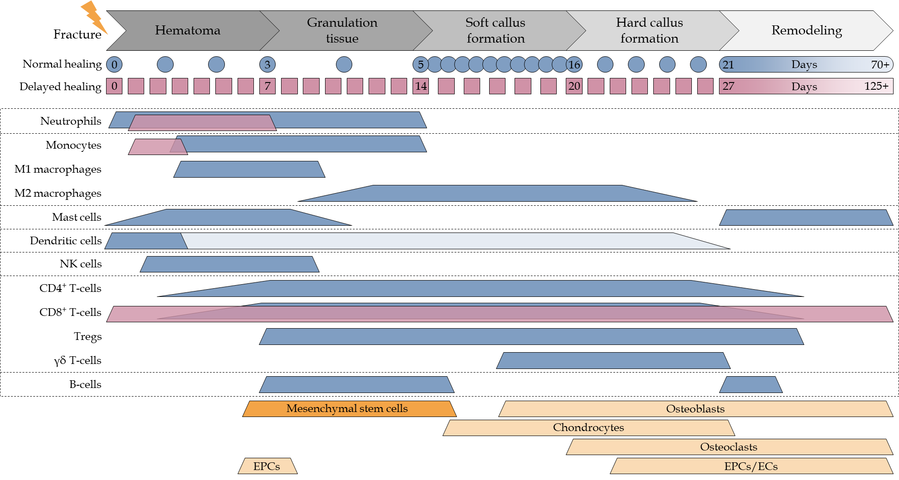
Figure 1 Cell composition at the site of fracture. During the different phases of fracture healing the cell composition at the site of fracture changes. Expected timeline of normal (blue) and delayed (magenta) fracture healing is depicted below the phases of fracture healing. Colored (blue and magenta) beams representing the timeframe where immune cells are expected to be active at the site of fracture, based on different in vivo studies. Orange beams representing the timeframe where mesenchymal stem cells, chondrocytes, osteoblasts, osteoclasts, endothelial progenitor cells, and endothelial cells are involved in the fracture healing process. CD: Cluster of differentiation; EPCs: Endothelial progenitor cells; ECs: Endothelial cells; NK: Natural killer.
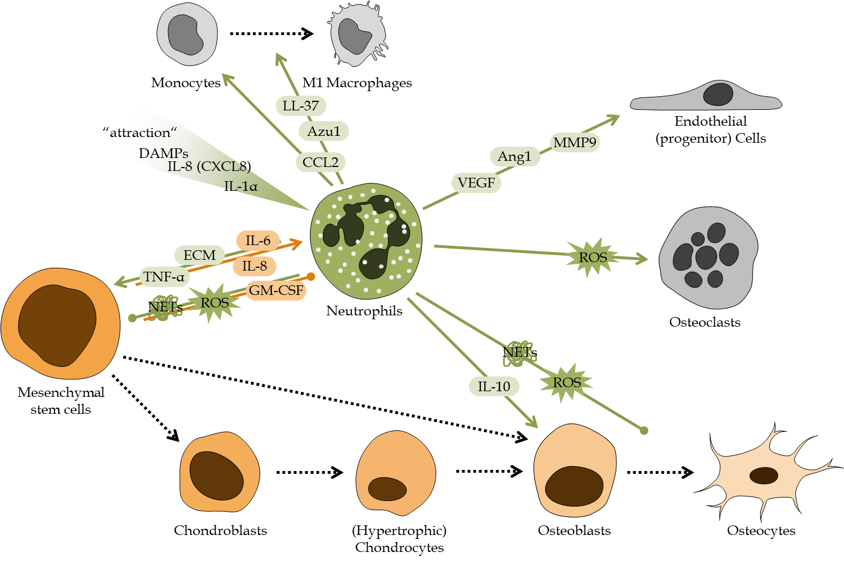
Figure 2 Schematic overview of the regulatory role of neutrophils during fracture healing. Factors secreted/released from neutrophils and mesenchymal stem cells (MSCs) regulate cellular responses during fracture healing. Neutrophil-derived factors are marked in green. MSC-derived factors are marked in orange. Local increase in danger associated molecular patterns, interleukins 8 (IL-8 or CXCL8) and 1 alpha (IL-1α) attract neutrophils to the fracture site. There neutrophils secrete /release factors e.g. tumor necrosis factor alpha, IL-10, C-C-motif chemokine ligand 2, azurocidin 1, cathelicidin (LL-37), vascular endothelial growth factor, angiopoietin 1, matrix metalloproteinase 9, reactive oxygen species, neutrophil extracellular traps, and extracellular matrix components to interact with other cells at the site of fracture. MSCs secrete/release factors e.g., granulocyte-macrophage colony-stimulating factor, IL-6 and 8 to affect neutrophils. Colored arrows depict stimulation and blunt end lines inhibition. Dashed black arrows indicate differentiation processes. DAMPs: Danger associated molecular patterns; IL: Interleukin; TNF-α: Tumor necrosis factor alpha; CCL2: C-C-motif chemokine ligand 2; CXCL: C-X-C motif chemokine ligand; Azu1: Azurocidin 1; VEGF: Vascular endothelial growth factor; Ang1: Angiopoietin 1; MMP9: Matrix metalloproteinase 9; ROS: Reactive oxygen species; NETs: Neutrophil extracellular traps; ECM: Extracellular matrix; GM-CSF: Granulocyte-macrophage colony-stimulating factor.
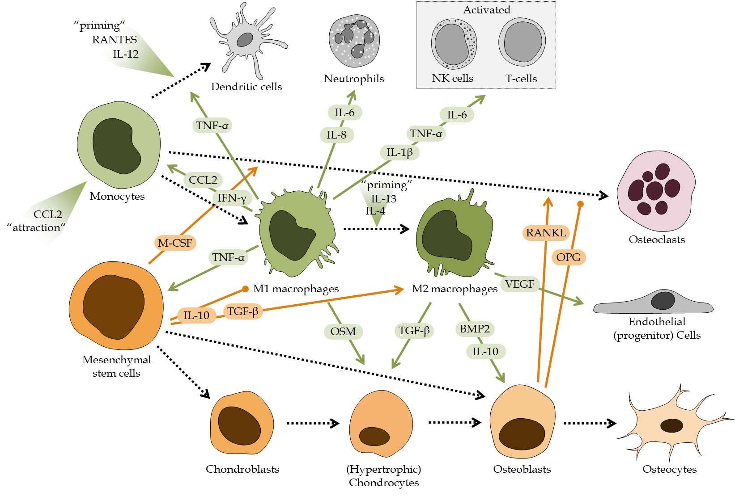
Figure 3 Schematic overview of the regulatory role of monocytes and macrophages during fracture healing. Factors secreted/released from mesenchymal stem cells (MSCs), monocytes, and monocyte-derived cells regulate cellular responses during fracture healing. Factors derived from monocytes and macrophages are marked in green. MSC-derived factors are marked in orange. Local increase in C-C-motif chemokine ligand 2 (CCL2) attract monocytes to the site of fracture, which in the presence of C-C-motif chemokine ligand 5 (RANTES or CCL5) and interleukin 12 (IL-12) differentiate into dendritic cells, in an inflammatory environment are primed towards pro-inflammatory M1 macrophages, or in the presence of IL-4 and IL-13 transform into anti-inflammatory M2 macrophages. Depending on their differentiation state, monocyte-derived cells secrete/release factors e.g., tumor necrosis factor alpha, interferon gamma, CCL2, vascular endothelial growth factor, bone morphogenetic protein 2, transforming growth factor beta (TGF-β), oncostatin M (OSM), IL-1β, IL-6, IL-8, and IL-10 to interact with other cells in the site of fracture. MSCs and MSC-derived cells secrete /release factors e.g., macrophage colony-stimulating factor, IL-10, TGF-β, receptor activator of nuclear factor kappa-Β ligand, or its antagonist osteoprotegerin to affect the monocyte derived-cells. Colored arrows depict stimulation and blunt end lines inhibition. Dashed black arrows indicate differentiation processes. CCL2: C-C-motif chemokine ligand 2; IL: Interleukin; TNF-α: Tumor necrosis factor alpha; IFN-γ: Interferon gamma; VEGF: Vascular endothelial growth factor; BMP2: Bone morphogenetic protein 2; TGF-β: Transforming growth factor beta; OSM: Oncostatin M; M-CSF: Macrophage colony-stimulating factor; RANKL: Receptor activator of nuclear factor kappa-Β ligand; OPG: Osteoprotegerin.
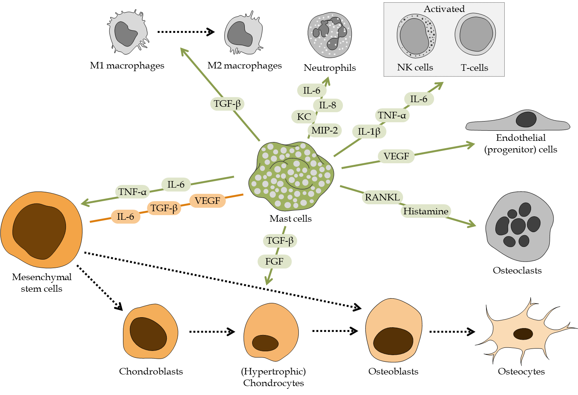
Figure 4 Schematic overview of the regulatory role of mast cells during fracture healing. Cellular responses during fracture healing are orchestrated by factors secreted/released from mast cells and mesenchymal stem cells (MSCs). Factors derived from mast cells are marked in green. MSC-derived factors are marked in orange. Mast cells communicate with other cells during fracture healing by producing and releasing a large variety of factors e.g., tumor necrosis factor alpha, interleukin 1 beta (IL-1β), IL-6, and IL-8, keratinocytes-derived chemokine (KC or CXCL1), macrophage inflammatory protein 2 (MIP-2 or CXCL2), fibroblast growth factors, vascular endothelial growth factor (VEGF), transforming growth factor beta (TGF-β), receptor activator of nuclear factor kappa-Β ligand, or histamines. MSCs in turn affect mast cells by secreted factors e.g., IL-6, TGF-β, or VEGF. Colored arrows depict stimulation and blunt end lines inhibition. Dashed black arrows indicate differentiation processes. TNF-α: Tumor necrosis factor alpha; IL: Interleukin; FGF: Fibroblast growth factor; TGF-β: Transforming growth factor beta; VEGF: Vascular endothelial growth factor; RANKL: Receptor activator of nuclear factor kappa-Β ligand.
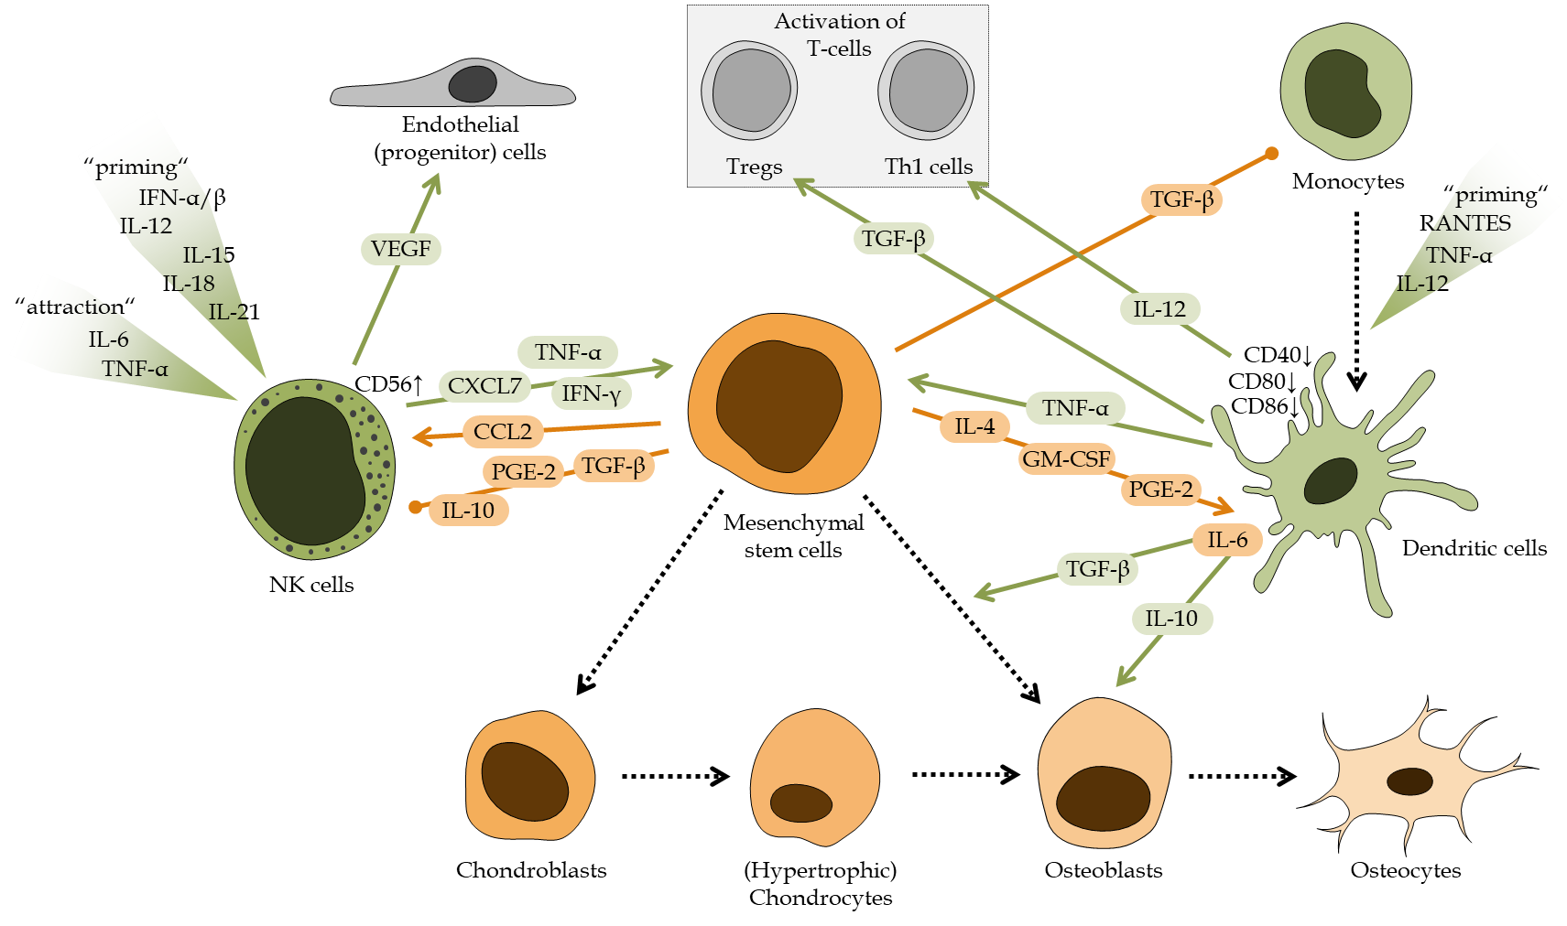
Figure 5 Schematic overview of the regulatory role of dendritic cells and natural killer cells during fracture healing. Fracture healing is affected by factors secreted / released from mesenchymal stem cells (MSCs), natural killer cells (NK cells) or monocyte-derived dendritic cells. Factors derived from NK cells and dendritic cells are marked in green. MSC-derived factors are marked in orange. NK cells are attracted and primed by local increase in factors, e.g., tumor necrosis factor alpha (TNF-α), interferons alpha and beta (IFN-β), and interleukin 6 (IL-6), IL-12, IL-15, IL-18, or IL-21. NK cells, depending on their activation status, secrete factors, e.g., TNF-α, interferon gamma, vascular endothelial growth factor, or pro-platelet basic protein (PPBP or CXCL7). Dendritic cells differentiate from monocytes in the presence of TNF-α, IL-12, and C-C-motif chemokine ligand 5 (RANTES or CCL5). Dendritic cells then secrete factors, e.g., TNF-α, transforming growth factor beta (TGF-β), and IL-10 and IL-12. Both cell types are strongly affected by factors secreted/released from MSCs, e.g., C-C-motif chemokine ligand 2 (CCL2), prostaglandin E2 (PGE2), granulocyte-macrophage colony-stimulating factor, TGF-β, or IL-4, IL-6 and IL-10. Colored arrows depict stimulation and blunt end lines inhibition. Dashed black arrows indicate differentiation processes. CD: Cluster of differentiation; NK: Natural killer; TNF-α: Tumor necrosis factor alpha; IL: Interleukin; IFN-α: Interferon alpha; IFN-γ: Interferon gamma; VEGF: Vascular endothelial growth factor; CCL: C-C-motif chemokine ligand; TGF-β: Transforming growth factor beta; PGE2: Prostaglandin E2; GM-CSF: Granulocyte-macrophage colony-stimulating factor.
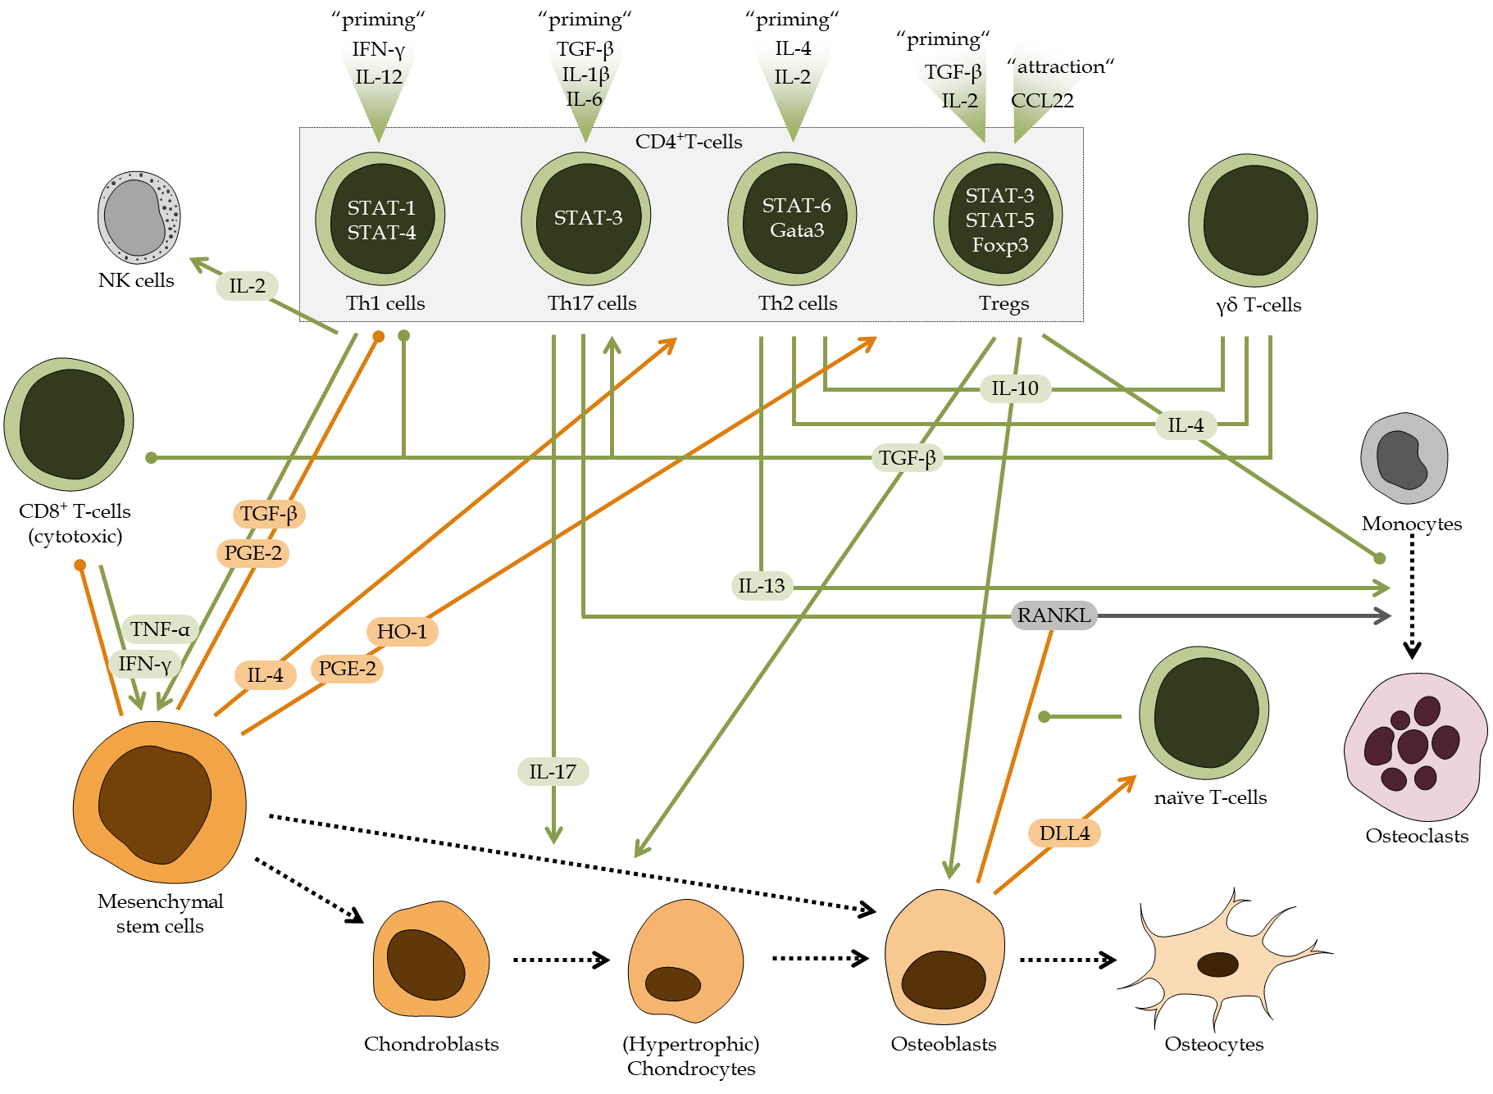
Figure 6 Schematic overview of the regulatory role of T-cells during fracture healing. Fracture healing is affected by interactions between mesenchymal stem cells (MSCs) and T-cells. However, the effect strongly depends on the activation or differentiation status of the T-cells, which is in CD4⁺ T-cells strongly dependent on activation of signal transducer and activator of transcription (STAT) signaling. Th1 cells are primed by interferon gamma (IFN-γ) and interleukin 12 (IL-12), which activate STAT-1 and STAT4 signaling in these cells. Th1 cells then secrete factors e.g., tumor necrosis factor alpha (TNF-α), IFN-γ, or IL-2. Th17 cells are primed by transforming growth factor beta (TGF-β), IL-1β and IL-6, which activate STAT3 signaling in the cells. Th17 cells then secrete factors e.g., IL-17 and receptor activator of nuclear factor kappa-Β ligand (RANKL). Th2 cells, characterized by activated STAT-6 and GATA3 (GATA Binding Protein 3) signaling, are primed by IL-2 and IL-4, and secrete factors e.g., IL-4, IL-10 and IL-13. Regulatory T cells (Tregs) are attracted and primed by factors, e.g., C-C-motif chemokine ligand 22 (CCL22), TGF-β, and IL-2, which activate forkhead box P3, STAT-3 and STAT-5 signaling in these cells. Tregs then secrete factors e.g., IL-4, IL-10, and TGF-β, to regulate osteoblast and osteoclast function, but also activation of T-cells. The same factors (IL-4, IL-10, and TGF-β) are also released by γδ T-cells. CD8⁺ cytotoxic T-cells enhance the pro-inflammatory reaction by releasing factors, e.g., TNF-α and IFN-γ. The different T-cell subsets, are influenced by MSCs and osteoblasts, which secrete / release factors, e.g. TGF-β, IL-4, prostaglandin E2, heme oxygenase 1 (HO-1), RANKL, or delta like ligand 4. Colored arrows depict stimulation and blunt end lines inhibition. Dashed black arrows indicate differentiation processes. CD: Cluster of differentiation; NK: Natural killer; TNF-α: Tumor necrosis factor alpha; IL: Interleukin; IFN: Interferon; CCL: C-C-motif chemokine ligand; TGF-β: Transforming growth factor beta; PGE2: Prostaglandin E2; RANKL: Receptor activator of nuclear factor kappa-Β ligand; STAT: Signal transducer and activator of transcription; Tregs: Regulatory T cells; Foxp3: Forkhead box P3; DLL4: Delta like ligand 4.
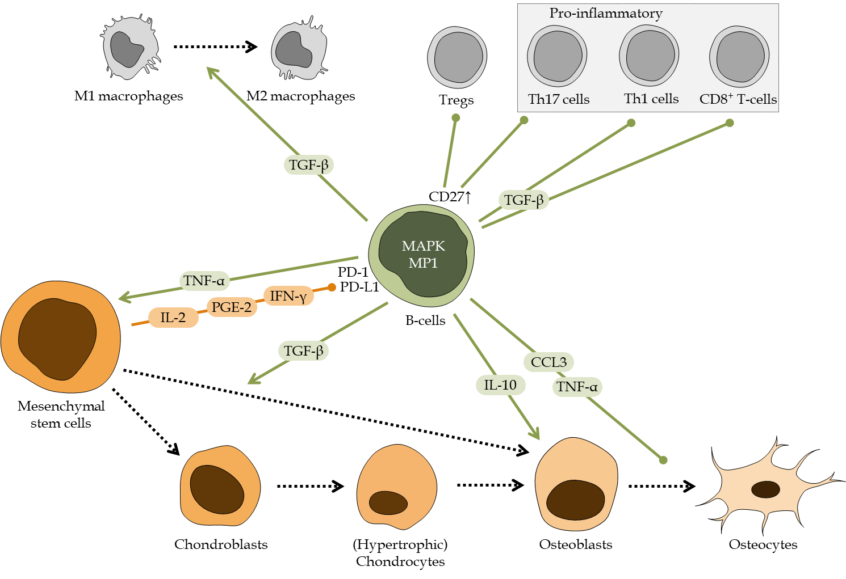
Figure 7 Schematic overview of the regulatory role of B-cells during fracture healing. Fracture healing is affected by interactions between mesenchymal stem cells (MSCs) and B-cells. MSCs may affect B-cells by factors, e.g., interleukin 2 (IL-2), prostaglandin E2, and interferon gamma (IFN-γ), which interact with the programmed cell death 1 receptor and its ligand. Resulting in activation of mitogen-activated protein kinase and its downstream target MEK partner 1, induces B-cells to secrete/release factors, e.g., tumor necrosis factor alpha, transforming growth factor beta, IL-10, and C-C-motif chemokine ligand 3. Colored arrows depict stimulation and blunt end lines inhibition. Dashed black arrows indicate differentiation processes. CD: Cluster of differentiation; TNF-α: Tumor necrosis factor alpha; IL: Interleukin; IFN: Interferon; CCL: C-C-motif chemokine ligand; TGF-β: Transforming growth factor beta; PGE2: Prostaglandin E2; Tregs: Regulatory T cells; MAPK: Mitogen-activated protein kinase; PD-1: Programmed cell death 1; PD-L1: Programmed cell death ligand 1; MP1: MEK partner 1.
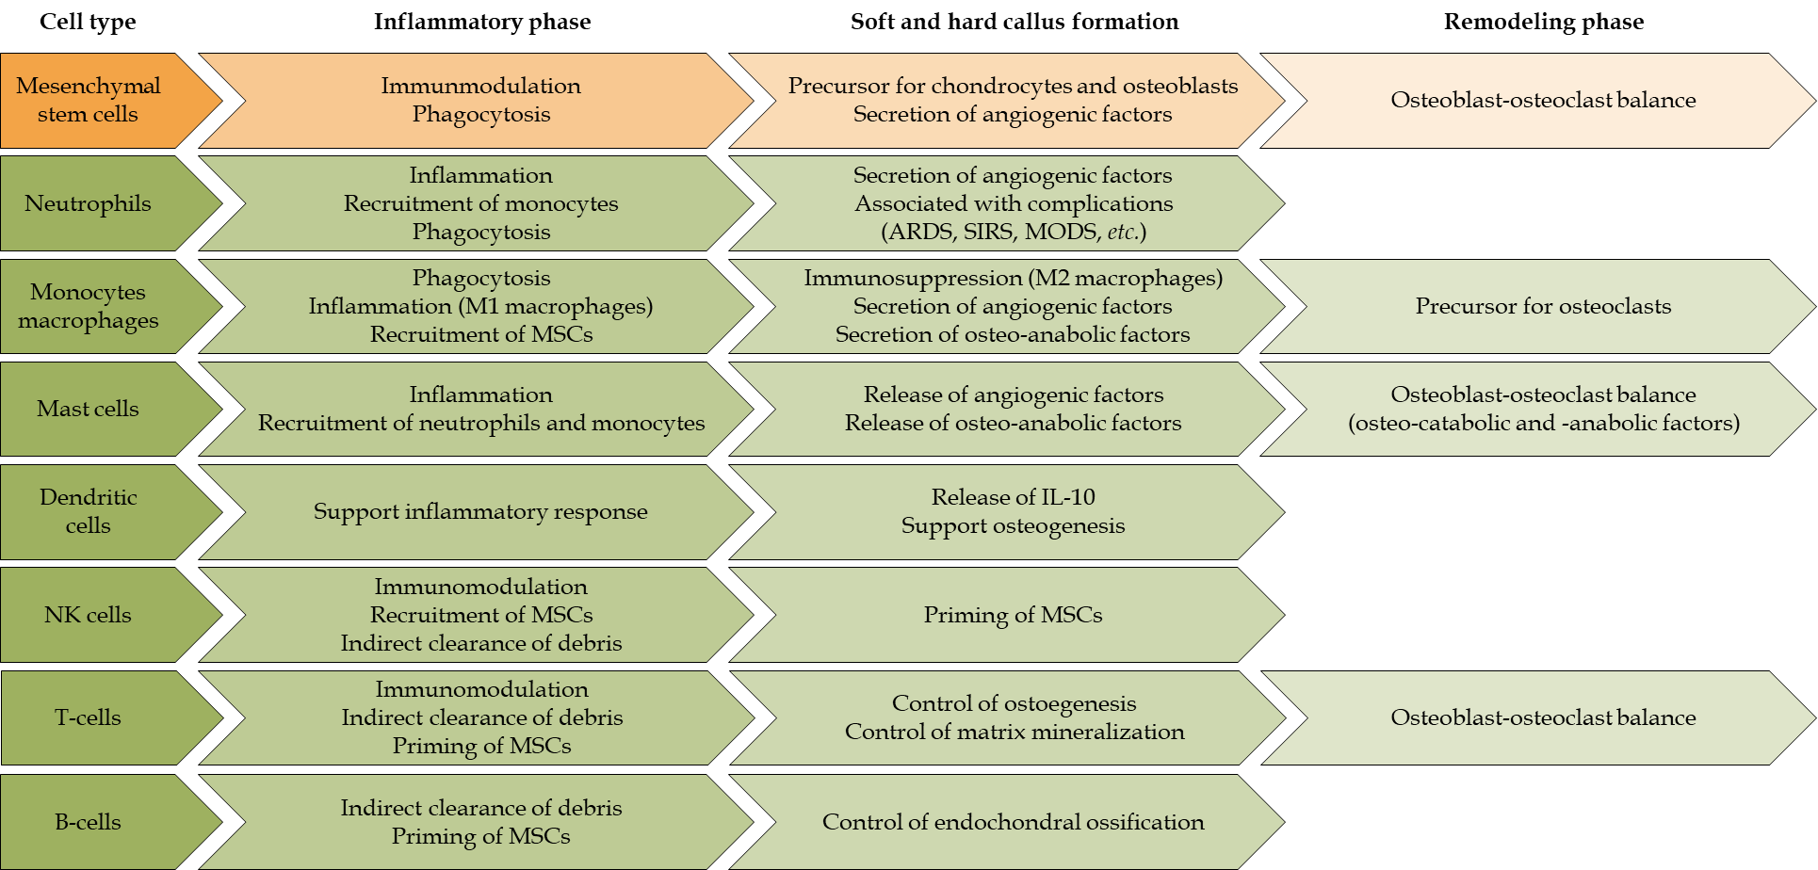
Figure 8 Overview of the roles of immune cells and mesenchymal stem cells during the different phases of fracture healing. NK cells: Natural killer cells; MSCs: Mesenchymal stem cells; ARDS: Acute respiratory distress syndrome; SIRS: Systemic inflammatory response syndrome; MODS: Multi-organ dysfunction syndrome; IL-10: Interleukin 10.

