Name of Journal: World Journal of Gastrointestinal Endoscopy
Manuscript NO: 90022
Manuscript Type: ORIGINAL ARTICLE

Retrospective Study
Tumor size discrepancy between endoscopic and pathological evaluations in colorectal endoscopic submucosal dissection

Onda T et al. Tumor size discrepancy in colorectal ESD

Takeshi Onda, Osamu Goto, Toshiaki Otsuka, Yoshiaki Hayasaka, Shun Nakagome, Tsugumi Habu, Yumiko Ishikawa, Kumiko Kirita, Eriko Koizumi, Hiroto Noda, Kazutoshi Higuchi, Jun Omori, Naohiko Akimoto, Katsuhiko Iwakiri

Takeshi Onda, Osamu Goto, Shun Nakagome, Tsugumi Habu, Yumiko Ishikawa, Kumiko Kirita, Eriko Koizumi, Hiroto Noda, Kazutoshi Higuchi, Jun Omori, Naohiko Akimoto, Katsuhiko Iwakiri, Department of Gastroenterology, Nippon Medical School, Graduate School of Medicine, Bunkyo-ku 113-8603, Tokyo, Japan

Osamu Goto, Endoscopy Center, Nippon Medical School Hospital, Bunkyo-ku 113-8603, Tokyo, Japan

Toshiaki Otsuka, Department of Hygiene and Public Health, Nippon Medical School, Bunkyo-ku 113-8603, Tokyo, Japan

Yoshiaki Hayasaka, Center for Medical Education, Nippon Medical School, Bunkyo-ku 113-8603, Tokyo, Japan

Author contributions: Onda T collected the research study data, analyzed the data, and wrote the manuscript; Goto O conceived the study and design and interpreted the data; Otsuka T and Hayasaka Y performed the statistical analyses; Nakagome S, Habu T, Ishikawa Y, Kirita K, Koizumi, E, Noda H, Higuchi K, Omori J, and Akimoto N critically revised the manuscript for important intellectual content; Iwakiri K provided research supervision.

Corresponding author: Osamu Goto, PhD, Associate Professor, Department of Gastroenterology, Nippon Medical School, Graduate School of Medicine, 1-1-5 Sendagi, Bunkyo-ku 113-8603, Tokyo, Japan. o-goto@nms.ac.jp

Received: November 22, 2023
Revised: December 22, 2023
Accepted: January 29, 2024
Published online: March 16, 2024

Abstract
BACKGROUND
Tumor size impacts the technical difficulty and histological curability of colorectal endoscopic submucosal dissection (ESD); however, the preoperative evaluation of tumor size is often different from histological assessment. Analyzing influential factors on failure to obtain an accurate tumor size evaluation could help prepare optimal conditions for safer and more reliable ESD.

AIM
To investigate the tumor size discrepancy between endoscopic and pathological evaluations and the influencing factors.

METHODS
This was a retrospective study conducted at a single institution. A total of 377 lesions removed by colorectal ESD at our hospital between April 2018 and March 2022 were collected. We first assessed the difference in size with an absolute percentage of the scaling discrepancy. Subsequently, we compared the clinicopathological characteristics of the correct scaling group (> -33% and < 33%) with that of the incorrect scaling group (< -33% or > 33%), which was further subdivided into the underscaling group (-33% or less of the discrepancy) and overscaling group (33% or more of the discrepancy), respectively. As secondary outcome measures, parameters on size estimation were compared between the underscaling and correct scaling groups, as well as between the overscaling and correct scaling groups. Finally, multivariate analysis was performed in terms of the following relevant parameters on size estimation: Pathological size, location, and possible influential factors (P < 0.1) in the univariate analysis.

RESULTS
The mean of absolute percentage in the scaling discordance was 21%, and 91 lesions were considered to be incorrectly estimated in size. The incorrect scaling was significantly remarkable in larger lesions (40 mm vs 28 mm; P < 0.001) and less experience (P < 0.001), and these two factors were influential on the underscaling (75 lesions; P < 0.001). Conversely, compared with the correct scaling group, 16 lesions in the overscaling group were significantly small (20 mm vs 28 mm; P < 0.001), and the small lesion size was influential on the overscaling (P = 0.002).

CONCLUSION
Lesions indicated for colorectal ESD tended to be underestimated in large tumors, but overestimated in small ones. This discrepancy appears worth understanding for optimal procedural preparation.

Key Words: Endoscopic submucosal dissection; Colorectal tumor; Tumor size; Size estimation; Size discrepancy

©The Author(s) 2024. Published by Baishideng Publishing Group Inc. All rights reserved.

Citation: Onda T, Goto O, Otsuka T, Hayasaka Y, Nakagome S, Habu T, Ishikawa Y, Kirita K, Koizumi E, Noda H, Higuchi K, Omori J, Akimoto N, Iwakiri K. Tumor size discrepancy between endoscopic and pathological evaluations in colorectal endoscopic submucosal dissection. World J Gastrointest Endosc 2024; 16(3): 136-147
URL: https://www.wjgnet.com/1948-5190/full/v16/i3/136.htm
DOI: https://dx.doi.org/10.4253/wjge.v16.i3.136

Core Tip: Tumor size impacts the technical difficulty and histological curability of colorectal endoscopic submucosal dissection (ESD). However, the preoperative evaluation of tumor size is often different from histological assessment. We retrospectively investigated the colorectal tumor size discrepancy between endoscopic and pathological evaluations and influential factors on the discordance. Conclusively, the data demonstrated that the accuracy in the size estimation of candidates for colorectal ESD was influenced by the tumor size and much experience. These lesions tended to be underestimated in large tumors, but overestimated in small ones. This discrepancy appears worth understanding for optimal procedural preparation.

INTRODUCTION
Colorectal cancer is one of the most common malignancies and relevant disease worldwide^{[1]}. The early detection and treatment of this disease are significant to prolong life expectancy; therefore, aggressive removal of colorectal polyps including precancerous lesions is recommended using colonoscopy^{[2,3]}.
Small colorectal polyps can be easily removed by polypectomy or endoscopic mucosal resection (EMR), whereas large lesions require technically challenging techniques including endoscopic submucosal dissection (ESD). Due to anatomical characteristics, including a thin intestinal wall and the presence of folds and bends, colorectal ESD is technically more difficult than upper gastrointestinal tract ESD. Intraoperative perforation, which is one of the major adverse events in colorectal ESD, is reported to be 1.3%-18.0%^{[4-7]}. Influential factors on the perforation in colorectal ESD include tumor diameter, fibrosis, and flexure^{[5]}. Moreover, it is reported that a larger tumor^{[6,7]}, less experience of endoscopists^{[6]}, and paradoxical movement^{[7]} are independent factors contributing to the difficulty of colorectal ESD. Particularly, a strong correlation is observed between tumor diameter and treatment duration^{[8]}.
Accordingly, an accurate understanding of tumor characteristics including tumor size, is significant for a safe and time-saving procedure. However, the preoperative estimation of the tumor diameter is often different from the postoperative histological size, and when a novice endoscopist is to treat an unexpectedly large lesion, unfavorable events can occur with a long procedural time.
There have been several studies on the discrepancy in the tumor diameter of colorectal neoplasia^{[9-12]}. However, these studies are mainly on small polyps, wherein tumors of approximately 10 mm are believed to be often overestimated^{[9,10]}. Conversely, pieces of evidence remain lacking on large tumors^{[12]}, particularly tumors that can be candidates for resection by ESD.
In this study, to investigate the accuracy of the preoperative endoscopic evaluation of tumor size, we retrospectively assessed the discrepancy between pre- and postoperatively evaluated tumor diameters of lesions that are indicated for colorectal ESD. Subsequently, influential factors on failure for an accurate tumor size evaluation were investigated.

MATERIALS AND METHODS
Study design
This was a retrospective study conducted at a single institution. In accordance with the Declaration of Helsinki, we obtained approval from the institutional review board of our hospital before study initiation. Consent from each patient was obtained as an opt-out; therefore, written consent was waived.

Data collection and ESD procedure
Of the 395 lesions removed by colorectal ESD performed between April 2018 and March 2022, 6 lesions with insufficient description of data on preoperative and/or pathological tumor diameter and 12 lesions with incomplete resection were excluded. Finally, we collected 377 lesions in this study (Figure 1).
ESD indication criteria were based on the Japanese Colorectal ESD/EMR guidelines^{[4]}. We mainly used the PCF-290ZI endoscope (Olympus Co., Ltd., Tokyo, Japan) with a transparent straight hood (D-201-12704; Olympus) under carbon dioxide insufflation. A 0.4% sodium hyaluronate solution (Ksmart; Olympus) diluted five times with normal saline, which included a small amount of indigo carmine, was used for submucosal injection. A mucosal incision was made around the tumor, and submucosal dissection for en bloc removal was performed using the DualKnife (KD-655Q; Olympus). A high-frequency generator (VIO 3; Erbe Elektromedizin GmbH, Tübingen, Germany) was used during ESD. ST-hood (DH-29CR; Fujifilm Co., Ltd., Tokyo, Japan), hemostatic forceps (FD-411QR; Olympus), or other endoscopic devices were used according to the situation. The transanally retrieved specimen was promptly spread, pinned on a sponge board, and immersed into 10% neutral buffered formalin for fixation for histological evaluation by pathologists.

Pre- and postoperative size assessment
For the preoperative tumor size evaluation, we referred to endoscopic reports, which were documented in preoperative colonoscopy before ESD. The tumor size, which was described as the largest diameter, was obtained from the endoscopic report at our institution when we performed the preoperative check or at other clinics where the tumor was indicated and introduced to us when ESD was directly booked without preoperative colonoscopy at our institution.
Postoperative size evaluation was performed using the largest diameter on the pathological report. In detail, board-certificated pathologists evaluated the specimen, which was sliced at 2-3-mm intervals. Based on the final pathological diagnosis, the pathologists in charge demarcated the neoplastic area on the specimen photo that was taken before slicing, and the maximal diameter of the tumor was described in a pathological report.

Outcome measures
As a primary outcome measure, the scaling discrepancy, which indicated an absolute percentage of the size discordance (a preoperatively estimated endoscopic diameter minus a postoperatively measured histological diameter) in a postoperatively measured diameter, was evaluated (Figure 2). Subsequently, lesions were divided into the following two groups according to the degree of discrepancy: The correct scaling group (> -33% and < 33% of the discordance) and the incorrect scaling group (≤ -33% or ≥ 33% of the discordance). Lesion-related parameters including pathological size, location, morphology, histology, localization, and degree of circumference were used to investigate influential factors on the discrepancy. Furthermore, endoscopist-related parameters included the experience of endoscopists who performed preoperative colonoscopy and the hospital type where the preoperative colonoscopy was performed. The multivariate analysis was followed by univariate analyses, which focused on the tumor size, location, and other parameters that seemed to be influential by showing that the P value was < 0.1 in the preceding univariate analysis.
As secondary outcome measures, the abovementioned parameters were compared between the underscaling (-33% or less of the discrepancy) and correct scaling groups as well as between the overscaling (33% or more of the discrepancy) and correct scaling groups, respectively. Subsequently, multivariate analysis was performed in terms of the following relevant parameters on size estimation: pathological size, location, and possible influential factors (P < 0.1) in the univariate analysis. When the size, a continuous parameter, was indicated as the influential factor, we drew a receiver operating characteristic (ROC) curve to investigate an optimal cut-off value of the size to differentiate the under/overscaling group from the correct scaling group.
Tumor locations were grouped into the colon and rectum. Morphology was divided into the following two macroscopic groups according to the Paris classification: The protruded type, which is 0-I with protruded features; and the flat type, which is 0-II with flat features. Histology was grouped into adenoma and adenocarcinoma. Regarding the localization, we focused on whether the lesion is over the haustra because it may hamper an entire lesion in a single visual field. Regarding the degree of circumference, lesions were divided into two groups by setting one-third as the cut-off value. The experience of endoscopists was classified on the basis of the years of experience in endoscopy and the number of ESD performed; those with 5 years or more of endoscopic experience and at least 100 cases of ESD were defined as experienced, and those who did not meet these criteria were defined as less-experienced. As all doctors at the clinics were general physicians and their experience in ESD is unknown, they were defined as less-experienced in this study. Regarding the hospital type, we set two groups, a referral hospital (our institution) and clinics, according to where the preoperative colonoscopy was performed just before ESD.

Statistical analysis
Categorical variables were analyzed using the chi-squared test or Fisher’s exact test. Continuous variables were tested for normality and analyzed using the Mann-Whitney U test between the two groups and using the Kruskal-Wallis H test among the three groups. To adjust for potential confounders, we used multivariate logistic regression. The Pearson product-moment correlation coefficient was used for regression analysis. The cut-off value was evaluated in the point with the highest Youden’s index. All statistical analyses were performed using Statistical Package for the Social Sciences (version 27, IBM, Armonk, NY, United States), and P < 0.05 was considered statistically significant.

RESULTS
Clinicopathological characteristics and size discrepancy
The mean age of patients was 70 years, and 61% of them were males. Approximately one-fifth of cases were located on the rectum. The number of experienced endoscopists in preoperative diagnosis was almost similar to that of less-experienced endoscopists. The mean size of preoperatively estimated and postoperatively measured tumors was 26.0 mm ± 10.5 mm and 31.0 mm ± 15.2 mm, respectively, and the mean of absolute percentage in the scaling discordance between pre- and postoperative evaluations was 21.0% ± 15.4% (Table 1). The distribution of lesions regarding the discordance is shown in Figure 3.

Influential factors on the incorrect scaling
Regarding the scaling discrepancy, the numbers of lesions in the incorrect and correct scaling groups were 91 and 286, respectively (Figure 1). As shown in Table 2, large lesions, the involvement of the haustra, over one-third of the lumen, and the assessment by less-experienced are significantly common in the incorrect scaling group. Multivariate analysis demonstrated that larger tumor size and less experience were significantly influential on the incorrect scaling of the size assessment (Table 3).

Influential factors on under/overscaling
The incorrect scaling group (91 lesions) was further divided into the under- and overscaling groups, with 75 and 16 lesions, respectively (Figure 1). As shown in Table 4, the influential factors on underscaling include tumor size, the involvement of the haustra, and over one-third of the lumen. Multivariate analysis showed that larger size and less experience significantly affected the underestimation of the scaling in lesion size (Table 5). The ROC curve indicated that the optimal cut-off value was 29.5 mm in 0.779 of the maximal area under the curve (AUC), with sensitivity and specificity of 80.0% and 69.9%, respectively.
Regarding overscaling, tumor size was the sole influential factor. However, lesions in the overscaling group were smaller than those in the correct scaling group, which was the opposite result in the analysis on underscaling (Table 6). Multivariate analysis showed that smaller size was significantly influential on overscaling (Table 7). In the ROC curve, the optimal cut-off value was 18.5 mm when the maximal AUC was 0.768, with sensitivity and specificity of 88.5% and 56.2%, respectively.

DISCUSSION
The present study showed that the tumor size was approximately ± 20% of the scaling discrepancy before colorectal ESD. One-fourth of those lesions were incorrectly evaluated in size, mainly toward the underestimation; this tendency was likely observed in large tumors > 3 cm and less-experienced endoscopists. By contrast, the overestimation, although occurred less frequently, tended to be made in smaller lesions < 2 cm. Overall, in the preoperative colonoscopy before ESD, lesions at both extremities in size were likely to be adjusted to the moderate diameter.
In this study, the mean pathological diameter of colorectal lesions that were removed by ESD was 31 mm, whereas the mean preoperative endoscopic evaluation diameter was 26 mm, indicating that the lesion size was almost correctly estimated before the procedure. The mean scaling discrepancy (± 21%) appeared to be an acceptable discordance. However, considering that the correct scaling was defined as from -33% to 33% of discrepancies, one-fourth (91/377) of lesions were incorrectly evaluated preoperatively. Multivariate analysis suggested that large lesions and less experience were independent influential factors on incorrect scaling. Regarding large lesions, the reason for the incorrect scaling may be attributed to the structure of the lens mounted on an endoscope. An endoscopic lens is designed as a fish-eye, which can visualize a wider field than reality. Therefore, a large objective tends to appear smaller. On the other hand, less ESD experience may contribute to incorrect size evaluation of large lesions due to less experience both in visualizing the actual specimen pinned following ESD and reviewing pathological results. In clinical practice, endoscopists can adjust the preoperative endoscopic size to the actual pathological size by repeatedly reviewing pathological diagnoses of endoscopically removed polyps. However, lesions that are candidates for ESD are not frequently encountered compared with small polyps. Therefore, endoscopists with less ESD experience should have less opportunity of providing feedback on the pathological diagnosis of ESD to further endoscopic evaluation.
In the incorrect scaling, underestimation mainly occurred in 82% of lesions (75/91). The comparison between the underscaling and correct scaling groups showed similar results to that between the incorrect and correct scaling groups. This suggests that the abovementioned speculations are considered appropriate. Particularly, lesions > 3 cm in actual size are inclined to be underscaled, as indicated in the ROC curve analysis. In contrast, 18% of the incorrect scaling was misdiagnosed as overestimation. Interestingly, the overestimation was also influenced by lesion size; however, small lesions tend to appear larger, which is the opposite phenomenon of underestimation. This reason may not be because of endoscopic visualization but the indication criteria of colorectal ESD. Considering the medical insurance from the Japanese government, the indication criteria of colorectal ESD for cancers are lesions ≥ 2 or ≥ 1 cm with possible severe submucosal fibrosis. In this condition, when endoscopists detect a small tumor that should be removed in an en bloc fashion but consider it difficult by snaring, they may be psychologically inclined to diagnose it as larger than the actual size to meet the ESD criteria. The small number of lesions in the overscaling group may be due to the nature of the lesions included in this study. Previous studies have indicated that small polyps are likely to be overestimated^{[9,10]}. In this study, the lesions were relatively large because this study included lesions removed by ESD. Therefore, we consider that the lesions in this study were less likely to be overscaled.
If we are aware that the larger the lesion appears, the much larger it may be, we can prepare an optimal condition for safe and reliable ESD as per operator’s discretion, including an endoscopic room for a long procedure time and the degree of sedation needed. Moreover, appropriate informed consent can be provided to patients and families. This tendency will be more distinct when the preoperative colonoscopy is performed by an endoscopist with less experience. Conversely, when an ESD candidate is small, it may be smaller than it appears, thereby making it suitable for removal via snaring resection, wherein unnecessary ESD can be avoided; however, sufficient technical skills for en bloc EMR are required.
This study had several limitations. First, it was a retrospective single-center study. Second, several endoscopists and pathologists were involved in the pre- and postoperative diagnoses, respectively. Third, since the shape of tumors was flexibly changed under intraluminal conditions, some lesion characteristics regarding the haustra or the degree of circumference could not be completely objective. Fourth, the threshold of discrepancies (33%) was subjectively determined in this study because referable previous papers were lacking. Lastly, the tumor size was slightly shortened following fixation with formalin; however, this change should be negligible^{[13]}.

CONCLUSION
The present study demonstrated that the accuracy in preoperative size estimation of large colorectal tumors that could be indicated for ESD was influenced by the tumor size and much experience. These lesions tended to be underestimated in large tumors, whereas overestimated in small ones, suggesting that endoscopists, particularly less-experienced in ESD, were inclined to change the lesions to a “moderate” size. The understanding of this discrepancy may be helpful for preoperative informed consent for patients and the decision-making of operative conditions.

ARTICLE HIGHLIGHTS
Research background
Pathological assessment of tumor size often differs from preoperative evaluation, which could render treatment difficult. This study retrospectively investigated size discrepancies between endoscopic and pathological assessment and factors influencing this discordance.

Research motivation
The preoperative estimation of the tumor size is often different from the postoperative histological size, and when a novice endoscopist is to treat an unexpectedly large lesion, unfavorable events can occur with a long procedural time. Accordingly, an accurate understanding of tumor characteristics including tumor size, is significant for a safe and time-saving procedure.

Research objectives
To analyze the discrepancy between tumor size in endoscopic and pathological assessment and the factors influencing this discrepancy will enable a more accurate prediction of tumor size in the preoperative phase.

Research methods
We included 377 lesions removed with colorectal endoscopic submucosal dissection (ESD) at our hospital between April 2018 and March 2022. We classified three groups to analyze the discrepancy by size variation: Overestimation, underestimation, and the correct diagnosis groups. We compared clinicopathological characteristics among these groups.

Research results
We showed that the larger the lesion, the more likely it is to be underestimated. This preoperative underestimation was contrary to previous reports for small polyps. The larger the lesion, the longer the ESD treatment time needed because ESD treatment time is influenced by lesion size. The present study results revealed that larger lesions should be assumed to require longer-than-predicted treatment time.

Research conclusions
Recognizing that the larger the lesion appears, the more likely it is to be a larger lesion, optimal conditions for safe and reliable ESD can be prepared according to the operator’s judgment, including an operation room for longer procedure times and the degree of sedation required.

Research perspectives
To investigate how tumor size discrepancies between endoscopic and pathological assessment affect ESD outcomes.

REFERENCES
1 Sung H, Ferlay J, Siegel RL, Laversanne M, Soerjomataram I, Jemal A, Bray F. Global Cancer Statistics 2020: GLOBOCAN Estimates of Incidence and Mortality Worldwide for 36 Cancers in 185 Countries. CA Cancer J Clin 2021; 71: 209-249 [PMID: 33538338 DOI: 10.3322/caac.21660]
2 Tanaka S, Kashida H, Saito Y, Yahagi N, Yamano H, Saito S, Hisabe T, Yao T, Watanabe M, Yoshida M, Saitoh Y, Tsuruta O, Sugihara KI, Igarashi M, Toyonaga T, Ajioka Y, Kusunoki M, Koike K, Fujimoto K, Tajiri H. Japan Gastroenterological Endoscopy Society guidelines for colorectal endoscopic submucosal dissection/endoscopic mucosal resection. Dig Endosc 2020; 32: 219-239 [PMID: 31566804 DOI: 10.1111/den.13545]
3 Park CH, Yang DH, Kim JW, Kim JH, Kim JH, Min YW, Lee SH, Bae JH, Chung H, Choi KD, Park JC, Lee H, Kwak MS, Kim B, Lee HJ, Lee HS, Choi M, Park DA, Lee JY, Byeon JS, Park CG, Cho JY, Lee ST, Chun HJ. Clinical Practice Guideline for Endoscopic Resection of Early Gastrointestinal Cancer. Clin Endosc 2020; 53: 142-166 [PMID: 32252507 DOI: 10.5946/ce.2020.032]
4 Rahmi G, Hotayt B, Chaussade S, Lepilliez V, Giovannini M, Coumaros D, Charachon A, Cholet F, Laquière A, Samaha E, Prat F, Ponchon T, Bories E, Robaszkiewicz M, Boustière C, Cellier C. Endoscopic submucosal dissection for superficial rectal tumors: prospective evaluation in France. Endoscopy 2014; 46: 670-676 [PMID: 24977400 DOI: 10.1055/s-0034-1365810]
5 Hori K, Uraoka T, Harada K, Higashi R, Kawahara Y, Okada H, Ramberan H, Yahagi N, Yamamoto K. Predictive factors for technically difficult endoscopic submucosal dissection in the colorectum. Endoscopy 2014; 46: 862-870 [PMID: 25208032 DOI: 10.1055/s-0034-1377205]
6 Zhu M, Xu Y, Yu L, Niu YL, Ji M, Li P, Shi HY, Zhang ST. Endoscopic submucosal dissection for colorectal laterally spreading tumors: Clinical outcomes and predictors of technical difficulty. J Dig Dis 2022; 23: 228-236 [PMID: 35297187 DOI: 10.1111/1751-2980.13091]
7 Sato K, Ito S, Kitagawa T, Kato M, Tominaga K, Suzuki T, Maetani I. Factors affecting the technical difficulty and clinical outcome of endoscopic submucosal dissection for colorectal tumors. Surg Endosc 2014; 28: 2959-2965 [PMID: 24853849 DOI: 10.1007/s00464-014-3558-y]
8 Agapov M, Dvoinikova E. Factors predicting clinical outcomes of endoscopic submucosal dissection in the rectum and sigmoid colon during the learning curve. Endosc Int Open 2014; 2: E235-E240 [PMID: 26135099 DOI: 10.1055/s-0034-1377613]
9 Anderson BW, Smyrk TC, Anderson KS, Mahoney DW, Devens ME, Sweetser SR, Kisiel JB, Ahlquist DA. Endoscopic overestimation of colorectal polyp size. Gastrointest Endosc 2016; 83: 201-208 [PMID: 26318830 DOI: 10.1016/j.gie.2015.06.058]
10 Eichenseer PJ, Dhanekula R, Jakate S, Mobarhan S, Melson JE. Endoscopic mis-sizing of polyps changes colorectal cancer surveillance recommendations. Dis Colon Rectum 2013; 56: 315-321 [PMID: 23392145 DOI: 10.1097/DCR.0b013e31826dd138]
11 Schoen RE, Gerber LD, Margulies C. The pathologic measurement of polyp size is preferable to the endoscopic estimate. Gastrointest Endosc 1997; 46: 492-496 [PMID: 9434214 DOI: 10.1016/S0016-5107(97)70002-6]
12 Buijs MM, Steele RJC, Buch N, Kolbro T, Zimmermann-Nielsen E, Kobaek-Larsen M, Baatrup G. Reproducibility and accuracy of visual estimation of polyp size in large colorectal polyps. Acta Oncol 2019; 58: S37-S41 [PMID: 30897992 DOI: 10.1080/0284186X.2019.1588990]
13 Moug SJ, Vernall N, Saldanha J, McGregor JR, Balsitis M, Diament RH. Endoscopists' estimation of size should not determine surveillance of colonic polyps. Colorectal Dis 2010; 12: 646-650 [PMID: 19486095 DOI: 10.1111/j.1463-1318.2009.01870.x]

Footnotes
Institutional review board statement: The study was reviewed and approved by the Nippon Medical School, Graduate School of Medicine Institutional Review Board (Approval No. 30-02-1077).

Informed consent statement: Informed consent was obtained by opting out, not in writing, as this is a retrospective analysis.

Conflict-of-interest statement: The authors have no conflicts of interest to declare.

Data sharing statement: No additional data are available.

Open-Access: This article is an open-access article that was selected by an in-house editor and fully peer-reviewed by external reviewers. It is distributed in accordance with the Creative Commons Attribution NonCommercial (CC BY-NC 4.0) license, which permits others to distribute, remix, adapt, build upon this work non-commercially, and license their derivative works on different terms, provided the original work is properly cited and the use is non-commercial. See: https://creativecommons.org/Licenses/by-nc/4.0/

Provenance and peer review: Unsolicited article; Externally peer reviewed.
Peer-review model: Single blind

Peer-review started: November 22, 2023
First decision: December 7, 2023
Article in press: January 29, 2024

Specialty type: Gastroenterology & hepatology
Country/Territory of origin: Japan
Peer-review report’s scientific quality classification
Grade A (Excellent): 0
Grade B (Very good): B, B
Grade C (Good): C
Grade D (Fair): D
Grade E (Poor): 0

P-Reviewer: Cho J, South Korea; Shi RH, China S-Editor: Chen YL L-Editor: Filipodia P-Editor: Zhao YQ
Figure Legends
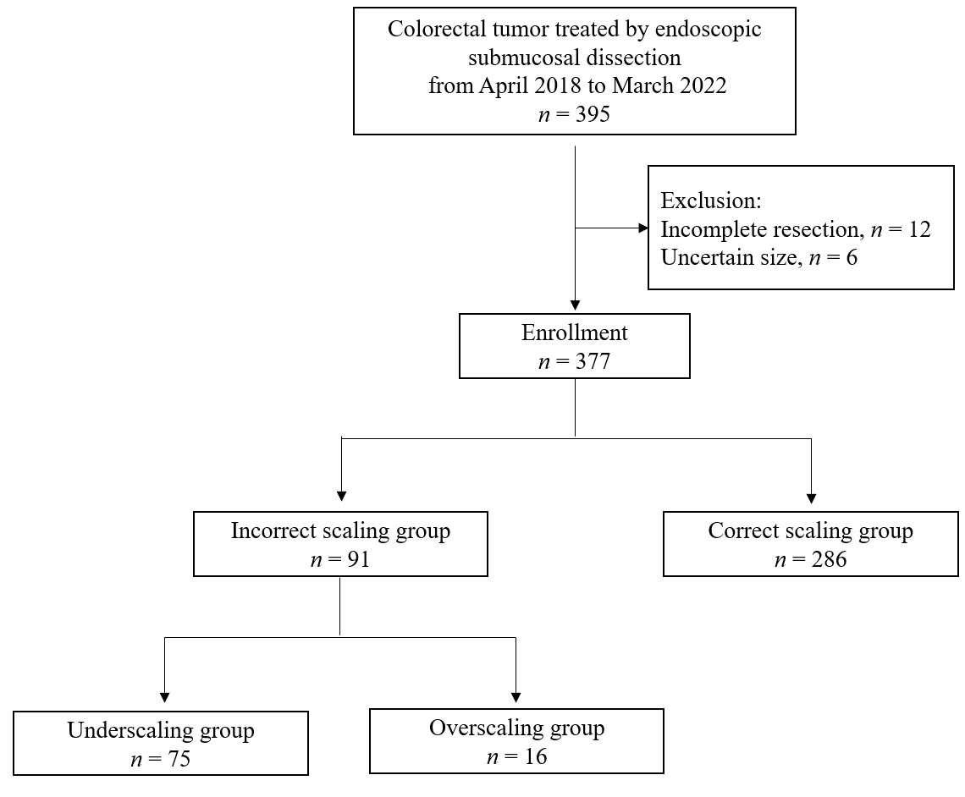
Figure 1 Flowchart of lesion enrollment in this study. Of the 395 colorectal lesions removed by endoscopic submucosal dissection, 377 were enrolled in this study. A total of 286 lesions obtained correct size evaluation. Most of the incorrect scaling lesions were underscaled (75 of 91 lesions).

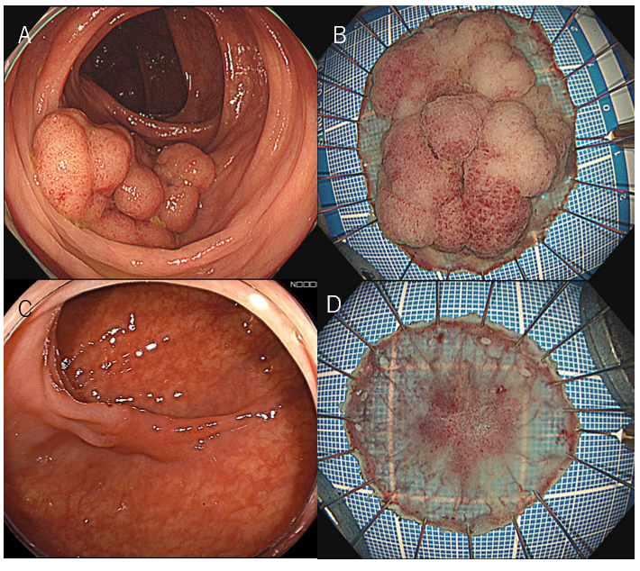
Figure 2 Representative cases of incorrect scaling. A: Underscaling case. The tumor size was evaluated as 30 mm; B: Pathology revealing the maximal diameter as 49 mm, wherein the size discrepancy was -39%; C: Overscaling case. The cancerous lesion was evaluated as 20 mm; D: The pathological size was 15 mm, resulting in a size discrepancy of 33%.
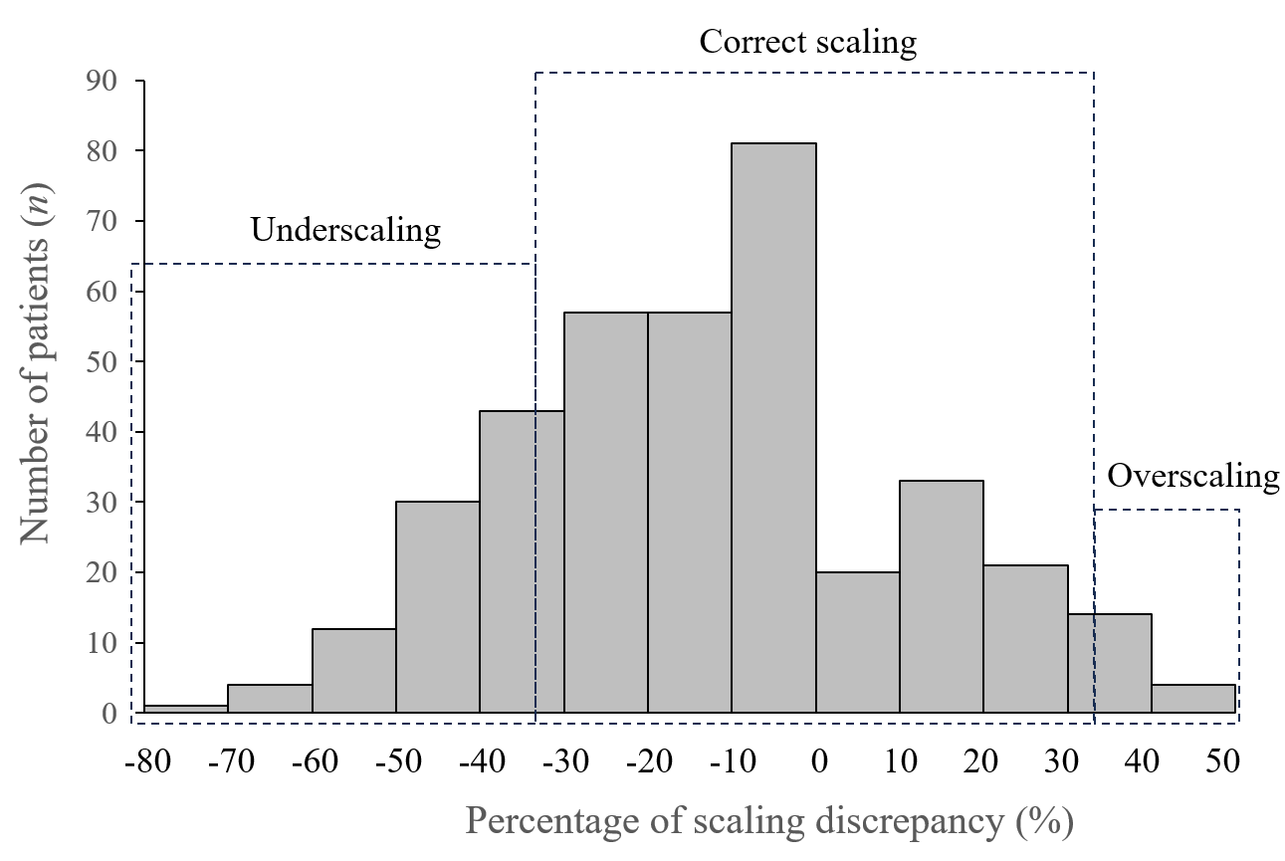
Figure 3 Lesion distribution in terms of size discrepancy. Incorrect scaling was made in 24%, which were mostly underscaled.
Table 1 Background characteristics and size assessment, n (%)
Item | Value
Background characteristics | n = 377
Lesion-related factors
Age in yr, mean | 70
Sex
Male | 231 (61)
Female | 146 (39)
Location
Colon | 298 (79)
Rectum | 79 (21)
Morphology
Protruded | 84 (22)
Flat | 293 (78)
Histology
Adenoma | 84 (22)
Adenocarcinoma | 293 (78)
Localization
Over the haustra | 212 (56)
On a flat lumen | 165 (44)
Degree of circumference
≥ 1/3 | 40 (11)
< 1/3 | 337 (89)
Endoscopist-related factors
Experience
Experienced | 186 (50)
Less-experienced | 191 (50)
Hospital type
Referral hospital | 351 (93)
Clinics | 26 (7)
Size assessment
Endoscopic size in mm, mean ± SD | 26.0 ± 10.5
Histological size in mm, mean ± SD | 31.0 ± 15.2
Absolute percentage of the size discordance, mean ± SD | 21.0 ± 15.4

Table 2 Univariate analysis of influential factors on incorrect scaling, n (%)
Item | Incorrect scaling group | Correct scaling group | P value
 | n = 91 | n = 286
Lesion-related factors
Pathological size in mm, mean | 40 | 28 | < 0.001
Location |  |  | 0.750
Colon | 73 (80) | 225 (79)
Rectum | 18 (20) | 61 (21)
Morphology |  |  | 0.210
Protruded | 16 (18) | 68 (24)
Flat | 75 (82) | 218 (76)
Histology |  |  | 0.830
Adenoma | 21 (23) | 63 (22)
Adenocarcinoma | 70 (77) | 223 (78)
Localization |  |  | 0.001
Over the haustra | 65 (71) | 147 (51)
On a flat lumen | 26 (29) | 139 (49)
Degree of circumference |  |  | < 0.001
≥ 1/3 | 21 (23) | 19 (7)
< 1/3 | 70 (77) | 267 (93)
Endoscopist-related factors
Experience |  |  | 0.050
Experienced | 37 (41) | 150 (52)
Less-experienced | 54 (59) | 136 (48)
Hospital type |  |  | 0.900
Referral hospital | 85 (93) | 266 (93)
Clinics | 6 (7) | 20 (7)

Table 3 Multivariate analysis of influential factors on incorrect scaling
Factor | Odds ratio | 95%CI | P value
Pathological size | 1.05 | 1.030-1.080 | < 0.001
Location
Rectum | 1.00
Colon | 1.20 | 0.612-2.360 | 0.590
Localization
Over the haustra | 1.00
On a flat lumen | 1.56 | 0.877-2.750 | 0.130
Degree of circumference
< 1/3 | 1.00
≥ 1/3 | 1.09 | 0.414-2.870 | 0.860
Experience
Less-experienced | 1.00
Experienced | 0.44 | 0.259-0.760 | 0.003
95%CI: 95% confidence interval.

Table 4 Univariate analysis of influential factors on underscaling, n (%)
Item | Underscaling group | Correct scaling group | P value
 | n = 75 | n = 286
Lesion-related factors
Pathological size in mm, mean | 44 | 28 | < 0.001
Location |  |  | 0.800
Colon | 58 (77) | 225 (79)
Rectum | 17 (23) | 61 (21)
Morphology |  |  | 0.150
Protruded | 12 (16) | 68 (24)
Flat | 63 (84) | 218 (76)
Histology |  |  | 0.400
Adenoma | 20 (27) | 63 (22)
Adenocarcinoma | 55 (73) | 223 (78)
Localization |  |  | 0.001
Over the haustra | 54 (72) | 147 (51)
On a flat lumen | 21 (28) | 139 (49)
Degree of circumference |  |  | < 0.001
≥ 1/3 | 20 (27) | 19 (7)
< 1/3 | 55 (73) | 267 (93)
Endoscopist-related factor
Experience |  |  | 0.056
Experienced | 30 (40) | 150 (52)
Less-experienced | 45 (60) | 136 (48)
Hospital type |  |  | 0.760
Referral hospital | 69 (92) | 266 (93)
Clinics | 6 (7) | 20 (7)

Table 5 Multivariate analysis of influential factors on underscaling
Factor | Odds ratio | 95%CI | P value
Pathological size | 1.08 | 1.05-1.11 | < 0.001
Location
Rectum | 1.00
Colon | 1.07 | 0.510-2.250 | 0.840
Localization
On a flat lumen | 1.00
Over the haustra | 1.36 | 0.705-2.600 | 0.340
Degree of circumference
< 1/3 | 1.00
≥ 1/3 | 0.65 | 0.227-1.890 | 0.290
Experience
Less-experienced | 1.00
Experienced | 0.36 | 0.192-0.666 | 0.001
95%CI: 95% confidence interval.
Table 6 Univariate analysis of influential factors on overscaling, n (%)
Factor | Overscaling group | Correct scaling group | P value
 | n = 16 | n = 286
Lesion-related factors
Pathological size in mm, mean | 20 | 28 | < 0.001
Location |  |  | 0.210
Colon | 15 (94) | 225 (79)
Rectum | 1 (6) | 61 (21)
Morphology |  |  | 1.000
Protruded | 4 (25) | 68 (24)
Flat | 12 (75) | 218 (76)
Histology |  |  | 0.210
Adenoma | 1 (6) | 63 (22)
Adenocarcinoma | 15 (94) | 223 (78)
Localization |  |  | 0.180
Over the haustra | 11 (69) | 147 (51)
On a flat lumen | 5 (31) | 139 (49)
Degree of circumference |  |  | 1.000
≥ 1/3 | 1 (6) | 19 (7)
< 1/3 | 15 (94) | 267 (93)
Endoscopist-related factor
Experience |  |  | 0.500
Experienced | 7 (44) | 150 (52)
Less-experienced | 9 (56) | 136 (48)
Hospital type |  |  | 0.610
Referral hospital | 16 (100) | 266 (93)
Clinics | 0 (0) | 20 (7)

Table 7 Multivariate analysis of influential factors on overscaling
Factor | Odds ratio | 95%CI | P value
Pathological size | 0.86 | 0.779-0.945 | 0.002
Location
Rectum | 1.00
Colon | 3.67 | 0.464-29.000 | 0.220
95%CI: 95% confidence interval.

Published by Baishideng Publishing Group Inc
7041 Koll Center Parkway, Suite 160, Pleasanton, CA 94566, USA
Telephone: +1-925-3991568
E-mail: office@baishideng.com
Help Desk: https://www.f6publishing.com/helpdesk
https://www.wjgnet.com

© 2024 Baishideng Publishing Group Inc. All rights reserved.

