Name of Journal: World Journal of Clinical Oncology
Manuscript NO: 87273
Manuscript Type: SCIENTOMETRICS

What should be the future direction of development in the field of prostate cancer with lung metastasis?

Huang ZG et al. PCLM

Zhi-Guang Huang, Yi Chen, Tong Wu, Bin-Tong Yin, Xiao Feng, Sheng-Hua Li, Dong-Ming Li, Gang Chen, Ji-Wen Cheng, Juan He

Zhi-Guang Huang, Yi Chen, Tong Wu, Bin-Tong Yin, Dong-Ming Li, Gang Chen, Juan He, Department of Pathology, First Affiliated Hospital of Guangxi Medical University, Nanning 530021, Guangxi Zhuang Autonomous Region, China

Xiao Feng, Department of Radiology, First Affiliated Hospital of Guangxi Medical University, Nanning 530021, Guangxi Zhuang Autonomous Region, China

Sheng-Hua Li, Ji-Wen Cheng, Department of Urology, First Affiliated Hospital of Guangxi Medical University, Nanning 530021, Guangxi Zhuang Autonomous Region, China

Author contributions: Huang ZG, Chen Y, Feng X, Li SH, Li DM, Chen G, Cheng JW, and He J conceived and designed the research; Chen Y, Wu T, and Yin BT did the experiments, analyzed the data and made all the graphs; Huang ZG, Feng X, Li SH, Li DM, Chen G, Cheng JW, and He J revised the manuscript; and all authors have read and approve the final manuscript.

Supported by the Natural Science Foundation of Guangxi, China, No. 2020GXNSFBA238017; Guangxi Zhuang Autonomous Region Health Commission Self-financed Scientific Research Project, No. Z20200963.

Corresponding author: Juan He, MM, Doctor, Department of Pathology, First Affiliated Hospital of Guangxi Medical University, No. 6 Shuangyong Road, Nanning 530021, Guangxi Zhuang Autonomous Region, China. hejuan@stu.gxmu.edu.cn

Received: August 14, 2023
Revised: September 12, 2023
Accepted: September 25, 2023
Published online:

Abstract
BACKGROUND
Since the start of the 21st century, prostate cancer with lung metastasis (PCLM) has accumulated significant scientific research output. However, a systematic knowledge framework for PCLM is still lacking.

AIM
To reconstruct the global knowledge system in the field of PCLM, sort out hot research directions, and provide reference for the clinical and mechanism research of PCLM.

METHODS
We retrieved 280 high-quality papers from the Web of Science Core Collection and conducted a bibliometric analysis of keywords, publication volume, and citation frequency. Additionally, we selected differentially expressed genes from global high-throughput datasets and performed enrichment analysis and protein-protein interaction analysis to further summarize and explore the mechanisms of PCLM.

RESULTS
PCLM has received extensive attention over the past 22 years, but there is an uneven spatial distribution in PCLM research. In the clinical aspect, the treatment of PCLM is mainly based on chemotherapy and immunotherapy, while diagnosis relies on methods such as prostate-specific membrane antigen positron emission tomography/computed tomography. In the basic research aspect, the focus is on cell adhesion molecules and signal transducer and activator of transcription 3, among others. Traditional treatments, such as chemotherapy, remain the mainstay of PCLM treatment, while novel approaches such as immunotherapy have limited effectiveness in PCLM. This study reveals for the first time that pathways related to coronavirus disease 2019, cytokine-cytokine receptor interaction, and ribosome are closely associated with PCLM.

CONCLUSION
Future research should focus on exploring and enhancing mechanisms such as cytokine-cytokine receptor interaction and ribosome and improve existing mechanisms like cadherin binding and cell adhesion molecules.

Key Words: Prostate cancer; Lung metastasis; Chemotherapy; Immunotherapy; Bibliometric analysis; Enrichment analysis

Huang ZG, Chen Y, Wu T, Yin BT, Feng X, Li SH, Li DM, Chen G, Cheng JW, He J. What should be the future direction of development in the field of prostate cancer with lung metastasis? World J Clin Oncol 2023; In press

Core Tip: Discovering new insights into prostate cancer with lung metastasis (PCLM), this study presents a systematic analysis of 280 high-quality papers and global datasets. The uneven distribution of PCLM research is highlighted. Notably, this study uncovers the association of PCLM with pathways related to coronavirus disease 2019, cytokine-cytokine receptor interaction, and ribosomes. While traditional treatments remain crucial, novel approaches like immunotherapy show limited effectiveness. Future research should prioritize exploring mechanisms such as cytokine-cytokine receptor interaction and ribosomes while enhancing existing mechanisms like cell adhesion molecules. This study’s innovative findings contribute to the advancement of PCLM research, stimulating further exploration and potential improvements in diagnosis and treatment strategies.

INTRODUCTION
Prostate cancer (PC) is the second most common cause of cancer-related fatalities^{[1]}. Globally, there are more than 1.4 million new cases of PC and over 370000 deaths related to PC each year^{[2]}. Due to the prostate’s unique location and function in the male anatomy, the early diagnosis and treatment of PC face numerous challenges^{[3]}. Consequently, many PC patients develop metastasis. Lung metastasis (LM) is a relatively common occurrence in PC, with over 10% of PC patients experiencing LM^{[4]}. Patients with PC with LM (PCLM) often present symptoms such as difficulty breathing, persistent dry cough, chest tightness, hemoptysis, and pain, which significantly impact their overall health^{[5]}. Moreover, PCLM often accompanies metastasis to other organs or tissues^{[6,7]}, which complicates the treatment process and increases patients’ suffering, further reducing the chances of a cure. Currently, treatment options for PCLM such as radiation therapy, chemotherapy, and surgical resection impose significant physiological, psychological, and economic burdens on patients due to their complex treatment procedures and high-risk operations, and these treatment strategies have a limited ability to achieve a complete cure for PCLM^{[8-10]}. Therefore, PCLM is a very harmful disease, regardless of the clinical characteristics of PCLM or the base number of patients.
Over the past 22 years, researchers have increasingly focused on the field of PCLM. With the development of PCLM, researchers have generated significant scientific output. However, as scientific output on PCLM has accumulated over the years, the knowledge structure of PCLM has become both disorganized and a hindrance to research efficiency^{[11,12]}. Bibliometrics, a method that quantitatively analyzes and measures literature information using statistical methods and information technology has been widely applied in medical research with promising results^{[13-17]}. Therefore, bibliometric analysis may provide a partial solution to the aforementioned challenges.
To comprehensively analyze and summarize the field of PCLM, this study retrieved relevant papers on PCLM from the Web of Science Core Collection (WOSCC) and conducted a bibliometric analysis of the citation references and keywords. Additionally, we conducted a preliminary exploration of potential biological behavior in the field of PCLM. This article aims to help researchers interested in the field of PCLM grasp the research trends in this field more accurately and quickly, and to deeply understand the related fields and technology development trends. We hope that this study can provide inspiration and assistance in the development and promotion of the research field of PCLM on a global scale.

MATERIALS AND METHODS
Collection of PCLM paper data
The data for PCLM papers were collected from the WOSCC (https://www.webofscience.com/). The search strategy used in this study was TS = ((“prostat* cancer”) OR (“prostat* carcinoma”)) AND ((“pulmonary metastas*”) OR (“lung metastas*”) OR (“metasta* tumor of lung”) OR (“metasta* carcinoma of lung”) OR (“metasta* lung carcinoma”)).
The inclusion and exclusion criteria for PCLM papers in this study were as follows: (1) To avoid the impact of data fluctuation due to WOSCC updates and restrictions, only papers published between 2000 and 2022 were included; (2) To ensure analytical rigor, only research articles, review articles, and early access papers were included; (3) Due to restrictions of the relevant software, only English-language papers were included; and (4) Finally, after manual screening, papers that were not relevant to the topic were excluded. Therefore, 280 articles were included in this study (see Figure 1).
All the data for this study were downloaded from WOSCC in BibTeX format on May 2, 2023, with the recorded content being “full record” and “cited reference”. The data collection work was conducted separately by two authors. Any discrepancies that arose between the two authors during this process were resolved through in-depth discussions involving both authors and other collaborators to reach a consensus.

Bibliometric analysis of PCLM paper data
We utilized R software (version 4.2.2) for advanced statistical calculations, visualization, and comprehensive bibliometric analysis. This included creating topic evolution maps and keyword temporal heat maps. Additionally, we employed VOSviewer software (version 1.6.18) to handle large amounts of data and create keyword clustering visualizations.

Exploration of molecular mechanisms in PCLM
We searched the Gene Expression Omnibus, the Cancer Genome Atlas, Sequence Read Archive, and ArrayExpress databases, to identify suitable human tissue datasets that included both PC and PCLM tissues. One dataset, GSE 74367, met our inclusion criteria, and we downloaded the corresponding data. Using R software, we extracted expression matrices from the dataset and identified differentially expressed genes (DEGs) specific to PCLM. The criteria for DEG selection were |logFC| > 1 and P-value < 0.05. Subsequently, we performed gene ontology and Kyoto Encyclopedia of Genes and Genomes analyses of the selected DEGs to gain preliminary insights into the potential molecular mechanisms of PCLM. Furthermore, we utilized STING (version 11.5) and Cytoscape (version 3.9.1) to construct protein-protein interaction networks for further analysis of PCLM mechanisms.

RESULTS
Spatial and temporal distribution and changes in PCLM knowledge volume
From a spatial dimension, Figure 2A illustrates the overall increasing trend in the publication and citation count of PCLM papers since 2000. However, the annual publication trends appear to be less stable. This does not indicate that the PCLM field has not received enough attention, but may be related to some bottlenecks encountered in the PCLM field. The steady increase in citation counts over the years further supports this statement. In terms of spatial distribution, Figure 2B reveals that developed countries have made significant contributions to the PCLM field, including the United States (130 papers), Japan (41 papers), Germany (27 papers), and Canada (20 papers), among others. This reflects the imbalance in the development of PCLM research across different regions. Encouragingly, emerging economies such as China and India are gaining importance and playing an increasingly significant role in the field.

Transition of hot topics in the PCLM field
Major hot directions in the PCLM field: Figure 3 illustrates that “expression”, “metastasis”, and “E-cadherin” are popular keywords in the PCLM field. We conducted a co-occurrence analysis using VOSviewer to identify the main hot directions in the PCLM field and provide an in-depth understanding of its knowledge composition. We selected 111 keywords with a frequency of occurrence greater than four times from the PCLM papers to construct a co-occurrence network. Based on Figure 4 and Supplementary Table 1, the network can be primarily divided into four clusters. Cluster 1: Basic research on tumor metastasis mechanisms (red portion in Figure 4A) includes keywords such as epithelial-mesenchymal transition (EMT), E-cadherin, adhesion, and migration. Cluster 2: Clinical treatment and related research (green portion in Figure 4A) includes keywords such as therapy, surgery, radiotherapy, radical prostatectomy, gene therapy, immunotherapy, and chemotherapy. Cluster 3: Clinical diagnosis-related research [blue portion in Figure 4A includes keywords such as diagnosis, prostate-specific membrane antigen (PSMA), and positron emission tomography/computed tomography (PET/CT)]. Cluster 4: Other basic research on PCLM (yellow portion in Figure 4A) includes keywords such as signal transducer and activator of transcription 3 (STAT3), microenvironment, androgen receptor (AR), mouse model, and angiogenesis. Surprisingly, recent hot topics, such as immunotherapy, are not emerging trends in this field, while phrases related to chemotherapy and targeted therapy, such as abiraterone acetate, docetaxel, cabazitaxel, and enzalutamide, are emerging keywords in this field (Figure 4B).

Evolution of hot topics in the PCLM field: Figures 5 and 6 demonstrate the evolution of hot topics in the PCLM field. In recent years, themes such as interleukin (IL)-12, gene therapy, and ganciclovir therapy have experienced a significant decrease in attention. On the other hand, PET/CT and PSMA in the diagnostic domain, enzalutamide, abiraterone acetate, and cabazitaxel in the clinical treatment domain, and metabolism and BReast-CAncer susceptibility gene 2 (BRCA2) in the basic research domain have emerged as new hot topics. Meanwhile, immunohistochemistry, immunotherapy, radiotherapy, migration, and angiogenesis have remained long-standing hot topics in the PCLM field. Additionally, it is surprising that terms related to bone metastasis, such as bone, bone metastasis, and bone scintigraphy, have appeared with a relatively high frequency in the PCLM field.

Development status of major research topics in PCLM
We constructed a thematic strategic coordinate map based on Keyword Plus (ID) and Author Keywords (DE) in the PCLM literature to determine the development status of major research topics. Figure 7 reflects the following themes in the field of PCLM: Motor themes, including chemotherapy, docetaxel, migration, and mitoxantrone, which are important and well-developed topics; niche themes, including Ga-68-PSMA, STAT3, and tumor-associated macrophages, which currently have low impact but need further strengthening; emerging or declining themes, including cisplatin, immunotherapy, gene therapy, and IL-12; and basic themes, including PET/CT, radiotherapy, and radical prostatectomy, which are important but have not yet received significant development in the field.

Exploration of the biological behavior of PCLM
We collected 12729 DEGs from a global dataset and compared PC patients without LM (i.e., locally metastatic) and PC patients with LM. Among these DEGs, 6138 genes were upregulated, and 6591 genes were downregulated. Figure 8A, which presents the gene ontology functional annotations, shows that, in the biological process category, there are pathways such as regulation of the immune effector process and lymphocyte proliferation. The molecular function category has pathways such as focal adhesion, while in the cellular component category, cytokine activity and cadherin binding are prominent (Supplementary Table 2). Figure 8B, representing the Kyoto Encyclopedia of Genes and Genomes’ functional annotations, reveals pathways such as cell adhesion molecules, neuroactive ligand-receptor interaction, salmonella infection, cytokine-cytokine receptor interaction, and the cAMP signaling pathway (Supplementary Table 3 ). It is worth noting that the findings related to cadherin binding and cell adhesion molecules align with the previous discussions, further confirming their promotional role in the development of LM in PC patients. To further investigate and explore the relevant pathways of PCLM, we applied the maximal clique centrality method to identify the top 20 key proteins from the cadherin binding and cell adhesion molecule pathways and construct a protein-protein interaction network. We found that cell adhesion molecules are closely associated with the immunoglobulin superfamily, such as CD8A, CD86, and ICAM1, as well as integrin family proteins, including ITGB1, ITGB2, and ITGAM (Figure 9A and Supplementary Table 4). On the other hand, cadherin binding shows close correlations with calcium-binding proteins from the cadherin family, such as CDH1, CDH5, and CDH11, as well as with catenin family proteins, such as CTNNA1 and CTNNB1 (Figure 9B and Supplementary Table 5).

DISCUSSION
PCLM is typically characterized by the presence of multiple nodules or areas of increased density in the lungs^{[18,19]}. Metastatic lesions in the lungs can affect respiratory function and cause symptoms such as shortness of breath and chest tightness^{[5,20]}. They can also exacerbate pre-existing lung diseases in patients, leading to poor prognoses. Extensive research efforts have been dedicated to understanding the biological behavior of PCLM, which has contributed to the continuous development of clinical treatment strategies. In recent years, the explosive growth and widespread adoption of bioinformatics, particularly next-generation sequencing technologies and single-cell sequencing, have enabled researchers to delve into the molecular mechanisms of PCLM in depth, leading to unprecedented progress in the field. However, the accumulation of scientific output over the years has resulted in a chaotic knowledge landscape in the field of PCLM. Therefore, this study aimed to systematically reconstruct the global knowledge system of PCLM, providing a reference for the future development of PCLM.

Spatial and temporal distribution and changes in scientific output in the PCLM field
In recent years, more systematic and precise screening and treatment have significantly improved the prognosis of PC up to a point^{[21,22]}. However, effective treatment of PCLM still faces significant challenges and requires further exploration and breakthroughs^{[23]}. Moreover, the number of PCLM patients is very large globally^{[1,2,4]}, which is further driving the exploration of and research into PCLM by scholars worldwide. This is consistent with the expanding volume of PCLM knowledge over the years. However, the uneven distribution of scientific output in the field of PCLM across regions in the spatial dimension may be related to the social and scientific development capabilities of those regions^{[24]}. This implies that the uneven country/region distribution of scientific output about PCLM in the spatial dimension may be related to two factors. First, developed countries and regions have invested more in healthcare resources and scientific research infrastructure. Second, they have a higher number of research institutes, laboratories, and researchers. In contrast, some developing countries or poor regions may face the challenges of limited funding and inadequate research conditions, resulting in a relative lag in scientific research. In this way, a contradiction has arisen between developing countries with limited medical technology but high PC morbidity and mortality and developed countries with advanced medical technology but reduced PC morbidity and mortality^{[25,26]}. Therefore, developed countries should proactively conduct international exchanges and cooperation in the field of PCLM to promote the sharing of data, funds and equipment, technology and methods, and the establishment of international cooperation networks. Developing countries should increase their investment in PCLM-related research and actively seek transnational cooperation in the future. This will not only benefit the lives and health of the world’s people but will also benefit the development of the field of PCLM by making full use of clinical resources and research due to the international cooperation network and the improvement of the technological level of developing countries. Additionally, it is exciting that, in recent years, some developing countries have been contributing more to research in the field of PCLM, which should further narrow the uneven spatial distribution of scientific output in PCLM.

Evaluation of hot research directions in the PCLM field
Researchers’ continuous exploration and attention worldwide have propelled ongoing iterations and updates in the field of PCLM knowledge. These changes are primarily reflected in the aspects described next.

Clinical treatment directions in the PCLM field
In the early years, researchers such as Ren et al^{[27]} utilized techniques like gene modification to enhance the expression of interferon-beta in mesenchymal stem cells in a mouse model of PCLM and found that tumor cell apoptosis increased and that natural killer cell activity, which is associated with anti-tumor activity, significantly increased. In addition, the invasion and metastasis suppressor gene RhoGDI2 was identified by DNA microarray technology, and after the reconstitution of RhoGDI2 in metastatic cancer cells, it was found that LM was inhibited and the motility of cancer cells in vitro was reduced^{[28]}. Therefore, interferon-beta and RhoGDI2 are considered effective potential targets for gene therapy. Additionally, researchers combined AdV-tk gene therapy with radiotherapy and chemotherapy in a mouse model of PCLM and found a significant reduction in lung nodules and cancer cell colonization in the lungs^{[29]}. However, studies have indicated that these gene therapies are challenging to deliver effectively to the tumor site, leading to inadequate gene delivery and resulting in various adverse outcomes^{[30]}. Currently, no effective clinical trials have successfully addressed this challenge. As a result, gene therapy is currently considered a peripheral topic, and it is not surprising that its popularity in the PCLM field has declined significantly in recent years.
In this field, radiation therapy has always been an important and highly regarded topic. In recent years, some reports have shown promising results in the treatment of PCLM patients using 177Lu-PSMA radioligand therapy (Lu-PRLT)^{[31,32]}. However, PCLM patients who are PSMA(-)/fluorescein Di-β-D-galactopyranoside (FDG)(+) may not benefit from Lu-PRLT^{[33]}. Therefore, some researchers have combined biologically guided radiation therapy with Lu-PRLT for PSMA(-)/FDG(+) PCLM patients and found this combination therapy to be beneficial^{[33]}. Moreover, there have been case reports suggesting that the combination of stereotactic body radiation therapy and androgen deprivation therapy (ADT) can confer benefits in terms of biochemical response and disease-free survival in PCLM patients^{[34]}. However, recurrences after radiation therapy in the treatment of PCLM frequently occur^{[35]}. Furthermore, guidelines define radiation therapy for PCLM as palliative treatment and do not recommend it as part of curative approaches^{[35]}. Therefore, although radiation therapy has broad prospects, it is considered a significant but underdeveloped topic in the PCLM field due to the many challenges it currently faces.
Radical surgery, as a traditional topic, has been widely applied in clinical practice for PC. However, there is currently insufficient evidence from evidence-based medicine and international guidelines to clearly define the role of radical surgery in PCLM patients^{[36]}. Thus, radical surgery is a significant but underdeveloped topic in the PCLM field. Studies have shown that performing radical prostatectomy in animal models of PCLM can significantly reduce the number of lung metastases^{[37]}. Furthermore, research reports have indicated that when the criteria for resection are met, LM resection as the preferred choice for PCLM patients can avoid or delay the use of ADT and its adverse effects, significantly improving patient prognosis^{[35]}. This also demonstrates the promising development prospects of radical surgery in the PCLM field.
Immunotherapy, as an emerging direction, has been a topic of long-standing interest in this field. In the field of immunotherapy for PC, treatment plans have limitations. One example is sipuleucel-T, the only United States Food and Drug Administration-approved immunotherapeutic agent for metastatic desmoplasia-resistant PC, but it is indicated for asymptomatic or minimally symptomatic patients only^{[38]}. Immune resistance poses another challenge in PC treatment. Factors like low tumor mutation loads and the presence of immunosuppressive cells can disrupt the immune system and create an immunosuppressive tumor microenvironment, leading to reduced therapeutic efficacy^{[39]}. Additionally, there can be adverse effects associated with immunosuppressant therapy. For instance, patients may experience immune-related adverse events, such as ulceration of the lower lip^{[40]}. Furthermore, the clinical utility of certain treatments has yet to be validated. For example, a study by Komaru et al^{[41]} that is currently in the animal experimentation stage has a long way to go before its potential in clinical practice can be determined. In addition, there have been fewer studies on relatively well-established immunotherapies in the field of PCLM relative to other treatments. These may be due to the unclear mechanisms currently available, which do not provide a solid theoretical basis for the development of more effective immunotherapies. These are significant barriers to the widespread clinical application of immunotherapy in PCLM. However, in recent years, targeted and less toxic immunotherapies have shown better and sustained response rates compared to conventional therapies. Immunotherapy has the potential to cure malignant tumors, including metastatic melanoma, lung cancer, and others^{[42-45]}. This also explains the broad prospects of immunotherapy, as it emerges as a relatively new and promising hotspot in the strategic landscape (Figure 7). For example, recent research reports have made clinical applications of oncolytic viruses, which can specifically replicate, proliferate, and destroy PCLM cells through the nanodrug packaging approach^{[46]}. Additionally, researchers have designed a spatially drug-loaded M1 macrophage system in which M1 macrophage accumulates significantly in LM lesions, effectively enhancing the infiltration of cytotoxic T cells into lung metastases and boosting local anti-tumor immunity^{[47]}. If these approaches could be widely implemented in clinical practice, a complete cure for PCLM might be within reach. In summary, the exploration of immunotherapy in this field has been long and challenging. However, breakthroughs in new technologies and a deeper understanding of molecular mechanisms in recent years have accelerated the progress of PCLM immunotherapy.
Contrary to immunotherapy, chemotherapy is a relatively new topic in the field of PCLM, despite being a traditional subject. Currently, there are several main directions for chemotherapy, including docetaxel, cabazitaxel, and combination therapy. Docetaxel is a well-established chemotherapy drug that has been proven to significantly prolong the survival of PCLM patients^{[48-50]}. However, most PCLM patients develop resistance to docetaxel, leading to disease progression^{[50]}. As for cabazitaxel, a phase 2 clinical trial has shown that it can significantly alleviate or stabilize the condition of metastatic castration-resistant PC and has the advantages of better tolerance and lower toxicity^{[51]}. Furthermore, one study designed a cabazitaxel nanoparticle carrier that can be inhaled by M2 macrophage vesicles and that, in experimental models, was able to more effectively enter tumor tissue and inhibit over 93% of LM occurrences^{[52]}. Additionally, combining chemotherapy with targeted therapy or immunotherapy has shown promising efficacy against LM^{[53-55]}. Chemotherapy is utilized in PCLM treatment, but it has limitations and challenges. One issue is resistance, such as the enhancement of doxorubicin resistance in PC by the TrkB protein^{[50]}. Additionally, PC cells display inherent and acquired resistance to cisplatin, making it ineffective as a first-line chemotherapeutic agent for PC^{[56]}. Most PC patients who undergo ADT eventually develop castration-resistant disease^{[57]}. Chemotherapy also has adverse effects. For instance, potentially life-threatening events like neutropenia and febrile neutropenia can occur in patients with metastatic PC who receive doxorubicin-related chemotherapy^{[58]}. Furthermore, ADT for PC increases the risk of cardiovascular and metabolic syndrome, which can lead to fatal outcomes^{[59]}. Despite these treatment efforts, chemotherapy alone cannot fully cure PCLM. However, in the context of the limitations of other non-traditional treatments, chemotherapy has been widely adopted in clinical practice, and its efficacy has been clearly demonstrated, whether applied alone or in combination with other therapeutic means. Hence, it is not surprising that chemotherapy is recognized as a mature and important topic in this field.
In addition, in the field of targeted therapy, enzalutamide, a next-generation AR inhibitor, has been proven to significantly prolong the survival of patients with metastatic PC, despite the inevitable resistance mediated by SPP1 through the phosphatidylinositol-4,5-bisphosphate 3-kinase/protein kinase B (Akt) and extracellular regulated kinase 1/2 pathways or the reactivation and splice variants of the AR^{[60-62]}. MiR-33b-3p inhibits metastasis by targeting DOCK4 in PC^{[63]}. We could enhance miR-33b-3p expression to overcome the poor efficacy of proteasome inhibitors in metastatic PC in the future. It has also been reported that treatment with Lu-177-PSMA radioligand showed significant efficacy in PC patients and responded favorably to the treatment and regression of lung metastases after PSMA radioligand therapy (Lu-PRLT)^{[31]}. High expression of C-C motif ligand 2 induced the production of carbon catabolite repression 4 (CCR4) in PC cells, which promotes migration and invasion of PC cells through enhanced Akt phosphorylation^{[64]}. This study reveals CCR4 as a potential target for the treatment of PCLM. Putz et al^{[65]} found that the cytokine signaling checkpoint CIS plays an important role in the occurrence of PC with LM and has a promising future in the treatment of PCLM. Furthermore, in recent years, the emergence of abiraterone acetate has been confirmed by numerous studies to alleviate lung metastases and significantly prolong the survival of PCLM patients, and it has been regarded as a safe and effective treatment for many advanced PCLM patients^{[8,54,66,67]}.
In recent years, precision medicine has played an important role in a variety of diseases. In particular, tumors involve alterations in the biological behavior of multiple genes. The biological behaviors of various tumors are complex and diverse. Therefore, precision medicine with personalized treatment characteristics is a solution to the difficult problem of PCLM, which is hard to cure completely. One study reported that AR plays dual and opposite roles in vasculature encapsulating tumor clusters, emphasizing the complex function of AR and its importance in individualized cancer therapy^{[68]}. This study provides new insights into the complex regulatory network of AR in metastatic tumors and lays the foundation for relevant precision medicine. It has also been reported that AuNSs@PDA-Ce6 nanoprobes significantly reduced tumor growth and inhibited LM, which has considerable potential for precise therapeutic diagnosis and metastasis inhibition^{[69]}. In addition, Hlavac et al^{[70]} revealed the characterization of prognostically distinct subgroups with precision medicine value by targeted sequencing of blood and archival samples from LM patients. However, regrettably, no mature precision medicine or personalized treatment for PCLM has been reported. In the future, precision medicine will also be an important endeavor in the field of PCLM.

Clinical diagnostic approaches in the field of PCLM
PSMA has been widely utilized in the PC screening. Many researchers have combined PSMA with PET/CT for clinical diagnosis. This includes the use of [99mTc]PSMA-T4 and 68Ga-PSMA-11, which have shown high efficacy in the diagnosis and detection of metastatic PC and recurrence, outperforming traditional imaging techniques^{[71-75]}. However, there is still a notable false-negative rate in some patients^{[75]}. Additionally, there are cases where lung metastases in PC patients are PSMA-negative, rendering PSMA-PET/CT unsuitable for detecting such patients^{[76]}. Furthermore, 18F-fluorocholine PET/CT has shown higher specificity compared to traditional methods for staging PCLM patients, but its sensitivity still needs improvement^{[77]}. Therefore, although this approach has some influence in the field of PCLM, several issues still need to be further addressed and developed in the future.

Exploratory mechanisms in the field of PCLM
In recent years, with the advancement and widespread application of bioinformatics, particularly the progress in second-generation DNA sequencing and single-cell sequencing technologies, researchers have been able to identify key molecules in PCLM more thoroughly and comprehensively, elucidating additional pathway mechanisms. This has led to the emergence of new research hotspots in basic research.
In terms of organism metabolism, studies have found that Camkk2 not only mediates the metastasis and colonization of PC cells in the lungs, but also disrupts normal metabolism, such as glucose and lipids, leading to the occurrence of metabolic syndrome and other complications^{[78]}. It has also been reported that the regulation of glutamine metabolism can upregulate ARPC1A in PC cells, resulting in changes in the PC cell cytoskeleton and the cells’ migration and invasion of the lungs^{[79]}. Furthermore, the regulatory role of the positive feedback loop between tryptophan hydroxylase 1 and β-catenin/ZBP-89 signaling, as well as the modulation of microribonucleic acids in acidosis mediated by the Warburg effect, can enhance the metastatic ability of PC cells^{[80,81]}. These findings indicate a close relationship between organism metabolism and the metastatic behavior of PC cells. In recent years, numerous studies have shown that mutations in BRCA2, which possesses DNA repair functions, enhance the ability of PC cells to develop LM and other types of metastases^{[8,82,83]}. However, these studies are based on sporadic cases, and it is necessary to conduct more comprehensive and systematic research for supplementary validation. Regarding STAT3, CCL5 secreted by M2 macrophages enriched in the PC tissue microenvironment can promote STAT3-dependent EMT, enhancing the resistance and metastatic ability of PC cells toward the lungs^{[84]}. In addition, immune checkpoints can inhibit T lymphocyte immune responses through the EGFR/JAK1/STAT3 pathway, promoting PC progression and the occurrence of LM^{[85,86]}. Encouragingly, based on the related mechanisms of STAT3, research has found that the traditional Chinese medicine CFF-1 can effectively inhibit LM, prolong survival, and improve the quality of life for patients^{[85]}. In terms of AR, PC cell growth is androgen-dependent in vitro, and the level of androgens in the body is positively correlated with tumor size in vivo^{[87]}. Studies have also revealed that cell cycle proteins interact with AR, regulate the promoters of vascular endothelial-derived growth factor and matrix metalloproteinase 2, and enhance their expression, thereby promoting PC progression and increasing metastatic capacity^{[88]}. These findings regarding AR indirectly provide theoretical evidence for the development and improvement of new-generation targeted drugs, such as enzalutamide, an AR inhibitor. These examples highlight the importance of translating basic research findings to clinical applications and improving PCLM treatment.
In addition, some mechanisms of PC metastasis have become independent clusters (Figure 4), indicating that this direction is relatively mature and independent as a hotspot. Studies have reported that the downregulation of E-cadherin, a result of certain inducing factors, promotes the migration and invasion of PC cells^{[89]}. It has also been found that silencing AKT1 downregulates epithelial-associated E-cadherin and upregulates mesenchymal-associated N-cadherin, promoting the occurrence of EMT closely related to PCLM^{[90]}. Furthermore, some studies have indicated that decreased cell adhesion caused by C-terminal binding protein or metabolic acidosis-induced abnormal expression of microribonucleic acids enhances the metastatic ability of PC cells^{[81,91]}. These findings suggest that abnormalities in cell-cell connections can enhance the likelihood of PC cell metastasis.
Finally, the presence of phrases such as “rats” suggests that many research results are still in the cellular, animal, and in vitro stages of experimentation and are still some distance from clinical translation. For example, the studies by Komaru et al^{[41]}, Pan et al^{[89]}, and Azhati et al^{[92]} are still in the cellular, animal, and in vitro experimental stages and a long way from clinical practice. As mentioned above, PCLM scientific outputs represent countries/regions with a high level of PCLM research but with fewer clinical case data due to the small number of PCLM patients, while countries/regions with high PCLM morbidity and mortality have a relatively weak level of research on PCLM. This may also be a major obstacle to the translation of basic research results into clinical practice. For this reason, international collaboration and knowledge sharing are particularly important. In addition, basic research often involves complex cellular, molecular, and biological processes, which may lead to problems of instability and reproducibility of results. One strategy to address this challenge is to increase the reliability and reproducibility of results through multicenter studies, validation experiments, and mutual evaluation. Clinical translation requires significant financial and resource support. However, research funding is often limited, and industry needs to consider commercial viability. Strategies to address this challenge include seeking support from public and private funding, building partnerships, and exploring new sustainable financing models. Thus, the translation of basic research findings into clinical applications is urgent in the context of the limited effectiveness of contemporary treatment options. In conclusion, basic research on PCLM is important but underdeveloped at the present time.
In addition, bone metastasis is a prominent point in the field of PCLM. This is mainly because LM often coexists with bone metastasis and other metastatic lesions, while isolated PCLM is less common, accounting for approximately 20.4% of all PCLM cases^{[6,7]}. This highlights the complexity and refractoriness of PCLM. Therefore, further exploration of the relevant mechanisms is necessary.

Summary and exploration of mechanisms in PCLM
The global state-of-the-art PCLM pathway map we have constructed suggests that LM in PC patients is likely closely related to abnormalities in pathways, such as cadherin binding and cell adhesion molecules. This is in line with existing reports and the information discussed herein. However, most of these studies have only associated adhesion or cadherin abnormalities with PC cell migration and invasion, and there is still a lack of mature research revealing their specific roles in in vivo metastasis. Nevertheless, the specific interactions between the immunoglobulin superfamily and the integrin family, as well as the mechanisms leading to abnormal cell adhesion, have been elucidated in other tumors^{[93]}. The mechanisms by which members of the cadherin gene family regulate EMT and promote breast cancer metastasis have also been identified^{[94]}. Therefore, the interactions we have identified among the immunoglobulin superfamily and the integrin, cadherin, and calcium-binding protein families in the cadherin binding and cell adhesion molecule pathways in PCLM may be directions that merit further exploration in the field of PCLM.
Additionally, mutual interactions between coronavirus [coronavirus disease 2019 (COVID-19)] and LM of other tumors have been reported^{[95-97]}. Cytokine-cytokine receptor interaction and cytokine activity have been shown to be closely associated with enhanced invasion in distant metastasis of thyroid cancer, lymph node metastasis of gastric adenocarcinoma, and liver metastasis of colon cancer^{[98-100]}. Furthermore, the ribosomal protein S6 kinase, which is closely related to EMT, invasion, and metastasis of tumor cells, has been proven to be an effective target for anticancer therapy^{[101]}. These findings indicate that COVID-19, cytokine-cytokine receptor interaction, and ribosomal pathways are closely related to tumor metastasis and have broad clinical application value. However, the detailed roles of these pathways in PCLM have not been reported. Therefore, these directions are also among worthy future explorations required in the field of PCLM.

Limitations of this study and future work plans
Several limitations of this study deserve attention. First, although most data in this study were analyzed using computer-based analysis methods that are objective, efficient, and relatively accurate, occasional errors that are difficult to avoid and detect may have occurred. In the future, we should strengthen manual interventions to address this issue. Second, due to the limitations of the analysis tools, our bibliometric analysis included only detailed data from English papers that are available globally. Some high-quality, non-English papers may have been overlooked. In the future, we should improve our analytical methods to further analyze these papers. Third, the paper data in this study came only from WOSCC. In future, we should analyze data from multiple databases to complement and validate our results. Fourth, due to the poor timeliness of the data, some emerging hotspots may have been overlooked. In the future, we should update the data in a timely manner and improve the analysis methods to better capture emerging hotspots. Fifth, while we have gained new insights into the pathways involved in the biological behaviors of PCLM, they still lack in vivo and in vitro experimental verification. In the future, we should conduct further experimental validations related to these pathways.

CONCLUSION
In conclusion, with the continuous advancement of scientific technology in recent years, PCLM has received widespread attention. In this study, we conducted a bibliometric analysis to summarize the global knowledge system of PCLM over the past 22 years. This included clinical aspects based on chemotherapy and immunotherapy, diagnostic aspects based on PSMA-PET/CT, and basic aspects based on cell adhesion molecules and STAT3. Although current treatment approaches can improve the prognosis of PCLM patients to some extent, resistance to traditional therapies and the limitations of novel therapies still prevent the complete cure of PCLM. Furthermore, we identified the close association of COVID-19, cytokine-cytokine receptor interaction, and ribosome-related pathways with PCLM for the first time. Therefore, future research in the field of PCLM should focus on exploring and enhancing mechanisms such as cytokine-cytokine receptor interaction and ribosome-related pathways, and further improving existing mechanisms such as cadherin binding and cell adhesion molecules. This study establishes a robust theoretical foundation for the advancement and enhancement of novel therapeutic approaches with the potential to facilitate the full remission of PCLM as soon as possible.

ARTICLE HIGHLIGHTS
Research background
Over the past 22 years, researchers have increasingly focused on prostate cancer (PC) with lung metastasis (LM), generating significant scientific output, but the accumulated knowledge has become disorganized and hindered research efficiency.

Research motivation
With the increase of researchers’ research enthusiasm in the field of PCLM over the years, scientific output has continued to increase, but there is no complete PCLM knowledge structure system. The purpose of this article is to establish a complete structural knowledge system and future development direction.

Research objectives
In order to further clarify the future development direction of PCLM, we reconstruct the global knowledge system in the field of PCLM. This research aims to help researchers interested in the field of PCLM grasp the research trends in this field more accurately and quickly, and to deeply understand the related fields and technology development trends. This study can provide inspiration and assistance in the development and promotion of the research field of PCLM on a global scale.

Research methods
The research gathered data on PCLM papers from Web of Science Core Collection (https://www.webofscience.com/) using a specific search strategy, resulting in 280 high-quality articles published between 2000 and 2022. Data was downloaded on May 2, 2023. We conducted a bibliometric analysis of keywords, publication volume, and citation frequency. Additionally, we selected differentially expressed genes from global high-throughput datasets and performed enrichment analysis and protein-protein interaction analysis to further summarize and explore the mechanisms of PCLM.

Research results
Over the past 22 years, PCLM has gained attention, with uneven research distribution. Clinically, chemotherapy and immunotherapy are primary treatments, while diagnosis relies on prostate-specific membrane antigen and positron emission tomography/computed tomography. Basic research focuses on cell adhesion molecules and signal transducer and activator of transcription 3. Traditional treatments like chemotherapy dominate, but novel approaches like immunotherapy show limited effectiveness. This research unveils the coronavirus disease 2019 (COVID-19)-related pathway’s newfound associations with PCLM.

Research conclusions
Recent scientific advancements have drawn attention to PCLM. This 22-year bibliometric analysis covered clinical diagnostic, and basic aspects. Current treatment improves prognosis, but resistance and limitations persist. The study identified novel associations with COVID-19 and pathways, suggesting future research should explore these mechanisms. This research provides a foundation for advancing novel PCLM therapies.

Research perspectives
Future research should prioritize enhancing cytokine-cytokine receptor interactions and ribosomal mechanisms while improving existing cadherin binding and cell adhesion molecules.

ACKNOWLEDGEMENTS
We would like to thank “Guangxi Zhuang Autonomous Region Clinicopathology Diagnosis and Research Center” for providing technical support.

REFERENCES
1 Ragavi R, Muthukumaran P, Nandagopal S, Ahirwar DK, Tomo S, Misra S, Guerriero G, Shukla KK. Epigenetics regulation of prostate cancer: Biomarker and therapeutic potential. Urol Oncol 2023; 41: 340-353 [PMID: 37032230 DOI: 10.1016/j.urolonc.2023.03.005]
2 Sung H, Ferlay J, Siegel RL, Laversanne M, Soerjomataram I, Jemal A, Bray F. Global Cancer Statistics 2020: GLOBOCAN Estimates of Incidence and Mortality Worldwide for 36 Cancers in 185 Countries. CA Cancer J Clin 2021; 71: 209-249 [PMID: 33538338 DOI: 10.3322/caac.21660]
3 Fan H, Li J, Manuel AM, Zhao Z. Enzalutamide-induced signatures revealed by epigenetic plasticity using single-cell multi-omics sequencing in prostate cancer. Mol Ther Nucleic Acids 2023; 31: 648-661 [PMID: 36910711 DOI: 10.1016/j.omtn.2023.02.022]
4 Shiota M, Terada N, Saito T, Yokomizo A, Kohei N, Goto T, Kawamura S, Hashimoto Y, Takahashi A, Kimura T, Tabata KI, Tomida R, Hashimoto K, Sakurai T, Shimazui T, Sakamoto S, Kamiyama M, Tanaka N, Mitsuzuka K, Kato T, Narita S, Yasumoto H, Teraoka S, Kato M, Osawa T, Nagumo Y, Matsumoto H, Enokida H, Sugiyama T, Kuroiwa K, Inoue T, Mizowaki T, Kamoto T, Kojima T, Kitamura H, Sugimoto M, Nishiyama H, Eto M; Japanese Urological Oncology Group (JUOG). Differential prognostic factors in low- and high-burden de novo metastatic hormone-sensitive prostate cancer patients. Cancer Sci 2021; 112: 1524-1533 [PMID: 33159829 DOI: 10.1111/cas.14722]
5 Yamazaki H, Iwasaki H, Masudo K, Toda S, Matsui A, Rino Y. Prognostic significance of lung metastasis-related finding in lenvatinib treatment for differentiated thyroid cancer. Endocrine 2022; 78: 543-551 [PMID: 36070050 DOI: 10.1007/s12020-022-03183-9]
6 Guo Y, Mao S, Zhang A, Wang R, Zhang Z, Zhang J, Wang L, Zhang W, Wu Y, Ye L, Yang B, Yao X. Prognostic Significance of Young Age and Non-Bone Metastasis at Diagnosis in Patients with Metastatic Prostate Cancer: a SEER Population-Based Data Analysis. J Cancer 2019; 10: 556-567 [PMID: 30719152 DOI: 10.7150/jca.29481]
7 Tarabaih M, Degheili JA, Nasser M. Isolated Solitary Lung Nodule in a Patient With Idiopathic Pulmonary Fibrosis and Concomitant Prostate Cancer: A Challenging Diagnosis. Cureus 2021; 13: e14218 [PMID: 33948408 DOI: 10.7759/cureus.14218]
8 Izawa M, Kosaka T, Nakamura K, Oba J, Hishida T, Hongo H, Mikami S, Nishihara H, Oya M. Pulmonary metastasis secondary to abiraterone-resistant prostate cancer with homozygous deletions of BRCA2: First Japanese case. IJU Case Rep 2021; 4: 14-17 [PMID: 33426488 DOI: 10.1002/iju5.12224]
9 Nakashima H, Takatsu T, Imai R. Radiation-induced osteosarcoma in the pubic bone after proton radiotherapy for prostate cancer: a case report. J Rural Med 2022; 17: 94-100 [PMID: 35432636 DOI: 10.2185/jrm.2021-047]
10 Ceylan KC, Batıhan G, Kaya SO. Pulmonary metastases in urogenital cancers: Surgical treatment and outcomes. Cir Esp (Engl Ed) 2023; 101: 116-122 [PMID: 36774001 DOI: 10.1016/j.cireng.2021.11.025]
11 Hess W, Marggraf G, Reidemeister C. [Pulmonary artery rupture caused by a Swan-Ganz catheter during heart surgery. A successful therapeutic procedure]. Anaesthesist 1988; 37: 446-449 [PMID: 3414956 DOI: 10.3389/fpsyg.2021.669000]
12 Wu H, Cheng K, Guo Q, Yang W, Tong L, Wang Y, Sun Z. Mapping Knowledge Structure and Themes Trends of Osteoporosis in Rheumatoid Arthritis: A Bibliometric Analysis. Front Med (Lausanne) 2021; 8: 787228 [PMID: 34888333 DOI: 10.3389/fmed.2021.787228]
13 Sholklapper TN, Ballon J, Sayegh AS, La Riva A, Perez LC, Huang S, Eppler M, Nelson G, Marchegiani G, Hinchliffe R, Gordini L, Furrer M, Brenner MJ, Dell-Kuster S, Biyani CS, Francis N, Kaafarani HMA, Siepe M, Winter D, Sosa JA, Bandello F, Siemens R, Walz J, Briganti A, Gratzke C, Abreu AL, Desai MM, Sotelo R, Agha R, Lillemoe KD, Wexner S, Collins GS, Gill I, Cacciamani GE. Bibliometric analysis of academic journal recommendations and requirements for surgical and anesthesiologic adverse events reporting. Int J Surg 2023; 109: 1489-1496 [PMID: 37132189 DOI: 10.1097/JS9.0000000000000323]
14 Porwal A, Al Moaleem MM, Adawi HA, Nandalur KR, Satpathy A, Mehta V, Cicciù M, Minervini G. Bibliographic analysis and evaluation of the mesh keywords in the journal of prosthodontics: Implant, esthetic, and reconstructive dentistry. Technol Health Care 2023 [PMID: 37125591 DOI: 10.3233/THC-230204]
15 Xiao H, Tang J, Zhang F, Liu L, Zhou J, Chen M, Li M, Wu X, Nie Y, Duan J. Global trends and performances in diabetic retinopathy studies: A bibliometric analysis. Front Public Health 2023; 11: 1128008 [PMID: 37124794 DOI: 10.3389/fpubh.2023.1128008]
16 Ninkov A, Frank JR, Maggio LA. Bibliometrics: Methods for studying academic publishing. Perspect Med Educ 2022; 11: 173-176 [PMID: 34914027 DOI: 10.1007/s40037-021-00695-4]
17 Brown R. Health care for the indigent. J Natl Med Assoc 1986; 78: 359-360 [PMID: 3712474 DOI: 10.3389/fendo.2023.1109456]
18 Große Hokamp N, Kobe C, Linzenich E, Maintz D, Drzezga A. Solitary PSMA-Positive Pulmonary Metastasis in Biochemical Relapse of Prostate Cancer. Clin Nucl Med 2017; 42: 406-407 [PMID: 28195907 DOI: 10.1097/RLU.0000000000001582]
19 Lubin DJ, Holden SB, Rettig MB, Reiter RE, King CR, Lee JM, Wallace DW, Calais J. Prostate Cancer Pulmonary Metastasis Presenting as a Ground-Glass Pulmonary Nodule on 68Ga-PSMA-11 PET/CT. Clin Nucl Med 2019; 44: e353-e356 [PMID: 30789399 DOI: 10.1097/RLU.0000000000002499]
20 Liu H, Zhang GN, Luo M, Zhang XD, Fan Y, Peng CR. [Clinicopathological features and prognostic factors of patients with lung metastasis of stage Ⅰa~Ⅲb cervical cancer]. Zhonghua Zhong Liu Za Zhi 2023; 45: 340-347 [PMID: 37078216 DOI: 10.3760/cma.j.cn112152-20211230-00984]
21 Schade AE, Kuzmickas R, Rodriguez CL, Mattioli K, Enos M, Gardner A, Cichowski K. Combating castration-resistant prostate cancer by co-targeting the epigenetic regulators EZH2 and HDAC. PLoS Biol 2023; 21: e3002038 [PMID: 37104245 DOI: 10.1371/journal.pbio.3002038]
22 Castro-Espin C, Agudo A. The Role of Diet in Prognosis among Cancer Survivors: A Systematic Review and Meta-Analysis of Dietary Patterns and Diet Interventions. Nutrients 2022; 14 [PMID: 35057525 DOI: 10.3390/nu14020348]
23 Chung I, Zhou K, Barrows C, Banyard J, Wilson A, Rummel N, Mizokami A, Basu S, Sengupta P, Shaikh B, Sengupta S, Bielenberg DR, Zetter BR. Unbiased Phenotype-Based Screen Identifies Therapeutic Agents Selective for Metastatic Prostate Cancer. Front Oncol 2020; 10: 594141 [PMID: 33738243 DOI: 10.3389/fonc.2020.594141]
24 Shi Y, Wei W, Li L, Wei Q, Jiang F, Xia G, Yu H. The global status of research in breast cancer liver metastasis: a bibliometric and visualized analysis. Bioengineered 2021; 12: 12246-12262 [PMID: 34783637 DOI: 10.1080/21655979.2021.2006552]
25 Lin J, Zhuo Y, Zhang Y, Liu R, Zhong W. Molecular predictors of metastasis in patients with prostate cancer. Expert Rev Mol Diagn 2023; 23: 199-215 [PMID: 36860119 DOI: 10.1080/14737159.2023.2187289]
26 Bosland MC, Shittu OB, Ikpi EE, Akinloye O. Potential New Approaches for Prostate Cancer Management in Resource-Limited Countries in Africa. Ann Glob Health 2023; 89: 14 [PMID: 36843668 DOI: 10.5334/aogh.3994]
27 Ren C, Kumar S, Chanda D, Kallman L, Chen J, Mountz JD, Ponnazhagan S. Cancer gene therapy using mesenchymal stem cells expressing interferon-beta in a mouse prostate cancer lung metastasis model. Gene Ther 2008; 15: 1446-1453 [PMID: 18596829 DOI: 10.1038/gt.2008.101]
28 Gildea JJ, Seraj MJ, Oxford G, Harding MA, Hampton GM, Moskaluk CA, Frierson HF, Conaway MR, Theodorescu D. RhoGDI2 is an invasion and metastasis suppressor gene in human cancer. Cancer Res 2002; 62: 6418-6423 [PMID: 12438227]
29 Chhikara M, Huang H, Vlachaki MT, Zhu X, Teh B, Chiu KJ, Woo S, Berner B, Smith EO, Oberg KC, Aguilar LK, Thompson TC, Butler EB, Aguilar-Cordova E. Enhanced therapeutic effect of HSV-tk+GCV gene therapy and ionizing radiation for prostate cancer. Mol Ther 2001; 3: 536-542 [PMID: 11319915 DOI: 10.1006/mthe.2001.0298]
30 Gao Y, Yao A, Zhang W, Lu S, Yu Y, Deng L, Yin A, Xia Y, Sun B, Wang X. Human mesenchymal stem cells overexpressing pigment epithelium-derived factor inhibit hepatocellular carcinoma in nude mice. Oncogene 2010; 29: 2784-2794 [PMID: 20190814 DOI: 10.1038/onc.2010.38]
31 Zhang J, Kulkarni HR, Singh A, Baum RP. Complete Regression of Lung Metastases in a Patient With Metastatic Castration-Resistant Prostate Cancer Using 177Lu-PSMA Radioligand Therapy. Clin Nucl Med 2020; 45: e48-e50 [PMID: 31162261 DOI: 10.1097/RLU.0000000000002655]
32 Kairemo K, Joensuu T. Lu-177-PSMA treatment for metastatic prostate cancer: case examples of major responses. Clin Transl Imaging 2018; 6: 223-237 [DOI: 10.1007/s40336-018-0274-y]
33 Gaudreault M, Chang D, Hardcastle N, Jackson P, Kron T, Hofman MS, Siva S. Combined biology-guided radiotherapy and Lutetium PSMA theranostics treatment in metastatic castrate-resistant prostate cancer. Front Oncol 2023; 13: 1134884 [PMID: 36994211 DOI: 10.3389/fonc.2023.1134884]
34 Mosca A, Mantica G, Giavarra M, Perrone V, De Marchi L, Gennari A, Toncini C, Terrone C. Curative Lung Metastasectomy Without Concomitant Androgen Deprivation Therapy in Oligometastatic Castration-resistant Prostate Cancer: A Case Report and Review of the Literature. Clin Genitourin Cancer 2020; 18: e295-e299 [PMID: 31917170 DOI: 10.1016/j.clgc.2019.11.018]
35 Raveglia F, Rosso L, Nosotti M, Cardillo G, Maffeis G, Scarci M. Pulmonary metastasectomy in germ cell tumors and prostate cancer. J Thorac Dis 2021; 13: 2661-2668 [PMID: 34012615 DOI: 10.21037/jtd.2020.04.51]
36 Caristo JM, Tian DH, Yan TD. Pulmonary metastasectomy: a cross sectional survey. J Thorac Dis 2018; 10: 3757-3766 [PMID: 30069374 DOI: 10.21037/jtd.2018.05.45]
37 Rebello RJ, Oing C, Knudsen KE, Loeb S, Johnson DC, Reiter RE, Gillessen S, Van der Kwast T, Bristow RG. Prostate cancer. Nat Rev Dis Primers 2021; 7: 9 [PMID: 33542230 DOI: 10.1038/s41572-020-00243-0]
38 McNeel DG, Bander NH, Beer TM, Drake CG, Fong L, Harrelson S, Kantoff PW, Madan RA, Oh WK, Peace DJ, Petrylak DP, Porterfield H, Sartor O, Shore ND, Slovin SF, Stein MN, Vieweg J, Gulley JL. The Society for Immunotherapy of Cancer consensus statement on immunotherapy for the treatment of prostate carcinoma. J Immunother Cancer 2016; 4: 92 [PMID: 28031820 DOI: 10.1186/s40425-016-0198-x]
39 Movassaghi M, Chung R, Anderson CB, Stein M, Saenger Y, Faiena I. Overcoming Immune Resistance in Prostate Cancer: Challenges and Advances. Cancers (Basel) 2021; 13 [PMID: 34638243 DOI: 10.3390/cancers13194757]
40 Kan S, Ren H, Gao Z, Dai E, Liu Y, Yang L, Cai Q. Lichenoid drug eruption on the lower lip caused by anti-PD-1 monoclonal antibody: a case report and literature review. Immunotherapy 2021; 13: 1373-1378 [PMID: 34632814 DOI: 10.2217/imt-2021-0234]
41 Komaru A, Ueda Y, Furuya A, Tanaka S, Yoshida K, Kato T, Kinoh H, Harada Y, Suzuki H, Inoue M, Hasegawa M, Ichikawa T, Yonemitsu Y. Sustained and NK/CD4+ T cell-dependent efficient prevention of lung metastasis induced by dendritic cells harboring recombinant Sendai virus. J Immunol 2009; 183: 4211-4219 [PMID: 19734206 DOI: 10.4049/jimmunol.0803845]
42 Ostrowski SM, Fisher DE. Biology of Melanoma. Hematol Oncol Clin North Am 2021; 35: 29-56 [PMID: 33759772 DOI: 10.1016/j.hoc.2020.08.010]
43 Kumar P, Brazel D, DeRogatis J, Valerin JBG, Whiteson K, Chow WA, Tinoco R, Moyers JT. The cure from within? a review of the microbiome and diet in melanoma. Cancer Metastasis Rev 2022; 41: 261-280 [PMID: 35474500 DOI: 10.1007/s10555-022-10029-3]
44 Chaft JE, Rimner A, Weder W, Azzoli CG, Kris MG, Cascone T. Evolution of systemic therapy for stages I-III non-metastatic non-small-cell lung cancer. Nat Rev Clin Oncol 2021; 18: 547-557 [PMID: 33911215 DOI: 10.1038/s41571-021-00501-4]
45 de Scordilli M, Michelotti A, Bertoli E, De Carlo E, Del Conte A, Bearz A. Targeted Therapy and Immunotherapy in Early-Stage Non-Small Cell Lung Cancer: Current Evidence and Ongoing Trials. Int J Mol Sci 2022; 23 [PMID: 35806230 DOI: 10.3390/ijms23137222]
46 Iscaro A, Jones C, Forbes N, Mughal A, Howard FN, Janabi HA, Demiral S, Perrie Y, Essand M, Weglarz A, Cruz LJ, Lewis CE, Muthana M. Targeting circulating monocytes with CCL2-loaded liposomes armed with an oncolytic adenovirus. Nanomedicine 2022; 40: 102506 [PMID: 34875352 DOI: 10.1016/j.nano.2021.102506]
47 Xu X, Wang Q, Qian X, Wu Y, Wang J, Li J, Li Y, Zhang Z. Spatial-Drug-Laden Protease-Activatable M1 Macrophage System Targets Lung Metastasis and Potentiates Antitumor Immunity. ACS Nano 2023; 17: 5354-5372 [PMID: 36877635 DOI: 10.1021/acsnano.2c08834]
48 Halabi S, Kelly WK, Ma H, Zhou H, Solomon NC, Fizazi K, Tangen CM, Rosenthal M, Petrylak DP, Hussain M, Vogelzang NJ, Thompson IM, Chi KN, de Bono J, Armstrong AJ, Eisenberger MA, Fandi A, Li S, Araujo JC, Logothetis CJ, Quinn DI, Morris MJ, Higano CS, Tannock IF, Small EJ. Meta-Analysis Evaluating the Impact of Site of Metastasis on Overall Survival in Men With Castration-Resistant Prostate Cancer. J Clin Oncol 2016; 34: 1652-1659 [PMID: 26951312 DOI: 10.1200/JCO.2015.65.7270]
49 Pond GR, Sonpavde G, de Wit R, Eisenberger MA, Tannock IF, Armstrong AJ. The prognostic importance of metastatic site in men with metastatic castration-resistant prostate cancer. Eur Urol 2014; 65: 3-6 [PMID: 24120464 DOI: 10.1016/j.eururo.2013.09.024]
50 Xing Z, Li S, Xing J, Yu G, Wang G, Liu Z. Silencing of LINC01963 enhances the chemosensitivity of prostate cancer cells to docetaxel by targeting the miR-216b-5p/TrkB axis. Lab Invest 2022; 102: 602-612 [PMID: 35152275 DOI: 10.1038/s41374-022-00736-4]
51 Climent MÁ, Pérez-Valderrama B, Mellado B, Fernández Parra EM, Fernández Calvo O, Ochoa de Olza M, Muinelo Romay L, Anido U, Domenech M, Hernando Polo S, Arranz Arija JÁ, Caballero C, Juan Fita MJ, Castellano D. Weekly cabazitaxel plus prednisone is effective and less toxic for 'unfit' metastatic castration-resistant prostate cancer: Phase II Spanish Oncology Genitourinary Group (SOGUG) trial. Eur J Cancer 2017; 87: 30-37 [PMID: 29102858 DOI: 10.1016/j.ejca.2017.09.028]
52 Wang Y, Gong X, Li J, Wang H, Xu X, Wu Y, Wang J, Wang S, Li Y, Zhang Z. M2 macrophage microvesicle-inspired nanovehicles improve accessibility to cancer cells and cancer stem cells in tumors. J Nanobiotechnology 2021; 19: 397 [PMID: 34838042 DOI: 10.1186/s12951-021-01143-5]
53 Ochi T, Wada H, Nakajima T, Tanaka K, Yamamoto T, Sakairi Y, Suzuki H, Yonekura S, Hanazawa T, Yoshino I. Surgical outcomes of pulmonary metastasectomy for head and neck cancer in the current era of advances in chemotherapy and immunotherapy. Gen Thorac Cardiovasc Surg 2021; 69: 1214-1221 [PMID: 33754238 DOI: 10.1007/s11748-021-01611-7]
54 Facchini G, Cavaliere C, D'Aniello C, Iovane G, Rossetti S. Abiraterone acetate treatment in patients with castration-resistant prostate cancer with visceral metastases: a real-world experience. Anticancer Drugs 2019; 30: 179-185 [PMID: 30320608 DOI: 10.1097/CAD.0000000000000703]
55 Bolzacchini E, Patriarca C, Giordano M. Abiraterone acetate and acute leukemia: a casual association? Anticancer Drugs 2021; 32: 102-104 [PMID: 32932280 DOI: 10.1097/CAD.0000000000000988]
56 Li QQ, Wang G, Reed E, Huang L, Cuff CF. Evaluation of cisplatin in combination with β-elemene as a regimen for prostate cancer chemotherapy. Basic Clin Pharmacol Toxicol 2010; 107: 868-876 [PMID: 22545969 DOI: 10.1111/j.1742-7843.2010.00592.x]
57 Baciarello G, Sternberg CN. Treatment of metastatic castration-resistant prostate cancer (mCRPC) with enzalutamide. Crit Rev Oncol Hematol 2016; 106: 14-24 [PMID: 27637350 DOI: 10.1016/j.critrevonc.2016.07.005]
58 Yanagisawa T, Kimura T, Hata K, Narita S, Hatakeyama S, Enei Y, Atsuta M, Mori K, Obayashi K, Yoshihara K, Kondo Y, Oguchi T, Sadakane I, Habuchi T, Ohyama C, Shariat SF, Egawa S. Does castration status affect docetaxel-related adverse events? :Identification of risk factors for docetaxel-related adverse events in metastatic prostate cancer. Prostate 2022; 82: 1322-1330 [PMID: 35767376 DOI: 10.1002/pros.24406]
59 Kakkat S, Pramanik P, Singh S, Singh AP, Sarkar C, Chakroborty D. Cardiovascular Complications in Patients with Prostate Cancer: Potential Molecular Connections. Int J Mol Sci 2023; 24 [PMID: 37108147 DOI: 10.3390/ijms24086984]
60 Wang Y, Chen J, Wu Z, Ding W, Gao S, Gao Y, Xu C. Mechanisms of enzalutamide resistance in castration-resistant prostate cancer and therapeutic strategies to overcome it. Br J Pharmacol 2021; 178: 239-261 [PMID: 33150960 DOI: 10.1111/bph.15300]
61 Gao L, Zhang W, Zhang J, Liu J, Sun F, Liu H, Hu J, Wang X, Wang X, Su P, Chen S, Qu S, Shi B, Xiong X, Chen W, Dong X, Han B. KIF15-Mediated Stabilization of AR and AR-V7 Contributes to Enzalutamide Resistance in Prostate Cancer. Cancer Res 2021; 81: 1026-1039 [PMID: 33277366 DOI: 10.1158/0008-5472.CAN-20-1965]
62 Pang X, Zhang J, He X, Gu Y, Qian BZ, Xie R, Yu W, Zhang X, Li T, Shi X, Zhou Y, Cui Y. SPP1 Promotes Enzalutamide Resistance and Epithelial-Mesenchymal-Transition Activation in Castration-Resistant Prostate Cancer via PI3K/AKT and ERK1/2 Pathways. Oxid Med Cell Longev 2021; 2021: 5806602 [PMID: 34721759 DOI: 10.1155/2021/5806602]
63 Mei Y, Li K, Zhang Z, Li M, Yang H, Wang H, Huang X, Li X, Shi S, Yang H. miR-33b-3p Acts as a Tumor Suppressor by Targeting DOCK4 in Prostate Cancer. Front Oncol 2021; 11: 740452 [PMID: 34804930 DOI: 10.3389/fonc.2021.740452]
64 Maolake A, Izumi K, Shigehara K, Natsagdorj A, Iwamoto H, Kadomoto S, Takezawa Y, Machioka K, Narimoto K, Namiki M, Lin WJ, Wufuer G, Mizokami A. Tumor-associated macrophages promote prostate cancer migration through activation of the CCL22-CCR4 axis. Oncotarget 2017; 8: 9739-9751 [PMID: 28039457 DOI: 10.18632/oncotarget.14185]
65 Putz EM, Guillerey C, Kos K, Stannard K, Miles K, Delconte RB, Takeda K, Nicholson SE, Huntington ND, Smyth MJ. Targeting cytokine signaling checkpoint CIS activates NK cells to protect from tumor initiation and metastasis. Oncoimmunology 2017; 6: e1267892 [PMID: 28344878 DOI: 10.1080/2162402X.2016.1267892]
66 Perez PM, Hope TA, Behr SC, van Zante A, Small EJ, Flavell RR. Intertumoral Heterogeneity of 18F-FDG and 68Ga-PSMA Uptake in Prostate Cancer Pulmonary Metastases. Clin Nucl Med 2019; 44: e28-e32 [PMID: 30394930 DOI: 10.1097/RLU.0000000000002367]
67 Baciarello G, Özgüroğlu M, Mundle S, Leitz G, Richarz U, Hu P, Feyerabend S, Matsubara N, Chi KN, Fizazi K. Impact of abiraterone acetate plus prednisone in patients with castration-sensitive prostate cancer and visceral metastases over four years of follow-up: A post-hoc exploratory analysis of the LATITUDE study. Eur J Cancer 2022; 162: 56-64 [PMID: 34953443 DOI: 10.1016/j.ejca.2021.11.026]
68 Zhou HC, Liu CX, Pan WD, Shang LR, Zheng JL, Huang BY, Chen JY, Zheng L, Fang JH, Zhuang SM. Dual and opposing roles of the androgen receptor in VETC-dependent and invasion-dependent metastasis of hepatocellular carcinoma. J Hepatol 2021; 75: 900-911 [PMID: 34004215 DOI: 10.1016/j.jhep.2021.04.053]
69 Li Z, Yang F, Wu D, Liu Y, Gao Y, Lian H, Zhang H, Yin Z, Wu A, Zeng L. Ce6-Conjugated and polydopamine-coated gold nanostars with enhanced photoacoustic imaging and photothermal/photodynamic therapy to inhibit lung metastasis of breast cancer. Nanoscale 2020; 12: 22173-22184 [PMID: 33135699 DOI: 10.1039/d0nr05386d]
70 Hlavac V, Mohelnikova-Duchonova B, Lovecek M, Ehrmann J, Brynychova V, Kolarova K, Soucek P. Targeted Sequencing of Pancreatic Adenocarcinomas from Patients with Metachronous Pulmonary Metastases. Genes (Basel) 2020; 11 [PMID: 33255265 DOI: 10.3390/genes11121391]
71 Sergieva S, Mangaldgiev R, Dimcheva M, Nedev K, Zahariev Z, Robev B. SPECT-CT Imaging with [99mTc]PSMA-T4 in patients with Recurrent Prostate Cancer. Nucl Med Rev Cent East Eur 2021; 24: 70-81 [PMID: 34382671 DOI: 10.5603/NMR.2021.0018]
72 Williams IS, McVey A, Perera S, O'Brien JS, Kostos L, Chen K, Siva S, Azad AA, Murphy DG, Kasivisvanathan V, Lawrentschuk N, Frydenberg M. Modern paradigms for prostate cancer detection and management. Med J Aust 2022; 217: 424-433 [PMID: 36183329 DOI: 10.5694/mja2.51722]
73 Farolfi A, Calderoni L, Mattana F, Mei R, Telo S, Fanti S, Castellucci P. Current and Emerging Clinical Applications of PSMA PET Diagnostic Imaging for Prostate Cancer. J Nucl Med 2021; 62: 596-604 [PMID: 33712536 DOI: 10.2967/jnumed.120.257238]
74 Morawitz J, Kirchner J, Hertelendy J, Loberg C, Schimmöller L, Dabir M, Häberle L, Mamlins E, Antke C, Arsov C, Antoch G, Sawicki LM. Is there a diagnostic benefit of late-phase abdomino-pelvic PET/CT after urination as part of whole-body (68) Ga-PSMA-11 PET/CT for restaging patients with biochemical recurrence of prostate cancer after radical prostatectomy? EJNMMI Res 2022; 12: 12 [PMID: 35244791 DOI: 10.1186/s13550-022-00885-z]
75 Zhou J, Wu R, Wang W, Zhao Y, Liu X. (68)Ga-PSMA PET/CT for the evaluation of metastasis in patients with prostate cancer: A systematic review and meta-analysis. Hell J Nucl Med 2022; 25: 297-311 [PMID: 36576728 DOI: 10.1967/s002449912525]
76 Damjanovic J, Janssen JC, Furth C, Diederichs G, Walter T, Amthauer H, Makowski MR. (68) Ga-PSMA-PET/CT for the evaluation of pulmonary metastases and opacities in patients with prostate cancer. Cancer Imaging 2018; 18: 20 [PMID: 29769114 DOI: 10.1186/s40644-018-0154-8]
77 Gauvin S, Rompré-Brodeur A, Chaussé G, Anidjar M, Bladou F, Probst S. (18)F-fluorocholine positron emission tomography-computed tomography ((18)F-FCH PET/CT) for staging of high-risk prostate cancer patients. Can Urol Assoc J 2019; 13: 84-91 [PMID: 30273114 DOI: 10.5489/cuaj.5142]
78 Pulliam TL, Awad D, Han JJ, Murray MM, Ackroyd JJ, Goli P, Oakhill JS, Scott JW, Ittmann MM, Frigo DE. Systemic Ablation of Camkk2 Impairs Metastatic Colonization and Improves Insulin Sensitivity in TRAMP Mice: Evidence for Cancer Cell-Extrinsic CAMKK2 Functions in Prostate Cancer. Cells 2022; 11 [PMID: 35741020 DOI: 10.3390/cells11121890]
79 Chen YH, Chen H, Lin TT, Zhu JM, Chen JY, Dong RN, Chen SH, Lin F, Ke ZB, Huang JB, Wei Y, Zheng QS, Xue XY, Xu N. ARPC1A correlates with poor prognosis in prostate cancer and is up-regulated by glutamine metabolism to promote tumor cell migration, invasion and cytoskeletal changes. Cell Biosci 2023; 13: 38 [PMID: 36814338 DOI: 10.1186/s13578-023-00985-w]
80 Ge C, Yan J, Yuan X, Xu G. A positive feedback loop between tryptophan hydroxylase 1 and β-Catenin/ZBP-89 signaling promotes prostate cancer progression. Front Oncol 2022; 12: 923307 [PMID: 36172162 DOI: 10.3389/fonc.2022.923307]
81 Hüsing T, Lange L, Rauschner M, Riemann A, Thews O. Functional Impact of Acidosis-Regulated MicroRNAs on the Migration and Adhesion of Tumor Cells. Adv Exp Med Biol 2021; 1269: 151-155 [PMID: 33966210 DOI: 10.1007/978-3-030-48238-1_24]
82 Tang T, Wang LA, Wang P, Tong D, Liu G, Zhang J, Dai N, Zhang Y, Yuan G, Geary K, Zhang D, Liu Q, Jiang J. Case Report: Co-Existence of BRCA2 and PALB2 Germline Mutations in Familial Prostate Cancer With Solitary Lung Metastasis. Front Oncol 2020; 10: 564694 [PMID: 33194641 DOI: 10.3389/fonc.2020.564694]
83 Kosaka T, Hongo H, Aimono E, Matsumoto K, Hayashida T, Mikami S, Nishihara H, Oya M. A first Japanese case of neuroendocrine prostate cancer accompanied by lung and brain metastasis with somatic and germline BRCA2 mutation. Pathol Int 2019; 69: 715-720 [PMID: 31631483 DOI: 10.1111/pin.12860]
84 Esposito M, Ganesan S, Kang Y. Emerging strategies for treating metastasis. Nat Cancer 2021; 2: 258-270 [PMID: 33899000 DOI: 10.1038/s43018-021-00181-0]
85 Zhang Y, Wei Y, Jiang S, Dang Y, Yang Y, Zuo W, Zhu Q, Liu P, Gao Y, Lu S. Traditional Chinese medicine CFF-1 exerts a potent anti-tumor immunity to hinder tumor growth and metastasis in prostate cancer through EGFR/JAK1/STAT3 pathway to inhibit PD-1/PD-L1 checkpoint signaling. Phytomedicine 2022; 99: 153939 [PMID: 35172257 DOI: 10.1016/j.phymed.2022.153939]
86 Lu X, Wu X, Jing L, Tao L, Zhang Y, Huang R, Zhang G, Ren J. Network Pharmacology Analysis and Experiments Validation of the Inhibitory Effect of JianPi Fu Recipe on Colorectal Cancer LoVo Cells Metastasis and Growth. Evid Based Complement Alternat Med 2020; 2020: 4517483 [PMID: 32774415 DOI: 10.1155/2020/4517483]
87 Abou-Kheir W, Hynes PG, Martin P, Yin JJ, Liu YN, Seng V, Lake R, Spurrier J, Kelly K. Self-renewing Pten-/- TP53-/- protospheres produce metastatic adenocarcinoma cell lines with multipotent progenitor activity. PLoS One 2011; 6: e26112 [PMID: 22022528 DOI: 10.1371/journal.pone.0026112]
88 Wegiel B, Bjartell A, Tuomela J, Dizeyi N, Tinzl M, Helczynski L, Nilsson E, Otterbein LE, Härkönen P, Persson JL. Multiple cellular mechanisms related to cyclin A1 in prostate cancer invasion and metastasis. J Natl Cancer Inst 2008; 100: 1022-1036 [PMID: 18612129 DOI: 10.1093/jnci/djn214]
89 Pan C, Qin H, Yan M, Qiu X, Gong W, Luo W, Guo H, Han X. Environmental microcystin exposure triggers the poor prognosis of prostate cancer: Evidence from case-control, animal, and in vitro studies. J Environ Sci (China) 2023; 127: 69-81 [PMID: 36522098 DOI: 10.1016/j.jes.2022.05.051]
90 Yang M, Liu H, Qiu GP, Gao F. Silencing Akt1 enhances the resistance of prostate cancer cells to starvation and inhibits starvation-induced lung metastasis through epithelial-mesenchymal transition in prostate cancer. Med Oncol 2021; 39: 8 [PMID: 34761338 DOI: 10.1007/s12032-021-01600-z]
91 Dalton GN, Massillo C, Scalise GD, Duca R, Porretti J, Farré PL, Gardner K, Paez A, Gueron G, De Luca P, De Siervi A. CTBP1 depletion on prostate tumors deregulates miRNA/mRNA expression and impairs cancer progression in metabolic syndrome mice. Cell Death Dis 2019; 10: 299 [PMID: 30931931 DOI: 10.1038/s41419-019-1535-z]
92 Azhati B, Reheman A, Dilixiati D, Rexiati M. FTO-stabilized miR-139-5p targets ZNF217 to suppress prostate cancer cell malignancies by inactivating the PI3K/Akt/mTOR signal pathway. Arch Biochem Biophys 2023; 741: 109604 [PMID: 37080415 DOI: 10.1016/j.abb.2023.109604]
93 Lu S, Lu T, Zhang J, Gan L, Wu X, Han D, Zhang K, Xu C, Liu S, Qin W, Yang F, Wen W. CD248 promotes migration and metastasis of osteosarcoma through ITGB1-mediated FAK-paxillin pathway activation. BMC Cancer 2023; 23: 290 [PMID: 36997926 DOI: 10.1186/s12885-023-10731-7]
94 Ku SC, Liu HL, Su CY, Yeh IJ, Yen MC, Anuraga G, Ta HDK, Chiao CC, Xuan DTM, Prayugo FB, Wang WJ, Wang CY. Comprehensive analysis of prognostic significance of cadherin (CDH) gene family in breast cancer. Aging (Albany NY) 2022; 14: 8498-8567 [PMID: 36315446 DOI: 10.18632/aging.204357]
95 Pooladanda V, Thatikonda S, Priya Muvvala S, Godugu C. Acute respiratory distress syndrome enhances tumor metastasis into lungs: Role of BRD4 in the tumor microenvironment. Int Immunopharmacol 2023; 115: 109701 [PMID: 36641892 DOI: 10.1016/j.intimp.2023.109701]
96 Sousa LG, McGrail DJ, Li K, Marques-Piubelli ML, Gonzalez C, Dai H, Ferri-Borgogno S, Godoy M, Burks J, Lin SY, Bell D, Ferrarotto R. Spontaneous tumor regression following COVID-19 vaccination. J Immunother Cancer 2022; 10 [PMID: 35241495 DOI: 10.1136/jitc-2021-004371]
97 He C, Hua X, Sun S, Li S, Wang J, Huang X. Integrated Bioinformatic Analysis of SARS-CoV-2 Infection Related Genes ACE2, BSG and TMPRSS2 in Aerodigestive Cancers. J Inflamm Res 2021; 14: 791-802 [PMID: 33732005 DOI: 10.2147/JIR.S300127]
98 Tong J, Jiang W, Zhang X, Wang R, Qiao T, Song Y, Gao D, Yu X, Lv Z, Li D. CCL22 and CCL26 are potential biomarkers for predicting distant metastasis in thyroid carcinoma. J Int Med Res 2022; 50: 3000605221139555 [PMID: 36495170 DOI: 10.1177/03000605221139555]
99 Wang X, Zhang W, Guo Y, Zhang Y, Bai X, Xie Y. Identification of critical prognosis signature associated with lymph node metastasis of stomach adenocarcinomas. World J Surg Oncol 2023; 21: 61 [PMID: 36823639 DOI: 10.1186/s12957-023-02940-y]
100 Fang S, Cheng X, Shen T, Dong J, Li Y, Li Z, Tian L, Zhang Y, Pan X, Yin Z, Yang Z. CXCL8 Up-Regulated LSECtin through AKT Signal and Correlates with the Immune Microenvironment Modulation in Colon Cancer. Cancers (Basel) 2022; 14 [PMID: 36358719 DOI: 10.3390/cancers14215300]
101 Koutsougianni F, Alexopoulou D, Uvez A, Lamprianidou A, Sereti E, Tsimplouli C, Ilkay Armutak E, Dimas K. P90 ribosomal S6 kinases: A bona fide target for novel targeted anticancer therapies? Biochem Pharmacol 2023; 210: 115488 [PMID: 36889445 DOI: 10.1016/j.bcp.2023.115488]

Footnotes
Conflict-of-interest statement: All the authors report no relevant conflicts of interest for this article.

PRISMA 2009 Checklist statement: The authors have read the PRISMA 2009 Checklist, and the manuscript was prepared and revised according to the PRISMA 2009 Checklist.

Open-Access: This article is an open-access article that was selected by an in-house editor and fully peer-reviewed by external reviewers. It is distributed in accordance with the Creative Commons Attribution NonCommercial (CC BY-NC 4.0) license, which permits others to distribute, remix, adapt, build upon this work non-commercially, and license their derivative works on different terms, provided the original work is properly cited and the use is non-commercial. See: https://creativecommons.org/Licenses/by-nc/4.0/

Provenance and peer review: Unsolicited article; Externally peer reviewed.
Peer-review model: Single blind

Peer-review started: August 14, 2023
First decision: August 24, 2023
Article in press:

Specialty type: Oncology
Country/Territory of origin: China
Peer-review report’s scientific quality classification
Grade A (Excellent): 0
Grade B (Very good): B
Grade C (Good): C
Grade D (Fair): 0
Grade E (Poor): 0

P-Reviewer: Fu L, China; Shalaby MN, Egypt S-Editor: Wang JJ L-Editor: A P-Editor:

Figure Legends
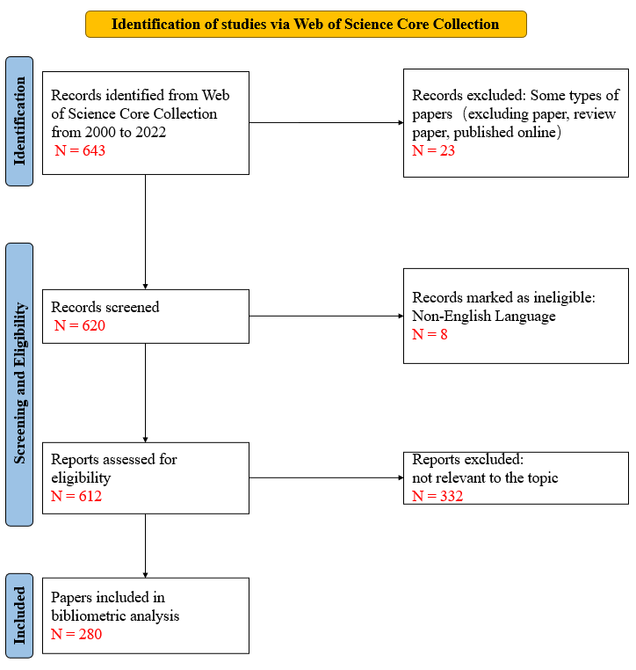
Figure 1 Flowchart of data collection from papers on prostate cancer with lung metastasis.

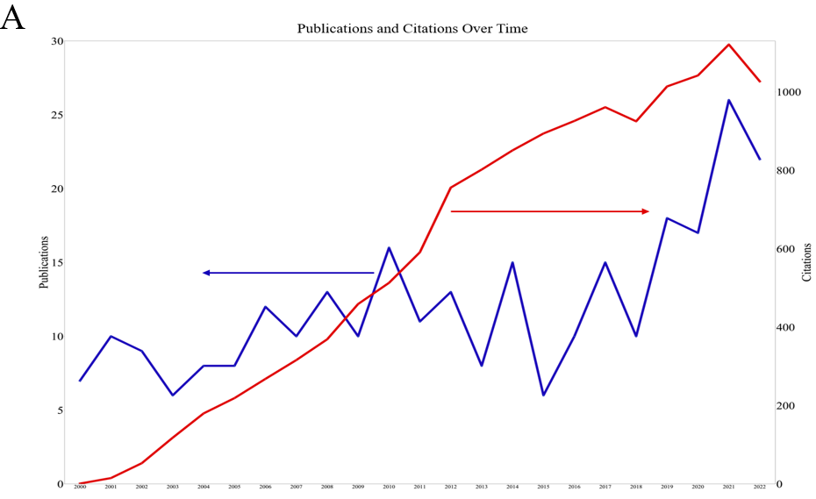
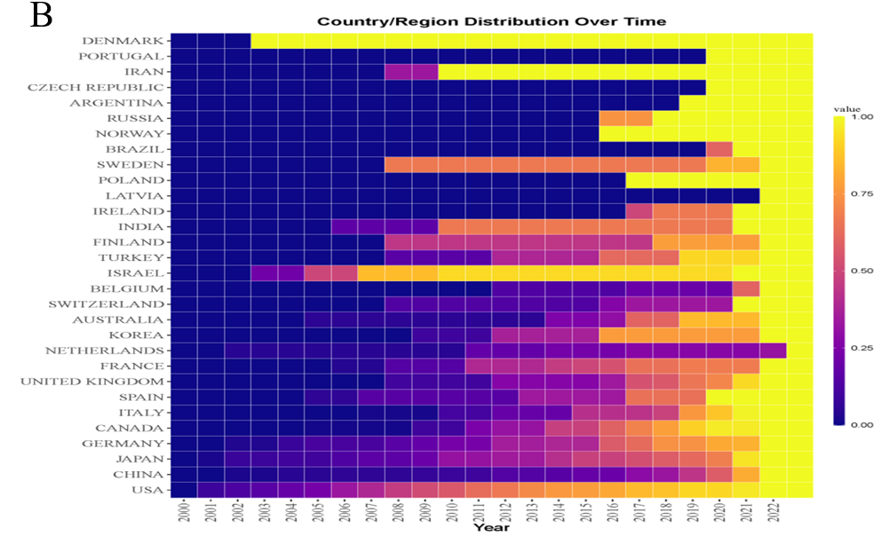
Figure 2 Distribution and change in time and space of knowledge volume in the prostate cancer with lung metastasis field. A: Annual publications and citations of papers on prostate cancer with lung metastasis (2000-2022); B: Thermal diagram of the time distribution of national/regional papers. The b values represent the ratio of the total number of papers published in a country from 2000 to a certain year to the total number of papers published in a country.

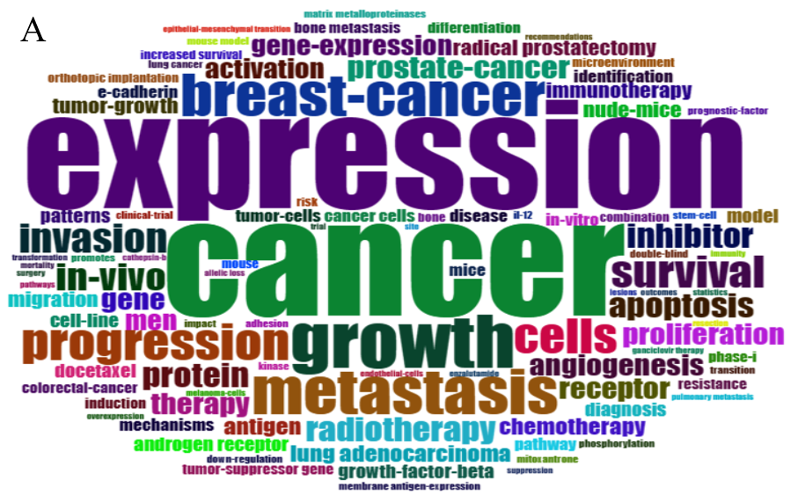
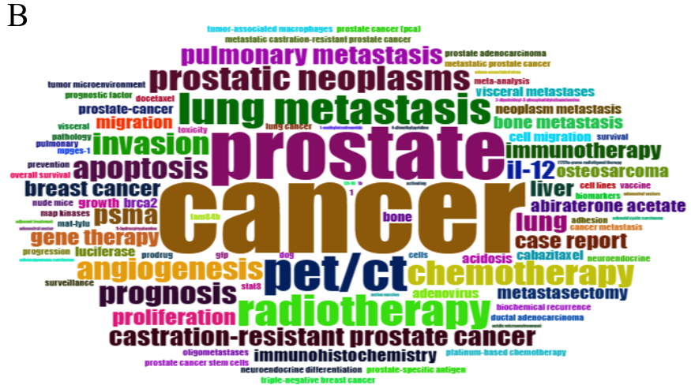
Figure 3 Word clouds of high-frequency keywords in the papers on prostate cancer with lung metastasis. A: Keywords plus; B: Author’s keywords.

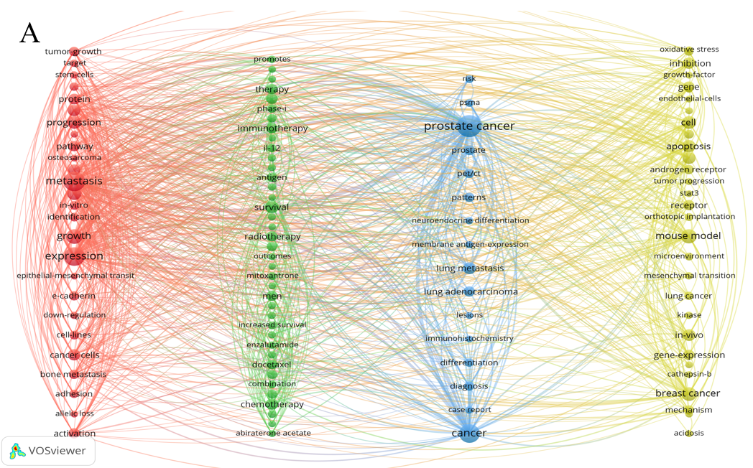
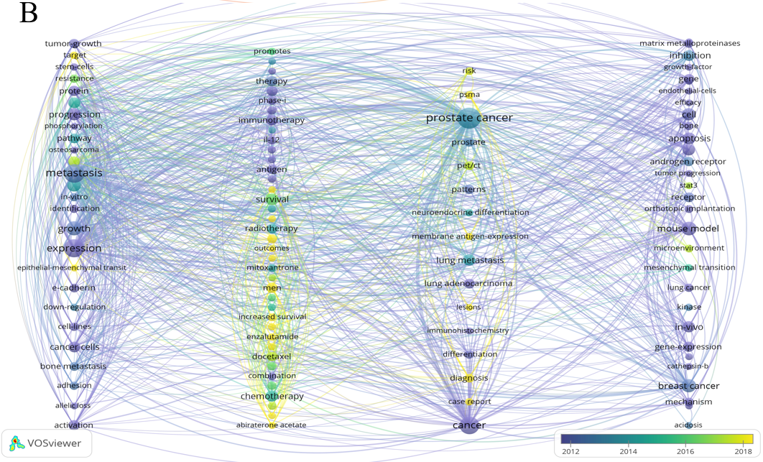
Figure 4 Analysis of the co-occurrence of all keywords in the papers on prostate cancer with lung metastasis. A: Network visualization map; B: Overlay visualization map. The small circle represents the keyword. The area of the small circle represents the frequency of the keyword. The colors of the different areas represent their categories. The lines of the connecting circles represent keywords that appear in an article simultaneously.

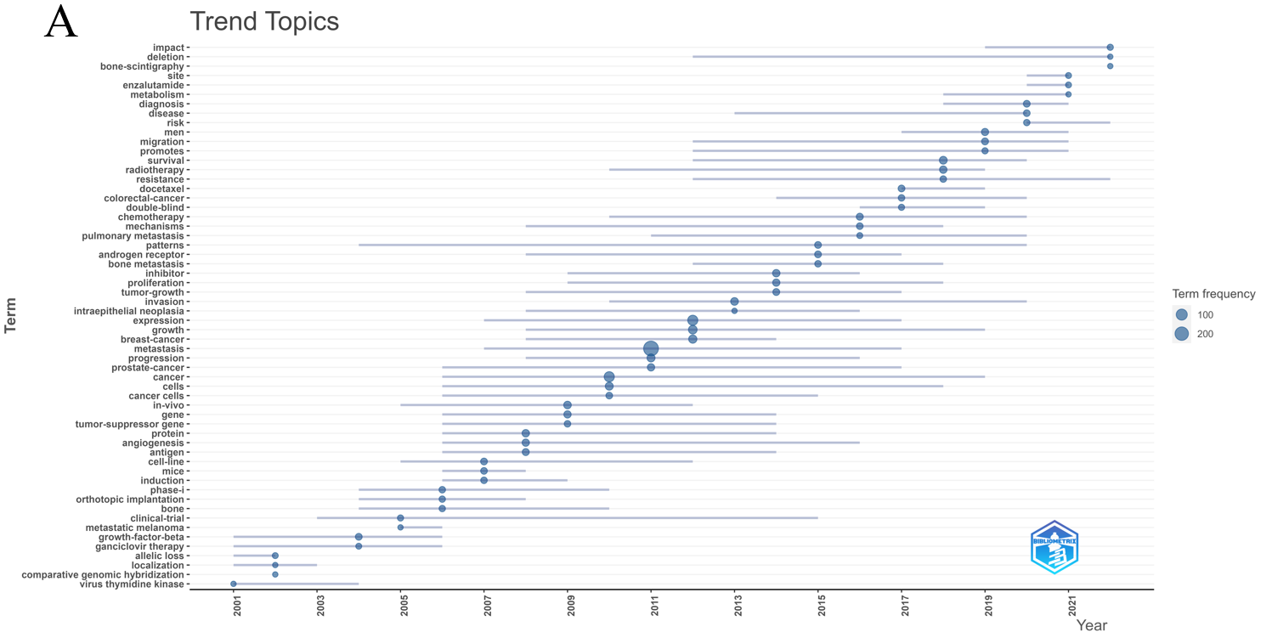
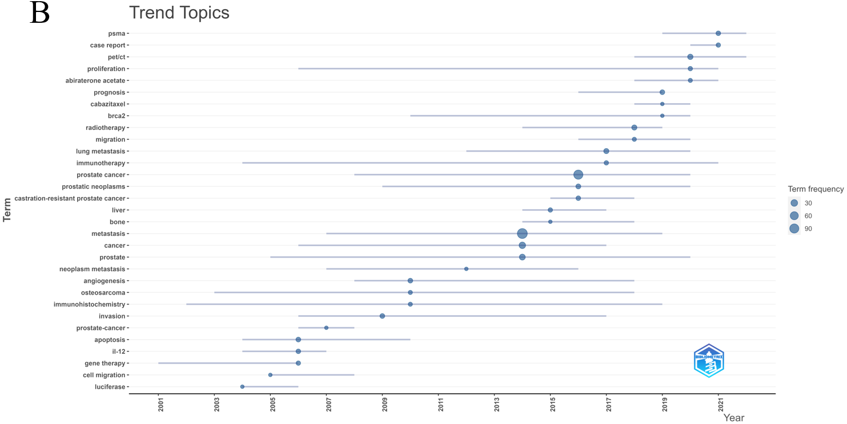
Figure 5 Topic trend graph. A: Keywords plus; B: Author’s keywords.

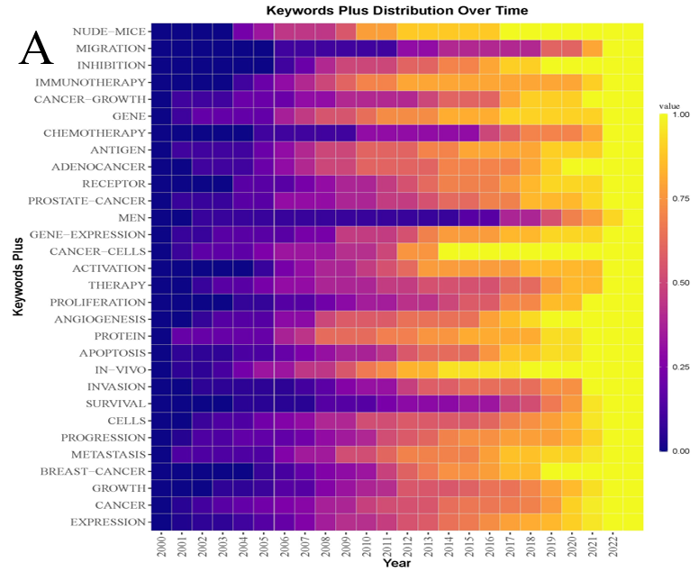
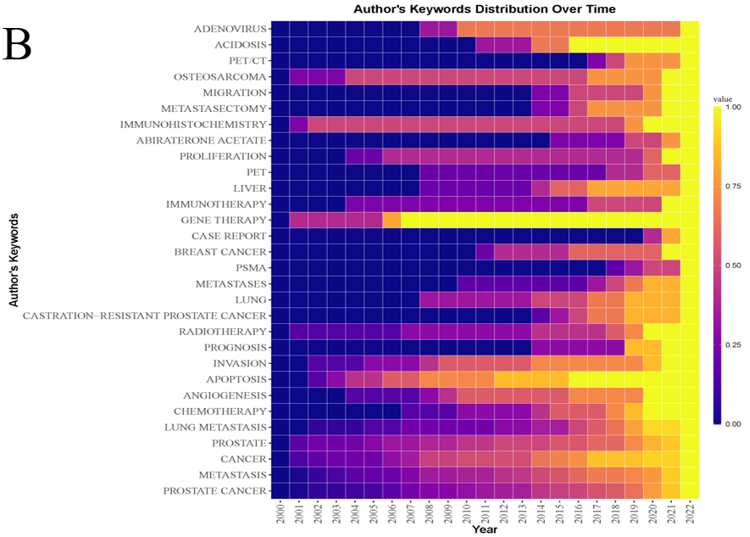
Figure 6 Keyword time heat map. A: Keywords plus; B: Author’s keywords. The values represent the ratio of the total frequency of the keyword from 2000 to a certain year to its total frequency; from top to bottom, the number of papers published by the country increased in turn.

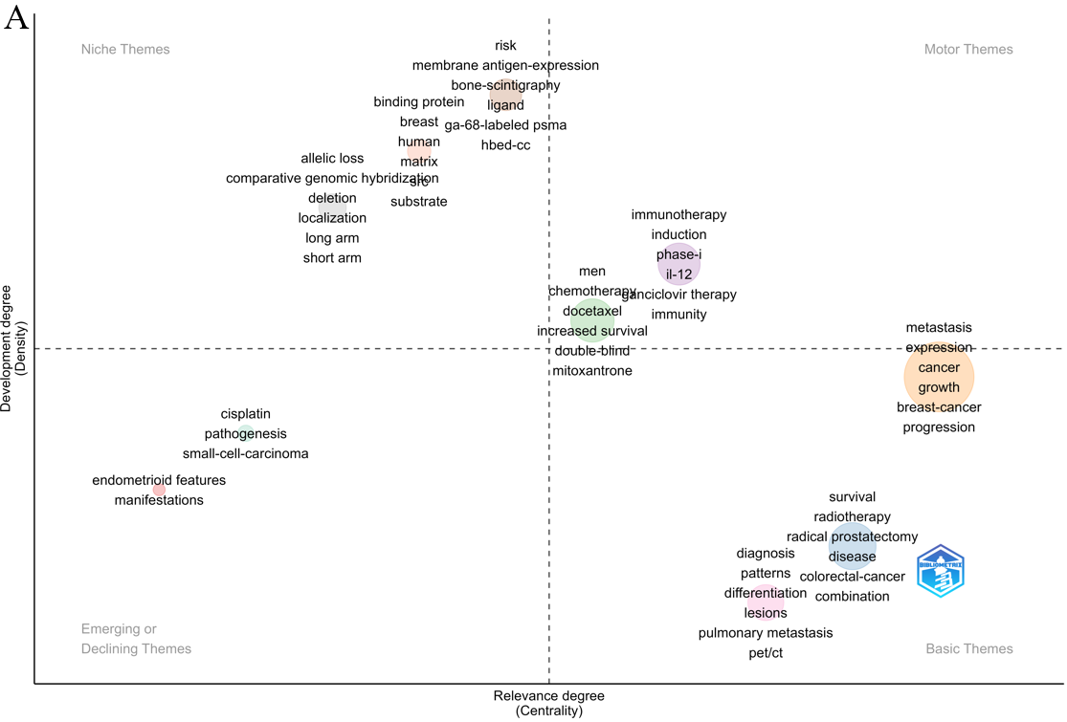
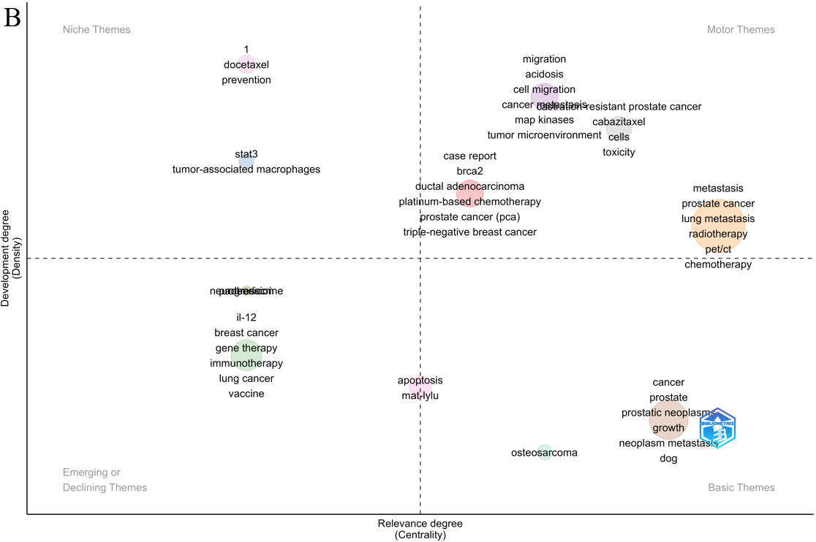
Figure 7 Theme strategic coordinate map. A: Keywords plus; B: Author’s keywords. PET/CT: Positron emission tomography/computed tomography; IL-12: Interleukin-12.

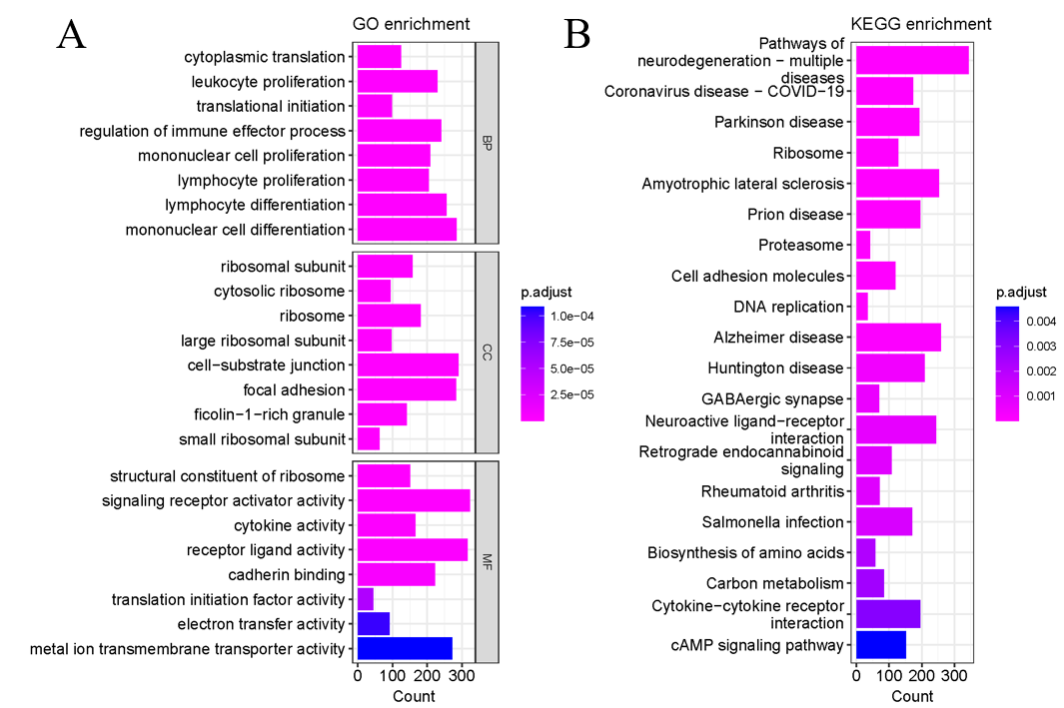
Figure 8 Molecular pathway map of prostate cancer with lung metastasis. A: Bubble map of differentially expressed genes (DEGs) based on the gene ontology enrichment analysis; B: Bubble map of DEGs based on the Kyoto Encyclopedia of Genes and Genomes enrichment analysis. GO: Gene ontology; KEGG: Kyoto Encyclopedia of Genes and Genomes.

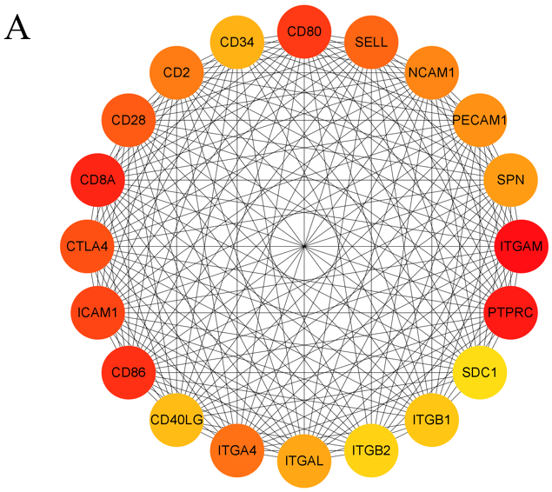
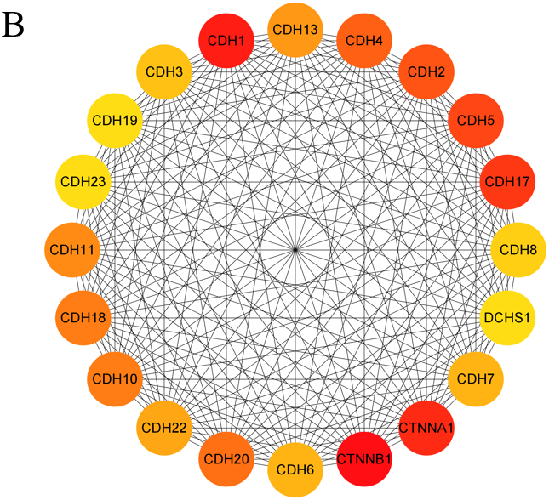
Figure 9 Protein–protein interaction network graph of the top 20 key proteins ranked by the maximal clique centrality method. A: Cell adhesion molecules; B: Cadherin binding.

