Name of Journal: World Journal of Clinical Cases
Manuscript NO: 62249
Manuscript Type: CASE REPORT

New mechanism of partial duplication and deletion of chromosome 8: A case report

Jiang Y et al. New mechanism of chromosome 8

Yan Jiang, Shuang Tang, Fang He, Jue-Xin Yuan, Zhu Zhang

Yan Jiang, Shuang Tang, Jue-Xin Yuan, Office of Prenatal Diagnosis, Mianyang People's Hospital, Mianyang 621000, Sichuan Province, China

Fang He, Department of Obstetrics, Mianyang People's Hospital, Mianyang 621000, Sichuan Province, China

Zhu Zhang, Office of Prenatal Diagnosis, West China Second University Hospital, Sichuan University, Chengdu 610000, Sichuan Province, China

Author contributions: Jiang Y and He F reviewed the literature and contributed to manuscript drafting; Yuan JX performed the G-banding chromosome analyses and contributed to manuscript drafting; Tang S performed the genetic counseling and contributed to manuscript drafting; Zhang Z performed the chromosome microarray analysis and contributed to manuscript drafting; Jiang Y and Tang S were responsible for revision of the manuscript for important intellectual content; all authors issued final approval for the version to be submitted.

Corresponding author: Shuang Tang, MBBS, Attending Doctor, Office of Prenatal Diagnosis, Mianyang People's Hospital, No. 10-12 West Jiannan Road, Fuchen District, Mianyang 621000, Sichuan Province, China. 154179285@qq.com

Received: February 21, 2021
Revised: May 23, 2021
Accepted: June 7, 2021
Published online:

Abstract
BACKGROUND
During meiosis, the recombination of homologous chromosomes produces some new heritable mutations, which are the basis of biological evolution and diversity. However, when there is pericentric inversion of chromosomes, unbalanced gametes will be formed in the process of germ cell meiosis.

CASE SUMMARY
A 23-year-old pregnant woman at 25 wk of gestation wanted to terminate her pregnancy due to fetal chromosomal abnormalities. She had no exposure to toxic or hazardous substances before and during pregnancy, no history of medication usage during pregnancy, and she underwent cystectomy of ovarian cysts in 2017. On the second day of the 16th week of gestation, non-invasive prenatal testing showed chromosome 8 copy number variation. Following genetic counseling, her pregnancy was terminated.

CONCLUSION
Recombinant offspring chromosome is rarely seen when the inversion segment is shorter than one-third of the chromosome length. In terms of the mechanism of chromosome 8 duplication/deletion occurrence, attention should be paid to the production of unbalanced gametes by the pairing of homologous chromosome during meiosis, and the possibility of mitotic recombination exchange as well.

Key Words: Chromosome 8; Spontaneous mutation; Mitosis; Non-invasive prenatal testing; Case report

Jiang Y, Tang S, He F, Yuan JX, Zhang Z. New mechanism of partial duplication and deletion of chromosome 8: A case report. World J Clin Cases 2021; In press

Core Tip: The mechanism of partial deletion/duplication at the end of chromosome 8 involves two prevailing theories: Parental chromosome 8 inversion producing unbalanced gametes, and a recombination hot spot of chromosome 8p. Although the recombination hot spot of chromosome 8q occurring during mitosis is rarely reported, it was confirmed in the present case. Non-invasive prenatal testing (NIPT) for copy number variation has been used, but 40% or less mosaic abnormalities cannot be detected by NIPT. When chromosome 8 partial deletion/duplication occurs, in addition to the unbalanced gamete production caused by parental chromosome 8 inversion, attention should be paid to the mechanism of spontaneous recombination in meiosis or mitosis.
INTRODUCTION
The occurrence of duplicated and deleted offspring chromosome ends is commonly triggered by the joint pairing of pericentric inversion of chromosomes and homologous chromosomes during the first stage of meiosis. If the joint pairing forms an inverted ring, four different gametes are theoretically produced, including one with a normal chromosome, one with an inverted chromosome, and the other two with both partial duplication and partial deletions; e.g., mother46,xx,inv(8)(p15q36), offspring: 46,xy,rec(8)dup p,inv(8)(p15q36)mat. Many factors seem to influence the production of recombinant chromosomes, such as the affected chromosome and involved region, location of the breakpoints, or size of the inverted segment. The rate of recombination varies according to the size of the inverted segment^{[1]}. Research has shown that chromosome 8p has a recombination hot spot, which leads to the complex de novo 8p rearrangement^{[2,3]}.

CASE PRESENTATION
Chief complaints
A 23-year-old pregnant woman at 25 wk of gestation wanted to terminate her pregnancy due to fetal chromosomal abnormalities.

History of present illness
On the second day of the 16th week of gestation, non-invasive prenatal testing (NIPT) showed chromosome 8 copy number variation.

History of past illness
The patient underwent a cystectomy for benign ovarian cysts in 2017.

Personal and family history
The patient had no special personal and family history.

Physical examination
The pregnant woman's uterine height was 23 cm, abdominal circumference was 84 cm and blood pressure was 114/64 mmHg.

Laboratory examinations
NIPT showed that there was low-risk syndrome of chromosome 13, 18 and 21 and high risk of the end of the short arm of chromosome 8 missing about 3 Mb (Figure 1). Amniocentesis chromosome microarray analysis showed: arr[GRCH37]8p23.3p23.2(158048-3220759)x1,8q21.11q24.3(77115706-146295771)x3 (Figure 2).

Imaging examinations
Systematic ultrasonography showed that the fetal ventricles were widened bilaterally, and the measured value of the septum pellucidum was smaller than the normal. Cardiac ultrasound suggested fetal venous catheter occlusion or absence.

FINAL DIAGNOSIS
The fetus had an abnormal copy number of chromosome 8 and restricted placental mosaicism.

TREATMENT
The pregnancy was terminated after genetic counseling.

OUTCOME AND FOLLOW-UP
The couple underwent peripheral blood karyotype examination, and no significant abnormalities were seen in the G-dominant band (400 bands). They have no plans for another pregnancy.

DISCUSSION
In the present case, NIPT showed that the fetus may have a terminal deletion of chromosome 8p (Figure 1), and amniocentesis chromosome microarray analysis showed a deletion/duplication of chromosome 8p/8q (Figure 2). They are not consistent with each other. It has been reported that NIPT has higher efficiency for detecting > 2 Mb copy number variations^{[4-7]} compared to other techniques. However, further placental high-throughput sequencing confirmed that the placental long-arm terminal duplication was 40% mosaic (Figure 3), indicating that NIPT may not have a high detection rate when chromosomal copy number variations show a low placental mosaic proportion, thus it has a limited role in the detection of chromosomal copy number variations.
All the chromosomes, mostly chromosomes 2 and 8, are known to be involved in pericentric inversions^{[8]}. Carriers of these inversions can produce a significant percentage of chromosomal unbalanced gametes (duplication q/deletion p or duplication p/deletion q). The rate of recombination varies according to the size of the inverted segment^{[1,9]}.
Chromosome 8p is especially prone to various genomic rearrangements mainly due to the existence of the two olfactory receptor gene clusters (REPD and REPP) of 8p23.1^{[10-12]}.
In the present case, the chromosome microarray analysis indicated a deletion of 8p and a duplication of 8q, and pericentric inversions of chromosome 8 were not found in the couple’s G-dominant band (400 bands) of chromosomal karyotype (Figure 4). CNV-seq of the placenta indicated a deletion of 8p and a duplication of 8q with 40% mosaicism (Figure 3). All the above data indicated that the short-arm deletion and long-arm duplication of fetal chromosome 8 were new mutations. The deletion of chromosome 8p is presumed to have a high possibility of a deletion in the meiotic homologous chromosome synapsis and exchange, which is consistent with the high recombination rate of the terminal arm of chromosome 8 based on the database of recombination rates of human homologous chromosomes^{[3]}. Cases of terminal deletion of chromosome 8p have also been reported^{[13,14]}, which further confirmed that mutation sites may be at the end of the short arm of chromosome 8 resulting in the prevention of breakpoints from synapsis and recombination. The duplication of chromosome 8q may arise from a disorder of the mitotic homologous chromosome recombination early in the development of the fertilized egg, and later the inner cell mass of the mulberry embryo develops from the deletion and repeated cell line of chromosome 8. Thus, two cell lines exist in the placenta resulting in the terminal deletion and duplication of chromosome 8p and chromosome 8q.

CONCLUSION
Recombinant offspring chromosomes are rarely seen when the inversion segment is shorter than one-third of the chromosome length. The extent of the genetic imbalance of these recombinants depends on the relative size of the inversion segment. In terms of the mechanism of chromosome 8 duplication/deletion occurrence, attention should be paid to the production of unbalanced gametes by the pairing of homologous chromosome during meiosis, and the possibility of mitotic recombination exchange as well.

REFERENCES
1 Caer E, Perrin A, Douet-Guilbert N, Amice V, De Braekeleer M, Morel F. Differing mechanisms of meiotic segregation in spermatozoa from three carriers of a pericentric inversion of chromosome 8. Fertil Steril 2008; 89: 1637-1640 [PMID: 17603050 DOI: 10.1016/j.fertnstert.2007.04.056]
2 Vermeesch JR, Thoelen R, Salden I, Raes M, Matthijs G, Fryns JP. Mosaicism del(8p)/inv dup(8p) in a dysmorphic female infant: a mosaic formed by a meiotic error at the 8p OR gene and an independent terminal deletion event. J Med Genet 2003; 40: e93 [PMID: 12920085 DOI: 10.1136/jmg.40.8.e93]
3 Giorda R, Ciccone R, Gimelli G, Pramparo T, Beri S, Bonaglia MC, Giglio S, Genuardi M, Argente J, Rocchi M, Zuffardi O. Two classes of low-copy repeats comediate a new recurrent rearrangement consisting of duplication at 8p23.1 and triplication at 8p23.2. Hum Mutat 2007; 28: 459-468 [PMID: 17262805 DOI: 10.1002/humu.20465]
4 Yin AH, Peng CF, Zhao X, Caughey BA, Yang JX, Liu J, Huang WW, Liu C, Luo DH, Liu HL, Chen YY, Wu J, Hou R, Zhang M, Ai M, Zheng L, Xue RQ, Mai MQ, Guo FF, Qi YM, Wang DM, Krawczyk M, Zhang D, Wang YN, Huang QF, Karin M, Zhang K. Noninvasive detection of fetal subchromosomal abnormalities by semiconductor sequencing of maternal plasma DNA. Proc Natl Acad Sci U S A 2015; 112: 14670-14675 [PMID: 26554006 DOI: 10.1073/pnas.1518151112]
5 Wang Q, Zeng XL, Yu L, Zhao SY. Clinical research progress of non-invasive prenatal detection for fetal chromosome microdeletion/microrepetition. Shiyong Fuke Neifenmi Dianzi Zazhi 2020; 13:22-24 [DOI: 10.16484/j.cnki.issn2095-8803.2019.13.008]
6 Ye XQ, Gao Y, Song XW, Wu XJ, Chen JY, Wang JY, Yan HC, Chen M. Evaluation of Detection Efficiency for Fetal Chromosome Copy Number Varia- tion Measured by Low-Depth Sequencing Noninvasive Prenatal Test. Shiyong Fuchanke Zazhi 2020; 36: 380-384
7 Yu D, Zhang K, Han M, Pan W, Chen Y, Wang Y, Jiao H, Duan L, Zhu Q, Song X, Hong Y, Chen C, Wang J, Hui F, Huang L, Chen C, Du Y. Noninvasive prenatal testing for fetal subchromosomal copy number variations and chromosomal aneuploidy by low-pass whole-genome sequencing. Mol Genet Genomic Med 2019; 7: e674 [PMID: 31004415 DOI: 10.1002/mgg3.674]
8 Jaarola M, Martin RH, Ashley T. Direct evidence for suppression of recombination within two pericentric inversions in humans: a new sperm-FISH technique. Am J Hum Genet 1998; 63: 218-224 [PMID: 9634501 DOI: 10.1086/301900]
9 Vera-Carbonell A, López-González V, Bafalliu JA, Piñero-Fernández J, Susmozas J, Sorli M, López-Pérez R, Fernández A, Guillén-Navarro E, López-Expósito I. Pre- and postnatal findings in a patient with a novel rec(8)dup(8q)inv(8)(p23.2q22.3) associated with San Luis Valley syndrome. Am J Med Genet A 2013; 161A: 2369-2375 [PMID: 23894102 DOI: 10.1002/ajmg.a.36103]
10 Hollox EJ, Barber JC, Brookes AJ, Armour JA. Defensins and the dynamic genome: what we can learn from structural variation at human chromosome band 8p23.1. Genome Res 2008; 18: 1686-1697 [PMID: 18974263 DOI: 10.1101/gr.080945.108]
11 Cooke SL, Northup JK, Champaige NL, Zinser W, Edwards PA, Lockhart LH, Velagaleti GV. Molecular cytogenetic characterization of a unique and complex de novo 8p rearrangement. Am J Med Genet A 2008; 146A: 1166-1172 [PMID: 18302246 DOI: 10.1002/ajmg.a.32248]
12 Shimokawa O, Miyake N, Yoshimura T, Sosonkina N, Harada N, Mizuguchi T, Kondoh S, Kishino T, Ohta T, Remco V, Takashima T, Kinoshita A, Yoshiura K, Niikawa N, Matsumoto N. Molecular characterization of del(8)(p23.1p23.1) in a case of congenital diaphragmatic hernia. Am J Med Genet A 2005; 136: 49-51 [PMID: 15937941 DOI: 10.1002/ajmg.a.30778]
13 Liu FR, Hao SJ, Zhang C, Zhou BB, Wang X, Zheng L. Cytogenetic and molecular genetic study of duplication deletion of 8p in a new case. Linchuang Erke Zazhi 2020; 38: 707-709 [DOI: 10.3969/j.issn.1000-3606.2020.09.016]
14 Han X, Zhang JM, Jiang WT, Hu Q, Tao J. Cytogenetic and molecular genetic study of a case with 8p inverted duplication deletion syndrome. Zhonghua Yixue Yichuanxue Zazhi 2010; 27: 361-366 [DOI: 10.3760/cma.j.issn.1003-9406.2010.04.001]

Footnotes
Informed consent statement: The patient provided informed written consent prior to study enrollment.

Conflict-of-interest statement: The authors declare that they have no conflict of interest.

CARE Checklist (2016) statement: The authors have read the CARE Checklist (2016), and the manuscript was prepared and revised according to the CARE Checklist (2016).

Open-Access: This article is an open-access article that was selected by an in-house editor and fully peer-reviewed by external reviewers. It is distributed in accordance with the Creative Commons Attribution NonCommercial (CC BY-NC 4.0) license, which permits others to distribute, remix, adapt, build upon this work non-commercially, and license their derivative works on different terms, provided the original work is properly cited and the use is non-commercial. See: http://creativecommons.org/Licenses/by-nc/4.0/

Manuscript source: Unsolicited manuscript

Peer-review started: February 21, 2021
First decision: May 6, 2021
Article in press:

Specialty type: Medicine, research and experimental
Country/Territory of origin: China
Peer-review report’s scientific quality classification
Grade A (Excellent): 0
Grade B (Very good): B, B
Grade C (Good): 0
Grade D (Fair): 0
Grade E (Poor): 0

P-Reviewer: Bolshakova GB, soleimanian S S-Editor: Gao CC L-Editor: Webster JR P-Editor:
Figure Legends
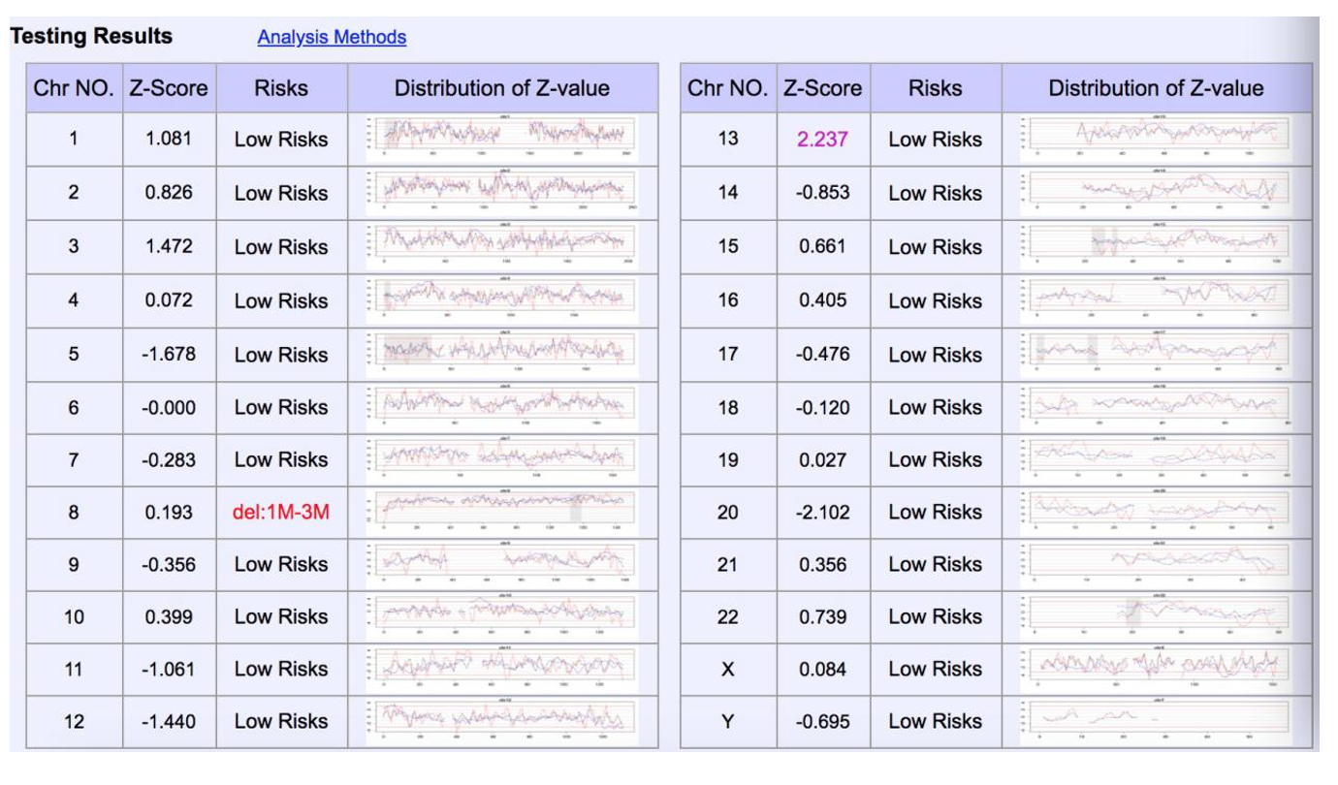
Figure 1 Non-invasive prenatal testing showed high risk of 3 Mb deletion at the end of chromosome 8p.
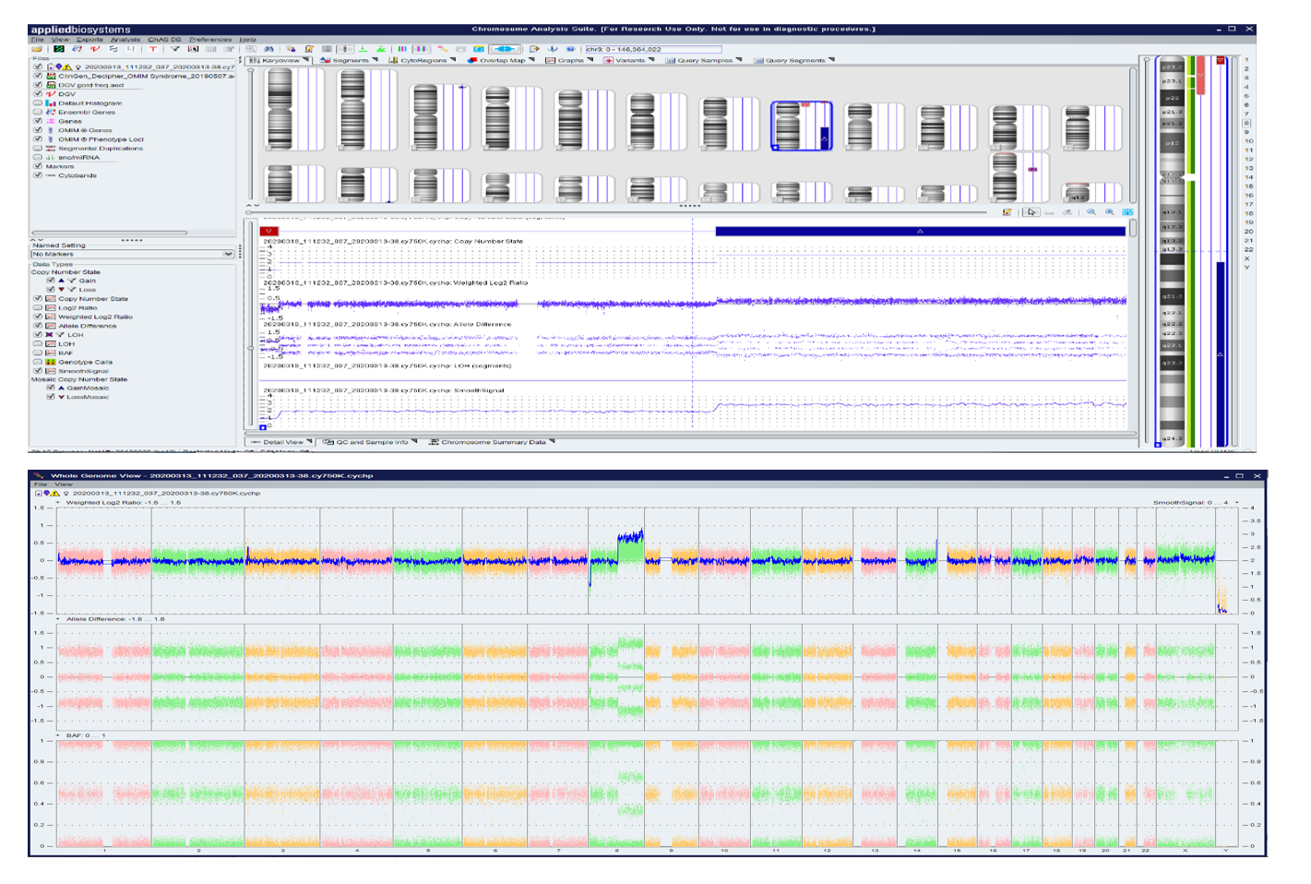
Figure 2 Amniocentesis chromosome microarray analysis showed 3.06Mb deletion in 8p23.3p23.2, and 69.18Mb duplication in 8q21.11q24.3.
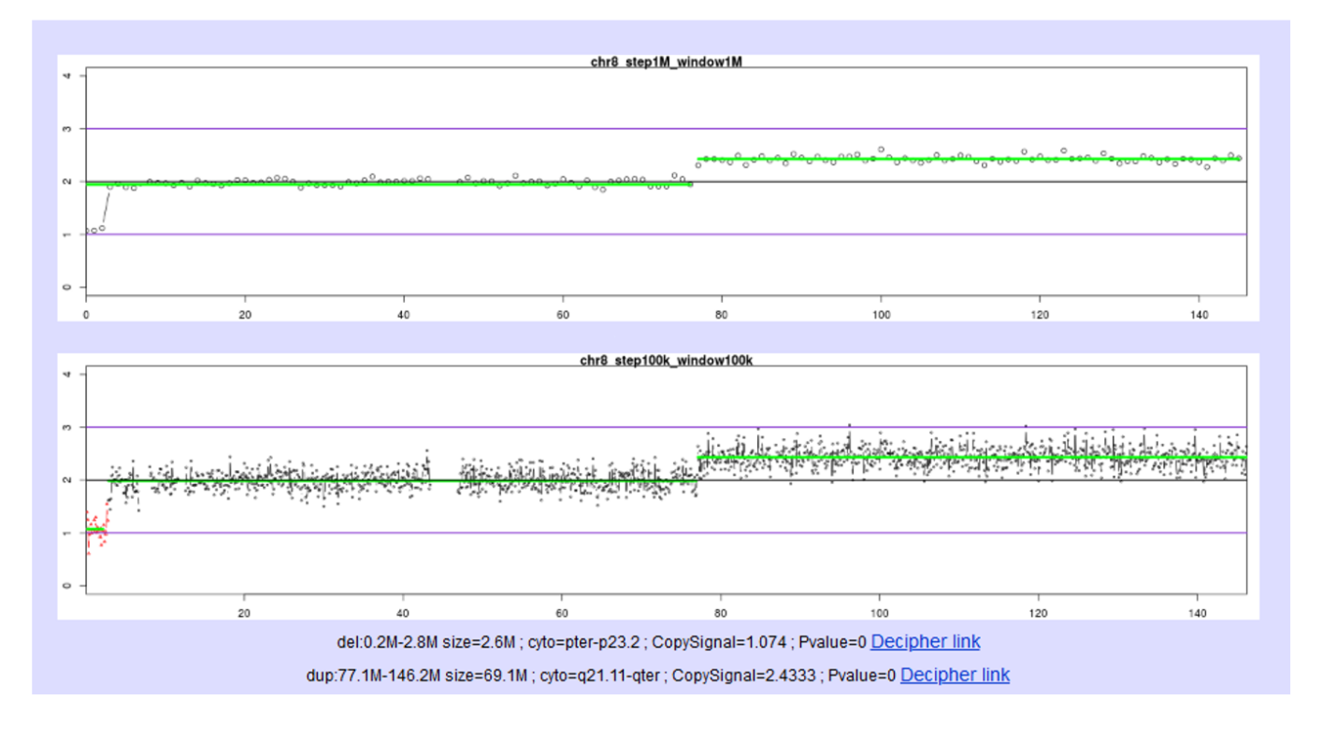
Figure 3 Placental high throughput sequencing showed 3.06Mb deletion in 8p23.3p23.2, and 69.18Mb duplication in 8q21.11q24.3 with 40% mosaicism.
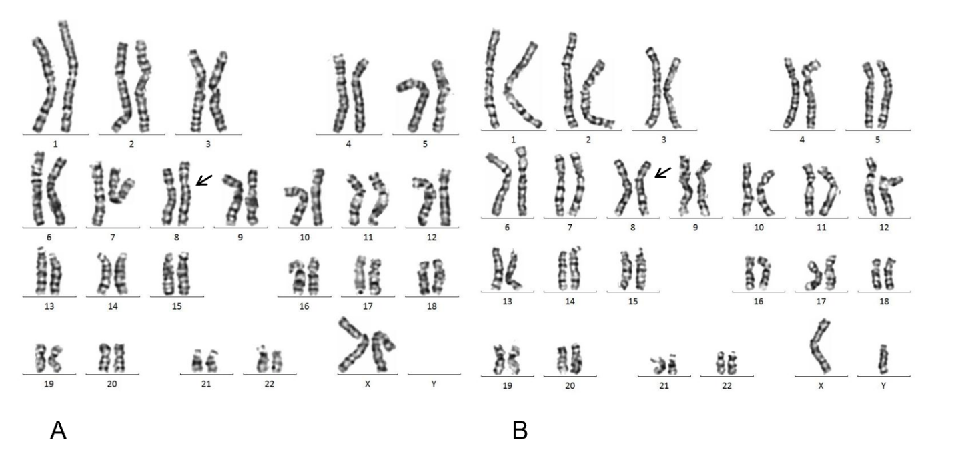
Figure 4 The karyotype of the mother and father. A: The karyotype of the mother was 46,XX; B: The karyotype of the father was 46,XY.

