Name of Journal: World Journal of Gastrointestinal Surgery
Manuscript NO: 84117
Manuscript Type: ORIGINAL ARTICLE

Observational Study
Diagnostic value of matrix metalloproteinases 2, 7 and 9 in urine for early detection of colorectal cancer

Peng L et al. Early detection of CRC

Liu Peng, Xin Zhang, Man-Li Zhang, Tao Jiang, Peng-Jun Zhang

Liu Peng, Xin Zhang, Peng-Jun Zhang, Key Laboratory of Carcinogenesis and Translational Research (Ministry of Education/Beijing), Department of Interventional Therapy, Peking University Cancer Hospital & Institute, Beijing 100142, China

Man-Li Zhang, Tao Jiang, Division of Medicine Innovation Research, Chinese PLA General Hospital, Beijing 100853, China

Author contributions: Peng L, Jiang T and Zhang PJ designed the study; Peng L, Zhang X performed the research; Peng L, Jiang T, Zhang ML and Zhang PJ analyzed the date; Peng L wrote the paper; Jiang T and Zhang PJ revised the manuscript for final submission; Peng L and Zhang X contributed equally to this study; Jiang T and Zhang PJ are the co-corresponding authors.

Supported by the National Key Research and Development Program of China, No. 2020YFC2004604 and 2020YFC2002700.

Corresponding author: Peng-Jun Zhang, PhD, Doctor, Key Laboratory of Carcinogenesis and Translational Research (Ministry of Education/Beijing), Department of Interventional Therapy, Peking University Cancer Hospital & Institute, No. 52 Fucheng Road, Beijing 100142, China. zhangpj301@126.com

Received: March 13, 2023
Revised: March 29, 2023
Accepted: April 7, 2023
Published online: May 27, 2023

Abstract
BACKGROUND
A noninvasive biomarker with high diagnostic performance is urgently needed for the early diagnosis of colorectal cancer (CRC).

AIM
To evaluate the diagnostic value of matrix metalloproteinases (MMPs) 2, 7 and 9 in urine for CRC.

METHODS
Of 59 healthy controls, 47 patients with colon polyps and 82 patients with CRC were included in this study. Carcinoembryonic antigen (CEA) in serum and MMP2, MMP7, and MMP9 in urine were detected. The combined diagnostic model of the indicators was established by binary logistic regression. The receiver operating characteristic curve (ROC) of the subjects was used to evaluate the independent and combined diagnostic value of the indicators.

RESULTS
The MMP2, MMP7, MMP9, and CEA levels in the CRC group differed significantly from levels in the healthy controls (P < 0.05). The levels of MMP7, MMP9, and CEA also differed significantly between the CRC group and the colon polyps group (P < 0.05). The area under the curve (AUC) distinguishing between the healthy control and the CRC patients using the joint model with CEA, MMP2, MMP7 and MMP9 was 0.977, and the sensitivity and specificity were 95.10% and 91.50%, respectively. For early-stage CRC, the AUC was 0.975, and the sensitivity and specificity were 94.30% and 98.30%, respectively. For advanced stage CRC, the AUC was 0.979, and the sensitivity and specificity were 95.70% and 91.50%, respectively. Using CEA, MMP7 and MMP9 to jointly established a model distinguishing the colorectal polyp group from the CRC group, the AUC was 0.849, and the sensitivity and specificity were 84.10% and 70.20%, respectively. For early-stage CRC, the AUC was 0.818, and the sensitivity and specificity were 76.30% and 72.30%, respectively. For advanced stage CRC, the AUC was 0.875, and the sensitivity and specificity were 81.80% and 72.30%, respectively.

CONCLUSION
MMP2, MMP7 and MMP 9 may exhibit diagnostic value for the early detection of CRC and may serve as auxiliary diagnostic markers for CRC.

Key Words: Colorectal cancer; Early detection; Matrix metalloproteinases; Urine; Biomarker

©The Author(s) 2023. Published by Baishideng Publishing Group Inc. All rights reserved.

Citation: Peng L, Zhang X, Zhang ML, Jiang T, Zhang PJ. Diagnostic value of matrix metalloproteinases 2, 7 and 9 in urine for early detection of colorectal cancer. World J Gastrointest Surg 2023; 15(5): 931-939
URL: https://www.wjgnet.com/1948-9366/full/v15/i5/931.htm
DOI: https://dx.doi.org/10.4240/wjgs.v15.i5.931

Core Tip: Colorectal cancer (CRC) is one of the most common cancers. Early diagnosis and early treatment have become the consensus of CRC diagnosis and treatment. Matrix metalloproteinases (MMPs), as a group of zinc-dependent endopeptidases, participate in the degradation of the extracellular matrix and are secreted and activated outside the cell. We aimed to evaluate the MMP2, MMP7 and MMP9 diagnostic value for early detection of CRC.

INTRODUCTION
Colorectal cancer (CRC) is one of the most common cancers. Although detection and treatment have improved, the incidence and mortality of CRC are on the rise^{[1]}. A large number of clinical studies have confirmed that early diagnosis of CRC can significantly prolong survival, but at present, only approximately 30% to 40% of patients are diagnosed at an early stage. Early diagnosis and early treatment have become the consensus of CRC diagnosis and treatment^{[2]}. At present, the commonly used clinical tests include invasive colonoscopy, noninvasive fecal occult blood testing, fecal DNA testing, carcinoembryonic antigen (CEA), carbohydrate antigen 199 (CA199) levels, and Septin 9 methylation levels, but such tests are limited by their complexity and diagnostic performance^{[3]}. A noninvasive biomarker with high diagnostic performance is urgently needed for the early diagnosis of clinical CRC^{[4]}.
Research has demonstrated that cytokines can be used as potential biomarkers for cancer detection and treatment response^{[5]}. Cytokines are soluble peptides that play an important role in inflammation and immune cells signaling as well as in the multistep process of carcinogenesis. Cytokines can bind to their receptor and trigger the production of additional cytokines, leading to high concentrations in blood or other body fluids^{[6]}. Compared with blood or stool, urine represents a better source because of its simple collection method, high patient acceptance and ability to collect repeated samples. Many urine biomarkers for CRC have been studied and have demonstrated potential diagnostic value^{[7-9]}. Matrix metalloproteinases (MMPs), as a group of zinc-dependent endopeptidases, participate in the degradation of the extracellular matrix and are secreted and activated outside the cell. The overexpression of MMPs in the development and progression of CRC has been confirmed, and the use of MMPs as a potential serum marker for the early diagnosis of CRC has been previously reported^{[10-13]}. Tumors represent multistage and multigene diseases. At present, the necessity of using multiple markers for cancer diagnosis has become accepted and can effectively improve the diagnostic value of a single marker. We aimed to evaluate the diagnostic value of serum CEA and CA199 and urine MMP2, MMP7 and MMP9 in distinguishing among healthy controls, colon polyps and CRC patients to establish an auxiliary diagnostic method for early CRC.

MATERIALS AND METHODS
Clinical samples
The study was approved by the Ethics Committee of Peking University Cancer Hospital & Institute and provided their informed consent. Serum and urine samples were collected from 59 healthy controls, 47 patients with colon polyps and 82 patients with CRC. The age and sex of the healthy control group, colon polyp group and CRC group were matched. Among the 82 patients with CRC, there were 10, 28, 20, and 24 Duke A, B, C and D stage cancers, respectively. The were 38 cases of early CRC and 44 cases of late CRC. The inclusion criteria for the colon polyps and colon cancer groups were as follows: No prior treatment (e.g., surgery, chemotherapy or radiotherapy), histopathological confirmation, no other gastrointestinal diseases and no other major diseases. The age-matched healthy controls all had negative blood biomarker, X-ray, ultrasound, computed tomography (CT), and fecal occult blood tests, and diagnosis was further confirmed by histopathological analysis. CRC sites included the cecum, ascending colon, descending colon, transverse colon, sigmoid colon and rectum. CRC was staged in accordance with Dukes staging criteria. Dukes stage A and B cancers represent early CRC, and Dukes stage C and D cancers represent late CRC. The clinical characteristics of the subjects are presented in Table 1.

Biomarker detection
Fasting peripheral blood was collected from all subjects included in this study in the morning and centrifuged at 3000 rpm for 10 min, and the supernatants were collected and labeled. All urine samples were collected from the middle section of the second morning urine (10 mL) and centrifuged at 1500 rpm for 10 min; the supernatant was collected, labeled, and stored at -80 °C. CEA and CA199 were detected by chemiluminescence, and a Roche E170 automatic immune analyzer was used for detection. The fasting peripheral blood of the subjects was collected using vacuum collecting tubes, and the serum was separated after centrifugation. CEA and CA199 were detected after the instrument was calibrated using standards. Urine MMP2, MMP7, and MMP9 were detected by a modular collection rapid detection system and using the antigen-antibody combination luminescence principle, which can detect trace MMP9 levels.

Statistical analysis
The data of this study were analyzed using SPSS 20.0. The CEA, CA199, MMP2, MMP7, and MMP9 levels are expressed as medians (25%, 75%). Differences in marker levels among the healthy control group, colon polyp group and CRC group were tested using one-way ANOVA for significance. The combined diagnostic model of the three indicators was established using binary logistic regression. The receiver operating characteristic curve (ROC) was used to evaluate the independent and combined diagnostic value of the indicators. P < 0.05 was defined as a significant difference.

RESULTS
Comparison of MMP2, MMP7, MMP9 and CEA levels among healthy control, colon polyp and CRC groups
The MMP2, MMP7 MMP9, and CEA levels in the three groups were detected and compared. As shown in Table 1, MMP2, MMP7 MMP9, and CEA levels in the healthy controls were 2128.42 (1635.60, 3119.34), 2612.71 (2087.86, 3110.04) and 8153.00 (5170.05, 11732.83), respectively. In the colon polyp group, the MMP2, MMP7 MMP9, and CEA levels were 15459.62 (12244.16, 18777.56), 3237.57 (2513.33, 3915.02), 14288.33 (8711.57, 17994.25), and 3.05 (1.55, 7.82). In the CRC group, the MMP2, MMP7 MMP9, and CEA levels were 15396.14 (6571.35, 20006.06), 4173.63 (3023.82, 6327.17), 8324.22 (4005.56, 11932.17), and 6.84 (1.86, 14.43), respectively. The MMP2, MMP7, MMP9, and CEA levels in the CRC group differed significantly from those in the healthy control group (P < 0.05). The MMP7, MMP9, and CEA levels in the CRC group differed significantly from the levels in the colon polyp group (P < 0.05). MMP2 levels did not differ significantly between the colon polyp and CRC groups.

Evaluation of the diagnostic value of CEA, MMP2, MMP7 and MMP9 in distinguishing healthy controls from CRC patients
CEA, MMP2, MMP7 and MMP9 were separately used to distinguish the 59 healthy controls from the 82 CRC patients; the results are presented in Figure 1 and Table 2, respectively. The area under the curve (AUC) of urine MMP2 was the highest, 0.875 [95% confidence interval (CI): 0.815-0.935], followed by MMP7, CEA, and MMP9. The AUCs were 0.786 (95%CI: 0.711-0.862), 0.779 (95%CI: 0.704-0.853) and 0.748 (95%CI: 0.667-0.830), respectively. As shown in Figure 2, when CEA, MMP2, MMP7 and MMP9 levels were combined to established a model to distinguish the 59 healthy controls and 82 CRC patients, the AUC was 0.977 (95%CI: 0.957-0.998), and the sensitivity and specificity were 95.10% and 91.50%, respectively. When this combined model was used to distinguish 59 healthy controls and 38 patients with early CRC, the AUC was 0.975 (95%CI: 0.940-1.000), and the sensitivity and specificity were 94.30% and 98.30%, respectively. When used to distinguish 59 healthy controls and 47 patients with advanced CRC, the AUC was 0.979 (95%CI: 0.956-1.000), and the sensitivity and specificity were 95.70% and 91.50%, respectively.

Evaluation of the diagnostic value of CEA, MMP7 and MMP9 in distinguishing patients with colorectal polyps from CRC patients
CEA, MMP7 and MMP9 were separately used to distinguish the 47 patients with colorectal polyps from the 82 CRC patients; the results are presented in Figure 3 and Table 3. The AUC of urine MMP7 was the highest, 0.769 (95%CI: 0.688-0.851), followed by MMP9 and CEA. The AUCs for MMP9 and CEA were 0.737 (95%CI: 0.647-0.827) and 0.626 (95%CI: 0.528-0.723), respectively. As shown in Figure 4, when CEA, MMP7 and MMP9 were combined to establish a model to distinguish the 47 colorectal polyp patients from the 82 CRC patients, the AUC was 0.849 (95%CI: 0.781-0.916), and the sensitivity and specificity were 84.10% and 70.20%, respectively. When this combined model was used to distinguish the 47 colorectal polyp patients and 38 patients with early CRC, the AUC was 0.818 (95%CI: 0.730-906), and the sensitivity and specificity were 76.30% and 72.30%, respectively. When used to distinguish 47 colorectal polyp patients and 47 patients with advanced CRC, the AUC was 0.875 (95%CI: 0.806-944), and the sensitivity and specificity were 81.80% and 72.30%, respectively.

DISCUSSION
CRC is one of the most common cancers worldwide and a leading cause of death. Detection of CRC at an early stage can significantly reduce CRC mortality. Early diagnosis is particularly important for improving the survival and quality of life of CRC patients^{[14]}. Colonoscopy is recognized as the gold standard for CRC screening due to its high sensitivity and specificity^{[15]}. However, colonoscopy requires experienced endoscopic doctors and patient cooperation. With the development of molecular biotechnology, the detection and treatment of tumors has improved. At present, protein, DNA (mutation and methylation), RNA (primarily microRNA), volatile organic compounds, and intestinal microflora have been identified as potential early diagnostic markers of CRC^{[16-18]}; however, there remain some limitations for their use in the early diagnosis of CRC^{[19]}. A highly sensitive and specific, easily collected, and noninvasive or minimally invasive method is urgently needed for the early diagnosis of CRC.
CEA has been used in diagnosis, disease monitoring and treatment response of various gastrointestinal tumors, and patients with positive and negative serum CEA expression prior surgery exhibit significant differences in the incidence of lymph node metastasis, nerve invasion and TNM staging^{[20]}. The rates of CEA positivity were 24%, 44%, 56% and 87% in patients stage I to IV CRC patients, respectively. Measurements of serum CEA levels can predict the disease status of CRC^{[21]}, including the tumor stage and presence of lymph node metastasis, and can provide guidance for clinical treatment and prognosis. In addition, CEA, as a common marker of CRC, can be used in combination with multiple indicators to improve the detection of CRC^{[22]}. In this study, CEA levels in CRC increased significantly, which demonstrates its diagnostic value for CRC.
MMP9 is upregulated in macrophages of various types of tumors, primarily in the subpopulations of macrophages located at the edge of tumors, indicating that the specific expression of MMP9 in macrophages is directly related to cancer invasion. In addition, MMP9 has been reportedly linked to the development and progression of cancer, including but not limited to cancer invasion, metastasis and angiogenesis^{[23]}. Furthermore, the value of MMP9 for tumor diagnosis, treatment response and disease progression has been studied in a variety of tumors^{[24,25]}. When MMP9 is used alone as a biomarker, it may lack sufficient specificity for clinical application. The combination of biomarkers can improve the specificity of biomarkers. To achieve high specificity, MMP9 can be used in combination with other cancer biomarkers. With the development of statistical methods, bioinformatics and interdisciplinary research, a variety of multiparameter diagnostic models have been widely used in clinical diagnosis^{[26]}, and their diagnostic efficiency is superior to that of single indicator detection^{[27]}.
This study has limitations. First, our research team evaluated the diagnostic value of serum MMP9 for the detection of early-stage CRC. Compared with urine MMP, serum MMP9 exhibits less diagnostic value for early CRC, and the relationship between serum and urine MMP9 requires further study. Second, although a diagnostic model based on three indicators has been established, the model has not yet been verified using a large sample size. Third, although the diagnostic value of this model is superior to the conventional indicators CEA or CA199, our model may be combined with other potential biomarkers or artificial intelligence to establish a multi-indicator model with improved diagnostic value.

CONCLUSION
Compared with the commonly used indicator CEA, the diagnostic performance of a model combining CEA, MMP2, MMP7 and MMP9 levels was significantly improved and can be used as a potential diagnostic method for CRC.

ARTICLE HIGHLIGHTS
Research background
Early diagnosis and early treatment are critical to improved colorectal cancer (CRC) diagnosis and treatment.

Research motivation
A noninvasive biomarker with high diagnostic performance is urgently needed for the early clinical diagnosis of CRC.

Research objectives
To evaluate the diagnostic value of matrix metalloproteinases (MMPs) 2, 7 and 9 for the early detection of CRC.

Research methods
Serum carcinoembryonic antigen (CEA) and urine MMP2, MMP7, and MMP9 levels were measured in 59 healthy controls, 47 patients with colon polyps and 82 patients with CRC. The independent and combined diagnostic values of the indicators for the detection of CRC were compared.

Research results
A model for CRC detection using CEA, MMP2, MMP7 and MMP9 exhibited an area under the curve (AUC) of 0.977. For early-stage and advanced-stage CRC, the model AUCs were 0.975 and 0.979, respectively. To distinguish the colorectal polyp patients from the CRC patients, the model using CEA, MMP7 and MMP9 levels produced an AUC of 0.849. For early-stage and advanced-stage CRC, the AUCs were 0.818 and 0.875, respectively.

Research conclusions
Compared with CEA alone, the diagnostic performance of a model combining CEA, MMP2, MMP7 and MMP9 established in this study was significantly improved.

Research perspectives
Validation of the model built in our study using a larger sample size should be performed.

REFERENCES
1 Baidoun F, Elshiwy K, Elkeraie Y, Merjaneh Z, Khoudari G, Sarmini MT, Gad M, Al-Husseini M, Saad A. Colorectal Cancer Epidemiology: Recent Trends and Impact on Outcomes. Curr Drug Targets 2021; 22: 998-1009 [PMID: 33208072 DOI: 10.2174/1389450121999201117115717]
2 Chan SCH, Liang JQ. Advances in tests for colorectal cancer screening and diagnosis. Expert Rev Mol Diagn 2022; 22: 449-460 [PMID: 35400293 DOI: 10.1080/14737159.2022.2065197]
3 Betesh AL, Schnoll-Sussman FH. Colorectal Cancer Screening in the Elderly. Clin Geriatr Med 2021; 37: 173-183 [PMID: 33213771 DOI: 10.1016/j.cger.2020.08.012]
4 Ladabaum U, Dominitz JA, Kahi C, Schoen RE. Strategies for Colorectal Cancer Screening. Gastroenterology 2020; 158: 418-432 [PMID: 31394083 DOI: 10.1053/j.gastro.2019.06.043]
5 Loo SW, Pui TS. Cytokine and Cancer Biomarkers Detection: The Dawn of Electrochemical Paper-Based Biosensor. Sensors (Basel) 2020; 20 [PMID: 32230808 DOI: 10.3390/s20071854]
6 Dranoff G. Cytokines in cancer pathogenesis and cancer therapy. Nat Rev Cancer 2004; 4: 11-22 [PMID: 14708024 DOI: 10.1038/nrc1252]
7 Lech G, Słotwiński R, Słodkowski M, Krasnodębski IW. Colorectal cancer tumour markers and biomarkers: Recent therapeutic advances. World J Gastroenterol 2016; 22: 1745-1755 [PMID: 26855534 DOI: 10.3748/wjg.v22.i5.1745]
8 Li A, Wang WC, McAlister V, Zhou Q, Zheng X. Circular RNA in colorectal cancer. J Cell Mol Med 2021; 25: 3667-3679 [PMID: 33687140 DOI: 10.1111/jcmm.16380]
9 Lu DC, Zhang QF, Li L, Luo XK, Liang B, Lu YH, Hu BL, Jiang HX. Methylated Septin9 has moderate diagnostic value in colorectal cancer detection in Chinese population: a multicenter study. BMC Gastroenterol 2022; 22: 232 [PMID: 35546391 DOI: 10.1186/s12876-022-02313-x]
10 Böckelman C, Beilmann-Lehtonen I, Kaprio T, Koskensalo S, Tervahartiala T, Mustonen H, Stenman UH, Sorsa T, Haglund C. Serum MMP-8 and TIMP-1 predict prognosis in colorectal cancer. BMC Cancer 2018; 18: 679 [PMID: 29929486 DOI: 10.1186/s12885-018-4589-x]
11 Sun DW, Zhang YY, Qi Y, Zhou XT, Lv GY. Prognostic significance of MMP-7 expression in colorectal cancer: a meta-analysis. Cancer Epidemiol 2015; 39: 135-142 [PMID: 25677090 DOI: 10.1016/j.canep.2015.01.009]
12 Tong WH, Mu JF, Zhang SP. LINC00346 accelerates the malignant progression of colorectal cancer via competitively binding to miRNA-101-5p/MMP9. Eur Rev Med Pharmacol Sci 2020; 24: 6639-6646 [PMID: 32633353 DOI: 10.26355/eurrev_202006_21650]
13 Yueh TC, Wu CN, Hung YW, Chang WS, Fu CK, Pei JS, Wu MH, Lai YL, Lee YM, Yen ST, Li HT, Tsai CW, Bau DT. The Contribution of MMP-7 Genotypes to Colorectal Cancer Susceptibility in Taiwan. Cancer Genomics Proteomics 2018; 15: 207-212 [PMID: 29695403 DOI: 10.21873/cgp.20079]
14 Issa IA, Noureddine M. Colorectal cancer screening: An updated review of the available options. World J Gastroenterol 2017; 23: 5086-5096 [PMID: 28811705 DOI: 10.3748/wjg.v23.i28.5086]
15 Dekker E, Tanis PJ, Vleugels JLA, Kasi PM, Wallace MB. Colorectal cancer. Lancet 2019; 394: 1467-1480 [PMID: 31631858 DOI: 10.1016/S0140-6736(19)32319-0]
16 Jung G, Hernández-Illán E, Moreira L, Balaguer F, Goel A. Epigenetics of colorectal cancer: biomarker and therapeutic potential. Nat Rev Gastroenterol Hepatol 2020; 17: 111-130 [PMID: 31900466 DOI: 10.1038/s41575-019-0230-y]
17 Zhang N, Hu X, Du Y, Du J. The role of miRNAs in colorectal cancer progression and chemoradiotherapy. Biomed Pharmacother 2021; 134: 111099 [PMID: 33338745 DOI: 10.1016/j.biopha.2020.111099]
18 Liu W, Zhang R, Shu R, Yu J, Li H, Long H, Jin S, Li S, Hu Q, Yao F, Zhou C, Huang Q, Hu X, Chen M, Hu W, Wang Q, Fang S, Wu Q. Study of the Relationship between Microbiome and Colorectal Cancer Susceptibility Using 16SrRNA Sequencing. Biomed Res Int 2020; 2020: 7828392 [PMID: 32083132 DOI: 10.1155/2020/7828392]
19 Eng C, Jácome AA, Agarwal R, Hayat MH, Byndloss MX, Holowatyj AN, Bailey C, Lieu CH. A comprehensive framework for early-onset colorectal cancer research. Lancet Oncol 2022; 23: e116-e128 [PMID: 35090673 DOI: 10.1016/S1470-2045(21)00588-X]
20 Duffy MJ, Lamerz R, Haglund C, Nicolini A, Kalousová M, Holubec L, Sturgeon C. Tumor markers in colorectal cancer, gastric cancer and gastrointestinal stromal cancers: European group on tumor markers 2014 guidelines update. Int J Cancer 2014; 134: 2513-2522 [PMID: 23852704 DOI: 10.1002/ijc.28384]
21 Grotowski M. [Antigens (CEA and CA 19-9) in diagnosis and prognosis colorectal cancer]. Pol Merkur Lekarski 2002; 12: 77-80 [PMID: 11957811]
22 Fakih MG, Padmanabhan A. CEA monitoring in colorectal cancer. What you should know. Oncology (Williston Park) 2006; 20: 579-87; discussion 588, 594, 596 passim [PMID: 16773844]
23 Zhao C, Yuan G, Jiang Y, Xu J, Ye L, Zhan W, Wang J. Capn4 contributes to tumor invasion and metastasis in gastric cancer via activation of the Wnt/β-catenin/MMP9 signalling pathways. Exp Cell Res 2020; 395: 112220 [PMID: 32777225 DOI: 10.1016/j.yexcr.2020.112220]
24 Xu Y, Yang Q, Fang Z, Tan X, Zhang M, Chen W. TRIM66 Promotes Malignant Progression of Non-Small-Cell Lung Cancer Cells via Targeting MMP9. Comput Math Methods Med 2022; 2022: 6058720 [PMID: 35912155 DOI: 10.1155/2022/6058720]
25 Chen Y, Jiang T, Mao A, Xu J. Esophageal cancer stem cells express PLGF to increase cancer invasion through MMP9 activation. Tumour Biol 2014; 35: 12749-12755 [PMID: 25213700 DOI: 10.1007/s13277-014-2601-x]
26 Muinao T, Deka Boruah HP, Pal M. Multi-biomarker panel signature as the key to diagnosis of ovarian cancer. Heliyon 2019; 5: e02826 [PMID: 31867451 DOI: 10.1016/j.heliyon.2019.e02826]
27 Thrift AP, Garcia JM, El-Serag HB. A multibiomarker risk score helps predict risk for Barrett's esophagus. Clin Gastroenterol Hepatol 2014; 12: 1267-1271 [PMID: 24362047 DOI: 10.1016/j.cgh.2013.12.014]

Footnotes
Institutional review board statement: The study was reviewed and approved by the Ethics Committee of Peking University Cancer Hospital & Institute.

Informed consent statement: All study participants or their legal guardian provided written informed consent prior to study enrollment.

Conflict-of-interest statement: All the authors report no relevant conflicts of interest for this article.

Data sharing statement: The study participants provided informed consent for data sharing. No additional data are available.

STROBE statement: The authors have read the STROBE Statement-checklist of items, and the manuscript was prepared and revised according to the STROBE Statement-checklist of items.

Open-Access: This article is an open-access article that was selected by an in-house editor and fully peer-reviewed by external reviewers. It is distributed in accordance with the Creative Commons Attribution NonCommercial (CC BY-NC 4.0) license, which permits others to distribute, remix, adapt, build upon this work non-commercially, and license their derivative works on different terms, provided the original work is properly cited and the use is non-commercial. See: https://creativecommons.org/Licenses/by-nc/4.0/

Provenance and peer review: Unsolicited article; Externally peer reviewed.
Peer-review model: Single blind

Peer-review started: March 13, 2023
First decision: March 28, 2023
Article in press: April 7, 2023

Specialty type: Gastroenterology and hepatology
Country/Territory of origin: China
Peer-review report’s scientific quality classification
Grade A (Excellent): 0
Grade B (Very good): B, B
Grade C (Good): 0
Grade D (Fair): 0
Grade E (Poor): 0

P-Reviewer: Lunkka P, Finland; Topi S, Italy S-Editor: Wang JJ L-Editor: A P-Editor: Zhao S

Figure Legends
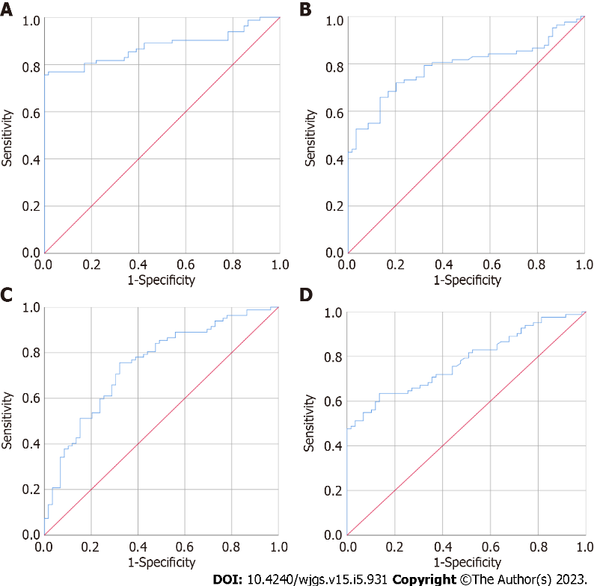
Figure 1 Receiver operating characteristic curve of matrix metalloproteinases 2, 7, 9 and carcinoembryonic antigen alone for distinguishing healthy control group from colorectal cancer group. A: Matrix metalloproteinase (MMP) 2; B: MMP7; C: MMP9; D: Carcinoembryonic antigen.

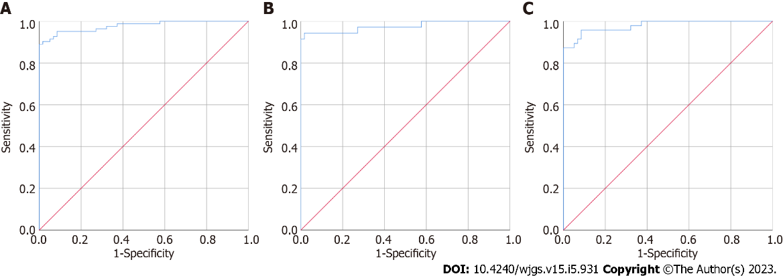
Figure 2 Receiver operating characteristic curve of matrix metalloproteinases 2, 7, 9 and carcinoembryonic antigen joint for distinguishing healthy control group from colorectal cancer group. A: Healthy control group vs colorectal cancer group; B: Healthy control group vs early stage of colorectal cancer group; C: Healthy control group vs advanced stage of colorectal cancer group.

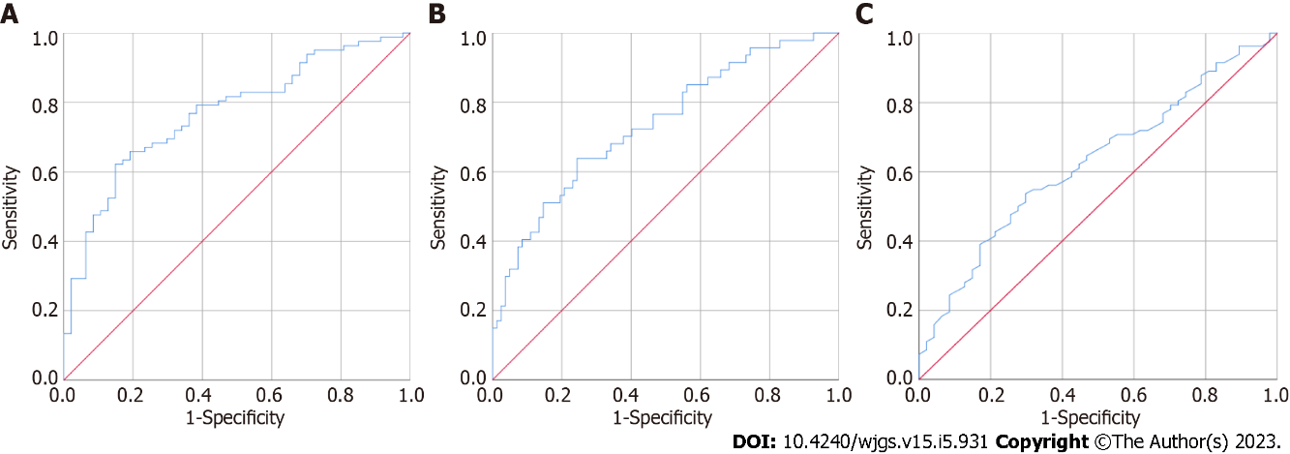
Figure 3 Receiver operating characteristic curve of matrix metalloproteinases 7, 9 and carcinoembryonic antigen alone for distinguishing colorectal polyp group from colorectal cancer group. A: Matrix metalloproteinase (MMP) 7; B: MMP9; C: Carcinoembryonic antigen.

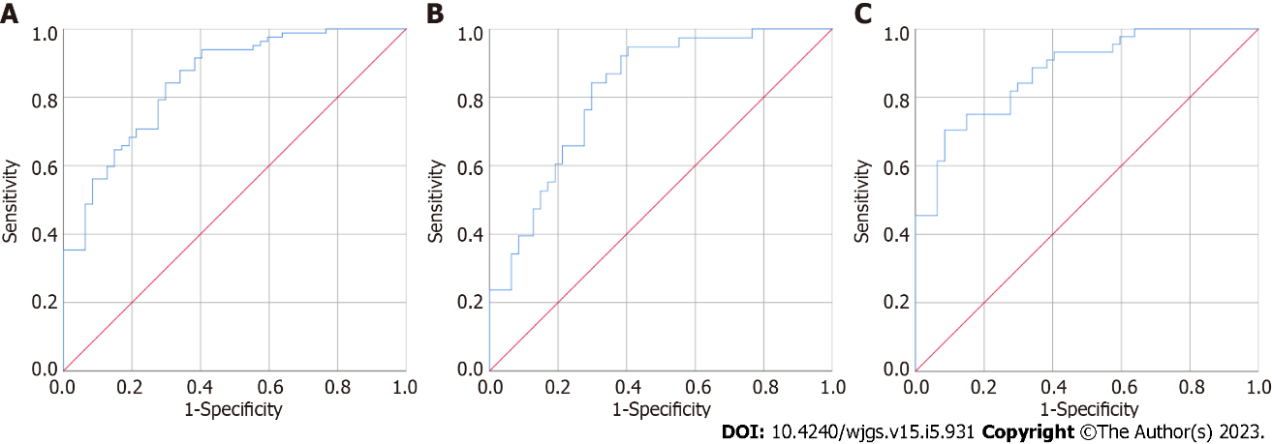
Figure 4 Receiver operating characteristic curve of matrix metalloproteinases 2, 7, 9 and carcinoembryonic antigen joint for distinguishing colorectal polyp from colorectal cancer group. A: Colorectal polyp group vs colorectal cancer group; B: Colorectal polyp group vs early stage of colorectal cancer group; C: Colorectal polyp group vs advanced stage of colorectal cancer group.

Table 1 Comparison of matrix metalloproteinases 2, 7, 9 and carcinoembryonic antigen contents in healthy controls, colon polyps and colorectal cancer groups
Group | Healthy control | Colon polyps | Colorectal cancer
MMP2 | 2128.42 (1635.60, 3119.34) | 15459.62 (12244.16, 18777.56) | 15396.14 (6571.35, 20006.06)
MMP7 | 2612.71 (2087.86, 3110.04) | 3237.57 (2513.33, 3915.02) | 4173.63 (3023.82, 6327.17)
MMP9 | 8153.00 (5170.05, 11732.83) | 14288.33 (8711.57, 17994.25) | 10324.22 (6005.56, 14932.17)
CEA | 1.52 (0.79, 2.26) | 3.05 (1.55, 7.82) | 6.84 (1.86, 14.43)
MMP: Matrix metalloproteinase; CEA: Carcinoembryonic antigen.

Table 2 Diagnostic value of matrix metalloproteinases 2, 7, 9 and carcinoembryonic antigen for distinguishing healthy control group from colorectal cancer group
 | AUC | Standard error | P value | 95%CI
 |  |  |  | Lower | Upper
MMP2 | 0.875 | 0.031 | < 0.001 | 0.815 | 0.935
MMP7 | 0.786 | 0.039 | < 0.001 | 0.711 | 0.862
MMP9 | 0.748 | 0.042 | < 0.001 | 0.667 | 0.830
CEA | 0.779 | 0.038 | < 0.001 | 0.704 | 0.853
MMP: Matrix metalloproteinase; CEA: Carcinoembryonic antigen; AUC: Area under the curve; CI: Confidence interval.

Table 3 Diagnostic value of matrix metalloproteinases 2, 7, 9 and carcinoembryonic antigen for distinguishing colorectal polyp from colorectal cancer group
Indicator | AUC | Standard error | P value | 95%CI
 |  |  |  | Lower | Upper
MMP2 | 0.532 | 0.050 | 0.550 | 0.433 | 0.630
MMP7 | 0.769 | 0.042 | < 0.001 | 0.688 | 0.851
MMP9 | 0.737 | 0.046 | < 0.001 | 0.647 | 0.827
CEA | 0.626 | 0.050 | 0.018 | 0.528 | 0.723
MMP: Matrix metalloproteinase; CEA: Carcinoembryonic antigen; AUC: Area under the curve; CI: Confidence interval.

Published by Baishideng Publishing Group Inc
7041 Koll Center Parkway, Suite 160, Pleasanton, CA 94566, USA
Telephone: +1-925-3991568
E-mail: bpgoffice@wjgnet.com
Help Desk: https://www.f6publishing.com/helpdesk
https://www.wjgnet.com

© 2023 Baishideng Publishing Group Inc. All rights reserved.

