Name of journal: World Journal of Gastroenterology
ESPS Manuscript NO: 4305
Columns: CASE REPORT

Massive upper gastrointestinal hemorrhage due to invasive hepatocellular carcinoma and hepato-gastric fistula

Sayana H et al. Hepato-gastric fistula presenting as GI bleeding

Hari Sayana, Osama Yousef, Wendell K Clarkston
Hari Sayana, Osama Yousef, Wendell K Clarkston, Section of Gastroenterology and Hepatology, Department of Internal Medicine, University of Missouri Kansas City, Kansas City, MO 64108-2640, United States

Author contributions: Sayana H did the literature search, written and drafted the manuscript and reviewed; Yousef O and Clarkston WK critically reviewed and edited the manuscript; all authors reviewed and approved the final revised version.

Correspondence to: Hari Sayana, MD, Section of Gastroenterology and Hepatology, Department of Internal Medicine, University of Missouri Kansas City, 2301 Holmes Street, Kansas City, MO 64108-2640, United States. sayana_h@yahoo.com
Telephone: +1-913-909-3652 Fax: +1-816-932-5179

Received: June 26, 2013 Revised: September 3, 2013
Accepted: September 15, 2013

Published online:
Abstract
A 36-year-old male Asian immigrant with a history of hepatitis B and hepatitis C related unresectable hepatocellular carcinoma in the left lobe of the liver presented with hematemesis and severe anemia. He was diagnosed with a liver mass that was resected 8 years ago described as a benign tumor in his home country. He had received trans-arterial chemoembolization (TACE) four months ago after subsequent diagnosis of unresectable hepatoma, and currently was receiving chemotherapy with Sorafenib. After resuscitation, a contrast enhanced computerized tomography was performed which showed fistulization of hepatocellular carcinoma into adjacent stomach. This finding was confirmed during endoscopy with direct visualization of the fistulous opening. Hepatocellular carcinoma (HCC) invading the gastrointestinal (GI) tract is rare. We present a case and literature review of HCC with local invasion of the stomach causing massive upper GI bleeding after receiving TACE.

© 2013 Baishideng. All rights reserved.

Key words: Hepatocellular carcinoma; Hepatogastric fistula; Fistula, Upper gastrointestinal bleeding

Core tip: Gastrointestinal bleeding is a common complication of hepatocellular carcinoma (HCC). However, HCC leading to Hepatogastric fistula presenting as massive upper gastrointestinal bleeding is uncommon. Here we report a case of HCC with direct invasion of the stomach leading to massive gastrointestinal bleeding. Patient was management with selective arterial angiogram and coil embolization to control bleeding. HCC with local metastasis to adjacent structures such gastrointestinal tract carries poor prognosis. With increasing incidence of HCC and recent improvements in the treatment of advanced HCC, this condition may become more common and awareness among clinicians should help consider this condition in the differential diagnosis and prompt management.

Sayana H, Yousef O, Clarkston WK. Massive upper gastrointestinal hemorrhage due to invasive hepatocellular carcinoma and hepato-gastric fistula.
Available from:
DOI:

INTRODUCTION
Hepatocellular carcinoma (HCC) is an aggressive primary malignancy of the liver with 5-year survival rates as low as 5%^{[1]}. It is the third leading causes of cancer deaths across the world and ninth leading cause of cancer deaths in United States^{[2]}. While the incidence of other common cancers is decreasing in the United States, HCC is on the rise with an average annual percentage change of incidence rate of 3.5%^{[2]}. The majority of cases of HCC are caused by chronic liver disease from hepatitis B and C (78%)^{[2]}. Extra-hepatic metastasis is found at the time of diagnosis in up to 15% of patients with HCC^{[3]}. Lung is the most common site of metastasis followed by intra-abdominal lymph nodes, and bone and adrenal glands^{[3]}. Median survival of patients with extra-hepatic manifestations is less than 6 mo^{[4]}. Metastasis to the gastrointestinal (GI) tract is rare with rates of 0.4%-2% of cases^{[5]} and in up to 12% of cases in autopsy series^{[6]}. Here we report a case of HCC with direct invasion of the stomach leading to massive GI bleeding.

CASE REPORT
A 36-year-old Asian male with hepatitis B and hepatitis C associated HCC presented with chronic melena and massive acute upper gastrointestinal (GI) bleeding with large volume hematemesis. He had undergone trans-arterial chemo-embolization (TACE) four months ago for a large, diffuse, unresectable, biopsy proven HCC in the left lobe of the liver. Due to side effects from the procedure, patient declined to undergo further TACE. He had been on Sorafenib for the preceding two and one-half months prior to this presentation. Apparently, the patient had a liver mass that was resected in his home country eight years ago, described verbally to him as “a benign” tumor. Vital signs on presentation included BP 131/75mm Hg, Pulse 123, RR 32, Temperature 96.0 F, and Oxygen saturation was 88% on 4 L via nasal cannula. On physical exam, he was tachycardic, chest was clear to auscultation; mucus membranes were pale, abdominal exam showed tender hepatomegaly (10 cm below right coastal margin in the mid-clavicular line) and mid-epigastric tenderness. Alpha fetoprotein level was 8.3 ng/mL. Laboratory data revealed hemoglobin of 2.5 gm/dL (hematocrit, 10%; MCV 94), leukocytosis (with WBC count 16.7), and platelet count of 539. Coagulation profile showed a mildly prolonged INR of 1.6 and activated partial thromboplastin time of 21. Hemoglobin from prior hospitalization 4 months ago was 13.3 gm/dL. The patient was transfused with packed red cells (7 units) and intravenous fluids were administered. Tumor marker studies including AFP (7.6 NG/mL), CEA (3.3 NG/mL), and CA 19.9 (< 0.1 U/ML), all of which were normal. Hepatitis B quantitative PCR was 41048 U/mL, Hepatitis Be antigen was negative and Hepatitis Be antibody was positive. Hepatitis C quantitative PCR was 65 IU/mL.
Abdominal computed tomography with intravenous and oral contrast noted a large left hepatic lobe mass which was increased in size (19 cm × 13 cm) compared to prior mass (16 cm × 10 cm) noted two months earlier. A large amount of air was seen centrally within the mass which appeared to communicate with the gastric lumen through a 7 mm defect along the lesser curvature near the gastric fundus (Figure 1). An EGD was performed and revealed a 1.4 cm fistula in the posterior wall of the distal gastric body with stigmata of recent bleeding via the fistula (Figure 2). Subsequently, a visceral (celiac, superior mesenteric artery, and left gastric artery) arteriogram demonstrated no evidence of active bleeding. However, selective left gastric artery angiogram showed hypervascular blush within the tumor and it was selectively embolized to achieve decreased flow, utilizing a total of three, 6 mm × 10 cm long Azur detachable coils. His hemoglobin stabilized and he was discharged with plans to start second line palliative chemotherapy. He subsequently presented a month later with recurrent GI bleeding for which he had to undergo further selective embolization of celiac artery branches, which showed signs of neovascularization. The patient opted for hospice care 10 mo after diagnosis of HCC and 6 months after treatment of acute GI bleed from hepato-gastric fistula.

DISCUSSION
GI bleeding is a common complication in patients with HCC. Common etiologies include peptic ulcer disease, variceal bleeding due to portal hypertension from underlying cirrhosis and/or tumor invasion of portal vein causing thrombosis, and portal hypertensive gastropathy. Yeo et al^{[5]} prospectively looked at 55 HCC patients who presented with GI bleeding over a period of 11 mo and found that majority had a non-variceal source of bleeding (53%) and the remainder variceal bleeding. Among patients with a non-variceal source, three patients (0.05%) bled secondary to direct invasion of tumor to gut. GI bleeding secondary to direct invasion by HCC is rare (0.05%-2%)^{[5,9-11]}. Metastatic spread can be due to hematogenous, lymphatic or by direct invasion of the tumor into adjacent organs. The most common site of direct tumor invasion of the GI tract is stomach followed by duodenum and colon. Predisposing factors for GI tract invasion include large liver lesions (> 5cm in size), sub-capsular location and exophytic growth pattern. Suspected predisposing features include prior TACE and/or radiation therapy which can lead to ischemia and inflammatory reactions in the tumor and adjoining bowel wall. These changes can potentially lead to adhesion and local tumor invasion with subsequent fistulization^{[7,8]}. We hypothesize a similar process in our case. Park et al found GI tract involvement at the time of diagnosis of HCC in 7/12 patients without any prior treatment^{[6]}. In our patient, we suspect an exophytic tumor growth pattern causing direct GI tract invasion and pressure necrosis on adjacent organs. This process was likely worsened by TACE/radiation related inflammatory reactions contributing to erosion and fistulization, with subsequent bleeding into the GI tract. Sources of gastrointestinal bleeding noted in the literature have included rupture of hepatoma into the GI tract, bleeding from the intrahepatic portion of the tumor, or bleeding from an involved vessel in the wall of the GI tract. In our case, we endoscopically documented oozing from the hypervascular edges of the gastro-hepatic fistula within the stomach.
The prognosis of patients with HCC and GI involvement is poor because of massive bleeding and/or hepatic failure. In one series, the median survival was 4 wk^{[7]} and in a second study none survived beyond 9 mo^{[8]}. Our patient survived 6 mo. Non-surgical techniques to achieve hemostasis include trans-arterial embolization, endoscopic injection of ethanol or adrenalin, and radiotherapy ablation. Korkolis et al^{[14]} reported a case of HCC invading the stomach and upper surface of the pancreas who underwent en bloc resection of left lobe of liver with liver mass (15 cm × 12 cm × 9.5cm), total gastrectomy, distal pancreatectomy, spleenectomy, cholecystectomy, radical excision of adjacent lymph node and survival of 16 mo with no local recurrence. Curative surgery is a potential option especially in good surgical candidates with reasonable functional reserve. Surgical intervention has showed prolonged survival with median survival rates of 9.7 mo as opposed to 3.0 mo in non-surgical therapy as reported in other case series^{[12,13]}.
In conclusion, due to improvements in chemotherapy and advanced interventional radiologic chemoembolization techniques with improved short term survival in patients with unresectable HCC^{[15,16]}, GI tract fistulization and associated upper GI bleeding are likely to become more frequent in the future. This complication may be managed via palliative surgical resection, or by angiographic embolization, as was performed in our patient.

REFERENCES
1 El-Serag HB, Mason AC. Rising incidence of hepatocellular carcinoma in the United States. N Engl J Med 1999; 340: 745-750 [PMID: 10072408 DOI: 10.1056/NEJM199903113401001]
2 Centers for Disease Control and Prevention (CDC). Hepatocellular carcinoma-United States, 2001-2006. MMWR Morb Mortal Wkly Rep 2010; 59: 517-520 [PMID: 20448528]
3 Uka K, Aikata H, Takaki S, Shirakawa H, Jeong SC, Yamashina K, Hiramatsu A, Kodama H, Takahashi S, Chayama K. Clinical features and prognosis of patients with extrahepatic metastases from hepatocellular carcinoma. World J Gastroenterol 2007; 13: 414-420 [PMID: 17230611]
4 Yoo DJ, Kim KM, Jin YJ, Shim JH, Ko GY, Yoon HK, Sung KB, Lee JL, Kang YK, Lim YS, Lee HC, Chung YH, Lee YS, Suh DJ. Clinical outcome of 251 patients with extrahepatic metastasis at initial diagnosis of hepatocellular carcinoma: does transarterial chemoembolization improve survival in these patients? J Gastroenterol Hepatol 2011; 26: 145-154 [PMID: 21175808 DOI: 10.1111/j.1440-1746.2010.06341.x]
5 Yeo W, Sung JY, Ward SC, Chung SC, Lee WY, Li AK, Johnson PJ. A prospective study of upper gastrointestinal hemorrhage in patients with hepatocellular carcinoma. Dig Dis Sci 1995; 40: 2516-2521 [PMID: 8536505 DOI: 10.1007/BF02220435]
6 Park MS, Kim KW, Yu JS, Kim MJ, Yoon SW, Chung KW, Lee JT, Yoo HS. Radiologic findings of gastrointestinal tract involvement in hepatocellular carcinoma. J Comput Assist Tomogr 2002; 26: 95-101 [PMID: 11801910 DOI: 10.1097/00004728-200201000-00014]
7 Chen LT, Chen CY, Jan CM, Wang WM, Lan TS, Hsieh MY, Liu GC. Gastrointestinal tract involvement in hepatocellular carcinoma: clinical, radiological and endoscopic studies. Endoscopy 1990; 22: 118-123 [PMID: 2162757 DOI: 10.1055/s-2007-1012815]
8 Lin CP, Cheng JS, Lai KH, Lo GH, Hsu PI, Chan HH, Hsu JH, Wang YY, Pan HB, Tseng HH. Gastrointestinal metastasis in hepatocellular carcinoma: radiological and endoscopic studies of 11 cases. J Gastroenterol Hepatol 2000; 15: 536-541 [PMID: 10847441 DOI: 10.1046/j.1440-1746.2000.02152.x]
9 Maruyama A, Murabayashi K, Hayashi M, Nakano H, Isaji S, Uehara S, Kusuda T, Miyahara S, Kondo A, Yabana T. Hepatocellular carcinoma complicated by gastrointestinal hemorrhage caused by direct tumor invasion of stomach. J Hepatobiliary Pancreat Surg 1999; 6: 90-93 [PMID: 10436243 DOI: 10.1007/s005340050089]
10 Nicoll AJ, Ireton HJ, Crotty B. Gastrointestinal bleeding from hepatocellular carcinoma invading the stomach. J Gastroenterol Hepatol 1994; 9: 533-535 [PMID: 7827310 DOI: 10.1111/j.1440-1746.1994.tb01290.x]
11 Lynch P, Green L, Jordan PH, Graham DY. Hepatocellular carcinoma metastatic to the stomach presenting as bleeding multiple craterogenic ulcers. Am J Gastroenterol 1989; 84: 653-655 [PMID: 2543213]
12 Fujii K, Nagino M, Kamiya J, Uesaka K, Sano T, Yuasa N, Oda K, Nimura Y. Complete resection of hepatocellular carcinoma with direct invasion to the stomach remnant. J Hepatobiliary Pancreat Surg 2004; 11: 441-444 [PMID: 15619024 DOI: 10.1007/s00534-004-0926-3]
13 Chen CY, Lu CL, Pan CC, Chiang JH, Chang FY, Lee SD. Lower gastrointestinal bleeding from a hepatocellular carcinoma invading the colon. J Clin Gastroenterol 1997; 25: 373-375 [PMID: 9412926 DOI: 10.1097/00004836-199707000-00019]
14 Korkolis DP, Aggeli C, Plataniotis GD, Gontikakis E, Zerbinis H, Papantoniou N, Xinopoulos D, Apostolikas N, Vassilopoulos PP. Successful en bloc resection of primary hepatocellular carcinoma directly invading the stomach and pancreas. World J Gastroenterol 2009; 15: 1134-1137 [PMID: 19266609 DOI: 10.3748/wjg.15.1134]
15 Llovet JM, Ricci S, Mazzaferro V, Hilgard P, Gane E, Blanc JF, de Oliveira AC, Santoro A, Raoul JL, Forner A, Schwartz M, Porta C, Zeuzem S, Bolondi L, Greten TF, Galle PR, Seitz JF, Borbath I, Häussinger D, Giannaris T, Shan M, Moscovici M, Voliotis D, Bruix J. Sorafenib in advanced hepatocellular carcinoma. N Engl J Med 2008; 359: 378-390 [PMID: 18650514 DOI: 10.1056/NEJMoa0708857]
16 Llovet JM, Real MI, Montaña X, Planas R, Coll S, Aponte J, Ayuso C, Sala M, Muchart J, Solà R, Rodés J, Bruix J. Arterial embolisation or chemoembolisation versus symptomatic treatment in patients with unresectable hepatocellular carcinoma: a randomised controlled trial. Lancet 2002; 359: 1734-1739 [PMID: 12049862 DOI: 10.1016/S0140-6736(02)08649-X]
P-Reviewers Helling T S-Editor Qi Y L-Editor E-Editor

Figure 1 Endoscopic image showing fistulous opening of hepatocellular carcinoma on the lesser curvature of stomach.

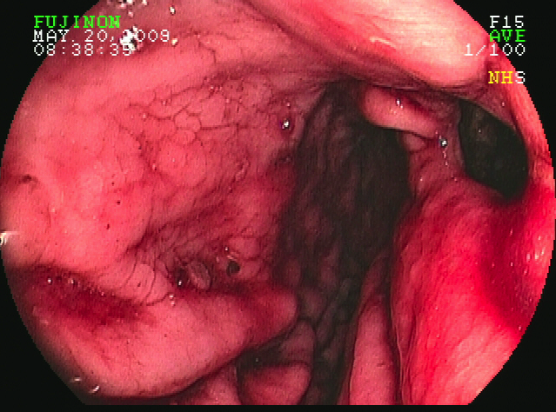

Figure 2 Computerized tomography image of abdomen. A: Showing large mass in the left lobe of the liver and oral contrast traced into liver (arrow) through fistulous opening in stomach; B: Showing large mass in the left lobe of the liver and fistulous communication between the liver mass and the stomach; C: Showing large mass in the left lobe of the liver and fistulous communication between the liver mass and the stomach.

A
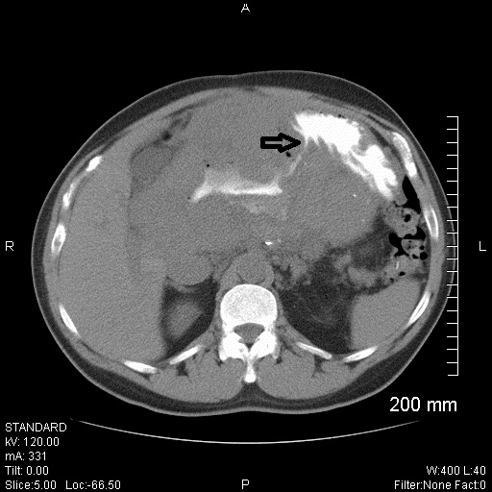

B
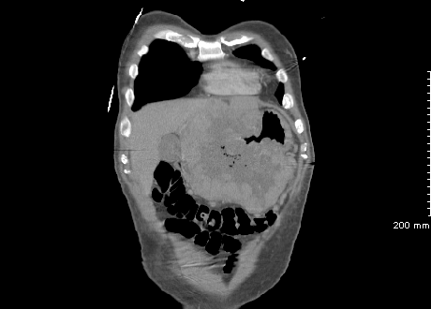

C
