Name of journal: World Journal of Gastroenterology
ESPS Manuscript NO: 5489
Columns: META-ANALYSIS

Combination of chemotherapy and immunotherapy on colon cancer in China: A meta-analysis

Wang ZX et al. A systematic review of immunotherapy in colon cancer

Zheng-Xu Wang, Jun-Xia Cao, Zhi-Ping Liu, Yu-Xin Cui, Chun-Yun Li, Duo Li, Xiao-Yan Zhang, Jin-Long Liu, Jun-Li Li

Zheng-Xu Wang, Jun-Xia Cao, Chun-Yun Li, Duo Li, Xiao-Yan Zhang, Jin-Long Liu, Jun-Li Li, Biotherapy Center, the General Hospital of Beijing Military Command, Beijing 100700, China

Zhi-Ping Liu, Department of Immunology, St Jude Children's Research Hospital, Memphis, TN 38105, United States

Yu-Xin Cui, School of Cellular and Molecular Medicine, University of Bristol, University Walk, Bristol BS8 1TD, United Kingdom

Author contributions: Wang ZX designed research; Cao JX and Li CY performed research; Liu ZP and Cui YX contributed new reagents or analytic tools; Cao JX, Li CY, Li D, Zhang XY, Liu JL and Li JL analyzed data; Wang ZX, Cao JX, Liu ZP and Cui YX wrote the paper.

Supported by National Natural Science Foundation of China, No. 31171427 and No. 30971651 to Wang ZX; National Natural Science Foundation of China, No. 30700974 to Cao JX; and Postdoctoral Foundation of China, No. 20060400775 to Cao JX

Correspondence to: Zheng-Xu Wang, MD, PhD, Associate Professor, Director of Biotherapy Center, the General Hospital of Beijing Military Command, No.5 of Nan Men Cang Rd, Dongcheng District, Beijing 100700, China. zhxwang18@hotmail.com

Telephone: +86-10-66721169 Fax: +86-10-64038276
Received: September 10, 2013 Revised: October 28, 2013
Accepted: November 12, 2013

Published online:

Abstract
AIM: To investigate whether autologous dendritic cell (DC)-cytokine-induced killer (CIK) therapy is able to improve the therapeutic efficacy of chemotherapy in colon cancer.

METHODS: We conducted a systematic review of published papers from the sources of MEDLINE, the Cochrane Central Register of Controlled Trials, EMBASE, the Wanfang Database, the China Science and Technology Periodical Database and China Journal Net. Published data were extracted independently by two authors using predefined database templates. The quality of the data from individual papers was also assessed. The chemotherapy was compared with the chemotherapy in combination with DC-CIK immunotherapy. The pooled analysis was performed using the data from random or fixed-effect models.

RESULTS: Seven trials eventually matched our inclusion criteria (n = 533). The overall analysis showed significant survival benefit (one-year over survival (OS), P < 0.0001; two-year OS, P = 0.009; three-year OS, P = 0.002) in favor of the beneficial effect of the DC-CIK immunotherapy on the chemotherapy. Disease free survival (DFS) rate was improved after the combination of DC-CIK immunotherapy and chemotherapy (one-year DFS, P < 0.0001; two-year DFS, P = 0.002; three-year DFS, P = 0.02). The improved overall response rate (P = 0.009) was also observed from the patients who were subjected to the DC-CIK therapy. Furthermore, the analysis of T-lymphocyte subsets in peripheral blood indicated that the number of CD4⁺ T cells significantly increased in the DC-CIK plus chemotherapy group (P < 0.05).

CONCLUSION: The combination of the DC-CIK immunotherapy and chemotherapy demonstrates a superiority in prolonging the survival time and enhancing immunological responses.

© 2013 Baishideng Publishing Group Co., Limited. All rights reserved.

Key words: Dendritic cells; Cytokine-induced killer cells; Meta-analysis; Colon cancer; Immunotherapy

Core tip: A growing body of knowledge about tumor immunosurveillance and loss thereof has contributed to the refinement of anti-tumor immunotherapy. The aim of our meta-analysis was to determine whether an association exists between dendritic cell (DC)-cytokine-induced killer (CIK) cell therapy combined with chemotherapy and chemotherapy alone. Our analysis demonstrates that DC-CIK therapy was proven efficacy lies in benefit for 1, 2 and 3-year over survival, 1, 2 and 3-year disease free survival, overall response rate and immune index in colon cancer. In all, the combination of the DC-CIK immunotherapy and chemotherapy demonstrates superiority in prolonging the survival time and enhancing immunological responses, suggesting the possibility of application of a promising adjuvant immunotherapy method for colon cancer.

Wang ZX, Cao JX, Liu ZP, Cui YX, Li CY, Li D, Zhang XY, Liu JL, Li JL. Combination of chemotherapy and immunotherapy on colon cancer in China: A meta-analysis. World J Gastroenterol 2013;
Available from: URL: http://www.wjgnet.com/esps/
DOI: http://dx.doi.org/10.3748/wjg.v19.i0.0000

INTRODUCTION
Colorectal cancer is the third most commonly diagnosed cancer in the human beings. As diet custom has changed these years, the number of cases of colon cancer have been increasing faster in the Eastern world^{[1,2]}. Although surgical resection is the first choice worldwide, colorectal cancer can also be treated effectively with chemotherapy, radiation therapy, or the combination to improve the modalities of the patients. However, 25% of the patients that present with metastatic disease have a five-year survival of only 10%. A variety of therapeutic strategies for metastatic colon cancer have been evaluated over the last decade, however most patients in advanced stages of the disease have little hope for longer survival. Therefore, an effective approach for the treatment of the colorectal cancer patients with metastasis and post-operation cancer recurrence will be critical. In recent years there has been great interest in cancer immunotherapy, which have the potential of controlling metastatic disease, prolonging time to recurrence, and ultimately serving as a preventive measure.
Adoptive immunotherapy holds great promises in the scenario of potential new approaches for the treatment of solid tumors that are refractory to conventional therapies. Recently, the effectiveness of immunotherapy in the treatment of numerous forms of cancers has been studied. For instance, it is reported that adoptive cell transfer of ex vivo-activated autologous tumor-reactive Tc1 or Tc17 T cells can mediate effective anti-tumor immunity and tumor regression in melanoma^{[3]}. Cytokine-induced killer (CIK) cell therapy is also able to induce complete clinical responses in renal cell carcinoma (RCC) patients, and has been demonstrated safe and competent to treat RCC patients^{[4]}. A systematic review and meta-analysis of randomized controlled trials in multiple myeloma (MM) indicate that autologous-allogeneic (auto-allo) hematopoietic cell transplantation (HCT) strategy can induce higher complete remission rates. There is no improvement in overall survival (OS) with auto-allo HCT, however this approach can achieve higher non-relapse mortality rates in patients with newly diagnosed MM^{[5]}. Another study suggests that erythropoietin-producing hepatocellular carcinoma A2 (EphA2)-specific T-cell immunotherapy may be a promising approach for the treatment of EphA2-positive glioblastoma^{[6]}. Furthermore, αβ and γδ T cell-based immunotherapy has been found to improve the treatment efficacy in osteosarcoma, especially at the recurrent and metastatic stages^{[7]}. A multi-center historical cohort study indicates that the effectiveness of immunotherapy on advanced lung cancer is limited but may extend life span under certain conditions. Moreover, immunotherapy can maintain good quality of life of the patients until near the time of death^{[8]}. Towards the bedside administration, Sipuleucel-T (Provenge, Dendreon) has been the first-in class therapeutic autologous vaccine which was approved for the treatment of men with asymptomatic or minimally symptomatic castrate-resistant metastatic prostate cancer in the spring of 2010^{[9]}. This product represents the culmination of basic immunological and prostate cancer investigations for decades, and 13 years of clinical trials^{[10]}. Also another immunotherapeutic drug, the cytotoxic T-lymphocyte antigen 4 antibody Ipilimumab, has been proved to provide beneficial OS for patients with metastatic melanoma in two phase III trials^{[11,12]} and was approved in March of 2011. These important drug development milestone provide solid evidence that targeting of the immune system could lead to clinically relevant immune responses thus extend the life span of cancer patients.
Challenging issues for all adoptive immunotherapy strategies include the obtainment of sufficient numbers of immune effectors, recognition of tumor targets and possible restriction to specific human leukocyte antigens-haplotypes. Such hurdles have been encountered in immunotherapy trials for colon cancer as well. CIK cells are ex vivo-expanded T lymphocytes that share phenotypic and functional properties with both natural killer and T cells. It has been reported that secretory glycoprotein 90K-specific cytotoxic T lymphocytes (CTLs) generated by 90K-pulsed dendritic cells (DCs) are useful effector cells for immunotherapy in colon cancer^{[13]}. Mucin 1 (CD227)-specific CTLs have also been shown to cause complete rejection of tumor cells, while in the therapeutic regimen, tumor burden is significantly reduced^{[14]}. CTLs specific for the tumor-associated antigen CEP55 can efficiently recognize colon cancer stem-like cells or tumor-initiating cells which highly expressed the stem cell marker SRY-box 2, POU class 5 homeobox 1, leucine-rich repeat-containing G protein-coupled receptor 5 and aldehyde dehydrogenase 1 family member A1 in vitro and in vivo^{[15]}. DCs are rare leucocytes that are uniquely potent in their ability to capture, process and present antigens to T cells. They selectively migrate through tissues to reach lymph nodes and spleen where the initiation of the immune response takes place. DC-based vaccinations are an attractive candidate adjunct therapy to treat colon cancer patients. It has been demonstrated that signal transducers and activators of transcription 3-depleted DC vaccination induces effective systemic anti-tumor effects through high antigen (Ag)-specific T cell responses accompanied by systemic T helper 1 immune responses in a murine colon cancer model^{[16]}. DCs pulsed with carcinoembryonic antigen (CEA) peptide resulted in prolonged antigen-presentation and efficient T-cell activation but not CEA mRNA for vaccination^{[17]}. A phase I-II CEA-loaded DC vaccine trial in patients with colon cancer is ongoing at the internet institution (www.clinicaltrial.gov id: NCT 01219348). In the microenvironment of human colon adenocarcinoma, the supernatant mediates endothelial-like differentiation of induced DC by extracellular signal-regulated protein kinases 1 and 2 signaling, which suggests that immunocytes are involved in the cancer microenvironment^{[18]}. Based on intensive findings of the microenviroment and the cancer stem cells in the cancer therapy, the immunotherapy strategy is worthy to be further investigated.
Over the past few years advances in our understanding of the immune system, improved design of clinical trials, improvement and compliance of manufacturing processes have provided opportunities to significantly improve efficacy and safety. However, clinical studies on DC-CIK cells are still in their infancy and no clear consensus about how they may be best optimized. Therefore, we performed a systematic review and meta-analysis of clinical trials to assess the therapeutic efficacy of DC-CIK cells combining with chemotherapy in colon cancer.

MATERIALS AND METHODS
Search strategy and selection criteria
Trials were identified by electronic search in the PubMed database (1976 onward), Embase (1966 onward), the Cochrane Central Registry of Controlled Trials (no date restriction), the Wanfang Database (no date restriction), the China Science and Technology Periodical Database (no date restriction), China Journal Net (no date restriction), reference lists of published trials and relevant review articles. The search strategy included the following medical subject headings: “colon cancer”, “cytokine-induced killer cells”, “dendritic cells”, “immunotherapy”, “colon rectal cancer” and free text search. No language limits were applied. The initial search was performed in June 2012 and updates were conducted in June 2013. Furthermore, we contacted drug manufacturers, asked experts in the field, and performed manual searches in reference lists, conference proceedings of the American Society of Clinical Oncology Annual Meetings and the European Cancer Conference. We also searched the http://www.ClinicalTrials.gov website for information on prospective and ongoing trials. No language restriction was applied. We excluded abstracts that were never subsequently published as full papers and studies on animals and cell lines.

Data extraction and quality assessment
Data extraction was independently conducted by two reviewers (Cao JX and Li CY) using a standardized approach. Disagreement was adjudicated by a third reviewer (Li D) after referring back to the original publications. We collected information including authors’ names, journal, year of publication, sample size per arm, regimen used, median or mean age of patients, sex, numbers of patients assessable for 1- and 3-year overall survival and numbers of patients assessable for 3-year disease free survival and information pertaining to study design (whether the trial reported the mode of randomization, allocation concealment, description of withdrawals per arm, and blinding) for the trials included in the study.

Definition of outcome measures
OS was defined as the time from the initiation of treatment until death. The secondary object was the disease-free survival (DFS). The third endpoints were disease control rate [DCR = complete response (CR) + partial response (PR) + stable disease (SD)] and objective response rate (ORR = CR+PR), respectively CR, PR, mixed response or SD were documented and extracted for analysis.

Statistical analysis
The analysis was carried out by pair-wise comparison of the immunotherapy-containing arms of the identified trials with the respective non-immunotherapy arms. Treatment effects are reflected by odds ratios (OR) for OS, DFS, ORR and clinical benefit rate. To calculate the pooled OR, the number of OS, DFS, ORR and DCR in each arm were extracted from each study and combined using a method reported by Mantel and Haenszel. A pooled OR < 1 indicated lower recurrence or lower survival in the immunotherapy arm. To evaluate whether the results of the studies were homogeneous, we used the Cochran’s Q test. This statistical analysis is a χ² test with df equal to the number of studies minus one, and tests the null hypothesis that the difference between the study estimates of OR is due to chance. We also calculated the quantity I² that descibes the percentage of variation across studies that is due to heterogeneity rather than chance. I² values of 25%, 50%, and 75% were used as evidence of low, moderate, and high heterogeneity, respectively. SPSS 11.5 was also used to carry out the data analysis. The OR was calculated with a fixed-effect model when no statistically significant heterogeneity existed; otherwise, a random-effect model was employed. P-values at < 0.05 were considered to be statistically significant. All reported P-values resulted from two-sided version tests of the respective tests.

RESULTS
Selection of the trials
The electronic search yielded 147 references. After title and abstract review, 122 publications were excluded for various reasons (17 for being review articles, 21 for using animal models, 28 for being case reports, 36 for being in vitro experiments, 20 for being nursing studies). The full texts of 25 articles were selected as potentially relevant and retrieved for more detailed assessment. We excluded a total of 18 studies for not including detailed patients clinical data or therapy response, and also the phase I clinical study in Germany with CIK for colorectal cancer patients, which did not include the control arm^{[19]}. The selection procedure of the clinical trials is shown in Figure 1. As a result, 7 articles reporting clinical trials for DC-CIK cell-based therapy combined with chemotherapy were selected for meta-analysis.

Characteristics of DC-CIK cell-based therapy
After the selection process, 7 eligible trials with a total of 533 patients were included in the present analysis. All of the trials were fully published. In our study there were seven selected papers, containing four randomized studies, two retrospective ananlysis and one study considering treatment programs to constructed the control and we described these contents in the Table 1 and other related clinical data of the trials are also listed.
Most of the patients in these studies had a good performance status and the expected duration of survival > 3 mo and the including patients’ mid-age is 54.5 years old. In all seven trials, DC-CIK or CIK therapy combined with chemotherapy was evaluated in patients with colon cancer. Interferon-γ, CD3 monoclonal antibody and interleukin (IL)-2 were used in the CIK cell culture systems in all of the trials analyzed. In addition, granulocyte-macrophage colony stimulating factor (GM-CSF), IL-4, and tumor necrosis factor-α were used in the DC cell culture system. Both CIK or DC-CIK therapy were included in this analysis. In one of the trials, only CIK cells therapy was used for colon cancer treatment^{[20]}, while the other six trials utilized both DC and CIK^{[21-26]}. The number of CIK cells transfused into patients in these studies was more than 1.0 × 10⁹/course.
The patient information from two groups (DC-CIK cell therapy combined with chemotherapy and chemotherapy alone) of the trials, such as gender, chemotherapy category (FOLFOX or XELOX and also other chemicals) and CIK cell dose, were analyzed by χ² test (data not shown). There was no statistically significant difference between the groups, with all P-values being > 0.05. The origins of the patient information from the articles in each group did not interfere with the results of the meta-analysis. However, the patient’s age (including all of the unknown patients) did impact on the efficacy of DC-CIK cell therapy by χ² test (data not shown), furthermore, other clinical information from the trials such as tumor diameter and performance status were not analyzed because of insufficient data.

1-year overall survival
Information on 1-year survival was available in six trials^{[20-25]}. These six trials contained 491 patients (224 patients received immunotherapy combined with chemotherapy) in total. The 1-year overall survival rates were 93% (208/224) for CC patients that received DC-CIK immunotherapy combined with chemotherapy. In comparison, 1-year overall survival rates were only 84% (224/267) in patients that did not receive DC-CIK immunotherapy. Each of the six trials showed longer survival for patients that received DC-CIK immunotherapy combined with chemotherapy patients. The estimated pooled OR for the six trials demonstrated a highly significantly improved one-year survival for patients receiving DC-CIK immunotherapy combined with chemotherapy (OR 0.23; 95%CI: 0.11–0.48, P < 0.0001). The Cochran’s Q test had a P value of 0.53 and corresponding quantity I² was 0%, indicating that the degree of variability between the trials was consistent with what would be expected to occur by chance alone (Figure 2A).

2-year overall survival
Information on 2-year survival was available in four trials^{[21-25]}. These studies contained a collective total of 411 patients (184 patients received immunotherapy combined with chemotherapy) (Figure 2A). DC-CIK immunotherapy combined with chemotherapy treatment promoted 76% (140/184) 2-year survival in CC patients. In comparison, the 2-year overall survival for the control group was only 69% (157/227). The results of the pooled analysis showed that patients in the DC-CIK combined group significantly improved two-year survival (OR 0.42; 95%CI: 0.22–0.81, P = 0.009). There was no evidence of heterogeneity among individual studies (P = 0.85; I² = 0%).

3-year overall survival
Information on 3-year survival was available in 3 trials^{[20,22,23]}, which contained 305 patients (132 patients received immunotherapy combined with chemotherapy). DC-CIK immunotherapy combined with chemotherapy provided 3-year overall survival in 80% (105/132) of CC patients, compared to 61% (106/173) in the chemotherapy only group. All three of the trials showed improved survival in the DC-CIK immunotherapy combined with chemotherapy patients. The estimated pooled OR for the three trials showed a highly significantly improved three-year survival for patients receiving DC-CIK immunotherapy combined with chemotherapy (OR 0.43; 95%CI: 0.25–0.74, P = 0.002) (Figure 2A). The Cochran’s Q test had a P value of 0.65 and the corresponding quantity I² was 0%, indicating there was no evidence of heterogeneity among the individual studies.
The adequate information of the survival rate of 1 year, 2 year and 3 year was only available in 2 trials (Wei et al^{[22]} and Ying et al^{[23]}), so we simply summarized these two trial’s data to show the survival graph (Figure 2B), the data were shown on the figure and the dotted line represented the linear trend line (r² = 0.9959 for immunotherapy group and r² = 0.9854 for control group).

1-year disease free survival
Information on 1-year DFS was available in two trials^{[22,23]} and contained 225 patients (92 patients received immunotherapy combined with chemotherapy) (Figure 3A). DC-CIK immunotherapy combined with chemotherapy led to 1-year DFS in 86% (79/92) of CC patients. In contrast, 1-year DFS was only 63% (84/133) in patients that received only chemotherapy. Both of the trials showed longer disease free survival for DC-CIK immunotherapy combined with chemotherapy patients in comparison to chemotherapy only in the first year. The estimated pooled OR for the two trials showed a highly significantly improved one-year disease free survival for patients receiving DC-CIK immunotherapy combined with chemotherapy (OR 0.24; 95%CI: 0.12–0.49, P < 0.0001). The Cochran’s Q test had a P value of 0.47 and corresponding quantity I² was 0%, indicating that the degree of variability between trials was consistent with what would be expected to occur by chance alone.

2-year disease free survival
Information on 2-year DFS was available for two trials^{[22,23]} and contained 225 patients (92 patients received immunotherapy combined with chemotherapy). DC-CIK immunotherapy plus chemotherapy treatment resulted in 60% (55/92) 2-year DFS in CC patients, compared to 40% (53/133) in the control group. The estimated pooled OR for the two trials shows a highly significantly improved two-year disease free survival for patients receiving DC-CIK immunotherapy combined with chemotherapy (OR 0.41; 95%CI: 0.23–0.71, P = 0.002). The Cochran’s Q test had a P value of 0.98 and corresponding quantity I² was 0% (Figure 3A).

3-year disease free survival
Information on 3-year DFS was available in two trials^{[22,23]} and contained 225 patients (92 patients received immunotherapy combined with chemotherapy). Immunotherapy plus chemotherapy promoted 50% (46/92) 3-year DFS in CC patients. In contrast, chemotherapy alone provided 3-year DFS in only 36% (48/133) of control patients. The estimated pooled OR for the two trials showed a highly significantly improved one-year disease free survival for patients receiving DC-CIK immunotherapy combined with chemotherapy (OR 0.50; 95%CI: 0.29–0.88, P = 0.02) (Figure 3A). The Cochran’s Q test had a P value of 0.99 and corresponding quantity I² was 0%, indicating that there was no evidence of heterogeneity among the individual studies.
The adequte information of the DFS of 1 year, 2 year and 3 year was only available in 2 trials (Wei et al^{[22]} and Ying et al^{[23]}), so we simply summarized these two trials’ data to show the DFS graph (Figure 3B), the data were shown on the figure and the dashed line represented the linear trend line (r² = 0.9382 for immunotherapy group and r² = 0.8583 for control group).

Response rate
The analysis of ORR also demonstrated favorable results for the DC-CIK therapy arm, with the OR being 0.35 (95%CI: 0.16–0.77, P = 0.009). However, the DCR for the chemotherapy combined with DC-CIK group did not significantly differ from the chemotherapy-alone group (OR 0.54; 95%CI: 0.21–1.43, P = 0.22) (Figure 4). The Cochran’s Q test had a P value of 0.80 and 0.68, while corresponding quantity I² both was 0%, indicating that there was no evidence of heterogeneity among the individual studies.

Comparison of lymphocyte/monocyte subsets in the peripheral blood of cancer patients
The analysis showed that the proportion of CD4⁺ cells was significantly increased in the DC-CIK group compared with corresponding baseline percentages before treatment, which was reflected by pooled OR of -6.80 for CD4⁺ cells [95%CI: -9.97–(-3.62), P < 0.0001] were significantly changed between the two groups (Figure 5), while -9.82 for CD3⁺ cells (95%CI: -22.36-2.73, P = 0.13), 1.44 for CD8⁺ cells (95%CI: -8.90-11.78, P = 0.78) and -0.71 for CD4⁺CD8⁺ cells (95%CI: -1.44-0.02, P = 0.06) did not differ. Overall, most of the selected T cells subsets were significantly increased after the treatment with DC-CIK group (P < 0.00001) (Figure 5).

DISCUSSION
CC is the third most common cancer in the world and more than half of patients diagnosed with CC will eventually die as a result of cancer-associated complications. Therefore, there is an urgent need for improvements in adjuvant therapies, as well as improved treatment options for metastatic disease.
The first clinical trial for CIK therapy was reported in 1999 by Schmidt-Wolf, while the first clinical studies for DC-based vaccines were described in 1973 by Steinman and Cohn. Additional studies have demonstrated that CIK cells and DC vaccine therapies have anti-tumor effects. Despite the drawbacks associated with in vitro cell manipulation and upscaling, several approaches have been assessed in the clinical cancer treatment. The use of DC vaccine, LAK3 cells, CTLs, CIK, and tumor infiltrating lymphocytes have been well studied, and additional trials are ongoing. Increasing information on the clinical anti-tumor activity of DC-CIK cells is available from autologous therapy trials and some systematic reviews yielded several findings. The meta-analysis of dendritic cell based tumor vaccination in prostate and renal cell cancers^{[27]}, adoptive immunotherapy in postoperative hepatocellular carcinoma^{[28]} and CIK cell therapy for patients with hepatocellular carcinoma and solid carcinomas^{[29]} confirm that immunotherapy is a safe and feasible treatment option for cancer patients, but there are also some limitations. For instance, cancers that escape host immune surveillance are generally more difficult to cure. Furthermore, it is often difficult to obtain the necessary numbers of cytotoxic cells that are required for effective tumor control.
A growing body of knowledge about tumor immunosurveillance and loss thereof has contributed to the refinement of anti-tumor immunotherapy. The aim of our meta-analysis was to determine whether an association exists between DC-CIK cell therapy combined with chemotherapy and chemotherapy alone concerning 1, 2 and 3-year over survival, 1, 2 and 3-year disease free survival, ORR and immune index in colon cancer. This study also was designed to elucidate whether DC-CIK can enhance the therapeutic efficacy by combing with chemotherapy in colon cancer.
First, our analysis showed that DC-CIK therapies were associated with significant prolonged 1-year OS (OR 0.23; 95%CI: 0.11–0.48, P < 0.0001), 2-year OS (OR 0.42; 95%CI: 0.22–0.81, P = 0.009) and 3-year OS (OR 0.43; 95%CI: 0.25–0.74, P = 0.002). There was no 5-year OS data in these studies. Our results, based on prospective studies showed DC-CIK therapies combined with chemotherapy provides improved survival for the colon patients compared with chemotherapy alone. In contrast, DC-CIK therapies plus chemotherapy was not found to improve survival in hepatocellular carcinoma patients. In that analysis, 3-year or 5-year survival showed no statistical significance with the CIK therapies^{[30]}. In addition, different stages (I to IV) were included in the trials and some trials’ data of 1 year, 2 year and 3 year survival rate was not provided adequately. Thus when we collected data, survival at 2 years (76%) include five trials, while survival at 3 years (80%) include three trials, which would impact the results.
Second, our analysis of DFS demonstrated that patients receiving DC-CIK cell therapy had better disease free survival compared with patients in the chemotherapy alone group, 1-year DFS (OR 0.24; 95%CI: 0.12–0.49, P < 0.0001), 2-year DFS (OR 0.41; 95%CI: 0.23–0.71, P = 0.002) and 3-year DFS (OR 0.50; 95%CI: 0.29–0.88, P = 0.02). GOLFIG represents a chemo-immunotherapeutic regimen including the standard poly-chemotherapy FOLFOX (5-fluorouracil, FU, leucovorin and oxaliplatin) plus gemcitabine and an immunoadjuvant treatment with subcutaneous injections of GM-CSF and low-dose IL-2, which showed high response rates and disease control rates as well as prolonged time to progression in CC patients^{[31-34]}. As we know, the DC-CIK immunotherapy would promote many cytokine factors secreting, including IL-2, thus our promising results, which prolonged OS and DFS, would provide evidences for the potential application of DC-CIK (adoptive cell therapy) combined with chemotherapy in colon cancer. Furthermore, whether there may be some interaction between differing chemotherapy regimens and immunotherapy, so we analyzed the different chemotherapy category, there was no significant impact on the results, so the immunotherapy does play the role for treatment the colon cancer. And also we should denote that the DFS analysis only included two trials for each endpoint, so the conclusion need more larger size trials.
Third, the analysis of ORR demonstrated that the ORR increased significantly in the DC-CIK group OR being 0.35 (95%CI: 0.16–0.77, P = 0.009) compared with the non-DC-CIK group. But the DCR did not significantly differ from the chemotherapy-alone group (OR 0.54; 95%CI: 0.21–1.43, P = 0.22) (Figure 4). In a proceeding pilot study, the sentinel node-derived lymphocytes were infused in colon patients. Clinical responses were seen for stage IV colon patients with complete remission (CR), and the four patients responding with CR recieved a significantly larger numbers of T cells than patients with SD and PR^{[35]}. So maybe in our selected study, there exit the difference between the transfused T cell in different group patients, that lead the clinical response DCR is not very obvious.
Fourth, the human immune response against a tumor is mainly dependent on cellular immunity. The ratios of T-lymphocyte subsets in the peripheral blood are usually distorted in tumor patients. In the present analysis, the percentages of CD4⁺ T cells were significantly increased in the DC-CIK group compared with the chemotherapy group (P < 0.05). So here, we demonstrated the therapies using DC-CIK cells are therefore suitable for enchancing the anti-tumor activity in colon cancer patients. Furthermore, the tumor-specific responses generated are potent, long-lasting, and require T cells^{[36]}. The therapeutic efficacy of immunotherapies generally correlates with the generation of strong antigen-specific T- and B-cell responses, and augmentation of such responses may increase the overall potency of immunotherapies. CD8⁺ cell (P = 0.78) percentages did not differ between the two groups after the treatment. It is known that the mere presence of tumor-specific CD8⁺ T cells (cytotoxic T cells) in the peripheral blood was not correlated with improved clinical outcome. In constrast, several studies indicated a correlation between the numbers of tumor infiltrating CD8⁺ T lymphocytes (TILs) and an improved prognosis in colorectal cancer^{[37]}, but not in other cancers, such as in HCC^{[38]}. Thus, compared to chemotherapy alone, combining DC-CIK immunotherapy with chemotherapy has a greater precision to seek and kill tumor cells and helps to increase the sensitivity of cancerous cells to chemotherapy and thus provides great hope in the treatment of colorectal cancer.

Limitations of the study
Our meta-analysis has limitations that affect the interpretation of the results. First, all seven trials included in the analysis were conducted in China, and published only in the Chinese language. But we should denote that on the website http://www.immunitynet.com/coloncancer.asp, which have demonstrated that there were many successful cases of colon cancer with immunotherapy. A clinical trial performed by Guangxi Medical University was registed in http://clinicaltrials.gov/ (NCT01839539). Schmidt-Wolf et al^{[19]} demonstrated seven colon cancer patients have response to the CIK cells and we excluded this Germany study for our data selected criteria. In addition there was also a successful case was reported by Sun Yatsen University Cancer Center performed with CIK cells alone published in English^{[39]}. Furthermore, the seven trials include a total of 533 patients, and none of the trials have more then 100 patients per arm. This is a limitation of the paper, so a larger sample size including more patients in all groups would also add more confidence. The follow-up time was also not sufficiently long. Some of the studies did not even report the follow-up time, tumor size, or background colon diseases. Moreover, patient information was limited in some cases.
The reliability of this systemic review might also be influenced by other factors. For example, not all of the included studies reported clinic random allocation concealment, so the meta-analysis may have distribution and implementation bias. And in another hand, we summarized the data from the published results, so it will induce the bias across the studies. Clinical studies with DC-CIK cells are still in their infancy and only involve a relatively small number of patients in most of these studies. The relatively robust and simple cell culture procedures to expand DC-CIK cells have enabled this approach of adoptive cellular immunotherapy to be widely studied. Based on the encouraging experimental and clinical evidence currently available, randomized clinical trials are justifiable and should be done under strigent compliance with the CONSORT principles. This will certainly involve a large number of patients in order to demonstrate statistical significance for a modest degree of outcome superiority. Such studies are urgently needed in order to provide unequivocal evidence of the clinical usefulness of this immunotherapy.
Collectively our analysis demonstrates that DC-CIK therapy can provide enhanced survival and improve clinical responses in colorectal patients. We also find that these DC-CIK-mediated improvements typically correspond with enhanced immunity function. Thus DC-CIK can enhance the therapeutic efficacy by combining with chemotherapy in colon cancer. Hence it was proven efficacy lies in the possibility of application of a promising adjuvant therapy method for colon cancer, but it also need more maturation immune therapy development.

COMMENTS
Background
Colorectal cancer is the third most commonly diagnosed cancer in the human beings. However, 25% of the patients that present with metastatic disease have a five-year survival of only 10%. In recent years there has been great interest in cancer immunotherapy, which has the potential of controlling metastatic disease, prolonging time to recurrence, and ultimately serving as a preventive measure. However, clinical studies on dendritic cell (DC)-cytokine-induced killer (CIK) cells are still in their infancy.

Research frontiers
Towards the bedside administration, Sipuleucel-T (Provenge, Dendreon) has been the first-in class therapeutic autologous vaccine which was approved for the treatment of men with asymptomatic or minimally symptomatic castrate-resistant metastatic prostate cancer in the spring of 2010. A phase I-II carcinoembryonic antigen-loaded DC vaccine trial in patients with colon cancer is ongoing (www.clinicaltrial.gov id: NCT 01219348). Based on intensive findings of the microenviroment and the cancer stem cells in the cancer therapy, the immunotherapy strategy is worthy to be further investigated.

Innovations and breakthroughs
Over the past few years advances in our understanding of the immune system, improved design of cancer immunotherapy clinical trials and compliance of manufacturing processes have provided opportunities to significantly improve efficacy and safety of the treatment. However, clinical studies on DC-CIK cells have not achieved clear consensus about how they may be best optimized. Therefore, authors performed a systematic review and meta-analysis of clinical trials to assess the therapeutic efficacy of DC-CIK cells combining with chemotherapy in colon cancer. The pooled analysis was performed using the data from random or fixed-effect models. The overall analysis showed significant one-year, two-year and three-year survival (over survival) benefit to the effect of the DC-CIK immunotherapy on the chemotherapy. Disease free survival rate was improved after the combination of DC-CIK immunotherapy and chemotherapy of one-year, two-year and three-year. The improved consequences of overall response rate was also observed from the patients who were subjected to the additional DC-CIK cellular therapy. Furthermore, the analysis of T-lymphocyte subsets in peripheral blood indicated that the number of CD4⁺ T cells significantly increased in the DC-CIK plus chemotherapy group, implying the enhanced immunological responses for anti-tumor regulation. There was no alteration of the number of CD3⁺, CD8⁺ and CD4⁺CD8⁺ T cells following DC-CIK treatment, suggesting that the T cell-mediated cytotoxicity was not aggravated. In all, the combination of the DC-CIK immunotherapy and chemotherapy demonstrates superiority in prolonging the survival time and enhancing immunological responses.

Applications
The analysis demonstrates that DC-CIK therapy was proven efficacy lies in the possibility of application of a promising adjuvant therapy method for colon cancer.

Terminology
DCs constitute a unique subset of extremely efficient antigen-presenting cells. They were first described in 1973 by Steinman and Cohn. Steinman received the 2011 Nobel Prize in Physiology or Medicine for the discovery of the dendritic cell and its role in adaptive immunity. CIK cells are non-major histocompatibility complex-restricted CD3⁺CD56⁺ T cells. They were first described as having a marked ability to proliferate and an increased superiority over lymphokine-activated killer cells in cytolytic activity against cancer by Schmidt Wolf et al. Adoptive immunotherapy is a form of immunotherapy used in the treatment of cancer in which an individual's own white blood cells are coupled with a naturally produced growth factor to enhance their cancer-fighting capacity and holds great promises in the scenario of potential new approaches for the treatment of solid tumors that are refractory to conventional therapies.

Peer review
In this manuscript the authors investigated whether autologous DC-CIK therapy was able to improve the therapeutic efficacy of chemotherapy in colon cancer. They conducted a systematic review of published papers from several different sources. Their findings support that the combination of the DC-CIK immunotherapy and chemotherapy has superiority in prolonging the survival time and enhancing immunological responses. In recent years there has been great interest in cancer immunotherapy, which has the potential of controlling metastatic disease, prolonging time to recurrence, and ultimately serving as a preventive measure. The study is well performed and the manuscript is clear and convincing.

REFERENCES
1 Siegel R, Naishadham D, Jemal A. Cancer statistics, 2013. CA Cancer J Clin 2013; 63: 11-30 [PMID: 23335087 DOI: 10.3322/caac.21166]
2 Yang VW, Lewis J, Wang TC, Rustgi AK. Colon cancer: an update and future directions. Gastroenterology 2010; 138: 2027-2028 [PMID: 20226784 DOI: 10.1053/j.gastro]
3 Yu Y, Cho HI, Wang D, Kaosaard K, Anasetti C, Celis E, Yu XZ. Adoptive transfer of Tc1 or Tc17 cells elicits antitumor immunity against established melanoma through distinct mechanisms. J Immunol 2013; 190: 1873-1881 [PMID: 23315072 DOI: 10.4049/jimmunol.1201989]
4 Jäkel CE, Hauser S, Rogenhofer S, Müller SC, Brossart P, Schmidt-Wolf IG. Clinical studies applying cytokine-induced killer cells for the treatment of renal cell carcinoma. Clin Dev Immunol 2012; 2012: 473245 [PMID: 23193418 DOI: 10.1155/2012/473245]
5 Kharfan-Dabaja MA, Hamadani M, Reljic T, Nishihori T, Bensinger W, Djulbegovic B, Kumar A. Comparative efficacy of tandem autologous versus autologous followed by allogeneic hematopoietic cell transplantation in patients with newly diagnosed multiple myeloma: a systematic review and meta-analysis of randomized controlled trials. J Hematol Oncol 2013; 6: 2 [PMID: 23289975 DOI: 10.1186/1756-8722-6-2]
6 Chow KK, Naik S, Kakarla S, Brawley VS, Shaffer DR, Yi Z, Rainusso N, Wu MF, Liu H, Kew Y, Grossman RG, Powell S, Lee D, Ahmed N, Gottschalk S. T cells redirected to EphA2 for the immunotherapy of glioblastoma. Mol Ther 2013; 21: 629-637 [PMID: 23070117 DOI: 10.1038/mt.2012.210]
7 Li Z. Potential of human γδ T cells for immunotherapy of osteosarcoma. Mol Biol Rep 2013; 40: 427-437 [PMID: 23065272 DOI: 10.1007/s11033-012-2077-y]
8 Iwai K, Soejima K, Kudoh S, Umezato Y, Kaneko T, Yoshimori K, Tokuda H, Yamaguchi T, Mizoo A, Setoguchi Y, Kamigaki T, Fujimoto K, Goto S. Extended survival observed in adoptive activated T lymphocyte immunotherapy for advanced lung cancer: results of a multicenter historical cohort study. Cancer Immunol Immunother 2012; 61: 1781-1790 [PMID: 22422103]
9 Higano CS, Small EJ, Schellhammer P, Yasothan U, Gubernick S, Kirkpatrick P, Kantoff PW. Sipuleucel-T. Nat Rev Drug Discov 2010; 9: 513-514 [PMID: 20592741 DOI: 10.1038/nrd3220]
10 Gardner TA, Elzey BD, Hahn NM. Sipuleucel-T (Provenge) autologous vaccine approved for treatment of men with asymptomatic or minimally symptomatic castrate-resistant metastatic prostate cancer. Hum Vaccin Immunother 2012; 8: 534-539 [PMID: 22832254 DOI: 10.4161/hv.19795]
11 Hodi FS, O'Day SJ, McDermott DF, Weber RW, Sosman JA, Haanen JB, Gonzalez R, Robert C, Schadendorf D, Hassel JC, Akerley W, van den Eertwegh AJ, Lutzky J, Lorigan P, Vaubel JM, Linette GP, Hogg D, Ottensmeier CH, Lebbé C, Peschel C, Quirt I, Clark JI, Wolchok JD, Weber JS, Tian J, Yellin MJ, Nichol GM, Hoos A, Urba WJ. Improved survival with ipilimumab in patients with metastatic melanoma. N Engl J Med 2010; 363: 711-723 [PMID: 20525992 DOI: 10.1056/NEJMoa1003466]
12 Robert C, Thomas L, Bondarenko I, O'Day S, M D JW, Garbe C, Lebbe C, Baurain JF, Testori A, Grob JJ, Davidson N, Richards J, Maio M, Hauschild A, Miller WH, Gascon P, Lotem M, Harmankaya K, Ibrahim R, Francis S, Chen TT, Humphrey R, Hoos A, Wolchok JD. Ipilimumab plus dacarbazine for previously untreated metastatic melanoma. N Engl J Med 2011; 364: 2517-2526 [PMID: 21639810 DOI: 10.1056/NEJMoa1104621]
13 Lee JH, Park MS, Chung IJ. Induction of 90K-specific Cytotoxic T Lymphocytes for Colon Cancer Immunotherapy. Immune Netw 2010; 10: 206-211 [PMID: 21286381 DOI: 10.4110/in.2010.10.6.206]
14 Mukherjee P, Pathangey LB, Bradley JB, Tinder TL, Basu GD, Akporiaye ET, Gendler SJ. MUC1-specific immune therapy generates a strong anti-tumor response in a MUC1-tolerant colon cancer model. Vaccine 2007; 25: 1607-1618 [PMID: 17166639]
15 Inoda S, Hirohashi Y, Torigoe T, Morita R, Takahashi A, Asanuma H, Nakatsugawa M, Nishizawa S, Tamura Y, Tsuruma T, Terui T, Kondo T, Ishitani K, Hasegawa T, Hirata K, Sato N. Cytotoxic T lymphocytes efficiently recognize human colon cancer stem-like cells. Am J Pathol 2011; 178: 1805-1813 [PMID: 21435460 DOI: 10.1016/j.ajpath.2011.01.004]
16 Iwata-Kajihara T, Sumimoto H, Kawamura N, Ueda R, Takahashi T, Mizuguchi H, Miyagishi M, Takeda K, Kawakami Y. Enhanced cancer immunotherapy using STAT3-depleted dendritic cells with high Th1-inducing ability and resistance to cancer cell-derived inhibitory factors. J Immunol 2011; 187: 27-36 [PMID: 21632716 DOI: 10.4049/jimmunol.1002067]
17 Lesterhuis WJ, De Vries IJ, Schreibelt G, Schuurhuis DH, Aarntzen EH, De Boer A, Scharenborg NM, Van De Rakt M, Hesselink EJ, Figdor CG, Adema GJ, Punt CJ. Immunogenicity of dendritic cells pulsed with CEA peptide or transfected with CEA mRNA for vaccination of colorectal cancer patients. Anticancer Res 2010; 30: 5091-5097 [PMID: 21187495]
18 Lu J, Liu K, Zhao J, Zhao J, Ma J, Yang H, Huang Y, Qin Z, Bai R, Jiang L, Lv F, Li P, Yan W, Zhao M, Dong Z. VEGF-A not Ang2 mediates endothelial-like differentiation of immature DCs by ERK1/2 signaling in the microenvironment of human colon adenocarcinoma. Int J Oncol 2011; 38: 1579-1588 [PMID: 21455573 DOI: 10.3892/ijo.2011.989]
19 Schmidt-Wolf IG, Finke S, Trojaneck B, Denkena A, Lefterova P, Schwella N, Heuft HG, Prange G, Korte M, Takeya M, Dorbic T, Neubauer A, Wittig B, Huhn D. Phase I clinical study applying autologous immunological effector cells transfected with the interleukin-2 gene in patients with metastatic renal cancer, colorectal cancer and lymphoma. Br J Cancer 1999; 81: 1009-1016 [PMID: 10576658]
20 Cai XY, Xiong W, Li YF, Shen T. Clinical research of the treatment on patients of mid-low locally rectal cancer afteroperation with cytokine induced killers. Shiyong Aizheng Zazhi 2010; 25: 37-39 doi: 10.3969/j.issn.1001-5930.2010.01.011
21 Li S, Li Y, Liang J, Liu XL. The study of clinical application of DC-CIK combined with chemotherapy on colon cancer. Zhongguo Mianyixue Zazhi 2012; 9: 835-839 doi: 10.3969/j.issn.1000-484X.2012.09.016
22 Wei ZQ, Yang JW, Chen LC, Zheng QH, Ying MG. A retrospective analysis of postsurgical treatment for rectal cancer by chemotherapy and radiotherapy combined with dentritic cells. Fujian Yike Daxue Xuebao 2009; 43: 483-487 doi: 10.3969/j.issn.1672-4194.2009.06.013
23 Ying MG, Wei ZQ, Yang JW, Chen LC, Zheng QH. Retrospective analysis of pos-operative chemo-radiotherapy combined with DC－CIK in the treatment of patients with colorectal cancer. Shiyong Aizheng Zazhi 2010; 25: 274-276 doi: 10.3969/j.issn.1001-5930.2010.03.016
24 Zhang J, Geng J, Han ZX, Gao XY. Chemotherapy combined with CIK/DC cells in the treatment of advanced colorectal cancer: a clinical observation. Xuzhou Yixueyuan Xuebao 2011; 7: 457-459 doi: 10.3969/j.issn.1000-2065.2011.07.008
25 Zhu Y, Liu JQ, Zhang NZ, Chen FX, Chen L, Zhang S, Yang WaY, Zhou ZH, Xu YM. Clinical effects of treatment with comprehensive multipe autologous immune cells in patients with coclorectal carcinoma. Xuzhou Yixueyuan Xuebao 2011; 9: 631-636 doi: 10.3969/j.issn.1000-2065.2011.09.018
26 Yuan JH, Peng DW, Li JW, Wang MQ. Clinical research of dendritic cells combined with cytokine induced killer cells therapy for advanced colorectal cancer. Zhongguo Quanke Yixue 2011; 36: 4139-4141 doi: 10.3969/j.issn.1007-9572.2011.36.007
27 Draube A, Klein-González N, Mattheus S, Brillant C, Hellmich M, Engert A, von Bergwelt-Baildon M. Dendritic cell based tumor vaccination in prostate and renal cell cancer: a systematic review and meta-analysis. PLoS One 2011; 6: e18801 [PMID: 21533099 DOI: 10.1371/journal.pone.0018801]
28 Xie F, Zhang X, Li H, Zheng T, Xu F, Shen R, Yan L, Yang J, He J. Adoptive immunotherapy in postoperative hepatocellular carcinoma: a systemic review. PLoS One 2012; 7: e42879 [PMID: 22916174 DOI: 10.1371/journal.pone.0042879]
29 Ma Y, Zhang Z, Tang L, Xu YC, Xie ZM, Gu XF, Wang HX. Cytokine-induced killer cells in the treatment of patients with solid carcinomas: a systematic review and pooled analysis. Cytotherapy 2012; 14: 483-493 [PMID: 22277010 DOI: 10.3109/14653249]
30 Ma Y, Xu YC, Tang L, Zhang Z, Wang J, Wang HX. Cytokine-induced killer (CIK) cell therapy for patients with hepatocellular carcinoma: efficacy and safety. Exp Hematol Oncol 2012; 1: 11 [PMID: 23210562 DOI: 10.1186/2162-3619-1-11]
31 Correale P, Cusi MG, Tsang KY, Del Vecchio MT, Marsili S, Placa ML, Intrivici C, Aquino A, Micheli L, Nencini C, Ferrari F, Giorgi G, Bonmassar E, Francini G. Chemo-immunotherapy of metastatic colorectal carcinoma with gemcitabine plus FOLFOX 4 followed by subcutaneous granulocyte macrophage colony-stimulating factor and interleukin-2 induces strong immunologic and antitumor activity in metastatic colon cancer patients. J Clin Oncol 2005; 23: 8950-8958 [PMID: 16061910]
32 Correale P, Tagliaferri P, Fioravanti A, Del Vecchio MT, Remondo C, Montagnani F, Rotundo MS, Ginanneschi C, Martellucci I, Francini E, Cusi MG, Tassone P, Francini G. Immunity feedback and clinical outcome in colon cancer patients undergoing chemoimmunotherapy with gemcitabine + FOLFOX followed by subcutaneous granulocyte macrophage colony-stimulating factor and aldesleukin (GOLFIG-1 Trial). Clin Cancer Res 2008; 14: 4192-4199 [PMID: 18593999 DOI: 10.1158/1078-0432.CCR-07-5278]
33 Correale P, Rotundo MS, Del Vecchio MT, Remondo C, Migali C, Ginanneschi C, Tsang KY, Licchetta A, Mannucci S, Loiacono L, Tassone P, Francini G, Tagliaferri P. Regulatory (FoxP3+) T-cell tumor infiltration is a favorable prognostic factor in advanced colon cancer patients undergoing chemo or chemoimmunotherapy. J Immunother 2010; 33: 435-441 [PMID: 20386463 DOI: 10.1097/CJI.0b013e3181d32f01]
34 Ellebaek E, Andersen MH, Svane IM, Straten PT. Immunotherapy for metastatic colorectal cancer: present status and new options. Scand J Gastroenterol 2012; 47: 315-324 [PMID: 22214467 DOI: 10.3109/00365521.2012.640831]
35 Karlsson M, Marits P, Dahl K, Dagöö T, Enerbäck S, Thörn M, Winqvist O. Pilot study of sentinel-node-based adoptive immunotherapy in advanced colorectal cancer. Ann Surg Oncol 2010; 17: 1747-1757 [PMID: 20119674 DOI: 10.1245/s10434-010-0920-8]
36 Liu Z, Noh HS, Chen J, Kim JH, Falo LD, You Z. Potent tumor-specific protection ignited by adoptively transferred CD4+ T cells. J Immunol 2008; 181: 4363-4370 [PMID: 18768895]
37 Koch M, Beckhove P, Op den Winkel J, Autenrieth D, Wagner P, Nummer D, Specht S, Antolovic D, Galindo L, Schmitz-Winnenthal FH, Schirrmacher V, Büchler MW, Weitz J. Tumor infiltrating T lymphocytes in colorectal cancer: Tumor-selective activation and cytotoxic activity in situ. Ann Surg 2006; 244: 986-92; discussion 992-3 [PMID: 17122624]
38 Zhao M, Wu PH, Zeng YX, Xia JC, Zhang FJ, Xian LJ, Zhang YP, Zhou K, Fan WJ, Zhang L, Gao F, Zhou QM. [Cytokine-induced killer cell fusion to lower recurrence of hepatocellular carcinoma after transcatheter arterial chemoembolization sequentially combined with radiofrequency ablation: a randomized trial]. Zhonghua Yi Xue Za Zhi 2006; 86: 1823-1828 [PMID: 17054858]
39 Xia LP, Wu PH, Xia JC, Zhang B, Guan ZZ, Wan DS, Guo GF, Zeng YX. One patient with metastastic colorectal cancer successfully treated by combination of targeted agents after failure of chemotherapy. Chin J Cancer 2010; 29: 1023-1028 [PMID: 21114924]

P-Reviewers: D'Orazi G, Padin-Iruegas ME, Yeh JY S-Editor: Gou SX L-Editor: E-Editor:

Figure legends
147 Trials primary identified by literature search
28 case reports
17 review
21 animal model
36 in vitro experiment
20 nursing studies
25 Trials potentially eligible for more detailed evaluation
18 trials excluded after retrieval of full text
data incomplete
no appropriate control arm

7 Trials finally included in present meta-analysis

Figure 1

Figure 1 Flow diagram showing record identification, screening and study inclusion process.

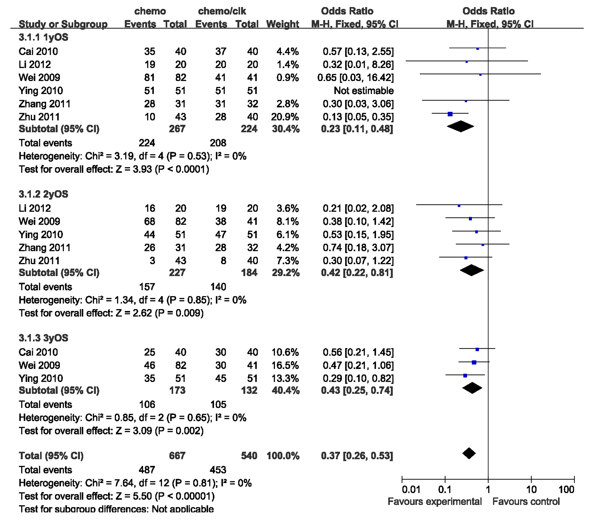
A
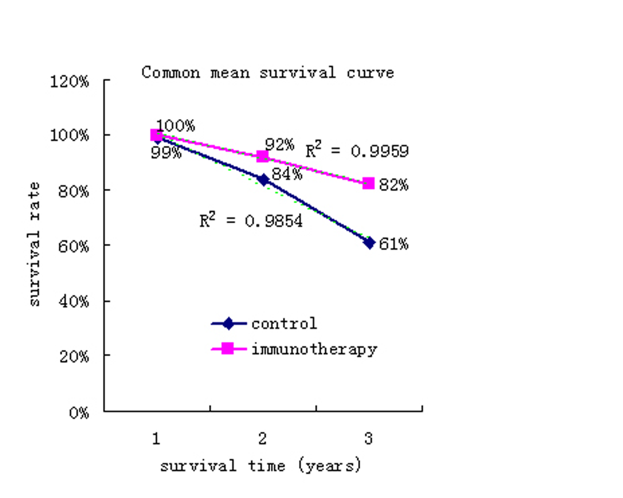
B
Figure 2 Overall survival. A: Comparison of 1-, 2-year and 3-year overall survival (OS) between the chemo-dendritic cell-cytokine-induced killer and chemo-alone groups. The fixed-effects meta-analysis model (Mantel-Haenszel method) was used. Each trial is represented by a square, the center of which gives the odds ratio for that trial. The size of the square is proportional to the information in that trial. The ends of the horizontal bars denote a 95%CI. The black diamond gives the overall odds ratio for the combined results of all trials; B: Mean survival including two trials (Wei et al^{[22]} and Ying et al^{[23]}) with excel line graph. The dotted line represent trend line of each group.

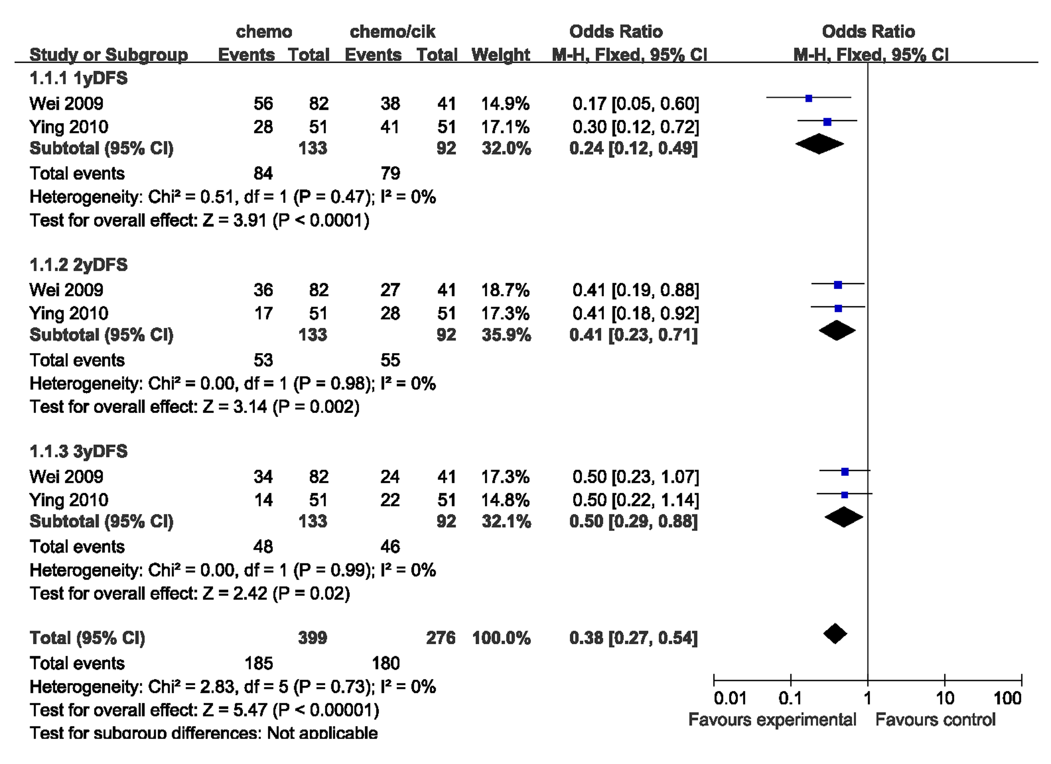
A
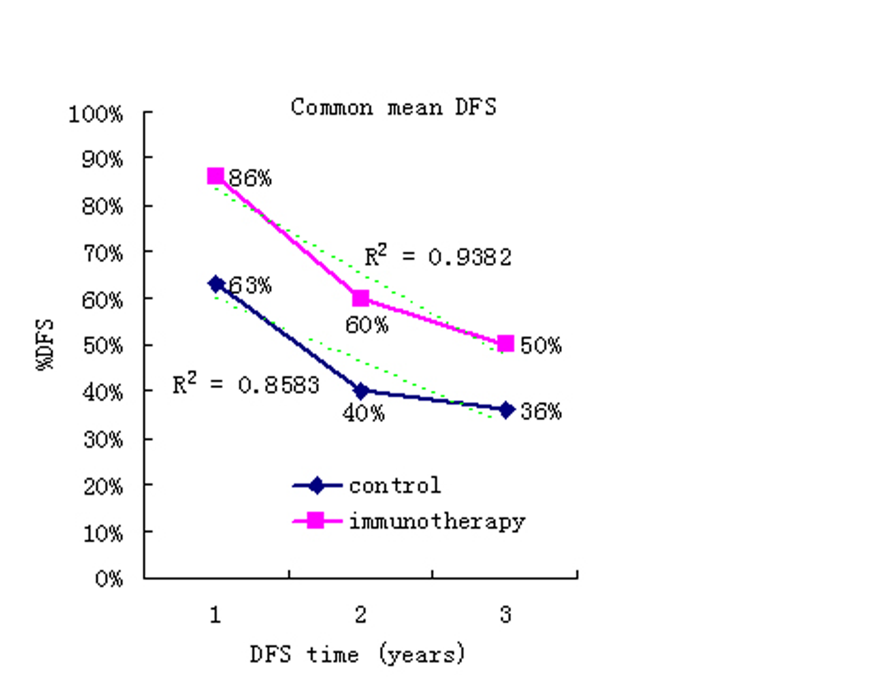
B
Figure 3 Disease-free survival. A: Forest plot for disease-free survival (DFS). The fixed effects model (Mantel-Haenszel method) was used in this analysis; B: Mean DFS including two trials (Wei et al^{[22]} and Ying et al^{[23]}) with excel line graph. The dotted line represent trend line of each group.
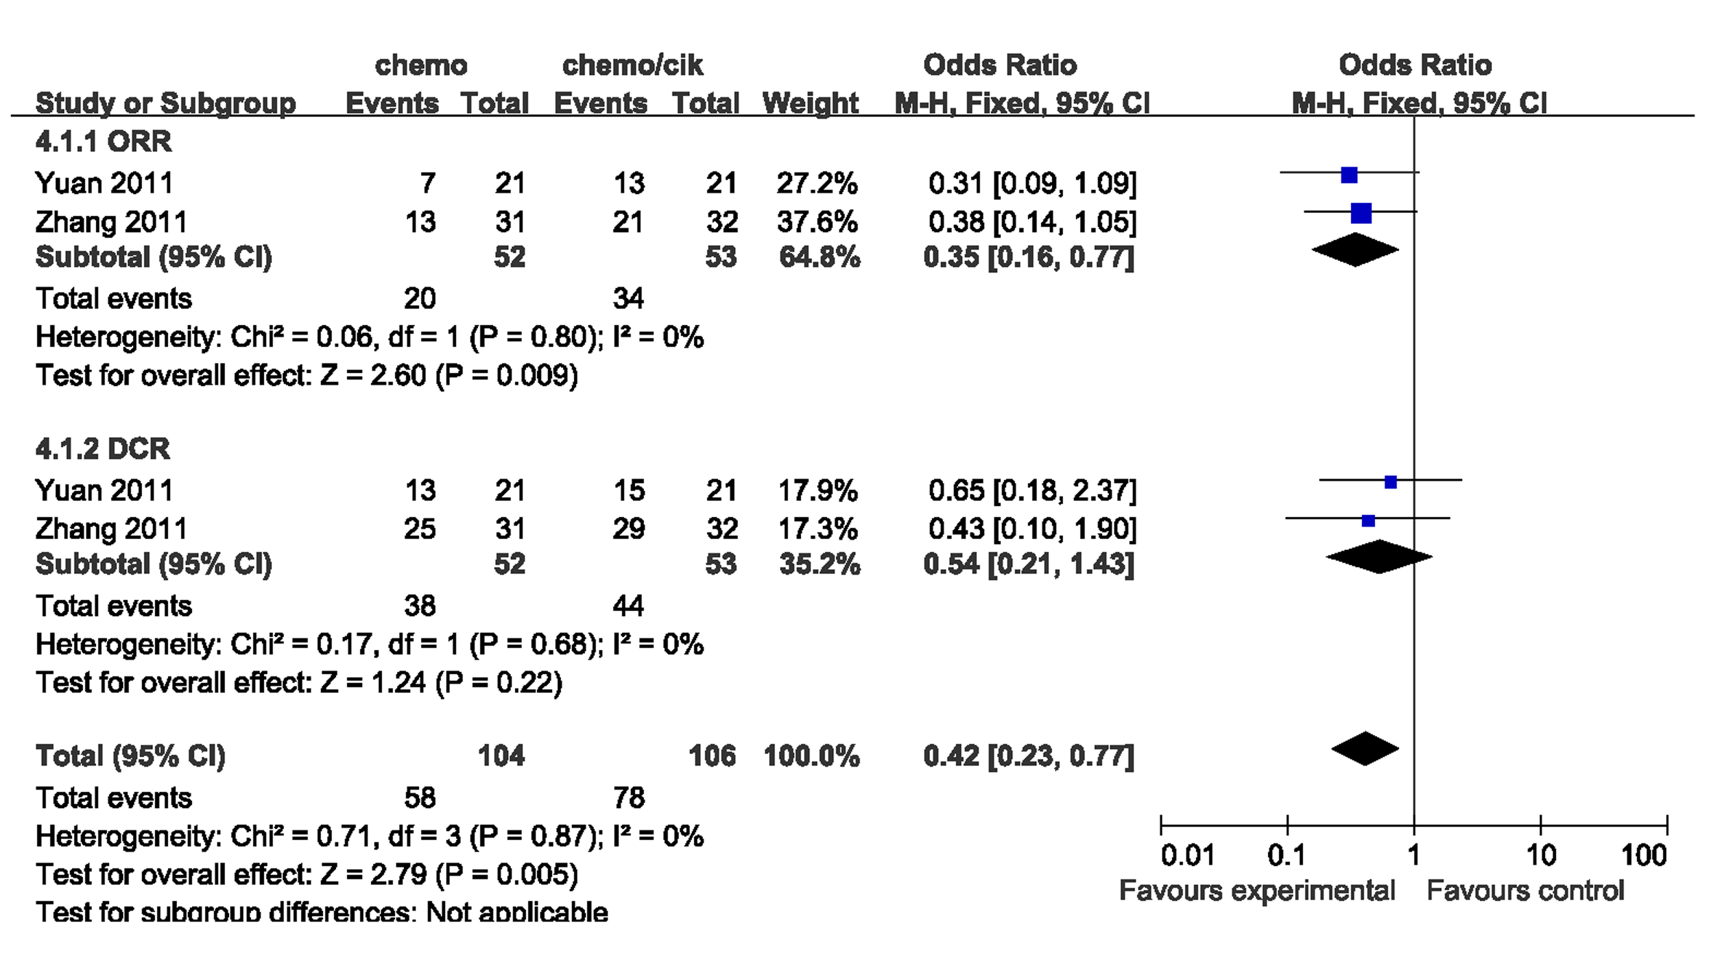
Figure 4 Comparison of objective response rate and disease control rate treatment with chemo-dendritic cell-cytokine-induced killer and chemo-alone. The fixed effects meta-analysis model (Mantel-Haenszel method) was used in this analysis. ORR: Objective response rate; DCR: Disease control rate.
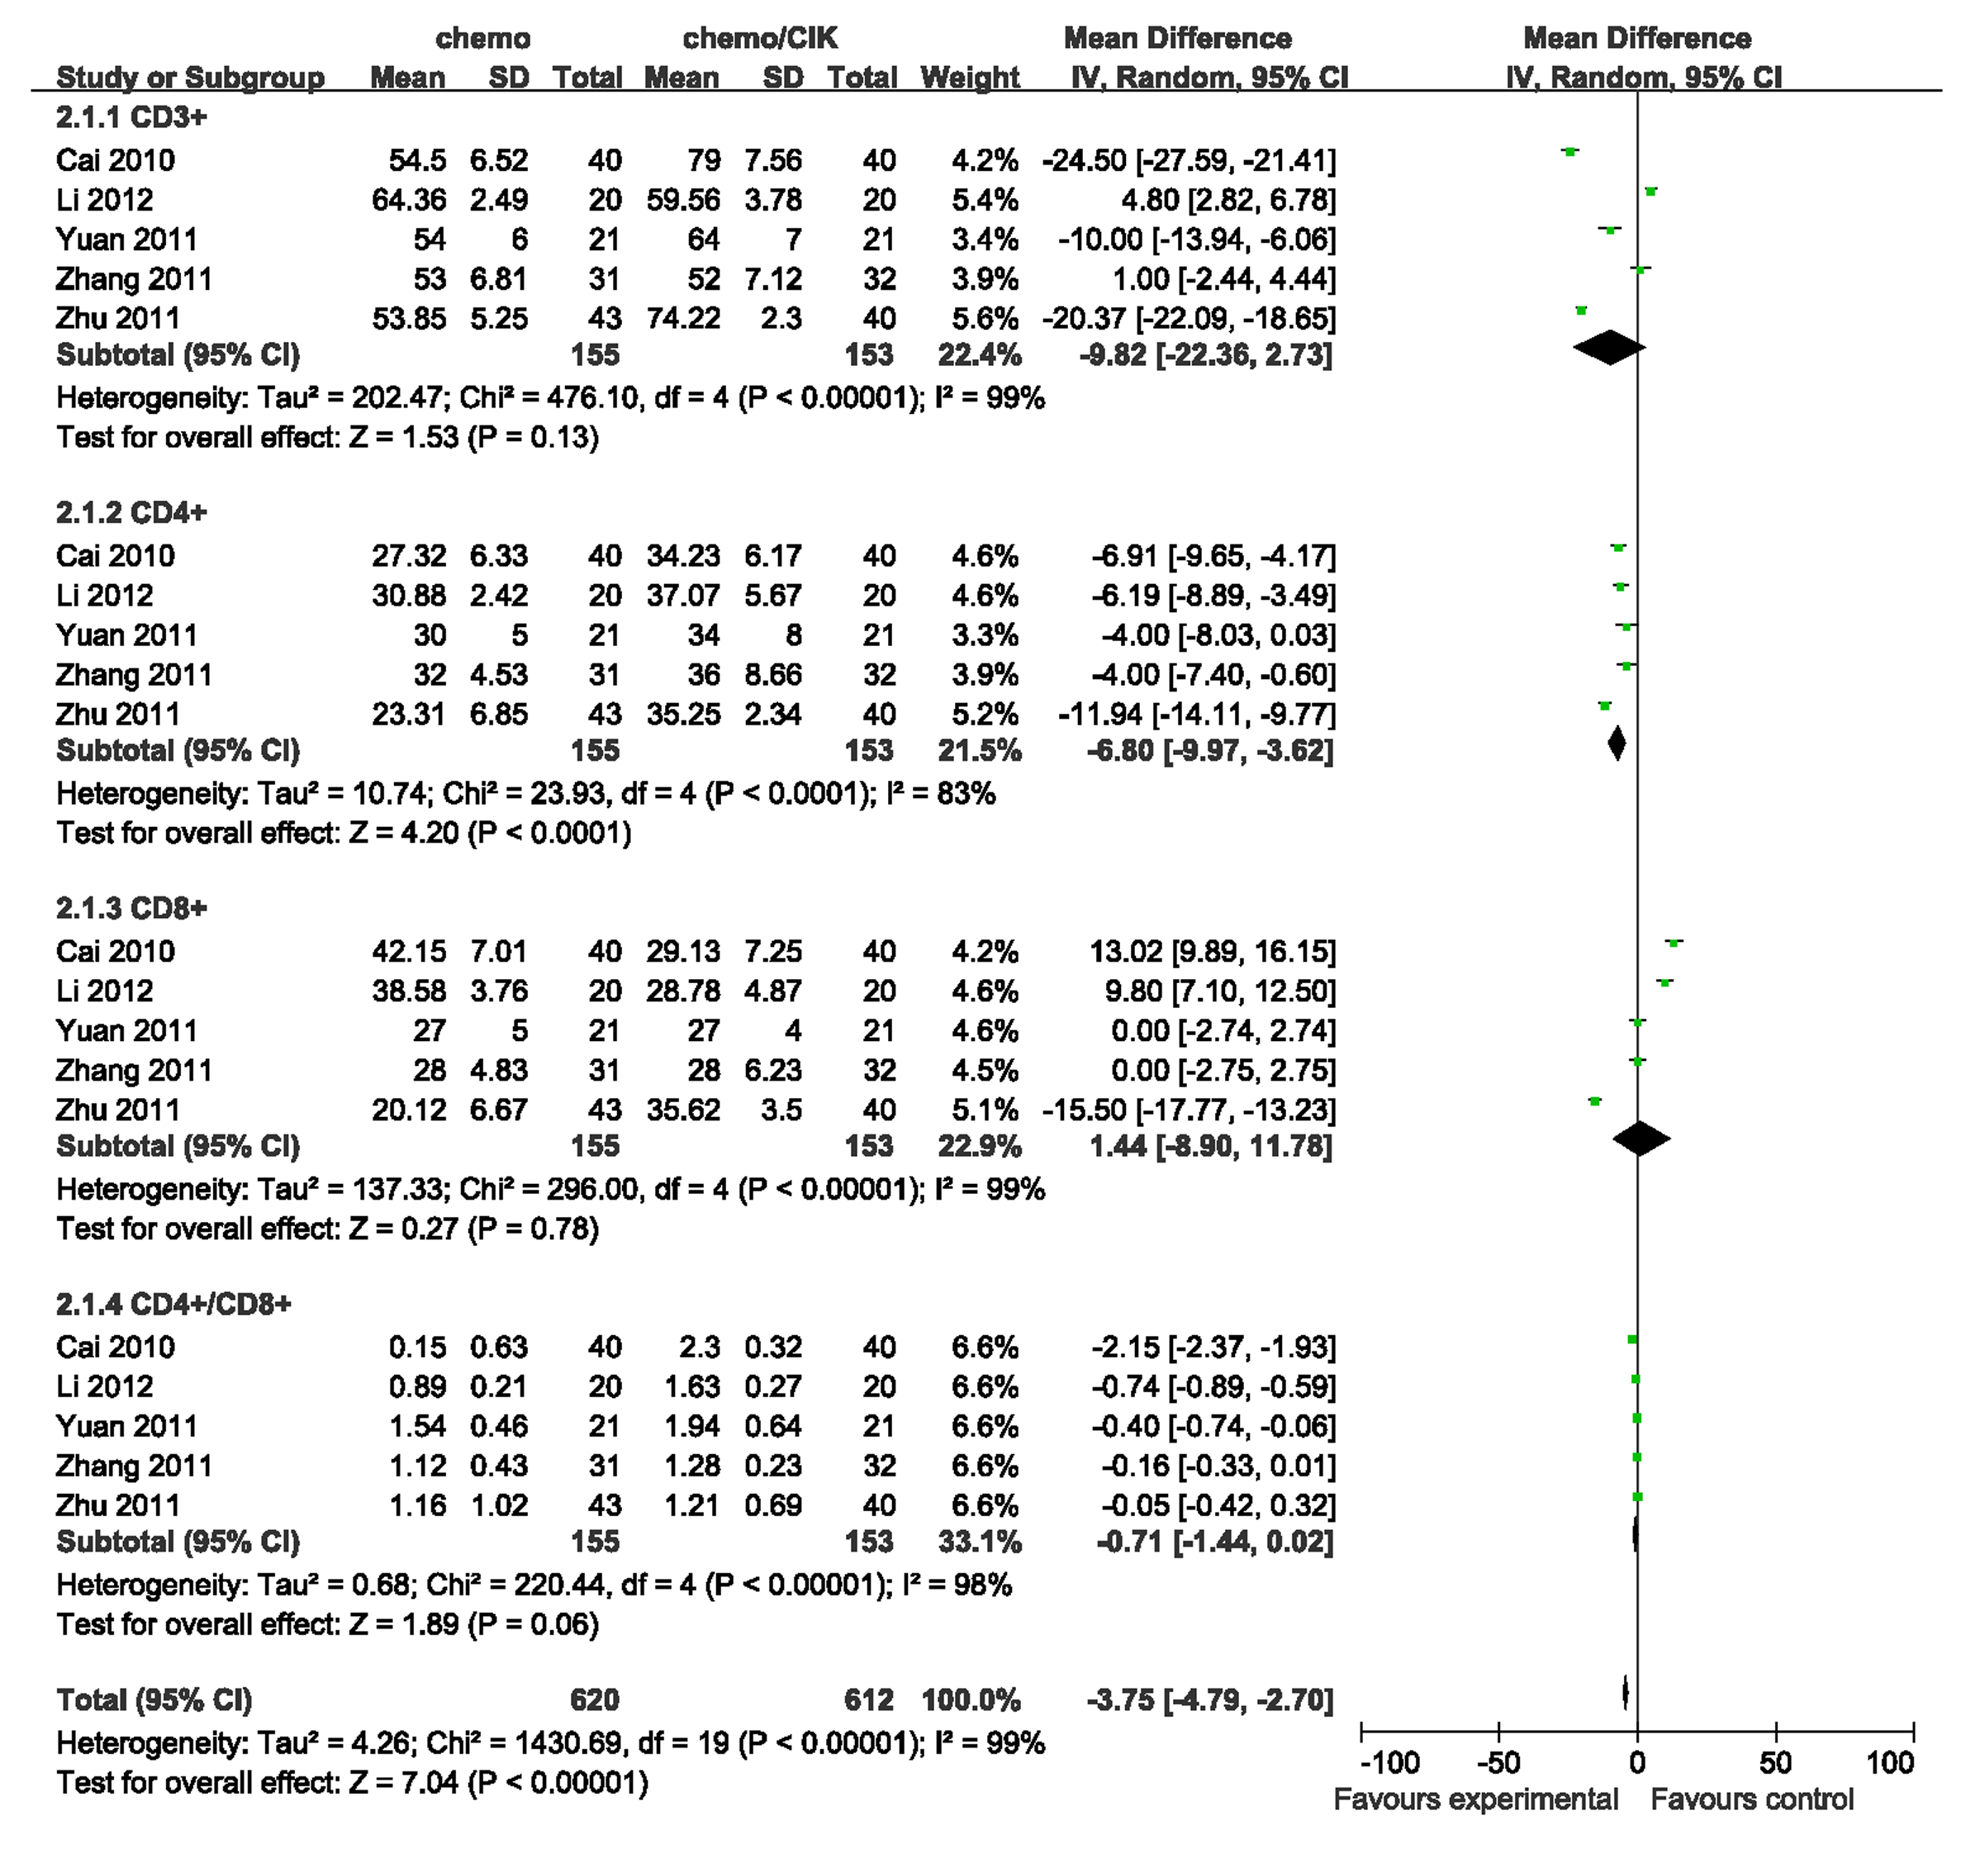
Figure 5 Forest plot for the immunophenotype assessment. The data come from the patients after chemo-dendritic cell-cytokine-induced killer treatment and chemo-alone treatment. The random effects meta-analysis model (Mantel-Haenszel method) was used in this analysis.

Table 1 Clinical information for the eligible meta-analysis trials
Reference | Age  (yr) | Tumor characteristic (TNM) | Regimens  (per arm) | Patients  (male) | Culture conditions of  CIK cells | Culture conditions of DC cells | CIK regimens
Zhang et al^{[24]} | UK | II, III, IV | Chemo  Chemo-  DC-CIK | 31 (UK)  32 (UK)  Randomized | IFNγ, CD3, IL1,  IL-2 | GM-CSF,  IL-4, TNFα | > 1.0 × 10⁹/ course
Zhu et al^{[25]} | 58.3 (Mid)  59.2 (Mid) | II, III, IV | Chemo  Chemo-  DC-CIK | 43 (27)  40 (24)  Treatment program | IFNγ, CD3, IL-2 | IFN-γ, LPS | 1.1-8.0×  10¹⁰/course
Ying et al^{[23]} | UK | II, III | Chemo  Chemo-  DC-CIK | 51 (25)  51 (31)  Retrospective analysis | IFNγ, CD3, IL-1,  IL-2 | GM-CSF,  IL-4, TNFα | ≥ 10¹⁰/course
Yuan et al^{[26]} | UK | III, IV | Chemo  Chemo-  DC-CIK | 21 (16)  21 (15)  Randomized | IFNγ, CD3, IL-1,  IL-2 | GM-CSF,  IL-4, TNFα,  IFN-γ | ≥ 10¹⁰/course
Cai et al^{[20]} | 44.5 (Ave)  46.7 (Ave) | II, III | Chemo  Chemo-  CIK | 40 (23)  40 (25)  Randomized | IFNγ, CD3, IL-1,  IL-2 |  | UK
Wei et al^{[22]} | 55.5 (Mid)  54 (Mid) | I, II, III | Chemo  Chemo-  DC-CIK | 82 (41)  41 (18)  Retrospective analysis | IFNγ, CD3, IL-1,  IL-2 | GM-CSF,  IL-4, TNFα,  IFN-γ | ≥ 10¹⁰/course
Li et al^{[21]} | 57.5 (Ave)  54.5 (Ave) | II, III | Chemo  Chemo-  DC-CIK | 20 (15)  20 (13)  Randomized | IFNγ, CD3, IL-2 | GM-CSF,  IL-4, IFN-γ | UK
The table summarizes patient information regarding cases, age, the details of the immunotherapy including dendritic cell (DC), cytokine-induced killer (CIK) or DC-CIK, and the last row is the culture condition used for the cells. IFNγ: Interferon-gamma; IL: Interleukin; GM-CSF: Granulocyte-macrophage colony-stimulating factor; TNFα: Tumour necrosis factor-alpha; UK: Unknown; Ave: Average; Mid: Median.

