Name of Journal: World Journal of Transplantation
Manuscript NO: 86645
Manuscript Type: EVIDENCE REVIEW

Simultaneous pancreas-kidney transplantation for end-stage renal failure in type 1 diabetes mellitus: Current perspectives

Nagendra L et al. SPKT for ESRF in T1DM

Lakshmi Nagendra, Cornelius James Fernandez, Joseph M Pappachan

Lakshmi Nagendra, Department of Endocrinology, JSS Medical College, JSS Academy of Higher Education and Research Center, Mysore 570015, India

Cornelius James Fernandez, Department of Endocrinology & Metabolism, Pilgrim Hospital, United Lincolnshire Hospitals NHS Trust, Boston PE21 9QS, United Kingdom

Joseph M Pappachan, Department of Endocrinology and Metabolism, Lancashire Teaching Hospitals NHS Trust, Preston PR2 9HT, United Kingdom

Joseph M Pappachan, Faculty of Science, Manchester Metropolitan University, Manchester M15 6BH, United Kingdom

Joseph M Pappachan, Faculty of Biology, Medicine and Health, The University of Manchester, Manchester M13 9PL, United Kingdom

Author contributions: Nagendra L performed the literature search, interpreted the relevant literature, and drafted the initial manuscript; Pappachan JM and Fernandez CJ conceived the idea and provided additional input to design the paper; Fernandez CJ prepared the figures and with additional input from Pappachan JM, revised the article critically for important intellectual content after peer reviews; All authors have read and approved the final version of the manuscript.

Corresponding author: Joseph M Pappachan, MD, FRCP, Academic Editor, Professor, Senior Researcher, Department of Endocrinology and Metabolism, Lancashire Teaching Hospitals NHS Trust, Sharoe Green Lane, Preston PR2 9HT, United Kingdom. drpappachan@yahoo.co.in

Received: June 30, 2023
Revised: August 1, 2023
Accepted: August 18, 2023
Published online:

Abstract
Type 1 diabetes mellitus (T1DM) is one of the important causes of chronic kidney disease (CKD) and end-stage renal failure (ESRF). Even with the best available treatment options, management of T1DM poses significant challenges for clinicians across the world, especially when associated with CKD and ESRF. Substantial increase in morbidity and mortality along with marked rise in treatment costs and marked reduction of quality of life are the usual consequences of onset of CKD and progression to ESRF in patients with T1DM. Simultaneous pancreas-kidney transplant (SPK) is an attractive and promising treatment option for patients with advanced CKD/ESRF and T1DM for potential cure of these diseases and possibly several complications of them. However, limited availability of the organs for transplantation, the need for long-term immunosuppression to prevent rejection, peri- and post-operative complications of SPK, lack of resources and the expertise for the procedure in many centers, and the cost implications related to the surgery and postoperative care of these patients are major issues faced by clinicians across the globe. This clinical update review compiles the latest evidence and current recommendations of SPK for patients with T1DM and advanced CKD/ESRF to enable clinicians to care for these diseases.

Key Words: Type 1 diabetes mellitus; Chronic kidney disease; End-stage renal failure; Simultaneous pancreas-kidney transplantation; Perioperative complications; Immunosuppression

Nagendra L, Fernandez CJ, Pappachan JM. Simultaneous pancreas-kidney transplantation for end-stage renal failure in type 1 diabetes mellitus: Current perspectives. World J Transplant 2023; In press

Core Tip: Simultaneous pancreas-kidney transplant (SPKT) is a promising management option for patients with advanced chronic kidney disease or end-stage renal failure (CKD/ESRF) and type 1 diabetes mellitus (T1DM) for probable cure of these diseases and possibly some of their complications. However, limited availability of these organs, need for long-term immunosuppression, the surgical complications, lack of availability of this procedure in most centers, and the cost implications related to SPKT are major challenges across the world. This clinical update review is to enable clinicians with the best evidence and current recommendations of SPKT for managing their patients with T1DM and advanced CKD/ESRF.

INTRODUCTION
Diabetes mellitus is one of the most common causes of chronic kidney disease (CKD) and end-stage renal failure (ESRF). Type 1 diabetes mellitus (T1DM), though less common when compared to type 2 diabetes, is associated with considerable morbidity and mortality secondary to microvascular and macrovascular complications including CKD. ESRF is a leading cause of death in patients with T1DM^{[1]}. Although there has been considerable progress in the development of insulin delivery devices, newer insulin molecules, and glucose monitoring systems in recent years, there is still a significant negative impact on the quality of life in relation to disease management among T1DM patients^{[2]}. Furthermore, these are not useful in reversing end-stage complications of diabetes such as ESRF. Despite extensive research, stem cell therapies in T1DM are still in the infantile stages^{[3]}. Simultaneous pancreas-kidney transplant (SPK) is an attractive modality that fills this treatment gap in the management of T1DM and ESRF. Lack of wide availability, high cost, infections, and immunological problems following SPK have long been the challenges precluding the widespread use of SPK. However, advanced surgical techniques and newer immunosuppressive drug regimens in recent years have resulted in dramatic improvement in SPK outcomes. We describe the current perspectives on SPK for individuals with T1DM and ESRF, with the latest evidence on indications, perioperative care, immediate and long-term complications, and clinical outcomes through this comprehensive review.

HISTORY OF SIMULTANEOUS PANCREAS-KIDNEY TRANSPLANTATION
Kelly et al^{[4]} from the University of Minnesota conducted the first pancreatic transplant in 1966 in combination with a kidney transplant to treat a 28-year-old uremic patient with T1DM. The patient was insulin-free for six days before needing exogenous insulin, which was brought on by the large dosages of steroids that were administered to avoid rejection. However, the patient developed graft pancreatitis, which was most likely caused by duct ligation and the transplantation procedure had to be reversed. Unfortunately, 13 days after the excision of the rejected pancreas and kidney transplant, the patient passed away from a pulmonary embolism^{[2]}. Surgical difficulties, wound infections, and graft rejection were all prevalent issues with pancreatic transplantation in this initial example, which persisted for the next 20 years. Despite difficulties, the Minnesota team had demonstrated the technical feasibility of SPK^{[4]}.
First documented effective use of cyclosporine A in two pancreatic transplants was by Calne et al^{[5]} in 1979. This heralded an exciting new era of effective immunosuppressive regimens which eventually led to the more widespread use of SPK. Triple immunosuppression (maintenance therapy with cyclosporine A, azathioprine, and steroids) soon gained popularity all over the world after the introduction of cyclosporine A^{[6]}. In 1989 Starzl et al^{[7]} used Tacrolimus as an immunosuppressive agent. This was followed by development of induction therapy initially using anti-thymocyte globulin such as thymoglobulin and later (1997) by a recombinant DNA-derived humanised anti-CD52 Lymphocyte depleting monoclonal antibody known as Alemtuzumab. Certain centres explored steroid-free regimens in the late 1990s and early 2000s which showed improvement in metabolic outcomes^{[6]}.
The initial pancreas transplant was done with ligation of the pancreatic duct^{[7]}. Montefiore used pancreatic duct to ureter anastomosis as a method of exocrine secretion drainage; however, it was complicated with anastomosis leakage. Bewick developed the open pancreatic duct drainage of exocrine secretions; however, it was complicated with peritonitis and ascites. Sollinger et al^{[8]} developed pancreas to bladder anastomosis for exocrine secretion drainage; however, it was complicated with urinary tract infections, chronic cystitis, reflux pancreatitis, metabolic acidosis, and haematuria. Currently, enteric drainage is widely used for exocrine drainage with anastomosis between transplanted duodenum and recipient ileum, jejunum, and duodenum, with drainage into a jejunal loop being the most used technique using techniques including Roux-en-Y reconstruction^{[9]}.
There are many types of pancreas and islet transplantations as depicted in Figure 1. The number of pancreas transplants (especially SPK) increased steadily in the US and worldwide since 1984. However, the number of pancreas transplants has shown a 20% decline between 2005 and 2014, with a nadir reaching in 2015. This decline in the pancreas transplants is due to various reasons including the availability of advanced alternative treatment options like sensors, pumps, and hybrid closed loops resulting in fewer referrals to the pancreas transplantation waiting list, diabetic complications like ESRF occurring at a later age group, worsening donor organ quality related to body mass index (BMI) among organ donors (BMI > 35 kg/m² associated with fatty infiltration of the pancreas), and high post-operative complication burden (> 50%) associated with the pancreas transplants^{[9]}.
Thereafter, though the pancreas transplant volume started to increase, there was a further decline to coincide with the beginning of the coronavirus disease 2019 (COVID-19) pandemic where the number of SPKs in the US dropped from 872 in 2019 to 827 in 2020^{[10]}. The number of pancreas transplants and the trends in pancreas transplants in the US between 1966 and 2021 are shown in Figures 2 and 3^{[11,12]}. This decline likely reflects the unwillingness of many transplant programs to move forward with pancreatic transplants due to COVID-19 limiting the resources. The pancreas after kidney (PAK) and pancreas transplant alone (PTA) increased marginally to compensate for the drop in SPK, as shown in Figure 3^{[10]}.

INDICATIONS FOR SPK
Typically, patients with T1DM who have low or absent C-peptide levels are eligible for the SPK. Candidates could also have severe nephropathy or ESRF, as well as comorbidities such hypoglycemia unawareness, recurrent hospitalisation for diabetic ketoacidosis, progressive retinopathy, enteropathy, and neuropathy. The current indications for SPK in T1DM are outlined in the Table 1^{[13,14]}.
In patients with stage 4/5 chronic kidney disease, preemptive SPK is described as the transplantation of both the pancreas and kidney before the patient is initiated on dialysis. Preemptive SPK has been shown to be related with better results when compared to SPK carried out in patients undergoing dialysis, according to several retrospective investigations, including registry analysis. In SPK patients, time spent on dialysis also has a poor prognostic significance^{[15,16]}.

CONTRAINDICATIONS
The absolute and relative contraindications for SPK in patients with T1DM are given in Table 1^{[17]}.
Obesity alone is not an absolute contraindication to SPK, given that positive outcomes have been documented^{[18]}. However, obese patients may experience a greater risk of early complications when compared to non-obese recipients^{[19]}. Additionally, the significance of BMI < 18.5 kg/m² as a risk factor for long-term mortality needs to be emphasized^{[18]}.
Previous history of limb amputation and presence of coronary heart disease are risk factors for worse outcomes, but neither is considered as an absolute contraindication to SPK^{[20]}. Pre-SPK limb amputation often indicates worse transplant results because it raises the risk of cardiovascular disease^{[21]}. The risk of serious adverse cardiovascular events following transplantation is further increased by a history of coronary artery disease prior to transplantation^{[22]}. If medically treated and revascularized in accordance with accepted standards, coronary artery disease, however, does not pose a significantly higher risk for death.

SURGICAL TECHNIQUES
Most of the pancreas grafts are retrieved from heart-beating brain dead donors, with an increasing number from non-heart-beating donors after circulatory death^{[17]}. The retrieval involves the removal of the pancreas en-bloc with the donor duodenum and spleen, with the spleen removed prior to implantation. In SPK, both kidney and pancreas grafts are taken from the same deceased donor. The donor pancreas has two arteries (superior mesenteric artery and splenic artery), and these are joined with a ‘Y’ graft utilizing the donor common iliac artery and its bifurcation to create a single arterial inflow which is anastomosed to the recipient’s right common iliac artery. The donor portal vein is anastomosed to the recipient’s right common iliac vein or inferior vena cava. Finally, the donor duodenal conduit is anastomosed to the recipient’s small bowel or urinary bladder. A pancreas transplant alone takes approximately 3-4 h, whereas a simultaneous pancreas and kidney transplant takes approximately 4-6 h^{[17,23]}.
Diverse and institution-specific procedures are employed for SPK. The intra-peritoneal technique is used by most transplant facilities for graft insertion. The kidney is transplanted to the left iliac fossa, the pancreas is generally placed in the right iliac fossa. The native pancreas and kidney remain in place. The peripancreatic fluid accumulations and wound complications are reduced because of this strategy. Extraperitoneal and ipsilateral insertion of both grafts constitute an alternate strategy^{[17,24]}.
Most pancreatic transplants use either enteric or bladder drainage. Comparing bladder and intestinal drainage of exocrine secretions in pancreas transplantation has been extensively studied. Compared to enteric drainage, bladder drainage increases late reintervention rates (primarily for enteric conversion), but it has no acute surgical risks^{[17]}. In a recent study by Riad et al^{[25]}, at 10 years posttransplant, 44.3% of simultaneous pancreas-kidney transplant recipients had undergone enteric conversion. The enteric conversion was associated with 85% increased risk of acute rejection but was not associated with graft loss or mortality. Additionally, bladder drainage is linked to long-term urologic problems such as bladder calculi, haemorrhagic cystitis, and recurrent urinary tract infections, as well as metabolic disturbances like acidosis and dehydration^{[26]}. These factors have contributed to a drop in use of bladder drainage over time.

PERIOPERATIVE CARE
Insulin regimens
Perioperative plasma glucose monitoring is crucial. The metabolic reaction to stress and the impact of corticosteroids contribute to the frequent occurrence of intraoperative hyperglycemia. As uncontrolled glucose levels are linked to impaired immune function and an increased risk of infection, insulin infusion should be started before unclamping of the pancreas transplant. Plasma glucose must be closely monitored after unclamping since glucose levels might dangerously plummet^{[27]}.

Heparin thromboprophylaxis
Thrombosis, which has a reported prevalence of 4%–20%, is a common complication associated with pancreatic transplantation. One of the main factors contributing to pancreatic transplant failure and graft loss has been identified as thrombosis. In spite of this, the effectiveness of preventive anticoagulation is still debatable, with some trials finding positive results from anticoagulation and other trials reporting no benefit^{[28,29]}. Pancreas transplant centers have various internal policies and practices, and there is still no standardised thromboprophylaxis approach for this procedure. According to a recent meta-analysis that included 11 studies and 1122 patients in the heparin group and 236 patients in the no-heparin group, prophylactic heparinization significantly reduced the risk of early pancreas thrombosis and pancreas loss for SPK without increasing the incidence of bleeding or acute return to the operating room when compared to the no-heparin control^{[30]}. In the included studies, intraoperative intravenous heparin 30-70 IU/kg was administered when heparin thromboprophylaxis was not contraindicated. Heparin was administered intravenously 200-1000 IU/h for 1-14 d or subcutaneously 3000-5000 IU 1-2 times daily during the postoperative period. Following this, aspirin 81-325 mg per day was used for maintenance^{[30]}.

IMMUNOSUPRESSION
The accepted practice in modern immunosuppression is to combine numerous drugs with various mechanisms of action for maintenance therapy and to employ biologic medicines for induction. These regimens achieve the main objectives of immunosuppression, which are to effectively manage acute rejection while reducing risks to the patient's safety and tolerability and damage to the allograft(s).

Induction immunosuppression
Early rejection and graft loss from combined pancreas-kidney transplants have been lower with the use of induction immunosuppression. Of the induction therapies, lymphocyte-depleting agents (alemtuzumab and antithymocyte globulin) and nondepleting agents [basiliximab and daclizumab (anti–interleukin 2 (anti–IL-2) receptor monoclonal antibody)] have been used in SPKs. Ninety percent of pancreatic transplant patients get a lympho-depleting drug during induction treatment, reflecting the widespread observation of greater rejection rates following pancreas transplant^{[10]}.
A recent meta-analysis studied 536 SPK participants in 7 randomised clinical trials that reported 5 induction methods. Antithymocyte globulin (97 patients), alemtuzumab (42 patients), 2 or 5 doses of daclizumab (113 patients), and no induction treatment (120 patients) were included in these regimens. A regimen containing 2 doses of daclizumab ranked highest for patient survival as well as kidney and pancreas transplant survival in the network meta-analysis. In contrast, alemtuzumab was ranked best for prevention of acute renal and pancreatic rejection^{[31]}.
In patients at low immunologic risk, there isn't any conclusive proof that induction with depleting vs nondepleting antibodies leads to better immunologic outcomes. When compared with the use of nondepleting antibodies or no induction therapy, induction with depleting antibodies is associated with cytokine release syndrome requiring premedication and with an increased incidence of early posttransplant infections, especially cytomegalovirus (CMV) viremia (that do not result in inferior patient and graft survival). There is no conclusive evidence that induction treatment with depleting antibodies increases the risk of oncologic problems in pancreatic transplant patients, despite data in renal transplantation to the contrary^{[20]}.

Maintenance Immunosuppression
Modern immunosuppressive protocols for all types of pancreatic transplantation include tacrolimus, mycophenolate, and steroids for the purpose of maintenance of immunosuppression. Tacrolimus has been the preferred calcineurin inhibitor (CNI) for more than ten years, despite the risks of beta cell toxicity and renal damage linked to it. Results of a 3 year single-center, prospective, randomized comparison of the two calcineurin inhibitors in the setting of mycophenolate mofetil (MMF)-based immunosuppression in 47 SPK patients did not show superiority of tacrolimus over cyclosporin^{[32]}. However, a larger study in 205 SPK recipients confirmed the superiority of tacrolimus over cyclosporine in preventing moderate or severe kidney or pancreas rejection and pancreatic thrombosis^{[33]}. Tacrolimus is available as an immediate-release formulation (IR-Tac) which is traditionally given twice daily. Extended-release tacrolimus (ER-Tac) given once daily was later explored with the expectation of improved medication adherence. Falconer et al^{[34]} reported that stable SPK recipients can safely be converted from IR-Tac to ER-Tac, with no clinical impact on the transplant function.
MMF continues to be the preferred antiproliferative drug for maintenance therapy. Following induction therapy, a review found that using mycophenolate mofetil in conjunction with a CNI and steroids was linked to a 40% decrease in the risk of acute rejection one year following pancreatic transplantation^{[35]}. When combined with tacrolimus or cyclosporine, retrospective studies have shown that mycophenolate mofetil, as opposed to azathioprine, improves the immunologic outcome of pancreas transplantation, but at the cost of more gastrointestinal side effects that frequently necessitate dose reduction^{[36,37]}.
A total avoidance of steroid immunosuppression is referred to as "steroid avoidance." Early avoidance is defined as steroid therapy for fewer than 14 d following transplantation, while late avoidance is defined as steroid withdrawal after 14 d^{[38]}. Though steroids form the cornerstone of immunosuppression therapy, steroid discontinuation is being explored and could lead to better metabolic outcomes over time. Although it fell from 27.2% in 2019 to 25.8% in 2020, the percentage of patients kept on a tacrolimus/MMF steroid-free therapy was mostly steady. Steroid withdrawal between 6-12 mo after transplantation was successful and safe in most patients without an increase of immune events. Additionally, the patients had a low prevalence of hypertension, dyslipidemia, and obesity^{[39]}.
Compared to the 12.4% reported in 2010, the percentage of pancreatic transplant patients in the "other" maintenance therapy regimens has reduced to 2.6%. This slow decline shows that co-stimulation blockade or mammalian target-of-rapamycin (mTOR) inhibitors have not been frequently used as alternate maintenance regimen components^{[9,20]}. Though mTOR inhibitors show noninferior immunological outcomes, the side effect profile of this group of drugs precludes its widespread use^{[40,41]}.

COMPLICATIONS
When compared to patients of kidney transplantation alone (KTA), those who received SPK typically have more severe and frequent complications in the first year after transplant. These complications are typically caused by either the more extensive surgical procedure or the necessary immunosuppression. Greater morbidity and early death are related to SPK than KTA because of perioperative problems. This difference is evidenced by longer initial hospital stays, higher rates of rehospitalization in the first 30 d, more serious infections necessitating rehospitalization, and higher perioperative mortality risk^{[42]}. Khubutia et al^{[43]} reported surgical complications in 37.5% of SPK patients. Asymptomatic para-pancreatic fluid collection (52.5%) was the most common surgical complication followed by Superior mesenteric artery thrombosis (12.5%). Surgical site infections after pancreas transplantation in the Swiss Transplant Cohort Study was seen in 14% of patients^{[44]}.
Following a pancreatic transplant, technical failure rates might reach 8%. Graft thrombosis, graft pancreatitis, anastomotic leak, and infection are some causes of failure^{[45,46]}. In a recent retrospective, single-center analysis, 114 adult patients who received an SPK between 2005 and 2018 were included. There was an 85.1% pancreas transplant survival rate at 3 mo. Early pancreatic transplant loss was mostly due to pancreatitis (2.6%), necrosis (2.6%), and thrombosis (6.1%). In contrast to patients with a functional pancreas, early pancreatic transplant loss was not linked to a lower chance of survival (P = 0.168) or severe adverse cerebral or cardiovascular events during a 10-year period^{[47]}. The majority of postoperative problems in the SPK population that necessitate surgical re-exploration are pancreas-related. In a recent study on SPK patients, while 28.2% patients experienced a major kidney complication, the rate for major pancreas-related complications was 43.6%^{[48]}.
Even though SPK outcomes have improved dramatically, infectious complications continue to be the leading cause of morbidity and death. Michalak et al^{[49]} reported 102 infections among 51 SPK patients during the posttransplant period. A total of 73 bacterial infections (systemic 13, pulmonary 13, intestinal 8, wound 23), 21 episodes of CMV infection (systemic 20, duodenal site 1), 73 fungal infections (central nervous system 5, gastrointestinal tract 3), and 8 bacterial infections (systemic 13, pulmonary 13, intestinal 8, wound 23) were reported. Some individuals had multiple infections. The overall mortality rate in the study cohort was 24.5%. Most deaths (77%) were due to infectious complications, which included systemic infection (38.5%) and CNS infection (38.5%). The majority of systemic illnesses had a bacterial aetiology and CNS infections had a fungal aetiology.
Metabolic complications are also a frequent cause of morbidity post SPK. Within the first six months, transient hyperglycemia may develop because of acute or chronic rejection, pancreatitis, or a significant rise in insulin resistance brought on by weight gain. Post-transplant hyperglycemia has also been associated with immunosuppressant drug side effects, including steroids, calcineurin inhibitors (particularly tacrolimus), sirolimus, and mycophenolate. About 60 to 80% of patients receiving immunosuppressive medication develop hyperlipidemia following solid organ transplantation. Two of the most significant lipid abnormalities seen are high triglyceride levels and low-density lipoprotein cholesterol concentrations. Combined hyperlipidemia is also typical. Many risk factors, including advanced age, obesity, post-transplant weight gain, pre-transplant dyslipidemia, male gender, graft malfunction, proteinuria, newly diagnosed diabetes mellitus, prednisone dose, and the kind of immunosuppressive regimen, might contribute to the development of dyslipidemia following pancreatic transplant. Although tacrolimus and cyclosporine similarly negatively impact lipid metabolism, sirolimus has been linked to larger elevations in triglycerides and cholesterol^{[50]}. The common complications of SPK are displayed in Figure 4.

OUTCOMES
Survival benefit
For transplants performed in 2018-2019, one year patient mortality remained low at 2.6%. Ten-year mortality rates among 2010-11 transplant recipients were 20.9% likely reflecting cardiovascular comorbidities in the population. Five year survival rates was 92.7%^{[10]}.
Compared with living- or deceased-donor kidney transplantation, SPK was associated with improved patient survival, especially in recipients with a long-term functioning pancreatic graft, and resulted in an almost 50% reduction 10-year mortality rate^{[51]}.

Glycemic control
Following a solid-organ pancreas transplant, the great majority of patients attain total insulin independence in both the short and long terms. In fact, glycemic control outperforms that attained with insulin pumps or islet-cell transplants by a wide margin^{[52]}. A recent study evaluated CGM-derived time in range and glucose variability in 43 patients with SPK. Time in range (TIR) at 5-12 years follow-up was 97.5%. Time above range (TAR) and time below range (TBR) were 2.5% and 3.5% respectively. Thus patients with functional pancreatic grafts exhibit very high TIR and low GV following SPK^{[53]}. In the immediate post-transplant period at 6 wk, Dadlani et al^{[54]} reported a TIR, TAR and TBR of 92%, 7.9% and 0.3% respectively in SPK patients.

Diabetes related complications
Diabetic retinopathy: A feared side effect of pancreatic transplantation is the worsening of diabetic retinopathy brought on by abrupt glucose normalisation. There have been conflicting results on retinopathy outcomes after SPK. Chow et al^{[55]} reported a high prevalence of severe proliferative diabetic retinopathy (DR) and blindness at the time of presentation for SPK. This was subsequently stabilised to inactive proliferative DR by appropriate laser therapy followed by metabolic control achieved by SPK. Voglová et al^{[56]} studied 43 pancreatic and kidney recipients for a 12-mo composite endpoint that included the requirement for fresh laser therapy, newly discovered proliferation, macular edema, deteriorating vision, and blindness. This primary goal was attained by 37% of patients, however the severity was only moderately high. Visual acuity remained constant. The absolute glycated haemoglobin, age, and duration of diabetes mellitus did not significantly differ between patients who met and did not achieve the primary goal, while a greater percentage of patients with deterioration had recently undergone laser therapy. 62.8% of individuals had stable retinal disease. In 26% of cases, visual acuity was noticeably improved. Despite the fact that retinal deterioration was observed in more than one-third of individuals, the progression of the condition was unrelated to the degree of metabolic alteration and instead followed the predicted normal course of retinopathy^{[56]}.

Diabetic neuropathy: Cardiac autonomic neuropathy is a dreaded complication of long-standing uncontrolled diabetes. Argente-Pla et al^{[57]} reported improved cardiac autonomic neuropathy post SPK as evidenced by an improved Valsalva ratio. SPK has been shown to be beneficial for diabetic polyneuropathy in earlier studies. Kennedy et al^{[58]} used muscle action potential and indices of nerve conduction velocity to examine how pancreatic transplantation affected peripheral motor, sensory, and autonomic nerve function. They discovered a notable improvement in motor and sensory indices during a 12-mo follow-up. Martinenghi et al^{[59]} demonstrated that even in the presence of severe polyneuropathy, a persistent normoglycemic condition can enhance nerve function.

Diabetic nephropathy: For most patients with type 1 DM and ESRF, SPK restores normal renal function. According to Fioretto et al^{[60]}, characteristics of diabetic nephropathy were restored after 10 years of sustained normoglycemia post-transplant. It greatly decreased the thickness of the mesangial matrix and glomerular basement membrane, and it significantly improved glomerular and tubular lesions. Additionally, a decline in the rate of urine albumin excretion (20 mg/d vs 103 mg/d) was seen, demonstrating improved renal function. Diabetic nephropathy is reported to alter circulating long noncoding RNA levels that normalize following SPK^{[61]}.

Macrovascular complications: Microvascular diabetic problems are stabilised more frequently following effective SPK, although macrovascular diabetic sequelae and diabetic Charcot neuro-osteoarthropathy have been traditionally thought to progress. Duration of hemodialysis is an important risk factor for adverse cardiac events^{[62]}. However, a recent study showed significant improvements in left ventricular systolic parameters during follow-up in SPK recipients^{[63]}. Another recent study concluded that SPK favorably slows down development and progression of peripheral vascular disease by maintaining a superior metabolic vascular risk profile^{[21]}.

Quality of life: When compared to KTA, it has been demonstrated that SPK improves quality of life (QoL). In addition to avoiding hypoglycemia spells and insulin injections, pancreas transplantation also lowers the risk of developing microvascular and macrovascular complications of diabetes and eliminates the need for glucose monitoring. After correcting for QoL, SPK outperformed KTA or dialysis in terms of cost effectiveness over five years in a trial on individuals with T1DM and ESRF^{[64]}. The outcomes of SPK are summarised in Figure 5.

Future perspectives of SPK in the context of islet transplantation
Pancreas transplantation is the best treatment to provide insulin-independence, excellent metabolic control, and an improvement in QoL. Additionally, it may be able to avoid, ameliorate, or even reverse most of the diabetic complications. The technique of pancreas transplantation has shown improvement over time. The factors playing their part in this improvement including intestinal drainage of pancreatic juices, introduction of calcineurin inhibitors and T-cell depleting agents, and improvements in maintenance immunosuppression with tacrolimus and mycophenolate mofetil. Though the sirolimus-based protocols showed initial promise, their use subsequently declined significantly.
PTA and PAK are more difficult to monitor. Hence, they carry a high risk of immunological rejection, and have less favourable outcomes in comparison to SPK. PAK is effective in those who have had KTA in the past and are now having trouble with achieving glycaemic control and/or management of diabetes-related complications. Thus, PAK is a therapeutic option as a life-preserving procedure that avoids long-term dialysis and mortality on the waitlist and provides the time to find a good pancreas graft after the kidney transplant. On the other hand, PTA is a treatment option for patients with brittle diabetes who suffer from hypoglycaemia unawareness impairing QoL or have difficulty adhering to insulin injection requirements, but with a normal or near-normal renal function. It provides the best one-year patient survival among all whole organ transplants^{[65]}.
Careful selection of recipients and donors, improvement in surgical techniques, and refinement in immunosuppressive protocols have provided excellent outcomes after pancreas transplantation. Additionally, early detection of post-operative complications through careful observation, and regular imaging, and prophylactic use of antimicrobial agents are possible strategies that would reduce the post-operative morbidity/mortality and thereby favour the expansion of existing pancreas transplant programs. Islets constitute only 1%-2% of the pancreas. Therefore, a less invasive procedure with lower procedural morbidity, islet transplantation, involving percutaneous intra-portal infusion of the islets is considered another alternative^{[17]}.
There are no trials comparing the outcomes of islet transplantation (SIK or IAK) vs SPK^{[17]}. Pancreas transplantation is a more acceptable treatment option for patients with ESRF, who are already undergoing a kidney transplantation. On the other hand, islet transplantation is preferred in elderly, frail, and morbid patients who are unfit for pancreas transplantation and in patients with a preference for a less invasive procedure. These two procedures have comparable results in glucose control, avoidance of severe hypoglycaemia, and recovery from hypoglycaemia unawareness. However, the insulin independence rates are ‘slow and low’ with islet transplants in comparison to pancreas transplants depending on the number of islet transplants and the success of engraftments. Multiple donors are needed in islet transplantation, thereby increasing the waiting list. Contrary to pancreas transplantation, obesity in the donor is not a contraindication for islet transplantation^{[65]}.

CONCLUSION
For individuals with T1DM and ESRF, simultaneous pancreas and kidney transplantation has become the gold standard of care. In terms of patient survival, graft survival, diabetes complications, and QoL, there is a substantial body of evidence from clinical research that supports the procedure. Only carefully chosen individuals should undergo simultaneous pancreas and kidney transplantation since it is a technically challenging treatment that is linked with serious short term and long-term complications. The wider adoption of this therapeutic paradigm can be made possible with patient education initiatives and public outreach to foster a charitable culture of organ donation.

REFERENCES
1 Deng Y, Li N, Wu Y, Wang M, Yang S, Zheng Y, Deng X, Xiang D, Zhu Y, Xu P, Zhai Z, Zhang D, Dai Z, Gao J. Global, Regional, and National Burden of Diabetes-Related Chronic Kidney Disease From 1990 to 2019. Front Endocrinol (Lausanne) 2021; 12: 672350 [PMID: 34276558 DOI: 10.3389/fendo.2021.672350]
2 Yazidi M, El Felah E, Oueslati I, Chaker F, Grira W, Khessairi N, Chihaoui M. Assessment of quality of life in adult type 1 diabetic patients. Tunis Med 2020; 98: 861-868 [PMID: 33479985 DOI: 10.5603/dk.a2022.0001]
3 Chen S, Du K, Zou C. Current progress in stem cell therapy for type 1 diabetes mellitus. Stem Cell Res Ther 2020; 11: 275 [PMID: 32641151 DOI: 10.1186/s13287-020-01793-6]
4 Kelly WD, Lillehei RC, Merkel FK, Idezuki Y, Goetz FC. Allotransplantation of the pancreas and duodenum along with the kidney in diabetic nephropathy. Surgery 1967; 61: 827-837 [PMID: 5338113]
5 Calne RY, Rolles K, White DJ, Thiru S, Evans DB, McMaster P, Dunn DC, Craddock GN, Henderson RG, Aziz S, Lewis P. Cyclosporin A initially as the only immunosuppressant in 34 recipients of cadaveric organs: 32 kidneys, 2 pancreases, and 2 livers. Lancet 1979; 2: 1033-1036 [PMID: 91781 DOI: 10.1016/s0140-6736(79)92440-1]
6 Squifflet JP, Gruessner RW, Sutherland DE. The history of pancreas transplantation: past, present and future. Acta Chir Belg 2008; 108: 367-378 [PMID: 18710120 DOI: 10.1080/00015458.2008.11680243]
7 Starzl TE, Todo S, Fung J, Demetris AJ, Venkataramman R, Jain A. FK 506 for liver, kidney, and pancreas transplantation. Lancet. 1989 Oct 28;2(8670):1000-4. [PMID: 2478846 DOI: 10.1016/s0140-6736(89)91014-3.]
8 Sollinger HW, Knechtle SJ, Reed A, D'Alessandro AM, Kalayoglu M, Belzer FO, Pirsch J. Experience with 100 consecutive simultaneous kidney-pancreas transplants with bladder drainage. Ann Surg. 1991 Dec;214(6):703-11. [PMID: 1741650 DOI: 10.1097/00000658-199112000-00010.]
9 Martin D, Alberti P, Demartines N, Phillips M, Casey J, Sutherland A. Whole-Organ Pancreas and Islets Transplantations in UK: An Overview and Future Directions. J Clin Med 2023; 12 [PMID: 37176684 DOI: 10.3390/jcm12093245]
10 Kandaswamy R, Stock PG, Miller JM, White J, Booker SE, Israni AK, Snyder JJ. OPTN/SRTR 2021 Annual Data Report: Pancreas. Am J Transplant 2023; 23: S121-S177 [PMID: 37132349 DOI: 10.1016/j.ajt.2023.02.005]
11 Gruessner AC, Gruessner RW. Pancreas Transplantation of US and Non-US Cases from 2005 to 2014 as Reported to the United Network for Organ Sharing (UNOS) and the International Pancreas Transplant Registry (IPTR). Rev Diabet Stud 2016; 13: 35-58 [PMID: 26982345 DOI: 10.1900/RDS.2016.13.35]
12 Gruessner AC. A Decade of pancreas transplantation-a registry report. Uro [Internet]. 2023; 3: 132–150 [DOI: 10.3390/uro3020015]
13 Sollinger HW, Odorico JS, Knechtle SJ, D'Alessandro AM, Kalayoglu M, Pirsch JD. Experience with 500 simultaneous pancreas-kidney transplants. Ann Surg 1998; 228: 284-296 [PMID: 9742912 DOI: 10.1097/00000658-199809000-00002]
14 Jiang AT, BHSc, Rowe N, Sener A, Luke P. Simultaneous pancreas-kidney transplantation: The role in the treatment of type 1 diabetes and end-stage renal disease. Can Urol Assoc J 2014; 8: 135-138 [PMID: 24839485 DOI: 10.5489/cuaj.1597]
15 Grochowiecki T, Szmidt J, Gałazka Z, Nazarewski S, Madej K, Meszaros J, Paczek L, Durlik M, Wyzgał J, Grygiel K, Wojtaszek M, Piwowarska J, Kański A. Comparison of 1-year patient and graft survival rates between preemptive and dialysed simultaneous pancreas and kidney transplant recipients. Transplant Proc 2006; 38: 261-262 [PMID: 16504719 DOI: 10.1016/j.transproceed.2005.12.039]
16 Pruijm MT, de Fijter HJ, Doxiadis II, Vandenbroucke JP. Preemptive versus Non-preemptive simultaneous pancreas-kidney transplantation: a single-center, long-term, follow-up study. Transplantation 2006; 81: 1119-1124 [PMID: 16641596 DOI: 10.1097/01.tp.0000208574.48230.fd]
17 Dholakia S, Royston E, Quiroga I, Sinha S, Reddy S, Gilbert J, Friend PJ. The rise and potential fall of pancreas transplantation. Br Med Bull 2017; 124: 171-179 [PMID: 29088319 DOI: 10.1093/bmb/ldx039]
18 Fridell JA, Mangus RS, Taber TE, Goble ML, Milgrom ML, Good J, Vetor R, Powelson JA. Growth of a nation part I: impact of organ donor obesity on whole-organ pancreas transplantation. Clin Transplant 2011; 25: E225-E232 [PMID: 21362050 DOI: 10.1111/j.1399-0012.2011.01419.x]
19 Bédat B, Niclauss N, Jannot AS, Andres A, Toso C, Morel P, Berney T. Impact of recipient body mass index on short-term and long-term survival of pancreatic grafts. Transplantation 2015; 99: 94-99 [PMID: 24914570 DOI: 10.1097/TP.0000000000000226]
20 Boggi U, Vistoli F, Andres A, Arbogast HP, Badet L, Baronti W, Bartlett ST, Benedetti E, Branchereau J, Burke GW 3rd, Buron F, Caldara R, Cardillo M, Casanova D, Cipriani F, Cooper M, Cupisti A, Davide J, Drachenberg C, de Koning EJP, Ettorre GM, Fernandez Cruz L, Fridell JA, Friend PJ, Furian L, Gaber OA, Gruessner AC, Gruessner RWG, Gunton JE, Han DJ, Iacopi S, Kauffmann EF, Kaufman D, Kenmochi T, Khambalia HA, Lai Q, Langer RM, Maffi P, Marselli L, Menichetti F, Miccoli M, Mittal S, Morelon E, Napoli N, Neri F, Oberholzer J, Odorico JS, Öllinger R, Oniscu G, Orlando G, Ortenzi M, Perosa M, Perrone VG, Pleass H, Redfield RR, Ricci C, Rigotti P, Paul Robertson R, Ross LF, Rossi M, Saudek F, Scalea JR, Schenker P, Secchi A, Socci C, Sousa Silva D, Squifflet JP, Stock PG, Stratta RJ, Terrenzio C, Uva P, Watson CJE, White SA, Marchetti P, Kandaswamy R, Berney T. First World Consensus Conference on pancreas transplantation: Part II - recommendations. Am J Transplant 2021; 21 Suppl 3: 17-59 [PMID: 34245223 DOI: 10.1111/ajt.16750]
21 Sucher R, Rademacher S, Jahn N, Brunotte M, Wagner T, Alvanos A, Sucher E, Seehofer D, Scheuermann U, Hau HM. Effects of simultaneous pancreas-kidney transplantation and kidney transplantation alone on the outcome of peripheral vascular diseases. BMC Nephrol 2019; 20: 453 [PMID: 31815616 DOI: 10.1186/s12882-019-1649-7]
22 Mangus RS, Powelson J, Kinsella SB, Farar DT, Creal CA, Fridell JA. Pretransplant coronary artery disease associated with worse clinical outcomes in pancreas transplantation. Clin Transplant 2013; 27: E442-E447 [PMID: 23923972 DOI: 10.1111/ctr.12185]
23 Bahar SG, Devulapally P. Pancreas Transplantation. 2023 Mar 14. In: StatPearls [Internet]. Treasure Island (FL): StatPearls Publishing; 2023 Jan [PMID: 32966009]
24 Becker BN, Odorico JS, Becker YT, Groshek M, Werwinski C, Pirsch JD, Sollinger HW. Simultaneous pancreas-kidney and pancreas transplantation. J Am Soc Nephrol 2001; 12: 2517-2527 [PMID: 11675431 DOI: 10.1681/ASN.V12112517]
25 Riad SM, Keys DO, Jackson S, Vakil V, Berglund D, Matas A, Finger EB, Kandaswamy R. Enteric Conversion of Bladder-drained Pancreas as a Predictor of Outcomes in Almost 600 Recipients at a Single Center. Transplant Direct 2020; 6: e550 [PMID: 32548244 DOI: 10.1097/TXD.0000000000000997]
26 Medina Polo J, Morales JM, Blanco M, Aguirre JF, Andrés A, Díaz R, Jiménez C, Leiva O, Meneu JC, Moreno E, Pamplona M, Passas J, Rodríguez A, de la Rosa F. Urological complications after simultaneous pancreas-kidney transplantation. Transplant Proc 2009; 41: 2457-2459 [PMID: 19715950 DOI: 10.1016/j.transproceed.2009.06.065]
27 Niemann CU, Biancofiore G. Transplant anesthesia and critical care: Current research and possible future developments. Best Pract Res Clin Anaesthesiol 2020; 34: 1-2 [PMID: 32334779 DOI: 10.1016/j.bpa.2020.03.001]
28 Arjona-Sánchez A, Rodríguez-Ortiz L, Sánchez-Hidalgo JM, Ruiz Rabelo J, Salamanca-Bustos JJ, Rodríguez-Benot A, Campos-Hernández P, Briceño-Delgado J. Intraoperative Heparinization During Simultaneous Pancreas-Kidney Transplantation: Is It Really Necessary? Transplant Proc 2018; 50: 673-675 [PMID: 29579885 DOI: 10.1016/j.transproceed.2017.09.055]
29 Aboalsamh G, Anderson P, Al-Abbassi A, McAlister V, Luke PP, Sener A. Heparin infusion in simultaneous pancreas and kidney transplantation reduces graft thrombosis and improves graft survival. Clin Transplant 2016; 30: 1002-1009 [PMID: 27293140 DOI: 10.1111/ctr.12780]
30 Ai Li E, Farrokhi K, Zhang MY, Offerni J, Luke PP, Sener A. Heparin Thromboprophylaxis in Simultaneous Pancreas-Kidney Transplantation: A Systematic Review and Meta-Analysis of Observational Studies. Transpl Int 2023; 36: 10442 [PMID: 36819126 DOI: 10.3389/ti.2023.10442]
312 Kamarajah SK, Bundred JR, Manas D, White SA. A Network Meta-Analysis of Induction Immunosuppression for Simultaneous Pancreas-Kidney Transplant From Randomized Clinical Trials. Exp Clin Transplant 2021; 19: 397-404 [PMID: 34053419 DOI: 10.6002/ect.2020.0231]
32 Boggi U, Vistoli F, Del Chiaro M, Signori S, Amorese G, Vahadia Bartolo T, Sgambelluri F, Barsotti M, Tregnaghi C, Paleologo G, Coppelli A, Giannarelli R, Rizzo G, Marchetti P, Mosca F. Neoral versus prograf in simultaneous pancreas-kidney transplantation with portal venous drainage: three-year results of a single-center, open-label, prospective, randomized pilot study. Transplant Proc 2005; 37: 2641-2643 [PMID: 16182772 DOI: 10.1016/j.transproceed.2005.06.086]
33 Malaise J, Saudek F, Boucek P, Adamec M, Van Ophem D, Squifflet JP; EUROSPK Study Group. Tacrolimus compared with cyclosporine microemulsion in primary simultaneous pancreas-kidney transplantation: the EURO-SPK 3-year results. Transplant Proc 2005; 37: 2843-2845 [PMID: 16182828 DOI: 10.1016/j.transproceed.2005.05.024]
34 Falconer SJ, Jansen C, Oniscu GC. Conversion from twice-daily to once-daily tacrolimus in simultaneous pancreas-kidney transplant patients. Transplant Proc 2014; 46: 1458-1462 [PMID: 24935313 DOI: 10.1016/j.transproceed.2013.12.056]
35 Demartines N, Schiesser M, Clavien PA. An evidence-based analysis of simultaneous pancreas-kidney and pancreas transplantation alone. Am J Transplant 2005; 5: 2688-2697 [PMID: 16212628 DOI: 10.1111/j.1600-6143.2005.01069.x]
36 Odorico JS, Pirsch JD, Knechtle SJ, D'Alessandro AM, Sollinger HW. A study comparing mycophenolate mofetil to azathioprine in simultaneous pancreas-kidney transplantation. Transplantation 1998; 66: 1751-1759 [PMID: 9884272 DOI: 10.1097/00007890-199812270-00032]
37 Oh JM, Wiland AM, Klassen DK, Weidle PJ, Bartlett ST. Comparison of azathioprine and mycophenolate mofetil for the prevention of acute rejection in recipients of pancreas transplantation. J Clin Pharmacol 2001; 41: 861-869 [PMID: 11504274 DOI: 10.1177/00912700122010762]
38 Montero N, Webster AC, Royuela A, Zamora J, Crespo Barrio M, Pascual J. Steroid avoidance or withdrawal for pancreas and pancreas with kidney transplant recipients. Cochrane Database Syst Rev 2014: CD007669 [PMID: 25220222 DOI: 10.1002/14651858.CD007669.pub2]
39 Malheiro J, Martins L, Fonseca I, Gomes AM, Santos J, Dias L, Dores J, Oliveira F, Seca R, Almeida R, Henriques A, Cabrita A, Teixeira M. Steroid withdrawal in simultaneous pancreas-kidney transplantation: a 7-year report. Transplant Proc 2009; 41: 909-912 [PMID: 19376386 DOI: 10.1016/j.transproceed.2009.03.036]
40 Cantarovich D, Kervella D, Karam G, Dantal J, Blancho G, Giral M, Garandeau C, Houzet A, Ville S, Branchereau J, Delbos F, Guillot-Gueguen C, Volteau C, Leroy M, Renaudin K, Soulillou JP, Hourmant M. Tacrolimus- versus sirolimus-based immunosuppression after simultaneous pancreas and kidney transplantation: 5-year results of a randomized trial. Am J Transplant 2020; 20: 1679-1690 [PMID: 32022990 DOI: 10.1111/ajt.15809]
41 Girman P, Lipár K, Kočík M, Voska L, Kožnarová R, Marada T, Lánská V, Saudek F. Sirolimus vs mycophenolate mofetil (MMF) in primary combined pancreas and kidney transplantation. Results of a long-term prospective randomized study. Am J Transplant 2020; 20: 779-787 [PMID: 31561278 DOI: 10.1111/ajt.15622]
42 King EA, Kucirka LM, McAdams-DeMarco MA, Massie AB, Al Ammary F, Ahmed R, Grams ME, Segev DL. Early Hospital Readmission After Simultaneous Pancreas-Kidney Transplantation: Patient and Center-Level Factors. Am J Transplant 2016; 16: 541-549 [PMID: 26474070 DOI: 10.1111/ajt.13485]
43 Khubutia MS, Pinchuk AV, Dmitriev IV, Balkarov AG, Storozhev RV, Anisimov YA. Surgical complications after simultaneous pancreas-kidney transplantation: A single-center experience. Asian J Surg 2016; 39: 232-237 [PMID: 26857852 DOI: 10.1016/j.asjsur.2015.11.003]
44 Schreiber PW, Laager M, Boggian K, Neofytos D, van Delden C, Egli A, Dickenmann M, Hirzel C, Manuel O, Koller M, Rossi S, Schmied B, Gürke L, Matter M, Berney T, de Rougemont O, Kuster SP, Stampf S, Mueller NJ; Swiss Transplant Cohort Study. Surgical site infections after simultaneous pancreas kidney and pancreas transplantation in the Swiss Transplant Cohort Study. J Hosp Infect 2022; 128: 47-53 [PMID: 35840001 DOI: 10.1016/j.jhin.2022.07.009]
45 Sollinger HW, Odorico JS, Becker YT, D'Alessandro AM, Pirsch JD. One thousand simultaneous pancreas-kidney transplants at a single center with 22-year follow-up. Ann Surg 2009; 250: 618-630 [PMID: 19730242 DOI: 10.1097/SLA.0b013e3181b76d2b]
46 Wakil K, Sugawara Y, Kokudo N, Kadowaki T. Causes of graft failure in simultaneous pancreas-kidney transplantation by various time periods. Clin Transpl 2013: 23-30 [PMID: 25095489 DOI: 10.1097/00007890-201407151-02926]
47 Lehner LJ, Öllinger R, Globke B, Naik MG, Budde K, Pratschke J, Eckardt KU, Kahl A, Zhang K, Halleck F. Impact of Early Pancreatic Graft Loss on Outcome after Simultaneous Pancreas-Kidney Transplantation (SPKT)-A Landmark Analysis. J Clin Med 2021; 10 [PMID: 34362019 DOI: 10.3390/jcm10153237]
48 Vidal Crespo N, López Cubillana P, López González PA, Alarcón CM, Hernández JR, Martínez LA, Abad AL, Fernández Garay JC, Muñoz RM, Viñas SL, Fernández Hernández JA, Gómez Gómez GA. Simultaneous pancreas-kidney transplantation: Early complications and long-term outcomes - a single-center experience. Can Urol Assoc J 2022; 16: E357-E362 [PMID: 35230938 DOI: 10.5489/cuaj.7635]
49 Michalak G, Kwiatkowski A, Bieniasz M, Meszaros J, Czerwinski J, Wszola M, Nosek R, Ostrowski K, Chmura A, Danielewicz R, Lisik W, Adadynski L, Fesołowicz S, Dobrowolska A, Durlik M, Rowiñski W. Infectious complications after simultaneous pancreas-kidney transplantation. Transplant Proc 2005; 37: 3560-3563 [PMID: 16298661 DOI: 10.1016/j.transproceed.2005.09.078]
50 Lauria MW, Ribeiro-Oliveira A Jr. Diabetes and other endocrine-metabolic abnormalities in the long-term follow-up of pancreas transplantation. Clin Diabetes Endocrinol 2016; 2: 14 [PMID: 28702248 DOI: 10.1186/s40842-016-0032-x]
51 Esmeijer K, Hoogeveen EK, van den Boog PJM, Konijn C, Mallat MJK, Baranski AG, Dekkers OM, de Fijter JW; Dutch Transplant Centers; Dutch Kidney Transplant Centres. Superior Long-term Survival for Simultaneous Pancreas-Kidney Transplantation as Renal Replacement Therapy: 30-Year Follow-up of a Nationwide Cohort. Diabetes Care 2020; 43: 321-328 [PMID: 31801788 DOI: 10.2337/dc19-1580]
52 Gerber PA, Pavlicek V, Demartines N, Zuellig R, Pfammatter T, Wüthrich R, Weber M, Spinas GA, Lehmann R. Simultaneous islet-kidney vs pancreas-kidney transplantation in type 1 diabetes mellitus: a 5 year single centre follow-up. Diabetologia 2008; 51: 110-119 [PMID: 17973096 DOI: 10.1007/s00125-007-0860-4]
53 Dmitriev IV, Severina AS, Zhuravel NS, Yevloyeva MI, Salimkhanov RK, Shchelykalina SP, Bezunov EA, Shamkhalova MS, Semenova JF, Klimontov VV, Shestakova MV. Continuous Glucose Monitoring in Patients Following Simultaneous Pancreas-Kidney Transplantation: Time in Range and Glucose Variability. Diagnostics (Basel) 2023; 13 [PMID: 37174997 DOI: 10.3390/diagnostics13091606]
54 Dadlani V, Kaur RJ, Stegall M, Xyda SE, Kumari K, Bonner K, Smith B, Thapa P, Dean PG, Kudva YC. Continuous glucose monitoring to assess glycemic control in the first 6 weeks after pancreas transplantation. Clin Transplant 2019; 33: e13719 [PMID: 31545535 DOI: 10.1111/ctr.13719]
55 Chow VC, Pai RP, Chapman JR, O'Connell PJ, Allen RD, Mitchell P, Nankivell BJ. Diabetic retinopathy after combined kidney-pancreas transplantation. Clin Transplant 1999; 13: 356-362 [PMID: 10485379 DOI: 10.1034/j.1399-0012.1999.130413.x]
56 Voglová B, Hladíková Z, Nemétová L, Zahradnická M, Kesslerová K, Sosna T, Lipár K, Kožnarová R, Girman P, Saudek F. Early worsening of diabetic retinopathy after simultaneous pancreas and kidney transplantation-Myth or reality? Am J Transplant 2020; 20: 2832-2841 [PMID: 32301225 DOI: 10.1111/ajt.15924]
57 Argente-Pla M, Pérez-Lázaro A, Martinez-Millana A, Del Olmo-García MI, Espí-Reig J, Beneyto-Castello I, López-Andújar R, Merino-Torres JF. Simultaneous Pancreas Kidney Transplantation Improves Cardiovascular Autonomic Neuropathy with Improved Valsalva Ratio as the Most Precocious Test. J Diabetes Res 2020; 2020: 7574628 [PMID: 32337297 DOI: 10.1155/2020/7574628]
58 Kennedy WR, Navarro X, Goetz FC, Sutherland DE, Najarian JS. Effects of pancreatic transplantation on diabetic neuropathy. N Engl J Med 1990; 322: 1031-1037 [PMID: 2320063 DOI: 10.1056/NEJM199004123221503]
59 Martinenghi S, Comi G, Galardi G, Di Carlo V, Pozza G, Secchi A. Amelioration of nerve conduction velocity following simultaneous kidney/pancreas transplantation is due to the glycaemic control provided by the pancreas. Diabetologia 1997; 40: 1110-1112 [PMID: 9300250 DOI: 10.1007/s001250050795]
60 Fioretto P, Steffes MW, Sutherland DE, Goetz FC, Mauer M. Reversal of lesions of diabetic nephropathy after pancreas transplantation. N Engl J Med 1998; 339: 69-75 [PMID: 9654536 DOI: 10.1056/NEJM199807093390202]
61 Groeneweg KE, Au YW, Duijs JMGJ, Florijn BW, van Kooten C, de Fijter JW, Reinders MEJ, van Zonneveld AJ, Bijkerk R. Diabetic nephropathy alters circulating long noncoding RNA levels that normalize following simultaneous pancreas-kidney transplantation. Am J Transplant 2020; 20: 3451-3461 [PMID: 32353171 DOI: 10.1111/ajt.15961]
62 Salimkhanov RK, Yevloyeva MI, Severina AS, Shamkhalova MS, Trubitsyna NP, Moysyuk YG. A simultaneous pancreas-kidney transplantation for type 1 diabetes mellitus after a long-term of receiving hemodialysis renal replacement therapy. Clinical сase. Diabetes Mellit 2022; 25: 192–198 [DOI: 10.14341/dm12881]
63 Lange UG, Rademacher S, Zirnstein B, Sucher R, Semmling K, Bobbert P, Lederer AA, Buchloh D, Seidemann L, Seehofer D, Jahn N, Hau HM. Cardiovascular outcomes after simultaneous pancreas kidney transplantation compared to kidney transplantation alone: a propensity score matching analysis. BMC Nephrol 2021; 22: 347 [PMID: 34674648 DOI: 10.1186/s12882-021-02522-8]
64 Douzdjian V, Ferrara D, Silvestri G. Treatment strategies for insulin-dependent diabetics with ESRD: a cost-effectiveness decision analysis model. Am J Kidney Dis 1998; 31: 794-802 [PMID: 9590189 DOI: 10.1016/s0272-6386(98)70048-4]
65 Al-Naseem AO, Attia A, Gonnah AR, Al-Naseem AOAS, Spiers HVM, Gruessner A, Leelarathna L, Thabit H, Augustine T. Pancreas transplantation today: quo vadis? Eur J Endocrinol 2023; 188: R73-R87 [PMID: 36929837 DOI: 10.1093/ejendo/lvad032]

Footnotes
Conflict-of-interest statement: All the authors declare that they have no conflict of interest.

Open-Access: This article is an open-access article that was selected by an in-house editor and fully peer-reviewed by external reviewers. It is distributed in accordance with the Creative Commons Attribution NonCommercial (CC BY-NC 4.0) license, which permits others to distribute, remix, adapt, build upon this work non-commercially, and license their derivative works on different terms, provided the original work is properly cited and the use is non-commercial. See: https://creativecommons.org/Licenses/by-nc/4.0/

Provenance and peer review: Invited article; Externally peer reviewed.
Peer-review model: Single blind

Peer-review started: June 30, 2023
First decision: July 28, 2023
Article in press:

Specialty type: Endocrinology and metabolism
Country/Territory of origin: United Kingdom
Peer-review report’s scientific quality classification
Grade A (Excellent): 0
Grade B (Very good): B, B
Grade C (Good): C, C
Grade D (Fair): 0
Grade E (Poor): 0

P-Reviewer: Favi E, Italy; Gong N, China S-Editor: Liu JH L-Editor: A P-Editor:
Figure Legends
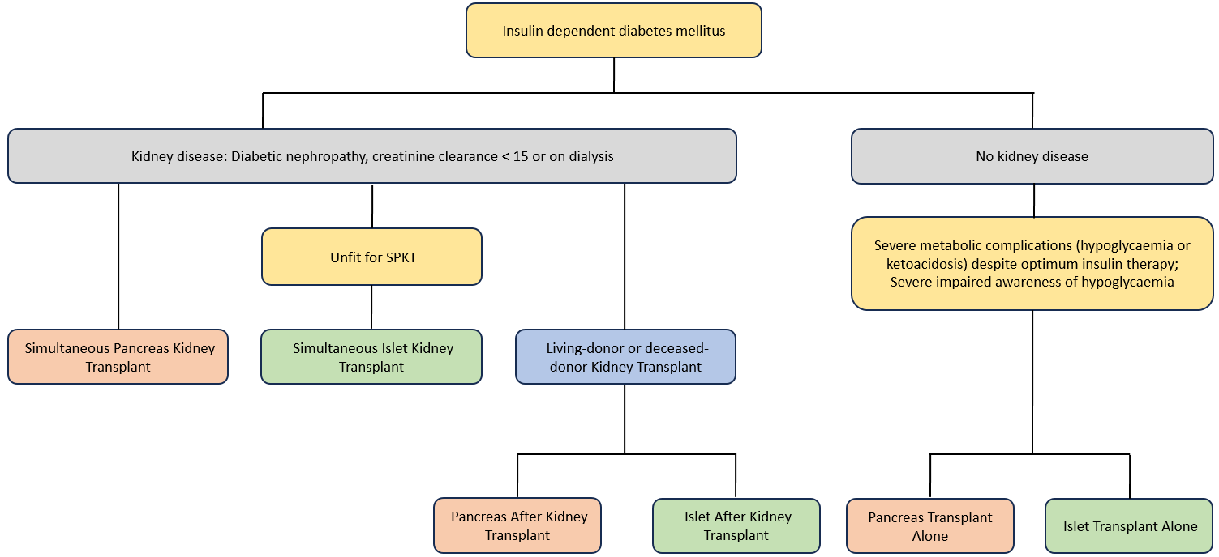
Figure 1 Various types of pancreas (red box) and islet (green box) transplantation^{[7]}. SPKT: Simultaneous pancreas-kidney transplant.

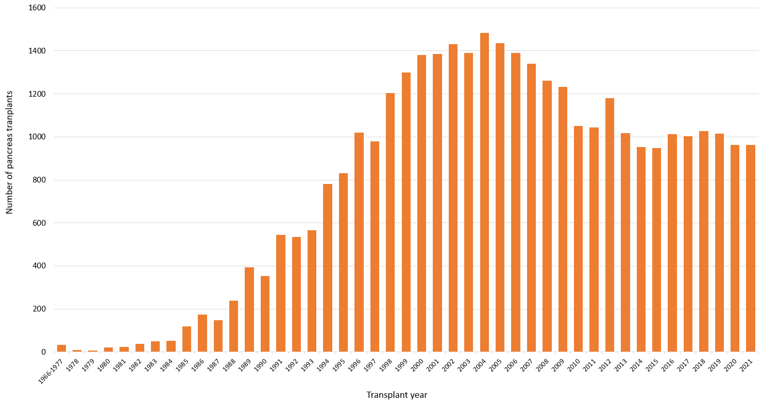
Figure 2 Number of pancreas transplants in the United States between 1966 and 2021^{[9,10]}.

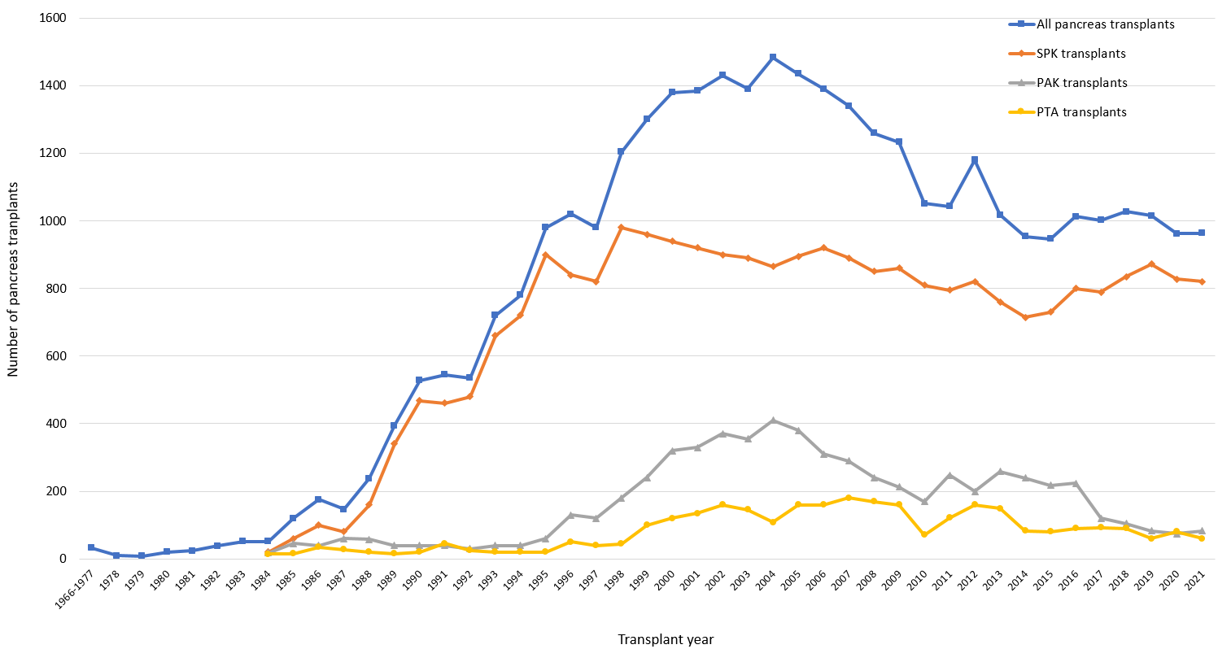
Figure 3 Trends in pancreas transplants in the United States between 1966 and 2021^{[9,10]}. SPK: Simultaneous pancreas-kidney; PAK: Pancreas after kidney; PTA: Pancreas transplant alone.

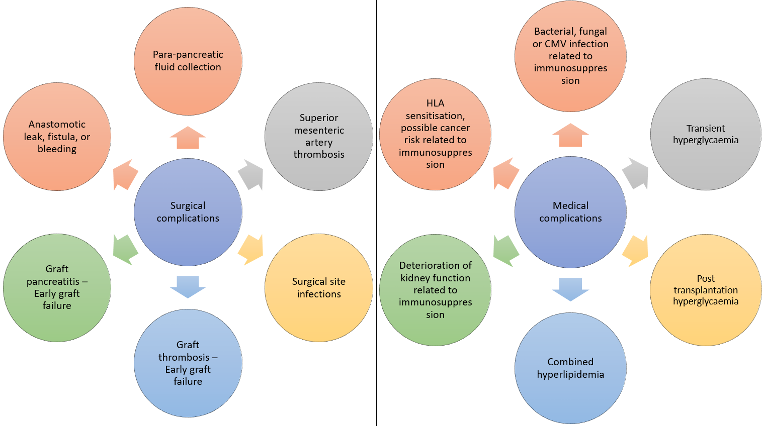
Figure 4 Common complications of simultaneous pancreas-kidney. CMV: Cytomegalovirus; HLA: Human leukocyte antigen.

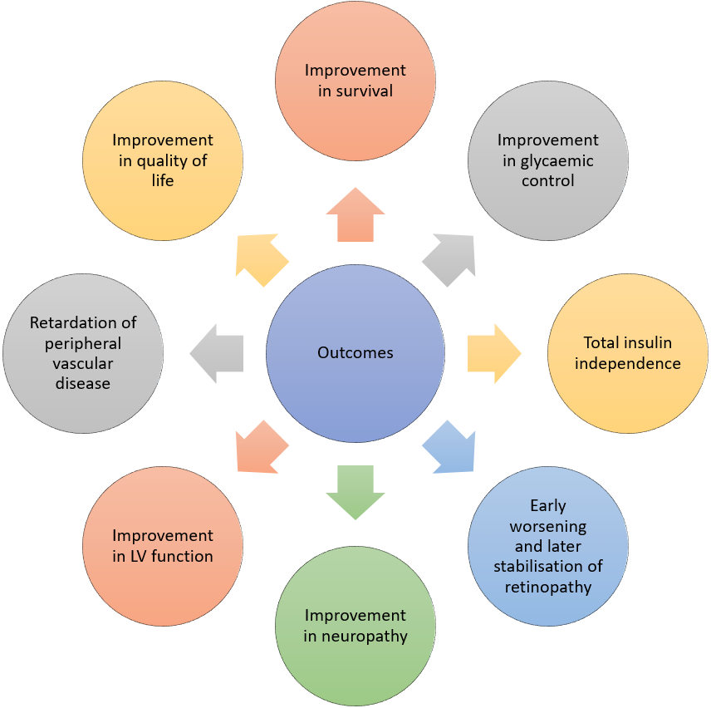
Figure 5 The outcomes of simultaneous pancreas-kidney. LV: Left ventricular.

Table 1 Current indications and contraindications for simultaneous pancreas-kidney in type 1 diabetes mellitus^{[11,12,15]}
Current indications for SPK in T1DM
Confirmed diabetic nephropathy with low or absent C-peptide, on insulin treatment
Creatinine clearance < 15 mL/min or on dialysis
Presence of other microvascular or macrovascular complications of T1DM
Ability to withstand immunosuppression and surgery
History of compliance with medical advice and treatment
Absolute contraindications for SPK in T1DM
Significant cardiovascular disease with severe or non-correctable coronary artery disease
Cardiac ejection fraction < 50%
Recent myocardial infarction
Non-curable malignancy except localized skin cancer
Active sepsis
Active peptic ulcer disease
Severe mental health conditions that can lead to noncompliance.
Inability to survive surgery or immunosuppression due to significant comorbidity
Relative contraindications for SPK in T1DM
Cerebrovascular event with long-standing impairment
Human immunodeficiency virus, hepatitis B and C virus infections
BMI > 30 kg/m²
Age > 60 yr
Extensive vascular, aortic, and renal artery disease (making surgery high-risk)
Excessive need for insulin > 1.5 U/kg/d
Continuous use of alcohol, smoking, and other drugs
T1DM: Type 1 diabetes mellitus; SPK: Simultaneous pancreas-kidney.

