Name of Journal: World Journal of Clinical Cases
Manuscript NO: 84865
Manuscript Type: CASE REPORT

Coexistence of urinary tuberculosis and urothelial carcinoma: A case report

Tsai YC et al. Coexistence of urinary tuberculosis and urothelial carcinoma

Yu-Chi Tsai, Chiao-Ching Li, Bing-Tau Chen, Chien-Yao Wang

Yu-Chi Tsai, Chien-Yao Wang, Division of Infectious Diseases, Department of Internal Medicine, Kaohsiung Armed Forces General Hospital, Kaohsiung 802301, Taiwan

Yu-Chi Tsai, Division of Infectious Diseases and Tropical Medicine, Department of Internal Medicine, Tri-Service General Hospital, National Defense Medical Center, Taipei 114202, Taiwan

Chiao-Ching Li, Division of Urology, Department of Surgery, Pingtung branch, Kaohsiung Armed Forces General Hospital, Pingtung 900048, Taiwan

Chiao-Ching Li, Bing-Tau Chen, Division of Urology, Department of Surgery, Kaohsiung Armed Forces General Hospital, Kaohsiung 802301, Taiwan

Chiao-Ching Li, Division of Urology, Department of Surgery, Tri-Service General Hospital, National Defense Medical Center, Taipei 114202, Taiwan

Bing-Tau Chen, Division of Urology, Department of Surgery, Kaohsiung Veterans General Hospital, Kaohsiung Veterans General Hospital, Kaohsiung 813414, Taiwan

Author contributions: Tsai YC and Wang CY designed this study; Li CC and Chen BT participated in the surgery; Tsai YC, Li CC, Chen BT, and Wang CY were involved in data acquisition; Tsai YC, Li CC, Chen BT, and Wang CY were involved in the statistical analysis and data interpretation; Tsai YC, Li CC, Chen BT, and Wang CY drafted the manuscript; Tsai YC made the final revisions; All authors have read and approved the final manuscript.

Corresponding author: Chien-Yao Wang, MD, Doctor, Division of Infectious Diseases, Department of Internal Medicine, Kaohsiung Armed Forces General Hospital, No. 2, Zhongzheng 1st Road, Lingya District, Kaohsiung 802301, Taiwan. atsb1234@msn.com

Received: March 30, 2023
Revised: April 20, 2023
Accepted: April 27, 2023
Published online: June 6, 2023

Abstract
BACKGROUND
Taiwan has a high prevalence of tuberculosis and urothelial carcinoma. However, the simultaneous occurrence of both disorders in one patient is uncommon. Tuberculosis and urothelial carcinoma share some common risk factors and could demonstrate overlapping clinical manifestations.

CASE SUMMARY
Herein, we report the case of a patient who presented with fever, persistent hematuria, and pyuria. Chest computed tomography scans revealed a bilateral upper lobes cavitary lesion with fibrosis. Severe hydronephrosis of the right kidney and renal stones and cysts in the left kidney were observed. Initial microbiological testing was negative; however, a polymerase chain reaction assay of the urine confirmed a urinary tuberculosis infection. The patient was started on an anti-tuberculosis regimen. Ureteroscopy performed to resolve obstructive nephropathy revealed the incidental finding of a left middle-third ureteral tumor. Examination after biopsy and transurethral resection of the bladder tumor indicated urothelial carcinoma. The patient underwent laparoscopic nephroureterectomy, with bladder cuff excision for the right kidney and ureter, and holmium laser ablation of the ureteral lesion to preserve the left kidney and ureter. He has remained stable after the procedures.

CONCLUSION
Although establishing a causal relationship between tuberculosis and cancer is difficult, medical personnel should consider their correlation.

Key Words: Urinary tuberculosis; Urothelial carcinoma; Fever; Hematuria; Taiwan; Case report

©The Author(s) 2023. Published by Baishideng Publishing Group Inc. All rights reserved.

Citation: Tsai YC, Li CC, Chen BT, Wang CY. Coexistence of urinary tuberculosis and urothelial carcinoma: A case report. World J Clin Cases 2023; 11(16): 3921-3928
URL: https://www.wjgnet.com/2307-8960/full/v11/i16/3921.htm
DOI: https://dx.doi.org/10.12998/wjcc.v11.i16.3921

Core Tip: We have reported the case of a patient who presented with fever, persistent hematuria, and pyuria and was diagnosed with both urinary tuberculosis and urothelial carcinoma. Tuberculosis and urothelial carcinoma have some common risk factors such as smoking, alcohol consumption, chronic diseases, and malnutrition. Although it is difficult to establish a causal relationship between these two diseases, clinical medical personnel should consider the correlation between the two diseases.

INTRODUCTION
Taiwan has a high prevalence of tuberculosis and urothelial carcinoma. However, the simultaneous occurrence of these disorders is uncommon in the same patient. The concurrent development of both of these diseases in the same patient could be explained by the following mechanisms: Local long-term inflammatory response, leading to the destruction of the host protective barrier, resulting in the invasion of microorganisms or cancer cells^{[1]}. In addition, the inflammatory response damages immune cells and weakens the host’s immunity.
Tuberculosis and urothelial carcinoma have some common risk factors, such as smoking, alcohol consumption, chronic diseases, and malnutrition. Although it is difficult to establish a causal relationship between these two diseases, clinical medical personnel should consider the correlation between the two. Herein, we report the case of a patient who presented with fever, persistent hematuria, and pyuria and was diagnosed with both urinary tuberculosis and urothelial carcinoma.

CASE PRESENTATION
Chief complaints
A 70-year-old man was transferred to our hospital for further management of intermittent fever, chills, and fatigue lasting for 10 d.

History of present illness
The patient experienced intermittent symptoms accompanied by severe night sweats. His body temperature was 38.5 °C, and his fever temporarily subsided after taking oral acetaminophen. He denied respiratory symptoms, such as cough, sore throat, or runny nose, and did not experience any gastrointestinal symptoms such as vomiting or diarrhea. Although the patient did not report urinary symptoms such as blood in urine, urgency, difficulty or pain during urination, or frequent voiding, he did report persistent bilateral lower back pain in the past 10 d. The patient had previously been diagnosed with lumbar herniated intervertebral disc disorder and had been undergoing rehabilitation therapy. As he believed that his current back pain was not significantly different from his previous pain, he did not pay particular attention to it.

History of past illness
The patient had developed anorexia, with a weight loss of 5.6 kg during the past year. Moreover, he had third–fourth lumbar herniated intervertebral disc disorder which had been treated with physical rehabilitation therapy since the age of 63. He did not have any systemic disorders, such as diabetes mellitus or liver cirrhosis.

Personal and family history
The patient disclosed a smoking history of 31 pack-years and reported infrequent alcohol consumption. He worked as a bus driver and had been experiencing fatigue prior to this visit. The patient denied any recent travel history or engagement in unsafe sexual activities or drug abuse. Furthermore, he had no history of prescription medication use or underlying medical conditions.

Physical examination
During the physical examination, dull percussions were noted bilaterally in the upper back, along with the presence of rhonchi in the same region. Despite these findings, the patient did not exhibit any signs of respiratory distress. His vital signs were within normal limits, with a temperature of 36.5 °C, blood pressure of 144/87 mmHg, heart rate of 102 beats per minute, and respiratory rate of 18 breaths per minute. The patient did not display any pain or discomfort upon percussion of the bilateral kidney areas. No discharge was observed around the urethra, and there were no suspicious lumps, rashes, or wounds in the perineal or other areas of the body.

Laboratory examinations
The patient’s hemogram revealed leukocytosis with neutrophil predominance. The blood electrolytes, glucose levels, and hepatic function were all within normal ranges. His serum urea nitrogen and creatinine levels were elevated. The urinal analysis found microscopic hematuria and pyuria. Detailed laboratory test results are presented in Table 1.

Imaging examinations
Chest radiography revealed patchy consolidation with fibrosis in both upper lungs (Figure 1).

MULTIDISCIPLINARY EXPERT CONSULTATION
The patient was admitted to our ward for further management of the bilateral upper lung lesions observed on chest radiography.
Initially, the patient was prescribed intravenous ceftriaxone 2 g per day after blood and sputum cultures had been obtained. On day 3 of admission, the empiric antibiotics were escalated to intravenous piperacillin/tazobactam 2.25 g every 6 h for broad-spectrum coverage as the patient was experiencing persistent fever and worsening conditions. Additionally, testing for lung lesions was performed. Chest computed tomography (CT) scans revealed fibrotic lesions surrounded by parenchymal fibrosis, calcified granuloma, calcification atelectasis, and bronchiectasis over the bilateral upper and right lower lobes. Severe hydronephrosis of the right kidney was further observed. Sequential CT scans of the abdomen revealed an upper-third ureteral stone complicated by severe hydronephrosis of the right kidney. Moreover, renal stones and cysts were observed in the left kidney with hemorrhagic changes (Figure 2).
Owing to the lack of an initial adequate microbiological clue, repeated sputum cultures and rapid serology tests, including pneumococcus urine antigen and Cryptococcus antigen serum test, were performed. However, they all demonstrated negative results. Four acid-fast stain sputum smear sets and the final tuberculosis culture results were also all negative. Sputum fungus culture yielded negative results as well.
A urologist was consulted for renal function deterioration and persistent turbid urine passage by the patient. On admission day 5, a decompressive percutaneous nephrostomy (PCN) was performed on the right kidney to correct the worsening infection and collect adequate microbiological evidence. Urine culture and cytology samples from the right kidney were collected, and acid-fast staining of the urine demonstrated positive results.
A polymerase chain reaction assay of the urine confirmed a urinary tuberculosis infection on admission day 12. The patient was initiated on empirical anti-tuberculosis regimen (isoniazid, rifampin, pyrazinamide, and ethambutol).
Ureteroscopy was performed to resolve obstructive nephropathy on admission day 15. However, during the procedure, a cauliflower-like lesion was incidentally observed over the right posterior and right lateral wall junction of the urinary bladder. A left middle-third ureter tumor was also incidentally diagnosed during the same procedure (Figure 3). After discussion with the family, a biopsy of the left ureteral tumor with double-J catheterization was performed.
Histological examination of the specimen obtained from the left middle third ureter revealed high-grade papillary pattern urothelial carcinoma with lamina propria invasion (cT1). Immunohistochemical staining was positive for CK7, CK20, and Ki67. Urothelial carcinoma of the urinary bladder was identified based on pathological evidence after transurethral resection of the bladder tumor.
An integrated tumor study was conducted for comprehensive disease staging. Through a dynamic renal function scan, it was discovered that the renal function of the left kidney was intact. Meanwhile, the right kidney was non-functioning.

FINAL DIAGNOSIS
Based on clinical manifestations, laboratory examinations, imaging examination, and pathological biopsy, the patient was finally diagnosed with coexisting urinary tuberculosis and urothelial carcinoma.

TREATMENT
After discussion, the surgeon decided to perform laparoscopic nephroureterectomy, with bladder cuff excision for the right kidney and ureter, and to preserve the left kidney and ureter with holmium laser ablation of the ureteral lesion on admission day 25. There were no surgery-related complications. The patient was discharged on admission day 30.

OUTCOME AND FOLLOW-UP
The initial anti-tuberculosis regimen consisted of four drugs (isoniazid, rifampin, pyrazinamide, and ethambutol) for 2 mo, followed by isoniazid and rifampin for 4 mo owing to susceptibility to the first-line therapy. One month after antibiotic treatment commencement, the patient’s urine culture demonstrated no growth of the tuberculosis species. Although the patient’s renal function did not fully recover, it also did not deteriorate to the extent of requiring dialysis. The patient continued regular follow-ups at our clinic.

DISCUSSION
In Taiwan, the incidence of genitourinary tuberculosis is approximately 0.19 cases per 100000 individuals per year, which has been demonstrating a downward trend since 2000^{[2]}. Moreover, Taiwan has a high incidence of upper tract urothelial carcinoma, with 3.14–3.41 cases being diagnosed in approximately 100000 people each year^{[3]}. It is very rare for both of these disorders to coexist in the same patient.
The simultaneous occurrence of both diseases in the same patient may be explained by the fact that tuberculosis may cause a long-term local inflammatory response, which may in turn induce cellular carcinogenesis. This could be further explained by the relationship between pulmonary tuberculosis and lung cancer^{[4]}, and ulcerative lesions of intestinal tuberculosis acting as a precursor to intestinal mucosal cancer^{[5]}. Mycobacterium tuberculosis may also promote the development of cancer by inducing a chronic inflammatory state and compromising T cell-mediated immunity^{[6]}. However, tumor cells may also weaken the host’s ability to resist the invasion of microorganisms such as mycobacteria by destroying the local infection barrier^{[7]}. These tumor cells can also affect pathogen resistance through systemic immunosuppression^{[8, 9]}.
Chen et al^{[6]} have conducted a retrospective study of 45455 cancer patients and reported that tuberculosis is an independent risk factor for the development of all cancers. Hence, tuberculosis could increase the risk of specific cancers in patients^{[6]}. A retrospective study by Lien et al^{[10]} in Taiwan that analyzed national data also reported that urinary tract tuberculosis was associated with the development of urothelial carcinoma^{[10]}.
However, cancer has been recognized as a risk factor for active Mycobacterium tuberculosis infection since the 1970s. All types of cancers increase the risk of developing active tuberculosis disease, albeit to varying degrees. This could be due to intrinsic immunosuppression caused by the cancer itself, immunosuppressive effects of chemotherapy, or factors related to the patients themselves. Tuberculosis shares several disease risk factors with cancer, such as smoking^{[11]}, alcohol consumption, chronic diseases such as diabetes^{[3]}, malnutrition, and low socioeconomic status^{[12]}. A previous study conducted in Taiwan on a large population reported that cancer was an independent risk factor for tuberculosis, with the highest risk observed 1 year before and 1 year after cancer diagnosis^{[13]}.
Although the temporal association between cancer and tuberculosis and a potential causal relationship between the two have not been established in the literature, as this may be challenging in clinical practice, clinicians should nonetheless be aware of this relationship^{[6,9,13]}.
The diagnosis and identification of a suitable treatment strategy in the present case were challenging, primarily because the patient had persistent pyuria and fever, and microbiological pathogenic evidence was lacking. To improve his condition and obtain relevant samples, we arranged decompressive PCN of the right kidney. Although the urine collected via PCN confirmed the tuberculosis infection, this patient already exhibited signs suggestive of urinary tuberculosis, including chest radiography resembling old pulmonary tuberculosis and persistent pyuria despite antibiotic treatment with sterile routine microbial cultures^{[14]}. After several consecutive sets of negative urine cultures, clinicians should perhaps consider urinary tuberculosis as a differential diagnosis.
Surgery is the treatment of choice for early localized urothelial carcinoma. The mainstay of treatment for genitourinary tuberculosis is anti-tuberculosis drugs^{[15]}. Indications for nephrectomy in case of genitourinary tuberculosis combination urothelial carcinoma include a nonfunctioning kidney, extensive disease involving the entire kidney along with hypertension and ureteropelvic junction obstruction, and renal carcinoma^{[16]}. Considering that this patient only had unilateral residual renal function and was worried about the coexistence of potential tumors in the right kidney, he eventually chose the surgical option to remove the non-functional right kidney and is undergoing regular follow-ups to closely monitor the left urinary system that still has renal function.

CONCLUSION
The association between tuberculosis and cancer could be multifaceted. Although the causal relationship between the two has not yet been established, clinicians should be aware of the link between cancer and tuberculosis.

ACKNOWLEDGEMENTS
Yu-Chi Tsai would like to thank his wife Meng-Huang Chang for being considerate and helpful.

REFERENCES
1 Coussens LM, Werb Z. Inflammation and cancer. Nature 2002; 420: 860-867 [PMID: 12490959 DOI: 10.1038/nature01322]
2 Huang TY, Hung CH, Hsu WH, Peng KT, Hung MS, Lai LJ, Chuang HJ, Tai WL, Ku YP, Wu TS. Genitourinary tuberculosis in Taiwan: A 15-year experience at a teaching hospital. J Microbiol Immunol Infect 2019; 52: 312-319 [PMID: 30472096 DOI: 10.1016/j.jmii.2018.10.007]
3 Lin MY, Niu SW, Li WM, Lee HL, Chen LT, Wu WJ, Hwang SJ. Incidence and survival variations of upper tract urothelial cancer in Taiwan (2001-2010). Int J Urol 2022; 29: 121-127 [PMID: 34708447 DOI: 10.1111/iju.14731]
4 Molina-Romero C, Arrieta O, Hernández-Pando R. Tuberculosis and lung cancer. Salud Publica Mex 2019; 61: 286-291 [PMID: 31276345 DOI: 10.21149/10090]
5 Chin SN, Foster T, Char G, Garrison A. Concomitant urothelial cancer and renal tuberculosis. Case Rep Urol 2014; 2014: 625153 [PMID: 25133009 DOI: 10.1155/2014/625153]
6 Chen GL, Guo L, Yang S, Ji DM. Cancer risk in tuberculosis patients in a high endemic area. BMC Cancer 2021; 21: 679 [PMID: 34107921 DOI: 10.1186/s12885-021-08391-6]
7 Simonsen DF, Farkas DK, Horsburgh CR, Thomsen RW, Sørensen HT. Increased risk of active tuberculosis after cancer diagnosis. J Infect 2017; 74: 590-598 [PMID: 28366685 DOI: 10.1016/j.jinf.2017.03.012]
8 Suzuki Y, Imokawa S, Sato J, Uto T, Suda T. Cumulative incidence of tuberculosis in lung cancer patients in Japan: A 6-year observational study. Respir Investig 2016; 54: 179-183 [PMID: 27108013 DOI: 10.1016/j.resinv.2015.11.001]
9 Kumar DS, Ronald LA, Romanowski K, Rose C, Shulha HP, Cook VJ, Johnston JC. Risk of active tuberculosis in migrants diagnosed with cancer: a retrospective cohort study in British Columbia, Canada. BMJ Open 2021; 11: e037827 [PMID: 33653739 DOI: 10.1136/bmjopen-2020-037827]
10 Lien YC, Wang JY, Lee MC, Shu CC, Chen HY, Hsieh CH, Lee CH, Lee LN, Chao KM. Urinary tuberculosis is associated with the development of urothelial carcinoma but not renal cell carcinoma: a nationwide cohort study in Taiwan. Br J Cancer 2013; 109: 2933-2940 [PMID: 24129236 DOI: 10.1038/bjc.2013.538]
11 Lin HH, Ezzati M, Chang HY, Murray M. Association between tobacco smoking and active tuberculosis in Taiwan: prospective cohort study. Am J Respir Crit Care Med 2009; 180: 475-480 [PMID: 19542475 DOI: 10.1164/rccm.200904-0549OC]
12 Cheng MP, Abou Chakra CN, Yansouni CP, Cnossen S, Shrier I, Menzies D, Greenaway C. Risk of Active Tuberculosis in Patients with Cancer: A Systematic Review and Meta-Analysis. Clin Infect Dis 2017; 64: 635-644 [PMID: 27986665 DOI: 10.1093/cid/ciw838]
13 Shen BJ, Lin HH. Time-dependent association between cancer and risk of tuberculosis: A population-based cohort study. Int J Infect Dis 2021; 108: 340-346 [PMID: 34022337 DOI: 10.1016/j.ijid.2021.05.037]
14 Figueiredo AA, Lucon AM, Srougi M. Urogenital Tuberculosis. Microbiol Spectr 2017; 5 [PMID: 28087922 DOI: 10.1128/microbiolspec.TNMI7-0015-2016]
15 Abbara A, Davidson RN; Medscape. Etiology and management of genitourinary tuberculosis. Nat Rev Urol 2011; 8: 678-688 [PMID: 22157940 DOI: 10.1038/nrurol.2011.172]
16 Cek M, Lenk S, Naber KG, Bishop MC, Johansen TE, Botto H, Grabe M, Lobel B, Redorta JP, Tenke P; Members of the Urinary Tract Infection (UTI) Working Group of the European Association of Urology (EAU) Guidelines Office. EAU guidelines for the management of genitourinary tuberculosis. Eur Urol 2005; 48: 353-362 [PMID: 15982799 DOI: 10.1016/j.eururo.2005.03.008]

Footnotes
Informed consent statement: Informed written consent was obtained from the patient for publication of this report and any accompanying images.

Conflict-of-interest statement: All the authors report no relevant conflicts of interest for this article.

CARE Checklist (2016) statement: The authors have read CARE Checklist (2016), and the manuscript was prepared and revised according to CARE Checklist (2016).

Open-Access: This article is an open-access article that was selected by an in-house editor and fully peer-reviewed by external reviewers. It is distributed in accordance with the Creative Commons Attribution NonCommercial (CC BY-NC 4.0) license, which permits others to distribute, remix, adapt, build upon this work non-commercially, and license their derivative works on different terms, provided the original work is properly cited and the use is non-commercial. See: https://creativecommons.org/Licenses/by-nc/4.0/

Provenance and peer review: Unsolicited article; Externally peer reviewed.

Peer-review model: Single blind

Peer-review started: March 30, 2023
First decision: April 13, 2023
Article in press: April 27, 2023

Specialty type: Medicine, research and experimental
Country/Territory of origin: Taiwan
Peer-review report’s scientific quality classification
Grade A (Excellent): 0
Grade B (Very good): 0
Grade C (Good): C, C
Grade D (Fair): 0
Grade E (Poor): 0

P-Reviewer: Oley MH, Indonesia; Yarmahmoodi F, Iran S-Editor: Li L L-Editor: A P-Editor: Li L

Figure Legends
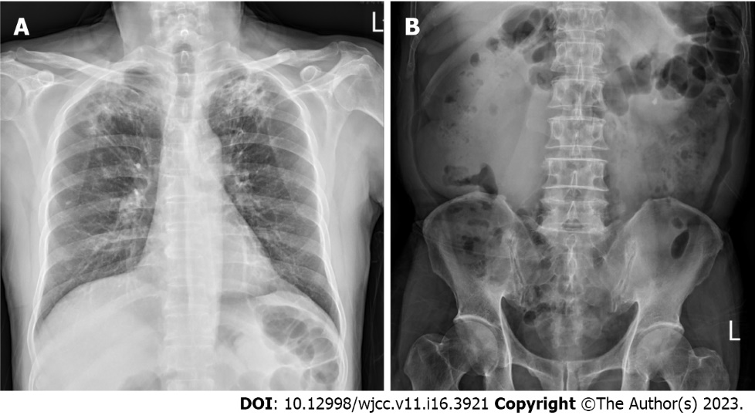
Figure 1 Chest and abdominal radiograph. A: Chest radiograph reveals the presence of a bilateral upper-lobe cavitary lesion with fibrosis; B: Abdominal radiograph reveals a renal stone in the left kidney.

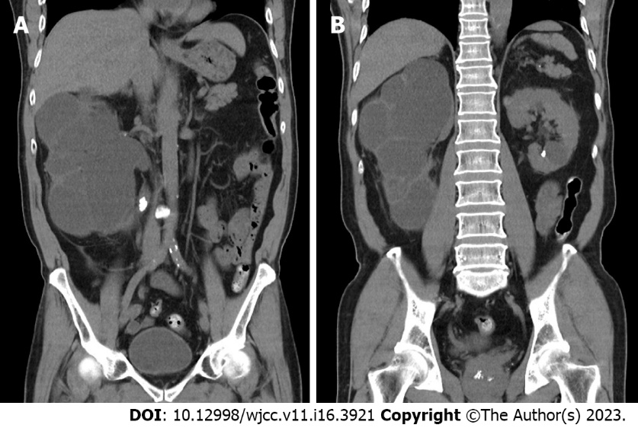
Figure 2 Computed tomography scans. A: Computed tomography (CT) scans of the abdomen demonstrate severe hydronephrosis of the right kidney with a paper-thin cortex. Upper-third ureteral stone is noted; B: CT scans of the same area revealed a left renal stone with a cyst.

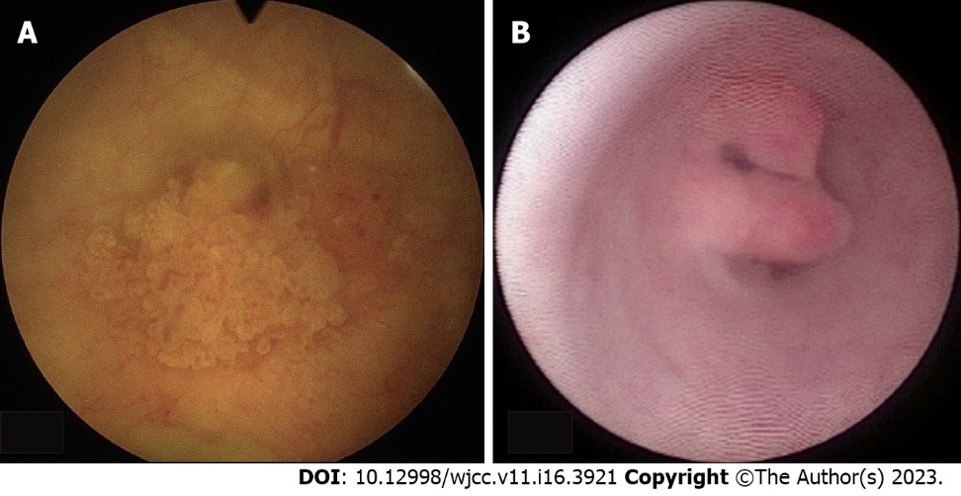
Figure 3 Photograph from ureteroscopy. A: Photograph from ureteroscopy; cauliflower-like lesions over right posterior and right lateral wall junction of the bladder are observed; B: Photograph of the patient’s left ureter via ureteroscopy; an intraluminal bulging tumor located at the middle third of the ureteral cavity (approximately 0.8 cm) is observed. Histological examination of the lesion confirms the diagnosis of urothelial carcinoma.

Table 1 Laboratory test results
Variable | Reference range | Illness day 10, On presentation | Illness day 30, on discharge
Hemoglobin (g/dL) | 12–15.5 | 14.9 | 12.4
Hematocrit (%) | 34.9–44.5 | 43.3 | 37.2
White-cell count (per mm³) | 4000–11000 | 12710 | 14960
Differential count (%)
Neutrophils | 40–70 | 83.0 | 86.1
Lymphocytes | 22–44 | 7.9 | 6.8
Monocytes | 4–11 | 8.4 | 5.8
Basophils | 0–3 | 0.4 | 0.5
Eosinophils | 0–8 | 0.3 | 0.8
Platelet count (×10³ per mm³) | 135–400 | 253 | 304
Red-cell count (×10⁶ per mm³) | 3.90–5.03 | 4.71 | 4.12
Mean corpuscular volume (fL) | 80.0–100.0 | 91.9 | 90.3
C-reactive protein (mg/dL) | < 1 | 16.11 | 7.69
Sodium (mmol/L) | 136–145 | 132 | 135
Potassium (mmol/L) | 3.5–5.2 | 3.9 | 4.0
Urea nitrogen (mg/dL) | 8–25 | 20 | 20
Creatinine (mg/dL) | 0.60–1.50 | 2.1 | 1.4
Estimated glomerular filtration rate (ml/min/1.73 m²) | > 60 | 33.4 | 53.3
Glucose (mg/dL) | 70–110
Aspartate aminotransferase (U/L) | ≤ 33 | 26 | 15
Alanine aminotransferase (U/L) | 10–49 | 24 | 32
Total bilirubin (mg/dL) | 0.3–1.2 | 0.79 | 0.68
Glycated Hemoglobin (%) | < 5.8 | 5.7
Specimen
Anti-human immunodeficiency virus test | negative | negative
Aspergillus antigen (serum) | negative | negative
Cryptococcus antigen (serum) | negative | negative
Pneumococcus antigen (urine) | negative | negative
Blood culture | negative | negative
Sputum culture | negative | negative
Sputum acid fasting smear | negative | negative
Urine acid fasting smear | negative | positive | negative
Urine polymerase chain reaction assay | negative | positive; Mycobacterium tuberculosis

Published by Baishideng Publishing Group Inc
7041 Koll Center Parkway, Suite 160, Pleasanton, CA 94566, USA
Telephone: +1-925-3991568
E-mail: bpgoffice@wjgnet.com
Help Desk: https://www.f6publishing.com/helpdesk
https://www.wjgnet.com

© 2023 Baishideng Publishing Group Inc. All rights reserved.

