AmEditor, Inc.
45 Hazelwood Ave., Livingston, NJ 07039, USA
Telephone: 505-231-2644; Fax: 888-389-7215
E-mail: ameditorjcv@gmail.com; website: www.ameditor.com

April 2, 2013

To Whom It May Concern,

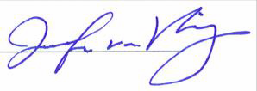Our editing company provided comprehensive editing services for the ESPS Manuscript NO: 2472: Effect of Helicobacter pylori eradication on serum ghrelin and obestatin levels, which is under consideration for publication in your journal. The edit has achieved Grade A: priority
publishing; no language polishing required after editing.

Should you require any additional information, please do not hesitate to contact me. Kind regards,
Jennifer C. van Velkinburgh, PhD Director, Ameditor Inc.

www.ameditor.com

Phone: +1-505-231-2644

Email: ameditorjcv@gmail.com

