Name of journal: World Journal of Gastroenterology
ESPS Manuscript NO: 31413
Manuscript type: ORIGINAL ARTICLE

Retrospective Study
possible role of soluble fibrin monomer complex after gastroenterological surgery

Kochi K et al. SFMC after gastroenterological surgery

Masatoshi Kochi, Manabu Shimomura, Takao Hinoi, Hiroyuki Egi, Kazuaki Tanabe, Yasuyo Ishizaki, Tomohiro Adachi, Hirotaka Tashiro, and Hideki Ohdan

Masatoshi Kochi, Hiroyuki Egi, Kazuaki Tanabe, Tomohiro Adachi, Hideki Ohdan, Department of Gastroenterological and Transplant Surgery, Applied Life Sciences, Institute of Biomedical and Health Sciences, Hiroshima University, Hiroshima city, Hiroshima 734-8551, Japan

Manabu Shimomura, Department of Surgery, National Hospital Organization Higashihiroshima Medical Center, Higashihiroshima City, Hiroshima 739-0041, Japan

Takao Hinoi, Hirotaka Tashiro, Department of Surgery, Institute for Clinical Research, National Hospital Organization Kure Medical Center and Chu-goku Cancer Center, Kure City, Hiroshima 737-0023, Japan

Yasuyo Ishizaki, Department of Surgery, National Hospital Organization Hiroshima-nishi Medical Center, Otake City, Hiroshima 739-0696, Japan

Author contributions: Shimomura M designed the study; Kochi M and Shimomura M analyzed and interpreted the data; Hinoi T, Egi H, Tanabe K, Ishizaki Y and Adachi T participated in this clinical study and treated the patients; Kochi M and Shimomura M wrote the paper; Ohdan H is the chief clinical investigator; all authors read and approved the final manuscript.

Institutional review board statement: This study was reviewed and approved by the Ethics Committee of Hiroshima University Hospital

Informed consent statement: All patients gave informed consent prior to study enrolment.

Conflict-of-interest statement: The authors have no potential conflicts of interest to disclose.

Data sharing statement: No additional data are available.

Open-Access: This article is an open-access article which was selected by an in-house editor and fully peer-reviewed by external reviewers. It is distributed in accordance with the Creative Commons Attribution Non Commercial (CC BY-NC 4.0) license, which permits others to distribute, remix, adapt, build upon this work non-commercially, and license their derivative works on different terms, provided the original work is properly cited and the use is non-commercial. See: http://creativecommons.org/licenses/by-nc/4.0/

Manuscript source: Unsolicited manuscript

Corresponding to: Manabu Shimomura, MD, PhD, Department of Surgery, National Hospital Organization Higashihiroshima Medical Center, 513 Jike, Saijyo-cho, Higashihiroshima, Hiroshima 739-0041, Japan. manabus761215@gmail.com
Telephone: +81-82-4232176
Fax: +81-82-4224675

Received: November 15, 2016
Peer-review started: November 18, 2016
First decision: December 19, 2016
Revised: January 5, 2017
Accepted: March 2, 2017
Article in press:
Published online:

Abstract
AIM
To examine the role of soluble fibrin monomer complex (SFMC) in the prediction of hypercoagulable state after gastroenterological surgery.

METHODS
We collected data on the clinical risk factors and fibrin-related makers from patients who underwent gastroenterological surgery at Hiroshima University Hospital between April 1, 2014 and March 31, 2015. We investigated the clinical significance of SFMC, which is known to reflect the early plasmatic activation of coagulation, in the view of these fibrin related markers.

RESULTS
A total of 123 patients were included in the present study. There were no patients with symptomatic VTE. Thirty-five (28%) patients received postoperative anticoagulant therapy. In the multivariate analysis, a high SFMC level on POD 1 was independently associated with D-dimer elevation on POD 7 (OR = 4.31; 95%CI: 1.10-18.30; P = 0.03). The cutoff SFMC level was 3.8 μg/ml (AUC, 0.78; sensitivity, 63%; specificity, 89%). The D-dimer level on POD 7 was significantly reduced in high-SFMC patients who received anticoagulant therapy in comparison to high-SFMC patients who did not.

CONCLUSION
The SFMC on POD 1 strongly predicted the hypercoagulable state after gastroenterological surgery than the clinical risk factors and the other fibrin related markers.

Key words: Hypercoagulable state; Gastroenterological surgery; Soluble fibrin monomer complex; Venous thromboembolism; anticoagulant therapy

© The Author(s) 2017. Published by Baishideng Publishing Group Inc. All rights reserved.

Core tip: We found that the plasma level of soluble fibrin monomer complex (SFMC) on POD 1 was more strongly associated with D-dimer elevation on POD 7 than were the clinical risk factors or other fibrin-related markers in 123 cases after gastroenterological surgery, suggesting the possible role of SFMC in the prediction of a hypercoagulable state and subsequent venous thromboembolism. The present study also demonstrated the possibility that the plasma levels of SFMC could be used as an indication for anticoagulant therapy in patients who have undergone gastroenterological surgery.

Kochi M, Shimomura M, Hinoi T, Egi H, Tanabe K, Ishizaki Y, Adachi T, Tashiro H, Ohdan H. possible role of soluble fibrin monomer complex after gastroenterological surgery. World J Gastroenterol 2017; In press

Introduction
Venous thromboembolism (VTE) remains a significant complication after gastroenterological surgery. Thrombosis is sometimes fatal and can worsen a patient’s quality of life^{[1]}. VTE is an important, potentially preventable condition that has the potential to increase the rates of morbidity and mortality^{[2,3]}.
The current American College of Chest Physicians (ACCP 2012) guideline recommends pharmacological prophylaxis with low-molecular weight heparin or low-dose unfractionated heparin in addition to mechanical prophylaxis such as elastic stockings and intermittent pneumatic compression (IPC) for general and abdominal-pelvic surgery patients who are at high risk for VTE (approximately 6.0%)^{[4,5]}. The Caprini score is widely accepted for selecting patients with a high clinical risk for VTE (score ≥ 5); however, the majority of patients who undergo gastroenterological surgery for malignant tumors are considered to be high risk. Although postoperative anticoagulant therapy is regarded as important for preventing VTE, it is not routinely used after gastroenterological surgery, mainly because it is associated with bleeding complications and epidural hematoma after epidural anesthesia.
The risk of VTE varies according to the thrombotic risk factors of individual patients; these include age, sex, obesity, cancer, familial history, infection, heart disease, respiratory disease, hormone treatment and poor functional status^{[1,4,6]}. Thus, in order to confirm a suspected VTE event after gastroenterological surgery, it is important to develop a diagnostic marker with high sensitivity and specificity. The establishment of a marker that can identify patients who are at high risk for VTE will help to minimize the disadvantages associated with anticoagulant therapy and unnecessary radiography.
Soluble fibrin monomer complex (SFMC) appears in the bloodstream during the extremely early stage of blood coagulation. Thrombin cleaves fibrinopeptides from a fibrinogen molecule, and yields a fibrin monomer. When fibrin monomers are produced in the presence of fibrinogens, two fibrinogen molecules and one fibrin monomer create a soluble complex known as SFMC (Figure 1). SFMC reflects the plasmatic activation of coagulation and fibrinolysis^{[7,8]}. However, there is little known about the clinical significance of SFMC after gastroenterological surgery.
The aim of the present study was to examine the possible role of the plasma level of SFMC in the prediction of hypercoagulable state and the subsequent VTE after gastroenterological surgery and to assess whether it can be used to indicate postoperative anticoagulant therapy.

Materials and methods
We retrospectively collected data related to the clinical risk factors for VTE and fibrin-related makers from 135 consecutive patients who had undergone gastroenterological surgery due to a diagnosed malignance or to treat a general abdominal disorder at Hiroshima University Hospital between April 1, 2014, and March 31, 2015. The levels of D-dimer, fibrin degradation products (FDP), SFMC, and thrombin antithrombin complex (TAT) (fibrin-related markers) were measured at four time points in the perioperative period (before and 1, 3, and 7 days after surgery). Twelve patients were excluded from the study due to missing fibrin-related marker data.
Symptomatic VTE did not occur in this study population. The D-dimer level on POD 7 reflected the hypercoagulable state after surgery and it have previously demonstrated the association of the presence of VTE; therefore, the D-dimer level on POD 7 was used as the main outcome in this study.

VTE prevention in the perioperative period
Mechanical prophylaxis against VTE, including the postoperative use of elastic stockings (ESs) and IPC was routinely applied in all cases. In the present study, unfractionated heparin (via continuous infusion unfractionated heparin for one week at a dose that maintained the APTT at 1.5 to 2 times the reference value) was administrated for the patients who was preoperatively medicated by anticoagulant therapy. Pharmacological prophylaxis was administered to the patients at high clinical risk of VTE, as determined by the original risk classification based on the Caprini score and the Japanese VTE guidelines. The safety and validity of this risk classification were demonstrated in the previous article^{[9]}. Pharmacological prophylaxis was administrated by low molecular weight heparin: Enoxaparin sodium [via subcutaneous injection, two times a day, with enoxaparin sodium (2000 IU) for one week]. Thus, postoperative anticoagulant therapy was administrated in 35 patients (28%). Unless contraindicated, anticoagulant therapy initiated from 24 hours after surgery to one week after surgery.
Post-operative pain control in patients receiving anticoagulant therapy was achieved via intravenous anesthesia (as a substitute for epidural anesthesia).

Plasma sample analyses
The levels of D-dimer (LIAS AUTO® D-dimer NEO, Sysmex, Kobe, Japan), SFMC (AUTO LIA® FM, Sysmex, Kobe, Japan), and FDP (LIAS AUTO® P-FDP, Sysmex, Kobe, Japan) were measured by the latex agglutination method using a commercial immunoassay kit (LIAS AUTO® D-dimer NEO, Sysmex, Kobe, Japan). All tests were performed on a Sysmex CS5100 analyzer (Sysmex, Kobe, Japan).
TAT was measured by an enzyme-linked immunosorbent assay (HISCL® TAT, Sysmex, Kobe, Japan). This test was performed on a Sysmex HISCL2000i analyzer (Sysmex, Kobe, Japan). In all analyses, statistical significance was set at a p value less than 0.05. The standard values were as follows: D-dimer, ≤ 1 µg/ml; FDP, ≤ 5 µg/ml; SFMC, ≤ 7 µg/ml; and TAT, < 4 ng/ml.

Statistical analysis
Pearson’s Chi-squared test was used to analyze each clinical characteristic, in order to determine the factors associated with postoperative hypercoagulability. These variables were dichotomized in the analysis. Receiver operating characteristic (ROC) curves were created to determine the appropriate cutoff points. Factors with a P value of < 0.05 on the univariate analysis were subjected to a multivariate analysis using a logistic regression model. The results of the multivariate analysis are presented as the odds ratio (OR) and 95% CI with the corresponding P-value. All of the analyses were performed using the JMP software program (version 11, SAS Institute, Cary, NC, United States). The statistical methods of this study were reviewed by Minoru Hattori from Hiroshima University.

RESULTS
Patient characteristics
The final study population included 123 patients (68 males and 55 females), the median age was 67 years (range, 32 to 89 years), the median operation time was 319 min (range, 74-795), the median bleeding volume was 70 ml (range, 5-4135). The patients’ characteristics and clinical data are summarized in Table 1. There were no patients with symptomatic VTE in this study population. Thirty-five patients (28%) received postoperative anticoagulant therapy. Bleeding complications occurred in 5 (14%) patients who received anticoagulant therapy (Clavien-Dindo Grade 1, n = 4; Grade 2, n = 1).

Univariate and multivariate analyses of the risk factors for D-dimer elevation on POD 7 in patients without anticoagulant therapy
We analyzed the correlation between D-dimer elevation on POD 7 and the clinical risk factors for VTE among the 88 patients who did not receive anticoagulant therapy. The median cutoff level for D-dimer on POD 7 was 6.45. In the univariate analysis the group with a higher D-dimer level (≥ 6.45 µg/ml) on POD 7, included a greater number of patients of ≥ 75 years of age, required a longer surgical time (≥ 321 min), and had a higher levels of D-dimer, FDP, TAT, and SFMC on POD 1 than the group of patients with lower D-dimer levels (< 6.45 µg/ml) on POD 7. According to a multivariate analysis, the SFMC on POD 1 (OR = 4.31, 95%CI: 1.10-18.30, P = 0.03) was an independent risk factor for D-dimer elevation on POD7 (Table 2). Their cutoff points with sensitivities and specificities were determined by a ROC analysis. The cutoff point of SFMC was 3.8 μg/ml, with an area under the curve (AUC) of 0.78, a sensitivity of 63% and a specificity of 89%.

Univariate and multivariate analyses of the risk factors for SFMC elevation on POD 1 in the whole study population
We analyzed the correlation between SFMC elevation on POD 1 and the clinical risk factors and surgical factors. In the univariate analysis, there were significant differences in age, the operative time, and the administration of antiplatelet therapy. Subsequently, in the multivariate analysis, age and operative time were found to be independent risk factors for SFMC elevation on POD 1 (Table 3).

Possible indications for anticoagulant therapy based on the SFMC level on POD 1
The anticoagulant therapy group and the no anticoagulant therapy group (n = 88) were divided into two subgroups [the SFMC-high group (POD 1 SFMC ≥ 3.8 µg/ml) and the SFMC-low group (POD 1 SFMC < 3.8 µg/ml)], and the D-dimer levels on PODs 1, 3, and 7 were examined to confirm the patients’ hypercoagulability. In the no anticoagulant therapy group, the D-dimer levels were significantly higher at every point of measurement than they were in the SFMC-low group. In the anticoagulant therapy group, however, there was no significant difference in the D-dimer levels on POD 7 (P = 0.14). Among the SFMC-High group, the D-dimer level on POD 7 was significantly reduced in patients who underwent anticoagulant therapy in comparison to patients who did not. This suggests the possibility that anticoagulant therapy might be indicated based on the SFMC level.

Discussion
In the current study, we demonstrated the SFMC predicted the postoperative hypercoagulable state more strongly than other clinical risk factors, including the Caprini score and the levels of other fibrin related markers on POD 1.
A hypercoagulable state is a precursor condition of VTE, which is a significant complication that is associated with a poor prognosis, increased morbidity and a longer hospital stay^{[3]}. Since it is well known that most cases of VTE are asymptomatic, perioperative patients who do not receive pharmacological prophylaxis should be carefully monitored to allow for the early detection of VTE^{[10]}. If we could detect the hypercoagulable state and presence of VTE using a simple blood test, we could expect a dramatic reduction in unnecessary imaging examinations, which would reduce both radiation exposure and the use of contrast agents that are needed for computed tomographic pulmonary angiography (CTPA)^{[11,12]}. The aim of a marker that identifies patients with a high risk of developing VTE will help to minimize the disadvantages of anticoagulant therapy and unnecessary radiographic examinations.
SFMC, which reflects acute intravascular fibrin formation, has been recognized as an independent marker for predicting VTE after orthopedic surgery, due to the substantial elevation of SFMC levels in patients who develop VTE^{[3,10,11,13]}. Although SFMC is a cost-effective and safe diagnostic method, little is known about the changes in SFMC levels after gastroenterological surgery. No studies have evaluated SFMC levels or the cutoff SFMC level for the diagnosis of thrombosis after gastroenterological surgery. Since most VTE events occur during the first week after surgery, we evaluated the risk factors based on the characteristics of patients, surgical factors, and blood tests on POD 1 with the aim of detecting suspected cases of VTE during the early postoperative phase^{[3,7,10,11,13]}.
In the current study, we demonstrated that among 88 patients without anticoagulant therapy, the SFMC level on POD 1 was an independent risk factor for D-dimer elevation on POD 7. There were no significant differences in the other clinical risk factors or fibrin-related markers. With a cutoff point of 3.8 µg/ml, the diagnostic sensitivity, specificity and odds ratio of the SFMC on POD 1 were 63%, 89% and 4.31, respectively. In previous studies in which SFMC was used to predict VTE (cutoff points: 7.05-19.8 µg/ml) the sensitivity and specificity were 88% and 62 to 90%, respectively^{[10,13]}. This difference in the cutoff points is considered to be due to the clinical endpoint (D-dimer elevation or the occurrence of VTE). An ROC analysis showed moderate accuracy in the prediction of D-dimer elevation on POD 7 using a cutoff point of 6.45 µg/ml (AUC: 0.78). Given that some reports used postoperative D-dimer cutoff values of 6.1 to 7.5 µg/ml for predicting the VTE, we consider this clinical endpoint to be reasonable^{[11,14]}.
Although, patients who are considered to have a high clinical risk for VTE based on the presence of risk factors such as pelvic surgery, obesity, and a previous history of thrombosis tend to receive appropriate perioperative anticoagulant therapy, the administration of perioperative anticoagulant therapy to patients who are deemed to have a low clinical risk of VTE is controversial^{[15]}. Surgeons may withhold perioperative anticoagulant therapy due to the risk of bleeding complications. Major bleeding is reported to occur in 2.9% to 9.4% of patients during the period of pharmacological prophylaxis^{[16,17]}. In the current study, post-operative bleeding complications, including subcutaneous bleeding, conjunctival bleeding, melena, and intraabdominal hemorrhage, occurred in 11.4% (5 of 35) of the patients. However, the incidence of major bleeding that necessitated a blood transfusion was 2% (1 of 35). The bleeding complications were classified as Grade 1, n = 4; Grade 2, n = 1 (Clavien-Dindo classification). We were therefore able to administer chemoprophylaxis without serious bleeding complications. Although this study did not use epidural anesthesia to avoid the risk of spinal epidural hematoma, previous studies have reported spinal epidural hematoma due to anticoagulant therapy to be extremely rare^{[18]}. Thus, the use of epidural anesthesia during anticoagulant therapy should be the subject of future studies.
In the current study, elderly patients and a longer duration of surgery had an impact on the occurrence of SFMC elevation on POD 1 (Table 3), and anticoagulant therapy inhibited D-dimer elevation on POD 7 in the SFMC-high group (Figure 2). These results suggest that the selective administration of anticoagulant therapy to the patients of the SFMC-high group, especially patients who had these two risk factors, might be effective for preventing the development of VTE.
The relationship between the preoperative SFMC and D-dimer levels and the development of VTE after surgery is important; however, the preoperative SFMC and D-dimer levels could not predict postoperative VTE in previous studies^{[10,13]}. These studies indicate that the preoperative SFMC level was not increased in patients who developed postoperative VTE.
This study is associated with several limitations. First, because there were no cases of symptomatic VTE was found, the D-dimer level on POD 7, which is well known to have high sensitivity (79%-95%) and a negative predictive value of nearly 100%, was used for the clinical endpoint, rather than the occurrence of VTE^{[10,19,20]}. However, D-dimer elevation can also represent infection, malignancy, heart failure, chronic renal disease and liver disease^{[19]}. Thus, it might not reflect true VTE. It would be therefore be better to consider the inclusion of asymptomatic VTE and to confirm the cutoff points in further clinical studies. Second, the further diagnostic work-up of patients with asymptomatic VTE, such as ultrasound, CT and CTPA, was performed at the discretion of the surgical team.
In conclusion, the plasma level of SFMC on POD 1 strongly associated with D-dimer elevation on POD7 than the clinical risk factors and the other fibrin related markers, which indicated the possible role of SFMC in the prediction of hypercoagulable state and subsequent VTE. The present study also demonstrated the possibility that the plasma levels of SFMC could be used as an indication for anticoagulant therapy, and the selective administration of anticoagulant therapy to the patients of the SFMC-high group would be effective for preventing the development of VTE. We are planning to perform another prospective study to examine the protective effects against VTE that are achieved by administering anticoagulant therapy based on the plasma levels of SFMC on POD 1.

Acknowledgements
We thank Minoru Hattori for statistical support.

Comments
Background
Venous thromboembolism (VTE) remains a significant complication after gastroenterological surgery. Therefore, a diagnostic marker with high sensitivity and specificity that can be used to identify patients at high risk for a hypercoagulable state and subsequent VTE will help to minimize the disadvantages associated with anticoagulant therapy and unnecessary radiography.

Research frontiers
The risk of VTE varies according to the thrombotic risk factors of individual patients; these include age, sex, obesity, cancer, family history, infection, heart disease, respiratory disease, hormone treatment and poor functional status. However, there is no simple maker that detects the hypercoagulable state and the presence of VTE after gastroenterological surgery.

Innovations and breakthroughs
This paper reports that the soluble fibrin monomer complex (SFMC) on POD 1 was more strongly associated with D-dimer elevation on POD 7 than were the clinical risk factors or other fibrin-related markers after gastroenterological surgery.

Applications
SFMC was able to be used as a marker to predict a postoperative hypercoagulable state and subsequent VTE after gastroenterological surgery. The present study also demonstrated the possibility that the plasma levels of SFMC could be used as an indication for anticoagulant therapy for patients who have undergone gastroenterological surgery.

Terminology
SFMC appears in the bloodstream during the extremely early stage of blood coagulation. It reflects the plasmatic activation of coagulation and fibrinolysis.

Peer-review
The authors examined the role of SFMC in the prediction of hypercoagulable state after gastroenterological surgery, and they concluded that the SFMC on POD 1 strongly predicted the hypercoagulable state after gastroenterological surgery than the clinical risk factors and the other fibrin related markers. VTE is serious problem after surgery. This article is thought to be significant for prediction of hypercoagulable state on early phase after gastroenterological surgery.
References
1 Yamashita Y, Wada H, Nomura H, Mizuno T, Saito K, Yamada N, Asanuma K, Usui M, Kamimoto Y, Matsumoto T, Ohishi K, Katayama N. Elevated fibrin-related markers in patients with malignant diseases frequently associated with disseminated intravascular coagulation and venous thromboembolism. Intern Med 2014; 53: 413-419 [PMID: 24583428]
2 Hamidi S, Riazi M. Cutoff values of plasma d-dimer level in patients with diagnosis of the venous thromboembolism after elective spinal surgery. Asian Spine J 2015; 9: 232-238 [PMID: 25901235 DOI: 10.4184/asj.2015.9.2.232]
3 Moghadamyeghaneh Z, Hanna MH, Carmichael JC, Nguyen NT, Stamos MJ. A nationwide analysis of postoperative deep vein thrombosis and pulmonary embolism in colon and rectal surgery. J Gastrointest Surg 2014; 18: 2169-2177 [PMID: 25213583 DOI: 10.1007/s11605-014-2647-5]
4 Gould MK, Garcia DA, Wren SM, Karanicolas PJ, Arcelus JI, Heit JA, Samama CM. Prevention of VTE in nonorthopedic surgical patients: Antithrombotic Therapy and Prevention of Thrombosis, 9th ed: American College of Chest Physicians Evidence-Based Clinical Practice Guidelines. Chest 2012; 141: e227S-e277S [PMID: 22315263 DOI: 10.1378/chest.11-2297]
5 Guyatt GH, Akl EA, Crowther M, Gutterman DD, Schuünemann HJ; American College of Chest Physicians Antithrombotic Therapy and Prevention of Thrombosis Panel. Executive summary: Antithrombotic Therapy and Prevention of Thrombosis, 9th ed: American College of Chest Physicians Evidence-Based Clinical Practice Guidelines. Chest 2012; 141: 7S-47S [PMID: 22315257 DOI: 10.1378/chest.1412S3]
6 Erem HH, Kiran RP, Remzi FH, Vogel JD. Venous thromboembolism in colorectal surgery: skip SCIP or comply? Tech Coloproctol 2014; 18: 719-724 [PMID: 24562596 DOI: 10.1007/s10151-014-1129-9]
7 Galster H, Kolb G, Kohsytorz A, Seidlmayer C, Paal V. The pre-, peri-, and postsurgical activation of coagulation and the thromboembolic risk for different risk groups. Thromb Res 2000; 100: 381-388 [PMID: 11150579]
8 Ieko M, Nakabayashi T, Tarumi T, Naito S, Yoshida M, Kanazawa K, Mizukami K, Koike T. Soluble fibrin monomer degradation products as a potentially useful marker for hypercoagulable states with accelerated fibrinolysis. Clin Chim Acta 2007; 386: 38-45 [PMID: 17803984 DOI: 10.1016/j.cca.2007.07.023]
9 Shimomura M, Kochi M, Hinoi T, Egi H, Adachi T, Kobayashi T, Tashiro T, Ohdan H. Clinical significance of Pharmacological Prophylaxis based on the Original Classification of Venous Thromboembolism after Lower Abdominal Surgery. Hiroshima J Med Sci 2016; 65: 53-59; In press
10 Yukizawa Y, Inaba Y, Watanabe S, Yajima S, Kobayashi N, Ishida T, Iwamoto N, Choe H, Saito T. Association between venous thromboembolism and plasma levels of both soluble fibrin and plasminogen-activator inhibitor 1 in 170 patients undergoing total hip arthroplasty. Acta Orthop 2012; 83: 14-21 [PMID: 22248164 DOI: 10.3109/17453674.2011.652886]
11 Watanabe H, Madoiwa S, Sekiya H, Nagahama Y, Matsuura S, Kariya Y, Ohmori T, Mimuro J, Hoshino Y, Hayasaka S, Sakata Y. Predictive blood coagulation markers for early diagnosis of venous thromboembolism after total knee joint replacement. Thromb Res 2011; 128: e137-e143 [PMID: 21839493 DOI: 10.1016/j.thromres.2011.07.030]
12 Wells PS, Anderson DR, Rodger M, Stiell I, Dreyer JF, Barnes D, Forgie M, Kovacs G, Ward J, Kovacs MJ. Excluding pulmonary embolism at the bedside without diagnostic imaging: management of patients with suspected pulmonary embolism presenting to the emergency department by using a simple clinical model and d-dimer. Ann Intern Med 2001; 135: 98-107 [PMID: 11453709]
13 Wada H, Kobayashi T, Abe Y, Hatada T, Yamada N, Sudo A, Uchida A, Nobori T. Elevated levels of soluble fibrin or D-dimer indicate high risk of thrombosis. J Thromb Haemost 2006; 4: 1253-1258 [PMID: 16706968 DOI: 10.1111/j.1538-7836.2006.01942.x]
14 Jiang Y, Li J, Liu Y, Li YC, Zhang WG. Risk factors for deep vein thrombosis after orthopedic surgery and the diagnostic value of D-dimer. Ann Vasc Surg 2015; 29: 675-681 [PMID: 25728333 DOI: 10.1016/j.avsg.2014.12.022]
15 Colorectal Writing Group for Surgical Care and Outcomes Assessment Program–Comparative Effectiveness Research Translation Network (SCOAP-CERTAIN) Collaborative, Nelson DW, Simianu VV, Bastawrous AL, Billingham RP, Fichera A, Florence MG, Johnson EK, Johnson MG, Thirlby RC, Flum DR, Steele SR. Thromboembolic Complications and Prophylaxis Patterns in Colorectal Surgery. JAMA Surg 2015; 150: 712-720 [PMID: 26060977 DOI: 10.1001/jamasurg.2015.1057]
16 Simonneau G, Laporte S, Mismetti P, Derlon A, Samii K, Samama CM, Bergman JF. A randomized study comparing the efficacy and safety of nadroparin 2850 IU (0.3 mL) vs. enoxaparin 4000 IU (40 mg) in the prevention of venous thromboembolism after colorectal surgery for cancer. J Thromb Haemost 2006; 4: 1693-1700 [PMID: 16796710 DOI: 10.1111/j.1538-7836.2006.02083.x]
17 Agnelli G, Bergqvist D, Cohen AT, Gallus AS, Gent M. Randomized clinical trial of postoperative fondaparinux versus perioperative dalteparin for prevention of venous thromboembolism in high-risk abdominal surgery. Br J Surg 2005; 92: 1212-1220 [PMID: 16175516 DOI: 10.1002/bjs.5154]
18 Singelyn FJ, Verheyen CC, Piovella F, Van Aken HK, Rosencher N. The safety and efficacy of extended thromboprophylaxis with fondaparinux after major orthopedic surgery of the lower limb with or without a neuraxial or deep peripheral nerve catheter: the EXPERT Study. Anesth Analg 2007; 105: 1540-157, table of contents [PMID: 18042845 DOI: 10.1213/01.ane.0000287677.95626.60]
19 Kim YJ, Im S, Jang YJ, Park SY, Sohn DG, Park GY. Diagnostic Value of Elevated D-Dimer Level in Venous Thromboembolism in Patients With Acute or Subacute Brain Lesions. Ann Rehabil Med 2015; 39: 1002-1010 [PMID: 26798616 DOI: 10.5535/arm.2015.39.6.1002]
20 Pabinger I, Ay C. Biomarkers and venous thromboembolism. Arterioscler Thromb Vasc Biol 2009; 29: 332-336 [PMID: 19228607 DOI: 10.1161/ATVBAHA.108.182188]
P-Reviewer: Aoyagi K S-Editor: Gong ZM
L-Editor: E-Editor:
Specialty type: Gastroenterology and hepatology
Country of origin: Japan
Peer-review report classification
Grade A (Excellent): 0
Grade B (Very good): 0
Grade C (Good): C
Grade D (Fair): 0
Grade E (Poor): 0

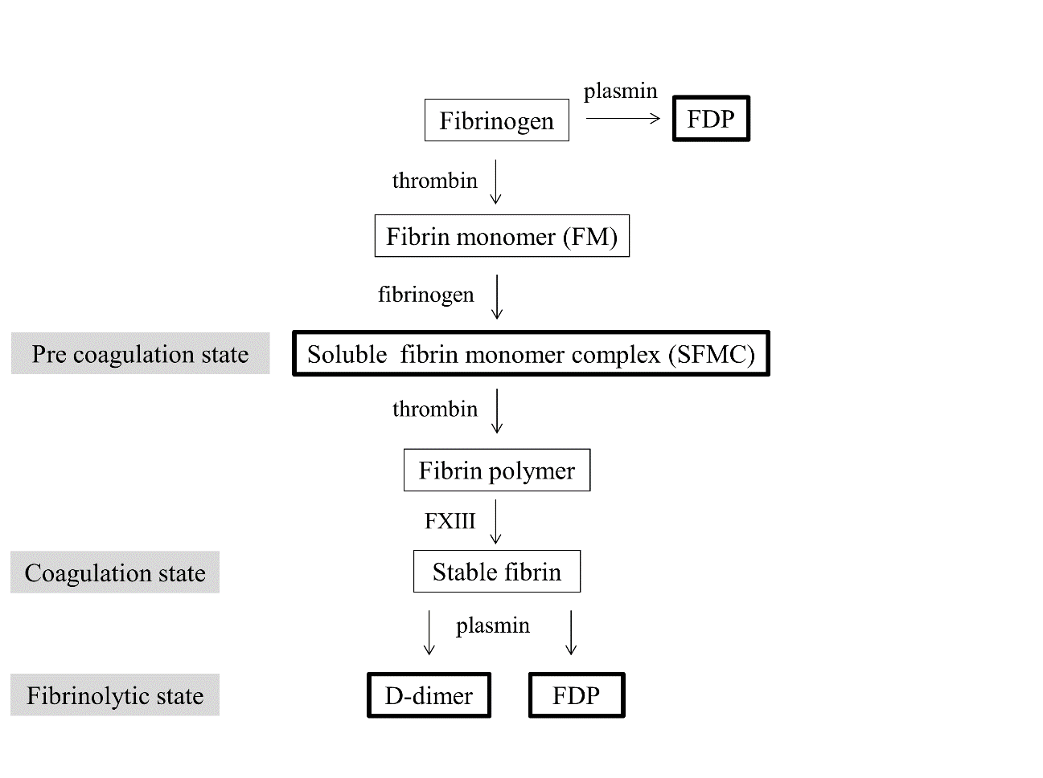
Figure 1 Schema of soluble fibrin monomer complex. soluble fibrin monomer complex (SFMC) appears in the bloodstream during the extremely early stage of blood coagulation, and reflects the plasmatic activation of coagulation and fibrinolysis.

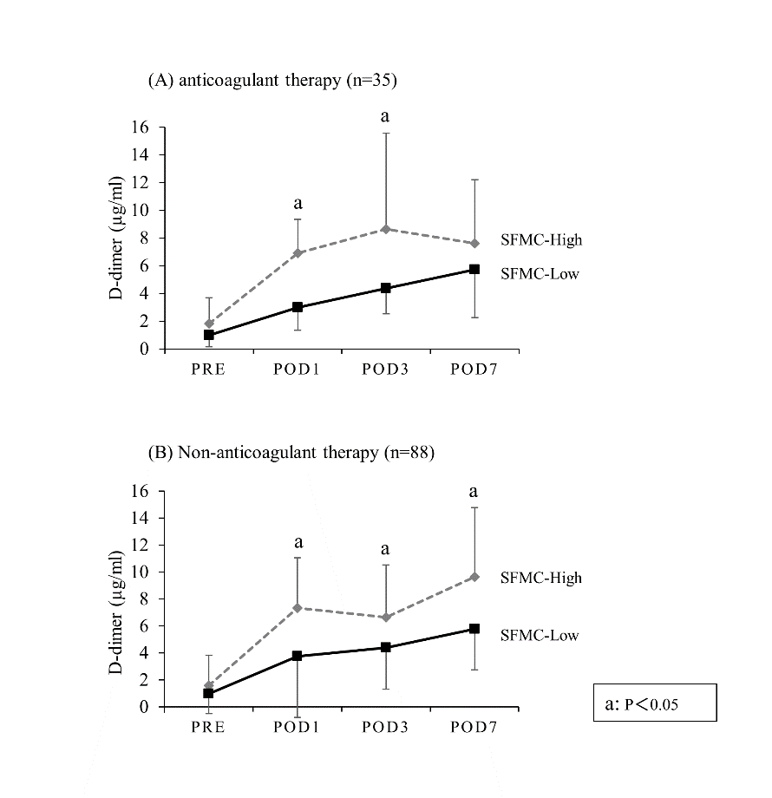
Figure 2 The postoperative kinetics of the D-dimer levels in patients who received anticoagulant therapy (A) and those who did not receive anticoagulant therapy (B). In the SFMC-High group, the plasma levels of D-dimer (POD 7) in patients who received anticoagulant therapy were reduced in comparison to those who did not. The mean D-dimer level ± SD in the SFMC-High group and ━ the SFMC-Low group.

Table 1 The baseline characteristics of the patients n (%)
Characteristic | n = 123
Age, median (range) | 67 (32-89)
Sex, Female | 55 (45)
BMI (kg/m²), median (range) | 22.8 (15.2-33.2)
Performance status
0-2 | 119 (97)
3-4 | 4 (3)
Surgical procedure
Gastrectomy | 32 (26)
Small bowel resection | 5 (4)
Colectomy | 45 (36)
Proctectomy | 32 (26)
Stoma closure | 2 (2)
Others | 7 (6)
Surgical technique
Laparoscopic surgery | 86 (70)
Operative time (min), median (range) | 319 (74-795)
Bleeding volume (ml), median (range) | 70 (5-4135)
Clinical risk factors for VTE
Malignancy | 118 (96)
Metastatic disease | 16 (13)
Diabetes mellitus | 16 (13)
Varicose vein | 1 (0.8)
Hormone therapy | 4 (3)
CV catheter | 4 (3)
Preoperative infection | 7 (6)
Cardiovascular disease | 6 (5)
Antiplatelet therapy | 10 (8)
Pelvic surgery | 22 (18)
Previous history of VTE | 0
BMI: body mass index; CV: central vein; VTE: venous thromboembolism.

Table 2 The relationship between the D-dimer level on POD 7 and the clinical characteristics of patients who did not receive anticoagulant therapy
Clinical risk factors for VTE |  | D-dimer (POD 7) |  | univariate | multivariate
 |  | Low (< 6.45) | High (≥ 6.45) | P value | OR | 95%CI | P value
Age | < 75 | 37 | 26 | <0.01 | 2.48 | 0.70-9.21 | 0.15
 | ≥ 75 | 7 | 18
Sex | Male | 20 | 21 | 0.83
 | Female | 24 | 23
Performance status | 0-2 | 43 | 43 | 1.00
 | 3-4 | 1 | 1
Operative time  (min) | < 321 | 32 | 19 | < 0.01 | 2.09 | 0.64-6.92 | 0.21
 | ≥ 321 | 12 | 25
Bleeding volume  (ml) | < 113 | 35 | 28 | 0.09
 | ≥ 113 | 9 | 16
Laparoscopic surgery | No | 11 | 16 | 0.24
 | Yes | 33 | 28
Malignancy | Absence | 2 | 3 | 0.64
 | Presence | 42 | 41
Metastatic disease | Absence | 38 | 39 | 0.74
 | Presence | 6 | 5
Diabetes mellitus | Absence | 39 | 39 | 1.00
 | Presence | 5 | 5
Hormone therapy | Absence | 43 | 43 | 1.00
 | Presence | 1 | 1
CV catheter | Absence | 42 | 43 | 0.55
 | Presence | 2 | 1
Preoperative infection | Absence | 42 | 41 | 0.64
 | Presence | 2 | 3
Antiplatelet therapy | Absence | 41 | 40 | 0.69
 | Presence | 3 | 4
Pelvic surgery | Absence | 41 | 41 | 1.00
 | Presence | 3 | 3
Caprini score | < 7 | 24 | 15 | 0.05
 | ≥ 7 | 20 | 29
Fibrin-related markers
D-dimer (µg/ml)  Preoperative | < 0.6 | 17 | 12 | 0.11
 | ≥ 0.6 | 13 | 21
D-dimer (µg/ml)  POD1 | < 3.8 | 33 | 11 | < 0.01 | 2.88 | 0.56-14.82 | 0.19
 | ≥ 3.8 | 11 | 33
FDP (µg/ml)  POD1 | < 10.1 | 38 | 18 | < 0.01 | 1.42 | 0.25-7.65 | 0.68
 | ≥ 10.1 | 6 | 26
TAT (ng/ml) POD1 | < 8.3 | 34 | 12 | < 0.01 | 1.83 | 0.44-7.27 | 0.39
 | ≥ 8.3 | 10 | 32
SFMC (µg/ml)  POD1 | < 3.8 | 39 | 16 | < 0.01 | 4.31 | 1.10-18.30 | 0.03
 | ≥ 3.8 | 5 | 28
VTE: venous thromboembolism; CV: central vein; FDP: fibrin degradation products; TAT: thrombin antithrombin complex; SFMC: soluble fibrin monomer complex; POD: postoperative day.

Table 3 The relationship between the soluble fibrin monomer complex on POD 1 and the clinical characteristics of the patients
Clinical risk factors for VTE |  | SFMC (POD 1) |  | univariate | multivariate
 |  | Low (<3.8) | High (≥ 3.8) | P value | OR | 95%CI | P value
Age | < 75 | 59 | 27 | 0.01 | 2.44 | 1.07-5.66 | 0.03
 | ≥ 75 | 16 | 21
Sex | Male | 45 | 23 | 0.18
 | Female | 30 | 25
BMI (kg/m²) | < 27 | 71 | 47 | 0.37
 | ≥ 27 | 4 | 1
Performance status | 0-2 | 73 | 46 | 0.64
 | 3-4 | 2 | 2
Operative time  (min) | < 321 | 45 | 18 | 0.01 | 2.33 | 1.08-5.12 | 0.02
 | ≥ 321 | 30 | 30
Bleeding volume  (ml) | < 113 | 47 | 28 | 0.63
 | ≥ 113 | 28 | 20
Laparoscopic surgery | No | 25 | 12 | 0.32
 | Yes | 50 | 36
Malignancy | Absence | 5 | 0 | 0.06
 | Presence | 70 | 48
Metastatic disease | Absence | 65 | 42 | 0.89
 | Presence | 10 | 6
Diabetes mellitus | Absence | 67 | 40 | 0.33
 | Presence | 8 | 8
Varicose vein | Absence | 75 | 47 | 0.2
 | Presence | 0 | 1
Hormone therapy | Absence | 72 | 47 | 0.55
 | Presence | 3 | 1
CV catheter | Absence | 72 | 47 | 0.55
 | Presence | 3 | 1
Preoperative infection | Absence | 71 | 45 | 0.83
 | Presence | 4 | 3
Cardiovascular disease | Absence | 73 | 44 | 0.15
 | Presence | 2 | 4
Antiplatelet therapy | Absence | 72 | 41 | 0.03 | 3.04 | 0.74-15.30 | 0.12
 | Presence | 3 | 7
Pelvic surgery | Absence | 62 | 39 | 0.84
 | Presence | 13 | 9
Caprini score | < 7 | 36 | 17 | 0.16
 | ≥ 7 | 39 | 31
Fibrin-related markers
D-dimer (µg/ml)  Preoperative | < 0.6 | 26 | 11 | 0.12
 | ≥ 0.6 | 30 | 25
SFMC: soluble fibrin monomer complex; POD: postoperative day; VTE: venous thromboembolism; BMI: body mass index; CV: central vein.

