Name of Journal: World Journal of Radiology
ESPS Manuscript NO: 22412
Manuscript Type: Review

Imaging and radiological interventions in extra-hepatic portal vein obstruction

Pargewar SS et al. Imaging and interventions in EHPVO

Sudheer S Pargewar, Saloni N Desai, S Rajesh, Vaibhav P Singh, Ankur Arora, Amar Mukund

Sudheer Pargewar, S Rajesh, Amar Mukund, Division of Interventional Radiology, Department of Radiology, Institute of Liver and Biliary Sciences (ILBS), New Delhi 110070, India

Saloni N Desai, Vaibhav P Singh, Ankur Arora, Division of Diagnostic Radiology, Department of Radiology, Institute of Liver and Biliary Sciences (ILBS), New Delhi 110070, India

Author contributions: Pargewar SS, Desai SN and Singh VP contributed to this paper with conception and design of the study, literature review and analysis as well as drafting; Rajesh S, Arora A and Mukund A contributed to this paper with critical revision, editing and final approval of the final revision.

Conflict-of-interest statement: No potential conflicts of interest. No financial support.

Open-Access: This article is an open-access article which was selected by an in-house editor and fully peer-reviewed by external reviewers. It is distributed in accordance with the Creative Commons Attribution Non Commercial (CC BY-NC 4.0) license, which permits others to distribute, remix, adapt, build upon this work non-commercially, and license their derivative works on different terms, provided the original work is properly cited and the use is non-commercial. See: http://creativecommons.org/licenses/by-nc/4.0/

Correspondence to: S Rajesh, MD, PDCC, Assistant Professor, Department of Radiology, Institute of Liver and Biliary Sciences, D1, Vasant Kunj, New Delhi 110070, India. rajesh387@gmail.com
Telephone: +91-783-8233499

Received: August 28, 2015
Peer-review started: September 1, 2015
First decision: October 8, 2015
Revised: February 26, 2016
Accepted: March 17, 2016
Article in press:
Published online:

Abstract
Extrahepatic portal vein obstruction (EHPVO) is a primary vascular condition characterized by chronic long standing blockage and cavernous transformation of portal vein with or without additional involvement of intrahepatic branches, splenic or superior mesenteric vein. Patients generally present in childhood with multiple episodes of variceal bleed and EHPVO is the predominant cause of paediatric portal hypertension (PHT) in developing countries. It is a pre-hepatic type of PHT in which liver functions and morphology are preserved till late. Characteristic imaging findings include multiple parabiliary venous collaterals which form to bypass the obstructed portal vein with resultant changes in biliary tree termed portal biliopathy or portal cavernoma cholangiopathy. Ultrasound with Doppler, computed tomography, magnetic resonance cholangiography and magnetic resonance portovenography are non-invasive techniques which can provide a comprehensive analysis of degree and extent of EHPVO, collaterals and bile duct abnormalities. These can also be used to assess in surgical planning as well screening for shunt patency in post-operative patients. The multitude of changes and complications seen in EHPVO can be addressed by various radiological interventional procedures. The myriad of symptoms arising secondary to vascular, biliary, visceral and neurocognitive changes in EHPVO can be managed by various radiological interventions like transjugular intra-hepatic portosystemic shunt, percutaneous transhepatic biliary drainage, partial splenic embolization, balloon occluded retrograde obliteration of portosystemic shunt (PSS) and revision of PSS.

Key words: Portal hypertension; Extrahepatic portal venous obstruction; Portal cavernoma; Transjugular intrahepatic portosystemic shunt; Splenic embolization

© The Author(s) 2016. Published by Baishideng Publishing Group Inc. All rights reserved.

Core tip: The present review describes the etiopathogenesis and role of imaging modalities in Extra-hepatic portal vein obstruction and role of various radiological interventional procedures in its management. The advantages and potential limitations of each imaging modality namely endoscopic retrograde cholangiography, ultrasonography and Doppler, multidetector computed tomography, magnetic resonance cholangiography and portovenography, endoscopic ultrasound and ultrasound transient elastography. Also, the concepts behind the use of interventional procedures like transjugular intra-hepatic portosystemic shunt, percutaneous transhepatic biliary drainage, partial splenic embolization, splenic artery aneurysmal embolization, balloon occluded retrograde obliteration of portosystemic shunt, etc., are described.

Pargewar SS, Desai SN, Rajesh S, Singh VP, Arora A, Mukund A. Imaging and radiological interventions in extra-hepatic portal vein obstruction. World J Radiol 2016; In press

INTRODUCTION
Extrahepatic portal vein obstruction (EHPVO) is a primary vascular condition characterized by chronic long standing blockage and cavernous transformation of portal vein with or without additional involvement of intrahepatic branches, splenic or superior mesenteric vein^{[1]}. The phrase “cavernous transformation of portal vein” was coined by Kobrich et al^{[2]} to describe the spongy appearance of fine blood vessels. Portal vein thrombosis secondary to cirrhosis, hepatocellular carcinoma, liver transplantation, pancreatitis or splenectomy is distinct from this condition. EHPVO and Non-cirrhotic portal fibrosis are the two principal causes of Non-cirrhotic portal hypertension (PHT) wherein patients present with PHT early in the disease course in the background of preserved liver functions and morphology. EHPVO is a disease of childhood, being the predominant cause of paediatric PHT and gastrointestinal bleed in first two decades (68%-84%) in developing countries, while in the western world, it is more common in adults, being the second most common cause of PHT and seen in only 11% of paediatric PHT cases^{[1]}.

ETIOPATHOGENESIS
Many etiologies have been proposed including hypercoagulable states, infections, inflammation and portal vein anomaly (stenosis, atresia, agenesis) although about 70% cases remain idiopathic despite extensive workup^{[1]}. Also, the risk factors of EHPVO are found to be different in children and adults. Congenital infections and prothrombin gene mutations are usual risk factors in children while myeloproliferative diseases as well as Paroxysmal nocturnal hemoglobinuria are common in elderly group. In EHPVO, the development of portal vein thrombosis is seldom recognized and patients may remain asymptomatic. Gradually there is organization and temporal evolution of thrombus with formation of portal collaterals within 6-20 d termed “cavernoma” aiming to bypass the obstructed portal vein^{[1,2]}. These collaterals are formed by the engorgement of two bile duct venous plexi namely paracholedochal plexus of Petren and epicholedochal plexus of Saint located adjacent to and within the bile duct wall respectively and shunting blood to the intrahepatic portal veins. These biliary plexi can have portoportal connections and generally have hepatopetal flow, while the right paracholedochal plexus may communicate with the gastrocolic trunk and pancreaticoduodenal vein to subsequently drain into cystic vein or directly into liver, the left paracholedochal plexus may communicate with the first jejunal trunk, right and left gastric veins and left portal vein. Additionally, there is opening up of multiple portosystemic collaterals (mainly left gastric and perisplenic) as a compensation to distribute the high splanchnic bed pressure. Sometimes, the accessory portal veins of Sappey which enter the liver capsule via falciform ligament, triangular ligament, gastrohepatic omentum, bare area of liver or ligamentum venosum supply portal blood to the liver by forming transhepatic portosystemic shunts (PSS)^{[3]}.
The cavernous transformation of portal vein and resultant extra and intrahepatic biliary ductal and gall bladder complications has been termed portal cavernoma cholangiopathy (PCC) also called portal biliopathy. The development of PCC has been attributed to two main causes: (1) Compression of the pliable common bile duct (CBD) by dilated collaterals and by new vessels formed due to long standing portal thrombosis (neovascularization); and (2) Bile duct ischaemia either due to prolonged compression by collaterals, thrombosis of smaller veins draining the duct or excessive deposition of connective tissue forming a ‘tumor-like’ cavernoma^{[4]}. In a study by Dhiman et al^{[5]}, 3 out of 5 patients of EHPVO showed partial resolution of biliary changes, 1 patient showed complete resolution whereas 1 patient had no reversal after PSS surgery, thus suggesting than both mechanical compression by collaterals and bile duct ischaemia can lead to cholangiopathy and both these causes are not mutually exclusive.

CLINICAL FEATURES
Clinically, children and young adults present initially with multiple episodes of hematemesis, moderate to marked splenomegaly with no features of chronic liver disease. Splenic infarcts and perisplenitis may give rise to left hypochondrium pain^{[1]}. Ascites is found in 10%-20% patients after surgery or following variceal bleed^{[6]}. Although imaging findings of PCC are found in 80%-100% patients, only 5%-38% are symptomatic^{[7]}. This disparity can be due to forceful post prandial gall bladder contractions which cause an increase in intraluminal pressure beyond that in parabiliary collaterals and prevent bile stasis^{[8]}. Symptoms of PCC are mainly due to chronic cholestasis and biliary stones and can manifest as jaundice, biliary colic or cholangitis. Such symptoms usually manifest 8-10 years after diagnosis of EHPVO, thus suggesting that PCC is a progressive condition developing after long standing obstruction^{[4,9]}. Khuroo et al^{[10]} reported that all patients with symptomatic portal biliopathy in their study presented almost a decade later than those patients presenting with variceal bleed. On long term follow-up, these patients may develop biochemical abnormalities of liver dysfunction and secondary biliary cirrhosis (2%-4%)^{[11,12]}. The chronic nature of the disease eventually leads to impaired growth and mild neurocognitive dysfunction^{[1]}.

IMAGING
The aim of imaging is two-fold: (1) To assess the severity of portal and splanchnic system thrombosis and depict the various portoportal and portosystemic collaterals; and (2) to define the association between the severity of portal venous occlusion and resultant biliary changes. With the advent of multidetector computed tomography (CT), and faster image acquisition protocols in magnetic resonance imaging (MRI), these two modalities along with ultrasonography (USG) play an indispensable role in diagnosis of EHPVO. They help in understanding the various collateral pathways bypassing the obstructed portal venous system and associated biliary tree changes. In the past, endoscopic retrograde cholangiography (ERC) was regarded as the gold standard for diagnosis of PCC. However, owing to the invasive nature of the procedure and the risk of bleeding from peribiliary collaterals it is now superseded by non-invasive imaging techniques. Role of ERC is now reserved for conditions which may need simultaneous therapeutic intervention. Endoscopic ultrasound (EUS) is also emerging as a modality in the diagnosis and management of EHPVO.

ERC
Various studies have described the findings of PCC using ERC. These include extrinsic impressions/indentations on bile duct, shallow impressions/indentations, irregular ductal contour, stenosis with or without upstream dilatation, filling defects due to stones, prolapsing intra-luminal varices or blood clots, bile duct angulation and duct ectasia^{[4]}. Bayraktar et al^{[13]} called such CBD changes as “pseudo-cholangiocarcinoma sign” while Perlemuter et al^{[14]} described strictures as having an “hourglass appearance”. Dilawari et al^{[8]} studied 20 patients of EHPVO, of which only one had mildly abnormal liver function tests but all showed biliary changes suggestive of sclerosing cholangitis on ERC. They found more severe changes in left intra-hepatic ducts (100%) and CBD (90%) than right intra-hepatic ducts (56%). While there may be a possibility of suboptimal evaluation of right sided ducts on ERC in supine position, there is also suggestion of more collateralization along the left sided ducts due to umbilical vein joining the left portal vein leading to more severe changes. In the study of Khuroo et al^{[10]}, cholangiographic abnormalities were seen in CBD in 66.6% and in intra-hepatic ducts in 38.1%. Nagi et al^{[15]} found involvement of extra-hepatic bile duct in 100% and intra-hepatic bile duct in 57% patients, but no predilection for left hepatic ducts was seen. Some studies show dilatation of intra-hepatic ducts with strictures and irregularity of extra-hepatic ducts, thereby postulating extra-hepatic obstruction as the cause of intra-hepatic changes^{[16,17]}. Chandra et al^{[11]} first proposed a system to classify PCC based on the location of narrowing on ERC in which type I is extra-hepatic duct involvement only, type II is involvement of intra-hepatic ducts only, type III a is extra-hepatic with unilateral intra-hepatic bile duct involvement and type III b is extra-hepatic with bilateral intra-hepatic bile duct involvement. Type I or type III changes are more frequently found^{[18]}. Apart from the invasive nature, a major drawback of ERC can be inadequate ductal opacification leading to over estimation of strictures or over filling and dense contrast opacification obscuring filling defects due to calculi and varices. Nevertheless, the higher spatial resolution of ERC allows better delineation of second and third order intra-hepatic ducts. With the advent of magnetic resonance cholangiography (MRC), ERC is now indicated in EHPVO only for therapeutic intent in case of bile duct stones or strictures.

USG and Doppler
USG and Doppler are the initial screening modality in patients suspected to have EHPVO. Liver size and echotexture usually remain normal in the early stages as EHPVO is a pre-hepatic condition. Nodularity and hepatic volume redistribution may be seen in patients on long term follow-up. Non visualization of portal vein with multiple tortuous anechoic structures at porta representing cavernoma formation is noted (Figure 1A). Both intra and extra-hepatic cavernoma formation can be seen according to the extent of portal vein thrombosis. Doppler shows absence of flow in the thrombosed portal vein with monophasic hepatopetal flow (Figure 1D) in these collaterals. Also, pericholecystic varices can be seen as tortuous collaterals around gall bladder wall (Figure 1C) or in gallbladder fossa post cholecystectomy in 30%-55% patients. Uncommonly, mural varices in gallbladder and bile duct wall can be found as wall thickening with color flow on Doppler. USG has an advantage in such scenarios over cross-sectional imaging to differentiate from other causes of wall thickening like inflammatory and neoplastic conditions^{[19]}. Doppler can also be used to detect shunt patency in post-surgical patients on follow-up (Figure 2A and B). Also, extra and intra-hepatic bile duct dilatation, narrowing or stenosis, cholelithiasis, choledocholithiasis and hepaticolithiasis can be detected. Liver parenchymal changes, splenomegaly, portosystemic collaterals and ascites, if any can be visualized. However, visualization of CBD may be difficult due to multiple portal collaterals and high level echoes at porta. Moreover, it is not possible to comment upon the exact etiology and nature of biliary narrowing.

Multidetector computed tomography
Multidetector computed tomography (MDCT) with its postprocessing software like multiplanar reformation, maximum and minimum intensity projections and volume rendering techniques plays an indispensable role in demonstrating the various vascular, biliary and visceral changes in EHPVO. The exact extent of portal vein thrombosis with or without extension to intrahepatic divisions, splenic and superior mesenteric vein can be visualized. The multiple portoportal and portosystemic collaterals and thin gallbladder varices not clearly seen on USG are better depicted on CT (Figure 3). The mural gallbladder varices can simulate thickened enhancing gallbladder wall on contrast CT. Dilatation of CBD and intrahepatic biliary radicles due to extrinsic compression by collaterals can also be seen on CT, however the detailed identification of extent and degree of narrowing may be difficult. The main role of CT lies in ruling out other causes of portal vein thrombosis and extra and intra-hepatic biliary dilatation like malignancy or extrinsic compression by lymph nodes. Transient hepatic attenuation differences can be seen as the central liver receives better perfusion from portoportal collaterals in comparison to peripheral aspects which show relatively reduced portal flow and compensatory increased arterial perfusion^{[20]}. Subsequently due to progressive nature of disease and compromised peripheral portal blood flow, liver parenchymal atrophy with lobulated contours (Figure 3D) may be seen mimicking imaging features of cirrhosis. Stigmata of cirrhosis like nodular contours, atrophy of medial segments of right lobe, hypertrophy of caudate and lateral segments of left lobe in EHPVO patients have been described by Aguirre et al^{[21]}. Splenomegaly is seen in 90%-100% patients which is usually moderate to severe in grade (mean size 11cm below costal margin)^{[1]}. Long standing nature of PHT may lead to development of intrasplenic siderotic nodules (Gamna Gandy bodies). CT arterial phase images are vital to look for presence, number and size of splenic artery aneurysms which form secondary to hyperkinetic splenic circulation ^{[22]}. CT plays an important role in pre-operative assessment for shunt surgery which requires detailed evaluation of intra-hepatic portal veins, splenic and superior mesenteric vein patency along with patency and anatomic variations of renal veins and inferior vena cava. Also, if splenic vein/superior mesenteric vein are found thrombosed, then the presence of any other varix (like gastroepiploic vein) which may be suitable for shunt surgery can be visualized on CT. Additionally, post-surgical shunt patency and disappearance of collaterals, if any, can be evaluated using MDCT (Figure 2C and D).

Magnetic resonance portovenography
MRC has now replaced ERC as the imaging modality of choice for mapping biliary abnormalities in patients of EHPVO. Magnetic resonance portovenography (MR portovenography), in addition, can delineate the complete spleno-portal axis and aid in shunt surgery planning and can also help in distinguishing parabiliary varices from stones^{[9]}. It has an obvious advantage over ERC as the relationship of collaterals to the biliary tree can be established. The paracholedochal collaterals are known to dilate first and are seen as enhancing tortuous collaterals causing smooth extrinsic impressions on bile duct (Figure 4). The epicholedochal plexus are seen as dot-like enhancing structures in the duct wall and cause fine irregularities^{[3]}. Bile duct wall thickening can be seen due to fibrosis which will show delayed enhancement on dynamic MRI as compared to early enhancement in cases of malignant thickening. Various studies have shown similar sensitivity of ERC and MRC for diagnosing biliary changes of PCC^{[12,23]}. MRC features in PCC are irregular wavy contour of bile ducts, biliary narrowing and stenosis with or without prestenotic dilatation, strictures, thickened gallbladder and bile duct walls, CBD angulation, cholelithiasis, choledocholithiasis and hepatolithiasis (Figures 5 and 6). The aforementioned theories of extrinsic compression or bile duct ischaemia lead to duct wall irregularity and narrowing. This predisposes to bile stasis and subsequent stone formation. Studies have revealed that gallstones are more frequent than CBD stones and 5%-20% of patients of PCC show evidence of choledocholithiasis and hepatolithiasis^{[8]}. Both short length (< 2cm) and long length (> 2cm) bile duct stenoses has been found^{[12]}. Walser et al described a more acute angulation of CBD (average 110º) in patients with portal biliopathy compared to non biliopathy patients (average 128º) at the superior aspect of pancreatic head secondary to kinking of bile duct by collaterals draining between the anterior-superior pancreaticoduodenal and posterior-superior pancreaticoduodenal veins^{[24]}. Keizman et al^{[25]} reported that an acute angle of CBD of ≤ 145º predisposes to recurrence of symptomatic bile duct stones (Figure 7). Shin et al^{[26]} have classified the biliary changes in EHPVO into three types depending on the pathogenesis and presence or absence of stricture. According to this classification, the varicoid type of PCC is caused by biliary obstruction due to compression by paracholedochal venous plexus (Figure 3A, 4B) resulting in wavy or undulating bile duct contour. The entire biliary system can be involved and these collaterals are best visualized in portal venous phase on dynamic MR. This type may show favourable response after decompression of splanchnic venous system. Fibrotic PCC is the second type resulting from scarring of bile duct wall due to chronic inflammation and ischaemia. Single or multiple segmental strictures are seen in this type with upstream dilatation and only CBD is commonly involved. On contrast MR, delayed progressive enhancement is noted consistent with fibrosis and this type of PCC is likely to be irreversible following surgery. The third type is mixed PCC showing findings of both types like irregular bile duct contour and multifocal areas of stenoses and dilatation, however, there is no delayed enhancement of the wall thickening at the level of narrowed portion. This type shows variable response to surgery^{[26]}. Llop et al^{[27]} has proposed a more clinically relevant classification based on severity of biliary dilatation on MRC findings of 67 patients. Grade 0 indicates no abnormality, Grade I indicates irregularities or angulations of biliary tree, Grade II indicates indentations or strictures without dilatation and Grade III indicates strictures with dilatation. They defined dilatation as extra-hepatic duct diameter > 7mm and/or intra-hepatic duct diameter > 4mm. Symptoms were found to be most frequent in grade III PCC.

EUS
The routine use of EUS in the diagnosis of PCC is not recommended, however it can be used to differentiate the various choledochal collaterals (paracholedochal, epicholedochal, intracholedochal and subepithelial varices) if an ERC is planned for stone retrieval or stricture dilatation. These varices pose an increased risk for bleeding and may sometimes be too small to be identified on cross sectional imaging^{[28]}. EUS may also help to identify stones, sludge and tumors when equivocal on other modalities.

Ultrasound transient elastography
Transient elastography with use of ultrasound is a promising noninvasive technique which can be used to measure liver and spleen stiffness. In a recent study by Sharma et al^{[29]} on 65 patients of EHPVO, liver stiffness (6.7 ± 2.3 kPa) and spleen stiffness (51.7 ± 21.5 kPa) were found to be significantly higher than healthy control subjects. They also suggest that splenic stiffness > 42.8 kPa has a high sensitivity (88%) and specificity (94%) for predicting variceal bleeds in these patients.

DIFFERENTIAL DIAGNOSIS
Portal venous thrombosis and cavernoma formation can occur in various conditions like cirrhosis and hepatocellular carcinoma. Many conditions can show features of PCC like biliary dilatation and strictures. These include primary sclerosing cholangitis, recurrent pyogenic cholangitis, HIV-cholangiopathy, autoimmune/IgG4-related cholangiopathy, bile duct neoplasms, biliary parasitic infection, post biliary tract surgery and strictures due to toxins or chronic pancreatitis. Multimodality imaging helps in distinguishing them from the typical venous, biliary and visceral EHPVO changes.

RADIOLOGICAL INTERVENTIONS IN EHPVO
The multitude of changes/ complications seen in EHPVO can be addressed by various radiological interventional procedures. The various changes/ complications seen in EHPVO and various possible radiological interventions available to manage them can be broadly categorized as in Table 1.

Transjugular Intrahepatic PSS
This procedure involves the creation of low resistance artificial conduit/ shunt between the hepatic vein and portal vein within the liver by deploying intrahepatic stent. Patients of EHPVO presenting with features of PHT in the form of variceal bleed either massive or recurrent inspite of pharmacological and/ or endoscopic therapy require measures for reduction of portal pressure either in the form of surgical PSS or transjugular intra-hepatic portosystemic shunt (TIPS)^{[30,31]}. Although technically challenging, TIPS is feasible in these patients but it can preclude a future Rex Shunt^{[31]}.
Patients with EHPVO pose technical challenge for TIPS because of difficulty in gaining access to portal system as main portal system is chronically thrombosed/ occluded and resistant to fibrinolysis^{[32]}. It is also difficult to puncture partially occluded intrahepatic portal radicle by avoiding the surrounding cavernous lesions^{[33]}. Various approaches have been proposed for gaining access to the portal system during TIPS. These are shown in Table 2^{[32-35]}. Intraparenchymal injection of CO₂ can be extremely useful in guiding the operator towards exact anatomic position of the portal tree^{[36]}. Having exact idea of intrahepatic portal tree by its delineation through any of these routes mentioned in Table 2 will guide the operator to aim the intraparenchymal needle. After gaining access into the portal system the next step is probing the guidewire towards the expected position of main portal vein and its confirmation by portography (Figure 8). This is followed by portal vein recanalization by mechanical thrombectomy, stent- graft placement or reverse Fogarty manoeuvre either alone or in combination^{[36]}. These initial steps are followed by routine steps in creation of TIPS.
Immediate complications of TIPS include intraperitoneal hemorrhage, local site hematoma, arrhythmia, bilhemia, stent displacement and shunt thrombosis. Chronic/ delayed complications include progression of spleno-portal thrombosis, congestive cardiac failure, sepsis, chronic recurrent encephalopathy, hepatic infarction, TIPS dysfunction and infection of TIPS.
Refractory/ recurrent HE due to TIPS shunt can be treated by deliberately occluding/ reducing these PSS keeping in mind the life threatening consequences of raised portal pressures with recurrence of massive variceal bleeding^{[37]}. The permanent occlusion tools include detachable balloons, coils, amplatzer device and sclerosants^{[37,38]}. Latex balloons are used for intentional reversible occlusion. Shunt reduction techniques includes use of constrained stents/ stent-grafts and adjunct embolization^{[37]}.
Percutaneous transluminal angioplasty (PTA) revision of thrombosed TIPS shunt is relatively safe and spares patients from surgical intervention^{[39]}. Percutaneous endovascular catheter directed transluminal chemical or mechanical thrombectomy is used successfully for restoring patency of thrombosed TIPS shunt^{[39-41]}.

Percutaneous transhepatic/ trans-splenic variceal embolization
Right from its inception by Lunderquist et al^{[42]} in the year 1974, several subsequent studies have proved that percutaneous transhepatic/ trans-splenic variceal embolization (PTE) via transhepatic route has excellent immediate success rates in controlling bleeding in 70%-90 % of patients. However, 37%-65% of these patients presented again with recurrent bleeding as PTE only addresses variceal bleed but not PHT per se^{[42-45]}. PTE is used to treat acute variceal bleed if it cannot be localized by endoscopy or are resistant to treatment by endoscopic means^{[46-48]}.
The gastro-esophageal varices are fed by portal system, i.e., either by the Left Gastric vein, the Posterior Gastric vein or the short Gastric vein, alone or in combination^{[49]}. These afferent veins are assessed either by transhepatic approach or by trans-splenic approach^{[42,49]}. Transhepatic approach is achieved by puncturing peripheral intrahepatic portal radicle using ultrasound/ fluoroscopic guidance or through pre-existing TIPS^{[50]}. Transplenic approach is specifically useful in patients with pre-existing portal vein thrombosis like EHPVO^{[49]}. Following assessment of size of varices, its afferents, efferents and flow velocities, sclerotherapy is carried out using various sclerosants like 3% Sodium Tetradecyl Sulphate, 10% Ethanolamine Oleate, Polidocanol, absolute alcohol, etc. mixed with radio-opaque agents like Lipiodol, nonionic contrast, air or CO₂ to form a sclerosant froth/ foam^{[51]}. Various other inventories like occlusion balloons and coils are also used during the procedure. Presence of a large draining vein warrants for occlusion/ closure of this gastro-renal shunt before starting embolization of gastric varices^{[50]}.

Percutaneous trans-hepatic biliary drainage
There are two schools of thought to treat symptomatic PCC. Some investigators believe that shunt surgery should be performed first in all cases of symptomatic PCC and if it fails to relieve biliary symptoms then a second stage biliary bypass surgery is recommended^{[52]}. Other school of thought is that endoscopic therapy should be the first resort to treat it and if it fails then the patient should be subjected to shunt surgery^{[53]}. Irrespective of these variant ideations in the treatment of PCC, the role of percutaneous trans-hepatic biliary drainage (PTBD) in its treatment is fixed. PTBD is indicated to treat cholangitis or for stone extraction in patients with failed/ abandoned endotherapy^{[54,55]}. Endoscopic interventions are failed/ abandoned due to following reasons: (1) Venous collaterals around ampulla of Vater leading to uncontrolled bleeding during sphincterotomy^{[56]}; (2) Uncontrolled bleeding from epi/ paracholedochal varices during stone extraction/ balloon dilatation of biliary strictures^{[54]}; and (3) Repeated stent block leading to repeated endotherapy sessions subjecting patient to inherent risk of uncontrolled bleeding^{[57]}. PTBD is also indicated in patients of EHPVO subjected to bilio-digestive bypass surgeries^{[55]}. The role of PTBD prior to bilio-digestive bypass surgeries is explained by Vibert et al^{[55]} According to them biliary-enteric bypass surgeries are associated with high risk of hemorrhage in the setting of PCC and also extension of mechanical biliary obstruction high into the porta hepatis and even in the liver may make anastomotic surgery difficult^{[57]}. PTBD is also indicated in patients of EHPVO treated with biliary-enteric anastomosis to treat cholangitis, for stone extraction and as an aid for percutaneous trans-hepatic cholangioplasty (PTC) of biliary-enteric anastomotic stricture as endoscopic approach is technically difficult in such patients^{[58-60]} (Figure 9).

PTC
PTC using cutting balloon and/or conventional balloons is of great help in treating benign biliary strictures including biliary-enteric anastomotic site strictures especially in patients with biliary-enteric anastomosis in whom endoscopic approach is technically difficult^{[58-61]}. The combined use of conventional and cutting balloons has better technical success rates and better patency rates in comparison with isolated use of conventional or cutting balloons^{[60,62,63]} (Figure 10).

Partial splenic embolization
According to Shneider et al^{[31]}, splenectomy in pediatric patients of EHPVO not only rules out the future option of distal spleno-renal shunt (SRS) but also will not improve the status of varices. Partial splenic embolization (PSE) is a safe and effective alternative for splenectomy in treatment of hypersplenism^{[64]}. PSE helps in reduction of splenic volume, thus decreasing portal venous inflow and thereby reducing portal pressure. It helps in improvement of hypersplenism induced thrombocytopenia with improvement in hematological parameters and hepatic protein synthesis^{[65]}. Polyvinyl alcohol is the most common embolizing agent used for this purpose. Other embolizing agents used for this purpose include gelatin, coil and amplatz^{[66]}. PSE has proved to be useful in management of bleeding gastric varices in patients with concomitant splenic vein thrombosis^{[67]}.

Balloon occluded trans-venous obliteration of PSS
Portal vein thrombosis (PVT) in EHPVO leads to PHT which acts as a stimulus for spontaneous PSS which is predictor of poor prognosis and a cause of hepatic encephalopathy (HE)^{[68]}. Refractory HE is treated by closure of PSS but it a relative contraindication in patients with EHPVO^{[69]}. Deliberate partial embolization of these shunts using coils^{[69]} or balloon occluded trans-venous obliteration of the larger shunts in presence of multiple PSS^{[70]} (Figure 11) using sclerosants and other inventories have been reported to be successful in treating recurrent HE in patients with PVT.

Surgical shunt revision by PTA
Deliberate reduction/ closure of surgical PSS is advocated in patients with refractory/ recurrent HE. The occlusion tools indicated for deliberate reduction/ closure of TIPS shunt can be used for the reduction/ closure of these surgical shunts^{[37,38]}. PTA revision of thrombosed surgical PSS by catheter directed transluminal chemical/ mechanical thrombectomy is indicated for restoring their patency similarly as in revision of thrombosed TIPS shunt^{[39-41]}.

Miscellaneous interventions
Splenic artery aneurysms which are the outcome of splenic hyperkinetic state seen in patients with EHPVO should be treated if they are > 2 cm as they are at high risk of rupture, although consensus over the size criteria are not available^{[71]}. They should be treated surgically, or with laparoscopic ligation or various endovascular techniques^{[71]}. Percutaneous trans-hepatic Hepatico-gastrostomy is a novel technique used in patients of EHPVO with PCC who are at risk of bleeding during sphincterotomy^{[56]}, when shuntable vein is not present for porto-systemic shunting^{[72]}, and when there is persistence of biliopathy inspite of shunt surgery/ biliary- enteric anastomosis or extensive venous collaterals making biliary- enteric anastomosis very dangerous. This procedure is generally used as last resort in presence of above mentioned criteria after failed attempts to cross the biliary stricture through PTBD access^{[73]}.

CONCLUSION
EHPVO is a chronic condition frequently presenting in childhood characterized by cavernous transformation of portal vein. Its long standing nature leads to impaired quality of life due to its diverse effects causing repeated variceal bleeds, PCC, hypersplenism, growth retardation and neurocognitive dysfunction. MDCT and MR portovenography play an indispensable role in identifying portal vein thrombosis, abdominal collaterals and visceral changes. MRC is non-invasive technique and can clearly depict the various biliary manifestations while the use of ERC is now mainly for therapeutic measures owing to potential complications. Role of EUS and transient elastography is evolving. The usefulness of radiological interventions in symptom management has to be correlated and customized according to the clinical scenario and imaging findings of each patient. In experienced hands with proper expertise, these minimally invasive techniques can help to significantly reduce patient morbidity.

REFERENCES
- Sarin SK, Khanna R. Non-cirrhotic portal hypertension. Clin Liver Dis 2014; 18: 451-476 [PMID: 24679506 DOI: 10.1016/j.cld.2014.01.009]
- De Gaetano AM, Lafortune M, Patriquin H, De Franco A, Aubin B, Paradis K. Cavernous transformation of the portal vein: patterns of intrahepatic and splanchnic collateral circulation detected with Doppler sonography. AJR Am J Roentgenol 1995; 165: 1151-1155 [PMID: 7572494 DOI: 10.2214/ajr.165.5.7572494]
- Sharma M, Rameshbabu CS. Collateral pathways in portal hypertension. J Clin Exp Hepatol 2012; 2: 338-352 [PMID: 25755456 DOI: 10.1016/j.jceh.2012.08.001]
- Dhiman RK, Saraswat VA, Valla DC, Chawla Y, Behera A, Varma V, Agarwal S, Duseja A, Puri P, Kalra N, Rameshbabu CS, Bhatia V, Sharma M, Kumar M, Gupta S, Taneja S, Kaman L, Zargar SA, Nundy S, Singh SP, Acharya SK, Dilawari JB. Portal cavernoma cholangiopathy: consensus statement of a working party of the Indian national association for study of the liver. J Clin Exp Hepatol 2014; 4: S2-S14 [PMID: 25755591 DOI: 10.1016/j.jceh.2014.02.003]
- Dhiman RK, Puri P, Chawla Y, Minz M, Bapuraj JR, Gupta S, Nagi B, Suri S. Biliary changes in extrahepatic portal venous obstruction: compression by collaterals or ischemic? Gastrointest Endosc 1999; 50: 646-652 [PMID: 10536320 DOI: 10.1016/S0016-5107(99)80013-3]
- Chiu B, Superina R. Extrahepatic portal vein thrombosis is associated with an increased incidence of cholelithiasis. J Pediatr Surg 2004; 39: 1059-1061 [PMID: 15213899 DOI: 10.1016/j.jpedsurg.2004.03.051]
- Bhatia V. Endoscopic retrograde cholangiography in portal cavernoma cholangiopathy - results from different studies and proposal for uniform terminology. J Clin Exp Hepatol 2014; 4: S37-S43 [PMID: 25755594 DOI: 10.1016/j.jceh.2013.05.013]
- Dilawari JB, Chawla YK. Pseudosclerosing cholangitis in extrahepatic portal venous obstruction. Gut 1992; 33: 272-276 [PMID: 1541425 DOI: 10.1136/gut.33.2.272]
- Dhiman RK, Behera A, Chawla YK, Dilawari JB, Suri S. Portal hypertensive biliopathy. Gut 2007; 56: 1001-1008 [PMID: 17170017 DOI: 10.1136/gut.2006.103606]
- Khuroo MS, Yattoo GN, Zargar SA, Javid G, Dar MY, Khan BA, Boda MI. Biliary abnormalities associated with extrahepatic portal venous obstruction. Hepatology 1993; 17: 807-813 [PMID: 8491448 DOI: 10.1002/hep.1840170510]
- Chandra R, Kapoor D, Tharakan A, Chaudhary A, Sarin SK. Portal biliopathy. J Gastroenterol Hepatol 2001; 16: 1086-1092 [PMID: 11686833 DOI: 10.1046/j.1440-1746.2001.02562.x]
- Condat B, Vilgrain V, Asselah T, O'Toole D, Rufat P, Zappa M, Moreau R, Valla D. Portal cavernoma-associated cholangiopathy: a clinical and MR cholangiography coupled with MR portography imaging study. Hepatology 2003; 37: 1302-1308 [PMID: 12774008 DOI: 10.1053/jhep.2003.50232]
- Bayraktar Y, Balkanci F, Ozenc A, Arslan S, Koseoglu T, Ozdemir A, Uzunalimoglu B, Telatar H, Gurakar A, Van Thiel DH. The "pseudo-cholangiocarcinoma sign" in patients with cavernous transformation of the portal vein and its effect on the serum alkaline phosphatase and bilirubin levels. Am J Gastroenterol 1995; 90: 2015-2019 [PMID: 7485013 DOI: 10.1016/S0168-8278(96)80328-X]
- Perlemuter G, Béjanin H, Fritsch J, Prat F, Gaudric M, Chaussade S, Buffet C. Biliary obstruction caused by portal cavernoma: a study of 8 cases. J Hepatol 1996; 25: 58-63 [PMID: 8836902]
- Nagi B, Kochhar R, Bhasin D, Singh K. Cholangiopathy in extrahepatic portal venous obstruction. Radiological appearances. Acta Radiol 2000; 41: 612-615 [PMID: 11092484 DOI: 10.1080/028418500127345992]
- Malkan GH, Bhatia SJ, Bashir K, Khemani R, Abraham P, Gandhi MS, Radhakrishnan R. Cholangiopathy associated with portal hypertension: diagnostic evaluation and clinical implications. Gastrointest Endosc 1999; 49: 344-348 [PMID: 10049418 DOI: 10.1016/S0016-5107(99)70011-8]
- Sezgin O, Oğuz D, Altintaş E, Saritaş U, Sahin B. Endoscopic management of biliary obstruction caused by cavernous transformation of the portal vein. Gastrointest Endosc 2003; 58: 602-608 [PMID: 14520303 DOI: 10.1067/S0016-5107(03)01975-8]
- Ozkavukcu E, Erden A, Erden I. Imaging features of portal biliopathy: frequency of involvement patterns with emphasis on MRCP. Eur J Radiol 2009; 71: 129-134 [PMID: 18448295 DOI: 10.1016/j.ejrad.2008.03.007]
- Gabata T, Matsui O, Kadoya M, Yoshikawa J, Ueda K, Nobata K, Kawamori Y, Takashima T. Gallbladder varices: demonstration of direct communication to intrahepatic portal veins by color doppler sonography and CT during arterial portography. Abdom Imaging 1997; 22: 82-84 [PMID: 9000362 DOI: 10.1007/s002619900145]
- Mathieu D, Vasile N, Dibie C, Grenier P. Portal cavernoma: dynamic CT features and transient differences in hepatic attenuation. Radiology 1985; 154: 743-748 [PMID: 3881794 DOI: 10.1148/radiology.154.3.3881794]
- Aguirre DA, Farhadi FA, Rattansingh A, Jhaveri KS. Portal biliopathy: imaging manifestations on multidetector computed tomography and magnetic resonance imaging. Clin Imaging 2012; 36: 126-134 [PMID: 22370133 DOI: 10.1016/j.clinimag.2011.07.001]
- Manjunatha YC, Prasad KN, Beeregowda YC, Bhaskaran A. Multiple splenic artery aneurysms secondary to extra hepatic portal vein obstruction. J Clin Diagn Res 2013; 7: 401-402 [PMID: 23543885 DOI: 10.7860/JCDR/2013/4087.2781]
- Leclerc JC, Cannard L, Debelle L, Laurent V, Béot S, Régent D. [MRI of portal cavernoma with biliary involvement]. J Radiol 2002; 83: 341-349 [PMID: 11979228]
- Walser EM, Runyan BR, Heckman MG, Bridges MD, Willingham DL, Paz-Fumagalli R, Nguyen JH. Extrahepatic portal biliopathy: proposed etiology on the basis of anatomic and clinical features. Radiology 2011; 258: 146-153 [PMID: 21045178 DOI: 10.1148/radiol.10090923]
- Keizman D, Shalom MI, Konikoff FM. An angulated common bile duct predisposes to recurrent symptomatic bile duct stones after endoscopic stone extraction. Surg Endosc 2006; 20: 1594-1599 [PMID: 16858527 DOI: 10.1007/s00464-005-0656-x]
- Shin SM, Kim S, Lee JW, Kim CW, Lee TH, Lee SH, Kim GH. Biliary abnormalities associated with portal biliopathy: evaluation on MR cholangiography. AJR Am J Roentgenol 2007; 188: W341-W347 [PMID: 17377002 DOI: 10.2214/AJR.05.1649]
- Llop E, de Juan C, Seijo S, García-Criado A, Abraldes JG, Bosch J, García-Pagán JC. Portal cholangiopathy: radiological classification and natural history. Gut 2011; 60: 853-860 [PMID: 21270119 DOI: 10.1136/gut.2010.230201]
- Sharma M, Rameshbabu CS. Portal cavernoma cholangiopathy: an endoscopic ultrasound based imaging approach. J Clin Exp Hepatol 2014; 4: S53-S61 [PMID: 25755596 DOI: 10.1016/j.jceh.2013.08.015]
- Sharma P, Mishra SR, Kumar M, Sharma BC, Sarin SK. Liver and spleen stiffness in patients with extrahepatic portal vein obstruction. Radiology 2012; 263: 893-899 [PMID: 22523326 DOI: 10.1148/radiol.12111046]
- Alberti D, Colusso M, Cheli M, Ravelli P, Indriolo A, Signorelli S, Fagiuoli S, D'Antiga L. Results of a stepwise approach to extrahepatic portal vein obstruction in children. J Pediatr Gastroenterol Nutr 2013; 57: 619-626 [PMID: 23783024 DOI: 10.1097/MPG.0b013e31829fad46]
- Shneider BL, Bosch J, de Franchis R, Emre SH, Groszmann RJ, Ling SC, Lorenz JM, Squires RH, Superina RA, Thompson AE, Mazariegos GV. Portal hypertension in children: expert pediatric opinion on the report of the Baveno v Consensus Workshop on Methodology of Diagnosis and Therapy in Portal Hypertension. Pediatr Transplant 2012; 16: 426-437 [PMID: 22409296 DOI: 10.1111/j.1399-3046.2012.01652.x]
- Bilbao JI, Elorz M, Vivas I, Martínez-Cuesta A, Bastarrika G, Benito A. Transjugular intrahepatic portosystemic shunt (TIPS) in the treatment of venous symptomatic chronic portal thrombosis in non-cirrhotic patients. Cardiovasc Intervent Radiol 2004; 27: 474-480 [PMID: 15383850 DOI: 10.1007/s00270-004-0241-z]
- Kawamata H, Kumazaki T, Kanazawa H, Takahashi S, Tajima H, Hayashi H. Transjugular intrahepatic portosystemic shunt in a patient with cavernomatous portal vein occlusion. Cardiovasc Intervent Radiol 2000; 23: 145-149 [PMID: 10795842 DOI : 10.1007/s002709910030]
- Han G, Qi X, He C, Yin Z, Wang J, Xia J, Yang Z, Bai M, Meng X, Niu J, Wu K, Fan D. Transjugular intrahepatic portosystemic shunt for portal vein thrombosis with symptomatic portal hypertension in liver cirrhosis. J Hepatol 2011; 54: 78-88 [PMID: 20932597 DOI: 10.1016/j.jhep.2010.06.029]
- Chin MS, Stavas JM, Burke CT, Dixon RG, Mauro MA. Direct puncture of the recanalized paraumbilical vein for portal vein targeting during transjugular intrahepatic portosystemic shunt procedures: assessment of technical success and safety. J Vasc Interv Radiol 2010; 21: 671-676 [PMID: 20430297 DOI: 10.1016/j.jvir.2010.01.036]
- Ferral H, Bilbao JI. The difficult transjugular intrahepatic portosystemic shunt: alternative techniques and "tips" to successful shunt creation. Semin Intervent Radiol 2005; 22: 300-308 [PMID: 21326708 DOI: 10.1055/s-2005-925556]
- Madoff DC, Wallace MJ, Ahrar K, Saxon RR. TIPS-related hepatic encephalopathy: management options with novel endovascular techniques. Radiographics 2004; 24: 21-36; discussion 36-37 [PMID: 14730033 DOI: 10.1148/rg.241035028]
- Ramírez-Polo A, Márquez-Guillén E, González-Aguirre AJ, Casanova-Sánchez IE, Chávez-Ruiz R, Carrillo-Maravilla E, López-Méndez E. Persistent hepatic encephalopathy secondary to portosystemic shunt occluded with Amplatzer device. Ann Hepatol 2014; 13: 456-460 [PMID: 24927618]
- Yussim E, Shapiro R, Mor E, Belenky A, Atar E. Percutaneous transluminal angioplasty of an occluded surgical splenorenal shunt in a 4-year-old child after liver transplantation. Pediatr Radiol 2005; 35: 688-690 [PMID: 15654604 DOI: 10.1007/s00247-004-1396-0]
- Arora A, Sarin SK. Multimodality imaging of primary extrahepatic portal vein obstruction (EHPVO): what every radiologist should know. Br J Radiol 2015; 88: 20150008 [PMID: 26111208 DOI: 10.1259/bjr.20150008]
- Ripamonti R, Ferral H, Alonzo M, Patel NH. Transjugular intrahepatic portosystemic shunt-related complications and practical solutions. Semin Intervent Radiol 2006; 23: 165-176 [PMID: 21326760 DOI: 10.1055/s-2006-941447]
- Lunderquist A, Vang J. Transhepatic catheterization and obliteration of the coronary vein in patients with portal hypertension and esophageal varices. N Engl J Med 1974; 291: 646-649 [PMID: 4546968 DOI : 10.1056/NEJM197409262911303]
- Benner KG, Keeffe EB, Keller FS, Rösch J. Clinical outcome after percutaneous transhepatic obliteration of esophageal varices. Gastroenterology 1983; 85: 146-153 [PMID: 6602081]
- Smith-Laing G, Scott J, Long RG, Dick R, Sherlock S. Role of percutaneous transhepatic obliteration of varices in the management of hemorrhage from gastroesophageal varices. Gastroenterology 1981; 80: 1031-1036 [PMID: 7009311]
- L'Herminé C, Chastanet P, Delemazure O, Bonnière PL, Durieu JP, Paris JC. Percutaneous transhepatic embolization of gastroesophageal varices: results in 400 patients. AJR Am J Roentgenol 1989; 152: 755-760 [PMID: 2784259 DOI: 10.2214/ajr.152.4.755]
- Sos TA. Transhepatic portal venous embolization of varices: pros and cons. Radiology 1983; 148: 569-570 [PMID: 6603000 DOI: 10.1148/radiology.148.2.6603000]
- Kwak HS, Han YM. Percutaneous transportal sclerotherapy with N-butyl-2-cyanoacrylate for gastric varices: technique and clinical efficacy. Korean J Radiol 2008; 9: 526-533 [PMID: 19039269 DOI: 10.3348/kjr.2008.9.6.526]
- Tian X, Wang Q, Zhang C, Liu F, Cui Y, Liu F, Liu J. Modified percutaneous transhepatic variceal embolization with 2-octylcyanoacrylate for bleeding gastric varices: long-term follow-up outcomes. AJR Am J Roentgenol 2011; 197: 502-509 [PMID: 21785101 DOI: 10.2214/AJR.10.6005]
- Gong GQ, Wang XL, Wang JH, Yan ZP, Cheng JM, Qian S, Chen Y. Percutaneous transsplenic embolization of esophageal and gastrio-fundal varices in 18 patients. World J Gastroenterol 2001; 7: 880-883 [PMID: 11854922 DOI: 10.3748/wjg.v7.i6.880]
- Saad WE, Sze DY. Variations of Balloon-occluded Retrograde Transvenous Obliteration (BRTO): Balloon-occluded Antegrade Transvenous Obliteration (BATO) and Alternative/Adjunctive Routes for BRTO. Semin Intervent Radiol 2011; 28: 314-324 [PMID: 22942549 DOI: 10.1055/s-0031-1284458]
- Saad WE, Nicholson D, Koizumi J. Inventory used for balloon-occluded retrograde (BRTO) and antegrade (BATO) transvenous obliteration: sclerosants and balloon occlusion devices. Tech Vasc Interv Radiol 2012; 15: 226-240 [PMID: 23021833 DOI: 10.1053/j.tvir.2012.07.005]
- Chaudhary A, Dhar P, Sarin SK, Sachdev A, Agarwal AK, Vij JC, Broor SL. Bile duct obstruction due to portal biliopathy in extrahepatic portal hypertension: surgical management. Br J Surg 1998; 85: 326-329 [PMID: 9529484]
- Khare R, Sikora SS, Srikanth G, Choudhuri G, Saraswat VA, Kumar A, Saxena R, Kapoor VK. Extrahepatic portal venous obstruction and obstructive jaundice: approach to management. J Gastroenterol Hepatol 2005; 20: 56-61 [PMID: 15610447]
- Chattopadhyay S, Nundy S. Portal biliopathy. World J Gastroenterol 2012; 18: 6177-6182 [PMID: 23180936 DOI: 10.3748/wjg.v18.i43.6177]
- Vibert E, Azoulay D, Aloia T, Pascal G, Veilhan LA, Adam R, Samuel D, Castaing D. Therapeutic strategies in symptomatic portal biliopathy. Ann Surg 2007; 246: 97-104 [PMID: 17592297]
- Mutignani M, Shah SK, Bruni A, Perri V, Costamagna G. Endoscopic treatment of extrahepatic bile duct strictures in patients with portal biliopathy carries a high risk of haemobilia: report of 3 cases. Dig Liver Dis 2002; 34: 587-591 [PMID: 12502216]
- Dumortier J, Vaillant E, Boillot O, Poncet G, Henry L, Scoazec JY, Partensky C, Valette PJ, Paliard P, Ponchon T. Diagnosis and treatment of biliary obstruction caused by portal cavernoma. Endoscopy 2003; 35: 446-450 [PMID: 12701019]
- Laštovičková J, Peregrin J. Biliary strictures after orthotopic liver transplantation: long-term results of percutaneous treatment in patients with nonfeasible endoscopic therapy. Transplant Proc 2012; 44: 1379-1384 [PMID: 22664019 DOI: 10.1016/j.transproceed.2012.02.026]
- Kucukay F, Okten RS, Yurdakul M, Ozdemir E, Erat S, Parlak E, Disibeyaz S, Ozer I, Bostanci EB, Olcer T, Tola M. Long-term results of percutaneous biliary balloon dilation treatment for benign hepaticojejunostomy strictures: are repeated balloon dilations necessary? J Vasc Interv Radiol 2012; 23: 1347-1355; quiz 1357 [PMID: 22999755 DOI: 10.1016/j.jvir.2012.07.004]
- Mukund A, Rajesh S, Agrawal N, Arora A, Arora A. Percutaneous management of resistant biliary-enteric anastomotic strictures with the use of a combined cutting and conventional balloon cholangioplasty protocol: a single-center experience. J Vasc Interv Radiol 2015; 26: 560-565 [PMID: 25666628 DOI: 10.1016/j.jvir.2014.12.011]
- Vos PM, van Beek EJ, Smits NJ, Rauws EA, Gouma DJ, Reeders JW. Percutaneous balloon dilatation for benign hepaticojejunostomy strictures. Abdom Imaging 2000; 25: 134-138 [PMID: 10675453]
- Saad WE, Davies MG, Saad NE, Waldman DL, Sahler LG, Lee DE, Kitanosono T, Sasson T, Patel NC. Transhepatic dilation of anastomotic biliary strictures in liver transplant recipients with use of a combined cutting and conventional balloon protocol: technical safety and efficacy. J Vasc Interv Radiol 2006; 17: 837-843 [PMID: 16687750]
- Kakani NK, Puckett M, Cooper M, Watkinson A. Percutaneous transhepatic use of a cutting balloon in the treatment of a benign common bile duct stricture. Cardiovasc Intervent Radiol 2006; 29: 462-464 [PMID: 16447007]
- Alwmark A, Bengmark S, Gullstrand P, Joelsson B, Lunderquist A, Owman T. Evaluation of splenic embolization in patients with portal hypertension and hypersplenism. Ann Surg 1982; 196: 518-524 [PMID: 7125739]
- Koconis KG, Singh H, Soares G. Partial splenic embolization in the treatment of patients with portal hypertension: a review of the english language literature. J Vasc Interv Radiol 2007; 18: 463-481 [PMID: 17446537]
- Petermann A, Chabrot P, Cassagnes L, Dumousset E, Alfidja A, Gageanu C, Ravel A, Abergel A, Boyer L. Hypersplenism due to portal hypertension: retrospective evaluation of 17 patients treated by splenic embolization. Diagn Interv Imaging 2012; 93: 30-36 [PMID: 22277708 DOI: 10.1016/j.diii.2011.11.008]
- Saugel B, Gaa J, Phillip V, Schmid RM, Huber W. Splenic artery embolization in a woman with bleeding gastric varices and splenic vein thrombosis: a case report. J Med Case Rep 2010; 4: 247 [PMID: 20684784 DOI: 10.1186/1752-1947-4-247]
- Kumamoto M, Toyonaga A, Inoue H, Miyakoda K, Morita Y, Emori K, Sakamoto Y, Oho K, Sata M. Long-term results of balloon-occluded retrograde transvenous obliteration for gastric fundal varices: hepatic deterioration links to portosystemic shunt syndrome. J Gastroenterol Hepatol 2010; 25: 1129-1135 [PMID: 20594229 DOI: 10.1111/j.1440-1746.2010.06262.x]
- Intagliata NM, Saad WE, Caldwell SH. Effects of restoring portal flow with anticoagulation and partial splenorenal shunt embolization. Hepatology 2015; 61: 1088-1090 [PMID: 24867875 DOI: 10.1002/hep.27241]
- Franzoni Lde C, de Carvalho FC, Garzon RG, Yamashiro Fda S, Augusti L, Santos LA, Dorna Mde S, Baima JP, Lima TB, Caramori CA, Silva GF, Romeiro FG. Embolization of splenorenal shunt associated to portal vein thrombosis and hepatic encephalopathy. World J Gastroenterol 2014; 20: 15910-15915 [PMID: 25400477 DOI: 10.3748/wjg.v20.i42.15910]
- Loffroy R, Favelier S, Pottecher P, Genson PY, Estivalet L, Gehin S, Cercueil JP, Krausé D. Endovascular management of visceral artery aneurysms: When to watch, when to intervene? World J Radiol 2015; 7: 143-148 [PMID: 26217453 DOI: 10.4329/wjr.v7.i7.143]
- Mitra SK, Kumar V, Datta DV, Rao PN, Sandhu K, Singh GK, Sodhi JS, Pathak IC. Extrahepatic portal hypertension: a review of 70 cases. J Pediatr Surg 1978; 13: 51-57 [PMID: 305475]
- Mistry JH, Varma V, Mehta N, Kumaran V, Nundy S, Gupta A. Percutaneous transhepatic hepaticogastrostomy for portal biliopathy: a novel approach. Trop Gastroenterol 2012; 33: 140-143 [PMID: 23025062]

P-Reviewer: Biecker E, Makisalo H S-Editor: Kong JX L-Editor: E-Editor:

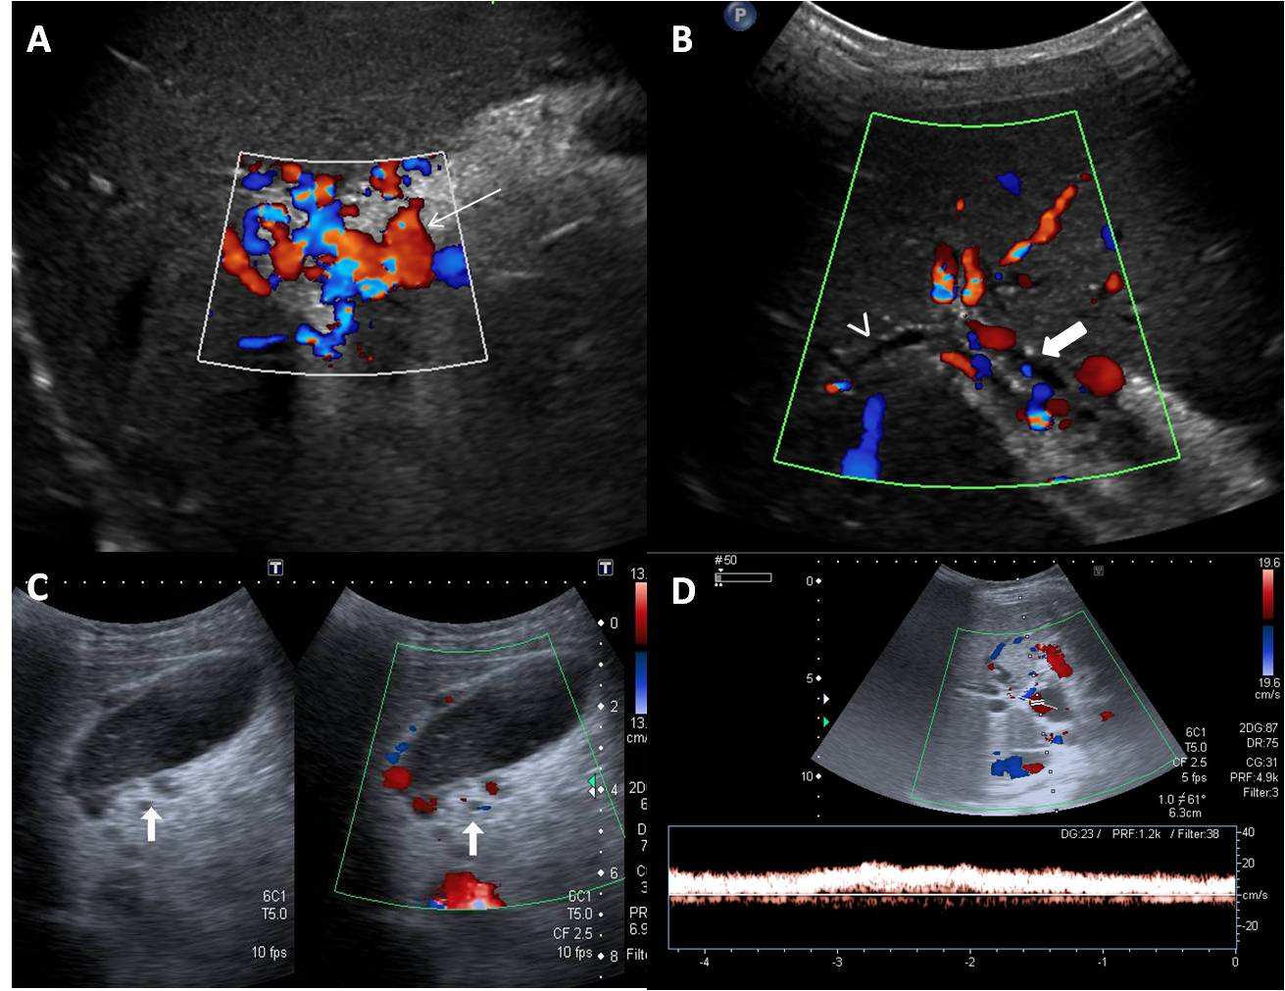
Figure 1 Ultrasonography and Doppler in extrahepatic portal vein obstruction. A: Doppler showing multiple tortuous portoportal collaterals forming a portal cavernoma (arrow) and replacing the portal vein; B: USG with Doppler showing parabiliary collaterals surrounding the prominent CBD (block arrow) and intrahepatic biliary radicles (arrow head); C: Pericholecystic varices (block arrow) are also noted; D: Spectral Doppler reveals hepatopetal flow with monophasic waveform. USG: Ultrasonography; CBD: Common bile duct.

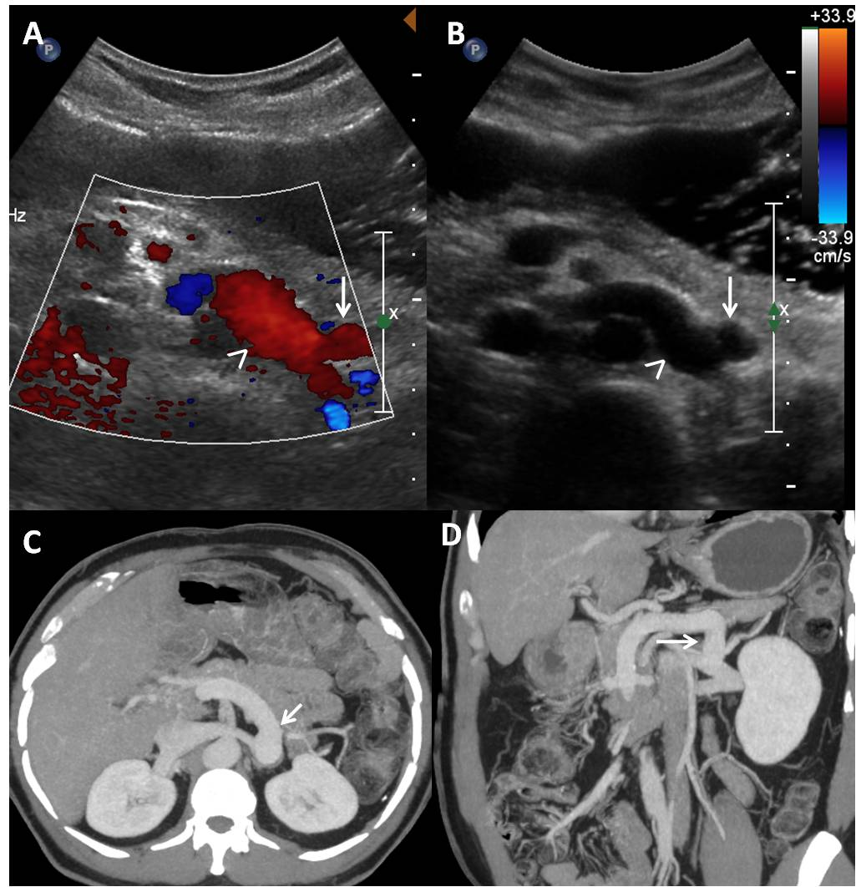
Figure 2 Proximal spleno-renal shunt. Doppler (A) and gray-scale (B) ultrasound images showing a postoperative patient with patent proximal splenorenal shunt (arrow) draining into patent left renal vein (arrow head). Axial (C) and coronal (D) thick maximum intensity projection images clearly demonstrating the shunt (arrow) patency.

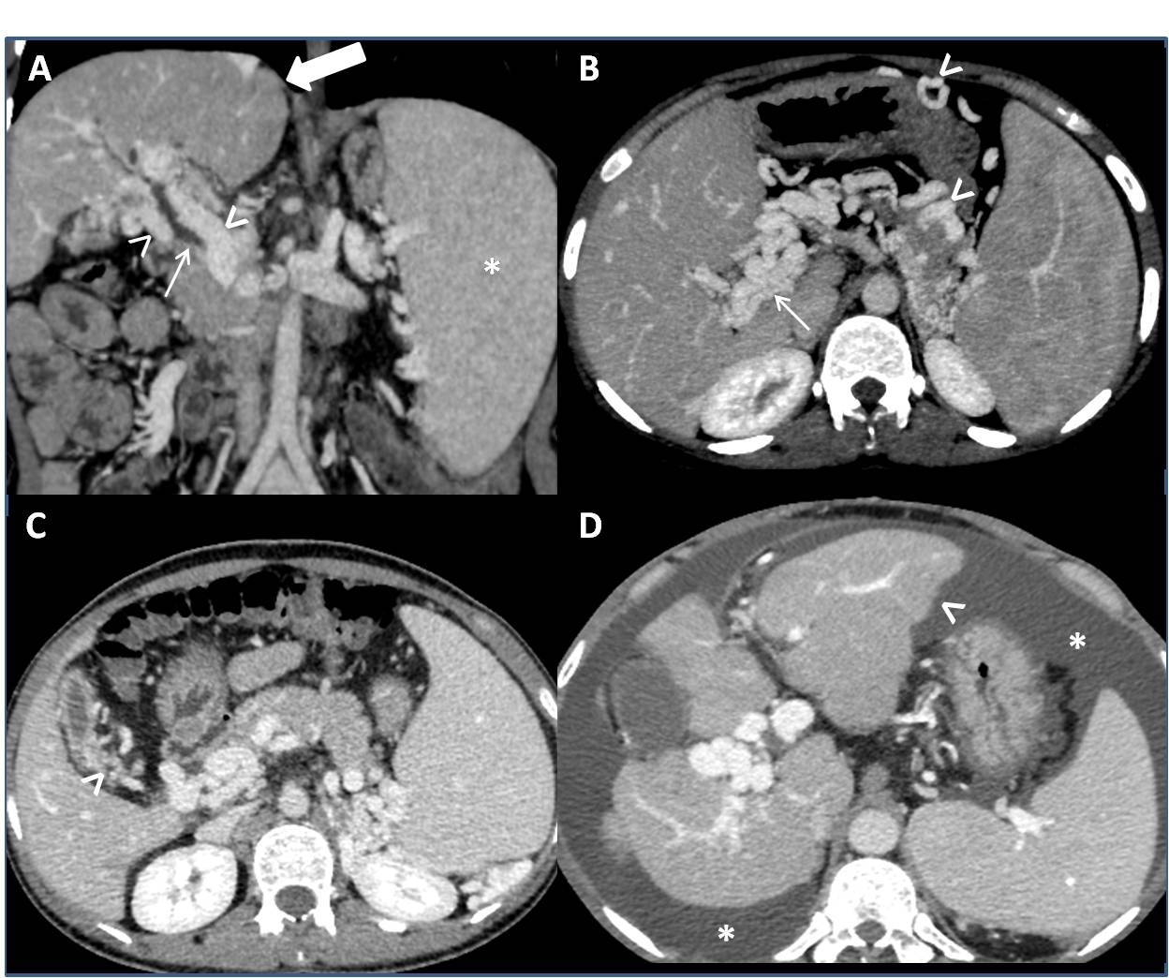Figure 3 Vascular, biliary and visceral changes on multidetector computed tomography. A: Coronal image shows paracholedochal collaterals (arrow heads) indenting the biliary tree (thin arrow) and causing upstream biliary dilatation. Note the normal liver outlines (thick arrow) and enlarged spleen (asterisk); B: Thick maximum intensity projection image depicts portal cavernoma formation (thin arrow), perigastric and pancreatic collaterals (arrow heads); C: Contracted gallbladder with pericholecystic varices (arrow head); D: A patient of extrahepatic portal vein obstruction showing lobulated liver contours (arrow head) and ascites (asterisks).

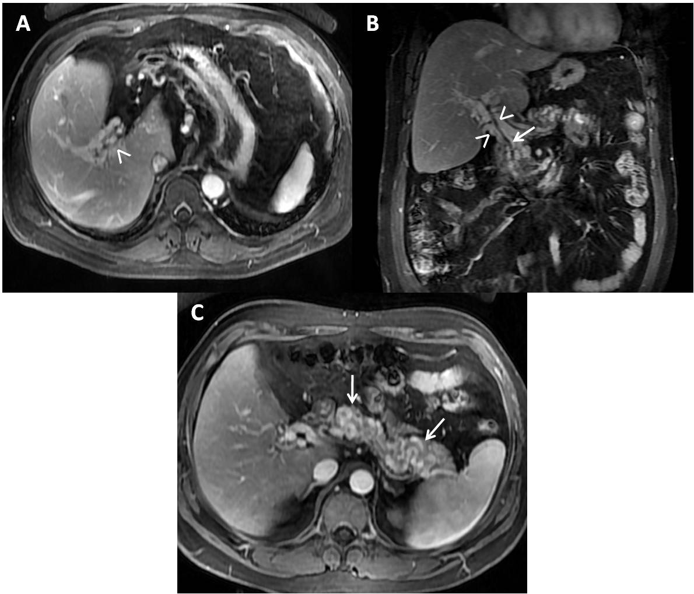Figure 4 Magnetic resonance portovenography showing portal cavernoma and pancreatic collaterals. Axial (A) and coronal (B) contrast magnetic resonance images in portovenous phase showing non visualization of portal vein and its intra-hepatic branches with formation of peribiliary varices (arrow heads) causing extrinsic impressions on common bile duct (thin arrow); C: Axial contrast magnetic resonance images revealing multiple tortuous pancreatic collaterals (arrows).

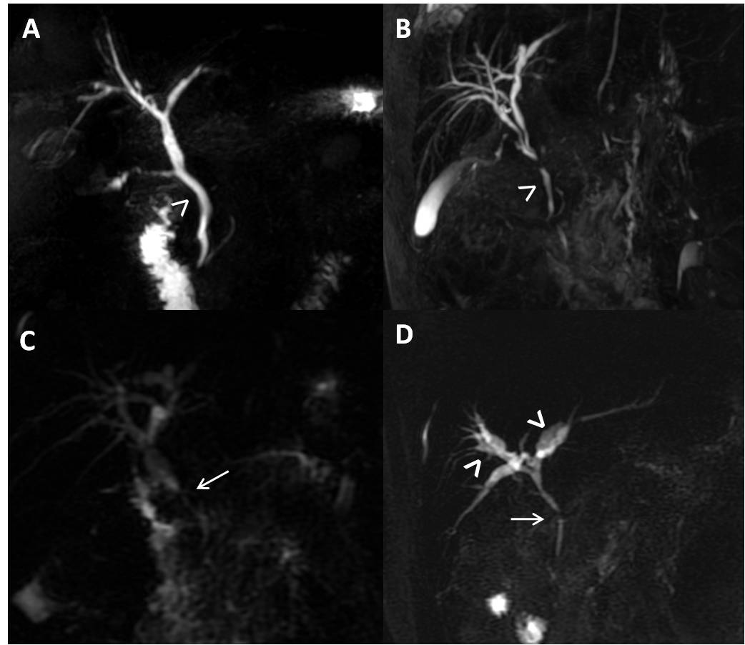Figure 5 Cholelithiasis and choledocholithiasis. A: MR Axial T2W GRE image showing multiple variable sized calculi (arrow) filling the gallbladder; B: Thick-slab two-dimensional MRC image of the same patient depicting additionally choledocholithiasis (arrow). Also note the irregular CBD contour (arrow head) with angulated appearance of suprapancreatic CBD (block arrow) consistent with biliopathy; C: ERC of this patient shows dilated intra and extra-hepatic biliary system (thin arrow) with multiple filling defects (arrow heads) in CBD consistent with calculi; D: Post stone retrieval and biliary stent placement (thin arrow). MRC: Magnetic resonance cholangiography; CBD: Common bile duct; ERC: Endoscopic retrograde cholangiography.
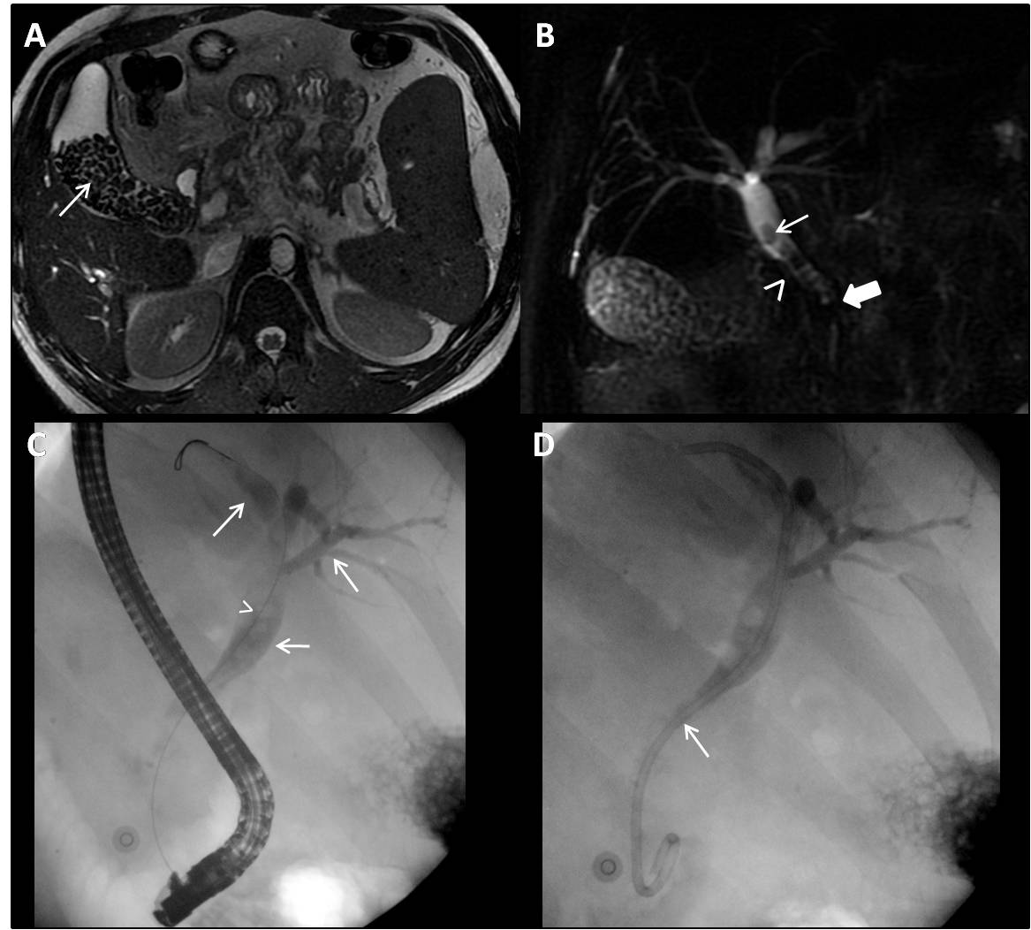Figure 6 Portal biliopathy changes on magnetic resonance cholangiography. Thick-slab two dimensional MRC images showing: A: Extrinsic nodular thumb-like impressions (arrow head) on CBD; B: Fine, wavy irregular contour (arrow head) of CBD; C: Stricture (arrow) in supra-pancreatic CBD with upstream dilatation; D: Angulated CBD (arrow) with smooth contour, patent primary confluence and intra-hepatic biliary ductal dilatation (arrow heads). MRC: Magnetic resonance cholangiography; CBD: Common bile duct.

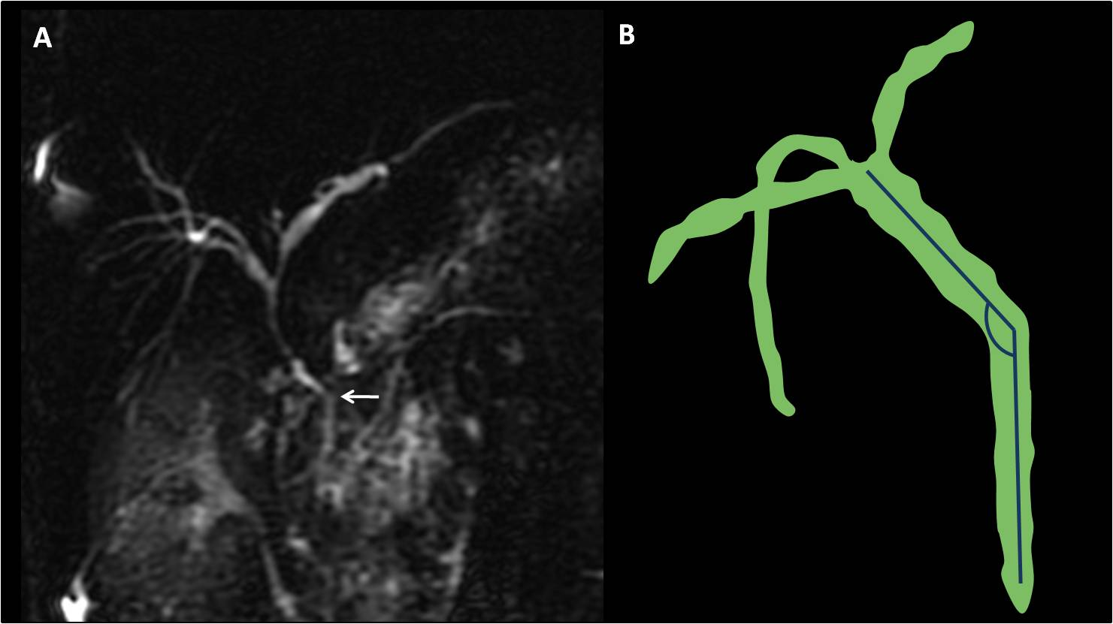Figure 7 Common bile duct angle measurement. A: Thick-slab two dimensional MRC image showing kinking and acute angulation (arrow) of suprapancreatic CBD (110°) in a patient of extrahepatic portal vein obstruction; B: Line is drawn along the long axis of CBD with angle measurement at the level of superior edge of pancreatic head. Lesser the value, greater is the CBD angulation. MRC: Magnetic resonance cholangiography; CBD: Common bile duct.

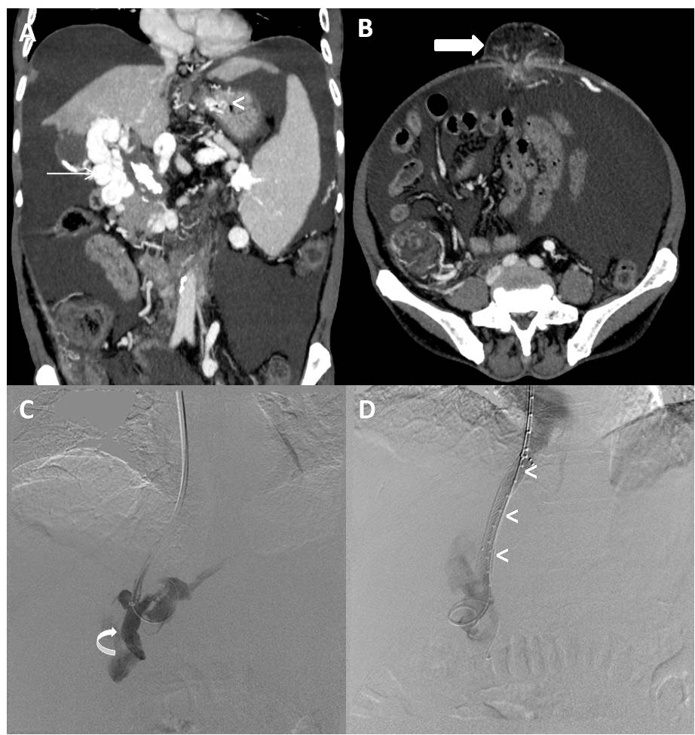Figure 8 Sixty-year-old male patient, a known case of extrahepatic portal vein obstruction with history of recurrent upper gastrointestinal bleed and umbilical hernia, subjected to transjugular intrahepatic portosystemic shunt procedure in order to reduce blood loss during contemplated future surgical repair of umbilical hernia. Maximum intensity projection coronal (A) and axial (B) post contrast CT images showing portal cavernoma (arrow), gastric varices (arrow head) and umbilical hernia (bold arrow). DSA images showing portal venogram (C) after accessing portal vein (curved arrow) through transjugular approach and post TIPS stent deployment (arrow heads), diversion of portal flow into right atrium via hepatic vein (D). TIPS: Transjugular intra-hepatic portosystemic shunt; DSA: Digital substration angiography; CT: Computed tomography.

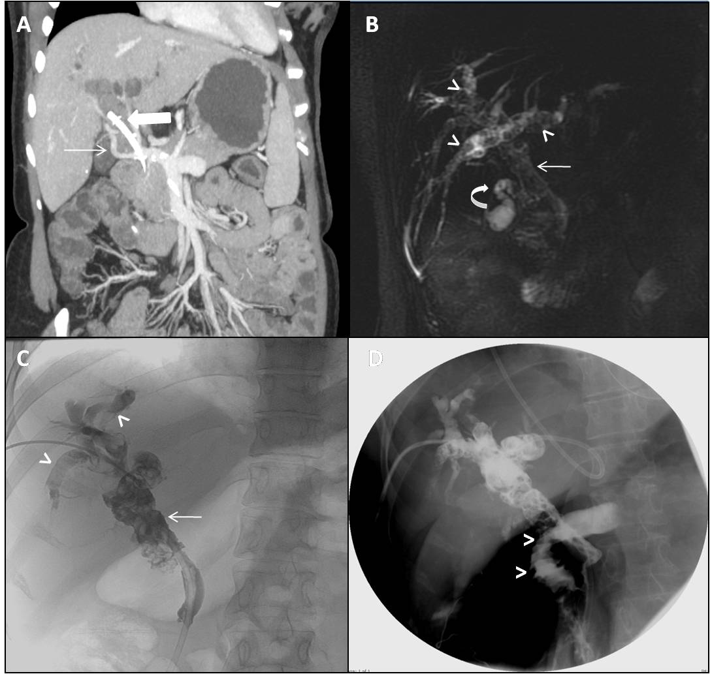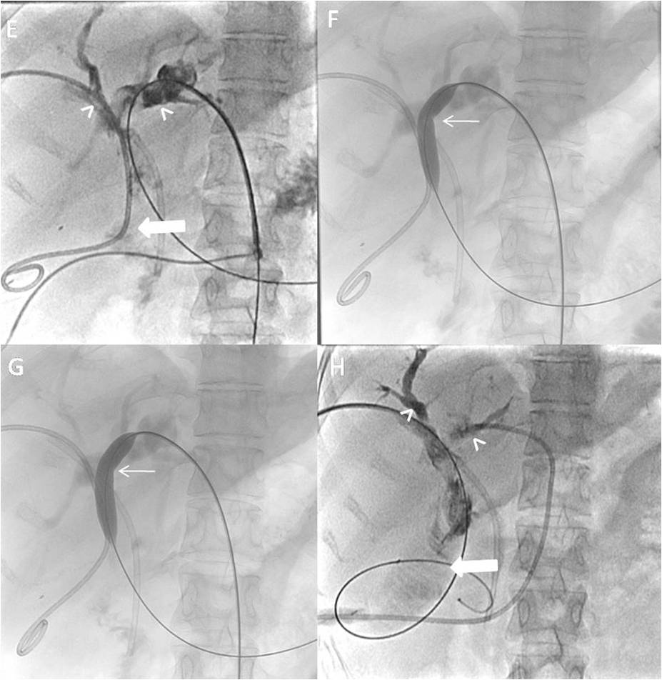
Figure 9 Twenty-five-years-old female, known case of extrahepatic portal vein obstruction with portal cavernoma cholangiopathy. A: Maximum intensity projection post contrast coronal image showing portal cevernoma (arrow) and changes of PCC in the form of bilobar IHBRD with dilated CBD having stent in situ (block arrow); 3D MRCP image (B) and PTC (C) showing dilated CBD with choledocholithiasis (thin arrow), IHBR dilatation with hepatolithiasis (arrow heads) and cholelithiasis (curved arrow); D: Intraoperative cholangiogram after biliary diversion in the form of hepatico-jejunal anastomosis showing free flow of contrast into jejunal lumen (arrow heads); E: Follow-up PTC showing hepatico-jejunostomy anastomotic site stricture (block arrow) with upstream bilobar IHBR dilatation and hepatolithiasis (arrow heads) with faint contrast opacification of jejunal loop (block arrow); F and G: Fluoroscopic spot images showing progressive dilatation of anastomotic site stricture using conventional balloon (thin arrow) with assisted stone clearance; H: Post balloon dilatation and stone clearance, PTC showing relatively better contrast opacification of jejunal loop (block arrow) and relative reduction in amount of IHBRD and hepatolithiasis (arrow heads). CBD: Common bile duct; PCC: Portal cavernoma cholangiopathy; IHBRD: Intrahepatic biliary dilatation; MRCP: Magnetic resonance cholangiopancreatography; PTC: Percutaneous transhepatic cholangiogram.

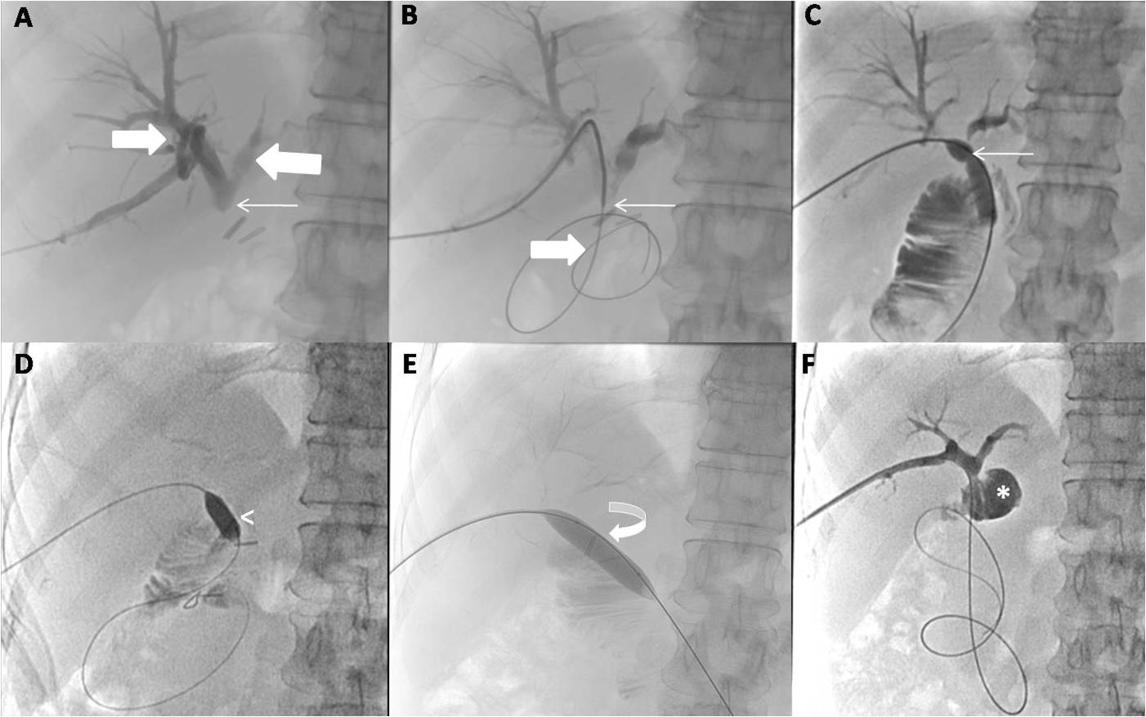Figure 10 Fifty-four-year-old female, known case of extrahepatic portal vein obstruction with portal cavernoma cholangiopathy, status post hepatico-jejunostomy. A: PTC showing complete cut-off at the HJ anastomotic site (thin arrow) with upstream bilobar biliary dilatation (block arrows); B: Fluoroscopic spot image showing the anastomotic site stricture (thin arrow) being negotiated using hydrophilic guide wire (block arrow); C: PTC with the help of conventional balloon showing resistent remant stricture at the anastomotic site in the form of persistent waist (thin arrow); D, E and F: Fluoroscopic spot images during PTC with combined use of cutting balloon (arrow head) and conventional balloon (curved arrow) showing complete disappearance of stricture waist resulting into free flow of contrast into jejunal loop (asterisk). PTC: Percutaneous transhepatic cholangiogram; HJ: Hepatico-jejunostomy.

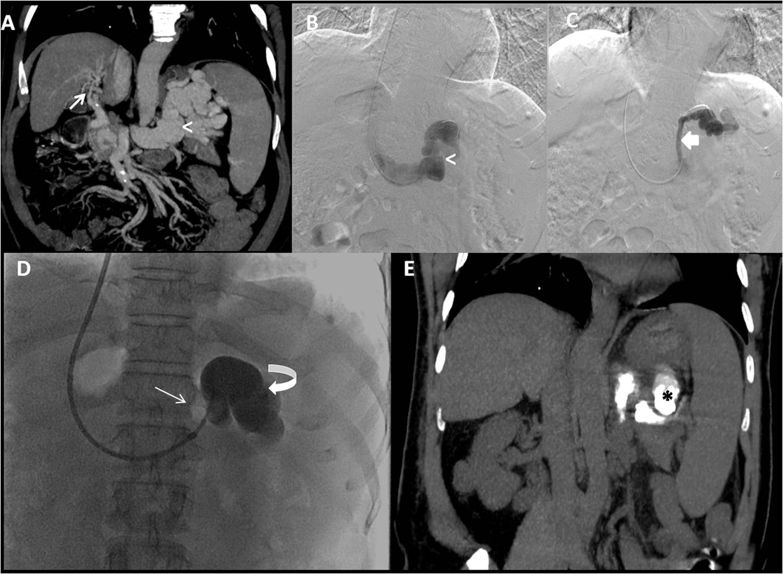Figure 11 A Fifty-year-old male patient, known case of extrahepatic portal vein obstruction with recurrent hepatic encephalopathy and hepatic parkinsonism. Maximum intensity projection coronal post contrast CT image (A) and DSA images (B and C) showing portal cavernoma formation (arrow), a large gastorenal shunt (arrow head) and another small gastrorenal shunt identified within same patient. DSA image (D) showing balloon occluded (thin arrow) retrograde transvenous occlusion (BRTO) of only the large gastrorenal shunt (curved arrow) through transjugular approach with the help of lipoidol-sclerosant foam. Post BRTO, non-contrast CT coronal image showing lipoidol cast (asterisk) within the large gastrorenal shunt (E). BRTO: Balloon occluded trans-venous obliteration; CT: Computed tomography; DSA: Digital substraction angiography.

Table 1 Radiological interventions available to address various changes/ complications in extrahepatic portal vein obstruction
Changes/ complications in EHPVO | Interventions
Vascular changes  PHT resulting in portoportal and porto-venous collaterals and gastro-esophageal varices- massive upper GI bleed | TIPS  PTE
Biliary Changes- PCC  Cholangitis  Choledocholithiasis and hepaticolithiasis  Post-surgical bilio-enteric anastomotic site stricture | PTBD  PTC
Visceral changes  Splenic changes  Hypersplenism | PSE
CNS changes-hepatic encephalopathy  Pre intervention-large spontaneous portosystemic Shunts like spleno-renal shunt and gastro-renal shunt  Iatrogenic porto-systemic shunts  SPSS namely Linton shunt, Warren shunt, Mesocaval shunt, Rex shunt  Endovascular shunts – TIPS | BRTO of porto-systemic shunt  Deliberate reduction/ closure of SRS  Deliberate reduction/ closure of TIPS
Reappearance/ increase in changes of EHPVO secondary to thrombosed/ stenosed SPSS/ TIPS | Shunt revision by PTA directed chemical or mechanical thrombectomy
BRTO: Balloon occluded trans-venous obliteration; EHPVO: Extrahepatic portal vein obstruction; PCC: Portal cavernoma cholangiopathy; PHT: Portal hypertension; PSE: Partial splenic embolization; PTA: Percutaneous transluminal angioplasty; PTBD: Percutaneous trans-hepatic biliary drainage; PTE: Percutaneous transhepatic/ trans-splenic variceal embolization; TIPS: Transjugular intra-hepatic portosystemic shunt; SPSS: Surgical portosystemic shunts; PTC: Percutaneous trans-hepatic cholangioplasty.

Table 2 Various routes for gaining access to portal system during transjugular intra-hepatic portosystemic shunt in patients with extrahepatic portal vein obstruction
Route | Condition/ preffered when
Transjugular | Routinely used
Transhepatic-IPVB is accessed using US guidance | Poor or non- visualization of MPV
Transsplenic-US guide puncture of SV | Failure of US guided puncture of IPVB
Trans-ileocolic-Mini-laparotomy is required to gain access to ileal vein | Failure of all above routes
Trans-RPUV | In combination with above routes to delineate portal tree if LHV-RPUV junction is patent
IPVB: Intrahepatic portal vein branch; MPV: Main portal vein; US: Ultrasound; SV: Splenic vein; RPUV: Recanalised paraumbilical vein; LHV: Left hepatic vein.

