Name of Journal: World Journal of Clinical Pediatrics
Manuscript NO: 36817
Manuscript Type: ORIGINAL ARTICLE

Clinical Practice Study
Outcomes of transconjuctival, sutureless 27 gauge vitrectomy for stage 4 retinopathy of prematurity

Shah PK et al. 27 G vitrectomy for ROP

Parag K Shah, Vishma Prabhu, Venkatapathy Narendran

Parag K Shah, Vishma Prabhu, Venkatapathy Narendran, Department of Pediatric Retina and Ocular Oncology, Aravind Eye Hospital, Coimbatore, Tamil Nadu 641014, India

ORCID number: Parag K Shah (0000-0002-5014-6599); Vishma Prabhu (0000-0001-6845-0209); Venkatapathy Narendran (0000-0003-1201-9801).

Author contributions: All authors equally contributed to this paper with conception and design of the study, literature review and analysis, drafting and critical revision and editing, and final approval of the final version.

Institutional review board statement: This study was reviewed and approved by the Ethics Committee of Aravind Eye Hospital.

Informed consent statement: The participating patient provided informed consent and gave permission for publication.

Conflict-of-interest statement: We have no financial relationships to disclose.

Open-Access: This article is an open-access article, which was selected by an in-house editor and fully peer-reviewed by external reviewers. It is distributed in accordance with the Creative Commons Attribution Non Commercial (CC BY-NC 4.0) license, which permits others to distribute, remix, adapt, build upon this work non-commercially, and license their derivative works on different terms, provided the original work is properly cited and the use is non-commercial. See: http://creativecommons.org/licenses/by-nc/4.0/

Manuscript source: Invited Manuscript

Correspondence to: Dr. Parag K Shah, DNB, Professor, Department of Pediatric Retina and Ocular Oncology, Aravind Eye Hospital, Avinashi Road and Postgraduate Institute of Ophthalmology, Coimbatore, Tamil Nadu 641014, India. parag@cbe.aravind.org
Telephone: +91-422-4360400
Fax: +91-422-2593030

Received: November 2, 2017
Peer-review started: November 2, 2017
First decision: November 30, 2017
Revised: December 3, 2017
Accepted: December 14, 2017
Article in press:
Published online:

Abstract
AIM
To report initial experience of lens sparing vitrectomy for stage 4 retinopathy of prematurity using 27 gauge (G) system.

METHODS
Retrospective case series involving 9 eyes of 5 babies with active stage 4 ROP, who underwent 27 G lens sparing vitrectomy. Surgery was done using 27 G valved cannulas and sclerotomies were made 1.5 mm from limbus. Bilateral sequential vitrectomy was done in eight eyes.

RESULTS
At one year follow up, anatomical outcome was favourable in all 9 eyes (100%). High speed cutting and smaller sclerotomies were helpful in reducing the intra and post-operative complications.

CONCLUSION
27 gauge vitrectomy is well suited for stage 4 ROP surgeries.

Key words: 27 gauge; Retinopathy of prematurity; Vitrectomy

© The Author(s) 2017. Published by Baishideng Publishing Group Inc. All right reserved.

Core tip: It was a retrospective study of 9 eyes of 5 children with active stage 4 retinopathy of prematurity, which underwent 27 gauge micro incision vitrectomy surgeries with excellent outcomes.

Shah PK, Prabhu V, Narendran V. Outcomes of transconjuctival, sutureless 27 gauge vitrectomy for stage 4 retinopathy of prematurity. World J Clin Pediatr 2017; In press
INTRODUCTION
Pars plana vitrectomy was first described by Machemer et al^{[1]} in 1971 when he used the 17 gauge (G) system, where the incisions were > 1 mm in size. Later O'Malley and Heintz^{[2]} introduced the 20 G system where the incisions became 0.9 mm in size. Although this remained the standard of care for almost three decades, the disadvantage was that apart from relatively bulky instruments, it needed conjunctival dissection followed by applications of sutures. A big change was seen when 23 and 25 G small-gauge instrumentation was introduced^{[3,4]}. With thinner instrumentation the incision became smaller, to 0.5 mm and trans-conjunctival entry with sutureless closure became a possibility. This is extremely beneficial in the small eyes of premature neonates^{[5]}. Advent of 27 G vitrectomy with only 0.4 mm incisions has led to a new beginning of transconjuctival microincision vitrectomy surgery (MIVS) in retinopathy of prematurity (ROP). Oshima et al^{[6]} in 2010 was the first to describe safety and feasibility of 27 gauge MIVS system with excellent visual and anatomical outcomes in adults. However its use in ROP is still not established, although Yonekawa et al^{[7]} have reported 25 and 27 G hybrid vitrectomy in complex surgeries including ROP.
The purpose of this study is to describe our initial experience in using 27 G trocar and cannula system in pediatric eyes with Stage 4 ROP.

MATERIALS AND METHODS
This is a retrospective non-comparative case series of 9 eyes of 5 babies. All eyes were with stage 4 ROP. Four babies had bilateral disease and both eyes were operated sequentially under same general anesthesia^{[8]}. Care was taken to rescrub and reperp the surgical field of second eye as done for any new case. The entire team rescrubbed and a new set of surgical instruments were used for each eye. Written informed consent was taken from their parents for the procedure. Ethics committee approval was taken for this study. The study was conducted between January 2015 to December 2015. Patients records were reviewed and the data collected were date of birth, gestational age, birth weight, post conceptional age, post natal age and intra and post-operative status of each eye.
All surgeries were performed under general anesthesia by a single surgeon. All surgeries were performed using the Constellation Vision System with Vitrectomy 27 G Total Plus Vitrectomy Pak system (Alcon Laboratories, Texas, United States). Valved 27 G cannulas were used. The intraocular portions of the 27 G cannula were shortened similar to what has been described by Babu et al^{[9]}. We took a 42 silicon band, which has a width of 4 mm and a thickness of 1.25 mm. The band was divided at 2 mm and again cut in the center to get 2 small pieces of 2 mm x 2 mm each. The trocar and cannula were passed through these pieces till the hub with the help of a toothed forceps. Cannulas were inserted at inferotemporal, superotemporal and superonasal quadrants, 1.5 mm away from the limbus (Figure 1). The conjunctiva and Tenon’s capsule were displaced over the sclera to avoid communication between conjunctival and scleral entry sites.
Trocar cannulas were inserted with a “straight in” (perpendicular to the sclera) or angled (less than 90 degrees to the sclera) approach in a 1-step procedure. First a core vitrectomy is performed using a cutting of 5000 cuts per minute and a suction of 150 mmHg in core mode. Peripheral vitrectomy is done using 7500 cuts per minute with the same suction in shave mode of the machine. After the vitrectomy, partial fluid air exchange was done, the cannulas were removed and sclerotomies were left sutureless after thorough examination for any leakage. Babies were examined on post-operative days 1, 14 and after one month.

RESULTS
Nine eyes of 4 babies were operated during the study period. Mean gestational age of these babies were 29.2 wk (range 28-31 wk). Mean birth weight 1177 g (range 950-1850 g). Mean post conceptional age at the time of surgery was 39 wk (range 36-43 wk) and the mean post natal age was 9.6 weeks (range 6-12 wk). Out of 9 eyes, 7 eyes had stage 4a and 2 eyes with 4b disease. Two eyes of case 1 had ROP in zone 1 while the rest of the eyes were in zone 2. 8 eyes of 4 cases had undergone laser prior to vitrectomy (Table 1). Two eyes of case 1 underwent vitrectomy along with intravitreal injection of Ranibizumab as this case had excessive vascularity. At four month follow up, anatomical success was seen in all 10 eyes (100%) (Figure 2). We did not encounter any post-operative hypotony in any of our cases. No other complications were noted in the follow up period. At averge follow-up of 12 mo, all eyes showed stable regressed ROP.

DISCUSSION
Introduction of 27 G vitrectomy had major concerns with like reduced endoillumination, instrument fragility and reduced flow rate during surgery^{[10]}. Oshima et al^{[6]} in his study describes the various steps taken to improvise the MIVS. This study done in 2010 with 31 adult eyes undergoing vitreoretinal surgeries for epiretinal membrane, macular hole, vitreous hemorrhage, focal tractional retinal detachment and vitreomacular traction also analyzed the duty cycles of cutter, infusion and aspiration rates and the clinical outcome of 27 gauge MIVS. Brighter light sources such as xenon and mercury vapour bulb were used to increase the endoillumination. The smaller gauge did increase the fragility of the cutter during vitrectomy and to avoid this, the shaft of the cutter was reduced from 32 mm to 25 mm, which gives a good rigidity similar to that of a conventional 25 G vitrectomy.
High cutting rates of 27 gauge vitrectomy was proved to be a major advantage as it reduced the risk of iatrogenic damage to the retinal surface and intraoperative retinal tears by preventing uncut vitreous fibers entering the cutter port. Clinically and experimentally it has been proved that high cutting rates reduces retinal traction and thereby the retinal breaks^{[11,12]}.
Post operative complications seen with 23 gauge and 25 gauge like poor wound sealing causing leakage, hypotony and endophthalmitis^{[13-15]} were serious concerns, but 1 step insertion technique in 27 G vitrectomy surgeries avoided these problems. Opening and closing procedures are simplified with 1 step insertion technique, consequently shortening the total operative time. Similarly, Rizzo and associates^{[16]} in 2012 described 27 G vitrectomy in 16 patients and had a good clinical outcome. Additional surgical indications included were rhegmatogenous retinal detachment and tractional retinal detachment. No intraoperative and postoperative complications were encountered and no cases were converted to 23 or 25 G system.
A retrospective case series of 95 adult eyes by Khan et al^{[17]} has been extremely valuable as it includes large sample size of 27 G MIVS operated till date. This study evaluated the change in visual acuity, post operative intraocular pressure (IOP) and the mean operative time by diagnosis. They reported an initial fall in IOP over the first week, and started increasing after day 30. A recently published study of cases with 20, 23 and 25 gauge showed decrease in baseline IOP for over a period of 3 mo and gradual regain^{[18]}. Thus they concluded that IOP regains faster to the baseline value in MIVS.
Our study 27 gauge MIVS in pediatric eyes is the first of its kind and has not been reported till date. The problem of bending of the shaft is minimal as the plus system has a small cuff of metal supporting the base and ROP vitrectomy just needs just a good core vitrectomy with keeping the instruments more perpendicular compared to adults where base shaving may be required. None of our case had hypotony in the post operative period as compared to 5% in a study by Khan et al^{[17]}. However our sample size is much smaller compared to their study. Singh et al^{[19]} showed that the different gauge vitrectomy systems are equally effective and safe. All of our cases were sutureless and at the end of the surgery none developed any wound leak, which is seen in about 0%-7.1% cases of 23 and 25-gauge vitrectomy^{[20-22]}. No sclerotomy related retinal tears were noted while with 23 and 25 gauge vitrectomy 0%-3.1% have been reported.^{[22-25]}
In one case during vitrectomy, the cannula came out along with the vitrectomy cutter, this could have been avoided by carefully removing the cutter. This could be more common in 27 G system compared to 25 G, as Alcon 27 G cannulas are valved and hence get snuggly attached to the instruments. In four babies bilateral simultaneous vitrectomy was performed as all these babies had bilateral acute disease. The anatomical outcome was 100% in our study which is better than previously reported ROP vitrectomies with larger gauges^{[8,26-28]}.
Limitation of our study is small sample size. Thus to summarize, 27-gauge system could be favourable for pediatric cases, since this technique has a favorable wound sealing structure with few postoperative complications and better surgical outcomes. However studies with a larger sample size are needed to substantiate this.

ARTICLE HIGHLIGHTS
Research background
Retinopathy of prematurity (ROP) vitrectomy is challenging due to the altered and more compact structures in a pediatric eye. Hence there is a need to invent smaller vitrectomy instruments to make the outcome of this surgery better. 27 gauge vitrectomy being the smallest gauge available commercially could have the most benefit in pediatric age group.

Research motivation
27 gauge instruments are smaller in size and has capability of high speed cutting, which is ideal for pediatric eyes. Hence this study was conducted to see the feasibility of this instrument in ROP surgery.

Research objectives
The main research objective was to assess the feasibility of 27 gauge vitrectomy for ROP and to see if the ease of surgery and surgical outcomes could be bettered.

Research methods
27 gauge vitrectomy has been reported mainly in adult eyes. Very few studies has explored its use in pediatric age group and especially in ROP. This is one of the few studies which has tried 27 gauge vitrectomy exclusively in stage 4 ROP.

Research results
The results of this study show that sutureless, trans conjuctival 27 gauge vitrectomy has good anatomical outcome in stage 4 ROP.

Research conclusions
27 gauge vitrectomy is beneficial for pediatric eyes. It is safe and effective. This study shows that smaller gauge instruments are most suitable for lens sparing vitrectomy in ROP where the surgical space in very limited with the ever looming danger of damaging the lens anteriorly and the retinal posteriorly. Even with the limited surgical space, it become easier to maneuver with 27 gauge instruments without damaging the critical structures.

Research perspectives
Thus in the future, 27 gauge vitrectomy has the potential to become the standard of care for all ROP related lens sparing vitrectomies.

REFERENCES
1 Machemer R, Buettner H, Norton EW, Parel JM. Vitrectomy: a pars plana approach. Trans Am Acad Ophthalmol Otolaryngol 1971; 75: 813-820 [PMID: 5566980]
2 O'Malley C, Heintz RM Sr. Vitrectomy with an alternative instrument system. Ann Ophthalmol 1975; 7: 585-588, 591-594 [PMID: 1147502]
3 Eckardt C. Transconjunctival sutureless 23-gauge vitrectomy. Retina 2005; 25: 208-211 [PMID: 15689813]
4 Fujii GY, De Juan E Jr, Humayun MS, Chang TS, Pieramici DJ, Barnes A, Kent D. Initial experience using the transconjunctival sutureless vitrectomy system for vitreoretinal surgery. Ophthalmology 2002; 109: 1814-1820 [PMID: 12359600]
5 Gonzales CR, Boshra J, Schwartz SD. 25-Gauge pars plicata vitrectomy for stage 4 and 5 retinopathy of prematurity. Retina 2006; 26: S42-S46 [PMID: 16946678 DOI: 10.1097/01.iae.0000244288.63757.be]
6 Oshima Y, Wakabayashi T, Sato T, Ohji M, Tano Y. A 27-gauge instrument system for transconjunctival sutureless microincision vitrectomy surgery. Ophthalmology 2010; 117: 93-102 [PMID: 19880185 DOI: 10.1016/j.ophtha.2009.06.043]
7 Yonekawa Y, Thanos A, Abbey AM, Thomas BJ, Todorich B, Faia LJ, Williams GA, Capone A Jr, Wolfe JD, Hassan TS. Hybrid 25- and 27-Gauge Vitrectomy for Complex Vitreoretinal Surgery. Ophthalmic Surg Lasers Imaging Retina 2016; 47: 352-355 [PMID: 27065375 DOI: 10.3928/23258160-20160324-08]
8 Shah PK, Narendran V, Kalpana N. Safety and efficacy of simultaneous bilateral 25-gauge lens-sparing vitrectomy for vascularly active stage 4 retinopathy of prematurity. Eye (Lond) 2015; 29: 1046-1050 [PMID: 25998945 DOI: 10.1038/eye.2015.78]
9 Babu N, Shah PK, Narendran V, Kalpana N, Kim R. An easy method to raise the 25-gauge trocar and cannula system for retinopathy of prematurity-related lens-sparing vitrectomy. Retina 2014; 34: 1014-1015 [PMID: 24695066 DOI: 10.1097/IAE.0000000000000128]
10 Thompson JT. Advantages and limitations of small gauge vitrectomy. Surv Ophthalmol 2011; 56: 162-172 [PMID: 21236459 DOI: 10.1016/j.survophthal.2010.08.003]
11 Rizzo S, Genovesi-Ebert F, Belting C. Comparative study between a standard 25-gauge vitrectomy system and a new ultrahigh-speed 25-gauge system with duty cycle control in the treatment of various vitreoretinal diseases. Retina 2011; 31: 2007-2013 [PMID: 21685823 DOI: 10.1097/IAE.0b013e318213623a]
12 Teixeira A, Chong LP, Matsuoka N, Arana L, Kerns R, Bhadri P, Humayun M. Vitreoretinal traction created by conventional cutters during vitrectomy. Ophthalmology 2010; 117: 1387-1392 [PMID: 20176400 DOI: 10.1016/j.ophtha.2009.11.004]
13 Woo SJ, Park KH, Hwang JM, Kim JH, Yu YS, Chung H. Risk factors associated with sclerotomy leakage and postoperative hypotony after 23-gauge transconjunctival sutureless vitrectomy. Retina 2009; 29: 456-463 [PMID: 19174725 DOI: 10.1097/IAE.0b013e318195cb28]
14 Shimada H, Nakashizuka H, Hattori T, Mori R, Mizutani Y, Yuzawa M. Incidence of endophthalmitis after 20- and 25-gauge vitrectomy causes and prevention. Ophthalmology 2008; 115: 2215-2220 [PMID: 18930557 DOI: 10.1016/j.ophtha.2008.07.015]
15 Byeon SH, Lew YJ, Kim M, Kwon OW. Wound leakage and hypotony after 25-gauge sutureless vitrectomy: factors affecting postoperative intraocular pressure. Ophthalmic Surg Lasers Imaging 2008; 39: 94-99 [PMID: 18435331]
16 Rizzo S, Barca F, Caporossi T, Mariotti C. Twenty-seven-gauge vitrectomy for various vitreoretinal diseases. Retina 2015; 35: 1273-1278 [PMID: 25946694 DOI: 10.1097/IAE.0000000000000545]
17 Khan MA, Shahlaee A, Toussaint B, Hsu J, Sivalingam A, Dugel PU, Lakhanpal RR, Riemann CD, Berrocal MH, Regillo CD, Ho AC. Outcomes of 27 Gauge Microincision Vitrectomy Surgery for Posterior Segment Disease. Am J Ophthalmol 2016; 161: 36-43 [PMID: 26429584 DOI: 10.1016/j.ajo.2015.09.024]
18 Mi CW, Thompson JT. Long-term follow-up of intraocular pressure after vitrectomy in eyes without preexisting glaucoma. Retina 2015; 35: 2543-2551 [PMID: 26035511 DOI: 10.1097/IAE.0000000000000641]
19 Singh RP, Bando H, Brasil OF, Williams DR, Kaiser PK. Evaluation of wound closure using different incision techniques with 23-gauge and 25-gauge microincision vitrectomy systems. Retina 2008; 28: 242-248 [PMID: 18301029 DOI: 10.1097/IAE.0b013e318156dea3]
20 Lakhanpal RR, Humayun MS, de Juan E Jr, Lim JI, Chong LP, Chang TS, Javaheri M, Fujii GY, Barnes AC, Alexandrou TJ. Outcomes of 140 consecutive cases of 25-gauge transconjunctival surgery for posterior segment disease. Ophthalmology 2005; 112: 817-824 [PMID: 15878061 DOI: 10.1016/j.ophtha.2004.11.053]
21 Ibarra MS, Hermel M, Prenner JL, Hassan TS. Longer-term outcomes of transconjunctival sutureless 25-gauge vitrectomy. Am J Ophthalmol 2005; 139: 831-836 [PMID: 15860288 DOI: 10.1016/j.ajo.2004.12.002]
22 Fine HF, Iranmanesh R, Iturralde D, Spaide RF. Outcomes of 77 consecutive cases of 23-gauge transconjunctival vitrectomy surgery for posterior segment disease. Ophthalmology 2007; 114: 1197-1200 [PMID: 17544779 DOI: 10.1016/j.ophtha.2007.02.020]
23 Gupta OP, Ho AC, Kaiser PK, Regillo CD, Chen S, Dyer DS, Dugel PU, Gupta S, Pollack JS. Short-term outcomes of 23-gauge pars plana vitrectomy. Am J Ophthalmol 2008; 146: 193-197 [PMID: 18547538 DOI: 10.1016/j.ajo.2008.04.010]
24 Jalil A, Ho WO, Charles S, Dhawahir-Scala F, Patton N. Iatrogenic retinal breaks in 20-G versus 23-G pars plana vitrectomy. Graefes Arch Clin Exp Ophthalmol 2013; 251: 1463-1467 [PMID: 23504085 DOI: 10.1007/s00417-013-2299-2]
25 Scartozzi R, Bessa AS, Gupta OP, Regillo CD. Intraoperative sclerotomy-related retinal breaks for macular surgery, 20- vs 25-gauge vitrectomy systems. Am J Ophthalmol 2007; 143: 155-156 [PMID: 17188054 DOI: 10.1016/j.ajo.2006.07.038]
26 Bhende P, Gopal L, Sharma T, Verma A, Biswas RK. Functional and anatomical outcomes after primary lens-sparing pars plana vitrectomy for Stage 4 retinopathy of prematurity. Indian J Ophthalmol 2009; 57: 267-271 [PMID: 19574693 DOI: 10.4103/0301-4738.53050]
27 Kychenthal A, Dorta P. 25-gauge lens-sparing vitrectomy for stage 4A retinopathy of prematurity. Retina 2008; 28: S65-S68 [PMID: 18317348 DOI: 10.1097/IAE.0b013e318159ec49]
28 El Rayes EN, Vinekar A, Capone A Jr. Three-year anatomic and visual outcomes after vitrectomy for stage 4B retinopathy of prematurity. Retina 2008; 28: 568-572 [PMID: 18398359 DOI: 10.1097/IAE.0b013e3181610f97]

P-Reviewer: Stewart MW S-Editor: Cui LJ L-Editor: E-Editor:

Specialty type: Pediatrics
Country of origin: India
Peer-review report classification
Grade A (Excellent): 0
Grade B (Very good): 0
Grade C (Good): C
Grade D (Fair): 0
Grade E (Poor): 0

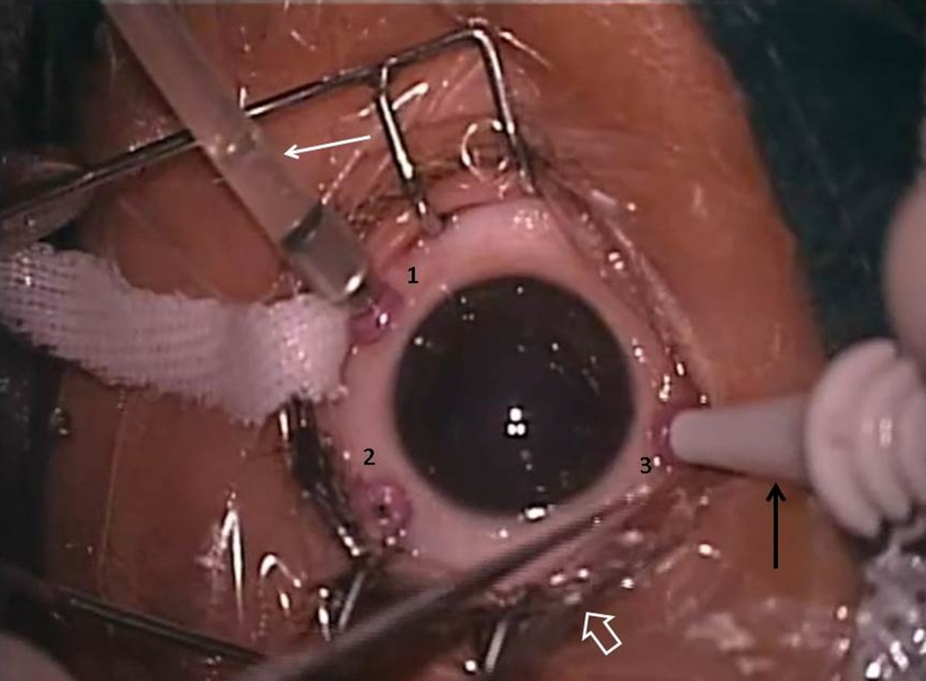

Figure 1 Intraoperative picture of left eye. The three sclerotomies 1.5 mm from limbus are labeled as 1 (infero temporal port), 2 (supero temporal port) and 3 (supero nasal port) of 27 gauge vitrectomy system. The white solid arrow shows the infusion tube through which balanced salt solution flows and maintains in intra ocular pressure. The black arrow shows the trocar handle inserting the last supero nasal port. The white outline arrow shows the tip of corneal forceps.

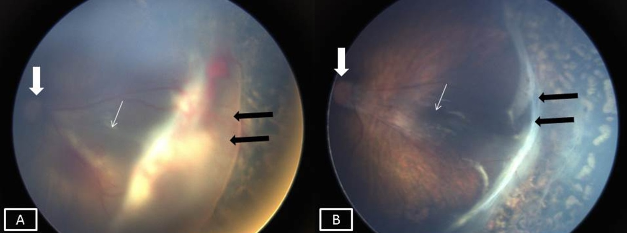

Figure 2 Anatomical success was seen in all 10 eyes at 4 mo follow-up. A: Preoperative picture of left eyes showing stage 4 A ROP with partial retinal detachment (black arrows), optic disc is shown by the think white arrow and fovea with the thin white arrow; B: Post-operative picture of same eye showing settled retinal detachment with residual fibrous tissue (black arrows), The optic disc and fovea are shown by the thick and thin white arrows respectively.

Table 1 Baseline characteristics and final outcome of the cases
Case No | GA  (wk) | BW (gm) | PCA  (wk) | Eye | Zone | Stage | Preoperative  laser | Intraoperative  Anti-VEGF | Final outcome
1 | 30 | 1100 | 36 | RE | 1 | 4a | Y | Y | F
 |  |  |  | LE | 1 | 4a | Y | Y | F
2 | 31 | 950 | 43 | RE | 2 | 4a | Y | N | F
 |  |  |  | LE | 2 | 4a | Y | N | F
3 | 28 | 1000 | 37 | RE | 2 | 4b | Y | N | F
 |  |  |  | LE | 2 | 4a | Y | N | F
4 | 28 | 1850 | 38 | RE | 2 | 4a | Y | N | F
 |  |  |  | LE | 2 | 4a | Y | N | F
5 | 29 | 985 | 41 | RE | 2 | 4b | N | N | F

GA: Gestational age; BW: Birth weight; PCA: Post conceptional age; RE: Right eye; LE: Left eye; F: Favourable.

