Name of Journal: World Journal of Critical Care Medicine
Manuscript NO: 62715
Manuscript Type: EDITORIAL

New Year's greeting and overview of World Journal of Critical Care Medicine in 2021

Wang LL. New Year’s greeting and overview of WJCCM in 2021

Li-Li Wang

Li-Li Wang, Production Department, Baishideng Publishing Group Inc, Pleasanton, CA 94566, United States

Author contributions: Wang LL contributed to drafting and revising of the manuscript.

Corresponding author: Li-Li Wang, MSc, Director, Production Department, Baishideng Publishing Group Inc, 7041 Koll Center Parkway, Suite 160, Pleasanton, CA 94566, United States. l.l.wang@wjgnet.com

Received: January 16, 2021
Revised: March 17, 2021
Accepted: April 26, 2021
Published online:

Abstract
As editors of World Journal of Critical Care Medicine (WJCCM), it is our great pleasure to take this opportunity to wish all our authors, subscribers, readers, Editorial Board members, independent expert referees, and staff of the Editorial Office a Very Happy New Year. On behalf of the Editorial Team, we would like to express our gratitude to all authors who have contributed their valuable manuscripts and to the independent referees and our subscribers and readers for their continuous support, dedication, and encouragement. The excellent team effort by our editorial board members and staff of the Editorial Office allowed WJCCM to advance remarkably in 2020. In the future, the Baishideng Publishing Group and WJCCM’s editorial board will continue to increase their communication and collaboration, both internally and involving our external contributors, in order to promote our collective impact on the field of Critical Care Medicine even further.

Key Words: Acknowledgments; Editorial members; World Journal of Critical Care Medicine; Baishideng Publishing Group; Journal development

Wang LL. New Year's greeting and overview of World Journal of Critical Care Medicine in 2021. World J Crit Care Med 2021; In press

Core Tip: As editors of the World Journal of Critical Care Medicine (WJCCM) and in view of the achievements of this journal in 2020, we take this opportunity to wish all our authors, subscribers, readers, Editorial Board members, independent expert referees, and staff of the Editorial Office a Very Happy New Year and express our gratitude to your collective and individual contributions and support. In the future, the Baishideng Publishing Group and the WJCCM’s editorial board will continue to work to strengthen further communication and cooperation within the field of critical care medicine and emergency medicine, while simultaneously promoting the development of WJCCM to a new level.

INTRODUCTION
First of all, we, on behalf of all editors of the Baishideng Publishing Group (BPG), extend our sincere gratitude to you for your contributions to the World Journal of Critical Care Medicine (WJCCM) in 2020. We wish you a Happy New Year!
In 2020, BPG routinely published 47 open-access journals, including 46 English-language journals and one Chinese-language journal. Our successes were accomplished through the collective dedicated efforts of BPG staff and Editorial Board Members, such as yourself. BPG’s Editorial Board Members number 3136, and Peer Reviewers number 29039.

ACADEMIC INFLUENCE OF WJCCM
As one of the key developing journals of BPG, WJCCM was founded in 2012 as a high-quality, online, open-access, single-blind, peer-reviewed journal published by the Baishideng Publishing Group^{[1]}. The journal has a total of 31 official editorial board members^{[2]}, and their country distribution is shown in Figure 1. WJCCM mainly publishes articles reporting research results obtained in the field of critical care medicine and covering a wide range of topics, including acute kidney failure, acute respiratory distress syndrome and mechanical ventilation, application of bronchofiberscopy in critically ill patients, cardiopulmonary cerebral resuscitation, coagulant dysfunction, continuous renal replacement therapy, fluid resuscitation and tissue perfusion, hemodynamic monitoring and circulatory support, intensive care unit management and treatment control, infection and anti-infection treatment, rational nutrition and immunomodulation in critically ill patients, sedation and analgesia, severe infection, and shock and multiple organ dysfunction syndrome. While we are celebrating WJCCM’s 9-year anniversary, we are very proud to share with you that since its launch, WJCCM has published 155 articles (Figure 2). Among these, the total cites is 1738, and the average cites per article is 11.21 (Figure 3). The current number of total visits to the WJCCM homepage is about 370000, of which 20.6% of those visits have been from the United States, 17.7% from Bosnia and Herzegovina, and 9.6% from China. The specific traffic data and download statistics are shown in Figure 4A and B. The WJCCM is now abstracted and indexed in PubMed, PubMed Central, China National Knowledge Infrastructure, China Science and Technology Journal, and Superstar Journals databases^{[2]}. BPG will be submitting an application to Clarivate Analytics in 2022, with anticipation of it being abstracted and indexed in the Science Citation Index Expanded.
In 2020, WJCCM received a total of 23 manuscripts from authors around the world for consideration of publication and published nine articles^{[3]}. The distribution of published manuscripts by type is shown in Figure 5. The distribution of authors of published articles by country/territory is shown in Figure 6.
In the last month of 2020, we received 68 manuscripts for consideration for publication in 2021 following successful completion of peer-review. The specific types and number of manuscripts received are shown in Figure 7A and B. As a global academic journal in critical care medicine, our authors hail from various countries and regions, reflecting a diversified contribution to the field that is embodied within an optimized platform to promote worldwide medical research sharing and exchange.
All the good achievements that were made in the past year are inseparable from the dedication of our authors, subscribers, readers, Editorial Board members, independent expert referees, and staff of the WJCCM’s Editorial Office. To date, WJCCM has 31 official editorial board members. We hope that each WJCCM Editorial Board Member will continue to conduct high-quality peer reviews for WJCCM in 2021 and support WJCCM’s mission of publishing high-quality articles that will make substantive contributions to the development of basic medical and clinical research. Meanwhile, we hope that every expert in the field of critical care medicine will contribute more articles to support our efforts towards that end. We look forward to more outstanding experts and scholars actively applying to become members of our editorial department. As always, all peer review experts are urged to review each manuscript in a timely manner.

CONCLUSION
It is with your great support that we expect to be more productive and to be able to raise the academic rank of WJCCM even higher in 2021. In order to achieve these goals, we appreciate the continuous support and submissions from authors and the dedicated efforts and expertise by our invited reviewers, many of who also serve on our editorial board. The Editors-in-Chief will continue to strive to work with the journal’s Editorial Office staff to make the manuscript submission process as simple as possible and to ensure efficient communication with the authors, providing professional support and answering their questions. Ultimately, we will remain open to any suggestions that could improve WJCCM’s operation and publication. Please feel free to contact us (editorialoffice@wjgnet.com) if any question on your personal submission arises or you have any suggestions.
Once again, on behalf of WJCCM, we wish you and your families the best for the New Year.

REFERENCES
1 Baishideng Publishing Group. The home page of World Journal of Critical Care Medicine. Available from: https://www.wjgnet.com/2220-3141/index.htm
3 Baishideng Publishing Group. Editorial Board Members. Available from: https://www.wjgnet.com/2218-4333/editorialboard.htm
3 PubMed Central. World Journal of Critical Care Medicine. Available from: https://www.ncbi.nlm.nih.gov/pmc/journals/2372/

Footnotes
Conflict-of-interest statement: No conflict of interest.

Open-Access: This article is an open-access article that was selected by an in-house editor and fully peer-reviewed by external reviewers. It is distributed in accordance with the Creative Commons Attribution NonCommercial (CC BY-NC 4.0) license, which permits others to distribute, remix, adapt, build upon this work non-commercially, and license their derivative works on different terms, provided the original work is properly cited and the use is non-commercial. See: http://creativecommons.org/Licenses/by-nc/4.0/

Manuscript source: Invited manuscript

Peer-review started: January 16, 2021
First decision: March 8, 2021
Article in press:

Specialty type: Critical Care Medicine
Country/Territory of origin: United States
Peer-review report’s scientific quality classification
Grade A (Excellent): A
Grade B (Very good): 0
Grade C (Good): 0
Grade D (Fair): 0
Grade E (Poor): 0

P-Reviewer: Li FX S-Editor: Wang JL L-Editor: Filipodia P-Editor:
Figure Legends
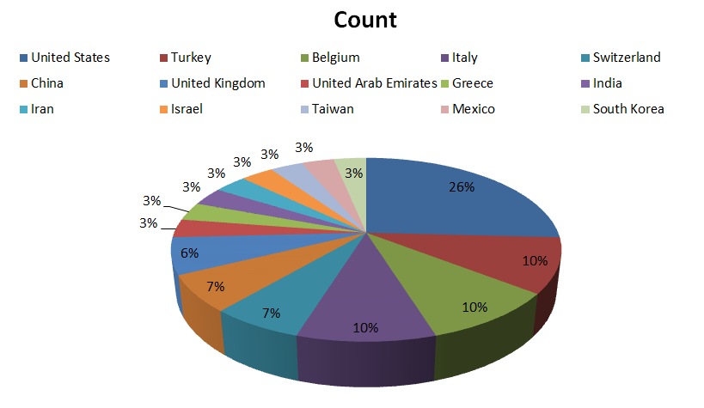
Figure 1 Distribution of Editorial Board members’ countries for World Journal of Critical Care Medicine.

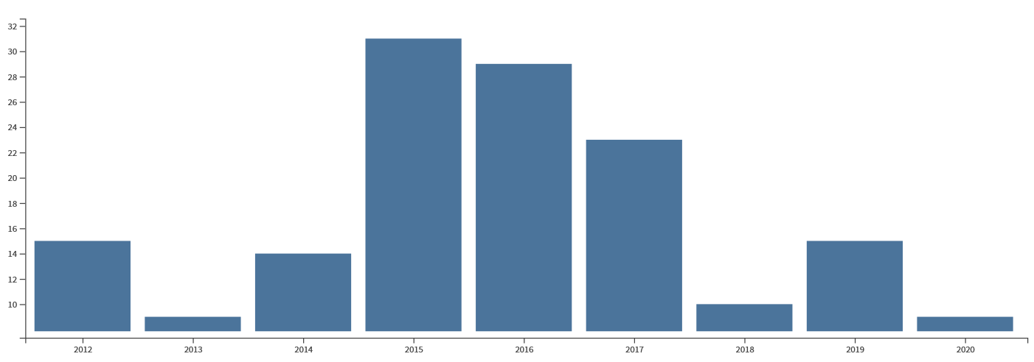
Figure 2 Analysis of the number of articles published since 2012.

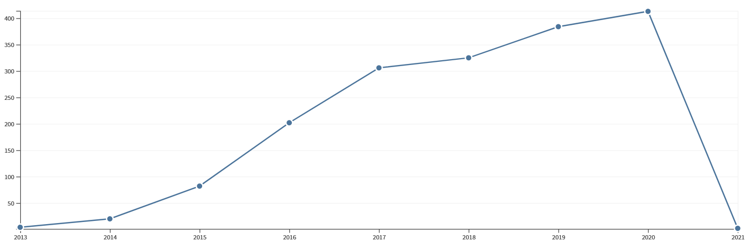
Figure 3 According to the year of publication, the citation frequency of the article.

A
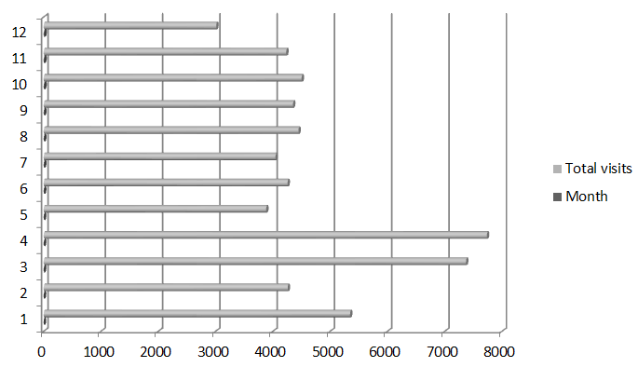
B
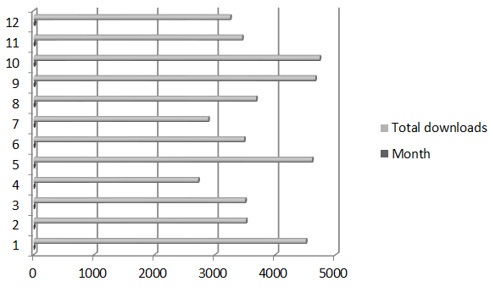
Figure 4 Number of total visits to the World Journal of Critical Care Medicine homepage and number of total downloads to the World Journal of Critical Care Medicine articles in 2020. A: Total visits; B: Total downloads.
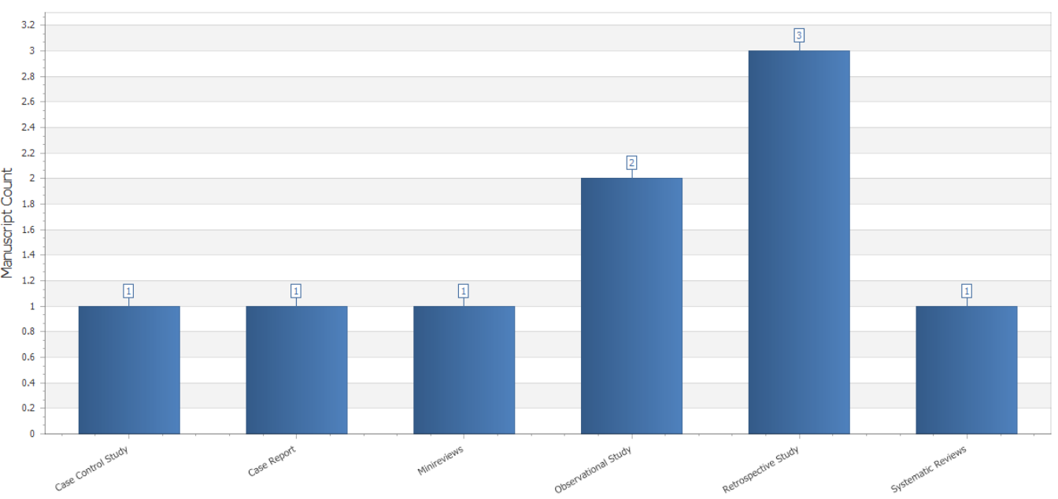
Figure 5 Column type distribution of manuscripts published in World Journal of Critical Care Medicine in 2020.

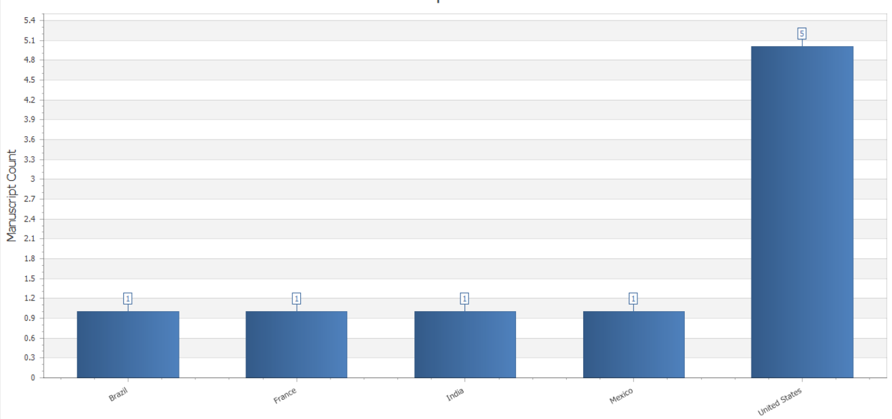
Figure 6 Distribution of authors’ countries for the manuscripts published in World Journal of Critical Care Medicine in 2020.

A
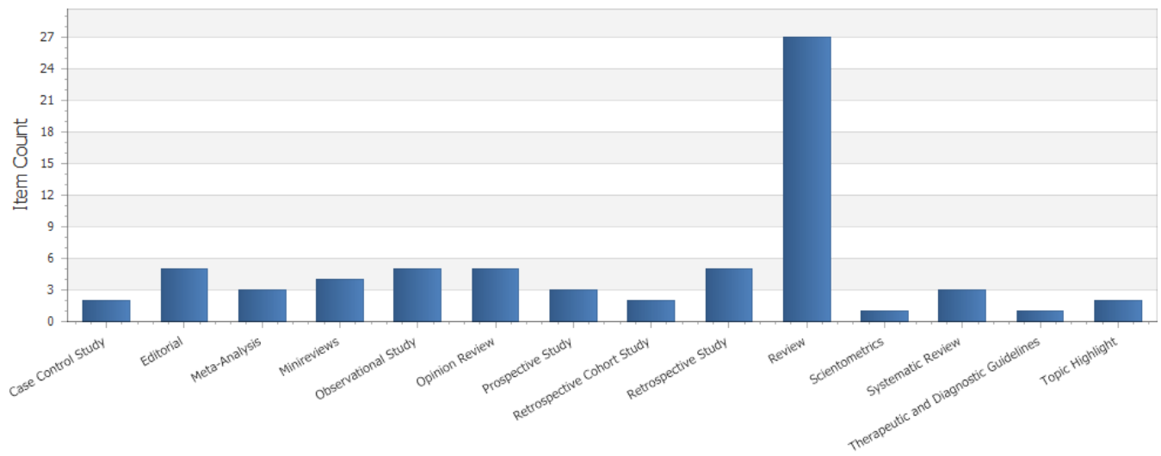
B
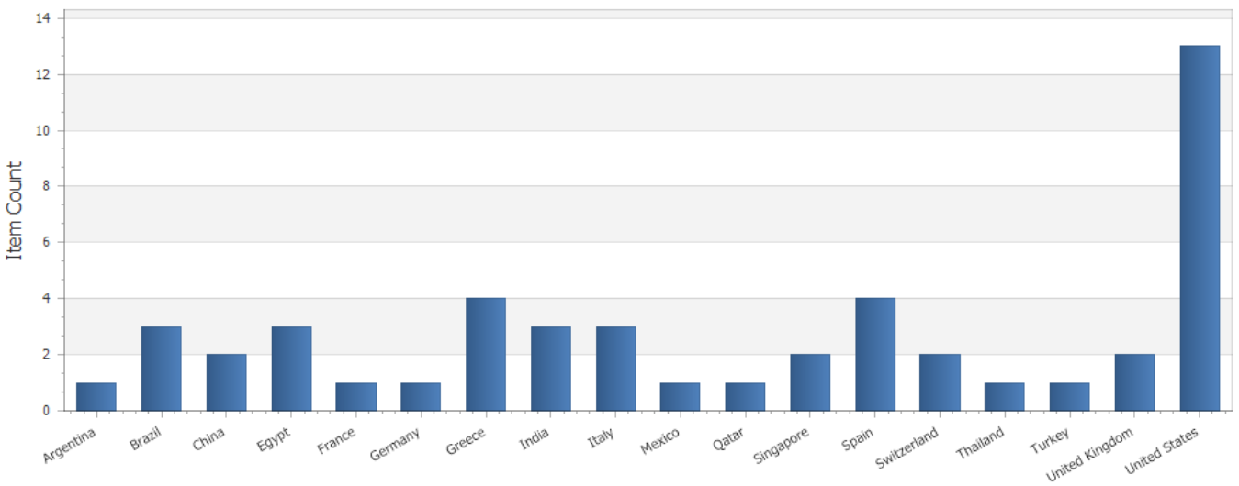
Figure 7 Bibliographic data for articles received by the World Journal of Orthopedics in the last month of 2020. A: Article types; B: Authors’ countries.

