Name of Journal: World Journal of Clinical Oncology
Manuscript NO: 45698
Manuscript Type: META-ANALYSIS

The metastatic potential and prognostic significance of SOX2: A meta-analysis

Javaeed A et al. SOX2 expression in metastasis

Arslaan Javaeed, Sanniya Khan Ghauri

Arslaan Javaeed, Department of Pathology, Poonch Medical College, Azad Kashmir, Rawalakot 1235, Pakistan

Sanniya Khan Ghauri, Department of Emergency Medicine, Shifa International Hospital, Islamabad, 44000, Pakistan

ORCID number: Arslaan Javaeed (0000-0002-8089-4221); Sanniya Khan Ghauri (0000-0002-5264-7709).

Author contributions: Javaeed A performed the literature search, study design and conception and data extraction, and provided final approval of the manuscript; Ghauri SK performed the data extraction, analysis and interpretation of the data, and drafting of the manuscript.

Conflict-of-interest statement: The authors declare no conflicts of interest.

PRISMA 2009 Checklist statement: The authors have read the PRISMA 2009 Checklist, and the manuscript was prepared and revised according to the PRISMA 2009 Checklist.

Open-Access: This article is an open-access article which was selected by an in-house editor and fully peer-reviewed by external reviewers. It is distributed in accordance with the Creative Commons Attribution Non Commercial (CC BY-NC 4.0) license, which permits others to distribute, remix, adapt, build upon this work non-commercially, and license their derivative works on different terms, provided the original work is properly cited and the use is non-commercial. See: http://creativecommons.org/licenses/by-nc/4.0/

Manuscript source: Unsolicited manuscript

Corresponding author: Arslaan Javaeed, MBBS, MPhil, MSc, Assistant Professor, Department of Pathology, Poonch Medical College, Azad Kashmir, Rawalakot 1235, Pakistan. arslaanjavaeed@yahoo.com
Telephone: +92-300-4717057

Received: January 21, 2019
Peer-review started: January 21, 2019
First decision: March 15, 2019
Revised: March 31, 2019
Accepted: April 8, 2019
Article in press:
Published online:
Abstract
BACKGROUND
SOX2 is a regulator of pluripotent cellular transcription, yet it has been recently integrated in cancer biology. The present study provides an analytic insight into the correlation of SOX2 overexpression with cancer metastasis and patient survival.

AIM
To investigate the association of SOX2 overexpression with metastasis and its implication in the prognosis of cancer patients.

METHODS
A meta-analysis was conducted including studies that compared the association of low or high SOX2 expression with lymph node metastasis (LNM) and/or distant metastasis (DM). The following data were additionally extracted: survival, including the overall survival (OS) and disease-free survival (DFS), and prevalence of high and low SOX2 expression. Odds ratios (commonly known as ORs) and their respective 95% confidence intervals (CIs) were used to investigate the association between SOX2 expression and LNM and DM, while hazard ratios (commonly known as HRs) and 95%CIs were applied to evaluate the prognostic markers.

RESULTS
In a total of 2643 patients (60.88% males), the pooled prevalence of SOX2 overexpression was 46.22% (95%CI: 39.07%-53.38%) in different types of cancer. SOX2 overexpression significantly correlated with DM (OR = 1.79, 95%CI: 1.20-3.25, P < 0.008) compared to low SOX2 expression. In subgroups analyses, a high SOX2 expression was associated with LNM in cancers of the lung, breast, and colon and associated with DM in hepatic, head and neck, and colon cancers. SOX2 overexpression was also associated with a shorter OS (HR = 1.65, 95%CI: 1.34-2.04, P < 0.001) and DFS (HR = 1.54, 95%CI: 1.14-2.08, P = 0.005).

CONCLUSION
A remarkable role of SOX2 overexpression was observed in cancer biology and metastasis. However, many questions in the regulatory pathways need to be addressed to reveal as many functional aspects as possible to tailor new targeted therapeutic strategies.

Key words: Tumor progression; SOX2; Cancer; Cancer stem cell markers; Lymphatic metastasis

© The Author(s) 2019. Published by Baishideng Publishing Group Inc. All rights reserved.

Core tip: SOX2 overexpression is associated with both lymph node and distant metastasis predominantly in cancers of the colon and head and neck. Targeting the biological pathways of SOX2 seems to provide a promising rationale for developing relevant therapeutic interventions.

Javaeed A, Ghauri SK. The metastatic potential and prognostic significance of SOX2: A meta-analysis. World J Clin Oncol 2019; In press

INTRODUCTION
The mechanisms by which the metastatic cascade is instigated and developed have merited the attention of the researchers worldwide. Tumor metastasis involves a sequential process, comprising cell invasion through the basement membrane and extracellular matrix followed by intravasation to access the vascular or lymphatic circulation, extravasation out of the circulatory system, and eventually distant localization and proliferation^{[1]}. Failure to manage distant dissemination of cancer cells causes a significant mortality burden, with approximately 1500 cancer spread-related deaths reported daily^{[2]}. A plethora of studies has been conducted on animal models to outline the metastatic phenotype. These studies usually employ intravenous injections for metastatic initiation. However, such an approach lacks the appropriate characterization of the origin of metastasis and, thus, multiple triggering factors are either still hypothesized or their contribution in metastasis is not fully delineated.
Of these factors, the transcription factor sex determining region Y-box 2 (SOX2) has been recently integrated in cancer biology^{[3]}. SOX2 is one of the SOX proteins that has ≥ 50% similarity in the amino acid structure to a specific domain (HMG domain) of the sex-determining region located on the Y chromosome (Sry)^{[4]}. The encoding gene was initially discovered in 1994 in human, being located on chromosome 3q26.3–q27^{[5]}. Heterozygous mutations of the SOX2 gene result in the development of anophthalmia syndrome, which includes an aberrant development of endodermal and ectodermal tissues^{[6]}. SOX2 is an important regulator of pluripotent cellular transcription and is a crucial factor implicated in the development and maintenance of undifferentiated embryonic stem cells. Besides, it contributes to somatic cell reprogramming back towards pluripotent features and this process was shown to be co-induced by ectopic expression of cMyc, Klf4, and Oct4^{[3]}.
Intriguingly, this discovery highlighted the role of SOX2 expression in different types of cancers. SOX2 gene amplification or increased expression has been demonstrated in malignancy, yet its involvement in the most important aspects of patient survival and metastasis remains relatively unclear. Herein, we provide analytic insight into the association between metastasis and SOX2 expression in cancer patients, along with its relation to the prognostic profile.

MATERIALS AND METHODS
A meta-analysis was conducted on studies that investigated the relationship between development of a metastatic phenotype as well as the prognostic significance of such expression. The general outline of the study was based on the guidelines in the Preferred Reporting Items for Systematic Reviews and Meta-Analyses (commonly known as PRISMA)^{[7]}.

Eligibility criteria
The included studies investigated at least the association of SOX2 expression, reported as “low” or “high” expression levels, and either lymph node metastasis (LNM) or distant metastasis (DM). When appropriate, patients’ prognosis should have been evaluated using survival analysis, where the overall survival (OS) and/or disease-free survival (DFS) were reported. Only peer-reviewed studies conducted on male or female human patients were considered. The cancer patients should have been diagnosed using pathological examinations. Studies were excluded if they provided insufficient data to be extracted or had employed animal subjects solely. Furthermore, non-English articles, case reports, reviews and cell experiments were omitted.

Information sources
The following scientific databases were used for the search process: MEDLINE, Embase, Cochrane Library, and Google Scholar. Additionally, the bibliographies of the screened articles were thoroughly searched for eligible studies.

Search strategy
Two authors performed the search process using the following key words: (“transcription factor sex determining region Y-box 2” OR “SOX2”) AND (“cancer” OR “metastasis”) AND (“prognosis” OR “survival” OR “hazard”). The publication dates of the included studies were limited to those articles published between 2010 and 2018, to attain the most recent evidence. Screening of the titles and abstracts was performed and the relevant articles were obtained for subsequent assessment of the full-texts. Any disagreement was resolved by discussion.

Data collection
A specifically-designated form was used in Microsoft Excel spreadsheet software (version 2016) to extract data. The extracted data for each study were categorized into four main categories: (1) study and patients’ characteristics, including the name of the first author, publication date, methods of detection of SOX2 expression, method of survival analysis, reported outcomes, number of samples, type of primary cancer, sex of patients, frequency of SOX2 expression (low or high), and clinical stage (I and II or III and IV); (2) primary outcomes, including the frequency of reported samples with low or high SOX2 expression in the regional lymph nodes (i.e. LNM) or distant organs (i.e. DM); (3) clinicopathological parameters, including SOX2 expression levels according to patients’ age, sex, clinical stage, and tumor size and differentiation; (4) prognostic data, including direct extraction of the hazard ratios (HRs) and their respective 95% confidence intervals (CIs) of the OS and/or DFS. When both univariate and multivariate analyses were used for survival analysis, multivariate tests were preferentially used.

Quality assessment
A specialized scale for quality assessment was used [i.e. Newcastle-Ottawa scale (commonly known as NOS)]^{[8]}, which employs a scoring system comprising nine items and yielding a total score of 0 to 9 for low-quality to high-quality articles, respectively. The assignment of such scores is based on the selection, comparability, and outcomes of the groups under investigation. A score of ≥ 6 indicated a high-quality study.

Statistical analysis
The following formula was used for calculation of the prevalence rate of high SOX2 expression: (number of samples with high SOX2 expression/total number of samples) × 100; the standard error and 95%CIs were calculated as described previously^{[9]}. The RevMan 5.3 software was used for statistical analysis (Review Manager, the Cochrane Collaboration, Oxford, United Kingdom). For dichotomous data (e.g., LNM, DM and clinicopathological data), odds ratios (ORs) and their respective 95%CIs were applied. Regarding prognostic markers (OS and DFS), HRs and their respective 95%CIs were integrated in the meta-analysis. Statistical heterogeneity was assessed using the I² statistical test, which was interpreted as a significant heterogeneity at I² > 50%. In such instance, a random effects model was applied. On the other hand, a fixed effects model was used when the heterogeneity was insignificant. Subgroup analyses were performed according to sample size, the type of primary cancer, and quality score.

RESULTS
Results of the search process
Figure 1 shows the outcomes of the employed search process. The initial search yielded a total of 1120 records, from which 45 records were considered duplicates, while an additional 5 records were identified from the bibliographies of the resultant records. Therefore, 1080 records were screened for eligibility through their titles and abstracts. Subsequently, the full-text versions of 23 articles were examined for inclusion. Ultimately, 20 studies were included in the meta-analysis.

Characteristics of the included studies
Table 1 demonstrates the main characteristics of the included studies. A total of 2643 patients (60.88% males) were investigated for eight types of cancer, including cancers of the breast^{[10,11]}, cervix^{[12]}, colon^{[13]}, esophagus^{[14-16]}, head and neck^{[17-23]}, liver^{[24]}, lung^{[25]}, and stomach^{[26-29]}. The sample sizes ranged between 20 and 307 patients. Excluding three studies in which the clinical stage was not reported^{[10,13,24]}, 1265 patients (54.98%) were at stage III or IV. Immunohistochemical staining was utilized in all studies to detect SOX2 expression. With respect to outcomes, only two studies did not report LNM^{[12,17]}, while DM was reported in 11 studies^{[12-14,17,19,20,22-24,26,27]}, OS in 11 studies^{[12,15-23,26]}, and DFS in 3 studies^{[17-19]}. Two studies were performed in European countries^{[13,19]}, one in Africa^{[10]}, and the remaining studies in Asia. All of the included studies scored a NOS equal to or greater than 6, indicating the inclusion of high-quality studies.

Prevalence of high SOX2 expression and its relationship to the clinicopathological parameters
The pooled prevalence of high SOX2 expression in different types of cancer was 46.22% (95%CI: 39.07%-53.38%) with a significant heterogeneity among the included studies (I² = 94%). Subgroup analysis was performed to detect the sources of heterogeneity, yet it remained significant for most of the subgroups. As for the clinicopathological parameters, SOX2 expression was not significantly correlated to patient’s age, sex and clinical stage as well as the size and differentiation of tumors (Table 2).

Relationship between SOX2 expression and metastasis
Although applying a random effects model yielded no remarkable association between high SOX2 expression and LNM (Figure 2A), the relationship was significant in the subgroup analyses for specific types of tumors, including cancers of the colon (OR = 4.15, 95%CI: 1.43-12.09, P = 0.009), breast (OR = 2.78, 95%CI: 1.50-5.50, P = 0.002, I² = 0%), and lung (OR = 1.74, 95%CI: 1.02-2.89, P = 0.04) (Table 3).
Interestingly, SOX2 was highly expressed in distant metastatic tumors (OR = 1.79, 95%CI: 1.20-3.25, P < 0.008; Figure 2B) despite the existence of a significant heterogeneity between studies (I² = 57%). Such relationship was also consistent for hepatic (OR = 4.80, 95%CI: 1.56-14.76, P = 0.006), colon (OR = 3.04, 95%CI: 1.15-8.04, P = 0.03), and head and neck tumors (OR = 2.46, 95%CI: 1.63-3.72, P < 0.001) (Table 3).

Relationship between SOX2 expression and patient prognosis
As compared to low SOX2 expression, high SOX2 expression was significantly associated with shorter OS and the studies showed no heterogeneity (HR = 1.65, 95%CI: 1.34-2.04, P < 0.001, I² = 44%; Figure 3A). Similarly, the included studies showed a significantly shorter DFS when SOX2 was highly expressed without heterogeneity (HR = 1.54, 95%CI: 1.14-2.08, P = 0.005, I² = 15%; Figure 3B).

DISCUSSION
Cancer biology involves a number of hallmarks that enable cellular division and spread, including continued proliferative signaling, initiation and maintenance of metastasis, and evasion of cell death^{[30]}. SOX2 has exhibited various roles in these hallmarks via promoting cellular proliferation through the induction of cyclin D3 transcription and enabling S-phase entry^{[31]} as well as evading apoptotic signals by precluding ORAI1 expression and subsequently reducing store-operated Ca²⁺ entry^{[32]}. The present meta-analysis showed that SOX2 contributed to the development of a metastatic phenotype to distant organs and its high expression was associated with shorter OS and DFS in patients with cancer.
SOX2 is one of the embryonic cell fate determinants which have been linked to increasing tumor aggressiveness, metastasis, and poor prognosis. In addition to SOX2, these factors, namely the Yamanaka factors^{[3]}, include Oct4, Klf4, and Myc, among others. SOX2 determines distinct cell fate decisions during embryonic development via antagonization of CDX2, NKX2-1, MITF, and other tissue-specific factors^{[33]}. In cancer, evidence from experimental studies has revealed different mechanisms of SOX2-mediated metastasis. Girouard et al^{[34]} showed that the transduction of G361 cells, which normally express low SOX2 levels, to enhance SOX2 overexpression led to a 3.8-fold increase in invasiveness (P = 0.0004) and, on the other hand, SOX2 knockdown in melanoma cells resulted in a significant reduction of invasiveness and diminished matrix metalloproteinase (MMP)-3 expression by 87.8%. Furthermore, invasion and migration of cancer cells in colorectal cancer (CRC), malignant glioma, and laryngeal squamous cell carcinoma were attributed to MMP-2-mediated effects and this was associated with SOX2 overexpression^{[35-37]}. Therefore, in the current study, it was not surprising that SOX2 overexpression was associated with LNM and DM in colon cancer and DM in head and neck cancer. MMP-2 is a type of IV collagenase that has been implicated previously in carcinogenesis and metastasis^{[38]}. In general, MMPs comprise a family of zinc-dependent endopeptidases that degrade extracellular matrix proteins and they are involved in metastasis via several aspects, including tumor invasion, angiogenesis, and establishing metastatic foci^{[39]}.
In hepatocellular carcinoma, SOX2 induced cell invasion and hence was associated with DM. SOX2 expression was low in non-carcinogenic liver cells, moderate in non-invasive cells, and highest in the invasive cells^{[24]}. Such an effect is mediated by enhancing cancer stemness properties through activation of the epithelial-to-mesenchymal transition (EMT) process, which is characterized by remarkable activation of distinct transcriptional factors, including Snail, Twist, and Slug. The SOX2-Slug axis has been consistently reported not only in hepatocellular carcinoma but also in esophageal squamous cell carcinoma and muscle-invasive bladder cancer^{[24,40,41]}. SOX2-mediated Slug expression was suppressed by inhibition of STAT3/HIF-1α signaling using siRNA, indicating a role of such pathway in the co-expression of SOX2 and Slug^{[40]}. Nonetheless, the exact regulatory mechanisms between EMT and SOX2 and other stemness-related transcriptional factors, considering their contribution to cancer metastasis, have yet to be clearly revealed. Through its common activating effect on EMT, SOX2 exerts its metastatic potential in CRC via a different mechanism. Activation of the WNT pathway, which is thought to be critical for CRC tumorigenesis, was demonstrated in CRC and cisplatin-resistant lung adenocarcinoma cells^{[35,42]}.
In contrast to our results, in ovarian cancer cells, SOX2 overexpression increased phosphorylation of Src and FAK proteins^{[43]}, both of which are well-established as prometastatic proteins through their abilities to mediate EMT^{[44]}. Additionally, SOX2 functionality was linked to the Hedgehog signaling pathway in controlling different hallmarks of prostate cancer, such as reduction of apoptotic death, increasing cellular proliferation, and augmenting the metastatic ability^{[45]}. This was also confirmed by the effects of SOX2 silencing, where it lowered the migration capabilities of different prostate cancer cell lines by 11%-31%^{[45]}. Similarly, SOX2 gene knockout or silencing led to loss of tumorigenic properties and reduced cellular proliferation in lung cancer^{[46]}, glioblastoma^{[47]}, and pancreatic cancer^{[31]}. Paradoxically, SOX2 overexpression was found in gastric cancer and could contribute to cellular invasion^{[48]}, while it was found to be significantly downregulated in the same type of cancer in other studies^{[28,49,50]}.
In the present meta-analysis, SOX2 correlated with poor prognosis in different types of cancers. Other investigations have also indicated higher rates of recurrence and that its expression was associated with the parameters of worse outcome in primary cancers of the head and neck^{[51]}. Furthermore, SOX2 was associated with advanced tumor stages in head and neck adenoid cystic carcinoma^{[52]}. However, we failed to prove such a relationship, possibly because the included studies had to report at least one parameter of metastasis (LNM and/or DM) in addition to the prognostic data. Thus, several prognosis-relevant studies might have escaped inclusion.
Given that SOX2 expression was detected not only in the nuclei of cancer cells but also in the their cytosols in hepatic cancer, pancreatic cancer and CRC^{[24,32,35]}, it is plausible that the intranuclear existence might explain its transcriptional role; yet, its functional role in the cytosol remains only fairly ununderstood. In light of the confirmed transcriptional roles, functional-depletion of SOX2, via knockdown approaches using siRNA, is possible experimentally; although, its clinical application is challenging. Alternatively, researchers should strive to identify the possible regulatory mechanisms of SOX2 to tailor distinct targeted therapies accordingly.
In conclusion, SOX2 has exhibited a significant metastatic potential in various types of cancer, including colorectal, head and neck, liver and breast. It can also be regarded as a poor prognostic indicator, and recurrence may be expected in patients with SOX2 overexpression. Different transcriptional regulation mechanisms of SOX2 are involved, yet promotion of the EMT was apparently of paramount importance. Implementing targeted therapies aimed to counteract high SOX2 expression might be beneficial to treat this deadly disease.

ARTICLE HIGHLIGHTS
Research background
SOX2 is a significant regulator of pluripotent cellular transcription and it helps in the reprogramming of somatic cells to the pluripotent properties. The involvement of SOX2 in cancer biology has been recently demonstrated.

Research motivation
Metastasis comprises the most important aspect of cancer-related mortality. Linking SOX2 expression to metastasis and subsequently to patient’s survival may open novel horizons for the implementation of future therapeutic strategies that target SOX2 biological pathways.

Research objectives
To investigate the association between SOX2 overexpression and the development of a metastatic phenotype as well as the survival patterns of patients with increased SOX2 expression.

Research methods
A meta-analysis was conducted, including studies that recruited patients with different types of cancer and reporting SOX2 expression as either “low” or “high”, and evaluating patient survival using the relevant analytical methods [overall survival (OS) and/or disease-free survival (DFS)]. A comprehensive search of articles published between 2010 and 2018 was performed in distinct scientific databases.

Research results
A total of 20 studies involving 2643 patients (60.88% males) were included. SOX2 overexpression was significantly associated with distant metastasis (odds ratio = 1.79, 95%CI: 1.20-3.25, P < 0.008), while it was associated with lymph node metastasis only in subgroup analyses of cancers of the colon, breast, and lung. Both OS and DFS were shorter in patients expressing high SOX2, as compared to those with low SOX2 expression (hazard ratio = 1.65, 95%CI: 1.34-2.04, P < 0.001 and hazard ratio = 1.54, 95%CI: 1.14-2.08, P = 0.005, respectively).

Research conclusions
The present study adds a comprehensive insight into the significant role of SOX2 in distant metastasis of different types of cancers and its correlation to poor prognosis rather than the outcomes obtained by individual studies. In line with the increased research interest in SOX2, we showed that it can be used as a prognostic marker in cancer patients, while, on the other hand, new therapeutic strategies are urgently needed to target the biological pathways implicated in SOX2 overexpression for more effective cancer treatment.

Research perspectives
Targeting SOX2 expression in cancer regimens is warranted. Future research studies should focus on developing novel drugs as well as the identification of the cut-off values of poor prognosis.

REFERENCES
1 Seyfried TN, Huysentruyt LC. On the origin of cancer metastasis. Crit Rev Oncog 2013; 18: 43-73 [PMID: 23237552 DOI: 10.1615/CritRevOncog.v18.i1-2.40]
2 Seyfried TN. Cancer as a metabolic disease: on the origin, management, and prevention of cancer. Hoboken, NJ: John Wiley & Sons, 2012 [DOI: 10.1002/9781118310311]
3 Takahashi K, Yamanaka S. Induction of pluripotent stem cells from mouse embryonic and adult fibroblast cultures by defined factors. Cell 2006; 126: 663-676 [PMID: 16904174 DOI: 10.1016/j.cell.2006.07.024]
4 Guth SI, Wegner M. Having it both ways: Sox protein function between conservation and innovation. Cell Mol Life Sci 2008; 65: 3000-3018 [PMID: 18516494 DOI: 10.1007/s00018-008-8138-7]
5 Stevanovic M, Zuffardi O, Collignon J, Lovell-Badge R, Goodfellow P. The cDNA sequence and chromosomal location of the human SOX2 gene. Mamm Genome 1994; 5: 640-642 [PMID: 7849401 DOI: 10.1007/BF00411460]
6 Williamson KA, Hever AM, Rainger J, Rogers RC, Magee A, Fiedler Z, Keng WT, Sharkey FH, McGill N, Hill CJ, Schneider A, Messina M, Turnpenny PD, Fantes JA, van Heyningen V, FitzPatrick DR. Mutations in SOX2 cause anophthalmia-esophageal-genital (AEG) syndrome. Hum Mol Genet 2006; 15: 1413-1422 [PMID: 16543359 DOI: 10.1093/hmg/ddl064]
7 Moher D, Liberati A, Tetzlaff J, Altman DG; PRISMA Group. Preferred reporting items for systematic reviews and meta-analyses: the PRISMA statement. BMJ 2009; 339: b2535 [PMID: 19622551 DOI: 10.1136/bmj.b2535]
8 Stang A. Critical evaluation of the Newcastle-Ottawa scale for the assessment of the quality of nonrandomized studies in meta-analyses. Eur J Epidemiol 2010; 25: 603-605 [PMID: 20652370 DOI: 10.1007/s10654-010-9491-z]
9 Allagh KP, Shamanna BR, Murthy GV, Ness AR, Doyle P, Neogi SB, Pant HB; Wellcome Trust- PHFI Folic Acid project team. Birth prevalence of neural tube defects and orofacial clefts in India: a systematic review and meta-analysis. PLoS One 2015; 10: e0118961 [PMID: 25768737 DOI: 10.1371/journal.pone.0118961]
10 Abd El-Maqsoud NM, Abd El-Rehim DM. Clinicopathologic implications of EpCAM and Sox2 expression in breast cancer. Clin Breast Cancer 2014; 14: e1-e9 [PMID: 24201161 DOI: 10.1016/j.clbc.2013.09.006]
11 Liu P, Tang H, Song C, Wang J, Chen B, Huang X, Pei X, Liu L. SOX2 Promotes Cell Proliferation and Metastasis in Triple Negative Breast Cancer. Front Pharmacol 2018; 9: 942 [PMID: 30186173 DOI: 10.3389/fphar.2018.00942]
12 Shen L, Huang X, Xie X, Su J, Yuan J, Chen X. High Expression of SOX2 and OCT4 Indicates Radiation Resistance and an Independent Negative Prognosis in Cervical Squamous Cell Carcinoma. J Histochem Cytochem 2014; 62: 499-509 [PMID: 24710660 DOI: 10.1369/0022155414532654]
13 Neumann J, Bahr F, Horst D, Kriegl L, Engel J, Luque RM, Gerhard M, Kirchner T, Jung A. SOX2 expression correlates with lymph-node metastases and distant spread in right-sided colon cancer. BMC Cancer 2011; 11: 518 [PMID: 22168803 DOI: 10.1186/1471-2407-11-518]
14 Chuang WY, Chang YS, Chao YK, Yeh CJ, Liu YH, Tseng CK, Chang HK, Wan YL, Hsueh C. High sex determining region Y-box 2 (SOX2) expression correlates with absence of nodal metastasis in esophageal squamous cell carcinoma. Int J Clin Exp Pathol 2015; 8: 9248-9255 [PMID: 26464673]
15 Saigusa S, Mohri Y, Ohi M, Toiyama Y, Ishino Y, Okugawa Y, Tanaka K, Inoue Y, Kusunoki M. Podoplanin and SOX2 expression in esophageal squamous cell carcinoma after neoadjuvant chemo-radiotherapy. Oncol Rep 2011; 26: 1069-1074 [PMID: 21811761 DOI: 10.3892/or.2011.1408]
16 Wang H, Zhou Y, Liu Q, Xu J, Ma Y. Prognostic value of <i>SOX2</i>, Cyclin D1, P53, and ki-67 in patients with esophageal squamous cell carcinoma. Onco Targets Ther 2018; 11: 5171-5181 [PMID: 30210237 DOI: 10.2147/OTT.S160066]
17 Dai W, Tan X, Sun C, Zhou Q. High expression of SOX2 is associated with poor prognosis in patients with salivary gland adenoid cystic carcinoma. Int J Mol Sci 2014; 15: 8393-8406 [PMID: 24828201 DOI: 10.3390/ijms15058393]
18 Ge N, Lin HX, Xiao XS, Guo L, Xu HM, Wang X, Jin T, Cai XY, Liang Y, Hu WH, Kang T. Prognostic significance of Oct4 and Sox2 expression in hypopharyngeal squamous cell carcinoma. J Transl Med 2010; 8: 94 [PMID: 20937145 DOI: 10.1186/1479-5876-8-94]
19 González-Márquez R, Llorente JL, Rodrigo JP, García-Pedrero JM, Álvarez-Marcos C, Suárez C, Hermsen MA. SOX2 expression in hypopharyngeal, laryngeal, and sinonasal squamous cell carcinoma. Hum Pathol 2014; 45: 851-857 [PMID: 24656096 DOI: 10.1016/j.humpath.2013.12.004]
20 Luo W, Li S, Peng B, Ye Y, Deng X, Yao K. Embryonic stem cells markers SOX2, OCT4 and Nanog expression and their correlations with epithelial-mesenchymal transition in nasopharyngeal carcinoma. PLoS One 2013; 8: e56324 [PMID: 23424657 DOI: 10.1371/journal.pone.0056324]
21 Tang XB, Shen XH, Li L, Zhang YF, Chen GQ. SOX2 overexpression correlates with poor prognosis in laryngeal squamous cell carcinoma. Auris Nasus Larynx 2013; 40: 481-486 [PMID: 23462687 DOI: 10.1016/j.anl.2013.01.003]
22 Yoshihama R, Yamaguchi K, Imajyo I, Mine M, Hiyake N, Akimoto N, Kobayashi Y, Chigita S, Kumamaru W, Kiyoshima T, Mori Y, Sugiura T. Expression levels of SOX2, KLF4 and brachyury transcription factors are associated with metastasis and poor prognosis in oral squamous cell carcinoma. Oncol Lett 2016; 11: 1435-1446 [PMID: 26893757 DOI: 10.3892/ol.2015.4047]
23 Liu X, Qiao B, Zhao T, Hu F, Lam AK, Tao Q. Sox2 promotes tumor aggressiveness and epithelial-mesenchymal transition in tongue squamous cell carcinoma. Int J Mol Med 2018; 42: 1418-1426 [PMID: 29956740 DOI: 10.3892/ijmm.2018.3742]
24 Sun C, Sun L, Li Y, Kang X, Zhang S, Liu Y. Sox2 expression predicts poor survival of hepatocellular carcinoma patients and it promotes liver cancer cell invasion by activating Slug. Med Oncol 2013; 30: 503 [PMID: 23430442 DOI: 10.1007/s12032-013-0503-1]
25 Yang F, Gao Y, Geng J, Qu D, Han Q, Qi J, Chen G. Elevated expression of SOX2 and FGFR1 in correlation with poor prognosis in patients with small cell lung cancer. Int J Clin Exp Pathol 2013; 6: 2846-2854 [PMID: 24294370]
26 Chen Y, Huang Y, Zhu L, Chen M, Huang Y, Zhang J, He S, Li A, Chen R, Zhou J. SOX2 inhibits metastasis in gastric cancer. J Cancer Res Clin Oncol 2016; 142: 1221-1230 [PMID: 26960758 DOI: 10.1007/s00432-016-2125-4]
27 Chen XL, Chen XZ, Wang YG, He D, Lu ZH, Liu K, Zhang WH, Wang W, Li CC, Xue L, Zhao LY, Yang K, Liu JP, Zhou ZG, Hu JK, Mo XM. Clinical significance of putative markers of cancer stem cells in gastric cancer: A retrospective cohort study. Oncotarget 2016; 7: 62049-62069 [PMID: 27557490 DOI: 10.18632/oncotarget.11384]
28 Wang S, Tie J, Wang R, Hu F, Gao L, Wang W, Wang L, Li Z, Hu S, Tang S, Li M, Wang X, Nie Y, Wu K, Fan D. SOX2, a predictor of survival in gastric cancer, inhibits cell proliferation and metastasis by regulating PTEN. Cancer Lett 2015; 358: 210-219 [PMID: 25543086 DOI: 10.1016/j.canlet.2014.12.045]
29 Zhang X, Yu H, Yang Y, Zhu R, Bai J, Peng Z, He Y, Chen L, Chen W, Fang D, Bian X, Wang R. SOX2 in gastric carcinoma, but not Hath1, is related to patients' clinicopathological features and prognosis. J Gastrointest Surg 2010; 14: 1220-1226 [PMID: 20532662 DOI: 10.1007/s11605-010-1246-3]
30 Hanahan D, Weinberg RA. Hallmarks of cancer: the next generation. Cell 2011; 144: 646-674 [PMID: 21376230 DOI: 10.1016/j.cell.2011.02.013]
31 Herreros-Villanueva M, Zhang JS, Koenig A, Abel EV, Smyrk TC, Bamlet WR, de Narvajas AA, Gomez TS, Simeone DM, Bujanda L, Billadeau DD. SOX2 promotes dedifferentiation and imparts stem cell-like features to pancreatic cancer cells. Oncogenesis 2013; 2: e61 [PMID: 23917223 DOI: 10.1038/oncsis.2013.23]
32 Jia X, Li X, Xu Y, Zhang S, Mou W, Liu Y, Liu Y, Lv D, Liu CH, Tan X, Xiang R, Li N. SOX2 promotes tumorigenesis and increases the anti-apoptotic property of human prostate cancer cell. J Mol Cell Biol 2011; 3: 230-238 [PMID: 21415100 DOI: 10.1093/jmcb/mjr002]
33 Celià-Terrassa T, Kang Y. Distinctive properties of metastasis-initiating cells. Genes Dev 2016; 30: 892-908 [PMID: 27083997 DOI: 10.1101/gad.277681.116]
34 Girouard SD, Laga AC, Mihm MC, Scolyer RA, Thompson JF, Zhan Q, Widlund HR, Lee CW, Murphy GF. SOX2 contributes to melanoma cell invasion. Lab Invest 2012; 92: 362-370 [PMID: 22184093 DOI: 10.1038/labinvest.2011.188]
35 Han X, Fang X, Lou X, Hua D, Ding W, Foltz G, Hood L, Yuan Y, Lin B. Silencing SOX2 induced mesenchymal-epithelial transition and its expression predicts liver and lymph node metastasis of CRC patients. PLoS One 2012; 7: e41335 [PMID: 22912670 DOI: 10.1371/journal.pone.0041335]
36 Yang N, Hui L, Wang Y, Yang H, Jiang X. SOX2 promotes the migration and invasion of laryngeal cancer cells by induction of MMP-2 via the PI3K/Akt/mTOR pathway. Oncol Rep 2014; 31: 2651-2659 [PMID: 24700142 DOI: 10.3892/or.2014.3120]
37 Alonso MM, Diez-Valle R, Manterola L, Rubio A, Liu D, Cortes-Santiago N, Urquiza L, Jauregi P, Lopez de Munain A, Sampron N, Aramburu A, Tejada-Solís S, Vicente C, Odero MD, Bandrés E, García-Foncillas J, Idoate MA, Lang FF, Fueyo J, Gomez-Manzano C. Genetic and epigenetic modifications of Sox2 contribute to the invasive phenotype of malignant gliomas. PLoS One 2011; 6: e26740 [PMID: 22069467 DOI: 10.1371/journal.pone.0026740]
38 Dragutinović VV, Radonjić NV, Petronijević ND, Tatić SB, Dimitrijević IB, Radovanović NS, Krivokapić ZV. Matrix metalloproteinase-2 (MMP-2) and -9 (MMP-9) in preoperative serum as independent prognostic markers in patients with colorectal cancer. Mol Cell Biochem 2011; 355: 173-178 [PMID: 21541674 DOI: 10.1007/s11010-011-0851-0]
39 Deryugina EI, Quigley JP. Matrix metalloproteinases and tumor metastasis. Cancer Metastasis Rev 2006; 25: 9-34 [PMID: 16680569 DOI: 10.1007/s10555-006-7886-9]
40 Gao H, Teng C, Huang W, Peng J, Wang C. SOX2 Promotes the Epithelial to Mesenchymal Transition of Esophageal Squamous Cells by Modulating Slug Expression through the Activation of STAT3/HIF-α Signaling. Int J Mol Sci 2015; 16: 21643-21657 [PMID: 26370982 DOI: 10.3390/ijms160921643]
41 Migita T, Ueda A, Ohishi T, Hatano M, Seimiya H, Horiguchi SI, Koga F, Shibasaki F. Epithelial-mesenchymal transition promotes SOX2 and NANOG expression in bladder cancer. Lab Invest 2017; [PMID: 28240746 DOI: 10.1038/labinvest.2017.17]
42 He J, Shi J, Zhang K, Xue J, Li J, Yang J, Chen J, Wei J, Ren H, Liu X. Sox2 inhibits Wnt-β-catenin signaling and metastatic potency of cisplatin-resistant lung adenocarcinoma cells. Mol Med Rep 2017; 15: 1693-1701 [PMID: 28259951 DOI: 10.3892/mmr.2017.6170]
43 Wang X, Ji X, Chen J, Yan D, Zhang Z, Wang Q, Xi X, Feng Y. SOX2 enhances the migration and invasion of ovarian cancer cells via Src kinase. PLoS One 2014; 9: e99594 [PMID: 24937695 DOI: 10.1371/journal.pone.0099594]
44 Bolós V, Gasent JM, López-Tarruella S, Grande E. The dual kinase complex FAK-Src as a promising therapeutic target in cancer. Onco Targets Ther 2010; 3: 83-97 [PMID: 20616959 DOI: 10.2147/OTT.S6909]
45 Kar S, Sengupta D, Deb M, Pradhan N, Patra SK. SOX2 function and Hedgehog signaling pathway are co-conspirators in promoting androgen independent prostate cancer. Biochim Biophys Acta Mol Basis Dis 2017; 1863: 253-265 [PMID: 27816521 DOI: 10.1016/j.bbadis.2016.11.001]
46 Fang WT, Fan CC, Li SM, Jang TH, Lin HP, Shih NY, Chen CH, Wang TY, Huang SF, Lee AY, Liu YL, Tsai FY, Huang CT, Yang SJ, Yen LJ, Chuu CP, Chen CY, Hsiung CA, Chang JY, Wang LH, Chang IS, Jiang SS. Downregulation of a putative tumor suppressor BMP4 by SOX2 promotes growth of lung squamous cell carcinoma. Int J Cancer 2014; 135: 809-819 [PMID: 24477565 DOI: 10.1002/ijc.28734]
47 Gangemi RM, Griffero F, Marubbi D, Perera M, Capra MC, Malatesta P, Ravetti GL, Zona GL, Daga A, Corte G. SOX2 silencing in glioblastoma tumor-initiating cells causes stop of proliferation and loss of tumorigenicity. Stem Cells 2009; 27: 40-48 [PMID: 18948646 DOI: 10.1634/stemcells.2008-0493]
48 Matsuoka J, Yashiro M, Sakurai K, Kubo N, Tanaka H, Muguruma K, Sawada T, Ohira M, Hirakawa K. Role of the stemness factors sox2, oct3/4, and nanog in gastric carcinoma. J Surg Res 2012; 174: 130-135 [PMID: 21227461 DOI: 10.1016/j.jss.2010.11.903]
49 Otsubo T, Akiyama Y, Yanagihara K, Yuasa Y. SOX2 is frequently downregulated in gastric cancers and inhibits cell growth through cell-cycle arrest and apoptosis. Br J Cancer 2008; 98: 824-831 [PMID: 18268498 DOI: 10.1038/sj.bjc.6604193]
50 Luo J, Yan R, He X, He J. SOX2 inhibits cell proliferation and metastasis, promotes apoptotic by downregulating CCND1 and PARP in gastric cancer. Am J Transl Res 2018; 10: 639-647 [PMID: 29511458]
51 Schröck A, Bode M, Göke FJ, Bareiss PM, Schairer R, Wang H, Weichert W, Franzen A, Kirsten R, van Bremen T, Queisser A, Kristiansen G, Heasley L, Bootz F, Lengerke C, Perner S. Expression and role of the embryonic protein SOX2 in head and neck squamous cell carcinoma. Carcinogenesis 2014; 35: 1636-1642 [PMID: 24743512 DOI: 10.1093/carcin/bgu094]
52 Thierauf J, Weissinger SE, Veit JA, Affolter A, Laureano NK, Beutner D, Heiduschka G, Kadletz L, Meyer M, Quaas A, Plinkert P, Hoffmann TK, Hess J. Low SOX2 expression marks a distinct subset of adenoid cystic carcinoma of the head and neck and is associated with an advanced tumor stage. PLoS One 2018; 13: e0194989 [PMID: 29596469 DOI: 10.1371/journal.pone.0194989]

P-Reviewer: Kim HS, Huo Q, Morelli F, Zhou J S-Editor: Dou Y L-Editor: E-Editor:

Specialty type: Oncology
Country of origin: Pakistan
Peer-review report classification
Grade A (Excellent): 0
Grade B (Very good): B, B
Grade C (Good): C
Grade D (Fair): D
Grade E (Poor): 0

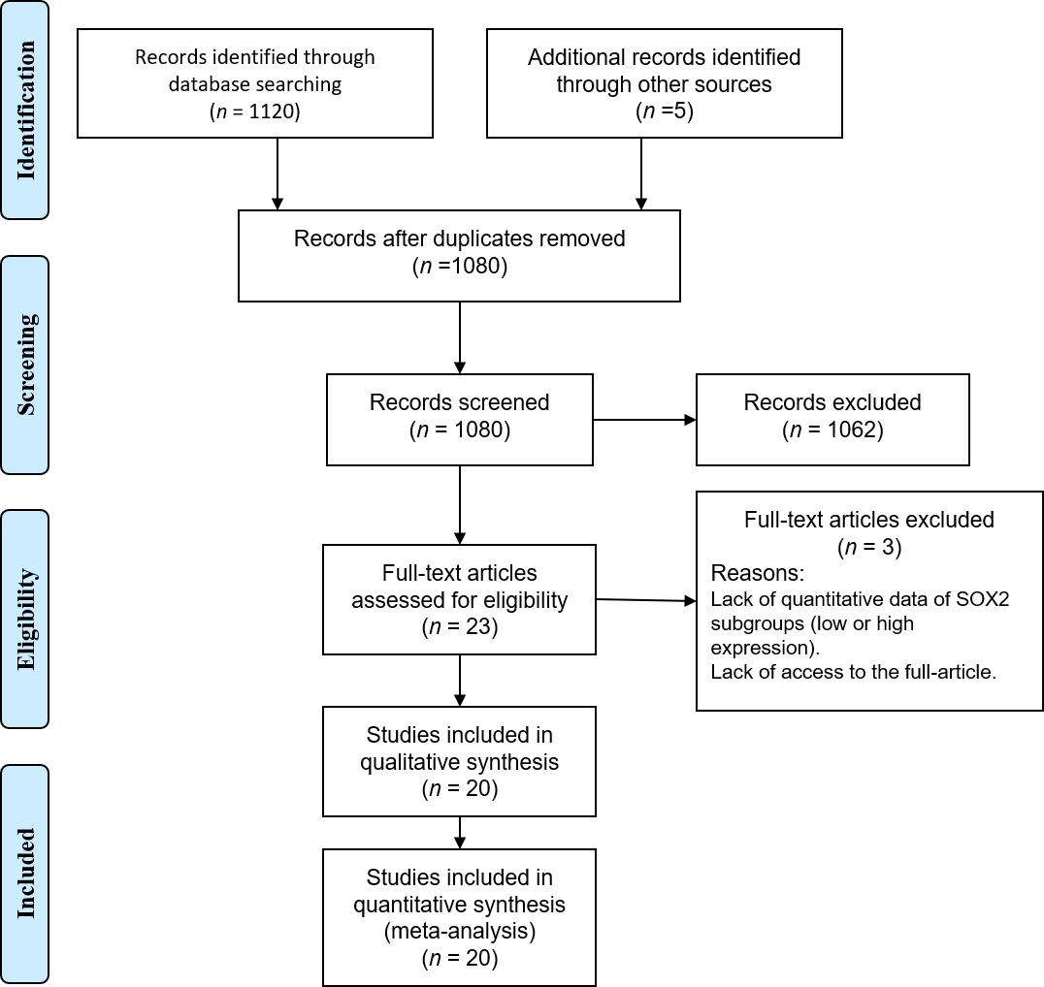

Figure 1 Flow diagram showing the search process used in the present study.
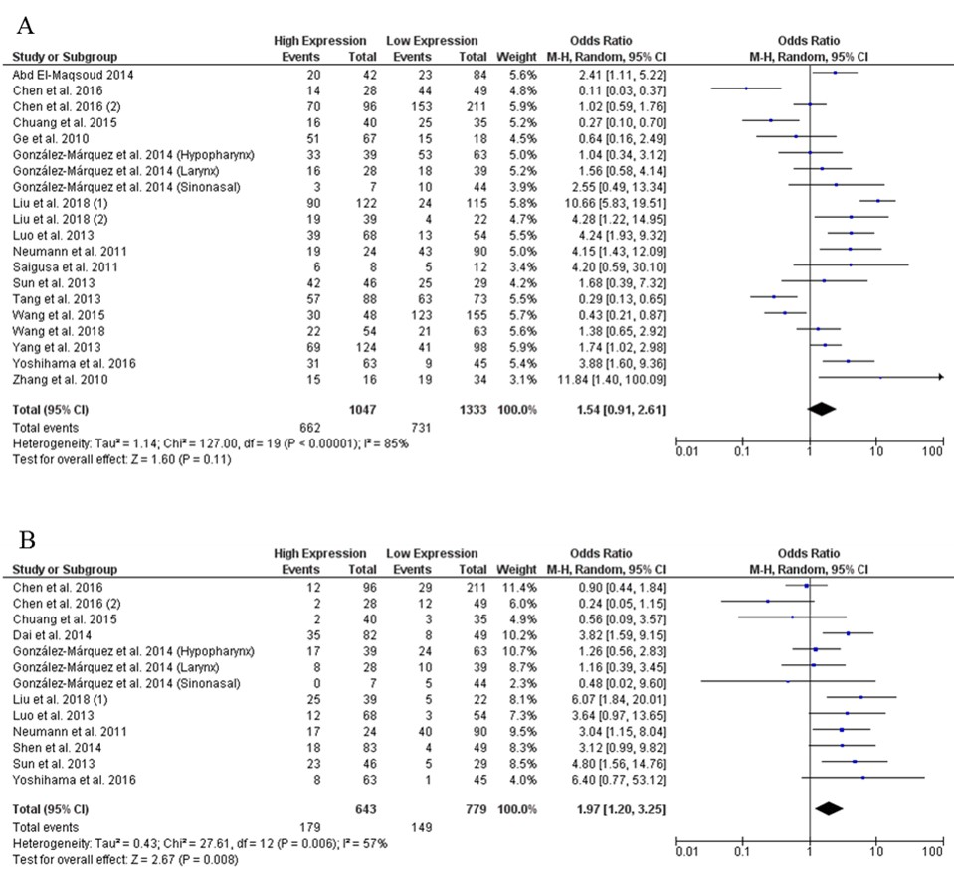
Figure 2 Forest plot of the association between SOX2 expression and lymph node metastasis and distant metastasis. A: Lymph node metastasis; B: Distant metastasis.
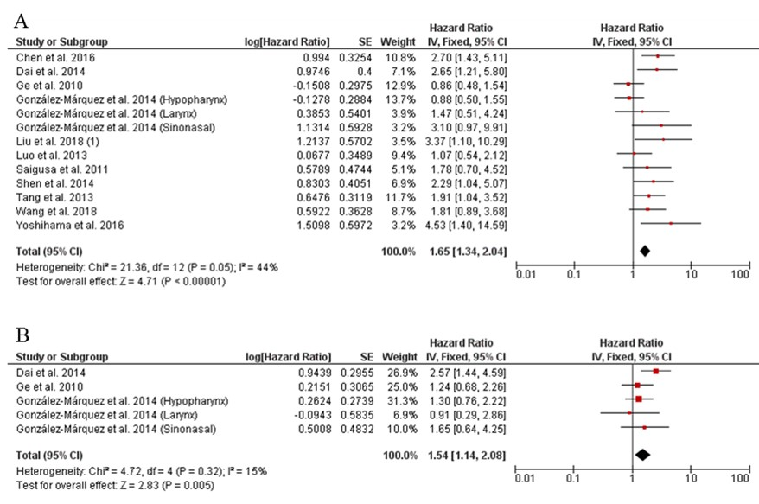

Figure 3 Forest plot of the association between high SOX2 expression and lymph node metastasis and distant metastasis. A: Lymph node metastasis; B: Distant metastasis.

Table 1 Characteristics of the included studies
Study | YOP | Patients, M/F/T | SOX2 expression, high/low | Clinical stage, I+II/ III +IV | Cancer type | Outcomes | Survival analysis | NOS
Abd El-Maqsoud et al^{[10]} | 2014 | 0/126/126 | 42/84 | NA | IBC | LNM | NA | 7
Chen et al^{[26]} | 2016 | 59/18/77 | 28/49 | 26/51 | GC | DM, LNM, OS | Mu | 8
Chen et al^{[27]} | 2016 | 233/74/307 | 96/211 | 95/212 | GC | DM, LNM | NA | 8
Chuang et al^{[14]} | 2015 | 72/3/75 | 40/35 | 21/27 | ESCC | DM, LNM | NA | 6
Dai et al^{[17]} | 2014 | 75/56/131 | 82/49 | 77/54 | ACC | DM, OS, DFS | Mu | 7
Ge et al^{[18]} | 2010 | 84/1/85 | 67/18 | 21/64 | HSCC | LNM, OS, DFS | Mu | 7
González-Márquez et al^{[19]} | 2014 | 203/17/220 | 74/146 | 24/196 | SCC | DM, LNM, OS, DFS | Mu | 6
Liu et al^{[23]} | 2018 | 35/26/61 | 39/22 | 46/15 | TSCC | DM, LNM, OS | Mu | 7
Liu et al^{[11]} | 2018 | 0/237/237 | 122/115 | 167/70 | BC | LNM | NA | 7
Luo et al^{[20]} | 2013 | 92/30/122 | 68/54 | 33/89 | NPC | DM, LNM, OS | Mu | 6
Neumann et al^{[13]} | 2011 | 58/56/114 | 24/90 | NA | CC | DM, LNM | NA | 7
Saigusa et al^{[15]} | 2011 | 18/2/20 | 8/12 | 10/10 | ESCC | LNM, OS | U | 7
Shen et al^{[12]} | 2014 | 0/132/132 | 83/49 | 70/62 | CSCC | DM, OS | Mu | 8
Sun et al^{[24]} | 2013 | 65/10/75 | 46/29 | NA | HCC | DM, LNM | NA | 6
Tang et al^{[21]} | 2013 | 152/9/161 | 88/73 | 65/96 | LSCC | LNM, OS | Mu | 8
Wang et al^{[16]} | 2018 | 87/30/117 | 54/63 | 48/69 | ESCC | LNM, OS | Mu | 7
Wang et al^{[28]} | 2015 | 132/71/203 | 48/155 | 65/138 | GC | LNM | NA | 6
Yang et al^{[25]} | 2013 | 140/82/222 | 124/98 | 173/49 | SCLC | LNM | NA | 7
Yoshihama et al^{[22]} | 2016 | 69/39/108 | 63/45 | 64/44 | OSCC | DM, LNM, OS | Mu | 7
Zhang et al^{[29]} | 2010 | 35/15/50 | 16/34 | 31/19 | GC | LNM | NA | 6
ACC: Adenoid cystic carcinoma of the salivary gland; CC: Colon cancer; CSCC: Cervical squamous cell carcinoma; DFS: Disease-free survival; DM: Distant metastasis; ESCC: Esophageal squamous cell carcinoma; F: Female; GC: Gastric cancer; HCC: Hepatocellular carcinoma; HSCC: Hypopharyngeal squamous cell carcinoma; IBC: Invasive breast cancer; LNM: Lymph node metastasis; LSCC: Laryngeal squamous cell carcinoma; M: Male; Mu: Multivariate; NOS: Newcastle-Ottawa scale; NPC: Nasopharyngeal carcinoma; OS: Overall survival; OSCC: Oral squamous cell carcinoma; SCLC: Small cell lung cancer; T: Total; TSCC: Tongue squamous cell carcinoma; U: Univariate; YOP: Year of publication.

Table 2 Pooled effect of the relationship between SOX2 expression (high vs low) and the clinicopathological parameters of cancer patients in the included studies
Variable | Studies | Model (I² %) | OR (95%CI) | P-value
Age | 17 | F (0) | 1.07 (0.90-1.28) | 0.43
Sex | 16 | F (0) | 1.13 (0.90-1.41) | 0.29
Clinical stage | 18 | R (79) | 1.51 (0.97-2.37) | 0.07
Tumor size | 9 | F (27) | 1.06 (0.84-1.33) | 0.64
Tumor differentiation | 14 | R (54) | 1.19 (0.80-1.75) | 0.39
CI: Confidence interval; F: Fixed effects model; OR: Odds ratio; R: Random effects model.

Table 3 Subgroup analysis of the association between SOX2 expression (high vs low) and LMN and DM
Variable |  | LNM |  |  |  | DM
 |  | studies | Model (I² %) | OR (95%CI) | P | studies | Model (I² %) | OR (95%CI) | P-value
Sample size
 | < 150 | 13 | R (83) | 1.85 (0.96-3.56) | 0.06 | 12 | F (47) | 2.16 (1.61-2.91) | < 0.0001
 | ≥ 150 | 5 | R (85) | 0.93 (0.43-2.01) | 0.11 | 1 | N/A | 0.24 (0.05-1.15) | 0.007
Cancer type
 | Head and neck | 6 | R (88) | 1.89 (0.72-4.96) | 0.19 | 7 | F (39) | 2.46 (1.63-3.72) | < 0.0001
 | Esophagus | 3 | R (79) | 0.98 (0.24-4.04) | 0.98 | 1 | N/A | 0.56 (0.09-3.57) | 0.54
 | Cervix | - | - | - | - | 1 | N/A | 3.12 (0.99-9.82) | 0.05
 | Stomach | 4 | R (85) | 0.68 (0.21-2.24) | 0.53 | 2 | R (56) | 0.56 (0.16-1.96) | 0.36
 | Breast | 2 | F (0) | 2.87 (1.50-5.50) | 0.002 | - | - | - | -
 | Liver | 1 | N/A | 1.68 (0.39-7.32) | 0.49 | 1 | N/A | 4.80 (1.56-14.76) | 0.006
 | Lung | 1 | N/A | 1.74 (1.02-2.89) | 0.04 | - | - | - | -
 | Colon | 1 | N/A | 4.15 (1.43-12.09) | 0.009 | 1 | N/A | 3.04 (1.15-8.04) | 0.03
Quality score
 | ≥ 7 | 12 | R (88) | 1.64 (0.82-3.27) | 0.16 | 7 | R (69) | 2.23 (1.04-4.77) | 0.04
 | < 7 | 6 | R (79) | 1.38 (0.60-3.18) | 0.45 | 6 | F (35) | 1.71 (0.89-3.27) | 0.11
DM: Distant metastasis; F: Fixed effects model; LNM: Lymph node metastasis; OR: Odds ratio; R: Random effects model.

