Name of Journal: World Journal of Clinical Cases
Manuscript NO: 56890
Manuscript Type: OPINION REVIEW

Minimizing the risk of community spread of COVID-19 via institutional quarantine of high-risk travelers with serial viral RNA testing: A successful experience from Macao SAR, China

Lio CF et al. Minimizing the risk of community spread of COVID-19

Chon Fu Lio, Hou Hon Cheong, Chin Ion Lei, Iek Long Lo, Chong Lam, Iek Hou Leong

Chon Fu Lio, Hou Hon Cheong, Macao Academy of Medicine, Health Bureau, Macao SAR, China

Chin Ion Lei, Department of Internal Medicine, Centro Hospitalar Conde de São Januário, Health Bureau, Macao SAR, China

Iek Long Lo, Department of Respiratory Medicine, Centro Hospitalar Conde de São Januário, Health Bureau, Macao SAR, China

Chong Lam, Iek Hou Leong, Center for Disease Control and Prevention, Health Bureau, Macao SAR, China

Author contributions: Lei CI, Lo IL, Lio CF and Cheong HH conceived the theme and plot of the opinion review; Lio CF and Cheong HH wrote the main manuscript text and prepared figure; Lei CI, Lo IL, Lam C and Leong IH analyzed and provided comments; all authors reviewed the manuscript and contributed to the preparation of the manuscript.

Corresponding author: Chin Ion Lei, MBBS, MSc, Chief Doctor, Department of Internal Medicine, Centro Hospitalar Conde de São Januário, Health Bureau, Estrada do Visconde de S. Januário, Macao SAR, China. cilei@ssm.gov.mo

Received: May 19, 2020
Revised: June 9, 2020
Accepted: June 29, 2020
Published online: July 6, 2020

Abstract
Macao, a special administrative region (SAR) of the People’s Republic of China, is located in southern China and shares the border with mainland China. It is the most densely populated region in the world, with a population of 667400 and a total land area of 32.9 square kilometers in 2019. Since the first case diagnosed on January 22, 2020, there was a total of 45 laboratory-confirmed coronavirus disease 2019 (COVID-19) cases in Macao, of which 43 patients (96%) were imported cases. To date, all patients had been discharged successfully from Centro Hospitalar Conde de São Januário, a designated hospital to manage all COVID-19 patients in Macao. Eventually, no patient died, and no local community outbreak was noted. This opinion review describes the underlying factors that could have contributed to the successful experience in Macao SAR, China, which include the following: (1) Early implementation of containment measures; (2) Large-scale quarantine using hotel rooms to reduce the risk of local outbreak; and (3) Multidisciplinary co-operation and transparency of information to the public. Although the successful experience in Macao SAR, China, may not be generalized to other regions, it should not be unreasonable to be well prepared with sufficient logistic support to conduct timely containment and early detection of episodic cases to prevent the backsliding of COVID-19 outbreak.

Key words: COVID-19; Macao; RNA test; Containment; Quarantine; Outbreak

Lio CF, Cheong HH, Lei CI, Lo IL, Lam C, Leong IH. Minimizing the risk of community spread of COVID-19 via institutional quarantine of high-risk travelers with serial viral RNA testing: A successful experience from Macao SAR, China. World J Clin Cases 2020; 2674-2678 URL: https://www.wjgnet.com/2307-8960/full/v8/i13/2674.htm DOI: https://dx.doi.org/10.12998/wjcc.v8.i13.2674

Core tip: In this article, we elaborated on some reasons behind the successful quarantine policy to curb the local outbreak in Macao. To sum up, that would be the early implementation of combined containment approach, expansion of institutional quarantine capacity with serial viral RNA tests, latest information transparently delivered to the public to ensure sufficient communication between the government and the public, and an efficient authority coordinating different parties in the society to respond to the outbreak.
A city with millions of tourists successfully avoiding the local coronavirus disease 2019 outbreak
Macao, a special administrative region (SAR) of the People’s Republic of China, is located in southern China and shares the border with mainland China. It is the most densely populated region in the world, with a population of 667400 and a total land area of 32.9 km² in 2019. The blooming gambling and tourism industry had attracted 39 million tourists coming to Macao in 2019. Like a double-edged sword, the influx of tourists also brought huge a risk of the local outbreak during the coronavirus disease 2019 (COVID-19) pandemic. Since the first case diagnosed on January 22, 2020, there was a total of 45 laboratory-confirmed COVID-19 cases in Macao, of which 43 patients (96%) were imported cases. To date, all patients had been discharged successfully from Centro Hospitalar Conde de São Januário, a designated hospital to manage all COVID-19 patients in Macao. Eventually, no patient died, and no local community outbreak was noted. From our perspectives, it was a win in the battle against COVID-19 to curb the virus spreading in the public leading a less drastic surge of medical demand. By doing so, every patient could receive adequate resources and possibly the best prognosis. Thus, the key question would be: “What factors might contribute to the success of mitigating the local outbreak in Macao?”

Early implementation of containment policy with additional preventive measures
The course of the epidemic in Macao could be divided into two waves, which the first phrase was those travelers coming from Mainland China in late January 2020 and the second advent of cases were citizens coming from foreign countries such as the United Kingdom and the United States between March and April 2020. Back to the early January, the available data regarding the route of transmission, infectivity, incubation period of SARS-CoV-2 were still scarce, nonetheless, Macao SAR government had adopted the combination of containment measures and additional preventive measures soon after the diagnosis of the first case in community, that the spur action showed a high level of vigilance. A study suggested that institutional quarantine combining with other measures had played a crucial role in suppressing the outbreak in Wuhan^{[1]}. During the first wave of COVID-19 in Macao, the containment policy mainly focused on people returning from the high-risk region in China such as Hubei province. To be specific, alongside with meticulous contact tracing of the index patient and early quarantine, all Hubei people who had been staying in Macao and not decided to return to mainland China, were required to undergo a mandatory 14-d quarantine in a designated hotel since 26 January 2020, while their entry to Macao was restricted except they could provide a suitable health certificate. Meanwhile, multifaceted preventive measures such as the closure of casino and school, cancellation of new year festival activities, mandatory mask-wearing in public transportations with “guaranteed mask supply scheme”, advocation of personal protective behaviors, were also implemented and timely adjusted according to the latest epidemic and scientific evidence^{[2,3]}. A Cochrane review demonstrated that the combination of containment with other interventions, such as school closures or social distancing, lessens COVID-19 spread more effectively than quarantine alone^{[4]}. From the aspect of the cost-effectiveness, mathematic models of SARS transmission showed the earlier starting quarantine would have the lower economic burden of the society^{[4]}. As a result, there was no local case except for two cases who had close contact with imported confirmed patients and were identified as import-related cases. Yet, the onward pandemic and school closure motivated a quite large number of oversea students going back to Macao that increased the risk of a local outbreak since late February 2020. Since 26 February, it was announced subsequently that people who traveled to Macao from countries with high incidences of cases, such as South Korea, Italy, Iran, Germany, France, Spain, and Japan, etc. were obligated to undergo a 14-d quarantine at a designated location including home, hotels and Public Health Clinical Center^{[5]}. Since 17 March 2020, the border entry policy was further restricted that people who had visited countries and regions outside of China within 14 d before entry must undergo a 14-d quarantine. Hence, more hotels were recruited to provide the concentrated locales for quarantine since then. Furthermore, several border medical checkpoints were also set up to carry out medical examinations for passengers from high-risk areas since 20 February 2020^{[5]}. The survey included self-declaration of fever and respiratory tract symptoms, history of travel to a high-risk area, and contact with suspected COVID-19 patients. There were a total of 4347 people who had undergone quarantine, and the hotels had accommodated 3784 people (87%) for quarantine till 13 May 2020.

Large-scale quarantine using hotel rooms with serial viral RNA tests
Figure 1 showed the accumulative cases classified by different sources of case origin in Macao between 22 January to 8 April 2020. Before recruiting more hotels to expand the quarantine target on 17 March 2020, the proportion of cases originated from the community was 90.9%, with 9.1% of cases detected via border checkpoint. However, the percentage of community cases gradually dropped to 24.4% after implementing an enhanced containment policy on 17 March 2020. Based on the facts that (1) 80% of the COVID-19 patients were asymptomatic^{[6]}; (2) evidence of a high level of viremia one to two days before symptoms onset implied possible pre-symptomatic transmission^{[7]}; and (3) the reproducing number was higher than seasonal influenza^{[8]}, it was advisable to adopt large-scale quarantine measures to halt disease transmission from “invisible patients” who had no symptoms or signs of illness. In doing so, thorough surveillance should be conducted. For example, there were three layers of a safety net during hotel quarantine including (1) collecting saliva or nasopharyngeal specimen for SARS-CoV-2 RNA testing for twice in 14 d, while the first one was collected at the beginning of quarantine and the second one was before the discontinuation of quarantine; (2) vital signs and symptoms monitoring twice a day; and (3) actively providing additional tests to high-risk people via contact tracing. The rationale of adopting twice viral tests was to ensure early detection and isolation of asymptomatic cases while minimizing false-negative results. Also, 539 people underwent home quarantine between 26 February and 18 March, they were also required viral RNA tests of saliva at home and had an obligation to report any symptoms. Although home quarantine successfully picked up 15.6% of cases in Macao, a study suggested that the efficacy of preventing transmission in home-based isolation for diagnosed patients was less than institution-based isolation due to the possibility of household infection^{[9]}. Furthermore, the public concerned that the risk of cross-transmission might not be fully preventable due to Macao’s densely populated nature. As a result, the hotels became the main venues for quarantine purpose and there had been no new home quarantine since 19 March 2020, after factoring the public concerns and risk of household transmission. Thus, the data above demonstrated a positive outcome of Macao’s approaches to suppress local virus spreading as evidenced by most of the cases (75.6%) had been detected in the port and cross-border inspection point and during quarantine period without posing additional risk to the society.

Not only containing the virus but also the backfire
Implementing a successful large-scale quarantine policy needs to overcome several stumbling blocks. There is no easy decision to find an appropriate facility with adequate capacity and logistic support. The efforts from the government, relevant corporations, and citizens would be indispensable. Besides, quarantine may have a negative impact on the psychological aspect such as confusion and anger^{[10]}. With this concern, there were volunteers with medical background actively enquiring about their daily needs and problems via telecommunications, and hotel personal for 24 h standby. If they appeared mental distress, psychiatrist and psychologist from the government would provide timely and sufficient support^{[11]}. Moreover, there may be a gap between public perception and the rationale of each control measures. The misunderstanding could be due to fear, misinformation, and inadequate knowledge of the disease. Also, there had been discriminatory speech arising from the internet stating the fear of being infected by people in home quarantine. These kinds of misunderstandings and irrational sentiment may cause distrust of authorities that hinder public compliance to other recommended measures against COVID-19 if the communication between each party is insufficient. During the influenza pandemic, a study revealed that perceived exaggeration was also linked to a reduced probability of implementing the suggested protective behaviors^{[12]}. Yet, communication with the public in an empathy, fair, and objective way could enhance their compliance with recommended practices^{[13,14]}. Therefore, a governmental press conference was hosted daily to provide timely information about the progress of COVID-19 outbreak and updates of control measures in a most transparent way, and also to clarify the misinformation and rumors which circulated in social media^{[15]}.

A successful experience from Macao SAR, China
In this article, we elaborated on some reasons behind the successful quarantine policy to curb the local outbreak in Macao. To sum up, that would be the early implementation of combined containment approach, expansion of institutional quarantine capacity with serial viral RNA tests, latest information transparently delivered to the public to ensure sufficient communication between government and public, and an efficient authority coordinating different parties in the society to respond to the outbreak. Although the successful experience in Macao SAR, China, may not be generalized to other regions, it should not be unreasonable to be well prepared with sufficient logistic support to conduct timely containment and early detection of episodic cases to prevent the backsliding of COVID-19 outbreak.

References
1 Pan A, Liu L, Wang C, Guo H, Hao X, Wang Q, Huang J, He N, Yu H, Lin X, Wei S, Wu T. Association of Public Health Interventions With the Epidemiology of the COVID-19 Outbreak in Wuhan, China. JAMA 2020; 323: 1-9 [PMID: 32275295 DOI: 10.1001/jama.2020.6130]
2 Government Information Bureau (GCS). Government’s face-mask supply scheme guaranteed for May. 2020. Available from: URL: https://www.gov.mo/en/news/125073/
3 Government Information Bureau (GCS). CE: Casino suspension aims to advance control of novel coronavirus. 2020. Available from: URL: https://www.gov.mo/en/news/122640/
4 Nussbaumer-Streit B, Mayr V, Dobrescu AI, Chapman A, Persad E, Klerings I, Wagner G, Siebert U, Christof C, Zachariah C, Gartlehner G. Quarantine alone or in combination with other public health measures to control COVID-19: a rapid review. Cochrane Database Syst Rev 2020; 4: CD013574 [PMID: 32267544 DOI: 10.1002/14651858.CD013574]
5 Special webpage against Epidemics - Preventive Measures. 2020. Available from: url: https://www.ssm.gov.mo/apps1/PreventCOVID-19/en.aspx#clg17048
6 Wu Z, McGoogan JM. Characteristics of and Important Lessons From the Coronavirus Disease 2019 (COVID-19) Outbreak in China: Summary of a Report of 72 314 Cases From the Chinese Center for Disease Control and Prevention. JAMA 2020 [PMID: 32091533 DOI: 10.1001/jama.2020.2648]
7 Zou L, Ruan F, Huang M, Liang L, Huang H, Hong Z, Yu J, Kang M, Song Y, Xia J, Guo Q, Song T, He J, Yen HL, Peiris M, Wu J. SARS-CoV-2 Viral Load in Upper Respiratory Specimens of Infected Patients. N Engl J Med 2020; 382: 1177-1179 [PMID: 32074444 DOI: 10.1056/NEJMc2001737]
8 Bai Y, Yao L, Wei T, Tian F, Jin DY, Chen L, Wang M. Presumed Asymptomatic Carrier Transmission of COVID-19. JAMA 2020; 323: 1406-1407 [PMID: 32083643 DOI: 10.1001/jama.2020.2565]
9 Dickens BL, Koo JR, Wilder-Smith A, Cook AR. Institutional, not home-based, isolation could contain the COVID-19 outbreak. Lancet 2020; 395: 1541-1542 [PMID: 32423581 DOI: 10.1016/S0140-6736(20)31016-3]
10 Brooks SK, Webster RK, Smith LE, Woodland L, Wessely S, Greenberg N, Rubin GJ. The psychological impact of quarantine and how to reduce it: rapid review of the evidence. Lancet 2020; 395: 912-920 [PMID: 32112714 DOI: 10.1016/S0140-6736(20)30460-8]
11 Government Information Bureau (GCS). Health conditions of people stayed in designated hotels for medical observation). 2020. Available from: URL: https://www.gov.mo/zh-hant/news/327175/
12 Rubin GJ, Amlôt R, Page L, Wessely S. Public perceptions, anxiety, and behaviour change in relation to the swine flu outbreak: cross sectional telephone survey. BMJ 2009; 339: b2651 [PMID: 19574308 DOI: 10.1136/bmj.b2651]
13 Glik DC. Risk communication for public health emergencies. Annu Rev Public Health 2007; 28: 33-54 [PMID: 17222081 DOI: 10.1146/annurev.publhealth.28.021406.144123]
14 WHO. Communicating risk in public health emergencies: a WHO guideline for emergency risk communication (ERC) policy and practice. 2018. Available from: URL: https://www.who.int/risk-communication/guidance/download/en/
15 Government Information Bureau (GCS). Call for mutual understanding and concessions; Avoid unnecessary accusations. 2020. Available from: URL: https://www.gov.mo/zh-hant/news/324986/

Footnotes
Conflict-of-interest statement: The authors declare no conflict of interests.

Open-Access: This article is an open-access article that was selected by an in-house editor and fully peer-reviewed by external reviewers. It is distributed in accordance with the Creative Commons Attribution NonCommercial (CC BY-NC 4.0) license, which permits others to distribute, remix, adapt, build upon this work non-commercially, and license their derivative works on different terms, provided the original work is properly cited and the use is non-commercial. See: http://creativecommons.org/licenses/by-nc/4.0/

Manuscript source: Invited manuscript

Peer-review started: May 19, 2020
First decision: June 9, 2020
Article in press: May 19, 2020

Specialty type: Medicine, research and experimental
Country/Territory of origin: China
Peer-review report’s scientific quality classification
Grade A (Excellent): 0
Grade B (Very good): B
Grade C (Good): 0
Grade D (Fair): 0
Grade E (Poor): 0

P-Reviewer: Zhu y S-Editor: Ma YJ L-Editor: A E-Editor: Liu JH

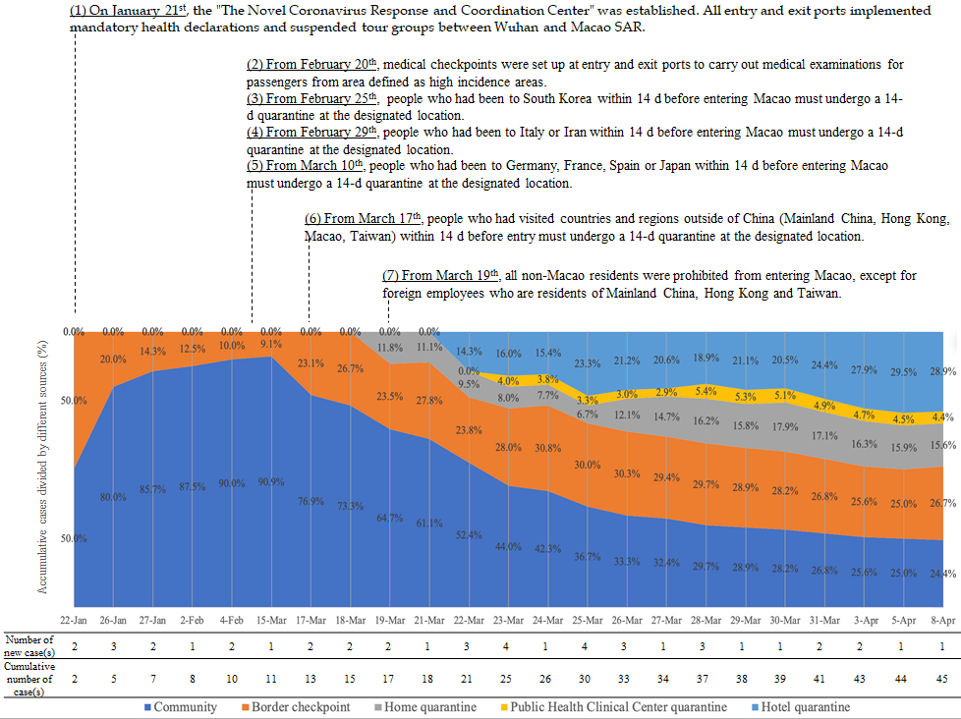
Figure 1 The cumulative cases classified by different sources of case origin in Macao between January 22 to April 8, 2020.

