Name of Journal: World Journal of Stem Cells
Manuscript NO: 53338
Manuscript Type: ORIGINAL ARTICLE

Basic Study
AlCl₃ exposure regulates neuronal development by modulating DNA modification

Cheng XJ et al. AlCl3 and neuronal development

Xue-Jun Cheng, Fu-Lai Guan, Qian Li, Gong Dai, Hai-Feng Li, Xue-Kun Li

Xue-Jun Cheng, Qian Li, Hai-Feng Li, Xue-Kun Li, The Children's Hospital, School of Medicine, Zhejiang University, Hangzhou 310052, Zhejiang Province, China

Xue-Jun Cheng, Qian Li, Xue-Kun Li, The Institute of Translational Medicine, School of Medicine, Zhejiang University, Hangzhou 310029, Zhejiang Province, China

Xue-Jun Cheng, Qian Li, Hai-Feng Li, Xue-Kun Li, National Clinical Research Center for Child Health, Hangzhou 310052, Zhejiang Province, China

Fu-Lai Guan, Gong Dai, School of Basic Medicine, Weifang Medical University, Weifang 261053, Shandong Province, China

Author contributions: Li XK designed the study; Cheng XJ performed the isolation and culture of adult neural stem cells, proliferation and differentiation assays, qRT-PCR, Western blot, and DNA dot-blots; Guan FL and Dai G performed the quantification analysis of immunofluorescence staining; Li Q performed neuronal culture and Sholl analysis; Li XK and Li HF wrote the manuscript; all authors reviewed and approved the final manuscript.

Supported by the National Key Research and Development Program of China during the 13th Five-Year Plan, No. 2016YFC1306205; the Provincial Key Disciplines of Zhejiang Traditional Chinese Medicine (Combination of Traditional Chinese and Western medicine), No. 2017-XK-A41 (to Li HF); and the National Natural Science Foundation of China, Nos. 31771395 and 31571518 (to Li XK).

Corresponding author: Xue-Kun Li, PhD, Professor, The Institute of Translational Medicine, School of Medicine, Zhejiang University, No. 268 Kaixuan Road, Central North Building Room 440, Huajiachi Campus, Hangzhou 310029, Zhejiang Province, China. xuekun_li@zju.edu.cn

Received: March 28, 2020
Revised: July 7, 2020
Accepted: September 8, 2020
Published online: November 26, 2020

Abstract
BACKGROUND
As the third most abundant element, aluminum is widespread in the environment. Previous studies have shown that aluminum has a neurotoxic effect and its exposure can impair neuronal development and cognitive function.

AIM
To study the effects of aluminum on epigenetic modification in neural stem cells and neurons.

METHODS
Neural stem cells were isolated from the forebrain of adult mice. Neurons were isolated from the hippocampi tissues of embryonic day 16-18 mice. AlCl₃ at 100 and 200 μmol/l was applied to stem cells and neurons.

RESULTS
Aluminum altered the differentiation of adult neural stem cells and caused apoptosis of newborn neurons while having no significant effects on the proliferation of neural stem cells. Aluminum application also significantly inhibited the dendritic development of hippocampal neurons. Mechanistically, aluminum exposure significantly affected the levels of DNA 5-hydroxymethylcytosine, 5-methylcytosine, and N⁶-methyladenine in stem cells and neurons.

CONCLUSION
Our findings indicate that aluminum may regulate neuronal development by modulating DNA modifications.

Key words: Aluminum; DNA demethylation; 5-hydroxymethylcytosine; Neural stem cells; Neuron; Neuronal development

Cheng XJ, Guan FL, Li Q, Dai G, Li HF, Li XK. AlCl₃ exposure regulates neuronal development through modulating DNA modification. World J Stem Cells 2020; 12(11): 1354-1365 URL: https://www.wjgnet.com/1948-0210/full/v12/i11/1354.htm DOI: https://dx.doi.org/10.4252/wjsc.v12.i11.1354

Core tip: Although the neurotoxic effects of aluminum have been known, it is still unclear regarding the effects of aluminum on epigenetic modifications in the context of neuronal development. Our present study revealed that aluminum exerted the neurotoxic effects including promoting cell death by regulating DNA modifications. These results highlight the crosstalk between the environment and epigenetics, and subsequent phenotypes. Our findings emphasize the importance of protecting the environment and improving food safety.

INTRODUCTION
Epigenetic modifications mainly include histone posttranslational modifications, DNA and RNA methylation and demethylation, and non-coding RNAs. Previous studies have indicated that epigenetic pathways play a critical function in diverse biological processes^{[1,2]}. DNA methylation, mainly on the fifth carbon of cytosine [5-methylcytosine (5mC)] in mammalian, is established by DNA methyltransferases (DNMTs), including DNMT1, DNMT3A, and DNMT3B. In embryonic and postnatal neuronal development, the deficiency of DNMTs affects embryonic viability, cell survival, synaptic development, and learning and memory; however, neuronal activity could influence DNA methylation, suggesting that DNA methylation is important for normal neuronal function^{[3-5]}.
Recent studies have shown that 5mC can be further converted to 5-hydroxymethylcytosine (5hmC) by ten-eleven translocation (TET) proteins including TET1, TET2, and TET3^{[6,7]}. 5hmC is significantly enriched in the brain relative to many other tissues and cell types, is acquired during postnatal neurodevelopment and aging, and displays spatial and temporal dynamics. Recent studies have shown consistently that Tet1 regulates neuronal activity, the formation and extinction of memory, and neurogenesis^{[8-13]}. Recently, DNA N⁶-methyladenine (6mA) modification has been uncovered, which regulates gene expression and is involved in neuronal outcomes induced by environmental stress^{[14,15]}.
Aluminum is a neurotoxin and is associated with neuronal inflammation, memory impairment, and neurological disorders through different mechanisms^{[16]}. AlCl₃ exposure (50-100 mg/kg in vivo) significantly exacerbates amyloid beta (Aβ) deposition, plaque formation, and tau phosphorylation; causes cognitive dysfunction and mitochondria oxidative; and therefore induces Alzheimer’s disease-like phenotypes in rats^{[17-19]}. Aluminum exposure (25 mg/kg in vivo or 0.5 mmol/L in vitro) also stimulates the expression of pro-inflammatory cytokines including TNF-α and IL-6, induces the production of reactive oxygen species (ROS), and then causes neuroinflammation and DNA damage^{[19-21]}. However, it remains largely unknown whether aluminum has a neurotoxic effect by altering epigenetic states.
In the present study, we found that aluminum (AlCl₃) skewed the differentiation of adult neural stem cells (aNSCs) toward glial cells and induced apoptosis of newborn neurons. Furthermore, aluminum inhibited the morphological development of neurons generated upon aNSC differentiation and hippocampal neurons. Finally, we found that AlCl₃ exposure differentially altered the level of DNA methylation and hydroxymethylation in aNSCs and neurons by regulating the expression of DNA methyltransferases and dioxygenases. In summary, our results suggest that AlCl₃ exerts a neurotoxic effect by modulating DNA modifications.

MATERIALS AND METHODS
Animals
Mice were housed in a standard condition of the Animal Center of Zhejiang University on a 12 h light/dark cycle with free access to food and water. All animal experiments were performed according to the protocols approved by the Institutional Animal Care and Use Committee of Zhejiang University.

Isolation and culture of adult neural stem cells
The isolation and culture of adult neural stem cells were performed according to an established protocol^{[9]}. The aNSCs were cultured in DMEM/F-12 medium containing 20 ng/mL FGF-2 (Catalog No. 100-18B-B, PeproTech), 20 ng/mL EGF (Catalog No. 100-15, PeproTech), 2% B27 supplement (Catalog No. 12587-010, Thermo Fisher Scientific), 1% antibiotic-antimycotic (Catalog No. 15140-122, Thermo Fisher Scientific), and 2 mmol/L L-glutamine (Catalog No. 25030–149, Thermo Fisher Scientific) in a humidified incubator supplied with 5% CO₂ at 37 °C.

AlCl₃ exposure
AlCl₃ was dissolved with nuclease free water to 50 mmol/L and applied to cells at a final concentration of 100 μmol/L or 200 μmol/L. The cells were collected at scheduled time-point for in vitro assay.

Proliferation and differentiation assays in vitro
For in vitro proliferation assay, aNSCs were cultured on coverslips with medium supplied with 5 mmol/L BrdU for 8 h. For in vitro differentiation assay, aNSCs were cultured on coverslips with proliferation medium, and then transferred into differentiation medium containing 1 mmol/L retinoic acid (Catalog No. R-2625, Sigma) and 5 mmol/L forskolin (Catalog No. F-6886, Sigma) for 48 h.

Isolation and culture of embryonic hippocampal neurons
Primary neurons were isolated from the hippocampus of E16-E18 mice and seeded in cell climbing slices (Corning, 354087) or plates that were coated with poly-D-lysine (5 μg/mL, Sigma, P0899-10). Approximately 1 × 10⁵ cells per well were seeded for a slice, while 1.5 million cells per well were seeded for a 6-well-plate. After growing in the plating medium for 4 h, which consisted of MEM (Gibco,11095-080), 10% FBS (Gibco,10091-148), 1% L-Glu (Gibco, 5030-149), 1% sodium pyruvate (Gibco, 11360-070), and 0.45% D-glucose (Amresco, 0188), the medium was changed to a maintaining medium that consisted of neurobasal (Gibco, 21103-049), 0.25% L-Glu (Gibco, 25030-149), 0.125% GlutaMax (Thermo, 35050061), and 2% B27 (Gibco, 17504-044). The medium was renewed half of the liquid volume every 3 d.

Immunofluorescence staining and quantification
To detect the function of proliferation and differentiation, cell samples were washed with PBS for 30 min followed by blocking with PBS containing 3% normal goat serum and 0.1% triton X-100 for 1 h at room temperature. Samples were incubated with primary antibodies overnight at 4 °C. For BrdU immunostaining, samples were treated with 1M HCl at 37 °C for 30 min before blocking. The following primary antibodies were used: GFAP (Catalog No. Z0334, DAKO), Tuj1 (Catalog No. G712A, Promega), Caspase 3 (Catalog No. AB3623, Millipore), and BrdU (Catalog No. ab6326, Abcam). The second day, after being washed with PBS for 30 min, sections were incubated with fluorophore-conjugated secondary antibodies for 1 h at room temperature. After final washes, samples were mounted onto glass slides and cover slipped with mounting medium. Images were captured using a Nikon invert microscope, and the numbers of BrdU⁺, Tuj1⁺, GFAP⁺, and Caspase3⁺Tuj1⁺ cells were quantified with image J software (NIH).

Total RNA isolation, reverse transcription, and quantitative real-time PCR
Total RNA was extracted with TRIzol reagent (Catalog No. 15596018, Thermo Fisher Scientific) following the manufacturer’s protocol. The concentration was determined using a NanoDrop 2000 spectrophotometer, and 500 ng of total RNA was subjected to reverse transcription. All real-time PCR reactions were performed in triplicate using power SYBR Green PCR master Mix (Catalog No. Q71502, Vazyme), and the results were analyzed using the ∆∆Ct method. The sequence of all the used primers can be found in Supplemental Table 1.

Western blot analysis
Cells were washed with PBS and resuspended in RIPA (Catalog No. ab156034, Abcam) containing 1 × protease inhibitor cocktail (Catalog No. 04693124001, Sigma). The samples were centrifuged at 4 °C for 20 min at 14000 rpm, and the supernatants were collected for further experiments. Protein concentrations of the samples were measured with a BioPhotometer, and 20 μg of each sample was used for electrophoresis after denaturation for 5 min at 95 °C. Samples were subjected to SDS-polyacrylamide gel electrophoresis and transferred to nitrocellulose membranes. The following primary antibodies were used: Anti-Tuj1 (Catalog No. G712A, Promega), anti-GFAP (Catalog No. 3670, Cell Signaling), and anti-GAPDH (Catalog No. AM4300, Thermo Fisher Scientific). Secondary HRP conjugated antibodies were applied for 1 h at room temperature. The signal was detected with the Tanon 5200 Detection system, and the relative level of signal intensity was normalized to that of GAPDH.

Genomic DNA extraction and DNA dot-blot
DNA extraction and DNA dot-blot were performed as described previously^{[9]}. The following primary antibodies were used: 5mC (Catalog No. 61255, Active Motif), 5hmC (Catalog No. 39769, Active Motif), and 6mA (Catalog No. 61496, Active Motif).

Statistical analysis
All data are expressed as the mean ± SE. GraphPad Prism (GraphPad Software Inc.) was used for statistical analyses. Unpaired student’s t-test was used to determine the differences between two groups with at least three replicates. P < 0.05 was considered statistically significant.

RESULTS
AlCl₃ affects the differentiation of aNSCs and survival of newborn neurons
To determine the effects of AlCl₃ on the proliferation of aNSCs, aNSCs were exposed to AlCl₃ for 48 h, and BrdU was administered at 5 μmol/L for 8 h followed by immunofluorescence staining (Supplemental Figure 1A). The quantification results showed that the number of BrdU positive (BrdU⁺) cells did not show a significant difference between control and AlCl₃ exposure aNSCs (Supplemental Figure 1B), suggesting that AlCl₃ does not affect the proliferation of aNSCs.
To examine the effects of AlCl₃ on the differentiation of aNSCs, aNSCs were exposed to AlCl₃ for 2 d and then underwent differentiation induction. Immunostaining for neuronal cell marker Tuj1 and astrocyte marker GFAP was performed (Figure 1A). The quantification results of immunofluorescence staining showed that the number of neuronal marker Tuj1 positive cells was significantly decreased (Figure 1B), but the number of glial cell marker GFAP positive cells increased after AlCl₃ application (200 μmol/L) (Figure 1C). We also detected the expression levels of Tuj1 and GFAP by qRT-PCR and Western blot, and we found that the level of Tuj1 decreased, while the level of GFAP increased (Figure 1D-F). Taken together, these results suggest that AlCl₃ regulates the differentiation of aNSCs.
To determine whether AlCl₃ affects the survival of newborn neurons, we performed immunofluorescence staining for Tuj1 and caspase 3. Representative images (Figure 1G) and quantification results (Figure 1H) show that AlCl₃ at a dosage of 200 μmol/L significantly increased the number of Caspase3 positive cells, suggesting that AlCl₃ exposure induces apoptosis of newborn neurons.

AlCl₃ inhibits the maturation of newborn neurons derived from aNSCs and hippocampal neurons
Next, we aimed to investigate whether AlCl₃ regulates neuronal development. We first analyzed the effects of AlCl₃ on the development of newborn neurons generated upon the differentiation of aNSCs. Immunostaining (Figure 2A) and Sholl analysis showed that AlCl₃ at a dosage of 200 μmol/L significantly decreased dendritic length and the number of intersections (Figure 2B-D).
Next, we isolated neurons from the hippocampal tissues of embryonic mice and examined the effects of AlCl₃ on the development of primary neurons. Immunofluorescence (Figure 2E) and Sholl analysis showed that AlCl₃ exposure at both 100 μmol/L and 200 μmol/L dosages significantly decreased the intersection number and dendritic length of hippocampal neurons (Figure 2F-H). Collectively, these results indicate that AlCl₃ exposure inhibits neuronal development.

AlCl₃ regulates DNA methylation and demethylation of aNSCs and neurons
Previous studies have shown the important function of DNA modifications in neurogenesis and neuronal development^{[22,23]}. To dissect the molecular mechanisms by which AlCl₃ regulates neuronal development, we first analyzed the effects of AlCl₃ on the DNA modifications of aNSCs and neurons. DNA dot-blots and quantification results showed that AlCl₃ exposure increased the global level of 5-hmC in proliferating and differentiated aNSCs, but AlCl₃ exposure decreased the global levels of 5-mC and 6mA (Figure 3A-F).
Next, we analyzed the effects of AlCl₃ on the DNA modifications in neurons. DNA dot-blot and quantification results showed that AlCl₃ exposure increased the global levels of 5-mC and 6mA but decreased the global level of 5-hmC in hippocampal neurons (Figure 3G-L). Taken together, these results indicate that AlCl₃ alters the epigenetic state in aNSCs and neurons.

AlCl₃ differentially regulates the expression of DNA modification related genes in aNSCs and neurons
Next, we examined the expression of genes related to DNA modifications. We found that AlCl₃ exposure significantly increased the mRNA level of Tet2 but did not affect the mRNA levels of Tet1 and Tet3 in aNSCs (Figure 4A-C). Meanwhile, AlCl₃ exposure significantly decreased the mRNA level of DNA methyltransferases Dnmt1 (Figure 4D) but did not affect the levels of Dnmt3a and Dnmt3b (Figure 4E and F).
We then aimed to determine the effects of AlCl₃ on the expression of Tets and DNMTs in neurons. We found that AlCl₃ exposure decreased the mRNA levels of Tet1 and Tet3 while not affecting the level of Tet2 (Figure 4G-I) in neurons. Furthermore, AlCl₃ exposure led to a decrease in hte mRNA levels of Dnmt1 and Dnmt3a but induced an increase in Dnmt3b (Figure 4J-L). Taken together, these results suggest that AlCl₃ differentially regulates the expression of genes relating to DNA methylation and demethylation in aNSCs and neurons.

DISCUSSION
Previous studies have shown that DNA modifications play an important role in neuronal development and function and that dysregulation of DNA modifications is involved in neurological disorders^{[24-26]}. Machineries of regulating DNA modifications have been identified. In the present study, we found that aluminum inhibits the differentiation of aNSCs and the development of neurons. Furthermore, aluminum can induce apoptosis of newborn neurons derived upon the differentiation of aNSCs. Mechanistically, aluminum affects the global level of 5mC, 5hmC, and 6mA in aNSCs and neurons by regulating the expression of DNA modification associated genes including Tets and DNMTs. Taken together, our results reveal a novel mechanism for regulating adult neurogenesis.
In adult mammalian brain, two regions, the subventricular zone in the lateral ventricle and subgranular zone in the dentate gyrus of hippocampus, maintain the neurogenic capacity^{[27]}. Adult neurogenesis is driven by aNSCs and regulated by multiple mechanisms including environmental stimuli, genetics, and epigenetics including DNA modifications^{[22,27,28]}. Our results show that aluminum can affect the differentiation of aNSCs and induce apoptosis of newborn neurons. Therefore, our study reveals the roles of aluminum in regulating neuronal development and associated mechanisms.
DNA modifications are regulated by diverse factors, such as environmental stimuli and food nutrients. Nutrient Vitamin C can serve as a cofactor for Tet and improves the reprogramming and neuronal differentiation by enhancing the expression level of Tets and therefore increasing the global level of 5hmC^{[29,30]}. As one type of environmental pollution, the excessive intake of aluminum could induce inflammatory responses and oxidative stress, and then cause toxic effects on the neural, immune, and reproductive systems. Aluminum exposure also increases apoptosis and impairs learning and memory in adult rats^{[31]}. These findings indicate the crosstalk between environmental signal and epigenetic modifications.

CONCLUSION
In summary, our findings show the neurotoxic effect of aluminum on neuronal development. One limitation of the present study is that the data were collected in vitro. A further study should be performed to examine the effects of aluminum on neuronal development and DNA modifications in vivo.

ARTICLE HIGHLIGHTS
Research background
With the industrial development of society, environmental pollution is becoming a serious challenge for humans. Previous studies have revealed the crosstalk between environment and epigenetics and consequent phenotypes.

Research motivation
Aluminum pollution is a common issue and its exposure induces neurotoxic effects and impairs neuronal development and cognitive function.

Research objectives
To study the effects of aluminum on epigenetics in the context of neuronal development.

Research methods
Neural stem cells were isolated from the brain of adult mice. Hippocampal neurons were isolated from the brain of embryonic mouse pups. The levels of DNA modifications were detected by dot-blot. The levels of DNA modification related genes were examined by qRT-PCR.

Research results
Our present findings uncovered the roles of aluminum in inhibiting neuronal development and promoting cell death. Our results also showed that aluminum exposure can display significant effects on DNA modifications.

Research conclusions
Our study indicated that aluminum exposure regulates neuronal development by modulating DNA modifications.

Research perspectives
Future studies should be performed to examine whether DNA modification could be a target for the treatment of neurological disorders induced by aberrant neuronal development.

ACKNOWLEDGEMENTS
We thank Dr. Dorazio RM for editing the manuscript. We thank Li YZ for narrating the core tip.

REFERENCES
1 Li X, Zhao X. Epigenetic regulation of mammalian stem cells. Stem Cells Dev 2008; 17: 1043-1052 [PMID: 18393635 DOI: 10.1089/scd.2008.0036]
2 Bird A. DNA methylation patterns and epigenetic memory. Genes Dev 2002; 16: 6-21 [PMID: 11782440 DOI: 10.1101/gad.947102]
3 LaPlant Q, Vialou V, Covington HE 3rd, Dumitriu D, Feng J, Warren BL, Maze I, Dietz DM, Watts EL, Iñiguez SD, Koo JW, Mouzon E, Renthal W, Hollis F, Wang H, Noonan MA, Ren Y, Eisch AJ, Bolaños CA, Kabbaj M, Xiao G, Neve RL, Hurd YL, Oosting RS, Fan G, Morrison JH, Nestler EJ. Dnmt3a regulates emotional behavior and spine plasticity in the nucleus accumbens. Nat Neurosci 2010; 13: 1137-1143 [PMID: 20729844 DOI: 10.1038/nn.2619]
4 Feng J, Zhou Y, Campbell SL, Le T, Li E, Sweatt JD, Silva AJ, Fan G. Dnmt1 and Dnmt3a maintain DNA methylation and regulate synaptic function in adult forebrain neurons. Nat Neurosci 2010; 13: 423-430 [PMID: 20228804 DOI: 10.1038/nn.2514]
5 Guo JU, Ma DK, Mo H, Ball MP, Jang MH, Bonaguidi MA, Balazer JA, Eaves HL, Xie B, Ford E, Zhang K, Ming GL, Gao Y, Song H. Neuronal activity modifies the DNA methylation landscape in the adult brain. Nat Neurosci 2011; 14: 1345-1351 [PMID: 21874013 DOI: 10.1038/nn.2900]
6 Kriaucionis S, Heintz N. The nuclear DNA base 5-hydroxymethylcytosine is present in Purkinje neurons and the brain. Science 2009; 324: 929-930 [PMID: 19372393 DOI: 10.1126/science.1169786]
7 Tahiliani M, Koh KP, Shen Y, Pastor WA, Bandukwala H, Brudno Y, Agarwal S, Iyer LM, Liu DR, Aravind L, Rao A. Conversion of 5-methylcytosine to 5-hydroxymethylcytosine in mammalian DNA by MLL partner TET1. Science 2009; 324: 930-935 [PMID: 19372391 DOI: 10.1126/science.1170116]
8 Zhang RR, Cui QY, Murai K, Lim YC, Smith ZD, Jin S, Ye P, Rosa L, Lee YK, Wu HP, Liu W, Xu ZM, Yang L, Ding YQ, Tang F, Meissner A, Ding C, Shi Y, Xu GL. Tet1 regulates adult hippocampal neurogenesis and cognition. Cell Stem Cell 2013; 13: 237-245 [PMID: 23770080 DOI: 10.1016/j.stem.2013.05.006]
9 Li X, Yao B, Chen L, Kang Y, Li Y, Cheng Y, Li L, Lin L, Wang Z, Wang M, Pan F, Dai Q, Zhang W, Wu H, Shu Q, Qin Z, He C, Xu M, Jin P. Ten-eleven translocation 2 interacts with forkhead box O3 and regulates adult neurogenesis. Nat Commun 2017; 8: 15903 [PMID: 28660881 DOI: 10.1038/ncomms15903]
10 Hahn MA, Qiu R, Wu X, Li AX, Zhang H, Wang J, Jui J, Jin SG, Jiang Y, Pfeifer GP, Lu Q. Dynamics of 5-hydroxymethylcytosine and chromatin marks in Mammalian neurogenesis. Cell Rep 2013; 3: 291-300 [PMID: 23403289 DOI: 10.1016/j.celrep.2013.01.011]
11 Kaas GA, Zhong C, Eason DE, Ross DL, Vachhani RV, Ming GL, King JR, Song H, Sweatt JD. TET1 controls CNS 5-methylcytosine hydroxylation, active DNA demethylation, gene transcription, and memory formation. Neuron 2013; 79: 1086-1093 [PMID: 24050399 DOI: 10.1016/j.neuron.2013.08.032]
12 Rudenko A, Dawlaty MM, Seo J, Cheng AW, Meng J, Le T, Faull KF, Jaenisch R, Tsai LH. Tet1 is critical for neuronal activity-regulated gene expression and memory extinction. Neuron 2013; 79: 1109-1122 [PMID: 24050401 DOI: 10.1016/j.neuron.2013.08.003]
13 Zhu X, Girardo D, Govek EE, John K, Mellén M, Tamayo P, Mesirov JP, Hatten ME. Role of Tet1/3 Genes and Chromatin Remodeling Genes in Cerebellar Circuit Formation. Neuron 2016; 89: 100-112 [PMID: 26711116 DOI: 10.1016/j.neuron.2015.11.030]
14 Yao B, Li Y, Wang Z, Chen L, Poidevin M, Zhang C, Lin L, Wang F, Bao H, Jiao B, Lim J, Cheng Y, Huang L, Phillips BL, Xu T, Duan R, Moberg KH, Wu H, Jin P. Active N⁶-Methyladenine Demethylation by DMAD Regulates Gene Expression by Coordinating with Polycomb Protein in Neurons. Mol Cell 2018; 71: 848-857.e6 [PMID: 30078725 DOI: 10.1016/j.molcel.2018.07.005]
15 Yao B, Cheng Y, Wang Z, Li Y, Chen L, Huang L, Zhang W, Chen D, Wu H, Tang B, Jin P. DNA N6-methyladenine is dynamically regulated in the mouse brain following environmental stress. Nat Commun 2017; 8: 1122 [PMID: 29066820 DOI: 10.1038/s41467-017-01195-y]
16 Liaquat L, Sadir S, Batool Z, Tabassum S, Shahzad S, Afzal A, Haider S. Acute aluminum chloride toxicity revisited: Study on DNA damage and histopathological, biochemical and neurochemical alterations in rat brain. Life Sci 2019; 217: 202-211 [PMID: 30528774 DOI: 10.1016/j.lfs.2018.12.009]
17 Prakash A, Shur B, Kumar A. Naringin protects memory impairment and mitochondrial oxidative damage against aluminum-induced neurotoxicity in rats. Int J Neurosci 2013; 123: 636-645 [PMID: 23510099 DOI: 10.3109/00207454.2013.785542]
18 Haider S, Liaquat L, Ahmad S, Batool Z, Siddiqui RA, Tabassum S, Shahzad S, Rafiq S, Naz N. Naringenin protects AlCl3/D-galactose induced neurotoxicity in rat model of AD via attenuation of acetylcholinesterase levels and inhibition of oxidative stress. PLoS One 2020; 15: e0227631 [PMID: 31945778 DOI: 10.1371/journal.pone.0227631]
19 Praticò D, Uryu K, Sung S, Tang S, Trojanowski JQ, Lee VM. Aluminum modulates brain amyloidosis through oxidative stress in APP transgenic mice. FASEB J 2002; 16: 1138-1140 [PMID: 12039845 DOI: 10.1096/fj.02-0012fje]
20 Zaky A, Mohammad B, Moftah M, Kandeel KM, Bassiouny AR. Apurinic/apyrimidinic endonuclease 1 is a key modulator of aluminum-induced neuroinflammation. BMC Neurosci 2013; 14: 26 [PMID: 23497276 DOI: 10.1186/1471-2202-14-26]
21 Zaky A, Bassiouny A, Farghaly M, El-Sabaa BM. A Combination of Resveratrol and Curcumin is Effective Against Aluminum Chloride-Induced Neuroinflammation in Rats. J Alzheimers Dis 2017; 60: S221-S235 [PMID: 28222524 DOI: 10.3233/JAD-161115]
22 Yao B, Christian KM, He C, Jin P, Ming GL, Song H. Epigenetic mechanisms in neurogenesis. Nat Rev Neurosci 2016; 17: 537-549 [PMID: 27334043 DOI: 10.1038/nrn.2016.70]
23 Sun W, Guan M, Li X. 5-hydroxymethylcytosine-mediated DNA demethylation in stem cells and development. Stem Cells Dev 2014; 23: 923-930 [PMID: 24400731 DOI: 10.1089/scd.2013.0428]
24 Sun W, Zang L, Shu Q, Li X. From development to diseases: the role of 5hmC in brain. Genomics 2014; 104: 347-351 [PMID: 25205306 DOI: 10.1016/j.ygeno.2014.08.021]
25 Jaenisch R, Bird A. Epigenetic regulation of gene expression: how the genome integrates intrinsic and environmental signals. Nat Genet 2003; 33 Suppl: 245-254 [PMID: 12610534 DOI: 10.1038/ng1089]
26 Chang CP, Bruneau BG. Epigenetics and cardiovascular development. Annu Rev Physiol 2012; 74: 41-68 [PMID: 22035349 DOI: 10.1146/annurev-physiol-020911-153242]
27 Christian KM, Song H, Ming GL. Functions and dysfunctions of adult hippocampal neurogenesis. Annu Rev Neurosci 2014; 37: 243-262 [PMID: 24905596 DOI: 10.1146/annurev-neuro-071013-014134]
28 Hsieh J, Zhao X. Genetics and Epigenetics in Adult Neurogenesis. Cold Spring Harb Perspect Biol 2016; 8: a018911 [PMID: 27143699 DOI: 10.1101/cshperspect.a018911]
29 Chen J, Guo L, Zhang L, Wu H, Yang J, Liu H, Wang X, Hu X, Gu T, Zhou Z, Liu J, Liu J, Wu H, Mao SQ, Mo K, Li Y, Lai K, Qi J, Yao H, Pan G, Xu GL, Pei D. Vitamin C modulates TET1 function during somatic cell reprogramming. Nat Genet 2013; 45: 1504-1509 [PMID: 24162740 DOI: 10.1038/ng.2807]
30 He XB, Kim M, Kim SY, Yi SH, Rhee YH, Kim T, Lee EH, Park CH, Dixit S, Harrison FE, Lee SH. Vitamin C facilitates dopamine neuron differentiation in fetal midbrain through TET1- and JMJD3-dependent epigenetic control manner. Stem Cells 2015; 33: 1320-1332 [PMID: 25535150 DOI: 10.1002/stem.1932]
31 Qin X, Li L, Nie X, Niu Q. Effects of Chronic Aluminum Lactate Exposure on Neuronal Apoptosis and Hippocampal Synaptic Plasticity in Rats. Biol Trace Elem Res 2020; 197: 571-579 [PMID: 31845204 DOI: 10.1007/s12011-019-02007-8]

Footnotes
Institutional review board statement: The study was reviewed and approved by the Institutional Review Board of the Institute of the Translational Medicine, School of Medicine, Zhejiang University.

Institutional animal care and use committee statement: All animal experiments conformed to The Institutional Animal Care and Use Committee (School of Medicine, Zhejiang University, China; protocol No. ZJU2015-136-01).

Conflict-of-interest statement: Dr. Li XK got the financial support from the National Natural Science Foundation of China.

Data sharing statement: No additional data are available.

ARRIVE guidelines statement: The authors have read the ARRIVE guidelines, and the manuscript was prepared and revised according to the ARRIVE guidelines.

Open-Access: This article is an open-access article that was selected by an in-house editor and fully peer-reviewed by external reviewers. It is distributed in accordance with the Creative Commons Attribution NonCommercial (CC BY-NC 4.0) license, which permits others to distribute, remix, adapt, build upon this work non-commercially, and license their derivative works on different terms, provided the original work is properly cited and the use is non-commercial. See: http://creativecommons.org/licenses/by-nc/4.0/

Manuscript source: Invited manuscript

Peer-review started: May 30, 2020
First decision: July 5, 2020
Article in press: September 8, 2020

Specialty type: Cell and tissue engineering
Country/Territory of origin: China
Peer-review report’s scientific quality classification
Grade A (Excellent): 0
Grade B (Very good): B, B
Grade C (Good): 0
Grade D (Fair): 0
Grade E (Poor): 0

P-Reviewer: Litofsky NS S-Editor: Yan JP L-Editor: Wang TQ P-Editor: Xing YX

Figure Legends
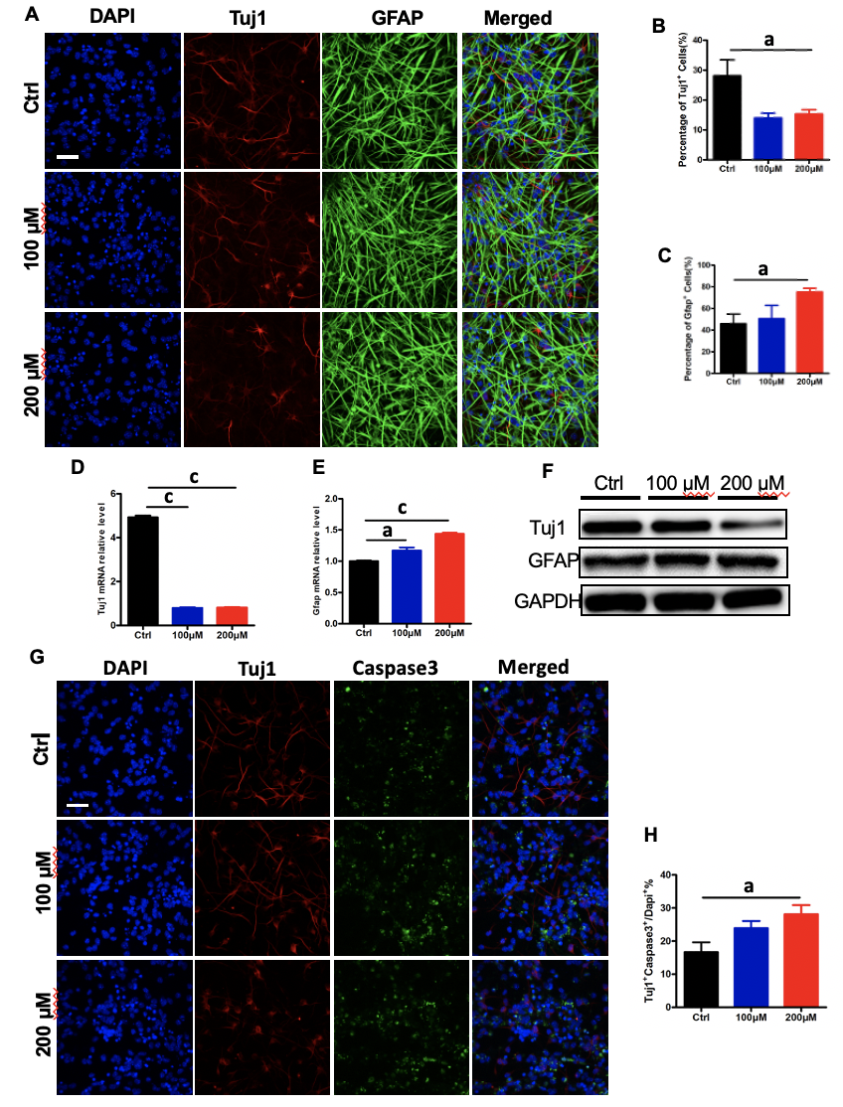
Figure 1 AlCl₃ exposure affects adult neural stem cell differentiation and neuron survival in vitro. A: Immunostaining of adult neural stem cell differentiated in the presence of AlCl₃ for β-III tubulin (Tuj1) and glial fibrillary acidic protein (GFAP) expression (Scale bar: 100 μm); B and C: The number of Tuj1⁺ cells decreased while that of GFAP⁺ cells increased (n = 8); D and E: The relative mRNA level of Tuj1 significantly decreased, and that of GFAP increased (n = 3); F: Western blot assay showing that Tuj1 protein expression was significantly decreased by AlCl₃ at 200 μmol/L, while GFAP protein expression was increased. GAPDH was used as a loading control; G: Representative images of apoptosis in newborn neurons (scale bar: 100 μm); H: The number of newborn neurons decreased after AlCl₃ exposure (n = 8). Data are represented as the mean ± SE (n = 3). Statistically significant differences are indicated: ªP < 0.05, ^{b}P < 0.01, ^{c}P < 0.001. Tuj1: β-III tubulin; GFAP: Glial fibrillary acidic protein.

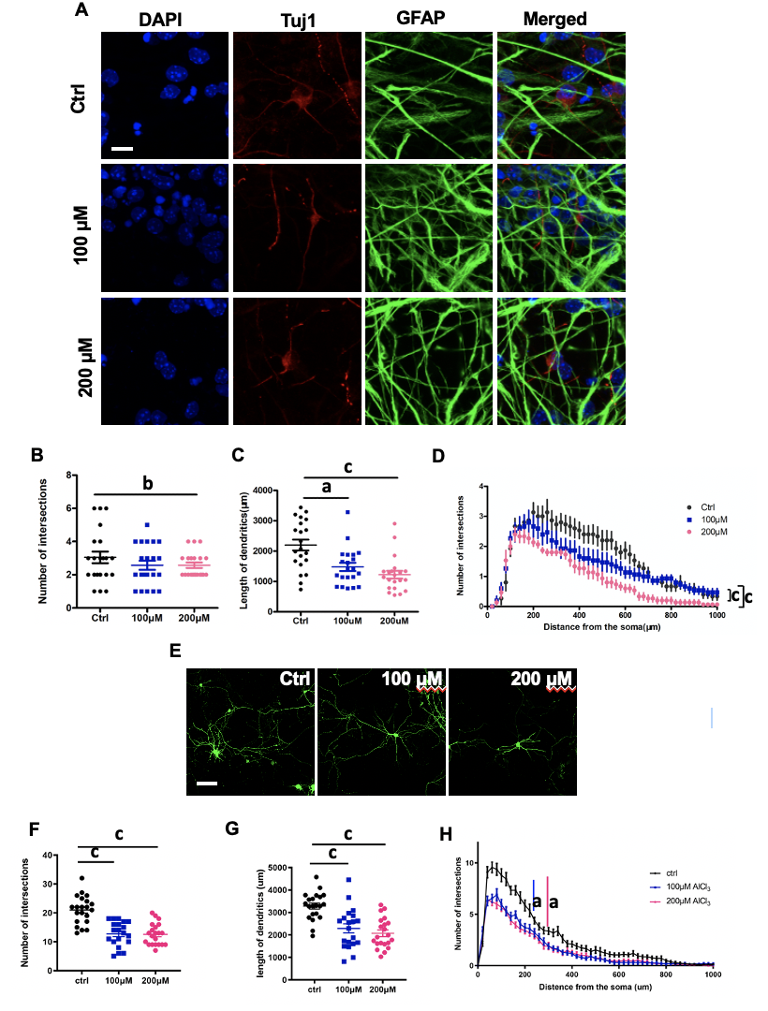
Figure 2 AlCl₃ exposure inhibits neuronal development. A: Representative images of adult neural stem cell differentiation (scale bar: 100 μm); B-D: Sholl analysis in newborn neuron indicated that the intersection number and length of dendrites both decreased after AlCl₃ exposure (n = 21); E: Representative images of hippocampal neurons (scale bar: 100 μm); F-H: Sholl analysis indicated that the intersection number and length of dendrites both significantly decreased in hippocampal neurons after AlCl₃ exposure (n = 21). Data are represented as the mean ± SE (n = 3). Statistically significant differences are indicated: ªP < 0.05, ^{b}P < 0.01, ^{c}P < 0.001. Tuj1: β-III tubulin; GFAP: Glial fibrillary acidic protein.
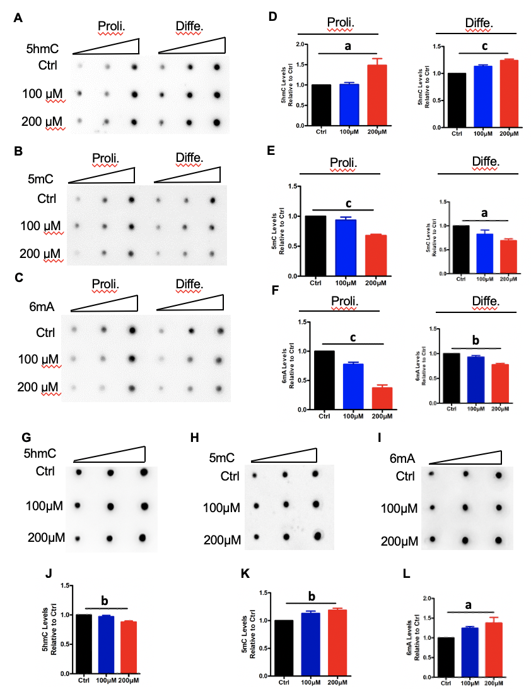
Figure 3 AlCl₃ exposure alters the levels of DNA 5-hydroxymethylcytosine, 5-methylcytosine, and N⁶-methyladenine in adult neural stem cells and neurons. A-C: Representative images of 5-hydroxymethylcytosine (5hmC), 5-methylcytosine (5mC), and N⁶-methyladenine (6mA) dot-blot assays in adult neural stem cell (aNSC) differentiation and proliferation; D-F: Quantification revealing that the relative levels of 5-mc and 6mA both decreased in aNSC proliferation and differentiation, but the level of 5hmc increased (n = 3); G-I: Representative images of 5hmC, 5mC, and 6mA dot-blot assays in neurons; J-L: Quantification revealing that the relative levels of 5hmC decreased but those of 5mC and 6mA increased in neurons (n = 3). Data are represented as the mean ± SE (n = 3). Statistically significant differences are indicated: ªP < 0.05, ^{b}P < 0.01, ^{c}P< 0.001. 5hmC: 5-hydroxymethylcytosine; 5mC: 5-methylcytosine; 6mA: N⁶-methyladenine.

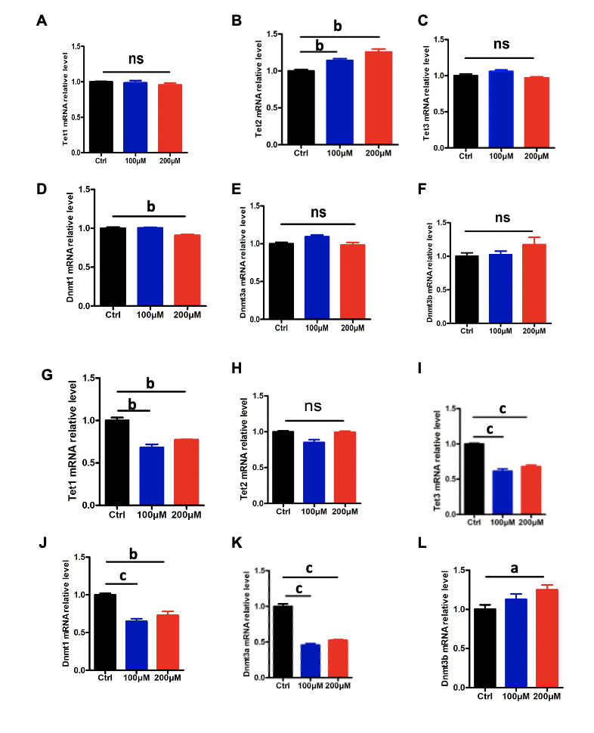
Figure 4 AlCl₃ exposure regulates the expression of Tets and Dnmts at the transcriptional level in adult neural stem cells and neurons. A-F: The relative mRNA levels of Tet1, Tet2, Tet3, Dnmt1, Dnmt3a, and Dnmt3b in aNSCs; G-L: The relative mRNA levels of Tet1, Tet2, Tet3, Dnmt1, Dnmt3a, and Dnmt3b in neurons. Data are represented as the mean ± SE (n = 3). Statistically significant differences are indicated: ªP < 0.05, ^{b}P < 0.01, ^{c}P < 0.001.

