Dear Editor,

The language of our manuscript was edited by Biomedical proofreading at the time of first submission (Representative of BioMed Proofreading, LLC. www.biomedproofreading.com. Crown Centre, Suite 600-093, 5005 Rockside Road, Cleveland, OH 44131, USA). And 2 reviewer gave marks as Grade A. Sorry for omission of description at the time of first submission. However, I think the language of our manuscript may be acceptable if you agree.

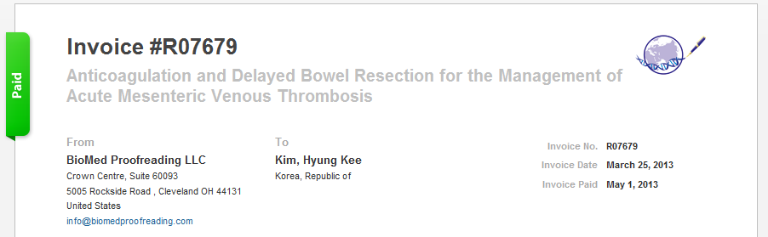

Thank you for consideration of publication in the World Journal of Gastroenterology.

Sincerely yours,
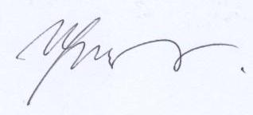
Hyung-Kee Kim, MD
Division of Transplantation & Vascular Surgery, Department of Surgery
Kyungpook National University Hospital
200, Dongduk-ro, Jung-gu, Daegu, 700-721, South Korea
Phone: +82-53-420-5605
Fax: +82-53-421-0510
E-mail address: hkkim6260@knu.ac.kr

