Informed consent statement
World Journal of Gastrointestinal Pharmacology and Therapeutics (WJGPT)
(ID 00253971) (ESPS Manuscript NO: 24835)

Manuscript title: “Incidence of leukopenia after only intraperitoneal- versus combined intravenous/intraperitoneal chemotherapy in patients with Pseudomyxoma peritonei”

We confirm that all patients gave written or oral informed consent prior to their inclusion.

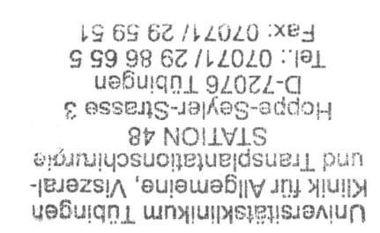
Priv.-Doz. Dr. Ingmar Königsrainer

Dr. Philipp Horvath

