Name of journal: World Journal of Respirology
ESPS Manuscript NO: 17594
Manuscript Type: MINIREVIEWS

Reducing acute respiratory distress syndrome occurrence using mechanical ventilation

Nieman GF et al. Never let the lung collapse

Gary F Nieman, Louis A Gatto, Nader M Habashi

Gary F Nieman, Department of Surgery, Upstate Medical University, Syracuse, NY 13210, United States

Louis A Gatto, Biology Department, SUNY Cortland, Cortland, NY 13210, United States

Nader M Habashi, Department of Trauma Critical Care Medicine, R Adams Cowley Shock Trauma Center, Baltimore, MD 21201, United States

Author contributions: Nieman GF, Gatto LA, Habashi NM wrote the paper.

Conflict-of-interest statement: The authors declare no conflicts of interest.

Open-Access: This article is an open-access article which selected by an in-house editor and fully peer-reviewed by external reviewers. It distributed in accordance with the Creative Commons Attribution Non Commercial (CC BY-NC 4.0) license, which permits others to distribute, remix, adapt, build upon this work non-commercially, and license their derivative works on different terms, provided the original work is properly cited and the use is non-commercial. See: http://creativecommons.org/licenses/by-nc/4.0/

Correspondence to: Gary F Nieman, BA, Department of Surgery, Upstate Medical University, 750 E Adams St Ste 329, Syracuse, NY 13210, United States. niemang@upstate.edu
Telephone: +1-315-4646302
Fax: +1-315-4646294

Received: March 14, 2015
Peer-review started: March 16, 2015
First decision: April 27, 2015
Revised: July 1, 2015
Accepted: July 16, 2015
Article in press:
Published online:

Abstract
The standard treatment for acute respiratory distress syndrome (ARDS) is supportive in the form of low tidal volume ventilation applied after significant lung injury has already developed. Nevertheless, ARDS mortality remains unacceptably high (> 40%). Indeed, once ARDS is established it becomes refractory to treatment, and therefore avoidance is key. However, preventive techniques and therapeutics to reduce the incidence of ARDS in patients at high-risk have not been validated clinically. This review discusses the current data suggesting that preemptive application of the properly adjusted mechanical breath can block progressive acute lung injury and significantly reduce the occurrence of ARDS.

Key words: Acute respiratory distress syndrome; Ventilator induced lung injury; Early acute lung injury; Acute respiratory distress syndrome incidence; Mechanical ventilation; Airway pressure release ventilation; Acute respiratory distress syndrome pathophysiology

© The Author(s) 2015. Published by Baishideng Publishing Group Inc. All rights reserved.

Core tip: In all patients at risk of developing acute lung injury or acute respiratory distress syndrome (ARDS), protective mechanical ventilation should be applied immediately upon intubation. However, the optimally protective breath to block progressive acute lung injury is not known. Recent clinical studies have shown that preemptive low tidal volume can both reduce and increase mortality. Application of preemptive airway pressure release ventilation has shown a great deal of promise at reducing ARDS occurrence in both animal and clinical studies.

Nieman GF, Gatto LA, Habashi NM. Reducing acute respiratory distress syndrome occurrence using mechanical ventilation. World J Respirol 2015; In press

INTRODUCTION
The standard treatment for acute respiratory distress syndrome (ARDS) is supportive in the form of low tidal volume (Vt) ventilation applied after significant lung injury has already developed^{[1]}. Nevertheless, ARDS mortality remains unacceptably high (> 40%)^{[2]}. Indeed, once ARDS is established it becomes refractory to treatment^{[3,4]}, and therefore avoidance is key. However, preventive techniques and therapeutics to reduce the incidence of ARDS in patients at high-risk have not been validated clinically. This review discusses the current data suggesting that preemptive application of the properly adjusted mechanical breath can block progressive acute lung injury and significantly reduce the occurrence of ARDS.
Currently the concept of ARDS is binary; either a patient has ARDS or they do not. However, it is now recognized that ARDS begins sub-clinically as Early Acute Lung Injury (EALI), which is developing long before (hours to days) the patient is even intubated^{[5]}. Over time EALI becomes clinically apparent and the patient is intubated and placed on mechanical ventilation (Figure 1). Non-protective mechanical ventilation (N-P_{MV}) during this EALI stage works synergistically with the initiating event (i.e., systemic inflammatory response syndrome -SIRS) to amplify lung injury by a mechanism of increased alveolar and alveolar duct mirco(μ)-strain and if unchecked will culminate in ARDS (Figure 1). This concept is supported by recent studies showing that application of mechanical ventilation with low tidal volume (Vt) during EALI significantly reduced the incidence of ARDS^{[6-14]}. In addition, early application of a novel ventilator strategy using an extended time at inspiration and minimal time at expiration delivered using the airway pressure release ventilation (APRV) mode, dramatically reduced the incidence of ARDS in patients at high risk secondary to major trauma^{[15]}. It has been shown that N-P_{MV} exacerbates alveolar and alveolar duct μ-strain^{[16,17]} causing extensive damage to the pulmonary parenchyma and deactivating surfactant, both of which are established mechanisms driving EALI to ARDS (Figure 1). Thus it has been shown that the combination of the parameters that comprise the MB_{P} (i.e., airway pressures, volumes, flows, rates and most importantly the time that these parameters are exposed to the lung during each breath) can either exacerbate or block progressive acute lung injury. Therefore a key research goal is to identify the optimal mechanical breath necessary to protect the lung and reduce ARDS incidence.

Ineffective ARDS treatments
There are no drugs currently available to reduce the occurrence of ARDS in patients at high-risk^{[18]}. Thus clinicians must attempt to treat the syndrome once it has fully developed^{[3]}. Although many treatment strategies have been tested in clinical trials almost all have failed^{[3,19-21]} and mortality of ARDS remains higher than 40%^{[2]}. In addition ARDS survivors often develop chronic pulmonary^{[22]} and brain^{[23]} lesions. Mechanical ventilation is essential in patients with respiratory failure^{[1]} but, if not adjusted properly, it can cause additional lung damage, termed ventilator induced lung injury (VILI) (Figure 1)^{[24]}. Injurious mechanical ventilation has not only been shown to damage the lung but to also injure distant organs, and thus VILI is a potential mechanism for the development of multiple organ dysfunction syndrome (MODS) with an even higher mortality than ARDS^{[25]}.
McIntyre et al^{[3]} rated multiple ARDS treatment strategies from ‘A’ (highly effective) to ‘E’ (no effect above placebo). Most treatments either received a ‘D’ or ‘E’ except for Low tidal volume and Open Lung protective ventilation strategies, which received a Recommendation of ‘B’ (no treatments received ‘A’). Brower et al^{[4]} published a similar report demonstrating the difficulty of treating established-ARDS. Thus, it appears that there is no effective treatment of established-ARDS and thus reducing the incidence of ARDS would have a remarkable benefit in reducing ARDS mortality. Therefore, if ARDS morbidity and mortality are going to be reduced, a preemptive treatment strategy will have to be employed to prevent the syndrome before it develops.

Ventilator-induced ARDS pathogenesis
It is well established that ARDS pathogenesis is due to an increased vascular permeability, which causes a high permeability pulmonary edema and sequentially deactivates pulmonary surfactant, resulting in alveolar instability (Figure 1)^{[26]}. However, the current binary concept that the lungs are ‘sick’ only after ARDS criteria are met perpetuates less than optimal treatment strategies, which are implemented only after established-ARDS has already developed. We postulate that in the EALI phase the identical pathologic mechanisms are at work, but lung injury is not identified because in this early stage only a relatively small percentage of the lung is damaged^{[27]}. With progressive alveolar flooding, which deactivates more and more surfactant, there is an alteration in alveolar mechanics (i.e., the dynamic change in alveolar size and shape during tidal ventilation) leading to alveolar instability and induced tissue damage at the cellular level (i.e., micro(μ)-strain) (Figure 1). Because of the limited volume of lung initially involved, the ability of hypoxic pulmonary vasoconstriction (HPV)^{[28]} to match ventilation with perfusion, and rapid transit time of hemoglobin saturation^{[29,30]}, there are minimal clinical signs or symptoms of EALI; nevertheless, over time a larger and larger portion of these patient’s lungs become abnormal despite normal blood gases. Thus, in the studies demonstrating that VILI occurs in ‘normal’ lungs before the development of acute lung injury (ALI)^{[6,7,31]}, we postulate that these lungs were not normal but rather a significant portion of lung was already edematous with unstable alveoli (EALI).
We also postulate that the systemic inflammatory response syndrome (SIRS) and VILI often work additively or synergistically in a progressive manner until a ‘tipping point’ in lung pathology is reached (Figure 2) resulting in the clinical manifestation of ARDS (Figure 1); however if preemptive mechanical ventilation with an appropriate airway mechanical breath is applied before this ‘tipping point’, ARDS can be prevented (Figure 1).

Our preemptive ventilator strategy
ARDS is rarely present at the time of hospital admission but develops over a period of hours to days^{[32]}, providing an opportunity for intervention. We postulate that not only airway pressure, but the time that this pressure is applied to the lung during each breath, is important to lung protection. Andrews et al^{[15]} placed all intubated patients arriving in the Multitrauma Critical Care unit (MTCC) on APRV with an extended time at inspiration and minimal time at expiration and showed ARDS rates were reduced (1.4%) by an order of magnitude as compared to the incidence of 15 other SICUs (14%). In addition, Roy et al^{[33]} showed a direct correlation between an elevated Pressure/Time Integral (PT_{I} - an integral of airway pressure over the time from peak inspiration to end expiration) and reduced ARDS incidence using the identical APRV strategy used by Andrews^{[15]}. APRV has the ability to precisely regulate the time spent during the plateau pressure as well as the time spent in the release phase. This allows precise control of the variables of pressure and time thus, controlling the breath profile that directly impacts the lung. However, the APRV acronym is a nebulous term for ventilation with an extended time (T_{high}) at peak airway pressure (P_{high}) and with a short time (T_{low}) at end expiratory pressure (P_{low}). Any combination of these times and pressures would be defined as APRV, yet, only a specific combination of these settings, developed by our group, is effective at reducing the incidence of ARDS^{[15-17,27,33-36]}. Our work shows that a specific protocol of T_{high}, P_{high} and T_{low} settings must be precisely followed in order for this airway PT_{I} to be effective at preventing ARDS.
To summarize, trauma/sepsis/hemorrhage induced SIRS initiates a heterogeneous lung injury caused by edema-induced surfactant deactivation, resulting in unstable alveoli. As the disease progresses and overwhelms more and more lung, the patient is intubated and placed on ventilation often with relatively high Vt. Ventilation with a N-P_{MV} strategy using an inappropriate PT_{I} exacerbates alveolar instability causing VILI (Figure 1). SIRS plus VILI (i.e., N-P_{MV}) combine to progress the lung from EALI into established-ARDS (Figure 1). The fact that acute lung injury develops slowly in stages while the patient is in the hospital, suggests the possibility that mechanical ventilation can be used as a therapeutic tool and if applied before a certain pathophysiological ‘tipping point’ can prevent or reduce the development of established-ARDS (Figure 3)^{[32]}. Our preliminary data has shown that the early application of the proper mechanical breath reduced the incidence of ARDS to 1.4%^{[15]}, as compared to the Nation Wide average of 13.5±2.2%, in severely injured trauma patients^{[37-45]} and in a high fidelity translational animal model^{[33]}. The mechanisms of lung protection involve limiting vascular permeability and pulmonary edema, and preservation of surfactant function^{[27,33]}. The Andrews study^{[15]}, combined with our animal data^{[27,33]}, strongly supports our hypothesis that the ventilator can reduce ARDS occurrence. Indeed, Villar and Slutsky recently suggested that it makes much more sense to prevent rather than treat ARDS once it fully develops^{[46]}.

‘Tipping point’ theory
Our group has been analyzing sepsis-induced ARDS pathogenesis using mathematical modeling^{[47-49]}. We found that sepsis pathogenesis does not progress in a linear fashion, but rather proceeds at a given scale until it exceeds a ‘tipping point’ (i.e., conversion from EALI to established-ARDS). Below this tipping point, mechanical stress/strain-induced tissue damage and inflammation is contained and manageable; when this threshold is crossed, mechanical damage and inflammation escalates, and dysfunction propagates to a higher biological scale (e.g., progressing from cellular, to tissue/organ, to multiple organs, to the organism; Figure 2)^{[47-49]}. We hypothesize that for as long as tissue injury and inflammation remain effectively controlled and confined to a given scale or compartment the process will affect only the physiology characteristic of that scale. If the perturbation can be reversed within that scale, before a critical ‘tipping point’ is reached, it will limit the possibility of impacting higher scales (Figure 2)^{[47-49]}. A global system-level insult, such as severe injury and hemorrhagic shock, can lead to systemic activation of inflammation (SIRS). This containment failure leads to the presence of inflammatory mediators throughout the circulation that when combined with injurious mechanical ventilation will cause progressive lung injury and if untreated will develop into ARDS (Figure 1)^{[47-49]}.
We clearly recognize that inappropriate ventilation therapies themselves carry detrimental potential (i.e., ventilator-associated injury - VILI). However, if ventilation therapies with appropriate mechanical breath are applied at an early ARDS stage, the initial tipping from cellular to the tissue level may be prevented without any negative side effects (i.e., VILI). We postulate that preemptive application of our APRV protocol arrests lung pathogenesis before the ‘tipping point’ is reached, thus preventing the damage from jumping scales, therefore preventing damage at the organ level (Figure 3)^{[47-49]}.
Starling forces: Although vascular permeability is critical in edema formation it is only one component in the Starling equation for fluid flux^{[50,51]}. Capillary filtration rate (Jv) is governed by the balance between capillary hydrostatic pressure (Pc) and plasma colloid osmotic pressure (πp), interstitial hydrostatic pressure (Pi) and colloid osmotic pressure (πi), the hydraulic conductivity (Lp), the surface area available for filtration (PS) and the vascular permeability expressed as a reflection coefficient (σ) (Equation 1):
Jv = LpPS [(Pc - Pi) – σ(πp – πi)] (Equation 1)
It is our hypothesis that ventilation with the appropriate mechanical breath can shift the balance of the Starling equation from high capillary filtration to a significantly reduced filtration rate, even in the presence of increased σ, by increasing Pi. Alternatively, an appropriate mechanical breath may prevent stretch induced increases in σ by stabilizing alveoli^{[52,53]}.

VENTILATOR AS A THERAPEUTIC TOOL TO PREVENT ARDS
We hypothesize that ARDS can be prevented if mechanical ventilation with the appropriate mechanical breath is applied during the EALI stage, before a ‘tipping point’ of no return is reached. We tested this hypothesis initially in our clinically applicable porcine model of peritoneal sepsis (PS) and gut ischemia/reperfusion (I/R) ARDS model^{[54]}. This is a highly sophisticated model that treats the animal as a trauma or septic patient would be treated in the ICU. Animals are ventilated with a critical care grade ventilator, receive fluid resuscitation according to surviving sepsis criteria^{[55]}, are given scheduled doses of wide spectrum antibiotics, vasopressors to maintain arterial pressure and urine output and, in spite of this treatment 100% of the animals develop ARDS over a 48hr period without additional protection. All of the main pathologic features required in a clinically applicable animal ARDS model including: 1) histological evidence of tissue injury, 2) alteration of alveolar capillary barrier, 3) an inflammatory response, and 4) evidence of physiological dysfunction^{[56]}, are also present in our porcine model^{[27,33]}. Since so many features of our model match those seen in the clinical practice, the model has been described as ‘good evidence’ in that whatever treatment proves successful in this model will also be successful in a clinical trial^{[57]}.

Animal experiment reducing ARDS incidence

We chose to use the APRV mode to test our first mechanical breath because APRV allows precise control of the time during which airway pressure and volume are applied to the lung with each breath and hypothesized that the extended time (T_{High}) at plateau pressure would keep the pulmonary interstitial pressure sustained for the majority of each breath, which would reduce transvascular fluid transduction by elevating Pi (Equation 1) and thus reduce edema. In addition we postulated that the brief time (T_{Low}) at expiratory pressure would prevent alveolar collapse and instability and that this combination would prevent ARDS development. We tested our hypothesis in our peritoneal sepsis + gut ischemia/reperfusion (PS+I/R) porcine ARDS model. In this study animals were on conventional mechanical ventilation (CMV) during the surgery and injury (i.e., PS+I/R) period and then either remained on CMV or were converted to APRV 1hr into the 48hr experiment.

APRV settings
There are 4 basic APRV adjustments that can be made: 1) Time at high pressure (T_{high}), 2) the magnitude of High pressure (P_{High}), 3) Time at low pressure (T_{Low}) and 4) the magnitude of Low pressure (P_{low}). In our studies the T_{high} was set at 90% of each breath. P_{High} was set to be similar to the plateau pressure with conventional ventilation (CMV). T_{Low} was very brief and is calculated as 75% of the peak expiratory flow rate (PEFR) thus, it is adjusted in response to changes in lung physiology (i.e., the rate of lung collapse) in a closed loop fashion^{[34]}. P_{low} was always set at zero to maximize the bulk gas flow movement during exhalation. However, P_{Low} never reached zero since T_{Low} is so short, the lung does not have sufficient time to totally deflate and thus P_{low} is always positive. Unpublished observations suggest that the P_{Low} is approximately 33%-50% of P_{High} with a T_{Low} set to 75% of the peak expiratory flow rate (PEFR). We postulate that the combined effects of our P_{High}, T_{High} and T_{Low} strategy will create a mechanical breath that can block the ARDS progressive pathogenesis and prevent the development of ARDS (Figure 1).

Experiments in our laboratory

In our initial study we compared two groups of animals^{[27]}: Group 1: Non-Protective Ventilation (NPV) - animals were ventilated with volume cycled ventilation [Tidal volume (Vt)=10cc/Kg] with 5cmH₂O of PEEP. Group II animals were converted to our APRV ventilation protocol with the settings described above, immediately following PS+I/R and remained on APRV for the entire 48hr experiment. The results of the study were very definitive; APRV completely protected the lung from injury^{[27]}. Lung injury was assessed at many levels including organ function, histologic and molecular. Lung function was assessed by oxygenation using the PaO₂/FiO₂ (P/F) ratio. Oxygenation was clearly maintained throughout the 48 h experiment in the APRV group, whereas in the CMV group P/F fell below 200^{[27]}, which is the Berlin definitions of ARDS^{[58]}. This was due to almost complete protection at the tissue level. APRV also protected the lung at the molecular level. There was a significant reduction in total protein and interleukin-6 (IL-6) in bronchoalveolar lavage fluid (BALF)^{[27]}. This suggests that APRV prevents the increase in pulmonary microvascular permeability and reduces lung inflammation. In addition, APRV preserved surfactant protein B (SP-B) concentration, which is known to play a critical role in surfactant function, thus, maintaining normal levels of SP-B would prevent alveolar instability^{[27]}. All of these physiologic, cellular and molecular improvements translated into a significant reduction in pulmonary edema^{[27]}.

More recently we compared preemptive application of APRV with the current standard of care low tidal volume ventilation (LVt). LVt was adjusted using the ARDSnet strategy and was applied similarily to current clinical practice once the patient’s P/F fell below > 300. Additional adjustments were made using the ARDSnet protocol following the high PEEP scale, as well as the protocol guidelines(i.e., SaO₂ < 88%)^{[1]}. APRV kept the lung fully inflated preventing the severe atelectasis associated with ARDS. In addition, APRV significantly reduced interstitial and airway edema as compared with the LVt group, with significantly less histopathologic injury (Figure 3). These improvements in lung function and pathology were coupled with preservation of E-Cadherin (reduced vascular permeability), surfactant protein-A (improved surfactant function) and IL-6 (reduced inflammation) (Figure 4)^{[33]}. Combined, these studies clearly show that preemptive mechanical ventilation applied early in the disease processes can block ARDS pathogenesis, significantly reducing ARDS incidence.

Clinical studies reducing ARDS incidence

We have conducted a statistical review comparing the incidence and mortality of ARDS in patients with APRV applied immediately upon intubation, against the standard of care ventilation in severely injured trauma patients. Even though our Injury Severity Score (ISS) was in the upper quartile, our ARDS incidence (14% vs 1.3%) and mortality (14.1% vs 3.9%) were both below the lower quartile. Although this study was a retrospective meta-analysis and not a prospective clinical trial, the order of magnitude differences in ARDS incidence and mortality strongly suggest that early application of protective mechanical ventilation, in the form of properly adjusted APRV, can reduce both ARDS incidence and mortality^{[15]}.

MECHANISM OF MECHANICAL BREATH PROTECTION

Although these studies offer proof-of-concept that preemptive APRV can reduce ARDS incidence^{[27,33]}, we need to better understand the mechanisms by which APRV protects the lung from progressive acute lung injury. To this end we have developed a rat trauma/hemorrhagic shock (T/HS) model with clinically applicable fluid resuscitation and mechanical ventilation protocols^{[35]}. This model initiates a systemic inflammatory injury that results in progressive acute lung injury culminating in the development of ARDS over a 6hr period. This model gives an opportunity to study progressive acute lung injury that if unblocked will lead to ARDS. Our hypothesis was that early application of APRV immediately following HS, when the lungs were still normal, would block progressive lung damage and reduce ARDS incidence.

In our preliminary experiments we studied two groups of rats: Group 1 - volume cycled ventilation (VC) with 0.5 cm H₂O PEEP and Group 2 - APRV with our standard settings (see APRV Settings above). Our model uniformly causes ARDS between 4 and 6 hours after HS when ventilated with VC. Lung function declined gradually over time in the VC group and all animals either died due to pulmonary edema, which was so severe that they could not be ventilated or the P/F ratio was below 200 at the end of the experiment^{[35]}. Pulmonary edema was confirmed histologically (Figure 5). Pulmonary edema-induced surfactant deactivation resulted in alveolar instability (Figure 6). Preemptive application of APRV maintained P/F in the normal range and prevented lung damage (Figure 5) and alveolar instability (Figure 6). Thus, early application of APRV protects the lung and prevents progressive lung injury by reducing pulmonary edema (see Starling forces above) and by stabilizing alveoli, which prevents mechanical damage caused by shear-stress during alveolar collapse and reopening.

More recently we have begun to explore the impact of any mechanical breath on the pulmonary microenvironment (i.e., alveoli and alveolar ducts). Gattinoni’s group has shown that excessive whole lung stress and strain, caused by injurious mechanical breath, are the mechanical mechanism of VILI^{[59]}. Our group has taken the whole lung stress/strain concept one step further and has analyzed the impact of ventilator-induced stress and strain in the microenvironment, or the alveoli and alveolar ducts^{[16,17]}. We used an in vivo microscopic technique to analyze the μ-strain on individual alveoli in a rat ARDS model using 4 different mechanical breath settings: (CMV - Vt 6cc/kg + PEEP 5 and 16 cm H₂O and APRV T_{High} 90% + T_{Low} 10% and 75%)^{[16]}. ARDS was caused using Tween 20 lavage and subpleural alveoli were photographed at peak inspiration and end-expiration using all 4 mechanical breath settings. Appropriately set APRV with a T_{High} of 90%, regardless of the T_{Low} setting (10% or 75%), caused significantly more alveolar recruitment than did CMV at any PEEP level. However, APRV with an inappropriately set T_{Low} of 10% allowed a large derecruitment of alveoli, which was prevented by setting T_{Low} appropriately at 75%. The fully recruited alveoli at peak inspiration, followed by collapse at end-expiration, caused a large μ-strain on the alveoli being ventilated with inappropriately set APRV T_{Low} 10% (Figure 7). Conversely, APRV with an appropriately set T_{Low} set at 75% PEFR had the least μ-strain, demonstrating the importance of all the parameters that make up the mechanical breath (see APRV Settings). Also important is the large difference between macro- and μ-strain (Figure 7). CMV with PEEP 5 caused a very small macro-strain, although it was the largest μ-strain of all the mechanical breaths tested. Thus, if a clinician used a protective ventilator strategy set to minimize the macro-strain, it would not be protective unless the μ-strain was also reduced. This highlights the importance of understanding how any mechanical breath impacts the strain on alveoli and alveolar ducts.

Although in vivo microscopy is a highly effective tool with which to measure dynamic alveolar μ-strain, we could not directly observe the impact of the mechanical breath on the alveolar ducts. We therefore developed a technique using lung tissue fixed at peak inspiration and end-expiration to analyze the μ-strain on both alveoli and alveolar ducts (Figure 8)^{[17]}. We color coded alveoli blue and alveolar ducts green and measured the change in alveolar and alveolar duct size using computer image analysis. Using the same four mechanical breath settings that we used in our previous study^{[16]}, we demonstrated that APRV with a T_{Low} set at 75% PEFR caused the least μ-strain on the alveolar duct, whereas APRV with an inappropriately T_{Low} set at 10% PEFR, effected the largest μ-strain (Figure 9).

CONCLUSION

To our knowledge we are the only group that is conducting experiments investigating the optimal mechanical breath necessary to reduce the incidence of ARDS in animals models of secondary ARDS (i.e., hemorrhagic shock and sepsis). Our work clearly shows that preemptive APRV using the settings developed by our group will reduce ARDS incidence in a rat trauma/hemorrhagic shock model and in a high fidelity, clinically applicable porcine ARDS model^{[27,35]}. Because our animal model so closely represents the clinical progression from injury (i.e., hemorrhagic shock and sepsis) to established-ARDS, it is considered ‘good evidence’ that any treatment shown efficacious in this model will be successful in a clinical trial^{[57]}. In addition, we have shown that part of the protective mechanism of preemptive APRV is minimizing μ-strain in the alveolus and alveolar ducts, highlighting the importance of understanding the impact of any given PT_{I} on the microenvironment^{[16,17]}. The meta-analysis on severely injured trauma patients showed an order of magnitude reduction in ARDS incidence and mortality with preemptive application of APRV strongly suggesting that a prospective clinical trail is warranted. In conclusion, the optimal method of protecting a patients lung with established-ARDS, as described by Dr. Lachmann^{[60]} in 1992, is to ‘Open the Lung and Keep it Open’ and likewise, the goal of preemptive mechanical ventilation to reduce ARDS incidence is to ‘Never let the Lung Collapse’.

REFERENCES
1 Ventilation with lower tidal volumes as compared with traditional tidal volumes for acute lung injury and the acute respiratory distress syndrome. The Acute Respiratory Distress Syndrome Network. N Engl J Med 2000; 342: 1301-1308 [PMID: 10793162 DOI: 10.1056/NEJM200005043421801]
2 Villar J, Blanco J, Añón JM, Santos-Bouza A, Blanch L, Ambrós A, Gandía F, Carriedo D, Mosteiro F, Basaldúa S, Fernández RL, Kacmarek RM. The ALIEN study: incidence and outcome of acute respiratory distress syndrome in the era of lung protective ventilation. Intensive Care Med 2011; 37: 1932-1941 [PMID: 21997128 DOI: 10.1007/s00134-011-2380-4]
3 McIntyre RC, Pulido EJ, Bensard DD, Shames BD, Abraham E. Thirty years of clinical trials in acute respiratory distress syndrome. Crit Care Med 2000; 28: 3314-3331 [PMID: 11008997 DOI: 10.1097/00003246-200009000-00034]
4 Brower RG, Fessler HE. Another "negative" trial of surfactant. Time to bury this idea? Am J Respir Crit Care Med 2011; 183: 966-968 [PMID: 21498819 DOI: 10.1164/rccm.201101-0018ED]
5 Levitt JE, Bedi H, Calfee CS, Gould MK, Matthay MA. Identification of early acute lung injury at initial evaluation in an acute care setting prior to the onset of respiratory failure. Chest 2009; 135: 936-943 [PMID: 19188549 DOI: 10.1378/chest.08-2346]
6 Gajic O, Dara SI, Mendez JL, Adesanya AO, Festic E, Caples SM, Rana R, St Sauver JL, Lymp JF, Afessa B, Hubmayr RD. Ventilator-associated lung injury in patients without acute lung injury at the onset of mechanical ventilation. Crit Care Med 2004; 32: 1817-1824 [PMID: 15343007 DOI: 10.1097/01.CCM.0000133019.52531.30]
7 Determann RM, Royakkers A, Wolthuis EK, Vlaar AP, Choi G, Paulus F, Hofstra JJ, de Graaff MJ, Korevaar JC, Schultz MJ. Ventilation with lower tidal volumes as compared with conventional tidal volumes for patients without acute lung injury: a preventive randomized controlled trial. Crit Care 2010; 14: R1 [PMID: 20055989 DOI: 10.1186/cc8230]
8 Fuller BM, Mohr NM, Drewry AM, Carpenter CR. Lower tidal volume at initiation of mechanical ventilation may reduce progression to acute respiratory distress syndrome: a systematic review. Crit Care 2013; 17: R11 [PMID: 23331507 DOI: 10.1186/cc11936]
9 Fuller BM, Mohr NM, Hotchkiss RS, Kollef MH. Reducing the burden of acute respiratory distress syndrome: the case for early intervention and the potential role of the emergency department. Shock 2014; 41: 378-387 [PMID: 24469236 DOI: 10.1097/SHK.0000000000000142]
10 Futier E, Constantin JM, Paugam-Burtz C, Pascal J, Eurin M, Neuschwander A, Marret E, Beaussier M, Gutton C, Lefrant JY, Allaouchiche B, Verzilli D, Leone M, De Jong A, Bazin JE, Pereira B, Jaber S. A trial of intraoperative low-tidal-volume ventilation in abdominal surgery. N Engl J Med 2013; 369: 428-437 [PMID: 23902482 DOI: 10.1056/NEJMoa1301082]
11 Severgnini P, Selmo G, Lanza C, Chiesa A, Frigerio A, Bacuzzi A, Dionigi G, Novario R, Gregoretti C, de Abreu MG, Schultz MJ, Jaber S, Futier E, Chiaranda M, Pelosi P. Protective mechanical ventilation during general anesthesia for open abdominal surgery improves postoperative pulmonary function. Anesthesiology 2013; 118: 1307-1321 [PMID: 23542800 DOI: 10.1097/ALN.0b013e31829102de]
12 Jia X, Malhotra A, Saeed M, Mark RG, Talmor D. Risk factors for ARDS in patients receiving mechanical ventilation for & gt; 48 h. Chest 2008; 133: 853-861 [PMID: 18263691 DOI: 10.1378/chest.07-1121]
13 Serpa Neto A, Cardoso SO, Manetta JA, Pereira VG, Espósito DC, Pasqualucci Mde O, Damasceno MC, Schultz MJ. Association between use of lung-protective ventilation with lower tidal volumes and clinical outcomes among patients without acute respiratory distress syndrome: a meta-analysis. JAMA 2012; 308: 1651-1659 [PMID: 23093163 DOI: 10.1001/jama.2012.13730]
14 Serpa Neto A, Nagtzaam L, Schultz MJ. Ventilation with lower tidal volumes for critically ill patients without the acute respiratory distress syndrome: a systematic translational review and meta-analysis. Curr Opin Crit Care 2014; 20: 25-32 [PMID: 24275571 DOI: 10.1097/MCC.0000000000000044]
15 Andrews PL, Shiber JR, Jaruga-Killeen E, Roy S, Sadowitz B, O'Toole RV, Gatto LA, Nieman GF, Scalea T, Habashi NM. Early application of airway pressure release ventilation may reduce mortality in high-risk trauma patients: a systematic review of observational trauma ARDS literature. J Trauma Acute Care Surg 2013; 75: 635-641 [PMID: 24064877 DOI: 10.1097/TA.0b013e31829d3504]
16 Kollisch-Singule M, Emr B, Smith B, Roy S, Jain S, Satalin J, Snyder K, Andrews P, Habashi N, Bates J, Marx W, Nieman G, Gatto LA. Mechanical breath profile of airway pressure release ventilation: the effect on alveolar recruitment and microstrain in acute lung injury. JAMA Surg 2014; 149: 1138-1145 [PMID: 25230047 DOI: 10.1001/jamasurg.2014.1829]
17 Kollisch-Singule M, Emr B, Smith B, Ruiz C, Roy S, Meng Q, Jain S, Satalin J, Snyder K, Ghosh A, Marx WH, Andrews P, Habashi N, Nieman GF, Gatto LA. Airway pressure release ventilation reduces conducting airway micro-strain in lung injury. J Am Coll Surg 2014; 219: 968-976 [PMID: 25440027 DOI: 10.1016/j.jamcollsurg.2014.09.011]
18 Zeni F, Freeman B, Natanson C. Anti-inflammatory therapies to treat sepsis and septic shock: a reassessment. Crit Care Med 1997; 25: 1095-1100 [PMID: 9233726 DOI: 10.1097/00003246-199707000-00001]
19 Doyle IR, Bersten AD, Nicholas TE. Surfactant proteins-A and -B are elevated in plasma of patients with acute respiratory failure. Am J Respir Crit Care Med 1997; 156: 1217-1229 [PMID: 9351625 DOI: 10.1164/ajrccm.156.4.9603061]
20 Matthay MA, Brower RG, Carson S, Douglas IS, Eisner M, Hite D, Holets S, Kallet RH, Liu KD, MacIntyre N, Moss M, Schoenfeld D, Steingrub J, Thompson BT. Randomized, placebo-controlled clinical trial of an aerosolized β₂-agonist for treatment of acute lung injury. Am J Respir Crit Care Med 2011; 184: 561-568 [PMID: 21562125 DOI: 10.1164/rccm.201012-2090OC]
21 Spragg RG, Gilliard N, Richman P, Smith RM, Hite RD, Pappert D, Robertson B, Curstedt T, Strayer D. Acute effects of a single dose of porcine surfactant on patients with the adult respiratory distress syndrome. Chest 1994; 105: 195-202 [PMID: 8031347 DOI: 10.1378/chest.105.1.195]
22 Herridge MS, Tansey CM, Matté A, Tomlinson G, Diaz-Granados N, Cooper A, Guest CB, Mazer CD, Mehta S, Stewart TE, Kudlow P, Cook D, Slutsky AS, Cheung AM. Functional disability 5 years after acute respiratory distress syndrome. N Engl J Med 2011; 364: 1293-1304 [PMID: 21470008 DOI: 10.1056/NEJMoa1011802]
23 Mikkelsen ME, Christie JD, Lanken PN, Biester RC, Thompson BT, Bellamy SL, Localio AR, Demissie E, Hopkins RO, Angus DC. The adult respiratory distress syndrome cognitive outcomes study: long-term neuropsychological function in survivors of acute lung injury. Am J Respir Crit Care Med 2012; 185: 1307-1315 [PMID: 22492988 DOI: 10.1164/rccm.201111-2025OC]
24 Uhlig U, Uhlig S. Ventilation-induced lung injury. Compr Physiol 2011; 1: 635-661 [PMID: 23737198]
25 Del Sorbo L, Slutsky AS. Acute respiratory distress syndrome and multiple organ failure. Curr Opin Crit Care 2011; 17: 1-6 [PMID: 21157315 DOI: 10.1097/MCC.0b013e3283427295]
26 Matthay MA, Zemans RL. The acute respiratory distress syndrome: pathogenesis and treatment. Annu Rev Pathol 2011; 6: 147-163 [PMID: 20936936 DOI: 10.1146/annurev-pathol-011110-130158]
27 Roy S, Sadowitz B, Andrews P, Gatto LA, Marx W, Ge L, Wang G, Lin X, Dean DA, Kuhn M, Ghosh A, Satalin J, Snyder K, Vodovotz Y, Nieman G, Habashi N. Early stabilizing alveolar ventilation prevents acute respiratory distress syndrome: a novel timing-based ventilatory intervention to avert lung injury. J Trauma Acute Care Surg 2012; 73: 391-400 [PMID: 22846945 DOI: 10.1097/TA.0b013e31825c7a82]
28 Benzing A, Mols G, Brieschal T, Geiger K. Hypoxic pulmonary vasoconstriction in nonventilated lung areas contributes to differences in hemodynamic and gas exchange responses to inhalation of nitric oxide. Anesthesiology 1997; 86: 1254-1261 [PMID: 9197293 DOI: 10.1097/00000542-199706000-00005]
29 Syring RS, Otto CM, Spivack RE, Markstaller K, Baumgardner JE. Maintenance of end-expiratory recruitment with increased respiratory rate after saline-lavage lung injury. J Appl Physiol (1985) 2007; 102: 331-339 [PMID: 16959915 DOI: 10.1152/japplphysiol.00002.2006]
30 Williams EM, Viale JP, Hamilton RM, McPeak H, Sutton L, Hahn CE. Within-breath arterial PO2 oscillations in an experimental model of acute respiratory distress syndrome. Br J Anaesth 2000; 85: 456-459 [PMID: 11103189 DOI: 10.1093/bja/85.3.456]
31 Gajic O, Frutos-Vivar F, Esteban A, Hubmayr RD, Anzueto A. Ventilator settings as a risk factor for acute respiratory distress syndrome in mechanically ventilated patients. Intensive Care Med 2005; 31: 922-926 [PMID: 15856172 DOI: 10.1007/s00134-005-2625-1]
32 Shari G, Kojicic M, Li G, Cartin-Ceba R, Alvarez CT, Kashyap R, Dong Y, Poulose JT, Herasevich V, Garza JA, Gajic O. Timing of the onset of acute respiratory distress syndrome: a population-based study. Respir Care 2011; 56: 576-582 [PMID: 21276315 DOI: 10.4187/respcare.00901]
33 Roy S, Habashi N, Sadowitz B, Andrews P, Ge L, Wang G, Roy P, Ghosh A, Kuhn M, Satalin J, Gatto LA, Lin X, Dean DA, Vodovotz Y, Nieman G. Early airway pressure release ventilation prevents ARDS-a novel preventive approach to lung injury. Shock 2013; 39: 28-38 [PMID: 23247119 DOI: 10.1097/SHK.0b013e31827b47bb]
34 Habashi N, Andrews P. Ventilator strategies for posttraumatic acute respiratory distress syndrome: airway pressure release ventilation and the role of spontaneous breathing in critically ill patients. Curr Opin Crit Care 2004; 10: 549-557 [PMID: 15616399 DOI: 10.1097/01.ccx.0000145473.01597.13]
35 Roy SK, Emr B, Sadowitz B, Gatto LA, Ghosh A, Satalin JM, Snyder KP, Ge L, Wang G, Marx W, Dean D, Andrews P, Singh A, Scalea T, Habashi N, Nieman GF. Preemptive application of airway pressure release ventilation prevents development of acute respiratory distress syndrome in a rat traumatic hemorrhagic shock model. Shock 2013; 40: 210-216 [PMID: 23799354 DOI: 10.1097/SHK.0b013e31829efb06]
36 Emr B, Gatto LA, Roy S, Satalin J, Ghosh A, Snyder K, Andrews P, Habashi N, Marx W, Ge L, Wang G, Dean DA, Vodovotz Y, Nieman G. Airway pressure release ventilation prevents ventilator-induced lung injury in normal lungs. JAMA Surg 2013; 148: 1005-1012 [PMID: 24026214 DOI: 10.1001/jamasurg.2013.3746]
37 Chaiwat O, Lang JD, Vavilala MS, Wang J, MacKenzie EJ, Jurkovich GJ, Rivara FP. Early packed red blood cell transfusion and acute respiratory distress syndrome after trauma. Anesthesiology 2009; 110: 351-360 [PMID: 19164959 DOI: 10.1097/ALN.0b013e3181948a97]
38 Dicker RA, Morabito DJ, Pittet JF, Campbell AR, Mackersie RC. Acute respiratory distress syndrome criteria in trauma patients: why the definitions do not work. J Trauma 2004; 57: 522-526; discussion 526-528 [PMID: 15454797 DOI: 10.1097/01.TA.0000135749.64867.06]
39 Johnston CJ, Rubenfeld GD, Hudson LD. Effect of age on the development of ARDS in trauma patients. Chest 2003; 124: 653-659 [PMID: 12907556 DOI: 10.1378/chest.124.2.653]
40 Laudi S, Donaubauer B, Busch T, Kerner T, Bercker S, Bail H, Feldheiser A, Haas N, Kaisers U. Low incidence of multiple organ failure after major trauma. Injury 2007; 38: 1052-1058 [PMID: 17572416 DOI: 10.1016/j.injury.2007.03.020]
41 Martin M, Salim A, Murray J, Demetriades D, Belzberg H, Rhee P. The decreasing incidence and mortality of acute respiratory distress syndrome after injury: a 5-year observational study. J Trauma 2005; 59: 1107-1113 [PMID: 16385287 DOI: 10.1097/01.ta.0000188633.94766.d0]
42 Nast-Kolb D, Aufmkolk M, Rucholtz S, Obertacke U, Waydhas C. Multiple organ failure still a major cause of morbidity but not mortality in blunt multiple trauma. J Trauma 2001; 51: 835-841; discussion 841-842 [PMID: 11706328 DOI: 10.1097/00005373-200111000-00003]
43 Plurad D, Martin M, Green D, Salim A, Inaba K, Belzberg H, Demetriades D, Rhee P. The decreasing incidence of late posttraumatic acute respiratory distress syndrome: the potential role of lung protective ventilation and conservative transfusion practice. J Trauma 2007; 63: 1-7; discussion 8 [PMID: 17622861 DOI: 10.1097/TA.0b013e318068b1ed]
44 Salim A, Martin M, Constantinou C, Sangthong B, Brown C, Kasotakis G, Demetriades D, Belzberg H. Acute respiratory distress syndrome in the trauma intensive care unit: Morbid but not mortal. Arch Surg 2006; 141: 655-658 [PMID: 16847235 DOI: 10.1001/archsurg.141.7.655]
45 Treggiari MM, Hudson LD, Martin DP, Weiss NS, Caldwell E, Rubenfeld G. Effect of acute lung injury and acute respiratory distress syndrome on outcome in critically ill trauma patients. Crit Care Med 2004; 32: 327-331 [PMID: 14758144 DOI: 10.1097/01.CCM.0000108870.09693.42]
46 Villar J, Slutsky AS. Is acute respiratory distress syndrome an iatrogenic disease? Crit Care 2010; 14: 120 [PMID: 20236490 DOI: 10.1186/cc8842]
47 Nieman G, Gatto LA, Habashi N. Lung recruitment: the combined effect of pressures "North" and "South" of the diaphragm. Crit Care Med 2012; 40: 1985-1986 [PMID: 22610215 DOI: 10.1097/CCM.0b013e31824c8fc0]
48 An G, Nieman G, Vodovotz Y. Toward computational identification of multiscale "tipping points" in acute inflammation and multiple organ failure. Ann Biomed Eng 2012; 40: 2414-2424 [PMID: 22527009 DOI: 10.1007/s10439-012-0565-9]
49 An G, Nieman G, Vodovotz Y. Computational and systems biology in trauma and sepsis: current state and future perspectives. Int J Burns Trauma 2012; 2: 1-10 [PMID: 22928162]
50 Parker JC. Hydraulic conductance of lung endothelial phenotypes and Starling safety factors against edema. Am J Physiol Lung Cell Mol Physiol 2007; 292: L378-L380 [PMID: 17041015 DOI: 10.1152/ajplung.00196.2006]
51 Effros RM, Parker JC. Pulmonary vascular heterogeneity and the Starling hypothesis. Microvasc Res 2009; 78: 71-77 [PMID: 19332080 DOI: 10.1016/j.mvr.2009.03.004]
52 Lowe K, Alvarez D, King J, Stevens T. Phenotypic heterogeneity in lung capillary and extra-alveolar endothelial cells. Increased extra-alveolar endothelial permeability is sufficient to decrease compliance. J Surg Res 2007; 143: 70-77 [PMID: 17950075 DOI: 10.1016/j.jss.2007.03.047]
53 Nilius B, Vriens J, Prenen J, Droogmans G, Voets T. TRPV4 calcium entry channel: a paradigm for gating diversity. Am J Physiol Cell Physiol 2004; 286: C195-C205 [PMID: 14707014 DOI: 10.1152/ajpcell.00365.2003]
54 Kubiak BD, Albert SP, Gatto LA, Vieau CJ, Roy SK, Snyder KP, Maier KG, Nieman GF. A clinically applicable porcine model of septic and ischemia/reperfusion-induced shock and multiple organ injury. J Surg Res 2011; 166: e59-e69 [PMID: 21193206 DOI: 10.1016/j.jss.2010.10.014]
55 Dellinger RP, Levy MM, Rhodes A, Annane D, Gerlach H, Opal SM, Sevransky JE, Sprung CL, Douglas IS, Jaeschke R, Osborn TM, Nunnally ME, Townsend SR, Reinhart K, Kleinpell RM, Angus DC, Deutschman CS, Machado FR, Rubenfeld GD, Webb S, Beale RJ, Vincent JL, Moreno R. Surviving Sepsis Campaign: international guidelines for management of severe sepsis and septic shock, 2012. Intensive Care Med 2013; 39: 165-228 [PMID: 23361625 DOI: 10.1007/s00134-012-2769-8]
56 Matute-Bello G, Downey G, Moore BB, Groshong SD, Matthay MA, Slutsky AS, Kuebler WM. An official American Thoracic Society workshop report: features and measurements of experimental acute lung injury in animals. Am J Respir Cell Mol Biol 2011; 44: 725-738 [PMID: 21531958 DOI: 10.1165/rcmb.2009-0210ST]
57 Piper RD, Cook DJ, Bone RC, Sibbald WJ. Introducing Critical Appraisal to studies of animal models investigating novel therapies in sepsis. Crit Care Med 1996; 24: 2059-2070 [PMID: 8968277]
58 Ranieri VM, Rubenfeld GD, Thompson BT, Ferguson ND, Caldwell E, Fan E, Camporota L, Slutsky AS. Acute respiratory distress syndrome: the Berlin Definition. JAMA 2012; 307: 2526-2533 [PMID: 22797452 DOI: 10.1001/jama.2012.5669]
59 Protti A, Andreis DT, Monti M, Santini A, Sparacino CC, Langer T, Votta E, Gatti S, Lombardi L, Leopardi O, Masson S, Cressoni M, Gattinoni L. Lung stress and strain during mechanical ventilation: any difference between statics and dynamics? Crit Care Med 2013; 41: 1046-1055 [PMID: 23385096 DOI: 10.1097/CCM.0b013e31827417a6]

60 Lachmann B. Open up the lung and keep the lung open. Intensive Care Med 1992; 18: 319-321 [PMID: 1469157]
P-Reviewer: Aggarwal D, Deng B, Kuan YH, Ledford JG S-Editor: Tian YL
L-Editor: E-Editor:

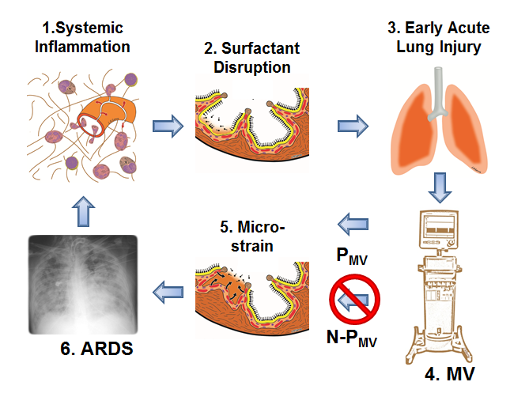
Figure 1 Pathogenesis of acute respiratory distress syndrome. 1: Systemic Inflammation, also know as the Systemic Inflammatory Response Syndrome (SIRS) activates white blood cells and increases vascular permeability (Red Arrows); 2: Surfactant Disruption occurs if increased permeability result in alveolar edema (tan color) forces surfactant molecules off of the alveolar surface into the lumen of the alveolus; 3: Early Acute Lung Injury (EALI) pathology is associated with moderate surfactant deactivation and pulmonary edema with limited clinical symptoms; 4: Mechanical Ventilation (MV) if non-protective (N-P_{MV}) will cause a ventilator induced lung injury, which greatly exacerbates progressive acute lung damage; 5: Micro-strain on the alveolar walls occurs as alveoli with limited surfactant function collapse and reopen during each breath. N-P_{MV} greatly accelerates and expands micro-strain injury and is one of the primary VILI mechanisms. However, if a protective mechanical breath (P_{MV}) is applied immediately upon intubation alveolar micro-strain is avoided; 6: Acute respiratory distress syndrome (ARDS) is caused by a combination of systemic inflammation-induced pulmonary edema, deactivation of surfactant and N-P_{MV,} resulting in alveolar micro-strain. If micro-strain is prevented () by applying P_{MV}, VILI will be avoided and ARDS incidence reduced.

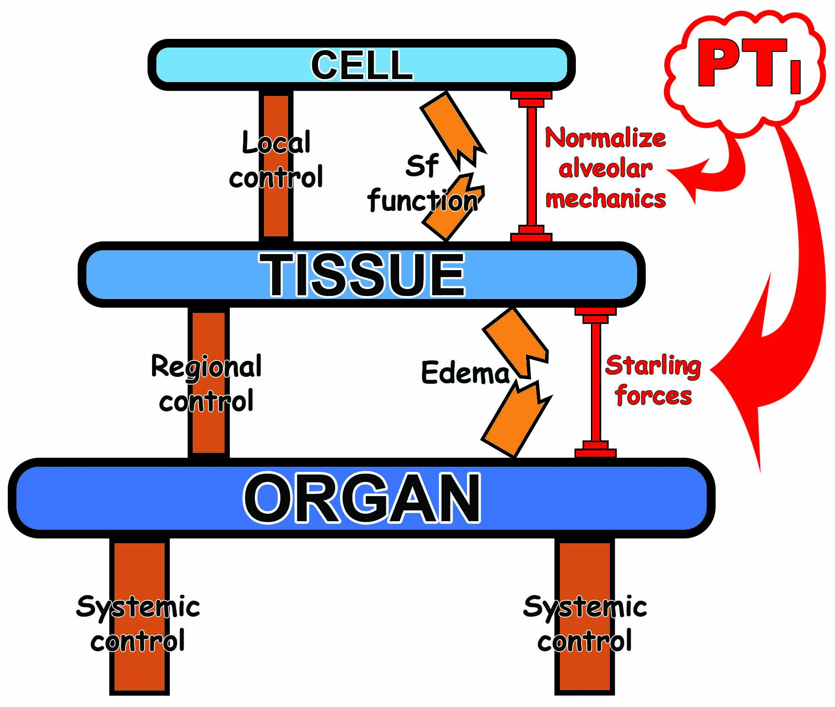
Figure 2 Appropriate mechanical breath settings prevent ‘tipping point’ cascade and acute respiratory distress syndrome. Control mechanisms at the Local (Cell), Regional (Tissue) and Systemic (Organ) level attempt to balance insults/perturbations such as loss of surfactant (Sf) function and pulmonary edema formation but can fail without additional support. The control systems can be overwhelmed, leading to a cascading effect that culminates in dysfunction at the next higher biologic level (Cell→Tissue→Organ). Current therapies for acute lung injury are applied too late, after the health state has cascaded all the way down to the Organ Level (i.e., development of established-ARDS). We propose that mechanical ventilation modulation strategies with an appropriate Pressure Time Integral (PT_{I}) directed at lower level control structures (i.e., Sf function by normalizing alveolar mechanics and edema prevention by altering the Starling fluid flux forces) early in the failure sequence, prior to complete loss of containment and tipping to the organ level, may help reset the underlying control mechanisms, limit spill-over effects and bolster maintenance of compartmental containment. Application of a preemptive mechanical breath with the proper PT_{I} can assist the endogenous control mechanisms and ‘shore up’ the insults/perturbations to prevent the development of established-ARDS. ARDS: Acute respiratory distress syndrome.

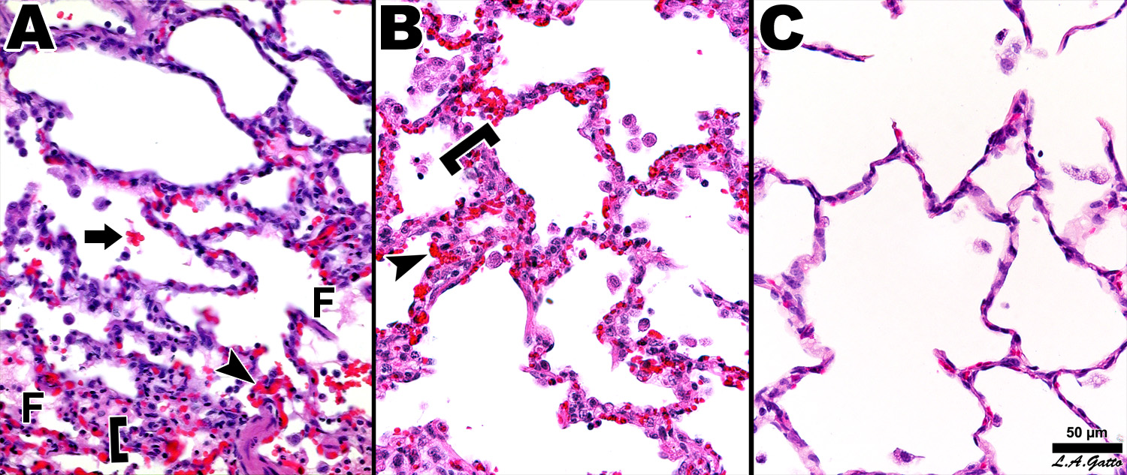
Figure 3 Pulmonary Histopathology - Photomicrographs of representative lung sections of specimens from each treatment group at 40 x magnification. A：Sham- animals received 48 hours of mechanical ventilation without peritoneal sepsis + gut ischemia/reperfusion (PS+I/R) injury. Specimen exhibits stigmata of lung injury including fibrinous deposits, blood in alveolus, congested capillaries, and thickened alveolar walls; B: LTV- animals received PS+I/R injury and LTV ventilation after onset of ALI. Specimen exhibits stigmata of lung injury including fibrinous deposits, blood in alveolus, congested capillaries, leukocyte infiltration, and thickened alveolar walls; C: APRV- Animals received APRV one hour following PS+I/R injury. Specimen shows normal pulmonary architecture, alveoli are well expanded, thin walled and there are no exudates. APRV applied early in animals with severe septic shock protected the lung superior to Sham animals with conventional mechanical ventilation without septic shock. (with permission)^{[33]}. F: Fibrinous deposit in the air compartment; Arrow: Blood in alveolus; Arrowhead: Congested alveolar capillary; Bracket: Thickened alveolar wall; APRV: Airway pressure release ventilation.

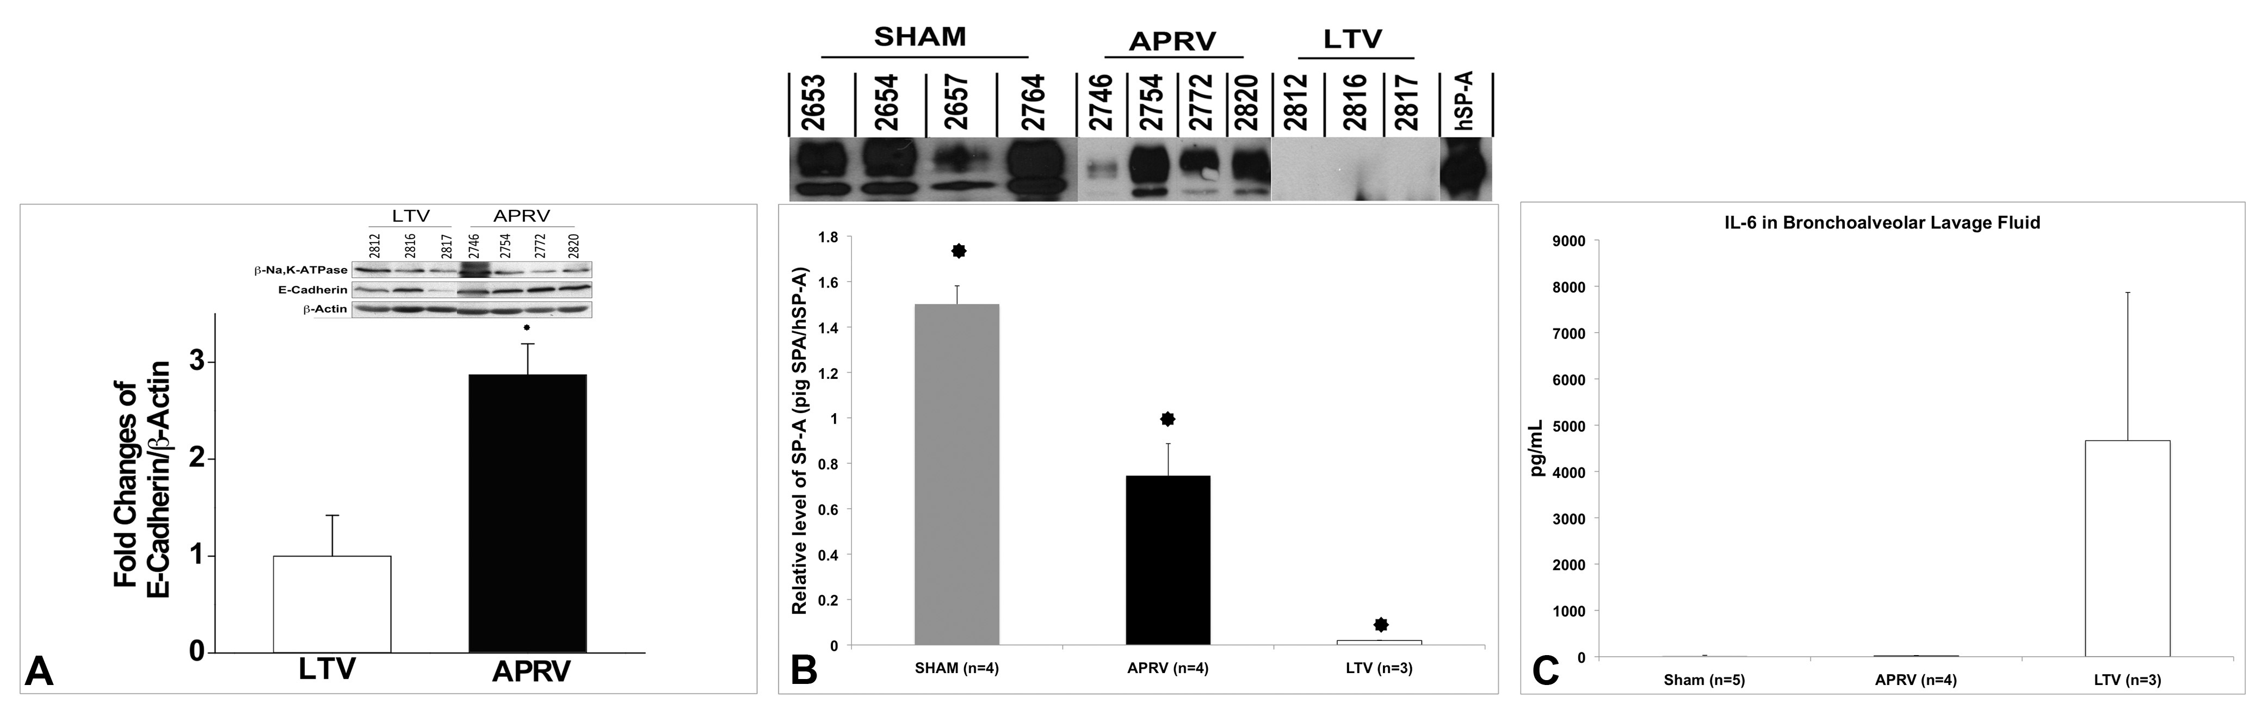
Figure 4 Bronchoalveolar lavage and lung tissue analysis. A: Epithelial Cadherin in Lung tissue showing APRV had significantly greater E-Cadherin abundance in lung tissue than LTV (P < 0.05); B: Surfactant protein A in BALF showing APRV had significantly higher SP-A abundance in BALF than LTV (P < 0.05); C: Interleukin-6 (IL-6) in BALF showing APRV had significantly lower IL-6 in BALF than LTV (P < 0.05)^{[33]}. APRV: Airway pressure release ventilation; BALF: Bronchoalveolar lavage fluid.

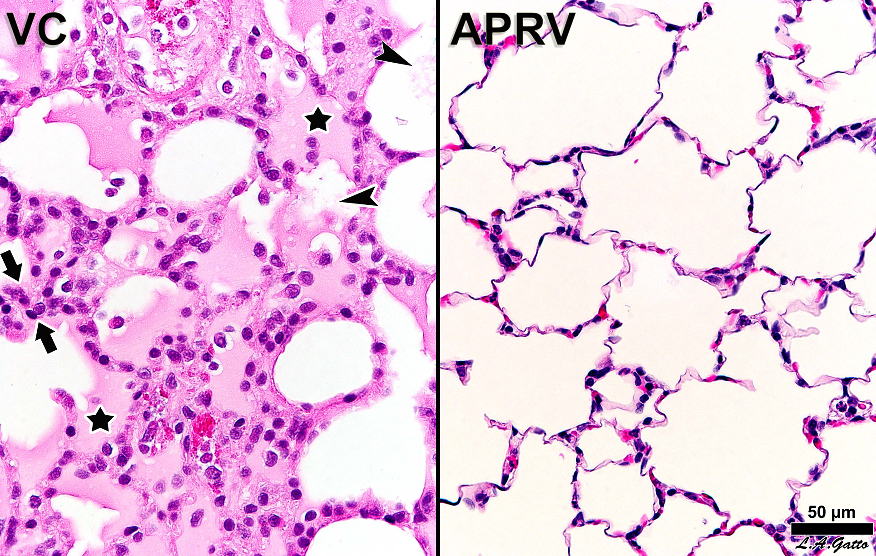
Figure 5 Histological comparison of a rat receiving early airway pressure release ventilation (APRV) with a rat receiving volume cycled ventilation (VC). The VC animal exhibits hallmarks of acute respiratory distress syndrome, including alveolar flooding (stars), fibrinous deposits in the air compartment (arrowheads) and high cellularity (between arrows). The APRV animal shows patent alveoli with notable preservation of nearly normal histology (with permission)^{[35]}.

Figure 6 In vivo photomicrographs and image analysis of inflated subpleural alveoli in the volume cycled ventilation (VC) (A, B) and airway pressure release ventilation (C, D) groups. Measurement of the % Air Space was accomplished by circling the inflated alveoli using computer image analysis. All inflated alveoli were then assigned the color yellow and noninflated areas were assigned the color red generating a sharp contrast for the image analysis software to identify and measure the % of inflated alveoli/microscopic field. Arrows (A, C) identify a single alveolus (with permission)^{[35]}.

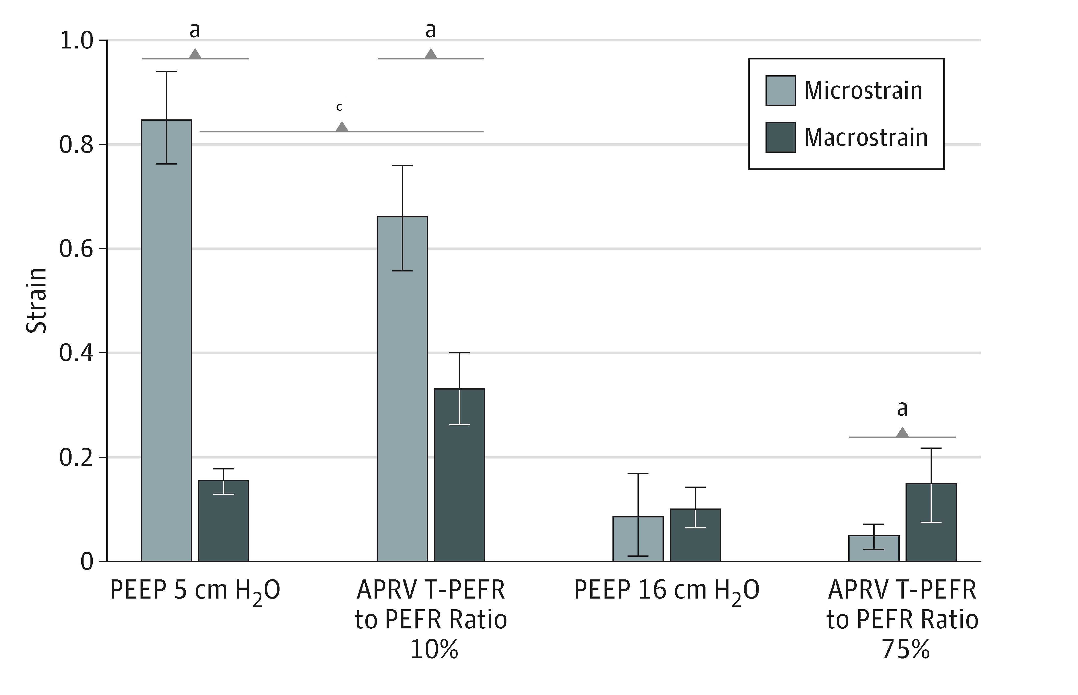
Figure 7 Macro-strain vs micro-strain. Macro-strain was that calculated for the entire lung and Micro-strain calculated for individual alveoli in the same lung under the identical conditions. Low PEEP (5 cm H₂O) with a conventional breath and an extended time at low pressure (10%) with APRV showed the largest difference between Macro- and Micro-strain. High PEEP (16 cm H₂O) and a brief time at low pressure with APRV (75%) minimized the differences between Macro- and Micro-strain. See text for description of APRV settings. ªP < 0.05 between Macro- and Micro-strain; ^{c}P < 0.05 between PEEP 5 and APRV 10 (with permission)^{[17]}. APRV: Airway pressure release ventilation.

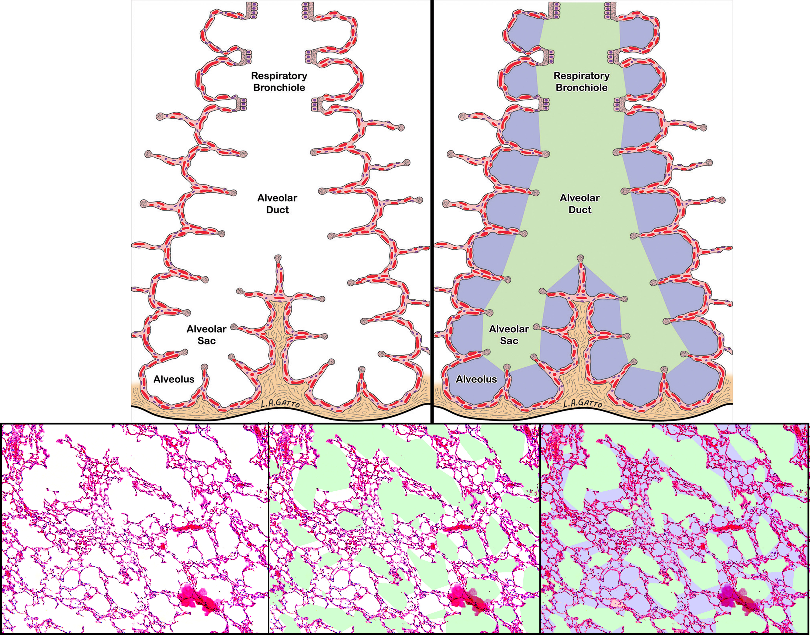
A
B
Figure 8 Impact of multiple ventilation strategies on the terminal airways. A: Schematic of the terminal airway before and after color demarcation; B: A standard hematoxylin-eosin staining of the lung is first analyzed for conducting airway air spaces and demarcated in green. The alveoli are demarcated in lilac while the remaining interstitium, blood vessels and lymphatics are colored in magenta^{[16]}.

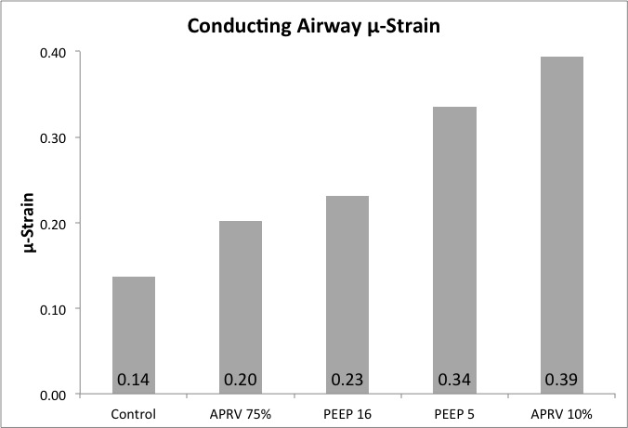
Figure 9 Airway duct μ-strain, was calculated from conducting airway perimeters at inspiration and expiration in all 4 mechanical breath strategies (CMV with PEEP 5 and 10; APRV with T_{Low} at 10% and 75%) tested, plus a Control group with normal lung under mechanical ventilation. (with permission)^{[16]}. CMV: Conventional mechanical ventilation; APRV: Airway pressure release ventilation.

