Name of Journal: World Journal of Cardiology
Manuscript NO: 86399
Manuscript Type: CASE REPORT

Systemic right ventricle complications in levo-transposition of the great arteries: A case report and review of literature

Almajed MR et al. Intracardiac thrombus of the systemic right ventricle

Mohamed Ramzi Almajed, Abdulla Almajed, Naoshin Khan, Mark S Obri, Karthikeyan Ananthasubramaniam

Mohamed Ramzi Almajed, Naoshin Khan, Mark S Obri, Department of Internal Medicine, Henry Ford Hospital, Detroit, MI 48202, United States

Abdulla Almajed, College of Medicine and Medical Sciences, Arabian Gulf University, Manama 00000, Bahrain

Karthikeyan Ananthasubramaniam, Heart and Vascular Institute, Henry Ford West Bloomfield Hospital, West Bloomfield, MI 48322, United States

Author contributions: Almajed MR, Almajed A, Khan N, Obri M, Ananthasubramaniam K contributed equally to this work; All authors evaluated the case, reviewed the literature, and wrote the manuscript; All authors have read and approve of the final manuscript.

Corresponding author: Karthikeyan Ananthasubramaniam, FACC, MD, Staff Physician, Heart and Vascular Institute, Henry Ford West Bloomfield Hospital, 6777 W Maple, West Bloomfield, MI 48322, United States. kananth1@hfhs.org

Received: June 17, 2023
Revised: August 23, 2023
Accepted: September 27, 2023
Published online:

Abstract
BACKGROUND
Congenitally corrected levo-transposition of the great arteries (L-TGA) is a congenital heart disease in which the ventricles and great arteries are transposed from their typical anatomy. In L-TGA, the double discordance, atrioventricular and ventriculoarterial, create an acyanotic milieu which allows patients to survive their early decades, however, progressive systemic right ventricle (sRV) dysfunction creates complications later in life. sRV dysfunction and remodeling predisposes patients to intracardiac thrombus (ICT) formation.

CASE SUMMARY
A 40-year-old male with L-TGA presented with symptoms of acute decompensated heart failure. In childhood, he had surgical repair of a ventricular septal defect. In adulthood, he developed sRV dysfunction, systemic tricuspid valve (sTV) regurgitation, and left-bundle branch block for which he underwent cardiac resynchronization therapy. Transthoracic echocardiogram showed a sRV ejection fraction of 40%, severe sTV regurgitation, and a newly identified sRV ICT. ICT was confirmed by ultrasound-enhancing agents and transesophageal echocardiography. Our patient was optimized with guideline-directed medical therapy and diuresis. Anticoagulation was achieved with a vitamin K antagonist (VKA) and he was later referred for evaluation by advanced heart failure and heart transplant services.

CONCLUSION
Anticoagulation with VKA is the mainstay of treatment in the absence of conclusive data supporting direct oral anticoagulant use in ICT in patients with congenital heart disease. This case illustrates the natural history of L-TGA and highlights the importance of surveillance and monitoring with dedicated cardiac imaging to identify complications.

Key Words: Levo-transposition of the great arteries; Systemic right ventricle; Congenital heart disease; Intracardiac thrombus; Anticoagulation; Direct oral anticoagulant; Case report

Almajed MR, Almajed A, Obri MS, Khan N, Ananthasubramaniam K. Complications of the systemic right ventricle in levo-transposition of the great arteries: A case report and review of literature. World J Cardiol 2023; In press

Core Tip: Patients with congenital heart disease such as levo-transposition of the great arteries experience progressive cardiac dysfunction and remodeling which manifests as heart failure. This predisposes patients to the formation of intracardiac thrombus (ICT). We present a case of progressive systemic right ventricle (sRV) dysfunction resulting in an apical thrombus. Review of literature identified no cases of sRV thrombus making this one of the first reports. Guidelines do not exist for anticoagulation in patients with congenital heart disease and ICT. Therefore, clinical decisions are extrapolated from anticoagulation principles in patients without congenital heart disease. Considerations for direct oral anticoagulants in this population should be individualized and involve shared decision making.

INTRODUCTION
Congenitally corrected transposition, or levo-transposition of the great arteries (L-TGA) is a rare congenital heart disease with an estimated prevalence of 0.4%-1.0% among patients with congenital heart disease^{[1,2]}. The double discordance, atrioventricular and ventriculoarterial, creates an acyanotic milieu in which both pulmonary and systemic circulations exist and freely communicate^{[3]}. This phenomenon, which is alluded to as “congenitally corrected”, allows patients to survive their early decades with minimal cardiac complications. A large prospective survival study found that 95.5% of patients survive the first month of life; 72.7% survive to the age of 3 and this percentage of patients continues to live to the age of 15^{[1]}. Survival data among adults is variable due to the presence of different associated cardiac lesions and the heterogenous surgical interventions these patients undergo^{[4]}. Among all patients with L-TGA, a minority survive beyond the fifth decade of life due to cardiac complications^{[5]}. In those who undergo surgical correction as children, the 10-year survival rate ranges from 60%-70%^{[6,7]}.
The natural history of L-TGA involves a wide spectrum of cardiac complications that manifest during early adulthood. The atypical anatomy and pathophysiologic circulation with the systemic right ventricle (sRV) in L-TGA predisposes patients to progressive sRV dysfunction, systemic tricuspid valve (sTV) regurgitation, and conduction defects including heart block^{[8]}. Patients commonly present with clinical manifestations of heart failure as the lifetime prevalence is 34% in L-TGA as opposed to 1%-2% across the general population^{[9,10]}.
A large multicenter study found that by the age of 45, heart failure develops in 67% of patients with L-TGA and associated cardiac lesions whereas it develops in 25% of patients with L-TGA and no associated cardiac lesions^{[9]}. Anatomical surgical repair, which aims to correct the double discordance by making the morphologic left ventricle the systemic ventricle and the morphologic right ventricle the pulmonary ventricle, is associated with higher survival rates and lower morbidity^{[11-13]}. Physiologic surgical repair, which targets associated cardiac lesions without correcting the double discordance, is associated with higher rates of sRV dysfunction and mortality in adulthood^{[14]}.
We report a case of sRV thrombus in a patient with L-TGA who presented with acute decompensated heart failure (ADHF) and discuss the state of current literature regarding anticoagulation management.

CASE PRESENTATION
Chief complaints
A 40-year-old male with L-TGA presented to the hospital with ADHF. Upon review of systems, he had no chest pain, palpitations, lightheadedness, or syncope; he also denied cough, sputum production, or fever. He was not recently ill and had no sick contacts.

History of present illness
Symptoms started three-weeks prior to presentation with progressive shortness of breath on exertion, orthopnea, paroxysmal nocturnal dyspnea, and bilateral lower limb swelling. His symptoms were severe enough to make conversation difficult and limited his activities of daily living.

History of past illness
His medical history was remarkable for L-TGA with an associated ventricular septal defect, he underwent physiologic surgical closure of the septal defect at three years of age. He was monitored by a pediatric cardiologist in childhood and early adulthood during; he remained free of cardiac symptoms during this time and was eventually lost to follow-up. At the age of thirty-five, he was hospitalized for ADHF and was found to have sRV dysfunction with severely reduced global systolic function and severe sTV regurgitation. He was also noted to have a progressive conduction disease as his previously known first degree atrioventricular block was replaced by a newly identified left-bundle branch block. He was medically managed for heart failure and underwent cardiac resynchronization therapy with biventricular pacemaker implantation. He followed with the advanced heart failure and transplant service but was then lost to follow-up for several years until this latest presentation to the hospital.

Personal and family history
The patient did not have a family history of congenital heart disease, heart failure, or respiratory illness.

Physical examination
During this presentation, the patient was tachycardic (108 beats per minute) and tachypneic (25-40 breaths per minute); blood pressure was 104/68 mmHg and he was not hypoxic on room air. Height was 168 cm and weight was 92 kg. Physical exam was positive for decreased bilateral breath sounds with mild crepitation. Jugular venous distension was present and pitting edema was noted in the bilateral lower limbs.

Laboratory examinations
Laboratory tests were notable for a brain natriuretic peptide of 472 pg/mL, high-sensitivity troponin of 16 ng/L, venous lactate of 1.2 mmol/L, and creatinine of 0.80 mg/dL (Table 1). Electrocardiogram showed an atrial-sensed ventricularly-paced rhythm without acute abnormalities (Figure 1).

Imaging examinations
Chest x-ray was remarkable for cardiomegaly with small bilateral pleural effusions (Figure 2). Chest pulmonary angiography was negative for pulmonary embolism, pericardial effusion, or pneumothorax (Figure 3). His cardiac anatomy of L-TGA is visualized on chest computed tomography (Figure 4).

Further diagnostic work-up
Our patient was managed for ADHF with guideline-directed medical therapy including diuresis with intravenous furosemide 40 mg once daily, oral metoprolol succinate 50 mg once daily, oral losartan 50 mg once daily, and oral dapagliflozin 10 mg daily. He had rapid clinical improvement with resolution of his symptoms and was transitioned to oral diuretic as needed.
Transthoracic echocardiogram obtained prior to discharge showed a mildly reduced global sRV ejection fraction of 40%, severe sAV regurgitation, and a newly identified apical thrombus in the sRV (Figures 5-8). Transesophageal echocardiogram confirmed this finding with visualization of a 2.07 cm by 1.43 cm well-circumscribed mass.

FINAL DIAGNOSIS
The final diagnosis was ADHF complicated by a systemic right ventricular thrombus in the setting of L-TGA.

TREATMENT
The presence of a sRV thrombus posed a dilemma given the limited literature on this topic. Our patient was anticoagulated with a vitamin K antagonist (VKA) and later referred for evaluation by advanced heart failure and heart transplant services.

OUTCOME AND FOLLOW-UP
On subsequent follow-up visits, our patient’s symptoms of heart failure continued to improve with medical optimization and cardiac rehabilitation. Transthoracic echocardiogram was performed 5 mo after the index echocardiogram that identified the sRV thrombus; it demonstrated interim resolution of the sRV thrombus with improvement in sAV regurgitation and estimated pulmonary artery systolic pressure (Table 2). Cardiopulmonary exercise testing (CPX) provides objective measures of cardiovascular fitness and allows them to be tracked over time; our patient’s peak oxygen uptake (peak VO₂), a strong prognostic indicator in heart failure, showed improvement (Table 3). Tables 2 and 3 allow readers to understand the natural history and progression of L-TGA in adults by demonstrating findings from CPX and echocardiography from the patient’s initial visit in 2016 to the last known follow-up in 2022.

DISCUSSION
Intracardiac thrombus (ICT) involves the formation of a blood clot within the heart chambers. It typically occurs in the setting of acute myocardial infarction, left ventricular aneurysm, and cardiomyopathy with dilated chambers^{[15]}. Pathophysiology of thrombus formation involves an interplay of prothrombotic state, tissue endothelial injury, and blood stasis as described by Virchow’s triad^{[16-18]}. Systemic embolization of left-sided ICT results in clinical manifestations of stroke and transient ischemic attack, mesenteric ischemia and infarction, renal infarction, and acute limb ischemia. Pulmonary embolization of right-sided ICT results in pulmonary embolism. Diagnostic gold standard is identification of a thrombus on cardiac magnetic resonance imaging, although echocardiography with the use of echocardiographic contrast agents is a widely used initial modality^{[19]}.
ICT of the sRV is sparsely covered in the literature with limited data and guidelines available regarding the approach to management. Clinicians resort to extrapolating from practice standards for systemic left ventricular (sLV) thrombus. A review of literature identified no published case reports of sRV thrombus.
Current American and European guidelines for ICT in patients with structurally typical hearts are covered by class IIa, LOE C recommendations. Standard of care consists of anticoagulation with a VKA for 3-6 mo with an international normalized ratio (INR) target range of 2.0-3.0 followed by repeat imaging to assess for thrombus resolution^{[20,21]}. Anticoagulation in this population has been shown to decrease major cardiovascular events including cerebral and systemic sequala of thrombus embolization^{[22]}. Patients who have interval resolution of ICT on repeat imaging typically have anticoagulation discontinued, although some experts continue anticoagulation as a preventative measure in select patients with persistent and significant sLV wall hypokinesis due to the higher risk of recurrence^{[23]}. In the absence of data on this population, patients with sRV dysfunction who develop right ventricular thrombus, such as our patient, can be similarly managed with anticoagulation using a VKA followed by repeat imaging.
Oral anticoagulant (OAC) agent of choice for the treatment of ICT has classically been a VKA as opposed to a direct OAC (DOAC), as early available literature demonstrated clinically significant difference in outcomes between the two agents. The largest study to date, a multicenter cohort study compared 514 patients with sLV thrombus and demonstrated a higher risk for stroke and systemic embolism with DOAC therapy compared to VKA which suggests against efficacy equivalence^{[24]}. However, more recent data derived from small-scale randomized controlled trials, cohort studies, and case series report similar outcomes and support the use of DOAC for sLV thrombus which has led experts to adopt it as an off-label alternative^{[23,25-31]}. A recent scientific statement by the American Heart Association carried out a comprehensive meta-analysis of all published studies that compared VKA and DOAC use in sLV thrombus, it demonstrated no differences in therapeutic efficacy and safety; the statement concluded that the use of DOAC for sLV thrombus is a reasonable alternative to VKA^{[32]}. This practice-changing statement is a yet to be reflected in society guidelines and adopted by other organizations.
Clinical consensus for the management of sRV thrombus in patients with congenital heart disease has been derived from the management principles of sLV thrombus in patients without congenital heart disease; it consists of OAC, interval repeat imaging, and case-by-case evaluation of anticoagulation duration. The advent of DOAC therapy has seen it become the OAC agent of choice for most anticoagulation indications which has raised questions regarding its applicability in the treatment of sRV thrombus in the setting of the limited data. The international NOTE registry evaluated 530 adults with congenital heart disease treated with OAC for various indications and concluded non-inferior efficacy and safety of DOAC use compared to VKA; subgroup analysis of 76 patients with sRV found high efficacy and safety rates^{[33,34]}. Another similar study of 215 patients with different congenital heart diseases quoted high efficacy rates but non-negligible bleeding risks^{[35]}. However, a retrospective cohort review of a German nationwide registry of 6504 adults with congenital heart disease on OAC determined that DOAC use was associated with higher rates of thromboembolism, bleeding, major adverse cardiac events, and all-cause mortality compared to VKA^{[36]}. The discrepancy of results between the former and latter studies raises concerns can be explained by the significant heterogeneity including differences in age and complexity of lesions in the latter’s study population. In the absence of conclusive data supporting DOAC use in sRV thrombus in patients with congenital heart disease, VKA remains the OAC of choice.
Patients with sRV thrombus are typically younger than those with sLV thrombus given the earlier development of heart failure in the setting of congenital heart disease. The structural cardiac anomalies and abnormal hemodynamics are likely contributors to abnormal flow and blood stasis, this predisposes patients to thrombus formation. Younger patients are more likely to have educational and workplace commitments that cause time constraints. VKA therapy is particularly challenging in this population as dietary restrictions and frequent laboratory testing results in difficulty achieving and maintaining therapeutic INR levels; lower time in therapeutic range is associated with higher risk of stroke in patients with sLV^{[37]}. Further studies evaluating the safety and efficacy of DOAC agents in sRV thrombus are necessary.

CONCLUSION
Systemic right ventricular thrombus is a rare complication of congenital heart disease. We describe the first reported case of sRV thrombus in a patient with L-TGA who presented with ADHF. Management of this condition is driven by expert opinion and extrapolation of treatment principles from ICT in patients with structurally normal hearts.
In the absence of conclusive data supporting DOAC use in sRV thrombus in patients with congenital heart disease, VKA bridged with intravenous heparin or subcutaneous low-molecular weight heparin and remains the time-honored approach particularly in patients with recent large thrombi and in the setting of dysfunctional ventricles or slow flow states. Transitioning to a DOAC in these cases should be individualized to a patient characteristics and imaging features; it should involve shared decision making regarding limited and conflicting literature. This case illustrates the natural history of L-TGA and highlights the importance of surveillance and monitoring in this patient population to prevent and treat complications.

REFERENCES
1 Samánek M, Vorísková M. Congenital heart disease among 815,569 children born between 1980 and 1990 and their 15-year survival: a prospective Bohemia survival study. Pediatr Cardiol 1999; 20: 411-417 [PMID: 10556387 DOI: 10.1007/s002469900502]
2 Baumgartner H, Bonhoeffer P, De Groot NM, de Haan F, Deanfield JE, Galie N, Gatzoulis MA, Gohlke-Baerwolf C, Kaemmerer H, Kilner P, Meijboom F, Mulder BJ, Oechslin E, Oliver JM, Serraf A, Szatmari A, Thaulow E, Vouhe PR, Walma E; Task Force on the Management of Grown-up Congenital Heart Disease of the European Society of Cardiology (ESC); Association for European Paediatric Cardiology (AEPC); ESC Committee for Practice Guidelines (CPG). ESC Guidelines for the management of grown-up congenital heart disease (new version 2010). Eur Heart J 2010; 31: 2915-2957 [PMID: 20801927 DOI: 10.1093/eurheartj/ehq249]
3 Wallis GA, Debich-Spicer D, Anderson RH. Congenitally corrected transposition. Orphanet J Rare Dis 2011; 6: 22 [PMID: 21569592 DOI: 10.1186/1750-1172-6-22]
4 Komarlu R, Morell VO, Munoz RA, Tsifansky MD. Congenitally Corrected Transposition of the Great Arteries (ccTGA) or Levo-Transposition of the Great Arteries (l-TGA). In: Munoz R, Morell V, da Cruz E, Vetterly C, da Silva J, editor. Critical Care of Children with Heart Disease. Cham: Springer, 2020: 369-77 [DOI:10.1007/978-3-030-21870-6_33]
5 Ikeda U, Furuse M, Suzuki O, Kimura K, Sekiguchi H, Shimada K. Long-term survival in aged patients with corrected transposition of the great arteries. Chest 1992; 101: 1382-1385 [PMID: 1582301 DOI: 10.1378/chest.101.5.1382]
6 Hraska V, Duncan BW, Mayer JE Jr, Freed M, del Nido PJ, Jonas RA. Long-term outcome of surgically treated patients with corrected transposition of the great arteries. J Thorac Cardiovasc Surg 2005; 129: 182-191 [PMID: 15632841 DOI: 10.1016/j.jtcvs.2004.02.046]
7 van Son JA, Danielson GK, Huhta JC, Warnes CA, Edwards WD, Schaff HV, Puga FJ, Ilstrup DM. Late results of systemic atrioventricular valve replacement in corrected transposition. J Thorac Cardiovasc Surg 1995; 109: 642-52; discussion 652-3 [PMID: 7715211 DOI: 10.1016/s0022-5223(95)70345-4]
8 Filippov AA, Del Nido PJ, Vasilyev NV. Management of Systemic Right Ventricular Failure in Patients With Congenitally Corrected Transposition of the Great Arteries. Circulation 2016; 134: 1293-1302 [PMID: 27777298 DOI: 10.1161/circulationaha.116.022106]
9 Graham TP Jr, Bernard YD, Mellen BG, Celermajer D, Baumgartner H, Cetta F, Connolly HM, Davidson WR, Dellborg M, Foster E, Gersony WM, Gessner IH, Hurwitz RA, Kaemmerer H, Kugler JD, Murphy DJ, Noonan JA, Morris C, Perloff JK, Sanders SP, Sutherland JL. Long-term outcome in congenitally corrected transposition of the great arteries: a multi-institutional study. J Am Coll Cardiol 2000; 36: 255-261 [PMID: 10898443 DOI: 10.1016/s0735-1097(00)00682-3]
10 Groenewegen A, Rutten FH, Mosterd A, Hoes AW. Epidemiology of heart failure. Eur J Heart Fail 2020; 22: 1342-1356 [PMID: 32483830 DOI: 10.1002/ejhf.1858]
11 Spigel Z, Binsalamah ZM, Caldarone C. Congenitally Corrected Transposition of the Great Arteries: Anatomic, Physiologic Repair, and Palliation. Semin Thorac Cardiovasc Surg Pediatr Card Surg Annu 2019; 22: 32-42 [PMID: 31027562 DOI: 10.1053/j.pcsu.2019.02.008]
12 Bautista-Hernandez V, Marx GR, Gauvreau K, Mayer JE Jr, Cecchin F, del Nido PJ. Determinants of left ventricular dysfunction after anatomic repair of congenitally corrected transposition of the great arteries. Ann Thorac Surg 2006; 82: 2059-65; discussion 2065-6 [PMID: 17126110 DOI: 10.1016/j.athoracsur.2006.06.045]
13 Hiramatsu T, Matsumura G, Konuma T, Yamazaki K, Kurosawa H, Imai Y. Long-term prognosis of double-switch operation for congenitally corrected transposition of the great arteries. Eur J Cardiothorac Surg 2012; 42: 1004-1008 [PMID: 22551964 DOI: 10.1093/ejcts/ezs118]
14 Mongeon FP, Connolly HM, Dearani JA, Li Z, Warnes CA. Congenitally corrected transposition of the great arteries ventricular function at the time of systemic atrioventricular valve replacement predicts long-term ventricular function. J Am Coll Cardiol 2011; 57: 2008-2017 [PMID: 21565637 DOI: 10.1016/j.jacc.2010.11.021]
15 Meltzer RS, Visser CA, Fuster V. Intracardiac thrombi and systemic embolization. Ann Intern Med 1986; 104: 689-698 [PMID: 3516044 DOI: 10.7326/0003-4819-104-5-689]
16 Massussi M, Scotti A, Lip GYH, Proietti R. Left ventricular thrombosis: new perspectives on an old problem. Eur Heart J Cardiovasc Pharmacother 2021; 7: 158-167 [PMID: 32569361 DOI: 10.1093/ehjcvp/pvaa066]
17 Garg P, van der Geest RJ, Swoboda PP, Crandon S, Fent GJ, Foley JRJ, Dobson LE, Al Musa T, Onciul S, Vijayan S, Chew PG, Brown LAE, Bissell M, Hassell MECJ, Nijveldt R, Elbaz MSM, Westenberg JJM, Dall'Armellina E, Greenwood JP, Plein S. Left ventricular thrombus formation in myocardial infarction is associated with altered left ventricular blood flow energetics. Eur Heart J Cardiovasc Imaging 2019; 20: 108-117 [PMID: 30137274 DOI: 10.1093/ehjci/jey121]
18 Yokota Y, Kawanishi H, Hayakawa M, Kumaki T, Takarada A, Nakanishi O, Fukuzaki H. Cardiac thrombus in dilated cardiomyopathy. Relationship between left ventricular pathophysiology and left ventricular thrombus. Jpn Heart J 1989; 30: 1-11 [PMID: 2724526 DOI: 10.1536/ihj.30.1]
19 McCarthy CP, Vaduganathan M, McCarthy KJ, Januzzi JL Jr, Bhatt DL, McEvoy JW. Left Ventricular Thrombus After Acute Myocardial Infarction: Screening, Prevention, and Treatment. JAMA Cardiol 2018; 3: 642-649 [PMID: 29800958 DOI: 10.1001/jamacardio.2018.1086]
20 O'Gara PT, Kushner FG, Ascheim DD, Casey DE Jr, Chung MK, de Lemos JA, Ettinger SM, Fang JC, Fesmire FM, Franklin BA, Granger CB, Krumholz HM, Linderbaum JA, Morrow DA, Newby LK, Ornato JP, Ou N, Radford MJ, Tamis-Holland JE, Tommaso CL, Tracy CM, Woo YJ, Zhao DX. 2013 ACCF/AHA guideline for the management of ST-elevation myocardial infarction: a report of the American College of Cardiology Foundation/American Heart Association Task Force on Practice Guidelines. J Am Coll Cardiol 2013; 61: e78-e140 [PMID: 23256914 DOI: 10.1016/j.jacc.2012.11.019]
21 Ibánez B, James S, Agewall S, Antunes MJ, Bucciarelli-Ducci C, Bueno H, Caforio ALP, Crea F, Goudevenos JA, Halvorsen S, Hindricks G, Kastrati A, Lenzen MJ, Prescott E, Roffi M, Valgimigli M, Varenhorst C, Vranckx P, Widimský P. 2017 ESC Guidelines for the management of acute myocardial infarction in patients presenting with ST-segment elevation. Rev Esp Cardiol (Engl Ed) 2017; 70: 1082 [PMID: 29198432 DOI: 10.1016/j.rec.2017.11.010]
22 Lattuca B, Bouziri N, Kerneis M, Portal JJ, Zhou J, Hauguel-Moreau M, Mameri A, Zeitouni M, Guedeney P, Hammoudi N, Isnard R, Pousset F, Collet JP, Vicaut E, Montalescot G, Silvain J; ACTION Study Group. Antithrombotic Therapy for Patients With Left Ventricular Mural Thrombus. J Am Coll Cardiol 2020; 75: 1676-1685 [PMID: 32273033 DOI: 10.1016/j.jacc.2020.01.057]
23 Cruz Rodriguez JB, Okajima K, Greenberg BH. Management of left ventricular thrombus: a narrative review. Ann Transl Med 2021; 9: 520 [PMID: 33850917 DOI: 10.21037/atm-20-7839]
24 Robinson AA, Trankle CR, Eubanks G, Schumann C, Thompson P, Wallace RL, Gottiparthi S, Ruth B, Kramer CM, Salerno M, Bilchick KC, Deen C, Kontos MC, Dent J. Off-label Use of Direct Oral Anticoagulants Compared With Warfarin for Left Ventricular Thrombi. JAMA Cardiol 2020; 5: 685-692 [PMID: 32320043 DOI: 10.1001/jamacardio.2020.0652]
25 Robinson AA, Ruth B, Dent J. Direct oral anticoagulants compared to warfarin for left ventricular thrombi: a single center experience. J Am Coll Cardiol 2018;71: A981 [DOI:10.1016/s0735-1097(18)31522-5]
26 Daher J, Da Costa A, Hilaire C, Ferreira T, Pierrard R, Guichard JB, Romeyer C, Isaaz K. Management of Left Ventricular Thrombi with Direct Oral Anticoagulants: Retrospective Comparative Study with Vitamin K Antagonists. Clin Drug Investig 2020; 40: 343-353 [PMID: 32144651 DOI: 10.1007/s40261-020-00898-3]
27 Fleddermann AM, Hayes CH, Magalski A, Main ML. Efficacy of Direct Acting Oral Anticoagulants in Treatment of Left Ventricular Thrombus. Am J Cardiol 2019; 124: 367-372 [PMID: 31126539 DOI: 10.1016/j.amjcard.2019.05.009]
28 Cochran JM, Jia X, Hamzeh I, Birnbaum Y. Direct oral anticoagulant use for left ventricular thrombus: a single center experience. Circulation 2018; 138: A16411 [DOI: 10.1161/circ.144.suppl_1.11808]
29 Isa WY, Hwong N, Yusof AK, Yusof Z, Loong N, Wan-Arfah N, Naing N. Apixaban vs warfarin in patients with left ventricular thrombus: A pilot prospective randomized outcome blinded study investigating size reduction or resolution of left ventricular thrombus. Journal of Clinical and Preventive Cardiology 2020; 9: 150-154 [DOI: 10.4103/jcpc.jcpc_41_20]
30 Abdelnabi M, Saleh Y, Fareed A, Nossikof A, Wang L, Morsi M, Eshak N, Abdelkarim O, Badran H, Almaghraby A. Comparative Study of Oral Anticoagulation in Left Ventricular Thrombi (No-LVT Trial). J Am Coll Cardiol 2021; 77: 1590-1592 [PMID: 33766266 DOI: 10.1016/j.jacc.2021.01.049]
31 Alcalai R, Butnaru A, Moravsky G, Yagel O, Rashad R, Ibrahimli M, Planer D, Amir O, Elbaz-Greener G, Leibowitz D. Apixaban vs. warfarin in patients with left ventricular thrombus: a prospective multicentre randomized clinical trial‡. Eur Heart J Cardiovasc Pharmacother 2022; 8: 660-667 [PMID: 34279598 DOI: 10.1093/ehjcvp/pvab057]
32 Levine GN, McEvoy JW, Fang JC, Ibeh C, McCarthy CP, Misra A, Shah ZI, Shenoy C, Spinler SA, Vallurupalli S, Lip GYH; American Heart Association Council on Clinical Cardiology; Council on Cardiovascular and Stroke Nursing; and Stroke Council. Management of Patients at Risk for and With Left Ventricular Thrombus: A Scientific Statement From the American Heart Association. Circulation 2022; 146: e205-e223 [PMID: 36106537 DOI: 10.1161/CIR.0000000000001092]
33 Yang H, Bouma BJ, Dimopoulos K, Khairy P, Ladouceur M, Niwa K, Greutmann M, Schwerzmann M, Egbe A, Scognamiglio G, Budts W, Veldtman G, Opotowsky AR, Broberg CS, Gumbiene L, Meijboom FJ, Rutz T, Post MC, Moe T, Lipczyńska M, Tsai SF, Chakrabarti S, Tobler D, Davidson W, Morissens M, van Dijk A, Buber J, Bouchardy J, Skoglund K, Christersson C, Kronvall T, Konings TC, Alonso-Gonzalez R, Mizuno A, Webb G, Laukyte M, Sieswerda GTJ, Shafer K, Aboulhosn J, Mulder BJM. Non-vitamin K antagonist oral anticoagulants (NOACs) for thromboembolic prevention, are they safe in congenital heart disease? Results of a worldwide study. Int J Cardiol 2020; 299: 123-130 [PMID: 31307847 DOI: 10.1016/j.ijcard.2019.06.014]
34 Scognamiglio G, Fusco F, Hankel TC, Bouma BJ, Greutmann M, Khairy P, Ladouceur M, Dimopoulos K, Niwa K, Broberg CS, Miranda B, Budts W, Bouchardy J, Schwerzmann M, Lipczyńska M, Tobler D, Tsai SF, Egbe AC, Aboulhosn J, Fernandes SM, Garr B, Rutz T, Mizuno A, Proietti A, Alonso-Gonzalez R, Mulder BJM, Sarubbi B; non-vitamin K antagonist oral anticoagulants for thromboembolic prevention in adult congenital heart disease (NOTE) registry Investigators. Safety and efficacy of non-vitamin K antagonist oral anticoagulants for prevention of thromboembolism in adults with systemic right ventricle: Results from the NOTE international registry. Int J Cardiol 2021; 322: 129-134 [PMID: 32805330 DOI: 10.1016/j.ijcard.2020.08.034]
35 Pujol C, Müssigmann M, Schiele S, Nagdyman N, Niesert AC, Kaemmerer H, Ewert P, Tutarel O. Direct oral anticoagulants in adults with congenital heart disease - a single centre study. Int J Cardiol 2020; 300: 127-131 [PMID: 31668654 DOI: 10.1016/j.ijcard.2019.09.077]
36 Freisinger E, Gerß J, Makowski L, Marschall U, Reinecke H, Baumgartner H, Koeppe J, Diller GP. Current use and safety of novel oral anticoagulants in adults with congenital heart disease: results of a nationwide analysis including more than 44 000 patients. Eur Heart J 2020; 41: 4168-4177 [PMID: 33184662 DOI: 10.1093/eurheartj/ehaa844]
37 Camaj A, Fuster V, Giustino G, Bienstock SW, Sternheim D, Mehran R, Dangas GD, Kini A, Sharma SK, Halperin J, Dweck MR, Goldman ME. Left Ventricular Thrombus Following Acute Myocardial Infarction: JACC State-of-the-Art Review. J Am Coll Cardiol 2022; 79: 1010-1022 [PMID: 35272796 DOI: 10.1016/j.jacc.2022.01.011]

Footnotes
Informed consent statement: Informed written consent was obtained from the patient for publication of this report and any accompanying images.

Conflict-of-interest statement: Dr. Ananthasubramaniam has nothing to disclose.

CARE Checklist (2016) statement: The authors have read the CARE Checklist (2016), and the manuscript was prepared and revised according to the CARE Checklist (2016).

Open-Access: This article is an open-access article that was selected by an in-house editor and fully peer-reviewed by external reviewers. It is distributed in accordance with the Creative Commons Attribution NonCommercial (CC BY-NC 4.0) license, which permits others to distribute, remix, adapt, build upon this work non-commercially, and license their derivative works on different terms, provided the original work is properly cited and the use is non-commercial. See: https://creativecommons.org/Licenses/by-nc/4.0/

Provenance and peer review: Unsolicited article; Externally peer reviewed.

Peer-review model: Single blind

Peer-review started: June 17, 2023
First decision: August 10, 2023
Article in press:

Specialty type: Cardiac and cardiovascular systems
Country/Territory of origin: United States
Peer-review report’s scientific quality classification
Grade A (Excellent): 0
Grade B (Very good): B
Grade C (Good): C
Grade D (Fair): 0
Grade E (Poor): 0

P-Reviewer: Ong H, Malaysia; Teragawa H, Japan S-Editor: Lin C L-Editor: P-Editor:

Figure Legends
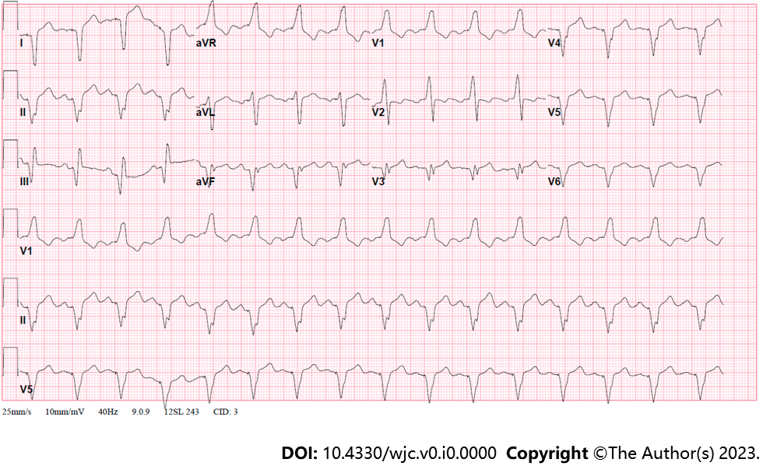
Figure 1 Electrocardiogram showing an atrial-sensed ventricularly-paced rhythm without acute abnormalities.

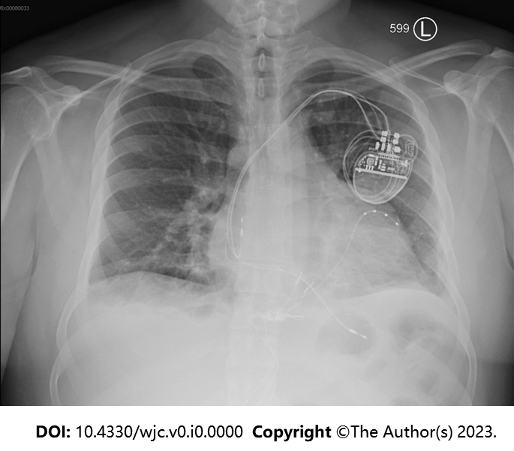
Figure 2 Chest x-ray showing cardiomegaly with small bilateral pleural effusions with unremarkable pulmonary vasculature. Biventricular pacemaker is present at the right chest.

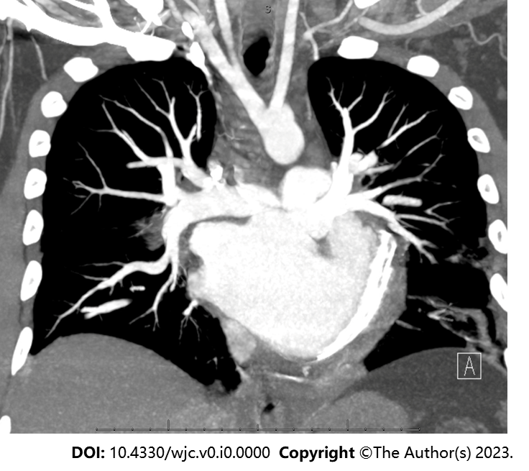
Figure 3 Chest pulmonary angiography demonstrating a levo-transposition of the great arteries cardiac anatomy. Examination was negative for pulmonary embolism, pericardial effusion, or pneumothorax.

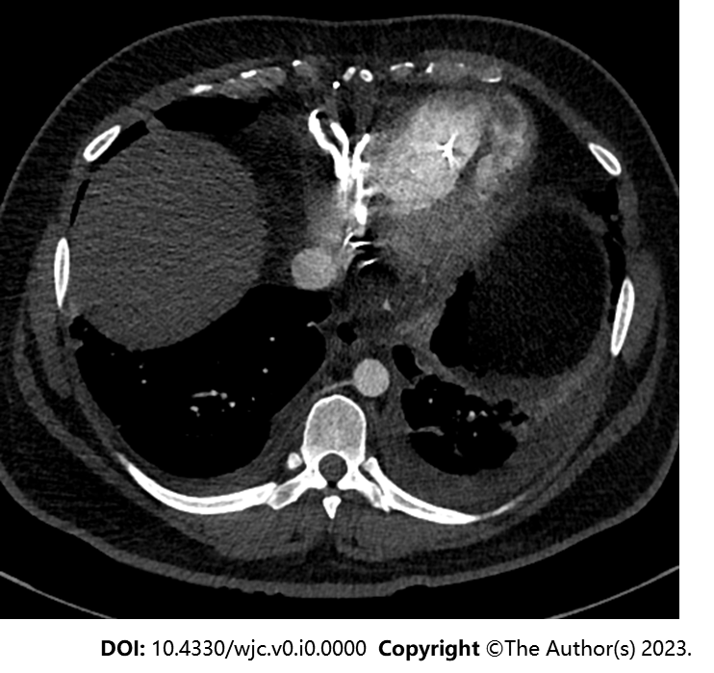
Figure 4 Computed tomography of the chest detailing the patient’s cardiac anatomy of levo-transposition of the great arteries. Venous circulation consists of the right atrium, left ventricle, and pulmonary artery. Systemic circulation consists of the pulmonary vein, left atrium, right ventricle, and aorta. Patient has a left-sided aortic arch with typical configuration.

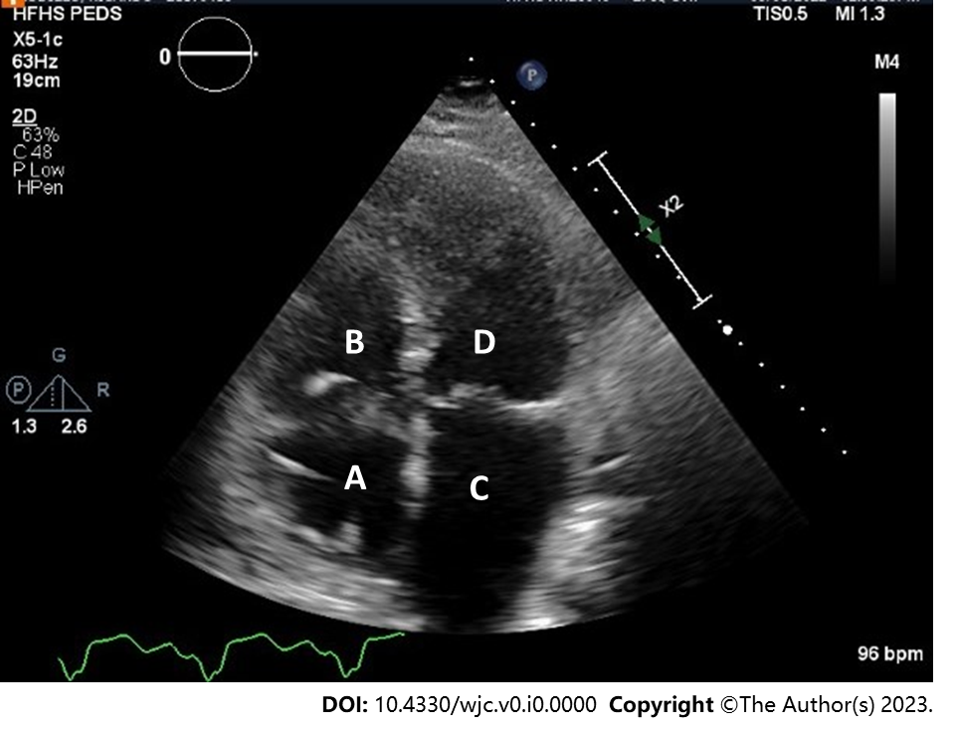
Figure 5 Transthoracic echocardiography demonstrating the patient’s classic levo-transposition of the great arteries anatomy. A: Right atrium; B: Venous left ventricle; C: Left atrium; D: Systemic right ventricle. Visualized is an apically displaced systemic tricuspid valve opening into systemic right ventricle.

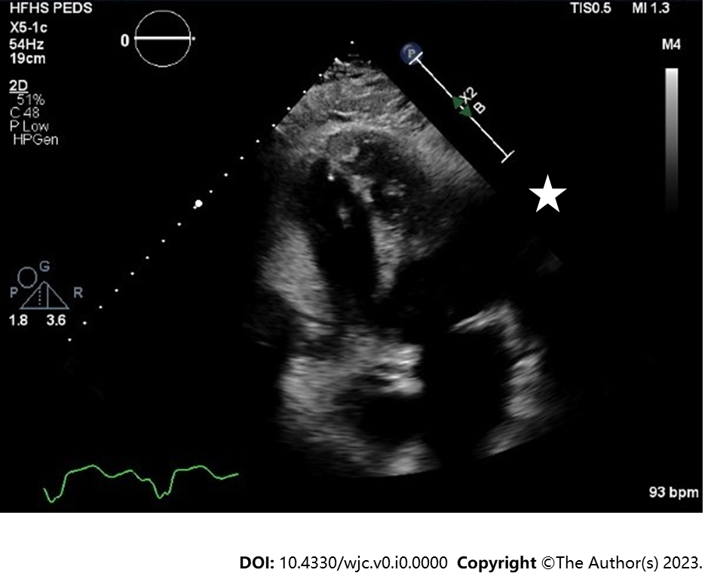
Figure 6 Transthoracic echocardiography in apical four chamber view showing an systemic right ventricle (sRV) apical thrombus. This view highlights the importance of visualizing the true apex of the sRV as the thrombus is not seen in Figure 5 where the apex is foreshortened.

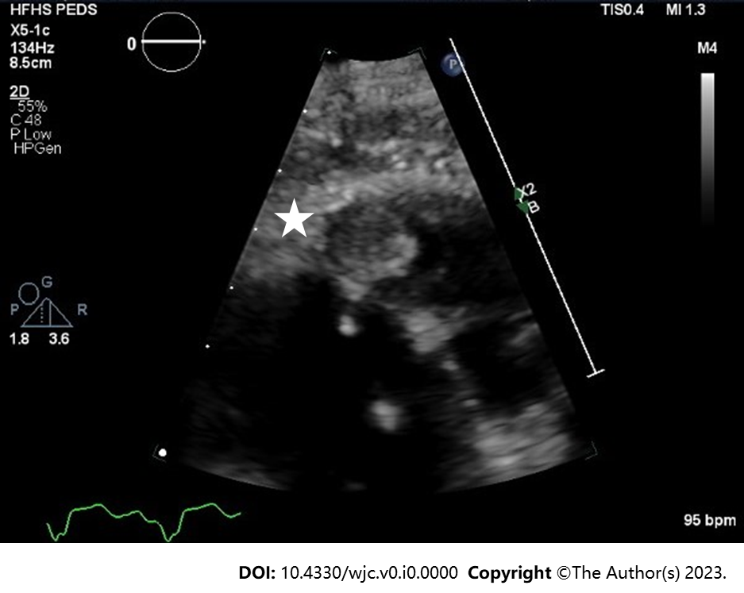
Figure 7 Transthoracic echocardiography highlighting the systemic right ventricle apical thrombus. A 1.3 cm × 1.3 cm well circumscribed mass with an echolucent center.

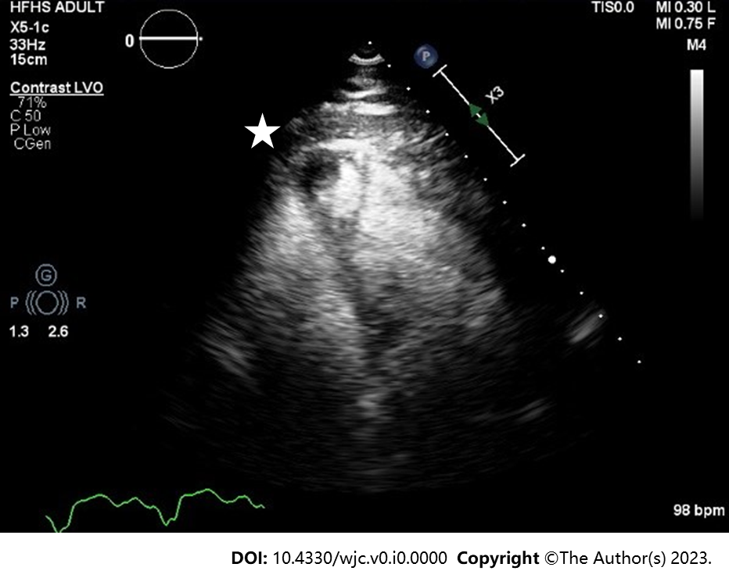
Figure 8 Transthoracic echocardiography with intravenous contrast demarcating the apical thrombus in the systemic right ventricle.

Table 1 Pertinent laboratory investigations
Investigation | Patient result | Reference range
Sodium (mmol/L) | 138 | 135-145
Potassium (mmol/L) | 4.1 | 3.5-5.0
Chloride (mmol/L) | 104 | 98-111
Carbon dioxide (mmol/L) | 22 | 21-35
Blood urea nitrogen (mg/dL) | 19 | 10-25
Creatinine (mg/dL) | 0.80 | < 1.28
Venous lactate (mmol/L) | 1.2 | < 2.1
High-sensitivity troponin (ng/L) | 16 | < 18
Brain natriuretic peptide (pg/mL) | 472 | < 50

Table 2 Cardiopulmonary exercise testing trend over time
Date of CPX | Peak HR (bpm) | Duration (min) | Peak VO₂ (ml/kig/min) | VO₂ at anerobic threshold (ml/kig/min) | Peak VO₂ (% of age predicted) | Peak RER | Actual METS achieved | VE-VO₂ slope | Peak double product | O₂ pulse rest | O₂ pulse peak
June 16, 2016 | 85 (46% predicted max) | 12.0 | 18.2 | 13.5 | 47 | 1.28 | 5.2 | 28.0 | 11900 | 4 | 16
February 16, 2017 | 145 (78% predicted max) | 13.5 | 22.4 | 16.4 | 59 | 1.23 | 6.4 | 25.6 | 22040 | 4 | 12
September6, 2018 | 173 (94% predicted max) | 10.5 | 20.1 | - | 58 | 1.20 | 5.7 | 28.8 | 25258 | 3 | 11
June 13, 2022 | 173 (96% predicted max) | 9.5 | 19.5 | - | 56 | 1.17 | 5.6 | 22.8 | 21106 | 3 | 11
CPX: Cardiopulmonary exercise testing; HR: Heart rate; METS: Metabolic equivalent of task; RER: Respiratory exchange ratio; VE: Ventilatory efficiency.

Table 3 Echocardiography trend over time
Date of study | Type of study | sRV parameters | sAV valve parameters | vLV parameters | vAV valve parameters | LA parameters | RA parameters | PA pressure (mmHg) | Other details
April 13, 2016 | Transthoracic | Severely reduced global RV SF. Moderately enlarged RV | Severe Reg (sAV Reg Vmax 4.17 m/s) | Mildly reduced LV SF (41%). Restrictive pattern of diastolic filling (G3) | Moderate-Severe Reg (vAV Reg Vmax 346.72 cm/s) | Mildly dilated | Normal | 51 | Side by side great arteries, anterior aorta consistent with L Trasnpostion of the Great Arteries (congenitally corrected). S/P VSD repair with intact patch in basal septum
November 10, 2016 | Transthoracic | Normal size and global systolic function (RV % FAC, A4C: 54.5%) | Moderate-Severe Reg (sAV Reg Vmax 5.28 m/s) | Mildly reduced LV SF (41%). Moderate hypokinesis of entire septal wall. Normal pattern of LV diastolic filling | Moderate Reg (vAV Reg Vmax 246.26 cm/s). Mildly thickened | Mildly dilated | Dilated | N/A | S/P BiV PPM
February 16, 2017 | Transthoracic | Mildly reduced global RV SF (RV % FAC, A4C: 44.7%). RV wall thickness is moderately increased | Severe Reg (sAV Reg Vmax 5.00 m/s) | Mildly reduced LV SF (48%). Normal size | Mild-moderate Reg (vAV Reg Vmax 332.84 cm/s) | Moderately dilated | Normal | 52 | Interim mild improvement in systemic RV function but persistent systemic AV valve severe regurgitation with moderate pulmonary hypertension
February 27, 2017 | Transthoracic | EF 54% (biplane) |  | EF 51% (A4C) |  |  |  |  | Limited study to quantify ventricular function
September 25, 2018 | Transthoracic | Mild dysfunction. RV wall thickness is moderately increased | Moderate-Severe Reg (sAV Reg Vmax 4.74 m/s) | Mildly reduced LV SF (47%). Normal size | Mild Reg (vAV Reg Vmax 243.67 cm/s) | Mildly dilated | Normal | 32 | Overall no major changes noted compared to prior studies eccept for mild fluctuations in systemic RV function.
May 1, 2022 | Transthoracic | Mildly reduced global RV SF (40%) | Moderate-Severe Reg (sAV Reg Vmax 4.71 m/s) | EF 45% | Moderate Reg (vAV Reg Vmax 328.85 cm/s) | Moderately dilated | Normal | 46 | There is a 1.3 cm × 1.3 cm, well circumscribed mass with echolucent center, seen apically, and likely represents a thrombus. Saline contrast bubble study -ve
May 4, 2022 | Transesophageal | N/A | Moderate-Severe Reg (sAV Reg Vmax 2.46 m/s) | Moderately reduced LV SF (35%). Normal thickness | Moderate-Severe Reg (vAV Reg Vmax 383.31 cm/s) | N/A | N/A | N/A | Well-circumscribed mass measuring 2.07 cm × 1.43 cm in the morphologic RV/Systemic ventricle with central echolucency. Saline contrast bubble study was negative
September 30, 2022 | Transthoracic | Mildly reduced global RV SF (40-45%). Mildly enlarged sRV | Mild-Mod Reg | Low-normal LV SF function | Moderate-Severe Reg (vAV Reg Vmax 228.43 cm/s) | Upper normal | Normal | 24 | Interim resolution of small systemic RV apical thrombus. Extensive trabeculation related to systemic RV hypertrophy noted
A4C: Apical 4 chamber; EF: Ejection fraction; FAC: Fractional area change; LA: Left atrium; LV: Left ventricle; PA: Pulmonary artery; PPM: Permanent pacemaker; RA: Right atrium; RV: Right ventricle; SAV: Systemic atrioventricular valve; SF: Systolic function; S/P: Status post; SRV: Systemic right ventricle; vAV: Venous atrioventricular valve; vLV: Venous left ventricle; VSD: Ventricular septal defect.

