Name of Journal: World Journal of Cardiology
Manuscript NO: 72356
Manuscript Type: CASE REPORT

Uncommon post-infarction pseudoaneurysms: A case report

Hamid J et al. Uncommon pseudoaneurysms

Hamid Jallal, Soufiane Belabes, Ali Khatouri

Hamid Jallal, Department of Cardiology, Military Hospital of instruction Omar Bongo Ondimba, Libreville 204040, Gabon

Soufiane Belabes, Department of Radiology, Military Hospital of instruction Omar Bongo Ondimba, Libreville 20404, Gabon

Ali Khatouri, Department of Cardiology, Military Hospital Avicenne, university Cadi Ayyad, Marrakech 40000, Morocco

Author contributions: Jallal H, Belabes S, and Khatouri A contributed equally to this work; Jallal H designed the case study, reviewed the literature, and wrote the manuscript; Khatouri A reviewed the literature and contributed to manuscript drafting; Belabes S performed the radiological analyses and interpreted the imaging findings; and all authors have read and approved the final manuscript.

Corresponding author: Hamid Jallal, MD, Assistant Professor, Department of Cardiology, Military Hospital of instruction Omar Bongo Ondimba, Street of Melene, Libreville 204040, Gabon. jalal-hamid@hotmail.com

Received: October 29, 2021
Revised: January 5, 2022
Accepted: March 15, 2022
Published online:

Abstract
BACKGROUND
Mechanical complications are a rare presentation in chronic coronary syndromes, which have significantly decreased in the primary coronary intervention era. Incomplete rupture may occur, resulting in pseudoaneurysms (PANs). Early reperfusion decreases the risk of this complication. Echocardiography is the method of choice for diagnosis.

CASE SUMMARY
A 54-year-old female hypertensive patient, with a history of non-revascularized inferior and anterior ST-segment elevation myocardial infarction (MI) 4 years prior, was admitted to the cardiac unit of the hospital with complaints of abdominal pain and dyspnea lasting 2 mo. The patient was hemodynamically stable, and 12-lead electrocardiogram showed persistent ST elevation and Q wave in the inferior and apical regions. Transthoracic echocardiogram in the two-chamber view showed a narrow neck of a wide PAN in the distal apical left ventricular inferior wall. In addition, the apical four-chamber and subcostal views revealed a second bulky PAN of the apical wall separated from the first by a common organizing thrombus. Cardiac magnetic resonance imaging confirmed the coexistence of more than one PAN. The patient received conservative medical treatment, and surgery was scheduled for outside the country. The patient had worsening multiple organ failure and died 4 wk after presentation.

CONCLUSION
Multifocal PANs rarely occur in chronic MI. Attention should be paid to patients with pain and cardiovascular risk factors.

Key Words: Cardiac rupture; Myocardial infarction; Pseudoaneurysm; Echocardiogram; Case report

Jallal H, Belabes S, Khatouri A. Uncommon post-infarction pseudoaneurysms: A case report. World J Cardiol 2022; In press

Core Tip: Multiple left ventricular pseudoaneurysms are a rare complication following myocardial infarction (MI), which can be diagnosed years after the infarction. This case highlights the ultimate importance of appropriate early reperfusion of MI and the role of echocardiography and multimodal imaging for the diagnostic assessment of this lethal condition.
INTRODUCTION
Left ventricular (LV) pseudoaneurysms (PANs) are rare mechanical complications of acute myocardial infarction (MI). They are caused by rupture of the free wall, are composed of organizing thrombus due to hemorrhage into the pericardial space after cardiac rupture (CR), and involve various amounts of epicardium and parietal pericardium. As stated by Hung et al^{[1]}, “PAN following transmural infarction has a high mortality rate of up to 20%”. There have been few reports of LV PAN during the chronic phase of MI, and among them all have had a single localization. Although surgical repair is the treatment of choice, transcatheter intervention for PAN repair is feasible in selected cases.
Herein, we present the first case of uncommon CR manifested as multiple adjacent LV PANs, which occurred in a female patient with a history of MI.

CASE PRESENTATION
Chief complaints
A 54-year-old female patient presented to the emergency department with complaints of abdominal pain and dyspnea.

History of present illness
The patient presented with recurrent episodes of epigastric pain and dyspnea, which began 2 mo prior and worsened 48 h before hospital admission.

History of past illness
The patient had a long history of untreated and advanced hypertension, as well as a history of inferior and anterior ST-segment elevation MI without revascularization, which had occurred 4 years prior.

Personal and family history
The patient had no relevant family history.

Physical examination
The patient presented with hemodynamic stability, a heart rate of 96 beats/min, respiratory rate of 16 breaths/min, blood pressure of 130/80 mmHg, and oxygen saturation in room air of 98%. Symptoms of acute heart failure were excluded by clinical cardiological examination. A painful and hard epigastric mass was detected upon abdominal examination.

Laboratory examinations
Blood analysis revealed mild leukocytosis (12 × 10⁹/L), with neutrophil predominance (80%) and normal hematocrit and platelet levels. Prothrombin and partial thromboplastin times were normal, and troponin T was slightly increased at 1.2 ng/mL. Blood creatinine was increased at 435 mmol/L. The 12-lead electrocardiogram showed persistent ST elevation and Q wave in the inferior and apical territory. Chest X-ray revealed increased cardiothoracic ratio with rounded opacity along the left cardiac silhouette.

Imaging examinations
Echocardiography is the first test performed after admission because of its availability. In the four-chamber view, initial imaging evaluation with transthoracic echocardiogram (TTE) showed the narrow neck of a large PAN in the LV apical wall (arrow) (Figure 1A), in the apical two-chamber view (Figure 1B) and modified short axis view (Figure 2A). TTE revealed a second PAN of the distal apical inferior wall, separated from the first PAN by a common organizing fibrous tissue, as detected in the subcostal view (Figure 3A) and apex view (Figure 3B), without pericardial effusion. Color Doppler imaging in the four-chamber view (Figure 2B) demonstrated flow in and out of the pericardial cavity at the site of the tear, as well as abnormal flow into the PAN without any shunt through the organizing thrombus. The LV communicated with the PAN via a narrow neck formed by the ruptured apical and inferior myocardium. The dimensions of the cavity (68/15 mm; Figure 2A) and imaging findings were indicative of a PAN; however, it is of great clinical importance to differentiate PANs, which have a high likelihood of spontaneous rupture, from a true aneurysm, which seldom ruptures.

Further diagnostic work-up
The patient was further evaluated with transesophageal echocardiogram, despite the difficulty in assessing the apical wall by this approach; however, the left ventricle communicated with the PANs via a narrow neck formed by the ruptured apical and inferior myocardium (Figure 4). To better characterize this finding, a cardiac magnetic resonance (CMR) scan was performed since the severe chronic renal failure precluded evaluation by thoracic computed tomography angiography and to take advantage of the good non-invasive tissue characterization offered by CMR; the cine sequence images confirmed severe LV dysfunction and showed an apical PAN without an intracavitary thrombus in the two-chamber view (Figure 5A). Curiously, a larger and a small outpouching, separated by fibrous tissue, was revealed in the inferior apical wall (Figure 5B); the outpouchings were seen to be associated with disrupted myocardial wall, and they were surrounded only by pericardium.

FINAL DIAGNOSIS
Multiple adjacent LV PANs following chronic MI.

TREATMENT
The patient was immediately started on conservative medical treatment, including a curative anticoagulant (acenocoumarolum at 4 mg/d), diuretic (furosemide at 40 mg/d), heart failure therapeutics (bisoprolol at 5 mg and ramipril 5 mg, both one pill per day) and coronary heart disease therapeutics (aspirin at 75 mg/d and atorvastatin at 20 mg/d). After collegial discussion among the care team, the decision was made to proceed with surgical repairs outside the country due to the lack of a cardiac surgery center.

OUTCOME AND FOLLOW-UP
The patient had an uneventful clinical course with medical treatment; surgery was delayed considering the suspension of air travel due to the coronavirus disease 2019 pandemic. The patient had multiple organ failure caused by acute free intrapericardial rupture, which usually causes cardiac tamponade and death, and died 4 wk after presentation.

DISCUSSION
PAN is a contained progressive rupture of the LV free wall. It is commonly caused by MI but may also occur after cardiac surgery, chest trauma or infection, and endocardial electrophysiologic procedures; “although in some cases the etiology may be unknown^{[2]}”. Typically, LV PANs can also be identified by echocardiography and are typified by a PAN cavity that communicates with the LV chamber via a very narrow neck and frequently contains a thrombus. The characteristic to-and-fro blood flow through the site of rupture can be detected with Doppler and color flow imaging; however, “magnetic resonance imaging is necessary to establish the diagnosis if echocardiography findings are atypical^{[3]}”. While most PANs are located in the inferoposterior or inferolateral region, “some studies have concluded that the most typical location is the anterior or lateral wall^{[4]”}.
In the last several years, the incidence of CR has decreased with the development of “primary percutaneous coronary intervention (PPCI), which has been an important protective factor^{[5]}”. Risk factors include advanced age, female sex, first infarction, large infarction, and delivery of fibrinolytic therapy more than 14 h after the onset of symptoms. Our patient was in the 5th decade of life, female sex, and hypertensive, with an untreated large anterior MI. Hence, our patient was at high risk of developing CR. “Early reperfusion and the presence of collateral circulation, which limit the extent of myocardial tissue damage, decrease the risk of free wall rupture^{[6]}”.
To the best of our knowledge, the presented case is the first in the literature to show more than one PAN caused by MI with long-term evolution. In this case, the onset and progression were possibly influenced by the large extension of non-revascularized MI, and the severity of hypertension explained by the advanced stage of chronic kidney failure. The first evaluation by echocardiography in the early phase of acute MI did not show the development of dyskinesia or aneurysm. In acute LV PAN, once the diagnosis is confirmed, surgical repair is the preferred treatment, although conservative medical treatment for certain high-risk patients may be associated with a good outcome, “as has been described in some retrospective studies showing that patients with an incidental finding of chronic small LV PAN, less than 3 cm in size, and patients with increased surgical risk can be managed conservatively^{[7]}”. However, the preferred approach remains surgical management. Our patient was primarily treated by medical treatment and was scheduled for surgery after discussion with the surgical team, but she died after 4 wk from acute free intrapericardial rupture, in accordance with the literature showing that “PANs have a high risk of rupture, occurring in 30% to 45% of cases^{[8]}”. In patients treated conservatively, some complications may occur, such as thromboembolism, compression of adjacent structures, and infection.

CONCLUSION
PANs are caused by rupture of the myocardial wall and are an infrequent complication of acute MI that rapidly leads to death. However, some cases may take a subacute or chronic course when a small rupture is temporarily sealed by fibrinous pericardial adhesions or thrombus. No cases of multiple PANs of LV have been reported. The best weapon against this lethal complication is timely pharmacologic or mechanical reperfusion.

REFERENCES
1 Hung MJ, Wang CH, Cherng WJ. Unruptured left ventricular pseudoaneurysm following myocardial infarction. Heart 1998; 80: 94-97 [PMID: 9764070 DOI: 10.1136/hrt.80.1.94]
2 Ashraf T, Aziz R, Khuwaja AM. Left ventricular aneurysmectomy in a young female with pseudoaneurysm of unknown etiology. J Saudi Heart Assoc 2020; 32: 110-113 [DOI: 10.37616/2212-5043.1019]
3 Caldeira A, Albuquerque D, Coelho M, Côrte-Real H. Left Ventricular Pseudoaneurysm: Imagiologic and Intraoperative Images. Circ Cardiovasc Imaging 2019; 12: e009500 [PMID: 31766861 DOI: 10.1161/CIRCIMAGING.119.009500]
4 Abdelnaby M, Al-Maghraby A, Saleh Y, El-Amin A, Hammad B. Post-Myocardial Infarction Left Ventricular Free Wall Rupture: A Review. Ann Med Health Sci Res 2017
5 Honda S, Asaumi Y, Yamane T, Nagai T, Miyagi T, Noguchi T, Anzai T, Goto Y, Ishihara M, Nishimura K, Ogawa H, Ishibashi-Ueda H, Yasuda S. Trends in the clinical and pathological characteristics of cardiac rupture in patients with acute myocardial infarction over 35 years. J Am Heart Assoc 2014; 3: e000984 [PMID: 25332178 DOI: 10.1161/JAHA.114.000984]
6 Sulzgruber P, El-Hamid F, Koller L, Forster S, Goliasch G, Wojta J, Niessner A. Long-term outcome and risk prediction in patients suffering acute myocardial infarction complicated by post-infarction cardiac rupture. Int J Cardiol 2017; 227: 399-403 [PMID: 27847155 DOI: 10.1016/j.ijcard.2016.11.037]
7 Yeo TC, Malouf JF, Oh JK, Seward JB. Clinical profile and outcome in 52 patients with cardiac pseudoaneurysm. Ann Intern Med 1998; 128: 299-305 [PMID: 9471934 DOI: 10.7326/0003-4819-128-4-199802150-00010]
8 Frances C, Romero A, Grady D. Left ventricular pseudoaneurysm. J Am Coll Cardiol 1998; 32: 557-561 [PMID: 9741493 DOI: 10.1016/s0735-1097(98)00290-3]

Footnotes
Informed consent statement: Informed written consent was obtained from the patient for publication of this report and any accompanying images.

Conflict-of-interest statement: The authors declare that they have no conflicts of interest.

CARE Checklist (2016) statement: The authors have read the CARE Checklist (2016), and the manuscript was prepared and revised according to the CARE Checklist (2016).

Open-Access: This article is an open-access article that was selected by an in-house editor and fully peer-reviewed by external reviewers. It is distributed in accordance with the Creative Commons Attribution NonCommercial (CC BY-NC 4.0) license, which permits others to distribute, remix, adapt, build upon this work non-commercially, and license their derivative works on different terms, provided the original work is properly cited and the use is non-commercial. See: https://creativecommons.org/Licenses/by-nc/4.0/

Provenance and peer review: Unsolicited article; Externally peer reviewed.
Peer-review model: Single blind

Peer-review started: October 29, 2021
First decision: December 27, 2021
Article in press:

Specialty type: Cardiac and cardiovascular systems
Country/Territory of origin: Gabon
Peer-review report’s scientific quality classification
Grade A (Excellent): A
Grade B (Very good): 0
Grade C (Good): C
Grade D (Fair): 0
Grade E (Poor): 0

P-Reviewer: Bairwa DBL, India; Wang Y, China S-Editor: Ma YJ L-Editor: A P-Editor: Ma YJ

Figure Legends
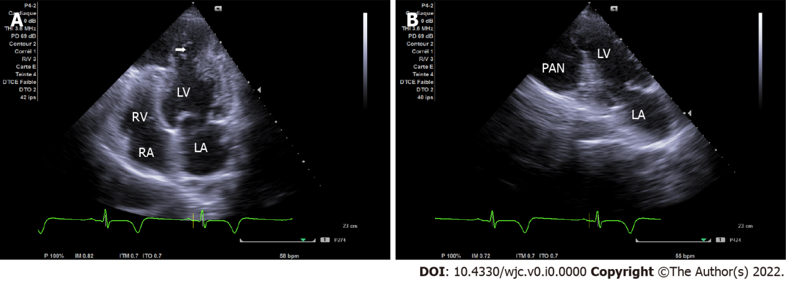
Figure 1 Apical chamber view on transthoracic echocardiogram. A: Apical four-chamber view demonstrating the narrow neck of a pseudoaneurysm (PAN) in the apical wall (arrow indicates the site of free wall rupture); B: Apical two-chamber view demonstrating a second PAN of the infero-apical wall. LA: Left atrium; LV: Left ventricular; RA: Right atrium; RV: Right ventricular.
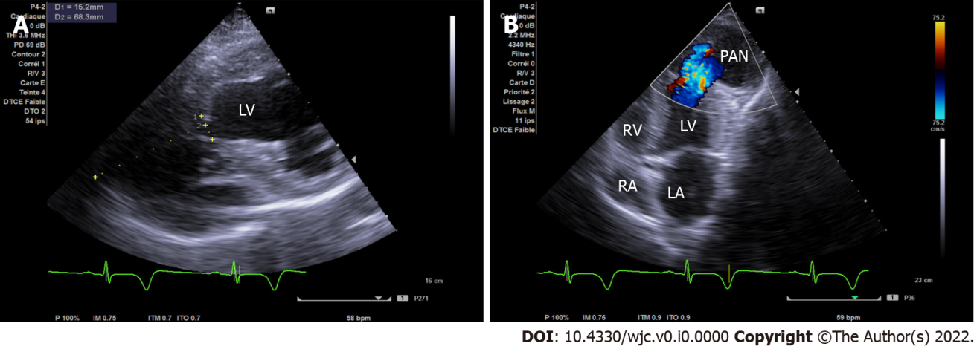
Figure 2 Transthoracic echocardiogram. A: Modified short axis view with the pseudoaneurysm dimensions (width of the neck was 15 mm and the maximal internal diameter of the aneurysmal sac was 68 mm with a neck to sac ratio of less than 0.5); B: Apical modified 4/5 chamber view showing bidirectional shunt through the left ventricular wall.
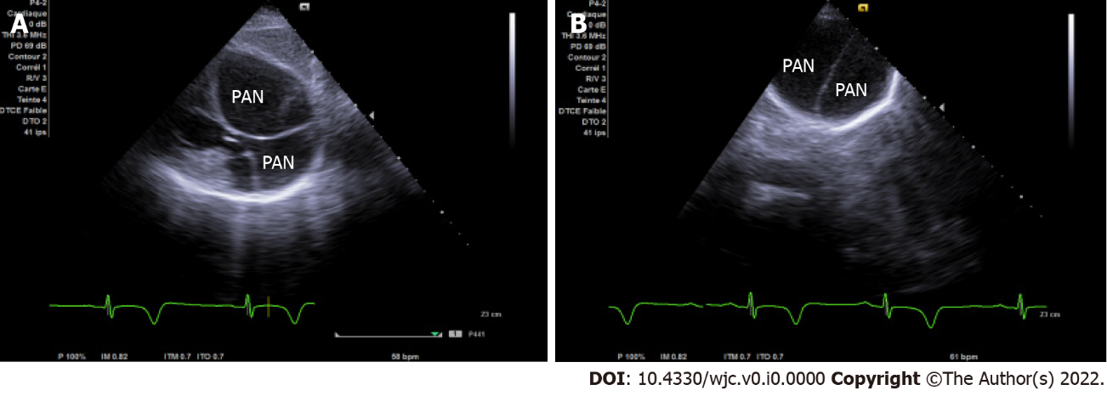
Figure 3 Subcostal and apical views on transthoracic echocardiogram. A: Subcostal view illustrating two wide pseudoaneurysms isolated by organizing fibrous tissue; B: Apical view with inclination of the probe at a right angle to the skin showing two non-communicant adjacent cavities separated by fibrous tissue.
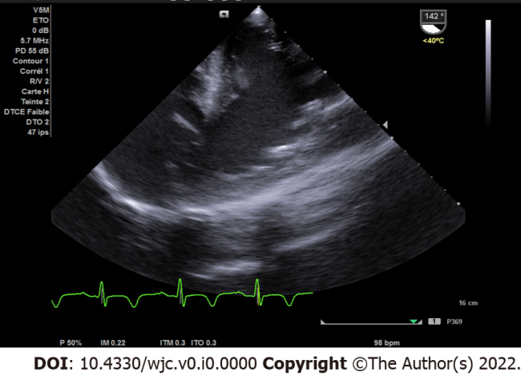
Figure 4 Two-chamber view on transesophageal echocardiogram. Two-chamber view confirming the pseudoaneurysm and flow through the left ventricle.
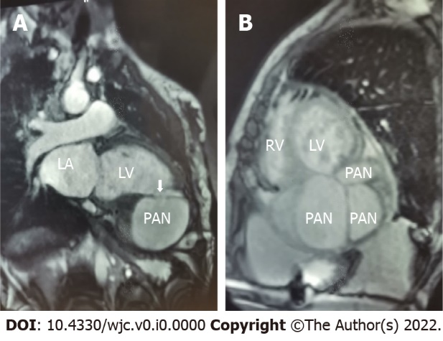
Figure 5 Cardiac magnetic resonance imaging. A: Two-chamber view showing the connection between the left ventricular (LV) cavity and the LV pseudoaneurysm (PAN) (arrow); B: Short axis view showing multiple cavities corresponding to the PANs isolated by fibrous tissue. LA: Left atrium; RV: Right ventricular.

