Name of journal: World Journal of Clinical Cases
ESPS Manuscript NO: 15937
Columns: Case Report

Extremely unusual case of gastrointestinal trichobezoar

Jatal SN et al. Large trichobezoar of stomach and intestine

Sopan N Jatal, Nawab P Jamadar, Bhagwat Jadhav, Saleha Siddiqui, Sachin B Ingle

Sopan N Jatal, Department of Surgery and Anesthesia, MIMSR Medical College, Latur, Maharashtra 4132512, India

Nawab P Jamadar, Department of Anesthesia, MIMSR Medical College, Latur, Maharashtra 4132512, India

Bhagwat Jadhav, Jatal Hospital & research centre, MIMSR Medical College, Latur, Maharashtra 4132512, India

Saleha Siddiqui, Sachin B Ingle, Department of Pathology and Secretary Research and Development, MIMSR Medical College, Latur, Maharashtra 4132512, India

Author contributions: Ingle SB and Siddiqui S prepared the manuscript; Jatal SN, JadhavB and Jamadar NP critically revised the intellectual content and gave final approval of manuscript.

Conflict-of-interest: None to be declared.

Open-Access: This article is an open-access article which was selected by an in-house editor and fully peer-reviewed by external reviewers. It is distributed in accordance with the Creative Commons Attribution Non Commercial (CC BY-NC 4.0) license, which permits others to distribute, remix, adapt, build upon this work non-commercially, and license their derivative works on different terms, provided the original work is properly cited and the use is non-commercial. See: http://creativecommons.org/licenses/by-nc/4.0/

Correspondence to: Sachin B Ingle, Professor, Department of Pathology and Secretary Research and Development, MIMSR Medical College, Ambajogai Road, Latur-Maharashtra 41353, India. dr.sachiningle@gmail.com

Telephone: +91-2382-227424
Fax: +91-2382-228939
Received: December 17, 2014
Peer-review started: December 18, 2014
First decision: December 26, 2014
Revised: January 29, 2015
Accepted: February 9, 2015
Article in press:
Published online:

Abstract
Trichobezoars (hair ball) are usually located in the stomach, but may extend through the pylorus into the duodenum and small bowel (Rapunzel syndrome). Rapunzel syndrome remains uncommon; with fewer than 40 cases reported. To the best of our knowledge, this case may be the first well-documented case with a length of 75 cm. They are almost always associated with trichotillomania and trichophagia or other psychiatric disorders. In the literature several treatment options are proposed, including removal by conventional laparotomy, laparoscopy and endoscopy. Herein, we are reporting an interesting case of an 18-year mentally retarded girl with history of trichotillomania and trichophagia who presented to our emergency department with a history of central abdominal pain associated with vomitingand constipation for five days. An examination showed a trichobezoar requiring emergent surgical intervention, and indicating the need for psychiatric treatment. The trichobezoar was treated successfully by laparoscopy.

Key words: Giant Trichobezoar; Trichotillomania; Rapunzel syndrome; Therapy Endoscopy; Laparoscopy

© The Author(s) 2015. Published by Baishideng Publishing Group Inc. All rights reserved.

Core tip: Laparoscopic management is ideal for trichobezoar due to an improved cosmetic appearance, fewer postoperative complications, and reduced hospital stay. It has a better outcome with many benefits over laparotomy and is slowly becoming the treatment of choice. After trichobezoar removal, prognosis is good if psychiatric therapy to control habitual trichophagia is successful.

Jatal SN, Jamadar NP, Jadhav B, Siddiqui S, Ingle SB. Extremely unusual case of gastrointestinal trichobezoar. World J Clin Cases 2015; In press

INTRODUCTION
A trichobezoar is an unusual condition hair bundles in stomach and small intestine, leading to intestinal obstruction usually affecting younger females^{[1,2]}. It is mainly associated with a psychiatric disorder, trichotillomania having tendency of pulling hairs and significant hairloss. The large number of patients with this disorder are having problem of depression, anxiety and poor self-image^{[3]}. The feel pleasant while pulling the hairs. The prevalence of the condition is 0.06% to 4%^{[4]}. Due to smoothness, the ingested hairs resist digestion as well as peristalsis and get accumulated in the gastric mucosal folds. Eating of hairs for a long period leads to trichobezoar. Its main location is in stomach. However, in some cases, there is extension in to small intestine and exceptionally in to large intestine, then the condition is labeled as Rapunzel syndrome. Rapunzel syndrome was first discovered by Vaughan et al^{[5]} in 1968. Fragmentation and dislodgement lead to obstruction^{[6-8]}. As they are clinically asymptomatic, many times there is delay in diagnosing the condition. Due to availability of newer techniques of removal, i.e., Laparoscopy and endoscopy, routinely laprotomy is not preferred^{[7-9]}. Herein, we are reporting a similar interesting case of trichobezoar, removed on laproscopy.

CASE REPORT
A mentally retarded an adolescent girl (18 year age) came to Jatal Hospital and Research Centre with history of trichotillomania and trichophagia. She was eating her own hairs since last 10 years. She was presented with central colicky abdominal pain along with episodes of vomiting for 7 d. she was clinically conscious, with signs and symptoms of mild dehydration, anemic and had no signs of jaundice. The systemic parameters are normal.
Patient’s upper gastrointestinal diagnostic endoscopy was performed and showed heavy large trichobezoar (hairball) in the stomach (Figure 1). Computed tomography (CT) scan was not done, in view of poor economical status of the patient and also as it was not indicated. Accordingly, patient was planned for emergency laparoscopic management.
A 10 mm umbilical port (telescopic port) was used having 30° telescope. Two 5 mm ports, one at right hypochondriac region and the other at midaxillary line was used. The one used at mid-axillary line was an operating port of 10 mm. Fourth port, i.e., a 5 mm port at epigastric region to retract the left lobe of liver was used (Figure 2).Laparoscopic gastrostomy was performed with the help of harmonic scalpel. There was a giant trichobezoar extending from stomach through pylorus upto the jejunum (Rapunzel Syndrome). Successful complete removal of trichobezoar was done laparoscopically. The length of the trichobezoar was 75 cm. (Figure 3).On follow up patient is doing well since one month and she is under treatment of psychiatrist.

DISCUSSION
Continued hair ingestion in the patients of trichophagia forms a tight, growing hair balls leading to obstruction in the intestine. After accumulation the hair traps the viscous materials, i.e., mucin, blood that forms tight and compact growing hairballs, not easy to remove^{[10]}. In addition, the gastric churning helps to trap new hair into already formed hairballs. Mucus gives the hairball a shiny surface. Due to denaturation of proteins in the acidic environment of stomach; the color of the ball remains black. The foul smelling breath that results from fermentation of fats^{[11]}. Many times, the patient remains asymptomatic for many years, until the point of obstruction^{[11]}. Subsequent gastrointestinal blood loss leads to anemia.
Depending on the composition they are classified as: Trichobezoars .Phytobezoars, Medication bezoars and Lactobezoars. Phytobezoars are more common that composed of indigestible fruits, vegetable fibers, skin, or seeds^{[12]}. Phytobezoars are mainly associated with a history of previous gastric surgery, conditions of reduced gastric acidity, delayed motility or poor gastric mixing. Medication bezoars composed of undigested tablets or semiliquid drugs. Lactobezoars are predominantly seen in lowbirth- weight or premature babies fed with a highly concentrated milk formula during the first weeks of life^{[12]}.
Rapunzel syndrome is defined as a bezoar extending down in to small intestine and exceptionally in to large intestine leading to obstruction^{[11]}. Rapunzel syndrome is very unusual with less than 40 cases documented^{[11]}. It is a reflection of psychiatric illness and no associated with gastrointestinal motility & first discovered by Vaughan et al^{[5]}.
Various modalities are used for diagnosis of this rare condition. A contrast upper gastrointestinal series often diagnostic of trichobezoars. They are also easily diagnosed on abdominal ultrasonography and or computed tomography scan^{[12,13]}. However, upper GI endoscopy is an effective diagnostic tool to confirm the presence of a trichobezoar. Endoscopy also helps the clinician to differentiate between a trichobezoar and another foreign body^{[14]}.
Several treatment modalities are available for the treatment of trichobezoar i.e. open surgery, Laproscopic or endoscopic removal by mechanical fragmentation or using chemicals^{[11]}. The main drawback of above methods is they are not useful in large trichobezoars^{[14]}.
Previously open surgery and or laprotomy was a treatment of choice ^{[14]}.However, they have postoperative complications, i.e., perforation, infection of wound, pneumonia etc^{[14]}. Other surgical complications are upper digestive tract bleeding, anemia, bowel intussusceptions and rarely death.
With the availability of newer less invasive modes, laparoscopic removal is preferred but it seems to be difficult. The advantages are less hospital stay, cosmetically accepted and minimal complications^{[14]}. However, there are chances of spillage of hairs into the peritoneal cavity and requires more time ^{[10,14]}.
To conclude psychiatric treatment and follow up is very important in the treatment and prevention of recurrence of Rapunzel syndrome.The long term prognosis is excellent^{[11]}.

COMMENTS
Case characteristics
Complained of central colicky abdominal pain with episodes of vomiting and constipation.

Clinical diagnosis
Trichobezoars.

Imaging diagnosis
CT scan was not performed due to the poor economical status of the patient and also as it was not indicated.

Pathological diagnosis
Trichobezoars.

Treatment
Laparoscopic removal followed by psychiatric therapy is ideal & is successful to control habitual trichophagia in this case.

Peer-review
The authors have performed a good study, the manuscript is interesting.

REFERENCES
1 Diefenbach GJ, Reitman D, Williamson DA. Trichotillomania: a challenge to research and practice. Clin Psychol Rev 2000; 20: 289-309 [PMID: 10779896 DOI: 10.1016/S0272-7358(98)00083-X]
2 Carr JR, Sholevar EH, Baron DA. Trichotillomania and trichobezoar: a clinical practice insight with report of illustrative case. J Am Osteopath Assoc 2006; 106: 647-652 [PMID: 17192451]
3 Higa-McMillan CK, Smith RL, Chorpita BF, Hayashi K. Common and unique factors associated with DSM-IV-TR internalizing disorders in children. J Abnorm Child Psychol 2008; 36: 1279-1288 [PMID: 18607718]
4 Duke DC, Keeley ML, Geffken GR, Storch EA. Trichotillomania: A current review. Clin Psychol Rev 2010; 30: 181-193 [PMID: 19926375 DOI: 10.1016/j.cpr.2009.10.008]
5 Vaughan ED, Sawyers JL, Scott HW. The Rapunzel syndrome. An unusual complication of intestinal bezoar. Surgery 1968; 63: 339-343 [PMID: 5638179]
6 Naik S, Gupta V, Naik S, Rangole A, Chaudhary AK, Jain P, Sharma AK. Rapunzel syndrome reviewed and redefined. Dig Surg 2007; 24: 157-161 [PMID: 17476105 DOI: 10.1159/000102098]
7 Tudor EC, Clark MC. Laparoscopic-assisted removal of gastric trichobezoar; a novel technique to reduce operative complications and time. J Pediatr Surg 2013; 48: e13-e15 [PMID: 23480941 DOI: 10.1016/j.jpedsurg.2012.12.028]
8 Pogorelić Z, Jurić I, Zitko V, Britvić-Pavlov S, Biocić M. Unusual cause of palpable mass in upper abdomen--giant gastric trichobezoar: report of a case. Acta Chir Belg 2012; 112: 160-163 [PMID: 22571081]
9 Kanetaka K, Azuma T, Ito S, Matsuo S, Yamaguchi S, Shirono K, Kanematsu T. Two-channel method for retrieval of gastric trichobezoar: report of a case. J Pediatr Surg 2003; 38: e7 [PMID: 12596127 DOI: 10.1053/jpsu.2003.50067]
10 Fraser JD, Leys CM, St Peter SD. Laparoscopic removal of a gastric trichobezoar in a pediatric patient. J Laparoendosc Adv Surg Tech A 2009; 19: 835-837 [PMID: 19405804 DOI: 10.1089/lap.2008.0367]
11 Gonuguntla V, Joshi DD. Rapunzel syndrome: a comprehensive review of an unusual case of trichobezoar. Clin Med Res 2009; 7: 99-102 [PMID: 19625498 DOI: 10.3121/cmr.2009.822]
12 Lin CS, Tung CF, Peng YC, Chow WK, Chang CS, Hu WH. Successful treatment with a combination of endoscopic injection and irrigation with coca cola for gastric bezoar-induced gastric outlet obstruction. J Chin Med Assoc 2008; 71: 49-52 [PMID: 18218561 DOI: 10.1016/S1726-4901(08)70073-X]
13 Taori K, Deshmukh A, Rathod J, Sheorain V, Sanyal R. Rapunzel syndrome: a trichobezoar extending into the ileum. Appl Radiol 2008; 34-35
14 Gorter RR, Kneepkens CM, Mattens EC, Aronson DC, Heij HA. Management of trichobezoar: case report and literature review. Pediatr Surg Int 2010; 26: 457-463 [PMID: 20213124 DOI: 10.1007/s00383-010-2570-0]
P-Reviewer: Cruz-Portelles A, Vij M S-Editor: Tian YL
L-Editor: E-Editor:
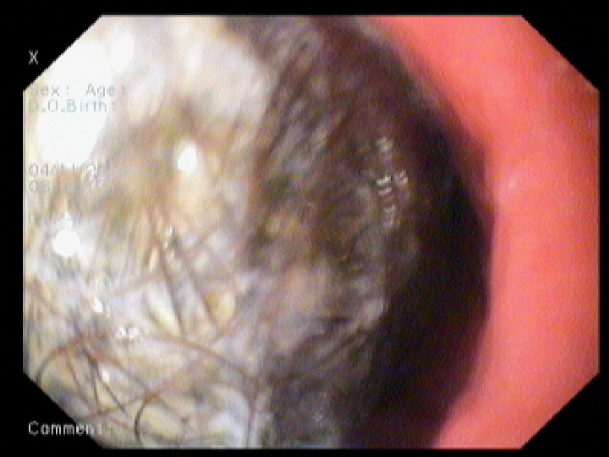
Figure 1 Upper gastrointestinal endoscopy shows a large hairball.

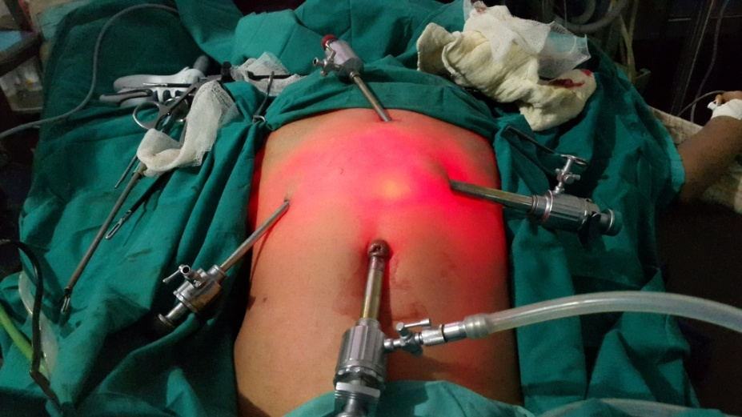
Figure 2 Showing laparoscopic ports.

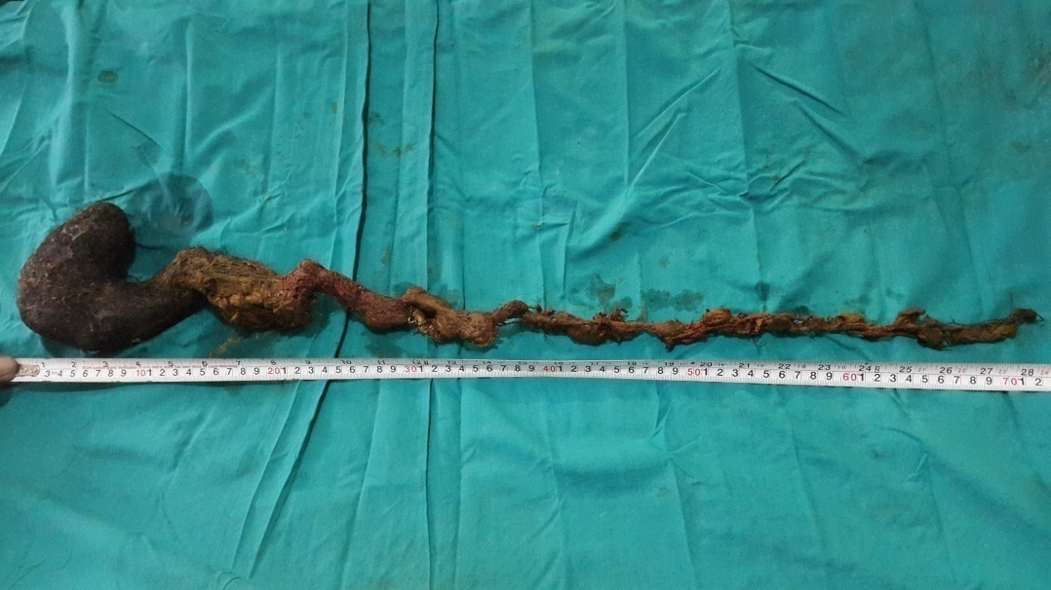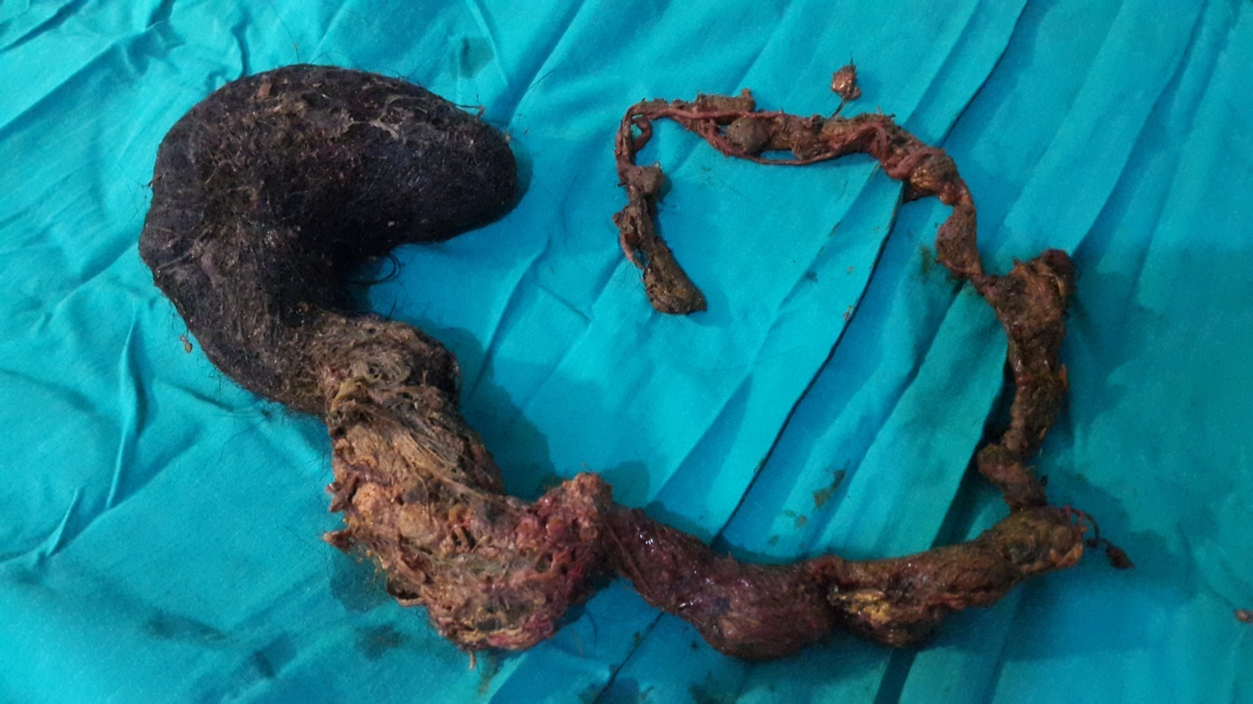
Figure 3 Large trichobezoar measuring 75 cm in length.

