Name of Journal: World Journal of Clinical Cases
Manuscript NO: 64123
Manuscript Type: META-ANALYSIS

Type 2 diabetes mellitus increases liver transplant-free mortality in patients with cirrhosis: A systematic review and meta-analysis

Liu ZJ et al. Diabetes mellitus increases mortality in patients with cirrhosis

Zi-Jin Liu, Yi-Jie Yan, Hong-Lei Weng, Hui-Guo Ding

Zi-Jin Liu, Yi-Jie Yan, Hui-Guo Ding, Department of Gastroenterology and Hepatology, Beijing You’an Hospital Affiliated to Capital Medical University, Beijing 100069, China

Hong-Lei Weng, Department of Medicine II, Section Molecular Hepatology, Medical Faculty Mannheim, Heidelberg University, Mannheim 68167, Germany
Author contributions: Liu ZJ and Yan YJ searched the literature and collected the data; Liu ZJ wrote the manuscript; Ding HG designed the project and edited the manuscript; Weng HL helped polish the language of the manuscript; all the authors have read and approved the manuscript.

Corresponding author: Hui-Guo Ding, MD, Chief Doctor, Director, Department of Gastroenterology and Hepatology, Beijing You’an Hospital Affiliated to Capital Medical University, No. 8 Xitoutiao, Youanmenwai, Fengtai District, Beijing 100069, China. dinghuiguo@ccmu.edu.cn

Received: February 9, 2021
Revised: April 27, 2021
Accepted: May 20, 2021
Published online: July 16, 2021

Abstract
BACKGROUND
The impact of type 2 diabetes mellitus (T2DM) on the prognosis and complications of liver cirrhosis is not fully clarified.

AIM
To clarify the mortality and related risk factors as well as complications in cirrhotic patients with T2DM.

METHODS
We searched PubMed, EMBASE, and the Cochrane Library from their inception to December 1, 2020 for cohort studies comparing liver transplant-free mortality, hepatocellular carcinoma (HCC), ascites, spontaneous bacterial peritonitis (SBP), variceal bleeding, and hepatic encephalopathy (HE) in cirrhotic patients with vs without T2DM. Odds ratios (ORs) were combined by using fixed-effects or random-effects models with RevMan software.

RESULTS
The database search generated a total of 17 cohort studies that met the inclusion criteria. Among these studies, eight reported the risk of mortality, and eight reported the risk of HCC. Three studies provided SBP rates, and two documented ascites rates. Four articles focused on HE rates, and three focused on variceal bleeding rates. Meta-analysis indicated that T2DM was significantly associated with an increased risk of liver transplant-free mortality [OR: 1.28, 95% confidence intervals (CI): 1.16-1.41, P < 0.0001] and HCC incidence (OR: 1.82, 95%CI: 1.32-2.51, P = 0.003). The risk of SBP was not significantly increased (OR: 1.16 95%CI: 0.86-1.57, P = 0.34). Additionally, T2DM did not significantly increase HE (OR: 1.31 95%CI: 0.97-1.77, P = 0.08), ascites (OR: 1.11 95%CI: 0.84-1.46, P = 0.46), and variceal bleeding (OR: 1.34, 95%CI: 0.99-1.82, P = 0.06).

CONCLUSION
The findings suggest that cirrhotic patients with T2DM have a poor prognosis and high risk of HCC. T2DM may not be associated with an increased risk of SBP, variceal bleeding, ascites, or HE in cirrhotic patients with T2DM.

Key Words: Diabetes mellitus; Mortality; Liver cirrhosis; Hepatocellular carcinoma; Meta-analysis

©The Author(s) 2021. Published by Baishideng Publishing Group Inc. All rights reserved.

Citation: Liu ZJ, Yan YJ, Weng HL, Ding HG. Type 2 diabetes mellitus increases liver transplant-free mortality in patients with cirrhosis: A systematic review and meta-analysis. World J Clin Cases 2021; 9(20): 5514-5525
URL: https://www.wjgnet.com/2307-8960/full/v9/i20/5514.htm
DOI: https://dx.doi.org/10.12998/wjcc.v9.i20.5514

Core Tip: No consensus is available in the literature about whether type 2 diabetes mellitus (T2DM) can influence the prognosis and complications of liver cirrhosis. This is the first systematic review and meta-analysis comparing the mortality, hepatocellular carcinoma, hepatic encephalopathy, ascites, esophageal varices bleeding, and spontaneous bacterial peritonitis rates between T2DM and non-T2DM cirrhotic patients.

INTRODUCTION
Globally, liver cirrhosis is an increasing cause of morbidity and mortality and is the 14th most common cause of death^{[1]}. The liver plays a pivotal role in glucose homeostasis. It stores glycogen in the fed state and produces glucose through glycogenolysis. Former researchers found that 20%-30% of overt type 2 diabetes mellitus (T2DM) cases and 60%-80% of impaired glucose tolerance cases occur in liver cirrhotic patients^{[2,3]}. Whether the presence of T2DM in patients with cirrhosis can increase mortality is also controversial. Some studies proved that cirrhosis patients with T2DM have higher mortality than patients without^{[4,5]}, while other studies found opposite results^{[6,7]}. T2DM may increase the risk of infection; however, some research found no difference in the spontaneous bacterial peritonitis (SBP) rate between cirrhosis patients with and without T2DM^{[8]}.
We therefore conducted a meta-analysis to evaluate the association between T2DM and mortality as well as its complications in patients with liver cirrhosis.

MATERIALS AND METHODS
Literature search
This systematic review and meta-analysis were conducted following the Preferred Reporting Items for Systematic Reviews and Meta-Analyses guidelines^{[9]}. Our primary endpoints were defined as liver transplant-free mortality and hepatocellular carcinoma (HCC) incidence. Secondary endpoints included ascites, SBP, variceal bleeding, and hepatic encephalopathy (HE). All these outcomes were defined by the authors of the primary studies. Two investigators (Liu ZJ and Yan YJ) independently searched PubMed, EMBASE, and the Cochrane Register of Controlled Trials (up to December 1, 2020) using the following MeSH and their free terms: “Liver cirrhosis” AND “type 2 diabetes mellitus” AND (“mortality” OR “spontaneous bacterial peritonitis” OR “ascites” OR “variceal bleeding” OR “hepatic encephalopathies” OR “hepatocellular carcinoma”). The search was further reviewed systematically, and the literature was limited by the language of English.

Eligibility criteria
Studies were included if: (1) They were retrospective or prospective cohort studies comparing mortality and complications of liver cirrhosis patients who had vs did not have T2DM; (2) They were published in full text in a peer-reviewed journal; and (3) They involved 50 or more adult patients and the follow-up period was longer than 6 mo. Studies were excluded if: (1) They were animal or basic studies; (2) They were meta-analyses or reviews; (3) They were cross-sectional studies or case-control studies; (4) They were case reports; (5) They involved patients undergoing liver transplant surgery; (6) They were conference abstracts; or (7) They were not published in English.

Data extraction
Two investigators (Liu ZJ and Yan YJ) independently and separately assessed the trials for eligibility and extracted data. For each individual study, the following study characteristics were collected: First authors’ name, total patients included, year, country, mean age, sex, study design, etiology of the underlying liver diseases, mean follow-up time, endpoint events, liver function, and glucose regulation (T2DM vs non-T2DM).

Quality assessment
The included cohort studies were assessed using the Newcastle–Ottawa Scale. Studies were considered high quality if they received 5 or more points, whereas studies were considered low quality if they received 4 or fewer points.

Statistical analysis
Meta-analysis was performed using Review Manager 5.4 (Cochrane Center, Denmark). Odds ratios (ORs) and 95% confidence intervals (95%CIs) were used as summary estimates, and analysis was performed using the fixed-effects model or random-effects model if heterogeneity was considered significant. Heterogeneity was measured using the I² statistic. High statistical heterogeneity was defined as greater than 70%, medium heterogeneity was defined as 50%-70%, and low heterogeneity was defined as 0%-50%. The Begg and Egger tests were performed using STATA MP16 with P < 0.05 indicating significant publication bias.

RESULTS
Literature identification
A total of 617 articles were searched from PubMed, EMBASE, and the Cochrane Register of Controlled Trials. After removal of duplicates, 439 articles were screened using the title and abstract. Full text was obtained for 50 articles, which were screened for inclusion eligibility in the study. Overall, 17 articles met the criteria for eligibility and were included in the meta-analysis^{[4-8,10-21]}. A Reviews and Meta-Analyses flow diagram showing the study selection process is shown in Figure 1. Eight articles focused on mortality, eight on HCC, two on ascites, three on variceal bleeding, four on HE, three on HCC, and three on SBP. The characteristics of the included studies are presented in Table 1. The methodologic quality assessment of the included studies is presented in Table 2. All studies were of high quality.

Primary outcomes
Mortality: Eight studies reported the mortality of cirrhotic patients with vs without T2DM^{[4-7,10,14,15,17]}. There was low heterogeneity across studies, so a fixed-effects model was used. Patients with T2DM were associated with a significantly higher liver transplant-free mortality than patients without T2DM (OR: 1.28, 95%CI: 1.16-1.41, P < 0.0001) (Figure 2). Begg’s test showed no significant publication bias (P = 0.07), while Egger’s test showed slight publication bias (P = 0.03).

HCC: Eight studies^{[4,8,11,16-20]} assessing the association between T2DM and HCC were enrolled. Compared to the non-T2DM patients, the T2DM patients had a higher incidence of HCC (OR 1.82, 95%CI: 1.32-2.51, P = 0.003, I² = 91%). Sensitivity analysis showed that after removing the study by Liu et al^{[8]}, the heterogeneity decreased from 91% to 79%. Subgroup analysis based on the category of the studies was performed to further reduce the heterogeneity among the studies. In the retrospective cohort study subgroup, the OR was 1.7 (95%CI: 1.25- 2.3, P = 0.0007, I² = 65%); however, in the other subgroup, the OR became 3.24 (95%CI: 2.36-4.43, P < 0.0001, I² = 0%) (Figure 3). Publication bias was not detected with a Begg’s test P value of 0.71 and an Egger’s of 0.11.

Secondary outcomes
SBP: Three retrospective studies on SBP were included and indicated that cirrhosis patients with T2DM had the same risk of SBP as non-T2DM patients (OR: 1.16 95%CI: 0.86-1.57; Figure 4) with medium heterogeneity^{[4,6,8]}. The sensitivity analysis results showed that Wlazlo et al^{[6]} was the source of the heterogeneity. After removing this study, the heterogeneity decreased to zero (OR: 1.01 95%CI: 0.89-1.54, P = 0.89). The incidence of SBP remained unchanged.

HE: In terms of HE, patients with T2DM did not have a significantly higher rate (OR: 1.31 95%CI: 0.97-1.77, P = 0.08, I² =77%)^{[4,8,11,21]}. We found that Yin et al^{[11]} was the source of the heterogeneity through sensitivity analysis. After combining the other studies, the OR became 1.12 (95%CI: 0.9-1.39, P = 0.3, I² =57%) (Figure 5).

Ascites: Of the two articles^{[4,8]} that reported T2DM and ascites in cirrhosis patients, our meta-analysis identified an OR of 1.11 (95%CI: 0.84-1.46, P = 0.46). Due to the limited study number, subgroup analysis and sensitivity analysis were infeasible. As a result, whether T2DM increases the ascites rate of cirrhosis patients remains controversial (Figure 6).

Variceal bleeding: We obtained three studies that focused on variceal bleeding^{[4,8,12]}. They reported an OR of 1.34 (95%CI: 0.99-1.82, P = 0.06, I² =93%). After the sensitivity study or the subgroup study, the heterogeneity was not decreased significantly (Figure 7).

DISCUSSION
The results of our meta-analysis showed that T2DM was associated with increased liver transplant-free mortality and HCC rates in patients with cirrhosis. The SBP and HE incidence of T2DM vs non-T2DM was not significantly different. Other comparisons of complication rates between T2DM and non-T2DM patients could not be made due to the high heterogeneity and low study numbers.
To the best of our knowledge, this is the first meta-analysis focused on the mortality of cirrhotic patients with T2DM. Because there was no randomized controlled trial study, we only enrolled high-quality cohort studies in this meta-analysis, which we believe did not reduce the credibility of the results. In terms of publication bias, due to the limited number of studies, Begg’s and Egger’s tests might not accurately reflect publication bias, so the contradictory results should be explained cautiously. There are many theories that could explain why T2DM increases the mortality of cirrhosis. As reported recently, inflammation status was enhanced in T2DM, and various cytokines and proinflammatory factors, such as C-reactive protein, tumor necrosis factor-alpha, interleukin-6, interleukin-1β, interleukin-18, and interferon-gamma, were detected in visceral and subcutaneous adipose tissue in patients with diabetes^{[22,23]}. Many of these factors stimulate collagen production by stellate cells, resulting in increased production of connective tissue growth factor and extracellular matrix accumulation and ultimately promoting fibrosis and cirrhosis^{[24]}. Moreover, cirrhotic patients with infections were prone to liver failure, hepatorenal syndrome, and high hospital mortality^{[25]}. In addition, oxidative stress is an upstream event for inflammation, as it induces the activation of monocytes and macrophages and promotes inflammatory responses involved in insulin resistance in T2DM^{[26]}. In the liver, oxidative stress can activate hepatic stellate cells, promote a phenotypic switch, and deposit an excessive amount of extracellular matrix that alters the normal liver architecture and negatively affects liver function. Additionally, oxidative stress can stimulate necrosis and apoptosis of hepatocytes, which can cause liver injury and lead to the progression of end-stage liver disease^{[27]}.
As previously reported, our meta-analysis showed that T2DM significantly increased the liver malignancy incidence in liver cirrhotic patients^{[28,29]}. After the sensitivity analysis, we found that Liu et al^{[8]} caused relatively high heterogeneity. This study was a large-number ‘real-world’ study, whose data mainly came from the electrical medical system. Liu et al^{[8]} estimated that the HCC rate in T2DM patients was 5.2%, which was lower than that in other cohort studies. This underestimation was probably caused by missing data and a lack of quality control in the ‘real-world’ study. The subgroup analysis based on the study category further reduced the heterogeneity to a medium level. Compared to retrospective cohort studies, prospective cohort studies could control the bias as well as missing data and make it closer to reality. As a result, we suspected that the OR of HCC in cirrhotic patients with T2DM was approximately 2-3 times that of their non-T2DM counterparts. T2DM might increase the risk of different cancers, and the mechanisms involve the oxidative stress process and activation of the IGF signaling pathway^{[30,31]}. Hyperglycemia could accelerate the formation of reactive oxygen species (ROS). Plasma membrane peroxidation was initiated by ROS and impaired PI-3-kinase signaling pathways. Hyperglycemia-induced cell damage induces ROS production along with cytokine activation, specifically NF-kB and STAT 3, which have an imperative role in inflammatory responses and altered homeostasis in the liver and cause HCC development and progression^{[32]}. Deregulation of the IGF axis signaling pathway may lead to the development of cancer in several tissue types. IGF-I, a major ligand that is extremely expressed in the liver, may be antitumorigenic in HCC but acts as a substrate for HCC development in liver cirrhosis; thus, decreased IGF-I levels could contribute to hepatocarcinogenesis. HCC development commences with a significant decrease in IGF-I levels and the extent of loss of liver function. A reduced IGF-I level is associated with higher tumor intrusiveness and reduced prognosis^{[33,34]}.
To our surprise, our meta-analysis did not find a significantly higher prevalence of SBP in T2DM patients. Theoretically, the low-grade inflammatory state of T2DM, as mentioned above, partly came from endotoxemia produced by intestinal microbiota. This might further cause gut permeability, disruption of tight junction proteins in gut epithelial cells, and bacterial translocation, which finally gave rise to SBP. However, Bajaj et al^{[35]} found that although T2DM in the presence of cirrhosis altered the mucosal and stool microbiota, it did not add to the 90-d hospitalization risk or other negative outcomes. Therefore, more research is needed on gut microbiota to determine the relationship between T2DM and SBP. In terms of HE, the present meta-analysis failed to find a clear connection between T2DM and HE. Past research has shown that T2DM can worsen hepatic encephalopathy by increasing glutaminase activity, impairing gut motility, and promoting constipation, intestinal bacterial overgrowth, and bacterial translocation. However, based on the latest guidelines, which kind of HE (minimal or overt HE) that T2DM might lead to is unknown^{[36]}. Because the studies that we enrolled did not define the diagnosis very accurately, future studies should further research this topic. Regarding ascites, some researchers found that perisinusoidal fibrosis, the so-called diabetic hepatosclerosis, most often occurred in subjects with longstanding diabetes and microvascular disease in other organs, especially the kidney, and caused refractory ascites in patients with advanced cirrhosis^{[37]}. Finally, hyperglycemia may aggravate liver function damage and cause hypoalbuminemia, decrease blood coagulation, and finally lead to a series of hemorrhages, including variceal bleeding.
This meta-analysis had some limitations. First, we could only enroll observational studies rather than clinical trials on this topic. Second, the high heterogeneity and low study number disabled us from making quantitative analysis of some secondary outcomes, such as HE, HCC, ascites, and variceal bleeding. Nevertheless, this was the first meta-analysis to research the mortality and major complications of cirrhotic patients with T2DM.

CONCLUSION
T2DM was associated with increased liver transplant-free mortality in patients with cirrhosis. Future studies should focus on the underlying mechanism and its management.

ARTICLE HIGHLIGHTS
Research background
Type 2 diabetes mellitus (T2DM) and liver cirrhosis have become the major threats to people’s health globally. However, whether the presence of T2DM in patients with cirrhosis can increase mortality and other liver-related complications is also controversial.

Research motivation
A comprehensive systemic review and meta-analysis can help conclude the relative article results and help doctors to make clinical decisions easily.

Research objectives
The aim of this meta-analysis was to clarify the mortality and related risk factors as well as complications in cirrhotic patients with T2DM.

Research methods
Studies were enrolled following specific criteria. The primary endpoints were defined as liver transplant-free mortality and hepatocellular carcinoma (HCC) incidence. Secondary endpoints included ascites, spontaneous bacterial peritonitis (SBP), variceal bleeding, and hepatic encephalopathy (HE). Studies results were combined using RevMan software.

Research results
Meta-analysis indicated that T2DM was significantly associated with an increased risk of liver transplant-free mortality [odds ratios (OR): 1.28, 95% confidence intervals (CI): 1.16-1.41, P < 0.0001] and HCC incidence (OR: 1.82, 95%CI: 1.32-2.51, P = 0.003). The risk of SBP was not significantly increased (OR: 1.16, 95%CI: 0.86-1.57, P = 0.34). Additionally, T2DM did not significantly increase HE (OR: 1.31, 95%CI: 0.97-1.77, P = 0.08), ascites (OR: 1.11, 95%CI: 0.84-1.46, P = 0.46), and variceal bleeding (OR: 1.34, 95%CI: 0.99-1.82, P = 0.06).

Research conclusions
T2DM patients have a poor prognosis and high risk of HCC. T2DM may not be associated with an increased risk of SBP, variceal bleeding, ascites, or HE in cirrhotic patients.

Research perspectives
More attention should be paid to T2DM in liver cirrhosis patients to improve better prognosis of these patients.

REFERENCES
1 Tsochatzis EA, Bosch J, Burroughs AK. Liver cirrhosis. Lancet 2014; 383: 1749-1761 [PMID: 24480518 DOI: 10.1016/S0140-6736(14)60121-5]
2 Hickman IJ, Macdonald GA. Impact of diabetes on the severity of liver disease. Am J Med 2007; 120: 829-834 [PMID: 17904449 DOI: 10.1016/j.amjmed.2007.03.025]
3 García-Compeán D, Jáquez-Quintana JO, Lavalle-González FJ, Reyes-Cabello E, González-González JA, Muñoz-Espinosa LE, Vázquez-Elizondo G, Villarreal-Pérez JZ, Maldonado-Garza HJ. The prevalence and clinical characteristics of glucose metabolism disorders in patients with liver cirrhosis. A prospective study. Ann Hepatol 2012; 11: 240-248 [PMID: 22345342 DOI: 10.1097/SGA.0b013e3182554182]
4 Ahn SB, Powell EE, Russell A, Hartel G, Irvine KM, Moser C, Valery PC. Type 2 Diabetes: A Risk Factor for Hospital Readmissions and Mortality in Australian Patients With Cirrhosis. Hepatol Commun 2020; 4: 1279-1292 [PMID: 32923832 DOI: 10.1002/hep4.1536]
5 Quintana JO, García-Compean D, González JA, Pérez JZ, González FJ, Espinosa LE, Hernández PL, Cabello ER, Villarreal ER, Rendón RF, Garza HM. The impact of diabetes mellitus in mortality of patients with compensated liver cirrhosis-a prospective study. Ann Hepatol 2011; 10: 56-62 [PMID: 21301011 DOI: 10.1152/ajpgi.00208.2010]
6 Wlazlo N, van Greevenbroek MM, Curvers J, Schoon EJ, Friederich P, Twisk JW, Bravenboer B, Stehouwer CD. Diabetes mellitus at the time of diagnosis of cirrhosis is associated with higher incidence of spontaneous bacterial peritonitis, but not with increased mortality. Clin Sci (Lond) 2013; 125: 341-348 [PMID: 23566037 DOI: 10.1042/CS20120596]
7 Elkrief L, Chouinard P, Bendersky N, Hajage D, Larroque B, Babany G, Kutala B, Francoz C, Boyer N, Moreau R, Durand F, Marcellin P, Rautou PE, Valla D. Diabetes mellitus is an independent prognostic factor for major liver-related outcomes in patients with cirrhosis and chronic hepatitis C. Hepatology 2014; 60: 823-831 [PMID: 24841704 DOI: 10.1002/hep.27228]
8 Liu TL, Trogdon J, Weinberger M, Fried B, Barritt AS 4th. Diabetes Is Associated with Clinical Decompensation Events in Patients with Cirrhosis. Dig Dis Sci 2016; 61: 3335-3345 [PMID: 27480088 DOI: 10.1007/s10620-016-4261-8]
9 Moher D, Liberati A, Tetzlaff J, Altman DG; PRISMA Group. Preferred reporting items for systematic reviews and meta-analyses: the PRISMA statement. BMJ 2009; 339: b2535 [PMID: 19622551 DOI: 10.1136/bmj.b2535]
10 Holstein A, Hinze S, Thiessen E, Plaschke A, Egberts EH. Clinical implications of hepatogenous diabetes in liver cirrhosis. J Gastroenterol Hepatol 2002; 17: 677-681 [PMID: 12100613 DOI: 10.1046/j.1440-1746.2002.02755.x]
11 Yin X, Zhang F, Xiao J, Wang Y, He Q, Zhu H, Leng X, Zou X, Zhang M, Zhuge Y. Diabetes mellitus increases the risk of hepatic encephalopathy after a transjugular intrahepatic portosystemic shunt in cirrhotic patients. Eur J Gastroenterol Hepatol 2019; 31: 1264-1269 [PMID: 31136318 DOI: 10.1097/MEG.0000000000001452]
12 Wang X, Mei X, Kong D. Effects of diabetes on the rebleeding rate following endoscopic treatment in patients with liver cirrhosis. Exp Ther Med 2020; 20: 1299-1306 [PMID: 32742363 DOI: 10.3892/etm.2020.8876]
13 Veldt BJ, Chen W, Heathcote EJ, Wedemeyer H, Reichen J, Hofmann WP, de Knegt RJ, Zeuzem S, Manns MP, Hansen BE, Schalm SW, Janssen HL. Increased risk of hepatocellular carcinoma among patients with hepatitis C cirrhosis and diabetes mellitus. Hepatology 2008; 47: 1856-1862 [PMID: 18506898 DOI: 10.1002/hep.22251]
14 Bianchi G, Marchesini G, Zoli M, Bugianesi E, Fabbri A, Pisi E. Prognostic significance of diabetes in patients with cirrhosis. Hepatology 1994; 20: 119-125 [PMID: 8020880 DOI: 10.1016/0270-9139(94)90143-0]
15 Nishida T, Tsuji S, Tsujii M, Arimitsu S, Haruna Y, Imano E, Suzuki M, Kanda T, Kawano S, Hiramatsu N, Hayashi N, Hori M. Oral glucose tolerance test predicts prognosis of patients with liver cirrhosis. Am J Gastroenterol 2006; 101: 70-75 [PMID: 16405536 DOI: 10.1111/j.1572-0241.2005.00307.x]
16 Torisu Y, Ikeda K, Kobayashi M, Hosaka T, Sezaki H, Akuta N, Kawamura Y, Yatsuji H, Suzuki F, Suzuki Y, Arase Y, Kumada H. Diabetes mellitus increases the risk of hepatocarcinogenesis in patients with alcoholic cirrhosis: A preliminary report. Hepatol Res 2007; 37: 517-523 [PMID: 17539994 DOI: 10.1111/j.1872-034X.2007.00077.x]
17 Yang JD, Mohamed HA, Cvinar JL, Gores GJ, Roberts LR, Kim WR. Diabetes Mellitus Heightens the Risk of Hepatocellular Carcinoma Except in Patients With Hepatitis C Cirrhosis. Am J Gastroenterol 2016; 111: 1573-1580 [PMID: 27527741 DOI: 10.1038/ajg.2016.330]
18 Braia N, Streba CT, Alexandru DO, Vere CC, Rogoveanu I. Hepatocellular Carcinoma in Diabetic Patients - a Single Center Experience. Curr Health Sci J 2016; 42: 180-187 [PMID: 30568830 DOI: 10.12865/CHSJ.42.02.10]
19 Ioannou GN, Splan MF, Weiss NS, McDonald GB, Beretta L, Lee SP. Incidence and predictors of hepatocellular carcinoma in patients with cirrhosis. Clin Gastroenterol Hepatol 2007; 5: 938-945, 945.e1-945.e4 [PMID: 17509946 DOI: 10.1016/j.cgh.2007.02.039]
20 N'Kontchou G, Paries J, Htar MT, Ganne-Carrie N, Costentin L, Grando-Lemaire V, Trinchet JC, Beaugrand M. Risk factors for hepatocellular carcinoma in patients with alcoholic or viral C cirrhosis. Clin Gastroenterol Hepatol 2006; 4: 1062-1068 [PMID: 16844421 DOI: 10.1016/j.cgh.2006.05.013]
21 Labenz C, Nagel M, Kremer WM, Hilscher M, Schilling CA, Toenges G, Kuchen R, Schattenberg JM, Galle PR, Wörns MA. Association between diabetes mellitus and hepatic encephalopathy in patients with cirrhosis. Aliment Pharmacol Ther 2020; 52: 527-536 [PMID: 32598080 DOI: 10.1111/apt.15915]
22 Guest CB, Park MJ, Johnson DR, Freund GG. The implication of proinflammatory cytokines in type 2 diabetes. Front Biosci 2008; 13: 5187-5194 [PMID: 18508580 DOI: 10.2741/3074]
23 Benomar Y, Gertler A, De Lacy P, Crépin D, Ould Hamouda H, Riffault L, Taouis M. Central resistin overexposure induces insulin resistance through Toll-like receptor 4. Diabetes 2013; 62: 102-114 [PMID: 22961082 DOI: 10.2337/db12-0237]
24 García-Compeán D, Jáquez-Quintana JO, Lavalle-González FJ, González-González JA, Maldonado-Garza HJ, Villarreal-Pérez JZ. Plasma cytokine levels imbalance in cirrhotic patients with impaired glucose tolerance and diabetes mellitus. A prospective study. Ann Hepatol 2014; 13: 403-410 [PMID: 24927611 DOI: 10.1016/S1665-2681(19)30847-6]
25 Sorrentino P, Tarantino G, Conca P, Perrella A, Perrella O. Clinical presentation and prevalence of spontaneous bacterial peritonitis in patients with cryptogenic cirrhosis and features of metabolic syndrome. Can J Gastroenterol 2004; 18: 381-386 [PMID: 15190393 DOI: 10.1155/2004/739509]
26 Bae H, Jeong CH, Cheng WN, Hong K, Seo HG, Han SG. Oxidative stress-induced inflammatory responses and effects of N-acetylcysteine in bovine mammary alveolar cells. J Dairy Res 2017; 84: 418-425 [PMID: 29154739 DOI: 10.1017/S002202991700067X]
27 Luangmonkong T, Suriguga S, Mutsaers HAM, Groothuis GMM, Olinga P, Boersema M. Targeting Oxidative Stress for the Treatment of Liver Fibrosis. Rev Physiol Biochem Pharmacol 2018; 175: 71-102 [PMID: 29728869 DOI: 10.1007/112_2018_10]
28 Jinjuvadia R, Patel S, Liangpunsakul S. The association between metabolic syndrome and hepatocellular carcinoma: systemic review and meta-analysis. J Clin Gastroenterol 2014; 48: 172-177 [PMID: 24402120 DOI: 10.1097/MCG.0b013e3182a030c4]
29 Wang C, Wang X, Gong G, Ben Q, Qiu W, Chen Y, Li G, Wang L. Increased risk of hepatocellular carcinoma in patients with diabetes mellitus: a systematic review and meta-analysis of cohort studies. Int J Cancer 2012; 130: 1639-1648 [PMID: 21544812 DOI: 10.1002/ijc.26165]
30 Jinjuvadia R, Lohia P, Jinjuvadia C, Montoya S, Liangpunsakul S. The association between metabolic syndrome and colorectal neoplasm: systemic review and meta-analysis. J Clin Gastroenterol 2013; 47: 33-44 [PMID: 23090040 DOI: 10.1097/MCG.0b013e3182688c15]
31 Jiang Y, Ben Q, Shen H, Lu W, Zhang Y, Zhu J. Diabetes mellitus and incidence and mortality of colorectal cancer: a systematic review and meta-analysis of cohort studies. Eur J Epidemiol 2011; 26: 863-876 [PMID: 21938478 DOI: 10.1007/s10654-011-9617-y]
32 Capone F, Guerriero E, Colonna G, Maio P, Mangia A, Marfella R, Paolisso G, Izzo F, Potenza N, Tomeo L, Castello G, Costantini S. The Cytokinome Profile in Patients with Hepatocellular Carcinoma and Type 2 Diabetes. PLoS One 2015; 10: e0134594 [PMID: 26226632 DOI: 10.1371/journal.pone.0134594]
33 Kasprzak A, Adamek A. The insulin-like growth factor (IGF) signaling axis and hepatitis C virus-associated carcinogenesis (review). Int J Oncol 2012; 41: 1919-1931 [PMID: 23076735 DOI: 10.3892/ijo.2012.1666]
34 de la Garza RG, Morales-Garza LA, Martin-Estal I, Castilla-Cortazar I. Insulin-Like Growth Factor-1 Deficiency and Cirrhosis Establishment. J Clin Med Res 2017; 9: 233-247 [PMID: 28270882 DOI: 10.14740/jocmr2761w]
35 Bajaj JS, Betrapally NS, Hylemon PB, Thacker LR, Daita K, Kang DJ, White MB, Unser AB, Fagan A, Gavis EA, Sikaroodi M, Dalmet S, Heuman DM, Gillevet PM. Gut Microbiota Alterations can predict Hospitalizations in Cirrhosis Independent of Diabetes Mellitus. Sci Rep 2015; 5: 18559 [PMID: 26692421 DOI: 10.1038/srep18559]
36 Sun Y, Yuan P, Zhang D, Zhong X. [Publication impact of the Chinese Journal of Hepatology from 2006 to 2014]. Zhonghua Gan Zang Bing Za Zhi 2015; 23: 368-371 [PMID: 26192244 DOI: 10.3760/cma.j.issn.1007-3418.2015.05.010]
37 Elkrief L, Buyse S, Panhard X, Baudry C, Gault N, Moreau R, Rautou PE, Belghiti J, Durand F, Bedossa P, Paradis V, Valla D. Microcirculatory changes in the liver of patients with refractory ascites and their relationship with diabetes and alcohol. Eur J Gastroenterol Hepatol 2020 [PMID: 33208687 DOI: 10.1097/MEG.0000000000001990]

Footnotes
Conflict-of-interest statement: The authors declare no conflict of interest for this article.

PRISMA 2009 Checklist statement: This systematic review and meta-analysis were conducted following the Preferred Reporting Items for Systematic Reviews and Meta-Analyses guidelines (PRISMA).

Open-Access: This article is an open-access article that was selected by an in-house editor and fully peer-reviewed by external reviewers. It is distributed in accordance with the Creative Commons Attribution NonCommercial (CC BY-NC 4.0) license, which permits others to distribute, remix, adapt, build upon this work non-commercially, and license their derivative works on different terms, provided the original work is properly cited and the use is non-commercial. See: http://creativecommons.org/Licenses/by-nc/4.0/

Manuscript source: Unsolicited manuscript

Peer-review started: February 9, 2021
First decision: April 19, 2021
Article in press: May 20, 2021

Specialty type: Gastroenterology and hepatology
Country/Territory of origin: China
Peer-review report’s scientific quality classification
Grade A (Excellent): 0
Grade B (Very good): 0
Grade C (Good): C
Grade D (Fair): D
Grade E (Poor): 0

P-Reviewer: Herold Z, Manesis EK S-Editor: Yan JP L-Editor: Wang TQ P-Editor: Xing YX

Figure Legends
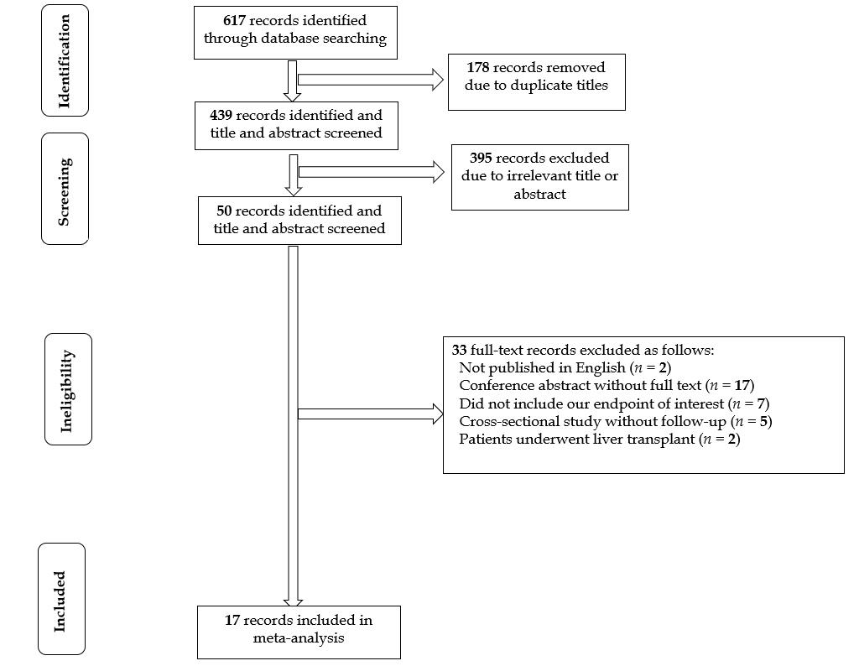
Figure 1 Flow diagram of the research selection process.

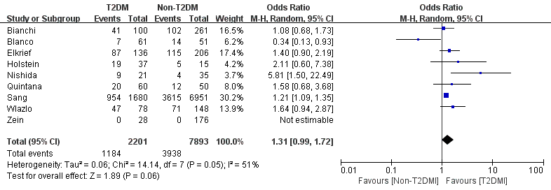
Figure 2 Liver transplant-free mortality of patients with vs without type 2 diabetes mellitus. T2DM: Type 2 diabetes mellitus; CI: Confidence interval.

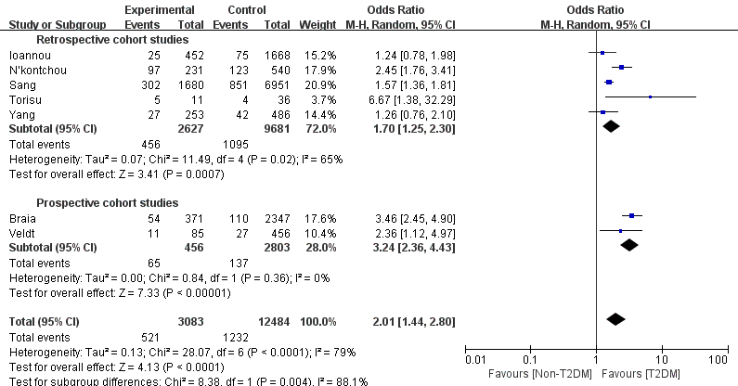

Figure 3 Hepatocellular carcinoma in patients with vs without type 2 diabetes mellitus. T2DM: Type 2 diabetes mellitus; CI: Confidence interval.

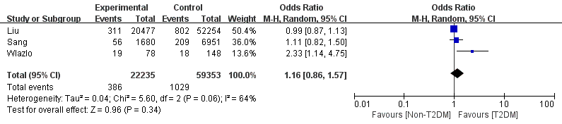
Figure 4 Spontaneous bacterial peritonitis in patients with vs without type 2 diabetes mellitus. T2DM: Type 2 diabetes mellitus; CI: Confidence interval.

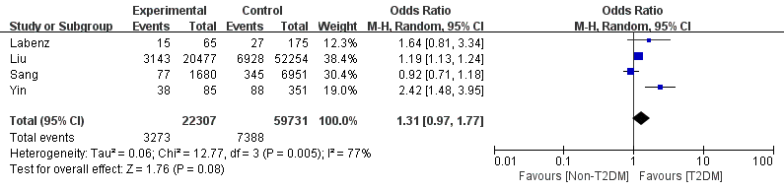
Figure 5 Hepatic encephalopathy in patients with vs without type 2 diabetes mellitus. T2DM: Type 2 diabetes mellitus; CI: Confidence interval.

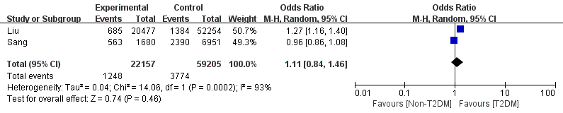

Figure 6 Ascites in patients with vs without type 2 diabetes mellitus. T2DM: Type 2 diabetes mellitus; CI: Confidence interval.

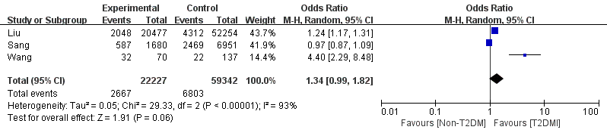
Figure 7 Variceal bleeding in patients with vs without type 2 diabetes mellitus. T2DM: Type 2 diabetes mellitus; CI: Confidence interval.

Table 1 Characteristics of the studies
Ref. | Year | Patients number | Country | Mean age (yr) | Male |  | Study design | Etiology | Median follow-up time (mo) | Endpoint event | MELD score/Child-Pugh score (Non-T2DM vs T2DM) | Glucose regulation o
Bianchi et al^{[14]} | 1994 | 382 | Italy | 54.6 |  | 229 | Retrospective cohort | Alcohol, HBV, PBC, autoimmune, and cryptogenic | 37 | Mortality | Child-Pugh score: 7.31 ± 2.28 vs 7.35 ± 2.20 (P > 0.05) | Not described
Quintana et al^{[5]} | 2011 | 110 | Mexico | 56.6 |  | 57 | Prospective cohort | Alcohol, HBV, HCV, autoimmunity, and cryptogenic | 41 | Mortality | MELD score: 10.3 ± 3.7 vs 11.9 ± 4.7 (P = 0.07) | Not described
Ahn et al^{[4]} | 2020 | 8631 | Australia | Not mentioned |  | 5813 | Retrospective cohort | Alcohol, cryptogenic, NAFLD, HBV, metabolic liver disease, autoimmune liver disease, inflammatory liver disease, and unspecified | 24 | Mortality | Not described | Not described
 |  |  |  |  |  |  |  |  |  | Ascites
 |  |  |  |  |  |  |  |  |  | Gastrointestinal bleeding
 |  |  |  |  |  |  |  |  |  | Hepatic encephalopathy
 |  |  |  |  |  |  |  |  |  | SBP
 |  |  |  |  |  |  |  |  |  | HCC
Wlazlo et al^{[6]} | 2013 | 226 | Netherlands | 59.2 |  | 129 | Retrospective cohort | Alcoholic, NASH, viral, autoimmune, and others | 74.4 | Mortality | MELD score: 12.2 ± 7.5 vs 11.8 ± 7.3 (P = 0.681) | Median non-fasting glucose of 9.8 mmol/L
 |  |  |  |  |  |  |  |  |  | SBP
Holstein et al^{[10]} | 2002 | 52 | Germany | 58.3 |  | Not mentioned | Prospectively cohort | Alcohol, hepatitis C, hepatitis B, cryptogenic, primary biliary cirrhosis, hemosiderosis, and hemochromatosis | 42 | Mortality | Child-Pugh score: 44% of patients had stage A cirrhosis, 37% had stage B, and 19% had stage C | Basal C-peptide of 1.66 ± 0.85 nmol/L
Liu et al^{[8]} | 2016 | 72731 | United States | Not mentioned |  | 39065 | Retrospective cohort | Alcoholic, nonalcoholic, and biliary | 18 | Ascites | Not described | Not described
 |  |  |  |  |  |  |  |  |  | Gastrointestinal bleeding
 |  |  |  |  |  |  |  |  |  | Hepatic encephalopathy
 |  |  |  |  |  |  |  |  |  | SBP
 |  |  |  |  |  |  |  |  |  | HCC
Ioannou et al^{[19]} | 2007 | 2120 | United States | Not mentioned |  | 2069 | Retrospective cohort | HBV, HCV, alcohol, and others | 43.4 | HCC | Not described | Not described
N’kontchou et al^{[20]} | 2006 | 771 | France | 61.4 |  | 431 | Retrospective cohort | HCV and alcoholic cirrhosis | 50.4 | HCC | Not described | Not described
Wang et al^{[12]} | 2020 | 207 | China | 53.1 |  | 140 | Retrospective cohort | Not described | 6 | Gastrointestinal rebleeding | MELD score: 7.22 ± 3.98 vs 8.29 ± 2.35 (P = 0.141) | Not described
Nishida et al^{[15]} | 2006 | 56 | Japan | 41 |  | 34 | Prospective cohort | HBV, HCV, alcohol, and unknown | 44 | Mortality | Child-Pugh score: 6.8 ± 2.4 vs 6.9 ± 2.3 (P > 0.05) | HbA1c (%) of 5.6 ± 1.6%
Yang et al^{[17]} | 2016 | 739 | United States | 57 |  | 433 | Retrospective cohort | HCV | 38 | Mortality | MELD score: 12.4 ± 5.7 vs 11.6 ± 5.1 (P = 0.04) | HOMA2-IR2: 8.3 ± 4.9
 |  |  |  |  |  |  |  |  |  | HCC
Elkrief et al^{[7]} | 2014 | 342 | France | 59 |  | 236 | Retrospective cohort | HCV | 24 | Mortality | Median MELD score of 10 | Not described
Veldt et al^{[13]} | 2008 | 541 | Netherlands | 50 |  | 370 | Prospective cohort | HCV | 48 | HCC | Not described | Not described
Yin et al^{[11]} | 2019 | 436 | China | 55 |  | 278 | Prospective cohort | Alcoholic, viral, AIH, and others | 12 | Hepatic encephalopathy | MELD score: 9.1 ± 2.1 vs 9.2 ± 1.9 (P = 0.537) | Not described
Labenz et al^{[21]} | 2020 | 240 | German | 60 |  | 137 | Prospective cohort | Alcohol, viral hepatitis, NAFLD, autoimmune, and cryptogenic | 17 | Hepatic encephalopathy | MELD score: 10 (8, 15) vs 9 (7, 13) (P = 0.043); Child-Pugh B/C: 42.3% vs 36.9% (P = 0.453) | HbA1c (%) of 5.1 (4.6, 5.5)
Torisu et al^{[16]} | 2007 | 47 | Japan | 54 |  | 47 | Retrospective cohort | Alcoholic | 81.6 | HCC | Not described | Not described
Braia et al^{[18]} | 2016 | 2556 | Romania | Not mentioned |  |  | Prospective cohort | Not described | 48 | HCC | Not described | Not described
HBV: Hepatitis B virus; HCV: Hepatitis C virus; PBC: Primary biliary cirrhosis; MELD: Model for End Stage Liver Disease; HCC: Hepatocellular carcinoma; NAFLD: Non-alcoholic fatty liver disease; SBP: Spontaneous bacterial peritonitis; NASH: Nonalcoholic steatohepatitis; AIH: Autoimmune hepatitis; T2DM: Type 2 diabetes mellitus.

Table 2 Newcastle-Ottawa Scale score
Ref. | Year | Type of study | Selection | Comparability | Outcome | Score
Bianchi et al^{[14]} | 1994 | Retrospective cohort | 4 | 1 | 3 | 8
Quintana et al^{[5]} | 2011 | Prospective cohort | 4 | 2 | 2 | 8
Ahn et al^{[4]} | 2020 | Retrospective cohort | 4 | 0 | 2 | 6
Wlazlo et al^{[6]} | 2013 | Retrospective cohort | 3 | 0 | 3 | 6
Holstein et al^{[10]} | 2002 | Prospective cohort | 4 | 2 | 2 | 8
Elkrief et al^{[7]} | 2014 | Retrospective cohort | 3 | 0 | 3 | 6
Liu et al^{[8]} | 2016 | Retrospective cohort | 3 | 0 | 3 | 6
Veldt et al^{[13]} | 2008 | Prospective cohort | 3 | 0 | 3 | 6
Yin et al^{[11]} | 2019 | Prospective cohort | 3 | 1 | 3 | 7
Wang et al^{[12]} | 2020 | Retrospective cohort | 3 | 1 | 2 | 6
Nishida et al^{[15]} | 2006 | Prospective cohort | 4 | 2 | 2 | 8
Ioannou et al^{[19]} | 2006 | Retrospective cohort | 3 | 2 | 3 | 8
N’kontchou et al^{[20]} | 2006 | Retrospective cohort | 3 | 0 | 3 | 6
Labenz et al^{[21]} | 2020 | Prospective cohort | 3 | 1 | 3 | 7
Torisu et al^{[16]} | 2007 | Retrospective cohort | 3 | 0 | 3 | 6
Braia et al^{[18]} | 2016 | Prospective cohort | 4 | 0 | 2 | 6
Yang et al^{[17]} | 2007 | Retrospective cohort | 4 | 0 | 3 | 7

Published by Baishideng Publishing Group Inc
7041 Koll Center Parkway, Suite 160, Pleasanton, CA 94566, USA
Telephone: +1-925-3991568
E-mail: bpgoffice@wjgnet.com
Help Desk: https://www.f6publishing.com/helpdesk
https://www.wjgnet.com

© 2021 Baishideng Publishing Group Inc. All rights reserved.

