Name of Journal: World Journal of Clinical Cases

Manuscript NO: 60011

Manuscript Type: CASE REPORT

Retroperitoneal laparoscopic partial resection of the renal pelvis for urothelial carcinoma: A case report

Wang YL et al. Laparoscopic partial resection of the renal pelvis

Yan-Long Wang, Hong-Lin Zhang, Hao Du, Wei Wang, Hai-Feng Gao, Guang-Hai Yu, Yu Ren

Yan-Long Wang, Hao Du, Wei Wang, Hai-Feng Gao, Guang-Hai Yu, Yu Ren, Department of Urology, Dalian Municipal Central Hospital Affiliated of Dalian Medical University, Dalian 116033, Liaoning Province, China

Hong-Lin Zhang, Center for Reproductive Health, Dalian Maternity Hospital Affiliated of Dalian Medical University, Dalian 116033, Liaoning Province, China

Author contributions: Yu GH was the patient’s surgeon and reviewed the literature; Zhang HL performed the pathology analyses and interpretation; Wang W and Gao HF analyzed and interpreted the imaging findings; Ren Y and Du H reviewed the literature and contributed to the manuscript; Wang YL were responsible for the revision of the manuscript for important intellectual content and contributed to manuscript drafting; All authors issued final approval for the version to be submitted.

Corresponding author: Yu Ren, MD, Professor, Department of Urology, Dalian Municipal Central Hospital Affiliated of Dalian Medical University, No. 826 Southwest Road, Shahekou District, Dalian 116033, Liaoning Province, China. 15509850654@163.com

Received: October 20, 2020
Revised: December 26, 2020

Accepted: January 6, 2021

Published online: March 16, 2021

Abstract

BACKGROUND
The standard treatment of transitional cell carcinoma of the upper urinary tract consists of radical nephroureterectomy with bladder cuff removal, which can be performed either in open or laparoscopy or robot-assisted laparoscopy. Treatment of chronic renal insufficiency patients with upper urothelial tumor is in a dilemma. Urologists weigh and consider the balance between tumor control and effective renal function preservation. European Association of Urology guidelines recommend that select patients may benefit from endoscopic treatment, but laparoscopic treatment is rarely reported.

CASE SUMMARY
In this case report, we describe a case of 79-year-old female diagnosed with urothelial carcinoma of the renal pelvis and adrenal adenoma with chronic renal insufficiency. The patient was treated with retroperitoneal laparoscopic partial resection of the renal pelvis and adrenal adenoma resection simultaneously.

CONCLUSION
Retroperitoneal laparoscopic partial resection of the renal pelvis is an effective surgical procedure for the treatment of urothelial carcinoma of the renal pelvis.

Key Words: Transitional cell carcinoma; Kidney sparing; Chronic renal insufficiency; Laparoscopy; Partial resection of the renal pelvis; New effective surgical method

©The Author(s) 2021. Published by Baishideng Publishing Group Inc. All rights reserved.

Citation: Wang YL, Zhang HL, Du H, Wang W, Gao HF, Yu GH, Ren Y. Retroperitoneal laparoscopic partial resection of the renal pelvis for urothelial carcinoma: A case report. World J Clin Cases 2021; 9(8): 1916-1922
URL: https://www.wjgnet.com/2307-8960/full/v9/i8/1916.htm
DOI: https://dx.doi.org/10.12998/wjcc.v9.i8.1916

Core Tip: For patients with chronic renal insufficiency diagnosed with renal pelvic urothelial carcinoma, retroperitoneal laparoscopic partial resection of the renal pelvis is a new effective surgical method and an alternative method for endoscopic treatment, especially for surgeons with rich experience in laparoscopic surgery and patients with other diseases for which laparoscopic surgery is needed simultaneously.

INTRODUCTION
The proportion of cases of transitional cell carcinoma of the upper urinary tract (UUT-TCC) is approximately 5% of all urothelial tumors^{[1]}, although renal pelvis tumors are relatively rare.
With the increase in many chronic diseases, such as hypertension, diabetes mellitus and medicinal renal injury, the number of patients with chronic renal insufficiency (CRI) is gradually increasing clinically. Overall, treatment of patients with upper urothelial tumors and chronic renal insufficiency remains a dilemma, and urologists must weigh and consider the balance between tumor control and renal function preservation.
The standard treatment for UUT-TCC consists of radical nephroureterectomy (RNU) with bladder cuff removal, which can be performed either in open surgery or laparoscopy, including robot-assisted laparoscopy^{[2,3]}.
In patients with organ-confined UUT-TCC, laparoscopic nephroureterectomy has the advantages of minimal invasiveness and oncologic outcomes comparable to those of open nephroureterectomy^{[4]}, with all the benefits of minimally invasive surgery including less blood loss, shorter hospital stays, reduced postoperative pain, and shorter convalescence time^{[3]}. In some selected cases of renal insufficiency, solitary kidney, bilateral tumors, high risk of complications associated with nephroureterectomy or low grade/low stage tumors, conservative treatment such as endoscopic resection or ablation may also be performed^{[5,6]}.

CASE PRESENTATION

Chief complaints

A 79-year-old female with a history of intermittent painless gross hematuria for 15 d.

History of present illness
The patient had intermittent painless gross hematuria but had no other symptoms such as flank or abdominal mass, weight loss, anorexia, fatigue, or bone pain.

History of past illness

The patient had no previous medical history.

Personal and family history

Her family history was unremarkable.

Physical examination
The patient’s temperature was 36.7 °C, heart rate was 78 beats per min, respiratory rate was 18 breaths per min, blood pressure was 118/78 mmHg, and oxygen saturation in room air was 97%. Clinical physical examination revealed no abnormalities.

Laboratory examinations
Urinalysis, routine blood tests, coagulation and liver function were normal; however, serum creatinine was 150 µmol/L and blood urea nitrogen (BUN) 10.04 mmol/L, and urinary cytology revealed heterocyte positivity. The level of adrenal gland hormone was in the normal range.

Imaging examinations
Ultrasound examination revealed a right renal pelvic mass located above the ureteric junction of the renal pelvis. The diameter of the tumor was 7 mm × 7 mm. A right adrenal gland mass was also found, the size of which was 12 mm × 12 mm. A computed tomography (CT) abdominal scan showed a mildly enlarged pelvis–calyceal system and right adrenal gland solitary mass. There was a pathological lesion visible in the right pelvis with dimensions of 10 mm × 8 mm, which was enhanced from 20 to 80 Hounsfield units after injection of contrast medium (Figure 1). The size of the right adrenal gland solitary mass was 14 mm × 14 mm (Figure 2). Preoperative rigid cystoscopy revealed normal mucosa in the bladder.

FINAL DIAGNOSIS
The patient was diagnosed with UUT-TCC complicated CRI and right adrenal gland adenoma. The patient underwent rigid ureteroscopy, which identified a cauliflower-like mass in the right renal pelvis.

TREATMENT
The prognostic indicators of UUT-TCC included tumor diameter, pT stage and tumor necrosis, which were independent predictors of metastasis-free and disease-free survival. The patients with advanced-stage tumors, extensive necrosis, and a tumor diameter of 3 cm were significantly impaired by increasing pT stage^{[7]}. We considered the renal pelvic tumor as a low grade based on ureteroscopy. Based on our medical center’s considerable experience in retroperitoneal laparoscopic surgery, the option of a retroperitoneal laparoscopic approach was offered to the patient. After induction of general anesthesia, the patient was placed in the left lateral position. The retroperitoneal approach was performed using the conventional three-hole approach according to a technique described previously^{[8]}. The right adrenal gland was first explored, and a right adrenal gland solitary mass was found located in the medial branch, consistent with the change in adenoma. Tumor resection was performed. Next, the right ureter, renal pelvis, lower pole of the kidney and genital vein were routinely freed. After releasing the ureter, the right renal pelvis was opened, and a cauliflower-like tumor was visualized (Figure 3). When the tumor was resected, a margin of approximately 0.5 cm of healthy renal pelvis tissue was preserved as much as possible; to avoid tumor implant metastasis, the tumor specimen was placed in a specimen bag immediately after resection. The renal pelvis was reconstructed with interrupted sutures.

OUTCOME AND FOLLOW-UP
Postoperative recovery was good, with no complications. Renal function was stabilized 1 wk after the surgery, with levels of serum creatinine 200 µmol/L and BUN 10.57 mmol/L. The pathology report showed renal pelvis TCC pTaG1 and right adrenal adenoma. Two years after the surgery, the patient underwent ultrasound and CT scan follow-up examinations, revealing no tumor recurrence or right renal hydronephrosis. The treatment was safe and efficient, but longer follow-up is still needed.

DISCUSSION
Nephro-ureterectomy with bladder cuff removal is the gold standard for the treatment of UUT-TCC. Some patients may benefit from endoscopic treatment (ET), such as holmium laser tumor ablation with a flexible ureteroscope or percutaneous nephrostomy tumor resection. For example, patients with unifocal, < 2 cm, and low-grade lesions without local invasion are considered to have low-risk disease^{[9]}. In the case of low-grade/low-stage TCC of the renal pelvis, open surgery is being replaced by endoscopic surgery^{[10,11]}. However, ureteroscopic tumor ablation remains associated with a high risk of disease recurrence and progression due to inadequate assessment of risk stratification by imaging or tumor biopsy^{[9]}. Moreover, the risk of perioperative bleeding with the percutaneous approach is higher than that with laparoscopic surgery, and the risk of needing dialysis after nephrectomy is extremely high in patients with isolated kidney or renal insufficiency if bleeding occurs. Tumor recurrence or trocar metastasis after percutaneous access has also been reported, as indicated in Table 1.
European Association of Urology (EAU) guidelines recommend offering kidney-sparing management to patients with solitary kidney and/or impaired renal function. Kidney-sparing surgery for low-risk upper urinary tract urothelial cell carcinoma reduces the morbidity associated with the loss of renal function without affecting oncologic outcomes^{[12]}. In low-risk cancers, kidney-sparing management is the preferred approach, as survival rates are similar to those after RNU^{[13]}. Furthermore, kidney preservation is advantageous if adjuvant or salvage chemotherapy is required. It also eliminates the possibility of overtreatment^{[14]}.
Our patient was treated with retroperitoneal laparoscopic partial resection of the renal pelvis. One previous case was reported by Wojtarowicz et al^{[14]} worldwide, but there were no long-term follow-up results. In the present case, the patient was followed up for 2 years and showed stabilized renal function without tumor recurrence and progression. We believe that retroperitoneal laparoscopic partial resection of the renal pelvis is an alternative method for suitable patients and for surgeons with rich experience in laparoscopic surgery.
The advantages of retroperitoneal laparoscopic partial resection of the renal pelvis are as follows. (1) It can ensure the resection depth and scope and reduce residual tumor. (2) Completely resected tissue can offer tumor staging and grading. (3) There is no possibility of tumor implantation and metastasis caused by renal pelvic lymph and venous reflux under high pressure by endoscopic treatment. And (4) The operation does not damage the renal parenchyma, with less bleeding and damage to the kidney.
However, this method does have limitations and shortcomings. It is only suitable for patients whose extrarenal pelvic tumors are confined to the renal pelvis, and it cannot be applied for tumors in the renal calyx. In addition, when the closed collection system is opened, there is concern that the tumor may overflow into the urine, leading to tumor implantation and metastasis. Therefore, the following methods are recommended to reduce the possibility of tumor implantation and metastasis. (1) Dry gauze is placed around the incision of the renal pelvis to reduce pollution of surrounding tissues by the urine after the incision is made. And (2) Direct contact of surgical instruments with the tumor during the operation is avoided. After resection, the tumor should be placed into a specimen bag that is sealed to prevent the tumor from contacting the surrounding tissues. The operation should be carried out under low pneumoperitoneum pressure as much as possible. The incision should be tightly sutured to fix the trocar, and the trocar should be pulled out after deflation to avoid the “chimney effect” and reduce trocar tumor planting. The wound should be washed with effective chemotherapeutic drugs.
When performing a kidney-sparing procedure, the ipsilateral upper urinary tract requires careful follow-up due to the high risk of disease recurrence^{[15]}. Patients undergoing kidney-sparing surgery should be followed more frequently and rigorously than those undergoing RNU, and repeated endoscopic procedures are necessary. EAU guidelines recommend ureteroscopy for low-risk tumors at 3 mo, followed by cystoscopy and CT urography at 3 and 6 mo and then annually for 5 years.

CONCLUSION
In conclusion, retroperitoneal laparoscopic partial resection of the renal pelvis is an effective surgical procedure for the treatment of urothelial carcinoma of the renal pelvis. It is indicated for patients with isolated kidneys or renal insufficiency, but its safety needs to be further evaluated. The procedure should not be routine but rather used as a supplement to ET, especially for surgeons with extensive experience in laparoscopic surgery and medical centers lacking flexible ureteroscopy equipment.

REFERENCES
1 Freund JE, Liem EIML, Savci-Heijink CD, Baard J, Kamphuis GM, de la Rosette JJMCH, de Bruin DM. Confocal laser endomicroscopy for upper tract urothelial carcinoma: validation of the proposed criteria and proposal of a scoring system for real-time tumor grading. World J Urol 2019; 37: 2155-2164 [PMID: 30684035 DOI: 10.1007/s00345-019-02646-5]
2 Lee H, Kim HJ, Lee SE, Hong SK, Byun SS. Comparison of oncological and perioperative outcomes of open, laparoscopic, and robotic nephroureterectomy approaches in patients with non-metastatic upper-tract urothelial carcinoma. PLoS One 2019; 14: e0210401 [PMID: 30620766 DOI: 10.1371/journal.pone.0210401]
3 Pathak RA, Hemal AK. Techniques and Outcomes of Robot-assisted Nephro-ureterectomy for Upper Tract Urothelial Carcinoma. Eur Urol Focus 2018; 4: 657-661 [PMID: 30146238 DOI: 10.1016/j.euf.2018.08.007]
4 Simone G, Papalia R, Guaglianone S, Ferriero M, Leonardo C, Forastiere E, Gallucci M. Laparoscopic versus open nephroureterectomy: perioperative and oncologic outcomes from a randomised prospective study. Eur Urol 2009; 56: 520-526 [PMID: 19560259 DOI: 10.1016/j.eururo.2009.06.013]
5 Seisen T, Peyronnet B, Dominguez-Escrig JL, Bruins HM, Yuan CY, Babjuk M, Böhle A, Burger M, Compérat EM, Cowan NC, Kaasinen E, Palou J, van Rhijn BW, Sylvester RJ, Zigeuner R, Shariat SF, Rouprêt M. Oncologic Outcomes of Kidney-sparing Surgery Versus Radical Nephroureterectomy for Upper Tract Urothelial Carcinoma: A Systematic Review by the EAU Non-muscle Invasive Bladder Cancer Guidelines Panel. Eur Urol 2016; 70: 1052-1068 [PMID: 27477528 DOI: 10.1016/j.eururo.2016.07.014]
6 Guan S, Tang Z, Sun Wb, Tian Hy, Wang Yl, Huang Zm, Yang B, Qian Zm. Percutaneous Resection of Renal Pelvic Neoplasms in Isolated Kidney through a Large Sheath: Report of Two Cases. Zhongguo Weichuang Waike Zazhi 2012; 12: 565-568
7 Simone G, Papalia R, Loreto A, Leonardo C, Sentinelli S, Gallucci M. Independent prognostic value of tumour diameter and tumour necrosis in upper urinary tract urothelial carcinoma. BJU Int 2009; 103: 1052-1057 [PMID: 18990140 DOI: 10.1111/j.1464-410X.2008.08134.x]
8 Melquist JJ, Redrow G, Delacroix S, Park A, Faria EE, Karam JA, Matin SF. Comparison of Single-docking Robotic-assisted and Traditional Laparoscopy for Retroperitoneal Lymph Node Dissection During Nephroureterectomy With Bladder Cuff Excision for Upper-tract Urothelial Carcinoma. Urology 2016; 87: 216-223 [PMID: 26494291 DOI: 10.1016/j.urology.2015.07.070]
9 Vemana G, Kim EH, Bhayani SB, Vetter JM, Strope SA. Survival Comparison Between Endoscopic and Surgical Management for Patients With Upper Tract Urothelial Cancer: A Matched Propensity Score Analysis Using Surveillance, Epidemiology and End Results-Medicare Data. Urology 2016; 95: 115-120 [PMID: 27233931 DOI: 10.1016/j.urology.2016.05.033]
10 Wang Q, Zhang T, Wu J, Wen J, Tao D, Wan T, Zhu W. Prognosis and risk factors of patients with upper urinary tract urothelial carcinoma and postoperative recurrence of bladder cancer in central China. BMC Urol 2019; 19: 24 [PMID: 30999871 DOI: 10.1186/s12894-019-0457-5]
11 Verges DP, Lallas CD, Hubosky SG, Bagley DH Jr. Endoscopic Treatment of Upper Tract Urothelial Carcinoma. Curr Urol Rep 2017; 18: 31 [PMID: 28251485 DOI: 10.1007/s11934-017-0675-x]
12 Rouprêt M, Babjuk M, Burger M, Capoun O, Cohen D, Compérat EM, Cowan NC, Dominguez-Escrig JL, Gontero P, Hugh Mostafid A, Palou J, Peyronnet B, Seisen T, Soukup V, Sylvester RJ, Rhijn BWGV, Zigeuner R, Shariat SF. European Association of Urology Guidelines on Upper Urinary Tract Urothelial Carcinoma: 2020 Update. Eur Urol 2021; 79: 62-79 [PMID: 32593530 DOI: 10.1016/j.eururo.2020.05.042]
13 Jung H, Giusti G, Fajkovic H, Herrmann T, Jones R, Straub M, Baard J, Osther PJS, Brehmer M. Consultation on UTUC, Stockholm 2018: aspects of treatment. World J Urol 2019; 37: 2279-2287 [PMID: 31123852 DOI: 10.1007/s00345-019-02811-w]
14 Wojtarowicz M, Słojewski M, Gołąb A, Petrasz P. Retroperitoneoscopic renal pelvis resection as treatment of the urothelial tumor in a solitary kidney. Cent European J Urol 2013; 66: 299-302 [PMID: 24707368 DOI: 10.5173/ceju.2013.03.art12]
15 Mandalapu RS, Remzi M, de Reijke TM, Margulis V, Palou J, Kapoor A, Yossepowitch O, Coleman J, Traxer O, Anderson JK, Catto J, de la Rosette J, O'Brien T, Zlotta A, Matin SF. Update of the ICUD-SIU consultation on upper tract urothelial carcinoma 2016: treatment of low-risk upper tract urothelial carcinoma. World J Urol 2017; 35: 355-365 [PMID: 27233780 DOI: 10.1007/s00345-016-1859-6]
16 Rastinehad AR, Ost MC, Vanderbrink BA, Greenberg KL, El-Hakim A, Marcovich R, Badlani GH, Smith AD. A 20-year experience with percutaneous resection of upper tract transitional carcinoma: is there an oncologic benefit with adjuvant bacillus Calmette Guérin therapy? Urology 2009; 73: 27-31 [PMID: 18929398 DOI: 10.1016/j.urology.2008.06.026]
17 Treuthardt C, Danuser H, Studer UE. Tumor seeding following percutaneous antegrade treatment of transitional cell carcinoma in the renal pelvis. Eur Urol 2004; 46: 442-443 [PMID: 15363557 DOI: 10.1016/j.eururo.2004.01.021]
18 Wang SS, Ho HC, Su CK, Chen WM, Cheng CL, Yang CR. Seeding of malignant renal tumor through a nephrostomy tract. J Chin Med Assoc 2004; 67: 308-310 [PMID: 15366410]
19 Oefelein MG, MacLennan G. Transitional cell carcinoma recurrence in the nephrostomy tract after percutaneous resection. J Urol 2003; 170: 521 [PMID: 12853816 DOI: 10.1097/01.ju.0000069430.39382.d0]
20 Fuglsig S, Krarup T. Percutaneous nephroscopic resection of renal pelvic tumors. Scand J Urol Nephrol Suppl 1995; 172: 15-17 [PMID: 8578249]
21 Sharma NK, Nicol A, Powell CS. Track infiltration following percutaneous resection of renal pelvic transitional cell carcinoma. Br J Urol 1994; 73: 597-598 [PMID: 8012794 DOI: 10.1111/j.1464-410x.1994.tb07660.x]

Footnotes
Informed consent statement: Informed written consent was obtained from the patient for publication of this report and any accompanying images.

Conflict-of-interest statement: The authors declare that they have no conflicts of interest.

CARE Checklist (2016) statement: The authors have read the CARE Checklist (2016), and the manuscript was prepared and revised according to the CARE Checklist (2016).

Open-Access: This article is an open-access article that was selected by an in-house editor and fully peer-reviewed by external reviewers. It is distributed in accordance with the Creative Commons Attribution NonCommercial (CC BY-NC 4.0) license, which permits others to distribute, remix, adapt, build upon this work non-commercially, and license their derivative works on different terms, provided the original work is properly cited and the use is non-commercial. See: http://creativecommons.org/Licenses/by-nc/4.0/

Manuscript source: Unsolicited manuscript

Peer-review started: October 20, 2020

First decision: December 24, 2020

Article in press: January 6, 2021

Specialty type: Urology and nephrology

Country/Territory of origin: China

Peer-review report’s scientific quality classification

Grade A (Excellent): 0
Grade B (Very good): 0
Grade C (Good): C
Grade D (Fair): 0
Grade E (Poor): 0

P-Reviewer: Simone G S-Editor: Zhang H L-Editor: Filipodia P-Editor: Wang LYT

Figure Legends
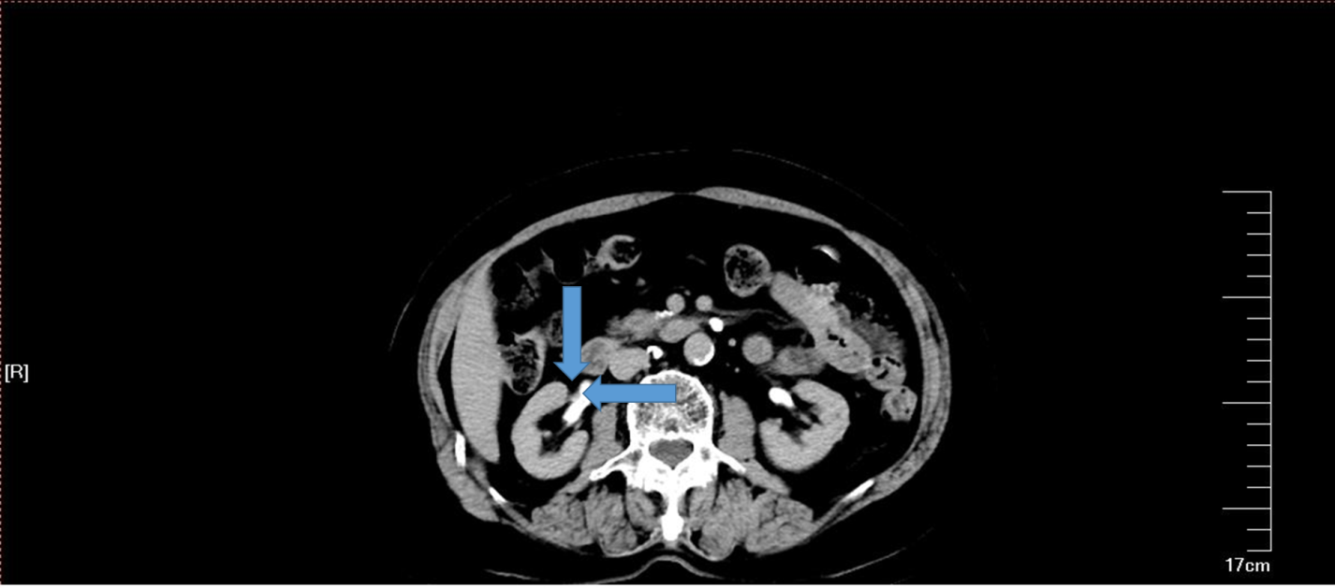
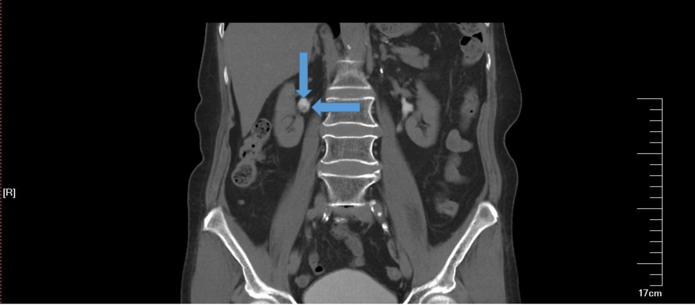
Figure 1 Computed tomography scan of the excretory urography stage. The arrow indicates a right renal pelvic tumor.
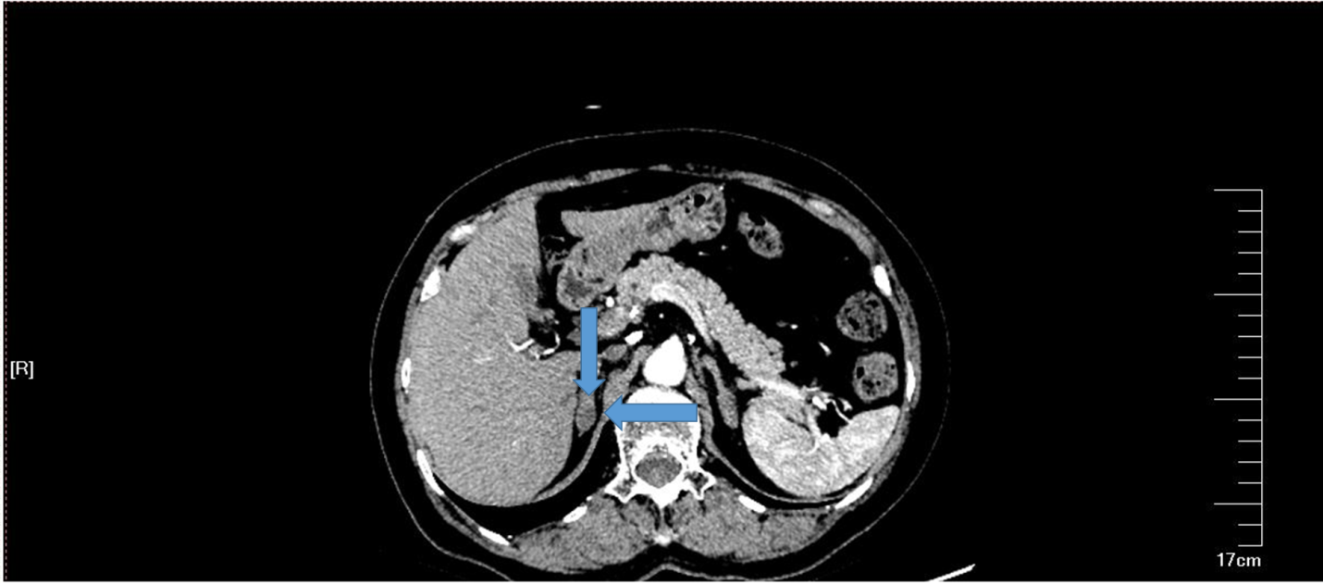
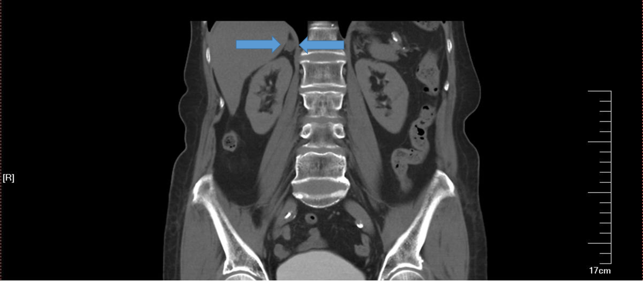
Figure 2 Computed tomography scan in the artery phase. The arrow indicates a right adrenal gland adenoma.
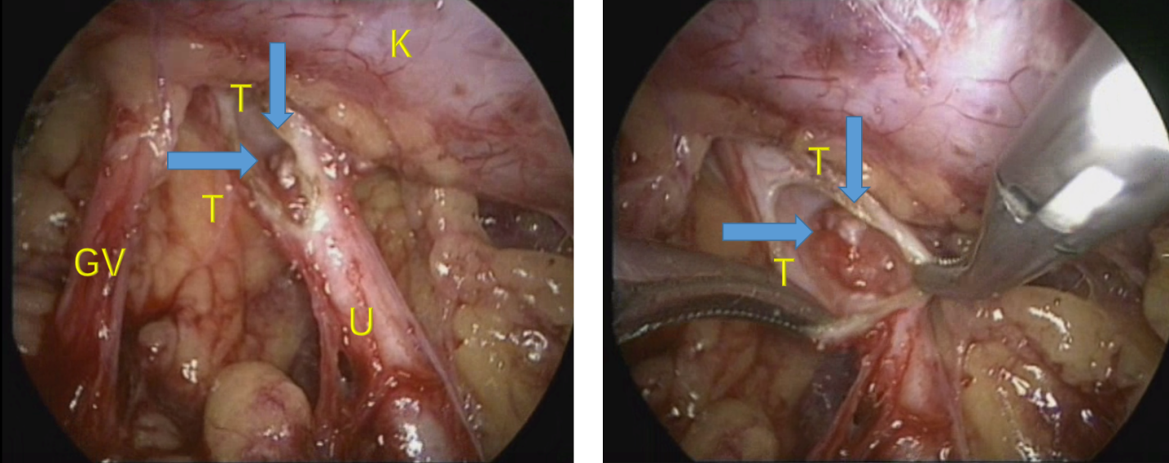
Figure 3 Intraoperative view of the right retroperitoneal space. GV: Genital vein; K: Kidney; T: Tumor; U: Ureter.

Table 1 Tumor recurrence or trocar metastasis after the percutaneous approach
Ref. | Number | Operation | Tumor grade
Rastinehad et al^{[16]} | 1 | PCN tumor resection | N/A
Treuthardt et al^{[17]} | 1 | PCN tumor resection + BCG perfusion therapy | High grade
Wang et al^{[18]} | 1 | Radical nephroureterectomy after PCN biopsy 1 wk | High grade
Oefelein et al^{[19]} | 1 | PCN tumor resection | Low grade
Fuglsig et al^{[20]} | 1 | PCN tumor resection | High grade
Sharma et al^{[21]} | 1 | PCN tumor resection | N/A
BCG: Bacillus Calmette-Guerin; N/A: Not applicable; PCN: Percutaneous nephrostomy.

Published by Baishideng Publishing Group Inc
7041 Koll Center Parkway, Suite 160, Pleasanton, CA 94566, USA
Telephone: +1-925-3991568
E-mail: bpgoffice@wjgnet.com
Help Desk: https://www.f6publishing.com/helpdesk
https://www.wjgnet.com

© 2021 Baishideng Publishing Group Inc. All rights reserved.

