Name of Journal: World Journal of Clinical Cases
Manuscript NO: 57081
Manuscript Type: CASE REPORT

Nasal mucosa pyoderma vegetans associated with ulcerative colitis: a case report

Yu SX et al. Pyoderma vegetans associated with UC

Shu-Xia Yu, Xian-Kui Cheng, Bin Li, Jing-Hua Hao

Shu-Xia Yu, Bin Li, Jing-Hua Hao, Department of gastroenterology and hepatology, Shandong Provincial Hospital Affiliated to Shandong First Medical University, Jinan 250021, Shandong Province, China

Xian-Kui Cheng, Department of Pathology, Shandong Provincial Hospital Affiliated to Shandong First Medical University, Jinan 250021, Shandong Province, China

Author contributions: Yu SX and Cheng XK contributed to this article equally; Yu SX provided data acquisition and data analysis; Cheng XK provided the pathological reports; Li B collected the patient’s information; Xu HW took apart in the treatment of the patient; Hao JH supervised the study and was responsible for ensuring the integrity of the work from inception to published article.

Supported by Shandong Medical and Health Science and Technology Development Plan Project, No. 2018WS275.

Corresponding author: Jing-Hua Hao, MD, Chief Doctor, Department of gastroenterology and hepatology, Shandong Provincial Hospital Affiliated to Shandong First Medical University, No. 324 Jingwu Road, Jinan 250021, Shandong Province, China. jinghua_hao@hotmail.com

Received: May 29, 2020
Revised: June 23, 2020
Accepted: September 2, 2020
Published online:

Abstract
BACKGROUND
Pyoderma vegetans (PV) is not a common extra-intestinal manifestation of ulcerative colitis (UC), while nasal mucosa PV associated with UC is particularly rare.

CASE SUMMARY
We report a 28-year-old female with a history of UC and pyoderma gangrenosum who presented with nasal pain. A nasal lesion could be observed in her nose, and histopathological examination was indicative of PV. The patient was treated with oral prednisone (40 mg per day) with good response and became symptomatically free. There was no recurrent attack after 1 year of follow-up.

CONCLUSION
inflammatory bowel disease patients presenting with nasal pain should be further investigated to rule out the coexistence of nasal mucosa PV.

Key words: Pyoderma vegetans; Extra-intestinal manifestations; Ulcerative colitis; Nasal lesion; Case report

Yu SX, Cheng XK, Li B, Hao JH. Nasal mucosa pyoderma vegetans associated with ulcerative colitis: A case report. World J Clin Cases 2020; In press

Core tip: Pyoderma vegetans (PV) is not a common extra-intestinal manifestation of ulcerative colitis (UC), while nasal mucosa PV associated with UC is particularly rare. We present herein a rare case of PV with nasal pain that evolved in a patient with ulcerative colitis. A nasal lesion could be observed in her nose and histopathological examination was indicative of PV. This case highlights that inflammatory bowel disease patients presenting with nasal pain should be further investigated to rule out the coexistence of nasal mucosa PV.

INTRODUCTION
Pyoderma vegetans (PV) is not a common extra-intestinal manifestation of ulcerative colitis (UC), while nasal mucosa PV associated with UC is particularly rare. We present herein a rare case of PV with nasal pain that evolved in a patient with UC.

CASE PRESENTATION
Chief complaints
A 28-year-old female presented to the hospital in January 2018 for the first time. She complained of six to seven bowel movements per day with pus and blood for 1 mo. Associated symptoms included cramping abdominal pain before bowel movements, nausea, anorexia, and a 3 kg weight loss. She had no fevers or night sweats.

History of present illness
Colonoscopy was performed, and she was diagnosed as UC limited to her left colon with a Mayo endoscopic subscore of 3 (severe disease, Figure 1). With treatment of mesalazine for 10 d, she was improving but developed skin lesions on her legs and right inguinal region, which appeared as skin pustules and then became burrowing ulcers between 2 cm and 10 cm in diameter. The skin lesions were finally diagnosed as pyoderma gangrenosum (Figure 2) by histology.

History of past illness
She had a history of hemorrhoids for more than 10 years. She had no family history of cancers or inflammatory bowel disease.

Laboratory examinations
On admission, laboratory investigations revealed a drop in hemoglobin to 73 g/L and increases in C-reactive protein, erythrocyte sedimentation rate, and fecal calprotectin to 63.38 mg/L, 61 mm/h, and 249.05 μg/g, respectively. The patient had a very low albumin at 22.2 g/L. Stool studies revealed numerous leukocytes and red blood cells but were negative for infectious etiology, including Clostridium difficile.

Medical management
The patient was then started on intravenous methylprednisolone. Daily medications with fibroblast growth factor gel and sodium fusidate ointment were also given to the patient for the treatment of pyoderma gangrenosum. At 1 wk after the steroid treatment, a clear improvement of the cutaneous lesions was observed with down-trending C-reactive protein and erythrocyte sedimentation rate. The patient was hereby transitioned to oral prednisone and discharged home.
One year later, the patient returned to the hospital and reported compliance with oral mesalamine and had been doing well since tapering off steroids 3 mo prior. At 1 wk before admission, she had defecation with mild bleeding two to three times daily and had severe nasal pain. She had no fever or abdominal pain. On physical examination, her vital signs were within the normal range. The only remarkable findings were old skin scars on her extremities. A colonoscopy was performed and revealed mild-to-moderate left-sided colitis consistent with a Mayo endoscopic subscore of 2, which was improved from her previous colonoscopy in May 2018.
She was then referred to an otolaryngologist. Her nasal mucosa was hyperemic, and nasal septum mucosa was remarkably thickened (Figure 3). Biopsies from left nasal septum mucosa revealed plasma cell and eosinophils infiltration, some neutrophil and lymphocyte infiltration, interstitial edema of mucosa, and fibrocyte and fibroblast hyperplasia (Figure 4). Based on the clinical and pathological findings, the patient was diagnosed with PV.

FINAL DIAGNOSIS
The final diagnosis of this case is nasal mucosa PV.

TREATMENT
The patient was hereby given oral prednisone (40 mg/d).

OUTCOME AND FOLLOW-UP
The bowel movements of this patient became normal in 1 wk. Notably, her nasal pain disappeared quickly. The patient was recovered from PG, and the skin lesions completely cleared after steroid treatment. Steroids were tapered off in 4 mo, and there were no recurrent attacks after 1 year of follow-up.

DISCUSSION
Extra-intestinal manifestations (EIMs) in patients with inflammatory bowel disease (IBD) are quite common. The organs most commonly involved are the skin, joints, the biliary tract, and the eyes. A Swiss IBD Cohort Study showed that 31% of UC patients developed EIMs, such as arthritis, uveitis, pyoderma gangrenosum, erythema nodosum, aphthous stomatitis, ankylosing spondylitis, primary scleroscholangitis, etc.^{[1]}.
PV is a rare benign cutaneous, chronic, inflammatory, pustular condition clinically characterized by raised, erythematous, exudative, vegetating plaques. This disease of unknown etiology is often associated with bacterial infections in immunocompromised patients^{[2]}. The association of PV and UC has rarely been reported in the literature^{[3]}.
Nearly one quarter of EIM affected IBD patients suffers from a combination of several EIM. More than one organ involved may suggest a common pathogenic pathway^{[4]}. However, the underlying mechanisms are not completely understood yet. As for this patient, PG was first diagnosed in her legs and right inguinal region, and her nasal mucosa subsequently suffered from PV. Till now, there is only one case report of nasal mucosa PVs in a patient with UC^{[5]}.
PV can heal spontaneously but usually recurs and becomes chronic. There are no standard treatment modalities. Systemic steroids and local wound care could control the disease^{[6]}. Considering the patient had severe UC accompanied with EIM, we suggested using infliximab, which is an appropriate option for the patient who does not respond to routine treatments. However, the patient refused the infliximab treatment due to the expensive cost. Finally, the patient got improved with the treatment of systemic steroids. Luckily, she had no recurrent attacks after 1 year of follow-up.

CONCLUSION
This case highlights that IBD patients presenting with nasal pain should be further investigated to rule out the coexistence of nasal mucosa PV.

REFERENCES
1 Vavricka SR, Brun L, Ballabeni P, Pittet V, Prinz Vavricka BM, Zeitz J, Rogler G, Schoepfer AM. Frequency and risk factors for extraintestinal manifestations in the Swiss inflammatory bowel disease cohort. Am J Gastroenterol 2011; 106: 110-119 [PMID: 20808297 DOI: 10.1038/ajg.2010.343]
2 Fantus SA, Zech LA, Hensley J, Norton SA, Dugan EM. Vegetating Plaques on the Lips. Pyostomatitis vegetans. Am J Dermatopathol 2015; 37: 699-700, 730-732 [PMID: 26291419 DOI: 10.1097/DAD.0000000000000217]
3 Bianchi L, Carrozzo AM, Orlandi A, Campione E, Hagman JH, Chimenti S. Pyoderma vegetans and ulcerative colitis. Br J Dermatol 2001; 144: 1224-1227 [PMID: 11422046 DOI: 10.1046/j.1365-2133.2001.04237.x]
4 Das KM. Relationship of extraintestinal involvements in inflammatory bowel disease: new insights into autoimmune pathogenesis. Dig Dis Sci 1999; 44: 1-13 [PMID: 9952216 DOI: 10.1023/a:1026629528233]
5 Vahedi H, Nozari N, Sotoudeh M. Report of a Rare Case of Nasal Mucosa Pyoderma Vegetans in a Patient with Ulcerative Colitis. Middle East J Dig Dis 2015; 7: 104-106 [PMID: 26106471]
6 Canpolat F, Cemil BÇ, Yılmazer D, Yeşilli O, Eskioğlu F. Pyoderma vegetans associated with ulcerative colitis: a case with good response to steroids. Case Rep Dermatol 2011; 3: 80-84 [PMID: 21503165 DOI: 10.1159/000327221]

Footnotes
Informed consent statement: Informed written consent was obtained from the patient for publication of this report and any accompanying images.

Conflict-of-interest statement: The authors declare that they have no conflict of interest.

CARE Checklist (2016) statement: The authors have read the CARE Checklist (2016), and the manuscript was prepared and revised according to the CARE Checklist (2016).

Open-Access: This article is an open-access article that was selected by an in-house editor and fully peer-reviewed by external reviewers. It is distributed in accordance with the Creative Commons Attribution NonCommercial (CC BY-NC 4.0) license, which permits others to distribute, remix, adapt, build upon this work non-commercially, and license their derivative works on different terms, provided the original work is properly cited and the use is non-commercial. See: http://creativecommons.org/Licenses/by-nc/4.0/

Manuscript source: Unsolicited manuscript

Peer-review started: May 29, 2020
First decision: June 13, 2020
Article in press:

Specialty type: Gastroenterology and hepatology
Country/Territory of origin: China
Peer-review report’s scientific quality classification
Grade A (Excellent): 0
Grade B (Very good): B
Grade C (Good): C, C
Grade D (Fair): 0
Grade E (Poor): 0

P-Reviewer: Choi YS, Ierardi E S-Editor: Ma YJ L-Editor: Filipodia P-Editor:

Figure Legends
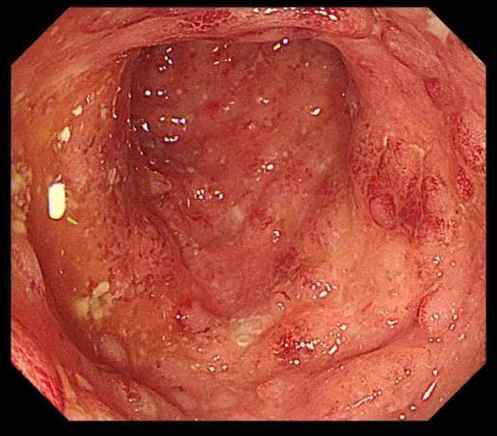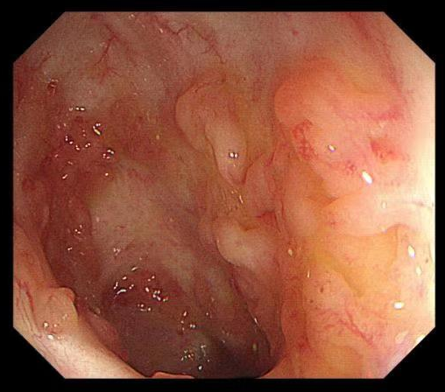
Figure 1 Colonoscopy showed severe ulcerative colitis.
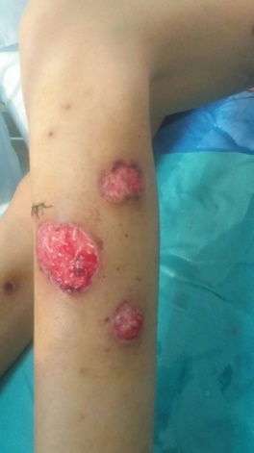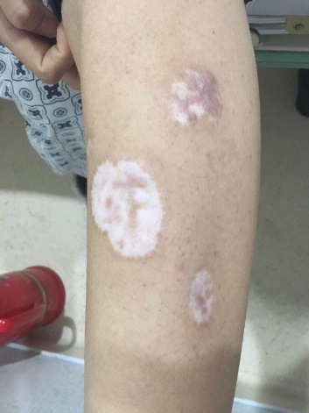
Figure 2 Skin lesions on the legs.
Figure 3 The patient’s nasal mucosa was hyperemic and nasal septum mucosa became remarkably thickened.

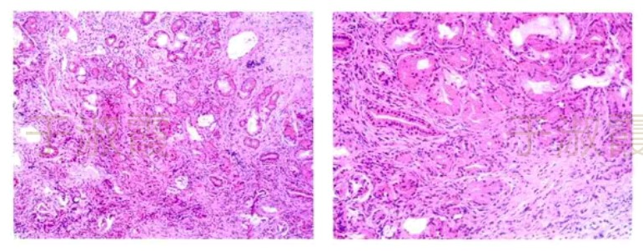
Figure 4 Photomicrograph of hematoxylin and eosin stain (× 20) showing plasma cell and eosinophil infiltration, some neutrophil and lymphocyte infiltration, interstitial edema of mucosa, and fibrocyte and fibroblast hyperplasia.

