Name of Journal: World Journal of Gastrointestinal Surgery
Manuscript NO: 89961
Manuscript Type: CASE REPORT

Intestinal tuberculosis with small bowel stricture and hemorrhage as the predominant manifestation: Three case reports

Huang G et al. Intestinal tuberculosis with small bowel involvement

Gang Huang, Kang-Kang Wu, Xiao-Na Li, Jing-Hua Kuai, Ai-Jun Zhang

Gang Huang, Kang-Kang Wu, Xiao-Na Li, Jing-Hua Kuai, Ai-Jun Zhang, Department of Gastroenterology, Qilu Hospital (Qingdao), Cheeloo College of Medicine, Shandong University, Qingdao 266000, Shandong Province, China

Co-first authors: Gang Huang and Kang-Kang Wu.

Author contributions: Huang G and Wu KK contributed to manuscript writing and editing; LI XN contributed to data collection; Kuai JH contributed to conceptualization; Zhang AJ contributed to proofreading and supervision; Huang G and Wu KK contributed equally to this work as co-first authors; All authors have read and approved the final manuscript.

Corresponding author: Jing-Hua Kuai, MD, Doctor, Department of Gastroenterology, Qilu Hospital (Qingdao), Cheeloo College of Medicine, Shandong University, No. 758 Hefei Road, Shibei District, Qingdao 266000, Shandong Province, China. kuaijinghua123@126.com

Received: November 20, 2023
Revised: December 24, 2023
Accepted: January 4, 2024
Published online: January 27, 2024

Abstract
BACKGROUND
Intestinal tuberculosis is a chronic disease caused by Mycobacterium tuberculosis that mainly affects the ileum and cecum. Small bowel tuberculosis, characterized by predominant involvement of the small intestine, is an extremely rare condition with highly atypical clinical presentations, making diagnosis even more challenging.

CASE SUMMARY
We report three cases of small intestinal tuberculosis, two of the patients presented primarily with abdominal pain, and one presented with gastrointestinal bleeding. All patients underwent blood tests and imaging examinations. Small bowel endoscopy (SBE) revealed that the main lesions in these patients were intestinal stenosis or gastrointestinal bleeding caused by small intestinal ulcers. One patient ultimately underwent surgical treatment. Following a complex diagnostic process and comprehensive analysis, all patients were confirmed to have small intestinal tuberculosis and received standard antituberculosis treatment, leading to an improvement in their condition.

CONCLUSION
Patients with SBTs present with nonspecific symptoms such as abdominal pain, weight loss, and occasional gastrointestinal bleeding. Accurate diagnosis requires a thorough evaluation of clinical symptoms and various tests to avoid misdiagnosis and complications.

Key Words: Intestinal tuberculosis; Gastrointestinal hemorrhage; Small bowel endoscopy; Case report

©The Author(s) 2024. Published by Baishideng Publishing Group Inc. All rights reserved.

Citation: Huang G, Wu KK, Li XN, Kuai JH, Zhang AJ. Intestinal tuberculosis with small bowel stricture and hemorrhage as the predominant manifestation: Three case reports. World J Gastrointest Surg 2024; 16(1): 248-256
URL: https://www.wjgnet.com/1948-9366/full/v16/i1/248.htm
DOI: https://dx.doi.org/10.4240/wjgs.v16.i1.248

Core Tip: Intestinal tuberculosis is a chronic disease caused by Mycobacterium tuberculosis and primarily affects the ileum and cecum. Small bowel tuberculosis (SBT) is rare. We report three cases in which patients with SBTs presented with intestinal stenosis or bleeding. Following a complex diagnostic process involving procedures such as small bowel endoscopy and even surgical intervention, all patients were definitively diagnosed and received standard antituberculosis treatment. SBT manifests primarily with nonspecific symptoms such as abdominal pain, weight loss, and occasional gastrointestinal bleeding. A comprehensive evaluation of clinical symptoms and various examinations including laboratory tests, endoscopy, and pathology, are essential for obtaining an accurate diagnosis.

INTRODUCTION
Tuberculosis (TB) is a chronic granulomatous inflammatory disease with diverse clinical presentations and can affect various systems of the body, such as the lungs, bones, lymphatic system, and intestines^{[1]}. The disease is caused by Mycobacterium tuberculosis, a gram-positive bacterium with high treatment resistance. Although existing drugs can effectively control this disease, tuberculosis still has high contagiousness and fatality rates globally^{[1-5]}. Intestinal tuberculosis accounts for 1%-3% of all tuberculosis cases, and the intestine is not a commonly affected site of tuberculosis^{[6]}. As a result, this issue has long been overlooked. The terminal ileum and cecum are common areas of involvement due to their rich lymphatic tissue, stagnant intestinal contents, and limited digestive activity^{[7]}. However, intestinal tuberculosis predominantly affecting the small intestine is very rare.
This case series aims to help clinicians understand the rare situation of intestinal tuberculosis with primary clinical manifestations of small intestinal bleeding or stenosis.

CASE PRESENTATION
Chief complaints
Case 1: A 49-year-old male patient presented with persistent complaint of melena for the previous 20 d.

Case 2: A 23-year-old female patient presented with recurrent abdominal pain over a span of 5 months.

Case 3: A 63-year-old female patient presented with recurrent abdominal pain that persisted for 2 years.

History of present illness
Case 1: The patient reported three episodes of melena over the last 20 d, amounting to approximately 300 mL. No obvious precipitating factors were identified, with the patient denying significant abdominal pain or bloating, as well as symptoms of dizziness or palpitations. Upon the patient’s presentation to a local hospital, the patient's hemoglobin level was measured at 134 g/L, while computed tomography (CT) scans revealed slight thickening of the colonic wall in the ascending colon. However, both colonoscopy and gastroscopy examinations conducted at that time failed to identify any sites of bleeding.

Case 2: The patient suffered from intermittent abdominal pain of unclear origin, primarily around the umbilicus, over the previous 5 months. The associated symptoms included decreased appetite, weight loss, and fatigue, but no fever. The patient had an average of two well-formed bowel movements per day, without mucus or bloody discharge on the stool surface. One month prior, the patient sought medical attention at a local hospital. Laboratory tests indicated a hemoglobin level of 84 g/L. The chest CT scans were normal, and colonoscopy demonstrated segmental ulcers at the terminal ileum and sigmoid colon, suggestive of Crohn's disease based on pathological findings. The patient received oral glutamine, probiotics, and sulfasalazine for treatment. However, one week prior to the patient’s current presentation, her abdominal pain significantly worsened, and her bowel movements increased to 5 times per day.

Case 3: Two years prior, this patient initially presented with recurrent paroxysmal epigastric pain without any clear etiology. These episodes occurred once every 1-2 months and lasted for 4-6 d each. A previous gastrointestinal endoscopy conducted at an external hospital failed to yield any definitive findings. The patient experienced multiple episodes of abdominal pain and sought medical attention at multiple sites. Positron emission (PET)/CT performed three months previously revealed thickening of the intestinal wall in the segment of the small intestine, accompanied by increased fluorodeoxyglucose metabolism. Additionally, multiple hypermetabolic lymph nodes were observed in the perilesional area, left pulmonary hilum, and mediastinum. Subsequently, a mediastinal lymph node biopsy was performed, and the pathological examination suggested a high possibility of tuberculosis infection.

History of past illness
Case 1: The patient had pulmonary tuberculosis during childhood, which was successfully treated. At the age of 24, the patient developed cervical lymph node tuberculosis and underwent surgical removal of the infected lymph nodes.

Case 2: The patient did not report any significant medical conditions.

Case 3: The patient did not report notable illnesses or conditions.

Personal and family history
The personal and family histories of these patients were unremarkable.

Physical examination
Case 1: The patient had a body mass index (BMI) of 19.42 kg/m² and displayed pallor of the skin and conjunctiva, with no apparent positive chest or abdominal signs.

Case 2: The patient had a BMI of 18.22 kg/m² and had pale conjunctiva and nail beds. Physical examination of the chest and abdomen revealed no specific positive signs.

Case 3: The patient had a BMI of 19.53 kg/m² and no apparent positive chest or abdominal signs.

Laboratory examinations
Case 1: Routine blood analysis revealed a hemoglobin level of 106 g/L, with positive fecal occult blood test results. The blood biochemistry and tumor marker levels were found to be within the normal range.

Case 2: The patient's complete blood count showed a hemoglobin level of 101 g/L. Blood biochemistry tests revealed a low albumin level of 20 g/L, an elevated erythrocyte sedimentation rate of 25 mm/h, and a C-reactive protein level of 113 mg/L. Tumor marker, Clostridium difficile, Epstein–Barr virus, and cytomegalovirus tests were negative.

Case 3: The patient's complete blood count, blood biochemistry, and tumor marker levels were within the normal range.

Imaging examinations
Case 1: Small bowel endoscopy (SBE) revealed multiple ulcers and stenosis in the middle and distal segments of the ileum. (Figure 1A-C). The affected areas exhibited friable mucosal tissue that was prone to bleeding upon touch. Pathological analysis revealed the predominance of chronic inflammation, along with granuloma formation in the submucosa, muscularis mucosa, and lamina propria (Figure 1D). Both the purified protein derivative (PPD) test and tuberculosis-specific T-cell spot test (T-SPOT) were positive.

Case 2: Computed tomography enterography (CTE) findings revealed the presence of multiple luminal strictures in both the small intestine and colon, as well as segmental thickening of the intestinal wall, consistent with characteristic features of Crohn's disease (Figure 2A and B). The patient's initial presentation suggested a diagnosis of Crohn's disease. However, upon admission, the patient experienced intermittent fever with a maximum temperature of 39 °C. Chest CT revealed interstitial inflammation and infection in both lungs (Figure 2C and D). Her T-SPOT test was remarkably positive (3+), which made a diagnosis of tuberculosis infection of the lungs possible. Although the patient's previous colonoscopy suggested Crohn's disease, it lacked specificity for differential diagnosis. Thus, further investigation is warranted to optimize the pathological basis of this diagnosis. Segmental ulcers were identified throughout the entire ileum and colon during SBE. Larger ulcers extended along the circumference of the intestinal lumen (Figure 2E and F). Pus patches covered the surface of the ulcers. Multiple biopsy samples were obtained from these areas. Pathological examination of the specimens revealed diffuse mucosal inflammation with the formation of multiple granulomas in the lamina propria and submucosa (Figure 2G). Positive acid-fast bacilli (AFB) staining indicated the presence of mycobacteria (Figure 2H). Based on the collective findings, the patient was diagnosed with intestinal tuberculosis.

Case 3: CTE revealed localized thickening of the lower left abdominal small intestinal wall (Figure 3A). During SBE, ileal stenosis and gastric mucosal lesions were identified (Figure 3B). Histopathological examination of the gastric mucosal lesions suggested gastric adenocarcinoma, while the histopathological findings of the ileum and jejunum indicated chronic inflammatory changes. However, the PPD test was positive. Consequently, a curative distal gastrectomy, intra-abdominal lymph node dissection, and partial small bowel resection were performed. The resected small bowel specimen exhibited significant thickening of the intestinal wall, luminal narrowing, and localized mass-like lesions. Pathological examination revealed granuloma formation in all layers of the intestinal wall (Figure 3C). Additionally, the pathology also revealed advanced dysplasia in the gastric mucosa with focal carcinoma in situ, confirming a moderately differentiated gastric adenocarcinoma (T1N0M0) (Figure 3D).

FINAL DIAGNOSIS
In all of these patients, the final diagnosis was intestinal tuberculosis.

TREATMENT
Case 1
Standard anti-tuberculosis treatment was given.

Case 2
One week after admission, the patient presented with gastrointestinal bleeding. Blood transfusions were administered, and anti-tuberculosis treatment was initiated, leading to a significant improvement in the symptoms compared to those that the patients had previously.

Case 3
Standard anti-tuberculosis treatment was given.

OUTCOME AND FOLLOW-UP
These patients recovered well and follow-up was routinely performed. During the telephone follow-up in the 10th month after discharge, the patients did not develop abdominal pain or other obvious discomfort (Table 1).

DISCUSSION
We report three cases of small bowel tuberculosis (SBT) involving the ileocecal region, which is a typical site affected by this disease. The diagnosis and differentiation of intestinal tuberculosis are challenging, and the confirmation of such cases can be further complicated by atypical lesion sites.
A recent series of studies indicated that the most common clinical features of intestinal tuberculosis are abdominal pain, weight loss and fever^{[8-13]}. Abdominal pain is typically chronic and occurs frequently in the right lower quadrant and periumbilical regions, with the symptoms of case 2. However, in case 3, the abdominal pain was mainly localized in the upper abdomen. Weight loss is also a common symptom among patients with intestinal tuberculosis. Among the three patients we described, all had a BMI less than 20 kg/m², which may be attributed to chronic inflammatory processes, reduced nutrient intake, or impaired absorption^{[14]}. Notably, none of the three patients presented with fever, indicating the atypical clinical manifestations of SBTs.
Cases 2 and 3 presented primarily with abdominal pain, while case 1 exhibited small intestine bleeding (SIB) as the main clinical feature. SIB, also known as obscure gastrointestinal bleeding, is commonly caused by malignancies (such as lymphoma), polyposis syndromes, Meckel's diverticulum, inflammatory bowel disease, Dieulafoy's lesions, vascular dilations, or ulcers induced by nonsteroidal anti-inflammatory drugs^{[15]}. There are reports of cases in which colonic tuberculosis has caused significant gastrointestinal hemorrhage^{[16,17]}, but SIB attributed to intestinal tuberculosis is extremely rare.
Intestinal tuberculosis is a disease known as the "great mimicker" due to its clinical symptoms, which can mimic various conditions. Currently, endoscopic combined biopsy histopathology is widely regarded as the most important approach for diagnosing intestinal tuberculosis. A meta-analysis study^{[18]} revealed that the relative endoscopic features of intestinal tuberculosis include transverse ulcers, a patulous ileocecal valve, and cecal involvement. Pathology is considered the gold standard for diagnosing intestinal tuberculosis, although its diagnostic efficacy heavily relies on the quality of the endoscopic biopsy specimens. In comparison to the granulomas of Crohn's disease, tuberculous granulomas in the intestine are typically larger (> 200 mm), confluent, and dense (> 5/hpf) and are predominantly distributed in the submucosal layer. The presence of central caseous necrosis allows for a specific diagnosis of intestinal tuberculosis^{[19,20]}. However, due to the typical location of tuberculous granulomas in the submucosal layer, endoscopic biopsies are often sampled too superficially, resulting in a relatively low detection rate of caseous granulomas. Several studies^{[21,22]} have suggested that extensive sampling during endoscopy could be performed to improve the diagnostic rate of tuberculosis, albeit at the cost of an increased biopsy and processing time. In some cases of intestinal tuberculosis, surgical intervention may be necessary to obtain sufficient pathological specimens for a definitive diagnosis. Additionally, interferon-gamma release assays (IGRAs) still hold significant value as a complementary method in the diagnosis of intestinal tuberculosis. A study indicated that the T-SPOT test has a sensitivity of 88% for diagnosing natural Mycobacterium tuberculosis infection, which is significantly greater than the 66% sensitivity of the tuberculin skin test^{[23]}. In recent years, several studies^{[24,25]} have utilized the ratio of visceral fat to subcutaneous fat on CT scans to distinguish between Crohn's disease and intestinal tuberculosis. A cutoff value of 0.63 for the VF/SC ratio demonstrated a high sensitivity of 82% and specificity of 81% in distinguishing intestinal tuberculosis from Crohn's disease.
Traditional examinations such as histopathological examination, AFB, and Mycobacterium tuberculosis culture exhibit high specificity but low sensitivity^{[26]}. Various novel molecular-based approaches, including IGRA, GeneXpert, polymerase chain reaction (PCR), and multiplex PCR, offer high sensitivity but limited specificity, resulting in limited clinical application^{[26]}. In conclusion, an accurate diagnosis of intestinal tuberculosis requires a combination of patient history, physical examination, imaging examination, endoscopy, pathology, and the latest molecular detection methods.
Regarding case 1, the patient had a history of tuberculosis, and both the PPD and T-SPOT results were positive. SBE revealed multiple ulcers and strictures in the small intestine, and histopathological examination revealed granuloma formation in the submucosa, muscularis mucosa, and lamina propria. Considering these findings collectively, a diagnosis of SBT was made. In case 2, the patient was initially misdiagnosed with Crohn's disease, but as the disease progressed, fever and pulmonary symptoms emerged. The chest CT and T-SPOT results suggested the possibility of tuberculosis, and small bowel endoscopic biopsy revealed AFB. The patient was ultimately diagnosed with SBT. For case 3, endoscopy did not reveal any specific findings, which led to doubts about the diagnosis of intestinal tuberculosis. However, CTE revealed thickening of the small intestine wall, suggesting further SBE examination. While identifying ileal stenosis, endoscopic biopsy pathology indicated gastric malignancy. As such, the patient underwent surgical intervention and postoperative pathological examination revealed multiple granulomas throughout the full thickness of the small intestinal wall, confirming the diagnosis of SBT.
Currently, conservative antituberculosis treatment is commonly used for patients with a confirmed diagnosis of SBT. A Cochrane meta-analysis of a randomized controlled trial (328 participants) revealed that patients treated with isoniazid, rifampicin, pyrazinamide, or ethambutol for a shorter duration (6 months) did not have a high rate of recurrence^{[27]}. Additional observational data suggest that in most cases, six months of treatment is sufficient^{[28,29]}. If drug therapy fails to relieve symptoms or if complications such as intestinal obstruction occur, surgical treatment may be considered based on careful evaluation of the patient. In our reported cases, except for case 3 who underwent surgical resection of the intestinal tuberculosis lesion due to gastric malignancy, the main approach was drug therapy, and all the patients achieved satisfactory therapeutic effects.

CONCLUSION
In summary, the clinical manifestations of SBT are complex and nonspecific, often presenting as abdominal pain, weight loss, and, occasionally, isolated gastrointestinal bleeding. Purely isolated SBTs are relatively rare, with most cases being associated with pulmonary tuberculosis or extrapulmonary tuberculosis. The diagnosis of intestinal tuberculosis relies on a comprehensive assessment of clinical symptom and the laboratory, radiological, endoscopic, bacteriological, and histopathology findings. Only through a thorough analysis of the disease can we distinguish between true and false cases, thus avoiding misdiagnosis and other potential complications.

REFERENCES
1 Schito M, Migliori GB, Fletcher HA, McNerney R, Centis R, D'Ambrosio L, Bates M, Kibiki G, Kapata N, Corrah T, Bomanji J, Vilaplana C, Johnson D, Mwaba P, Maeurer M, Zumla A. Perspectives on Advances in Tuberculosis Diagnostics, Drugs, and Vaccines. Clin Infect Dis2015; 61 Suppl 3: S102-S118 [PMID: 26409271 DOI: 10.1093/cid/civ609]
2 Aregawi AB, Alem AT, Girma A. A Rare Case of Intestinal Tuberculosis with Chronic Partial Small Bowel Obstruction in a 37-Year-Old Ethiopian Man. Int Med Case Rep J 2022; 15: 725-733 [PMID: 36540622 DOI: 10.2147/IMCRJ.S388269]
3 Merino Gallego E, Gallardo Sánchez F, Gallego Rojo FJ. Intestinal tuberculosis and Crohn's disease: the importance and difficulty of a differential diagnosis. Rev Esp Enferm Dig 2018; 110: 650-657 [PMID: 30168341 DOI: 10.17235/reed.2018.5184/2017]
4 Donoghue HD, Holton J. Intestinal tuberculosis. Curr Opin Infect Dis 2009; 22: 490-496 [PMID: 19623062 DOI: 10.1097/QCO.0b013e3283306712]
5 Ma JY, Tong JL, Ran ZH. Intestinal tuberculosis and Crohn's disease: challenging differential diagnosis. J Dig Dis 2016; 17: 155-161 [PMID: 26854750 DOI: 10.1111/1751-2980.12324]
6 Wu YF, Ho CM, Yuan CT, Chen CN. Intestinal tuberculosis previously mistreated as Crohn's disease and complicated with perforation: a case report and literature review. Springerplus 2015; 4: 326 [PMID: 26180746 DOI: 10.1186/s40064-015-1129-x]
7 Park H, Kansara T, Victoria AM, Boma N, Hong J. Intestinal Tuberculosis: A Diagnostic Challenge. Cureus 2021; 13: e13058 [PMID: 33680600 DOI: 10.7759/cureus.13058]
8 Kentley J, Ooi JL, Potter J, Tiberi S, O'Shaughnessy T, Langmead L, Chin Aleong J, Thaha MA, Kunst H. Intestinal tuberculosis: a diagnostic challenge. Trop Med Int Health 2017; 22: 994-999 [PMID: 28609809 DOI: 10.1111/tmi.12908]
9 Shi XC, Zhang LF, Zhang YQ, Liu XQ, Fei GJ. Clinical and Laboratory Diagnosis of Intestinal Tuberculosis. Chin Med J (Engl) 2016; 129: 1330-1333 [PMID: 27231171 DOI: 10.4103/0366-6999.182840]
10 Patel B, Yagnik VD. Clinical and laboratory features of intestinal tuberculosis. Clin Exp Gastroenterol 2018; 11: 97-103 [PMID: 29559804 DOI: 10.2147/CEG.S154235]
11 Gan H, Mely M, Zhao J, Zhu L. An Analysis of the Clinical, Endoscopic, and Pathologic Features of Intestinal Tuberculosis. J Clin Gastroenterol 2016; 50: 470-475 [PMID: 26974755 DOI: 10.1097/MCG.0000000000000514]
12 Tanoglu A, Erdem H, Friedland JS, Almajid FM, Batirel A, Kulzhanova S, Konkayeva M, Smagulova Z, Pehlivanoglu F, de Saram S, Gulsun S, Amer F, Balkan II, Tekin R, Cascio A, Dauby N, Sirmatel F, Tasbakan M, Erdem A, Wegdan AA, Aydin O, Cesur S, Deniz S, Senbayrak S, Denk A, Duzenli T, Siméon S, Oncul A, Ozseker B, Yakar T, Ormeci N. Clinicopathological profile of gastrointestinal tuberculosis: a multinational ID-IRI study. Eur J Clin Microbiol Infect Dis 2020; 39: 493-500 [PMID: 31758440 DOI: 10.1007/s10096-019-03749-y]
13 Cheng W, Zhang S, Li Y, Wang J, Li J. Intestinal tuberculosis: clinico-pathological profile and the importance of a high degree of suspicion. Trop Med Int Health 2019; 24: 81-90 [PMID: 30338607 DOI: 10.1111/tmi.13169]
14 Maulahela H, Simadibrata M, Nelwan EJ, Rahadiani N, Renesteen E, Suwarti SWT, Anggraini YW. Recent advances in the diagnosis of intestinal tuberculosis. BMC Gastroenterol 2022; 22: 89 [PMID: 35227196 DOI: 10.1186/s12876-022-02171-7]
15 Awadie H, Zoabi A, Gralnek IM. Obscure-overt gastrointestinal bleeding: a review. Pol Arch Intern Med 2022; 132 [PMID: 35635400 DOI: 10.20452/pamw.16253]
16 Valainathan SR, Thabut D, Rudler M. Colonic tuberculosis as a cause of massive intestinal bleeding. Clin Res Hepatol Gastroenterol2021; 45: 101365 [PMID: 33358145 DOI: 10.1016/j.clinre.2019.12.011]
17 Nagahashi M, Aoyagi T, Yamada A, Rashid OM, Adams BJ, Takabe K. Intestinal Co-infection of Tuberculosis and CMV can Cause Massive Lower GI Bleeding in a Patient with HIV. J Surg Sci 2013; 1: 12-15 [PMID: 25068146]
18 Limsrivilai J, Shreiner AB, Pongpaibul A, Laohapand C, Boonanuwat R, Pausawasdi N, Pongprasobchai S, Manatsathit S, Higgins PD. Meta-Analytic Bayesian Model For Differentiating Intestinal Tuberculosis from Crohn's Disease. Am J Gastroenterol 2017; 112: 415-427 [PMID: 28045023 DOI: 10.1038/ajg.2016.529]
19 Jung Y, Hwangbo Y, Yoon SM, Koo HS, Shin HD, Shin JE, Moon HS, Kang SB, Lee JR, Huh KC. Predictive Factors for Differentiating Between Crohn's Disease and Intestinal Tuberculosis in Koreans. Am J Gastroenterol 2016; 111: 1156-1164 [PMID: 27296940 DOI: 10.1038/ajg.2016.212]
20 Ye Z, Lin Y, Cao Q, He Y, Xue L. Granulomas as the Most Useful Histopathological Feature in Distinguishing between Crohn's Disease and Intestinal Tuberculosis in Endoscopic Biopsy Specimens. Medicine (Baltimore) 2015; 94: e2157 [PMID: 26656343 DOI: 10.1097/MD.0000000000002157]
21 Mehta V, Desai D, Abraham P, Gupta T, Rodrigues C, Joshi A, Deshpande R, Sawant P, Ingle M, Rathi P, Mandot A. Do additional colonoscopic biopsies increase the yield of Mycobacterium tuberculosis culture in suspected ileo-colonic tuberculosis? Indian J Gastroenterol 2018; 37: 226-230 [PMID: 29967961 DOI: 10.1007/s12664-018-0863-8]
22 Yönal O, Hamzaoğlu HO. What is the most accurate method for the diagnosis of intestinal tuberculosis? Turk J Gastroenterol 2010; 21: 91-96 [PMID: 20549889 DOI: 10.4318/tjg.2010.0063]
23 Weng MT, Wei SC, Lin CC, Tsang YM, Shun CT, Wang JY, Shieh MJ, Wang CY, Wong JM. Seminar Report From the 2014 Taiwan Society of Inflammatory Bowel Disease (TSIBD) Spring Forum (May 24th, 2014): Crohn's Disease Versus Intestinal Tuberculosis Infection. Intest Res 2015; 13: 6-10 [PMID: 25691838 DOI: 10.5217/ir.2015.13.1.6]
24 Ko JK, Lee HL, Kim JO, Song SY, Lee KN, Jun DW, Lee OY, Han DS, Yoon BC, Choi HS, Hahm JS, Kim SY. Visceral fat as a useful parameter in the differential diagnosis of Crohn's disease and intestinal tuberculosis. Intest Res 2014; 12: 42-47 [PMID: 25349562 DOI: 10.5217/ir.2014.12.1.42]
25 Yadav DP, Madhusudhan KS, Kedia S, Sharma R, Pratap Mouli V, Bopanna S, Dhingra R, Pradhan R, Goyal S, Sreenivas V, Vikram NK, Makharia G, Ahuja V. Development and validation of visceral fat quantification as a surrogate marker for differentiation of Crohn's disease and intestinal tuberculosis. J Gastroenterol Hepatol 2017; 32: 420-426 [PMID: 27532624 DOI: 10.1111/jgh.13535]
26 Mehta V, Desai D, Abraham P, Rodrigues C. Making a Positive Diagnosis of Intestinal Tuberculosis with the Aid of New Biologic and Histologic Features: How Far Have We Reached? Inflamm Intest Dis 2019; 3: 155-160 [PMID: 31111030 DOI: 10.1159/000496482]
27 Jullien S, Jain S, Ryan H, Ahuja V. Six-month therapy for abdominal tuberculosis. Cochrane Database Syst Rev 2016; 11: CD012163 [PMID: 27801499 DOI: 10.1002/14651858.CD012163.pub2]
28 Mandavdhare HS, Singh H, Dutta U, Sharma V. A real-world experience with 6 months of antitubercular therapy in abdominal tuberculosis. JGH Open 2019; 3: 201-205 [PMID: 31276036 DOI: 10.1002/jgh3.12136]
29 Jha DK, Pathiyil MM, Sharma V. Evidence-based approach to diagnosis and management of abdominal tuberculosis. Indian J Gastroenterol 2023; 42: 17-31 [PMID: 36899289 DOI: 10.1007/s12664-023-01343-x]

Footnotes
Informed consent statement: Informed written consent was obtained from the patient for publication of this report and any accompanying images.

Conflict-of-interest statement: The authors declare that they have no conflict of interest to disclose.

CARE Checklist (2016) statement: The authors have read the CARE Checklist (2016), and the manuscript was prepared and revised according to the CARE Checklist (2016).

Open-Access: This article is an open-access article that was selected by an in-house editor and fully peer-reviewed by external reviewers. It is distributed in accordance with the Creative Commons Attribution NonCommercial (CC BY-NC 4.0) license, which permits others to distribute, remix, adapt, build upon this work non-commercially, and license their derivative works on different terms, provided the original work is properly cited and the use is non-commercial. See: https://creativecommons.org/Licenses/by-nc/4.0/

Provenance and peer review: Unsolicited article; Externally peer reviewed.
Peer-review model: Single blind

Peer-review started: November 20, 2023
First decision: December 11, 2023
Article in press: January 4, 2024

Specialty type: Gastroenterology and hepatology
Country/Territory of origin: China
Peer-review report’s scientific quality classification
Grade A (Excellent): 0
Grade B (Very good): 0
Grade C (Good): C
Grade D (Fair): 0
Grade E (Poor): 0

P-Reviewer: Alzerwi NAN, Saudi Arabia S-Editor: Zhang H L-Editor: A P-Editor: Xu ZH
Figure Legends
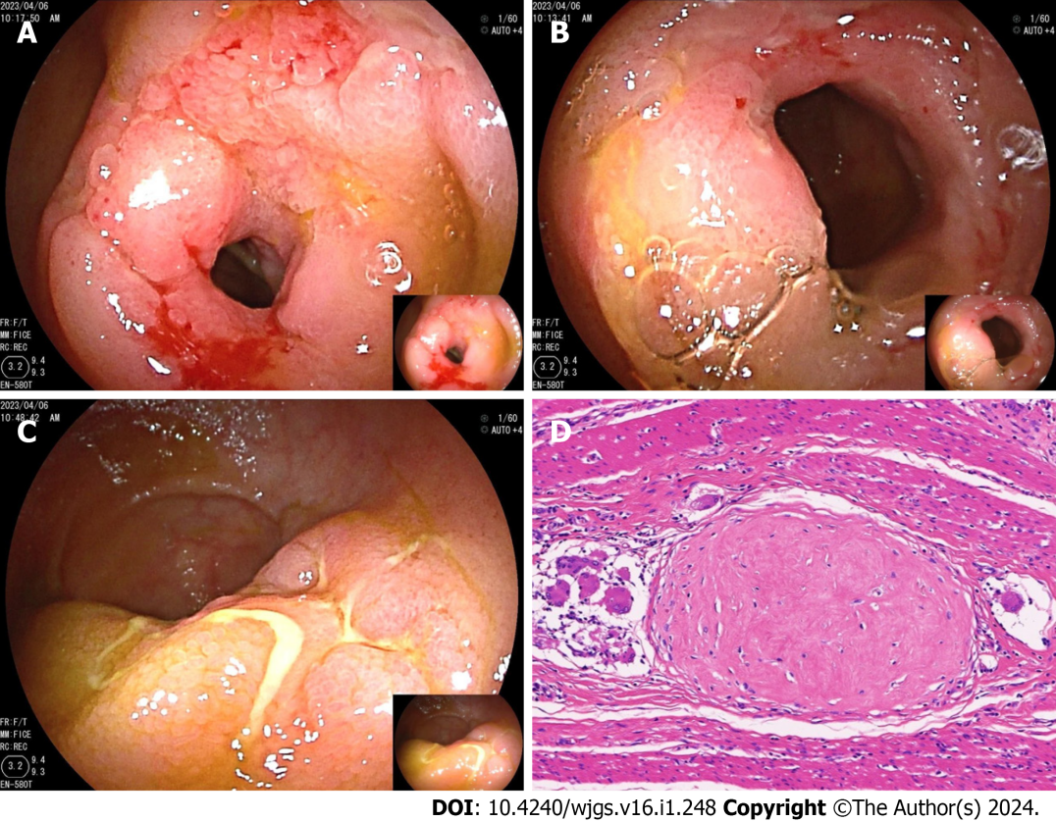
Figure 1 Small bowel endoscopy and pathology images from case 1. A: A circular ulcer with luminal narrowing and mucosal hyperplasia located in the middle segment of the ileum; B: Another circular ulcer with a narrowing located in the middle segment of the ileum; C: A longitudinal ulcer with mucosal hyperplasia located in the terminal segment of the ileum; D: Histopathological examination by hematoxylin-eosin (200 ×) staining demonstrated the formation of multiple granulomas.
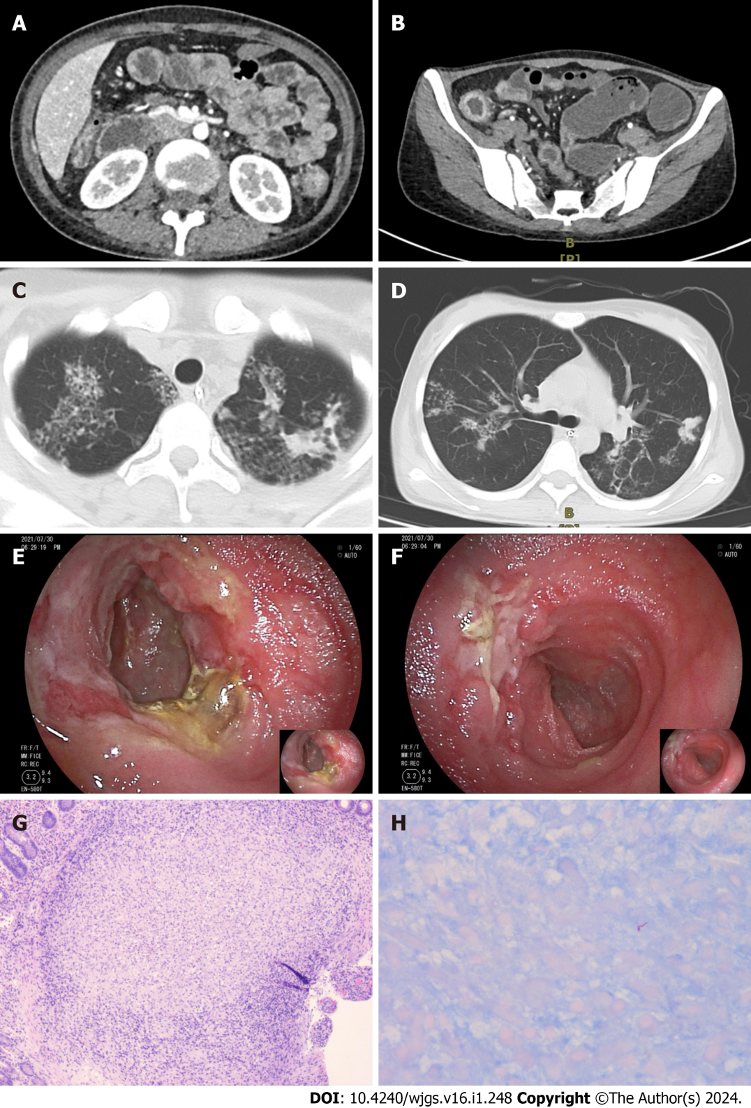
Figure 2 Computed tomography, small bowel endoscopy, and pathology images from case 2. A: Computed tomography scan showing multiple strictures in the small intestine; B: CT scan showing multiple strictures and thickening of the colonic wall; C: CT scan showing multifocal patchy opacities in the upper lungs; D: CT scan showing multifocal patchy opacities in both lungs, predominantly in the right middle lobe and left lower lobe; E: An ulcer with purulent exudate and surrounding mucosal hyperplasia was observed at the terminal ileum; F: An ulcer with luminal involvement was observed at the terminal ileum; G: Histopathological examination via hematoxylin-eosin staining (100 ×) revealed the presence of multiple granulomas; H: Histopathological examination via acid-fast bacilli staining (400 ×) revealed positive bacteria.
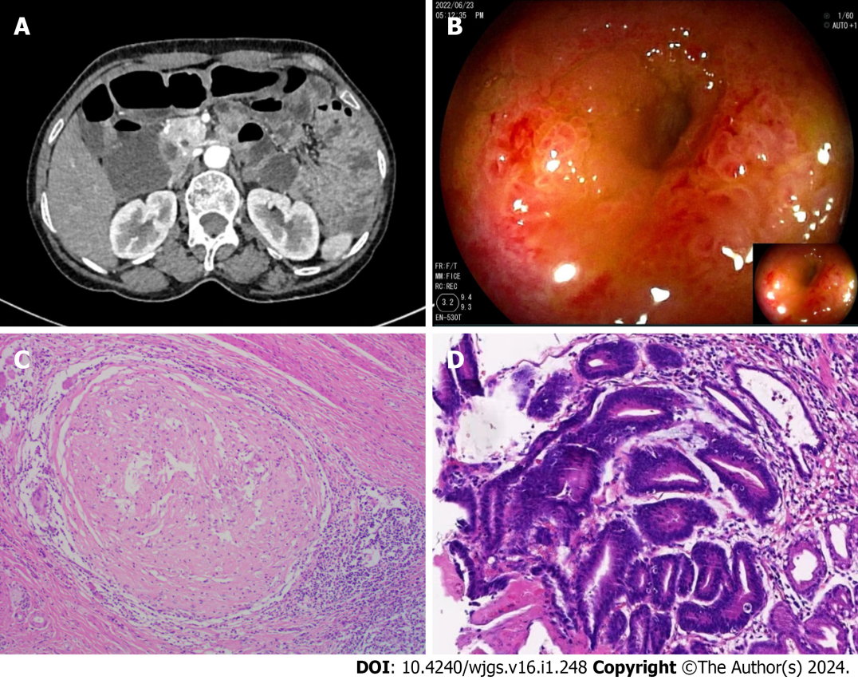
Figure 3 Computed tomography, small bowel endoscopy, and pathology images from case 3. A: Computed tomography (CT) enterography revealed localized thickening of the small intestine with clustering in the lower left abdomen; B: Small bowel endoscopy revealing ileal stenosis; C: Histopathological examination by hematoxylin-eosin staining (100 ×) demonstrated the formation of granulomas; D: Histopathological examination by hematoxylin-eosin staining (200 ×) demonstrated advanced dysplasia in the gastric mucosa and focal carcinoma in situ.

Table 1 Patients' clinical features, management and outcomes
Case/gender | Age at diagnosis | Main clinical features | Examinations for tuberculosis | Features of CTE | Endoscopic appearance | Histopathological examination | Management | Outcome
1/male | 49 yr | Melena | PPD (+); TSPOT (+) | Multiple luminal strictures and thickened intestinal walls | Multiple ulcers and stenosis in the small intestine | Multiple granulomas | Standard anti-tuberculosis treatment | No symptoms at the 10th month after discharge
2/female | 23 yr | Recurrent abdominal pain | T-SPOT (+) | Multiple luminal strictures and thickened intestinal walls | Segmental ulcers were identified throughout the entire ileum and colon | Multiple granulomas; acid-fast staining detects positive bacteria | Standard anti-tuberculosis treatment | No symptoms at the 10th month after discharge
3/female | 63 yr | Recurrent abdominal pain | PPD (+) | Localized thickening of the small intestine with clustering in the lower left abdomen | Ileal stenosis | Multiple granulomas | Standard anti-tuberculosis treatment | No symptoms at the 10th month after discharge
CTE: Computed tomography enterography; PPD: Purified protein derivative test; T-SPOT: Tuberculosis-specific T-cell spot test.

Published by Baishideng Publishing Group Inc
7041 Koll Center Parkway, Suite 160, Pleasanton, CA 94566, USA
Telephone: +1-925-3991568
E-mail: office@baishideng.com
Help Desk: https://www.f6publishing.com/helpdesk
https://www.wjgnet.com

© 2024 Baishideng Publishing Group Inc. All rights reserved.

