Name of Journal: World Journal of Clinical Cases
Manuscript NO: 42903
Manuscript Type: CASE REPORT

Endodontic management of the maxillary first molars with two root canals: A case report and review of literature

Liu J et al. Endodontic management of maxillary first molars

Jie Liu, Ke-Hua Que, Zuo-Hui Xiao, Wen Wen

Jie Liu, Kehua Que, Department of Endodontics, College of Stomatology, Tianjin Medical University, Tianjin 300070, China

Zuohui Xiao, Department of Geriatric Dentistry, National Engineering Laboratory for Digital and Material Technology of Stomatology, Beijing Laboratory of Biomedical Materials, Peking University School and Hospital of Stomatology, Beijing 100081, China

Wen Wen, Department of Endodontics, College of Stomatology, Tianjin Medical University, Tianjin 300070, China

Wen Wen, Department of Stomatology, Tianjin Academy of Traditional Chinese Medicine Affiliated Hospital, Tianjin 300120, China

ORCID number: Jie Liu (0000-0003-4180-5641); Kehua Que (0000-0001-9311-7766); Zuohui Xiao (0000-0002-9185-1024); Wen Wen (0000-0001-8576-4437).

Author contributions: Que KH and Wen W designed the treatment plan for patients; Liu J and Wen W treated patients; Liu J, Wen W and Xiao ZH collected material and clinical data; Liu J wrote the paper.

Informed consent statement: Consent was obtained from the patients for publication of this report and any accompanying images.

Conflict-of-interest statement: The authors declare that they have no conflicts of interest.

CARE Checklist (2016) statement: The authors have read the CARE Checklist (2016), and the manuscript was prepared and revised according to the CARE Checklist (2016).

Open-Access: This article is an open-access article which was selected by an in-house editor and fully peer-reviewed by external reviewers. It is distributed in accordance with the Creative Commons Attribution Non Commercial (CC BY-NC 4.0) license, which permits others to distribute, remix, adapt, build upon this work non-commercially, and license their derivative works on different terms, provided the original work is properly cited and the use is non-commercial. See: http://creativecommons.org/licenses/by-nc/4.0/

Manuscript source: Unsolicited manuscript

Corresponding author to: Wen Wen, DDS, Doctor, Department of Endodontics, College of Stomatology, Tianjin Medical University, Heping District, Qixiangtai Road, No. 12, Tianjin 300070, China. tjdentwen92@163.com
Telephone: +86-22-23332095

Received: November 1, 2018
Peer-review started: November 1, 2018
First decision: November 15, 2018
Revised: November 26, 2018
Accepted: November 30, 2018
Article in press:
Published online:

Abstract
BACKGROUND
The complex anatomy of the maxillary first molars has always been a major challenge for the complete root canal treatment in endodontic therapy. We here present two cases of maxillary first molars each with only two root canals, which have been rarely reported, and perform a literature review of this anatomy in maxillary first molar.

CASE SUMMARY
The patients were referred to hospital for finding a cavity in tooth with color change and feeling toothache during mastication respectively. Both of them were diagnosed as apical periodontitis by X-ray imaging and cone beam computed tomography (CBCT). Non-surgical endodontic therapy was performed with the assistance of a dental operating microscope (DOM). CBCT showed rare but accurate images of both patients each with two root canals and two roots in their maxillary first molars. Both roots were located in the buccal to the palatal direction and each root had only one clear root canal. In addition, each maxillary first molar in both patients was symmetrical to that in the opposite side with only two separate root canals. Non-surgical endodontic therapy was performed with the assistance of a DOM. Finally, the teeth were restored using composite resin and the patients were satisfied with the results.

CONCLUSION
Making full use of CBCT and DOM would contribute to help dentists in making correct diagnosis and treatment of teeth with rare root canal morphology.

Key words: Root canal anatomy; Maxillary first molar; Cone beam computed tomography; Dental operating microscope; Endodontic therapy; Case report

© The Author(s) 2018. Published by Baishideng Publishing Group Inc. All rights reserved.

Core tip: We describe two rare cases of maxillary first molars with only two separate root canals, and another impressive find was that the left and right sides were also symmetrical, which extend the range of knowledge on both roots and root canals in relation to permanent maxillary first molar anatomy. Advanced surgical facilities and diagnostic methods such as cone beam computed tomography and dental operating microscope play an important role in the diagnosis and treatment of these endodontic diseases and facilitate a better understanding of complicated root canal treatment.

Liu J, Que KH, Xiao ZH, Wen W. Endodontic management of the maxillary first molars with two root canals: A case report and review of literature. World J Clin Cases 2018; In press

INTRODUCTION
In-depth knowledge of the internal anatomy of the root canal system is mandatory for success in endodontic therapy^{[1]}. The anatomy and morphology of roots and root canals vary greatly and among all of the permanent teeth, maxillary first molars have the highest rates of root canal therapy failure in clinical practice^{[2,3]} because of associated complexities and anatomic variations^{[4,5]}. The number of roots in maxillary first molars detected by endodontics and general dentists ranges from 1 to 5 according to the literature^{[6-9]}. The number of root canals has been reported to range between 1 and 8^{[7-9]}, and even a C-shaped root canal has been observed^{[6,13]}. Over 95% of maxillary first molars have 3 roots^{[14]} and most have 3-4 root canals^{[15]}. However, attention should be paid to fewer roots and root canal variations to identify the root canal system in the case of clinical failure such as perforations.
Contemporary root canal treatment requires accurate knowledge of root canal anatomy and highly specialized facilities and materials. Currently, advanced techniques including cone beam computed tomography (CBCT) are widely used in endodontic treatment to provide three-dimensional images of the tooth. It has become an important tool both for diagnosis and planning dental treatment including endodontic treatments^{[16,17,18]}, and also assists in the assessment of anatomic findings such as isthmus and lateral canals and leads to a more predictable and effective treatment^{[19]}. A dental operating microscope (DOM) also increases the success rate of difficult treatment as it provides a better operating field. The patients described in this report were diagnosed and treated with the assistance of CBCT and DOM, and both of them had maxillary first molars with a special root canal anatomy of 2 roots and 2 root canals, which has seldom been reported. These cases were intended to reinforce clinicians’ awareness of the rare morphology of root canals.

CASE PRESENTATION
Chief complaints
In case 1, the patient’s chief complaint was a cavity and color change in her maxillary molar on the left side for approximately 2 mo. In case 2, the patient’s chief complaint was toothache during mastication in the maxillary right posterior region for more than one week.

History of present illness
In case 1, the patient found a cavity in the maxillary molar on the left side accompanied with discoloration two months ago. The tooth was insensitive to cold and heat, and had no spontaneous pain or cold and heat stimulation pain. Sometimes the patient felt uncomfortable when chewing. In case 2, the patient felt an obvious toothache during mastication in the maxillary right posterior region for more than one week. The tooth was insensitive to cold and heat, and had no spontaneous pain or cold and heat stimulation pain and there is no loose. The tooth and its periodontal tissue had never been swollen before.

History of past illness
None in case 1. In case 2, the patient had undergone a root canal treatment in the right posterior tooth several years previously. And the patient denied tooth extraction or orthodontic history.

Physical examination upon admission
In case 1, clinical examination revealed a cavity due to deep caries in the left maxillary molar and exposed pulp cavity without pain. The tooth was sensitive to percussion and the periodontal tissue was swollen but there is no loose. In case 2, clinical examination revealed a metal crown and pain on vertical percussion in tooth 16. A buccally periodontal pocket approximately 6 mm was detected in tooth 16 which illustrated an unhealthy periodontal condition.

Imaging examinations
In case 1, a pre-operative X-ray image showed an obviously low density in the distal area of tooth decay. The CBCT images clearly showed that this maxillary first molar had only 2 roots and 2 root canals, and the root canals were located in the buccal-palatal direction and were separate to each other in each root, respectively. In case 2, a preoperative intraoral periapical radiograph revealed a maxillary first molar with an unsatisfactory root canal filling with 2 roots and an obvious low-density image around the periapical area which indicated severe inflammation. CBCT showed that the patient’s maxillary first molars both only had 2 roots and root canals, buccal and palatal, as seen in case 1.

Case 1: A 63-year-old woman was referred to the Endodontic Department of Stomatology Hospital of Tianjin Medical University. The patient’s chief complaint was a cavity and color change in her maxillary molar on the left side for approximately 2 mo. Her medical history was noncontributory and the patient denied any tooth extractions or orthodontic history. Clinical examination revealed a cavity due to deep caries in the left maxillary molar and exposed pulp cavity without pain. The tooth was sensitive to percussion and the periodontal tissue was swollen. The diagnosis was deep caries with apical periodontitis in tooth 26. Endodontic therapy was proposed and accepted. Written informed consent was obtained from the patient.
A pre-operative X-ray image was obtained before surgery (Figure 1A). It showed an obviously low density in the distal area of tooth decay. Isolation of the tooth using a rubber dam was carried out during the entire procedure. The pulp chamber was localized, and the access opening was expanded from the palate distally to the center of the tooth after removal of the decay. When the access opening was completed, an anatomic variation was seen on the pulp chamber floor (Figure 1B and C). Under the DOM visual field, only one buccal canal orifice and one palatal canal orifice were detected. Further inspection of the pulpal floor revealed the absence of other canal orifices. The pulp tissue in the chamber and two root canals was extirpated and the canals were flooded with 3% sodium hypochlorite (Beyond Technology Corp., Beijing, China). The cavity was temporarily sealed with zinc oxide. As the X-ray did not reveal the condition of the root canal system, the patient underwent CBCT to acquire the three-dimensional (3D) morphology of the tooth.
When the 3D images were obtained, longitudinal and cross-sections of 0.5 mm thickness were analyzed (Figure 2A-E). The CBCT images clearly showed the anatomical variation in the maxillary first molar of the patient with only 2 roots and 2 root canals. As seen from the 3D-reconstruction of the patient’s maxillary first molar, the root canals were located in the buccal-palatal direction and were separate to each other in each root, respectively (Figure 2F-H), which was in accordance with the DOM examination.
When the canals had been confirmed, the working length was measured and confirmed by an electronic apex locator (Morita Corporation, Kyoto, Japan). The root canals were shaped by Ni-Ti rotary instrumentation (M3, United Dental, Shanghai, China), irrigated with 1% sodium hypochlorite (Beyond Technology Corp., Beijing, China) and 0.9% sodium chloride (China Otsuka Pharmaceutical Co., Ltd., China), and obturated by gutta-percha using the thermafil obturation technique step by step with the assistance of DOM, and then confirmed by X-ray images (Figure 1D-F). The tooth was finally restored using composite resin and the patient was satisfied with the results.

Case 2: A 45-year-old female presented to the Endodontics Department of Stomatology Hospital of Tianjin Medical University with the complaint of toothache during mastication in the maxillary right posterior region for more than one week. Both second maxillary molars were missing and the patient denied tooth extraction or orthodontic history. However, she had undergone a root canal treatment in the right posterior tooth several years previously. Clinical examination revealed a metal crown and pain on vertical percussion in tooth 16. A buccally periodontal pocket approximately 6 mm was detected in tooth 16 which illustrated an unhealthy periodontal condition. The patient’s medical history was noncontributory. A preoperative intraoral periapical radiograph revealed a maxillary first molar with an unsatisfactory root canal filling with 2 roots and an obvious low-density image around the periapical area which indicated severe inflammation (Figure 3A). From the clinical and radiographic findings, a diagnosis of apical periodontitis was made and re-root canal treatment was planned and accepted. Written informed consent was obtained from the patient. Access to the pulp cavity and root canal was achieved through the crown using the DOM. The former core and gutta-percha were removed and only 2 separate root canals were detected (Figure 3B and C). In order to ensure the efficacy of treatment, CBCT was suggested to determine the number of root canals.
Based on the images directly and reconstructed from CBCT, it was surprising to find that the patient’s maxillary first molars both only had 2 roots and root canals, buccal and palatal, as seen in case 1 (Figure 4A-E). The re-root canal treatment was completed and confirmed by CBCT and DOM as in patient 1. Her pain was relieved after the first treatment as shown by the patient’s subjective sensation. The root canals were filled with gutta-percha (Figure 3D-E) and the tooth was finally restored using composite resin.
It is significant that in both of these cases, the right maxillary first molars were symmetrical to the left maxillary first molars in anatomical details, which has seldom been reported before and illustrates the condition of 2 root canals and 2 roots in both maxillary sides in these 2 patients.

FINAL DIAGNOSIS
Clinical examination revealed apical periodontitis in both two cases.

TREATMENT
Non-surgical endodontic therapy was performed with the assistance of a DOM.

OUTCOME AND FOLLOW-UP
The teeth were both finally restored using composite resin. The inflammation was controlled and the patients' discomfort disappeared. So the patients were satisfied with the results.

DISCUSSION
The most common anatomy in maxillary first molars is 3 roots (96.2%) and 3-4 root canals (98.32%)^{[14,20,21]}. Hence, the reports of variation in maxillary first molars mainly focus on the morphology of MB2 and the detection of multiple canals, and the 2-rooted form of the maxillary first molar is rarely reported. Several previous studies in vitro, such as clearing, sectioning, or radiographic examination with radiopaque gel infusion of canals, have shown that the incidence of maxillary first molar with only 2 roots varies from 0 to 6.3%^{[22-24]}. To date, there is only one report in the literature of 1 single buccal root and 1 single palatal root, which should be emphasized to avoid treatment errors^{[25]}. In the present report, the patients’ CBCT images showed that the 2 roots were isolated from each other. One was the buccal root and the other one was the palatal root. The 2 root canals opened from the same chamber and had their own apex respectively.
In our cases, the buccal root was more likely to be C-shaped, while the root canal was straight without morphological change. When a tooth shows only 1 buccal root, it is possible that the tooth has indeed only 1 buccal root or that 2 buccal roots have fused into a stronger root^{[26]}. This may be caused by non-fused or non-divided roots, which were established during the root embryologic stages^{[27]}. The Hertwig horizontal root sheath is supposed to retain the shape of the root. When the epithelium is inadequately developed, the inadequate Hertwig sheath may promote the condition seen in our patients, or C-shaped canals.
In maxillary first molars, fusion may be divided into 3 types: fusion of the distobuccal (DB) root with the palatal (P) root (Type A), fusion of the mesiobuccal (MB) root and the distobuccal root (Type B), and fusion of 2 palatal roots (Type C)^{[6]}. We performed an extensive review of available reports about maxillary first molars with fewer root canals and C-shaped root canals (Table 1). As the table showed, the majority of fusion occurred between DB and P roots (Type A), and MB and DB roots (Type B), with a lower incidence of the fusion of two P roots, which is referred to as Type C.
In this study, according to the location of the root canals, fusion may have occurred between the MB and DB root (Type B). The cases reported here may be the special condition of the C-shaped maxillary. Some studies have shown that C-shaped roots occur differently due to ethnic variation. In the white population, the incidence of C-shaped roots is reported to be 2.7%-7.6%^{[27]}, while the incidence in the Chinese population may be as high as 31.5%^{[33]}, which is very common and widely accepted in mandibular second molars. However, in maxillary first molars, it is still very rare to see a C-shaped root and root canal (approximately 0.12%)^{[2,34]}. In the Chinese population with a high risk of C-shaped roots, it was reported that only 0.3% of extracted maxillary first molars had C-shaped roots^{[35]}. In Europeans, the incidence is only 0.09%^{[34]}.
Plotino has reported that the percentage of symmetry in root and canal anatomy between left and right sides varied from 70% to 81%^{[36]}. Therefore, it was also interesting to find that the morphology of each maxillary first molar was symmetrical to that of the opposite side in our 2 cases. In the literature, this symmetry is rare. In most patients, it is meaningful to check the tooth on the opposite side, which may have an essential guiding value for treatment of the opposite tooth.
It is extremely important that clinicians use all of the armamentarium at their disposal to locate and treat the entire root canal system^{[37]}. The routine use of preoperative CBCT imaging with small field of view could be recommended for both initial endodontic treatment and nonsurgical retreatment of maxillary molars^{[38]}. On the other hand, DOM usage in daily clinical practice could also potentialize and facilitate the localization and handling of additional canals as a result of lighter and significantly higher magnification of the field of view^{[39,40]}. Therefore, clinicians should be more aware of the morphological variations in permanent teeth to complete satisfactory root canal treatment with the help of techniques such as CBCT and DOM.

CONCLUSION
In conclusion, the permanent maxillary first molars with 2 root canals and 2 roots are rare and unusual clinical cases. In our patients with this rare condition, the left and right sides were symmetrical. Attention should be paid to patients with fewer root canals and root anatomical variations to overcome the fixed idea regarding the morphology of molars. Advanced surgical facilities and diagnostic methods such as DOM and CBCT can assist in diagnosis and modern root canal treatment.

REFERENCES
1 Estrela C, Holland R, Estrela CR, Alencar AH, Sousa-Neto MD, Pécora JD. Characterization of successful root canal treatment. Braz Dent J 2014; 25: 3-11 [PMID: 24789284 DOI: 10.1590/0103-6440201302356]
2 Christie WH, Peikoff MD, Fogel HM. Maxillary molars with two palatal roots: a retrospective clinical study. J Endod 1991; 17: 80-84 [PMID: 1919407 DOI: 10.1016/S0099-2399(06)81613-4]
3 Vertucci FJ. Root canal anatomy of the human permanent teeth. Oral Surg Oral Med Oral Pathol 1984; 58: 589-599 [PMID: 6595621 DOI: 10.1016/0030-4220(84)90085-9]
4 Lee KW, Kim Y, Perinpanayagam H, Lee JK, Yoo YJ, Lim SM, Chang SW, Ha BH, Zhu Q, Kum KY. Comparison of alternative image reformatting techniques in micro-computed tomography and tooth clearing for detailed canal morphology. J Endod 2014; 40: 417-422 [PMID: 24565663 DOI: 10.1016/j.joen.2013.09.014]
5 Briseño-Marroquín B, Paqué F, Maier K, Willershausen B, Wolf TG. Root Canal Morphology and Configuration of 179 Maxillary First Molars by Means of Micro-computed Tomography: An Ex Vivo Study. J Endod 2015; 41: 2008-2013 [PMID: 26518215 DOI: 10.1016/j.joen.2015.09.007]
6 Martins JN, Quaresma S, Quaresma MC, Frisbie-Teel J. C-shaped maxillary permanent first molar: a case report and literature review. J Endod 2013; 39: 1649-1653 [PMID: 24238466 DOI: 10.1016/j.joen.2013.06.032]
7 Gopikrishna V, Bhargavi N, Kandaswamy D. Endodontic management of a maxillary first molar with a single root and a single canal diagnosed with the aid of spiral CT: a case report. J Endod 2006; 32: 687-691 [PMID: 16793482 DOI: 10.1016/j.joen.2005.10.057]
8 Fava LR. Root canal treatment in an unusual maxillary first molar: a case report. Int Endod J 2001; 34: 649-653 [PMID: 11762503 DOI: 10.1046/j.1365-2591.2001.00445.x]
9 Barbizam JV, Ribeiro RG, Tanomaru Filho M. Unusual anatomy of permanent maxillary molars. J Endod 2004; 30: 668-671 [PMID: 15329575 DOI: 10.1097/01.DON.0000121618.45515.5A]
10 Kottoor J, Velmurugan N, Sudha R, Hemamalathi S. Maxillary first molar with seven root canals diagnosed with cone-beam computed tomography scanning: a case report. J Endod 2010; 36: 915-921 [PMID: 20416446 DOI: 10.1016/j.joen.2009.12.015]
11 Kottoor J, Velmurugan N, Surendran S. Endodontic management of a maxillary first molar with eight root canal systems evaluated using cone-beam computed tomography scanning: a case report. J Endod 2011; 37: 715-719 [PMID: 21496678 DOI: 10.1016/j.joen.2011.01.008]
12 Martins JN, Anderson C. Endodontic treatment of the maxillary first molar with five root canals–three case reports. Rev Port Estomatol Cir Maxilofac 2013; 54: 37-42 [DOI: 10.1016/j.rpemd.2012.11.004]
13 Newton CW, McDonald S. A C-shaped canal configuration in a maxillary first molar. J Endod 1984; 10: 397-399 [PMID: 6590751 DOI: 10.1016/S0099-2399(84)80162-4]
14 Cleghorn BM, Christie WH, Dong CC. Root and root canal morphology of the human permanent maxillary first molar: a literature review. J Endod 2006; 32: 813-821 [PMID: 16934622 DOI: 10.1016/j.joen.2006.04.014]
15 Pécora JD, Woelfel JB, Sousa Neto MD, Issa EP. Morphologic study of the maxillary molars. Part II: Internal anatomy. Braz Dent J 1992; 3: 53-57 [PMID: 1303118]
16 Special Committee to Revise the Joint AAE/AAOMR Position Statement on use of CBCT in Endodontics. AAE and AAOMR Joint Position Statement: Use of Cone Beam Computed Tomography in Endodontics 2015 Update. Oral Surg Oral Med Oral Pathol Oral Radiol 2015; 120: 508-512 [PMID: 26346911 DOI: 10.1016/j.oooo.2015.07.033]
17 Neelakantan P, Subbarao C, Subbarao CV. Comparative evaluation of modified canal staining and clearing technique, cone-beam computed tomography, peripheral quantitative computed tomography, spiral computed tomography, and plain and contrast medium-enhanced digital radiography in studying root canal morphology. J Endod 2010; 36: 1547-1551 [PMID: 20728725 DOI: 10.1016/j.joen.2010.05.008]
18 Jeger FB, Lussi A, Bornstein MM, Jacobs R, Janner SF. [Cone beam computed tomography in endodontics: a review for daily clinical practice]. Schweiz Monatsschr Zahnmed 2013; 123: 661-668 [PMID: 23966013]
19 Venskutonis T, Plotino G, Juodzbalys G, Mickevičienė L. The importance of cone-beam computed tomography in the management of endodontic problems: a review of the literature. J Endod 2014; 40: 1895-1901 [PMID: 25287321 DOI: 10.1016/j.joen.2014.05.009]
20 Badole GP, Warhadpande MM, Shenoi PR, Lachure C, Badole SG. A rare root canal configuration of bilateral maxillary first molar with 7 root canals diagnosed using cone-beam computed tomographic scanning: a case report. J Endod 2014; 40: 296-301 [PMID: 24461422 DOI: 10.1016/j.joen.2013.09.004]
21 Ghobashy AM, Nagy MM, Bayoumi AA. Evaluation of Root and Canal Morphology of Maxillary Permanent Molars in an Egyptian Population by Cone-beam Computed Tomography. J Endod 2017; 43: 1089-1092 [PMID: 28476465 DOI: 10.1016/j.joen.2017.02.014]
22 al Shalabi RM, Omer OE, Glennon J, Jennings M, Claffey NM. Root canal anatomy of maxillary first and second permanent molars. Int Endod J 2000; 33: 405-414 [PMID: 11307458 DOI: 10.1046/j.1365-2591.2000.00221.x]
23 Thomas RP, Moule AJ, Bryant R. Root canal morphology of maxillary permanent first molar teeth at various ages. Int Endod J 1993; 26: 257-267 [PMID: 8300257 DOI: 10.1111/j.1365-2591.1993.tb00570.x]
24 Cleghorn BM, Christie WH, Dong CC. Root and root canal morphology of the human permanent maxillary first molar: a literature review. J Endod 2006; 32: 813-821 [PMID: 16934622 DOI: 10.1016/j.joen.2006.04.014]
25 Ma L, Chen J, Wang H. Root canal treatment in an unusual maxillary first molar diagnosed with the aid of spiral computerized tomography and in vitro sectioning: a case report. Oral Surg Oral Med Oral Pathol Oral Radiol Endod 2009; 107: e68-e73 [PMID: 19464648 DOI: 10.1016/j.tripleo.2009.01.051]
26 Jin GC, Lee SJ, Roh BD. Anatomical study of C-shaped canals in mandibular second molars by analysis of computed tomography. J Endod 2006; 32: 10-13 [PMID: 16410060 DOI: 10.1016/j.joen.2005.10.007]
27 Marzioni D, Capparuccia L, Todros T, Giovannelli A, Castellucci M. Growth factors and their receptors: fundamental molecules for human placental development. Ital J Anat Embryol 2005; 110: 183-187 [PMID: 16101037]
28 Dankner E, Friedman S, Stabholz A. Bilateral C shape configuration in maxillary first molars. J Endod 1990; 16: 601-603 [PMID: 2094764 DOI: 10.1016/S0099-2399(07)80204-4]
29 Yilmaz Z, Tuncel B, Serper A, Calt S. C-shaped root canal in a maxillary first molar: a case report. Int Endod J 2006; 39: 162-166 [PMID: 16454798 DOI: 10.1111/j.1365-2591.2006.01069.x]
30 Shin Y, Kim Y, Roh BD. Maxillary first molar with an O-shaped root morphology: report of a case. Int J Oral Sci 2013; 5: 242-244 [PMID: 24008268 DOI: 10.1038/ijos.2013.68]
31 Joshi C, Joshi S. C-shaped canal in maxillary first molars: a case report. J Dent (Tehran) 2014; 11: 111-117 [PMID: 24910684]
32 Paksefat S, Rahimi S. Root canal treatment of a two-rooted C-shaped maxillary first molar: a case report. Iran Endod J 2014; 9: 301-303 [PMID: 25386214 DOI: 10.1002/ccd.24279]
33 Yang ZP, Yang SF, Lin YC, Shay JC, Chi CY. C-shaped root canals in mandibular second molars in a Chinese population. Endod Dent Traumatol 1988; 4: 160-163 [PMID: 3267526 DOI: 10.1111/j.1600-9657.1988.tb00315.x]
34 De Moor RJ. C-shaped root canal configuration in maxillary first molars. Int Endod J 2002; 35: 200-208 [PMID: 12019491 DOI: 10.1046/j.1365-2591.2002.00461.x]
35 Yang ZP, Yang SF, Lee G. The root and root canal anatomy of maxillary molars in a Chinese population. Endod Dent Traumatol 1988; 4: 215-218 [PMID: 3248579 DOI: 10.1111/j.1600-9657.1988.tb00324.x]
36 Plotino G, Tocci L, Grande NM, Testarelli L, Messineo D, Ciotti M, Glassman G, D'ambrosio F, Gambarini G. Symmetry of root and root canal morphology of maxillary and mandibular molars in a white population: a cone-beam computed tomography study in vivo. J Endod 2013; 39: 1545-1548 [PMID: 24238444 DOI: 10.1016/j.joen.2013.09.012]
37 Patel B. Anatomy and Root Canal Morphology. Endodontic Diagnosis, Pathology, and Treatment Planning. Springer International Publishing, 2015
38 Studebaker B, Hollender L, Mancl L, Johnson JD, Paranjpe A. The Incidence of Second Mesiobuccal Canals Located in Maxillary Molars with the Aid of Cone-beam Computed Tomography. J Endod 2018; 44: 565-570 [PMID: 29153734 DOI: 10.1016/j.joen.2017.08.026]
39 Sempira HN, Hartwell GR. Frequency of second mesiobuccal canals in maxillary molars as determined by use of an operating microscope: a clinical study. J Endod 2000; 26: 673-674 [PMID: 11469299 DOI: 10.1097/00004770-200011000-00010]
40 Görduysus MO, Görduysus M, Friedman S. Operating microscope improves negotiation of second mesiobuccal canals in maxillary molars. J Endod 2001; 27: 683-686 [PMID: 11716081 DOI: 10.1097/00004770-200111000-00008]

P-Reviewer: Zhou M, Maric I, Vieyra JP S-Editor: Dou Y L-Editor: E-Editor:

Specialty type: Medicine, research and experimental
Country of origin: China
Peer-review report classification
Grade A (Excellent): 0
Grade B (Very good): B
Grade C (Good): C
Grade D (Fair): D
Grade E (Poor): 0

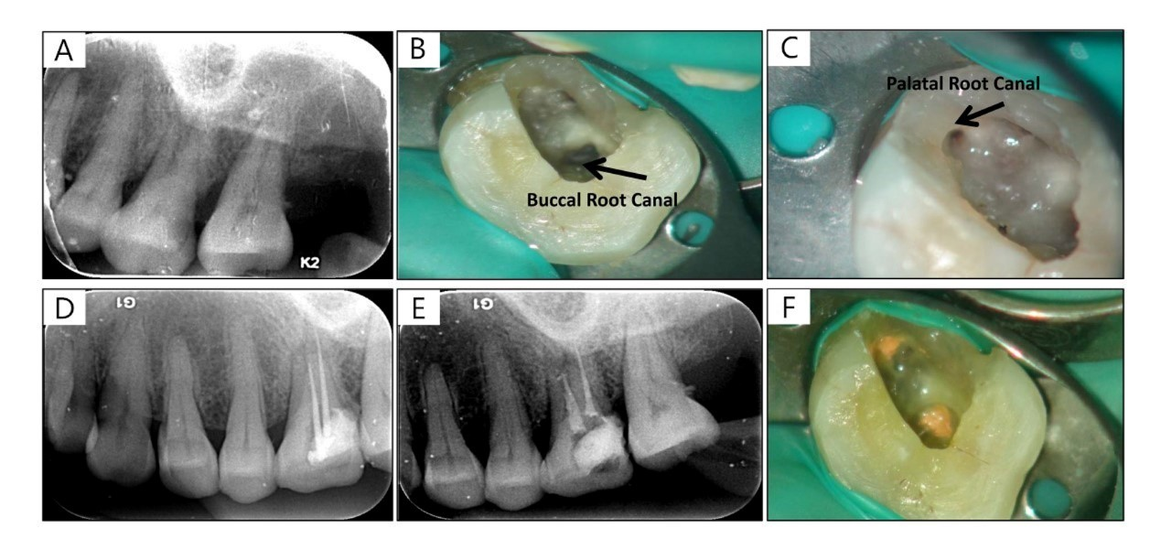
Figure 1 The treatment process under dental operating microscope and X-ray images. A: Preoperative periapical radiograph of tooth indicates the existence of decay in the distal part of tooth; B and C: Only one buccal canal orifice and palatal canal orifice can be detected under the visual field of dental operating microscope; D: Radiograph of master cone; E: Post-obturation periapical radiograph; F: Two root canals are obturated by gutta-percha.

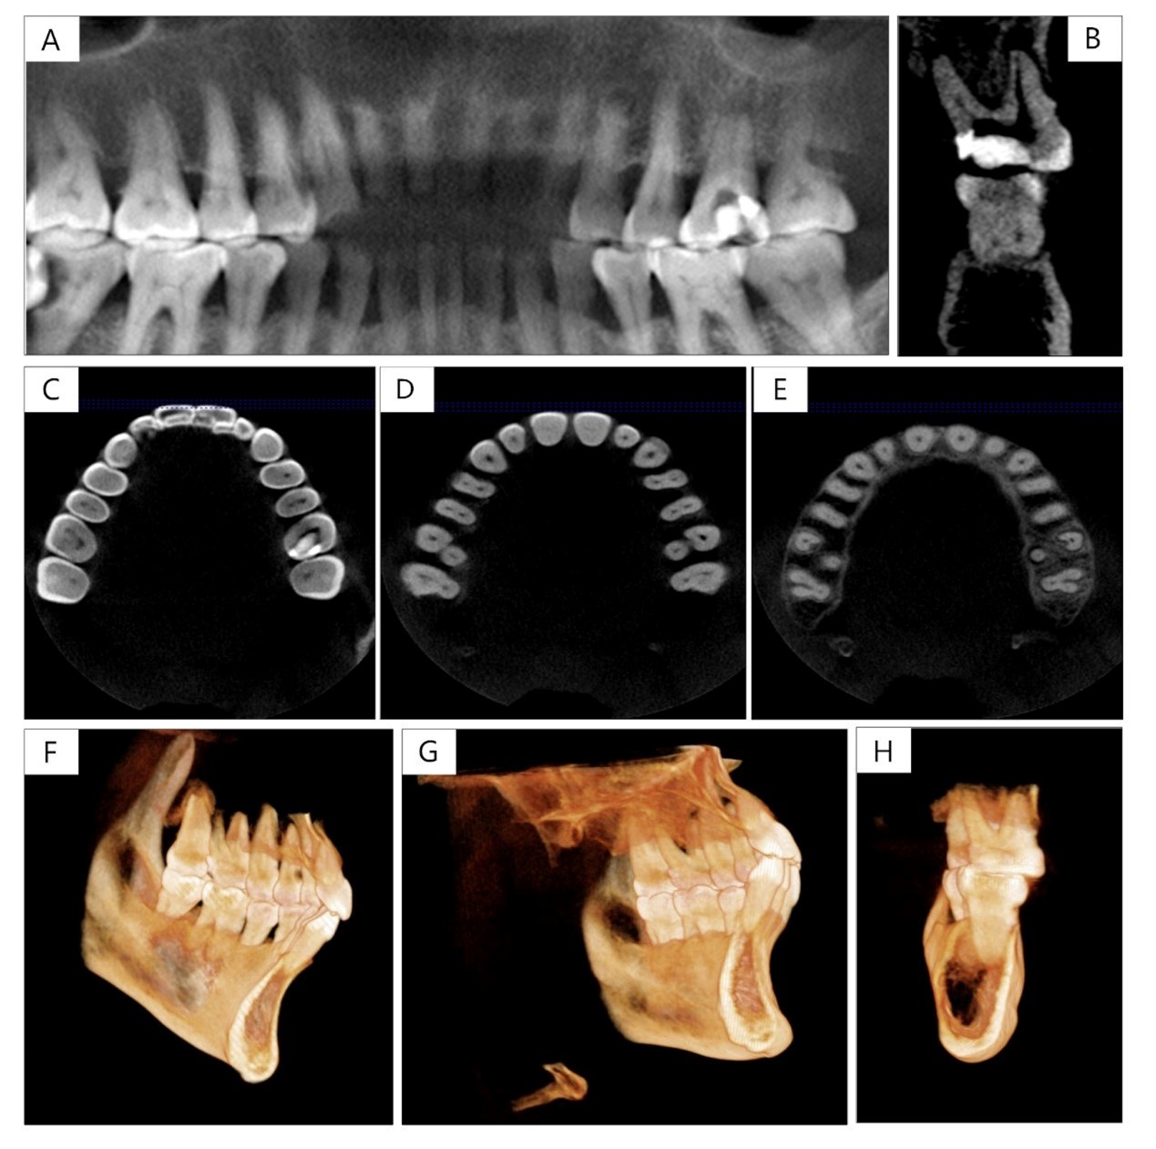
Figure 2 The analysis of the anatomical structure with cone beam computed tomography. A and B: The images of cone beam computed tomography (CBCT) show the decay in the distal part of maxillary molar on the left side; C-E: CBCT images show clear anatomical conditions of the left and right maxillary first molars with only 2 roots and 2 root canals; F-H: 3D-reconstruction of maxillary first molar shows the root canals is located in the buccal-palatal direction and were single in the different root.

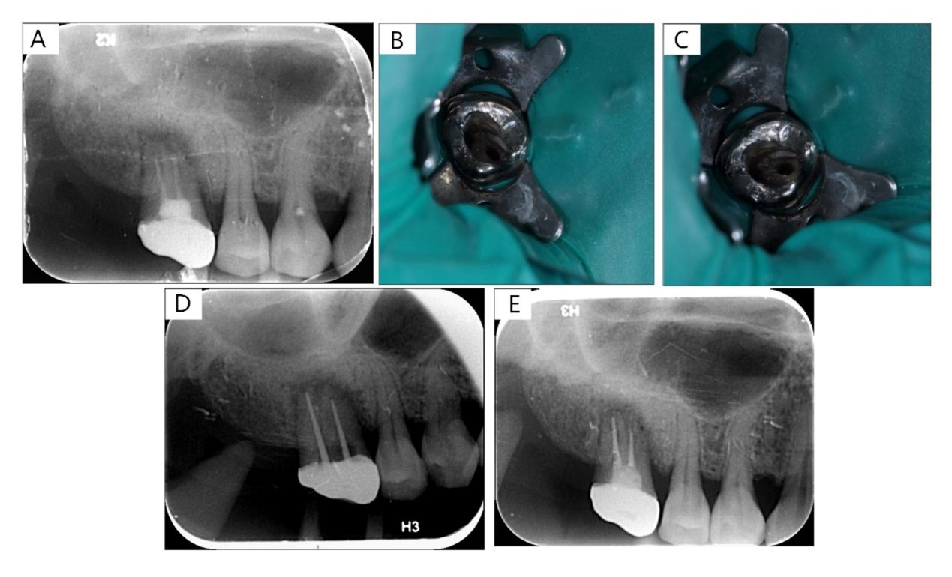
Figure 3 The treatment process under dental operating microscope and X-ray images. A: Radiograph shows incomplete root canal obturation of 2 root canals and the existence of periapical lesion; B and C: Only two separate root canals are detected under the visual field of dental operating microscope; D: Radiograph of master cone; E: Post-obturation periapical radiograph.

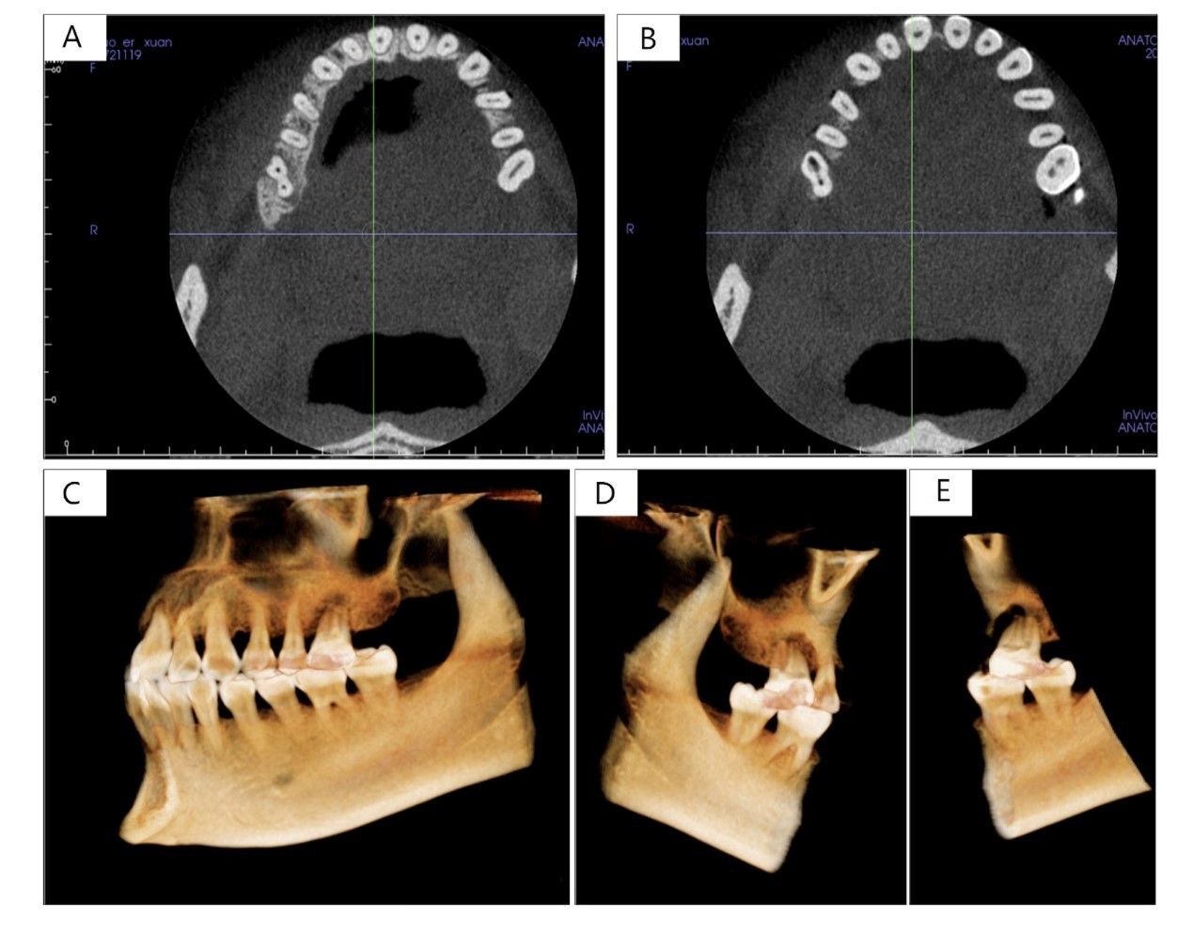
Figure 4 The analysis of the anatomical structure with cone beam computed tomography. A and B: Cone beam computed tomography images show only 2 root canals separately in 2 roots in both left and right maxillary first molars; C-E: 3D-reconstruction of maxillary first molar shows the root canals are located in the buccal-palatal direction and were single in the different root as case 1.

Table 1 Available case reports of maxillary first molar with fewer root canals and C-shaped root canals
reference | Country | Gender | Ethnicity | No. of canals | Features of the root canals | Type | Symmetry or not
Newton et al^{[13]} | United States | Male | White | 2 | Fusion between P and DB canals, and a single MB canal | Type A | N/A
Dankner et al^{[28]} | Israel | Female | White | 3 | Fusion between P and DB canals, and a single MP canal | Type A | Yes
Fava et al^{[8]} | Brazil | Female | N/A | 3 | Fusion between MB and DB, but with 2 root canal apexes, and a single C-shaped P canal | Type B | N/A
De Moor et al^{[34]} | Belgium | Female | White | 3 | Fusion between P and DB canals, and single MB, MP canals | Type A | N/A
De Moor et al^{[34]} | Belgium | Male | White | 2 | Fusion between P and DB canals, and a single MB canal | Type A | No
Gopikrishna et al^{[7]} | India |  | N/A | 1 | A single root with 1 root canal | / | N/A
Yilmaz et al^{[29]} | Turkey | Female | White | 2 | Fusion between MB and DB canals, but with 3 foramina, and a single P canal | Type B | N/A
Ma et al^{[25]} | China | Female | Yellow | 2 | Fusion between MB and DB canals, and a single P canal | Type B | Yes
Kottoor et al^{[11]} | India | Male | N/A | 4 | Fusion between 2 P canals, and single MB, DB canals | Type C | No
Martins et al^{[6]} | Portugal | Male | White | 2 | Fusion between P and DB canals, and a single MB canal | Type A | Yes
Martins et al^{[6]} | Portugal | Female | White | 2 | Fusion between MB and DB canals, and a single P canal | Type B | N/A
Shin et al^{[30]} | Korea | Male | Yellow | 1 | All the roots fuse together into one O-shaped root, but 5–6 root canals with connecting fins at the apical 3mm | O-shaped | Yes
Joshi et al^{[31]} | India | female | N/A | 1 | A single fused root with a single canal | / | Yes
Paksefat et al^{[32]} | Iran | female | N/A | 3 | Fusion between MB and DB canals, and single separate P and MB2 canals | Type B | No
Present study  (case 1) | China | Female | Yellow | 2 | Fusion between MB and DB canals, and a single P canal | Type B | Yes
Present study  (case 2) | China | Female | Yellow | 2 | Fusion between MB and DB canals, and a single P canal | Type B | Yes
DB: Distobuccal; MB: Mesiobuccal; N/A: Not available; P: Palatal.

