Name of journal: World Journal of Clinical Urology

ESPS Manuscript NO: 8203

Columns: Minireviews

Laparoscopic single site surgery: Experience in the pediatric urology

Wagmaister J et al. Laparoscopic single site surgery

Jonathan Wagmaister, Stanislav Kocherov, Boris Chertin

Jonathan Wagmaister, Stanislav Kocherov, Boris Chertin, the Department of Pediatric Urology, Shaare Zedek Medical Center, the Faculty of Medicine, the Hebrew University, 91031 Jerusalem, Israel

Author contributions: All authors contributed to this work.

Correspondence to: Boris Chertin, MD, Head, Department of Pediatric Urology, The Shaare Zedek Medical Center, the Faculty of Medicine, the Hebrew University, P.O.B 3235, 91031 Jerusalem, Israel. boris.chertin@gmail.com

Telephone: +972-2-6555560 Fax: +972-2-6555160

Received: December 19, 2013 Revised: March 05, 2014
Accepted: March 13, 2014
Published online:

Abstract
Laparoendoscopic single-site surgery (LESS) has been developed to benefit patients by enabling surgeons to perform scarless surgery. In this review we have aimed to summarize and critically analyze the available evidence on the current status and future perspectives of LESS in pediatric urology with special emphasis on our experience with LESS surgery in pediatric population. The clinical data available clearly demonstrated that LESS can safely and effectively be performed in a variety of pediatric urology settings. As clinical experience increases, expanding indications are expected to be documented and the efficacy of the procedure to improve. So far, the quality of evidence of all available studies remains low, mostly being small case series or case control studies from selected centers. Thus, the only objective benefit of LESS remains the improved cosmetic outcome. Prospective, randomized studies are largely awaited to determine which LESS procedures will be established and which are unlikely to stand the test of time. Technology advances hold promise to minimize the challenging technical nature of scarless surgery. In this respect, robotics may be a drive in the development of LESS.

© 2014 Baishideng Publishing Group Co., Limited. All rights reserved.

Key words: Laparoendoscopic single-site surgery; Pediatric urology; Laparoscopy; Review

Core tip: Laparoendoscopic single-site surgery (LESS) has been developed to benefit patients by enabling surgeons to perform scarless surgery. The clinical data available clearly demonstrated that LESS can safely and effectively be performed in a variety of pediatric urology settings. As clinical experience increases, expanding indications are expected to be documented and the efficacy of the procedure to improve. However prospective, randomized studies are largely awaited to determine whether LESS procedures will be established as a routine practice and will be able to stand the test of time. Technology advances hold promise to minimize the challenging technical nature of scarless surgery. In this respect, robotics is likely to drive a major paradigm shift in the development of LESS.

Wagmaister J, Kocherov S, Chertin B. Laparoscopic single site surgery: Experience in the pediatric urology
Available from:
DOI:
INTRODUCTION
Laparoscopic surgery is beginning to gain acceptance as a standard of care in many intra-abdominal procedures in adult and pediatric urology^{[1]}. Today laparoscopic procedures are commonly performed and have become widely accepted as alternatives to open surgery, if not the gold standard in some procedures, like radical or partial nephrectomy^{[2]}. Furthermore even the more technically demanding procedures, such as laparoscopic pyeloplasty, laparoscopic-assisted bladder reconstruction, and laparoscopic ureteral reimplantation, have achieved widespread acceptance and now routinely perform at many centers worldwide. With increasing experience in the laparoscopic environment, efforts are now directed at further minimizing morbidity and improving cosmetic outcomes. This has led to the development of techniques, multichannel single-access ports, and novel bent/articulating instruments that could allow the laparoscopic procedure to be performed through a single skin incision often hidden within the umbilicus or utilizing the nature orifices of the human body in order to completely seal surgical incisions. Following this concept natural orifice transluminal endoscopic surgery (NOTES) and laparoendoscopic single-site surgery (LESS) have then been developed in an attempt to further reduce the morbidity and scaring associated with surgical intervention^{[3-5]}. Conceptually, these techniques share a common underlying ‘‘hypothesis’’ that has driven their development—namely, that a reduction in the number of transcutaneous points of access may benefit patients in terms of port-related complications, recovery time, pain, and cosmesis by potentially performing scarless surgery. The first documented one-port single-incision laparoscopy was Cholecystectomy in 1997. Ten years later, the first single-port nephrectomy was done. Since then urologists have successfully performed various procedures with LESS, including partial nephrectomy, pyeloplasty, orchiectomy, orchiopexy, varicocelectomy, uretero-lithotomy, sacrocolpopexy, renal biopsy, renal cryotherapy, and adrenalectomy^{[6,7]}. In this review, we describe the rationale of the technique, the current clinical applications, the advantages and disadvantages compared to standard laparoscopy, and the results of LESS in Pediatric Urological Surgery, with some attention in Robotic Surgery.

DEFINITION
LESS
LESS is a minimally invasive surgical procedure in which the surgeon operates almost exclusively through a single entry point, typically the patient’s navel. Unlike a traditional multi-port laparoscopic approach, LESS leaves only a single small umbilical scar, usually not larger than 2 cm. This particular access can be achieved through a single fascial incision site with a single trocar with multiple ports, or through a single skin incision site with multiple fascial incisions with individual trocars. The most popular technique is the first mentioned above: a single port with multiple channels. Like conventional laparoscopy, there are 2 principal approaches for renal, adrenal and ureteric surgery: Transperitoneal and Retroperitoneal^{[8]}. Although the first mentioned above is the most known and usually performed, today there are enough clinical studies that show the effectiveness and safeness of LESS through a Retroperitoneal approach, especially in Nephrectomy for non-functioning kidney and in other extirpative retroperitoneal procedures^{[9]}.
With the time and the development of the technique, the concept of LESS was diversified and the surgeons proposed different acronyms for LESS and associated procedures. They include: Single Port Access (SPA), single incision laparoscopic surgery (SILS), Natural orifice transumbilical surgery (NOTUS), transumbilical endoscopic surgery (TUES), Single-access site (SAS) laparoscopic surgery Single-site access (SSA), One-port umbilical surgery (OPUS), Transumbilical laparoendoscopic single-site surgery (U-LESS), Transumbilical laparoscopic assisted surgery (TULA) and Embryonic natural orifice translumenal endoscopic surgery (ENOTES)^{[10-14]}. The common factor: a single small skin incision, usually at the umbilicus (Figure1).

Robotic LESS
R-LESS is the use of the da Vinci Surgery System via one single-port approach to improve ergonomics that limit conventional single-port laparoscopy^{[15]}.

HISTORY
The Minimally Invasive Surgery is a changing and evolving field. Since the first documented laparoscopic procedure in humans performed by Hans Christian Jacobaeus in 1910, there was a tremendous progress that expanded all over the surgical specialties. In 1918 O. Goetze, developed the first automatic pneumoperitoneum needle. In 1929 Kalk, a German physician introduced the forward oblique (135 degree) view lens systems, and in 1938 Janos Veress of Hungary developed a specially designed spring-loaded needle. Interestingly, Veress did not promote the use of his needle for laparoscopy purposes. He used Veress needle for the induction of pneumothorax. To date Veress Needle is the most important instrument to create pneumo-peritoneum. The real credit of videoscopic surgery goes to Professor Hopkins, who discovered in 1953 the rigid rod lens system that revolutionized the field of Laparoscopic Surgery. As a result of this development, in 1970 gynecologists started to embrace laparoscopy and thoroughly incorporated the technique into their practice. General surgeons, despite their exposure to laparoscopy remained confined to traditional open surgery until 1977, when the first laparoscopic assisted appendicectomy was performed by Dekok. In that setup, the appendix was exteriorized and ligated outside. The same year, Kurt Semm first time demonstrated endoloop suturing technique in laparoscopic surgery. The first documented laparoscopic cholecystectomy was performed by Erich Mühe in Germany in 1985. In 1994 the first robotic arm was designed to hold the telescope and in 1996 live telecast of laparoscopic surgery was performed remotely via the Internet (Robotic Telesurgery)^{[16]}. As part of the natural development of minimally invasive surgery, in the late 1990's emerged Laparoscopic Single Site Surgery (LESS)^{[3]}. In a simplified way, the reason for the development of this type of procedures rests on the premise "LESS pain, LESS scar", but the practical advantages in the field are many more than those. As we have aforementioned, the first urological use of LESS was reported in 2007 with the completion of a single-port nephrectomy for a small nonfunctioning kidney, as well as a transperitoneal ureterolithotomy^{[3,6]}. To date there is an extensive experience with LESS in Urology and Pediatric Urology in extirpative and non-extirpative procedures like Pyeloplasty, Varicocelectomy and Orchidopexy^{[3]}. In other specialties as Gynecology,
LESS has been used for several years, being Single Incision Laparoscopic Tubal Ligation one of the most popular procedures in that field^{[17-19]}.

EQUIPMENT
Access devices
Multichannel ports can be employed during LESS as one approach to access. These devices allow for the insertion of instruments and a camera and involve a single fascial incision. The TriPort™ (Advanced Surgical Concepts, Bray, Ireland) is the best known FDA-approved access system. The size of the TriPort™ is fully adjustable, and allows a series of instruments to be introduced into any sized abdominal incision, from a 5 mm incision up to a hand-assisted laparoscopic surgery incision. Each device consists of a retractor component and a valve component, where the instruments are inserted. The valve component of the TriPort™ is made of a unique elastomeric material that allows the passage of standard laparoscopic instruments and scopes simultaneously. The TriPort™ has three inlet valves: one inlet for a 12 mm instrument and two for 5 mm instruments. A QuadPort™ (from Olimpus and Advanced Surgical Concepts, Bray, Ireland) is also available, and has four ports: two inlets for 12 mm instruments and two inlets for 5 mm instruments. A separate insufflation port is provided through the valve housing in both devices. The high elasticity of the gel valve allows the removal of small specimens, whereas larger specimens are withdrawn into the distal end of the port and removed simultaneously with the device at the end of the procedure (Figure 2).
The Uni-X™ Single Port Access Laparoscopic System (Pnavel Systems, Cleveland, OH) is a single port with three working channels, which all accommodate specialized 5 mm laparoscopic instruments. The device is placed through an open access technique and requires a 2 cm fascial incision. Once passed into the abdomen, the port is anchored in place using fascial sutures that are placed before attaching the device to the patient. As with the TriPort™, the Uni-X™ has a separate valve port for insufflation. Once the procedure is complete, the port is untied and the specimen is removed through the initial incision^{[6]}. The GelPOINT system from Applied Medical accommodates varying abdominal walls and incision sizes, provides continuous access and ensures improved articulation of 5 to 12 mm instruments. The Alexis wound protector/retractor offers atraumatic retraction and protection, maintains moisture at the incision site, while providing convenient extracorporeal resection and specimen retrieval. The SILS™ Port designed by Covidien consists of a blue flexible soft-foam port, with access channels for three cannulae. The 5 mm cannula may be interchanged at any time during the procedure with a 5 to 12 mm cannula. The SILS™ Port will adapt its configuration to the size of the cannulae while maintaining pneumoperitoneum (Figure 3). We have utilized in all our patients the SILS™ Port (Covidien, Tyco Health Care). It is our preferential access devise for all LESS surgeries. It is foam port that expands after insertion to prevent air leakage. It is significantly cheaper compared with the others at least on the Israeli market. The access port is easy inserted via 2 cm incision which is performed within umbilicus. During the procedure the 5 mm trocars can be easily replaced by 10-12 mm trocars during surgery when is needed.

Hand instruments
A basic tenet of laparoscopic surgery involves triangulation of instruments so as to produce adequate intracorporeal working space for anatomic dissection and manipulation of tissues. The parallel and close proximity of the right-hand and left-hand instrument shafts of standard laparoscopic instruments through a solitary port results in crowding of the laparoscope and instruments, preventing appropriate triangulation. Articulated instruments were designed to overcome these challenges. Some of articulated instruments include the SILS Multiple Instrument Access Port manufactured by Covidien and the Laparo-Angle Articulating Instruments made by Cambridge Endoscopic Devices, articulating laparoscopic graspers (e.g., Real Hand™, Novare Surgical Systems, Cupertino, CA, and Autonomy Laparo-angle™, Cambridge Endo, Framingham, MA), endoshears (Cambridge Endo, Framingham, MA), and laparoscopic needle drivers (Cambridge Endo, Framingham, MA). A combination of conventional and flexible (articulating) instruments provides improved intraoperative ergonomics and further facilitates dissection during surgery.

Telescope
There are 2 types of telescope for LESS: 30° and 0°. Pelvic procedures require the use of a 30° lens directed upwards while upper tract procedures need either a 30° lens facing downward or a 0° lens^{[20]} (Figure 4).
We have utilized a 60 cm. 5-mm, 0 degree telescope (Karl Storz, Germany) for all LESS intraabdominal or renal surgeries and a 30-degree telescope with a right-angle light cord adapter in order to move the camera further from the operating surgeon, minimizing incidental collision of instruments during pelvic surgery. We think that it is crucial to use a long 60 cm telescope with an adaptor which allows receiving a fair laparoscopic picture without interfere the surgeons one to the other within the very limited operative field (Figure 5).
Key problem with conventional laparoscopes is that they have a large extracorporeal profile, with a light cable exiting at 90°. This configuration leads to clashing of instruments and the camera during LESS. Thus, the ideal telescope for LESS should remove the light cord and camera head from the operative field. Low-profile camera systems have been introduced for this purpose.

Accessories
Park and colleagues have developed a “Transabdominal Magnetic Anchoring and Guidance System” (MAGS), which can be used to control an intra-abdominal laparoscope and multiple working instruments introduced through a single 1.5 cm port^{[21]}. Once passed into the abdomen, instruments are affixed to the abdominal wall using external magnetic anchors. Currently, the MAGS system incorporates an internal camera system, two types of passive tissue retractors, and a robotic arm cauterizer. By fixing internal instruments to external magnetic anchors, this platform allows for unrestricted intra-abdominal movement of surgical instruments, creating the potential benefits of LESS while maintaining an operative perspective similar to that of standard laparoscopy. This system has the added benefit of allowing the surgeon to reposition instruments intraoperatively without additional incisions.

TECHNIQUE
LESS is performed through a single abdominal incision, usually at the umbilicus. We and others have adapted the technique of routine laparoscopic procedures with some modifications in order to overcome the limitations of LESS. In general a single port with multiple channels is used through which the laparoscope and the operative instruments are passed. The procedure usually involves two surgeons. As we have aforementioned, pelvic procedures require the use of a 30° lens directed upwards while upper tract procedures need either a 30° lens facing downward or a 0° lens^{[20]}.
We have performed LESS Nephrectomies by a trans-peritoneal approach while the patient is in a flank position, utilizing the usual technique. In this setting, the retro-peritoneal space is entered through the Told line utilizing Ligasure 5 mm-37 cm (Covidien, Tyco Health Care). An articulating grasper (Covidien, Tyco Health Care) and an articulating dissector (Cambridge Endo) are used in order to develop an operative space. Using both articulating instruments at this stage avoids extra-corporeal hand cross and intra-corporeal instruments collision. However, we have found particularly useful the use of both articulating instruments only at the initial stage of the surgery. After the initial dissection and the formation of an operation space, the articulating dissector can be easily replaced by a straight instrument like Ligasure, allowing not only the dissection, but also quick hemostasis, which shortens the time of the operation. After the dissection of the colon away from the kidney, the ureter is identified and is then transected. Ligation of the hilium vessels is performed utilizing large Auto Suture haemostatic clips (Covidien, Tyco Health Care). The specimen is retrieved into a laparoscopic bag and is then removed through one of the ports or together with the LESS port. No drain is needed for these cases. In the cases of huge hydronephrosis and right sided kidney, trans-flank holding stitch through the renal pelvis, in the same fashion as used in laparoscopic pyeloplasty, can be used in order to facilitate renal dissection.
For single site laparoscopic gonadectomy LESS port is inserted in the same fashion as for nephrectomy. Vascular control is achieved solely by utilizing the Ligasure system. In the case of varicocelectomy, laparoscopic dissection of the spermatic vein is performed sparing the spermatic artery and dissecting away the lymphatic vessels. Ligation of the spermatic vein is performed utilizing Auto Suture hemostatic clips (Endo Clip, Tyco Health Care) or using sealing devises like Ligasure system only without hemostatic clips.
Robotic LESS is performed through the same umbillical incision than conventional LESS. When the SILS port (Covidien) is used a finger is placed to guide the introduction of two robotic trocars adjacent to the fascial incision through two separate fascial stab incisions. If using a GelPort (Applied Medical) the access device is placed through the fascial incision and the robot is subsequently docked. The robotic cannulae utilized vary from 8 to 5 mm to accommodate the Endowrist® (Intuitive Surgical) monopolar shears and the Endowrist® Schertel Grasper, depending on the procedure to be performed.

ADVANTAGES AND INDICATIONS
Beyond the obvious better cosmetic results, advantages of LESS include reduced postoperative pain, reduced operative complications related to trocar insertion (like wound infections, epigastric vessel injury and organ herniation), and easier specimen removal through a larger incision (Specimen may be fragmented in the laparoscopic bag)^{[22,23]}. Those benefits are especially relevant in pediatric and young population where the esthetic outcome is crucial (Figure 6).

LIMITATIONS OF THE TECHNIQUE
Not all patients will be candidates for single-site surgery^{[24]}. As with any other minimally invasive surgery technique (laparoscopy or robotics), patient selection is a composite of clinical judgment, risk, benefits, alternatives and a well informed patient. Other limitations of this technique are mainly the added cost and the technical challenges of the procedure. The major limitation is the lack of working space. The surgeon and the assistant must maneuver in a very small space resulting in hand and instrument collisions. The laparoscopic surgery concept of “triangulation” is challenged with the single-port procedure, and the ability to move the scope is significantly limited by other instruments^{[25]}.
Specialized equipment for single-port procedures can be used to help overcome these technical challenges including the use of articulating instruments, a flexible laparoscope or a 30° laparoscope, and instruments of varying lengths. Articulating instruments can help with triangulation as the operator is able to work with 2 instruments in a similar location inside the abdomen while his or her hands are separated on the outside of the abdomen. Other disadvantages of LESS are related to operative time and learning curve.

CLINICAL STUDIES IN PEDIATRIC UROLOGY
Since almost all body cavities can be entered through a small skin incision, the theoretical applications of LESS seem to be unlimited. However in a practical way, this statement is not entirely correct. Although LESS has successfully been proved for almost all diagnostic, extirpative and reconstructive surgeries, there are limitations inherent to patient selection, surgical skills of the team, operative time, set up of the operating room and availability of devices. In Urology, LESS has been principally described for renal, ureteral, and prostatic surgery. Moreover in the most specialized centers is now used for adrenal, bladder and testicular minimally invasive surgery as well. Despite the slower introduction of LESS in the pediatric population, today various LESS procedures have been described in pediatric urology with apparently good results.
Nephrectomy for non-functioning kidney is a good example. In 2010 Desai et al^{[26]} reported outcome in 11 LESS nephrectomies in pediatric patients (age range 0.1-16.2 years, with a mean age of 5.7 years) using an umbilical incision. None of the patients required conversion to conventional laparoscopy or open surgery. However an accessory port was used in 5 out of 11 cases. Of the 11 patients, 2 were infants, aged 39 d and 3.5 mo. The mean operative time was 139 min (range 85-205), and the mean hospital stay was 1.5 d (range 1.0-2.1)^{[26]}. Furthermore Han et al^{[27]} reported their results in 4 LESS nephrectomies and 2 nephroureterectomies through a homemade transumbilical port in children, without intraoperative or postoperative complications. The median operation time was 112 min (range 90-148), and the median blood loss was 0 mL (range 0-50). All patients were discharged on postoperative day 2. As the surgeon had gained experience, the length of the umbilical incision was decreased from 2.0 to 1.0 cm^{[27]}. In another recent study of Desai et al^{[28]} reported on 10 patients underwent different LESS procedures through the umbilicus. Seven patients underwent nephrectomy and 3 underwent pyeloplasty. Mean age in nephrectomized patients was 3.14 ± 1.7 years; the mean operative room time (ORT) was 97.5 ± 12.54 min. All procedures were technically successful^{[28]}.
Another usual application of LESS in Pediatric Urology is Varicocelectomy. Kaouk et al^{[29]} reported three consecutive adolescents pastients who underwent transumbilical varicocelectomy without placement of any additional ports or conversion to open surgery. The mean operative duration was less than 1 h and all patients were discharged on the same day as their surgery and none required re-hospitalization. There was no varicocele recurrence, or intraoperative or postoperative complications including wound infection, hydrocele, or incision site herniation^{[29]}.
LESS pyeloplasty is another popular but technically demanding procedure. Desai et al^{[30]} performed 17 pyeloplasties, two with robotic assistance. The mean operative time and blood loss were 236 min and 79 mL, respectively. There were no complications, but all cases required an additional 2-mm port to aid suturing. One case was converted to conventional laparoscopy. All patients were symptom-free post procedure and postoperative imaging showed unobstructed drainage in 15 of the 16 patients in whom data were available^{[30]}. White et al^{[7]} performed eight pyeloplasties, one with the aid of the Da Vinci robotic platform. The mean operative time and blood loss were 233 min and 62.5 mL, respectively. Renographic follow-up was documented as within normal limits and there were no complications apart from a wound site hernia^{[7]}. One of the most recent studies was done at the Bayi Children’s Hospital and included 24 pediatric patients with Ureteropelvic junction obstruction (UPJO) who underwent transumbilical LESS pyeloplasty. All operations were successful. None was converted to open surgery and no additional sheath tube or incision besides umbilicus was needed. No intraoperative complications occurred. The mean operative time was 145 min, and the average blood loss about 10 mL. Two patients had postoperative urinary fistula, which naturally disappeared at 4 and 7 d of postoperation, respectively. In follow-up 23 out of 24 patients had demonstrated significant decrease of renal pelvis diameter^{[31]}.
Orchidopexies were done with LESS as well. Noh et al published the result of 17 LESS Orchidopexies where the median age was 11 mo (range 3-43). The study included two bilateral procedures and five primary fowler-stephens (FS) procedures. One patient underwent a staged FS orchidopexy, with the LESS technique utilized during the second stage. Median laparoscopic dissection time for each testis was 35 min (range 22-40). There was no blood loss or intraoperative complications. In follow up all testes were noted to be in the scrotum without testicular atrophy^{[32]}.
Other LESS procedures have been also performed in pediatric urology, like ureteral reimplantation and bladder augmentation. The data about the results of this kind of surgeries is limited to case reports and small series^{[33,34]} (Table 1).

OUR EXPERIENCE
Since 2011 a total of 18 patients underwent 23 procedures at our department: eight patients underwent nephrectomy due to non-functioning kidneys, 4 patients removal of bilateral intra-abdominal gonads, 4 patients high ligation of spermatic vein (HLSV), one patient hysterectomy and the remaining one patient bilateral HLSV(BHLSV). The one year child who required hysterectomy was diagnosed as 46 XY ovotestis disorders of sexual differentiation (DSD) and was raised as a boy. He required the removal opposite to the choose gender gonads and hypoplastic uterus. In all the patients a multi-channel single laparoscopic port (Covidien) inserted through a 2-cm skin incision was used in order to obtain an access into the abdominal cavity. All the patients underwent the LESS surgery without complications within a reasonable operating time. No one required conversion to an open or to a conventional laparoscopic surgery. In two patients with huge hydronephrosis we have utilized a transcutaneous holding stitch which is introduced through renal pelvis and allow additional manipulation on the severely hydronephrotic kidney facilitating dissection and omitting a need in additional trocars insertion. All but one patient were discharged on the day of surgery or on the day after^{[35]} (Table 1).

LIMITATIONS OF CLINICAL STUDIES
Thus far LESS is no longer an “experimental technique”; however there are only a few retrospective studies with significant number of cases that can prove the efficacy and safeness of this technique for different indications. The advantages of LESS still exist at a theoretical level, because no clear benefit on postoperative course and patient convalescence has been definitively proven. The only potential benefit of LESS remains the claimed cosmetic outcome. Another obvious limitation is the lack of comparative studies between LESS and standard laparoscopy in terms of clinical outcome. There are only a few retrospective case–control studies that compared LESS procedure with standard laparoscopic technique. In one such study LESS nephrectomy (11 procedures) demonstrated no difference in median operating room time (122 min vs 125 min), change in hemoglobin levels, analgesic use, length of hospital stay, or complication rate compared to standard laparoscopic nephrectomy (22 procedures)^{[22]}. A limitation of this study, in addition to it being retrospective, is that patients had their nephrectomy specimens removed through an extension of the umbilical incision up to 4–6 cm, thus clouding the possible benefits of LESS, such as shorter convalescence and reduced postoperative pain, compared with standard laparoscopy. These results might not indicate any advantages of LESS over standard laparoscopy^{[36]}.We have also identified a similar historic group of patients from our database who underwent conventional laparoscopy and have compared their outcome to those patients undergoing the LESS technique^{[35]}. This group included two patients with androgen insensitivity that underwent gonadectomy, 4 patients with non functioning kidneys who underwent nephrectomy and 4 remaining patients who underwent HLSV. All patients in this group had similar parameters in terms of age and indications for surgery as the LESS group of patients. Outcome data regarding operative time, narcotic requirements, and the length of hospitalization and complications rate was obtained following charts review. In spite of the fact that in those patients who underwent LESS surgery the operating time seems to be a little bit longer, there was no difference in the length of surgery and intraoperative narcotic requirements between conventional laparoscopy and LESS technique. Moreover none of the patients in the LESS group required narcotic administration compared with three patients from the conventional laparoscopy group (one gonadectomy and two nephrectomies) who required narcotic treatment during post operative period. LESS patients had shorter hospitalization period compared with the conventional laparoscopy group, but only in the nephrectomy group.

CONCLUSION
LESS has proved to be immediately applicable in the clinical field of pediatric urology, being safe and feasible in the hands of experienced laparoscopic surgeons in well-selected patients. We believe that one of the future challenges for LESS in the pediatric population may be the treatment of nephrolithiasis. Despite promising early outcomes, the benefits of LESS are not obvious at present, with the only claimed advantage being cosmetic. Prospective randomized studies are largely required to define the benefits of this technique for patients as well as to elucidate the cost-effectiveness of the approach.
REFERENCES
1 Smaldone MC, Sweeney DD, Ost MC, Docimo SG. Laparoscopy in paediatric urology: present status. BJU Int 2007; 100: 143-150 [PMID: 17419701 DOI: 10.1111/j.1464-410X.2007.06854.x]
2 Eskicorapci SY, Teber D, Schulze M, Ates M, Stock C, Rassweiler JJ. Laparoscopic radical nephrectomy: the new gold standard surgical treatment for localized renal cell carcinoma. ScientificWorldJournal 2007; 7: 825-836 [PMID: 17619767 DOI: 10.1100/tsw.2007.153]
3 Raman JD, Bensalah K, Bagrodia A, Stern JM, Cadeddu JA. Laboratory and clinical development of single keyhole umbilical nephrectomy. Urology 2007; 70: 1039-1042 [PMID: 18158008 DOI: 10.1016/j.urology.2007.10.001]
4 Gettman MT, Lotan Y, Napper CA, Cadeddu JA. Transvaginal laparoscopic nephrectomy: development and feasibility in the porcine model. Urology 2002; 59: 446-50 [PMID: 11880100]
5 Kaouk JH, Haber GP, Goel RK, Crouzet S, Brethauer S, Firoozi F, Goldman HB, White WM. Pure natural orifice translumenal endoscopic surgery (NOTES) transvaginal nephrectomy. Eur Urol 2010; 57: 723-726 [PMID: 19913991 DOI: 10.1016/j.eururo.2009.10.027]
6 Tracy CR, Raman JD, Cadeddu JA, Rane A. Laparoendoscopic single-site surgery in urology: where have we been and where are we heading? Nat Clin Pract Urol 2008; 5: 561-568 [PMID: 18836465 DOI: 10.1038/ncpuro1215]
7 White WM, Haber GP, Goel RK, Crouzet S, Stein RJ, Kaouk JH. Single-port urological surgery: single-center experience with the first 100 cases. Urology 2009; 74: 801-804 [PMID: 19615721 DOI: 10.1016/j.urology.2009.04.030]
8 Rane A‏, Jeffrey A. Cadeddu‏, Inderbir S. Gill‏,Mihir M. Desai Scar-Less Surgery: NOTES, Transumbilical, and Others: 284
9 Wang L, Cai C, Liu B, Yang Q, Wu Z, Xiao L, Yang B, Chen W, Xu Z, Song S, Sun Y. Perioperative outcomes and cosmesis analysis of patients undergoing laparoendoscopic single-site adrenalectomy: a comparison of transumbilical, transperitoneal subcostal, and retroperitoneal subcostal approaches. Urology 2013; 82: 358-364 [PMID: 23896097 DOI: 10.1016/j.urology.2013.03.060]
10 Cuesta MA, Berends F, Veenhof AA. The "invisible cholecystectomy": A transumbilical laparoscopic operation without a scar. Surg Endosc 2008; 22: 1211-1213 [PMID: 17943370 DOI: 10.1007/s00464-007-9588-y]
11 Zhu JF. “Scarless endoscopic surgery: NOTES or TUES”. Surg Endosc 2007; 21: 1898-9 [PMID: 17705069 DOI: 10.1007/s00464-007-9551-y]
12 Pappalepore N, Tursini S, Marino N, Lisi G, Lelli Chiesa P. Transumbilical laparoscopic-assisted appendectomy (TULAA): a safe and useful alternative for uncomplicated appendicitis. Eur J Pediatr Surg 2002; 12: 383-386 [PMID: 12548490 DOI: 10.1055/s-2002-36846]
13 Rao P, Desai MM, Gill IS, Rane A, Rao PP. Dombivli E, India: E-NOTES: A new paradigm: experience in 33 cases. J Urol 2008; 179 (Suppl): 238. [DOI: 10.1016/S0022-5347(08)60686-2]
14 Michalik M, Frask A. Natural Orifice Transluminal Endoscopic Surgery. Polish J Surgery 2008; 80: 51-53
15 Kaouk JH, Goel RK. Single-port laparoscopic and robotic partial nephrectomy. Eur Urol 2009; 55: 1163-1169 [PMID: 19185415 DOI: 10.1016/j.eururo.2008.12.029]
16 Mishra RK. History of Minimal Access Surgery: World Laparoscopy Hospital. History of Minimal Access Surgery, October 7th 2011. Cyber City, DLF Phase II, Gurgaon, NCR Delhi, India
17 Wheeless CR Jr, Thompson BH. Laparoscopic sterilization: review of 3, 600 cases. Obstet Gynecol 1973; 42: 303–306
18 Singh KB. Tubal sterilization by laparoscopy: simplified technique. N Y State J Med 1977; 77: 194–196
19 Wheeless CR. A rapid, inexpensive, and effective method of surgical sterilization by laparoscopy. J Reprod Med 1969; 5: 255
20 Michael A, Georges-Pascal W, Autorino HR, Khanna R, Altunrende F, Yang B, Stein RJ, Kaouk JH. Robotic laparoendoscopic single-site surgery. BJUI 2010
21 Park S, Bergs RA, Eberhart R, Baker L, Fernandez R, Cadeddu JA. Trocar-less instrumentation for laparoscopy: magnetic positioning of intra-abdominal camera and retractor. Ann Surg 2007; 245: 379-384 [PMID: 17435544 DOI: 10.1097/01.sla.0000232518.01447.c7]
22 Jay D. Raman: Single access "keyhole" laparoscopic versus conventional laparoscopic nephrectomy: comparing perioperative outcomes and early convalescence. Eur Urol, in press
23 Pak CH, Baik S, Kim CS. Initial experience with retroperitoneal laparoendoscopic single-site surgery for upper urinary tract surgery. Korean J Urol 2011; 52: 842-846 [PMID: 22216397 DOI: 10.4111/kju.2011.52.12.842]
24 Irwin BH, Cadeddu JA, Tracy CR, Kim FJ, Molina WR, Rane A, Sundaram CP, Raybourn III JH, Stein RJ, Gill IS, Kavoussi LR, Richstone L, Desai MM. Complications and conversions of upper tract urological laparoendoscopic single-site surgery (LESS): multicentre experience: results from the NOTES Working Group. BJU 2011; 107: 1284–1289
25 Romanelli JR, Earle DB. Single-port laparoscopic surgery: an overview. Surg Endosc 2009; 23: 1419-1427 [PMID: 19347400 DOI: 10.1007/s00464-009-0463-x]
26 Koh CJ, De Filippo RE, Chang AY, Hardy BE, Berger A, Eisenberg M, Patil M, Aron A, Gill IS, and Mihir M. Desai. Laparoendoscopic Single-site Nephrectomy in Pediatric Patients: Initial Clinical Series of Infants to Adolescents. UROLOGY 2010; 76: 1461
27 Ham WS, Im YJ, Jung HJ, Hong CH, Han WK, Han SW. Initial experience with laparoendoscopic single-site nephrectomy and nephroureterectomy in children. Urology 2011; 77: 1204-1208 [PMID: 21131028 DOI: 10.1016/j.urology.2010.07.535]
28 Ganpule A, Sheladiya C, Mishra S, Sabnis R, Desai M. Laparoendoscopic single-site urologic surgery in children less than 5 years of age. Korean J Urol 2013; 54: 541-546 [PMID: 23956831 DOI: 10.4111/kju.2013.54.8.541]
29 Kaouk JH, Palmer JS. Single-port laparoscopic surgery: initial experience in children for varicocelectomy. BJU Int 2008; 102: 97-99 [PMID: 18325060 DOI: 10.1111/j.1464-410X.2008.07584.x]
30 Desai MM, Berger AK, Brandina R, Aron M, Irwin BH, Canes D, Desai MR, Rao PP, Sotelo R, Stein R, Gill IS. Laparoendoscopic single-site surgery: initial hundred patients. Urology 2009; 74: 805-812 [PMID: 19643465 DOI: 10.1016/j.urology.2009.02.083]
31 Zhou H, Sun N, Zhang X, Xie H, Ma L, Shen Z, Zhou X, Tao T. Transumbilical laparoendoscopic single-site pyeloplasty in infants and children: initial experience and short-term outcome. Pediatr Surg Int 2012; 28: 321-325 [PMID: 22205576 DOI: 10.1007/s00383-011-3040-z]
32 Noh PH, Vinson MA, Bansal D. LaparoEndoscopic Single Site orchidopexy for intra-abdominal testes in the pediatric population with a multichannel single port and flexible tip laparoscope. J Endourol 2013; 27: 1381-1383 [PMID: 23750538 DOI: 10.1089/end.2013.0182]
33 Permpongkosol S, Ungbhakorn P, Leenanupunth C. Laparoendoscopic Single-Site Ureteral Reimplantation as a Treatment of the Single Ectopic Ureter. June 17, 2011 - Volume 25 - Issue 3 - Mary Ann Liebert, Inc. publishers.
34 Noguera RJS, Astigueta JC, Carmona O, De Andrade RJ, Luis S, Cuomo B, Manrique J, Gill IS, Desai MM. Laparoscopic Augmentation Enterocystoplasty Through a Single Trocar. Urology 2009; 73: 1371–1374
35 Kocherov S, Lev G, Shenfeld OZ, Chertin B. Laparoscopic single site surgery: initial experience and description of techniques in the pediatric population. J Urol 2011; 186: 1653-1657 [PMID: 21855906 DOI: 10.1016/j.juro.2011.03.100]
36 Raman JD, Bagrodia A, Cadeddu JA. Single-Incision, Umbilical Laparoscopic versus Conventional Laparoscopic Nephrectomy: A Comparison of Perioperative Outcomes and Short-Term Measures of Convalescence. European Urology 2009; 55: 1198–1206.

P-Reviewers: Liatsikos E, Papatsoris AG, Sofikerim M, Venkatachalam RV
S-Editor: Song XX L-Editor: E-Editor:

Table 1 Clinical studies in pediatric urology
Ref. | Type of study | Procedure | Nºpts | Operating time | Need for conversion | Complications/events | Blood loss
Desai et al^{[26]}  Chertin et al^{[35]}  Desai et al^{[28]}  Han et al^{[27]}  Han et al^{[27]}  Chertin et al^{[35]}  Chertin et al^{[35]}  Kaouk et al^{[29]}  Noh et al^{[32]}  Desai et al^{[30]}  White et al^{[7]}  Zhou et al^{[31]} | Retrospective Case Control  Retrospective  Prospective Prospective  Case Control  Case Control  Retrospective Retrospective Retrospective Prospective Prospective | Nephrectomy Nephrectomy Nephrectomy Nephrectomy Nephro-U Bil Gonadectomy Varicocelectomy Varicocelectomy Orchidopexy Pyeloplasty Pyeloplasty Pyeloplasty | 11 8 7 4 2 4 6 3 17 17 8 24 | 139 min 65 min 97.5 min 112 min 112 min 37.5 min 26 min < 1 h  35 min 236 min 233 min 145 min | No No No No No No No No No No No No | Acc. port in 5 None None None None None None None None Acc. port in all None Two urinary fistulas | 20 mL  None  None  0-50 mL  0-50 mL  None  None  None  None  79 mL  136 mL  10 mL

Figure 1 Laparoscopic single site surgery.

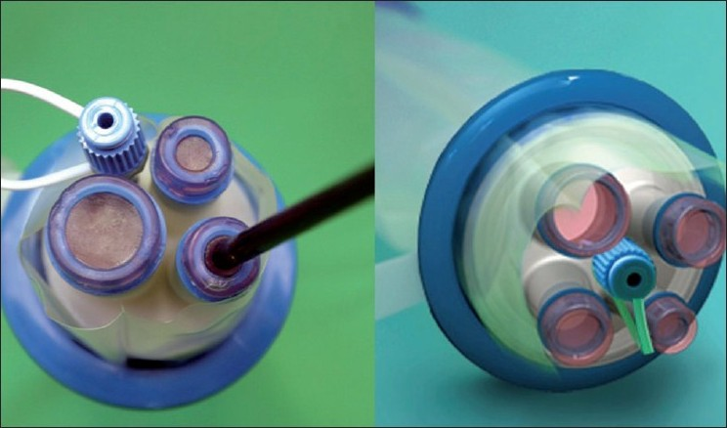

Figure 2 QuadPort+ (Olimpus) port system.

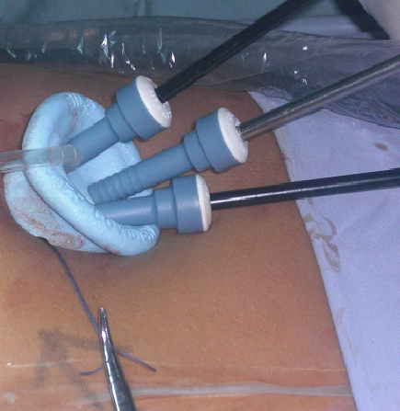
Figure 3 Single incision laparoscopic surgery (Covidien, Tyco Health care) port system.

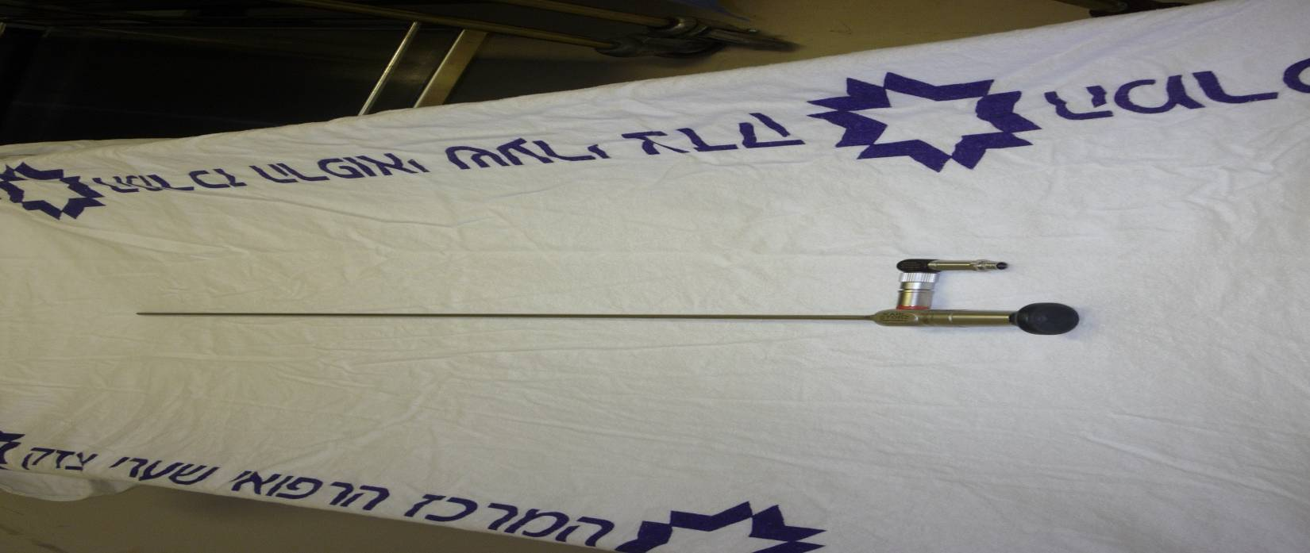
Figure 4 Sixty cm, 5-mm telescope with right-angle light cord adapter (Karl Storz).
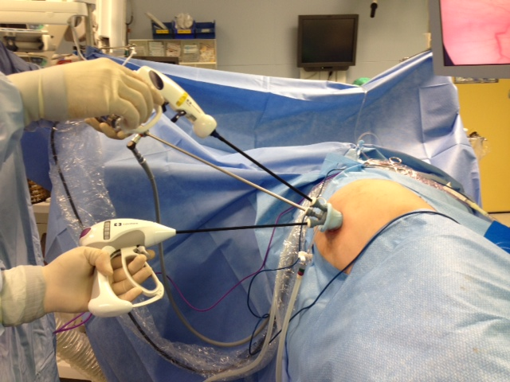
Figure 5 Operating field.

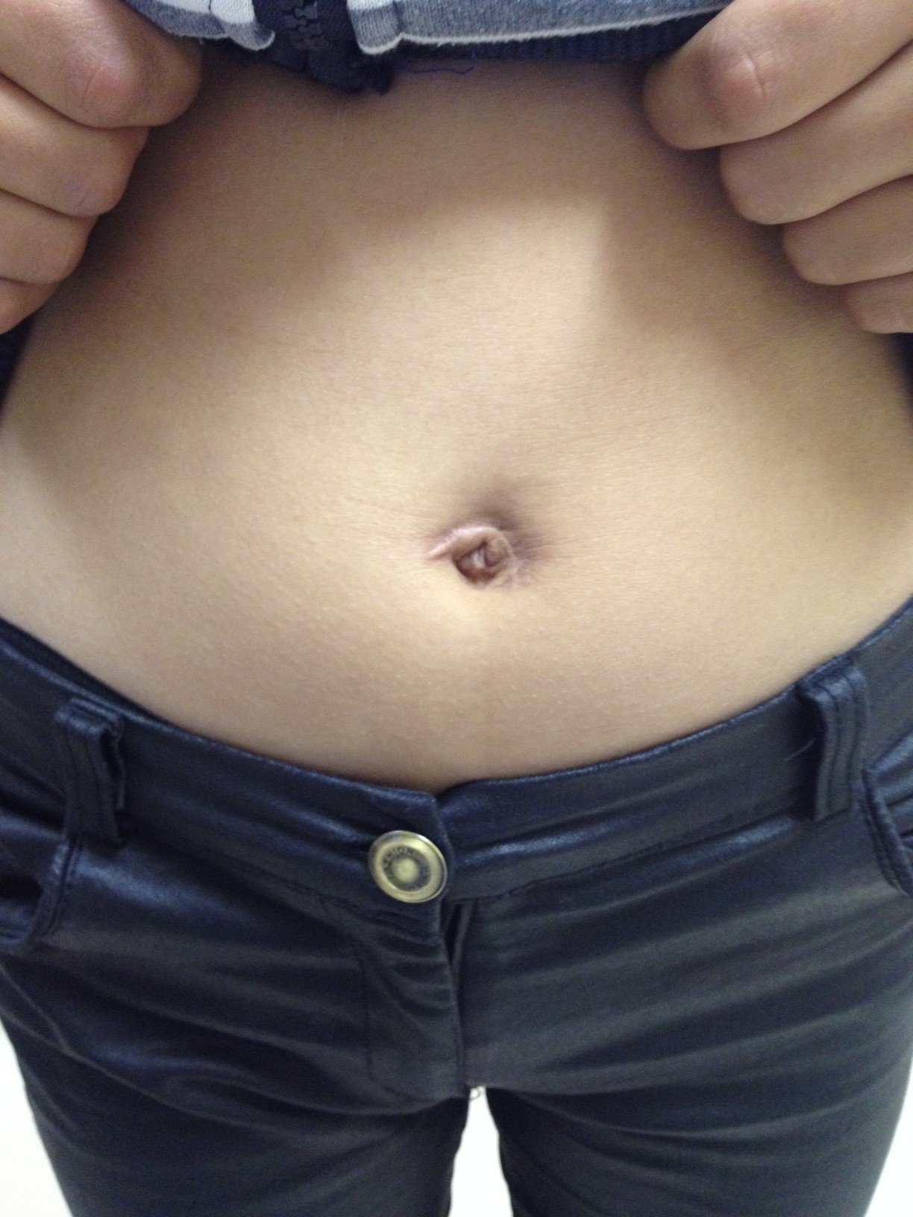
Figure 6 Final incision.

