Name of journal: World Journal of Gastroenterology
ESPS Manuscript NO: 14988
Columns: ORIGINAL ARTICLE

Retrospective Study
Factors associated with early recurrence after curative surgery for gastric cancer

Kang WM et al. Recurrence after gastric cancer surgery

Wei-Ming Kang, Qing-Bin Meng, Jian-Chun Yu, Zhi-Qiang Ma, Zhi-Tian Li

Wei-Ming Kang, Jian-Chun Yu, Zhi-Qiang Ma, Zhi-Tian Li, Department of General Surgery, Peking Union Medical College Hospital, Chinese Academy of Medical Science and Peking Union Medical College, Beijing 100730, China

Qing-Bin Meng, Department of Gastrointestinal Surgery, First Hospital of
Wu Han City, Wuhan 430022, Hubei Provence, China

Author contributions: Kang WM and Meng QB contributed equally to this work both as the first author; Kang WM, Meng QB and Yu JC designed the research; Kang WM, Meng QB and Ma ZQ performed the research; Yu JC, Ma ZQ and Li ZT analyzed the data; Kang WM, Meng QB and Li ZT wrote the paper.

Supported by grants from the Beijing Municipal Natural Science Foundation, No. 7132209; and Major Science and Technology projects in Beijing City, No. D141100000414004.

Ethics approval: The study was reviewed and approved by the Ethics Committee of Peking Union Medical College Hospital, Chinese Academy of Medical Science and Peking Union Medical College.

Informed consent: All study participants, or their legal guardian, provided informed written consent prior to study enrollment.

Conflict-of-interest: The authors have no conflicts of interest to declare.

Data sharing: No additional data are available.

Open-Access: This article is an open-access article which was selected by an in-house editor and fully peer-reviewed by external reviewers. It is distributed in accordance with the Creative Commons Attribution Non Commercial (CC BY-NC 4.0) license, which permits others to distribute, remix, adapt, build upon this work non-commercially, and license their derivative works on different terms, provided the original work is properly cited and the use is non-commercial. See: http://creativecommons.org/licenses/by-nc/4.0/

Correspondence to: Jian-Chun Yu, MD, Department of General Surgery, Peking Union Medical College Hospital, Chinese Academy of Medical Science and Peking Union Medical College, No.1 Shuai Fu Yuan, Dongcheng District, 100730 Beijing, China. yu-jch@163.com
Telephone: +86-10-69152213
Fax: +86-10-69152213
Received: November 2, 2014
Peer-review started: November 2, 2014
First decision: November 27, 2014
Revised: January 7, 2015
Accepted: February 5, 2015

Article in press:
Published online:

Abstract
AIM: To characterize patterns of gastric cancer recurrence and patient survival and to identify predictors of early recurrence after surgery.

METHODS: Clinicopathological data of 417 consecutive patients who underwent curative resection for gastric cancer were retrospectively analyzed. Tumor and node status were reclassified according to the 7th edition of the American Joint Committee on Cancer tumor-node-metastasis classification for carcinoma of the stomach. Survival data came from both the patients’ follow-up records and telephone follow-ups. Recurrent gastric cancer was diagnosed based on clinical imaging, gastroscopy with biopsy, and/or cytological examination of ascites, or intraoperative findings in patients who underwent reoperation. Predictors of early recurrence were compared in patients with pT1 and pT2–4a stage tumors. Pearson’s χ² test and Fisher’s exact test were used to compare differences between categorical variables. Survival curves were constructed using the Kaplan–Meier method and compared via the log-rank test. Variables identified as potentially important for early recurrence using univariate analysis were determined by multivariate logistic regression analysis.

RESULTS: Of 417 gastric cancer patients, 80 (19.2%) were diagnosed with early gastric cancer and the remaining 337 (80.8%) were diagnosed with locally advanced gastric cancer. After a median follow-up period of 56 months, 194 patients (46.5%) experienced recurrence. The mean time from curative surgery to recurrence in these 194 patients was 24 ± 18 mo (range, 1-84 mo). Additionally, of these 194 patients, 129 (66.5%) experienced recurrence within 2 years after surgery. There was no significant difference in recurrence patterns between early and late recurrence (P < 0.05 each). For pT1 stage gastric cancer, tumor size (P = 0.011) and pN stage (P = 0.048) were associated with early recurrence of pT1 stage gastric tumors. Patient age, pT stage, pN stage, Lauren histotype, lymphovascular invasion, intraoperative chemotherapy, and postoperative chemotherapy were independent predictors of early recurrence in patients with pT2–4a stage gastric cancers (P < 0.05 each).

CONCLUSION: Age, pT stage, pN stage, Lauren histotype, lymphovascular invasion, intraoperative chemotherapy, and postoperative chemotherapy are independent factors influencing early recurrence of pT2-4a stage gastric cancer.

Key words: Stomach neoplasms; Gastrectomy; D2 lymphadenectomy; Recurrence; Chemotherapy

© The Author(s) 2015. Published by Baishideng Publishing Group Inc. All rights reserved.

Core tip: Few studies have assessed recurrence patterns or predictors of early recurrence after curative surgery in Chinese patients with gastric carcinoma. This study found that survival after gastric cancer recurrence was poor. Large tumor size and advanced pN stage was associated with early recurrence of tumor pT1 stage tumors. Age, pT stage, pN stage, Lauren histotype, lymphovascular invasion, intraoperative chemotherapy, and postoperative chemotherapy were independent predictors of early recurrence of pT2-4a stage tumors.

Kang WM, Meng QB, Yu JC, Ma ZQ, Li ZT. Factors associated with early recurrence after curative surgery for gastric cancer. World J Gastroenterol 2015; In press

INTRODUCTION
Although it has declined somewhat, the overall age-standardized incidence of gastric cancer in China in 2009 was 17.85 per 100000 persons^{[1,2]}. Despite improvements in diagnostic procedures and the introduction of multimodal treatment strategies, patient survival remains dismal owing to early recurrence originating from minimal residual disease^{[3-8]}. More than 70% of recurrences and tumor-related deaths occur within 2 years after surgery^{[9-11]}, with tumor recurrence being the leading cause of death in patients who undergo curative surgery for gastric cancer.
Although several studies have sought to identify clinicopathological factors that predict early recurrence, their methodologies and definitions of early gastric cancer vary^{[11-13]}. Few studies to date have focused on patterns and timing of recurrence, or on predictors of early recurrence, after curative surgery in Chinese patients.
Multimodal treatments, including intraoperative and/or postoperative chemotherapy, have been used for some patients undergoing D2 gastrectomy for locally advanced gastric cancer^{[14]}. However, little is known about the effects of intraoperative and postoperative chemotherapy on early recurrence of gastric cancer. This study therefore retrospectively analyzed patterns and timing of recurrence in patients who underwent curative surgery for gastric cancer. Clinicopathological factors and therapeutic modalities significantly associated with early recurrence were identified to develop appropriate treatments and follow-up programs.

MATERIALS AND METHODS
Patients
Between January 2002 and February 2008, 516 patients with gastric adenocarcinoma underwent radical gastrectomy and D2 lymphadenectomy in the Department of General Surgery, Peking Union Medical College Hospital (PUMCH), Chinese Academy of Medical Science and Peking Union Medical College. Patients with gastric stump cancer (n = 7), those who received neoadjuvant chemotherapy (n = 4) or postoperative radiotherapy (n = 2), patients with incomplete or inaccurate medical records (n = 10), patients lost to follow up within 2 years after surgery (n = 68) and those who died of disease other than gastric cancer within 2 years after curative surgery (n = 8 cases) were excluded. The study therefore included a total of 417 patients. None of these patients had distant or peritoneal metastasis at the time of resection, as shown by chest X-ray or chest computed tomography (CT) scan and abdominal pelvic CT scan before surgery. Tumor (T) and node (N) status were reclassified according to the 7th edition of the American Joint Committee on Cancer (AJCC) tumor-node-metastasis (TNM) classification for carcinoma of the stomach^{[15,16]}.

Variables
Clinicopathological features and therapeutic modalities reviewed included sex, age at diagnosis, tumor size, Lauren histotype (intestinal or diffuse-mixed type)^{[17,18]}, lymphovascular invasion, AJCC pT stage of the primary tumor, AJCC pN stage, intraoperative chemotherapy and postoperative chemotherapy.

Treatments
All patients in this study underwent curative (R0) resection and D2 lymphadenectomy as primary treatment^{[19,20]}. Of the 80 patients with early gastric cancer (pT1), 20 (25%) received intraoperative chemotherapy, and 3 (2 pT1N1M0 and 1 pT1N2M0) received six cycles of postoperative adjuvant chemotherapy. Of the 337 patients with locally advanced gastric cancer (pT2–4a), 190 (56.4%) received intraoperative chemotherapy, and 246 (73%) received postoperative adjuvant chemotherapy, with 200 (81.3%) of the latter completing at least six cycles.
Intraoperative chemotherapy consisted of intravenously administration of epirubicin 20 mg/m², leucovorin 200 mg, 5-fluorouracil (5-FU) 600 mg/m² (maximum ≤ 1000 mg), and mitomycin 5 mg/m² (maximum ≤ 10 mg).
Three main postoperative adjuvant chemotherapy regimens were used: XELOX^{[21]} (2-h iv infusion of oxaliplatin 130 mg/m² on day 1 and oral capecitabine 1000 mg/m² twice daily on days 1–14, with cycles every 21 d); FOLFOX4^{[22]} (iv infusion of oxaliplatin 85 mg/m² on day 1, leucovorin 200 mg/m² as a 2-h infusion followed by bolus injection of 5-FU 400 mg/m² on days 1, 2, and 22-h continuous iv infusion of 5-FU 600 mg/m² on days 1, 2, every 2 wk for at least six cycles); and FOLFOX6^{[23]} (iv infusion of oxaliplatin 100 mg/m² on day 1, leucovorin 200 mg/m2 as a 2-h infusion followed by bolus injection of 5-FU 400 mg/m² on day 1, and 46-h continuous iv infusion of 5-FU 3000 mg/m² starting on day 1, every 2 wk for at least six cycles).

Follow up
All patients were followed up regularly from the date of surgery to death, emigration, or February 10, 2012, whichever came first. Survival data was obtained from both patients’ follow-up records and telephone follow-up. History and physical examinations were routinely performed every 3–6 mo for the first 3 years and every 6–12 mo thereafter. CT examinations were performed at least twice a year for the first 2 years, and annually thereafter. Gastroscopy with or without biopsy was performed every 1–2 years.
Recurrent gastric cancer was diagnosed based on clinical imaging, gastroscopy with biopsy, and/or cytological examination of ascites, or intraoperative findings in patients who underwent reoperation. Recurrences were classified as locoregional, hematogenous, peritoneal or distant lymphatic, according to the sites of relapse.

Statistical analysis

Categorical variables were compared using Pearson’s χ² tests and Fisher’s exact tests. Variables differing significantly on univariate analysis were included in multivariate models of logistic regression analysis. Survival curves were constructed using the Kaplan–Meier method and compared by the log-rank test. Multicollinearity, defined as a tolerance < 0.1, was diagnosed by the linear regression model. All analyses were performed using SPSS 12.0 (SPSS, Chicago, Illinois, USA). The prognostic powers of covariates were expressed by calculating odds ratios (ORs) and 95% confidence internals (CIs). All P values were two-sided and P values < 0.05 were considered statistically significant.
The study was approved by the Ethics Committee of PUMCH, Chinese Academy of Medical Science and Peking Union Medical College, Beijing, China.

RESULTS
Of the 417 patients included in the current study, 80 (19.2%) were diagnosed with early gastric cancer and 337 (80.8%) with locally advanced gastric cancer. The median follow-up time of all 417 patients was 56 mo (range 3–117 mo), during which gastric cancer recurrence was detected in 194 patients (46.5%), with 184 patients dying of gastric cancer recurrence. Ten patients with recurrence remained alive after the end of follow-up. In contrast, nine of 223 patients without recurrence died of other diseases within 2 years after surgery, with the other 214 patients remaining alive without recurrence during follow-up.
The mean time from curative surgery to recurrence in the 194 patients with recurrence was 24 ± 18 mo (range, 1–84 mo), with 129 (66.5%) of these patients experience recurrence within 2 years (Figure 1). Those 129 patients were classified as the early recurrence group, whereas the late/no recurrence group was defined as patients who lived without recurrence for more than 2 years after surgery.

Patterns of initial recurrence
Of the 194 patients with recurrence, 99 (51.0%) experienced locoregional recurrence, 86 had peritoneal dissemination (44.3%), 77 (39.7%) showed hematogenous metastases, and 11 (5.7%) had distant lymphatic recurrence (Table 1). Of the 129 patients with early recurrence, 56 (43.4%) had hematogenous recurrence, 59 (45.7%) had peritoneal recurrence, and 68 (52.7%) had locoregional recurrence. Recurrence patterns did not differ significantly in patients with early and late recurrence (Table 1).

Survival time after recurrence
Median survival after recurrence in all patients with recurrence was 6 months (95%CI: 5.32–6.68 mo), 5 mo (95%CI: 6.01–7.92 mo) in patients with early recurrence and 7 mo (95%CI: 4.21–5.80 mo) in patients with late recurrence (log rank test, P﹦0.045) (Figure 2).

Factors predictive of early recurrence
Of the 80 patients with early gastric cancer, 4 (5.0%) experienced early recurrence, as did 125 of the 337 patients (37.1%) with advanced gastric cancer. Analysis of predictors of early recurrence in patients with early gastric cancer (pT1) showed that larger tumor size (P = 0.011) and advanced AJCC pN stage (P = 0.048) were significantly associated with early recurrence (Table 2). Univariate analyses of clinicopathological factors predictive of recurrence in patients with locally advanced gastric cancer showed that age at diagnosis, tumor size, Lauren histotype, lymphovascular invasion, AJCC pT stage, AJCC pN stage, intraoperative systemic chemotherapy, and postoperative chemotherapy were significantly associated with early recurrences (Table 3). Multivariate analysis showed that age at diagnosis (P = 0.033), AJCC pT stage (P < 0.001), AJCC pN stage (P < 0.001), Lauren histotype (P < 0.001), lymphovascular invasion (P = 0.011), intraoperative chemotherapy (P < 0.001), and postoperative chemotherapy (P = 0.007) were independent predictors of early recurrence, whereas gender was not (Table 4).
All tolerance values of significant factors were greater than 0.1.

DISCUSSION
Many studies have reported that approximately 70% of patients with gastric cancer experience early tumor recurrence, defined as within 2 years after surgery^{[9,11,24]}. Less is known, however, about patterns of recurrence and predictors of early recurrence, especially in Chinese patients. This study therefore investigated recurrence patterns and factors predicting early recurrence in patients undergoing curative surgery for gastric cancer.
In agreement with earlier findings^{[9,11]}, we found that most recurrences (129/194, 66.5%) were early, occurring within 2 years after curative surgery. The three main types of early recurrence were hematogenous (56/129, 43.4%), peritoneal (59/129, 45.7%), and locoregional (68/129, 52.7%). Patients with early recurrence had more liver metastases than patients with late recurrence (32.6% vs 20.0%), although the difference was not significant (P = 0.067). No other differences in recurrence patterns were observed between the early and late recurrence groups. As previously reported^{[12]}, survival after recurrence was poor, especially in patients with early recurrence.
Because 66.5% of recurrences occurred within 2 years after surgery and this study focused on factors associated with early recurrence, clinicopathologic characteristics were compared in patients with and without early recurrence within 2 years after surgery.
Age, lymphatic metastasis and submucosal invasion have been reported to be significantly associated with recurrence of gastric cancer^{[25]}. In the current study, only 5% (4/80) of patients with early gastric cancer experienced early recurrence. Although larger tumor size and advanced AJCC pN stage were found to be significantly associated with early recurrence in this group, the number of patients was small, indicating that these results require further validation.
The early recurrence rate was significantly higher in patients with locally advanced than early gastric cancer. Age at diagnosis, AJCC pT stage, AJCC pN stage, Lauren histotype, lymphovascular invasion, intraoperative chemotherapy, and postoperative chemotherapy were found to be independent factors influencing timing of recurrence in patients who underwent curative surgery for locally advanced gastric cancer. No obvious multicollinearity was observed among these factors.
Interestingly, we found that more patients in the late- and non-recurrence groups received intraoperative chemotherapy than did patients in the early recurrence group, with intraoperative chemotherapy found to be an independent predictor of early recurrence [hazard ratio (HR) = 0.327, P < 0.001]. Most previous studies of intraoperative chemotherapy assessed only patients who received hyperthermic intraperitoneal chemotherapy, not intravenous chemotherapy, although intravenous 5-FU during surgery for advanced gastric cancer was first administered in 1987^{[26,27]}. A randomized controlled clinical trial is required to confirm the benefits of intraoperative chemotherapy.
The current study also found that postoperative chemotherapy was an independent predictor of early recurrence (HR = 0.423, P < 0.007). Results of both the the Capecitabine and oxaliplatin Adjuvant Study in Stomach Cancer and the Adjuvant Chemotherapy Trial of TS-1 for Gastric Cancer trials suggested that FU-based adjuvant therapy improves survival of patients with gastric cancer following gastrectomy combined with D2 lymphadenectomy^{[28-31]}. However, another study found that adjuvant chemotherapy was not a significant predictor of the timing of recurrence^{[12]}. Further evaluation is necessary to assess the effect of adjuvant chemotherapy on early recurrence.
The main limitations of this study were its retrospective nature and relatively small sample size.
In summary, this retrospective study found that larger tumor size and advanced AJCC pN stage were significantly associated with early recurrence of early gastric cancer; whereas age at diagnosis, AJCC pT stage, AJCC pN stage, Lauren histotype, and lymphovascular invasion were all independent predictors of early recurrence in patients undergoing curative surgery for locally advanced gastric cancer. Chemotherapy, both intraoperative and postoperative, was associated with early recurrence of gastric carcinoma. Patients with gastric cancer should be closely monitored and actively followed-up for at least 2 years after surgery.

COMMENTS
Background
Tumor recurrence is the leading cause of death in patients who undergo curative surgery for gastric cancer. Few studies have assessed the patterns and timing of recurrence or predictors of early recurrence following surgery in Chinese patients. This retrospective study analyzed patterns and timing of recurrence in patients who underwent curative surgery for gastric cancer, and identified clinicopathological factors and therapeutic modalities, especially intraoperative chemotherapy, significantly associated with early recurrence, in order to develop appropriate treatments and follow-up programs.

Research frontiers
This study was based on the experience of a large single center with intraoperative chemotherapy, curative surgery and postoperative chemotherapy for gastric cancer. Factors correlated with early recurrence were analyzed.

Innovations and breakthroughs
Intraoperative chemotherapy, as well as postoperative chemotherapy, age, pT stage, pN stage, Lauren histotype, and lymphovascular invasion were found to be independent predictors of early recurrence of pT2-4a stage gastric cancer .

Applications
Intraoperative chemotherapy combined with postoperative chemotherapy may reduce rates of early recurrence in patients with locally advanced gastric cancer.

Peer-review
This manuscript identified predictors of early recurrence after curative surgery and characterized patterns of recurrence and survival after gastric cancer recurrence. The study was very well designed and interesting.

REFERENCES
1 Chen W, Zheng R, Zhang S, Zhao P, Li G, Wu L, He J. Report of incidence and mortality in China cancer registries, 2009. Chin J Cancer Res 2013; 25: 10-21 [PMID: 23372337 DOI: 10.3978/j.issn.1000-9604.2012.12.04]
2 Chen W, Zheng R, Zhang S, Zhao P, Li G, Wu L, He J. The incidences and mortalities of major cancers in China, 2009. Chin J Cancer 2013; 32: 106-112 [PMID: 23452393 DOI: 10.5732/cjc.013.10018]
3 Zou ZH, Zhao LY, Mou TY, Hu YF, Yu J, Liu H, Chen H, Wu JM, An SL, Li GX. Laparoscopic vs open D2 gastrectomy for locally advanced gastric cancer: a meta-analysis. World J Gastroenterol 2014; 20: 16750-16764 [PMID: 25469048 DOI: 10.3748/wjg.v20.i44.16750]
4 Seeliger H, Spatz H, Jauch KW. Minimal residual disease in gastric cancer. Recent Results Cancer Res 2003; 162: 79-87 [PMID: 12790323]
5 Ubukata H, Motohashi G, Tabuchi T, Nagata H, Konishi S, Tabuchi T. Overt bone metastasis and bone marrow micrometastasis of early gastric cancer. Surg Today 2011; 41: 169-174 [PMID: 21264750 DOI: 10.1007/s00595-010-4389-7]
6 Zhang ZY, Dai ZL, Yin XW, Li SH, Li SP, Ge HY. Meta-analysis shows that circulating tumor cells including circulating microRNAs are useful to predict the survival of patients with gastric cancer. BMC Cancer 2014; 14: 773 [PMID: 25330717 DOI: 10.1186/1471-2407-14-773]
7 Ito H, Inoue H, Kimura S, Ohmori T, Ishikawa F, Gohda K, Sato J. Prognostic impact of the number of viable circulating cells with high telomerase activity in gastric cancer patients: a prospective study. Int J Oncol 2014; 45: 227-234 [PMID: 24788213 DOI: 10.3892/ijo.2014.2409]
8 Uenosono Y, Arigami T, Kozono T, Yanagita S, Hagihara T, Haraguchi N, Matsushita D, Hirata M, Arima H, Funasako Y, Kijima Y, Nakajo A, Okumura H, Ishigami S, Hokita S, Ueno S, Natsugoe S. Clinical significance of circulating tumor cells in peripheral blood from patients with gastric cancer. Cancer 2013; 119: 3984-3991 [PMID: 23963829 DOI: 10.1002/cncr.28309]
9 Shiraishi N, Inomata M, Osawa N, Yasuda K, Adachi Y, Kitano S. Early and late recurrence after gastrectomy for gastric carcinoma. Univariate and multivariate analyses. Cancer 2000; 89: 255-261 [PMID: 10918153]
10 Marrelli D, De Stefano A, de Manzoni G, Morgagni P, Di Leo A, Roviello F. Prediction of recurrence after radical surgery for gastric cancer: a scoring system obtained from a prospective multicenter study. Ann Surg 2005; 241: 247-255 [PMID: 15650634]
11 Chiang CY, Huang KH, Fang WL, Wu CW, Chen JH, Lo SS, Hsieh MC, Shen KH, Li AF, Niu DM, Chiou SH. Factors associated with recurrence within 2 years after curative surgery for gastric adenocarcinoma. World J Surg 2011; 35: 2472-2478 [PMID: 21879421 DOI: 10.1007/s00268-011-1247-8]
12 Eom BW, Yoon H, Ryu KW, Lee JH, Cho SJ, Lee JY, Kim CG, Choi IJ, Lee JS, Kook MC, Park SR, Nam BH, Kim YW. Predictors of timing and patterns of recurrence after curative resection for gastric cancer. Dig Surg 2010; 27: 481-486 [PMID: 21063125 DOI: 10.1159/000320691]
13 Lee SE, Lee JH, Ryu KW, Nam B, Kim CG, Park SR, Kook MC, Kim YW. Changing pattern of postoperative body weight and its association with recurrence and survival after curative resection for gastric cancer. Hepatogastroenterology 2012; 59: 430-435 [PMID: 22353511 DOI: 10.5754/hge09218]
14 Meng QB, Yu JC, Ma ZQ, Kang WM, Zhou L, Ye X. Benefits of intra-operative systemic chemotherapy during curative surgery in patients with locally advanced gastric cancer. Chin Med J (Engl) 2013; 126: 3493-3498 [PMID: 24034096 DOI: 10.3760/cma.j.issn.0366-6999.20120379]
15 Washington K. 7th edition of the AJCC cancer staging manual: stomach. Ann Surg Oncol 2010; 17: 3077-3079 [PMID: 20882416 DOI: 10.1245/s10434-010-1362-z]
16 Zhang J, Zhou Y, Jiang K, Shen Z, Ye Y, Wang S. Evaluation of the seventh AJCC TNM staging system for gastric cancer: a meta-analysis of cohort studies. Tumour Biol 2014; 35: 8525-8532 [PMID: 24696259 DOI: 10.1007/s13277-014-1848-6]
17 Lauren P. The two histological main types of gastric carcinoma: diffuse and so-called intestinal-type carcinoma. An attempt at a histo-clinical classification. Acta Pathol Microbiol Scand 1965; 64: 31-49 [PMID: 14320675]
18 Patel SH, Kooby DA. Gastric adenocarcinoma surgery and adjuvant therapy. Surg Clin North Am 2011; 91: 1039-1077 [PMID: 21889029 DOI: 10.1016/j.suc.2011.06.009]
19 Waddell T, Verheij M, Allum W, Cunningham D, Cervantes A, Arnold D; European Society for Medical Oncology (ESMO); European Society of Surgical Oncology (ESSO); European Society of Radiotherapy and Oncology (ESTRO). Gastric cancer: ESMO-ESSO-ESTRO clinical practice guidelines for diagnosis, treatment and follow-up. Eur J Surg Oncol 2014; 40: 584-591 [PMID: 24685156 DOI: 10.1016/j.ejso.2013.09.020]
20 Japanese Gastric Cancer Association. Japanese gastric cancer treatment guidelines 2010 (ver. 3). Gastric Cancer 2011; 14: 113-123 [PMID: 21573742 DOI: 10.1007/s10120-011-0042-4]
21 Orditura M, Galizia G, Sforza V, Gambardella V, Fabozzi A, Laterza MM, Andreozzi F, Ventriglia J, Savastano B, Mabilia A, Lieto E, Ciardiello F, De Vita F. Treatment of gastric cancer. World J Gastroenterol 2014; 20: 1635-1649 [PMID: 24587643 DOI: 10.3748/wjg.v20.i7.1635]
22 Wang X, Wang Y, Qiu M, Li Q, Li ZP, He B, Xu F, Shen YL, Gou HF, Yang Y, Cao D, Yi C, Liu JY, Luo DY, Liao ZY, Bi F. Postoperative chemoradiotherapy in gastric cancer: a phase I study of radiotherapy with dose escalation of oxaliplatin, 5-fluorouracil, and leucovorin (FOLFOX regimen). Med Oncol 2011; 28 Suppl 1: S274-S279 [PMID: 21116880 DOI: 10.1007/s12032-010-9741-7]
23 Wu Y, Wei ZW, He YL, Schwarz RE, Smith DD, Xia GK, Zhang CH. Efficacy of adjuvant XELOX and FOLFOX6 chemotherapy after D2 dissection for gastric cancer. World J Gastroenterol 2013; 19: 3309-3315 [PMID: 23745033 DOI: 10.3748/wjg.v19.i21.3309]
24 Sakar B, Karagol H, Gumus M, Basaran M, Kaytan E, Argon A, Ustuner Z, Bavbek SE, Bugra D, Aykan FN. Timing of death from tumor recurrence after curative gastrectomy for gastric cancer. Am J Clin Oncol 2004; 27: 205-209 [PMID: 15057162]
25 Wu B, Wu D, Wang M, Wang G. Recurrence in patients following curative resection of early gastric carcinoma. J Surg Oncol 2008; 98: 411-414 [PMID: 18767119 DOI: 10.1002/jso.21133]
26 Lelcuk S, Klausner JM, Inbar M, Kaplan O, Merhav A, Rozin RR. Gastrointestinal anastomotic healing during treatment with perioperative 5-fluorouracil. Am J Clin Oncol 1987; 10: 317-319 [PMID: 3618543]
27 Yan TD, Black D, Sugarbaker PH, Zhu J, Yonemura Y, Petrou G, Morris DL. A systematic review and meta-analysis of the randomized controlled trials on adjuvant intraperitoneal chemotherapy for resectable gastric cancer. Ann Surg Oncol 2007; 14: 2702-2713 [PMID: 17653801]
28 Bang YJ, Kim YW, Yang HK, Chung HC, Park YK, Lee KH, Lee KW, Kim YH, Noh SI, Cho JY, Mok YJ, Kim YH, Ji J, Yeh TS, Button P, Sirzén F, Noh SH. Adjuvant capecitabine and oxaliplatin for gastric cancer after D2 gastrectomy (CLASSIC): a phase 3 open-label, randomised controlled trial. Lancet 2012; 379: 315-321 [PMID: 22226517 DOI: 10.1016/S0140-6736(11)61873-4]
29 Noh SH, Park SR, Yang HK, Chung HC, Chung IJ, Kim SW, Kim HH, Choi JH, Kim HK, Yu W, Lee JI, Shin DB, Ji J, Chen JS, Lim Y, Ha S, Bang YJ; CLASSIC trial investigators. Adjuvant capecitabine plus oxaliplatin for gastric cancer after D2 gastrectomy (CLASSIC): 5-year follow-up of an open-label, randomised phase 3 trial. Lancet Oncol 2014; 15: 1389-1396 [PMID: 25439693 DOI: 10.1016/S1470-2045(14)70473-5]
30 Sakuramoto S, Sasako M, Yamaguchi T, Kinoshita T, Fujii M, Nashimoto A, Furukawa H, Nakajima T, Ohashi Y, Imamura H, Higashino M, Yamamura Y, Kurita A, Arai K. Adjuvant chemotherapy for gastric cancer with S-1, an oral fluoropyrimidine. N Engl J Med 2007; 357: 1810-1820 [PMID: 17978289]
31 Sasako M, Sakuramoto S, Katai H, Kinoshita T, Furukawa H, Yamaguchi T, Nashimoto A, Fujii M, Nakajima T, Ohashi Y. Five-year outcomes of a randomized phase III trial comparing adjuvant chemotherapy with S-1 versus surgery alone in stage II or III gastric cancer. J Clin Oncol 2011; 29: 4387-4393 [PMID: 22010012 DOI: 10.1200/JCO.2011.36.5908]
P-Reviewer: Bell E, Ozdemir O S-Editor: Yu J L-Editor: E-Editor:

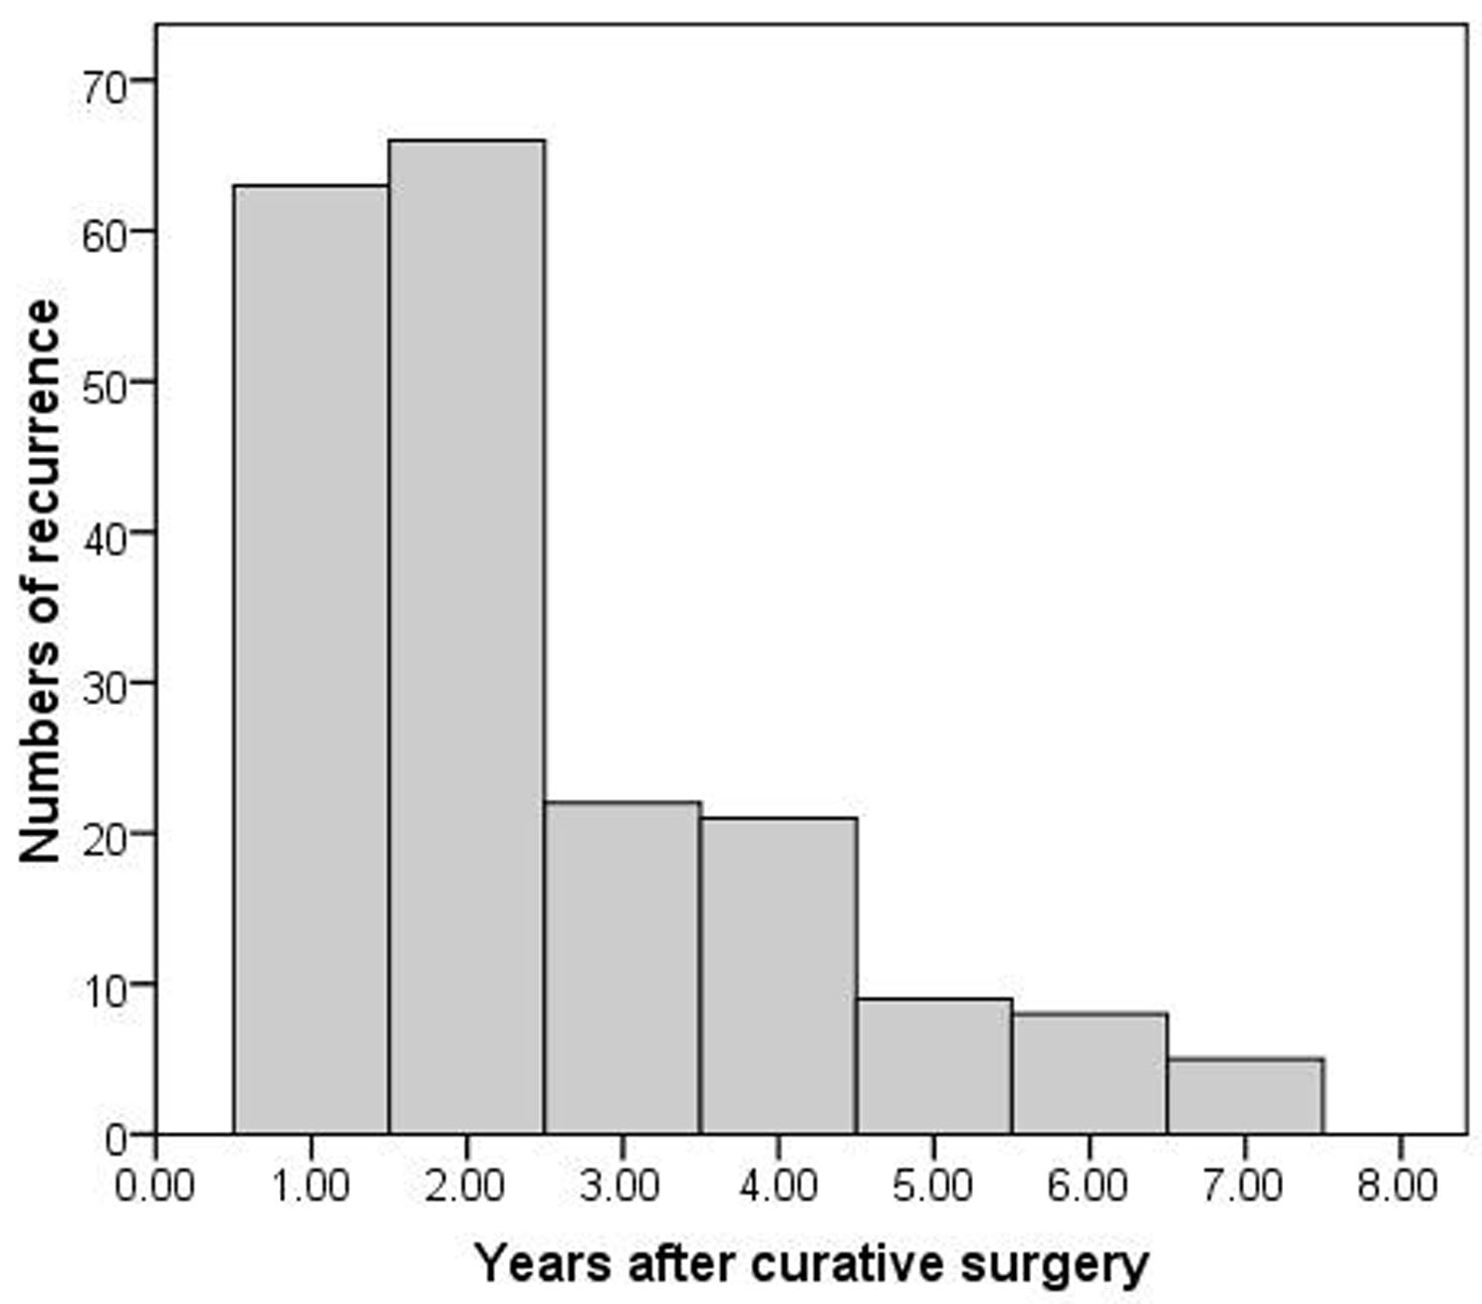
Figure 1 Number of patients in this study dying of recurrent gastric cancer per year. Most recurrences (129/194, 66.5%) occurred within 2 years (early recurrence).

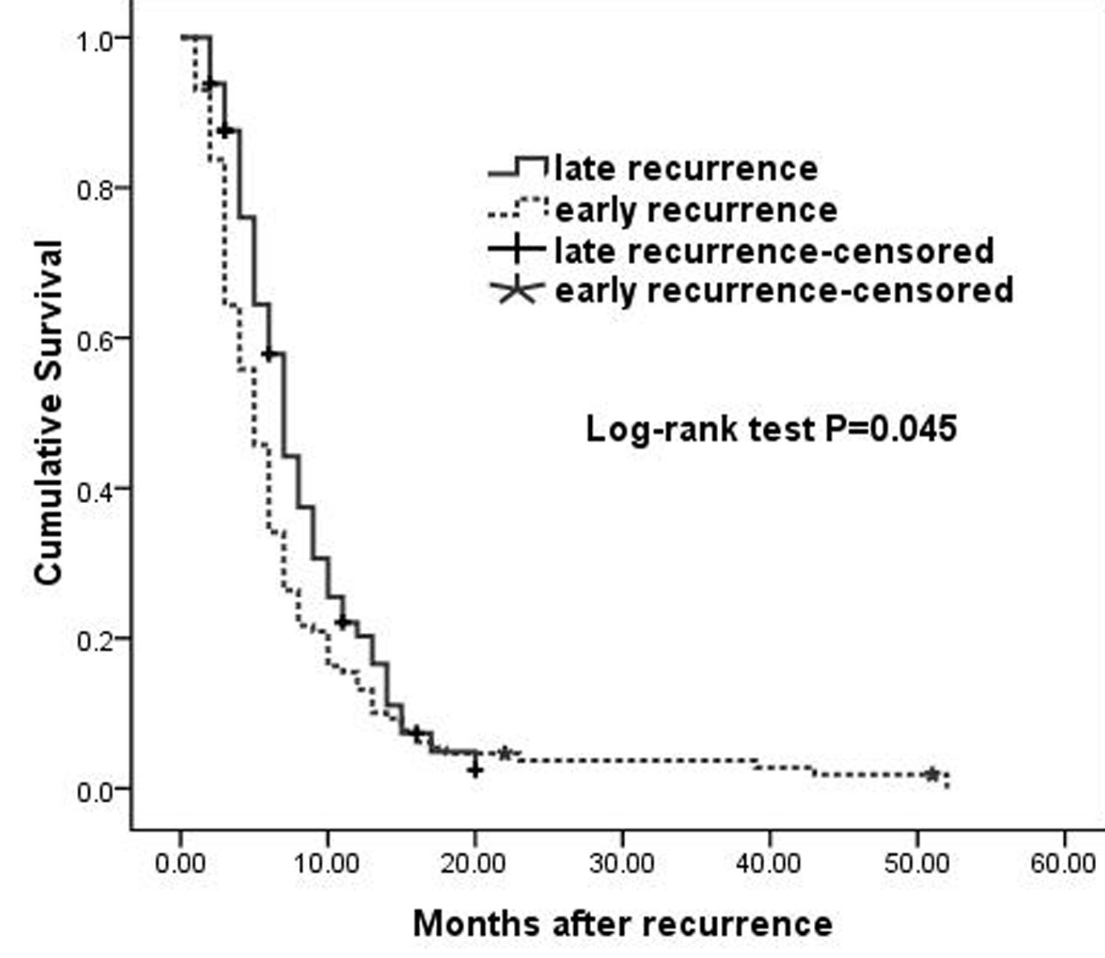
Figure 2 Survival after recurrence. Survival was significantly poorer in patients with early than late recurrence of gastric cancer (P = 0.045).

Table 1 Initial recurrence patterns in the 194 patients with recurrence n (%)
Patterns | Total recurrence  n = 194 (100.0) | Early recurrence  n = 129 (66.5) | Late recurrence  n = 65 (33.5) | P value
Hematogenous recurrence | 77 (39.7) | 56 (43.4) | 21 (32.3) | 0.136
Liver | 55 (28.4) | 42 (32.6) | 13 (20.0) | 0.067
Lung | 16 (8.2) | 10 (7.8) | 6 (9.2) | 0.724
Bone | 14 (7.2) | 8 (6.2) | 6 (9.2) | 0.442
Brain | 3 (1.5) | 2 (1.6) | 1 (1.5) | 0.995
Locoregional recurrence | 99 (51.0) | 68 (52.7) | 31 (47.7) | 0.509
Remnant stomach | 10 (5.2) | 6 (4.7) | 4 (6.2) | 0.734
Anastomosis | 32 (16.5) | 25 (19.4) | 7 (10.8) | 0.127
Perigastric area | 40 (20.6) | 27 (20.9) | 13 (20.0) | 0.880
Peripancreatic area | 13 (6.7) | 10 (7.8) | 3 (4.6) | 0.410
Abdominal wall | 2 (1.6) | 2 (1.9) | 0 (0.0) | 0.313
Local lymph node | 34 (17.5) | 27 (20.9) | 7 (10.8) | 0.079
Peritoneal recurrence | 86 (44.3) | 59 (45.7) | 27 (41.5) | 0.579
Distant lymphatic recurrence | 11 (5.7) | 7 (5.4) | 4 (6.2) | 1.000
Virchow’s node | 6 (3.1) | 4 (3.1) | 2 (3.1) | 1.000
Inguinal lymph node | 1 (0.5) | 0 (0.0) | 1 (1.5) | 0.335
Mediastinal lymph node | 3 (1.5) | 2 (1.6) | 1 (1.5) | 1.000
Para-aortic lymph node | 2 (1.0) | 2 (1.6) | 0 (0.0) | 0.552
P values were evaluated by Pearson’s χ² test or Fisher’s exact test, as appropriate. Some patients experienced initial recurrence at multiple sites.

Table 2 Univariate analysis of factors predicting early recurrence in patients with early gastric cancer n (%)
Variables | Early recurrence  n = 4 | Late/no recurrence  n = 76 | Univariate analysis  P value
Gender |  |  | 0.623
Women | 1 (25.0) | 35 (46.1)
Men | 3 (75.0) | 41 (53.9)
Age at diagnosis (yr) |  |  | 0.646
≤ 60 | 3 (75.0) | 45 (59.2)
> 60 | 1 (25.0) | 31 (40.8)
Tumor size (cm) |  |  | 0.011
≤ 5.0 | 2 (50.0) | 74 (97.4)
> 5.0 | 2 (50.0) | 2(2.6)
Lauren histotype |  |  | 0.646
Intestinal | 3 (75.0) | 45 (59.2)
Diffuse-mixed | 1 (25.0) | 31 (40.8)
Lymphovascular invasion |  |  | < 0.144
Present | 1 (25.0) | 2 (2.6)
Absent | 3 (75.0) | 74 (97.4)
pT stage |  |  | < 0.639
pT1a | 2 (50.0) | 47 (61.8)
pT1b | 2 (50.0) | 29 (38.2)
pN stage |  |  | 0.048
N0 | 2 (50.0) | 70 (92.1)
N1, N2 | 2 (50.0) | 6 ( 7.9)
Intraoperative chemotherapy |  |  | 1.000
Yes | 1 (25.0) | 19 (25.0)
No | 3 (75.0) | 57 (75.0)
P values were evaluated by Fisher’s exact test.

Table 3 Univariate analysis of factors predicting early recurrence in patients with locally advanced gastric cancer n (%)
Variables | Early recurrence  n = 125 | Late/no recurrence  n = 212 | Univariate analysis  P value
Gender |  |  | 0.683
Women | 41 (32.8) | 65 (30.7)
Men | 84 (67.2) | 147 (69.3
Age at diagnosis (yr) |  |  | 0.016
≤ 60 | 52 (41.6) | 117(55.2)
> 60 | 73 (58.4) | 95 (44.8)
Tumor size (cm) |  |  | 0.019
≤ 5.0 | 76 (60.8) | 155 (73.1)
> 5.0 | 49 (392) | 57 (26.9)
Lauren histotype |  |  | 0.016
Intestinal | 85 (68.0) | 169 (79.7)
Diffuse-mixed | 40 (32.0) | 43 (20.3)
Lymphovascular invasion |  |  | < 0.001
Present | 21 (16.8) | 9 (4.2)
Absent | 104 (83.2) | 203 (95.8)
pT stage |  |  | < 0.001
pT2, pT3 | 30 (24.0) | 105 (49.5)
pT4a | 95 (76.0) | 107 (50.5)
pN stage |  |  | < 0.001
N0 | 13 (10.4) | 82 (38.7)
N1 | 25 (20.0) | 52 (24.5)
N2 | 30 (24.0) | 46 (21.7)
N3 | 57 (45.6) | 32 (15.1)
Intraoperative chemotherapy |  |  | < 0.001
Yes | 54 (43.2) | 136 (64.2)
No | 71 (56.8) | 76 (35.8)
Postoperative chemotherapy |  |  | 0.036
No | 42 (33.6) | 49 (23.1)
5-FU-based regimen | 83 (66.4) | 163 (76.9)
P values were evaluated by Pearson’s χ² test.

Table 4 Multivariate analysis of factors predicting early recurrence by binary logistic regression model
Factors | P value | Odds Ratio | 95%CI
A Age at diagnosis | 0.033 | 1.813 | 1.050–3.131
pT pT stage | < 0.001 | 2.865 | 1.603–5.123
pN stage | < 0.001
N0 |  | 1.00 (reference)
N1 | 0.001 | 4.029 | 1.708–9.500
N2 | 0.001 | 4.425 | 1.889-10.365
N3 | < 0.001 | 9.860 | 4.314-22.536
Lauren histotype | < 0.001 | 3.492 | 1.810–6.736
Lymphovascular invasion | 0.011 | 3.460 | 1.335–8.969
Intraoperative chemotherapy | < 0.001 | 0.327 | 0.190–0.564
Postoperative chemotherapy | 0.007 | 0.423 | 0.225–0.793
The constant of the model was −2.087 (standard error 0.468).

