Name of Journal: World Journal of Gastrointestinal Endoscopy
Manuscript NO: 66547
Manuscript Type: CASE REPORT

Small bowel perforation from a migrated biliary stent: a case report and review of literature

Zorbas KA et al. Small bowel perforation from a migrated biliary stent

Konstantinos A Zorbas, Shane Ashmeade, William Lois, Daniel T Farkas

Konstantinos A Zorbas, Shane Ashmeade, William Lois, Daniel T Farkas, Department of Surgery, Bronx Care Health System, New York, NY 10457, United States

Author contributions: All the authors have seen and approved this manuscript and contributed equally to the final submission.

Corresponding author: Konstantinos A Zorbas, MD, Doctor, Department of Surgery, Bronx Care Health System, 1650 Grand Concourse, New York, NY 10457, United States. zorbasko@gmail.com

Received: March 30, 2021
Revised: July 10, 2021
Accepted: September 8, 2021
Published online: October 16, 2021

Abstract
BACKGROUND
Bowel perforation from biliary stent migration is a serious potential complication of biliary stents, but fortunately has an incidence of less than 1%.

CASE SUMMARY
We report a case of a 54-year-old Caucasian woman with a history of Human Immunodeficiency virus with acquired immunodeficiency syndrome, chronic obstructive pulmonary disease, alcoholic liver cirrhosis, portal vein thrombosis and extensive past surgical history who presented with acute abdominal pain and local peritonitis. On further evaluation she was diagnosed with small bowel perforation secondary to migrated biliary stents and underwent exploratory laparotomy with therapeutic intervention.

CONCLUSION
This case presentation reports on the unusual finding of two migrated biliary stents, with one causing perforation. In addition, we review the relevant literature on migrated stents.

Key Words: Biliary stent; Biliary stent migration; Small bowel perforation; Endoscopic retrograde cholangiopancreatography; Case report

©The Author(s) 2021. Published by Baishideng Publishing Group Inc. All rights reserved.

Citation: Zorbas KA, Ashmeade S, Lois W, Farkas DT. Small bowel perforation from a migrated biliary stent: A case report and review of literature. World J Gastrointest Endosc 2021; 13(10): 543-554
URL: https://www.wjgnet.com/1948-5190/full/v13/i10/543.htm
DOI: https://dx.doi.org/10.4253/wjge.v13.i10.543

Core Tip: Bowel perforation from biliary stent migration is a serious potential complication of biliary stents, but fortunately has an incidence of less than 1%. From this review of literature, we can see that most common types of migrated stents entailing bowel perforation are the plastic stents and the most common site of perforation is duodenum. A significant finding is the mortality after bowel perforation from biliary stent which is as high as 10.3%. The main treatment is surgical stent removal, but a growing body of literature shows that endoscopic removal and mucosal repair is feasible in select cases. This has still not been accomplished in the mid portion of the bowel.

INTRODUCTION
Endoscopic biliary stents placement is a well-established therapeutic intervention in the era of modern medicine. It has been used either for temporary or permanent decompression of biliary system, for benign or malignant diseases. Biliary stents are classified by material into two categories: plastic and metallic stents, with the former being less expensive and easier to remove or change^{[1]}. However, this technologically advanced treatment has not been free from complications. The complication rate ranges between 8% and 10% and serious common complications are stent occlusion, cholangitis, bleeding, pancreatitis, duodenal perforation and stent migration^{[2]}. Biliary stent migration is well known with a rate of 5%-10% and can be either proximal or distal^{[2]}.
A serious potential consequence of stent migration is bowel perforation which can happen at any part of the small or large bowel, but fortunately has an incidence of less than 1%^{[3,4]}. The majority of the case reports with bowel perforation secondary to migrated biliary stent describe duodenal or colonic perforations, with very few cases of small bowel perforations. Herein we report a case of a patient with multiple comorbidities and surgical interventions, who presents with two migrated biliary stents, one of which was perforating through the small bowel. Both stents were removed uneventfully with laparotomy and a single small bowel resection.

CASE PRESENTATION
Chief complaints
Diffuse abdominal pain.

History of present illness
We present the case of a 54-year-old Caucasian female, who presented in the emergency department of our hospital with diffuse abdominal pain for one week, which had become severe in the last day.

History of past illness
She initially presented in October 2019 with hyperbilirubinemia. At the time she had an ultrasound that showed gallstones as well as a dilated common bile duct of 10 mm. She underwent an magnetic resonance cholangiopacreatography (MRCP) which showed an 8mm duct, but no definite filling defects. Following this she underwent a diagnostic ERCP, at which time a distal stricture was noted, and a plastic stent [7 French (Fr) 7 cm single external and single internal flap] was placed. A second ERCP was done in February 2020, at which time choledocholithiasis was identified and felt to be the cause of the stricture. At that time a new plastic stent was placed (8.5 Fr 7 cm). The original stent was not seen at that time. In August 2020 she went for another ERCP at which time she had a normal cholangiogram, and the stent was not seen at that time. She presented to our Emergency Department in November 2020.

Personal and family history
Her past medical history was significant for human immunodeficiency virus (HIV) infection with acquired immunodeficiency syndrome, chronic obstructive pulmonary disease, alcoholic liver cirrhosis, and portal vein thrombosis. Her past surgical history was significant for colectomy with end ileostomy for toxic megacolon from Clostridium difficile, followed later by a re-exploration and ileorectal anastomosis with proximal diverting loop ileostomy, which was still in place.

Physical examination
On initial evaluation the patient had temperature 98.2 °F (36.7 °C), pulse 87 per minute, blood pressure 115/83 mmHg. Her clinical examination revealed diffuse abdominal tenderness and focal peritonitis in the left lower quadrant of the abdomen.

Laboratory examinations
From laboratory evaluation the patient had WBC 6.1 k/μL and total bilirubin 0.7 mg/dL.

Imaging examinations
Computed tomography (CT) scan of the abdomen and pelvis with intravenous contrast showed two migrated biliary stents. The first was in an ileal loop and was perforating through the bowel wall into the mesentery (Figure 1A) and a second stent within a mid-jejunal loop (Figure 1B, C). The CT scan showed significant surrounding inflammatory phlegmon, but no free air or focal abscess was noted. After discussion with the patient, it was decided to proceed with surgical treatment of the bowel perforation and removal of both biliary stents.

MULTIDISCIPLINARY EXPERT CONSULTATION
The gastroenterology team was consulted, and they agreed with surgical exploration.

FINAL DIAGNOSIS
Small bowel perforation from a migrated biliary stent.

TREATMENT
The patient underwent a laparotomy at which time extensive adhesions were noted. The bowel was cocooned in most of the abdomen, with multiple interloop adhesions, as well as adhesions to the abdominal wall. The segment of bowel with the perforation was planned for resection due to the extensive inflammation. The second stent was milked within the bowel lumen to the area of the first stent, and both stents were removed in a single resection, after which a primary anastomosis was done. As a result of the extensive adhesions, and the urgent nature of the surgery, the right upper quadrant was not explored at this time. On detailed examination of the specimen, the resected small bowel had hypertrophic changes of the luminal mucosa at the internal opening of the perforation track (Figures 2, 3).

OUTCOME AND FOLLOW-UP
The patient had an uneventful recovery and she was discharged eight days later to a rehab facility.

DISCUSSION
Endoscopic placement of stents in common bile duct of pancreatic duct has been an important scientific achievement of modern medicine and is a frequently employed method to relieve either benign or malignant stenosis/obstruction of biliary or pancreatic tract. It was first described in 1980 by Soehandra et al^{[5]} as an alternative method of decompressing the biliary system for high risk or inoperable cases instead of surgical choledochoduodenostomy. After the first description of endoscopic biliary stent placement, the whole procedure and the available stents have been significantly improved and the popularity of this technique is gradually increasing as it constitutes a less morbid intervention comparing to a surgical operation^{[6]}. Despite its clear benefit and the significant improvements in this field, there is always the risk of significant complications during or after endoscopic procedures like upper endoscopy and biliary tract cannulation.
Well described complications of biliary stent placement include stent occlusion by clogging with possible subsequent cholecystitis or cholangitis, pancreatitis from duct manipulation, hemorrhage, stent fracture and stent migration^{[1,2,6,7]}. The total rate of biliary stent complications varies among different institutes because of different level of experience, different available equipment and different etiologic reasons for the intervention. According to Arhan et al^{[2]} the complication rete for biliary stents is between 8% and 10%. Stent migration rate ranges from 5% to 10%, with the migration rates in plastic stents higher compared to others^{[2,7,8]}. Biliary stent migration can be further categorized into proximal and distal migration. Distally migrated stents usually pass through the bowel without any complication^{[1,9]}. In our case the patient had multiple previous laparotomies which led to adhesions, thereby making the bowel less mobile. This led to an increased likelihood that the stent would get impacted and not pass. In general, most institutions have policies in place to make sure all stent patients are called back for stent removal, including our own. At the last ERCP there was a normal cholangiogram and the stent was no longer in place. It was felt to have migrated, but without symptoms the impression was that it had completely passed through and eliminated from the GI tract safely. In retrospect an X-ray or further imaging at that time would have been helpful.
Bowel perforation from a migrated stent is a serious complication, which can occur in any part of the small or large bowel. The vast majority of reported cases with bowel perforation from migrated biliary stent describe either duodenal perforation or large bowel perforation, with very few cases of small bowel perforation. Most patients with perforation will present with diffuse peritonitis and signs of sepsis. In our patient, we believe the amount of infection was limited by the perforation happening slowly over time, and her septic response was also blunted by her HIV with a low CD4 count.
A growing body of literature exists on this topic and different treatment approaches have been proposed. Diller et al^{[10]} reported a case series of stent migration necessitating surgical intervention in 2003. The size of the stents varied between 7 and 14 Fr and the lengths ranged from 7 to 12 cm. Two patients had Polyurethane stents, one patient had Teflon stent placement and the other two patients had metallic stents. The diagnosis was biliary obstruction from acute pancreatitis in 4 patients and the fifth patient received a prophylactic stent after liver transplantation. One of those five patients died from postoperative respiratory failure. In this study they reported a stent migration rate of 3.7% among 987 patients. Namdar et al^{[1]} reported a case of rectal perforation from migrated biliary stent and review of literature with 12 cases in total and 7 cases from 2000. Several studies have shown that downstream migration is more frequent in benign than in malignant biliary disease, with the possible explanation being the resolution of the stenosis after regression of inflammation^{[1]}. In addition, they state that any migrated biliary stent should be removed immediately regardless of the patient’s clinical status^{[1]}. An early growing body of literature describes endoscopic techniques for treatment of bowel perforation from migrated stent, but the majority focus on duodenal perforation or distal large bowel perforation. Bureau et al^{[11]} recently described a case series of six patients with lateral duodenal wall perforation from displaced plastic biliary stent that were treated with over-the-scope clip. Given that in our case the bowel perforation was in a mid-jejunal loop, the endoscopic approach was less feasible. In addition, there was already significant inflammation seen around the bowel on CT scan, and we were concerned that an endoscopic mucosal repair would not hold. As such, we proceeded directly to surgery.
We performed a systematic review of literature from 2000 until 2020 for bowel perforation from migrated biliary stents and we found 81 cases (Table 1). Eligible articles were identified by a search of MEDLINE bibliographical database (last search: July 4th, 2021) using the following search algorithm: (("intestinal perforation"[MeSH Terms] OR ("intestinal"[All Fields] AND "perforation"[All Fields]) OR "intestinal perforation"[All Fields] OR ("bowel"[All Fields] AND "perforation"[All Fields]) OR "bowel perforation"[All Fields]) AND ("migrate"[All Fields] OR "migrated"[All Fields] OR "migrates"[All Fields] OR "migrating"[All Fields] OR "migration"[All Fields] OR "migrational"[All Fields] OR "migrations"[All Fields] OR "migrator"[All Fields] OR "migrators"[All Fields]) AND "biliary"[All Fields] AND ("stent s"[All Fields] OR "stentings"[All Fields] OR "stents"[MeSH Terms] OR "stents"[All Fields] OR "stent"[All Fields] OR "stented"[All Fields] OR "stenting"[All Fields])) AND (2000:2020[pdat]). Further search was performed in the references of related articles and relative articles with our topic were included. Manuscripts with full text available online were used and E-Videos, E-pictures and not English manuscripts were excluded. Cases were also excluded if there was not full text available online. Wang et al^{[3]} in 2020 reported three cases of duodenal perforation due to biliary stent migration and performed a review of literature of duodenal perforation from migrated stents. In this study they reported that duodenal perforation from migrated biliary stents are mainly caused by distal stent migration^{[3]}. Kawaguchi et al^{[12]} studied 396 patients with bile duct stenosis between June 2003 and March 2009, retrospectively examined the frequency of stent migration and analyzed the patient factors and stent characteristics. They found that potential risk factors for stent migration are stent with large diameter, straight-type stents, stent duration > 1 mo, and common bile duct diameter > 10 mm^{[12]}.
In our review of literature (Table 1) there were 39 (50%) of male gender, 35 (44.9%) of female gender and 4 (5.1%) patients with missing data. The mean age of the total population was 66 (± 15.5) and the median 67 (IQR-56-77.5). The majority of patients had a plastic stent (93.6%). The stent length ranged from 5 to 15 cm and the stent size from 5 to 14 Fr. However, the majority of patients (50%) had a stent of 10 Fr or 12 Fr size. From the total population 35 patients (44.9%) had duodenal perforation, 23 patients (29.5%) had large bowel perforation, 18 patients (23.1%) had small bowel perforation, one patient had bile duct perforation and the last patient had no available information regarding the site of perforation. From the whole cohort, 47 patients (60.3%) had surgical intervention, 27 patients (34.6%) had endoscopic removal of the stent and 3 patients (3.8) had percutaneous removal of the stent. The overall mortality among the 54 patients was 8 patients (10.1%). Finally, the distribution of case reports was 38 (48.7%) from Europe, 21 (26.9%) from Asia-Middle East, 12 (15.4%) from the United States, 5 (6.4%) from Australia and 2 (2.6%) from South America.

CONCLUSION
From this review of literature, we can see that most common types of migrated stents entailing bowel perforation are the plastic stents and the most common site of perforation is duodenum. A significant finding is the mortality after bowel perforation from biliary stent which is as high as 10.3%. The main treatment is surgical stent removal, but a growing body of literature shows that endoscopic removal and mucosal repair is feasible in select cases. This has still not been accomplished in the mid portion of the bowel, however this might be an area for future innovation and research.

REFERENCES
1 Namdar T, Raffel AM, Topp SA, Namdar L, Alldinger I, Schmitt M, Knoefel WT, Eisenberger CF. Complications and treatment of migrated biliary endoprostheses: a review of the literature. World J Gastroenterol 2007; 13: 5397-5399 [PMID: 17879415 DOI: 10.3748/wjg.v13.i40.5397]
2 Arhan M, Odemiş B, Parlak E, Ertuğrul I, Başar O. Migration of biliary plastic stents: experience of a tertiary center. Surg Endosc 2009; 23: 769-775 [PMID: 18649099 DOI: 10.1007/s00464-008-0067-x]
3 Wang X, Qu J, Li K. Duodenal perforations secondary to a migrated biliary plastic stent successfully treated by endoscope: case-report and review of the literature. BMC Gastroenterol 2020; 20: 149 [PMID: 32398025 DOI: 10.1186/s12876-020-01294-z]
4 Johanson JF, Schmalz MJ, Geenen JE. Incidence and risk factors for biliary and pancreatic stent migration. Gastrointest Endosc 1992; 38: 341-346 [PMID: 1607087 DOI: 10.1016/s0016-5107(92)70429-5]
5 Soehendra N, Reynders-Frederix V. Palliative bile duct drainage - a new endoscopic method of introducing a transpapillary drain. Endoscopy 1980; 12: 8-11 [PMID: 7353562 DOI: 10.1055/s-2007-1021702]
6 Güngör G, Okur N. A Fatal Complication: Intestinal Perforation Secondary to Migration of a Biliary Stent. Pol J Radiol 2016; 81: 170-172 [PMID: 27141238 DOI: 10.12659/PJR.896231]
7 Yilmaz Ö, Kiziltan R, Aydin O, Bayrak V, Kotan Ç. A Rare Complication of Biliary Stent Migration: Small Bowel Perforation in a Patient with Incisional Hernia. Case Rep Surg 2015; 2015: 860286 [PMID: 26273488 DOI: 10.1155/2015/860286]
8 Görich J, Rilinger N, Krämer S, Aschoff AJ, Vogel J, Brambs HJ, Sokiranski R. Displaced metallic biliary stents: technique and rationale for interventional radiologic retrieval. AJR Am J Roentgenol 1997; 169: 1529-1533 [PMID: 9393158 DOI: 10.2214/ajr.169.6.9393158]
9 Garg K, Zagzag J, Khaykis I, Liang H. Surgical relief of small bowel obstruction by migrated biliary stent: extraction without enterotomy. JSLS 2011; 15: 232-235 [PMID: 21902982 DOI: 10.4293/108680811X13071180406998]
10 Diller R, Senninger N, Kautz G, Tübergen D. Stent migration necessitating surgical intervention. Surg Endosc 2003; 17: 1803-1807 [PMID: 14508668 DOI: 10.1007/s00464-002-9163-5]
11 Bureau MA, Gkolfakis P, Blero D, Pezzullo M, Devière J, Lemmers A. Lateral duodenal wall perforation due to plastic biliary stent migration: a case series of endoscopic closure. Endosc Int Open 2020; 8: E573-E577 [PMID: 32355873 DOI: 10.1055/a-1123-7782]
12 Kawaguchi Y, Ogawa M, Kawashima Y, Mizukami H, Maruno A, Ito H, Mine T. Risk factors for proximal migration of biliary tube stents. World J Gastroenterol 2014; 20: 1318-1324 [PMID: 24574806 DOI: 10.3748/wjg.v20.i5.1318]
13 Størkson RH, Edwin B, Reiertsen O, Faerden AE, Sortland O, Rosseland AR. Gut perforation caused by biliary endoprosthesis. Endoscopy 2000; 32: 87-89 [PMID: 10691280 DOI: 10.1055/s-2000-87]
14 Rosés LL, Ramirez AG, Seco AL, Blanco ES, Alonso DI, Avila S, Lopez BU. Clip closure of a duodenal perforation secondary to a biliary stent. Gastrointest Endosc 2000; 51: 487-489 [PMID: 10744829 DOI: 10.1016/s0016-5107(00)70454-8]
15 Distefano M, Bonanno G, Russo A. Biliocutaneous fistula following biliary stent migration. Endoscopy 2001; 33: 97 [PMID: 11204999 DOI: 10.1055/s-2001-17404]
16 Pathak KA, de Souza LJ. Duodenocolic fistula: an unusual sequela of stent migration. Endoscopy 2001; 33: 731 [PMID: 11490393 DOI: 10.1055/s-2001-16220]
17 Mistry BM, Memon MA, Silverman R, Burton FR, Varma CR, Solomon H, Garvin PJ. Small bowel perforation from a migrated biliary stent. Surg Endosc 2001; 15: 1043 [PMID: 11443435 DOI: 10.1007/s004640041008]
18 Liebich-Bartholain L, Kleinau U, Elsbernd H, Büchsel R. Biliary pneumonitis after proximal stent migration. Gastrointest Endosc 2001; 54: 382-384 [PMID: 11522987 DOI: 10.1067/mge.2001.113646]
19 Jendresen MB, Svendsen LB. Proximal displacement of biliary stent with distal perforation and impaction in the pancreas. Endoscopy 2001; 33: 195 [PMID: 11272227 DOI: 10.1055/s-2001-11920]
20 Figueiras RG, Echart MO, Figueiras AG, González GP. Colocutaneous fistula relating to the migration of a biliary stent. Eur J Gastroenterol Hepatol 2001; 13: 1251-1253 [PMID: 11711785 DOI: 10.1097/00042737-200110000-00021]
21 Fiori E, Mazzoni G, Galati G, Lutzu SE, Cesare A, Bononi M, Bolognese A, Tocchi A. Unusual breakage of a plastic biliary endoprosthesis causing an enterocutaneous fistula. Surg Endosc 2002; 16: 870 [PMID: 11997843 DOI: 10.1007/s004640042021]
22 Levey JM. Intestinal perforation in a parastomal hernia by a migrated plastic biliary stent. Surg Endosc 2002; 16: 1636-1637 [PMID: 12085152 DOI: 10.1007/s00464-002-4506-9]
23 Wilhelm A, Langer C, Zoeller G, Nustede R, Becker H. Complex colovesicular fistula: A severe complication caused by biliary stent migration. Gastrointest Endosc 2003; 57: 124-126 [PMID: 12518151 DOI: 10.1067/mge.2003.71]
24 Basile A, Macri' A, Lamberto S, Caloggero S, Versaci A, Famulari C. Duodenoscrotal fistula secondary to retroperitoneal migration of an endoscopically placed plastic biliary stent. Gastrointest Endosc 2003; 57: 136-138 [PMID: 12518156 DOI: 10.1067/mge.2003.37]
25 Cerisoli C, Diez J, Giménez M, Oria M, Pardo R, Pujato M. Implantation of migrated biliary stents in the digestive tract. HPB (Oxford) 2003; 5: 180-182 [PMID: 18332981 DOI: 10.1080/13651820310015301]
26 Elliott M, Boland S. Sigmoid colon perforation following a migrated biliary stent. ANZ J Surg 2003; 73: 669-670 [PMID: 12887548 DOI: 10.1046/j.1445-2197.2003.02698.x]
27 Blake AM, Monga N, Dunn EM. Biliary stent causing colovaginal fistula: case report. JSLS 2004; 8: 73-75 [PMID: 14974669]
28 Miller G, Yim D, Macari M, Harris M, Shamamian P. Retroperitoneal perforation of the duodenum from biliary stent erosion. Curr Surg 2005; 62: 512-515 [PMID: 16125609 DOI: 10.1016/j.cursur.2005.03.011]
29 Paikos D, Gatopoulou A, Moschos J, Soufleris K, Tarpagos A, Katsos I. Migrated biliary stent predisposing to fatal ERCP-related perforation of the duodenum. J Gastrointestin Liver Dis 2006; 15: 387-388 [PMID: 17205153]
30 Bharathi RS, Rao PP, Ghosh K. Intra-peritoneal duodenal perforation caused by delayed migration of endobiliary stent: a case report. Int J Surg 2008; 6: 478-480 [PMID: 19059151 DOI: 10.1016/j.ijsu.2006.06.012]
31 Akimboye F, Lloyd T, Hobson S, Garcea G. Migration of endoscopic biliary stent and small bowel perforation within an incisional hernia. Surg Laparosc Endosc Percutan Tech 2006; 16: 39-40 [PMID: 16552378 DOI: 10.1097/01.sle.0000202198.74569.5a]
32 Lanteri R, Naso P, Rapisarda C, Santangelo M, Di Cataldo A, Licata A. Jejunal perforation for biliary stent dislocation. Am J Gastroenterol 2006; 101: 908-909 [PMID: 16635240 DOI: 10.1111/j.1572-0241.2006.00509.x]
33 Hsu YC, Wu YM, Wang HP. Education of imaging. Hepatobiliary and pancreatic: biliary stent causing imminent duodenal perforation. J Gastroenterol Hepatol 2008; 23: 817 [PMID: 18410612 DOI: 10.1111/j.1440-1746.2008.05335.x]
34 Yaprak M, Mesci A, Colak T, Yildirim B. Biliary stent migration with duodenal perforation. Eurasian J Med 2008; 40: 154-156 [PMID: 25610053]
35 Lo CH, Chung S, Bohmer RD. A devastating complication: duodenal perforation due to biliary stent migration. Surg Laparosc Endosc Percutan Tech 2008; 18: 608-610 [PMID: 19098671 DOI: 10.1097/SLE.0b013e318185a07a]
36 Seerden TC, Moreels TG, Salgado RA, Francque SM, Michielsen PP, Parizel PM, Pelckmans PA. Intestinal bowel perforation and bacterial peritonitis secondary to migrated biliary and pancreatic stents. Endoscopy 2008; 40 Suppl 2: E25 [PMID: 18278716 DOI: 10.1055/s-2007-966961]
37 Brinkley M, Wible BC, Hong K, Georgiades C. Colonic perforation by a percutaneously displaced biliary stent: report of a case and a review of current practice. J Vasc Interv Radiol 2009; 20: 680-683 [PMID: 19339202 DOI: 10.1016/j.jvir.2009.02.005]
38 Culnan DM, Cicuto BJ, Singh H, Cherry RA. Percutaneous retrieval of a biliary stent after migration and ileal perforation. World J Emerg Surg 2009; 4: 6 [PMID: 19183489 DOI: 10.1186/1749-7922-4-6]
39 Akbulut S, Cakabay B, Ozmen CA, Sezgin A, Sevinc MM. An unusual cause of ileal perforation: report of a case and literature review. World J Gastroenterol 2009; 15: 2672-2674 [PMID: 19496201 DOI: 10.3748/wjg.15.2672]
40 Papadopoulou I, Fotiadis NI, Ahmed I, Thurley P, Hutchins RR, Fotheringham T. Perforation and abscess formation after radiological placement of a retrievable plastic biliary stent. J Med Case Rep 2011; 5: 103 [PMID: 21401933 DOI: 10.1186/1752-1947-5-103]
41 Lankisch TO, Alten TA, Lehner F, Knitsch W. Biliary stent migration with colonic perforation: a very rare complication and the lesson that should be learned from it. Gastrointest Endosc 2011; 74: 924-5; discussion 925 [PMID: 21951480 DOI: 10.1016/j.gie.2011.06.011]
42 Malgras B, Pierret C, Tourtier JP, Olagui G, Nizou C, Duverger V. Double Sigmoid colon perforation due to migration of a biliary stent. J Visc Surg 2011; 148: e397-e399 [PMID: 22075561 DOI: 10.1016/j.jviscsurg.2011.09.011]
43 Abela JE, Anderson JE, Whalen HR, Mitchell KG. Endo-biliary stents for benign disease: not always benign after all! Clin Pract 2011; 1: e102 [PMID: 24765343 DOI: 10.4081/cp.2011.e102]
44 Lin H, Li ZS, Zhan XB. Asymptomatic duodenal perforation from obstructed and migrated biliary stent. Endoscopy 2011; 43 Suppl 2 UCTN: E40-E41 [PMID: 21287443 DOI: 10.1055/s-0029-1244037]
45 Jafferbhoy SF, Scriven P, Bannister J, Shiwani MH, Hurlstone P. Endoscopic management of migrated biliary stent causing sigmoid perforation. BMJ Case Rep 2011; 2011 [PMID: 22696699 DOI: 10.1136/bcr.04.2011.4078]
46 Oh HC, Kim SW, Do JH, Kim G. Duodenal perforation caused by a cutting-induced sharp-edged plastic stent (with video). Gastrointest Endosc 2012; 76: 1050; discussion 1050-1050; discussion 1051 [PMID: 22902144 DOI: 10.1016/j.gie.2012.06.024]
47 Smart P, Keenan D, Campbell W, Morris-Stiff G. Duodenal perforation secondary to migration of endobiliary prosthesis. BMJ Case Rep 2012; 2012 [PMID: 23008374 DOI: 10.1136/bcr-2012-006711]
48 O'Connor R, Agrawal S, Aoun E, Kulkarni A. Biliary stent migration presenting with leg pain. BMJ Case Rep 2012; 2012 [PMID: 23162034 DOI: 10.1136/bcr-2012-007588]
49 Alcaide N, Lorenzo-Pelayo S, Herranz-Bachiller MT, de la Serna-Higuera C, Barrio J, Perez-Miranda M. Sigmoid perforation caused by a migrated biliary stent and closed with clips. Endoscopy 2012; 44 Suppl 2 UCTN: E274 [PMID: 22814918 DOI: 10.1055/s-0032-1309719]
50 Depuydt P, Aerts R, Van Steenbergen W, Verslype C, Laleman W, Cassiman D, Nevens F, Pirenne J, Monbaliu D. An unusual case of rectal perforation after liver transplantation. Acta Chir Belg 2012; 112: 232-233 [PMID: 22808766]
51 Issa H, Nahawi M, Bseiso B, Al-Salem A. Migration of a biliary stent causing duodenal perforation and biliary peritonitis. World J Gastrointest Endosc 2013; 5: 523-526 [PMID: 24147198 DOI: 10.4253/wjge.v5.i10.523]
52 Jones M, George B, Jameson J, Garcea G. Biliary stent migration causing perforation of the caecum and chronic abdominal pain. BMJ Case Rep 2013; 2013 [PMID: 24022897 DOI: 10.1136/bcr-2013-009124]
53 Saravanan MN, Mathai V, Kapoor D, Singh B. Fractured metallic biliary stent causing obstruction and jejunal perforation. Asian J Endosc Surg 2013; 6: 234-236 [PMID: 23879419 DOI: 10.1111/ases.12033]
54 El Zein MH, Kumbhari V, Tieu A, Saxena P, Messallam AA, Azola A, Li Z, Weiss M, Khashab MA. Duodenal perforation as a consequence of biliary stent migration can occur regardless of stent type or duration. Endoscopy 2014; 46 Suppl 1 UCTN: E281-E282 [PMID: 24906101 DOI: 10.1055/s-0034-1365790]
55 Chittleborough TJ, Mgaieth S, Kirkby B, Zakon J. Remove the migrated stent: sigmoid colon perforation from migrated biliary stent. ANZ J Surg 2016; 86: 947-948 [PMID: 25078878 DOI: 10.1111/ans.12796]
56 Kusters PJ, Keulen ET, Peters FP. Duodenal perforation following bile duct endoprosthesis placement. Endoscopy 2014; 46 Suppl 1 UCTN: E646-E647 [PMID: 25526406 DOI: 10.1055/s-0034-1390849]
57 Kriss M, Yen R, Fukami N, Bambha K, Wani S. Duodenal perforation secondary to migrated biliary stent in a liver transplant patient: successful endoscopic closure with an over-the-scope clip. Gastrointest Endosc 2015; 81: 1258-1259 [PMID: 25293828 DOI: 10.1016/j.gie.2014.08.003]
58 Virgilio E, Pascarella G, Scandavini CM, Frezza B, Bocchetti T, Balducci G. Colonic perforations caused by migrated plastic biliary stents. Korean J Radiol 2015; 16: 444-445 [PMID: 25741207 DOI: 10.3348/kjr.2015.16.2.444]
59 Mady RF, Niaz OS, Assal MM. Migrated biliary stent causing perforation of sigmoid colon and pelvic abscess. BMJ Case Rep 2015; 2015 [PMID: 25870211 DOI: 10.1136/bcr-2014-206805]
60 Siaperas P, Ioannidis A, Skarpas A, Angelopoulos A, Drikos I, Karanikas I. A rare cause for Hartmann's procedure due to biliary stent migration: A case report. Int J Surg Case Rep 2017; 31: 83-85 [PMID: 28122319 DOI: 10.1016/j.ijscr.2017.01.016]
61 Barakat MT, Kothari S, Banerjee S. Cut and Paste: Endoscopic Management of a Perforating Biliary Stent Utilizing Scissors and Clips. Dig Dis Sci 2018; 63: 2202-2205 [PMID: 29127608 DOI: 10.1007/s10620-017-4837-y]
62 Ferm S, Fisher C, Hassam A, Rubin M, Kim SH, Hussain SA. Primary Endoscopic Closure of Duodenal Perforation Secondary to Biliary Stent Migration: A Case Report and Review of the Literature. J Investig Med High Impact Case Rep 2018; 6: 2324709618792031 [PMID: 30116760 DOI: 10.1177/2324709618792031]
63 Ekmektzoglou K, Nikou E, Apostolopoulos P, Grigoraki D, Manesis K, Alexandrakis G. Size does matter: when a large plastic biliary stent ends up in the root of the mesentery. Clin J Gastroenterol 2019; 12: 102-105 [PMID: 30284196 DOI: 10.1007/s12328-018-0914-9]
64 Topal U, Ülkü A, Sarıtaş AG, Akçam AT. A rare complication in a liver transplant patient: Meckel diverticulum perforation due to biliary stent. Int J Surg Case Rep 2018; 53: 35-38 [PMID: 30368122 DOI: 10.1016/j.ijscr.2018.09.034]
65 Le Mouel JP, Hakim S, Thiebault H. Duodenal Perforation Caused by Early Migration of a Biliary Plastic Stent: Closure With Over-the-Scope Clip. Clin Gastroenterol Hepatol 2019; 17: e6-e7 [PMID: 29307844 DOI: 10.1016/j.cgh.2017.12.047]
66 Kim HS, Moon HJ, Lee NY, Lee HT, Woo MS, Lee JW, Jang IS, Lee KD. Endoscopic management of duodenal perforations caused by migrated biliary plastic stents. Endosc Int Open 2019; 7: E792-E795 [PMID: 31198841 DOI: 10.1055/a-0887-4200]
67 Jadallah K, Alzubi B, Sweidan A, Almanasra AR. Intraperitoneal duodenal perforation secondary to early migration of biliary stent: closure with through-the-scope clip. BMJ Case Rep 2019; 12 [PMID: 31488444 DOI: 10.1136/bcr-2019-230324]
68 Marcos P, Capelão G, Atalaia-Martins C, Clara P, Eliseu L, Vasconcelos H. Sigmoid Perforation by a Migrated Plastic Biliary Stent. GE Port J Gastroenterol 2020; 27: 215-218 [PMID: 32509931 DOI: 10.1159/000503076]
69 Riccardi M, Deters K, Jabbar F. Sigmoid Diverticulitis and Perforation Secondary to Biliary Stent Migration. Case Rep Surg 2019; 2019: 2549170 [PMID: 31236301 DOI: 10.1155/2019/2549170]
70 Tsang CLN, O'Neill RS, Joseph CM, Palasovski T. Small Bowel Perforation Secondary to Biliary Stent Migration in an Incarcerated Inguinal Hernia. Cureus 2020; 12: e7268 [PMID: 32292679 DOI: 10.7759/cureus.7268]
71 Ip CCK, Hong M. Small bowel perforation from migrated biliary stent: why did it happen? ANZ J Surg 2020; 90: 1779-1780 [PMID: 32011769 DOI: 10.1111/ans.15646]

Footnotes
Informed consent statement: Patient provided us informed consent for publication of this case report.

Conflict-of-interest statement: All authors declare that they have no known competing financial interests or personal relationships that could have appeared to influence the work reported in this paper.

CARE Checklist (2016) statement: Care checklist has been uploaded.

Open-Access: This article is an open-access article that was selected by an in-house editor and fully peer-reviewed by external reviewers. It is distributed in accordance with the Creative Commons Attribution NonCommercial (CC BY-NC 4.0) license, which permits others to distribute, remix, adapt, build upon this work non-commercially, and license their derivative works on different terms, provided the original work is properly cited and the use is non-commercial. See: http://creativecommons.org/Licenses/by-nc/4.0/

Manuscript source: Unsolicited manuscript

Corresponding Author's Membership in Professional Societies: The Society for Surgery of the Alimentary Tract.

Peer-review started: March 30, 2021
First decision: June 25, 2021
Article in press: September 8, 2021

Specialty type: Gastroenterology and hepatology
Country/Territory of origin: United States
Peer-review report’s scientific quality classification
Grade A (Excellent): 0
Grade B (Very good): B, B
Grade C (Good): C
Grade D (Fair): D, D
Grade E (Poor): 0

P-Reviewer: Gkolfakis P, Kitamura K, Kumar S, Nunes TF, Zhang WH S-Editor: Ma YJ L-Editor: A P-Editor:Guo X

Figure Legends
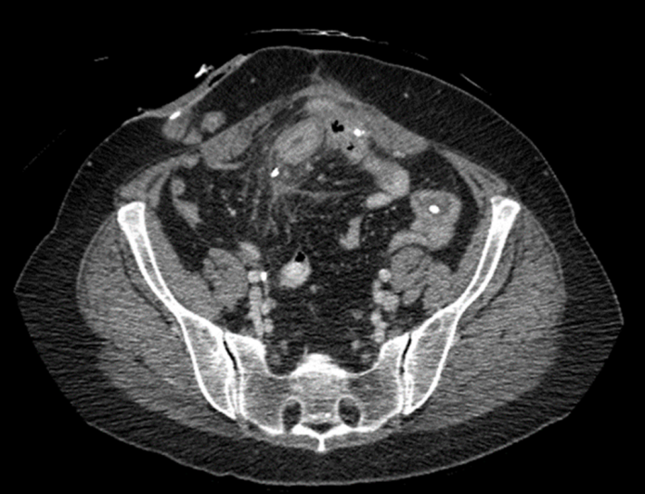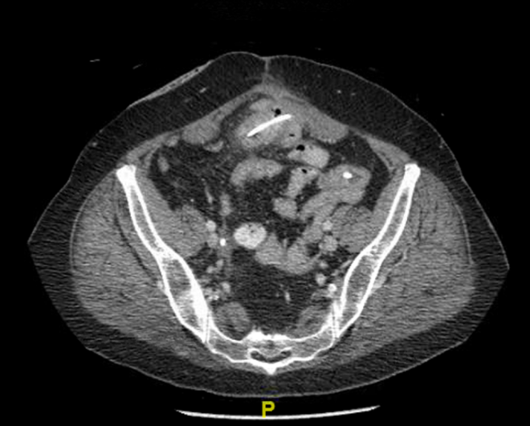
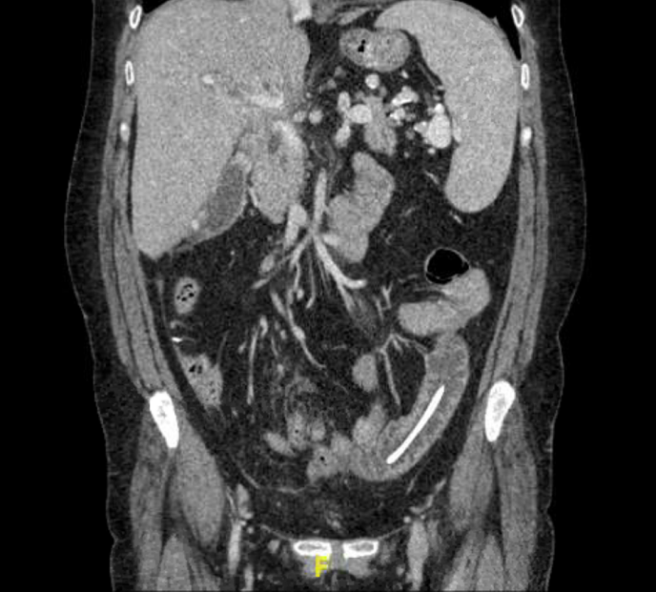
Figure 1 Computed tomography scan. A: small bowel perforation by migrated biliary stent (Axial view); B: second migrated biliary stent (Axial view); C: second migrated biliary stent (Coronal view).

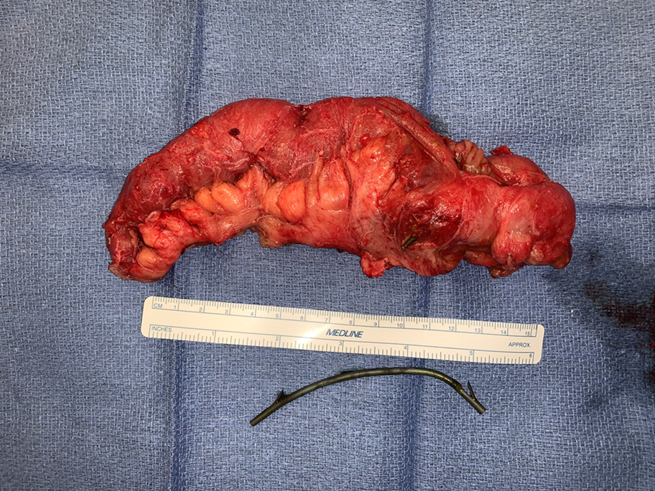
Figure 2 Small bowel segment with stent perforating through it, together with second migrated stent.
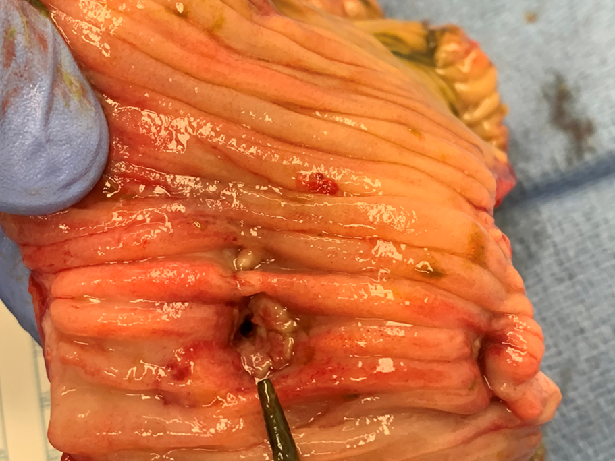
Figure 3 Internal opening of perforation.

Table 1 systematic review of literature from 2000 until 2020 for bowel perforation from migrated biliary stents
No | Year | Age, yr | Gender | Type of stent¹ | Site of perforation | Treatment | Country | Mortality | Stent length | Stent size | Ref.
1 | 2000 | 81 | M | P | SB | ST | Norway | Y | 6.5 | 10 Fr | [13]
2 | 2000 | 86 | M | P | LB | ST | Norway | N | 5 | 7 Fr | [13]
3 | 2000 | 74 | M | P | DU | ET | Spain | N | 15 | 10 Fr | [14]
4 | 2001 | 58 | M | P | DU | ET | Italy | N | 12 | 10 Fr | [15]
5 | 2001 | 43 | F | P | DU | ET | India | N | NA | 10 Fr | [16]
6 | 2001 | NA | NA | P | SB | ST | United States | N | 12 | 11.5 Fr | [17]
7 | 2001 | 88 | F | P | DU | ST | Germany | N | 10 | 7 Fr | [18]
9 | 2001 | 31 | F | NA | BD | ST | Denmark | N | NA | NA | [19]
10 | 2001 | 47 | M | P | LB | ST | Spain | N | 10 | 10 Fr | [20]
11 | 2002 | 72 | F | P | SB | ST | Italy | N | NA | 12 Fr | [21]
12 | 2002 | NA | NA | P | SB | ST | United States | N | 7 | 8.5 Fr | [22]
13 | 2003 | 85 | F | P | LB | ST | Germany | N | NA | NA | [23]
14 | 2003 | 86 | M | P | DU | ET | Italy | Y | 15 | 10 Fr | [24]
15 | 2003 | 27 | F | P | SB | ST | Germany | N | 12 | 12 Fr | [10]
16 | 2003 | 58 | M | P | LB | ET-ST | Germany | N | 10 | 7 Fr | [10]
17 | 2003 | 60 | F | P | SB | ST | Germany | N | 12 | 14 Fr | [10]
18 | 2003 | 64 | M | M | LB | ST | Germany | Y | 7 | 10 Fr | [10]
19 | 2003 | 65 | M | M | NA | ST | Germany | N | 7 | 10 Fr | [10]
20 | 2003 | 62 | F | P | LB | ST | Argentina | N | NA | 8 Fr | [25]
21 | 2003 | 62 | F | P | SB | ST | Argentina | N | NA | 5.5/10 Fr | [25]
22 | 2003 | 80 | F | P | LB | ST | Australia | N | 10 | 10 Fr | [26]
23 | 2004 | 65 | F | P | LB | ST | United States | N | NA | NA | [27]
24 | 2005 | 69 | M | M | DU | ST | United States | N | NA | NA | [28]
25 | 2006 | 55 | M | P | DU | ET | Greece | Y | NA | NA | [29]
26 | 2006 | 74 | M | P | DU | ST | India | NA | 10 | 7 Fr | [30]
27 | 2006 | 54 | F | P | SB | ST | United Kingdom | N | 7 | 10 Fr | [31]
28 | 2006 | 85 | M | P | DU | ST | Italy | N | 10 | 9 Fr | [32]
29 | 2007 | 65 | F | P | LB | ST | Germany | N | 10 | 12 Fr | [1]
30 | 2008 | 75 | M | P | DU | ST | Taiwan | N | NA | NA | [33]
31 | 2008 | 52 | F | P | DU | ST | Turkey | N | 10 | 8.5 Fr | [34]
32 | 2008 | 67 | M | P | DU | ST | Australia | Y | NA | 5/10 Fr | [35]
33 | 2008 | 43 | M | P | DU | ET | Belgium | N | NA | NA | [36]
34 | 2008 | 71 | F | P | SB | ST | Belgium | N | NA | NA | [36]
35 | 2009 | 77 | M | P | LB | PI | United States | N | 12 | 10 Fr | [37]
36 | 2009 | 76 | F | P | SB | PI | United States | N | NA | 10 Fr | [38]
37 | 2009 | 59 | F | P | SB | ST | Turkey | N | 7 | 11 Fr | [39]
38 | 2011 | 58 | M | P | DU | PI | United Kingdom | N | 10 | 8.5 Fr | [40]
39 | 2011 | 65 | F | P | LB | ST | Germany | N | 10 | 10 F Fr | [41]
40 | 2011 | 73 | NA | P | LB | ST | France | N | 5 | 10 Fr | [42]
41 | 2011 | 75 | M | P | SB | ST | United Kingdom | N | NA | NA | [43]
42 | 2011 | 70 | M | P | DU | ET | China | N | NA | 8.5 Fr | [44]
43 | 2011 | 82 | F | P | LB | ET | United Kingdom | N | 7 | 7 Fr | [45]
44 | 2012 | 55 | M | P | DU | ET | South Korea | N | 7/5 | 5 Fr | [46]
45 | 2012 | 27 | F | P | DU | ST | United Kingdom | N | 12 | 7 Fr | [47]
46 | 2012 | 87 | F | P | DU | ET | United States | N | 15 | 8.5 Fr | [48]
47 | 2012 | 73 | M | P | LB | ET | Spain | N | 12 | 10 Fr | [49]
48 | 2012 | 50 | NA | P | LB | ET | Belgium | N | NA | NA | [50]
49 | 2013 | 51 | M | P | DU | ST | S. Arabia | N | 10 | 10 Fr | [51]
50 | 2013 | 66 | M | P | LB | ET | United Kingdom | N | NA | NA | [52]
51 | 2013 | 50 | M | M | SB | ST | India | N | NA | NA | [53]
52 | 2014 | 67 | M | P | DU | ST | United States | Y | 12 | 10 Fr | [54]
53 | 2014 | 73 | M | P | LB | ST | Australia | N | 5 | 10 Fr | [55]
54 | 2014 | 66 | F | P | DU | ET | The Netherlands | N | 15 | NA | [56]
55 | 2015 | 48 | M | P | DU | ET | United States | N | NA | NA | [57]
56 | 2015 | NA | F | P | LB | ST | Italy | N | 12 | 12 Fr | [58]
57 | 2015 | NA | F | P | LB | ET | Italy | N | 12 | 12 Fr | [58]
58 | 2015 | 52 | F | P | SB | ST | Turkey | N | NA | NA | [7]
59 | 2015 | NA | M | P | LB | ST | United Kingdom | Y | NA | NA | [59]
60 | 2016 | 85 | F | P | SB | NA | Turkey | Y | NA | NA | [6]
61 | 2017 | 75 | F | P | LB | ST | Greece | N | NA | NA | [60]
62 | 2018 | 57 | M | P | DU | ET | United States | N | 15 | 8.5 Fr | [61]
63 | 2018 | 79 | F | P | DU | ET | United States | N | 12+15 | 7+10 Fr | [62]
64 | 2018 | 87 | M | P | DU | ST | Greece | N | 15 | 10F | [63]
65 | 2018 | 20 | M | P | SB | ST | Turkey | N | NA | NA | [64]
66 | 2019 | 71 | M | P | DU | ET | France | N | 12 | 8.5 Fr | [65]
67 | 2019 | 50 | M | P | DU | ET | South Korea | N | 10 | 10F | [66]
68 | 2019 | 78 | M | P | DU | ET | South Korea | N | 10 | 7 Fr | [66]
69 | 2019 | 72 | M | P | DU | ET | South Korea | N | 12 | 10 Fr | [66]
70 | 2019 | 84 | F | P | DU | ET | South Korea | N | 12 | 10 Fr | [66]
71 | 2019 | 73 | F | P | DU | ET | South Korea | N | 15 | 10 Fr | [66]
72 | 2019 | 63 | F | P | DU | ST | Jordan | N | 10 | 10 Fr | [67]
73 | 2019 | 65 | F | P | LB | ST | Portugal | N | 5 | 10 Fr | [68]
74 | 2019 | 79 | F | P | LB | ST | United States | N | 10 | 7+10 Fr | [69]
75 | 2020 | 90 | F | P | SB | ST | Australia | N | 9 | 10 Fr | [70]
76 | 2020 | 84 | F | P | SB | ST | Australia | N | 7 | 10 Fr | [71]
77 | 2020 | 72 | M | P | DU | ET | China | N | 9 | 8.5 Fr | [3]
78 | 2020 | 84 | M | P | DU | ET | China | N | 12 | 7 Fr | [3]
79 | 2020 | 52 | M | P | DU | ET | China | N | 9 | 8.5 Fr | [3]
¹Time interval from stent placement to complication in days.
P: Plastic; M: Metallic; BD: Bile duct; DU: Duodenum; SB: Small bowel; LB: Large bowel; ST: Surgical treatment; ET: Endoscopic treatment; PI: Percutaneous intervention; NA: Not available.

Published by Baishideng Publishing Group Inc
7041 Koll Center Parkway, Suite 160, Pleasanton, CA 94566, USA
Telephone: +1-925-3991568
E-mail: bpgoffice@wjgnet.com
Help Desk: https://www.f6publishing.com/helpdesk
https://www.wjgnet.com

© 2021 Baishideng Publishing Group Inc. All rights reserved.

