Name of journal: World Journal of Gastroenterology
ESPS Manuscript NO: 4772
Columns: CASE REPORT

Ileal polypoid lymphangiectasial bleeding diagnosed and treated by double balloon enteroscopy

Park MS et al. DBE-treated ileal polypoid lymphangiectasial bleeding

Min Seon Park, Beom Jae Lee, Dae Hoe Gu, Jeung-Hui Pyo, Kyeong Jin Kim, Yun Ho Lee, Moon Kyung Joo, Jong-Jae Park, Jae Seon Kim, Young-Tae Bak

Min Seon Park, Beom Jae Lee, Dae Hoe Gu, Jeung-Hui Pyo, Kyeong Jin Kim, Yun Ho Lee, Moon Kyung Joo, Jong-Jae Park, Jae Seon Kim, Young-Tae Bak, Division of Gastroenterology, Department of Internal Medicine, Korea University Guro hospitial, Gurodong-gil 97, Guro-gu, Seoul 152-703, South Korea

Author contributions: Park MS, Lee BJ designed the report; Park MS, Lee BJ, Park JJ, Joo MK, Gu DH, Kim KJ, Pyo JH, and Lee YH reviewed the case and collected the data; Lee BJ organized the report; and Park MS wrote paper.

Correspondence to: Beom Jae Lee, MD, PhD, Division of Gastroenterology, Department of Internal Medicine, Korea University Guro hospitial, Gurodong-gil 97, Guro-gu, Seoul 152-703, South Korea. I85210@medimail.co.kr
Telephone: +82-2-2626-3004 Fax: +82-2-853-1943

Received: July 22, 2013 Revised: September 17, 2013
Accepted: September 29, 2013

Published online:

Abstract
Intestinal lymphangiectasia is rare disease characterized by focal or diffuse dilated enteric lymphatics with impaired lymph drainage. It causes protein-losing enteropathy and may lead to gastrointestinal bleeding. Commonly, lymphangiectasia presents as whitish spots or specks. To our knowledge, small bowel bleeding resulting from polypoid intestinal lymphangiectasia has not been reported. Here, we report a rare case of active bleeding from the small bowel caused by polypoid lymphangiectasia with a review of the relevant literature. An 80-year-old woman was hospitalized for melena. Esophagogastroduodenoscopy could not identify the source of bleeding. Subsequent colonoscopy showed fresh bloody material gushing from the small bowel. An abdominal-pelvic contrast-enhanced computed tomography scan did reveal any abnormal findings. Video capsule endoscopy showed evidence of active and recent bleeding in the ileum. To localize the bleeding site, we performed double balloon enteroscopy by the anal approach. A small, bleeding, polypoid lesion was found in the distal ileum and was successfully removed using endoscopic snare electrocautery.

© 2013 Baishideng. All rights reserved.

Key words: Intestinal lymphangiectasia; Small bowel bleeding; Double balloon endoscopy; Solitary ileal polypoid lesion; Endoscopic polypectomy

Core tip: Intestinal lymphangiectasia is a relatively rare disease. To date, only a few cases of small bowel bleeding resulting from intestinal lymphangiectasia have been reported. Herein, we report a case of active bleeding from the small bowel caused by polypoid lymphangiectasia with a review of the relevant literature.

Park MS, Lee BJ, Gu DH, Pyo JH, Kim KJ, Lee YH, Joo MK, Park JJ, Kim JS, Bak YT. Ileal polypoid lymphangiectasial bleeding diagnosed and treated by double balloon enteroscopy.

Available from: URL:
DOI:

INTRODUCTION
Nonpathologic lymphangiectasias are commonly detected throughout the gastrointestinal (GI) tract^{[1]}. Lymphangiectasias can be pathologic, thus leading to GI symptoms including abdominal pain, steatorrhea, ascites, and, rarely, mid-gastrointestinal bleeding^{[2-4]}. Small bowel infections such as tuberculosis or parasitic infections that cause impaired lymph flow might lead to diffuse lymphangiectasia resulting in protein-losing enteropathy^{[5]}. Other infectious diseases can also cause focal lymphangiectasia and obscure gastrointestinal bleeding. Lymphangiectasia presents either as whitish spots or specks, or yellowish, well-circumscribed, raised mucosal or submucosal lesions on endoscopy^{[6, 7]}. The polypoid form is extremely rare in patients with gastrointestinal vascular and lymphatic malformation. A few cases of small bowel bleeding resulting from lymphangiectasia have been reported. In this report, we present a case of ileal lymphangiectasia that was detected and treated by double balloon enteroscopy (DBE).

CASE REPORT
An 80-year-old woman was referred to our department for investigation of gastrointestinal bleeding that she experienced for 7 d. She had chronic kidney disease and atrial fibrillation. She had been receiving hemodialysis twice a week for approximately 1 year prior to this episode and had been taking warfarin for approximately two years. She had no history of habitual drinking or smoking and no specific family history of other diseases. On admission, her blood pressure was 120/80 mmHg, heart rate was 66 bpm, body temperature was 36.1 ℃, and respiratory rate was 22 breaths/min. On physical examination, the patient was alert and pale, and digital rectal examination revealed melena. Laboratory studies showed the following values: hemoglobin (Hb), 8.1 g/dL; hematocrit, 23.6%; white blood cells, 11300/μL (neutrophils, 79.1%; lymphocytes, 13.9%; eosinophils, 2.5%); platelets, 209/μL; prothrombin time, 27.3 s (International Normalized Ratio, 2.53); activated partial thromboplastin time; 28.8 s, protein, 8.2 g/dL; albumin, 4.5 g/dL; aspartate aminotransferase/alanine aminotransferase, 19/11 IU/L; alkaline phosphatase/gamma-glutamyl transpeptidase, 64/14 IU/L; total bilirubin, 0.43 mg/dL; and direct bilirubin, 0.15 mg/dL. We stopped warfarin on admission. We measured her Hb level every 4 h and administered packed red blood cell (RBC) transfusion when her Hb level was < 8.0 g/dL. Consequently, she received 4 pints of packed RBC by transfusion during hospitalization. An emergency esophagogastroduodenoscopy revealed atrophic mucosal changes and several raised erosions on antrum; however, no active bleeding was found. A subsequent colonoscopy showed fresh bloody material gushing from the small bowel (Figure 1A-C). An abdominal-pelvic contrast-enhanced computed tomography scan did reveal any abnormal findings. Video capsule endoscopy (IntroMedic, Seoul, South Korea) showed evidence of active and recent bleeding in the ileum but could not localize the bleeding site (Figure 1D). To localize the bleeding site, we performed double balloon enteroscopy (DBE). Retrograde DBE (EN450T5, Fujinon, Saitama, Japan) showed a small bleeding polyp in the distal ileum (Figure 2A). The ileal polyp was removed using an endoscopic snare (SD-9L-1; Olympus Optical Co., Ltd., Tokyo, Japan). Thereafter, electrocautery was performed after submucosal injection of a hypertonic saline-epinephrine solution (Figure 2B, 2C). After the procedure, argon plasma coagulation was performed for the ulcer caused by polypectomy to attain hemostasis (Figure 2D). The entire procedure lasted for approximately 150 min. The results of the histological examination were consistent with a diagnosis of lymphangiectasia characterized by dilated lymphatic channels in the lamina propria (Figure 3A,B). We administered warfarin 3 d after the procedure. After removal of the ileal polyp, the patient was discharged with no gastrointestinal bleeding. The patient has been followed up for 1 year and has shown no sign of recurrence.

DISCUSSION
Intestinal lymphangiectasia is a rare disease characterized by dilated intestinal lacteals causing loss of lymph into the lumen of the small intestine resulting in hypoproteinemia, hypogammaglobulinemia, hypoalbuminemia, and lymphopenia^{[8]}. The most commonly affected site in the intestine is the duodenum^{[9, 10]}.
Gastrointestinal symptoms range from mild to severe presentations such as diarrhea, steatorrhea, abdominal mass, and mechanical ileus. Chronic occult blood loss may occur in some cases, and non-specific small bowel ulceration has been reported in others^{[9, 11, 12]}. Rarely, massive bleeding has also been recorded^{[13, 14]}. The patient in our case had chronic kidney disease and was receiving treatment with warfarin for atrial fibrillation. Although we could not find any report on whether anticoagulation or hemodialysis increased the risk of bleeding in patients with lymphangiectasia, we consider that she had a bleeding diathesis and hence, had bleeding from the ileal polyp.
Several mechanisms have been suggested to interpret the pathophysiology of bleeding lymphangiectasias. Obstruction of the normal flow of chyle from the small intestine may increase intraluminal pressure sufficiently to open latent lymphatic-venous connections^{[15]}. Consequently, this pressure gradient opens latent lymphatic-arterial (rather than venous) connections^{[16]}. Such openings into another closed system of higher pressure would allow the retrograde flow of blood into the lymphatics and as a result, bursting of blood-filled dilated lymphatics may lead to intestinal bleeding. However, we could find neither the pathologic lymphatic-blood vessel connection nor obstruction of lymphatic channel in the pathological sections of the biopsy specimen.
Intestinal lymphangiectasia was confirmed by the endoscopic findings and intestinal biopsy results. Marked dilation of the lymphatics was seen in the mucosa, sometimes extending into the submucosa. The overlying intestinal epithelium usually appears normal, but occasionally creamy yellow villi may be seen.^{[17]} In recent years, the development of newer endoscopic methods, particularly video capsule endoscopy and DBE has simplified diagnosis and treatment of small bowel lesions. In our case, although small bowel bleeding was detected by video capsule endoscopy, the definite location and etiology of bleeding could not be confirmed. As the bleeding lesion was found to be limited to the ileum in video capsule endoscopy, DBE was performed by the anal approach. The oral approach was not used subsequently because there were no signs of bleeding after polypectomy and coagulation. We diagnosed and treated ileal polypoid intestinal lymphangiectasia using DBE.
To our knowledge, this is the first case to report small bowel bleeding from a solitary ileal polypoid intestinal lymphangiectasia. This case represents the successful detection and treatment of bleeding resulting from rare, solitary, ileal polypoid intestinal lymphangiectasia using DBE.

REFERENCES
1 Bellutti M, Mönkemüller K, Fry LC, Dombrowski F, Malfertheiner P. Characterization of yellow plaques found in the small bowel during double-balloon enteroscopy. Endoscopy 2007; 39: 1059-1063 [PMID: 18072056 DOI: 10.1055/s-2007-966824]
2 Barquist ES, Apple SK, Jensen DM, Ashley SW. Jejunal lymphangioma. An unusual cause of chronic gastrointestinal bleeding. Dig Dis Sci 1997; 42: 1179-1183 [PMID: 9201081]
3 Maunoury V, Plane C, Cortot A. Lymphangiectasia in Waldmann's disease. Clin Gastroenterol Hepatol 2005; 3: xxxiii [PMID: 16233996]
4 Flieger D, Keller R, May A, Ell C, Fischbach W. Capsule endoscopy in gastrointestinal lymphomas. Endoscopy 2005; 37: 1174-1180 [PMID: 16329013 DOI: 10.1055/s-2005-921045]
5 Kolfenbach S, Mönkemüller K, Röcken C, Malfertheiner P. Whipple's disease: magnification endoscopy and histological characteristics. Endoscopy 2008; 40 Suppl 2: E112 [PMID: 18464190 DOI: 10.1055/s-2006-925321]
6 Kim JW, Oh HC, Kim MK, Kim JG. Polypoid vascular and lymphatic malformation of the duodenum: a case report. J Gastrointestin Liver Dis 2010; 19: 85-88 [PMID: 20361082]
7 Aoyagi K, Iida M, Yao T, Matsui T, Okada M, Oh K, Fujishima M. Characteristic endoscopic features of intestinal lymphangiectasia: correlation with histological findings. Hepatogastroenterology 1997; 44: 133-138 [PMID: 9058131]
8 Vignes S, Bellanger J. Primary intestinal lymphangiectasia (Waldmann's disease). Orphanet J Rare Dis 2008; 3: 5 [PMID: 18294365 DOI: 10.1186/1750-1172-3-5]
9 Freeman HJ, Nimmo M. Intestinal lymphangiectasia in adults. World J Gastrointest Oncol 2011; 3: 19-23 [PMID: 21364842 DOI: 10.4251/wjgo.v3.i2.19]
10 Davis M, Fenoglio-Preiser C, Haque AK. Cavernous lymphangioma of the duodenum: case report and review of the literature. Gastrointest Radiol 1987; 12: 10-12 [PMID: 3792749 DOI: 10.1007/BF01885092]
11 Iida F, Wada R, Sato A, Yamada T. Clinicopathologic consideration of protein-losing enteropathy due to lymphangiectasia of the intestine. Surg Gynecol Obstet 1980; 151: 391-395 [PMID: 7404312]
12 Herfarth H, Hofstädter F, Feuerbach S, Jürgen Schlitt H, Schölmerich J, Rogler G. A case of recurrent gastrointestinal bleeding and protein-losing gastroenteropathy. Nat Clin Pract Gastroenterol Hepatol 2007; 4: 288-293 [PMID: 17476211 DOI: 10.1038/ncpgasthep0812]
13 Baichi MM, Arifuddin RM, Mantry PS. Acute gastrointestinal bleeding from focal duodenal lymphangiectasia. Scand J Gastroenterol 2007; 42: 1269-1270 [PMID: 17918009 DOI: 10.1080/00365520701250538]
14 Lom J, Dhere T, Obideen K. Intestinal lymphangiectasia causing massive gastrointestinal bleed. J Clin Gastroenterol 2010; 44: 74-75 [PMID: 19661816 DOI: 10.1097/MCG.0b013e3181a403af]
15 Davidson JD, Flynn EP, Kirkpatrick JB. Protein-losing enteropathy and intestinal bleeding. The role of lymphatic-venous connections. Ann Intern Med 1966; 64: 628-635 [PMID: 5295448]
16 Poirier VC, Alfidi RJ. Intestinal lymphangiectasia associated with fatal gastrointestinal bleeding. Am J Dig Dis 1973; 18: 54-58 [PMID: 4539153]
17 Imbesi V, Ciccocioppo R, Corazza GR. Long-standing intestinal lymphangiectasia detected by double-balloon enteroscopy. Clin Gastroenterol Hepatol 2011; 9: e88-e89 [PMID: 21596158 DOI: 10.1016/j.cgh.2011.04.005]

P-Reviewers Ciaccio EJ, Oka S, Shah JA, Ye BD S-Editor Wen LL L-Editor E-Editor

A
B

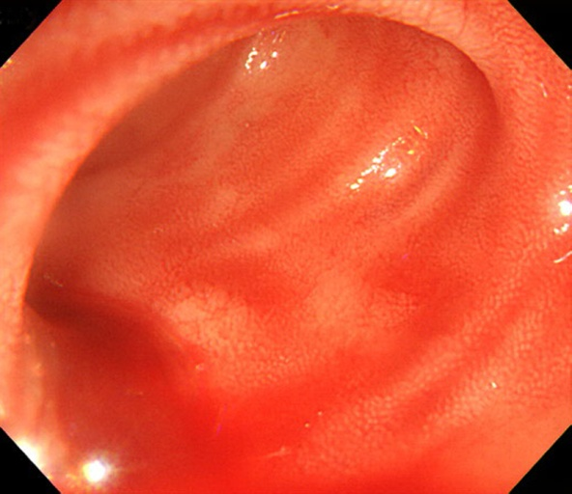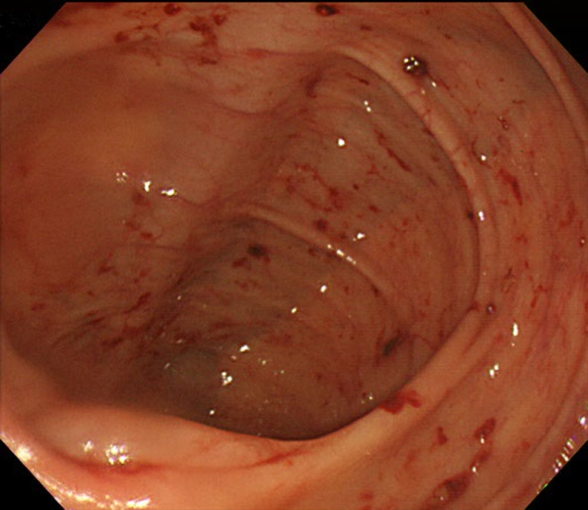

D
C

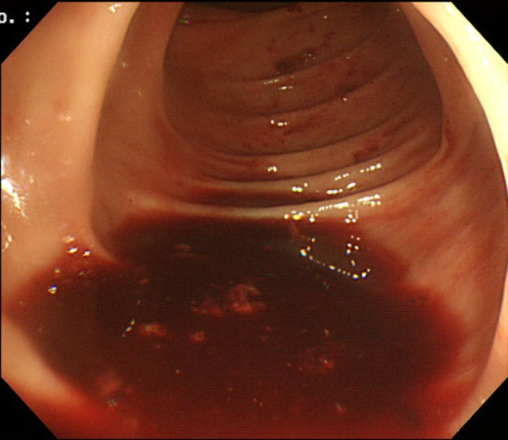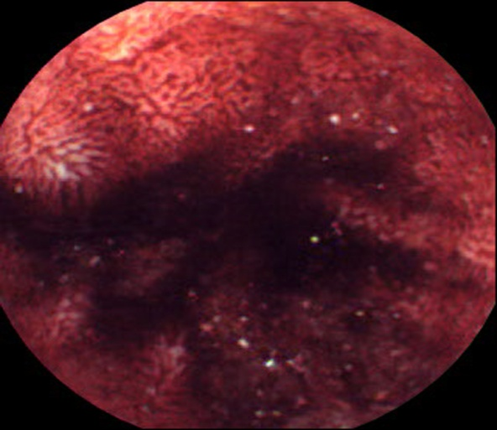

Figure 1 Colonoscopy and video capsule endoscopy findings. A-C: Colonoscopy shows fresh blood material that gushed from the small bowel; D: Subsequent video capsule endoscopy shows evidence of active and recent bleeding in the ileum.

B
A

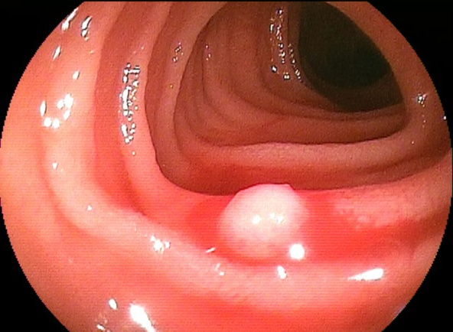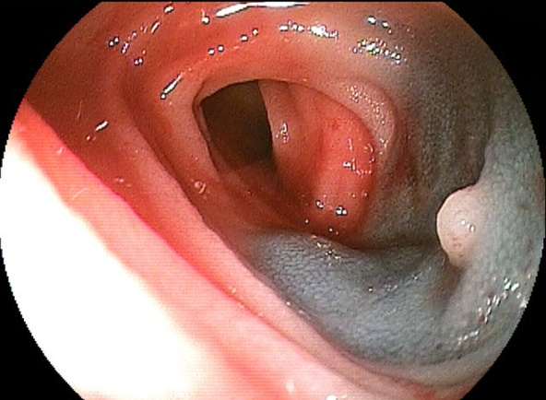
D
C

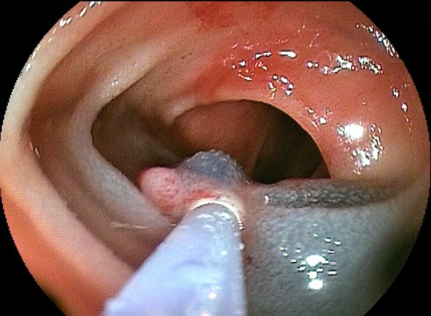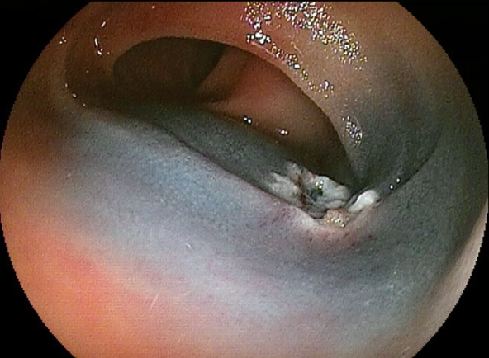

Figure 2 Double balloon enteroscopy findings. A: Double balloon enteroscopy shows a small, whitish polypoid lesion with active bleeding in the distal ileum; B, C: After submucosal injection of a saline-epinephrine mixture, polypectomy was performed; D: After the procedure, argon plasma coagulation was performed for the post-polypectomy ulcer to achieve hemostasis.

A
B

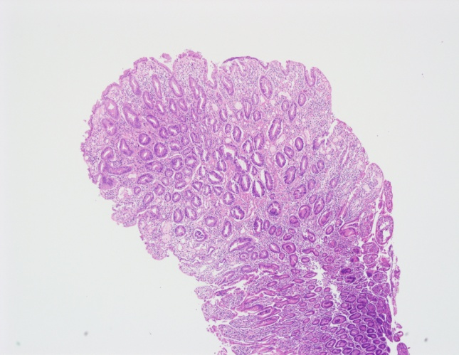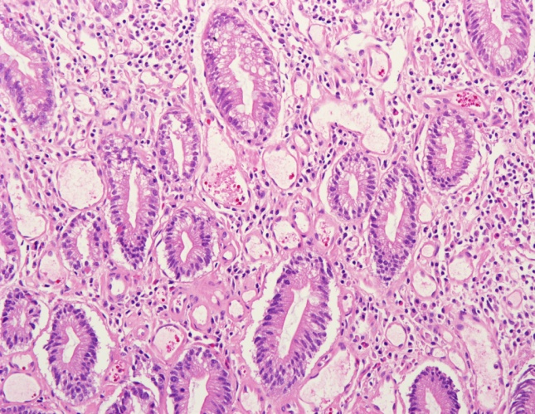

Figure 3 Histopathologic findings of intestinal lymphangiectasia. A, B: Microscopic examination shows dilated lymphatic channels in the lamina propria (H and E, ×40). Protein-rich fluid can escape from these channels into the extracellular space of the lamina propria and ultimately into the gut lumen (H and E, ×200).

