Name of journal: World Journal of Clinical Oncology
ESPS Manuscript NO: 9467
Columns: ORIGINAL ARTICLES

Clinicopathological features and treatment outcomes of brain stem gliomas in Saudi population

Bayoumi Y et al. Brainstem gliomas in Saudi population

Yasser Bayoumi, Abdulrahman J Sabbagh, Reham Mohamed, Usama M ElShokhaiby, Ahmed Marzouk Maklad, Mutahir A Tunio, Ali Abdullah O Balbaid

Yasser Bayoumi, Consultant Radiation Oncology, Comprehensive Cancer Center, King Fahad Medical City, Riyadh-59046, Saudi Arabia

Yasser Bayoumi, Radiation Oncology, NCI, Cairo University, Cairo 11435, Egypt

Abdulrahman J Sabbagh, Usama M ElShokhaiby, Neurosurgery King Fahad Medical City, Riyadh-59046, Saudi Arabia

Reham Mohamed, Radiation Oncology NCI, Cairo University, Cairo 11435, Egypt

Ahmed Marzouk Maklad, Clinical Oncology, Sohag University, Sohag 11432, Egypt

Mutahir A Tunio, Ali Abdullah O Balbaid, Radiation Oncology, Comprehensive Cancer Center, King Fahad Medical City, Riyadh-59046, Saudi Arabia

Author contributions: Bayoumi Y and Sabbagh AJ designed the study; ElShokhaiby UM, Maklad AM, Reham Mohamed and Balbaid AAO collected the data; Tunio MA, Maklad AM and Reham Mohamed analyzed the data; Maklad AM, Reham Mohamed and Balbaid AAO wrote the manuscript; Tunio MA, Bayoumi Y, Sabbagh AJ and ElShokhaiby UM edited the manuscript; Bayoumi Y, Sabbagh AJ, ElShokhaiby UM, Maklad AM and Tunio MA reviewed the manuscript.

Correspondence to: Mutahir Ali Tunio, FCPS (Radiation Oncology), Assistant Consultant, Radiation Oncology, Comprehensive Cancer Center, King Fahad Medical City, Khurais Road, Riyadh-59046, Saudi Arabia. mkhairuddin@kfmc.med.sa

Telephone: +966-12-889999 Fax: +966-12-889965

Received: February 12, 2014 Revised: April 16, 2014
Accepted: June 10, 2014

Published online:

Abstract
AIM: To analyze experience to find out treatment outcomes and prognostic factors in Saudi population.

METHODS: Medical records of patients with brainstem glioma treated during July 2001 and December 2012 were reviewed to find out treatment outcomes of surgery, radiation therapy and chemotherapy and associated prognostic factors in Saudi population

RESULTS: Since July 2001 to December 2012, we analyzed 49 brain stem glioma (BSG) patients; 31 of them were males (63.3%), median age of 12.6 years (range: 8 mo -64). Twenty-two patients (44.9%) had diffuse intrinsic pontine gliomas (DIPG) and 15 (30.6%) presented with focal/tectal BSG. Histopathology was available in 30 patients (61.2%). Median survival time for whole cohort was 1.5 years. One and two year OS rates were 51.1% and 41.9% respectively. Two year OS rates for focal/tectal, dorsally exophytic, cervicomedullary and DIPG tumors were 60%, 33.3%, 33.3% and 13.6% respectively (P < 0.0001). Significant prognostic factors related to OS were age at diagnosis (worse for > 18 years) P = 0.01, KPS < 70 P = 0.02, duration of symptoms (< 60 d) P = 0.002, histology (better for favorable) P = 0.002, surgery (maximal resection) P = 0.002, and concurrent chemotherapy with radiation therapy in DIPG (better if given) P = 0.01.

CONCLUSION: BSG especially DIPG subgroup had a dismal prognosis, needing more aggressive neurosurgical, radiation and chemotherapy techniques, while focal and tectal tumors were found to have better prognosis.

© 2014 Baishideng Publishing Group Inc. All rights reserved.

Key words: Brain stem glioma; Children; Adults; Saudi Arabia; Treatment outcomes

Core tip: Brain stem gliomas (BSG) are heterogeneous group of tumors with poor prognosis. Since July 2001 to December 2012, we analyzed 49 BSG patients; median age of 12.6 years (range: 8 mo -64). Twenty-two patients (44.9%) had diffuse intrinsic pontine gliomas (DIPG) and 15 (30.6%) presented with focal/tectal BSG. Histopathology was available in 30 patients (61.2%). Median survival time for whole cohort was 1.5 years. One and two year OS rates were 51.1% and 41.9% respectively. Two year OS rates for focal/tectal, dorsally exophytic, cervicomedullary and DIPG tumors were 60%, 33.3%, 33.3% and 13.6% respectively (P < 0.0001). We concluded that BSG especially DIPG subgroup had a dismal prognosis, needing more aggressive neurosurgical, radiation and chemotherapy techniques, while focal and tectal tumors were found to have better prognosis.

Bayoumi Y, Sabbagh AJ, Mohamed R, ElShokhaiby UM, Maklad AM, Mutahir A Tunio, Balbaid AAO. Clinicopathological features and treatment outcomes of brain stem gliomas in Saudi Population. World J Clin Oncol 2014; In press

INTRODUCTION
Brain stem gliomas (BSG) account for about 10%-20% of all central nervous system (CNS) tumors in children and 1%-2% in adults^{[1,2]}. Traditionally the term “brain stem glioma” was designed as a clinical diagnosis without histological confirmation because the morbidity for surgical intervention within the pons was high and the relevance of histological diagnoses was low. With advent of newer diagnostic modalities, BSG are now considered a heterogeneous group of tumors which are mainly divided into three categories according to treatment and prognosis^{[3]}. (1) The dorsally exophytic and cervicomedullary tumors appear to benefit significantly from surgical resection^{[3]}; (2) focal tectum glioma (solid or cystic) may be associated with a long history of symptoms and with neurofibromatosis type I^{[4]} andthe largest subgroup of (3) diffuse intrinsic pontine glioma (DIPG), in contrast, have a poor prognosis^{[5]}. DIPG subgroup clearly differs from focal, dorsally exophytic, and cervicomedullary tumors on various points as DIPG is typically seen with rapidly progressing symptoms and signs comprising multiple erratic cranial nerve palsies, long track deficits, cerebellar symptoms, and/or raised intracranial pressure with median survival of 9 mo^{[6,7]} and gadolinium enhanced magnetic resonance imaging (MRI) allows easy confirmation of diagnosis for DIPG and high-grade BSG ^{[8]}.
Surgery is the mainstay of therapy for focal, dorsally exophytic and cervicomedullary BSG, however for DIPG the radiation therapy remains the standard treatment option^{[9,10]}. Various chemotherapeutic agents investigated as monotherapy neoadjuvant agents (carboplatin or irinotecan) or as combination neoadjuvant chemotherapeutic agents (carboplatin, etoposide, and vincristine or cisplatin, cyclophosphamide, etoposide, and vincristine) has offered no significant improvements^{[11,12]}. Similarly, concurrent chemotherapeutic agents (etanidazole, topotecan, carboplatin and temozolomide) or high-dose chemotherapy followed by stem cell support have not shown any significant improvements in overall and progression free survival rates^{[13,14]}.
Our aim was to evaluate frequency of BSG and to find out treatment outcomes of surgery, radiation therapy and chemotherapy and associated prognostic factors in Saudi population.

MATERIALS AND METHODS
After formal approval from institutional ethical committee, medical charts of patients with confirmed brainstem gliomas were reviewed, who were treated in our hospital. Patients were selected if they met the following criteria.
Availability of complete medical record: (1) Demographic data (age at diagnosis, gender, main symptoms and duration, performance status according to Karnofsky Performance Scale (KPS) and main neurological signs); (2) radiological characteristics of the tumors on magnetic resonance imaging (MRI) (T1 and T2-weighted images) and (3) Surgical procedures including histopathological characteristics and other treatment modalities (radiation therapy and chemotherapy).
Epicenter (main bulk) of the tumorwas located in the brainstem (midbrain, pons and medulla oblongata), and diagnosis either was based on clinical history and characteristic magnetic resonance imaging (MRI) features or histopathological confirmation.
Exclusion criteria were: (1) Epicenter of tumor was located in thalamus, cerebellar peduncles or cervical spinal cord or; and (2) suspicion of infection could not be ruled out on MRI in absence biopsy results.

Toxicity
The National Cancer Institute Common Toxicity Criteria (NCI-CTC) version 2.0 were used to scoreacute radiation and chemotherapy toxicity (< 90 d from the start of radiation therapy). The Radiation Therapy Oncology Group Late Radiation Morbidity Scoring Criteria were used to score radiation toxicity persisting beyond 90 d from the completion of radiotherapy.

Follow-up
Functional recovery after surgical and other treatment modalities was assessment. Radiological response to radiotherapy and chemotherapy was reported according to Response Evaluation Criteria in Solid tumors (RECIST): (1) a complete response (CR), i.e., disappearance of all visible tumor; (2) a partial response (PR), i.e., a decrease of > 50% in the axial cross-sectionof the greatest surface area; (3) progressive disease (PD), i.e., > 25% increase in axial cross-section of the greatest surface area; or (4) stable disease (SD), i.e., all other situations.

Statistical analysis
The primary endpoints were functional recovery, response rates and the overall survival. Progression-free survival (PFS) was defined as the duration between thecompletion of treatment and the date of documented disease progression, death resulting from the cancer, and/or last follow-up visit (censored). Overall survival (OS) was defined as the duration between the completion of treatment and the date of patient death or last follow-up visit (censored). The probabilities of OS were determined with the Kaplan-Meier method and its 95%CI by the Rothman method. The comparisons for various endpoints were performed using the log-rank test. A P value of 0.05 was considered statistically significant. The multivariate analysis was used to test prognostic factors in multivariate analysis. Results are expressed with relative risk and its 95%CI. Statistical analyses were performed using the computer program SPSS (Statistical Package for the Social Sciences, version 17.0, SPSS Inc., Chicago, IL).

RESULTS
Study population
Between July 2001 to December 2012, 49 patients with BSG from institutional database fulfilled the criteria and were analyzed.

Clinicopathological characteristics
Among forty-nine patients, majority of cohort consisted of children and adolescents (81.6%) with a median age of 12.62 years (range: 0.8-64). An age of > 18 years at diagnosis was associated with a significantly shorter OS compared with a younger age (P = 0.0001) (Figure 1A). Median Karnofsky performance status (KPS) at diagnosis was 80 (range: 40–100). KPS < 70 was related with a shorter OS (P = 0.0001) (Figure 1B). Main symptoms at time of diagnosis were; headaches (42.8%), diplopia or squint (38.8%), gait disturbance (34.7%), nystagmus (37.7%) and difficulty in swallowing or choking (26.5%). Mean duration of symptoms before diagnosis was 83.4 d ± 47.5. Patients with short duration of symptoms (< 2 mo) had poor OS (P = 0.04) (Figure 1C). Main neurological signs were cranial nerve palsies mainly VI, VII, IX, X (65.3%), cerebellar dysfunction (51%), bilateral Papilledema (38.8%), nystagmus (37.7%) and motor weakness (28.6%). Histopathological diagnosis was available in 30 patients (61.2%) of whom mainly were of astrocytic origin (23/28) and high grade (63.3%) (Table1).

MRI characteristics at time of diagnosis
The main MRI characteristics are illustrated in Table 2.
Patterns identified on MRI were namely patterns representing non-enhancing diffusely infiltrative tumors (54.5%), contrast-enhancing localized masses (33.3%) and tectal tumors (33.3%). Presumed necrosis on MRI, defined as a zone of irregularly shaped T1 hyposignal surrounded by contrast enhancement, was found in 5 (10.2%) of patients.

Treatment characteristics
Thirty patients (61.2%) had surgery. Complete resection was done in dorsally exophytic (83.3%), focal tectal (66.7%) and focal (50%) tumors. Cerebrospinal fluid (CSF) shunts including ventriculo-peritoneal (VP) shunt, endoscopic third ventriculostomy (EDV), endoscopic ventricular drain EDV) was performed in 28/49 patients (57.1%) to control raised intracranial pressure (ICP). Interestingly, 6/22 patients (27.3%) with DIPG underwent surgical debulking Table 3. Postoperative radiation therapy was given in 14/32 patients (43.7%) and radical radiation therapy with and without chemotherapy was given in 18/32 patients (56.3%). Mean duration of time between surgery and starting radiation therapy was 25 d (range: 21-28). Majority of cases (17/32) were treated with intensity modulated radiation therapy (IMRT) (Table 4). Among all 32 patients, who received radiation therapy, the treatment protocol completion rate was 90 % (95% confidence interval [CI], 85-100). Chemotherapy in adjuvant or salvage setting was given mainly for DIPG subgroup and patients with leptomeningeal dissemination which was seen in 5/49 patients (10.2%) (Table 5).

Toxicity profile
Common acute grade 2 radiation induced toxicities were; nausea and vomiting (30/32) and worsening of weakness (21/32) and grade 3 toxicities were nausea and vomiting (2/32) and worsening of weakness (4/32) and were treated with antiemetics and corticosteroids. Acute grade 2 otitis media was seen in one patient. Late toxicities at time of analysis were minimal and of grade 2 skin pigmentation seen in one patient. Common acute grade 3 chemotherapy induced toxicities were myelo-suppression (5/23), thrombocytopenia (2/23), rash (1/23) and febrile neutropenia (5/23) of whom three had repeated episodes. No treatment related death was seen.

Response rates
Clinical response of radiotherapy ± chemotherapy (defined as regression of cranial nerve palsies or weakness of the limbs or cerebellar symptoms for > 3 mo) was seen in 16/32 (50%) patients confirmed by neurologist. Radiological response was also evaluated in all patients and response rates according to RECIST were as; CR (0/32), PR (16/32), SD (6/32) and PD (11/32).The mean response time was 12 ± 8 mo (range: 7-30). The mean reduction of tumor volume was 50% and clinical benefit (PR + SD) was 68.7% for all patients. Clinical response of adjuvant chemotherapy was seen in 2/11 (18.1%) at the mean time of 5 mo (range: 4-18). Three months after chemotherapy, the radiological PR was seen in two patients, SD in five (45.7%) and progressive disease in four cases (36.2%).

Progression free survival and overall survival
Median survival time for whole cohort was 1.5 years and 1, 2, 3 year OS rates for whole cohort were 51.1%, 41.9% (29/49 died) and 23.1% (Figure 2). PFS rates at 1 and 2 years were 57.3% and 38.2% respectively.
At 2 years, OS rate for radiologically low grade (favorable) tumors was clearly high ( 57.1%) as compared to high grade (unfavorable) in which OS rate was 17.9% (P < 0.001) (Figure 3A). Further, among subgroups, two year OS rates for focal/tectal, dorsally exophytic, cervicomedullary and DIPG tumors were 60%, 33.3%, 33.3% and 13.6% respectively (P < 0.0001) (Figure 3B).
Two year OS rates for patients (14/30) with complete or maximal resection and patients (16/30) with incomplete resection or biopsy only were 53.8% and 27.8% respectively (p 0.002) (Figure 3C).
Median time of survival, one and two year OS rates for patients who were treated with postoperative (16/32) or radical radiation therapy (16/32) were 1.09 year, 50% and 17.9% respectively Figure 4A. Patients treated with chemotherapy (neoadjuvant, concurrent or adjuvant/salvage) had median survival time of 1.3 years and one and two year OS rates of 56.5% and 21.7% respectively Figure 4B.
Multivariate analysis showed that for favorable tumors, important prognostic factors were: (1) age at diagnosis (worse for > 18 years); (2) KPS < 70; (3) histopathologically high grade; and (4) incomplete resection. Important prognostic factors for unfavorable tumors including DIPG were: (1) age at diagnosis (worse for > 18 years); (2) KPS < 70; (3) histopathologically high grade; (4) radiological high grade (necrosis on MRI); and (5) no concurrent chemotherapy as shown in Table 6.

DISCUSSION
BSG remains a therapeutic dilemma because of the location and heterogeneous biological behavior of these tumors as seen in our cohort, which was comprised mainly of pediatric and adolescents (81.6%). With median survival time of 1.5 years, one and two year OS rates of 51.1%, 41.9% and clinical prognostic factors in our cohort were found in agreement with previous reported data^{[15,16]}. We found no significant difference between pediatric, adolescents and adults BSG in clinical presentation, MRI characteristics and treatment course, but significant difference in median survival times (1.8 year in pediatric/adolescents vs 1.2 year in adults) which is similar to other previous pediatric studies, however clearly shorter than reported by previous studies in adult BSG. The possible explanation for shorter median survival rates in adults could be high grade histology in our cohort. Similar findings were reported by Reithmeier T et al^{[15,16]}.
In our cohort most common subgroup was DIPG and of whom 27.3% underwent biopsy and subtotal resection, which is far from routine practice. Majority of biopsy proven DIPG had high grade astrocytoma on histology, which reflects the poor prognosis and shorter median survival in DIPG cases without histopathological confirmation. In addition, DIPG were also found to be more responsive to radiotherapy with concurrent chemotherapy (TMZ) in our cohort suggesting that OS rates differ with different treatment strategies. However, trials of dose escalation (> 54Gy), hyperfractionated radiation therapy and incorporation of novel chemotherapeutic agents have been failed to produce any meaningful change in the outcomes^{[11-14,16]}. These findings are confirmatory for heterogeneous nature of DIPG^{[17]}.
Subgroup of focal gliomas was the second most predominant in our cohort and these tumors were found clearly different from those DIPG, however the clinical picture was similar to DIPG. Complete removal in majority of cases in our cohort reflected the improvement in median survival for such cases. Focal tectal gliomas constituted a small subgroup and these cases required CSF shunts for raised intracranial pressure as reported by other studies^{[18]}. However, adjuvant radiotherapy can be criticized in children as such patients have been managed with CSF shunt or observation alone for long periods^{[19]}.
Third common most subgroup of dorsally exophytic gliomas in our cohort were managed successfully with complete resection in majority of patients. However, in contradiction to the literature, our patients had shorter median survival. Possible explanation could be high grade histology and no adjuvant radiotherapy^{[20,21]}. Similar explanation for shorter median survival was also justified in our cohort of cervicomedullary glioma. Non-specific BSG including medullary astroblastoma and pontomedullary BSG had similar clinical behavior and treatment outcome to DIPG^{[22]}.
In conclusion, brain stem gliomas have heterogeneous biological behavior. DIPG subgroup had a dismal prognosis, needing more aggressive neurosurgical, radiation and chemotherapy techniques, while focal and tectal tumors were found to have better prognosis.

COMMENTS
Background
BSG remains a therapeutic dilemma because of the location and heterogeneous biological behavior of these tumors and treatment is mainly through multidisciplinary approach.

Research frontiers
Present study focused on Saudi population and found that DIPG subgroup had a dismal prognosis, requiring more aggressive neurosurgical, radiation and chemotherapy techniques

Innovations and breakthroughs
Present study revealed that stereotactic biopsy is feasible in DIPG and Radiation therapy is associated with improvement of survival in patients with DIPG.

Applications
This study provides treatment algorithm in brainstem glioma.

Peer review
The article addressed an important disease with poor prognosis.

REFERENCES
1 Laigle-Donadey F, Doz F, Delattre JY. Brainstem gliomas in children and adults. Curr Opin Oncol 2008; 20: 662-667 [PMID: 18841048 DOI: 10.1097/CCO.0b013e32831186e0]
2 Kesari S, Kim RS, Markos V, Drappatz J, Wen PY, Pruitt AA. Prognostic factors in adult brainstem gliomas: a multicenter, retrospective analysis of 101 cases. J Neurooncol 2008; 88: 175-183 [PMID: 18365144 DOI: 10.1007/s11060-008-9545-1]
3 Ueoka DI, Nogueira J, Campos JC, Maranhão Filho P, Ferman S, Lima MA. Brainstem gliomas--retrospective analysis of 86 patients. J Neurol Sci 2009; 281: 20-23 [PMID: 19345380 DOI: 10.1016/j.jns.2009.03.009]
4 Bauman G, Pahapill P, Macdonald D, Fisher B, Leighton C, Cairncross G. Low grade glioma: a measuring radiographic response to radiotherapy. Can J Neurol Sci 1999; 26: 18-22 [PMID: 10068802]
5 Wagner S, Warmuth-Metz M, Emser A, Gnekow AK, Sträter R, Rutkowski S, Jorch N, Schmid HJ, Berthold F, Graf N, Kortmann RD, Pietsch T, Sörensen N, Peters O, Wolff JE. Treatment options in childhood pontine gliomas. J Neurooncol 2006; 79: 281-287 [PMID: 16598416]
6 Hargrave D, Bartels U, Bouffet E. Diffuse brainstem glioma in children: critical review of clinical trials. Lancet Oncol 2006; 7: 241-248 [PMID: 16510333]
7 Frazier JL, Lee J, Thomale UW, Noggle JC, Cohen KJ, Jallo GI. Treatment of diffuse intrinsic brainstem gliomas: failed approaches and future strategies. J Neurosurg Pediatr 2009; 3: 259-269 [PMID: 19338403 DOI: 10.3171/2008.11.PEDS08281]
8 Schumacher M, Schulte-Mönting J, Stoeter P, Warmuth-Metz M, Solymosi L. Magnetic resonance imaging compared with biopsy in the diagnosis of brainstem diseases of childhood: a multicenter review. J Neurosurg 2007; 106: 111-119 [PMID: 17330536]
9 Kebudi R, Cakir FB. Management of diffuse pontine gliomas in children: recent developments. Paediatr Drugs 2013; 15: 351-362 [PMID: 23719782 DOI: 10.1007/s40272-013-0033-5]
10 Kretschmar CS, Tarbell NJ, Barnes PD, Krischer JP, Burger PC, Kun L. Pre-irradiation chemotherapy and hyperfractionated radiation therapy 66 Gy for children with brain stem tumors. A phase II study of the Pediatric Oncology Group, Protocol 8833. Cancer 1993; 72: 1404-1413 [PMID: 8339231]
11 Doz F, Neuenschwander S, Bouffet E, Gentet JC, Schneider P, Kalifa C, Mechinaud F, Chastagner P, De Lumley L, Sariban E, Plantaz D, Mosseri V, Bours D, Alapetite C, Zucker JM. Carboplatin before and during radiation therapy for the treatment of malignant brain stem tumours: a study by the Société Française d'Oncologie Pédiatrique. Eur J Cancer 2002; 38: 815-819 [PMID: 11937316]
12 Jennings MT, Sposto R, Boyett JM, Vezina LG, Holmes E, Berger MS, Bruggers CS, Bruner JM, Chan KW, Dusenbery KE, Ettinger LJ, Fitz CR, Lafond D, Mandelbaum DE, Massey V, McGuire W, McNeely L, Moulton T, Pollack IF, Shen V. Preradiation chemotherapy in primary high-risk brainstem tumors: phase II study CCG-9941 of the Children's Cancer Group. J Clin Oncol 2002; 20: 3431-3437 [PMID: 12177103]
13 Drabko K, Wiśniewska-Slusarz H, Wójcik B, Choma M, Zaucha-Prazmo A, Kowalczyk JR. [Megachemotherapy followed by autologous haematopoietic stem cell rescue in children with high risk CNS tumours]. Med Wieku Rozwoj 2005; 9: 439-447 [PMID: 16719156]
14 Jalali R, Raut N, Arora B, Gupta T, Dutta D, Munshi A, Sarin R, Kurkure P. Prospective evaluation of radiotherapy with concurrent and adjuvant temozolomide in children with newly diagnosed diffuse intrinsic pontine glioma. Int J Radiat Oncol Biol Phys 2010; 77: 113-118 [PMID: 19647954 DOI: 10.1016/j.ijrobp.2009.04.031]
15 Kaplan AM, Albright AL, Zimmerman RA, Rorke LB, Li H, Boyett JM, Finlay JL, Wara WM, Packer RJ. Brainstem gliomas in children. A Children's Cancer Group review of 119 cases. Pediatr Neurosurg 1996; 24: 185-192 [PMID: 8873160]
16 Reithmeier T, Kuzeawu A, Hentschel B, Loeffler M, Trippel M, Nikkhah G. Retrospective analysis of 104 histologically proven adult brainstem gliomas: clinical symptoms, therapeutic approaches and prognostic factors. BMC Cancer 2014; 14: 115 [PMID: 24555482 DOI: 10.1186/1471-2407-14-115]
17 Warren KE. Diffuse intrinsic pontine glioma: poised for progress. Front Oncol 2012; 2: 205 [PMID: 23293772 DOI: 10.3389/fonc.2012.00205]
18 Gomez-Gosalvez FA, Menor F, Morant A, Clemente F, Escriva P, Carbonell J, Mulas F. Tectal tumours in paediatrics. A review of eight patients. Rev Neurol 2001; 33: 605-11
19 Dağlioğlu E, Cataltepe O, Akalan N. Tectal gliomas in children: the implications for natural history and management strategy. Pediatr Neurosurg 2003; 38: 223-231 [PMID: 12686764]
20 Sridhar K, Sridhar R, Venkatprasanna G. Management of posterior fossa gliomas in children. J Pediatr Neurosci 2011; 6: S72-S77 [PMID: 22069433 DOI: 10.4103/1817-1745.85714]
21 Oka H, Utsuki S, Tanizaki Y, Hagiwara H, Miyajima Y, Sato K, Kusumi M, Kijima C, Fujii K. Clinicopathological features of human brainstem gliomas. Brain Tumor Pathol 2013; 30: 1-7 [PMID: 22484454 DOI: 10.1007/s10014-012-0099-8]
22 Notarianni C, Akin M, Fowler M, Nanda A. Brainstem astroblastoma: a case report and review of the literature. Surg Neurol 2008; 69: 201-205 [PMID: 17765957]

P-Reviewer: Ho I S-Editor: Ji FF L-Editor: E-Editor:

A B
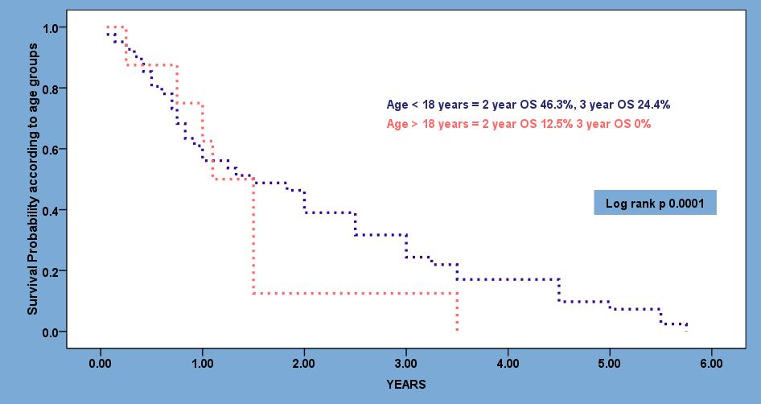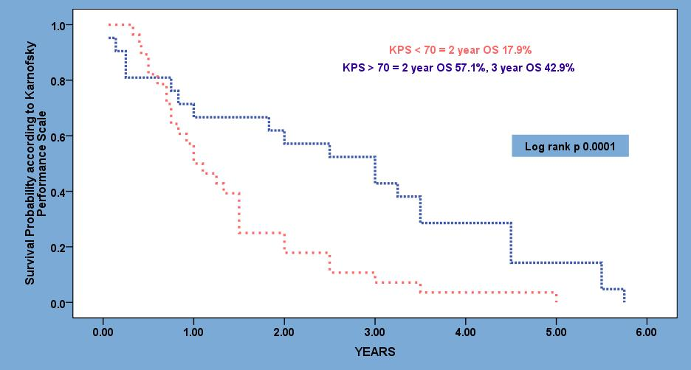
C
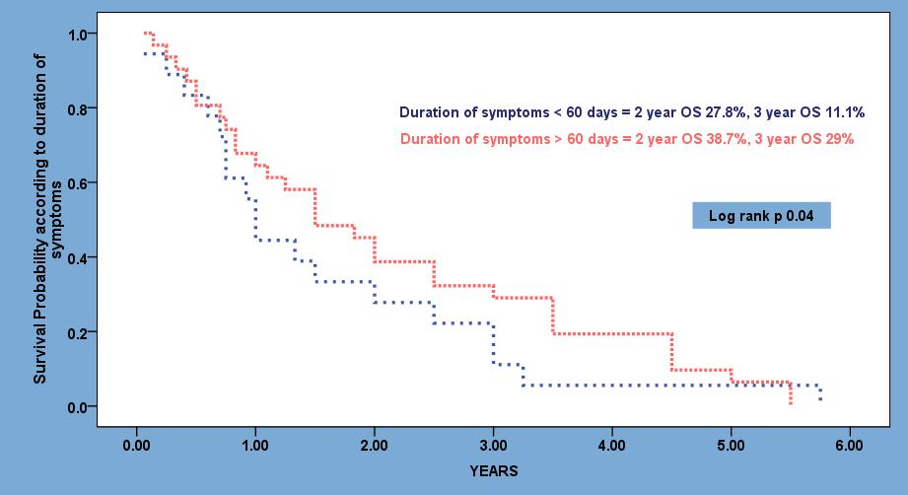
Figure 1 Kaplan-Meier curve. A: Showing overall survival probability according to age groups (< 18 yr vs > 18 yr); B: Showing overall survival probability according to Karnofsky performance scale (< 70 vs > 70); C: Showing overall survival probability according to duration of symptoms (< 60 d vs > 60 d).

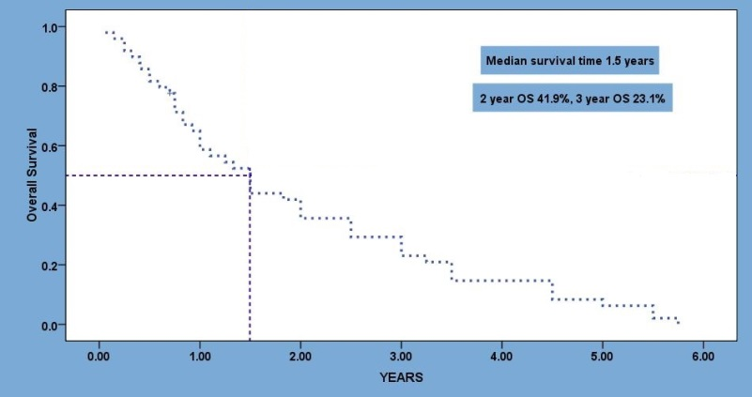
Figure 2 Median survival time, one, two and three year overall survival rates for whole cohort.

A B
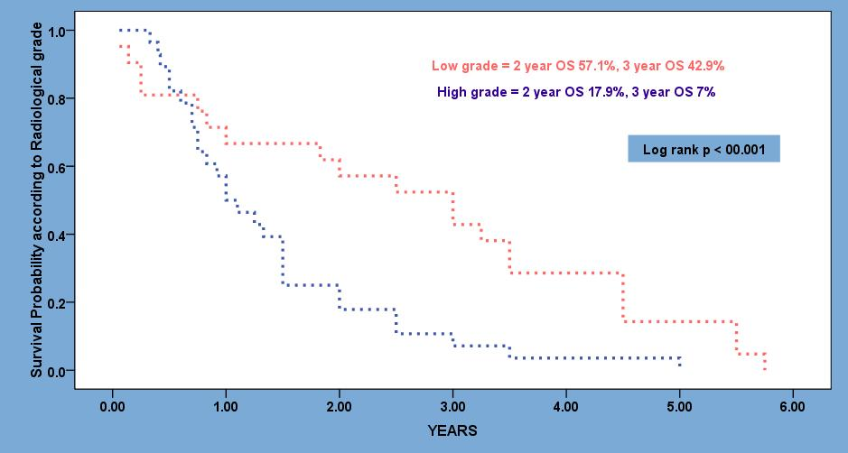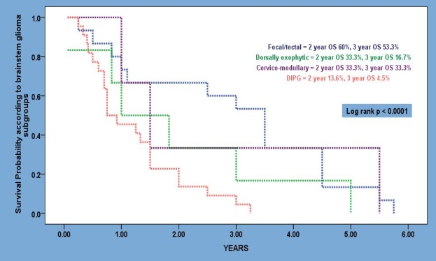
C
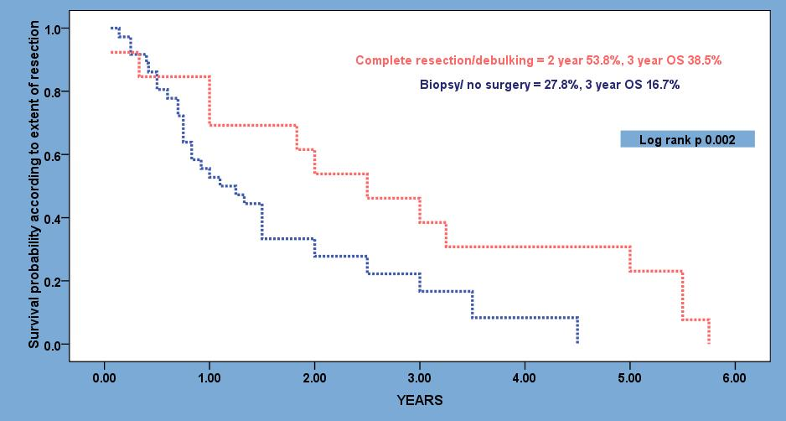
Figure 3 Kaplan-Meier curve. A: Showing overall survival probability according to grade of tumors (<low grade vs high grade); B: Showing overall survival probability according to tumor subgroups (focal/tectal vs dorsally exophytic vs cervicomedullary vs diffuse intrinsic pontine glioma); C: Showing overall survival probability according to type of resection (complete/maximal vs incomplete/biopsy).

A B
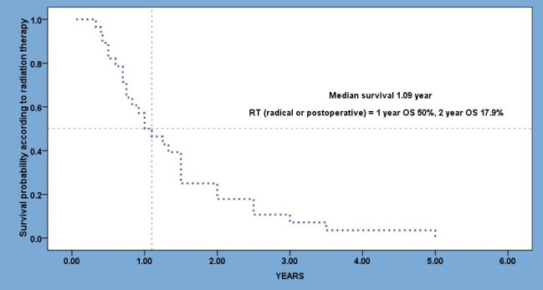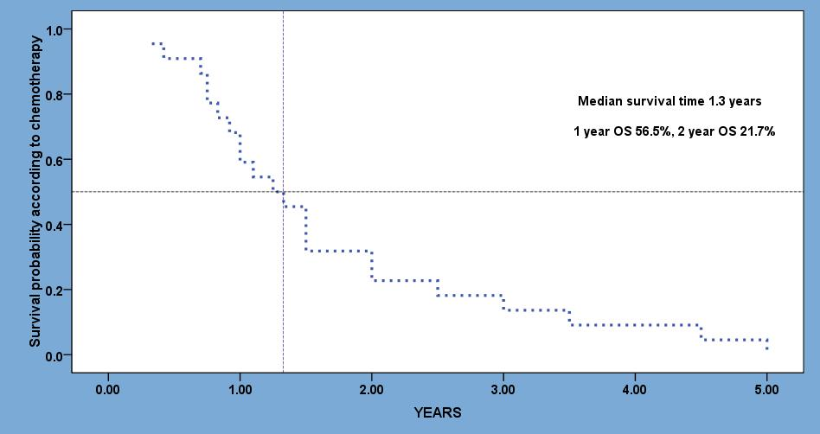
Figure 4 Median time of survival, one and two year overall survival rates for patients. A: Treated with radiation therapy (postoperative or radical radiation therapy); B: Treated with chemotherapy (neoadjuvant, concurrent or adjuvant/salvage).

Table 1 Clinico-pathogical characteristics of cohort
Variab | N (%)
Mean age at diagnosis (yr) | 12.62 (0.8-64) SD ± 13.42
Gender  Male  Female | 31 (63.3%)  18 (36.7%)
According to age  Children and adolescents  Adults | 40 (81.6%)  9 (18.4%)
Duration of symptoms (d) | 83.4, SD ± 47.5
Karnofsky Performance Status | 80 (50-100)
Symptoms at time of presentation  Headache  Vomiting  Diplopia/ squint  Unsteady Gait  Difficulty in swallowing or choking  Motor weakness/ paresis  Convulsions  Dysphonia/ dysarthria  Altered consciousness  Isolated facial paresis  Hearing problems  Fever  Failure to thrive | 21 (42.8%)  11 (22.4%)  19 (38.8%)  17 (34.7%)  13 (26.5%)  10 (20.4%)  4 (8.2%)  11 (22.4%)  5 (10.2%)  6 (12.2%)  3 (6.1%)  2 (4.1%)  1 (2.0%)
Neurological signs at time of presentation  Mental status change  Cranial nerve palsies  Trigeminal  Abduncens  Facial  Vestibulochochlear  Glossopahrygneal  Vagus  Motor deficit  Sensory deficit  Bilateral Babinski sign  Cerebellar signs  Nystagmus  Bilateral Papilledema | 8 (16.3%)  32 (65.3%)  2 (6.3%)  18 (56.3%)  12 (37.5%)  2 (6.3%)  12 (37.5%)  8 (25.0%)  14 (28.6%)  6 (12.2%)  13 (26.5%)  25 (51.0%)  17 (34.7%)  19 (38.8%)
Pathological diagnosis  Yes  Pilocytic astrocytoma  Diffuse astrocytoma grade II  Anaplastic astrocytoma  Glioblastoma multiforme  Astroblastoma  Nonspecified glioma  No | 30 (61.2%)  6/30 (20.0%)  4/30 (13.3%)  10/30 (33.3%)  4/30 (13.3%)  1/30 (3.3%)  5/30 (16.7%)  19 (38.8%)
Radiological diagnosis  Focal  tectal  Dorsally exophytic  Cervicomedullary  DIPG  Others | 12 (24.5%)  3 (6.1%)  6 (12.2%)  3 (6.1%)  22 (44.9%)  3 (6.1%)
Surgery  Total/maximal resection  Subtotal resection  Biopsy only  VP shunt  ETV  EDV  IONP | 30/49 (61.2%)  14/30 (36.7%)  14/30 (36.7%)  2/30 (6.1%)  19/30 (63.3%)  4/30 (13.3%)  5/30 (16.7%)  14/30 (36.7%)
Radiation therapy  Postoperative  Radiotherapy alone  Total dose (Gy)  Fractions  Duration (wk)  Technique  3DCRT  IMRT | 32/49 (65.3%)  14/32 (43.7%)  18/32 (56.3%)  50.4-59.4  30-33  6-6.5  15 (46.9%)  17 (53.1%)
Chemotherapy  Concurrent  TMZ  Neoadjuvant  Vincristine + carboplatin  High dose chemotherapy with stem cell rescue  Cyclophosphamide  Adjuvant/ salvage  BCNU + procarbazine + vincristine  Vincristine + carboplatin  Irinotecan + Bevacizumab | 23/49 (46.9%)  12/23 (52.2%)  12/12 (100%)  7/23 (30.4%)  4/7 (51.1%)  2/7 (28.7%)  1/7 (14.3%)  11/23 (47.8%)  5/11(45.7%)  4/11 (36.2%)  2/11 (18.1%)
DIPG: Diffuse intrinsic pontine glioma; VP shunt: Ventriculo-peritoneal; ETV: Endoscopic third ventriculostomy; EDV: Endoscopic ventricular drain; IONP: Intra-operative neurophysiology; 3DCRT: Three dimensional conformal radiation therapy; IMRT: Intensity modulated radiation therapy; TMZ: Temozolomide; BCNU: 1,2-bis (2-chloroethyl) 1-nitrosourea.

Table 2 Magnetic resonance imaging characteristics in our cohort of brain stem glioma n (%)
Subgroups | Enhancement  enhancing Non-enhancing | T2W image Intensity  hyper mixed | Character  Cystic Solid Mixed
Focal (12) | 17 (100) - | 10 (83.3) 2 (16.7) | 3 (25) 6 (50) 3 (25)
Focal tectal (3) | 2 (66.7) 1 (33.3) | 1 (33.3) 2 (66.7) | 3 (100)
Dorsally exophytic (6) | 4 (66.7) 2 (33.3) | 3 (50.0) 3 (50.0) | 4 (667) 2 (33.3)
Cervico-medullary (3) | 2 (66.7) 1 (33.3) | - 3 (100) | 3 (100)
DIPG (22) | 10 (45.5) 12 (54.5) | 10(45.4%) 12 (54.5) | 19 (86.4) 3 (13.6)
DIPG: Diffuse intrinsic pontine glioma.

Table 3 Surgical resection in our cohort of brain stem glioma n (%)
Subgroups | Resection  complete incomplete/biopsy | VP shunt | ETV | EVD | IONP
Focal (12) | 6 (50.0) 6 (50.0) | 3 (25.0) | 1 (8.3) | 2 (16.6) | 5 (41.7)
Focal tectal (3) | 2 (66.7) 1 (33.3) | 2 (66.7) | 1 (33.3) | 1 (33.3) | 2 (66.7)
Dorsally exophytic (6) | 5 (83.3) 1 (16.7) | 3 (50.0) | - | 2 (33.3) | 5 (83.3)
Cervico-medullary (3) | 1(33.3) 2 (66.7) | - | - | - | 2 (33.3)
DIPG (22) | - 6 (27.3) | 11 (50) | 2 (9.0) | - | 1 (4.5)
VP shunt: Ventriculo-peritoneal; ETV: Endoscopic third ventriculostomy; EDV: Endoscopic ventricular drain; IONP: Intra-operative neurophysiology.

Table 4 Radiation therapy in our cohort of brain stem glioma
Subgroups | Indication  postoperative Radical | Technique  3DCRT IMRT | Total Dose (Gy)
Focal (12) | 6 (50%) - | 3 (50%) 3 (50%) | 50.4-54
Focal tectal (3) | 1 (33.3%) - | - 1 (100%) | 54
Dorsally exophytic (6) | 1 (16.7%) - | 1 (100%) - | 54
Cervico-medullary (3) | 2 (66.7%) - | 2 (100%) - | 50.4-54
DIPG (22) | 6 (27.3%) 16(72.7%) | 9 (40.9%) 13 (59.1%) | 54-59.4

3DCRT: Three dimensional conformal radiation therapy; IMRT: Intensity modulated radiation therapy; Gy: Gray.

Table 5 Chemotherapy in our cohort of brain stem glioma n (%)

Subgroups | Neoadjuvant | Concurrent | Adjuvant/ Salvage
Focal (12) |  | - | 3 (25.0)
Focal tectal (3) | - | - | -
Dorsally exophytic (6) | - | - | -
Cervico-medullary (3) | 1 (33.3) | - | 2 (66.6)
DIPG (22) | 6 (27.3) | 12 (54.5) | 6 (27.3)

DIPG: Diffuse intrinsic pontine glioma.
Table 6 Multivariate analysis of various prognostic factors in brainstem glioma
Variables | RR (95% CI) | P value
Age at diagnosis (> 18 yr) | 3.0 (1.8-6.0) | 0.01
KPS < 80 | 3.3 (1.7–5.3) | 0.02
Duration of symptoms (< 60 d) | 6.7 (4.3-9.4) | 0.002
Histopathology (high grade) | 6.1 (3.5-10.2) | 0.002
MRI characteristics (presence of necrosis) | 3.0 (1.9-5.9) | 0.01
Incomplete resection for favorable tumors | 6.6 (3.9-12.2) | 0.002
No concurrent chemotherapy with RT | 3.1 (2.2- 8.2) | 0.01

RR: Relative risk; CI: Confidence interval; KPS: Karnofsky performance scale; MRI: Magnetic resonance imaging; RT: Radiation therapy.

