エディテージをお選び頂き、ありがとうございます。
弊社サービスをより理解して頂けるよう、下記のとおりご案内いたします。

- 初回の校正終了後に弊社で提供しているサポートの概要
- 校正者からのメッセージ
- 次の論文を書く際のヒント

サポートが必要な際はいつでも御連絡ください！弊社のサポートが必要な場合は、Editage Onlineにログインし、案内に沿ってお進みください。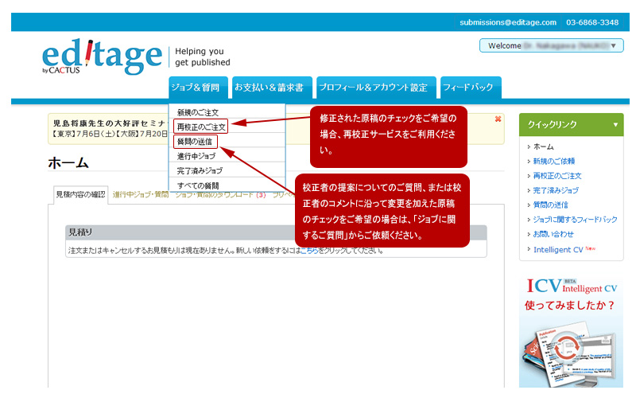

From your editor, Paul
Dear Author,
It was a pleasure working on your document. Do go through my changes as well as comments and additional notes in this file.
Please send me your feedback or any questions through your Editage Online account (http://online.editage.jp/).
Best regards,
Your editor

Notes related to Tables, Figures, or Formatting

This table contains recommendations that I was unable to insert in your manuscript.
Figures and Tables  Recommended changes to embedded figures/tables, which I was unable to modify | - All Tables: Tables and table legends were not included in this document, so I was unable to edit them.

A QUICK TIP
GUIDELINE | Insert a comma before the conjunction that precedes the last element of a series (e.g., bread, eggs, and milk).
EXPLANATION | In American English, a comma is inserted before the conjunction that precedes the last element of a series (e.g., bread, eggs, and milk). This comma is called the series comma and is inserted for clarity. Although this comma is not commonly used in British English, its usage is gaining acceptance. In British English, it’s called the Oxford comma.  As this comma aids clarity, its use is encouraged in academic writing in both American and British English.
EXAMPLE | Original: …1-year, 2-year, 3-year, 4-year and 5-year survival rate were…  Corrected: …the 1-year, 2-year, 3-year, 4-year, and 5-year survival rates were…

