Table 1: Summary of Clinical data in athletes with neck pain (n = 100).
Outcome Measures | Mean | SD | Range
 |  |  | Minimum | Maximum
PFRI | 30.85 | 15.94 | 10.00 |  | 92.50
PNDI | 30.22 | 15.93 | 8.00 |  | 88.00
NRS | Median (IQR) 2 (2-3)
PFRI: Persian Functional Rating Index; PNDI: Persian Neck Disability Index; NRS: Numerical Rating Scale; SD: standard deviation; IQR: interquartile range

Table 2: Cronbach’s alpha and item-total statistics for Persian Functional Rating Index.

FRI items | Scale mean if item deleted | Scale variance if item deleted | Corrected item-total correlation | Squared multiple correlation | Cronbach’s Alpha if item deleted
Pain intensity | 10.89 | 34.240 | 0.877 | 0.801 | 0.963
Sleeping | 11.45 | 33.563 | 0.823 | 0.724 | 0.964
Personal care | 11.02 | 33.353 | 0.852 | 0.780 | 0.963
Travel | 10.83 | 31.819 | 0.852 | 0.753 | 0.963
Work | 11.04 | 34.463 | 0.867 | 0.804 | 0.963
Recreation | 11.07 | 33.399 | 0.846 | 0.735 | 0.963
Frequency of pain | 10.57 | 32.591 | 0.812 | 0.750 | 0.964
Lifting | 10.97 | 33.686 | 0.831 | 0.723 | 0.963
Walking | 11.58 | 31.620 | 0.896 | 0.865 | 0.961
Standing | 11.64 | 31.930 | 0.883 | 0.854 | 0.962

Table 3: Results of relative and absolute reliability measures for the Persian Functional Rating Index (PFRI) in athletes with neck pain (n=50).
Scale | Mean ± SD |  | d (SD) | ICC_{agreement} (95% CI) | SEM | SDC
 | Test | Retest
PFRI | 32.15±19.04 | 30.70±15.90 | 1.45(4.95) | 0.96 (0.93-0.98) | 3.2 | 8.84
SD: standard deviation; d, mean difference of the test and retest scores; ICC: intraclass correlation coefficient; SEM, standard error of measurement; SDC, smallest detectable change.

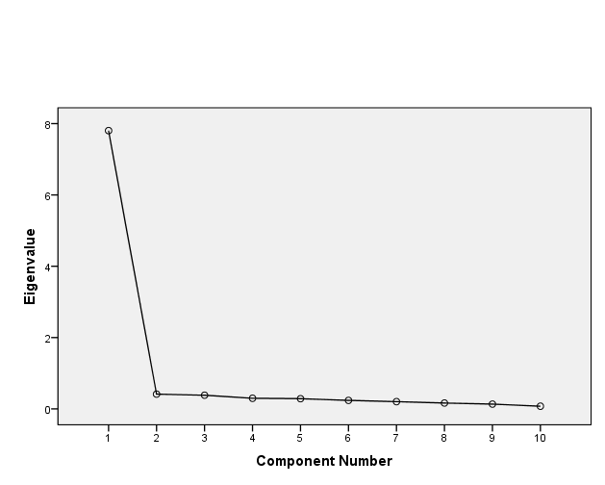Figure 1: Scree plot of eigenvalues produced 1 factor for Persian Functional Rating Index in athletes with neck pain (n = 100).

