Name of Journal: World Journal of Clinical Cases
Manuscript NO: 83420
Manuscript Type: CASE REPORT

Morphological features and endovascular repair for type B multichanneled aortic dissection: A case report

Lu WF et al. Application of medical 3D modeling system

Wei-Feng Lu, Gang Chen, Li-Xin Wang

Wei-Feng Lu, Gang Chen, Li-Xin Wang, Department of Vascular Surgery, Zhongshan Hospital (Xiamen), Fudan University, Xiamen 361015, Fujian Province, China

Author contributions: Lu WF and Chen G contributed equally to this work; Lu WF and Wang LX designed the research study; Lu WF, Wang LX and Chen G performed the research; Lu WF, Wang LX and Chen G analyzed the data and wrote the manuscript; All authors have read and approve the final manuscript.

Corresponding author: Li-Xin Wang, MD, PhD, Doctor, Professor, Surgeon, Department of Vascular Surgery, Zhongshan Hospital (Xiamen), Fudan University, No. 668 Jinhu Road, Huli District, Xiamen 361015, Fujian Province, China. wang.lixin@zs-hospital.sh.cn

Received: February 11, 2023
Revised: April 3, 2023
Accepted: May 16, 2023
Published online: June 26, 2023

Abstract
BACKGROUND
Among the various types of aortic dissection, multichanneled aortic dissection (MCAD) differs from classic double-channeled aortic dissection and involves the formation of an additional false lumen in the aortic wall or the flaps. It is considered a relatively rare condition with high perioperative mortality and morbidity. However, the morphological characteristic and the optimal therapeutic strategy for MCAD has not been fully determined.

CASE SUMMARY
A 64-year-old man presented to our hospital with severe epigastric abdominal pain radiating to the back that was associated with nausea without emesis. A computed tomography angiogram was performed that revealed a type B aortic dissection with multiple channels extending from the level of the left subclavian artery to the bilateral femoral arteries. We used a medical three-dimensional modeling (3D) modeling system to identify the location and extension of multiple lumens from different angles. It also precisely located the two primary entries leading to the false lumens, which helped us to exclude the two false lumens with one stent-graft.

CONCLUSION
By applying medical 3D modeling system, we discover the fragility of aortic wall and the collapse of true lumen caused by the multiple false lumens are the two morphological features of MCAD.

Key Words: Aortic dissection; Endovascular repair; Three-dimensional modeling; Multichanneled; Case report

©The Author(s) 2023. Published by Baishideng Publishing Group Inc. All rights reserved.

Citation: Lu WF, Chen G, Wang LX. Morphological features and endovascular repair for type B multichanneled aortic dissection: A case report. World J Clin Cases 2023; 11(18): 4313-4317
URL: https://www.wjgnet.com/2307-8960/full/v11/i18/4313.htm
DOI: https://dx.doi.org/10.12998/wjcc.v11.i18.4313

Core Tip: Multichanneled aortic dissection usually causes the formation of more than two false lumens in the aortic wall. We used medical three-dimensional modeling (3D) modeling system preoperatively to help identify the location and extension of multiple lumens from different angles. It also precisely located the two primary entries leading to the false lumens, which helped us to exclude the two false lumens with one stent-graft. The 3D modeling system has a potential new role in clinical assessment and operative project planning for complicated aortic dissection.
INTRODUCTION
Among the various types of aortic dissection, multichanneled aortic dissection (MCAD) differs from classic double-channeled aortic dissection and involves the formation of an additional false lumen in the aortic wall or the flaps. It is considered a relatively rare condition with high perioperative mortality and morbidity^{[1]}. However, the morphological characteristic and the optimal therapeutic strategy for MCAD has not been fully determined.

CASE PRESENTATION
Chief complaints
Severe epigastric abdominal pain radiating to the back for 1 wk.

History of present illness
A 64-year-old man presented to our hospital with severe epigastric abdominal pain radiating to the back that was associated with nausea without emesis for 1 wk.

History of past illness
Hypertension and stroke.

Personal and family history
Hypertension.

Physical examination
A physical examination revealed significant tenderness in the abdomen and a palpable pulse throughout his distal extremities.

Laboratory examinations
Normal.

Imaging examinations
A computed tomography (CT) angiogram was performed that revealed a type B aortic dissection with multiple channels extending from the level of the left subclavian artery to the bilateral femoral arteries. To identify the specific location of entry tears and the origin of abdominal branches, we used a medical three-dimensional (3D) modeling system to reconstruct and create an omnidirectional image by analyzing and integrating CT angiographic images. It confirmed a typical three-channeled aortic dissection, and the location of the primary entry tears of two different false lumens could be clearly recognized. The superior mesentery artery and the right renal artery originated from one of the false lumens (Figure 1 and Video), which suggested the complexity and potential risk of organ malperfusion of the MCAD.

FINAL DIAGNOSIS
Type B aortic dissection.

TREATMENT
Because this patient was resistant to open chest and abdominal surgery, we performed thoracic endovascular aortic repair (TEVAR) with a debranching technique. We made a longitudinal incision on both sides of the neck to expose the left and right common carotid artery, then the end-to-side anastomosis was made from the artificial graft to the left common carotid artery. After the graft was tunneled from the left side to the right side, the end-to-side anastomosis was performed on the right common carotid artery. Then we made a left carotid to left subclavian artery bypass. After successful anastomosis, the left common carotid artery was ligated and TEVAR was performed with the help of an intravascular ultrasound to guide the wire through the true lumen from the right femoral artery to the aortic arch. Then the stent-graft (Zenith Alpha Thoracic Endograft, Cook Medical, Bloomington, IN) was precisely deployed within the aortic arch just adjacent to the innominate artery distally. The complete angiograph showed that the primary entries of both two false lumens were sealed without type I endoleaks (Figure 2), and the true lumen was enlarged with good blood flow perfusion to visceral organs.

OUTCOME AND FOLLOW-UP
After the operation, the patient had a thoracic duct injury with increased drainage from the incision, which was managed with percutaneous coil embolization. He was discharged one week later after a successful recovery.

DISCUSSION
MCAD was first reported in 1978 by McReynolds et al^{[1]}. The incidence of MCAD ranges from 4.9% to 9% with higher observed rates in patients with Marfan syndrome^{[2-4]}. Due to the difference and complexity of its flow patterns and hemodynamics, conventional CT imaging has difficulty in clearly depicting the morphological configuration of MCAD. An important morphological feature of MCAD, as shown in our case by the medical 3D modeling system, is a relatively greater risk of collapse of true lumen compressed by the false lumens on both sides. This morphology may often cause a potential risk of organ malperfusion. Another important feature is the fragility of the aortic wall when the second false lumen develops laterally on the wall of the first false lumen in the acute dissection. The false lumens usually have no re-entry formation which increases the pressure in the false lumens and causes rupture^{[3]}.
Due to its hemodynamic instability and potential risk of organ malperfusion, early surgical or endovascular intervention such as TEVAR is recommended^{[3]}. However, the relevant literature is limited. Generally, for debranching technique, if the aortic dissection involves the innominate artery, graft from the ascending aorta to the neck vessels is performed. In our case, the innominate artery was not involved by the aortic dissection, so we performed the right common carotid - left common carotid artery bypass and left carotid to left subclavian artery bypass before TEVAR procedure. During the TEVAR procedure of MCAD, it is challenging to identify the configuration of multiple lumens and their relationship with aortic branches. Preoperative evaluation is crucial to the success of TEVAR. In our case, a medical 3D modeling system was used preoperatively to help identify the location and extension of multiple lumens from different angles. It also precisely located the two primary entries leading to the false lumens, which helped us to exclude the two false lumens with one stent-graft. Additionally, an intravascular ultrasound was also used to guide the wire and assure the precise deployment of the stent graft within the true lumen. Our results showed that the MCAD with complex configuration could be managed with endovascular repair with the help of 3D modeling system and intravascular ultrasound.

CONCLUSION
The fragility of the aortic wall and the collapse of the true lumen caused by the multiple false lumens are the two morphological features of MCAD. Notably a 3D modeling system has a potential new role in clinical assessment and operative project planning for complicated aortic dissection such as MCAD. More in-depth studies are required.

REFERENCES
1 McReynolds RA, Shin MS, Sims RD. Three-channeled aortic dissection. AJR Am J Roentgenol 1978; 130: 549-552 [PMID: 415567 DOI: 10.2214/ajr.130.3.549]
2 Sueyoshi E, Nagayama H, Hayashida T, Sakamoto I, Uetani M. Comparison of outcome in aortic dissection with single false lumen vs multiple false lumens: CT assessment. Radiology 2013; 267: 368-375 [PMID: 23297333 DOI: 10.1148/radiol.12121274]
3 Ando M, Okita Y, Tagusari O, Kitamura S, Matsuo H. Surgery in three-channeled aortic dissection. A 31-patient review. Jpn J Thorac Cardiovasc Surg 2000; 48: 339-343 [PMID: 10935323 DOI: 10.1007/BF03218153]
4 Guo B, Hou K, Guo D, Xu X, Shi Z, Shan Y, Lv P, Fu W. Outcomes of thoracic endovascular repair for type B aortic dissection with multichanneled morphology. J Vasc Surg 2017; 66: 1007-1017 [PMID: 28390772 DOI: 10.1016/j.jvs.2016.12.145]

Footnotes
Informed consent statement: The study participant provided informed written consent prior to study enrollment.

Conflict-of-interest statement: All the authors report no relevant conflicts of interest for this article.

CARE Checklist (2016) statement: The authors have read CARE Checklist (2016), and the manuscript was prepared and revised according to CARE Checklist (2016).

Open-Access: This article is an open-access article that was selected by an in-house editor and fully peer-reviewed by external reviewers. It is distributed in accordance with the Creative Commons Attribution NonCommercial (CC BY-NC 4.0) license, which permits others to distribute, remix, adapt, build upon this work non-commercially, and license their derivative works on different terms, provided the original work is properly cited and the use is non-commercial. See: https://creativecommons.org/Licenses/by-nc/4.0/

Provenance and peer review: Unsolicited article; Externally peer reviewed.

Peer-review model: Single blind

Peer-review started: February 11, 2023
First decision: March 24, 2023
Article in press: May 16, 2023

Specialty type: Medicine, research and experimental
Country/Territory of origin: China
Peer-review report’s scientific quality classification
Grade A (Excellent): 0
Grade B (Very good): B
Grade C (Good): C
Grade D (Fair): 0
Grade E (Poor): 0

P-Reviewer: Schoenhagen P, United States; Shuhaiber JH, United States S-Editor: Li L L-Editor: A P-Editor: Li L

Figure Legends
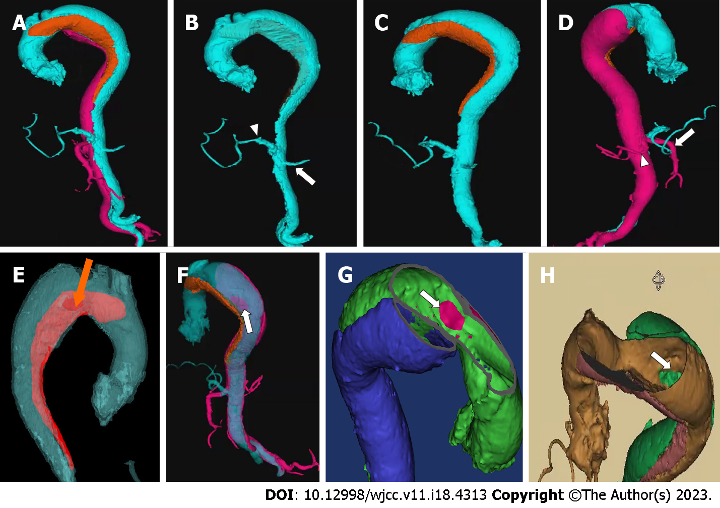
Figure 1 Image of medical 3D printing and modeling system for operative project planning. A: Three channels with different colors were clearly shown in this case by a 3D modeling image; B: The true lumen depicted in blue color was collapsed with the celiac artery (white arrowhead) and the left renal artery (white arrow) originated from it; C: One of the false lumen (in orange) started from the less curvature of the aortic arch, whose entry tear was at the front wall of the aorta; D: The other false lumen (in pink) started from the greater curvature of the distal aortic arch and extended to the right common iliac artery, involving the superior mesentery artery (white arrow) and the right renal artery (white arrowhead). The second entry (to pink false lumen) was located at the back wall of the aorta; E: The entry tear of false lumen (in red) started from the less curvature of the aortic arch could be clearly recognized at the front wall of the aorta from outside (orange arrow); F: The second entry of the false lumen (in pink) started from the greater curvature of the distal aortic arch was located at the back wall of the aorta, as seen from the outside (white arrow); G: The entry tear of false lumen (in blue) started from the less curvature of the aortic arch could be clearly recognized within the true lumen (white arrow); H: The second entry of the false lumen (in green) started from the greater curvature of the distal aortic arch was located at the back wall of the aorta, as seen within the true lumen (white arrow).
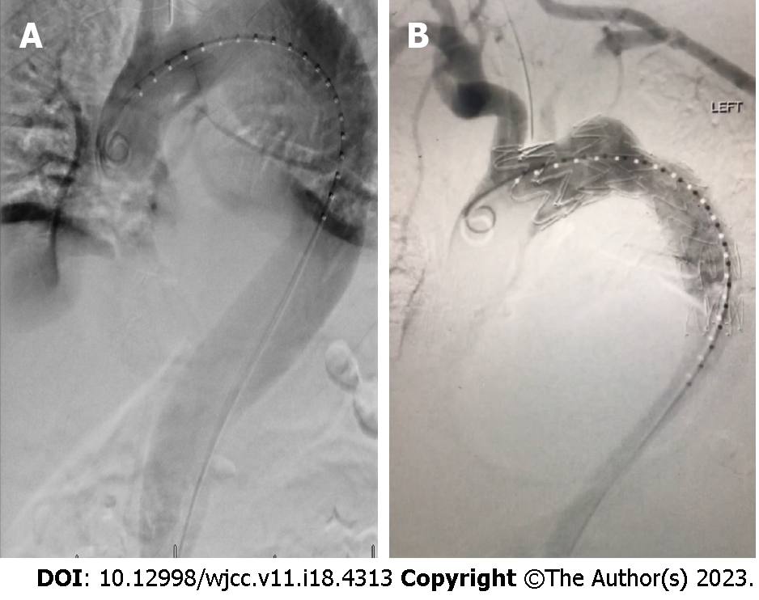
Figure 2 Angiographic findings during the procedure. A: Preoperative angiogram showed huge aneurysm caused by three-channeled aortic dissection; B: After stent graft deployment, the primary entries of both two false lumens were sealed without type I endoleaks as shown on the complete angiogram.

Published by Baishideng Publishing Group Inc
7041 Koll Center Parkway, Suite 160, Pleasanton, CA 94566, USA
Telephone: +1-925-3991568
E-mail: bpgoffice@wjgnet.com
Help Desk: https://www.f6publishing.com/helpdesk
https://www.wjgnet.com

© 2023 Baishideng Publishing Group Inc. All rights reserved.

