Name of Journal: World Journal of Clinical Cases
Manuscript NO: 60596
Manuscript Type: CASE REPORT

Multiple left ventricular myxomas combined with severe rheumatic valvular lesions: A case report

Liu SZ et al. Multiple left ventricular myxomas

Sheng-Zhong Liu, Ying Hong, Ke-Li Huang, Xiao-Ping Li

Sheng-Zhong Liu, Ke-Li Huang, Cardiac Surgery Center, Sichuan Academy of Medical Sciences & Sichuan Provincial People’s Hospital, Chengdu 610072, Sichuan Province, China

Ying Hong, Department of Cardiology, Chengdu University of Traditional Chinese Medicine, Chengdu 610075, Sichuan Province, China

Xiao-Ping Li, Department of Cardiology, Sichuan Academy of Medical Sciences & Sichuan Provincial People's Hospital, Chengdu 610072, Sichuan Province, China

Author contributions: Liu SZ and Hong Y contributed equally to this work; Hong Y collected the clinical data and wrote the manuscript; Liu SZ provided this case and drafted the manuscript; Liu SZ and Huang KL performed the surgery; Li XP helped perform the analysis with constructive discussions and approved the final version of the manuscript; all authors read and approved the final manuscript.

Supported by National Natural Science Foundation of China, No. 81770379.

Corresponding author: Xiao-Ping Li, PhD, Associate Professor, Department of Cardiology, Sichuan Academy of Medical Sciences & Sichuan Provincial People's Hospital, No. 32 Section 2 West 1st Ring Road, Chengdu 610072, Sichuan Province, China. lixiaoping0119@163.com

Received: November 8, 2020
Revised: May 10, 2021
Accepted: May 17, 2021
Published online: July 16, 2021

Abstract
BACKGROUND
Primary cardiac tumors are uncommon, of which cardiac myxoma accounts for 50%-80%. Left ventricular myxoma has been rarely reported, accounting for only 3%-4% of all cardiac myxomas. Multiple left ventricular myxomas are, relatively, even rarer.

CASE SUMMARY
In this report, we present a case of multiple left ventricular myxomas combined with severe rheumatic valve lesions. Symptomatically, the patient presented with fatigue, shortness of breath, and palpitation after activities. The patient underwent complete surgical resection of multiple left ventricular myxomas combined with mechanical replacement of the mitral and aortic valves, tricuspid valvuloplasty. The patient recovered well after the operation, with no obvious related complications.

CONCLUSION
Multiple left ventricular myxomas may coexist with severe rheumatic valve disease. Operation is an effective treatment.

Key Words: Left ventricular myxoma; Multiple; Rheumatic valvular lesions; Cardiac tumor; Surgery; Case report

©The Author(s) 2021. Published by Baishideng Publishing Group Inc. All rights reserved.

Citation: Liu SZ, Hong Y, Huang KL, Li XP. Multiple left ventricular myxomas combined with severe rheumatic valvular lesions: A case report. World J Clin Cases 2021; 9(20): 5535-5539
URL: https://www.wjgnet.com/2307-8960/full/v9/i20/5535.htm
DOI: https://dx.doi.org/10.12998/wjcc.v9.i20.5535

Core Tip: The patient in our case complained of fatigue, shortness of breath, and palpitation after activities. Based on a series of examinations, he was diagnosed with multiple left ventricular myxomas combined with severe rheumatic valve lesions; clinically, this is a relatively rare case.
INTRODUCTION
Cardiac myxoma is the most common primary cardiac benign tumor, with about 75%-80% occurring in left atrium, and only 3%-4% in left ventricle^{[1]}. Multiple left ventricular myxomas are extremely rare. In this report, we present a case of multiple left ventricular myxomas combined with severe rheumatic valve lesions.

CASE PRESENTATION
Chief complaints
Patient complained of a 20-year history of fatigue after activities, which was aggravated over the previous 2 mo.

History of present illness
A 53-year-old male was admitted to hospital with complaints of a 20-year history of fatigue after activities, which was aggravated over the previous 2 mo.

History of past illness
He had a more than 2-year history of diabetes.

Personal and family history
There was no history of rheumatic fever and family history of cardiac tumor or sudden death.

Physical examination
On admission, there was a diastolic rumbling pathological murmur of grade III/VI in the apical region. Grade IV/VI systolic ejection murmur and III/VI diastolic sighing murmur in the second intercostal space near the right margin of sternum were heard. Electrocardiogram showed atrial fibrillation with rapid ventricular rate.

Laboratory examinations
Laboratory data revealed slightly elevated glutamic oxaloacetic transaminase (45 U/L, normal level < 40 U/L) and total bilirubin (56 μmol/L, normal range < 23 μmol/L) and remarkably increased brain natriuretic peptide (692.7 pg/mL, normal range 0-100 pg/mL). Erythrocyte sedimentation rate was 6 mm/h. There were unremarkable abnormalities in circulation levels of serum tumor markers.

Imaging examinations
Chest computed tomography revealed bilateral emphysema with mild pulmonary edema, generally enlarged heart, and calcification of the aortic and mitral valves. Transesophageal echocardiography (TEE) demonstrated enlarged left atrium (50 mm), left ventricle (60 mm), and right atrium (64 mm × 57 mm). Mitral, aortic, and tricuspid valves were thickened and adhered, similar to rheumatic valve lesions. The mitral and aortic valve orifices exhibited severe stenosis, and the areas were 0.64 cm² and 0.87 cm², respectively. Multiple abnormal echo masses were found in the left ventricle (Figure 1), with the largest mass (about 23 mm × 15 mm in diameter) located in the left ventricular cavity at the junction of the anterior septum and the posterior papillary muscle.

FINAL DIAGNOSIS
Postoperative histopathological examination showed that the tumor cells were irregular, surrounded by empty halos, and scattered with sparse stroma, which confirmed the cardiac myxoma (Figure 2A). Mitral valve and aortic valve exhibited very obvious rheumatic lesions. The main manifestations of the microscopic examination of the valve specimens were comprehensive, manifested fibrous tissue hyperplasia, hyaline degeneration, and mucoid degeneration (Figure 2B). According to clinical manifestations, TEE and pathological biopsy, the final diagnosis was as follows: Multiple left ventricular myxomas combined with severe rheumatic valve lesions.

TREATMENT
The patient underwent surgical treatment through median sternotomy under cardiopulmonary bypass. Multiple masses were found in the left ventricle, which existed in the left ventricular outflow tract, anterior interventricular septum, anterior and posterior papillary muscle roots, and anterior mitral valve. The diameter of masses ranged from 5 mm to 20 mm; they had a crisp texture and were gelatinous with high mobility (Figure 3). The masses in the left ventricle were completely resected via the mitral and aortic valve orifices. The thickened and adhered mitral and aortic valves were replaced with mechanical valves. The tricuspid valvuloplasty was performed by incising the junction of anterior and septal valve and the junction of posterior and anterior valve. Then, the thickened leaflet was thinned to increase the activity of leaflet. Meanwhile, a tricuspid annuloplasty ring was used. The left atrial appendage was ligated during operation.

OUTCOME AND FOLLOW-UP
The patient recovered well after the operation, and his condition improved considerably; there were no obvious related complications.

DISCUSSION
Myxoma, the most common primary cardiac tumor, mainly arises from the left atrium, with barely 3%-4% arising in left ventricle. Cardiac myxoma typically occurs as a single mass and originates from the subendocardial interlobular tissue and occasionally from the remains of the embryo^{[1]}. The symptoms and signs may be nonspecific. In this case, although the patient had multiple myxomas, there was no family history and no extracardiac symptoms such as skin pigmentation, heart or endocrine abnormalities, and nerve tumors. Therefore, Carney complex was excluded^{[2]}. TEE is the most frequently used method for diagnosing cardiac myxoma and can determine the location, size, valve shape, valve leaf activity, etc.^{[3]}. It needs to be differentiated from left ventricular thrombus and cardiac valve excrescences. The left ventricular function of this patient was acceptable, and no signs of infection were found in laboratory examination, so left ventricular thrombus and cardiac valve excrescences were excluded.
Surgery is an effective treatment for cardiac myxoma. Left ventricular myxoma is usually removed through the mitral orifice or aortic valve orifice or via left ventricular incision^{[4]}. Due to severe rheumatic valve lesions, the patient required simultaneous mitral and aortic valve replacement, tricuspid valvuloplasty. Thus, the multiple left ventricular myxomas were completely removed through combination of mitral and aortic valve orifices approaches. In addition, considering the patient’s financial difficulties, the radiofrequency ablation for atrial fibrillation was not performed. However, we ligated the left atrial appendage to avoid the possibility of embolism caused by left atrial appendage thrombosis.

CONCLUSION
In conclusion, we describe here a unique case with multiple left ventricular myxomas combined and severe rheumatic valve lesions. Surgical treatment was effective.

REFERENCES
1 Natale E, Minardi G, Casali G, Pulignano G, Musumeci F. Left ventricular myxoma originating from the interventricular septum and obstructing the left ventricular outflow tract. Eur J Echocardiogr 2008; 9: 84-85 [PMID: 17379578 DOI: 10.1016/j.euje.2007.01.007]
2 Kuyama N, Hamatani Y, Fukushima S, Ikeda Y, Nakai E, Okada A, Takahama H, Amaki M, Hasegawa T, Sugano Y, Kanzaki H, Fujita T, Ishibashi-Ueda H, Yasuda S, Anzai T, Kobayashi J. Left ventricular myxoma with Carney complex. ESC Heart Fail 2018; 5: 713-715 [PMID: 29542870 DOI: 10.1002/ehf2.12282]
3 El Sabbagh A, Al-Hijji MA, Thaden JJ, Pislaru SV, Pislaru C, Pellikka PA, Arruda-Olson AM, Grogan M, Greason KL, Maleszewski JJ, Klarich KW, Nkomo VT. Cardiac Myxoma: The Great Mimicker. JACC Cardiovasc Imaging 2017; 10: 203-206 [PMID: 28183439 DOI: 10.1016/j.jcmg.2016.06.018]
4 Liu J, Guo HM, Xie B, Guo HJ, Chen JM, Zhuang J. Giant Left Ventricular Myxoma With Obstruction of the Left Ventricular Outflow Tract. Ann Thorac Surg 2016; 101: e63-e64 [PMID: 26897231 DOI: 10.1016/j.athoracsur.2015.09.043]

Footnotes
Informed consent statement: Written informed consent was obtained from the patient for publication of this case report and any accompanying images.

Conflict-of-interest statement: The authors declare that they have no conflict.

CARE Checklist (2016) statement: The authors have read the CARE Checklist (2016), and the manuscript was prepared and revised according to the CARE Checklist (2016).

Open-Access: This article is an open-access article that was selected by an in-house editor and fully peer-reviewed by external reviewers. It is distributed in accordance with the Creative Commons Attribution NonCommercial (CC BY-NC 4.0) license, which permits others to distribute, remix, adapt, build upon this work non-commercially, and license their derivative works on different terms, provided the original work is properly cited and the use is non-commercial. See: http://creativecommons.org/Licenses/by-nc/4.0/

Manuscript source: Unsolicited manuscript

Peer-review started: November 8, 2020
First decision: April 29, 2021
Article in press: May 17, 2021

Specialty type: Medicine, research and experimental
Country/Territory of origin: China
Peer-review report’s scientific quality classification
Grade A (Excellent): A
Grade B (Very good): 0
Grade C (Good): C
Grade D (Fair): 0
Grade E (Poor): 0

P-Reviewer: Nisi F, Xue L S-Editor: Fan JR L-Editor: Filipodia P-Editor: Yuan YY

Figure Legends
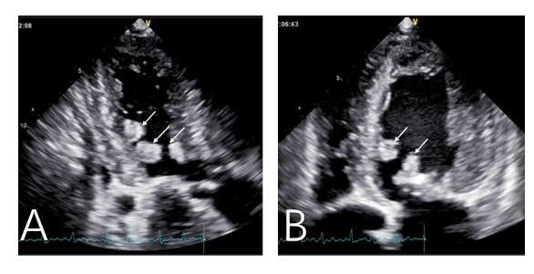
Figure 1 Transesophageal echocardiography demonstrates multiple abnormal masses were in the left ventricle. A: Apical three chamber view showed abnormal echo masses in the anterior septum and posterior wall of the left ventricle (arrows); B: Apical four chamber echocardiography showed abnormal echo mass in left ventricular posterior septum and mitral leaflet (arrows).
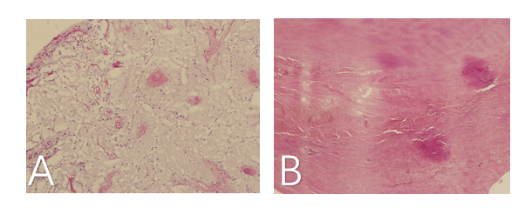
Figure 2 Histopathological findings. A. The tumor cells were irregular, surrounded by empty halos, and scattered with sparse stroma; B: The valve specimens manifested fibrous tissue hyperplasia, hyaline degeneration, and mucoid degeneration.
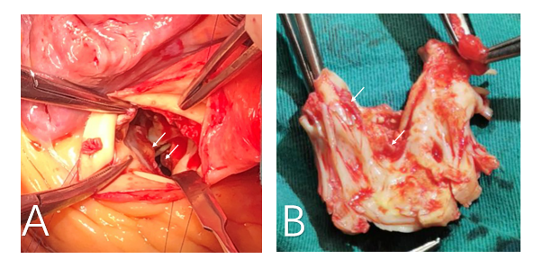
Figure 3 Intra-operative finding. A: Multiple masses were found in the left ventricular outflow tract (arrows); B: Multiple masses were found in the anterior mitral valve (arrows).

Published by Baishideng Publishing Group Inc
7041 Koll Center Parkway, Suite 160, Pleasanton, CA 94566, USA
Telephone: +1-925-3991568
E-mail: bpgoffice@wjgnet.com
Help Desk: https://www.f6publishing.com/helpdesk
https://www.wjgnet.com

© 2021 Baishideng Publishing Group Inc. All rights reserved.

