Name of Journal: World Journal of Meta-Analysis
Manuscript NO: 90229
Manuscript Type: SYSTEMATIC REVIEWS

Epidemiology of carbapenem-resistant Acinetobacter baumannii colonization in neonatal intensive care units: A systematic review and meta-analysis

Mbaga DS et al. Epidemiology of CRAB in NICU

Donatien Serge Mbaga, Sebastien Kenmoe, Seraphine Nkie Esemu, Arnol Bowo-Ngandji, Nene Kaah Keneh, Jane-Francis Tatah Kihla Akoachere, Hortense Kamga Gonsu, Roland Ndip Ndip, Jean Thierry Ebogo-Belobo, Cyprien Kengne-Ndé, Nicholas Tendongfor, Jean Paul Assam Assam, Lucy Mande Ndip, Jacky Njiki Bikoï, Sara Honorine Riwom Essama

Donatien Serge Mbaga, Arnol Bowo-Ngandji, Jacky Njiki Bikoï, Sara Honorine Riwom Essama, Jean Paul Assam Assam, Department of Microbiology, The University of Yaounde I, Yaounde 00237, Cameroon

Sebastien Kenmoe, Seraphine Nkie Esemu, Nene Kaah Keneh, Jane-Francis Tatah Kihla Akoachere, Roland Ndip Ndip, Nicholas Tendongfor, Lucy Mande Ndip, Department of Microbiology and Parasitology, University of Buea, Buea 00237, Cameroon

Hortense Kamga Gonsu, Faculty of Medicine and Biomedical Sciences, The University of Yaounde I, Yaounde 00237, Cameroon

Jean Thierry Ebogo-Belobo, Center for Research in Health and Priority Pathologies, Institute of Medical Research and Medicinal Plants Studies, Yaounde 00237, Cameroon

Cyprien Kengne-Ndé, Epidemiological Surveillance, Evaluation and Research Unit, National AIDS Control Committee, Douala 00237, Cameroon

Author contributions: Mbaga DS, Kenmoe S, Njiki Bikoï J and Riwom Essama SH were responsible for conception and design of the study as well as project administration; Mbaga DS, Kenmoe S, Nkie Esemu S, Kaah Keneh N, Tatah Kihla Akoachere JF, Gonsu Kamga H, Ndip Ndip R, Ebogo-Belobo JT, Kengne-Ndé C, Mbaga DS, Tendongfor N, Mande Ndip L, Assam Assam JP, Njiki Bikoï J and Riwom Essama SH were responsible for the data curation and interpretation of results; Kengne-Nde C and Kenmoe S were responsible for statistical analysis; Kenmoe S Njiki Bikoï J and Riwom Essama SH were responsible for the project supervision; Mbaga DS and Kenmoe S wrote the original draft; All authors critically reviewed the first draft and approved the final version of the paper for submission, and have read and approve the final manuscript.

Corresponding author: Sebastien Kenmoe, PhD, Lecturer, Department of Microbiology and Parasitology, University of Buea, Molyko, Buea 00237, Cameroon. sebastien.kenmoe@ubuea.cm

Received: November 27, 2023
Revised: January 5, 2024
Accepted: January 31, 2024
Published online:

Abstract
BACKGROUND
The rising prevalence of carbapenem-resistant Acinetobacter baumannii (CRAB) in neonatal intensive care units (NICUs) represents an escalating challenge in healthcare settings, particularly in managing hospital-acquired infections (HAIs). Studies across various World Health Organization regions have documented a significant incidence of CRAB-related HAIs, with rates as high as 41.7 cases per 1000 patients in ICUs, accounting for 13.6% of all HAIs. These infections pose a doubled mortality risk compared to infections with carbapenem-susceptible Acinetobacter baumannii. A particularly concerning aspect of CRAB colonization is its asymptomatic nature, enabling its transmission through healthcare workers (HCWs) or the NICU environment to vulnerable neonates with developing immune systems.

AIM
To explore the prevalence of CRAB colonization in NICUs, focusing on neonates, healthcare workers, and the environmental samples, to enhance epidemiological understanding and inform targeted interventions.

METHODS
We conducted according to PRISMA 2020 checklist guidelines, a comprehensive literature search across multiple databases including Medline (Ovid), Embase (Ovid), Global Health (Ovid), Web of Science, and Global Index Medicus. Studies were selected based on predetermined criteria, primarily involving neonates, HCWs, and environmental swabs, using culture or molecular methods to detect CRAB colonization. We excluded studies that did not specifically focus on NICUs, were duplicates, or lacked necessary data. The study selection and quality assessment were conducted independently by two reviewers. Data extraction involved collecting comprehensive details about each study. Our statistical analysis used a random-effects model to calculate the pooled prevalence and confidence intervals, stratifying results by regional location. We assessed study heterogeneity using Cochran's Q statistic and I² statistic, with regression tests employed to evaluate potential publication bias.

RESULTS
We analyzed 737 records from five databases, ultimately including 13 studies from ten countries. For neonates, the pooled prevalence was 4.8% (95%CI 1.1%-10.5%) with the highest rates observed in South-East Asia (10.5%; 95%CI 2.4%-23.3%). Among HCWs, a single Indian study reported a 3.3% prevalence. Environmental samples showed a prevalence of 2.3% (95%CI 0%-9.3%), with the highest rates in South-East Asia (10%; 95%CI 4.2%-17.7%). Significant heterogeneity was found across studies, and no publication bias was detected.

CONCLUSION
This systematic review highlights a significant prevalence of CRAB colonization in neonates across various regions, particularly in South-East Asia, contrasting with lower rates in high-income countries. The study reveals a gap in research on HCWs colonization, with only a single study from India reporting moderate prevalence. Environmental samples indicate moderate levels of CRAB contamination, again higher in South-East Asia. These findings underscore the need for more extensive and focused research on CRAB colonization in NICUs, including exploring the roles of HCWs and the environment in transmission, understanding antimicrobial resistance patterns, and developing effective prevention measures.

Key Words: Colonization; Carbapenem-resistant Acinetobacter baumannii; Neonatal intensive-care unit

Mbaga DS, Kenmoe S, Esemu SN, Bowo-Ngandji A, Keneh NK, Tatah Kihla Akoachere JF, Gonsu HK, Ndip Ndip R, Ebogo-Belobo JT, Kengne-Ndé C, Tendongfor N, Assam Assam JP, Ndip LM, Njiki Bikoï J, Riwom Essama SH. Epidemiology of carbapenem-resistant Acinetobacter baumannii colonization in neonatal intensive care units: A systematic review and meta-analysis. World J Meta-Anal 2024; In press

Core Tip: This study reveals a notable prevalence of carbapenem-resistant Acinetobacter baumannii colonization in neonatal intensive care units. The analysis revealed a pooled prevalence of 4.8% in neonates, with a considerable gap in research on healthcare workers colonization and a 2.3% prevalence in environmental samples. The substantial heterogeneity across studies and the observed regional variations underlines the need for more targeted research.

INTRODUCTION
The escalation of carbapenem-resistant Acinetobacter baumannii (CRAB) in neonatal intensive care units (NICUs) is a mounting concern in the healthcare settings. A study has highlighted the significance of CRAB healthcare-acquired infections (HAIs) in various World Health Organization (WHO) regions, revealing an incidence of 21.4 (95%CI 11.0-41.3) cases per 1000 patients in hospital settings, and a higher incidence of 41.7 (95%CI 21.6-78.7) cases per 1000 patients in intensive care units^{[1]}. CRAB accounts for 13.6% (95%CI 9.7-18.7%) of all HAIs in these settings^{[1]}. Another study has highlighted the severe implications of CRAB infections, with patients exhibiting a doubled mortality risk compared to those with carbapenem-susceptible Acinetobacter baumannii (CSAB), evidenced by a pooled crude odds ratio of 2.22 (95%CI = 1.66, 2.98)^{[2]}. A retrospective study from Thailand has highlighted the economic impact of CRAB infections in ventilator-associated pneumonia (VAP), where CRAB VAP patients incurred a median total hospital cost of US$11773, higher than the US$9735 for CSAB VAP patients^{[3]}.
The asymptomatic nature of CRAB colonization and the possibility of its transmission to vulnerable neonates with developing immune systems through healthcare workers (HCWs) or the NICU environment exacerbate this risk^{[4,5]}. This scenario is challenging because the absence of symptoms in colonized individuals makes early detection and isolation difficult, increasing the risk of transmission to vulnerable newborns. The findings from a study investigating nosocomial rectal CRAB colonization in a tertiary-care hospital identified several significant risk factors associated with CRAB colonization, notably the use of permanent devices (OR 10.15, 95%CI 2.27-45.39), mechanical ventilation (OR 40.01, 95%CI 4.05-395.1), urinary catheters (OR 4.9, 95%CI 1.52-16.19), a poorer prognosis (OR 5.45, 95%CI 1.87-15.89), increased length of stay (OR 1.03, 95%CI 1.01-1.05), and carbapenem use (OR 5.39, 95%CI 1.14-25.44)^{[6]}. Effective management in NICUs demands a comprehensive strategy encompassing regular screening of neonates and HCWs, strict hand hygiene, thorough environmental cleaning and disinfection, and adherence to infection control protocols^{[7]}. CRAB, identified by the WHO and the Infectious Diseases Society of America (IDSA) as a high-priority pathogen, poses a significant threat due to its resistance to a wide range of antibiotics^{[8,9]}. CRAB’s resistance to a broad range of antibiotics, including cephalosporins, fluoroquinolones, and commonly used hospital antibiotics like piperacillin, ticarcillin, and ampicillin, limits treatment options^{[10]}. Colistin and polymyxin B show the lowest resistance rates, suggesting potential therapeutic alternatives^{[10]}. The prevalence of CRAB colonization in NICUs is subject to significant variation, reflecting disparities in healthcare practices, hospital environments, geographic locations, and patient demographics. Despite the critical impact of CRAB in NICUs, current epidemiological understanding, particularly regarding neonates, HCWs, and the NICU environment, remains limited. The objective of this review is to examine the prevalence of CRAB colonization in NICUs, focusing on neonates, HCWs, and the NICU environment.

MATERIALS AND METHODS
Protocol registration and review design
The protocol was registered on the International Prospective Register of Systematic Reviews, PROSPERO, as CRD42023463547 and to conduct this systematic review, the study design followed PRISMA 2020 guidelines^{[11]}.

Search strategy
The search strategy included looking through five databases, such as Medline (Ovid), Embase (Ovid), Global Health (Ovid), Web of Science, and Global Index Medicus (Supplementary Table 1). The databases query was done on September 13, 2023. The reference list of pertinent papers was also hand-searched. The review focused on papers published in English or French that were not time limited.

Eligibility criteria
After removing duplicates from the detected papers across bibliographic databases, the titles and abstracts of the remaining articles were independently examined by two reviewers. The studies were chosen based on preset inclusion criteria, which included studies that recruited neonates, HCW, and swabbed inert surfaces in environment to investigate CRAB colonization or carriage using culture or molecular techniques. Studies focusing on clinical CRAB infections, CRAB outbreaks, research done outside of NICUs, review studies, duplicates, and those without abstracts or complete texts were removed. Publications not in English or French, articles with irrelevant or inadequate data were all excluded from the analysis.

Study selection
The selection was done by two independent reviewers (DSM and SK) based on the predefined inclusion and exclusion criteria. The reviewers individually examined all of the publication titles and abstracts to find potentially qualifying studies. The entire texts of these possibly qualifying papers were then evaluated to decide their inclusion in the review. Any discrepancies or contradictions were reviewed and resolved by consensus. If an agreement could not be reached, a third reviewer was consulted.

Data extraction
SK and DSM independently examined the data retrieved from selected studies. Data was extracted online by google form and summarized in a Microsoft Excel file. From each study we collected first author names, publication year, reason of exclusion if study were excluded, study design, country of study, sampling method, setting, levels of care, number of sites, timing of samples collection, countries; Geographic regions; number of participants screened, number of participants colonized with CRAB, isolation method utilized.

Quality assessment
The studies that met the inclusion criteria were rated for methodological quality by two investigators (SK and DSM) independently. Quality assessment of the included studies were done by using the Hoy et al^{[12]} tools (Supplementary Table 2). Any disagreements were settled verbally, and consensus was obtained.

Data analysis
The analysis was carried out with R software version 4.0.3 utilising the statistical software packages meta (version 4.18-2) and metafor (version 3.0-2)^{[13,14]}. The pooled percentage and 95% confidence interval (CI) were calculated using a random-effects model^{[15]}. Results in subgroup analysis were stratified by geographical and regional location. Heterogeneity of study effect sizes was evaluated using Cochran's Q statistic and I² statistic^{[16,17]}. Significant heterogeneity is defined by a P value < 0.05 for the Cochran Q statistic or by I² values > 50%. Regression tests were used to investigate publication bias^{[18]}.

RESULTS
Study selection
A total of 737 records were identified from five databases: Medline (n = 98), Embase (n = 337), Global Health (n = 117), Web of Science (n = 164), and Global Index Medicus (n = 21). Of these, 454 records were screened, leading to the exclusion of 107 reports. Subsequently, 347 reports were sought for retrieval, but 14 could not be retrieved. Upon assessing the 333 retrieved reports for eligibility, 320 were excluded for various reasons, including the absence of CRAB colonization or carriage data (n = 225), language barriers (n = 41), lack of NICU data (n = 36), and other categorizations such as reviews, case reports, article comments, duplicates, editorials, and outbreak investigations. Ultimately, 13 studies were included in the analysis (Figure 1)^{[19-31]}.

Study characteristics
We gathered published data from ten countries, with Brazil, Morocco, and Thailand each contributing two studies, and Egypt, Germany, India, Italy, Netherlands, Serbia, and Türkiye each providing one (Supplementary Table 3). Geographically, the majority of the studies hailed from Europe (n = 5), followed by the Eastern Mediterranean and South-East Asia each with three studies, and America with two studies (Figure 2). When segmented by income, most of the studies were from upper-middle-income countries (n = 6), with lower-middle-income countries providing four and high-income countries three. The majority of these studies were recent, with various participant recruitment periods ranging from January 1989 to February 2020. Concerning the populations under study, neonates dominated the research (n = 9), compared to environmental samples (n = 4) and HCWs (n = 1). Different methods, such as culture and biochemical (API gallery), were used for CRAB identification, with disk diffusion test being the most common antimicrobial susceptibility testing method and following mainly Clinical and Laboratory Standards Institute guidelines. The antibiotics primarily used for these tests were carbapenem including imipenem and meropenem. Samples varied from endotracheal aspirates and environmental samples to various swabs like rectal and surface. A study in Brazil from September 2013 to September 2015 involving 21 neonates tested CRAB antimicrobial susceptibility and reported 100% resistance to ampicillin/sulbactam, piperacillin/tazobactam, ceftazidime, ceftriaxone, cefepime, gentamicin, and ciprofloxacin, 76.2% to tigecycline, 47.6% to amikacin, and no resistance to colistin^{[24]}. All the studies reviewed had a moderate risk of bias (Supplementary Table 4).

Prevalence of CRAB colonization in neonates in neonatal intensive care units
The prevalence of CRAB colonization in neonatal intensive care units for neonates was 4.8% (95%CI 1.1-10.5%) based on 10 studies with 6610 participants, with a heterogeneity of I² = 98.7% (95%CI 98.3-99), indicating significant heterogeneity (Figure 3). A study in Germany during the study period from November 2016 to March 2018 reported a prevalence of 0% among 584 preterm infants and severely ill neonates, including those with very low birth weight^{[20]}. In Serbia, from December 2017 to April 2018, found a colonization prevalence of 13.6% among 103 premature neonates, with 14 neonates testing positive for CRAB^{[26]}. A study in Thailand, during the study period from February 2015 to September 2015, reported a prevalence of 27.9% among 660 outborn neonates, with 184 of these neonates testing positive for CRAB colonization^{[29]}. In a study in Thailand, during the preintervention period from January 2011 to December 2013, which involved pasteurization cleaning of a reused ventilator circuit and daily cleaning of the NICU environment with 0.5% NaOCl, the prevalence was 14.0% among 1437 neonates, with 201 neonates testing positive for CRAB^{[31]}. During the intervention period from January 2014 to December 2014, which implemented the use of disposable HMEs, HME equipment for all ventilated neonates, 0.5% NaOCl for NICU cleaning, 0.05% NaOCl for neonatal environment cleaning, and ongoing education for HCWs about HME and NaOCl use, the prevalence dropped to 5.1% among 455 neonates, with 23 neonates testing positive. In the postintervention period spanning from January 2015 to December 2017, which maintained the use of disposable HMEs and HME equipment for all ventilated neonates, 0.5% NaOCl for NICU cleaning, and 0.05% NaOCl for neonatal environment cleaning without additional training for HCWs, the prevalence further decreased to 2.2% among 1475 neonates, with 33 neonates found to be colonized with CRAB. P values for heterogeneity were significant at less than 0.001, while the Egger test results, indicative of no publication bias was 0.718 (Table 1).

Prevalence of CRAB colonization in healthcare workers, and environmental samples in neonatal intensive care units
For HCWs, the prevalence was 3.3% (95%CI 0-13.8) from a singular study conducted in India and involving 30 participants.
In the case of environmental samples, the prevalence was reported at 2.3% (95%CI 0-9.3) from four studies with 530 samples, showcasing a heterogeneity of I² = 86.4% (95%CI 67-94.4) (Figure 4). P values for heterogeneity were significant at less than 0.001, while the Egger test results, indicative of no publication bias was 0.989 (Table 1).

Subgroup analysis
In a subgroup analysis of a systematic review aimed at describing the colonization of CRAB in neonatal intensive care units, among neonates, Serbia reported the highest prevalence at 13.6% (95%CI 7.6%-21%) followed by Thailand with 10.5% (95%CI 2.4%-23.3%) and Türkiye with 7.2% (95%CI 5.5%-9.2%) (Supplementary Table 5). When grouped by WHO regions, South-East Asia had the highest prevalence at 10.5% (95%CI 2.4%-23.3%), while Europe reported a prevalence of 3.1% (95%CI 0%-11.9%). By World Bank Income Groups, upper-middle-income countries showed the highest colonization at 8% (95%CI 2.5%-16.1%). For environmental samples, India reported the highest prevalence at 10% (95%CI 4.2%-17.7%), followed by Morocco at 5.2% (95%CI 2.9%-8.1%). In the WHO regional breakdown for environmental samples, South-East Asia had a prevalence of 10% (95%CI 4.2%-17.7%). The differences in prevalence among country subtypes for both neonates and environmental samples were significant with p-values less than 0.001. In contrast, differences among the WHO regions for environmental samples were not statistically significant with a p-value of 0.187.

DISCUSSION
The present systematic review is the first to examine CRAB colonization in neonates, HCWs, and environmental samples in NICUs in ten countries, encompassing 13 included studies. The review found a substantial variability in CRAB colonization rates among neonates, with a pooled prevalence of 4.8% (95%CI 1.1%-10.5%). For HCWs, a single study from India reported a 3.3% prevalence, while environmental samples showed a pooled prevalence at 2.3% (95%CI 0%-9.3%). South-East Asia recorded the highest prevalence of CRAB colonization for both neonates (10.5%; 95%CI 2.4%-23.3%) and environmental samples (10%; 95%CI 4.2%-17.7%). High-income countries exhibited minimal prevalence of CRAB colonization in these categories. A Brazilian study involving neonates found 100% resistance to several antibiotics, but no resistance to colistin. In Thailand, interventions like the use of disposable ventilation equipment and improved cleaning protocols significantly reduced CRAB prevalence in NICUs.
The review identifies a pooled prevalence of 4.8% (95%CI 1.1%-10.5%) among neonates, with notable geographical variability, highlighting the influence of regional socioeconomic factors and healthcare practices. South-East Asia showed the highest prevalence at 10.5% (95%CI 2.4%-23.3%), contrasting with minimal rates in high-income countries. This disparity in CRAB colonization rates may be attributed to infection control standards, healthcare infrastructures, distinct local healthcare protocols, environmental conditions, and variations in antibiotic usage, which warrant further detailed investigation to understand their contributions to these regional differences^{[7,32,33]}. However, a significant limitation is the absence of data on neonatal length of stay in NICUs in included studies, a critical factor in assessing colonization risk^{[34]}. Another limitation of this study is the absence of data from low-income countries, which potentially limits the generalizability of the findings. There is a clear need for further research on CRAB in NICUs from low- and middle-income countries.
The review also points to a significant knowledge gap regarding HCW colonization, with only one study from India indicating a 3.3% prevalence. Given the potential of HCWs as vectors for asymptomatic transmission of CRAB to highly susceptible neonates, this lack of data hampers the development of comprehensive infection control strategies in non-outbreak settings in NICUs^{[35]}. Environmental samples revealed a pooled prevalence of 2.3% (95%CI 0%-9.3%), with a peak prevalence of 10% in South-East Asia (95%CI 4.2%-17.7%), suggesting that hospital environments, particularly in resource-limited settings, can act as reservoirs for CRAB, facilitating its spread within NICUs^{[5,36]}.
Antimicrobial resistance patterns in neonates are poorly represented in the literature, with only one Brazilian study included, reporting a 100% resistance rate to several antibiotics except for colistin. This finding aligns with Lima's 2019 study, which documented high resistance rates to various antibiotics in CRAB isolates from burn injury patients^{[10]}. The emerging challenge in treating CRAB infections is evident, highlighting the urgent need for judicious antibiotic use and alternative therapeutic strategies^{[5,37]}.
In terms of preventive measures, the review includes a study from Thailand, demonstrating a significant reduction in CRAB prevalence in NICUs following specific interventions. This contrasts with Tomczyk's 2019 review, which provides a broader view of effective infection prevention and control measures across various healthcare settings^{[38]}. The specific challenges and needs of neonatal populations in NICUs, however, remain under-researched, underscoring the necessity for more focused interventional studies on effective preventive strategies for this vulnerable group.

CONCLUSION
This systematic review finds a notable prevalence of CRAB colonization in neonates, with significant regional differences, being higher in South-East Asia and lower in high-income countries. The research on HCWs colonization is limited, with only one study from India indicating a moderate prevalence. Environmental samples also show a moderate CRAB contamination, with higher rates again observed in South-East Asia. This study highlights the need for more comprehensive research focused on CRAB on neonatal populations in NICUs, including studies on HCW colonization, environmental contamination, antimicrobial resistance patterns, and effective prevention measures. The development of tailored strategies that address the unique vulnerabilities of neonates in NICUs is essential to combat the threat of CRAB colonization and ensure the safety and health of these patients.

ARTICLE HIGHLIGHTS
Research background
The surge of carbapenem-resistant Acinetobacter baumannii (CRAB) in neonatal intensive care units (NICUs) has emerged as a significant healthcare concern, particularly due to its role in healthcare-acquired infections (HAIs). CRAB doubles the mortality risk compared to patients with carbapenem-susceptible Acinetobacter baumannii.

Research motivation
The asymptomatic nature of CRAB colonization, especially in NICU settings, and its potential transmission through healthcare workers (HCWs) or the environment, intensify the risks to vulnerable neonates with developing immune systems.

Research objectives
This review aims to examine the prevalence of CRAB colonization in NICUs, focusing on neonates, HCWs, and the NICU environment.

Research methods
Our systematic review was conducted following the PRISMA 2020 guidelines. We initiated our search across Medline (Ovid), Embase (Ovid), Global Health (Ovid), Web of Science, and Global Index Medicus. We also conducted a manual search through the references of relevant papers. Our inclusion criteria focused on studies in English or French that investigated CRAB colonization in neonates, HCWs, and environmental samples using culture or molecular techniques. Studies that did not focus on NICUs, were duplicates, or lacked adequate data were excluded. A random-effects model was applied to calculate the pooled prevalence and 95% confidence intervals, with subgroup analysis stratified by regional location.

Research results
Our systematic review collated data from 13 studies across ten countries. We found that neonates had a pooled CRAB colonization prevalence of 4.8%, though this varied widely by region, with South-East Asia reporting the highest rates. The prevalence in HCWs was only documented in a single study from India, suggesting a significant research gap in understanding the role of HCWs as potential vectors in CRAB transmission. Environmental samples exhibited CRAB presence, with a pooled prevalence of 2.3%, again with the highest rates in South-East Asia.

Research conclusions
The study revealed significant geographical variability in CRAB colonization rates, with a pooled prevalence of 4.8% among neonates and notable higher rates in South-East Asia and lower in high-income countries. A critical gap in research was identified regarding HCW colonization, with only a single study from India reporting a prevalence of 3.3%. Environmental samples showed a 2.3% pooled prevalence, with the highest rates again in South-East Asia.

Research perspectives
This study underscores the necessity of tailored research and intervention strategies in NICUs to address the unique challenges of neonatal populations and combat the threat of CRAB colonization effectively.

REFERENCES
1 Ayobami O, Willrich N, Harder T, Okeke IN, Eckmanns T, Markwart R. The incidence and prevalence of hospital-acquired (carbapenem-resistant) Acinetobacter baumannii in Europe, Eastern Mediterranean and Africa: a systematic review and meta-analysis. Emerg Microbes Infect 2019; 8: 1747-1759 [PMID: 31805829 DOI: 10.1080/22221751.2019.1698273]
2 Lemos EV, de la Hoz FP, Einarson TR, McGhan WF, Quevedo E, Castañeda C, Kawai K. Carbapenem resistance and mortality in patients with Acinetobacter baumannii infection: systematic review and meta-analysis. Clin Microbiol Infect 2014; 20: 416-423 [PMID: 24131374 DOI: 10.1111/1469-0691.12363]
3 Thatrimontrichai A, Apisarnthanarak A, Chanvitan P, Janjindamai W, Dissaneevate S, Maneenil G. Risk factors and outcomes of carbapenem-resistant Acinetobacter baumannii bacteremia in neonatal intensive care unit: a case-case-control study. Pediatr Infect Dis J 2013; 32: 140-145 [PMID: 22935872 DOI: 10.1097/INF.0b013e318270b108]
4 Ng DHL, Marimuthu K, Lee JJ, Khong WX, Ng OT, Zhang W, Poh BF, Rao P, Raj MDR, Ang B, De PP. Environmental colonization and onward clonal transmission of carbapenem-resistant Acinetobacter baumannii (CRAB) in a medical intensive care unit: the case for environmental hygiene. Antimicrob Resist Infect Control 2018; 7: 51 [PMID: 29644052 DOI: 10.1186/s13756-018-0343-z]
5 Jiang Y, Ding Y, Wei Y, Jian C, Liu J, Zeng Z. Carbapenem-resistant Acinetobacter baumannii: A challenge in the intensive care unit. Front Microbiol 2022; 13: 1045206 [PMID: 36439795 DOI: 10.3389/fmicb.2022.1045206]
6 Meschiari M, Kaleci S, Orlando G, Selmi S, Santoro A, Bacca E, Menozzi M, Franceschini E, Puzzolante C, Bedini A, Sarti M, Venturelli C, Vecchi E, Mussini C. Risk factors for nosocomial rectal colonization with carbapenem-resistant Acinetobacter baumannii in hospital: a matched case-control study. Antimicrob Resist Infect Control 2021; 10: 69 [PMID: 33832538 DOI: 10.1186/s13756-021-00919-6]
7 Wong SC, Chau PH, So SY, Lam GK, Chan VW, Yuen LL, Au Yeung CH, Chen JH, Ho PL, Yuen KY, Cheng VC. Control of Healthcare-Associated Carbapenem-Resistant Acinetobacter baumannii by Enhancement of Infection Control Measures. Antibiotics (Basel) 2022; 11 [PMID: 36009945 DOI: 10.3390/antibiotics11081076]
8 Tacconelli E, Carrara E, Savoldi A, Harbarth S, Mendelson M, Monnet DL, Pulcini C, Kahlmeter G, Kluytmans J, Carmeli Y, Ouellette M, Outterson K, Patel J, Cavaleri M, Cox EM, Houchens CR, Grayson ML, Hansen P, Singh N, Theuretzbacher U, Magrini N; WHO Pathogens Priority List Working Group. Discovery, research, and development of new antibiotics: the WHO priority list of antibiotic-resistant bacteria and tuberculosis. Lancet Infect Dis 2018; 18: 318-327 [PMID: 29276051 DOI: 10.1016/S1473-3099(17)30753-3]
9 Nelson R. IDSA releases “hit list”. Lancet Infect Dis 2006; 6: 265 [DOI: 10.1016/s1473-3099(06)70453-4]
10 Lima WG, Silva Alves GC, Sanches C, Antunes Fernandes SO, de Paiva MC. Carbapenem-resistant Acinetobacter baumannii in patients with burn injury: A systematic review and meta-analysis. Burns 2019; 45: 1495-1508 [PMID: 31351820 DOI: 10.1016/j.burns.2019.07.006]
11 Page MJ, Moher D, Bossuyt PM, Boutron I, Hoffmann TC, Mulrow CD, Shamseer L, Tetzlaff JM, Akl EA, Brennan SE, Chou R, Glanville J, Grimshaw JM, Hróbjartsson A, Lalu MM, Li T, Loder EW, Mayo-Wilson E, McDonald S, McGuinness LA, Stewart LA, Thomas J, Tricco AC, Welch VA, Whiting P, McKenzie JE. PRISMA 2020 explanation and elaboration: updated guidance and exemplars for reporting systematic reviews. BMJ 2021; 372: n160 [PMID: 33781993 DOI: 10.1136/bmj.n160]
12 Hoy D, Brooks P, Woolf A, Blyth F, March L, Bain C, Baker P, Smith E, Buchbinder R. Assessing risk of bias in prevalence studies: modification of an existing tool and evidence of interrater agreement. J Clin Epidemiol 2012; 65: 934-939 [PMID: 22742910 DOI: 10.1016/j.jclinepi.2011.11.014]
13 Borenstein M, Hedges LV, Higgins JP, Rothstein HR. A basic introduction to fixed-effect and random-effects models for meta-analysis. Res Synth Methods 2010; 1: 97-111 [PMID: 26061376 DOI: 10.1002/jrsm.12]
14 Schwarzer G. meta: An R Package for Meta-Analysis. 2007; 7: 40-45
15 DerSimonian R, Laird N. Meta-analysis in clinical trials. Control Clin Trials 1986; 7: 177-188 [PMID: 3802833 DOI: 10.1016/0197-2456(86)90046-2]
16 Cochran WG. The Combination of Estimates from Different Experiments. Biometrics 1954; 10: 101-129 [DOI: 10.2307/3001666]
17 Veroniki AA, Jackson D, Viechtbauer W, Bender R, Bowden J, Knapp G, Kuss O, Higgins JP, Langan D, Salanti G. Methods to estimate the between-study variance and its uncertainty in meta-analysis. Res Synth Methods 2016; 7: 55-79 [PMID: 26332144 DOI: 10.1002/jrsm.1164]
18 Egger M, Davey Smith G, Schneider M, Minder C. Bias in meta-analysis detected by a simple, graphical test. BMJ 1997; 315: 629-634 [PMID: 9310563 DOI: 10.1136/bmj.315.7109.629]
19 Arhoune B, Oumokhtar B, Hmami F, El Fakir S, Moutaouakkil K, Chami F, Bouharrou A. Intestinal carriage of antibiotic resistant Acinetobacter baumannii among newborns hospitalized in Moroccan neonatal intensive care unit. PLoS One 2019; 14: e0209425 [PMID: 30629614 DOI: 10.1371/journal.pone.0209425]
20 Baier C, Pirr S, Ziesing S, Ebadi E, Hansen G, Bohnhorst B, Bange FC. Prospective surveillance of bacterial colonization and primary sepsis: findings of a tertiary neonatal intensive and intermediate care unit. J Hosp Infect 2019; 102: 325-331 [PMID: 30716339 DOI: 10.1016/j.jhin.2019.01.021]
21 Chiguer M, Maleb A, Amrani R, Abda N, Alami Z. Assessment of surface cleaning and disinfection in neonatal intensive care unit. Heliyon 2019; 5: e02966 [PMID: 31872128 DOI: 10.1016/j.heliyon.2019.e02966]
22 Horrevorts A, Bergman K, Kollée L, Breuker I, Tjernberg I, Dijkshoorn L. Clinical and epidemiological investigations of Acinetobacter genomospecies 3 in a neonatal intensive care unit. J Clin Microbiol 1995; 33: 1567-1572 [PMID: 7650188 DOI: 10.1128/jcm.33.6.1567-1572.1995]
23 Karaaslan A, Soysal A, Altinkanat Gelmez G, Kepenekli Kadayifci E, Söyletir G, Bakir M. Molecular characterization and risk factors for carbapenem-resistant Gram-negative bacilli colonization in children: emergence of NDM-producing Acinetobacter baumannii in a newborn intensive care unit in Turkey. J Hosp Infect 2016; 92: 67-72 [PMID: 26601601 DOI: 10.1016/j.jhin.2015.09.011]
24 Maciel WG, da Silva KE, Croda J, Cayô R, Ramos AC, de Sales RO, de Almeida de Souza GH, Bampi JVB, Limiere LC, Casagrande JC, Gales AC, Simionatto S. Clonal spread of carbapenem-resistant Acinetobacter baumannii in a neonatal intensive care unit. J Hosp Infect 2018; 98: 300-304 [PMID: 29107079 DOI: 10.1016/j.jhin.2017.10.015]
25 Mariani M, Bandettini R, LA Masa D, Minghetti D, Baldelli I, Serveli S, Mesini A, Saffioti C, Ramenghi LA, Castagnola E. Bacterial invasive infections in a neonatal intensive care unit: a 13 years microbiological report from an Italian tertiary care centre. J Prev Med Hyg 2020; 61: E162-E166 [PMID: 32803000 DOI: 10.15167/2421-4248/jpmh2020.61.2.1401]
26 Milic M, Siljic M, Cirkovic V, Jovicevic M, Perovic V, Markovic M, Martic J, Stanojevic M, Mijac V. Colonization with Multidrug-Resistant Bacteria in the First Week of Life among Hospitalized Preterm Neonates in Serbia: Risk Factors and Outcomes. Microorganisms 2021; 9 [PMID: 34946217 DOI: 10.3390/microorganisms9122613]
27 Mir MA, Ashraf MW, Tripathi V, Mir BA. Isolation, characterization and prevention of various microbial strains in NIC unit and PIC unit. Sci Rep 2021; 11: 647 [PMID: 33436783 DOI: 10.1038/s41598-020-79364-1]
28 Omran EA, Eisa FF, Bakr WMK. Microbial Contamination of Neonatal Injectable Lipid Emulsions at 12 and 24 Hours' Infusion Time With Evaluation of Infection Control Measures. J Pediatr Pharmacol Ther 2020; 25: 53-60 [PMID: 31897076 DOI: 10.5863/1551-6776-25.1.53]
29 Roberts T, Limmathurotsakul D, Turner P, Day NPJ, Vandepitte WP, Cooper BS. Antimicrobial-resistant Gram-negative colonization in infants from a neonatal intensive care unit in Thailand. J Hosp Infect 2019; 103: 151-155 [PMID: 30995491 DOI: 10.1016/j.jhin.2019.04.004]
30 Sakai AM, Iensue TNAN, Pereira KO, Silva RLD, Pegoraro LGO, Salvador MSA, Rodrigues R, Capobiango JD, Souza NAA, Pelisson M, Vespero EC, Yamauchi LM, Perugini MRE, Yamada-Ogatta SF, Rossetto EG, Kerbauy G. Colonization profile and duration by multi-resistant organisms in a prospective cohort of newborns after hospital discharge. Rev Inst Med Trop Sao Paulo 2020; 62: e22 [PMID: 32236389 DOI: 10.1590/S1678-9946202062022]
31 Thatrimontrichai A, Pannaraj PS, Janjindamai W, Dissaneevate S, Maneenil G, Apisarnthanarak A. Intervention to reduce carbapenem-resistant Acinetobacter baumannii in a neonatal intensive care unit. Infect Control Hosp Epidemiol 2020; 41: 710-715 [PMID: 32131902 DOI: 10.1017/ice.2020.35]
32 Jung J, Choe PG, Choi S, Kim E, Lee HY, Kang CK, Lee J, Park WB, Lee S, Kim NJ, Choi EH, Oh M. Reduction in the acquisition rate of carbapenem-resistant Acinetobacter baumannii (CRAB) after room privatization in an intensive care unit. J Hosp Infect 2022; 121: 14-21 [PMID: 34929231 DOI: 10.1016/j.jhin.2021.12.012]
33 Meschiari M, Lòpez-Lozano JM, Di Pilato V, Gimenez-Esparza C, Vecchi E, Bacca E, Orlando G, Franceschini E, Sarti M, Pecorari M, Grottola A, Venturelli C, Busani S, Serio L, Girardis M, Rossolini GM, Gyssens IC, Monnet DL, Mussini C. A five-component infection control bundle to permanently eliminate a carbapenem-resistant Acinetobacter baumannii spreading in an intensive care unit. Antimicrob Resist Infect Control 2021; 10: 123 [PMID: 34412693 DOI: 10.1186/s13756-021-00990-z]
34 Sultan AM, Seliem WA. Identifying Risk Factors for Healthcare-Associated Infections Caused by Carbapenem-Resistant Acinetobacter baumannii in a Neonatal Intensive Care Unit. Sultan Qaboos Univ Med J 2018; 18: e75-e80 [PMID: 29666685 DOI: 10.18295/squmj.2018.18.01.012]
35 Blanco N, O'Hara LM, Harris AD. Transmission pathways of multidrug-resistant organisms in the hospital setting: a scoping review. Infect Control Hosp Epidemiol 2019; 40: 447-456 [PMID: 30837029 DOI: 10.1017/ice.2018.359]
36 Chia PY, Sengupta S, Kukreja A, S L Ponnampalavanar S, Ng OT, Marimuthu K. The role of hospital environment in transmissions of multidrug-resistant gram-negative organisms. Antimicrob Resist Infect Control 2020; 9: 29 [PMID: 32046775 DOI: 10.1186/s13756-020-0685-1]
37 Isler B, Doi Y, Bonomo RA, Paterson DL. New Treatment Options against Carbapenem-Resistant Acinetobacter baumannii Infections. Antimicrob Agents Chemother 2019; 63 [PMID: 30323035 DOI: 10.1128/AAC.01110-18]
38 Tomczyk S, Zanichelli V, Grayson ML, Twyman A, Abbas M, Pires D, Allegranzi B, Harbarth S. Control of Carbapenem-resistant Enterobacteriaceae, Acinetobacter baumannii, and Pseudomonas aeruginosa in Healthcare Facilities: A Systematic Review and Reanalysis of Quasi-experimental Studies. Clin Infect Dis 2019; 68: 873-884 [PMID: 30475989 DOI: 10.1093/cid/ciy752]

Footnotes
Conflict-of-interest statement: All authors declare that they have no conflicts of interest.

PRISMA 2009 Checklist statement: The authors have read the PRISMA 2009 Checklist, and the manuscript was prepared and revised according to the PRISMA 2009 Checklist.

Open-Access: This article is an open-access article that was selected by an in-house editor and fully peer-reviewed by external reviewers. It is distributed in accordance with the Creative Commons Attribution NonCommercial (CC BY-NC 4.0) license, which permits others to distribute, remix, adapt, build upon this work non-commercially, and license their derivative works on different terms, provided the original work is properly cited and the use is non-commercial. See: https://creativecommons.org/Licenses/by-nc/4.0/

Provenance and peer review: Invited article; Externally peer reviewed.
Peer-review model: Single blind

Peer-review started: November 27, 2023
First decision: December 28, 2023
Article in press:

Specialty type: Microbiology
Country/Territory of origin: Cameroon
Peer-review report’s scientific quality classification
Grade A (Excellent): 0
Grade B (Very good): 0
Grade C (Good): C
Grade D (Fair): 0
Grade E (Poor): 0

P-Reviewer: Lv L, China S-Editor: Liu JH L-Editor: A P-Editor:
Figure Legends
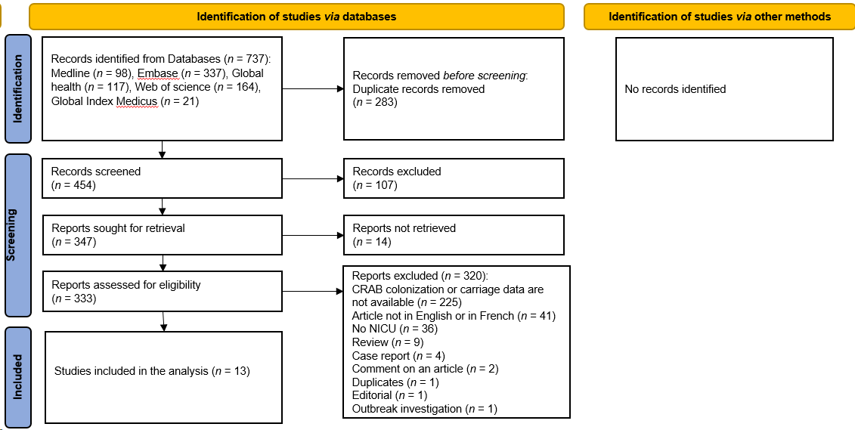
Figure 1 PRISMA diagram showing selection of studies.
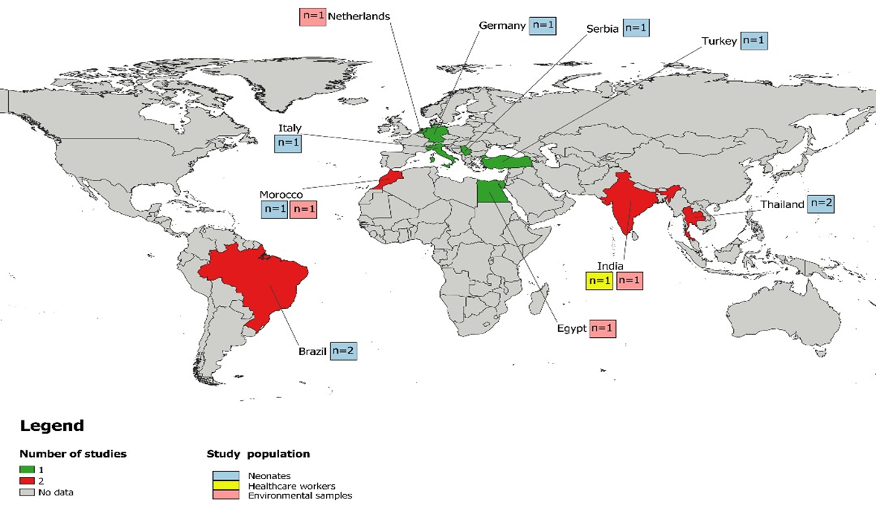
Figure 2 Map of the distribution of carbapenem-resistant Acinetobacter baumannii data among neonates, healthcare workers and environmental samples.
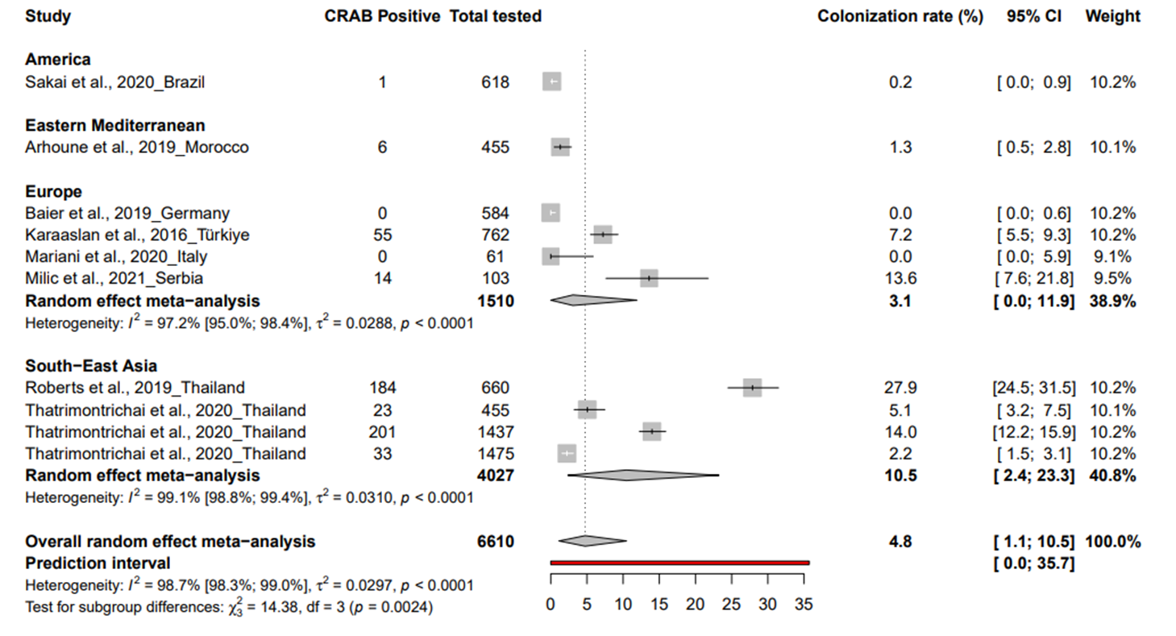
Figure 3 Prevalence of carbapenem-resistant Acinetobacter baumannii colonization in neonates in neonatal intensive care units.
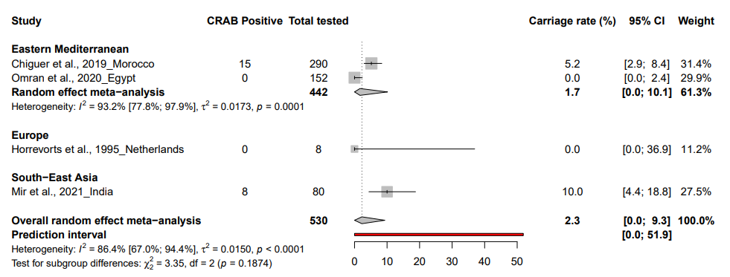
Figure 4 Prevalence of carbapenem-resistant Acinetobacter baumannii environmental contamination in neonatal intensive care units.

Table 1 Summary of meta-analysis results for estimates of carbapenem-resistant Acinetobacter baumannii colonization in neonatal intensive care units
 | Prevalence % (95%CI) | 95% prediction interval | N studies | N participants | ¹H (95%CI) | ²I² (95%CI) | P heterogeneity | P egger test
Neonates | 4.8 [1.1-10.5] | [0-35.7] | 10 | 6610 | 8.7 [7.6-9.9] | 98.7 [98.3-99] | < 0.001 | 0.718
HCWs | 3.3 [0-13.8] | NA | 1 | 30 | NA | NA | 1 | NA
Environmental samples | 2.3 [0-9.3] | [0-51.9] | 4 | 530 | 2.7 [1.7-4.2] | 86.4 [67-94.4] | < 0.001 | 0.989
¹H is a measure of the extent of heterogeneity, a value of H = 1 indicates homogeneity of effects and a value of H > 1 indicates a potential heterogeneity of effects.
²I² describes the proportion of total variation in study estimates that is due to heterogeneity, a value > 50% indicates presence of heterogeneity.
CI: Confidence interval; N: Number; 95%CI: 95% Confidence interval; NA: Not available; HCWs: Healthcare workers.

