Name of Journal: World Journal of Gastrointestinal Oncology
Manuscript NO: 78804
Manuscript Type: ORIGINAL ARTICLE

Basic Study
MiR-30e-3p inhibits gastric cancer development by negatively regulating THO complex 2 and PI3K/AKT/mTOR signaling

Gu XJ et al. MiR-30e-3p/THOC2 axis in gastric cancer

Xiao-Jing Gu, Ya-Jun Li, Fang Wang, Ting Ye

Xiao-Jing Gu, Ya-Jun Li, Fang Wang, Ting Ye, Department of Gastroenterology, General Hospital of Ningxia Medical University, Yinchuan 750004, Ningxia Hui Autonomous Prefecture, China

Author contributions: Gu XJ and Li YJ conceived, designed the experiments, wrote and revised the manuscript; Gu XJ, Li YJ, Wang F and Ye T performed the experiments; Wang F and Ye T analyzed and interpreted the data; All the authors have read and approved the final version of the manuscript.

Supported by National Natural Science Foundation of China, No. 81860442; and Ningxia Natural Science Foundation Project, No. 2022AAC03525.

Corresponding author: Ya-Jun Li, Doctor, DPhil, Chief Doctor, Department of Gastroenterology, General Hospital of Ningxia Medical University, No. 804 Shengli South Street, Xingqing District, Yinchuan 750004, Ningxia Hui Autonomous Prefecture, China. lyajundoc@126.com

Received: July 15, 2022
Revised: September 5, 2022
Accepted: October 12, 2022
Published online: November 15, 2022

Abstract
BACKGROUND
Gastric cancer (GC) is a common type of digestive cancer with high morbidity and mortality rates worldwide. Considerable effort has been expended in understanding the mechanism of GC development and metastasis. The current study therefore explores the involvement of microRNAs in the regulation of GC progression.

AIM
To explore the expression and function of miR-30e-3p in GC development.

METHODS
MiR-30e-3p was found to be downregulated in GC, with low levels thereof predicting poor outcomes among patients with GC. Functionally, we revealed that miR-30e-3p suppressed cell growth and metastatic behaviors of GC cells. Bioinformatics analysis predicted that THO complex 2 (THOC2) was a direct target of miR-30e-3p, and the interaction between miR-30e-3p and THOC2 was further validated by a luciferase reporter assay.

RESULTS
Our findings revealed that knockdown of THOC2 inhibited the growth and metastatic behaviors of GC cells. After investigating signaling pathways involved in miR-30e-3p regulation, we found that the miR-30e-3p/THOC2 axis regulated the PI3K/AKT/mTOR pathway in GC.

CONCLUSION
Our findings suggest the novel functional axis miR-30e-3p/THOC2 is involved in GC development and progression. The miR-30e-3p/THOC2 axis could be utilized to develop new therapies against GC.

Key Words: Gastric cancer; MiR-30e-3p; THO complex2; PI3K/AKT/mTOR signaling

©The Author(s) 2022. Published by Baishideng Publishing Group Inc. All rights reserved.

Citation: Gu XJ, Li YJ, Wang F, Ye T. MiR-30e-3p inhibits gastric cancer development by negatively regulating THO complex 2 and PI3K/AKT/mTOR signaling. World J Gastrointest Oncol 2022; 14(11): 2170-2182
URL: https://www.wjgnet.com/1948-5204/full/v14/i11/2170.htm
DOI: https://dx.doi.org/10.4251/wjgo.v14.i11. 2170

Core Tip: Gastric cancer (GC) is a common digestive cancer with high morbidity and mortality rates worldwide. Considerable effort has been expended in understanding the mechanism of GC development and metastasis. Given that microRNAs have been found to participate in the regulation of GC progression, we explored the expression and function of miR-30e-3p in GC development and revealed that knockdown of THO complex 2 (THOC2) inhibited the growth and metastatic behaviors of GC cells. After investigating signaling pathways involved in miR-30e-3p regulation were investigated, we found that the miR-30e-3p/THOC2 axis regulated the PI3K/AKT/mTOR pathway in GC.
INTRODUCTION
Gastric cancer (GC) is a common type of digestive cancer with high morbidity and mortality rates worldwide^{[1]}. Helicobacter pylori (H. pylori) infection has been considered the most significant risk factor for GC, especially in China^{[2,3]}. Nonetheless, the incidence of GC has substantially declined with improvements in the treatment of H. pylori infection over the past decades^{[4]}. Technical advances of diagnosis and therapy improve the survival of patients with GC^{[5,6]}. However, the prognosis remains unsatisfactory as patients with GC are mostly diagnosed at later stages and develop drug-resistance after treatment. Thus, it is essential to understand the tumorigenesis of GC and identify novel early diagnostic biomarkers and therapeutic targets for its treatment.
MicroRNAs (miRNAs) are small non-coding RNAs that participate in various biological processes^{[7]}. Mounting evidence has shown that miRNA regulates tumorigenesis of multiple cancers, including GC^{[8,9]}. MiRNAs exert their functions in GC development and metastasis by modulating tumor cell growth and malignancy^{[10]}. For instance, miR-181a acts as an oncogenic miRNA in GC by negatively regulating caprin-1 expression, and overexpression of miR-181a predicts poor patient survival^{[11]}. In contrast, microRNA profiling has identified that miR-6165 is a tumor suppressor and inhibits GC progression by regulating STRN4^{[12]}. Moreover, miRNAs can be utilized as biomarkers for GC diagnosis and patient prognosis^{[13]}. Our preliminary screening identified low miR-30e-3p expression in GC tissues. It has been reported that miR-30e-3p suppressed clear cell renal cell carcinoma (ccRCC) development and metastasis via targeting snail 1^{[14]}. Nevertheless, the function of miR-30e-3p in GC has yet to be studied.
THO complex 2 (THOC2) is an RNA-binding protein involved in mRNA export, genomic stability, and mitotic progression^{[15]}. THOC2 is essential for the early embryonic development of zebrafish^{[16]}. Zhou et al^{[17]} reported that THOC2 serves as an oncogene in melanoma and that knockdown of THOC2 inhibits the growth and metastasis of melanoma. Nevertheless, the function and regulation of THOC2 in GC remain unclear.
In the current study, we showed that miR-30e-3p was downregulated in GC tissues and cell lines, and low miR-30e-3p levels predicted unfavorable prognosis in patients with GC. Overexpression of miR-30e-3p suppressed the malignant behaviors of GC cells by negatively regulating THOC2. We also confirmed that the miR-30e-3p/THOC2 axis regulated the PI3K/AKT/mTOR pathway in GC. These findings indicate that miR-30e-3p/THOC2 could serve as a novel diagnosis biomarker and therapeutic target for GC treatment.

MATERIALS AND METHODS
Patient tissues
Human GC tissues and matched adjacent tissues (20 pair) were obtained during surgery on patients with GC at General Hospital of Ningxia Medical University. The primary clinicopathological features of the patients are summarized in Supplementary Table 1. The tissues were stored in liquid nitrogen until further use. All tissue samples were validated by two independent pathologists. All patients participating in the study provided written informed consent. The Institutional Review Board and ethics committee of Ningxia Medical University reviewed and approved the protocol.

Cell culture
Human GC cells (MGC803, AGS, MKN45, and BGC-823) and control human GES-1 cells were obtained from American Type Culture Collection (ATCC, VA, United States) and cultured following the guidelines provided by ATCC in an incubator at 37 °C and 5% CO₂.

Quantitative real-time polymerase chain reaction
RNA from tissue specimens or cells were extracted using Trizol (Thermo Scientific, United States) and reverse-transcribed into cDNA using the TaqMan microRNA RT Kit (Thermo Scientific, United States). Quantitative real-time polymerase chain reaction (qRT-PCR) was conducted using the PowerUP SYBR Master Mix (Applied Biosystems, United States). The 2^{−ΔΔCT} method was used to calculate the relative expression of miR-30e-3p or THOC2. The sequences of primers were as follows: miR-30e-3p: 5′-GCGTCTTTCAGTCGGATGTTTACAGC-3′; COLEC12: 5′-TCTCCTCCGTCAGTAACCGT-3′, and 5′-CAGGCTTGATTGACACTGGC-3′; CNPY2: 5′-GGCCACTCCTATTCTACGGC-3′, and 5′-CATCCAAAGCCAGAGTGAGC-3′; YTHDF3: 5′-CGAGAAGCAGAGAGCGAGAG-3′, and 5′-TACTGCTAATGCCAGGCACC-3′; SLC25A33: 5′-TGTGCCTCCTGCATTGCTTA-3′, and 5′-TCTGCAGTTCTAGGGCAGGT-3′; NPY2R: 5′-CGAGGTCCAGGTCAGTTGTA-3′, and 5′-TACTGTGCGCATGCTCTTGA-3′; CDKN1B: 5′-AGTGTCTAACGGGAGCCCTA-3′, and 5′-AAGAATCGTCGGTTGCAGGT-3′; C20orf202: 5′-GTGCTCTAGTGCTCTGGCAA-3′, and 5'-CATCTGTTGTGTGGCCCTCT-3′; THOC2: 5′-TATGGGCTACTCTGGGCAGT-3′, and 5'-TAAGTCCGGTGGCACTTCAC-3′.

Transfection
MiR-30e-3p mimics (5′-CUUUCAGUCGGAUGUUUACAGC-3′), miR-30e-3p inhibitors (5′-CTGTAAACATCCGACTGAAA-3′), and the relative negative controls (5′-UCACAACCUCCUAGAAAGAGUAGA-3′) were purchased from GenePharma (Shanghai, China). SiRNA targeting THOC2 (siRNA1: CGAAUUUUUGCAUUUAUGUCG-3′, siRNA1: 5′-CAUGAUAGUUCAACAUACAGA-3′) and scramble negative control (5′-UUCUCCGAACGUGUCACGUTT-3′) were obtained from GeneCopoeia (Shanghai, China). Transfection was conducted using FuGene HD (Roche, Switzerland).

Cell growth assays
Cell growth was assessed using a colony formation assay and CCK-8 assay as previously described^{[18]}.

Transwell assay
Transwell assay was conducted using a transwell 24-well plate (Corning, United States) with or without matrigel precoating (BD Bioscience, United States). Cells were suspended in medium without serum and added into the upper chamber. The bottom chamber was filled with 500 µL complete medium. After 48 h, the migration or invasive cells were fixed, stained with crystal violet, and then calculated.

Luciferase reporter assay
The putative WT or mutated 3′-UTR of THOC2 was cloned into the pGL3 plasmid (Promega, United States). The luciferase reporter vector and control Renilla vector were co-transfected into AGS or BGC-823 cells with miR-30e-3p mimics or control. The relative luciferase activity was assessed 48 h later using the Dual-Glo kit (Promega, United States).

Western blot
Protein lysate preparation, SDS-PAGE, and Western blot were performed following the standard protocol. The following primary antibodies were used: THOC2 (ab129485) from Abcam, United States and mTOR (#2983), Akt (#4685), and PI3K (#17366) from Cell Signaling Technology, United States. E-cadherin (20874-1-AP), N-cadherin (22018-1-AP), vimentin (10366-1-AP), CNPY2 (14635-1-AP), YTHDF3 (25537-1-AP), SLC25A33 (17794-1-AP), CDKN1B (25614-1-AP), and β-actin (81115-1-RR) were purchased from Proteintech; COLEC12 (SAB1403383) was purchased from Sigma; and was purchased from NPY2R (PA5-102110) from Invitrogen.

Tumor implantation in vivo
Four-week-old male BALB/c nude mice were obtained from Jiangsu Aniphe Biolaboratory Inc. The guidelines for the animal studies were approved by the Animal Care Committee of Ningxia Medical University Hospital. BGC-823 cells were selected for tumor implantation. Around 48 h after transfection of miR-30e-3p mimic, approximately 1 ×10⁷ BGC-823 cells were harvested and implanted subcutaneously into the nude mice.

Statistical analysis
All results were presented as mean ± SD. Statistical analysis was conducted using GraphPad Prism V6.0 (GraphPad, United States). Student t-test or one-way ANOVA was used as necessary. A P < 0.05 indicated statistical significance.

RESULTS
MiR-30e-3p expression is downregulated in patients with GC and low expression of miR-30e-3p predicts poor outcome
We first examined the miR-30e-3p expression in several GC cell lines. As detailed in Figure 1A, miR-30e-3p levels were lower in GC cells (MGC803, AGS, MKN45, and BGC-823) than in control GES-1 cells. Additionally, we demonstrated that miR-30e-3p expression was much lower in GC tissues than in matched adjacent non-tumor tissues (Figure 1B). Kaplan–Meier survival analysis suggested that patients with low miR-30e-3p expression had worse overall survival rate compared to those with high miR-30e-3p expression (Figure 1C). Thus, miR-30e-3p might function as a tumor suppressor in GC.

Overexpression of miR-30e-3p suppresses the malignant behaviors of GC cells
To explore miR-30e-3p function in GC, we transfected miR-30e-3p mimics into AGS or BGC-823 cells, after which the overexpression of miR-30e-3p was validated using qRT-PCR (Figure 2A). Functionally, we found that miR-30e-3p overexpression suppressed cell proliferation and colony formation of AGS or BGC-823 (Figure 2B and C). Furthermore, transfection of miR-30e-3p mimics resulted in decreased metastatic abilities of GC cells, with lesser cell migration or invasion (Figure 2D and E). In addition, transfection of miR-30e-3p mimics increased E-cadherin expression but decreased the expression of N-cadherin and vimentin (Figure 2F). These findings suggest that overexpression of miR-30e-3p suppresses the growth and metastatic behaviors of GC cells.

Inhibition of miR-30e-3p promotes the malignant behaviors of GC cells
Conversely, we utilized miR-30e-3p inhibitors to suppress miR-30e-ep expression in GC cells (Figure 3A). MiR-30e-3p inhibitors also dampened the cell proliferation of GC cells (Figure 3B). Inhibition of miR-30e-3p promoted a higher colony number in AGC or SGC-823 cells compared with the control or negative control group (Figure 3C). Consistently, inhibition of miR-30e-3p enhanced GC cell migration and invasion (Figure 3D and E). In addition, transfection of miR-30e-3p inhibitors suppressed E-cadherin expression but promoted N-cadherin and Vimentin expression (Figure 3F). Taken together, both the overexpression and knockdown experiments demonstrated that miR-30e-3p negatively regulated GC cell growth and metastasis.

THOC2 is a direct target of miR-30e-3p in GC cells
Bioinformatics analysis identified THOC2 as a top candidate of miR-30e-3p (Figure 4A and Supplementary Table 2). Overexpression of miR-30e-3p inhibitor significantly promoted CNPY2, YTHDF3, SLC25A33, C20orf202, and THOC2 expression, among which THOC2 demonstrated the greatest upregulation (Figure 4B). After also detecting the protein levels of these potential target genes, we found that the results were consistent with the mRNA expression level of these genes (Figure 4C and D). Moreover, suppression of miR-30e-3p also upregulated THOC2 expression in GES-1 cells (Figure 4E), suggesting that miR-30e-3p could bind to the 3′-URT of THOC2 (Figure 4F). Luciferase reporter assay further confirmed the binding between miR-30e-3p and the wild-type 3′-UTR of THOC2 (Figure 4F). We found that THOC2 expression was significantly higher in GC cells than in GES-1 cells (Figure 4G). Furthermore, both THOC2 mRNA and protein levels were markedly enhanced in GC tissues (Figure 4H–J). THOC2 expression was negatively associated with miR-30e-3p expression in GC tissues (Figure 4J). Hence, THOC2 is a direct target of miR-30e-3p in GC cells.

Knockdown of THOC2 suppresses the malignant behaviors of GC cells
To evaluate the function of THOC2 in GC, we silenced THOC2 expression in AGS or BGC-823 cells using siRNA targeting THOC2 (Figure 5A). THOC2 knockdown significantly dampened colony formation and cell viability of GC cells (Figure 5B and 5C). The CCK-8 assay showed that knockdown of THOC2 significantly inhibited GC cells proliferation (Figure 5D). Furthermore, the metastasis behaviors of GC cells transfected with siTHOC2 were drastically inhibited (Figure 5E-H). In addition, silencing THOC2 significantly increase E-cadherin expression but decreased the expression of N-cadherin and Vimentin in AGS and BGC-823 cells (Figure 5I). In summary, the provided data indicated that knockdown of THOC2 suppresses the malignant behaviors of GC cells.

MiR-30e-3p/THOC2 axis regulates the PI3K/AKT/mTOR pathway in GC cells
A previous study has demonstrated that the THO complex participates in the modulation of the p53 and PI3K/AKT pathways^{[19]}. As such, we examined the PI3K/AKT/mTOR pathway in GC and analyzed the functional role of miR-30e-3p/THOC2. As shown in Figure 6A and B, inhibition of miR-30e-3p enhanced PI3K/AKT/mTOR expression, whereas overexpression of miR-30e-3p using miR-30e-3p mimics significantly decreased the expression of PI3K/AKT/mTOR in AGS or BGC-823 cells. Additionally, we demonstrated that THOC2 knockdown inhibited the expression of PI3K/AKT/mTOR (Figure 6C and D). Moreover, a restoration assay designed by our group showed that inhibition of miR-30e-3p interfered with THOC2 siRNA and that miR-30e-3p played a regulatory role by directly targeting THOC2 to regulate PI3K/AKT/mTOR signaling pathway in gastric cancer (Figure 6E and F). Thus, miR-30e-3p/THOC2 might regulate GC cell growth and metastasis by modulating the PI3K/AKT/mTOR signaling pathway.

MiR-30e-3p inhibits GC cells growth in vivo
To investigate the function of miR-30e-3p on GC cell growth in vivo, BGC-823 cells transfected with miR-30e-3p mimics after 48 h were injected subcutaneously into BALB/c nude mice. After 16 d, the growth status of the tumor was analyzed. The tumor diameter of the miR-30e-3p mimic group was significantly smaller than that of the control group (Figure 7A). The tumor volume and weight of the miRNA mimic group were smaller than that of the control group (Figure 7B and C). In addition, we also detected the protein expression of THOC2, the target gene of miR-30e-3p, and genes associated with the PI3K/AKT/mTOR signaling pathway (Figure 7D). Accordingly, we found that the protein expression of these genes was consistent with that in vitro. Taken together, the presented data showed that miR-30e-3p inhibits GC cells growth in vivo.

DISCUSSION
Accumulating evidence has revealed that miRNAs play important regulatory roles in GC development and metastasis^{[20]}. MiRNAs can also serve as non-invasive diagnostic biomarkers for GC^{[21]}. In line with this, the current study sought to further investigate the expression and function of miR-30e-3p. Notably, we found that miRNA-30e-3p functioned as a tumor suppressor in GC and that miR-30e-3p overexpression inhibited GC cell growth and invasion. Additionally, we identified that THOC2 was a target of miR-30e-3p and that knockdown of THOC2 suppressed the malignant behaviors of GC cells. Taken together, our results demonstrated that miR-30e-3p/THOC2 could be utilized to develop new diagnostic biomarker and therapeutic target for GC treatment.
The current study found that GC tissues and cells had lower miR-30e-3p levels compared to matched normal tissues and control cells. Previous studies have shown that miR-30e-3p expression decreased in hepatocellular carcinoma (HCC) and that miR-30e-3p regulated HCC development by modulating MDM2/TP53 signaling^{[22]}. Moreover, low expression of miR-30e-3p in HCC predicted drug-resistance to sorafenib treatment^{[22]}. Similarly, evidence has shown that miR-30e inhibited breast cancer development and progression by targeting IRS1, and low miR-30e expression mediated the chemosensitivity of paclitaxel treatment in breast cancer^{[23]}. We also showed that miR-30e-3p decreased GC cell proliferation, migration, and invasion. Low levels of miR-30e-3p in patients with GC indicated poor prognosis. Thus, miR-30e-3p functions as a tumor suppressor in GC. However, further investigations are needed to determine whether miR-30e-3p exerts regulatory effects on drug sensitivity during GC treatment. One intriguing finding of the current stud was the regulation of miR-30e-3p expression in GC. In ovarian cancer, lncRNA MEG3 had been found to sponge miR-30e-3p and regulate LAMA4 expression^{[24]}.
Multiple targets of miR-30e-3p have been identified, including Ubc9, P4HA1, IRS1, and ATG5^{[23,25-27]}. We found that THOC2 was directly targeted by miR-30e-3p. Studies on the function of THOC2 in patients with psychomotor retardation showed that THOC2 was involved in mRNA-Export pathway in X-linked intellectual disability^{[28,29]}. The dysregulated expression of THOC2 has been reported in severe neurocognitive and growth disorders^{[30]}. Recently, the oncogenic function of THOC2 has been revealed in malignancies such as melanoma^{[17]}. To the best of our knowledge, this has been the first study to demonstrated that THOC2 exhibited oncogenic function in GC development. Knockdown of THOC2 suppressed GC cell growth and metastasis. The regulatory axis of miR-30e-3p/THOC2 has been validated using the luciferase reporter assay, and Pearson analysis indicated that miR-30e-3p expression was negatively associated with THOC2 expression. Although our data confirmed that THOC2 was regulated by miR-30e-3p, other miRNAs might regulate THOC2, which could suppress GC development and progression.
Bioinformatics analysis was conducted to study the signaling pathways involved in miR-30e-3p/THOC2 regulation in GC. One study showed that the THO complex participates in the regulation of p53 and PI3K/AKT signaling^{[19]}. The PI3K/AKT pathway is critical for cancer cell survival, proliferation, and apoptosis^{[31,32]}. Consistently, we also found that the PI3K/AKT/mTOR signaling pathway was regulated by miR-30e-3p/THOC2 axis in vitro and in vivo. Thus, our findings provide a new approach in regulating the PI3K/AKT/mTOR pathway.

CONCLUSION
In conclusion, our findings suggested that miR-30e-3p directly targets THOC2 and that THOC2 mediates the tumor suppression function of miR-30e-3p in GC. Low expression of miR-30e-3p or upregulation of THOC2 predicts poor prognosis of patients with GC. The diagnostic and therapeutic value of miR-30e-3p/THOC2 in GC should be further investigated in future studies.

ARTICLE HIGHLIGHTS
Research background
Gastric cancer (GC) is a common type of digestive cancer with high morbidity and mortality rates worldwide.

Research motivation
Considerable effort has been expended in understanding the mechanism of GC development and metastasis.

Research objectives
We explored the expression and function of miR-30e-3p in GC development.

Research methods
We conducted quantitative real-time polymerase chain reaction, transfection, cell growth assays, transwell assay, luciferase reporter assay, western blot assays to explore the expression and function of miR-30e-3p.

Research results
Our findings revealed that knockdown of THO complex 2 (THOC2) inhibited the growth and metastatic behaviors of GC cells. After investigating signaling pathways involved in miR-30e-3p regulation, we found that the miR-30e-3p/THOC2 axis regulated the PI3K/AKT/mTOR pathway in GC.

Research conclusions
Our findings suggested that miR-30e-3p directly targets THOC2 and that THOC2 mediates the tumor suppression function of miR-30e-3p in GC. Low expression of miR-30e-3p or upregulation of THOC2 predicts poor prognosis of patients with GC. The diagnostic and therapeutic value of miR-30e-3p/THOC2 in GC should be further investigated in future studies.

Research perspectives
Considerable effort has been expended in understanding the mechanism of GC development and metastasis. Given that microRNAs have been found to participate in the regulation of GC progression.

REFERENCES
1 Rawla P, Barsouk A. Epidemiology of gastric cancer: global trends, risk factors and prevention. Prz Gastroenterol 2019; 14: 26-38 [PMID: 30944675 DOI: 10.5114/pg.2018.80001]
2 Khasag O, Boldbaatar G, Tegshee T, Duger D, Dashdorj A, Uchida T, Matsuhisa T, Yamaoka Y. The prevalence of Helicobacter pylori infection and other risk factors among Mongolian dyspeptic patients who have a high incidence and mortality rate of gastric cancer. Gut Pathog 2018; 10: 14 [PMID: 29636824 DOI: 10.1186/s13099-018-0240-2]
3 Fuccio L, Eusebi LH, Bazzoli F. Gastric cancer, Helicobacter pylori infection and other risk factors. World J Gastrointest Oncol 2010; 2: 342-347 [PMID: 21160805 DOI: 10.4251/wjgo.v2.i9.342]
4 Balakrishnan M, George R, Sharma A, Graham DY. Changing Trends in Stomach Cancer Throughout the World. Curr Gastroenterol Rep 2017; 19: 36 [PMID: 28730504 DOI: 10.1007/s11894-017-0575-8]
5 Necula L, Matei L, Dragu D, Neagu AI, Mambet C, Nedeianu S, Bleotu C, Diaconu CC, Chivu-Economescu M. Recent advances in gastric cancer early diagnosis. World J Gastroenterol 2019; 25: 2029-2044 [PMID: 31114131 DOI: 10.3748/wjg.v25.i17.2029]
6 Xu HM, Wang X. [Current status and prospects of clinical research on diagnosis and treatment of gastric cancer in China]. Zhonghua Wei Chang Wai Ke Za Zhi 2020; 23: 109-114 [PMID: 32074788 DOI: 10.3760/cma.j.issn.1671-0274.2020.02.003]
7 O'Brien J, Hayder H, Zayed Y, Peng C. Overview of MicroRNA Biogenesis, Mechanisms of Actions, and Circulation. Front Endocrinol (Lausanne) 2018; 9: 402 [PMID: 30123182 DOI: 10.3389/fendo.2018.00402]
8 Zheng Q, Chen C, Guan H, Kang W, Yu C. Prognostic role of microRNAs in human gastrointestinal cancer: A systematic review and meta-analysis. Oncotarget 2017; 8: 46611-46623 [PMID: 28402940 DOI: 10.18632/oncotarget.16679]
9 Peng Y, Croce CM. The role of MicroRNAs in human cancer. Signal Transduct Target Ther 2016; 1: 15004 [PMID: 29263891 DOI: 10.1038/sigtrans.2015.4]
10 Yoda Y, Takeshima H, Niwa T, Kim JG, Ando T, Kushima R, Sugiyama T, Katai H, Noshiro H, Ushijima T. Integrated analysis of cancer-related pathways affected by genetic and epigenetic alterations in gastric cancer. Gastric Cancer 2015; 18: 65-76 [PMID: 24510342 DOI: 10.1007/s10120-014-0348-0]
11 Lu Q, Chen Y, Sun D, Wang S, Ding K, Liu M, Zhang Y, Miao Y, Liu H, Zhou F. MicroRNA-181a Functions as an Oncogene in Gastric Cancer by Targeting Caprin-1. Front Pharmacol 2018; 9: 1565 [PMID: 30687106 DOI: 10.3389/fphar.2018.01565]
12 Wang Z, Li Y, Cao J, Zhang W, Wang Q, Zhang Z, Gao Z, Ye Y, Jiang K, Wang S. MicroRNA Profile Identifies miR-6165 Could Suppress Gastric Cancer Migration and Invasion by Targeting STRN4. Onco Targets Ther 2020; 13: 1859-1869 [PMID: 32184620 DOI: 10.2147/OTT.S208024]
13 Yuan HL, Wang T, Zhang KH. MicroRNAs as potential biomarkers for diagnosis, therapy and prognosis of gastric cancer. Onco Targets Ther 2018; 11: 3891-3900 [PMID: 30013369 DOI: 10.2147/OTT.S156921]
14 Wang D, Zhu C, Zhang Y, Zheng Y, Ma F, Su L, Shao G. MicroRNA-30e-3p inhibits cell invasion and migration in clear cell renal cell carcinoma by targeting Snail1. Oncol Lett 2017; 13: 2053-2058 [PMID: 28454361 DOI: 10.3892/ol.2017.5690]
15 Francisco-Mangilet AG, Karlsson P, Kim MH, Eo HJ, Oh SA, Kim JH, Kulcheski FR, Park SK, Manavella PA. THO2, a core member of the THO/TREX complex, is required for microRNA production in Arabidopsis. Plant J 2015; 82: 1018-1029 [PMID: 25976549 DOI: 10.1111/tpj.12874]
16 Amsterdam A, Nissen RM, Sun Z, Swindell EC, Farrington S, Hopkins N. Identification of 315 genes essential for early zebrafish development. Proc Natl Acad Sci U S A 2004; 101: 12792-12797 [PMID: 15256591 DOI: 10.1073/pnas.0403929101]
17 Zhou X, Liu X, Zhang G, Zhang Q, Chen H, Wang Y, Fang F, Sun J. Knockdown THOC2 suppresses the proliferation and invasion of melanoma. Bioengineered 2019; 10: 635-645 [PMID: 31680623 DOI: 10.1080/21655979.2019.1685727]
18 Recent advances in the management of children with Wilms' tumor. Prog Clin Biol Res 1983; 132E: 153-158 [PMID: 6316364]
19 Moon S, Chung YD. p53 and PI3K/AKT signalings are up-regulated in flies with defects in the THO complex. Mol Cells 2013; 35: 261-268 [PMID: 23475424 DOI: 10.1007/s10059-013-0009-x]
20 Hwang J, Min BH, Jang J, Kang SY, Bae H, Jang SS, Kim JI, Kim KM. MicroRNA Expression Profiles in Gastric Carcinogenesis. Sci Rep 2018; 8: 14393 [PMID: 30258124 DOI: 10.1038/s41598-018-32782-8]
21 Link A, Kupcinskas J. MicroRNAs as non-invasive diagnostic biomarkers for gastric cancer: Current insights and future perspectives. World J Gastroenterol 2018; 24: 3313-3329 [PMID: 30122873 DOI: 10.3748/wjg.v24.i30.3313]
22 Gramantieri L, Pollutri D, Gagliardi M, Giovannini C, Quarta S, Ferracin M, Casadei-Gardini A, Callegari E, De Carolis S, Marinelli S, Benevento F, Vasuri F, Ravaioli M, Cescon M, Piscaglia F, Negrini M, Bolondi L, Fornari F. MiR-30e-3p Influences Tumor Phenotype through MDM2/TP53 Axis and Predicts Sorafenib Resistance in Hepatocellular Carcinoma. Cancer Res 2020; 80: 1720-1734 [PMID: 32015093 DOI: 10.1158/0008-5472.CAN-19-0472]
23 Liu MM, Li Z, Han XD, Shi JH, Tu DY, Song W, Zhang J, Qiu XL, Ren Y, Zhen LL. MiR-30e inhibits tumor growth and chemoresistance via targeting IRS1 in Breast Cancer. Sci Rep 2017; 7: 15929 [PMID: 29162879 DOI: 10.1038/s41598-017-16175-x]
24 Liu Y, Xu Y, Ding L, Yu L, Zhang B, Wei D. LncRNA MEG3 suppressed the progression of ovarian cancer via sponging miR-30e-3p and regulating LAMA4 expression. Cancer Cell Int 2020; 20: 181 [PMID: 32489317 DOI: 10.1186/s12935-020-01259-y]
25 Wu F, Zhu S, Ding Y, Beck WT, Mo YY. MicroRNA-mediated regulation of Ubc9 expression in cancer cells. Clin Cancer Res 2009; 15: 1550-1557 [PMID: 19223510 DOI: 10.1158/1078-0432.CCR-08-0820]
26 Feng G, Shi H, Li J, Yang Z, Fang R, Ye L, Zhang W, Zhang X. MiR-30e suppresses proliferation of hepatoma cells via targeting prolyl 4-hydroxylase subunit alpha-1 (P4HA1) mRNA. Biochem Biophys Res Commun 2016; 472: 516-522 [PMID: 26966067 DOI: 10.1016/j.bbrc.2016.03.008]
27 Ye Y, Fang Y, Xu W, Wang Q, Zhou J, Lu R. 3,3'-Diindolylmethane induces anti-human gastric cancer cells by the miR-30e-ATG5 modulating autophagy. Biochem Pharmacol 2016; 115: 77-84 [PMID: 27372603 DOI: 10.1016/j.bcp.2016.06.018]
28 Kumar R, Corbett MA, van Bon BW, Woenig JA, Weir L, Douglas E, Friend KL, Gardner A, Shaw M, Jolly LA, Tan C, Hunter MF, Hackett A, Field M, Palmer EE, Leffler M, Rogers C, Boyle J, Bienek M, Jensen C, Van Buggenhout G, Van Esch H, Hoffmann K, Raynaud M, Zhao H, Reed R, Hu H, Haas SA, Haan E, Kalscheuer VM, Gecz J. THOC2 Mutations Implicate mRNA-Export Pathway in X-Linked Intellectual Disability. Am J Hum Genet 2015; 97: 302-310 [PMID: 26166480 DOI: 10.1016/j.ajhg.2015.05.021]
29 Di Gregorio E, Bianchi FT, Schiavi A, Chiotto AM, Rolando M, Verdun di Cantogno L, Grosso E, Cavalieri S, Calcia A, Lacerenza D, Zuffardi O, Retta SF, Stevanin G, Marelli C, Durr A, Forlani S, Chelly J, Montarolo F, Tempia F, Beggs HE, Reed R, Squadrone S, Abete MC, Brussino A, Ventura N, Di Cunto F, Brusco A. A de novo X;8 translocation creates a PTK2-THOC2 gene fusion with THOC2 expression knockdown in a patient with psychomotor retardation and congenital cerebellar hypoplasia. J Med Genet 2013; 50: 543-551 [PMID: 23749989 DOI: 10.1136/jmedgenet-2013-101542]
30 Kumar R, Gardner A, Homan CC, Douglas E, Mefford H, Wieczorek D, Lüdecke HJ, Stark Z, Sadedin S; Broad CMG, Nowak CB, Douglas J, Parsons G, Mark P, Loidi L, Herman GE, Mihalic Mosher T, Gillespie MK, Brady L, Tarnopolsky M, Madrigal I, Eiris J, Domènech Salgado L, Rabionet R, Strom TM, Ishihara N, Inagaki H, Kurahashi H, Dudding-Byth T, Palmer EE, Field M, Gecz J. Severe neurocognitive and growth disorders due to variation in THOC2, an essential component of nuclear mRNA export machinery. Hum Mutat 2018; 39: 1126-1138 [PMID: 29851191 DOI: 10.1002/humu.23557]
31 Zhang H, Xu W, Li B, Zhang K, Wu Y, Xu H, Wang J, Zhang J, Fan R, Wei J. Curcumin Promotes Cell Cycle Arrest and Inhibits Survival of Human Renal Cancer Cells by Negative Modulation of the PI3K/AKT Signaling Pathway. Cell Biochem Biophys 2015; 73: 681-686 [PMID: 27259310 DOI: 10.1007/s12013-015-0694-5]
32 Zhou C, Qiu L, Sun Y, Healey S, Wanebo H, Kouttab N, Di W, Yan B, Wan Y. Inhibition of EGFR/PI3K/AKT cell survival pathway promotes TSA's effect on cell death and migration in human ovarian cancer cells. Int J Oncol 2006; 29: 269-278 [PMID: 16773209]

Footnotes
Institutional review board statement: The study was reviewed and approved by the Institutional Review Board of Ningxia Medical University.

Institutional animal care and use committee statement: All animal experiments conformed to the internationally accepted principles for the care and use of laboratory animals.

Conflict-of-interest statement: The authors declare that they have no competing interests.

Data sharing statement: No additional data are available.

ARRIVE guidelines statement: The authors have read the ARRIVE guidelines, and the manuscript was prepared and revised according to the ARRIVE guidelines.

Open-Access: This article is an open-access article that was selected by an in-house editor and fully peer-reviewed by external reviewers. It is distributed in accordance with the Creative Commons Attribution NonCommercial (CC BY-NC 4.0) license, which permits others to distribute, remix, adapt, build upon this work non-commercially, and license their derivative works on different terms, provided the original work is properly cited and the use is non-commercial. See: https://creativecommons.org/Licenses/by-nc/4.0/

Provenance and peer review: Unsolicited article; Externally peer reviewed.
Peer-review model: Single blind

Peer-review started: July 15, 2022
First decision: August 8, 2022
Article in press: October 12, 2022

Specialty type: Gastroenterology and hepatology
Country/Territory of origin: China
Peer-review report’s scientific quality classification
Grade A (Excellent): 0
Grade B (Very good): B
Grade C (Good): C, C
Grade D (Fair): 0
Grade E (Poor): 0

P-Reviewer: Liu YQ, United States; Tanabe S, Japan S-Editor: Zhang H L-Editor: A P-Editor: Zhang XD
Figure Legends
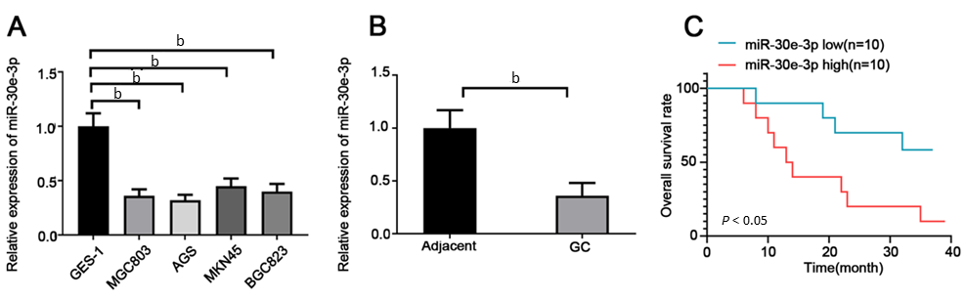
Figure 1 MiR-30e-3p expression is downregulated in gastric cancer and low expression of miR-30e-3p predicts poor outcome of gastric cancer patients. A: Quantitative real-time polymerase chain reaction (RT-PCR) was performed to analyze the expression of miR-30e-3p in normal human gastric epithelium cell line and four human gastric cancer (GC) cell lines (AGS, MGC803, BGC-823, and MKN45). n = 3 for each group; B: Quantitative RT-PCR was performed to analyze the expression of miR-30e-3p in GC and adjacent non-cancerous tissues. n = 20 for each group; C: Kaplan-Meier survival analysis of prognosis in GC patients with high or low expression of miR-30e-3p. n = 10 for each group. Error bars represented the mean ± SD of more than two independent experiments. ^{b}P < 0.01.
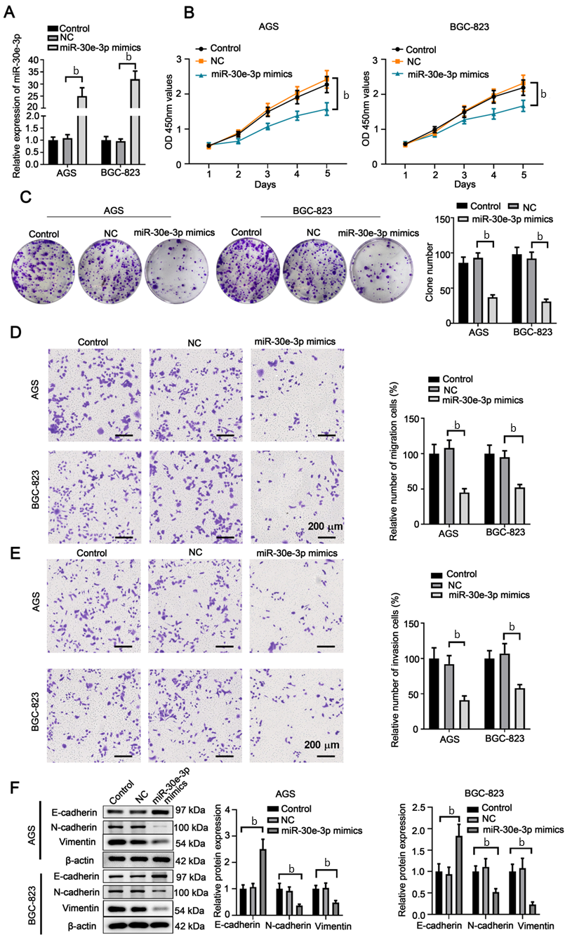
Figure 2 Overexpression of miR-30e-3p suppresses the malignant behaviors of gastric cancer cells. AGS or BGC-823 cells were transfected with negative control, miR-30e-3p mimics, or left untreated (control). A: Quantitative real-time polymerase chain reaction was performed to analyze miR-30e-3p expression levels in AGS or BGC-823 cells 48 h post transfection; B: CCK-8 assay was conducted to evaluate cell viability; C: Colony formation assay was conducted to evaluate the cell proliferation; D and E: Transwell assay was conducted using transwell chamber with or without matrigel to evaluate the cell migration (D) and invasion (E); F: Expression of E-cadherin, N-cadherin, and vimentin in AGS or BGC-823 was determined using western blotting. n = 3 for each group. ^{b}P < 0.01.
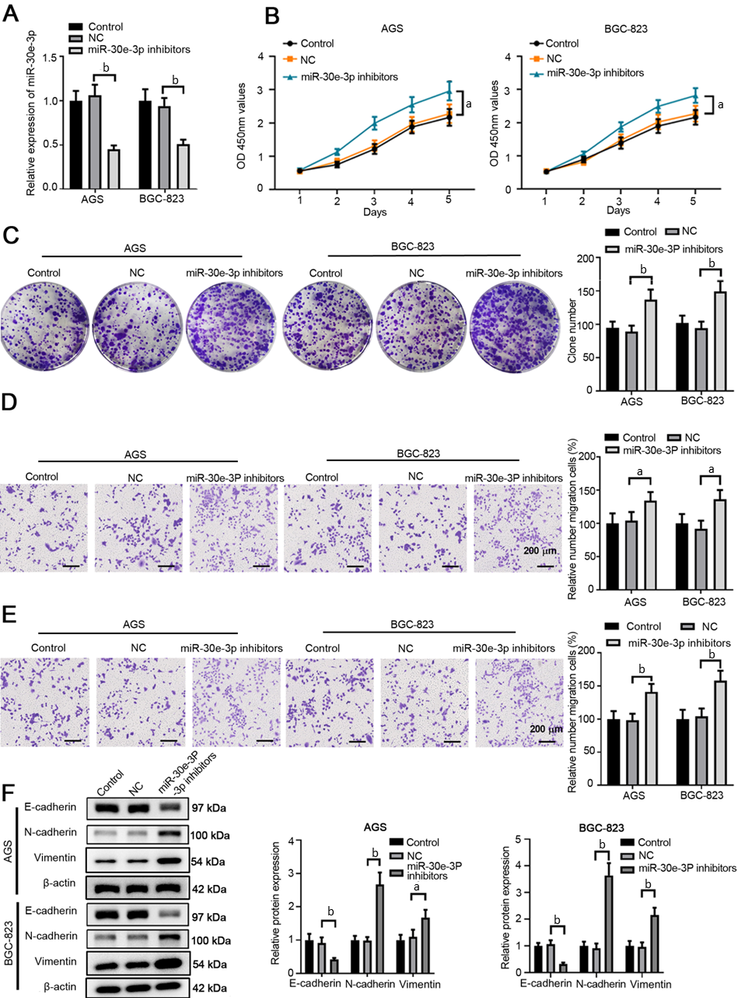
Figure 3 Inhibition of miR-30e-3p promotes the malignant behaviors of gastric cancer cells. AGS or BGC-823 cells were transfected with negative control, miR-30e-3p inhibitors, or left untreated (control). A: Quantitative real-time polymerase chain reaction was performed to analyze miR-30e-3p expression levels in AGS or BGC-823 cells 48 hours post transfection; B: CCK-8 assay was conducted to evaluate cell viability; C: Colony formation assay was conducted to evaluate the cell proliferation; D and E: Transwell assay was conducted using transwell chamber with or without matrigel to evaluate the cell migration (D) and invasion (E); F: Expression of E-cadherin, N-cadherin, and vimentin in AGS or BGC-823 was determined using western blotting. n = 3 for each group. ªP < 0.05, ^{b}P < 0.01.
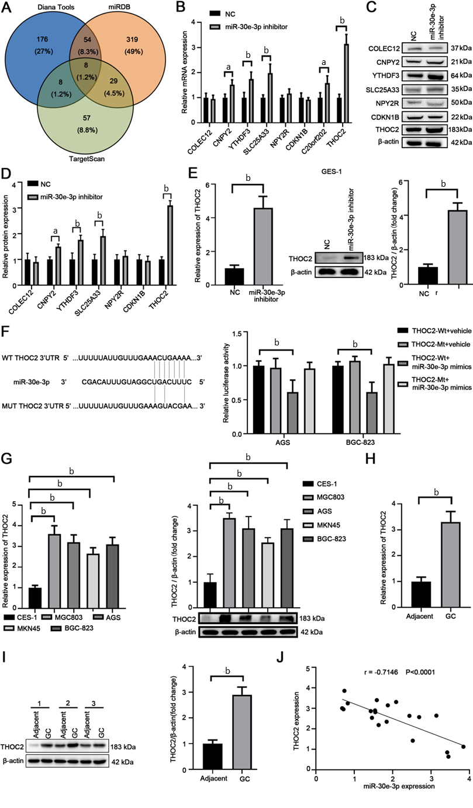
Figure 4 THO complex 2 is a direct target of miR-30e-3p in gastric cancer cells. A: Bioinformatics analysis predicted the potential targets of miR-30e-3p in gastric cancer (GC) cells; B: The mRNA expression level of candidate genes in GC after transfecting with miR-30e-3p inhibitor; C and D: The protein expression level of candidate genes in GC after transfecting with miR-30e-3p inhibitor; E: The expression of THO complex 2 (THOC2) in GSE-1 cells after transfecting with miR-30e-3p; F: The putative binding sequences between miR-30e-3p and 3’-UTR of THOC2 was shown. AGS or BGC-823 cells were co-transfected with luciferase reporter vector, with or without miR-30e-3p mimics. The relative luciferase activity in AGS or BGC-823 cells was analyzed 48 hours later. n = 3 for each group. G: The expression of THOC2 in human GC cell lines and control GES-1 cells were analyzed by quantitative real-time polymerase chain reaction (qRT-PCR) and western blot. n = 3 for each group; H: The expression of THOC2 in GC tissues and adjacent non-tumor normal tissues were analyzed by qRT-PCR. n = 20 for each group; I: Western blot was performed to examine THOC2 protein expression in human GC tissues and adjacent non-tumor normal tissues. n = 20 for each group. J: Pearson correlation analysis was performed to evaluate the relationship between THOC2 mRNA and miR-30e-3p expression in GC tissues. n = 20. ^{b}P < 0.01.
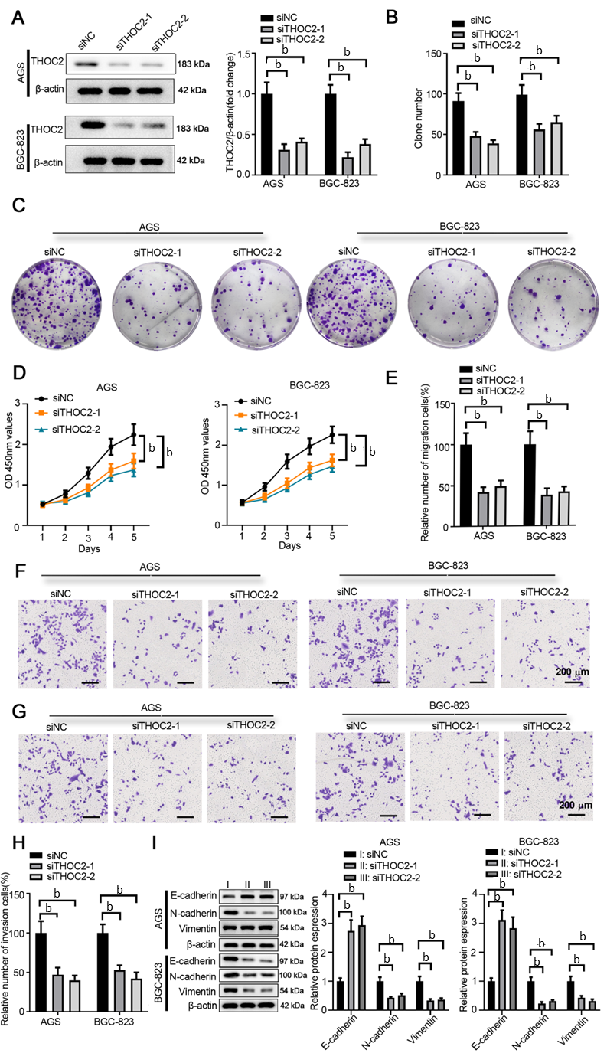
Figure 5 Knockdown of THO complex 2 suppresses malignant behaviors of gastric cancer cells. AGS or BGC-823 cells were transfected with siNC or siTHO complex 2 (siTHOC2)-1/2 to knockdown the expression of THOC2. A: The protein expression of THOC2 was analyzed by western blotting 48 hours later; B and C: Colony formation assay was conducted to evaluate the cell proliferation; D: CCK-8 assay was conducted to evaluate cell viability; E-H: Transwell assay was conducted using transwell chamber with or without Matrigel to evaluate the cell migration (E and F) and invasion (G and H); I: Expression of E-cadherin, N-cadherin, and vimentin in AGS or BGC-823 was determined using western blotting. n = 3 for each group. ^{b}P < 0.01.
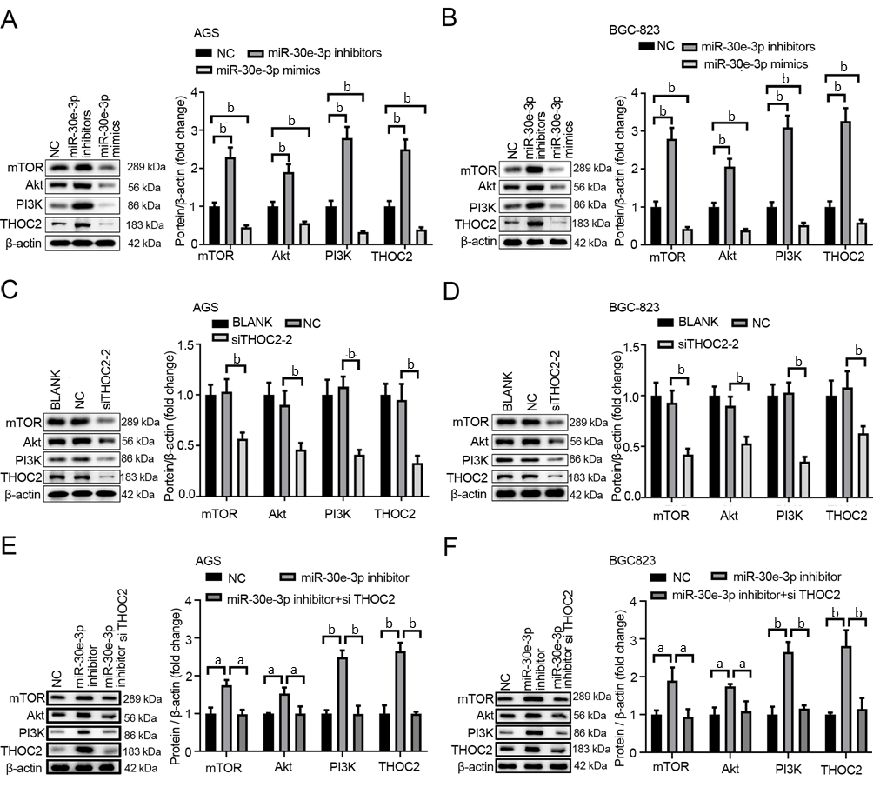
Figure 6 MiR-30e-3p regulates the PI3K/AKT/mTOR signaling pathway via inhibiting THO complex 2 expression in gastric cancer cells. A and B: AGS or BGC-823 cells were transfected with NC, miR-30e-3p inhibitors or miR-30e-3p mimics. The relative protein expression of THO complex 2 (THOC2), PI3K, AKT and mTOR was detected by western blot after 48 h; C and D: AGS or BGC-823 cells were transfected with NC, siTHOC2 or left untreated (blank). The relative protein expression of THOC2, PI3K, AKT and mTOR was detected by western blot after 48 h; E and F: AGS or BGC-823 cells were transfected with NC, miR-30e-3p inhibitor, miR-30e-3p inhibitor and si-THOC2. The relative protein expression of THOC2, PI3K, AKT and mTOR was detected by western blot after 48 h. n = 3 for each group. ^{b}P < 0.01.
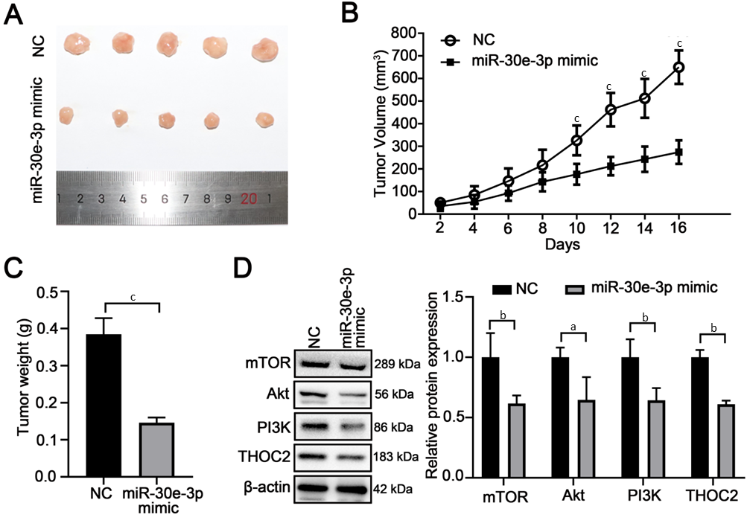
Figure 7 MiR-30e-3p inhibits gastric cancer cells growth in vivo. A: BGC-823 cells were transfected with NC, miR-30e-3p mimic and injected subcutaneously into BALB/c nude mice. Sixteen days later, the tumors diameter were analyzed. n = 5 for each group; B: The tumor volume (mm³) was measured after the tumor implantation every other day; C: Sixteen days after the tumor implantation, the tumor weight (g) was measured; D: Sixteen days after the tumor implantation, the relative protein expression of THOC2, PI3K, AKT and mTOR was detected by Western blot. ªP < 0.05, ^{b}P < 0.01.

Published by Baishideng Publishing Group Inc
7041 Koll Center Parkway, Suite 160, Pleasanton, CA 94566, USA
Telephone: +1-925-3991568
E-mail: bpgoffice@wjgnet.com
Help Desk: https://www.f6publishing.com/helpdesk
https://www.wjgnet.com

© 2022 Baishideng Publishing Group Inc. All rights reserved.

