Name of Journal: World Journal of Clinical Cases
Manuscript NO: 69152
Manuscript Type: META-ANALYSIS

Efficacy and safety of argatroban in treatment of acute ischemic stroke: A meta-analysis

Lv B et al. Efficacy and safety evaluation of argatroban

Bin Lv, Fang-Fang Guo, Jia-Cai Lin, Feng Jing

Bin Lv, Feng Jing, Department of Neurology, Chinese PLA General Hospital, Beijing 100853, China

Fang-Fang Guo, Health Management Institute, The Second Medical Center & National Clinical Research Center for Geriatric Diseases, Chinese PLA General Hospital, Beijing 100853, China

Jia-Cai Lin, Department of Neurology, Hainan Hospital of Chinese PLA General Hospital, Sanya 572022, Hainan Province, China

Author contributions: Lv B and Guo FF contributed equally to this work; Lv B and Guo FF searched the related articles, analyzed the data, and wrote the manuscript; Lin JC analyzed and interpreted the data; Jing F conceived and designed this study, and made critical revision to the manuscript; all the authors have read and approved the final manuscript.

Corresponding author: Feng Jing, MD, Doctor, Department of Neurology, Chinese PLA General Hospital, No. 28 Fuxing Road, Haidian District, Beijing 100853, China. jfsuccess@126.com

Received: June 18, 2021
Revised: October 14, 2021
Accepted: December 2, 2021
Published online:

Abstract
BACKGROUND
Argatroban is a novel direct thrombin inhibitor that has been used for treatment of acute ischemic stroke (AIS). To our knowledge, no systematic analysis has assessed the efficacy and safety of argatroban for treatment of AIS.

AIM
To evaluate the efficacy and safety of argatroban for treatment of AIS.

METHODS
Cochrane Library, Medline, PubMed, and Web of Science were searched to retrieve all studies associated with argatroban and AIS. Effective rate, adverse events rate, and 95% confidence intervals were calculated and pooled using meta-analysis methodology.

RESULTS
We only found four randomized controlled studies, comprising 354 cases with 213 in the argatroban group and 141 in the control group. Great heterogeneity was found in the four studies (c² = 11.44, I² = 74%, P = 0.01). Subgroup analysis could not be performed because of the absence of detailed data. The two most recent studies showed acceptable heterogeneity (c² = 1.56, I² = 36%, P = 0.21). Our analysis showed that argatroban was not more effective than the control therapy in the acute phase of ischemic stroke (Z = 0.01, P = 0.99). Argatroban did not increase the risk of bleeding compared with the control group (c² = 0.37, I² = 0%, P = 0.54, Z = 0.80, P = 0.42).

CONCLUSION
Patients with AIS might not benefit from argatroban and combination therapy with argatroban does not increase bleeding tendency.

Key Words: Argatroban; Anticoagulation agents; Acute ischemic stroke; Thrombin; Thrombolysis; Meta-analysis

Lv B, Guo FF, Lin JC, Jing F. Efficacy and safety of argatroban in treatment of acute ischemic stroke: A meta-analysis. World J Clin Cases 2021; In press

Core Tip: This study is the first meta-analysis that systematically assessed the efficacy and safety of argatroban as a cure for acute ischemic stroke (AIS). The results showed that argatroban might not benefit for AIS. Also, this meta-analysis further suggested that argatroban does not increase the risk of bleeding for AIS.

INTRODUCTION
Acute ischemic stroke (AIS) is the most common type of cerebrovascular disease. Ischemic stroke (IS) is the leading cause of adult disability and has the second-highest fatality rate in the world^{[1]}. Still, morbidity and mortality have shown a growing trend in recent years^{[2]}. Evidence suggests that only aspirin and recombinant tissue-type plasminogen activator (r-tPA) have a definite curative effect on the acute phase of IS (Class A evidence, level I recommendation). The efficacy of other drugs is still lacking evidence-based support. Anticoagulant therapy has always been a focus in the field of AIS, but the results were controversial. Although anticoagulant therapy can reduce the recurrence of IS and the incidence of pulmonary embolism and deep vein thrombosis, its effect on the mortality and disability rate of IS is still unknown^{[3]}. Also, anticoagulation increases the incidence of intracranial hemorrhage (ICH)^{[4]}. So, traditionally used anticoagulant drugs, such as heparin, low molecular weight heparin, and warfarin are not recommended for AIS treatment. Argatroban is a novel, small-molecule, direct thrombin inhibitor. It exerts its anticoagulant function by binding with thrombin, not only in the state of dissolution but also in blood clotting^{[5]}. It has been mainly proved for the treatment of thrombosis caused by heparin-induced thrombocytopenia. There is a growing body of evidence on the safety and efficiency of argatroban therapy for AIS^{[6-8]}. In Japan and South Korea, argatroban therapy is also used in ischemic diseases including myocardial and cerebral ischemia^{[9]}. However, there is still a lack of evidence for its efficacy and safety. To provide more reliable evidence for clinical practice, we conducted a Cochrane Collaboration systematic review that included the randomized controlled studies on AIS treatment using argatroban.

MATERIALS AND METHODS
Search strategy
A search of PubMed, Embase, Science Citation Index, Medline, and Cochrane Library was performed up to October 2020. The search was conducted using medical subject headings and keywords including “argatroban”, “4-methyl-1-(N(2)-(3-methyl-1,2,3,4-tetrahydro-8-quinolinesulfonyl)-L-arginyl)-2-piperidinecarboxylic acid”, “cerebral infarction”, “ischemic stroke”, “cerebrovascular disorder”, and “cerebrovascular accident”. Meanwhile, we retrieved references listed in studies and reviews researched from the online databases to obtain relevant data.

Selection criteria
We only enrolled randomized controlled studies that assessed the efficacy and safety of argatroban in treating AIS. All the studies were in English and published as full articles. Case reports, reviews, commentaries, editorials, and studies written in abstract form or published repeatedly were excluded to prevent homogeneity. The methodological quality of the included studies was assessed using the risk assessment tool for RCT bias in the Cochrane Systematic Reviewers’ Handbook.

Outcome index
The outcome and adverse effects were calculated from the data provided by the researchers. Validity and adverse effect assessment were based on the information synthesized from the studies. Validity mainly referred to therapeutic effect, assessed by neurological function scores. Adverse effects mainly referred to bleeding.

Statistical analysis
Relative risk ratio (RR) and 95% confidence interval (CI) were used as effect analysis statistics for categorical data. Efficiency and safety were calculated for all of the studies that were identiﬁed for the meta-analysis, and the results were combined using fixed- or random-effects modeling. Statistical heterogeneity was assessed using χ² tests (P < 0.05 indicated statistical significance) and I² tests (P <0.05, I² > 50% indicated significant heterogeneity; P > 0.05, I² < 50% indicated insignificant heterogeneity). The fixed-effects model was used if there was no statistical heterogeneity, otherwise, the random-effects model was used. Subgroup analyses were conducted for further investigation. Meta-analysis was conducted using RevMan version 5.4 (Cochrane collaboration), and P < 0.05 was defined as statistically signiﬁcant.

RESULTS
Description of the studies
A total of 412 relevant studies were retrieved, and 408 were excluded because of duplication or failure to meet the inclusion criteria. Finally, four trials were included in our study^{[6,10-12]}. The studies included 354 cases with 213 in the argatroban group and 141 in the control group. The literature screening process and results are showed in Figure 1. Two of the studies were conducted in North America and two in Japan. Three studies were multicenter and one was single center. The main characteristics of the included studies are presented in Table 1.
All four studies used improvement of neurological deficits to assess the efficiency of argatroban. The National Institutes of Health Stroke Scale, Modified Rankin Scale, Barthel Index, and activity in daily living were used in three studies. The evaluation method was not described in the other study^{[10]}. Although there was no uniform standard, all the enrolled studies reported the effective rate of nerve function improvement, which was used to assess the efficacy of argatroban in the treatment of AIS. Three studies^{[6,11,12]} ICH or major bleeding as an adverse reaction, which was not found in the fourth study^{[10]}.

Main analysis
We performed a meta-analysis of the four studies mentioned above. The efficacy of argatroban was controversial. Two studies reported superior improvements in the argatroban group than in the control group^{[6,11]}. However, the other two studies did not find definitive effectiveness of argatroban in the treatment of AIS compared with the control groups^{[10,12]}. The P value of heterogeneity among the studies was significant (P < 0.05, I² = 74%), so the random-effects model was used for the analysis. The result showed that the overall effect was not significant (RR = 1.24; 95%CI: 0.74–2.10; P = 0.42) (Figure 2). Since there was considerable heterogeneity among the four studies, the result was not reliable. The nonconformity of enrollment criteria and result evaluation might have been the cause of the heterogeneity. We found that the inclusion and assessment criteria of two studies^{[6,12]} performed in recent years were in good coincidence. Therefore, we only analyzed the results of these two studies. The results showed that the heterogeneity was insignificant (P = 0.21, I² = 36%). And the fixed-effects model was used for the analysis. The overall effect was also not significant (RR = 1.0; 95%CI: 0.72–1.39; P = 0.99) (Figure 3).The existing research results do not support the efficacy of argatroban in treating AIS.
In the three studies that assessed adverse reactions, none of them found that argatroban increased the risk of bleeding. Detailed data were not provided by Kobayashi et al^{[11]}, so only the studies of Barreto et al^{[6]} and LaMonte et al^{[12]} were included in our analysis. The heterogeneity of the two studies was insignificant (P = 0.54, I² = 0%) and the fixed-effects model was used. The overall analysis showed that there was no significant difference between the argatroban and control groups (RR = 1.34; 95%CI: 0.66–2.74; P = 0.42) (Figure 4). The results indicated that argatroban does not increase the risk of bleeding in AIS. In all the four studies, there was no gender difference between the argatroban and control groups (P > 0.05). The safety and efficacy of argatroban were not assessed according to gender. Therefore, the impact of gender on the safety and efficacy of argatroban cannot be evaluated. We analyzed the impact of patient age. In the studies of Barreto et al^{[6]}, Kari et al^{[10]}, and Kobayashi et al^{[11]}, the mean age of different groups was described but comparisons were not made. In LaMonte et al^{[12]}’s study, there was an age difference between the argatroban and control groups (P = 0.038), but the results were not grouped by age. Therefore, the variable of age cannot be analyzed. In Barreto et al^{[6]}’s study, medical history was described, and patients may have had prior stroke, hypertension, coronary artery disease, diabetes mellitus, heart failure, or atrial fibrillation. However, the impact of comorbidity on the efficacy and safety of argatroban was not analyzed. None of the studies mentioned whether the patients had renal or liver disease. Therefore, the metabolism of argatroban cannot be evaluated.

DISCUSSION
Although the results of this meta-analysis suggested that argatroban did not increase the risk of ICH in the acute phase of cerebral infarction, it failed to show the advantage of argatroban over other drugs in the treatment of AIS. Anticoagulants have been used to treat AIS for > 70 years^{[13]}. The use of anticoagulants for prevention and treatment of IS is still controversial. Anticoagulants are effective in preventing recurrence of cerebral infarction but can also cause bleeding. So far, there is no evidence to support short or long-term benefit of anticoagulants for patients with AIS^{[14]}, and more evidence-based data are needed.
Argatroban is a small-molecule thrombin inhibitor that was first synthesized by Japanese scientists^{[15]}. It can inhibit coagulation by interacting with the catalytic site of thrombin reversibly^{[16]}. Compared with other anticoagulant drugs, argatroban has some advantages. First, argatroban can penetrate and inhibit thrombin effectively despite the fibrin barrier, benefiting from its small molecular size. That means that argatroban has a therapeutic effect on more organized thrombi^{[5]}. Second, argatroban acts quickly. Normally, it can reach steady-state plasma levels in 1–3 h after intravenous administration. Besides, the dose–response curve of argatroban is steady and predictable, which means that it has a wide margin of safety of dose titration^{[17,18]}. Third, argatroban is metabolized rapidly in the liver. The elimination half-life is 39–51 min and is mostly affected by hepatic function, despite age, gender, and renal function^{[19]}. Although there is no specific antidote, the coagulation parameters generally return to normal within 2–4 h after withdrawal of argatroban, as long as liver function is normal^{[20]}. Also, its pharmacological mechanism is selective and it hardly influences other serine proteases.
At present, argatroban is mainly used to treat heparin-induced thrombocytopenia^{[21]}. In Japan and Korea, it has also been used to treat AIS^{[19]}. Several reports have shown that argatroban is effective in treating AIS. Compared with high-dose aspirin (300 mg daily), argatroban plus standard-dose aspirin (100 mg daily) was as effective and safe for the treatment of moderate AIS^{[22]}. Several single-center, nonrandomized, controlled studies have found that argatroban is effective for treating AIS^{[23-25]}. However, the number of patients enrolled in the published studies was small and the studies were all carried out in Asia. In addition to the anticoagulant effect, some studies have shown that argatroban can improve ischemic symptoms by ameliorating cerebral blood flow in patients with AIS^{[26,27]}. However, the number of studies is small and evidence-based medicine is insufficient. Therefore, these findings cannot be extrapolated to clinical application.
The efficiency and safety of argatroban in treating cardiogenic and non-cardioembolic stroke have differed among studies. A retrospective study in Japan analyzed the efficacy and safety of argatroban in the treatment of cardiogenic stroke. The study divided 2529 eligible patients into heparin, argatroban, and control (not receiving anticoagulant or antiplatelet therapy) groups, and the results showed that both heparin and argatroban decreased the risk of death from stroke, but the risk of bleeding was not increased in the argatroban group^{[28]}. However, for non-cardioembolic stroke, the efficiency of argatroban was indefinite. A study including 2289 pairs of patients with atherothrombotic stroke was performed in 2016. The results showed that, despite its safety, argatroban yielded no additional benefit for acute atherothrombotic stroke^{[29]}. Another study found that argatroban was not superior to control therapy in non-cardioembolic AIS^{[30]}. On the contrary, a recent retrospective study of 1325 patients found that argatroban was safe and effective for improving short and long-term outcomes in patients with non-cardioembolic AIS^{[31]}. The results of the studies above indicate that argatroban might have a better therapeutic effect in treating cardiogenic stroke than non-cardioembolic stroke. In Japan, argatroban has already been recommended for patients without embolic IS within 48 h of onset in their 2013 guidelines for management of IS^{[32]}. However, for acute non-cardiogenic stroke, the benefit of argatroban is not definite, and the drug has not been recommended in any treatment guidelines. Most of the recent studies were performed in Japan and were retrospective. More high-quality studies from other regions are needed to support the advantages of argatroban in treating cardiogenic stroke.
As far as we know, this study is the first systematic review of the safety and efficacy of argatroban for treatment of AIS. We only analyzed four studies. We found considerable heterogeneity among the studies. Clinical heterogeneity might occur for many reasons, such as geographic region, racial difference in severity of initial symptoms, and interference with other treatment. The four studies were not designed to the same standard, which may have caused heterogeneity. Also, subgroup analysis was not possible because of the absence of detailed data. Although we did not find evidence supporting the efficacy of argatroban for treatment of AIS, there were some shortcomings in our study. First, we found considerable heterogeneity in the data sources. We only analyzed four studies. The small sample size limits the credibility of the results and was the main source of the heterogeneity. The chronological span of the four studies was large. Kario et al^{[10]}’s and Kobayashi et al^{[11]}’s studies were performed in 1995 and 1997, respectively. The inclusion criteria were not fully described in these studies. Both reported clinical improvement, but the assessment tools and criteria for evaluation were not listed clearly. On the contrary, the studies of Barreto et al^{[6]} and LaMonte et al^{[12]} had unified standards. The heterogeneity of all four studies was large, but was smaller in the studies of Barreto et al^{[6]} and LaMonte et al^{[12]}. Differences in inclusion and assessment criteria may have caused heterogeneity. Besides, the clinical characteristics of patients enrolled in the studies of Kario et al^{[10]} and Kobayashi et al^{[11]} were not described in detail. Thus, it was hard to perform subgroup analysis and meta-regression. We are not able to analyze the specific reason for the heterogeneity, and the heterogeneity made it hard to draw a significant conclusion. However, the quality of the other two recent studies was higher. The inclusion and assessment standards were unified and the heterogeneity of the studies was small. Although the two studies yielded different results on efficacy, the meta-analysis still found no evidence supporting the therapeutic effect of argatroban in AIS. However, the conclusion is debatable due to the limited amount of research and its quality. We might conclude that it is safe to use argatroban for treatment of AIS, but the efficacy needs verification. More high-quality surveys with a large sample are needed in the future for more reliable results. Therefore, our results need to be interpreted with caution.

CONCLUSION
Patients with AIS might not benefit from argatroban and combination therapy with argatroban does not increase bleeding tendency.

ARTICLE HIGHLIGHTS
Research background
Acute ischemic stroke (AIS) has been a global health challenge. And new treatments have been explored. Argatroban as a novel direct thrombin inhibitor has been used in treating AIS. However, the exact efficiency and safety remain unclear.

Research motivation
The drug safety of argatroban has been proved by many studies. However, the results of present studies on evaluating curative effect of argatroban on AIS were quite controversial, which has puzzled us in confirming the role of argatroban in AIS treatment. Therefore, it is necessary to do such an analysis to further evaluate the efficiency and safety of argatroban in treating AIS.

Research objectives
The objective of this study was to evaluate the efficiency and safety of argatroban in treating AIS by extracting available data from existing studies.

Research methods
We have searched database PubMed, Embase, Science, Medline, and Cochrane Library to retrieve all of the studies associated with argatroban and AIS. Only randomized controlled clinical studies were screened for this review. Meta-analysis methodology was used and the standard mean difference values and 95% confidence intervals were estimated to get final results.

Research results
Only four studies that met the criteria were included in our review, which contained a total of 354 cases with 213 cases in the argatroban group and 141 in the control group. The overall analysis showed that patients with AIS did not improve more with argatroban treatment. And argatroban did not increase the bleeding risk in AIS patients.

Research conclusions
Our study that integrated the existing data suggested that patients with AIS might not benefit more from argatroban and combination therapy with argatroban will not increase bleeding tendency.

Research perspectives
More high-quality studies are needed for further evaluation of the efficacy and safety of argatroban in treating AIS.

REFERENCES
1 Thrift AG, Howard G, Cadilhac DA, Howard VJ, Rothwell PM, Thayabaranathan T, Feigin VL, Norrving B, Donnan GA. Global stroke statistics: An update of mortality data from countries using a broad code of "cerebrovascular diseases". Int J Stroke 2017; 12: 796-801 [PMID: 28895807 DOI: 10.1177/1747493017730782]
2 Thrift AG, Thayabaranathan T, Howard G, Howard VJ, Rothwell PM, Feigin VL, Norrving B, Donnan GA, Cadilhac DA. Global stroke statistics. Int J Stroke 2017; 12: 13-32 [PMID: 27794138 DOI: 10.1177/1747493016676285]
3 Geeganage CM, Sprigg N, Bath MW, Bath PM. Balance of symptomatic pulmonary embolism and symptomatic intracerebral hemorrhage with low-dose anticoagulation in recent ischemic stroke: a systematic review and meta-analysis of randomized controlled trials. J Stroke Cerebrovasc Dis 2013; 22: 1018-1027 [PMID: 22516428 DOI: 10.1016/j.jstrokecerebrovasdis.2012.03.005]
4 Kelly AG, Holloway RG. Guideline: The AHA/ASA made 217 recommendations for early management of acute ischemic stroke in adults. Ann Intern Med 2018; 168: JC63 [PMID: 29913488 DOI: 10.7326/ACPJC-2018-168-12-063]
5 Jeske WP, Fareed J, Hoppensteadt DA, Lewis B, Walenga JM. Pharmacology of argatroban. Expert Rev Hematol 2010; 3: 527-539 [PMID: 21083469 DOI: 10.1586/ehm.10.53]
6 Barreto AD, Ford GA, Shen L, Pedroza C, Tyson J, Cai C, Rahbar MH, Grotta JC; ARTSS-2 Investigators. Randomized, Multicenter Trial of ARTSS-2 (Argatroban With Recombinant Tissue Plasminogen Activator for Acute Stroke). Stroke 2017; 48: 1608-1616 [PMID: 28507269 DOI: 10.1161/STROKEAHA.117.016720]
7 Berekashvili K, Soomro J, Shen L, Misra V, Chen PR, Blackburn S, Dannenbaum M, Grotta JC, Barreto AD. Safety and Feasibility of Argatroban, Recombinant Tissue Plasminogen Activator, and Intra-Arterial Therapy in Stroke (ARTSS-IA Study). J Stroke Cerebrovasc Dis 2018; 27: 3647-3651 [PMID: 30249518 DOI: 10.1016/j.jstrokecerebrovasdis.2018.08.036]
8 Yang Y, Zhou Z, Pan Y, Chen H, Wang Y; ARAIS Protocol Steering Group. Randomized trial of argatroban plus recombinant tissue-type plasminogen activator for acute ischemic stroke (ARAIS): Rationale and design. Am Heart J 2020; 225: 38-43 [PMID: 32485328 DOI: 10.1016/j.ahj.2020.04.003]
9 Sanchez R, Picard N, Mouly-Bandini A, Chalvignac V, Lacarelle B, Sampol-Manos E. Severe decrease of cyclosporine levels in a heart transplant recipient receiving the direct thrombin inhibitor argatroban. Ther Drug Monit 2014; 36: 273-277 [PMID: 24365983 DOI: 10.1097/FTD.0000000000000026]
10 Kario K, Kodama K, Koide M, Matsuo T. Thrombin inhibition in the acute phase of ischaemic stroke using argatroban. Blood Coagul Fibrinolysis 1995; 6: 423-427 [PMID: 8589208 DOI: 10.1097/00001721-199507000-00008]
11 Kobayashi S, Tazaki Y. Effect of the thrombin inhibitor argatroban in acute cerebral thrombosis. Semin Thromb Hemost 1997; 23: 531-534 [PMID: 9469625 DOI: 10.1055/s-2007-996131]
12 LaMonte MP, Nash ML, Wang DZ, Woolfenden AR, Schultz J, Hursting MJ, Brown PM; ARGIS-1 Investigators. Argatroban anticoagulation in patients with acute ischemic stroke (ARGIS-1): a randomized, placebo-controlled safety study. Stroke 2004; 35: 1677-1682 [PMID: 15155959 DOI: 10.1161/01.str.0000131549.20581.ba]
13 Gubitz G, Counsell C, Sandercock P, Signorini D. Anticoagulants for acute ischaemic stroke. Cochrane Database Syst Rev 2000: CD000024 [PMID: 10796283 DOI: 10.1002/14651858.CD000024]
14 Wang X, Ouyang M, Yang J, Song L, Yang M, Anderson CS. Anticoagulants for acute ischaemic stroke. Cochrane Database Syst Rev 2021; 10: CD000024 [PMID: 34676532 DOI: 10.1002/14651858.CD000024.pub5]
15 Okamoto S, Hijikata-Okunomiya A. Synthetic selective inhibitors of thrombin. Methods Enzymol 1993; 222: 328-340 [PMID: 8412802 DOI: 10.1016/0076-6879(93)22022-8]
16 Yeh RW, Jang IK. Argatroban: update. Am Heart J 2006; 151: 1131-1138 [PMID: 16781211 DOI: 10.1016/j.ahj.2005.09.002]
17 Swan SK, Hursting MJ. The pharmacokinetics and pharmacodynamics of argatroban: effects of age, gender, and hepatic or renal dysfunction. Pharmacotherapy 2000; 20: 318-329 [PMID: 10730687 DOI: 10.1592/phco.20.4.318.34881]
18 Escolar G, Bozzo J, Maragall S. Argatroban: a direct thrombin inhibitor with reliable and predictable anticoagulant actions. Drugs Today (Barc) 2006; 42: 223-236 [PMID: 16703119 DOI: 10.1358/dot.2006.42.4.953588]
19 Walenga JM. An overview of the direct thrombin inhibitor argatroban. Pathophysiol Haemost Thromb 2002; 32 Suppl 3: 9-14 [PMID: 12811006 DOI: 10.1159/000069103]
20 Swan SK, St Peter JV, Lambrecht LJ, Hursting MJ. Comparison of anticoagulant effects and safety of argatroban and heparin in healthy subjects. Pharmacotherapy 2000; 20: 756-770 [PMID: 10907966 DOI: 10.1592/phco.20.9.756.35194]
21 Prince M, Wenham T. Heparin-induced thrombocytopaenia. Postgrad Med J 2018; 94: 453-457 [PMID: 30126928 DOI: 10.1136/postgradmedj-2018-135702]
22 Chen L, Cao S, Yang J. Argatroban plus aspirin versus aspirin in acute ischemic stroke. Neurol Res 2018; 40: 862-867 [PMID: 30052164 DOI: 10.1080/01616412.2018.1495882]
23 Urabe T, Tanaka R, Noda K, Mizuno Y. Anticoagulant therapy with a selective thrombin inhibitor for acute cerebral infarction: usefulness of coagulation markers for evaluation of efficacy. J Thromb Thrombolysis 2002; 13: 155-160 [PMID: 12355032 DOI: 10.1023/a:1020426906956]
24 Park JS, Park SS, Koh EJ, Eun JP, Choi HY. Treatment for Patients with Acute Ischemic Stroke Presenting beyond Six Hours of Ischemic Symptom Onset : Effectiveness of Intravenous Direct Thrombin Inhibitor, Argatroban. J Korean Neurosurg Soc 2010; 47: 258-264 [PMID: 20461165 DOI: 10.3340/jkns.2010.47.4.258]
25 Liu S, Liu P, Wang P, Zhang F, Wang L, Wang Y, Lu H, Ma X. Argatroban Increased the Basal Vein Drainage and Improved Outcomes in Acute Paraventricular Ischemic Stroke Patients. Med Sci Monit 2020; 26: e924593 [PMID: 32667287 DOI: 10.12659/MSM.924593]
26 Yamashita T, Hayashida O, Nagamitsu T, Nagatsuna T, Wakuta Y, Fudaba H. The regional cerebral blood flow amelioration of argatroban in the acute stage of cerebral thrombosis. Keio J Med 2000; 49 Suppl 1: A141-A144 [PMID: 10750366 DOI: 10.2335/scs.29.178]
27 Maruki Y, Onoda A, Matsuzaki M, Narabayashi Y, Sawada M, Shimazu K. A specific thrombin inhibitor (argatroban) ameliorated cerebral blood flow in the patients with acute cerebral infarction. Keio J Med 2000; 49 Suppl 1: A138-A140 [PMID: 10750365 DOI: 10.1016/s1052-3057(97)80087-0]
28 Hosomi N, Naya T, Kohno M, Kobayashi S, Koziol JA; Japan Standard Stroke Registry Study Group. Efficacy of anti-coagulant treatment with argatroban on cardioembolic stroke. J Neurol 2007; 254: 605-612 [PMID: 17417744 DOI: 10.1007/s00415-006-0365-y]
29 Wada T, Yasunaga H, Horiguchi H, Matsubara T, Fushimi K, Nakajima S, Yahagi N. Outcomes of Argatroban Treatment in Patients With Atherothrombotic Stroke: Observational Nationwide Study in Japan. Stroke 2016; 47: 471-476 [PMID: 26670085 DOI: 10.1161/STROKEAHA.115.011250]
30 Oguro H, Mitaki S, Takayoshi H, Abe S, Onoda K, Yamaguchi S. Retrospective Analysis of Argatroban in 353 Patients with Acute Noncardioembolic Stroke. J Stroke Cerebrovasc Dis 2018; 27: 2175-2181 [PMID: 29706441 DOI: 10.1016/j.jstrokecerebrovasdis.2018.03.016]
31 Chen S, Cai D, Huang P, Liu J, Lai Y, He J, Zhou L, Sun H. Early and long-term outcomes of argatroban use in patients with acute noncardioembolic stroke. Clin Neurol Neurosurg 2020; 198: 106233 [PMID: 32977247 DOI: 10.1016/j.clineuro.2020.106233]
32 Kern R, Nagayama M, Toyoda K, Steiner T, Hennerici MG, Shinohara Y. Comparison of the European and Japanese guidelines for the management of ischemic stroke. Cerebrovasc Dis 2013; 35: 402-418 [PMID: 23712178 DOI: 10.1159/000351753]

Footnotes
Conflict-of-interest statement: The authors deny any conflict of interest for this article.

PRISMA 2009 Checklist statement: The authors have read the PRISMA 2009 Checklist, and the manuscript was prepared and revised according to the PRISMA 2009 Checklist.

Open-Access: This article is an open-access article that was selected by an in-house editor and fully peer-reviewed by external reviewers. It is distributed in accordance with the Creative Commons Attribution NonCommercial (CC BY-NC 4.0) license, which permits others to distribute, remix, adapt, build upon this work non-commercially, and license their derivative works on different terms, provided the original work is properly cited and the use is non-commercial. See: http://creativecommons.org/Licenses/by-nc/4.0/

Provenance and peer review: Unsolicited article; Externally peer reviewed.

Peer-review model: Single blind

Peer-review started: June 18, 2021
First decision: September 28, 2021
Article in press:

Specialty type: Medicine, research and experimental
Country/Territory of origin: China
Peer-review report’s scientific quality classification
Grade A (Excellent): 0
Grade B (Very good): 0
Grade C (Good): C
Grade D (Fair): 0
Grade E (Poor): 0

P-Reviewer: Ciarambino T S-Editor: Fan JR L-Editor: Wang TQ P-Editor: Fan JR

Figure Legends
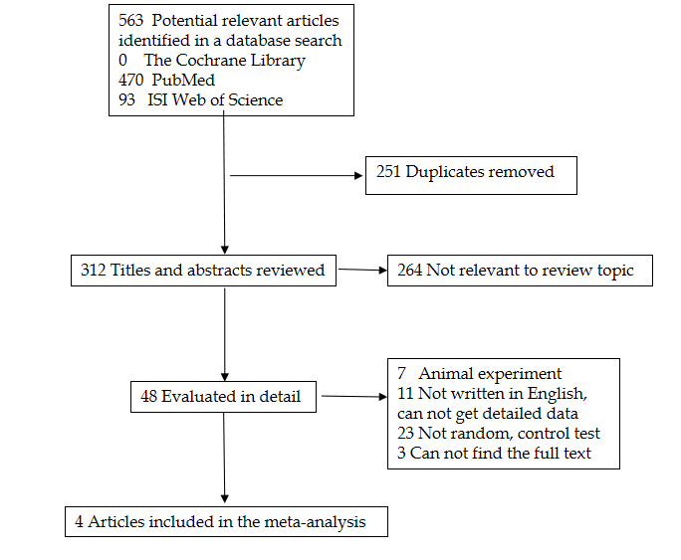
Figure 1 Flow chart of article search and selection for this meta-analysis.
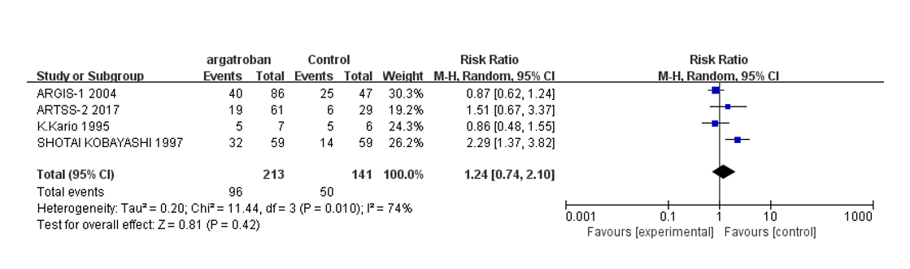
Figure 2 Forest plot showing that there was no significant difference in efficacy among the studies. The results might not be reliable considering the heterogeneity.
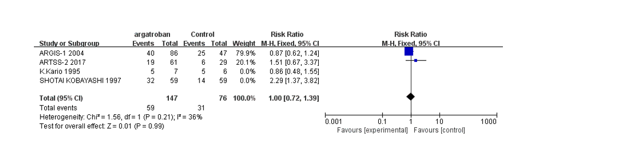
Figure 3 Marian’s and Andrew’s studies were performed recently. The heterogeneity was within the acceptable limit. Although the results were different, the overall meta-analysis showed no difference.
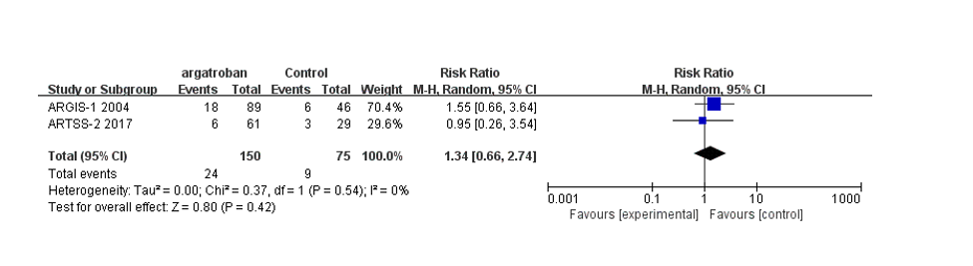
Figure 4 Only Marian’s and Andrew’s studies provided detailed data of bleeding events. Analysis showed no difference compared with the control group.
Table 1 Characteristics of included studies
Title | Country | Multiple/single center | Date | Argatroban/control
Thrombin inhibition in the acute phase of IS using argatroban | Japan | Single center | 1995 | 7/6
Effect of the argatroban in acute cerebral thrombosis | Japan | Multicenter | 1997 | 59/59
Argatroban in patients with acute  ischemic stroke | United States | Multicenter | 2004 | 86/47
Randomized, multicenter trial of ARTSS-2 (Argatroban with Recombinant Tissue Plasminogen Activator for Acute Stroke) | United States | Multicenter | 2017 | 61/29

