Name of journal: World Journal of Gastroenterology
ESPS Manuscript NO: 18891
Manuscript Type: Review

Endosonography guided management of pancreatic fluid collections

Vilmann AS et al. EUS-guided management of pancreatic fluid collection

Andreas S Vilmann, John Menachery, Shou-jiang Tang, Indu Srinivasan, Peter Vilmann

Andreas S Vilmann, Peter Vilmann, Department of Surgical Gastroenterology, Copenhagen University Hospital Herlev, 2730 Herlev, Denmark

John Menachery, Department of Gastroenterology, Rajagiri Hospital Aluva, Kerala 683112, India

Shou-jiang Tang, Indu Srinivasan, Division of Digestive Diseases, Department of Medicine, University of Mississippi Medical Center, Jackson, MS 39216, United States

Author contributions: All authors have been involved in the design and conduct of this work. Research was done by Tang SJ and Menachery J; Drafting the article was equally done by Vilmann AS and Menachery J; Critically revision was equally done by all authors; Final version was approved by all authors.

Conflict-of-interest statement: Vilmann AS, Menarchy J, Srinivasan I and Tang SJ have no conflict of interest. Vilmann P reported a conflict as a consultant for MediGlobe, GmbH, Grassau, Germany.

Open-Access: This article is an open-access article which was selected by an in-house editor and fully peer-reviewed by external reviewers. It is distributed in accordance with the Creative Commons Attribution Non Commercial (CC BY-NC 4.0) license, which permits others to distribute, remix, adapt, build upon this work non-commercially, and license their derivative works on different terms, provided the original work is properly cited and the use is non-commercial. See: http://creativecommons.org/licenses/by-nc/4.0/

Correspondence to: Andreas S Vilmann, MD, Department of Surgical Gastroenterology, Copenhagen University Hospital Herlev, Herlev Ringvej 75, 2730 Herlev, Denmark. andreas.vilmann@gmail.com
Telephone: +45-51-365185

Received: April 28, 2015
Peer-review started: May 6, 2015
First decision: June 2, 2015
Revised: June 24, 2015
Accepted: August 30, 2015
Article in press:
Published online:

Abstract
The revised Atlanta classification of acute pancreatitis was induced by international consensus and is based on the actual local and systemic determinants of severity. The local determinant includes pancreatic necrosis (sterile or infected) and the systemic determinant involves organ failure. Local complications of pancreatitis include acute peri-pancreatic fluid collection, acute necrotic collection, pseudocyst, and walled-off necrosis. Increasingly, interventional endoscopic ultrasound (EUS) is utilized in the management of these local complications. The authors performed PubMed search and a pre-defined inclusion criteria or filter was then manually applied. The authors reviewed the utility, efficacy and risks of therapeutic EUS and involved EUS devices among these settings, which we grouped as pancreatic fluid collections (PFC). The authors predict a continuing evolution in the management of these PFCs with improved and novel endoscopic devices dedicated for transmural drainage of fluid and necrotic debris: access and patency devices. EUS should become an indispensable part of this procedure for diagnosis and image guided interventions. The amount of necrosis is the most important predictor of successful outcome after drainage of these PFCs, regardless of their different terminologies. Hence it would seem logical to classify these collections based on the percentage of necrotic component or debris under radiological imaging studies or EUS. The authors propose an algorithm in managing these fluid collections based on their size, locations, associated symptoms, internal echogenic patterns and content.

Key words: Endoscopic ultrasound; Drainage; Pancreatic fluid collection; Pseudocyst; Patency device; Abscess; Walled of necrosis; Pancreas

© The Author(s) 2015. Published by Baishideng Publishing Group Inc. All rights reserved.

Core tip: The revised Atlanta classification of acute pancreatitis was induced by international consensus and is based on the actual local and systemic determinants of severity. Local complications of pancreatitis include acute peri-pancreatic fluid collection, acute necrotic collection, pseudocyst, and walled-off necrosis. Increasingly, interventional endoscopic ultrasound (EUS) is utilized in the management. In this review, the authors reviewed the utility, efficacy and risks of therapeutic EUS and involved EUS devices among these settings. The authors propose an algorithm in managing these fluid collections based on their size, locations, associated symptoms, internal echogenic patterns and content.

Vilmann AS, Menachery J, Tang SJ, Srinivasan I, Vilmann P. Endosonography guided management of pancreatic fluid collections. World J Gastroenterol 2015; In press

Introduction
In 1992, the Atlanta classification of acute pancreatitis was induced by international consensus. The Atlanta classification aimed to standardize reporting and communication between health care professionals. However, some of the terminologies used are confusing and lack objective description of local complications so that new treatment can be provided. In 2012, the revised Atlanta classification was released after years of web-based consultation among a global panel of experts and international pancreatic associations^{[1–3]}. The new classification is based on the actual local and systemic determinants of severity, rather than description of events that are correlated with severity^{[1,2]}. The local determinant includes pancreatic necrosis (sterile or infected) and the systemic determinant involves organ failure (transient or persistent). Acute pancreatitis is now identified as early and late phases and its severity is classified as mild, moderate or severe. Mild acute pancreatitis has no organ failure, local or systemic complications and usually resolves in the first week. Moderately severe acute pancreatitis has transient organ failure, local complications or exacerbation of co-morbid disease. Severe acute pancreatitis displays persistent organ failure (> 48 h) (Table 1).
Local complications of pancreatitis include acute peri-pancreatic fluid collection, acute necrotic collection (ANC, sterile or infected), pseudocyst, and walled-off necrosis (WON) (sterile or infected). WON is characterized by a distinct rim that forms around the necrosis and adjacent pancreatic parenchyma. Increasingly, interventional endoscopic ultrasound (EUS) is utilized in the management of these local complications^{[4,5]}. In this review, the authors searched the English language medical literature and reviewed the utility, efficacy and risks of therapeutic EUS and involved EUS devices among these settings, which we grouped as pancreatic fluid collections (PFC). The authors propose an algorithm in managing these fluid collections based on their size, locations, associated symptoms, internal echogenic patterns and structures.

Methods and Review Strategy
On November 15, 2014, the authors performed PubMed search using following key word sets: EUS in combination with terminologies related to pancreatic fluid collections such as pseudocyst, fluid collection, abscess, and WON. A pre-defined inclusion criteria or filter was then manually applied to PubMed search results (Figure 1). The inclusion criteria were: (1) original reports; (2) case number > 6; and (3) and English language publication only. The authors then performed manual review of these publications and their listed references, i.e. cross-reference search. Finally, each published paper was reviewed by two of these authors together, extracting the important information related to this review.

Indications and timing for transmural drainage
The decision to drain a pancreatic fluid collection depends on clinical symptoms, condition of the patient, change in size over time, time from onset of symptoms, infection and other complications. Asymptomatic pancreatic and/or extra-pancreatic fluid collections do not warrant intervention regardless of size, location, and/or extension, drainage is considered only when a collection becomes symptomatic or is infected^{[6]}. Infection is more common in necrotic collections and is suggested by air pockets inside the collection visible on computerized tomography (CT) scan. If the clinical scenario strongly raises the suspicion of an infected collection it may be documented by fine needle aspiration. In case of sterile collections, luminal or biliary obstruction from external compression, persistent abdominal pain requiring narcotics or an undiagnosed sepsis syndrome can be indications for drainage^{[7]}. PFC may be drained surgically, percutaneously or endoscopically.
Timing is critical for successful endoscopic drainage in necrotizing pancreatitis. Interventions within the first few weeks for necrotizing pancreatitis are generally associated with poor outcomes. The guiding principle for timing of debridement is to delay, any intervention until the collection has become encapsulated and the content liquefied as much as possible. Typically encapsulation does not occur until at least 4 weeks after the initial injury.
Endoscopic treatment has been shown to have comparable efficacy to surgical drainage albeit with shorter hospital stays, better physical and mental health of patients and lower cost^{[8]}. Percutaneous drainage requires the patient to have an external drain for an extended period of time. This may lead to development of pancreatico-cutaneous fistulas especially in those cases with ductal disruption. When compared to percutaneous drainage endoscopic approach allows placement of multiple drainage modalities through a single puncture site.
EUS permits visualization of the entire cavity, assesses the maturity of the wall, measures the distance of the collection from the luminal wall and also identifies intervening vessels (collaterals) along the puncture site (Figures 2 and 3). EUS guided drainage of PFC has been shown to have higher technical success when compared to conventional transmural endoscopic drainage without EUS guidance^{[9]}. EUS guided drainage is the preferred modality when there is no visible luminal bulge or when there is a clinical suspicion of portal hypertension and collateral formation or in patients with coagulopathy^{[4,6,7]}.

Should ERCP and trans-papillary drainage be performed on these patients?
Endoscopic drainage of PFCs may be performed either during endoscopic retrograde cholangiopancreatography (ERCP) with drainage through the main ampulla of Vater or via a transmural route, either via the duodenum or the stomach. There are at present no comparative or randomized studies from which solid data can be extracted regarding the preferred method for drainage. Only case series with inconsistency of methods and guidelines based on expert opinions have been published^{[10,11]}. According to these transpapillary drainage is preferred to EUS guided transmural drainage as a first step procedure for small collections communicating with the main pancreatic duct in the head or body of the pancreas (Figure 4). In most publications with EUS guided drainage there is no description whether all patients had undergone ERCP prior to EUS guided drainage. In a series of 116 patients of which 15 had transpapillary drainage, 60 transmural and 41 both methods, successful drainage was achieved in 88% of the patients^{[12]}. There was no difference in success between the methods. Hence, the recommendation statement that a pancreatic fluid collection preferably should be drained via the pancreatic papilla and the pancreatic duct is based on very low evidence.

Does location of the fluid collection matter
Transmural drainage has been attempted in pancreatic pseudocysts (Figure 5A). and WON (Figure 5B). of suitable size located in the head, body or tail of pancreas provided the distance between the lumen wall and cyst is less than 1 cm. Due to their location in the lesser sac or extension to the pararenal space, PFC in the pancreatic tail do not cause a luminal compression and can be accessed only by EUS. Varadarajalu et al^{[13]} have noted that the location of the pseudocyst is not a predictor for treatment success. However 2 cases of perforation have been described when transgastric drainage was attempted for pseudocysts located in the uncinate process of pancreas. This complication did not occur in uncinate pseudocysts when the drainage was attempted from the duodenum. Following transmural stenting, the pseudocyst hanging low from the uncinate region gets decompressed and probably disconnect from the stomach wall, leading to perforation^{[14]}.

Does the amount of internal debris matter
In the context of drainage of PFCs, technical success refers to achieving access and placement of transmural stents whereas clinical success would mean resolution of the collection. Very high clinical success rates between 90%-100% have been achieved in drainage of pseudocysts^{[9,12,15]}. However in cases of walled off pancreatic necrosis, the results for clinical resolution are generally poor. In a recent study of 211 patients with symptomatic PFCs, whereas the rate of treatment success for sterile and infective pseudocysts was 93.5%, it was only 63.2% for WON^{[13]}. Baron et al^{[16]} showed that the success rate of pseudocyst drainage was 92%, compared to 72% in patients with necrosis. Although this study utilized non-EUS-guided endoscopic drainage, it illustrates the principle that the outcome of endoscopic drainage for pseudocysts was superior to drainage of infected necrosis. In another study, drainage of necrosis resulted in clinical success in only 25% and technical success in 50% of the cases^{[12]}. If an aggressive endoscopic approach using endoscopic necrosectomy is adopted, success rates up to 81% can be achieved in WON^{[17]}. Adjunctive surgical and percutaneous drainage may be needed. Varadarajalu et al. suggested multiple transluminal gateway treatment (MTGT) for WON by which they could attain successful response in 92% of patients. Two or three transmural tracts were created by using EUS guidance between the necrotic cavity and the gastrointestinal lumen. While one tract was used to flush normal saline solution via a nasocystic catheter, multiple stents were deployed in others to facilitate drainage of necrotic contents^{[18]}.
As the necrotic component in the collection increases the success rate decreases progressively unless aggressive endoscopic necrosectomy or concomitant percutaneous drainage is also used. The progression to surgery is also more common in these groups. The revised Atlanta classification suggests that WON is a well encapsulated fluid collection which occurs 4 weeks in the setting of a necrotic pancreatitis. However, this may not always be true as necrotic collections can liquefy over time. An Indian study with follow-up EUS at 6 weeks, 3 months and 6 months after the onset of acute necrotic pancreatitis demonstrated that all the fluid collections following acute necrotic pancreatitis may not have solid necrotic content and over a period of time the collections tend to decrease in size and the solid content tends to liquefy with almost half of PFCs completely liquefying at 6 months^{[19]}.
Another study from the same group looked at 43 patients with symptomatic WON who were treated by endoscopic drainage^{[20]}. They divided the patients into three groups. The mean size of WON was 9.95 ± 2.75 cm with < 10%, 10%-40% and > 40% solid debris being present in 6, 33, and 4 patients, respectively. Patients with < 10% necrotic debris needed only single session of endoscopic drainage, whereas patients with 10%-40% solid debris needed two or more sessions. Patients with > 40% solid debris either needed direct endoscopic debridement or surgical necrosectomy. The extent of necrosis correlated significantly (r = 0.703, P < 0.001) with the type of treatment received by the patient.

choice of transmural access devices
EUS-guided PFC drainage is limited by the lack of dedicated accessories, which necessitates multiple steps for transluminal stent placement. At first the fluid collection is visualized using a linear echoendoscope. Any intervening vessel in the line of puncture is ruled out using Doppler technology. The PFC is then punctured under vision. Puncture of the cyst wall could be performed in one of three ways: (1) a 19-gauge FNA needle; (2) a cystostome; or (3) a needle wire followed by the insertion of a 0.035 guide wire. When multiple stents need to be placed some authors prefer a double guide wire approach in which two guide wires are simultaneously inserted after the first puncture^{[21]}. Recently, a novel lumen-apposing self-expandable metal stent (AXIOSTM system, Xlumina, Mountain View, CA, United States) has been developed that can be deployed in a single step (Figures 6 and 7). The stent has a dumbbell-shaped configuration that foreshortens on deployment, thereby minimizing the possibility of leak or perforation^{[22]}.

Cystoenterotomy patency devices
A variety of stents have been used to maintain patency of the fistulous tract between the gut lumen and the PFC. Single plastic stents (straight or double pigtail), multiple plastic stents, nasocystic drainage catheters, enteral metal stents and biliary metal stents have been tried. Some studies have also described a combination of modalities like plastic stents in combination with nasocystic drainage catheters or double pigtail stents axially placed through a metal stent. The available literature contain studies with heterogenous nature and there is no clear evidence to suggest metal stents are better than plastic stents or one type of plastic stent is better than another.

Pseudocysts
Lopez et al used single plastic stents for draining pseudocysts. The drainage was successful in 93% patients with a recurrence noted in 25% cases. They also noted that straight stents had a trend for higher complications as compared to double pigtail stents even though the difference was not statistically significant^{[23]}. The straight stents do not have anchorage and may migrate more easily as compared to double pigtail stents. Straight stents have also been reported to cause bleeding and perforation.
In a single centre prospective cohort study Antillon et al^{[24]} looked at the efficacy of single-step EUS-guided transmural drainage of pseudocysts. Complete resolution of the pseudocyst was achieved in 27 (82%) of the 33 patients at the index procedure. Four additional patients (12%) had only partial resolution (50% reduction in cyst size), accompanied by symptom resolution. Recurrence was observed in only 1 patient over a median follow-up of 46 wk.
In a retrospective study 87 consecutive patients with pancreatic pseudocysts were managed by EUS-guided drainage: those with solid debris who underwent drainage via nasocystic drains alongside stents (n = 63) and those with solid debris who underwent drainage via transmural stents only (n = 24). The patients with viscous solid debris-laden fluid whose pseudocysts were drained by both stents and nasocystic tubes had a 3 times greater short-term success rate compared with those who had drainage by stents alone (OR = 3.6; 95%CI: 1.2-10.7; P = 0.03). Long-term follow-up showed a non-significant trend toward better resolution of pseudocyst with debris drainage via nasocystic drains alongside stents compared with stents alone (79% vs 58% respectively, OR = 2.7; P = 0.059). The rate of stent occlusion was higher in cysts with debris drained by stents alone compared with those drained via nasocystic drains alongside stents (33% vs 13%; P = 0.03)^{[25]}.
A single step, simultaneous double-wire technique with a prototype device was introduced by Seewald et al^{[21]} Eight patients with symptomatic pseudocysts underwent drainage. After puncture two 0.035-inch guide wires were simultaneously inserted into the cyst cavity followed by transmural stenting with an 8.5F double pigtail stent and insertion of a 7 French nasocystic catheter. The cavity was irrigated with a total of 1500 mL of saline solution daily through the nasocystic catheter to prevent accumulation of pus and debris. The nasocystic catheter was used to provide irrigation over a range of 7 to 21 d. Complete resolution of the pseudocysts was achieved in all patients as determined by follow-up CT scan. There was no pseudocyst recurrence during the follow-up period, which ranged from 6 to 16 mo.
Due et al described 10 cases of pancreatic pseudocyst drainage out of which 7 patients received a 10 mm × 20 mm covered double-flanged metal stent^{[26]}. Three patients had sepsis due to stent blockage and one patient had a persistent leak. Two patients with stent blockage and the one patient with leak ultimately required surgical intervention. Fabbry et al^{[27]} reported the drainage of 20 cases of infected fluid collection using covered self expanding metal stents (SEMS). Either 4cms or 6cms long SEMS were used with a diameter of 10 mm. The procedure was technically successful in all and the treatment success was 90%. The stents were removed after 1 mo. Removal was successful in all except one case and one stent was found to be migrated. One patient required surgery. There have been attempts to provide better anchorage to metal stents by deploying plastic stents through them thereby reducing chances of SEMS migration. Talreja et al^{[28]} described a series of seventeen patients with PFC who underwent endoscopic drainage. 10 mm × 60 mm SEMS were used and double pigtail plastic stents were deployed through or along the side of the metal stents to provide better anchorage. They had reported 95% treatment response with stent migration reported in only one patient. Comparable results were noted by Penn et al^{[29]} when they used this technique for pseudocyst drainage.
A study from California evaluated EUS guided drainage of PFCs using a one-step access device (NAVIXTM, Xlumina) followed by placement of a fully covered SEMS. Eighteen patients with PFC with indeterminate adherence were enrolled. After 7–10 d, the fully covered SEMSs were removed and exchanged for double-pigtail stents. When indicated, tract dilation and endoscopy-guided cyst debridement was performed. Fully covered SEMS placement was technically successful in all patients without complications. Median procedure time was 37.5 min. Cyst resolution was achieved in 78% of patients^{[30]}. Berzosa et al^{[31]} also showed 100% technical and clinical success with SEMS. No instance of stent migration was reported in this study. Most of these SEMS’s were tubular stents designed for transluminal drainage, such as bile duct drainage. When used for transmural drainage, these SEMSs have some limitations, including a high risk of stent migration and may cause tissue injury and bleeding. Therefore, a novel large-diameter SEMS with bilateral flanges, the AXIOS stent, has been designed especially for transmural drainage. It consists of a barbell-shaped, flexible, fully covered, self-expanding nitinol stent housed within a catheter-based delivery system. The stents are available in 2 sizes: 10 mm × 10 mm and 15 mm × 10 mm. The 10 mm saddle length is designed to appose the stomach or duodenum to the PFC wall. In 2012, Itoi et al^{[32]} first described the use of AXIOS stents in a series of 15 patients with symptomatic pseudocysts who underwent drainage. All stents were successfully deployed without complications, with a median time to removal of 35 d. All pseudocysts resolved after a single drainage procedure. One stent migrated into the stomach, and the remaining 14 were found to be patent at the time of removal. There was no pseudocyst recurrence during the 11-month median follow-up period. In 2013, a Spanish study reported the usage of AXIOS stents for pseudocyst drainage^{[33]}. They had a technical success of 88% (8/9) as there was failure of the delivery system in one case. No stent migration was reported and all stents were removed easily. All patients had a successful treatment outcome achieving complete cyst resolution.

Walled-off necrosis
WON often leads to severe clinical deterioration necessitating open debridement or endoscopic necrosectomy. Infection is a common complication in the endoscopic drainage of pancreatic fluid collections. It is more commonly observed in WON than in pseudocysts presumably due to stent occlusion by the solid debris and subsequent bacterial colonization. Hence the general opinion is in favor of placing multiple stents especially in WON. In MTGT, 2 or 3 transmural tracts were created by using EUS guidance between the necrotic cavity and the gastrointestinal lumen. While one tract was used to flush normal saline solution via a nasocystic catheter, multiple stents were deployed in others to facilitate drainage of necrotic contents. Varadarajalu et al compared MTGT with conventional EUS guided drainage. Of 60 patients with symptomatic WON, 12 were managed by MTGT and 48 by conventional drainage. Treatment was successful in 11 of 12 (91.7%) patients managed by MTGT vs 25 of 48 (52.1%) managed by conventional drainage (P = 0.01). Although 1 patient in the MTGT cohort required endoscopic necrosectomy, in the conventional drainage cohort, 17 required surgery, 3 underwent endoscopic necrosectomy, and 3 died of multiple-organ failure^{[18]}.
A multicentre prospective study from United States evaluated the outcomes of AXIOS stent placement in 33 patients with symptomatic pancreatic pseudocysts and WON^{[22]}. The devices were placed successfully under endoscopic ultrasound guidance in 30 patients (91%); the remaining 3 patients received 2 double-pigtail stents. One subject could not be evaluated because of a pseudoaneurysm. In the patients receiving AXIOS stents, PFCs resolved in 27 of 29 (93%). Stent migration was noted only in one patient. In a large multicentre trial involving 15 European centers, 61 patients with either pseudocyst (n = 46, 75%) or WON (n = 15, 25%) were drained using AXIOS stents. Stent placement was technically successful in 60 patients (98%). Clinical success, defined as resolution of clinical symptoms in combination with a decrease in the PFC size to ≤ 2 cm on imaging, was achieved in 93% of patients with a pancreatic pseudocyst and in 81% of patients with WON. Treatment failure occurred in nine patients (16%) including four patients who required surgical intervention. Stent removal was performed in 82% of patients after a median of 32 days and was rated as easy in all but one patient. In 10 patients, endoscopic stent removal was not performed because of stent migration (n = 3), stent dislodgement during necrosectomy (n = 3), stent removal during surgery (n = 2), or refusal by the patient (n = 2).

Single or multiple stents
In cases of pseudocysts there is no randomized control trial, which has looked at the question whether a single plastic stent or multiple plastic stents or a metal stent is better. However retrospective studies have shown that even single stents have given high rates of clinical resolution. This is probably because stent occlusion may not have occurred as there is no solid necrotic debris. In a recent meta-analysis, 14 studies involving 698 patients were evaluated and no difference was detected in the rates of treatment success between patients managed with multiple plastic stents vs metal stents at 89% (95%CI: 87-91) vs 87% (95%CI: 76 to 91; P = 0.22), respectively. Also, there was no difference in the rates of adverse events or pseudocyst recurrence between the two cohorts^{[34]}. However in cases of WON this may not be applicable as stent occlusion and consequent treatment failure are very much likely and it should be stressed that the chance of clinical resolution and success is depended on adequate drainage. This is underlined by the success of MTGT technique for WON proposed by Varadarajalu et al where placement of multiple stents at different sites along with a nasocystic drain achieved clinical resolution in more than 90% cases^{[18]}.

Definition of clinical and radiological success
Technical success is defined as the ability to access and drain the pancreatic pseudocyst by the placement of a stent. Treatment success involves both clinical and radiologic improvement. Clinical success refers to the resolution of the symptoms that prompted the intervention. Radiologic success refers to the decrease in size or resolution of the cyst. In a randomized clinical trial which compared endoscopic and surgical drainage for pseudocysts, treatment success for endoscopy was defined as complete resolution or a decrease in size of the fluid collection to 2 cm or smaller on CT scan in association with resolution of symptoms at the 8 weeks outpatient follow up evaluation^{[8]}. Follow up is usually done with upper endoscopies and imaging which could be either CT scan or abdominal ultrasound.

Efficacy of EUS guided drainage of pancreatic fluid collections
Very high clinical success rates between 90%-100% have been achieved in drainage of pseudocysts^{[9,12,23]}. The data on abscess drainage are more limited than pseudocyst drainage. High treatment success rates ranging from 80%^{[35]} to greater than 90%^{[12]} have been reported. However in cases of WON, the results for clinical resolution are generally poor. In a recent study of 211 patients with symptomatic PFCs, whereas the rate of treatment success for sterile and infected pseudocysts was 93.5%, it was only 63.2% for WON^{[36]}. If an aggressive endoscopic approach using endoscopic necrosectomy is adopted, success rates up to 81%^{[17]} can be achieved in WON. Adjunctive surgical and percutaneous drainage may be needed. Varadarajalu et al suggested multiple transluminal gateway treatment for WON by which they could attain successful response in 92% of patients^{[18]}. In a retrospective review of 31 patients who underwent EUS guided drainage of fluid collections after pancreatic resection, EUS guided drainage was performed effectively with a technical success rate of 100%. Clinical success was achieved in 29 of 31 patients (93%)^{[37]}.

Complications and risks of EUS guided transmural drainage
The rate of complications range from 1%-18%^{[12,24,36,38–40]}, most commonly in the form of bleeding, perforation, secondary infection and stent migration. A retrospective study, by Varadarajulu et al reported a significantly higher complication frequency in cases of pancreatic necrosis (15%) compared with pseudocysts and abscess (5%)^{[13]}. Secondary infection is caused by contamination of an incompletely drained WON or pseudocyst from premature stent occlusion or uneven collapse. The frequency of secondary infection is up to 10%. The perforation risk increases when the pseudocyst wall is poorly defined or has a distance of more than 1 cm from the intestinal lumen. Very few cases of procedure related mortality have been reported mainly related to bleeding^{[12,41,42]}. Surgery is required in up to 5%-11% of the cases, thus most complications are managed conservatively, by interventional radiologist or by endoscopy^{[43]}. Complication such as pneumothorax, air embolism and intra-abdominal abscess are seldom reported.

When consider surgery
Surgical management of walled-off pancreatic collections can be performed with an open surgical procedure or with a laparoscopic approach. Most of the surgical literature is based on open surgical drainage procedures. Open surgical drainage can be accomplished via cystgastrostomy, cystenterostomy (direct drainage or via a Roux limb), or resection. Drainage can also be accomplished laparoscopically. Laparoscopic cystgastrostomy can be performed via an anterior transgastric approach or a posterior approach through the lesser sac requiring only a single gastrotomy in continuity with the walled-off pancreatic fluid collection. Over the last 10 years endoscopic drainage has come to the forefront and has been shown to have comparable efficacy to surgical drainage with lesser treatment costs and shorter hospital stay.
Surgical drainage is a multidisciplinary decision and should only be considered for patients with endoscopic failures, recurrence following successful endoscopic drainage or those not meeting criteria for endoscopic or percutaneous drainage. In 2011 Seewald et al^{[44]} published the long term results of endoscopic drainage of PFCs. The data of 80 patients with symptomatic PFCs were analyzed retrospectively. Clinical resolution of the collections was achieved endoscopically in 67/80 (83.8%), with surgery required in 13/80 (perforation: four; endoscopically inaccessible areas: two; inadequate drainage: seven). Within 6 mo five patients required surgery due to recurrent fluid collections. Over a mean follow up of 31 months, surgery was required in four more patients due to recurrent collections as a consequence of underlying pancreatic duct abnormalities that could not be treated endoscopically. The long-term success of endoscopic treatment was 58/80 (72.5%) and surgery was required in 28% of patients.
The traditional approach to the treatment of necrotizing pancreatitis with secondary infection of necrotic tissue is open necrosectomy to completely remove the infected necrotic tissue. This invasive approach is associated with high rates of complications and death (11%-39%) and with a risk of long-term pancreatic insufficiency. The Dutch pancreatitis study group has shown that a step up approach consisting of percutaneous drainage followed, if necessary, by minimally invasive retroperitoneal necrosectomy is a better treatment strategy than open necrosectomy in patients with necrotizing pancreatitis and secondary infection^{[45]}. New-onset multiple-organ failure occurred less often in patients assigned to the step-up approach than in those assigned to open necrosectomy (12% vs 40%, P = 0.002).

Future directions
The revised Atlanta classification of acute pancreatitis better defines the local complications associated with pancreatitis: acute PFC, acute necrotic collection, pseudocyst, and WON. In the past decades, interventional EUS is increasingly utilized in the management of these local complications. The authors predict a continuing evolution in the management of these PFCs with improved and novel endoscopic devices dedicated for transmural drainage of fluid and necrotic debris: access and patency devices. EUS should become an indispensable part of this procedure for diagnosis and image guided interventions.
As the authors have extensively reviewed and outlined the evidence, the amount of necrosis is the most important predictor of successful outcome after drainage of these PFCs, regardless of their different terminologies. Hence it would seem logical to classify these collections based on the percentage of necrotic component or debris under radiological imaging studies or EUS. We would like to propose a classification system where these fluid collections can be categorized into 3 groups, those with solid component < 20%, those with solid component between 20%-50% and those with solid component > 50%. As the clinical outcomes are directly related to the type of fluid collection being treated, accurate distinction is important before undertaking any intervention. The authors proposed a management algorithm based on the amount of internal debris (Figure 8). For PFCs with internal debris < 20%, transmural drainage with 1-2 double pigtail plastic stents or lumen apposing metal stent is probably enough. For PFCs with internal debris > 50%, endoscopic necrosectomy with multiple plastic stents or lumen apposing metal stent placement is needed. Trans-papillary drainage through ERCP, if the pancreatic duct is connected to the cyst, can be performed on all these patients at the discretion of the endoscopists.

References
1 Banks PA, Bollen TL, Dervenis C, Gooszen HG, Johnson CD, Sarr MG, Tsiotos GG, Vege SS. Classification of acute pancreatitis--2012: revision of the Atlanta classification and definitions by international consensus. Gut 2013; 62: 102-111 [PMID: 23100216 DOI: 10.1136/gutjnl-2012-302779]
2 Dellinger EP, Forsmark CE, Layer P, Lévy P, Maraví-Poma E, Petrov MS, Shimosegawa T, Siriwardena AK, Uomo G, Whitcomb DC, Windsor JA. Determinant-based classification of acute pancreatitis severity: an international multidisciplinary consultation. Ann Surg 2012; 256: 875-880 [PMID: 22735715 DOI: 10.1097/SLA.0b013e318256f778]
3 Thoeni RF. The revised Atlanta classification of acute pancreatitis: its importance for the radiologist and its effect on treatment. Radiology 2012; 262: 751-764 [PMID: 22357880 DOI: 10.1148/radiol.11110947]
4 Kaul V, Adler DG, Conway JD, Farraye FA, Kantsevoy SV, Kethu SR, Kwon RS, Mamula P, Pedrosa MC, Rodriguez SA, Tierney WM. Interventional EUS. Gastrointest Endosc 2010; 72: 1-4 [PMID: 20381044 DOI: 10.1016/j.gie.2010.01.023]
5 Alvarez-Sánchez MV, Jenssen C, Faiss S, Napoléon B. Interventional endoscopic ultrasonography: an overview of safety and complications. Surg Endosc 2014; 28: 712-734 [PMID: 24196551 DOI: 10.1007/s00464-013-3260-5]
6 Gardner TB. Endoscopic management of necrotizing pancreatitis. Gastrointest Endosc 2012; 76: 1214-1223 [PMID: 23040609 DOI: 10.1016/j.gie.2012.05.028]
7 Gardner TB, Chahal P, Papachristou GI, Vege SS, Petersen BT, Gostout CJ, Topazian MD, Takahashi N, Sarr MG, Baron TH. A comparison of direct endoscopic necrosectomy with transmural endoscopic drainage for the treatment of walled-off pancreatic necrosis. Gastrointest Endosc 2009; 69: 1085-1094 [PMID: 19243764 DOI: 10.1016/j.gie.2008.06.061]
8 Varadarajulu S, Bang JY, Sutton BS, Trevino JM, Christein JD, Wilcox CM. Equal efficacy of endoscopic and surgical cystogastrostomy for pancreatic pseudocyst drainage in a randomized trial. Gastroenterology 2013; 145: 583-90.e1 [PMID: 23732774 DOI: 10.1053/j.gastro.2013.05.046]
9 Varadarajulu S, Christein JD, Tamhane A, Drelichman ER, Wilcox CM. Prospective randomized trial comparing EUS and EGD for transmural drainage of pancreatic pseudocysts (with videos). Gastrointest Endosc 2008; 68: 1102-1111 [PMID: 18640677 DOI: 10.1016/j.gie.2008.04.028]
10 Dumonceau JM, Delhaye M, Tringali A, Dominguez-Munoz JE, Poley JW, Arvanitaki M, Costamagna G, Costea F, Devière J, Eisendrath P, Lakhtakia S, Reddy N, Fockens P, Ponchon T, Bruno M. Endoscopic treatment of chronic pancreatitis: European Society of Gastrointestinal Endoscopy (ESGE) Clinical Guideline. Endoscopy 2012; 44: 784-800 [PMID: 22752888 DOI: 10.1055/s-0032-1309840]
11 Tenner S, Baillie J, DeWitt J, Vege SS. American College of Gastroenterology guideline: management of acute pancreatitis. Am J Gastroenterol 2013; 108: 1400-115; 1416 [PMID: 23896955 DOI: 10.1038/ajg.2013.218]
12 Hookey LC, Debroux S, Delhaye M, Arvanitakis M, Le Moine O, Devière J. Endoscopic drainage of pancreatic-fluid collections in 116 patients: a comparison of etiologies, drainage techniques, and outcomes. Gastrointest Endosc 2006; 63: 635-643 [PMID: 16564865 DOI: 10.1016/j.gie.2005.06.028]
13 Varadarajulu S, Bang JY, Phadnis MA, Christein JD, Wilcox CM. Endoscopic transmural drainage of peripancreatic fluid collections: outcomes and predictors of treatment success in 211 consecutive patients. J Gastrointest Surg 2011; 15: 2080-2088 [PMID: 21786063 DOI: 10.1007/s11605-011-1621-8]
14 Varadarajulu S, Christein JD, Wilcox CM. Frequency of complications during EUS-guided drainage of pancreatic fluid collections in 148 consecutive patients. J Gastroenterol Hepatol 2011; 26: 1504-1508 [PMID: 21575060 DOI: 10.1111/j.1440-1746.2011.06771.x]
15 Varadarajulu S, Lopes TL, Wilcox CM, Drelichman ER, Kilgore ML, Christein JD. EUS versus surgical cyst-gastrostomy for management of pancreatic pseudocysts. Gastrointest Endosc 2008; 68: 649-655 [PMID: 18547566 DOI: 10.1016/j.gie.2008.02.057]
16 Baron TH, Harewood GC, Morgan DE, Yates MR. Outcome differences after endoscopic drainage of pancreatic necrosis, acute pancreatic pseudocysts, and chronic pancreatic pseudocysts. Gastrointest Endosc 2002; 56: 7-17 [PMID: 12085029 DOI: 10.1067/mge.2002.125106]
17 Seifert H, Biermer M, Schmitt W, Jürgensen C, Will U, Gerlach R, Kreitmair C, Meining A, Wehrmann T, Rösch T. Transluminal endoscopic necrosectomy after acute pancreatitis: a multicentre study with long-term follow-up (the GEPARD Study). Gut 2009; 58: 1260-1266 [PMID: 19282306 DOI: 10.1136/gut.2008.163733]
18 Varadarajulu S, Phadnis MA, Christein JD, Wilcox CM. Multiple transluminal gateway technique for EUS-guided drainage of symptomatic walled-off pancreatic necrosis. Gastrointest Endosc 2011; 74: 74-80 [PMID: 21612778 DOI: 10.1016/j.gie.2011.03.1122]
19 Rana SS, Bhasin DK, Reddy YR, Sharma V, Rao C, Sharma RK, Gupta R. Morphological features of fluid collections on endoscopic ultrasound in acute necrotizing pancreatitis: do they change over time? Ann Gastroenterol 2014; 27: 258-261 [PMID: 24975052]
20 Rana SS, Bhasin DK, Sharma RK, Kathiresan J, Gupta R. Do the morphological features of walled off pancreatic necrosis on endoscopic ultrasound determine the outcome of endoscopic transmural drainage? Endosc Ultrasound 2014; 3: 118-122 [PMID: 24955341 DOI: 10.4103/2303-9027.131039]
21 Seewald S, Thonke F, Ang TL, Omar S, Seitz U, Groth S, Zhong Y, Yekebas E, Izbicki J, Soehendra N. One-step, simultaneous double-wire technique facilitates pancreatic pseudocyst and abscess drainage (with videos). Gastrointest Endosc 2006; 64: 805-808 [PMID: 17055880 DOI: 10.1016/j.gie.2006.07.049]
22 Walter D, Will U, Sanchez-Yague A, Brenke D, Hampe J, Wollny H, López-Jamar JM, Jechart G, Vilmann P, Gornals JB, Ullrich S, Fähndrich M, de Tejada AH, Junquera F, Gonzalez-Huix F, Siersema PD, Vleggaar FP. A novel lumen-apposing metal stent for endoscopic ultrasound-guided drainage of pancreatic fluid collections: a prospective cohort study. Endoscopy 2015; 47: 63-67 [PMID: 25268308 DOI: 10.1055/s-0034-1378113]
23 Lopes CV, Pesenti C, Bories E, Caillol F, Giovannini M. Endoscopic ultrasound-guided endoscopic transmural drainage of pancreatic pseudocysts. Arq Gastroenterol 2008; 45: 17-21 [PMID: 18425223]
24 Antillon MR, Shah RJ, Stiegmann G, Chen YK. Single-step EUS-guided transmural drainage of simple and complicated pancreatic pseudocysts. Gastrointest Endosc 2006; 63: 797-803 [PMID: 16650541 DOI: 10.1016/j.gie.2005.10.025]
25 Siddiqui AA, Dewitt JM, Strongin A, Singh H, Jordan S, Loren DE, Kowalski T, Eloubeidi MA. Outcomes of EUS-guided drainage of debris-containing pancreatic pseudocysts by using combined endoprosthesis and a nasocystic drain. Gastrointest Endosc 2013; 78: 589-595 [PMID: 23660566 DOI: 10.1016/j.gie.2013.03.1337]
26 Due SL, Wilson TG, Chung A, Chen JWC. Endoscopic cyst-gastrostomy for pancreatic pseudocysts: refining the indications. ANZ J Surg 2014; : [PMID: 24801660 DOI: 10.1111/ans.12648]
27 Fabbri C, Luigiano C, Cennamo V, Polifemo AM, Barresi L, Jovine E, Traina M, D'Imperio N, Tarantino I. Endoscopic ultrasound-guided transmural drainage of infected pancreatic fluid collections with placement of covered self-expanding metal stents: a case series. Endoscopy 2012; 44: 429-433 [PMID: 22382852 DOI: 10.1055/s-0031-1291624]
28 Talreja JP, Shami VM, Ku J, Morris TD, Ellen K, Kahaleh M. Transenteric drainage of pancreatic-fluid collections with fully covered self-expanding metallic stents (with video). Gastrointest Endosc 2008; 68: 1199-1203 [PMID: 19028232 DOI: 10.1016/j.gie.2008.06.015]
29 Penn DE, Draganov PV, Wagh MS, Forsmark CE, Gupte AR, Chauhan SS. Prospective evaluation of the use of fully covered self-expanding metal stents for EUS-guided transmural drainage of pancreatic pseudocysts. Gastrointest Endosc 2012; 76: 679-684 [PMID: 22732874 DOI: 10.1016/j.gie.2012.04.457]
30 Weilert F, Binmoeller KF, Shah JN, Bhat YM, Kane S. Endoscopic ultrasound-guided drainage of pancreatic fluid collections with indeterminate adherence using temporary covered metal stents. Endoscopy 2012; 44: 780-783 [PMID: 22791588 DOI: 10.1055/s-0032-1309839]
31 Berzosa M, Maheshwari S, Patel KK, Shaib YH. Single-step endoscopic ultrasonography-guided drainage of peripancreatic fluid collections with a single self-expandable metal stent and standard linear echoendoscope. Endoscopy 2012; 44: 543-547 [PMID: 22407382 DOI: 10.1055/s-0031-1291710]
32 Itoi T, Binmoeller KF, Shah J, Sofuni A, Itokawa F, Kurihara T, Tsuchiya T, Ishii K, Tsuji S, Ikeuchi N, Moriyasu F. Clinical evaluation of a novel lumen-apposing metal stent for endosonography-guided pancreatic pseudocyst and gallbladder drainage (with videos). Gastrointest Endosc 2012; 75: 870-876 [PMID: 22301347 DOI: 10.1016/j.gie.2011.10.020]
33 Gornals JB, De la Serna-Higuera C, Sánchez-Yague A, Loras C, Sánchez-Cantos AM, Pérez-Miranda M. Endosonography-guided drainage of pancreatic fluid collections with a novel lumen-apposing stent. Surg Endosc 2013; 27: 1428-1434 [PMID: 23232994 DOI: 10.1007/s00464-012-2591-y]
34 Navaneethan U, Njei B, Sanaka MR. 734 Endoscopic Transmural Drainage of Pancreatic Pseudocysts: Multiple Plastic Stents Versus Metal Stents- a Systematic Review and Meta-Analysis. Gastrointest Endosc 2014; 79: AB167–8 [DOI: 10.1016/j.gie.2014.02.171]
35 Seewald S, Groth S, Omar S, Imazu H, Seitz U, de Weerth A, Soetikno R, Zhong Y, Sriram PV, Ponnudurai R, Sikka S, Thonke F, Soehendra N. Aggressive endoscopic therapy for pancreatic necrosis and pancreatic abscess: a new safe and effective treatment algorithm (videos). Gastrointest Endosc 2005; 62: 92-100 [PMID: 15990825 DOI: 10.1016/S0016-5107(05)00541-9]
36 Varadarajulu S, Tamhane A, Blakely J. Graded dilation technique for EUS-guided drainage of peripancreatic fluid collections: an assessment of outcomes and complications and technical proficiency (with video). Gastrointest Endosc 2008; 68: 656-666 [PMID: 18599050 DOI: 10.1016/j.gie.2008.03.1091]
37 Tilara A, Gerdes H, Allen P, Jarnagin W, Kingham P, Fong Y, DeMatteo R, D'Angelica M, Schattner M. Endoscopic ultrasound-guided transmural drainage of postoperative pancreatic collections. J Am Coll Surg 2014; 218: 33-40 [PMID: 24099888 DOI: 10.1016/j.jamcollsurg.2013.09.001]
38 Lopes CV, Pesenti C, Bories E, Caillol F, Giovannini M. Endoscopic-ultrasound-guided endoscopic transmural drainage of pancreatic pseudocysts and abscesses. Scand J Gastroenterol 2007; 42: 524-529 [PMID: 17454865 DOI: 10.1080/00365520601065093]
39 Kahaleh M, Shami VM, Conaway MR, Tokar J, Rockoff T, De La Rue SA, de Lange E, Bassignani M, Gay S, Adams RB, Yeaton P. Endoscopic ultrasound drainage of pancreatic pseudocyst: a prospective comparison with conventional endoscopic drainage. Endoscopy 2006; 38: 355-359 [PMID: 16680634]
40 Barthet M, Lamblin G, Gasmi M, Vitton V, Desjeux A, Grimaud JC. Clinical usefulness of a treatment algorithm for pancreatic pseudocysts. Gastrointest Endosc 2008; 67: 245-252 [PMID: 18226686 DOI: 10.1016/j.gie.2007.06.014]
41 Trevino JM, Tamhane A, Varadarajulu S. Successful stenting in ductal disruption favorably impacts treatment outcomes in patients undergoing transmural drainage of peripancreatic fluid collections. J Gastroenterol Hepatol 2010; 25: 526-531 [PMID: 20074158 DOI: 10.1111/j.1440-1746.2009.06109.x]
42 Ardengh JC, Coelho DE, Coelho JF, de Lima LF, dos Santos JS, Módena JL. Single-step EUS-guided endoscopic treatment for sterile pancreatic collections: a single-center experience. Dig Dis 2008; 26: 370-376 [PMID: 19188730 DOI: 10.1159/000177024]
43 Sadik R, Kalaitzakis E, Thune A, Hansen J, Jönson C. EUS-guided drainage is more successful in pancreatic pseudocysts compared with abscesses. World J Gastroenterol 2011; 17: 499-505 [PMID: 21274380 DOI: 10.3748/wjg.v17.i4.499]
44 Seewald S, Ang TL, Richter H, Teng KY, Zhong Y, Groth S, Omar S, Soehendra N. Long-term results after endoscopic drainage and necrosectomy of symptomatic pancreatic fluid collections. Dig Endosc 2012; 24: 36-41 [PMID: 22211410 DOI: 10.1111/j.1443-1661.2011.01162.x]
45 van Santvoort HC, Besselink MG, Bakker OJ, Hofker HS, Boermeester MA, Dejong CH, van Goor H, Schaapherder AF, van Eijck CH, Bollen TL, van Ramshorst B, Nieuwenhuijs VB, Timmer R, Laméris JS, Kruyt PM, Manusama ER, van der Harst E, van der Schelling GP, Karsten T, Hesselink EJ, van Laarhoven CJ, Rosman C, Bosscha K, de Wit RJ, Houdijk AP, van Leeuwen MS, Buskens E, Gooszen HG. A step-up approach or open necrosectomy for necrotizing pancreatitis. N Engl J Med 2010; 362: 1491-1502 [PMID: 20410514 DOI: 10.1056/NEJMoa0908821]

P-Reviewer: Tomizawa m, Wilcox cm S-Editor: Ma YJ L-Editor: E-Editor:

Table 1 Revised Atlanta classification (2012) of pancreatic/peripancreatic fluid collections
Type of pancreatic or peripancreatic fluid collection | Etiology | Capsule | Specific features
Acute peripancreatic fluid collection, APFC | ≤ 4 wk after onset of acute interstitial-edematous  Pancreatitis | - | Homogeneous, liquid, infection +/-, no features of a pseudocyst, usually spontaneous resolution
Pancreatic pseudocyst, PPC | > 4 wk after onset of acute interstitial-edematous  Pancreatitis | + | Round/ oval,  Liquid, no non-liquid contents, persistent
Acute necrotic collection, ANC | Acute necrotizing pancreatitis | - | Heterogeneous, liquid and necrotic contents, usually spontaneous resolution
Walled-off pancreatic necrosis, WOPN | > 4 wk after onset of necrotizing Pancreatitis | + | Heterogeneous, liquid and necrotic contents, infection +/-
ANC: acute necrotic collection.

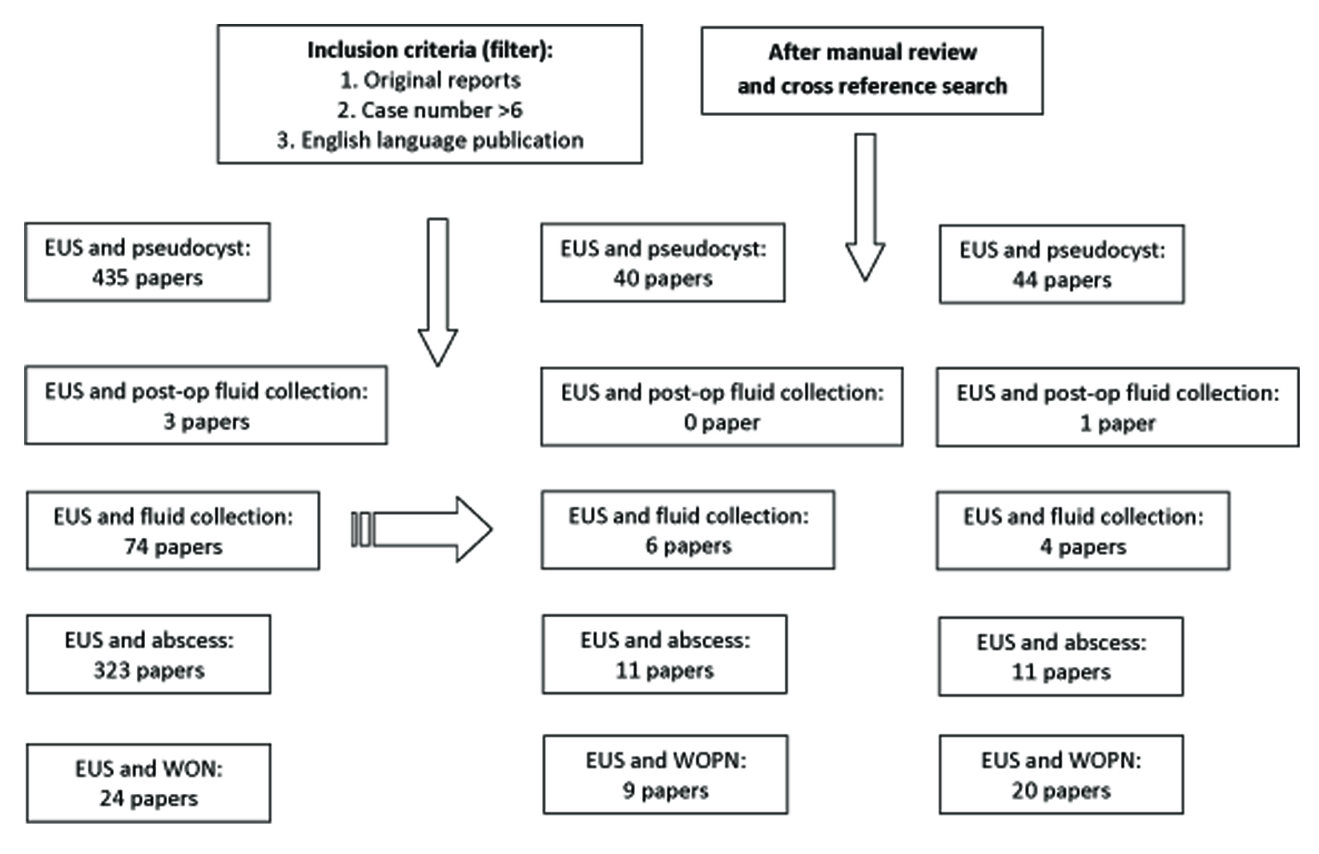
Figure 1 On November 15, 2014, the authors performed PubMed search using following key word sets: endoscopic ultrasound in combination with terminologies related to pancreatic fluid collections such as pseudocyst, fluid collection, abscess, and walled off necrosis. Each published paper was reviewed by two of these authors together, extracting the important information related to this review. EUS: Endoscopic ultrasound; WON: Walled off necrosis.

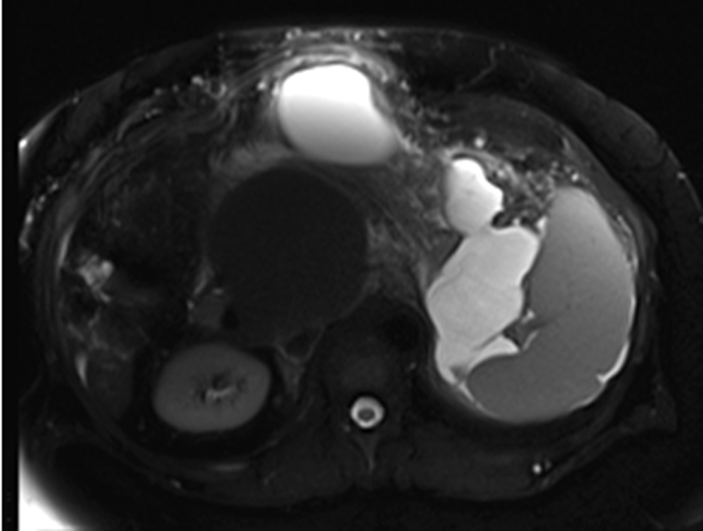
Figure 2 selected magnetic resonance imaging frame showing a large peri-pancreatic pseudocyst extending from the pancreatic tail to the anterior abdominal wall in a patient with pancreatitis and splenic vein thrombosis.

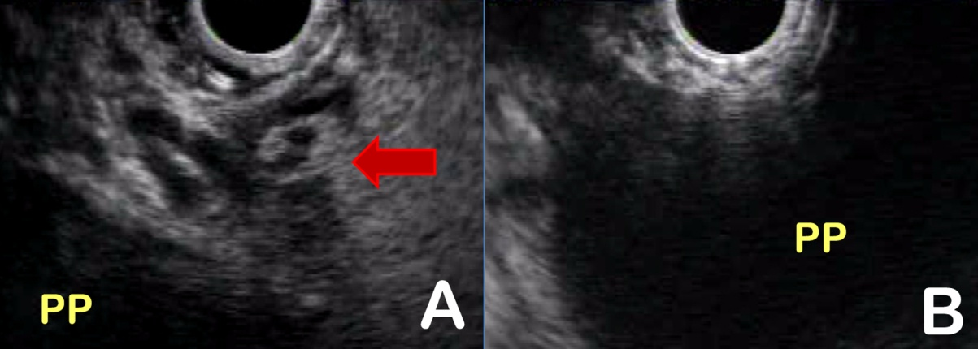
Figure 3 In the same patient, endoscopic ultrasound permits visualization of the pancreatic pseudocyst, assesses the maturity of the wall, measures the distance of the collection from the luminal wall, identifies intervening vessels or collaterals (red arrow) (A), and selects the optimal puncture site (B). PP: pancreatic pseudocyst.

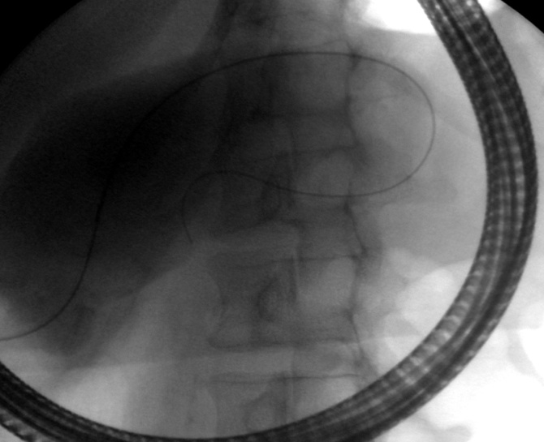
Figure 4 fluoroscopic image showing transpapillary drainage of a pancreatic pseudocyst that is communicated with the main pancreatic duct.

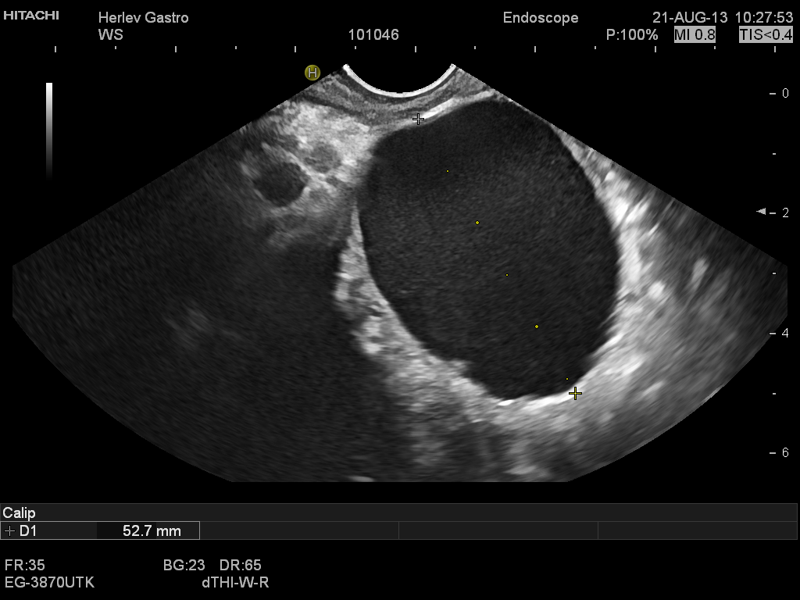
A
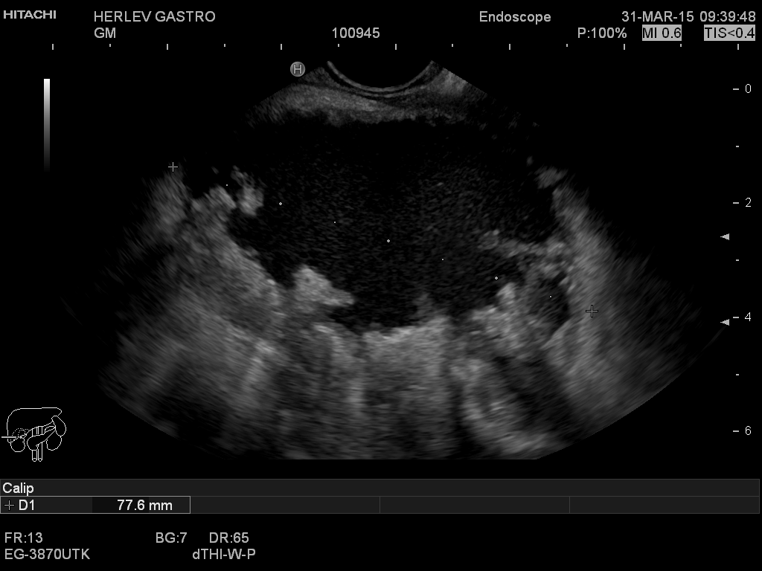
B
Figure 5 Endoscopic ultrasound image of a 5 cm chronic pseudocyst with a thin wall (A) or a 7.8 cm irregular pseudocyst with walled off necrosis

Figure 6 Endoscopic image of a self-expandable metal stent immediately after endoscopic ultrasound guided drainage (AXIOSTM system, Xlumina, Mountain View, CA, United States). Note the fluid floating through the stent opening. A guidewire is still visible extending through the stent lumen.

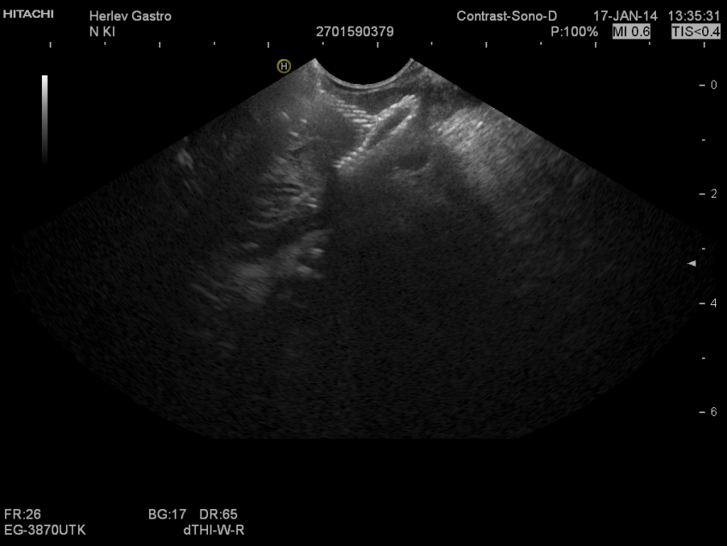
Figure 7 Corresponding endoscopic ultrasound image of a collapsed pancreatic psuedocyst immediately after drainage. Note reflexions from the stent mesh inside the collapsed cyst.

Pancreatic fluid collections
(acute pancreatic fluid collection, acute necrotic collection, pseudocyst, and walled-off necrosis

Pancreatic fluid collections
with solid debris < 20%
Pancreatic fluid collections
with solid debris > 50%
Pancreatic fluid collections
with solid debris 20%-50%

- Transmural drainage with 1-2 double pigtail plastic stents or lumen apposing metal stent
or
- Trans-papillary drainage through ERCP if pancreatic duct involved
- Lumen apposing metal stent placement
or
- Transmural drainage with multiple (> 2) double pigtail plastic stents at single site or multiple sites
+/- Transmural drainage with nasocystic drainage
- Endoscopic necrosectomy
- Transmural drainage with multiple (> 2) double pigtail plastic stents at single site or multiple sites or Lumen apposing metal stent placement
+/- Transmural drainage with nasocystic drainage
+/- Transcutaneus ultrasound drainage depending on size location and content

Figure 8 authors' proposed endoscopic ultrasound guided management algorithm based on the amount of internal debris inside the pancreatic fluid collections.

