Name of Journal: World Journal of Clinical Cases
Manuscript NO: 55805
Manuscript Type: CASE REPORT

Multiple schwannomas with pseudoglandular element synchronously occurring under the tongue: A case report

Chen YL et al. Multiple schwannomas with pseudoglandular under tongue

Yong-Lin Chen, Deng-Qi He, Hai-Xia Yang, Yu Dou

Yong-Lin Chen, Department of Pathology, The First Hospital of Lanzhou University, Lanzhou 730000, Gansu Province, China

Deng-Qi He, Department of Oral Surgery, The First Hospital of Lanzhou University, Lanzhou 730000, Gansu Province, China

Hai-Xia Yang, Department of Pathology, Gansu General Hospital of Armed Police, Lanzhou 730030, Gansu Province, China

Yu Dou, Department of Radiology, The First Hospital of Lanzhou University, Lanzhou 730000, Gansu Province, China

Author contributions: Chen YL and He DQ conceptualized the manuscript; Chen YL, He DQ, and Yang HX curated the data; Chen YL, He DQ, and Dou Y supported the methodology; He DQ supervised this study; Chen YL and He DQ validated the study; Chen YL and Yang HX wrote the original draft.

Supported by Basic Clinical Fund Project of The Fist Hospital of Lanzhou University, No. ldyyyn2015-04.

Corresponding author: Yong-Lin Chen, MD, PhD, Associate Chief Physician, Department of Pathology, The First Hospital of Lanzhou University, No.1 Donggangxi Road, Chengguan District, Lanzhou 730000, Gansu Province, China. chenyonglin01234@163.com

Received: July 21, 2020
Revised: August 19, 2020
Accepted: October 1, 2020
Published online:

Abstract
BACKGROUND
Schwannoma is a rare benign, encapsulated tumor of the nerve sheath under the tongue, mostly occurring as solitary tumors with classical histological pattern and several common morphological variants. To our knowledge, multiple schwannomas with pseudoglandular element synchronously occurring under the tongue are rare; we report herein the first such case.

CASE SUMMARY
A 53-year-old man had first noticed an isolated asymptomatic mass under the tongue, and as the mass grew, the tongue was elevated. Physical examination showed multiple oval neoplasms, and the overlying mucosa was normal. Computed tomography showed three low-density oval neoplasms under the tongue, which were cystic-solid with unclear boundary. The patient has no cutaneous tumors, VIII nerve tumors, or lens opacities and no history of neurofibromatosis 2 or confirmed schwannomatosis in any first-degree relative. Magnetic resonance imaging showed no evidence of vestibular schwannoma. The preoperative diagnosis was mucoepidermoid carcinoma. During hospitalization, all neoplasms were completely excised by surgeons through an intraoral approach under general anesthesia. The diagnosis of the multiple schwannomas with pseudoglandular element was made by histopathology after surgery. At the 15-mo follow-up visit, the patient had no sign of recurrence or development of other peripheral nerve tumors.

CONCLUSION
Although rare, multiple schwannomas with pseudoglandular element do exist in patients presenting with masses under the tongue. Oral surgeons should be aware of the existence of multiple schwannomas with pseudoglandular element when considering masses under the tongue due to the different prognosis between multiple schwannomas with pseudoglandular element and mucoepidermoid carcinoma.

Key Words: Case report; Multiple schwannomas; Pseudoglandular variant; Tongue; Mucoepidermoid carcinoma

Chen YL, He DQ, Yang HX, Dou Y. Multiple schwannomas with pseudoglandular element synchronously occurring under the tongue: A case report. World J Clin Cases 2020; In press

Core Tip: Schwannoma is a rare benign, encapsulated tumor of the nerve sheath under the tongue and mostly occurs as solitary tumors with classical histological pattern and several common morphological variants. Multiple schwannomas with pseudoglandular element synchronously occurring under the tongue are of great rarity. Here, we present the first report of a case of multiple schwannomas with pseudoglandular element synchronously occurring under the tongue.
INTRODUCTION
Schwannoma is a rare benign, encapsulated tumor of the nerve sheath under the tongue, and it mostly occurs as solitary tumors with classical histological pattern and several common morphological variants. Multiple schwannomas with pseudoglandular element synchronously occurring under the tongue are of great rarity. Here, we present the first report of a case of multiple schwannomas with pseudoglandular element synchronously occurring under the tongue.

CASE PRESENTATION
Chief complaints
A 53-year-old man had first noticed an isolated asymptomatic mass under the tongue, and then the mass grew, causing the tongue to be elevated.

History of present illness
The patient has no cutaneous tumors, VIII nerve tumors, or lens opacities.

History of past illness
The patient has no history of neurofibromatosis 2 or confirmed schwannomatosis in any first-degree relative.

Physical examination
Physical examination showed multiple oval neoplasms, and the overlying mucosa was normal. We considered mucoepidermoid carcinoma as our main differential diagnosis.

Laboratory examinations
All neoplasms were completely excised by surgeons through an intraoral approach under general anesthesia. There was no communication between the neoplasms and nerve bundles. Gross examinations showed three separated oval encapsulated masses with smooth surface. The biggest tumor was 4 cm × 3 cm × 3 cm, and the smallest was 2.2 cm × 1.8 cm × 1.3 cm. The sectioned surface was grayish-white in color and cystic-solid lesion with moderate hardness (Figure 1). Microscopic examination showed a lesion composed of bland spindle cells and demonstrated typical Antoni A and Antoni B areas with scattered pseudoglandular and microcystic foci. These pseudoglandular and microcystic areas were lined by flat to cuboidal cells (Figure 2). Some cystic areas showed hemorrhage. There were some hyalinized blood vessels elsewhere. No mitotic figure was found in tumor cells. The tumor cells and lining cells were positive for the S-100 protein and negative for Ckp protein by immunohistochemistry (IHC) staining (Figure 3).

Imaging examinations
Computed tomography showed three low-density oval neoplasms under the tongue, which were cystic-solid lesion and unclear boundary (Figure 4). Magnetic resonance imaging scan showed no evidence of vestibular schwannoma.

Timeline
The timeline of case reports is shown in Table 1.

FINAL DIAGNOSIS
Consequently, the diagnosis of the multiple schwannomas with pseudoglandular element under the tongue was established.

TREATMENT
During hospitalization, the all neoplasms were completely excised by surgeons through an intraoral approach under general anesthesia. Three days after the operation, the patient recovered well and discharged.

OUTCOME AND FOLLOW-UP
The diagnosis of the multiple schwannomas with pseudoglandular element was made by histopathology after surgery. At the 15-mo follow-up visit, the patient had no sign of recurrence or no other peripheral nerve tumors had developed.

DISCUSSION
Schwannomas are benign neoplasms derived from Schwann cells^{[1]}. They mostly occur as solitary tumors^{[2]}. Multiple schwannomas developing in individual nerves are very rare^{[3]}. Ogose et al^{[4]} reported multiple schwannomas were in 4.6% of all patients with schwannoma. Their presence may be one of the symptoms indicative of neurofibromatosis 2, which is an autosomal dominant inherited disorder, or schwannomatosis, which is recognized as the third main form of NF^{[5]}.
Apart from the classic biphasic pattern, schwannomas may show several common morphologic variants including cellular, plexiform, epithelioid, ancient, and glandular variants^{[6]}. A very rare pseudoglandular variant that has gland-like structure or cystic spaces that sometimes contain secretion-like material was first described by Ferry and Dickersin in 1988^{[7]}. Since then, this extremely rare variant has been reported in a few case reports. The frequency of pseudoglandular element was 6.3% of schwannomas^{[8]}. Most cases of schwannomas with pseudoglandular element have shown a predilection for location in the spinal nerve roots. Ud Din et al^{[8]} and Robinson et al^{[15]} reported that 56 or 61 cases (91.8%) and 13 of 16 cases (81%), respectively, showed pseudoglandular spaces located in the spinal nerve roots. Other schwannomas with pseudoglandular elements have been described only in single case reports and involved the right forearm, the right index finger, the retrobulbar region, submandibular region, soft tissue of shoulder, the parotid gland, the scalp, the retroperitoneum, thigh, popliteal fossa, and toe (Table 2)^{[6,8-12]}. However, to date, schwannomas with pseudoglandular element located under the tongue have not been described previously in the English literature. In order to broaden further the clinicopathological spectrum of schwannomas with pseudoglandular element, we present the first report of a case of multiple schwannomas with pseudoglandular element under the tongue.
The gland-like structure or cystic spaces in the pseudoglandular variant of schwannomas must be different from those true glandular structures in schwannomas and mucoepidermoid carcinoma^{[13]}. These pseudoglandular structures are lined by Schwann cells, and these lining cells were positive for the S-100 protein and negative for Ckp protein by IHC staining^{[14]}. Robison et al^{[15]} suggested that the pseudoglandular element schwannomas likely represented a type of response to degenerative changes, perhaps reflecting the propensity of the tumors to form palisading structures. However, the true glandular structures in schwannomas may line intestinal and respiratory type epithelium^{[16]}, representing true epithelial differentiation, and IHC stains are negative for S-100 and positive for epithelial membrane antigen and Ckp. The theory is that glandular schwannomas are derived from multipotential neural crest cells that can develop into various phenotypes. This would explain the different types of elements found in schwannomas. Another conjecture is that tumorigenesis may involve stem cells with the potential to produce both neural and heterologous elements^{[17]}.
Mucoepidermoid carcinoma (MEC) is characterized by variable components of squamoid, mucin-producing, and intermediate-type cells, with a cystic and solid growth pattern^{[18]}. However, it is usually difficult to distinguish MEC based on computed tomography. IHC stains are negative for S-100 and positive for epithelial membrane antigen and Ckp. MECs are characterized by gene translocation and fusion, but their diagnostic and clinical implications in the pathological evaluation remain uncertain.

CONCLUSION
We suggest that multiple schwannomas with pseudoglandular element may affect a wider range of body locations than previously reported. It is important to deepen our understanding of the clinicopathological spectrum of multiple schwannomas with pseudoglandular element so as to avoid its misdiagnosis.

REFERENCES
1 Gosk J, Gutkowska O, Urban M, Wnukiewicz W, Reichert P, Ziółkowski P. Results of surgical treatment of schwannomas arising from extremities. Biomed Res Int 2015; 2015: 547926 [PMID: 25793198 DOI: 10.1155/2015/547926]
2 Leverkus M, Kluwe L, Röll EM, Becker G, Bröcker EB, Mautner VF, Hamm H. Multiple unilateral schwannomas: segmental neurofibromatosis type 2 or schwannomatosis? Br J Dermatol 2003; 148: 804-809 [PMID: 12752143 DOI: 10.1046/j.1365-2133.2003.05249.x]
3 Shao X, Zhang X, Su X. Multiple schwannomas of the ulnar nerve. J Plast Surg Hand Surg 2014; 48: 281-282 [PMID: 23834304 DOI: 10.3109/2000656X.2013.779796]
4 Ogose A, Hotta T, Morita T, Otsuka H, Hirata Y. Multiple schwannomas in the peripheral nerves. J Bone Joint Surg Br 1998; 80: 657-661 [PMID: 9699832 DOI: 10.1302/0301-620X.80B4.0800657]
5 Baser ME, Friedman JM, Evans DG. Increasing the specificity of diagnostic criteria for schwannomatosis. Neurology 2006; 66: 730-732 [PMID: 16534111 DOI: 10.1212/01.wnl.0000201190.89751.41]
6 Lisle A, Jokinen C, Argenyi Z. Cutaneous pseudoglandular schwannoma: a case report of an unusual histopathologic variant. Am J Dermatopathol 2011; 33: e63-e65 [PMID: 21478728 DOI: 10.1097/DAD.0b013e3181f86879]
7 Ferry JA, Dickersin GR. Pseudoglandular schwannoma. Am J Clin Pathol 1988; 89: 546-552 [PMID: 3354508 DOI: 10.1093/ajcp/89.4.546]
8 Ud Din N, Ahmad Z, Ahmed A. Schwannomas with pseudoglandular elements: clinicopathologic study of 61 cases. Ann Diagn Pathol 2016; 20: 24-28 [PMID: 26626208 DOI: 10.1016/j.anndiagpath.2015.10.009]
9 Deng A, Petrali J, Jaffe D, Sina B, Gaspari A. Benign cutaneous pseudoglandular schwannoma: a case report. Am J Dermatopathol 2005; 27: 432-435 [PMID: 16148415 DOI: 10.1097/01.dad.0000175534.73110.4e]
10 Chan JK, Fok KO. Pseudoglandular schwannoma. Histopathology 1996; 29: 481-483 [PMID: 8951498 DOI: 10.1046/j.1365-2559.1996.d01-526.x]
11 Ide F, Obara K, Mishima K, Saito I. Intraparotid pseudoglandular schwannoma. J Oral Pathol Med 2006; 35: 379-381 [PMID: 16762020 DOI: 10.1111/j.1600-0714.2006.00413.x]
12 Ruggeri F, De Cerchio L, Bakacs A, Orlandi A, Lunardi P. Pseudoglandular schwannoma of the cauda equina. Case report. J Neurosurg Spine 2006; 5: 543-545 [PMID: 17176020 DOI: 10.3171/spi.2006.5.6.543]
13 Sundarkrishnan L, Bradish JR, Oliai BR, Hosler GA. Cutaneous Cellular Pseudoglandular Schwannoma: An Unusual Histopathologic Variant. Am J Dermatopathol 2016; 38: 315-318 [PMID: 26844614 DOI: 10.1097/DAD.0000000000000448]
14 Gómez-Mateo Mdel C, Compañ-Quilis A, Monteagudo C. Microcystic pseudoglandular plexiform cutaneous neurofibroma. J Cutan Pathol 2015; 42: 884-888 [PMID: 26269328 DOI: 10.1111/cup.12572]
15 Robinson CA, Curry B, Rewcastle NB. Pseudoglandular elements in schwannomas. Arch Pathol Lab Med 2005; 129: 1106-1112 [PMID: 16119981]
16 Uri AK, Witzleben CL, Raney RB. Electron microscopy of glandular Schwannoma. Cancer 1984; 53: 493-497 [PMID: 6692256 DOI: 10.1002/1097-0142(19840201)53:3<493::AID-CNCR2820530320>3.0.CO;2-M]
17 Ducatman BS, Scheithauer BW. Malignant peripheral nerve sheath tumors with divergent differentiation. Cancer 1984; 54: 1049-1057 [PMID: 6432304 DOI: 10.1002/1097-0142(19840915)54:6<1049::AID-CNCR2820540620>3.0.CO;2-1]
18 Jhuang JY, Chou YH, Hua SF, Hsieh MS. Mixed lung mucoepidermoid carcinoma and adenocarcinoma with identical mutations in an epidermal growth factor receptor gene. Ann Thorac Surg 2014; 98: 695-697 [PMID: 25087791 DOI: 10.1016/j.athoracsur.2013.10.035]

Footnotes
Informed consent statement: Informed written consent was obtained from the patient for publication of this case report and accompanying images.

Conflict-of-interest statement: No benefits in any form have been received or will be received from a commercial party related directly or indirect to the subject of this article.

CARE Checklist (2016) statement: The authors have read the CARE Checklist (2016), and the manuscript was prepared and revised according to the CARE Checklist (2016).

Open-Access: This article is an open-access article that was selected by an in-house editor and fully peer-reviewed by external reviewers. It is distributed in accordance with the Creative Commons Attribution NonCommercial (CC BY-NC 4.0) license, which permits others to distribute, remix, adapt, build upon this work non-commercially, and license their derivative works on different terms, provided the original work is properly cited and the use is non-commercial. See: http://creativecommons.org/Licenses/by-nc/4.0/

Manuscript source: Unsolicited manuscript

Peer-review started: July 21, 2020
First decision: August 8, 2020
Article in press:

Specialty type: Medicine, research and experimental
Country/Territory of origin: China
Peer-review report’s scientific quality classification
Grade A (Excellent): 0
Grade B (Very good): B, B
Grade C (Good): C
Grade D (Fair): 0
Grade E (Poor): 0

P-Reviewer: Gordon L, Parikh ND, Shimizu Y S-Editor: Gao CC L-Editor: Filipodia P-Editor:
Figure Legends
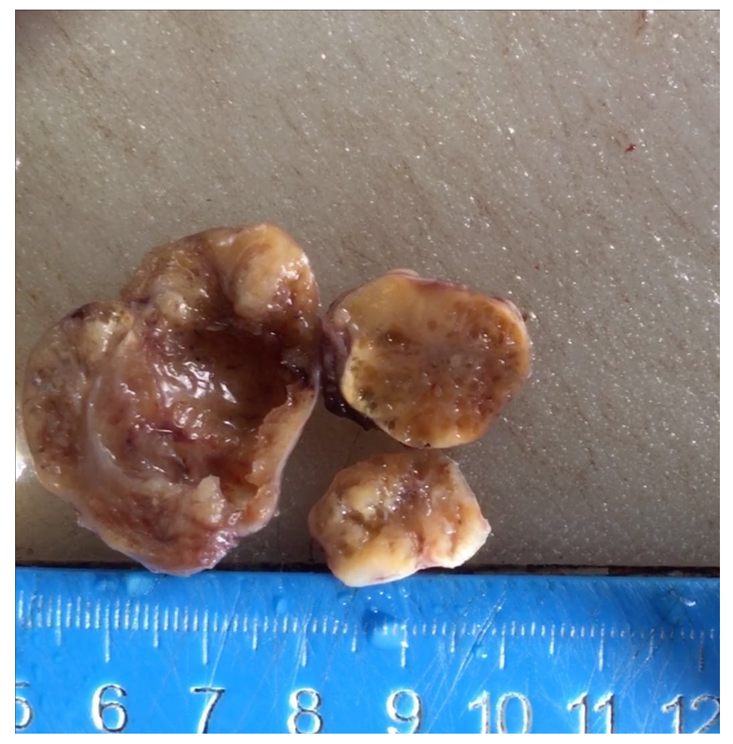
Figure 1 Three separated oval encapsulated masses with smooth surface. The sectioned surface was grayish-white in color and cystic-solid lesion.
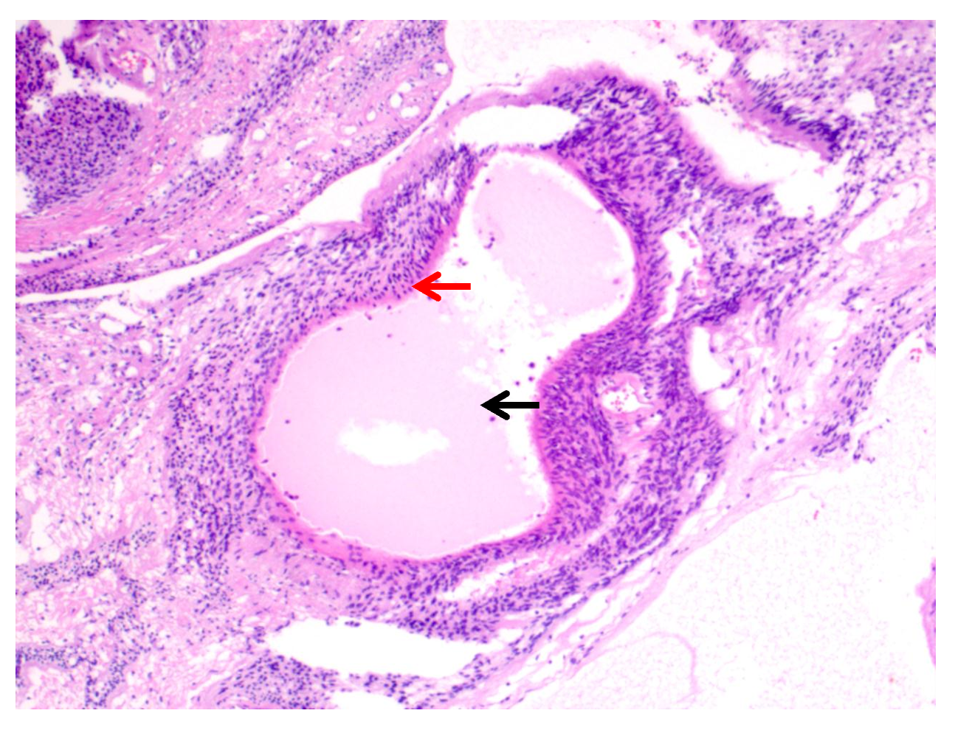
Figure 2 Pseudoglandular areas were lined by flat to cuboidal cells.
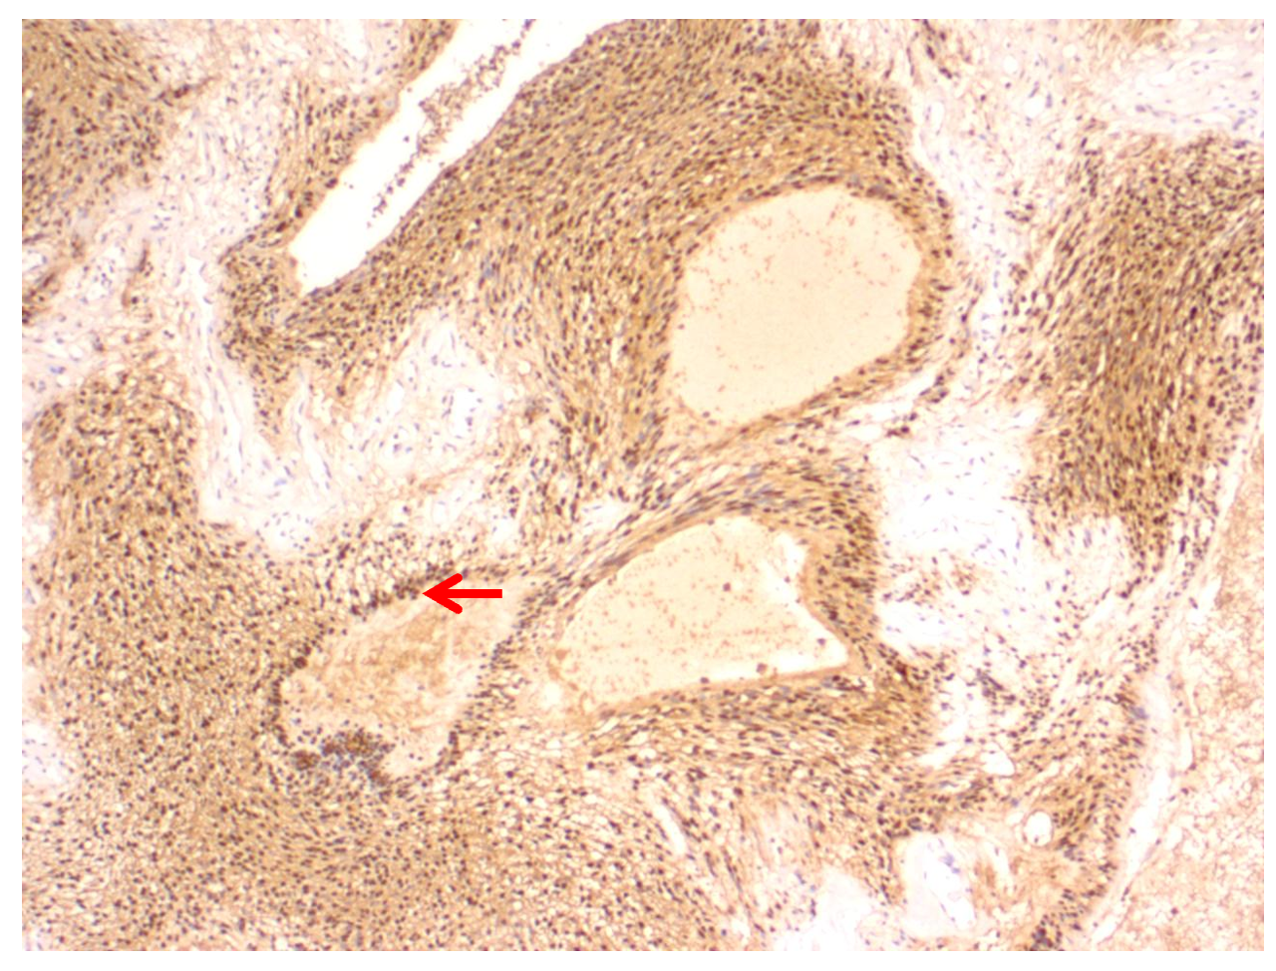
Figure 3 Immunohistochemistry stains showed strong S-100 protein positivity in the cells lining pseudoglandular cystic spaces as well as intervening cells.
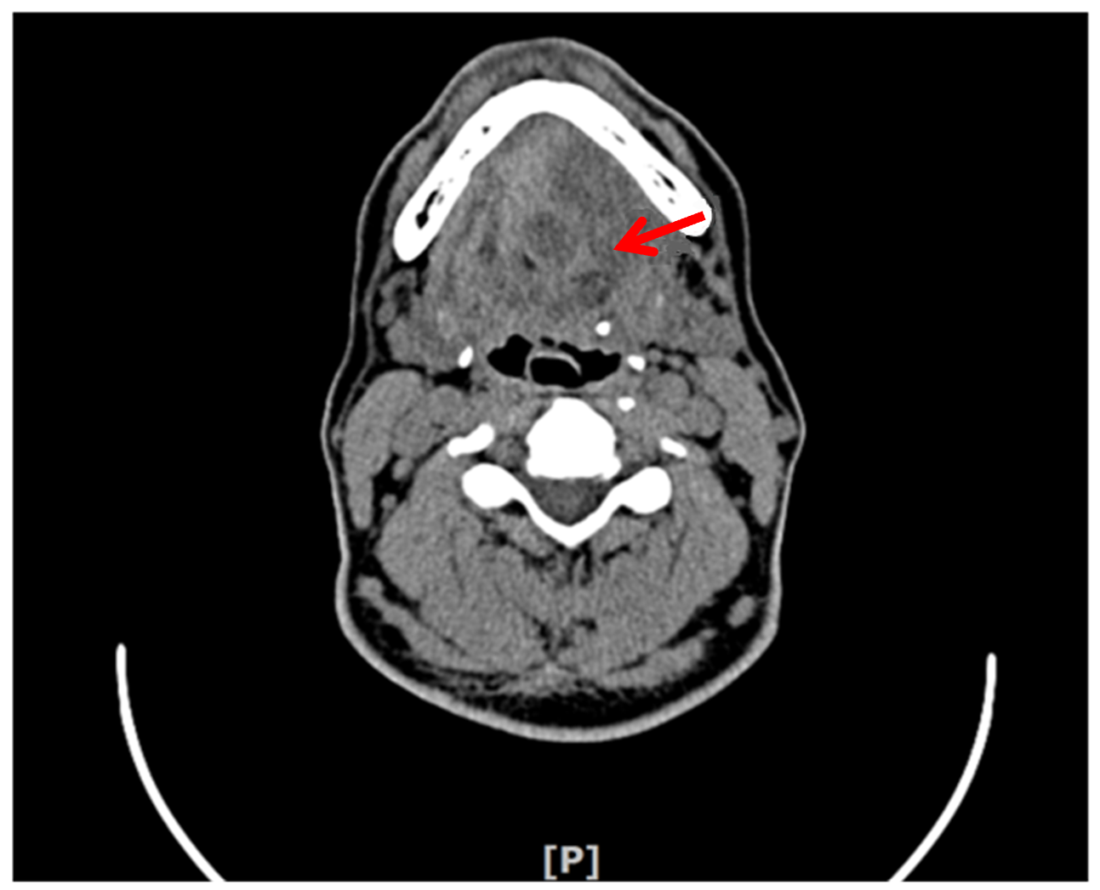
Figure 4 Computed tomography showed three low-density oval neoplasms under the tongue.
Table 1 Timeline of this case
Events | Timeline | Description
Consultation | 2018-01-03 | First outpatient
Physical exam | 2018-01-10 | Gross and Microscopic examinations, CT
Surgical operation | 2018-02-07 | An intraoral approach under general anesthesia
Postoperative examination | 2018-02-10 | 3 d after the operation
Follow-up | 2019-07-21 | 15-mo follow-up visit, no recurrence
CT: Computed tomography.
Table 2 Summary of schwannoma with pseudoglandular elements located outside the central nervous system, including the presented case
No. | Age/sex | Location of tumors and number | Size in cm | Follow-up | Ref.
1 | 60/F | Right forearm, one | 1.1 | 6 mo, no recurrence | Deng et al^{[9]}
2 | 34/F | Right index, one | Not described | Not described | Lisle et al^{[6]}
3 | 37/M | Retrobulbar mass, one | 1.5 | 10 yr, no recurrence | Chan et al^{[10]}
4 | 31/F | Submandibular region, one | 5.8 | Not described | Chan et al^{[10]}
5 | 24/F | Soft tissue of shoulder, one | 2.5 | Not described | Chan et al^{[10]}
6 | 27/M | Parotid gland, one | 3.5 | Not described | Ide et al^{[11]}
7 | 33/M | Cauda equine, one | 3 | 18 mo, no recurrence | Ruggeri et al^{[12]}
8 | Not described | Scalp, one | Not described | Not described | Ud Din et al^{[8]}
9 | Not described | Retroperitoneum, one | Not described | Not described | Ud Din et al^{[8]}
10 | Not described | Thigh, one | Not described | Not described | Ud Din et al^{[8]}
11 | Not described | Popliteal fossa, one | Not described | Not described | Ud Din et al^{[8]}
12 | Not described | Toe, one | Not described | Not described | Ud Din et al^{[8]}
13 | 53/M | Under the tongue, multiple (three) | The biggest was 4, and the smallest was 2.2 | 15 mo, no recurrence | Chen et al (the present case)
F: Female; M: Male.

