Name of Journal: World Journal of Clinical Cases
Manuscript NO: 56130
Manuscript Type: ORIGINAL ARTICLE

Case Control Study
Correlation between ductus venosus spectrum and right ventricular diastolic function in isolated single-umbilical-artery foetus and normal foetus in third trimester

Li TG et al. Ductus venosus spectrum and ventricular function

Tian-Gang Li, Fang Nie, Xiao-Yan Xu

Tian-Gang Li, Xiao-Yan Xu, Department of Ultrasound Diagnosis, Gansu Provincial Maternity and Child-Care Hospital, Lanzhou 730050, Gansu Province, China

Fang Nie, Department of Ultrasound Diagnosis, Lanzhou University Second Hospital, Lanzhou 733000, Gansu Province, China

Author contributions: Li TG carried out imaging, participated in image acquisition and analysis, participated in the design of the study and drafted the manuscript; Nie F participated in the design and coordination of the study; Xu XY conceived of the study, participated in its design and coordination and performed the statistical analysis; All authors read and approved the final manuscript.

Corresponding author: Fang Nie, MD, Chief Doctor, Chief Physician, Professor, Department of Ultrasound Diagnosis, Lanzhou University Second Hospital, No. 82 Cuiyingmen, Chengguan District, Lanzhou 733000, Gansu Province, China. fang_nie_1969@126.com

Received: April 18, 2020
Revised: September 23, 2020
Accepted: October 26, 2020
Published online: December 6, 2020

Abstract
BACKGROUND
Single umbilical artery (SUA) is the most common umbilical cord malformation in prenatal diagnosis. The presence of an SUA can cause blood circulation disorder in the foetus and functional changes of the foetal heart, affecting foetal circulation. The right ventricular diastolic functions in foetuses with isolated SUA and in normal foetuses in the third trimester were evaluated using the spectral Doppler of blood flow in the foetal ductus venosus (DV).

AIM
To evaluate the right ventricular diastolic functions in foetuses with isolated SUA and in normal foetuses in the third trimester.

METHODS
Colour Doppler was used to measure the spectrum of foetal DV and tricuspid orifice in 34 foetuses with isolated SUA aged 28-39 wk and in age-matched healthy controls. The DV flow velocities and velocity ratios were measured. The early passive/late active (E/A) ratio at the tricuspid orifice and tissue Doppler Tei index of the foetal right ventricular in the two groups were also measured.

RESULTS
During the third trimester, the isolated SUA group showed a lower ‘a’-wave peak velocity in the DV than the control group (P < 0.05). The correlations between the velocity ratios and E/A ratio at the tricuspid orifice in the two groups were analysed, and the correlation between the ventricular late diastolic velocity/ventricular diastolic peak flow velocity and E/A ratios was the best (R² of the isolated SUA group: 0.520; R² of the control group: 0.358). The correlations between the velocity ratios and tissue Doppler Tei index of foetal right ventricular in the two groups were analysed, and the correlation between the pulsatility index for veins (PIV) and tissue Doppler Tei index ratios was the best (R² of the isolated SUA group: 0.865; R² of the control group: 0.627).

CONCLUSION
In the isolated SUA group, the atrial systolic peak velocity ‘a’ decreased, and this finding might be related to the changes in foetal cardiac functions. The ratio of ventricular late diastolic velocity to ventricular diastolic peak flow velocity was closely related to the E/A ratio at the tricuspid valve and can be used to identify changes in the right ventricular diastolic functions of isolated SUA and healthy foetuses. PIV was closely related to the tissue Doppler Tei index of the foetal right ventricular and can be used to identify the right ventricular overall functions of isolated SUA and healthy foetuses.

Key Words: Isolated single umbilical artery; Ductus venosus; Velocity; Right ventricular diastolic function; Foetus

Li TG, Nie F, Xu XY. Correlation between ductus venosus spectrum and right ventricular diastolic function in isolated single-umbilical-artery foetus and normal foetus in third trimester. World J Clin Cases 2020; 8(23): 5866-5875 URL: https://www.wjgnet.com/2307-8960/full/v8/i23/5866.htm DOI: https://dx.doi.org/10.12998/wjcc.v8.i23.5866

Core Tip: Single umbilical artery (SUA) is the most common umbilical cord malformation in prenatal diagnosis. The presence of an SUA can cause blood circulation disorder in the foetus and functional changes of the foetal heart, affecting foetal circulation. We used ductus venosus velocity ﬁrstly for the evaluation of right ventricular diastolic function in foetuses with isolated SUA and in those with normal cardiac anatomy. This study performed an objective assessment of the occurrence and development of isolated SUA in foetuses, predicted its prognosis and guided clinical work.
INTRODUCTION
Normal umbilical cords contain two umbilical arteries (UAs) and one umbilical vein (UV). A condition in which only one UA is present, single UA (SUA), is the most common malformation of the umbilical cord. SUA is a soft marker for chromosomal abnormalities, congenital structural malformations and preterm birth. Depending on the presence of other structural malformations and/or karyotype abnormalities, SUA is divided into isolated and nonisolated SUA, with the former accounting for approximately 65% of all SUA cases^{[1-3]}. Isolated SUA results in the development of certain obstetric complications, such as foetal growth restriction and increased perinatal mortality^{[4-7]}.
The presence of an SUA can cause blood circulation disorder in the foetus and functional changes of the foetal heart, affecting foetal circulation^{[6,8,9]}. Anatomically, the ductus venosus (DV) enters directly into the right atrium or is connected to the right atrium via the inferior vena cava (IVC). Changes in the right ventricular function of the foetus may be reflected in changes in the DV blood flow pattern, as can be observed on spectral Doppler^{[10-12]}. Currently, pulsatility index for veins (PIV) is clinically used for evaluating changes in the DV blood flow spectrum^{[12]}. However, the foetal cardiac cycle involves four different stages, including ventricular systole, ventricular diastole, atrial diastole and atrial systole, and DV is greatly affected by factors such as the cardiac cycle, volume and pressure^{[13,14]}. As a result, evaluating foetal cardiac functions using PIV alone may not be objective and accurate. Evaluating the right ventricular function changes in foetuses with isolated SUA in the third trimester aids in the assessment of intrauterine conditions and perinatal outcomes^{[15]}.
In this study, foetal DV flow velocities, flow velocity ratios and the tricuspid valve inflow Doppler pattern were used to evaluate changes in the right ventricular diastolic function of foetuses with isolated SUA in the third trimester to identify sensitive indicators for evaluating the right ventricular diastolic function of foetuses with isolated SUA and thereby provide an objective basis for clinical practice.

MATERIALS AND METHODS
Study subjects
We prospectively studied 34 foetuses with prenatally identified isolated SUA with gestational age of 28-39 wk and 34 gestational age-matched healthy foetuses from the Gansu Provincial Maternity and Child-care Hospital between July 2017 and December 2018. The study protocol was approved by the Medical Ethics Committee of Gansu Provincial Maternity and Child-care Hospital ethics committee (No. 2017-04), and the pregnant mothers provided their written informed consent. We excluded pregnant mothers with multiple gestations, pregnancies presenting associated foetal anomalies, including structural abnormalities, congenital heart disease and abnormal karyotype and pregnant mothers with conditions that may affect foetal haemodynamics, such as maternal diabetes, pre-eclampsia, preterm labour or endocrinological disorders such as thyroid disease.
The diagnosis of isolated SUA was conﬁrmed using colour Doppler ultrasonography by observing the absence of one UA at the level of the foetal abdominal cord insertion. In all cases, the diagnosis of isolated SUA was conﬁrmed by postnatal pathological examination, and all newborns were determined to be anatomically normal at delivery. The newborns were diagnosed with a small-for-gestational-age (SGA) condition when their birth weight was below the 10th percentile for gestational age. Demographic data, including maternal age, weight, body mass index, parity and medical history, were collected. Gestational age was calculated based on the ﬁrst day of the last menstrual period and conﬁrmed by crown–rump length measurement at the ﬁrst-trimester ultrasound scan.

Instruments and methods
E10 (GE Healthcare, United States) and EPIQ5 (Philips, The Netherlands) ultrasound systems were used. Foetal biometric measurements were performed during each scan. The pregnant women were asked to lie in a supine position. The median sagittal section or oblique transection of the upper abdomen of the foetus was assessed to display the long axis of the UV and track it toward the foetus head. Before the UV turned toward the left branch of the portal vein, a small tubular structure was shown to be connected to the IVC. After turning on the colour Doppler function, bright blood flow signals were identified as the DV blood flow (Figure 1). To obtain the DV blood flow spectrum, we initiated colour Doppler ultrasonography with the Doppler sampling line paralleling the DV blood flow (angle < 30 °). Blood flow parameters, including the ventricular systolic peak flow velocity (S), ventricular late diastolic velocity (v), ventricular diastolic peak flow velocity (D) and the atrial systolic peak velocity (a), were measured (Figure 2A), and the velocity ratios, including S/v, S/D, S/a, v/D, v/a and D/a, were calculated based on these parameters. During measurement, the sample volume was placed inside the DV to reduce interference of the surrounding vessels. A four-chamber view of the foetus was obtained, and the sample volume was placed at the tip of the tricuspid valve to measure the early passive (E) and late active (A) peak blood flow velocities to calculate the E/A ratio (Figure 2B).
The right ventricular function was evaluated using the tissue Doppler Tei index described in the literature^{[16]}. In the four-chamber view, the tissue Doppler sample volume was placed at the junction of the free wall of the right ventricle and posterior leaflet of the tricuspid valve, the sample line was parallel to the direction of movement (angle < 20 °), the tissue Doppler sample volume was 2 mm³ and the scanning speed was adjusted to 10-15 cm/s to obtain tissue Doppler spectrum images to measure the isovolumic contraction time (ICT), ejection time (ET) and isovolumic relaxation time (IRT). The tissue Doppler Tei index was calculated in accordance with the measurement method (as shown in Figure 3A): Tei = (ICT + IRT)/ET (Figure 3B). When the foetal position was poor, measurement was conducted again after the foetus changed position. The above parameters were measured three consecutive times, and the average values were calculated.

Statistical analysis
The data analysis was performed using IBM SPSS Statistics for Windows, version 23.0 (IBM Corp., Armonk, NY, United States). Continuous variables were presented as the mean ± standard deviation or median (interquartile range) as appropriate. The independent sample t test was used for comparisons between groups, and P < 0.05 was considered statistically significant. The velocity ratios of DV with the E/A ratio at the tricuspid orifice and the tissue Doppler Tei index of the foetal right ventricular were analysed using linear regression, and the regression coefficient R² was calculated accordingly.

RESULTS
The colour flow Doppler of the umbilical cords in all 34 healthy foetuses showed two UAs and one UV. The colour flow Doppler of umbilical cords in the 34 isolated SUA foetuses showed one UA and one UV. In the latter group, the left branch was absent in 20 cases, and the right branch was absent in 14 cases. One healthy foetus displayed mild tricuspid regurgitation (TR), whereas in the isolated SUA, two foetuses had mild TR, and three had moderate TR. TR was considered abnormal if holosystolic with a maximum velocity of more than 2 m/s^{[17]}.
In the control group, the foetal DV spectrum ‘a’-wave was a forward wave. In the isolated SUA group, the ‘a’-waves of 32 foetuses were forward, whereas those of two foetuses, both of which were SGA, were reversed (Figure 2C). A comparison of blood flow parameters between the two groups showed that the isolated SUA group exhibited a lower DV atrial systolic peak velocity ‘a’-wave than the control group (P < 0.05), whereas the PIV, S/v, S/D, S/a, v/D, v/a, D/a and E/A ratios at the tricuspid orifice showed no significant change (P > 0.05) (Table 1).
The correlations between the velocity ratios and E/A ratio at the tricuspid orifice in the two groups were analysed. The correlation between the v/D and E/A ratios was the best in both groups (R² of 0.520 in the isolated SUA group and 0.358 in the control group) (Figure 4A and 4B). The correlations between the velocity ratios and tissue Doppler Tei index of foetal right ventricular in the two groups were analysed. The correlation between the PIV and tissue Doppler Tei index of foetal right ventricular was the best in both groups (R² of 0.865 in the isolated SUA group and 0.627 in the control group) (Figure 5A and 5B).
During the follow-up of all foetuses until birth, the general conditions of the newborns at birth were analysed, and their bodyweight and placental mass in the two groups were compared. The differences were statistically significant (P < 0.05). In the univariate analysis, the presence of an isolated SUA was associated with a low birth weight (2940 g vs 3260 g) and a high prevalence of SGA (13.0% vs 3.9%; P < 0.01). No statistically significant difference was observed in the pregnant women’s age, gravidity and parity and gestational age (P > 0.05) (Table 2).

DISCUSSION
In foetuses, the diastolic function changes before the cardiac function. The foetal DV directly delivers the umbilical venous blood with high oxygen saturation through the IVC to the right atrium, the pressure of which is the major factor affecting DV blood flow^{[18]}. When dynamic changes in foetal heart blood flow lead to changes in the right atrial pressure, changes in the DV spectral blood flow parameters occur, most evidently PIV^{[19,20]}. This study evaluated the relationship between the DV Doppler flow velocity ratios and right ventricular function.
The foetal DV spectral waveform is closely related to the four periods of the cardiac cycle^{[13]}. The ‘S’-wave corresponds to ventricular systole, which is produced by an increase in the venous forward blood flow velocity caused by atrial diastole during ventricular systole and followed by the ‘v’ wave during end-systolic ventricular relaxation and the ascent of the atrioventricular (AV) valves before the onset of diastole. With the opening of the AV valves, the ‘D’- and ‘a’-waves correspond to E and A diastolic filling, respectively. In particular, the highest velocity occurs at the ‘S’-wave and the lowest at the ‘a’-wave. The S/v ratio quantifies the relative forward flow into the atria as the ventricle relaxes before the AV valves open. The v/D ratio reflects early diastolic filling immediately following this event. The D/a ratio is a diastolic parameter relating to the magnitude of forward flow during passive and active diastolic filling; it is analogous to the E/A ratio but for the AV valves. Three ratios describe nonconsecutive cardiac events: the S/D ratio that quantifies ventricular systolic to E diastolic filling^{[13]}; the S/a ratio that quantifies ventricular systolic to active diastolic filling^{[21]}; and the v/a ratio that quantifies end-systolic relaxation and active diastolic filling. The relative decrease in the ‘a’-wave is closely associated with the increase in PIV.
Currently, PIV is used as the primary indicator for evaluating changes in the DV blood flow spectrum^{[22-24]}. However, this study showed that in both isolated SUA and healthy foetuses, the v/D ratio significantly correlated with the E/A ratio at the tricuspid orifice. Thus, the E/A ratio can be used for the evaluation of conventional Doppler foetal cardiac diastolic function^{[25]}. The PIV ratio was significantly correlated with the tissue Doppler Tei index of foetal right ventricular. Therefore, the tissue Doppler Tei index can be used for the evaluation of foetal cardiac overall function. These findings suggest that when evaluating cardiac function using the DV spectrum, in addition to monitoring PIV, attention should be paid to the correlation between the ‘v’ wave-related ratios and right ventricular function.
A decline in cardiac diastolic function is often observed as an increase in the DV spectrum PIV, a decrease in ‘a’-wave velocity and disappearance or reversal of blood flow^{[22,23]}. This condition may occur because subjects in previous studies were foetuses with significant changes in cardiac functions, including gestational hypertension, intrauterine growth restriction and twin-to-twin transfusion syndrome^{[24-30]}. In this study, all the foetal DV spectrum ‘a’-waves in the control group were forward and can be observed throughout the entire cardiac cycle, potentially because of the high resistance of the foetal DV venous system and the weak atrial systolic force. Consequently, the DV pressure in the entire cardiac cycle was consistently greater than the atrial pressure. Thus, the blood was unable to flow in the reverse direction into the DV. In the isolated SUA group, however, the DV spectrum ‘a’-waves of two cases, both of which were SGA foetuses, were backward. Reversal of the ‘a’-wave might indicate a decrease in ventricular compliance, which is caused by atrial systolic venous blood reflux resulting in increased atrial pressure^{[28]}. Therefore, close attention should be paid to whether the DV reversed ‘a’-wave occurs. In such a case, maternal and foetal examinations should be enhanced and the pregnancy be terminated if necessary.
This study showed that the ‘a’-wave flow velocity was lower in foetuses with isolated SUA than in the controls. This condition might have occurred because foetuses with isolated SUA are prone to having a low bodyweight at birth resulting in decreased circulating blood volume and DV blood flow volume. Moreover, none of the DV blood flow parameters in the foetuses with isolated SUA changed significantly compared with the healthy controls. This finding might be explained as follows: although the foetuses with isolated SUA exhibited dynamic changes in their blood flow in the absence of one UA, such changes were inadequate to cause an insufficient blood supply, which led to increased right heart load and right atrial pressure and blocked DV reflux.
In this study, one of the healthy controls displayed a mild TR, whereas five of the isolated SUA foetuses had mild or moderate TR. Thus, the isolated SUA group had a slightly higher TR rate than the control group. Therefore, once isolated SUA is diagnosed, TR should be monitored to facilitate the preliminary determination of right ventricular function in the foetus.

Limitation
First, given that atrial pressure is a major factor affecting the changes in DV blood flow and both respiration and motion of the foetus can affect the DV spectrum, atrial pressure should preferably be measured with the foetus in the resting state. Second, mapping of the foetal DV spectrum can be easily affected by adjacent blood vessels, particularly the vena cava. Given that vena cava displays continuous reversed blood flow under normal circumstances of atrial systole, it can be easily misjudged as the DV spectrum. Finally, acquisition of the tissue Doppler Tei index of the foetal right ventricular is difficult and affected by the foetal position, and thus, the measurement may be inaccurate.

CONCLUSION
Foetuses with isolated SUA are prone to having a low bodyweight at birth. Changes in the cardiac functions of foetuses with isolated SUA can be evaluated by the DV spectrum velocities and velocity ratios. When monitoring the DV spectrum, v/D and PIV may be used to identify changes in the right ventricular function of isolated SUA foetuses early.

ARTICLE HIGHLIGHTS
Research background
Single umbilical artery (SUA) is the most common umbilical cord malformation in prenatal diagnosis. The presence of an SUA can cause blood circulation disorder in the foetus and functional changes of the foetal heart, affecting foetal circulation.

Research motivation
We used ductus venosus (DV) velocity for the evaluation of right ventricular diastolic function in foetuses with isolated SUA and in those with normal cardiac anatomy.

Research objectives
The right ventricular diastolic functions in foetuses with isolated SUA and normal foetuses in the third trimester were evaluated using the spectral Doppler of blood flow in the foetal DV.

Research methods
Colour Doppler was used to measure the spectrum of foetal DV and tricuspid orifice in SUA foetuses and in age-matched healthy controls. The DV flow velocities and velocity ratios were measured. The early passive/late active ratio at the tricuspid orifice and tissue Doppler Tei index of the foetal right ventricular in the two groups were measured.

Research results
During the third trimester, the isolated SUA group showed a lower ‘a’-wave peak velocity in the DV than the control group. The correlation between the ventricular late diastolic velocity/ventricular diastolic peak flow velocity and early passive/late active ratios was the best. The correlation between the pulsatility index for veins and tissue Doppler Tei index ratios was the best.

Research conclusions
The spectral Doppler of blood flow in the foetal DV can be used to identify the right ventricular diastolic functions of isolated SUA and healthy foetuses.

Research perspectives
Through the detection of spectral Doppler of blood flow in the foetal DV between the isolated SUA group and the control group, we can accurately evaluate the foetal ventricular diastolic function of isolated SUA to provide more accurate and objective diagnosis and treatment basis for the clinic.

REFERENCES
1 Voskamp BJ, Fleurke-Rozema H, Oude-Rengerink K, Snijders RJ, Bilardo CM, Mol BW, Pajkrt E. Relationship of isolated single umbilical artery to fetal growth, aneuploidy and perinatal mortality: systematic review and meta-analysis. Ultrasound Obstet Gynecol 2013; 42: 622-628 [PMID: 23775879 DOI: 10.1002/uog.12541]
2 Bombrys AE, Neiger R, Hawkins S, Sonek J, Croom C, McKenna D, Ventolini G, Habli M, How H, Sibai B. Pregnancy outcome in isolated single umbilical artery. Am J Perinatol 2008; 25: 239-242 [PMID: 18548398 DOI: 10.1055/s-2008-1061504]
3 Granese R, Coco C, Jeanty P. The value of single umbilical artery in the prediction of fetal aneuploidy: findings in 12,672 pregnant women. Ultrasound Q 2007; 23: 117-121 [PMID: 17538487 DOI: 10.1097/01.ruq.0000263848.07808.02]
4 Araujo Júnior E, Palma-Dias R, Martins WP, Reidy K, da Silva Costa F. Congenital heart disease and adverse perinatal outcome in fetuses with confirmed isolated single functioning umbilical artery. J Obstet Gynaecol 2015; 35: 85-87 [PMID: 25020205 DOI: 10.3109/01443615.2014.935720]
5 Bugatto F, Quintero-Prado R, Melero-Jiménez V, Fajardo-Expósito MA, Hervías-Vivancos B, Bartha JL. Ultrasound predictors of birth weight in euploid fetuses with isolated single umbilical artery. Ultrasound Obstet Gynecol 2010; 36: 724-727 [PMID: 20533439 DOI: 10.1002/uog.7708]
6 De Catte L, Burrini D, Mares C, Waterschoot T. Single umbilical artery: analysis of Doppler flow indices and arterial diameters in normal and small-for-gestational age fetuses. Ultrasound Obstet Gynecol 1996; 8: 27-30 [PMID: 8843615 DOI: 10.1046/j.1469-0705.1996.08010027.x]
7 Martínez-Payo C, Gaitero A, Tamarit I, García-Espantaleón M, Iglesias Goy E. Perinatal results following the prenatal ultrasound diagnosis of single umbilical artery. Acta Obstet Gynecol Scand 2005; 84: 1068-1074 [PMID: 16232174 DOI: 10.1111/j.0001-6349.2005.00884.x]
8 Raio L, Ghezzi F, Di Naro E, Cromi A, Buttarelli M, Sonnenschein M, Dürig P. Ductus venosus blood flow velocity characteristics of fetuses with single umbilical artery. Ultrasound Obstet Gynecol 2003; 22: 252-256 [PMID: 12942496 DOI: 10.1002/uog.210]
9 Murphy-Kaulbeck L, Dodds L, Joseph KS, Van den Hof M. Single umbilical artery risk factors and pregnancy outcomes. Obstet Gynecol 2010; 116: 843-850 [PMID: 20859147 DOI: 10.1097/AOG.0b013e3181f0bc08]
10 Crispi F, Gratacós E. Fetal cardiac function: technical considerations and potential research and clinical applications. Fetal Diagn Ther 2012; 32: 47-64 [PMID: 22614129 DOI: 10.1159/000338003]
11 Baschat AA, Turan OM, Turan S. Ductus venosus blood-flow patterns: more than meets the eye? Ultrasound Obstet Gynecol 2012; 39: 598-599 [PMID: 22223470 DOI: 10.1002/uog.10151]
12 Baschat AA. Examination of the fetal cardiovascular system. Semin Fetal Neonatal Med 2011; 16: 2-12 [PMID: 20864421 DOI: 10.1016/j.siny.2010.09.002]
13 Turan OM, Turan S, Sanapo L, Willruth A, Berg C, Gembruch U, Harman CR, Baschat AA. Reference ranges for ductus venosus velocity ratios in pregnancies with normal outcomes. J Ultrasound Med 2014; 33: 329-336 [PMID: 24449737 DOI: 10.7863/ultra.33.2.329]
14 Smrcek JM, Krapp M, Axt-Fliedner R, Kohl T, Geipel A, Diedrich K, Gembruch U, Berg C. Atypical ductus venosus blood flow pattern in fetuses with severe tricuspid valve regurgitation. Ultrasound Obstet Gynecol 2005; 26: 180-182 [PMID: 16038016 DOI: 10.1002/uog.1950]
15 Li TG, Nie F, Li ZD, Wang YF, Li Q. Evaluation of right ventricular function in fetuses with isolated single umbilical artery using spatiotemporal image correlation M-mode. Cardiovasc Ultrasound 2019; 17: 14 [PMID: 31325956 DOI: 10.1186/s12947-019-0164-0]
16 Bokiniec R, Własienko P, Borszewska-Kornacka MK, Madajczak D, Szymkiewicz-Dangel J. Myocardial performance index (Tei index) in term and preterm neonates during the neonatal period. Kardiol Pol 2016; 74: 1002-1009 [PMID: 27112943 DOI: 10.5603/KP.a2016.0056]
17 Respondek ML, Kammermeier M, Ludomirsky A, Weil SR, Huhta JC. The prevalence and clinical significance of fetal tricuspid valve regurgitation with normal heart anatomy. Am J Obstet Gynecol 1994; 171: 1265-1270 [PMID: 7977531 DOI: 10.1016/0002-9378(94)90144-9]
18 Hassan WA, Brockelsby J, Alberry M, Fanelli T, Wladimiroff J, Lees CC. Cardiac function in early onset small for gestational age and growth restricted fetuses. Eur J Obstet Gynecol Reprod Biol 2013; 171: 262-265 [PMID: 24176539 DOI: 10.1016/j.ejogrb.2013.09.020]
19 Crispi F, Hernandez-Andrade E, Pelsers MM, Plasencia W, Benavides-Serralde JA, Eixarch E, Le Noble F, Ahmed A, Glatz JF, Nicolaides KH, Gratacos E. Cardiac dysfunction and cell damage across clinical stages of severity in growth-restricted fetuses. Am J Obstet Gynecol 2008; 199: 254.e1-254.e8 [PMID: 18771973 DOI: 10.1016/j.ajog.2008.06.056]
20 Rychik J, Tian Z, Bebbington M, Xu F, McCann M, Mann S, Wilson RD, Johnson MP. The twin-twin transfusion syndrome: spectrum of cardiovascular abnormality and development of a cardiovascular score to assess severity of disease. Am J Obstet Gynecol 2007; 197: 392.e1-392.e8 [PMID: 17904973 DOI: 10.1016/j.ajog.2007.06.055]
21 Kanzaki T, Chiba Y. Evaluation of the preload condition of the fetus by inferior vena caval blood flow pattern. Fetal Diagn Ther 1990; 5: 168-174 [PMID: 2130842 DOI: 10.1159/000263589]
22 Seravalli V, Miller JL, Block-Abraham D, Baschat AA. Ductus venosus Doppler in the assessment of fetal cardiovascular health: an updated practical approach. Acta Obstet Gynecol Scand 2016; 95: 635-644 [PMID: 26946331 DOI: 10.1111/aogs.12893]
23 Morris RK, Selman TJ, Verma M, Robson SC, Kleijnen J, Khan KS. Systematic review and meta-analysis of the test accuracy of ductus venosus Doppler to predict compromise of fetal/neonatal wellbeing in high risk pregnancies with placental insufficiency. Eur J Obstet Gynecol Reprod Biol 2010; 152: 3-12 [PMID: 20493624 DOI: 10.1016/j.ejogrb.2010.04.017]
24 Turan OM, Turan S, Berg C, Gembruch U, Nicolaides KH, Harman CR, Baschat AA. Duration of persistent abnormal ductus venosus flow and its impact on perinatal outcome in fetal growth restriction. Ultrasound Obstet Gynecol 2011; 38: 295-302 [PMID: 21465604 DOI: 10.1002/uog.9011]
25 Hernandez-Andrade E, Benavides-Serralde JA, Cruz-Martinez R, Welsh A, Mancilla-Ramirez J. Evaluation of conventional Doppler fetal cardiac function parameters: E/A ratios, outflow tracts, and myocardial performance index. Fetal Diagn Ther 2012; 32: 22-29 [PMID: 22677618 DOI: 10.1159/000330792]
26 Stirnemann JJ, Mougeot M, Proulx F, Nasr B, Essaoui M, Fouron JC, Ville Y. Profiling fetal cardiac function in twin-twin transfusion syndrome. Ultrasound Obstet Gynecol 2010; 35: 19-27 [PMID: 20020467 DOI: 10.1002/uog.7488]
27 Hofstaetter C, Gudmundsson S. Venous Doppler in the evaluation of fetal hydrops. Obstet Gynecol Int 2010; 2010: 430157 [PMID: 20454533 DOI: 10.1155/2010/430157]
28 Nakagawa K, Tachibana D, Nobeyama H, Fukui M, Sumi T, Koyama M, Ishiko O, Hecher K. Reference ranges for time-related analysis of ductus venosus flow velocity waveforms in singleton pregnancies. Prenat Diagn 2012; 32: 803-809 [PMID: 22653711 DOI: 10.1002/pd.3908]
29 Tachibana D, Glosemeyer P, Diehl W, Nakagawa K, Wada N, Kurihara Y, Fukui M, Koyama M, Hecher K. Time-interval analysis of ductus venosus flow velocity waveforms in twin-to-twin transfusion syndrome treated with laser surgery. Ultrasound Obstet Gynecol 2015; 45: 544-550 [PMID: 24975921 DOI: 10.1002/uog.13449]
30 Wada N, Tachibana D, Kurihara Y, Nakagawa K, Nakano A, Terada H, Tanaka K, Fukui M, Koyama M, Hecher K. Alterations in time intervals of ductus venosus and atrioventricular flow velocity waveforms in growth-restricted fetuses. Ultrasound Obstet Gynecol 2015; 46: 221-226 [PMID: 25366537 DOI: 10.1002/uog.14717]

Footnotes
Institutional review board statement: The study protocol was approved by the Medical Ethics Committee of Gansu Provincial Maternity and Child-Care Hospital.

Informed consent statement: All study participants, or their legal guardian, provided informed written consent prior to study enrollment.

Conflict-of-interest statement: The authors declare that they have no competing interests.

Data sharing statement: The data and material in the current study are available from the corresponding author upon reasonable request.

STROBE statement: The authors have read the STROBE Statement-checklist of items, and the manuscript was prepared and revised according to the STROBE Statement-checklist of items.

Open-Access: This article is an open-access article that was selected by an in-house editor and fully peer-reviewed by external reviewers. It is distributed in accordance with the Creative Commons Attribution NonCommercial (CC BY-NC 4.0) license, which permits others to distribute, remix, adapt, build upon this work non-commercially, and license their derivative works on different terms, provided the original work is properly cited and the use is non-commercial. See: http://creativecommons.org/Licenses/by-nc/4.0/

Manuscript source: Unsolicited manuscript

Peer-review started: April 18, 2020
First decision: September 14, 2020
Article in press: October 26, 2020

Specialty type: Medicine, research and experimental
Country/Territory of origin: China
Peer-review report’s scientific quality classification
Grade A (Excellent): 0
Grade B (Very good): B
Grade C (Good): 0
Grade D (Fair): 0
Grade E (Poor): 0

P-Reviewer: Daniilidis A S-Editor: Gao CC L-Editor: Filipodia P-Editor: Xing YX
Figure Legends
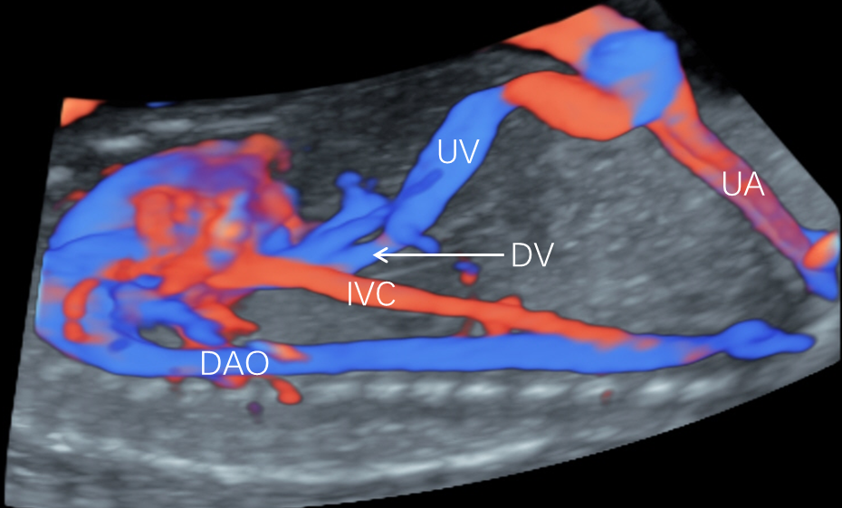
Figure 1 Sagittal view of the foetal chest and abdomen of a 28-wk-old healthy foetus in colour Doppler. The ductus venosus (DV) is directly connected to the umbilical vein (UV) and the inferior vena cava (IVC). UA: Umbilical artery; DAO: Descending aorta.
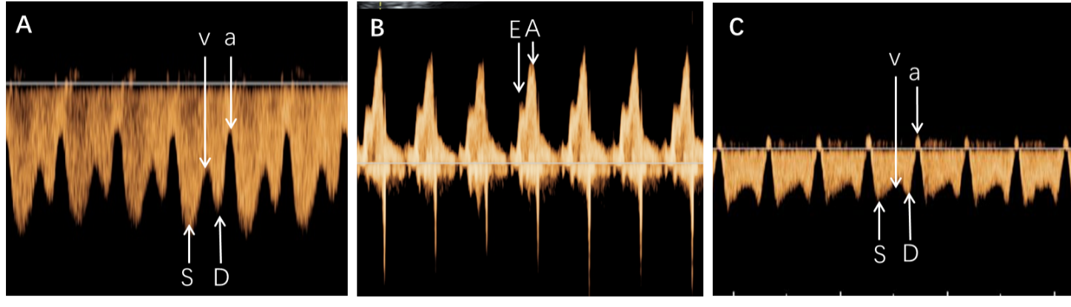
Figure 2 The ductus venosus flow velocities, velocity ratios and the early passive /late active ratio at the tricuspid orifice were measured. A: Typical ﬂow velocity waveform of the ductus venosus. The peak velocities during ventricular systolic peak flow velocity (S), ventricular late diastolic velocity (v), ventricular diastolic peak flow velocity (D) and atrial systolic peak velocity (a) were measured to calculate the velocity ratios; B: From these waveforms, peak systolic velocities during early passive (E) and late active (A) ventricular ﬁlling were measured to calculate the E/A ratio for the tricuspid valve; C: Ductus venosus velocimetry of isolated single umbilical artery foetuses with small-for-gestational-age. The ductus venosus spectrum ‘a’-waves were backward.
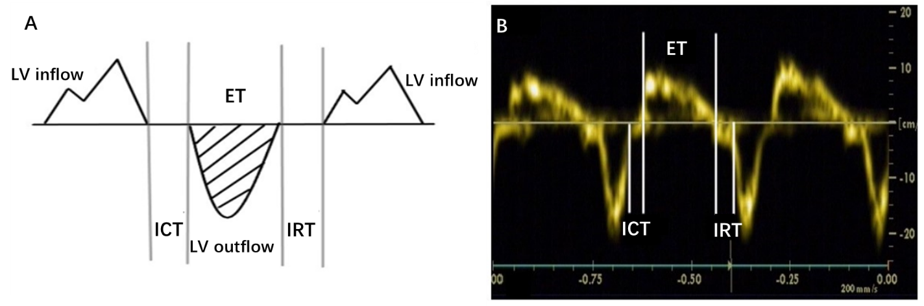
Figure 3 Schematic diagram and tissue Doppler Tei index of the foetal right ventricular measurement. A: Tissue Doppler Tei index measurement model of foetal right ventricular, isovolumic contraction time (ICT), ejection time (ET) and isovolumic relaxation time (IRT); B: Doppler Tei index measurement of foetal right heart tissue: Tei index = (isovolumic contraction time + isovolumic relaxation time)/ejection time. LV: Left ventricular.
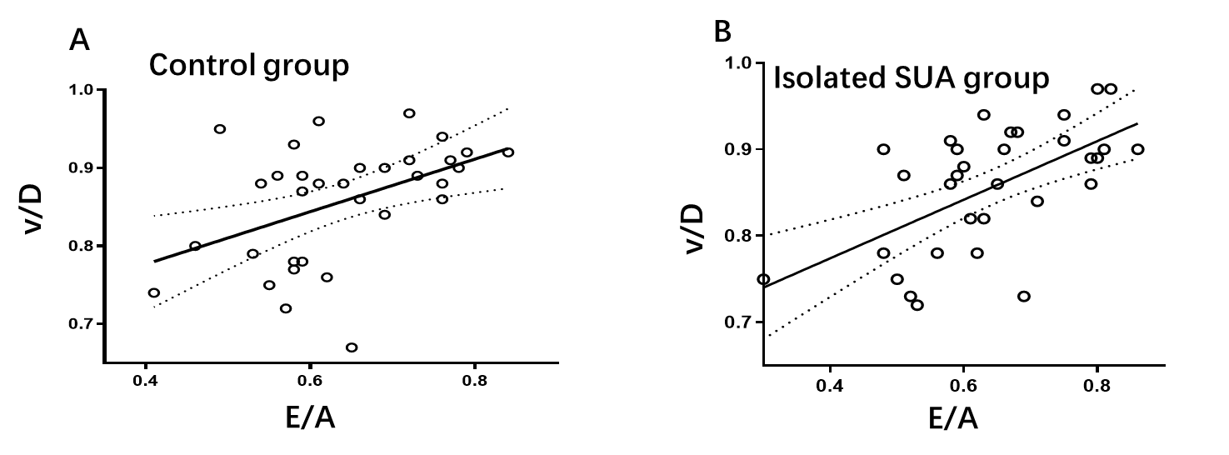
Figure 4 Scatterplots of the correlations between the ventricular late diastolic velocity/ventricular diastolic peak flow velocity and early passive/late active ratio of the isolated single umbilical artery (R² = 0.520) and control (R² = 0.358). A: Control group; B: Isolated single umbilical artery (SUA) group. v/D: Ventricular late diastolic velocity/ventricular diastolic peak flow velocity; E/A: Early passive/late active.
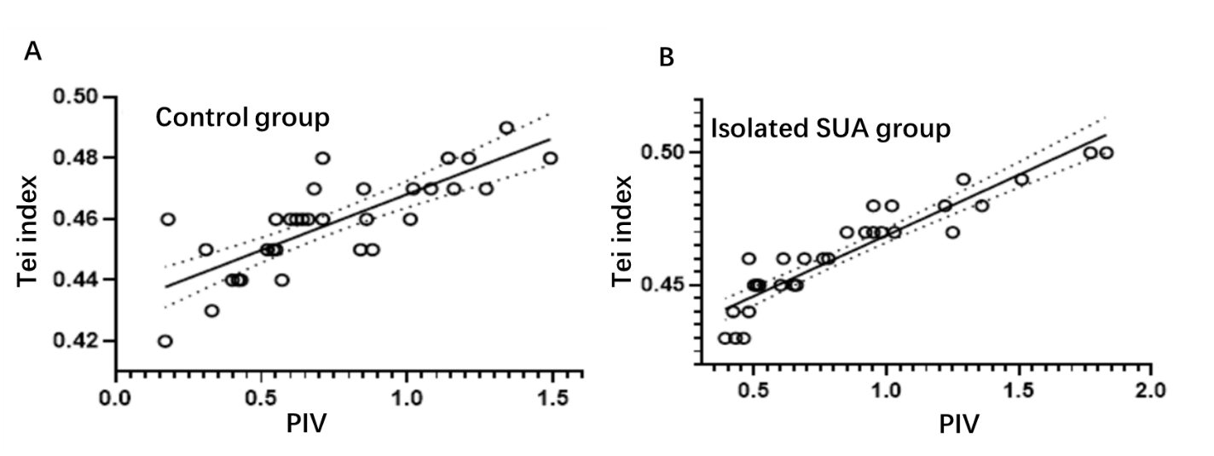
Figure 5 Scatterplots of the correlations between the pulsatility index for veins and Tei index of the isolated single umbilical artery (R² = 0.865) and control (R² = 0.627) groups. A: Control group; B: Isolated single umbilical artery (SUA) group. PIV: Pulsatility index for veins.
Table 1 Comparison of the measured foetal ductus venosus blood flow velocities and velocity ratios between the two groups, mean ± standard deviation
 | Isolated SUA group | Control group | P value
S, cm/s | 32.8 ± 14.0 | 34.9 ± 14.3 | 0.552
v, cm/s | 22.6 ± 9.4 | 24.1 ± 9.8 | 0.508
D, cm/s | 26.7 ± 12.0 | 28.2 ± 11.6 | 0.600
a, cm/s | 13.0 ± 7.1 | 17.5 ± 7.4 | 0.013
PIV | 0.81 ± 0.33 | 0.73 ± 0.34 | 0.310
S/v | 1.48 ± 0.30 | 1.47 ± 0.30 | 0.816
S/D | 1.26 ± 0.20 | 1.24 ± 0.15 | 0.778
S/a | 2.37 ± 0.79 | 2.13 ± 0.77 | 0.214
v/D | 0.86 ± 0.71 | 0.86 ± 0.75 | 0.921
v/a | 1.61 ± 0.48 | 1.44 ± 0.41 | 0.126
D/a | 1.90 ± 0.60 | 1.70 ± 0.53 | 0.163
E/A | 0.64 ± 0.13 | 0.64 ± 0.10 | 0.975
a: Atrial systolic peak velocity; A: Late active; E: Early passive; D: Ventricular diastolic peak flow velocity; PIV: Pulsatility index for veins; S: Ventricular systolic peak flow velocity; SUA: Single umbilical artery; v: Ventricular late diastolic velocity.
Table 2 Comparison of basic characteristics and clinical data between the two groups, mean ± standard deviation
 | Isolated SUA group | Control group | P value
Maternal weight, kg | 61.9 ± 5.8 | 61.8 ± 5.5 | 0.978
Body mass index, kg/m² | 24.1 ± 3.6 | 24.6 ± 3.7 | 0.853
Maternal age in yr | 27.7 ± 5.2 | 27.5 ± 4.5 | 0.382
Delivery at wk | 37.9 ± 1.1 | 38.8 ± 0.9 | 0.139
Birth weight, kg | 2.9 ± 0.3 | 3.3 ± 0.4 | 0.011
Placental weight, kg | 461 ± 59 | 523 ± 62 | < 0.001
SUA: Single umbilical artery.

