Name of Journal: World Journal of Gastrointestinal Oncology
Manuscript NO: 65832
Manuscript Type: REVIEW

Bromodomain and extra-terminal inhibitors emerge as potential therapeutic avenues for gastrointestinal cancers

Sun HY et al. BET inhibitors for gastrointestinal cancers treatment

Hui-Yan Sun, Song-Tao Du, Ya-Yun Li, Guang-Tong Deng, Fu-Rong Zeng

Hui-Yan Sun, Song-Tao Du, Ya-Yun Li, Guang-Tong Deng, Fu-Rong Zeng, Department of Dermatology, Xiangya Hospital, Central South University, Changsha 410008, Hunan Province, China

Hui-Yan Sun, Fu-Rong Zeng, Department of Oncology, Xiangya Hospital, Central South University, Changsha 410008, Hunan Province, China

Hui-Yan Sun, Song-Tao Du, Ya-Yun Li, Guang-Tong Deng, Fu-Rong Zeng, Hunan Engineering Research Center of Skin Health and Disease, Hunan Key Laboratory of Skin Cancer and Psoriasis, Xiangya Hospital, Central South University, Changsha 410008, Hunan Province, China

Hui-Yan Sun, Song-Tao Du, Ya-Yun Li, Guang-Tong Deng, Fu-Rong Zeng, National Clinical Research Center for Geriatric Disorders, Xiangya Hospital, Central South University, Changsha 410008, Hunan Province, China

Song-Tao Du, Department of Colorectal Surgical Oncology, Harbin Medical University Cancer Hospital, Harbin 150081, Heilongjiang Province, China
Author contributions: Zeng FR, Deng GT and Sun HY designed the study; Sun HY and Deng GT wrote the manuscript; Du ST, Li YY helped to revise the manuscript; all the authors supported the study.

Supported by Fellowship of the China Postdoctoral Science Foundation, No. 2020M682594, and No. 2021T140748.

Corresponding author: Fu-Rong Zeng, MD, Doctor, Department of Oncology, Xiangya Hospital, Central South University, No. 87 Xiangya Road, Changsha 410008, Hunan Province, China. zengflorachn@hotmail.com

Received: March 17, 2021
Revised: August 11, 2021
Accepted: November 30, 2021
Published online: January 15, 2022

Abstract
Gastrointestinal (GI) cancers, including colorectal cancer, pancreatic cancer, liver cancer and gastric cancer, are severe social burdens due to high incidence and mortality rates. Bromodomain and extra-terminal (BET) proteins are epigenetic readers consisting of four conserved members (BRD2, BRD3, BRD4 and BRDT). BET family perform pivotal roles in tumorigenesis through transcriptional regulation, thereby emerging as potential therapeutic targets. BET inhibitors, disrupting the interaction between BET proteins and acetylated lysines, have been reported to suppress tumor initiation and progression in most of GI cancers. In this review, we will demonstrate how BET proteins participate in the GI cancers progression and highlight the therapeutic potential of targeting BET proteins for GI cancers treatment.

Key Words: Gastrointestinal cancer; Bromodomain and extra-terminal proteins; Bromodomain and extra-terminal inhibitors; Acetylated lysines

©The Author(s) 2022. Published by Baishideng Publishing Group Inc. All rights reserved.

Citation: Sun HY, Du ST, Li YY, Deng GT, Zeng FR. Bromodomain and extra-terminal inhibitors emerge as potential therapeutic avenues for gastrointestinal cancers. World J Gastrointest Oncol 2022; 14(1): 75-89
URL: https://www.wjgnet.com/1948-5204/full/v14/i1/75.htm
DOI: https://dx.doi.org/10.4251/wjgo.v14.i1.75

Core Tip: Bromodomain and extra-terminal (BET) inhibitors, as promising targeted agents, emerge as a new therapeutic avenue for gastrointestinal (GI) cancers. Based on preclinical evidence, BET inhibitors, alone or in combination with other therapies, were effective to suppress the progression of GI cancers.

INTRODUCTION
Gastrointestinal (GI) cancers, including colorectal cancer (CRC), liver cancer, gastric cancer (GC) and pancreatic cancer, are among the most common malignancies worldwide with high incidence and mortality rates. In the latest global cancer data of 2020, CRC is the second leading cause of cancer death (9.4% of the total cancer deaths), followed by stomach cancer (8.3%), liver cancer (7.7%) and pancreatic cancer (4.6%)^{[1]}. Surgery still remains the only curative treatment for GI cancers^{[2]}. However, most patients are diagnosed as GI cancer at advanced stages or metastases, and thus lose the chance of surgery. Several therapies including chemotherapy^{[3,4]}, radiotherapy^{[5]}, chemoradiotherapy^{[6]} and immunotherapy^{[7,8]}, have been developed for those GI cancers patients who are intolerable to operation. Unfortunately, inevitable toxicity^{[9]}, innate or acquired chemo-resistance^{[10]} and low response^{[11]} limit the clinical use of these treatments, highlighting the need for developing new therapeutic strategies.
Bromodomain and extra-terminal (BET) protein inhibitors emerge as a new therapeutic avenue for multiple cancers, including GI cancers. BET inhibitors exert anti-cancer activities by competitively binding to BET proteins and disrupting the interaction between BET proteins and acetylated lysines. Increasing studies have reported that upregulation of BET proteins leads to abnormal transcriptional regulation^{[12]}, which facilitates tumor initiation and progression. Down-regulation of BET proteins expression and inactivation of their function represent a possible mechanism of anti-tumor effect of BET inhibitors. Therefore, BET inhibitors present to be a rational strategy for the sake of GI cancers treatment. Several BET inhibitors targeting the BET bromodomains (BD) are currently under clinical investigations and preclinical data provides rationale for the use of BET inhibitors in treating GI cancers.
In this review, we will briefly describe the structure and inhibition mechanism of BET proteins and illustrate the role of BET proteins in the initiation and progression of human GI cancers. Then, we will identify whether targeting BET proteins, alone or in combination with other therapies, exhibits potential benefits in GI cancers through preclinical evidence. Finally, we will speculate the outlook of the translation of BET inhibitors into clinic.

BET PROTEINS: STRUCTURE AND INHIBITION MECHANISM
BET family proteins include four subtypes: BRD2 (also known as FSRG1, RING3, RNF3, FSH, or D6S113E), BRD3 (also known as ORFX or RING3L), BRD4 (also known as MCAP or HUNK1) and BRDT (also known as BRD6, CT9, or SPGF21)^{[13,14]}. Each of the BET proteins has a highly conversed structure including two tandem -110 amino acid bromodomains (BD1 and BD2) with direct specificity for acetylated lysines, followed by an extra-terminal (ET) protein-protein interaction domain^{[15]}. Notably, BRD4 and BRDT comprise a C-terminal domain, which functionally recruits transcriptional regulators, like the positive transcription elongation factor b (P-TEFb)^{[16,17]} (Figure 1). The similarity and difference in structure among BET proteins may partly interpret the parallel and differential function in human disease, especially in cancer.
BET proteins have two BDs with the acetylated lysine binding pocket. Compared with acetylated histones, BDs have a higher affinity for small molecules, which provide new possibilities for the development of inhibitors^{[18]}. By occupying the BD pockets, BET inhibitors, such as JQ-1, mimic the binding mode and competitively inhibit binding between acetylated lysines and BDs, resulting in disrupting oncogenic rearrangement and inhibiting the development of some aggressive types of cancer (Figure 2).

BET PROTEINS IN GI CANCERS
Oncogenic roles of BET proteins family were firstly revealed in the NUT carcinoma. BRD4 and BRD3 are involved in the chromosomal rearrangements of NUT carcinoma by forming BET-NUT fusion protein^{[19]}. The inspirational discovery that BET proteins serve as potential cancer therapeutic targets encourages researchers to look for possible functions of BET proteins in other cancers, including GI cancers. Strikingly, BET proteins (BRD2, BRD4) are overexpressed in GI cancers and have been reported to promote GI cancers progression via multiple mechanisms.
BRD2 was firstly defined as a non-canonical protein kinase^{[20]}, which could promote the GI cancers progression by recruiting transcriptional factors and initiating transcriptional regulation. Recent studies demonstrated that BRD2 promoted the progression of CRC, pancreatic ductal adenocarcinoma (PDAC) and GC^{[21]}. Specifically, BRD2 forms a complex with transcription factor ELK4 by recognizing its K125 acetyl-lysine, and then activates transcription of LAMB3 in CRC, leading to tumor growth and metastasis^{[22]}. Moreover, BRD2 drives a fibroinflammatory stromal reaction in PDAC by initiating the transcription of oncogene cellular-myelocytomatosis (c-MYC) and other stroma-inducible genes^{[23]}. Huang et al^{[24]} illustrated a different pathway that BRD2 could activate the transcriptional factor GLI, which regulated the pancreatic cancer microenvironment. These findings suggest that BRD2 is a poor prognostic predictor of GI cancers.
BRD3 was rarely studied in GI cancers. However, recently, some frameshift mutations of BRD3 have been found in GC^{[25]}. Also, Tan et al^{[26]} found that BRD3 was among the top six driver genes for familial aggregation of PDAC through whole-genome sequencing. That means unlike BRD2/4, BRD3 may function in GI cancer through a different mechanism.
BRD4 is the most extensively studied BET proteins in GI cancers which is highly expressed in cancer tissues and cell lines, including CRC^{[27]}, pancreatic cancer^{[28]}, liver cancer^{[29]}, and GC^{[30]}. The overexpression of BRD4 promotes GI cancer cell growth, differentiation and metastasis, and correlates with poor outcome of GI cancers patients^{[31,32]}. On one hand, BRD4 could directly bind to the promoter region of oncogenes and induce their overexpression, including c-MYC^{[33]}, E2F2^{[34]}, caveolin-2^{[28]}, PES1^{[35]} and CD276^{[36]}. On the other hand, BRD4 could recognize acetylated lysines on epithelial-to-mesenchymal transition (EMT)-activating transcriptional factors like Twist or Snail, the activation of which facilitated the differentiation and survival of EMT cells and promoted metastatic growth in GI cancers^{[27,37,38]}. Additionally, BRD4 was reported to be recruited to senescence-activated super-enhancers to mediate cellular senescence^{[39]}. The senescent cancer cells induced the secretion of various cytokines and increased CRC cells migration and invasion abilities^{[40]}. In addition to the direct induction of tumorigenesis, BRD4 was also involved in the crosstalk between cancer and cancer-associated fibroblasts. Inhibiting the BRD4 protein changed both transcription and structure of matrisome in PDAC and resulted in better patients’ survival^{[41]}. Moreover, Yasukawa et al^{[42]} also described that BRD4 played an important role in cancer associated fibroblasts in GC^{[42]}. These oncogenic functions suggest that BRD4 is an important molecular target for GI cancers.

BET INHIBITORS IN GI CANCERS
Given that BET proteins are important regulators in GI cancer, targeting BET proteins will be a good therapeutic strategy for GI cancers treatment. A series of compounds have been reported as potential therapeutic avenues for GI cancers by targeting BET proteins (Table 1). BET inhibitors share the similar mechanism by displacing BET proteins from chromatin and regulating transcriptional factors. By mediating cell cycle arrest, facilitating apoptosis, and inducing senescence, BET inhibitors functionally inhibit cell proliferation, invasion and migration in most GI cancers including CRC, pancreatic cancer, liver cancer and GC^{[43]}. Mechanically, BET inhibitors exert anti-tumor activity in c-MYC dependent, as well as c-MYC independent manners^{[44]}. BET inhibitors have been widely used in preclinical models, but BET inhibitors alone exhibit limited-single agent activity confronting drug resistance. Combinational therapy with chemotherapy, immunotherapy or other small molecule inhibitors may amplify the clinical outcomes in GI cancers. Herein, we review the application of BET inhibitors in GI cancers.

CRC
Preclinical data demonstrated that BET inhibitors alone had exhibited efficacy against CRC by inhibiting tumor growth and inducing apoptosis in vivo and vitro^{[27,45]}. However, resistance to BET inhibitors was the major obstacle to CRC treatment. Wang et al^{[46]} raised one possible mechanism that the interaction of STAT3 through BRD4 phosphorylation might result in the resistance of BET inhibitors in CRC. Combining BET inhibitors and other targeted therapies could help to overcome resistance and render CRC more sensitive to BET inhibitors. For example, nuclear factor-kappa B inhibitors^{[47]}, PI3K/mTOR inhibitors^{[40]}, HDAC3 inhibitor^{[48]} have been reported to sensitize GI cancers to BET inhibitors, and finally achieve synergistical effects.
Moreover, BET inhibition could be used in combination with chemotherapy to enhance chemotherapy effect via increasing the apoptosis induction^{[49]}. For example, BET inhibitors could increase the sensitivity of CRC cells to 5-fluorouracil^{[50]} and Arsenic sulfide^{[51,52]} (Figure 3). More importantly, this combination therapy could decrease the side effect of chemotherapeutic drugs^{[53]}. Moreover, BET inhibitors conferred a synthetic lethality with loss of SMAD4 in CRC cells by restoring the loss of c-MYC repression^{[54]}, suggesting that BET inhibitors were essential for the treatment of SMAD4-deficient CRC.

Pancreatic cancer
BET inhibitors not only effectively inhibited PDAC cell growth in three-dimensional collagen partly by repressing c-MYC expression, but also conducted its efficacy in a MYC-independent way by repressing the expression of FOSL1^{[55]}. However, clinical studies suggested that BET inhibitors monotherapies were not effective revenues for PDAC treatment^{[56]}. Drug resistance assumed the major responsibility for treatment failure. The main mechanism of resistance was associated with either up-regulating or stabilizing c-MYC expression. Loss of FBP1^{[57]} , aberrant expression of ADAR1^{[58]}, high levels of GLI^{[24]} and overexpression of PES1^{[59]} could explain the up-regulation of c-MYC in pancreatic cancer.
To improve the efficacy of BET inhibitor on PDAC, several studies evaluated the efficiency of BET inhibitors in combination with other agents. Encouragingly, BET inhibitors could synergize with other target therapy in preclinical PDAC models. For example, BET inhibitor attenuated the DNA repair through decreasing Ku80 and RAD51 proteins, and sensitized the PDAC to PARP inhibitors^{[60]}. Another team also illustrated that BET inhibitors synergizing with HDAC inhibitors enhanced the efficacy of inducing cell death via de-repressing p57^{[61]}. In addition to being combined with target therapies, BET augmented the efficiency of chemotherapeutic drugs like Gemcitabine by increasing DNA damage and apoptosis^{[62]}. Besides, BET inhibitors combined with Quercetin suppress hnRNPA1 leading to better therapeutic effect compared with monotherapy^{[63]}.

Liver cancer
BET inhibitors exhibit anti-tumorigenic effects on both hepatocellular carcinoma (HCC) and cholangiocarcinoma (CCA), but in different manners. JQ-1 inhibited CCA growth in a MYC-dependent way^{[64]}, while JQ-1 played its anti-tumor role in HCC by suppressing E2F2-cell cycle regulation circuit^{[34]} or the expression of SMARCA4^{[65]}. Notably, Yin et al^{[66]} stated that JQ-1 exerted more cytotoxicity on MYC-positive HCC cells than sorafenib (first-line drug for advanced HCC) by inducing more apoptosis. This team further demonstrated that EGFR signaling contributed to the JQ1 resistance by stabilizing MYC. Zhang et al^{[67]} arrived at a different resistance mechanism that upregulation of Mcl-1 was a major contributor to the resistance to BET inhibitor in HCC cells. They further found that BET inhibitors, in combination with other drugs capable of down-regulating Mcl-1 had a synergic effect in human HCC. Liu et al^{[68]} reported another resistance mechanism and the reactivation of WNT pathway in liver cancer cells could increase the sensitivity of HCC to BET inhibitor^{[68]}.
BET inhibitor were also reported to impact the immunotherapy efficacy in HCC (Figure 4). Several studies had shown that BET inhibition could enhance anti-tumor immunity via modulating programmed cell death-ligand 1 (PD-L1) expression^{[69,70]}. Liu et al^{[71]} demonstrated that JQ-1 could decrease the total mRNA and protein levels of PD-L1 in liver cancer cell lines. However, Liu et al^{[72]} reported that JQ1 upregulated the expression of PD-L1 on the plasma membrane in vivo and in vitro, but did not change the total levels of PD-L1 mRNA and protein. Another study conducted by Cheng and his colleague^{[73]} reported that I-BET762, exerted a synergistic effect with anti-PD-L1 in the HCC model leading to augment tumor infiltrating lymphocytes. Altogether, the mechanism by which BET inhibitors modulate immunotherapy is different, but the phenotypic enhancement of immunotherapy by BET inhibitors is assured.

GC
JQ-1 exerts an anti-cancer effect on GC as well. Interestingly, JQ-1 has race specificity on GC that Asians rendered more resistance to BET inhibitors than Brazilians^{[74]}. Recently, Zhou et al^{[75]} noted that JQ-1 suppressed proliferation, migration and invasion of GC cells via targeting RUNX2/NID1 axis, while BET inhibitor AZD5153 inhibited GC metastasis by regulating Mus81 at both RNA and protein levels^{[76]}. Kim et al^{[77]} revealed new BRD4 inhibitor that showed efficiency in I-BET762 resistant GC cell lines^{[77]}. Additionally, through blocking the expression of c-MYC and YAP1, JQ-1 reduced gastric adenocarcinoma cell growth induced by Gal-3, and the anti-cancer activity could be improved in combination with YAP inhibitors^{[78]}. Other combination strategies with chemotherapy drugs have also been reported. The combination of I-BET151 and paclitaxel increased the anti-GC tumor effect than single-treatment^{[79]}. Also, JQ-1 synergized with arsenic sulfide targeting c-MYC, exhibits an increasing cytotoxic activity in both gastric and colon cells^{[52]}.

NEW BET INHIBITORS USING PROTAC TECHNOLOGY
Though exhibiting promising outcomes in GI cancers, BET inhibitors showed therapeutic limitations due to their reversibility, often followed by re-accumulating BET proteins and removing inhibition of c-MYC^{[19]}. This motivated new BET targeting molecules using Proteolysis Targeting Chimeras (PROTACs) technology to be invented like ARV-825 and A1874. These molecules, also called BRD4-degrading PROTACs, are heterobifunctional compounds that contain two binders with one recruiting an E3 ubiquitin ligase cereblon (CRBN) and the other targeting BRD4 proteins based on BET inhibitors. Data has shown that these molecules induce effective and selective degradation of BRD4^{[80]} (Figure 5). The approach to target BRD4 degradation instead of inhibition resulted in more potent suppression of c-MYC as well as c-MYC-dependent genes and led to a longer-lasting effect in GI cancers. For example, Lu et al^{[81]} stated that ARV-825 was superior to OTX-015 and JQ-1 in the suppression of c-MYC expression in CCA and thus exerted more inhibition on CCA cell proliferation and apoptosis. Minko^{[82]} reported a similar anticancer activity of ARV-825 in pancreatic cancer and this activity exhibited in both 2D cell culture and 3D multicellular tumor spheroid models. Additionally, Qin et al^{[83]} showed that A1874 down-regulated c-MYC, Bcl-2, and cyclin D1 in colon cancer cells and had an anti-colon cancer activity by inhibiting cell proliferation, invasion and migration. Strikingly, A1874 presented to be much more effective than other BET inhibitors including JQ1 and I-BET151. However, after long-term exposure to BRD4-degrading PROTACs, resistance exists^{[84]}. Downregulating the expression of CRBN is a common mechanism of resistance. In terms of this issue, Otto et al^{[85]} proposed an alternative avenue to prevent the development of resistance, which might be the use of several PROTACs to recruit different E3 Ligases.

CLINICAL LANDSCAPE
BET inhibitors, including I-BET762 (NCT01587703), INCB057643 (NCT02711137), INCB054329 (NCT02431260), AZD5153 (NCT03205176) and OTX-015(NCT02698176) have entered Clinical Trial for diverse cancers^{[86]}, but the majority of them remain in the Phase I/II. Here, we are concentrating on the trials of BET inhibitors alone or in combination with other inhibitors in GI cancers (Table 2).
I-BET762 (Molibresib) is a pan-BET inhibitor that remarkably inhibits the PDAC cell proliferation by down-regulating c-MYC and reducing protein levels of ERK1/2. Remarkably, the anti-tumor effect can be enhanced combined with gemcitabine^{[87]}. NCT03925428 is a phase I clinical trial that tests the side effects and best dose of I-BET 762 combined with entinostat in solid tumors or lymphomas advanced or refractory, including PDAC. However, the study was withdrawn because other protocol moved to disapprove.
INCB054329 and INCB057643 are two small-molecule BET inhibitors which exhibit anti-cancer activity by reducing the expression level of c-MYC^{[88,89]}. Phase I/II dose-escalation, safety and tolerability studies of INCB054329 and INCB057643 were conducted in subjects with advanced malignancies including GI cancers. INCB054329 was terminated due to an unfavorable clinical Pharmacokinetic (PK) profile (NCT02431260). INCB057643 compared with INCB054329 has a longer half-life and a shorter PK variability. However, patients received INCB057643 resulted in treatment discontinuance or dose interruption or dose reduction due to TRAEs and the study ultimately terminated in 2020 (NCT02711137).
AZD5153 is a novel BRD4 inhibitor, effecting Mus81 down-regulation and suppressing tumor migration in GC^{[76]}. A Phase I study was initiated to evaluate the safety, pharmacokinetics, and pharmacodynamics of AZD5253 alone or in combination with Olaparib in patients with malignant solid tumors, including pancreatic cancer. The recruiting status of this study remains active, not recruiting (NCT03205176).
Dual PI3K/BRD4 Inhibitor SF1126 blocks both the Ras/Raf/MAPK and PI3K/AKT/mTOR pathways and disrupts c-MYC expression as well^{[90]}. And a Phase I clinical trial of SF1126 has completed in humans with well toleration and efficacy in solid tumor including CRC^{[91]}. Recently, SF1126 is being tested in combination with Nivolumab in patients with advanced HCC and this study is expected to be completed by October 2022 (NCT03059147).
With high bioavailability and biosafety, SF1126 has completed a Phase I clinical study and steps into a Phase II study in advanced HCC. And AZD5153 shows an optimistic preclinical result in GC treatment. All these evidences demonstrate that BET inhibitors constitute a promising field of clinical research in GI cancers. Continued progresses are required especially in exploring rational combinations to open new possibilities for BET inhibitors as anti-GI cancers agents.

CONCLUSION
BET inhibitors have emerged as a new possible strategy for the treatment of GI cancers in recent years. However, either nondurable cytotoxic effects, such as thrombocytopenia and GI disorders^{[92]} or drug resistance make BET inhibitors fail to be administrated as single agents by far. To achieve better selectivity and reduce unwanted toxicities, BET inhibitors continue to be updated, increasing their potential in cancer treatment.
The first-generation pan-BET inhibitors have been identified to suppress GI cancer in preclinical results, however, the inevitable side effects limit their clinical applications. Hence, drug discovery efforts concentrate on selectively inhibiting BET proteins^{[93]}. Selective BD inhibitors achieved almost equally efficiency in cancer to the pan-BET inhibitors^{[94]} and showed less toxicity^{[95]}. A set of selective BD inhibitors help to understand the role of BD in cancers and further focusing on specific BD perturbations may provide more efficiency and tolerability in GI cancers treatment.
Another approach to acquire selective inhibition is to target each BET family members. Since BRD4 is the predominant BET protein that mediates the development of GI cancers, selective BRD4 inhibition may have a better outlook. New BRD4 degraders ARV-825 and A1874 that have already shown their antitumor efficiency in preclinical results support further clinical development of BET inhibitors in GI cancers.
Other strategy to improve the efficacy and pharmacokinetic property of BET inhibitors is via modulating their structure. After modification, these major clinical stage BET inhibitors acquire better tumor killing capacity with minimal IC₅₀ in multiple solid tumors^{[96]}. The optimistic preclinical result makes it possible to treat GI cancer with single agents.
Additionally, synergistic inhibition provides an optimistic prospect for increasing the efficacy of BET inhibitors. The preclinical and clinical results verify high potential in combinational therapy. The resistance to BET inhibitors will be overcome if combined with drugs targeting the pathways that cause resistance^{[47]}. Besides, the dosage will be decreased dramatically if combined with drugs rendering GI cancers more sensitive to BET inhibitors^{[97]}. Without a doubt, BET inhibitors emerge as a promising avenue for the GI cancers treatment.

REFERENCES
1 Sung H, Ferlay J, Siegel RL, Laversanne M, Soerjomataram I, Jemal A, Bray F. Global Cancer Statistics 2020: GLOBOCAN Estimates of Incidence and Mortality Worldwide for 36 Cancers in 185 Countries. CA Cancer J Clin 2021; 71: 209-249 [PMID: 33538338 DOI: 10.3322/caac.21660]
2 Stoica AF, Chang CH, Pauklin S. Molecular Therapeutics of Pancreatic Ductal Adenocarcinoma: Targeted Pathways and the Role of Cancer Stem Cells. Trends Pharmacol Sci 2020; 41: 977-993 [PMID: 33092892 DOI: 10.1016/j.tips.2020.09.008]
3 Moertel CG. Chemotherapy of gastrointestinal cancer. N Engl J Med 1978; 299: 1049-1052 [PMID: 360064 DOI: 10.1056/NEJM197811092991906]
4 Chen X, Zeh HJ, Kang R, Kroemer G, Tang D. Cell death in pancreatic cancer: from pathogenesis to therapy. Nat Rev Gastroenterol Hepatol 2021; 18: 804-823 [PMID: 34331036 DOI: 10.1038/s41575-021-00486-6]
5 Debenham BJ, Hu KS, Harrison LB. Present status and future directions of intraoperative radiotherapy. Lancet Oncol 2013; 14: e457-e464 [PMID: 24079873 DOI: 10.1016/S1470-2045(13)70270-5]
6 Joshi SS, Badgwell BD. Current treatment and recent progress in gastric cancer. CA Cancer J Clin 2021; 71: 264-279 [PMID: 33592120 DOI: 10.3322/caac.21657]
7 Long J, Lin J, Wang A, Wu L, Zheng Y, Yang X, Wan X, Xu H, Chen S, Zhao H. PD-1/PD-L blockade in gastrointestinal cancers: lessons learned and the road toward precision immunotherapy. J Hematol Oncol 2017; 10: 146 [PMID: 28774337 DOI: 10.1186/s13045-017-0511-2]
8 Golan T, Hammel P, Reni M, Van Cutsem E, Macarulla T, Hall MJ, Park JO, Hochhauser D, Arnold D, Oh DY, Reinacher-Schick A, Tortora G, Algül H, O'Reilly EM, McGuinness D, Cui KY, Schlienger K, Locker GY, Kindler HL. Maintenance Olaparib for Germline BRCA-Mutated Metastatic Pancreatic Cancer. N Engl J Med 2019; 381: 317-327 [PMID: 31157963 DOI: 10.1056/NEJMoa1903387]
9 Dunn C, Hong W, Gibbs P, Ackland S, Sjoquist K, Tebbutt NC, Price T, Burge M. Personalizing First-Line Systemic Therapy in Metastatic Colorectal Cancer: Is There a Role for Initial Low-Intensity Therapy in 2021 and Beyond? A Perspective From Members of the Australasian Gastrointestinal Trials Group. Clin Colorectal Cancer 2021; 20: 245-255 [PMID: 34103264 DOI: 10.1016/j.clcc.2021.05.001]
10 Zhang N, Ng AS, Cai S, Li Q, Yang L, Kerr D. Novel therapeutic strategies: targeting epithelial-mesenchymal transition in colorectal cancer. Lancet Oncol 2021; 22: e358-e368 [PMID: 34339656 DOI: 10.1016/S1470-2045(21)00343-0]
11 Nussbaum YI, Manjunath Y, Suvilesh KN, Warren WC, Shyu CR, Kaifi JT, Ciorba MA, Mitchem JB. Current and Prospective Methods for Assessing Anti-Tumor Immunity in Colorectal Cancer. Int J Mol Sci 2021; 22 [PMID: 33946558 DOI: 10.3390/ijms22094802]
12 Doroshow DB, Eder JP, LoRusso PM. BET inhibitors: a novel epigenetic approach. Ann Oncol 2017; 28: 1776-1787 [PMID: 28838216 DOI: 10.1093/annonc/mdx157]
13 Florence B, Faller DV. You bet-cha: a novel family of transcriptional regulators. Front Biosci 2001; 6: D1008-D1018 [PMID: 11487468 DOI: 10.2741/florence]
14 Wang N, Wu R, Tang D, Kang R. The BET family in immunity and disease. Signal Transduct Target Ther 2021; 6: 23 [PMID: 33462181 DOI: 10.1038/s41392-020-00384-4]
15 Dhalluin C, Carlson JE, Zeng L, He C, Aggarwal AK, Zhou MM. Structure and ligand of a histone acetyltransferase bromodomain. Nature 1999; 399: 491-496 [PMID: 10365964 DOI: 10.1038/20974]
16 Itzen F, Greifenberg AK, Bösken CA, Geyer M. Brd4 activates P-TEFb for RNA polymerase II CTD phosphorylation. Nucleic Acids Res 2014; 42: 7577-7590 [PMID: 24860166 DOI: 10.1093/nar/gku449]
17 Wu SY, Chiang CM. The double bromodomain-containing chromatin adaptor Brd4 and transcriptional regulation. J Biol Chem 2007; 282: 13141-13145 [PMID: 17329240 DOI: 10.1074/jbc.R700001200]
18 Filippakopoulos P, Knapp S. Targeting bromodomains: epigenetic readers of lysine acetylation. Nat Rev Drug Discov 2014; 13: 337-356 [PMID: 24751816 DOI: 10.1038/nrd4286]
19 Stathis A, Bertoni F. BET Proteins as Targets for Anticancer Treatment. Cancer Discov 2018; 8: 24-36 [PMID: 29263030 DOI: 10.1158/2159-8290.CD-17-0605]
20 Belkina AC, Denis GV. BET domain co-regulators in obesity, inflammation and cancer. Nat Rev Cancer 2012; 12: 465-477 [PMID: 22722403 DOI: 10.1038/nrc3256]
21 Chen Z, Li Z, Soutto M, Wang W, Piazuelo MB, Zhu S, Guo Y, Maturana MJ, Corvalan AH, Chen X, Xu Z, El-Rifai WM. Integrated Analysis of Mouse and Human Gastric Neoplasms Identifies Conserved microRNA Networks in Gastric Carcinogenesis. Gastroenterology 2019; 156: 1127-1139.e8 [PMID: 30502323 DOI: 10.1053/j.gastro.2018.11.052]
22 Zhu Z, Song J, Guo Y, Huang Z, Chen X, Dang X, Huang Y, Wang Y, Ou W, Yang Y, Yu W, Liu CY, Cui L. LAMB3 promotes tumour progression through the AKT-FOXO3/4 axis and is transcriptionally regulated by the BRD2/acetylated ELK4 complex in colorectal cancer. Oncogene 2020; 39: 4666-4680 [PMID: 32398865 DOI: 10.1038/s41388-020-1321-5]
23 Sherman MH, Yu RT, Tseng TW, Sousa CM, Liu S, Truitt ML, He N, Ding N, Liddle C, Atkins AR, Leblanc M, Collisson EA, Asara JM, Kimmelman AC, Downes M, Evans RM. Stromal cues regulate the pancreatic cancer epigenome and metabolome. Proc Natl Acad Sci U S A 2017; 114: 1129-1134 [PMID: 28096419 DOI: 10.1073/pnas.1620164114]
24 Huang Y, Nahar S, Nakagawa A, Fernandez-Barrena MG, Mertz JA, Bryant BM, Adams CE, Mino-Kenudson M, Von Alt KN, Chang K, Conery AR, Hatton C, Sims RJ 3rd, Fernandez-Zapico ME, Wang X, Lillemoe KD, Fernández-Del Castillo C, Warshaw AL, Thayer SP, Liss AS. Regulation of GLI Underlies a Role for BET Bromodomains in Pancreatic Cancer Growth and the Tumor Microenvironment. Clin Cancer Res 2016; 22: 4259-4270 [PMID: 27169995 DOI: 10.1158/1078-0432.CCR-15-2068]
25 Cho J, Chang YH, Heo YJ, Kim S, Kim NK, Park JO, Kang WK, Lee J, Kim KM. Four distinct immune microenvironment subtypes in gastric adenocarcinoma with special reference to microsatellite instability. ESMO Open 2018; 3: e000326 [PMID: 29636988 DOI: 10.1136/esmoopen-2018-000326]
26 Tan M, Brusgaard K, Gerdes AM, Mortensen MB, Detlefsen S, Schaffalitzky de Muckadell OB, Joergensen MT. Whole genome sequencing identifies rare germline variants enriched in cancer related genes in first degree relatives of familial pancreatic cancer patients. Clin Genet 2021; 100: 551-562 [PMID: 34313325 DOI: 10.1111/cge.14038]
27 Hu Y, Zhou J, Ye F, Xiong H, Peng L, Zheng Z, Xu F, Cui M, Wei C, Wang X, Wang Z, Zhu H, Lee P, Zhou M, Jiang B, Zhang DY. BRD4 inhibitor inhibits colorectal cancer growth and metastasis. Int J Mol Sci 2015; 16: 1928-1948 [PMID: 25603177 DOI: 10.3390/ijms16011928]
28 Jiao F, Han T, Yuan C, Liang Y, Cui J, Zhuo M, Wang L. Caveolin-2 is regulated by BRD4 and contributes to cell growth in pancreatic cancer. Cancer Cell Int 2020; 20: 55 [PMID: 32099528 DOI: 10.1186/s12935-020-1135-0]
29 Niu X, Wang W, Liang T, Li S, Yang C, Xu X, Li L, Liu S. CPI-203 improves the efficacy of anti-PD-1 therapy by inhibiting the induced PD-L1 overexpression in liver cancer. Cancer Sci 2021 [PMID: 34727389 DOI: 10.1111/cas.15190]
30 Zhu Y, Yang W, Ji G, Lin N, Wu W, Xiong P, Zheng C, Yan L, Wan P, Wang Y. Bromodomain protein 4 is a novel predictor of survival for gastric carcinoma. Oncotarget 2017; 8: 31092-31100 [PMID: 28415703 DOI: 10.18632/oncotarget.16087]
31 Zhang P, Dong Z, Cai J, Zhang C, Shen Z, Ke A, Gao D, Fan J, Shi G. BRD4 promotes tumor growth and epithelial-mesenchymal transition in hepatocellular carcinoma. Int J Immunopathol Pharmacol 2015; 28: 36-44 [PMID: 25816404 DOI: 10.1177/0394632015572070]
32 Dong X, Hu X, Chen J, Hu D, Chen LF. BRD4 regulates cellular senescence in gastric cancer cells via E2F/miR-106b/p21 axis. Cell Death Dis 2018; 9: 203 [PMID: 29434197 DOI: 10.1038/s41419-017-0181-6]
33 Ba M, Long H, Yan Z, Wang S, Wu Y, Tu Y, Gong Y, Cui S. BRD4 promotes gastric cancer progression through the transcriptional and epigenetic regulation of c-MYC. J Cell Biochem 2018; 119: 973-982 [PMID: 28681984 DOI: 10.1002/jcb.26264]
34 Hong SH, Eun JW, Choi SK, Shen Q, Choi WS, Han JW, Nam SW, You JS. Epigenetic reader BRD4 inhibition as a therapeutic strategy to suppress E2F2-cell cycle regulation circuit in liver cancer. Oncotarget 2016; 7: 32628-32640 [PMID: 27081696 DOI: 10.18632/oncotarget.8701]
35 Fan P, Wang B, Meng Z, Zhao J, Jin X. PES1 is transcriptionally regulated by BRD4 and promotes cell proliferation and glycolysis in hepatocellular carcinoma. Int J Biochem Cell Biol 2018; 104: 1-8 [PMID: 30172011 DOI: 10.1016/j.biocel.2018.08.014]
36 Zhao J, Meng Z, Xie C, Yang C, Liu Z, Wu S, Wang B, Fan P, Jin X, Wu H. B7-H3 is regulated by BRD4 and promotes TLR4 expression in pancreatic ductal adenocarcinoma. Int J Biochem Cell Biol 2019; 108: 84-91 [PMID: 30664982 DOI: 10.1016/j.biocel.2019.01.011]
37 Wang LT, Wang SN, Chiou SS, Liu KY, Chai CY, Chiang CM, Huang SK, Yokoyama KK, Hsu SH. TIP60-dependent acetylation of the SPZ1-TWIST complex promotes epithelial-mesenchymal transition and metastasis in liver cancer. Oncogene 2019; 38: 518-532 [PMID: 30154425 DOI: 10.1038/s41388-018-0457-z]
38 Qin ZY, Wang T, Su S, Shen LT, Zhu GX, Liu Q, Zhang L, Liu KW, Zhang Y, Zhou ZH, Zhang XN, Wen LZ, Yao YL, Sun WJ, Guo Y, Liu KJ, Liu L, Wang XW, Wei YL, Wang J, Xiao HL, Liu P, Bian XW, Chen DF, Wang B. BRD4 Promotes Gastric Cancer Progression and Metastasis through Acetylation-Dependent Stabilization of Snail. Cancer Res 2019; 79: 4869-4881 [PMID: 31311807 DOI: 10.1158/0008-5472.CAN-19-0442]
39 Tasdemir N, Banito A, Roe JS, Alonso-Curbelo D, Camiolo M, Tschaharganeh DF, Huang CH, Aksoy O, Bolden JE, Chen CC, Fennell M, Thapar V, Chicas A, Vakoc CR, Lowe SW. BRD4 Connects Enhancer Remodeling to Senescence Immune Surveillance. Cancer Discov 2016; 6: 612-629 [PMID: 27099234 DOI: 10.1158/2159-8290.CD-16-0217]
40 Lee HS, Lee S, Cho KH. Cotargeting BET proteins overcomes resistance arising from PI3K/mTOR blockade-induced protumorigenic senescence in colorectal cancer. Int J Cancer 2020; 147: 2824-2837 [PMID: 32599680 DOI: 10.1002/ijc.33047]
41 Honselmann KC, Finetti P, Birnbaum DJ, Monsalve CS, Wellner UF, Begg SKS, Nakagawa A, Hank T, Li A, Goldsworthy MA, Sharma H, Bertucci F, Birnbaum D, Tai E, Ligorio M, Ting DT, Schilling O, Biniossek ML, Bronsert P, Ferrone CR, Keck T, Mino-Kenudson M, Lillemoe KD, Warshaw AL, Fernández-Del Castillo C, Liss AS. Neoplastic-Stromal Cell Cross-talk Regulates Matrisome Expression in Pancreatic Cancer. Mol Cancer Res 2020; 18: 1889-1902 [PMID: 32873625 DOI: 10.1158/1541-7786.MCR-20-0439]
42 Yasukawa Y, Hattori N, Iida N, Takeshima H, Maeda M, Kiyono T, Sekine S, Seto Y, Ushijima T. SAA1 is upregulated in gastric cancer-associated fibroblasts possibly by its enhancer activation. Carcinogenesis 2021; 42: 180-189 [PMID: 33284950 DOI: 10.1093/carcin/bgaa131]
43 Filippakopoulos P, Qi J, Picaud S, Shen Y, Smith WB, Fedorov O, Morse EM, Keates T, Hickman TT, Felletar I, Philpott M, Munro S, McKeown MR, Wang Y, Christie AL, West N, Cameron MJ, Schwartz B, Heightman TD, La Thangue N, French CA, Wiest O, Kung AL, Knapp S, Bradner JE. Selective inhibition of BET bromodomains. Nature 2010; 468: 1067-1073 [PMID: 20871596 DOI: 10.1038/nature09504]
44 Delmore JE, Issa GC, Lemieux ME, Rahl PB, Shi J, Jacobs HM, Kastritis E, Gilpatrick T, Paranal RM, Qi J, Chesi M, Schinzel AC, McKeown MR, Heffernan TP, Vakoc CR, Bergsagel PL, Ghobrial IM, Richardson PG, Young RA, Hahn WC, Anderson KC, Kung AL, Bradner JE, Mitsiades CS. BET bromodomain inhibition as a therapeutic strategy to target c-Myc. Cell 2011; 146: 904-917 [PMID: 21889194 DOI: 10.1016/j.cell.2011.08.017]
45 Zhang Y, Tian S, Xiong J, Zhou Y, Song H, Liu C. JQ-1 Inhibits Colon Cancer Proliferation via Suppressing Wnt/β-Catenin Signaling and miR-21. Chem Res Toxicol 2018; 31: 302-307 [PMID: 29600711 DOI: 10.1021/acs.chemrestox.7b00346]
46 Wang W, Tang YA, Xiao Q, Lee WC, Cheng B, Niu Z, Oguz G, Feng M, Lee PL, Li B, Yang ZH, Chen YF, Lan P, Wu XJ, Yu Q. Stromal induction of BRD4 phosphorylation Results in Chromatin Remodeling and BET inhibitor Resistance in Colorectal Cancer. Nat Commun 2021; 12: 4441 [PMID: 34290255 DOI: 10.1038/s41467-021-24687-4]
47 Wu T, Wang G, Chen W, Zhu Z, Liu Y, Huang Z, Huang Y, Du P, Yang Y, Liu CY, Cui L. Co-inhibition of BET proteins and NF-κB as a potential therapy for colorectal cancer through synergistic inhibiting MYC and FOXM1 expressions. Cell Death Dis 2018; 9: 315 [PMID: 29472532 DOI: 10.1038/s41419-018-0354-y]
48 Kapoor S, Gustafson T, Zhang M, Chen YS, Li J, Nguyen N, Perez JET, Dashwood WM, Rajendran P, Dashwood RH. Deacetylase Plus Bromodomain Inhibition Downregulates ERCC2 and Suppresses the Growth of Metastatic Colon Cancer Cells. Cancers (Basel) 2021; 13 [PMID: 33809839 DOI: 10.3390/cancers13061438]
49 Tan X, Tong J, Wang YJ, Fletcher R, Schoen RE, Yu J, Shen L, Zhang L. BET Inhibitors Potentiate Chemotherapy and Killing of SPOP-Mutant Colon Cancer Cells via Induction of DR5. Cancer Res 2019; 79: 1191-1203 [PMID: 30674532 DOI: 10.1158/0008-5472.CAN-18-3223]
50 Cheng X, Huang Z, Long D, Jin W. BET inhibitor bromosporine enhances 5-FU effect in colorectal cancer cells. Biochem Biophys Res Commun 2020; 521: 840-845 [PMID: 31708100 DOI: 10.1016/j.bbrc.2019.11.009]
51 Tan Z, Zhang X, Kang T, Zhang L, Chen S. Arsenic sulfide amplifies JQ1 toxicity via mitochondrial pathway in gastric and colon cancer cells. Drug Des Devel Ther 2018; 12: 3913-3927 [PMID: 30532520 DOI: 10.2147/DDDT.S180976]
52 Zhang L, Tong Y, Zhang X, Pan M, Chen S. Arsenic sulfide combined with JQ1, chemotherapy agents, or celecoxib inhibit gastric and colon cancer cell growth. Drug Des Devel Ther 2015; 9: 5851-5862 [PMID: 26586936 DOI: 10.2147/DDDT.S92943]
53 Lei L, Xie X, He L, Chen K, Lv Z, Zhou B, Li Y, Hu W, Zhou Z. The bromodomain and extra-terminal domain inhibitor JQ1 synergistically sensitizes human colorectal cancer cells to topoisomerase I inhibitors through repression of Mre11-mediated DNA repair pathway. Invest New Drugs 2021; 39: 362-376 [PMID: 32981006 DOI: 10.1007/s10637-020-01014-0]
54 Shi C, Yang EJ, Liu Y, Mou PK, Ren G, Shim JS. Bromodomain and extra-terminal motif (BET) inhibition is synthetic lethal with loss of SMAD4 in colorectal cancer cells via restoring the loss of MYC repression. Oncogene 2021; 40: 937-950 [PMID: 33293694 DOI: 10.1038/s41388-020-01580-w]
55 Sahai V, Kumar K, Knab LM, Chow CR, Raza SS, Bentrem DJ, Ebine K, Munshi HG. BET bromodomain inhibitors block growth of pancreatic cancer cells in three-dimensional collagen. Mol Cancer Ther 2014; 13: 1907-1917 [PMID: 24807963 DOI: 10.1158/1535-7163.MCT-13-0925]
56 Hessmann E, Johnsen SA, Siveke JT, Ellenrieder V. Epigenetic treatment of pancreatic cancer: is there a therapeutic perspective on the horizon? Gut 2017; 66: 168-179 [PMID: 27811314 DOI: 10.1136/gutjnl-2016-312539]
57 Wang B, Fan P, Zhao J, Wu H, Jin X, Wu H. FBP1 Loss contributes to BET inhibitors resistance by undermining c-Myc expression in pancreatic ductal adenocarcinoma. J Exp Clin Cancer Res 2018; 37: 224 [PMID: 30201002 DOI: 10.1186/s13046-018-0888-y]
58 Sun Y, Fan J, Wang B, Meng Z, Ren D, Zhao J, Liu Z, Li D, Jin X, Wu H. The aberrant expression of ADAR1 promotes resistance to BET inhibitors in pancreatic cancer by stabilizing c-Myc. Am J Cancer Res 2020; 10: 148-163 [PMID: 32064158]
59 Jin X, Fang R, Fan P, Zeng L, Zhang B, Lu X, Liu T. PES1 promotes BET inhibitors resistance and cells proliferation through increasing c-Myc expression in pancreatic cancer. J Exp Clin Cancer Res 2019; 38: 463 [PMID: 31718704 DOI: 10.1186/s13046-019-1466-7]
60 Miller AL, Fehling SC, Garcia PL, Gamblin TL, Council LN, van Waardenburg RCAM, Yang ES, Bradner JE, Yoon KJ. The BET inhibitor JQ1 attenuates double-strand break repair and sensitizes models of pancreatic ductal adenocarcinoma to PARP inhibitors. EBioMedicine 2019; 44: 419-430 [PMID: 31126889 DOI: 10.1016/j.ebiom.2019.05.035]
61 Mazur PK, Herner A, Mello SS, Wirth M, Hausmann S, Sánchez-Rivera FJ, Lofgren SM, Kuschma T, Hahn SA, Vangala D, Trajkovic-Arsic M, Gupta A, Heid I, Noël PB, Braren R, Erkan M, Kleeff J, Sipos B, Sayles LC, Heikenwalder M, Heßmann E, Ellenrieder V, Esposito I, Jacks T, Bradner JE, Khatri P, Sweet-Cordero EA, Attardi LD, Schmid RM, Schneider G, Sage J, Siveke JT. Combined inhibition of BET family proteins and histone deacetylases as a potential epigenetics-based therapy for pancreatic ductal adenocarcinoma. Nat Med 2015; 21: 1163-1171 [PMID: 26390243 DOI: 10.1038/nm.3952]
62 Miller AL, Garcia PL, Fehling SC, Gamblin TL, Vance RB, Council LN, Chen D, Yang ES, van Waardenburg RCAM, Yoon KJ. The BET Inhibitor JQ1 Augments the Antitumor Efficacy of Gemcitabine in Preclinical Models of Pancreatic Cancer. Cancers (Basel) 2021; 13 [PMID: 34298684 DOI: 10.3390/cancers13143470]
63 Pham TND, Stempel S, Shields MA, Spaulding C, Kumar K, Bentrem DJ, Matsangou M, Munshi HG. Quercetin Enhances the Anti-Tumor Effects of BET Inhibitors by Suppressing hnRNPA1. Int J Mol Sci 2019; 20 [PMID: 31480735 DOI: 10.3390/ijms20174293]
64 Miao X, Liu C, Jiang Y, Wang Y, Kong D, Wu Z, Wang X, Tian R, Yu X, Zhu X, Gong W. BET protein inhibition evidently enhances sensitivity to PI3K/mTOR dual inhibition in intrahepatic cholangiocarcinoma. Cell Death Dis 2021; 12: 1020 [PMID: 34716294 DOI: 10.1038/s41419-021-04305-3]
65 Choi HI, An GY, Baek M, Yoo E, Chai JC, Lee YS, Jung KH, Chai YG. BET inhibitor suppresses migration of human hepatocellular carcinoma by inhibiting SMARCA4. Sci Rep 2021; 11: 11799 [PMID: 34083693 DOI: 10.1038/s41598-021-91284-2]
66 Yin Y, Sun M, Zhan X, Wu C, Geng P, Sun X, Wu Y, Zhang S, Qin J, Zhuang Z, Liu Y. EGFR signaling confers resistance to BET inhibition in hepatocellular carcinoma through stabilizing oncogenic MYC. J Exp Clin Cancer Res 2019; 38: 83 [PMID: 30770740 DOI: 10.1186/s13046-019-1082-6]
67 Zhang HP, Li GQ, Zhang Y, Guo WZ, Zhang JK, Li J, Lv JF, Zhang SJ. Upregulation of Mcl-1 inhibits JQ1-triggered anticancer activity in hepatocellular carcinoma cells. Biochem Biophys Res Commun 2018; 495: 2456-2461 [PMID: 29287727 DOI: 10.1016/j.bbrc.2017.12.153]
68 Liu Y, Xue M, Cao D, Qin L, Wang Y, Miao Z, Wang P, Hu X, Shen J, Xiong B. Multi-omics characterization of WNT pathway reactivation to ameliorate BET inhibitor resistance in liver cancer cells. Genomics 2021; 113: 1057-1069 [PMID: 33667649 DOI: 10.1016/j.ygeno.2021.02.017]
69 Zhu H, Bengsch F, Svoronos N, Rutkowski MR, Bitler BG, Allegrezza MJ, Yokoyama Y, Kossenkov AV, Bradner JE, Conejo-Garcia JR, Zhang R. BET Bromodomain Inhibition Promotes Anti-tumor Immunity by Suppressing PD-L1 Expression. Cell Rep 2016; 16: 2829-2837 [PMID: 27626654 DOI: 10.1016/j.celrep.2016.08.032]
70 Hogg SJ, Vervoort SJ, Deswal S, Ott CJ, Li J, Cluse LA, Beavis PA, Darcy PK, Martin BP, Spencer A, Traunbauer AK, Sadovnik I, Bauer K, Valent P, Bradner JE, Zuber J, Shortt J, Johnstone RW. BET-Bromodomain Inhibitors Engage the Host Immune System and Regulate Expression of the Immune Checkpoint Ligand PD-L1. Cell Rep 2017; 18: 2162-2174 [PMID: 28249162 DOI: 10.1016/j.celrep.2017.02.011]
71 Liu K, Zhou Z, Gao H, Yang F, Qian Y, Jin H, Guo Y, Liu Y, Li H, Zhang C, Guo J, Wan Y, Chen R. JQ1, a BET-bromodomain inhibitor, inhibits human cancer growth and suppresses PD-L1 expression. Cell Biol Int 2019; 43: 642-650 [PMID: 30958600 DOI: 10.1002/cbin.11139]
72 Liu C, Miao X, Wang Y, Wen L, Cheng X, Kong D, Zhao P, Song D, Wang X, Ding X, Xia H, Wang W, Sun Q, Gong W. Bromo- and extraterminal domain protein inhibition improves immunotherapy efficacy in hepatocellular carcinoma. Cancer Sci 2020; 111: 3503-3515 [PMID: 32726482 DOI: 10.1111/cas.14588]
73 Liu M, Zhou J, Liu X, Feng Y, Yang W, Wu F, Cheung OK, Sun H, Zeng X, Tang W, Mok MTS, Wong J, Yeung PC, Lai PBS, Chen Z, Jin H, Chen J, Chan SL, Chan AWH, To KF, Sung JJY, Chen M, Cheng AS. Targeting monocyte-intrinsic enhancer reprogramming improves immunotherapy efficacy in hepatocellular carcinoma. Gut 2020; 69: 365-379 [PMID: 31076403 DOI: 10.1136/gutjnl-2018-317257]
74 Montenegro RC, Clark PG, Howarth A, Wan X, Ceroni A, Siejka P, Nunez-Alonso GA, Monteiro O, Rogers C, Gamble V, Burbano R, Brennan PE, Tallant C, Ebner D, Fedorov O, O'Neill E, Knapp S, Dixon D, Müller S. BET inhibition as a new strategy for the treatment of gastric cancer. Oncotarget 2016; 7: 43997-44012 [PMID: 27259267 DOI: 10.18632/oncotarget.9766]
75 Zhou S, Zhang S, Wang L, Huang S, Yuan Y, Yang J, Wang H, Li X, Wang P, Zhou L, Yang J, Xu Y, Gao H, Zhang Y, Lv Y, Zou X. BET protein inhibitor JQ1 downregulates chromatin accessibility and suppresses metastasis of gastric cancer via inactivating RUNX2/NID1 signaling. Oncogenesis 2020; 9: 33 [PMID: 32157097 DOI: 10.1038/s41389-020-0218-z]
76 Yin Y, Liu W, Shen Q, Zhang P, Wang L, Tao R, Li H, Ma X, Zeng X, Cheong JH, Song S, Ajani JA, Mills GB, Tao K, Peng G. The DNA Endonuclease Mus81 Regulates ZEB1 Expression and Serves as a Target of BET4 Inhibitors in Gastric Cancer. Mol Cancer Ther 2019; 18: 1439-1450 [PMID: 31142662 DOI: 10.1158/1535-7163.MCT-18-0833]
77 Kim YH, Kim M, Kim JE, Yoo M, Lee HK, Lee CO, Yoo M, Jung KY, Kim Y, Choi SU, Park CH. Novel brd4 inhibitors with a unique scaffold exhibit antitumor effects. Oncol Lett 2021; 21: 473 [PMID: 33907583 DOI: 10.3892/ol.2021.12734]
78 Ajani JA, Estrella JS, Chen Q, Correa AM, Ma L, Scott AW, Jin J, Liu B, Xie M, Sudo K, Shiozaki H, Badgwell B, Weston B, Lee JH, Bhutani MS, Onodera H, Suzuki K, Suzuki A, Ding S, Hofstetter WL, Johnson RL, Bresalier RS, Song S. Galectin-3 expression is prognostic in diffuse type gastric adenocarcinoma, confers aggressive phenotype, and can be targeted by YAP1/BET inhibitors. Br J Cancer 2018; 118: 52-61 [PMID: 29136404 DOI: 10.1038/bjc.2017.388]
79 Kang SK, Bae HJ, Kwon WS, Che J, Kim TS, Chung HC, Rha SY. Transcriptome analysis of iBET-151, a BET inhibitor alone and in combination with paclitaxel in gastric cancer cells. Genomics Inform 2020; 18: e37 [PMID: 33412753 DOI: 10.5808/GI.2020.18.4.e37]
80 Zengerle M, Chan KH, Ciulli A. Selective Small Molecule Induced Degradation of the BET Bromodomain Protein BRD4. ACS Chem Biol 2015; 10: 1770-1777 [PMID: 26035625 DOI: 10.1021/acschembio.5b00216]
81 Lu Q, Ding X, Huang T, Zhang S, Li Y, Xu L, Chen G, Ying Y, Wang Y, Feng Z, Wang L, Zou X. BRD4 degrader ARV-825 produces long-lasting loss of BRD4 protein and exhibits potent efficacy against cholangiocarcinoma cells. Am J Transl Res 2019; 11: 5728-5739 [PMID: 31632543]
82 Minko T. Nanoformulation of BRD4-Degrading PROTAC: Improving Druggability To Target the 'Undruggable' MYC in Pancreatic Cancer. Trends Pharmacol Sci 2020; 41: 684-686 [PMID: 32893006 DOI: 10.1016/j.tips.2020.08.008]
83 Qin AC, Jin H, Song Y, Gao Y, Chen YF, Zhou LN, Wang SS, Lu XS. The therapeutic effect of the BRD4-degrading PROTAC A1874 in human colon cancer cells. Cell Death Dis 2020; 11: 805 [DOI: 10.1038/s41419-020-03015-6]
84 Shirasaki R, Matthews GM, Gandolfi S, de Matos Simoes R, Buckley DL, Raja Vora J, Sievers QL, Brüggenthies JB, Dashevsky O, Poarch H, Tang H, Bariteau MA, Sheffer M, Hu Y, Downey-Kopyscinski SL, Hengeveld PJ, Glassner BJ, Dhimolea E, Ott CJ, Zhang T, Kwiatkowski NP, Laubach JP, Schlossman RL, Richardson PG, Culhane AC, Groen RWJ, Fischer ES, Vazquez F, Tsherniak A, Hahn WC, Levy J, Auclair D, Licht JD, Keats JJ, Boise LH, Ebert BL, Bradner JE, Gray NS, Mitsiades CS. Functional Genomics Identify Distinct and Overlapping Genes Mediating Resistance to Different Classes of Heterobifunctional Degraders of Oncoproteins. Cell Rep 2021; 34: 108532 [PMID: 33406420 DOI: 10.1016/j.celrep.2020.108532]
85 Otto C, Schmidt S, Kastner C, Denk S, Kettler J, Müller N, Germer CT, Wolf E, Gallant P, Wiegering A. Targeting bromodomain-containing protein 4 (BRD4) inhibits MYC expression in colorectal cancer cells. Neoplasia 2019; 21: 1110-1120 [PMID: 31734632 DOI: 10.1016/j.neo.2019.10.003]
86 Alqahtani A, Choucair K, Ashraf M, Hammouda DM, Alloghbi A, Khan T, Senzer N, Nemunaitis J. Bromodomain and extra-terminal motif inhibitors: a review of preclinical and clinical advances in cancer therapy. Future Sci OA 2019; 5: FSO372 [PMID: 30906568 DOI: 10.4155/fsoa-2018-0115]
87 Xie F, Huang M, Lin X, Liu C, Liu Z, Meng F, Wang C, Huang Q. The BET inhibitor I-BET762 inhibits pancreatic ductal adenocarcinoma cell proliferation and enhances the therapeutic effect of gemcitabine. Sci Rep 2018; 8: 8102 [PMID: 29802402 DOI: 10.1038/s41598-018-26496-0]
88 Falchook G, Rosen S, LoRusso P, Watts J, Gupta S, Coombs CC, Talpaz M, Kurzrock R, Mita M, Cassaday R, Harb W, Peguero J, Smith DC, Piha-Paul SA, Szmulewitz R, Noel MS, Yeleswaram S, Liu P, Switzky J, Zhou G, Zheng F, Mehta A. Development of 2 Bromodomain and Extraterminal Inhibitors With Distinct Pharmacokinetic and Pharmacodynamic Profiles for the Treatment of Advanced Malignancies. Clin Cancer Res 2020; 26: 1247-1257 [PMID: 31527168 DOI: 10.1158/1078-0432.CCR-18-4071]
89 Leal AS, Liu P, Krieger-Burke T, Ruggeri B, Liby KT. The Bromodomain Inhibitor, INCB057643, Targets Both Cancer Cells and the Tumor Microenvironment in Two Preclinical Models of Pancreatic Cancer. Cancers (Basel) 2020; 13 [PMID: 33396954 DOI: 10.3390/cancers13010096]
90 Singh AR, Joshi S, Burgoyne AM, Sicklick JK, Ikeda S, Kono Y, Garlich JR, Morales GA, Durden DL. Single Agent and Synergistic Activity of the "First-in-Class" Dual PI3K/BRD4 Inhibitor SF1126 with Sorafenib in Hepatocellular Carcinoma. Mol Cancer Ther 2016; 15: 2553-2562 [PMID: 27496136 DOI: 10.1158/1535-7163.MCT-15-0976]
91 Mahadevan D, Chiorean EG, Harris WB, Von Hoff DD, Stejskal-Barnett A, Qi W, Anthony SP, Younger AE, Rensvold DM, Cordova F, Shelton CF, Becker MD, Garlich JR, Durden DL, Ramanathan RK. Phase I pharmacokinetic and pharmacodynamic study of the pan-PI3K/mTORC vascular targeted pro-drug SF1126 in patients with advanced solid tumours and B-cell malignancies. Eur J Cancer 2012; 48: 3319-3327 [PMID: 22921184 DOI: 10.1016/j.ejca.2012.06.027]
92 Halder TG, Soldi R, Sharma S. Bromodomain and extraterminal domain protein bromodomain inhibitor based cancer therapeutics. Curr Opin Oncol 2021; 33: 526-531 [PMID: 34280171 DOI: 10.1097/CCO.0000000000000763]
93 Petretich M, Demont EH, Grandi P. Domain-selective targeting of BET proteins in cancer and immunological diseases. Curr Opin Chem Biol 2020; 57: 184-193 [PMID: 32741705 DOI: 10.1016/j.cbpa.2020.02.003]
94 Gilan O, Rioja I, Knezevic K, Bell MJ, Yeung MM, Harker NR, Lam EYN, Chung CW, Bamborough P, Petretich M, Urh M, Atkinson SJ, Bassil AK, Roberts EJ, Vassiliadis D, Burr ML, Preston AGS, Wellaway C, Werner T, Gray JR, Michon AM, Gobbetti T, Kumar V, Soden PE, Haynes A, Vappiani J, Tough DF, Taylor S, Dawson SJ, Bantscheff M, Lindon M, Drewes G, Demont EH, Daniels DL, Grandi P, Prinjha RK, Dawson MA. Selective targeting of BD1 and BD2 of the BET proteins in cancer and immunoinflammation. Science 2020; 368: 387-394 [PMID: 32193360 DOI: 10.1126/science.aaz8455]
95 Faivre EJ, McDaniel KF, Albert DH, Mantena SR, Plotnik JP, Wilcox D, Zhang L, Bui MH, Sheppard GS, Wang L, Sehgal V, Lin X, Huang X, Lu X, Uziel T, Hessler P, Lam LT, Bellin RJ, Mehta G, Fidanze S, Pratt JK, Liu D, Hasvold LA, Sun C, Panchal SC, Nicolette JJ, Fossey SL, Park CH, Longenecker K, Bigelow L, Torrent M, Rosenberg SH, Kati WM, Shen Y. Selective inhibition of the BD2 bromodomain of BET proteins in prostate cancer. Nature 2020; 578: 306-310 [PMID: 31969702 DOI: 10.1038/s41586-020-1930-8]
96 Yin M, Guo Y, Hu R, Cai WL, Li Y, Pei S, Sun H, Peng C, Li J, Ye R, Yang Q, Wang N, Tao Y, Chen X, Yan Q. Potent BRD4 inhibitor suppresses cancer cell-macrophage interaction. Nat Commun 2020; 11: 1833 [PMID: 32286255 DOI: 10.1038/s41467-020-15290-0]
97 Bechter O, Schöffski P. Make your best BET: The emerging role of BET inhibitor treatment in malignant tumors. Pharmacol Ther 2020; 208: 107479 [PMID: 31931101 DOI: 10.1016/j.pharmthera.2020.107479]
98 Wen D, Wang Y, Zhu Z, Huang Z, Cui L, Wu T, Liu CY. Bromodomain and Extraterminal (BET) protein inhibition suppresses tumor progression and inhibits HGF-MET signaling through targeting cancer-associated fibroblasts in colorectal cancer. Biochim Biophys Acta Mol Basis Dis 2020; 1866: 165923 [PMID: 32800944 DOI: 10.1016/j.bbadis.2020.165923]
99 Aguirre-Portolés C, Feliu J, Reglero G, Ramírez de Molina A. ABCA1 overexpression worsens colorectal cancer prognosis by facilitating tumour growth and caveolin-1-dependent invasiveness, and these effects can be ameliorated using the BET inhibitor apabetalone. Mol Oncol 2018; 12: 1735-1752 [PMID: 30098223 DOI: 10.1002/1878-0261.12367]
100 Kato Y, Kondo S, Itakura T, Tokunaga M, Hatayama S, Katayama K, Sugimoto Y. SNAIL- and SLUG-induced side population phenotype of HCT116 human colorectal cancer cells and its regulation by BET inhibitors. Biochem Biophys Res Commun 2020; 521: 152-157 [PMID: 31653342 DOI: 10.1016/j.bbrc.2019.10.094]
101 Andricovich J, Perkail S, Kai Y, Casasanta N, Peng W, Tzatsos A. Loss of KDM6A Activates Super-Enhancers to Induce Gender-Specific Squamous-like Pancreatic Cancer and Confers Sensitivity to BET Inhibitors. Cancer Cell 2018; 33: 512-526.e8 [PMID: 29533787 DOI: 10.1016/j.ccell.2018.02.003]
102 Garcia PL, Miller AL, Gamblin TL, Council LN, Christein JD, Arnoletti JP, Heslin MJ, Reddy S, Richardson JH, Cui X, van Waardenburg RCAM, Bradner JE, Yang ES, Yoon KJ. JQ1 Induces DNA Damage and Apoptosis, and Inhibits Tumor Growth in a Patient-Derived Xenograft Model of Cholangiocarcinoma. Mol Cancer Ther 2018; 17: 107-118 [DOI: 10.1158/1535-7163.MCT-16-0922]

Footnotes
Conflict-of-interest statement: No conflict of interest.

Open-Access: This article is an open-access article that was selected by an in-house editor and fully peer-reviewed by external reviewers. It is distributed in accordance with the Creative Commons Attribution NonCommercial (CC BY-NC 4.0) license, which permits others to distribute, remix, adapt, build upon this work non-commercially, and license their derivative works on different terms, provided the original work is properly cited and the use is non-commercial. See: https://creativecommons.org/Licenses/by-nc/4.0/

Provenance and peer review: Invited article; Externally peer reviewed.
Peer-review model: Single blind

Peer-review started: March 17, 2021
First decision: July 27, 2021
Article in press: November 30, 2021

Specialty type: Oncology
Country/Territory of origin: China
Peer-review report’s scientific quality classification
Grade A (Excellent): 0
Grade B (Very good): B
Grade C (Good): 0
Grade D (Fair): 0
Grade E (Poor): 0

P-Reviewer: Biondi A S-Editor: Fan JR L-Editor: A P-Editor: Fan JR

Figure Legends
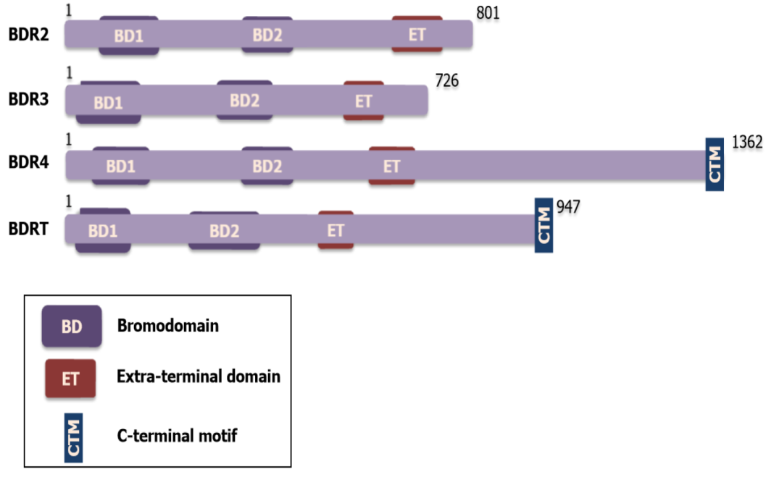
Figure 1 Schematic of basic domain structure of Bromodomain and extra-terminal protein family; BRD2, BRD3, BRD4, and BRDT. Each Bromodomain and extra-terminal protein has two bromodomains (BD1 and BD2) and one extra-terminal domain. And BRD4 and BRDT specially contain a C-terminal motif. ET: Extra-terminal; BD: Bromodomain.
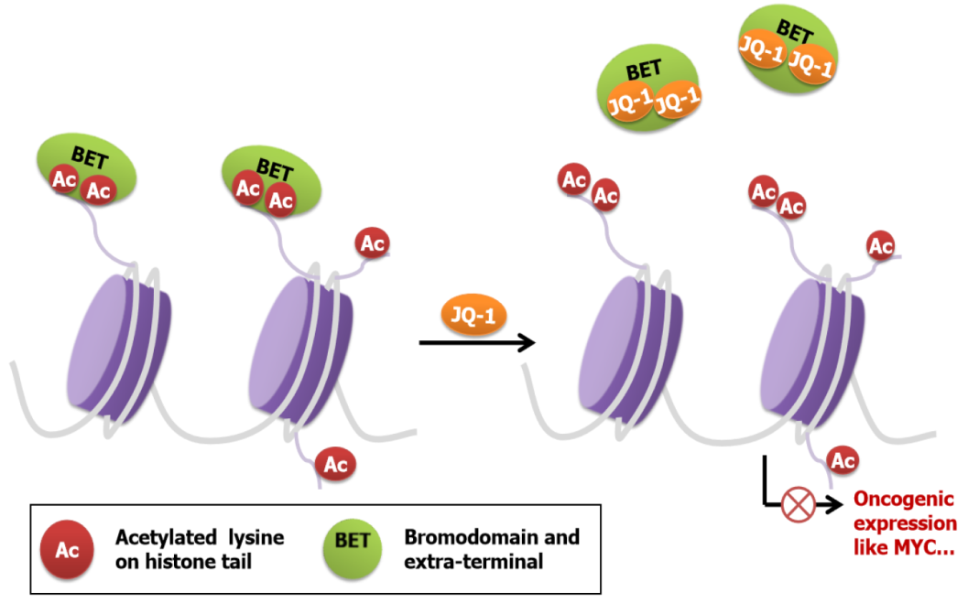
Figure 2 Schematic of the mechanism of the action of Bromodomain and extra-terminal inhibitors. Upon Bromodomain and extra-terminal (BET) inhibitors binding to Bromodomains, BET proteins are displaced from chromatin. Lacking domains directly interacting with chromatin, BET proteins fail to activate oncogenes, and thus BET inhibitors exert cytotoxic effects on cancer cells. BET: Bromodomain and extra-terminal.
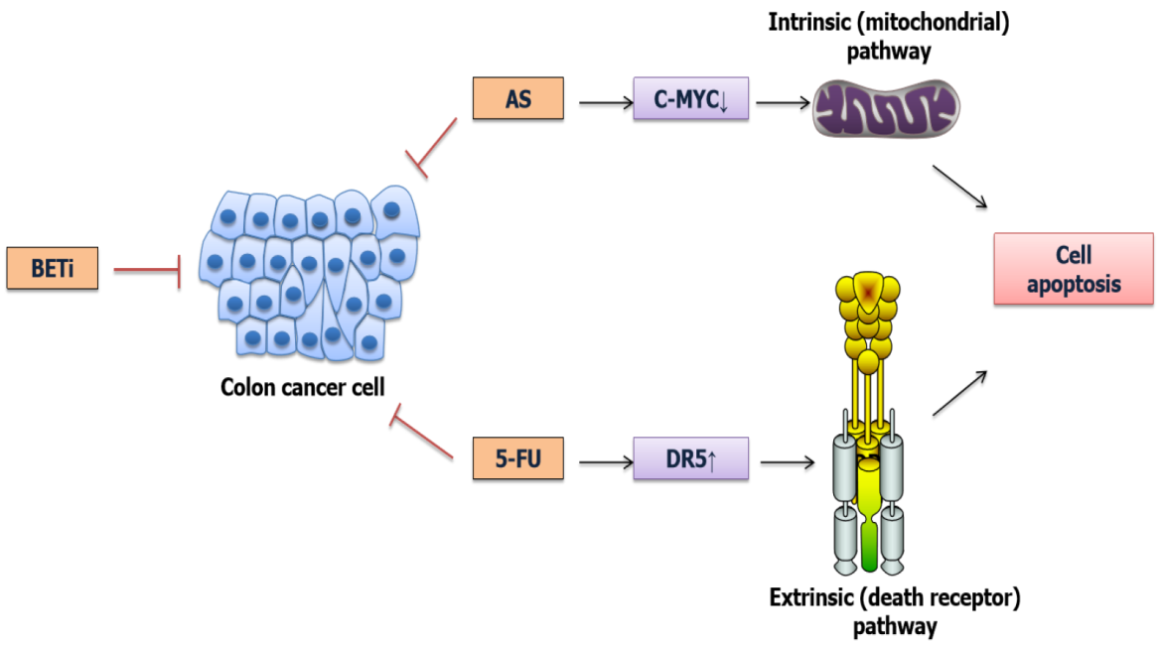
Figure 3 Schematic of Bromodomain and extra-terminal inhibitors enhancing chemotherapy effect through apoptosis induction. Bromodomain and extra-terminal (BET) inhibitors and arsenic sulfide exert synergistic cytotoxicity via down-regulating c-MYC and induce cell apoptosis in an intrinsic (mitochondrial) pathway; while BET inhibitors in combination with 5-Fluorouracil mediate apoptosis in a death receptor 5-depedent manner which is regulated in extrinsic(death receptor) pathway. BET: Bromodomain and extra-terminal; AS: Arsenic sulfide; 5-FU: 5-fluorouracil; DR5: Death receptor 5; c-MYC: Cellular-myelocytomatosis.
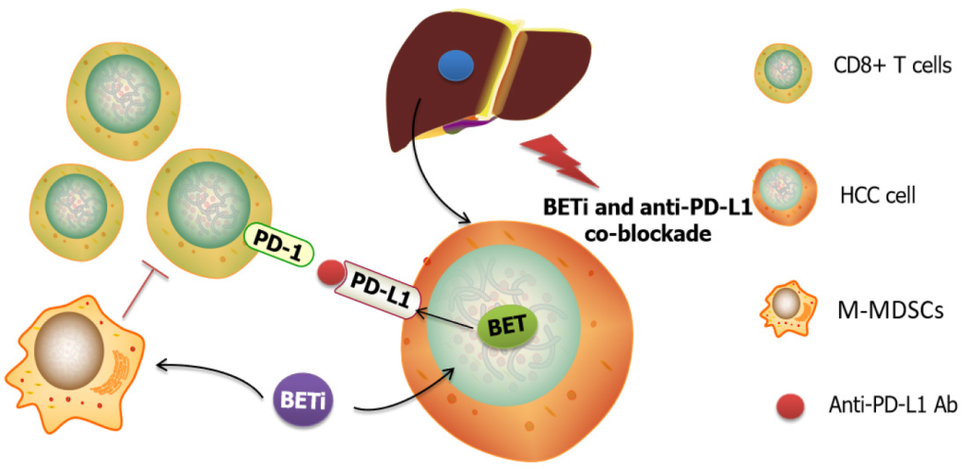
Figure 4 Schematic of Bromodomain and extra-terminal inhibitors combined with anti-programmed death-1-ligand-1 Ab therapeutic effects. Bromodomain and extra-terminal (BET) inhibitors treatment impacts programmed death-1-ligand-1 (PD-L1) expression, resulting in sensitizing the liver response to anti-PD-L1 blockade. Also, the co-inhibition can inhibit liver-infiltrating monocytic myeloid-derived suppressor cells and enhance tumor-infiltrating CD8+ T cells, which contributes to the elimination of drug resistance. BET: Bromodomain and extra-terminal; HCC: Hepatocellular carcinoma; M-MDSCs: Monocytic myeloid-derived suppressor cells; PD-L1: Programmed death-1-ligand-1.
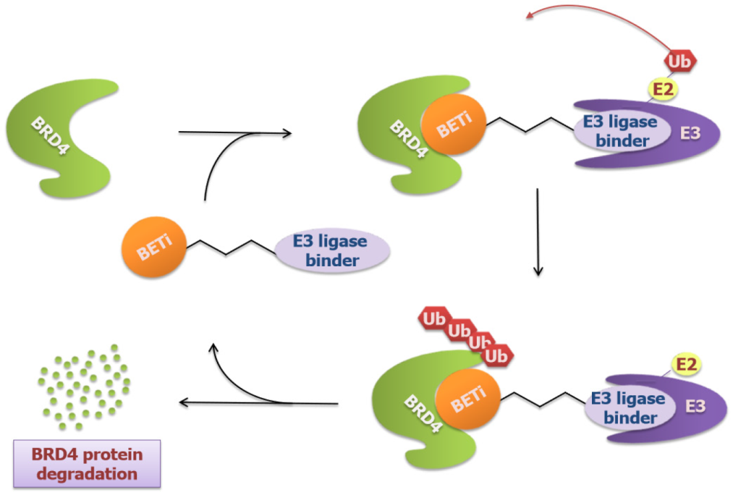
Figure 5 Schematic of new Bromodomain and extra-terminal molecules targeting Bromodomain-containing protein 4 using PROTACs technology. The bifunctional molecules contain two binders with one (usually bromodomain and extra-terminal inhibitors like JQ-1 or OTX015) targeting Bromodomain-containing protein 4 (BRD4) and the other binding E3 Ligase, which triggers the ubiquitination and degradation of BRD4. BRD4: Bromodomain-containing protein 4.
Table 1 Preclinical models of Bromodomain and extra-terminal inhibitors in gastrointestinal cancers
GI cancers models | BET inhibitors | Combination with | Targets | Pathway/mechanism | Ref.
CRC | JQ-1 | 5-FU | DR5 | Apoptosis | ^{[49]}
 | JQ-1 | Bortezomib | MYC, FOXM1 | G2/M arrest | ^{[47]}
 | JQ-1 | - | HGF, MET | Cancer-associated fibroblasts | ^{[98]}
 | Apabetalone | - | APOA1 | Intracellular cholesterol metabolism | ^{[99]}
 | JQ-1 | BEZ235 (PI3K/mTOR inhibitor) | RTKs | Overcome resistance to PI3K/mTOR inhibition | ^{[40]}
 | JQ-1 | Sulforaphane (HDAC3 inhibitor) | ERCC2 | Nucleotide excision repair pathway | ^{[48]}
 | I-BET151, bromosporine | - | BRD4, SNAIL, SLUG | EMT | ^{[100]}
SMAD4-defificient CRC | OTX-015 | - | MYC | MYC-p21 axis, G1 cell cycle arrest | ^{[54]}
Colon cancer | JQ-1 | - | Nkd2, β-catenin, miR-21 | Wnt/β-catenin signaling, apoptosis | ^{[45]}
Gastric and colon cancer | JQ-1 | Arsenic sulfide | NFATs, c-MYC | Mitochondrial pathway induced cell apoptosis | ^{[51]}
PDAC | JQ-1 | - | HMGA2 | Block growth of chemoresistant cells | ^{[55]}
 | JQ-1 | Olaparib (PARP inhibitor) | BRD2/4, Ku80, RAD51 | DNA damage | ^{[60]}
 | JQ-1 | SAHA (HDAC inhibitor) | p57 | Cell death | ^{[61]}
 | JQ-1 | Gemcitabine | HMGCS2, APOC1 | DNA damage and apoptosis | ^{[62]}
 | CPI203 | - | MYC, GLI, SHH | SHH-GLI signaling pathway, cell cycle progression | ^{[24]}
Pancreatic cancer | JQ-1, OTX-015 | Quercetin | BRD4(JQ-1) and hnRNPA1(Quercetin) | Apoptosis | ^{[63]}
KDM6A null pancreatic cancer | JQ-1 | - | MYC, p63, RUNX3 | Reverse squamous differentiation | ^{[101,102]}
Liver cancer | JQ-1 | - | BRD4, E2F2 | BRD4-E2F2-cell cycle regulation axis | ^{[34]}
 | JQ-1 | - | PD-L1, PD-L2 | PD-1/PD-L1 signaling | ^{[71]}
HCC | JQ-1, I-BET762 | Anti-PD-L1 Ab | BRD4, C/EBPβ, p300 | Suppress M-MDSCs, enhance PD-L1 blockade efficacy | ^{[73]}
 | JQ-1 | - | MYC | Impair mitochondrial respiration and glycolysis, induce apoptosis | ^{[66]}
 | Hjp-6-171 | GSK3β inhibitor (CHIR-98014) | β-catenin, NOTUM | WNT pathway | ^{[68]}
 | SF1126 (Pan PI3K/BRD4 Inhibitor) | Sorafenib | BRD4, c-MYC | Ras/Raf/MAPK, PI3K/AKT/mTOR pathways | ^{[90]}
 | JQ-1 | - | PES1 | Cell proliferation, glycolysis | ^{[35]}
 | JQ-1 | Flavopiridol | Mcl-1 | Apoptosis | ^{[67]}
 | JQ-1, OTX-015 | - | SMARCA4 | Down-regulate migration related genes | ^{[65]}
CCA2 | JQ-1 | PI3K/mTOR inhibitors | c-Myc, YAP | Overcome resistance to PI3K/mTOR inhibition | ^{[64]}
Gastric cancer | JQ-1 | - | BRD4, E2F | E2F/miR-106b-5p/p21 axis, cellular senescence | ^{[32]}
 | JQ-1 | - | RUNX2 | RUNX2/NID1 signaling, site-specific chromatin  remodeling | ^{[75]}
 | JQ1, PNZ5 | - | c-MYC | Apoptosis | ^{[33,74]}
 | iBET-151 | Paclitaxel | RTK | G1 cell cycle arrest | ^{[79]}
 | AZD5153 | - | Sirt5, Mus81 | Sirt5/Mus81/ZEB1 axis, inhibit metastasis | ^{[76]}
GAC | JQ-1 | CA3 (YAP inhibitor) | c-MYC | Gal3/RalA/YAP1/c-MYC axis | ^{[78]}
CRC: Colorectal cancer; PDAC: Pancreatic ductal adenocarcinoma; HCC: Hepatocellular carcinoma; CCA: Cholangiocarcinoma; GAC: Gastric adenocarcinoma; 5-FU: 5-fluorouracil; c-MYC: Cellular-myelocytomatosis.
Table 2 Clinical trials of Bromodomain and extra-terminal inhibitors in gastrointestinal cancers (Trial ID on www.clinicaltrials.gov)
Drug | Combination with | Condition | Status | Clinical phase | Trial ID
INCB054329 | - | Solid Tumors and Hematologic Malignancy (CRPC, BC, HGSC, CRC, Ewing sarcoma, Pancreatic adenocarcinoma, AML, MDS, MF, MM) | Terminated due to PK variability | Phase I/II | NCT02431260
INCB057643 | Gemcitabine; Paclitaxel; Rucaparib; Abiraterone; Ruxolitinib; Azacitidine | Solid Tumors (CRPC, BC, HGSC, CRC, Glioblastoma multiforme, Ewing sarcoma, Pancreatic adenocarcinoma, AML, MDS) | Terminated due to safety issues | Phase I/II | NCT02711137
AZD5153 | Olaparib | Malignant Solid Tumors, Lymphoma, Ovarian Cancer, Breast Cancer, Pancreatic Cancer, Prostate Cancer | Active, not recruiting | Phase I | NCT03205176
I-BET762 (Molibresib, GSK525762) | Entinostat | Solid tumors (Advanced Malignant Solid Neoplasm, Refractory Malignant Solid Neoplasm, Refractory Pancreatic Carcinoma, Stage II/IIA/IIB/III/IV Pancreatic cancer AJCC v8, Unresectable Pancreatic Carcinoma) or Lymphomas | Withdrawn (Other-Protocol moved to Disapprove) | Phase I | NCT03925428
SF1126 | - | Advanced Hepatocellular Carcinoma | Active, not recruiting | Phase I | NCT03059147

Published by Baishideng Publishing Group Inc
7041 Koll Center Parkway, Suite 160, Pleasanton, CA 94566, USA
Telephone: +1-925-3991568
E-mail: bpgoffice@wjgnet.com
Help Desk: https://www.f6publishing.com/helpdesk
https://www.wjgnet.com

© 2022 Baishideng Publishing Group Inc. All rights reserved.

