Name of Journal: World Journal of Clinical Cases
Manuscript NO: 68865
Manuscript Type: CASE REPORT

Ethambutol-induced optic neuropathy with rare bilateral asymmetry onset: A case report

Sheng WY et al. Asymmetric-onset ethambutol-induced optic neuropathy

Wen-Yan Sheng, Shuang-Qing Wu, Ling-Ya Su, Li-Wei Zhu

Wen-Yan Sheng, Shuang-Qing Wu, Ling-Ya Su, Li-Wei Zhu, Department of Ophthalmology, Affiliated Hangzhou Chest Hospital, Zhejiang University School of Medicine, Hangzhou 310003, Zhejiang Province, China

Author contributions: Sheng WY was the patient’s ophthalmologist, reviewed the literature and contributed to manuscript drafting; Wu SQ reviewed the literature and contributed to manuscript drafting; Su LY performed the examinations and collected all the data; Zhu LW was responsible for revision of the manuscript for important intellectual content; all authors issued final approval for the version to be submitted.

Supported by the Hangzhou Science and Technology Development Project, No. 20170533B70.

Corresponding author: Li-Wei Zhu, MD, Chief Doctor, Department of Ophthalmology, Affiliated Hangzhou Chest Hospital, Zhejiang University School of Medicine, 208 Huancheng Road East, Gongshu District, Hangzhou 310003, Zhejiang Province, China. zlwgsy1995@126.com

Received: June 7, 2021
Revised: July 12, 2021
Accepted: December 8, 2021
Published online: January 14, 2022

Abstract
BACKGROUND
Ethambutol-induced optic neuropathy (EON) most commonly manifests as bilateral symmetrical loss of vision and often cause serious and irreversible visual impairment because of the lack of early detection and effective treatment. We followed a case of EON with rare binocular asymmetric clinical manifestations and observed the changes of visual function and retinal structure after drug withdrawal, so as to further understand the clinical characteristics of this disease.

CASE SUMMARY
A 54-year-old man complained of gradual visual decline in the left eye. The patient presented with best-corrected visual acuity of 20/20 in the right eye and 20/50 in the left eye. Color vision examination revealed difficulty in reading green color plates in the left eye. The visual field manifested as concentric contraction in the left eye. After nearly a month of drug withdrawal, the right eye had a similar decline in visual function. At the last visit, 19 mo after drug withdrawal, the visual function significantly recovered in both eyes. During follow-up optical coherence tomography (OCT) examination, both eyes manifested the thickness of the retinal nerve fiber layer from mild thickening to thinning and finally temporal atrophy, and the ganglion cell-inner plexiform layer showed significant thinning. The difference was that a reversible structural disorder in the outer retina of the nasal macula was detected in the left eye by macular high-definition OCT.

CONCLUSION
Nephropathy and high blood pressure, which damage the retinal microcirculation, may cause damage to the outer layer of the retina. Ethambutol may influence photoreceptor as well as retinal ganglion cells.

Key Words: Ethambutol-induced optic neuropathy; Retinal nerve fiber layer; Ganglion cell-inner plexiform layer; Optical coherence tomography; Asymmetry; Case report

©The Author(s) 2022. Published by Baishideng Publishing Group Inc. All rights reserved.

Citation: Sheng WY, Wu SQ, Su LY, Zhu LW. Ethambutol-induced optic neuropathy with rare bilateral asymmetry onset: A case report. World J Clin Cases 2022; 10(2): 663-670
URL: https://www.wjgnet.com/2307-8960/full/v10/i2/663.htm
DOI: https://dx.doi.org/10.12998/wjcc.v10.i2.663

Core Tip: Ethambutol-induced optic neuropathy is most commonly characterized by bilateral symmetrical loss of vision, but it may also occur successively in both eyes. Ethambutol may influence retinal photoreceptor cells and retinal ganglion cells.

INTRODUCTION
Ethambutol is an antimycobacterial agent that is most commonly used in combination with other drugs for the treatment of diseases, including tuberculosis, Mycobacterium avium complex, and other species in the Mycobacterium genus. However, a common and devastating adverse effect of this drug is ethambutol-induced optic neuropathy (EON), which can lead to permanent loss of visual function^{[1]}. It is currently reported that 1%-2% of patients receiving ethambutol may develop EON^{[2]}. Globally, there are nearly 9.2 million new cases of tuberculosis annually, and approximately 100000 patients annually develop toxic optic neuropathy due to ethambutol treatment^{[3]}. The clinical manifestations of EON are characterized by subacute, symmetrical, painless loss of vision, with color vision dysfunction and visual field defects. There are few reports on bilateral asymmetry onset and manifestation of EON cases. Here, we present a case of EON with bilateral asymmetric manifestations over 19 mo. A full battery of objective and subjective tests was performed. These tests show how the condition changes in detail.

CASE PRESENTATION
Chief complaints
A 54-year-old male patient was admitted to the Department of Ophthalmology of Affiliated Hangzhou Chest Hospital, Zhejiang University School of Medicine (Hangzhou, Zhejiang Province, China), on September 1, 2019. The patient complained of gradual painless loss of vision in the left eye for 5 mo.

History of present illness
The patient had been diagnosed with tuberculosis of thoracic vertebrae 10 mo earlier in the Tuberculosis Department. Because this patient suffered from renal failure, the tuberculologist did not use an intensive treatment plan. He received daily combination treatment consisting of 750 mg ethambutol (11.5 mg/kg), 600 mg rifampin, and 300 mg isoniazid. After 2 wk, the patient had an allergic rash and drug-induced liver damage, so rifampin was discontinued. Therefore, the patient was finally treated with ethambutol and isoniazid for 10 mo, until loss of vision developed and he came to the ophthalmology clinic.

History of past illness
The patient had a history of renal dysfunction and renal hypertension (blood pressure 160/98 mmHg) for about 10 years, and he had been undergoing abdominal dialysis treatment for up to 8 years. He had no history of diabetes or any other eye diseases. The patient complained that he could correctly judge the traffic lights before the onset of the disease and denied a history of color vision dysfunction.

Personal and family history
The patient was married and had a son. His grandparents, parents and son did not have similar episodes of loss of vision. He denied smoking and alcohol consumption.

Physical examination
At the first visit, the best-corrected visual acuity was 20/20 in the right eye and 20/50 in the left eye. Color vision examination with Ishihara color plates revealed a difficulty in reading green color plates in the left eye. Pupillary reactions were normal with no relative afferent pupillary defect. Intraocular pressure was 15 and 14 mmHg with applanation tonometry. Slit-lamp microscopy of the bilateral anterior segments did not reveal any abnormality. Fundus examination showed normal appearance of the disk in both eyes (Figure 1). The Humphrey Field Analyzer (with SITA-FAST strategy and C30-2 program; Carl Zeiss Meditec, Dublin, CA, USA) was used for visual field examination. Concentric contraction was observed in the left eye, and there was no obvious visual field defect in the right eye (Figure 2).

Laboratory examinations
The renal function was abnormal: urea nitrogen 26.51 mmol/L (normal range 3.1-8.8 mmol/L), creatinine 1123.9 μmol/L (normal range 44-133 μmol/L), uric acid 359 mmol/L (normal range 90-420 mmol/L).

Imaging examinations
Cranial and orbit magnetic resonance examinations did not show any abnormal lesions. Cirrus high-definition optical coherence tomography (OCT) (Carl Zeiss Meditec) examination showed that, in the left eye, the peripapillary retinal nerve fiber layer (p-RNFL) slightly increased on the temporal side (Figure 3), and the thickness of the ganglion cell layer and inner plexiform layer (GCIPL) decreased (Figure 4). In the right eye, GCIPL was normal, but the thickness of p-RNFL increased on the inferior, superior and temporal sides. We found that the outer nuclear layer under the fovea and outer reflection bands representing the photoreceptor cells of the left eye were blurred (mainly the ellipsoid zone and intersection area), and the damaged intersection area was mainly on the nasal side of the macula (Figure 5).

FINAL DIAGNOSIS
EON, based on ocular examination and clinical findings

TREATMENT
Treatment with ethambutol and isoniazid was immediately discontinued, and the patient received oral administration of vitamin B12, vitamin C, and mecobalamin for 6 mo.

OUTCOME AND FOLLOW-UP
At nearly 1 mo after discontinuation of ethambutol, the visual function in both eyes had deteriorated further. The best-corrected visual acuity was 20/50 in the right eye and 20/200 in the left eye. The color vision test revealed that both red and green were indistinguishable in the left and right eyes. At the third visit, 6 mo after discontinuation of ethambutol, the best-corrected visual acuity was 20/80 in the right eye and 20/200 in the left eye. Color vision examination remained red and green dyschromatopsia in both eyes. At the fourth visit, 19 mo after discontinuation of ethambutol, the best-corrected visual acuity improved to 20/20 in the right eye and 20/50 in the left eye. Color vision examination also showed recovery; only some pictures with green color were indistinguishable in both eyes.

DISCUSSION
The exact pathophysiological mechanism underlying EON is still unclear, although it may be caused by disrupted oxidative phosphorylation secondary to decreased available copper in the human mitochondria, or from inhibited lysosomal activation due to zinc chelation^{[4]}. There have been studies stating that EON is a dose- and time-dependent adverse effect^{[5]}. The frequency of visual impairment has been reported in 50% of patients at a dose of 60-100 mg/kg/d, 5%-6% at 25 mg/kg/d, and 1% at 15 mg/kg/d. Visual loss is typically insidious and symmetrical, occurring typically 2-8 mo after initiation of therapy^{[6]}. However, a controlled study of 231 patients found that age > 65 years, hypertension, and kidney disease were also risk factors for the development of EON^{[2,7]}.
In > 60% of patients with EON, ocular examination reveals bilateral, painless and typically symmetric loss of visual acuity and abnormal color vision^{[8]}. However, the onset may be unilateral, but eventually both eyes are involved^{[1]}. Loss of color vision is typically reported for green and red, although blue–yellow color changes may also occur^{[9,10]}. Initially, the optic disc may appear normal; however, as the disease progresses, it eventually develops into a pale optic disc^{[11,12]}. Visual field test usually reveals central or paracentral scotoma and less commonly includes peripheral constriction, altitudinal field defects, and bilateral temporal field defects^{[13]}. The diagnosis of EON is based on the identification of a toxic factor and exclusion of other pathologies exhibiting a similar clinical profile. Differential diagnoses include Leber’s hereditary optic neuropathy, dominantly inherited optic neuropathy, compressive or infiltrative lesion of optic chiasm, bilateral inflammatory or demyelinative optic neuropathy, maculopathies/macular dystrophy. Often, visual loss from EON can be regained after stopping the drug. The amount and time frame for visual recovery varies. If detected early and with prompt discontinuation of ethambutol, between 30% and 64% of patients show some improvement in their visual disturbances over a period of several months. However, even in patients who report improvement after therapy discontinuation, complete recovery is not always achieved^{[14]}. Progressive worsening of vision after ethambutol discontinuation has also been documented^{[15]}.
In this report, the patient was referred to the ophthalmology department after 10 mo of antituberculosis therapy with a gradual painless loss of vision in the left eye for 5 mo. At the first visit, color visual dysfunction and visual field defects were detected only in the left eye. OCT examinations showed that the RNFL had a slight thickening and the thickness of GCIPL became thinner. Magnetic resonance imaging of the head and orbital optic nerves was normal. Although the present patient could not be checked for any mitochondrial DNA mutations, but combined with the patient’s medication history and clinical manifestations, we diagnosed EON. Although the patient was within the safe dose range, toxic optic neuropathy occurred and was attributed to renal dysfunction.
In the reported case, the eyes were asymmetric. The left eye had visual impairment 6 mo earlier than the right eye. At the second visit after nearly a month, the right eye showed the same visual dysfunction with a normal appearance of the optic disc. OCT examination of the right eye showed thinning of the GCIPL and mild thickening of the RNFL. The difference was that the macular high-definition scan of the left eye revealed structural damage to the outer nuclear layer, ellipsoid zone, and interdigitation zone mainly on the nasal side of the macula. After treatment, the macular lesions gradually disappeared, but there was no similar change in the right eye throughout follow-up.
OCT measurement of the RNFL are effective tools for the evaluation of optic neuropathies. Reports on the thickness of RNFL in EON are inconsistent^{[16-19]}. These discrepancies may be attributed to different stages of the disease in the examined patients. Several studies have reported that the GCIPL was significantly thinner in patients with EON and suggested that, whether the p-RNFL was swollen or atrophic, loss of ganglion cells in the macular region had occurred^{[20-22]}. As reported, retinal ganglion cells located in the papillomacular bundle have narrow caliber axons, rendering them even more susceptible to mitochondrial dysfunction, and contribute to RNFL atrophy on the temporal side and thinning of the GCIPL^{[20]}. The RNFL and GCIPL changes in this patient were consistent with these reports.
The ellipsoid zone is composed of the inner section of the photoreceptors. The interdigitation zone is the chimera between the tip of the outer section of the photoreceptor and the microvilli on the top of the retinal pigment epithelial cells. Therefore, the macular lesion in the left eye of this patient was located in the outer layer of the macula, especially the photoreceptor layer. There is a rare disease named acute macular neuro-retinopathy (AMNR) that has similar structural manifestations on OCT examination. AMNR is a rare unilateral or bilateral macular disorder. OCT images showed focal abnormalities in the photoreceptor outer segments. The pathogenesis of the disease is still unclear. The main related factors reported so far include oral contraceptives, viral infections, adrenergic receptor agonists, trauma, and chronic kidney disease^{[23,24]}. However, this patient does not completely rule out the presence of AMNR-like lesions in the left eye, but AMNR typically occurs in young women presenting with sudden onset of central scotomas^{[25]}. They correspond to sharp reddish-brown areas in the macular region. These were inconsistent with the characteristics of our case.
Ethambutol poisoning causes mitochondrial dysfunction. Although the literature describes ethambutol toxicity mainly as a neuropathy, histopathological and electrophysiological evidence supports the involvement of different retinal cell layers^{[26]}. In this regard, we consider that he had nephropathy and high blood pressure, which damaged the retinal microcirculation, resulting in insufficient blood supply to the outer layer of the retina, and damage to the outer layer of the retina. The damage to the macula may be an important factor influencing the recovery.
After withdrawal of ethambutol for as long as 19 mo, the visual function partly recovered. The thickness of the GCIPL and RNFL on the temporal side was apparently lower than normal. A previous study also reported that, even if a patient with EON can regain 1.0 visual acuity, their visual function may not recover completely^{[27]}. Improvement in visual acuity as the nerve fiber layer progressively thinned suggests that, while some axons had irreversible damage and underwent apoptosis, the function of the remaining axons improved as the toxic effect of ethambutol waned. Presumably some axons, including those in the papillomacular bundle, did not reach a threshold for apoptosis and were able to survive and partly recover function.
There is currently no effective treatment for EON. Drug discontinuation is the only effective management that can halt the progression of visual loss and allow recovery of vision. Some authors recommend treating patients with 100-250 mg oral zinc sulfate three times per day. If vision does not improve at 10-15 wk after stopping ethambutol, parenteral administration of 40 mg/d hydroxycobalamine (vitamin B12) for 1-28 wk has been suggested^{[26]}.

CONCLUSION
EON can occur even in cases of low-dose ethambutol administration in patients with renal dysfunction. EON is most commonly characterized by bilateral symmetrical loss of vision but may also occur successively. This report highlights the need for identification of patients at risk, adjusting the dose regimen for impaired renal function, regular monitoring for early signs of ocular toxicity, and patient education.

REFERENCES
1 Koul PA. Ocular toxicity with ethambutol therapy: Timely recaution. Lung India 2015; 32: 1-3 [PMID: 25624586 DOI: 10.4103/0970-2113.148395]
2 Chen SC, Lin MC, Sheu SJ. Incidence and prognostic factor of ethambutol-related optic neuropathy: 10-year experience in southern Taiwan. Kaohsiung J Med Sci 2015; 31: 358-362 [PMID: 26162816 DOI: 10.1016/j.kjms.2015.05.004]
3 Sadun AA, Wang MY. Ethambutol optic neuropathy: how we can prevent 100,000 new cases of blindness each year. J Neuroophthalmol 2008; 28: 265-268[PMID: 19145122 DOI: 10.1097/WNO.0b013e31818f138f]
4 Chamberlain PD, Sadaka A, Berry S, Lee AG. Ethambutol optic neuropathy.Curr Opin Ophthalmol 2017; 28: 545-551 [PMID: 28759559 DOI: 10.1097/ICU.0000000000000416]
5 Yang HK, Park MJ, Lee JH, Lee CT, Park JS, Hwang JM. Incidence of toxic optic neuropathy with low-dose ethambutol. Int J Tuberc Lung Dis 2016; 20: 261-264 [PMID: 26792482 DOI: 10.5588/ijtld.15.0275]
6 Wang MY, Sadun AA. Drug-related mitochondrial optic neuropathies. J Neuroophthalmol 2013; 33: 172-178 [PMID:23681241 DOI: 10.1097/WNO.0b013e3182901969]
7 Santaella RM, Fraunfelder FW. Ocular adverse effects associated with systemic medications: recognition and management. Drugs 2007; 67: 75-93 [PMID: 17209665 DOI: 10.2165/00003495-200767010-00006]
8 Lee EJ, Kim SJ, Choung HK, Kim JH, Yu YS. Incidence and clinical features of ethambutol-induced optic neuropathy in Korea. J Neuroophthalmol 2008; 28: 269-277 [PMID: 19145123 DOI: 10.1097/WNO.0b013e31818e3c6b]
9 Ezer N, Benedetti A, Darvish-Zargar M, Menzies D. Incidence of ethambutol-related visual impairment during treatment of active tuberculosis. Int J Tuberc Lung Dis 2013; 17: 447-455 [PMID: 23394767 DOI: 10.5588/ijtld.11.0766]
10 Woung LC, Jou JR, Liaw SL. Visual function in recovered ethambutol optic neuropathy. J Ocul Pharmacol Ther 1995; 11: 411-419 [PMID: 8590273 DOI: 10.1089/jop.1995.11.411]
11 Polak BC, Leys M, van Lith GH. Blue-yellow colour vision changes as early symptoms of ethambutol oculotoxicity. Ophthalmologica 1985; 191: 223-226 [PMID: 4088610 DOI: 10.1159/000309592]
12 Chai SJ, Foroozan R. Decreased retinal nerve fibre layer thickness detected by optical coherence tomography in patients with ethambutol-induced optic neuropathy. Br J Ophthalmol 2007; 91: 895-897 [PMID: 17215265 DOI: 10.1136/bjo.2006.113118]
13 Kim U, Hwang JM. Early stage ethambutol optic neuropathy: retinal nerve fiber layer and optical coherence tomography. Eur J Ophthalmol 2009; 19: 466-469 [PMID: 19396796 DOI: 10.1177/112067210901900323]
14 Kho RC, Al-Obailan M, Arnold AC. Bitemporal visual field defects in ethambutol-induced optic neuropathy. J Neuroophthalmol 2011; 31: 121-126 [PMID: 21597402 DOI: 10.1097/WNO.0b013e318205a148]
15 Tsai RK, Lee YH. Reversibility of ethambutol optic neuropathy. J Ocul Pharmacol Ther 1997; 13: 473-477 [PMID: 9326729 DOI: 10.1089/jop.1997.13.473]
16 Sivakumaran P, Harrison AC, Marschner J, Martin P. Ocular toxicity from ethambutol: a review of four cases and recommended precautions. N Z Med J 1998; 111: 428-430 [PMID: 9861923]
17 Zoumalan CI, Agarwal M, Sadun AA. Optical coherence tomography can measure axonal loss in patients with ethambutol-induced optic neuropathy. Graefes Arch Clin Exp Ophthalmol 2005; 243: 410-416 [PMID: 15565293 DOI: 10.1007/s00417-004-1053-1]
18 Zoumalan CI, Sadun AA. Optical coherence tomography can monitor reversible nerve-fibre layer changes in a patient with ethambutol-induced optic neuropathy. Br J Ophthalmol 2007; 91: 839-840 [PMID: 17510481 DOI: 10.1136/bjo.2006.107326]
19 Menon V, Jain D, Saxena R, Sood R. Prospective evaluation of visual function for early detection of ethambutol toxicity. Br J Ophthalmol 2009; 93: 1251-1254 [PMID: 19525243 DOI: 10.1136/bjo.2008.148502]
20 Kim YK, Hwang JM. Serial retinal nerve fiber layer changes in patients with toxic optic neuropathy associated with antituberculosis pharmacotherapy. J Ocul Pharmacol Ther 2009; 25: 531-535 [PMID: 20028260 DOI: 10.1089/jop.2009.0064]
21 Lee JY, Han J, Seo JG, Park KA, Oh SY. Diagnostic value of ganglion cell-inner plexiform layer for early detection of ethambutol-induced optic neuropathy. Br J Ophthalmol 2019; 103: 379-384 [PMID: 29699978 DOI: 10.1136/bjophthalmol-2018-312063]
22 Lee JY, Choi JH, Park KA, Oh SY. Ganglion Cell Layer and Inner Plexiform Layer as Predictors of Vision Recovery in Ethambutol-Induced Optic Neuropathy: A Longitudinal OCT Analysis. Invest Ophthalmol Vis Sci 2018; 59: 2104-2109 [PMID: 29677374 DOI: 10.1167/iovs.17-22988]
23 Peng CX, Zhang AD, Chen B, Yang BJ, Wang QH, Yang M, Wei SH. Macular thickness as a predictor of loss of visual sensitivity in ethambutol-induced optic neuropathy. Neural Regen Res 2016; 11: 469-475 [PMID: 27127488 DOI: 10.4103/1673-5374.179061]
24 Miller MH, Spalton DJ, Fitzke FW, Bird AC. Acute macular neuroretinopathy. Ophthalmology 1989; 96: 265-269 [PMID: 2704546 DOI: 10.1016/s0161-6420(89)32906-x]
25 Li M, Zhang X, Ji Y, Ye B, Wen F. Acute Macular Neuroretinopathy in Dengue Fever: Short-term Prospectively Followed Up Case Series. JAMA Ophthalmol 2015; 133: 1329-1333 [PMID: 26269969 DOI: 10.1001/jamaophthalmol.2015.2687]
26 Maschi C, Schneider-Lise B, Paoli V, Gastaud P. Acute macular neuroretinopathy: contribution of spectral-domain optical coherence tomography and multifocal ERG. Graefes Arch Clin Exp Ophthalmol 2011; 249: 827-831 [PMID: 21103887 DOI: 10.1007/s00417-010-1560-1]
27 Vistamehr S, Walsh TJ, Adelman RA. Ethambutol neuroretinopathy. Semin Ophthalmol 2007; 22: 141-146 [PMID: 17763233 DOI: 10.1080/08820530701457134]

Footnotes
Informed consent statement: Informed written consent was obtained from the patient for publication of this report and any accompanying images.

Conflict-of-interest statement: The authors declare that they have no conflict of interest.

CARE Checklist (2016) statement: The authors have read the CARE Checklist (2016), and the manuscript was prepared and revised according to the CARE Checklist (2016).

Open-Access: This article is an open-access article that was selected by an in-house editor and fully peer-reviewed by external reviewers. It is distributed in accordance with the Creative Commons Attribution NonCommercial (CC BY-NC 4.0) license, which permits others to distribute, remix, adapt, build upon this work non-commercially, and license their derivative works on different terms, provided the original work is properly cited and the use is non-commercial. See: http://creativecommons.org/Licenses/by-nc/4.0/

Manuscript source: Unsolicited manuscript

Peer-review started: June 7, 2021
First decision: June 25, 2021
Article in press: December 8, 2021

Specialty type: Medicine, research and experimental
Country/Territory of origin: China
Peer-review report’s scientific quality classification
Grade A (Excellent): 0
Grade B (Very good): B
Grade C (Good): C, C, C, C
Grade D (Fair): 0
Grade E (Poor): 0

P-Reviewer: Bains L, Fernandez Escamez CS, Marques JH, Naswhan AJ, Salimi M S-Editor: Chang KL L-Editor: A P-Editor: Chang KL

Figure Legends
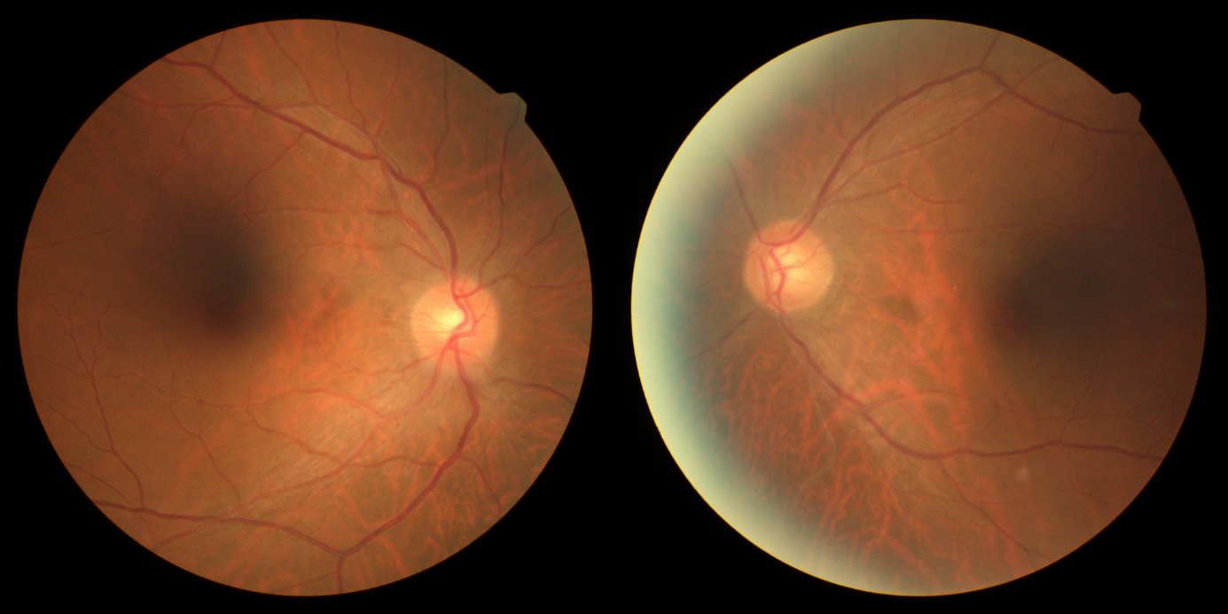
Figure 1 Color fundus photography at the initial visit. The optic disk of both eyes was normal at the initial visit.

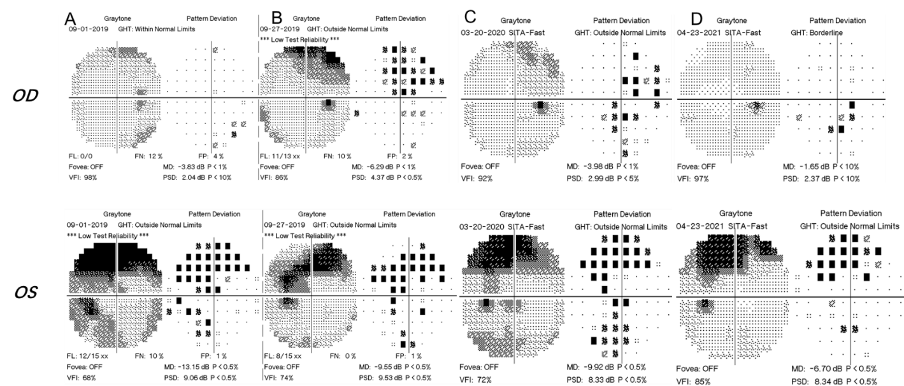
Figure 2 Computer perimetry results of four follow-up visits. A: At the initial visit, there were suspicious dark spots in the inferonasal region of the right eye, and the visual field defect of the left eye manifested as concentric contraction; B: At the second visit, visual field defects had worsened in the right eye; C: At the third visit, the defect showed progression in the left eye, but improved in the right eye; D: At the fourth visit, the visual field in both eyes improved.

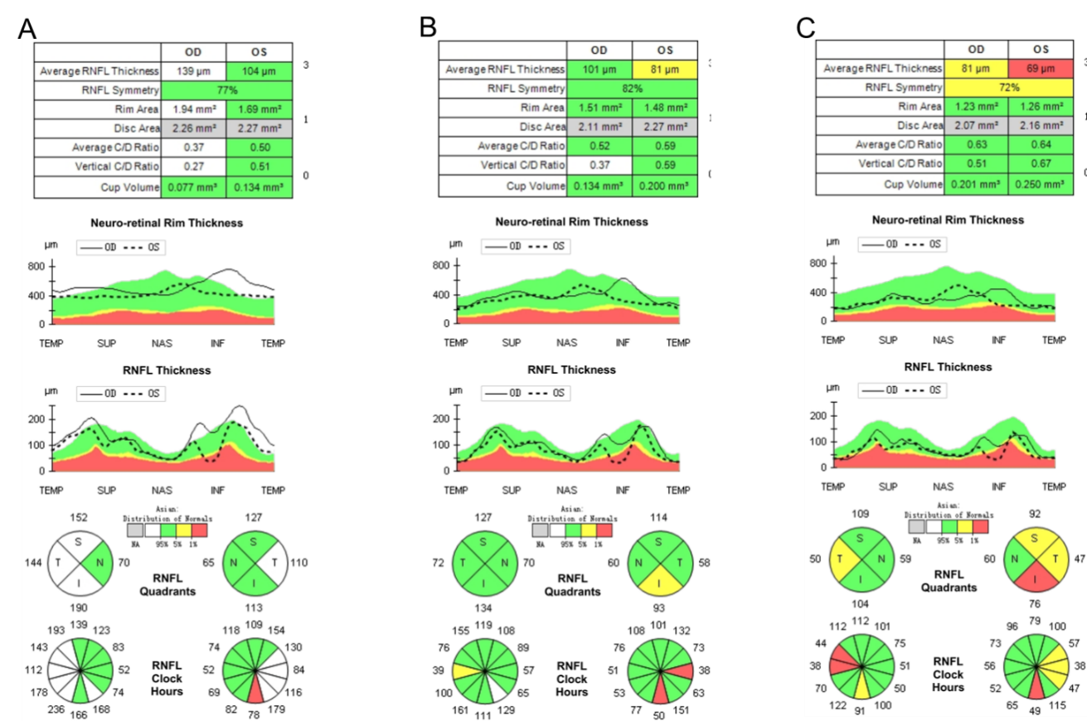
Figure 3 Retinal nerve fiber layer high-definition optical coherence tomography. A: At the first visit, the retinal nerve fiber layer (RNFL) of the right eye had mild thickening in the superior, inferior and nasal regions; the RNFL of the left eye had mild thickening on the temporal side; B: Six months after drug withdrawal, the RNFL of both eyes became thinner compared with the first visit; the RNFL of the right eye was within the normal range; and the average and inferior thicknesses of the RNFL in the left eye were lower than normal; C: Eighteen months after stopping drug treatment, the RNFL of both eyes further decreased, and the temporal side of both eyes became thinner significantly.

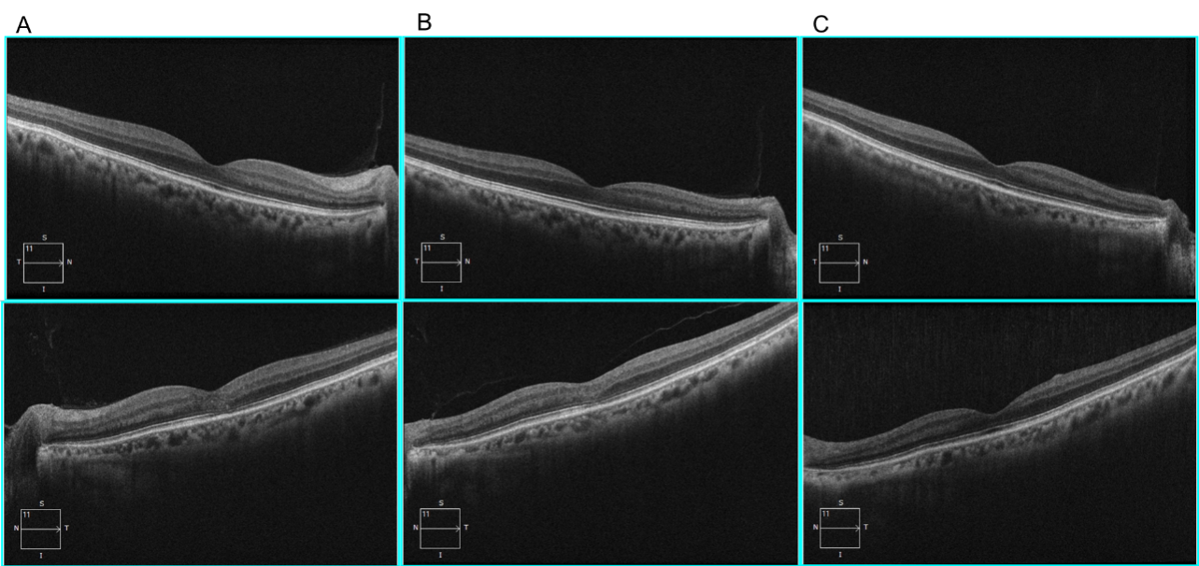
Figure 4 Outer nuclear layer high-definition optical coherence tomography. A: At the initial visit, the outer nuclear layer under the fovea and the outer reflection bands representing the photoreceptor cells of the left eye were blurred (mainly the ellipsoid zone and the intersection area), and the damaged intersection area was mainly on the nasal side of the macula; B: Six months after drug withdrawal, compared with the first visit, the structure of the outer nuclear layer and ellipsoid zone of the macula had partially recovered; C: Eighteen months after drug withdrawl, the structure of the outer nuclear layer and the ellipsoid zone of the macula had recovered to normal appearance.
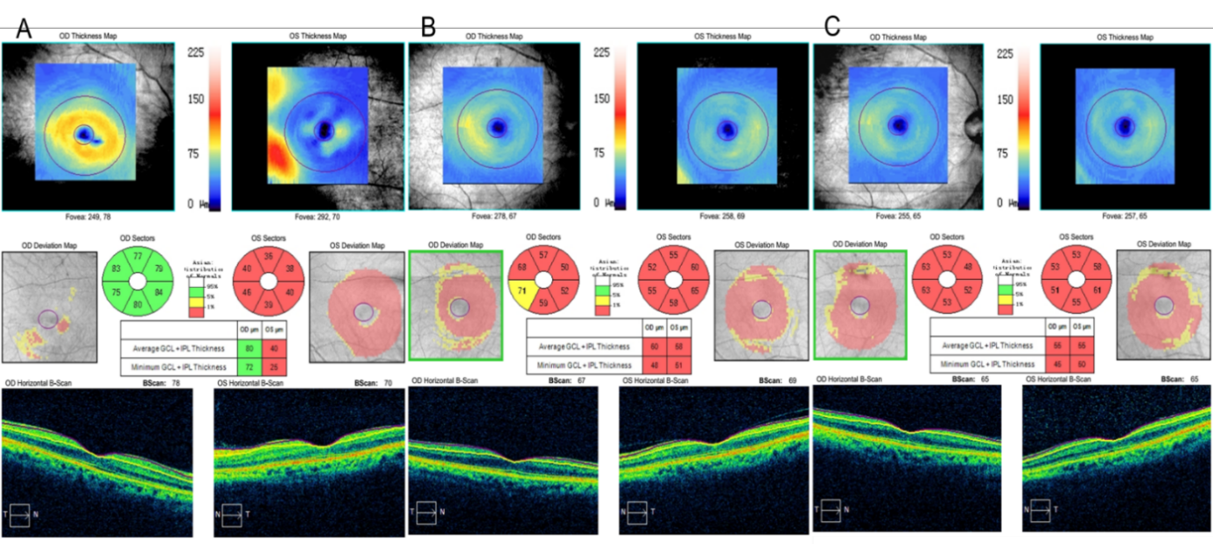
Figure 5 Ganglion cell layer and inner plexiform layer high-definition optical coherence tomography. A: At the first visit, the thickness of ganglion cell layer and inner plexiform layer (GCIPL) in the right eye was normal, and the GCIPL in the left eye was significantly lower than normal; B: At the second visit, the GCIPL of the right eye also decreased; C: At the third visit, the binocular visual function recovered, but the GCIPL was still lower than normal without any obvious recovery.

Published by Baishideng Publishing Group Inc
7041 Koll Center Parkway, Suite 160, Pleasanton, CA 94566, USA
Telephone: +1-925-3991568
E-mail: bpgoffice@wjgnet.com
Help Desk: https://www.f6publishing.com/helpdesk
https://www.wjgnet.com

© 2022 Baishideng Publishing Group Inc. All rights reserved.

