Name of Journal: World Journal of Orthopedics
ESPS Manuscript NO: 26541
Manuscript Type: Minireviews

Lessons learned from the study of congenital hip disease in adults

Hartofilakidis G et al. Congenital hip disease in adults

George Hartofilakidis, Kalliopi Lampropoulou-Adamidou

George Hartofilakidis, Laboratory for the Research of Musculoskeletal System “Th. Garofalidis”, Medical School, University of Athens, General Hospital of Athens KAT, 14561 Athens, Greece

Kalliopi Lampropoulou-Adamidou, 3rd Orthopaedic Department, Medical School, University of Athens, General Hospital of Athens KAT, 14561 Athens, Greece

Author contributions: Hartofilakidis G contributed to the conception of the study; both authors involved to the design of the study and acquisition of data, drafting the article and final approval of the version of the article to be published.

Conflict-of-interest statement: The authors declare no conflicts of interest regarding this manuscript.

Open-Access: This article is an open-access article which was selected by an in-house editor and fully peer-reviewed by external reviewers. It is distributed in accordance with the Creative Commons Attribution Non Commercial (CC BY-NC 4.0) license, which permits others to distribute, remix, adapt, build upon this work non-commercially, and license their derivative works on different terms, provided the original work is properly cited and the use is non-commercial. See: http://creativecommons.org/licenses/by-nc/4.0/

Manuscript source: Invited manuscript

Correspondence to: George Hartofilakidis, MD, FACS, Professor Emeritus, Laboratory for the Research of Musculoskeletal System “Th. Garofalidis”, Medical School, University of Athens, General Hospital of Athens KAT, 10 Athinas Str., 14561 Athens, Greece. geo@hart7.com
Telephone: +30-210-3610990
Fax: +30-210-3610990

Received: April 14, 2016
Peer-review started: April 18, 2016
First decision: June 14, 2016
Revised: June 29, 2016
Accepted: August 27, 2016
Article in press:
Published online:

Abstract
Orthopaedic surgeons, specialising in adult hip reconstruction surgery, often face the problem of osteoarthritis secondary to congenital hip disease (CHD). In order to achieve better communication, treatment planning and evaluation of the results of various treatment options, an agreed term is needed to cover the entire pathology and furthermore, a generally accepted classification is necessary. The authors recommend the use of the term “congenital hip disease” and the classification in dysplasia, low dislocation and high dislocation. Knowledge of the natural history of CHD facilitates the comprehension of the potential development and progress of the disease, which differs among the three types. It can lead to a better understanding of the anatomical abnormalities found in the different types and thus facilitates preoperative planning and choice of the most appropriate therapeutic measures for adult patients. The basic principles for better results of total hip replacement in patients with CHD, especially those with low and high dislocation, are: wide exposure, restoration of the normal centre of rotation and the use of special techniques and implants for the reconstruction of the acetabulum and femur. There is radical improvement of young female patients’ quality of life, born with severe deformities of the hip joint, after total hip replacement. Letters of these patients, many years after surgery, show their satisfaction for the great changes in their physical and psychological status, and in their social and family life.

Key words: Congenital hip disease; Hartofilakidis classification; Dysplasia of the hip; Low dislocation of the hip; High dislocation of the hip; Total hip replacement; Trochanteric osteotomy; Restoration of the normal centre of rotation; Femoral shortening; Patients’ satisfaction

© The Author(s) 2016. Published by Baishideng Publishing Group Inc. All rights reserved.

Core tip: This review is based on the knowledge and experience acquired in the long course of the senior author’s surgical practice on the complex problem of congenital deformities of the hip in adults.

Hartofilakidis G, Lampropoulou-Adamidou K. Lessons learned from the study of congenital hip disease in adults. World J Orthop 2016; In press

INTRODUCTION
Congenital deformities of the hip are the main cause of secondary osteoarthritis (OA) of the joint. Undiagnosed patients, or these treated insufficiently at infancy, face the problem of OA, earlier or later in their adult life, depending on the severity of the deformity.
Before the introduction of total hip replacement (THR), our experience to treat these patients was limited to the different types of osteotomies, without enough knowledge of the pathological anatomy and the natural history of the underlying deformity. This was the reason why the results of osteotomies were not always satisfactory. Later, when we started to treat these patients with THR, we realised that the anatomy of the joint differs between patients, requiring adjustment of the surgical technique. The complex problem of congenital hip deformities became since that time one of the main subject of the scientific interest of the senior author (GH). Lessons learned, in the long course of this experience, are summarised in this review article.

Lesson 1
The first lesson involves the understanding of the nature of the hip deformities that are present at birth. The terms used for these deformities were mostly misleading, causing misunderstandings and confusion. We have been concerned about the use of the term “developmental dysplasia of the hip (DDH)” mainly for two reasons: 1. The term “developmental” is not descriptive of the congenital origin of the deformity and 2. An indiscriminate use of the term “dysplasia” is not in agreement with the variety of the underlying pathology. For that reason, we recommended the use of the term congenital hip disease (CHD) for the entire spectrum of related deformities. Congenital hip disease is congenital in nature and has the potential to develop.
Furthermore, we recognized that for better communication, planning of treatment and evaluation of the results of different treatments, a classification system of general acceptance must be used. Based on the classification of Weinstein of CHD in infancy in three radiographic types: dysplasia (inclination of the acetabulum with centralized ossification centre- Shenton’s line intact), subluxation (subluxed ossification centre- Shenton’s line broken), and complete dislocation (ossification centre outside the acetabulum) (Figure 1), we recognized three different types in adults of increasing severity: dysplasia, low dislocation and high dislocation, requiring an adjustment of our surgical technique during THR. In dysplasia, the femoral head is contained within the original acetabulum, in low dislocation, the femoral head articulates with a false acetabulum that partially covers the true acetabulum and, in high dislocation, the femoral head is migrated superiorly and posteriorly to the hypoplastic true acetabulum. The proximal part of the femur, in dysplasia, is normal. In low dislocation, the femoral neck is short, and shorter still in a high dislocation, with excessive anteversion. The diaphysis, in high dislocation, is hypoplastic with excessive narrowing of the femoral canal and has thin cortices. The lesson learned by using this classification system was that: “Better understanding of the pathologic anatomy and the specific characteristics of these hips, make easier their THR reconstruction” (Figure 2).
Later, in a refinement of our classification system, we further subdivided low and high dislocation. Low dislocation was subdivided in B1 subtype, when the false acetabulum covers more than 50% of the true acetabulum, and B2 subtype, when the false acetabulum covers less than 50% of the true acetabulum. High dislocation was subdivided in subtypes C1 and C2 depending on the presence or the absence of a false acetabulum (Figures 3 and 4)^{[1-10]}.

Lesson 2
The second lesson learned was that knowledge of the natural history of CHD facilitates the comprehension of the potential development and progress of the disease, which differs among the three types. It can lead to a better understanding of the anatomical abnormalities found in the different types, and thus facilitates preoperative planning and choice of the most appropriate therapeutic measures for adult patients. In our country, before the introduction of screening systems, the majority of infant dysplastic hips remained undiagnosed until the onset of symptoms, usually at the third decade of patient’s life. Degenerative changes progress slowly since that time, and usually THR can be postponed till the age of 45-50 years.
Patients with low dislocation who had received no previous treatment at infancy are limping since childhood, but pain starts later, usually at the age of 25-30 years. Degenerated changes develop within the false acetabulum and THR, in the majority of cases, becomes necessary earlier that in dysplastic hips.
Patients with high dislocation who had not been previously treated are also limping since early childhood. Limping is more severe in patients with unilateral involvement. Natural history depends on the presence or absence of a false acetabulum. In patients with a false acetabulum, pain starts early, usually around 30 years of age, while in patients without a false acetabulum pain starts much later, around 40-45 years, as a consequence of muscle fatigue (Figures 5-7). In unilateral involvement, the leg-length discrepancy ranged between 4 cm and 10 cm, increasing the disability of the patient. Also, the ipsilateral knee presents valgus deformity, sometimes severe, and the spine thoracolumbar scoliosis.
The indication for a THR, considering the degree of pain and disability, also includes emotional parameters, given that these patients are young females with an active and productive life^{[11,12]}.

Lesson 3
Another lesson learned was that THR is a difficult operation and should be performed by experienced surgeons and when there is an absolute indication, based on patients’ symptoms, psychological problems, clinical findings and the potential of development of each case. Several technical details should be considered^{[9,13-18]}.

Transtrochanteric approach: Wide exposure is essential for the reconstruction, especially of hips with low and high dislocation. We learned that the complications of this exposure were less important than benefits gained^{[17]}.

Restoration of the normal centre of rotation of the joint: Placement of the acetabular component at the level of true acetabulum is essential for restoration of the hip biomechanics and improvement of survival of the prosthesis. However, it is not always possible to achieve bony coverage of the acetabular component at this level. Two alternative techniques have been used to solve this problem. When the reamed acetabulum can provide at least 80% osseous coverage of the implant, we use an uncemented small 40-42 mm metal backed acetabular component. If this is not feasible, the cotyloplasty technique is a good alternative. Cotyloplasty involves medialization of the acetabular floor by the creation of a comminuted fracture of the entire medial wall, impaction of autogenous cancellous morselized bone grafts and the implantation of a small, all-polyethylene (PE), usually the offset-bore acetabular cup (Figure 8)^{[3,9,14]}. The main mechanical advantage with of this technique is that the weight-bearing area is allowed to shift to beneath the acetabular roof, while adequate anterior and posterior coverage of the cup is achieved. Moreover, the host-graft interface is biologically active, which may ensure incorporation of the graft and the anatomical placement of the cup, combined with carefully controlled medialization, optimizes the mechanical environment and influences the long-term survival of the artificial hip.
On the other hand, augmentation of superior segmental defects with structural autograft or allograft and the placement of the acetabular component in the anatomical position had been suggested. Although the short-term results of this technique were excellent, a high failure rate has been reported after approximately 12 years. This may be related to the complex pathological anatomy encountered at the level of the true acetabulum, and the abnormal distribution of stresses combined with the unfavourable long-term biological behaviour of structural grafts^{[3,9]}.

Shortening of the femur: For the hips with high dislocation, shortening of the femur during THR is inevitable. We favor shortening of the femur with progressive resection of bone at the level of the femoral neck. We argue against leaving the greater trochanter in place and subtrochanteric femoral shortening osteotomy, because in the most hips with high dislocation the greater trochanter lies above the center of rotation of the femoral head and its resection and advancement is essential (Figure 9). Besides, a subtrochanteric osteotomy resembles an artificial fracture needing additional osteosynthesis that may cause undesirable complications^{[9]}.

Special implants: We have been using the Charnley’s offset bore cup in most of our cases. It is an extra small all-PE implant with a 35 mm face diameter, offset articular surface and approximately 10 mm PE thickness at the upper weight-bearing part, equal to that of a conventional socket, that decreases to a few millimetres in the lower part. For the reconstruction of the femur, in cases with a narrow femoral canal and short and anteverted neck, we have mostly used the stainless steel Charnley CDH stems, with polished surface, monoblock and collarless and the Harris CDH stem made of CoCr, precoated at the proximal part, modular and with collar^{[19-21]}. Currently new cementless designs are used.

Lesson 4
Females, with congenital dislocation of the hip represent a special cohort of patients with a problematic life since birth. Apart from their young age, these patients may have pain, severe limping and deformation, major leg-length discrepancies and several psychological disorders, as anxiety and depression, since their early childhood. THR, performed in this special group of young patients, radically improves their quality of life for a long period of time. Even patients who underwent subsequently several revisions had enjoyed pain relief and function improvement^{[22]}.
It is of particular interest, how some patients describe certain life experiences after surgery^{[13]}: “My childhood was a life of torrent. My mother used to tell me that no man is going to love me. She made me feel useless. My life changed after surgeries at the age of 28. I get married and now I have a 15-year-old son. We are a happy family”. “My childhood and teenage life were very difficult with many complexities and insecurities. I was feeling like a child of an inferior God. I took the decision to have an arthroplasty at the age of 29. Even though it was necessary to be operated again after 11 years, now I am fully active with a normal life. I am very pleased”. “My life was an Odyssey. In the school the children were making fun of me that I was so different because of my pelvic deformity and my movements. When I had the arthroplasties in my hips, I was at 47. My life changed. I look at the mirror and I don’t believe my eyes. People who knew me did not recognize me. Twenty-four years are gone since I was operated and I have a normal life”.

Conclusive messages
The most suitable term for the total spectrum of congenital hip deformities is: Congenital hip disease (CHD), classified in adults in dysplasia (type A), low dislocation (type B) and high dislocation (type C). The types B and C are subdivided in the subtypes B1, B2 and C1, C2 depending on their different anatomic characteristics.
- The three types of CHD are the main causes of secondary OA. Degenerative changes develop gradually, usually from the age of 30-35 years, causing pain and increasing functional disability over time. Knowledge of the natural history of the three types of CHD facilitates the choice of the most appropriate time for THR.
- The transtrochanteric approach is essential in cases with low and high dislocation and in certain dysplastic hips with great limitation of the range of motion.
- Restoration of the normal centre of rotation is fundamental for the joint biomechanics and the survival of the prosthesis.
- Shortening of the femur, if needed, is better to perform at the level of the femoral neck.
- In the majority of cases, special implants are needed for the reconstruction of the acetabulum and the femur.
- The improvement of the quality of life, especially in young females with high dislocation, is impressive. Most of these patients stated that after surgery they feel like they were born gain.

REFERENCES
1 Hartofilakidis G, Babis GC, Lampropoulou-Adamidou K. Congenital Hip Disease in Adults: Springer-Verlag Italia, 2014: 11-27
2 Hartofilakidis G, Stamos K, Ioannidis TT. Low friction arthroplasty for old untreated congenital dislocation of the hip. J Bone Joint Surg Br 1988; 70: 182-186 [PMID: 3346284]
3 Hartofilakidis G, Stamos K, Karachalios T, Ioannidis TT, Zacharakis N. Congenital hip disease in adults. Classification of acetabular deficiencies and operative treatment with acetabuloplasty combined with total hip arthroplasty. J Bone Joint Surg Am 1996; 78: 683-692 [PMID: 8642024]
4 Kobayashi S, Saito N, Nawata M, Horiuchi H, Iorio R, Takaoka K. Total hip arthroplasty with bulk femoral head autograft for acetabular reconstruction in DDH. Surgical technique. J Bone Joint Surg Am 2004; 86-A Suppl 1: 11-17 [PMID: 14996917]
5 Yiannakopoulos CK, Xenakis T, Karachalios T, Babis GC, Hartofilakidis G. Reliability and validity of the Hartofilakidis classification system of congenital hip disease in adults. Int Orthop 2009; 33: 353-358 [PMID: 17985130 DOI: 10.1007/s00264-007-0472-0]
6 Yiannakopoulos CK, Chougle A, Eskelinen A, Hodgkinson JP, Hartofilakidis G. Inter- and intra-observer variability of the Crowe and Hartofilakidis classification systems for congenital hip disease in adults. J Bone Joint Surg Br 2008; 90: 579-583 [PMID: 18450622 DOI: 10.1302/0301-620X.90B5.19724]
7 Hartofilakidis G, Yiannakopoulos CK, Babis GC. The morphologic variations of low and high hip dislocation. Clin Orthop Relat Res 2008; 466: 820-824 [PMID: 18288552 DOI: 10.1007/s11999-008-0131-9]
8 Hartofilakidis G, Babis GC. Congenital disease of the hip. Clin Orthop Relat Res 2009; 467: 578-59; discussion 578-59; [PMID: 19030940 DOI: 10.1007/s11999-008-0629-1]
9 Karachalios T, Hartofilakidis G. Congenital hip disease in adults: terminology, classification, pre-operative planning and management. J Bone Joint Surg Br 2010; 92: 914-921 [PMID: 20595107 DOI: 10.1302/0301-620X.92B7.24114]
10 Karachalios T, Lampropoulou-Adamidou K, Hartofilakidis G. An attempt to throw light on congenital hip disease’ terminology and anticipation of clinical outcomes when treated with total hip replacement. Hip International 2016; Epub ahead of print
11 Hartofilakidis G, Babis GC, Lampropoulou-Adamidou K. Congenital Hip Disease in Adults. Milan: Springer-Verlag Italia, 2014: 29-43
12 Hartofilakidis G, Karachalios T, Stamos KG. Epidemiology, demographics, and natural history of congenital hip disease in adults. Orthopedics 2000; 23: 823-827 [PMID: 10952045]
13 Hartofilakidis G, Babis GC, Lampropoulou-Adamidou K. Congenital Hip Disease in Adults: Springer-Verlag Italia, 2014: 63-75
14 Hartofilakidis G, Stamos K, Karachalios T. Treatment of high dislocation of the hip in adults with total hip arthroplasty. Operative technique and long-term clinical results. J Bone Joint Surg Am 1998; 80: 510-517 [PMID: 9563380]
15 Stamos KG, Karachalios T, Papagelopoulos PJ, Xenakis T, Korres DS, Koroneos E, Hartofilakidis G. Long-term mechanical stability of the impacted morselized graft-cement interface in total joint replacement: an experimental study in dogs. Orthopedics 2000; 23: 809-814 [PMID: 10952043]
16 Hartofilakidis G, Karachalios T. Total hip arthroplasty for congenital hip disease. J Bone Joint Surg Am 2004; 86-A: 242-250 [PMID: 14960667]
17 Hartofilakidis G, Babis GC, Georgiades G, Kourlaba G. Trochanteric osteotomy in total hip replacement for congenital hip disease. J Bone Joint Surg Br 2011; 93: 601-607 [PMID: 21511924 DOI: 10.1302/0301-620X.93B5.24780]
18 Hartofilakidis G, Karachalios T, Georgiades G, Kourlaba G. Total hip arthroplasty in patients with high dislocation: a concise follow-up, at a minimum of fifteen years, of previous reports. J Bone Joint Surg Am 2011; 93: 1614-1618 [PMID: 21915576 DOI: 10.2106/JBJS.J.00875]
19 Ioannidis TT, Zacharakis N, Magnissalis EA, Eliades G, Hartofilakidis G. Long-term behaviour of the Charnley offset-bore acetabular cup. J Bone Joint Surg Br 1998; 80: 48-53 [PMID: 9460952 DOI: 10.1302/0301-620X.80B1.8057]
20 Hartofilakidis G, Georgiades G, Babis GC, Yiannakopoulos CK. Evaluation of two surgical techniques for acetabular reconstruction in total hip replacement for congenital hip disease: results after a minimum ten-year follow-up. J Bone Joint Surg Br 2008; 90: 724-730 [PMID: 18539664 DOI: 10.1302/0301-620X.90B6.20490]
21 Digas G, Georgiades G, Lampropoulou-Adamidou K, Hartofilakidis G. The twenty-year survivorship of two CDH stems with different design features. Eur J Orthop Surg Traumatol 2013; 23: 901-906 [PMID: 23412232 DOI: 10.1007/s00590-012-1105-x]
22 Roidis NT, Pollalis AP, Hartofilakidis GC. Total hip arthroplasty in young females with congenital dislocation of the hip, radically improves their long-term quality of life. J Arthroplasty 2013; 28: 1206-1211 [PMID: 23566699 DOI: 10.1016/j.arth.2012.09.025]

P-Reviewer: Fukiage K, Macheras GA, Zahar A S-Editor: Qiu S L-Editor: E-Editor:

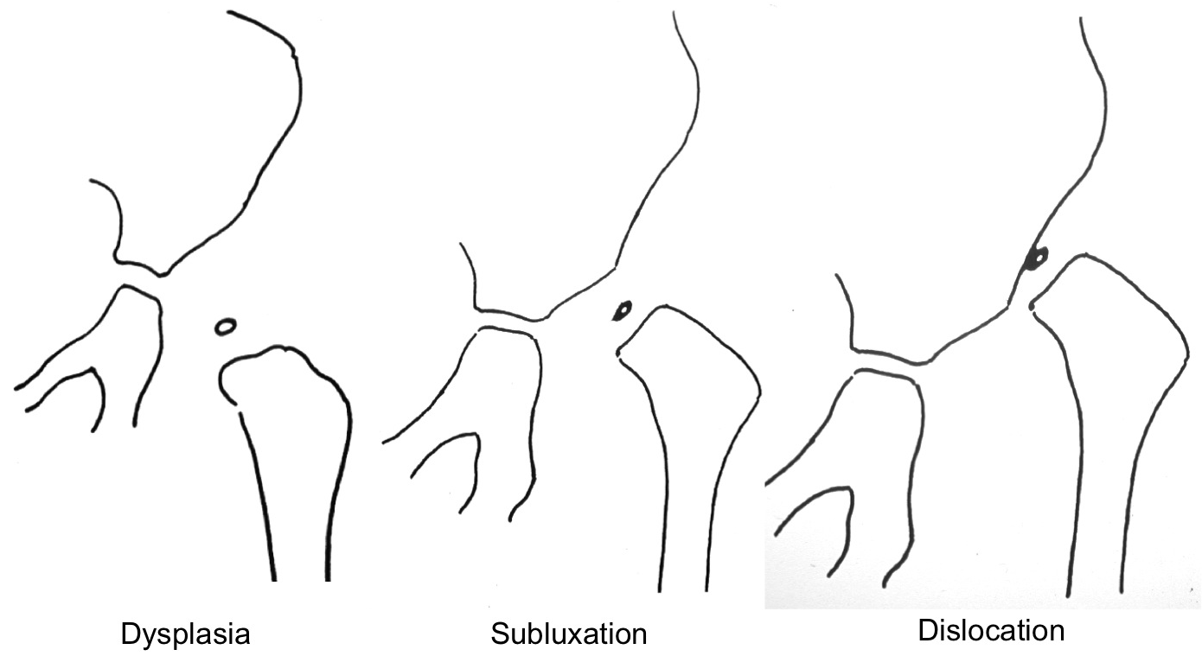

Figure 1 Drawing of the three types of the disease in infants.

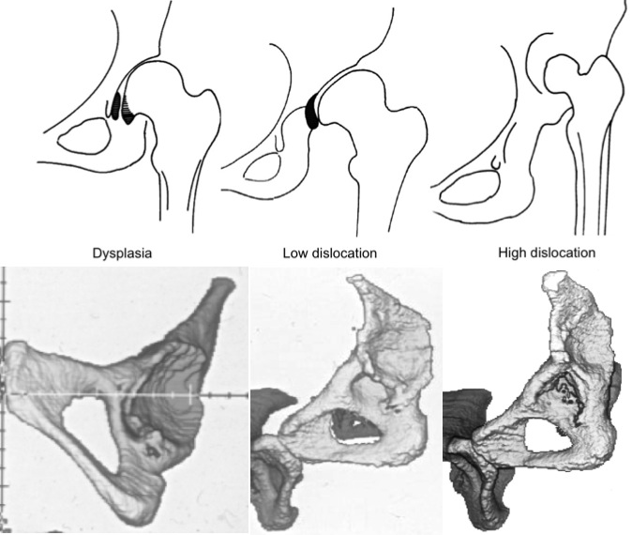
Figure 2 Drawing and three dimensional-computed tomographys of the three types of congenital hip disease in adults. The black-colored areas in dysplasia are: the large osteophyte that covers the acetabular fossa and the medial marginal osteophyte of the femoral head (capital drop), and in low dislocation represents the inferior part of the false acetabulum that is an osteophyte that begins at the level of the superior rim of the true acetabulum.

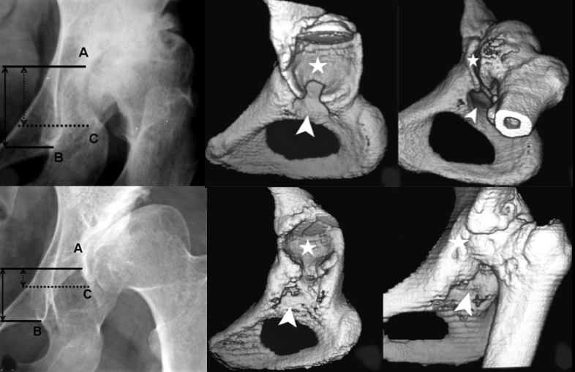
Figure 3 Images illustrate the two subtypes of low dislocation: B1 and B2. Three points must be recognised on radiographs: (A) the superior limit of the true acetabulum; (B) the inferior point of the teardrop; (C) the most inferior point of the false acetabulum. Three dimensional-computed tomography scans may help to determine the superior limit of the true acetabulum when it is not clear in plain radiographs. Asterisks depict false acetabulum and arrowheads true acetabulum.

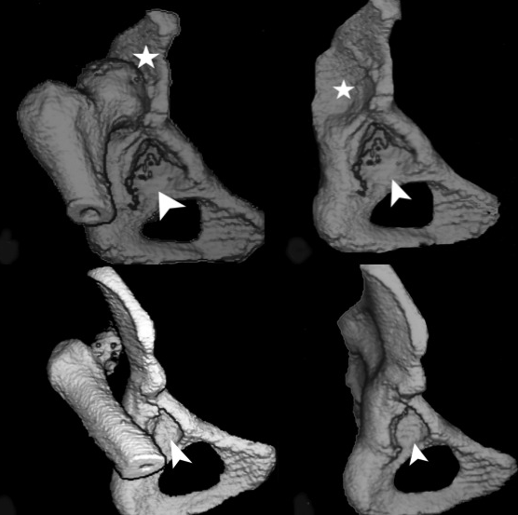
Figure 4 Three dimensional-computed tomography scans of the two subtypes of high dislocation. Arrowheads indicate the true asterisks the false acetabulum.

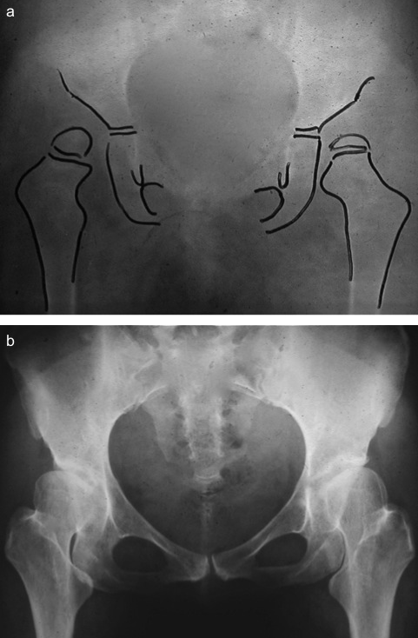

Figure 5 Development of dysplastic hips. (A) At the age of 3 when the child was first seen by his/her physician. An abduction frame was applied for 6 mo; (B) At the age of 35, patient had the first symptoms, pain and limping, due to the development of secondary osteoarthritis.

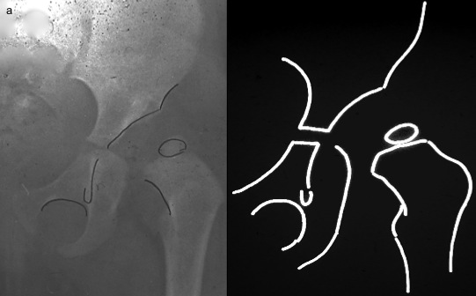
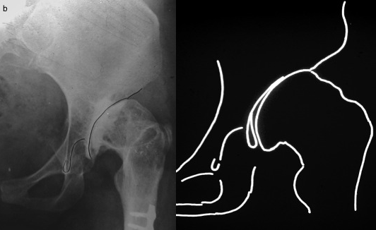
Figure 6 Radiographs and diagrams of a female patient with subluxation of the left hip at infancy developed to low dislocation. (A) At the age of 2; (B) the final image, when the patient was 37 years old.

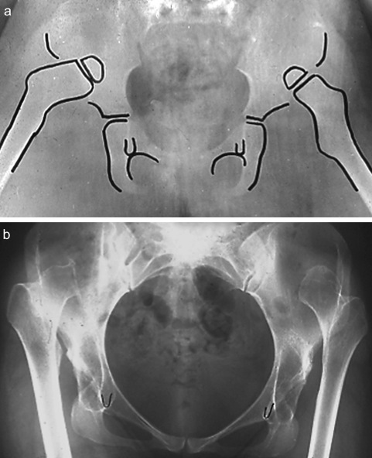

Figure 7 Images illustrate the case of a female patient with bilateral high dislocation. (A) Radiograph at the age of 2; (B) Radiograph at the age of 33 when the patient was consulted for bilateral total hip replacements.

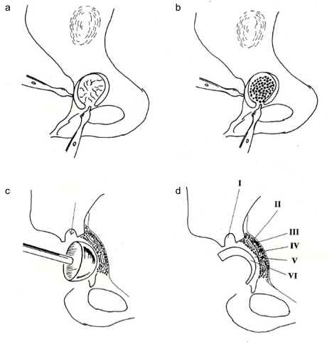

Figure 8 Cotyloplasty technique. (A) comminuted fracture of the entire medial wall; (B) large amount of cancellous morselised graft placed between the fragments of the acetabular floor, onto the periosteum; (C) grafts moulded with a hemispherical pusher; (D) final appearance: I anchorage hole, II internal layer of the periosteum, III autogenous morselised graft, IV fragments of the acetabular floor, V cement mantle, VI offset-bore acetabular component.

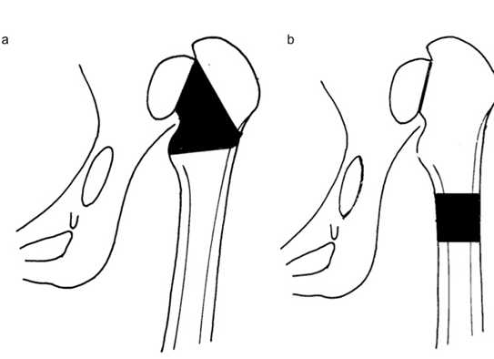

Figure 9 Drawings of the two alternatives of shortening of the femur. (A) at the level of femoral neck and (B) distal shortening at the level of femoral shaft.

